

European Union

GRANTS COI HORIZON 2030

N° NDICI AFRICA/2024/455-218

TENDER DOSSIER
(Local open tender)

COI/HORIZON2030/AO/2026/013

SUPPLY OF EQUIPMENT FOR THE FIT-OUT OF THE COI OFFICES (HORIZON 2030).

Location: Ebene, Mauritius
Letter of invitation to tender
<Letterhead of the contracting authority>

Ébène, 11/09/2026

Our ref.: COI/HORIZON2030/AO/2026/013
Subject: Invitation to tender for supply of equipment for the fit-out of the COI offices (Horizon 2030).
Dear ,
I am pleased to inform you that [your legal entity] [the consortium led by you] is invited to take part in the local open procedure for the above supply contract. The complete tender dossier includes:
- Instructions to tenderers
- Draft contract: main and special conditions and annexes:
I. General conditions for supply contracts
II. and III. Technical specifications technical offer (to be tailored to the specific project)
IV. Budget breakdown (model financial offer)
V. Forms
- Further information
I. Administrative compliance grid
II. Evaluation grid
- Tender form for a supply contract and Declaration on honour on exclusion and selection criteria (annex A14a)
For full information about procurement procedures please consult the practical guide and its annexes, which can be downloaded from the following web page: https://wikis.ec.europa.eu/display/ExactExternalWiki/ePRAG
We look forward to receiving your tender which has to be submitted no later than the submission deadline mentioned in the contract notice.
By submitting a tender you accept to receive notification of the outcome of the procedure by electronic means. Such notification shall be deemed to have been received by you on the date upon which the contracting authority sends it to the electronic address you referred to in your offer.

If you decide not to submit a tender, we would be grateful if you could inform us in writing, stating the reasons for your decision.
Yours sincerely,

Name and signature

A. INSTRUCTIONS TO TENDERERS
PUBLICATION REF.: COI/HORIZON2030/AO/2026/013
By submitting a tender, tenderers fully and unreservedly accept the main, special and general conditions governing the contract as the sole basis of this tendering procedure, whatever their own conditions of sale may be, which they hereby waive. Tenderers are expected to examine carefully and comply with all instructions, forms, contract provisions and specifications contained in this tender dossier. Failure to submit a tender containing all the required information and documentation within the deadline specified will lead to the rejection of the tender. No account can be taken of any remarks in the tender relating to the tender dossier; remarks may result in the immediate rejection of the tender without further evaluation.
These instructions set out the rules for the submission, selection and implementation of contracts financed under this call for tenders, in conformity with the practical guide (available on the internet at: https://wikis.ec.europa.eu/display/ExactExternalWiki/ePRAG).

1. Supplies to be provided

1.1 The subject of the contract is:
the supply, delivery and installation of the following supplies:
Lot 1 — IT and audio-visual equipment (e.g. 23 laptops, 19×27" and 3×32" monitors, 4 multifunction A4/A3 printers, 2 interactive 75" panels, 1 interactive totem, privacy filters, external drives, laptop stands).
Lot 2 — Furniture (meeting/conference tables and chairs, metal cabinets, office desks and chairs, stainless-steel kitchen furniture).
Lot 3 — Appliances and accessories (refrigerators, microwave oven, transparent lectern, document stands, indoor flag poles), to the COI offices in Ebène, Mauritius, DDP before 19 December 2026 in accordance with the contract notice/additional information about the contract notice.

1.2 The supplies must comply fully with the technical specifications set out in the tender dossier (technical annex) and conform in all respects with the drawings, quantities, models, samples, measurements and other instructions.

1.4 Tenderers are not authorised to tender for a variant solution in addition to the present tender.

2 Timetable
 | DATE | TIME**
Information meeting / site visit (if any) | Not applicable | Not applicable
Deadline for requesting clarifications from the contracting authority | Tuesday 22 September 2026 (at the latest 21 days before the submission deadline) | –
Last date on which clarifications are issued by the contracting authority | Monday 5 October 2026 (at the latest 8 days before the submission deadline) | –
Deadline for submission of tenders | Tuesday 13 October 2026 | 15:00 (local time, Mauritius)
Tender opening session | Wednesday 14 October 2026 | 10:00
Notification of award to the successful tenderer | Friday 30 October 2026 (at most 90 days after the submission deadline) | –
Signature of the contract | Friday 13 November 2026 (at most 150 days after the submission deadline) | –
* Provisional date
**The time zone of the country of the contracting authority.

3. Participation

3.1. The eligibility requirements detailed in the Additional information about the contract notice (Annex A5f) or, if applicable, in the Contract Notice (C2), apply to all members of a joint venture/consortium and all subcontractors, as well as to all entities upon whose capacity the tenderer relies for the selection criteria. Every tenderer, member of a joint venture/consortium, every capacity-providing entity, every subcontractor must certify that they meet these conditions. They must prove their eligibility by a document dated less than one year earlier than the deadline for submitting tenders, drawn up in accordance with their national law or practice or by copies of the original documents stating the constitution and/or legal status and the place of registration and/or statutory seat and, if it is different, the place of central administration. The contracting authority may accept other satisfactory evidence that these conditions are met.

3.2. Natural or legal persons are not entitled to participate in this tender procedure or be awarded a contract if they are in any of the situations mentioned in Sections 2.4.1 (EU restrictive measures), 2.4.2.1 (exclusion criteria) or 2.4.2.2(rejection from a procedure) of the practical guide. Should they do so, their tender will be considered unsuitable or irregular respectively. In the cases listed in Section 2.4.2.1 of the practical guide tenderers may also be excluded from EU financed procedures and/or be subject to financial penalties up to 10 % of the total value of the contract in accordance with the Financial Regulation in force. This information may be published on the Commission website in accordance with the Financial Regulation in force. Tenderers must provide declarations on honour that they are not in any of these exclusion situations. Such declarations must also be submitted by all the members of a joint venture/consortium, by any sub-contractor and by any capacity providing entities. Tenderers who make false declarations may also incur financial penalties and exclusion in accordance with the Financial Regulation in force. Their tender will be considered irregular.

The exclusion situations referred to above also apply to all members of a joint venture/consortium, all subcontractors and all suppliers to tenderers, as well as to all entities upon whose capacity the tenderer relies for the selection criteria. In cases of doubt over declarations, the contracting authority will request documentary evidence that subcontractors and/or capacity providing entities are not in a situation that excludes them.

3.3. To be eligible to take part in this tender procedure, tenderers must prove to the satisfaction of the contracting authority that they comply with the necessary legal, technical and financial requirements and have the means to carry out the contract effectively.

3.4. Subcontracting is allowed. The tenderer and, where applicable, entities on whose capacities it has relied with regard to criteria relating to the economic and financial capacity shall be jointly liable for the performance of the contract.

4. Origin
4.1 All goods purchased under this contract may originate in any country.

4.2 When submitting tenders, tenderers must state expressly that all the goods meet the requirements concerning origin and must state the countries of origin. They may be asked to provide additional information in this connection.

5. Type of contract

Unit-price

6. Currency

Tenders must be presented in Euro

7 Lots

7.1 The tenderer may submit a tender for one lot, several or all of the lots.

7.2 Each lot will form a separate contract and the quantities indicated for different lots will be indivisible. The tenderer must offer the whole of the quantity or quantities indicated for each lot. Under no circumstances must tenders be considered for part of the quantities required. If the tenderer is awarded more than one lot, a single contract may be concluded covering all those lots.

7.3 A tenderer may include in its tender the overall discount it would grant in the event of some or all of the lots for which it has submitted a tender being awarded. The discount should be clearly indicated for each lot in such a way that it can be announced during the public tender opening session.

7.4 Contracts will be awarded lot by lot, but the contracting authority may select the most favourable overall solution after taking account of any discounts offered.

8 Period of validity

8.1 Tenderers will be bound by their tenders for a period of 90 days from the deadline for the submission of tenders.

8.2 In exceptional cases and prior to the expiry of the original tender validity period, the contracting authority may ask tenderers in writing to extend this period by 40 days. Such requests and the responses to them must be made in writing. Tenderers that agree to do so will not be permitted to modify their tenders and they are bound to extend the validity of their tender guarantees for the revised period of validity of the tender. If they refuse, without forfeiture of their tender guarantees, their participation in the tender procedure will be terminated. In case the contracting authority is required to obtain the recommendation of the panel referred to in Section 2.4.2.1. of the practical guide, the contracting authority may, before the validity period expires, request an extension of the validity of the tenders up to the adoption of that recommendation.
8.3 The successful tenderer will be bound by its tender for a further period of 60 days. The further period is added to the validity period of the tender irrespective of the date of notification.

9 Language of tenders

9.1 The tenders, all correspondence and documents related to the tender exchanged by the tenderer and the contracting authority must be written in the language of the procedure, which is English.

If the supporting documents are not written in one of the official languages of the European Union, a translation into the language of the call for tender must be attached. Where the documents are in an official language of the European Union other than English, it is strongly recommended to provide a translation into English, to facilitate evaluation of the documents.

10. Submission of tenders
10.1 In order to participate, economic operators will not need to register in the European Commission's Participant Register - an online register of organisations participating in EU calls for tenders or proposals (PIC registration). Therefore, the PIC number will not need to be filled in in the tender form (Annex c4l).

Tenders must be sent to the contracting authority before the deadline specified in Contract Notice. They must include all the documents specified in point 11 of these Instructions and be sent to the following address:
Contracts and Procurement Department
Indian Ocean Commission
Blue Tower, 4th floor
Institute Road, Ebène, Mauritius

If the tenders are hand delivered they should be delivered to the following address:
Contracts and Procurement Department
Indian Ocean Commission
Blue Tower, 4th floor
Institute Road, Ebène, Mauritius
8h30-16h (from Monday to Friday)
Tenders must comply with the following conditions:

10.2 All tenders must be submitted in one original, marked ‘original’, and two copies signed in the same way as the original and marked ‘copy’.

10.3 The tenders should be submitted:

(a) either by post or by courier service, in which case the evidence shall be constituted by the postmark or the date of the deposit slip

(b) or by hand-delivery to the premises of the contracting authority by the participant in person or by an agent, in which case the evidence shall be constituted by the acknowledgment of receipt.

The contracting authority may, for reasons of administrative efficiency, reject any application or tender submitted on time to the postal service but received, for any reason beyond the contracting authority's control, after the effective date of approval of the short-list report or of the evaluation report, if accepting applications or tenders that were submitted on time but arrived late would considerably delay the evaluation procedure or jeopardise decisions already taken and notified.

10.4 All tenders, including annexes and all supporting documents, must be submitted in a sealed envelope bearing only:

a) the above address;

b) the reference code of this tender procedure, COI/HORIZON2030/AO/2026/013;

c) where applicable, the number of the lot(s) tendered for;

d) the words ‘Not to be opened before the tender opening session’ in the language of the tender dossier.

e) the name of the tenderer.

The technical and financial offers must be placed together in a sealed envelope. The envelope should then be placed in another single sealed envelope/package, unless their volume requires a separate submission for each lot.

11. Content of tenders
The tender must include a technical offer and a financial offer, which must be submitted in separate envelopes either by post or by hand-delivery.

Failure to fulfil the below requirements will constitute an irregularity and may result in rejection of the tender. All tenders submitted must comply with the requirements in the tender dossier and comprise:

Part 1: Technical offer:

a detailed description of the supplies tendered in conformity with the technical specifications, including any documentation required, including if applicable:
  - technical proposals related to ancillary services.
The technical offer should be presented as per template (Annex II+III*, Contractor’s technical offer) adding separate sheets for details if necessary.

Part 2: Financial offer:

A financial offer calculated on a DDP basis for the supplies tendered.

This financial offer should be presented as per template (Annex IV*, Budget breakdown), adding separate sheets for details if necessary. All amounts are to be quoted excluding taxes. VAT, if applicable, is to be mentioned separately.
In case of doubt about the applicable VAT system, it is the tenderer's responsibility to contact his or her national authorities to clarify the way in which the European Union is exempt from VAT.

Part 3: Documentation:
To be supplied using the templates attached*:
- The "Tender form for a supply contract", together with Annex 1 "Declaration on honour on exclusion criteria and selection criteria", both duly completed, which includes the tenderer’s declaration, point 7, (from each member if a consortium, (if any)).
Signed originals of the Declaration on honour shall be submitted.
- A completed identification form (see Annex V to the draft contract) and supporting documents to the identification form.
To be supplied in free-text format:
- A description of the warranty conditions, which must be in accordance with the conditions laid down in Article 32 of the general conditions.
- A description of the organisation of the commercial warranty tendered in accordance with the conditions laid down in Article 32 of the special conditions
- Duly authorised signature: an official document (statutes, power of attorney, notary statement, etc.) proving that the person who signs on behalf of the company, joint venture or consortium is duly authorised to do so.

Remarks:
Tenderers are requested to follow this order of presentation.
Annex* refers to templates attached to the tender dossier. These templates are also available on: https://wikis.ec.europa.eu/display/ExactExternalWiki/Annexes#Annexes-AnnexesC(Ch.4):Supplies

12. Taxes and other charges

The applicable tax and customs arrangements are the following:
There is no agreement between the European Commission and Mauritius allowing partial or full exemption from taxes.

13. Additional information before the deadline for submission of tenders
The tender dossier should be clear enough so that tenderers do not need to request additional information during the procedure. If the contracting authority, on its own initiative or in response to a request from a prospective tenderer, provides additional information on the tender dossier, it must send such information in writing to all other prospective tenderers at the same time.
Tenderers may submit questions in writing to the following address up to 21 days before the deadline for submission of tenders, specifying the publication reference and the contract title:
Contracts and Procurement Department
Indian Ocean Commission
Blue Tower, 4th floor
Institute Road, Ebène, Mauritius
Email : smc@coi-ioc.org ;

Any clarification of the tender dossier will be communicated simultaneously in writing to all tenderers at the latest 8 days before the deadline for submitting tenders
Any prospective tenderers seeking to arrange individual meetings with either the contracting authority and/or the European Commission during the tender period may be excluded from the tender procedure.

14. Clarification meeting / site visit
14.1 No information meeting / site visit planned. Visits by individual prospective tenderers during the tender period cannot be organised.

15. Alteration or withdrawal of tenders

15.1 Tenderers may alter or withdraw their tenders by written notification prior to the deadline for submission of tenders. No tender may be altered after this deadline. Withdrawals must be unconditional and will end all participation in the tender procedure.

Any such notification of alteration or withdrawal must be prepared and submitted in accordance with Section 10. The outer envelope must be marked ‘Alteration’ or ‘Withdrawal’ as appropriate.

15.2 No tender may be withdrawn in the interval between the deadline for submission of tenders and the expiry of the tender validity period. Withdrawal of a tender during this interval may result in forfeiture of the tender guarantee.

16. Costs of preparing tenders
No costs incurred by the tenderer in preparing and submitting the tender are reimbursable. All such costs will be borne by the tenderer.

17. Ownership of tenders
The contracting authority retains ownership of all tenders received under this tender procedure. Consequently, tenderers have no right to have their tenders returned to them.

18. Joint venture or consortium

18.1 If a tenderer is a joint venture or consortium of two or more persons, the tender must be a single one with the object of securing a single contract, each person must sign the tender and will be jointly and severally liable for the tender and any contract. Those persons must designate one of their members to act as leader with authority to bind the joint venture or consortium. The composition of the joint venture or consortium must not be altered without the prior written consent of the contracting authority.

18.2 The tender may be signed by the representative of the joint venture or consortium only if it has been expressly so authorised in writing by the members of the joint venture or consortium, and the authorising contract, notarial act or deed must be submitted to the contracting authority in accordance with point 11 of these instructions to tenderers. All signatures to the authorising instrument must be certified in accordance with the national laws and regulations of each party comprising the joint venture or consortium together with the powers of attorney establishing, in writing, that the signatories to the tender are empowered to enter into commitments on behalf of the members of the joint venture or consortium.

19. Opening of tenders

19.1 The purpose of the opening session is to check whether the tenders have been submitted in accordance with the submission requirements of the call for tenders.

19.2 The date and venue of the tender opening session are indicated in the Contract Notice.
Tenderers wishing to attend the opening session, are required to send a request by email to smc@coi-ioc.org no later than two working days before the scheduled start of the opening session. A maximum of two representatives per tender may attend. The representatives will receive an invitation to attend the opening session by email. This invitation will include the instructions on how to attend the opening.

The committee will draw up minutes of the meeting, which will be available on request.
In the case that at the date of the opening session some tenders have not been delivered to the contracting authority but their representatives can show evidence that it has been sent on time, the contracting authority will allow them to participate in the first opening session and inform all representatives of the tenderers that a second opening session will be organised.
19.3 At the tender opening, the tenderers’ names, the tender prices, any discount offered, written notifications of alteration and withdrawal, the presence of the requisite tender guarantee (if required) and such other information as the contracting authority may consider appropriate may be announced.

19.4 After the public opening of the tenders, no information relating to the examination, clarification, evaluation of tenders, or recommendations concerning the award of the contract can be disclosed until after the contract has been awarded.

19.5 Any attempt by tenderers to influence the evaluation committee in the process of examination, clarification, evaluation and comparison of tenders, to obtain information on how the procedure is progressing or to influence the contracting authority in its decision concerning the award of the contract will result in the immediate rejection of their tenders.

19.6 All tenders received after the deadline for submission specified in the contract notice or these instructions will be kept by the contracting authority. The associated guarantees will be returned to the tenderers. No liability can be accepted for late delivery of tenders. Late tenders will be rejected and will not be evaluated.

20. Evaluation of tenders

20.1 Examination of the administrative conformity of tenders

The aim at this stage is to check that tenders comply with the essential requirements of the tender dossier. A tender is deemed to comply if it satisfies all the conditions, procedures and specifications in the tender dossier without substantially departing from or attaching restrictions to them.

Substantial departures or restrictions are those which affect the scope, quality or execution of the contract, differ widely from the terms of the tender dossier, limit the rights of the contracting authority or the tenderer’s obligations under the contract or distort competition for tenderers whose tenders do comply. Decisions to the effect that a tender is not administratively compliant must be duly justified in the evaluation minutes.

If a tender does not comply with the tender dossier, it will be rejected immediately and may not subsequently be made to comply by correcting it or withdrawing the departure or restriction.

20.2 Technical evaluation

After analysing the tenders deemed to comply in administrative terms, the evaluation committee will rule on the technical admissibility of each tender, classifying it as technically compliant or non-compliant.

The minimum qualifications required (see selection criteria in the additional information about the contract notice are to be evaluated at the start of this stage.

Where contracts include after-sales service and/or training, the technical quality of such services will also be evaluated by using yes/no criteria as specified in the tender dossier.

20.3 In the interests of transparency and equal treatment and to facilitate the examination and evaluation of tenders, the evaluation committee may ask each tenderer individually for clarification of its tender including breakdowns of prices, within a reasonable time limit to be fixed by the evaluation committee. The request for clarification and the response must be in writing, but no change in the price or substance of the tender may be sought, offered or permitted except as required to confirm the correction of arithmetical errors discovered during the evaluation of tenders pursuant to Article 20.4. Any such request for clarification must not distort competition. Decisions to the effect that a tender is not technically compliant must be duly justified in the evaluation minutes.

20.4 Financial evaluation
a) Tenders found to be technically compliant will be checked for any arithmetical errors in computation and summation. Errors will be corrected by the evaluation committee as follows:

- where there is a discrepancy between amounts in figures and in words, the amount in words will be the amount taken into account;

- except for lump-sum contracts, where there is a discrepancy between a unit price and the total amount derived from the multiplication of the unit price and the quantity, the unit price as quoted will be the price taken into account.
b) Amounts corrected in this way will be binding on the tenderer. If the tenderer does not accept them, its tender will be rejected.
c) Unless specified otherwise, the purpose of the financial evaluation process is to identify the tenderer offering the lowest price. Where specified in the technical specifications, the evaluation of tenders may take into account not only the acquisition costs but, to the extent relevant, costs borne over the life cycle of the supplies (such as for instance maintenance costs and operating costs), in line with the technical specifications. In such case, the contracting authority will examine in detail all the information supplied by the tenderers and will formulate its judgment on the basis of the lowest total cost, including additional costs.

20.5 Variant solutions
Variant solutions will not be taken into consideration.

20.6 Award criteria

The sole award criterion will be the price. The contract will be awarded to the lowest compliant tender.

20.7 Documentary evidence for exclusion and selection criteria
At any time during the procurement procedure and before the award of the contract, the contracting authority may request documentary evidence on compliance with the exclusion criteria and selection criteria (financial, economic, technical and professional capacity) set out in these instructions. Please note that a request for evidence in no way implies that the tenderer has been successful. All tenderers are invited to prepare in advance the documents related to the evidence, since they may be requested to provide such evidence within a short deadline. In any event, the tenderer proposed by the evaluation committee for the award of the contract, will be requested to provide such evidence at short notice.
When requested, regarding the exclusion criteria, the tenderers should be able to provide the documentary proof or statements required under the law of the country in which the company (or, for consortia, each of the companies) is established, to show that it does not fall into any of the exclusion situations listed in Section 2.4.2 of the practical guide.
At any time during the procurement procedure, the contracting authority may request information on natural or legal persons that are members of the administrative, management or supervisory body or that have powers of representation, decision or control, including legal and natural persons within the ownership and control structure and beneficial owners, and appropriate evidence that none of those persons are in one of the exclusion situations referred to in the Declaration on Honour.

This evidence, documents or statements must be dated, no more than one year before the date of submission of the tender.
The above-mentioned documents must be submitted for every member of a joint venture/consortium, all subcontractors and every capacity providing entity.

The contracting authority may waive the obligation of any tenderer to submit the documentary evidence referred to above if such evidence has already been submitted for the purposes of another procurement procedure, provided that the issue date of the documents does not exceed one year and that they are still valid. In this case, the tenderer must declare on his/her honour that the documentary evidence has already been provided in a previous procurement procedure and confirm that his/her situation has not changed.

Where the documentary evidence submitted is in an official language of the European Union other than the one of the procedure, it is strongly recommended to provide a translation into the language of the procedure, in order to facilitate the evaluation of the documents.

Failure to provide valid documentary evidence at the request and within the deadline set by the Contracting Authority shall lead to the rejection of the tender for the award of the contract, unless the tenderer can justify the failure on the grounds of material impossibility.
If the successful tenderer fails to provide this documentary proof or statement or if the successful tenderer is found to have provided misrepresented information, the award will be considered null and void. In this case, the contracting authority may award the tender to the next lowest tenderer or cancel the tender procedure.

21. Notification of award

By submitting a tender, each tenderer accepts to receive notification of the outcome of the procedure by electronic means. Such notification shall be deemed to have been received on the date upon which the contracting authority sends it to the electronic address referred to in the offer.
The contracting authority will inform all tenderers simultaneously and individually of the award decision. The tender guarantees of the unsuccessful tenderers will be released once the contract is signed. The successful tenderer will be informed in writing that its tender has been accepted (notification of award).

22. Signature of the contract and performance guarantee

22.1 The contracting authority reserves the right to vary quantities specified in the tender by +/- 100 % at the time of contracting and during the validity of the contract. The total value of the supplies may not, as a result of the variation rise or fall by more than 10 % of the original financial offer in the tender. The unit prices quoted in the tender shall be used.

22.2 Within 30 days of receipt of the contract signed, the other party must countersign and date the contract and return it. If applicable, the contractor shall together with the return of the countersigned contract, submit to the contracting authority a performance guarantee. On signing the contract, the successful tenderer will become the contractor and the contract will enter into force.
If a tenderer to whom the contract is awarded (any of the group members in case of a consortium) has established debt(s) owed to the Union, the European Atomic Energy Community or an executive agency when the latter implements the Union budget, such debt(s) may be offset, in line with Articles 101(1) and 102 the Financial Regulation and the conditions set out in the draft contract, against any payment due under the contract. The contracting authority will verify the existence of overdue debts of the successful tenderers (any of the group members in case of a consortium), and, if any such debt is found, will inform the tenderer (the leader in case of a consortium who will then have the obligation to inform all other group members before signing the contract) that the debt(s) may be offset against any payment under due the contract.

22.3 If it fails to sign and return the contract and any financial guarantee required within 30 days after receipt of notification, the contracting authority may consider the acceptance of the tender to be cancelled without prejudice to the contracting authority’s right to seize the guarantee, claim compensation or pursue any other remedy in respect of such failure, and the successful tenderer will have no claim whatsoever on the contracting authority.

22.4 For contracts of EUR 150 000 or below, on the basis of objective criteria such as the type and value of the contract, the contracting authority may decide not to require the performance guarantee

23. Tender guarantee

No tender guarantee is required.

24. Ethics, values and code of conduct

24.1 Absence of conflict of interest and of professional conflicting interest
The tenderer must not be affected by any professional conflicting interest nor any conflict of interest and must have no equivalent relation in that respect with other tenderers or parties involved in the project. Any unduly influence or attempt to unduly influence the evaluation committee or the contracting authority during the process of examining, clarifying, evaluating comparing tenders, any attempt to obtain confidential information or entering into unlawful agreements with competitors will lead to the rejection of its tender and may result in exclusion from future award procedures and/or financial penalties according to the Financial Regulation in force.

24.2 Respect for human rights and EU values as well as environmental legislation and core labour standards

The tenderer must respect environmental legislation and core labour standards: participants that are awarded the contract must comply with the environmental legislation including multilateral environmental agreements, and with the core labour standards as applicable and as defined in the relevant International Labour Organisation conventions (such as the conventions on freedom of association and collective bargaining; elimination of forced and compulsory labour; abolition of child labour).

The tenderer and its personnel must commit to and ensure the respect of basic EU values, the tenderer and its personnel must comply with basic EU values such as respect for human dignity, freedom, democracy, equality, the rule of law and human rights, including the rights of minorities. The tenderer and its personnel must comply with applicable data protection rules and environmental legislation. In particular, tenderers who have been awarded the contract must also comply with multilateral environmental agreements, and with the core labour standards as applicable and as defined in the relevant International Labour Organisation conventions (such as the conventions on freedom of association and collective bargaining; elimination of forced and compulsory labour; abolition of child labour).

The tenderer and its personnel must comply with EU values, such as respect for human dignity, freedom, democracy, equality, the rule of law and human rights, including the rights of minorities.
Zero tolerance for sexual exploitation, abuse and harassment:
The European Commission applies a policy of 'zero tolerance' in relation to all wrongful conduct which has an impact on the professional credibility of the tenderer.
Physical abuse or punishment, or threats of physical abuse, sexual abuse or exploitation, harassment and verbal abuse, as well as other forms of intimidation shall be prohibited.

24.3 Anti-corruption and anti-bribery
The tenderer shall comply with all applicable laws and regulations and codes relating to anti-bribery and anti-corruption. The European Commission reserves the right to suspend or cancel project financing if corrupt practices of any kind are discovered at any stage of the award process or during the execution of a contract and if the contracting authority fails to take all appropriate measures to remedy the situation. For the purposes of this provision, ‘corrupt practices’ are the offer of a bribe, gift, gratuity or commission to any person as an inducement or reward for performing or refraining from any act relating to the award of a contract or execution of a contract already concluded with the contracting authority.

24.4 Unusual commercial expenses
Tenders will be rejected or contracts terminated if it emerges that the award or execution of a contract has given rise to unusual commercial expenses. Such unusual commercial expenses are commissions not mentioned in the main contract or not stemming from a properly concluded contract referring to the main contract, commissions not paid in return for any actual and legitimate service, commissions remitted to a tax haven, commissions paid to a payee who is not clearly identified or commissions paid to a company which has every appearance of being a front company.
Contractors found to have paid unusual commercial expenses on projects funded by the European Union are liable, depending on the seriousness of the facts observed, to have their contracts terminated or to be excluded from future award procedures.

24.5 Breach of obligations, irregularities or fraud
The contracting authority reserves the right to suspend or cancel the procedure, where the award procedure proves to have been subject to breach of obligations, irregularities or fraud. If breach of obligations, irregularities or fraud are discovered after the award of the contract, the contracting authority may refrain from concluding the contract.

25. Cancellation of the tender procedure
If a tender procedure is cancelled, tenderers will be notified by the contracting authority.
If the tender procedure is cancelled before the tender opening session the sealed envelopes will be returned, unopened, to the tenderers.
Cancellation may occur, for example, if:
- the tender procedure has been unsuccessful, namely where no suitable, qualitatively or financially acceptable tender has been received or there has been no valid response at all;
- the economic or technical parameters of the project have changed fundamentally;
- exceptional circumstances or force majeure render normal implementation of the project impossible;
- all technically acceptable tenders exceed the financial resources available;
- there have been breach of obligations, irregularities or frauds in the procedure, in particular where these have prevented fair competition;
- the award is not in compliance with sound financial management, i.e. does not respect the principles of economy, efficiency and effectiveness (e.g. the price proposed by the tenderer to whom the contract is to be awarded is objectively disproportionate with regard to the price of the market.
In no event will the contracting authority be liable for any damages whatsoever including, without limitation, damages for loss of profits, in any way connected with the cancellation of a tender procedure even if the contracting authority has been advised of the possibility of damages. The publication of a contract notice does not commit the contracting authority to implement the programme or project announced.

26. Appeals
Tenderers believing that they have been harmed by an error or irregularity during the award process may file a complaint. See Section 2.12. of the practical guide.
27. Data Protection
Processing of personal data related to this tender procedure by the contracting authority takes place in accordance with the national legislation of the state of the contracting authority and with the provisions of the respective financing agreement.
The tender procedure and the contract relate to an external action funded by the EU, represented by the European Commission. If processing your reply to the invitation to tender involves transfer of personal data (such as names, contact details and CVs) to the European Commission, they will be processed solely for the purposes of the monitoring of the procurement procedure and of the implementation of the contract by the Commission, for the latter to comply with its obligations under the applicable legislative framework and under the financing agreement concluded between the EU and the Partner Country without prejudice to possible transmission to the bodies in charge of monitoring or inspection tasks in application of EU law. For the part of the data transferred by the contracting authority to the European Commission, the controller for the processing of personal data carried out within the Commission is the head of legal affairs unit of DG International Partnerships
Details concerning processing of your personal data by the Commission are available on the privacy statement at:
https://wikis.ec.europa.eu/display/ExactExternalWiki/Annexes#Annexes-AnnexesA(Ch.2):General

28. Early detection and exclusion system
The tenderers and, if they are legal entities, persons who have powers of representation, decision-making or control over them, natural or legal person that assumes unlimited liability for the debts, natural or legal person who is essential for the award or the implementation of the legal commitment, beneficial owner or any affiliate of the tender, are informed that, should they be in one of the situations of early detection or exclusion, their personal details (name, given name if natural person, address, legal form) may be registered in the early detection and exclusion system, and communicated to the persons and entities listed in the above-mentioned decision, in relation to the award or the execution of a procurement contract.
For more information, you may consult the privacy statement available on http://ec.europa.eu/budget/explained/management/protecting/protect_en.cfm

SUPPLY CONTRACT
Financed by Commission financing decision n° NDICI AFRICA/2024/455-218
Nº COI/HORIZON2030/AO/2026/013
financed from the general budget of the Union
MAIN CONDITIONS
The Indian Ocean Commission (IOC) — General Secretariat, Rue de l’Institut, Blue Tower, Ebène, Republic of Mauritius, (‘the contracting authority’),
represented for the purposes of the signature of this contract by the authorised representative indicated in the respective field under “SIGNATURES” below
of the one part, and
[Option 1: The tender was submitted by a single tenderer or by a group of economic operators with a separate legal personality:
2. [Contractor’s full official name]
Legal form: [Contractor’s official legal form]
Registration number: [Contractor’s statutory registration number or ID or passport number]
Official address: [Contractor’s full official address]
VAT: [OPTION for contractors with VAT: VAT registration number]
(‘the contractor’)
[Option 2: The tender was submitted by a group of economic operators without a separate legal personality (de facto consortium/joint tender):
2. [[Include the name of the group if any -] group of economic operators who submitted a joint tender (‘the group’) [composed of the following members who are jointly and severally liable vis-a-vis the contracting authority for the implementation of this contract]
Legal form: [Contractor’s official legal form]
Registration number: [Contractor’s statutory registration number or ID or passport number]
Official address: [Contractor’s full official address]
VAT: [OPTION for contractors with VAT: VAT registration number]
appointed as leader of the group by the members of the group that submitted the joint tender,
[repeat the above data as many times as there are contractors in case of consortium/joint tender and continue numbering]
(collectively "the contractor"),
represented for the purposes of signing this contract by the authorised representative indicated in the respective field under “SIGNATURES” below,
on the other part,
HAVE AGREED as follows:
1. Subject matter
The title of this contract is: “ Supply of equipment for the fit-out of the offices of the Indian Ocean Commission (Horizon 2030).”
The terms and conditions applying to this contract are laid down hereafter and in the special and general conditions and their annexes. They shall be deemed to form and be read and construed as an integral part of this contract in the order described in the special conditions.
2. Contract value
The maximum amount covering all purchases under this contract is EUR insert amount (insert amount in words).
3 Entry into force and duration
This contract enters into force on the date on which the last party signs it.
The maximum duration of this contract is thirty-seven (37) months from the date this contract enters into force.
4. Bank account
Payments shall be made in accordance with the special conditions into the following bank account:
Name of bank: insert bank name
Exact denomination of account holder: full name of account holder
Bank account number: insert bank account number.
Signatures
For the contractor |  | For the contracting authority
electronic signature  contractor |  | electronic signature contracting authority

Endorsed for financing by the European Union*
* The European Union is not a party to the contract, shall not be subject to any obligation in connection therewith and shall not be involved in any dispute settlement, including arbitration proceedings, which may arise therefrom.

SPECIAL CONDITIONS FOR EUROPEAN UNION EXTERNAL ACTIONS

Contents
These conditions amplify and supplement the general conditions governing the contract. Unless the special conditions provide otherwise, those general conditions remain fully applicable. The numbering of the articles of the special conditions is not consecutive but follows the numbering of the articles of the general conditions. Exceptionally, and with the approval of the competent European Commission departments, other clauses can be indicated to cover particular situations.

The subject of the contract shall be:
the supply, delivery, siting and installation, etc.,
of the following supplies:
Lot 1 — IT and audio-visual equipment (e.g. 23 laptops, 19×27" and 3×32" monitors, 4 multifunction A4/A3 printers, 2 interactive 75" panels, 1 interactive totem, privacy filters, external drives, laptop stands).
Lot 2 — Furniture (meeting/conference tables and chairs, metal cabinets, office desks and chairs, stainless-steel kitchen furniture).
Lot 3 — Appliances and accessories (refrigerators, microwave oven, transparent lectern, document stands, indoor flag poles).

Order of precedence of contract documents
The following documents shall be deemed to form and be read and construed as part of this contract, in the following order of precedence:
- the main conditions;
- the special conditions;
- the general conditions (Annex I);
- applicable only if the contract is a transnational contract: the PRAG Procedural rules on conciliation and arbitration.
- the technical specifications (Annex II including clarifications before the deadline for submission of tenders;
- the technical offer (Annex III including clarifications from the tenderer provided during tender evaluation);
- the budget breakdown (Annex IV);
- specified forms and other relevant documents (Annex V);
The various documents making up the contract shall be deemed to be mutually explanatory; in cases of ambiguity or divergence, they shall prevail in the order in which they appear above. Addenda shall have the order of precedence of the document they are amending.
Article 2 Language of the contract
2.1 The language used shall be English.
Article 4 Communications
4.1 Communication details
4.4 Communication via electronic exchange system (EES)
An electronic system will be used by the contracting authority and the contractor for all stages of implementation including, inter alia, management of the contract (amendments and administrative orders), reporting (including reporting on results) and payments. The contractor will be required to register in and use the appropriate electronic exchange system to allow for the e-management of the contract.
After the entry into force of this contract, at any time during its course the contracting authority may formally notify in writing the contractor that certain communications will be made by electronic means through the EU Funding & Tenders Portal (the Portal), in accordance with the Portal Terms and Conditions and using the forms and templates provided there. The Portal can be accessed via the following URL: https://ec.europa.eu/info/funding-tenders/opportunities/portal/ The notification shall indicate whether all or only certain communications under the contract will take place through the Portal. The notification shall have full legal effect from the date specified therein, which shall allow a reasonable period of time for the contractor to complete all necessary steps to have access to the Portal. The activation of the use of the Portal shall be at no additional cost for the contracting authority.
If the use of the Portal is activated, any communication covered by the activation notification related to the implementation of this contract shall be made through the Portal (except if explicitly instructed otherwise by the contracting authority or if communication via the Portal is hindered by factors beyond the control of the parties).
Communications by contractors through the Portal must be made by persons authorised according to the Portal Terms and Conditions. For naming the authorised persons to use the Portal, each contractor must designate before the date of effect of the activation notification a ‘legal entity appointed representative (LEAR)’. The role and tasks of the LEAR are stipulated in their appointment letter (see Portal Terms and Conditions).
If the communication via the Portal is hindered, instructions will be provided by the contracting authority by email and may also be published on the Portal.
During the course of the contract, the contracting authority reserve(s) the right to further extend the coverage of the communications made through the Portal (if its use has been already activated) or to activate the use of other electronic exchange systems, at no additional cost for the contracting authority.
In case of discrepancy between the clauses of the Portal Terms and Conditions or Terms and Conditions of other electronic exchange system and the clauses of this contract, the clauses of this contract (including its annexes) shall prevail.
4.5 & 4.6 Mail or email communication
If communications through the Portal have not been activated or a certain type of communication is not yet supported by the Portal, communications will be sent via email, or, exceptionally, on paper, via mail services, to the following addresses, until communications via the Portal are activated.
For the purpose of this contract, mail or email communications must be sent to the following addresses:
Contracting Authority:
Mme Gina BONNE
Chargée de Mission
Secrétariat Général
Blue Tower, 3ème Etage, Rue de l’Institut
Ebène Maurice
Tel : (230) 402 6100
Courriel: smc@coi-ioc.org

Contractor (or leader in the case of a joint tender):
Full name
Function
Company name
Full official address
Email: complete
Article 7 Supply of documents
The contractor shall provide, in English and free of charge, the following documents relating to the supplies delivered:
(a) technical documentation (data sheets) identifying the make, model and configuration of each item;
(b) user manuals and, where applicable, operation and maintenance (O&M) manuals;
(c) the manufacturer's warranty certificates;
(d) certificates of conformity (e.g. CE marking) and, where relevant, safety/EN conformity;
(e) for the interactive flat-panel displays and the totem: the mounting/installation instructions and the commissioning/configuration documentation;
(f) delivery notes and packing lists.
No specific design drawings are required for this contract. Should the contractor submit any drawings or documents requiring approval, they shall be transmitted to the project manager, who shall approve them or notify observations within seven (7) working days; the contractor shall incorporate any observations. All the documents listed above must be submitted at the latest at the time of the request for provisional acceptance; incomplete documentation may result in the postponement of provisional acceptance.
Article 8 Assistance with local regulations
The contractor is responsible for obtaining any permits, authorisations, licences and, where applicable, visas or work permits required under the laws of the Republic of Mauritius for the performance of this contract, and for completing all import and customs formalities. Under the agreed DDP (Delivered Duty Paid) delivery term, the import clearance, duties and taxes are borne by the contractor. Upon written request, the contracting authority will provide the contractor with reasonable assistance (for example, supporting letters to the competent authorities), without thereby assuming any responsibility for delays, costs or refusals. Relevant reference texts: the customs and import legislation of the Republic of Mauritius.
Article 9 General obligations
9.9 The contractor shall ensure a proportionate visibility of the European Union financing. As a minimum, the contractor shall affix the emblem of the European Union together with the statement "Funded by the European Union", by means of a small durable label, on the main durable equipment items only (for example the interactive panels, the totem, printers and larger appliances/furniture), where practical and appropriate. Labelling of small items, consumables and packaging is not required. The contractor shall acknowledge the European Union financing in the delivery documentation. The format of the label shall follow the Communication and Visibility Requirements for EU-funded external action and be submitted to the contracting authority for prior approval. No further communication activities are required.
Article 10 Origin

10.1 All goods purchased can originate in any country.
Article 11 Performance guarantee
11.1 No performance guarantee is required.
Article 12 Liabilities and insurance
12.1(a) Not applicable. The liability regime set out in Article 12.1(a) of the general conditions applies.
12.1(b) Not applicable.
12.2(a), paragraph 1 Not applicable.
12.2(a), paragraph 2 Not applicable.
12.2(b), paragraph 2 Under the DDP (Delivered Duty Paid) delivery term, the contractor bears all transport and loss/damage risks up to delivery at the place of destination and shall maintain transport insurance covering the supplies accordingly, in line with Article 12.2 of the general conditions.
Article 13 Programme of implementation of the tasks
13.2 The contractor shall submit, within five (5) days of the entry into force of the contract, an indicative delivery programme per lot (for information), showing the expected delivery dates and any coordination required with the works contractor for the mounting of the interactive panels and the totem. All deliveries must in any event be completed DDP no later than 19 December 2026.
Article 14 Contractor’s drawings
14.1 Not applicable
Article 15 Sufficiency of tender prices
The price of the supplies shall be that shown on the financial offer (specimen in Annex IV).
15.1 The unit prices are firm and not subject to revision, and are deemed to cover all the contractor's obligations under the contract — including delivery DDP to the COI premises in Ebène, all duties and taxes, transport, unloading, positioning, basic configuration, coordination with the works contractor for the mounting of the interactive panels and the totem, and user training where specified. No claim for additional payment on the grounds of errors or omissions in the tender prices will be admitted.
Article 16 Tax and customs arrangements
16.1 Not applicable
Article 17 Patents and licences
17.1 Not applicable
Article 18 Delivery order
18.1 Delivery of the goods shall commence on the date of entry into force of this contract (i.e. the date of the last signature).
Article 19 Period of implementation of the tasks
19.1 The time limit for delivery and the implementation period are the same for the three (3) lots.
The time limit for delivery shall be 19 December 2026, by 16:00 (local time, Mauritius).
The implementation period of tasks shall be 1 month.
Article 24 Quality of supplies
24.2 No preliminary technical acceptance is required.
Article 25 Inspection and testing
25.2 Inspection and testing shall be carried out at the place of delivery (the COI premises, Blue Tower, Ebène, Mauritius), upon delivery of the supplies. They shall consist of: (a) verification of conformity with the technical specifications (make, model, characteristics) and of the quantities delivered; (b) a functional test of the IT and audio-visual equipment (interactive panels, totem, printers, computers/monitors); (c) a visual and conformity check of the furniture, appliances and accessories. The contractor shall make the goods available and provide the means necessary for the tests. Any item found non-conforming shall be repaired or replaced by the contractor, at no additional cost, before provisional acceptance.
Article 26 General principles
26.1 Payments shall be made in euro.
Pre-financing is not applicable to this contract.
Payments shall be authorised and made by the Procurement and Contracts Service (SMC) / Finance, Indian Ocean Commission, Blue Tower, 4th floor, Rue de l'Institut, Ebène, Mauritius.
26.3 By derogation, the final payment to the contractor of the amounts due shall be made within 90 days after receipt by the contracting authority of an invoice and of the application for the certificate of provisional acceptance.
26.5 In order to obtain payments, the contractor must submit to the authority referred to in paragraph 26.1 above:
a) Not applicable.
b) For the 100 % balance, the invoice(s) and the application for the certificate of provisional acceptance, and if applicable, the certificates of origin for the supplies delivered and Annex V - VAT instructions indicating the group members shares for VAT purposes.
26.9 The contract does not include a price revision clause. The prices are firm and not subject to revision.
26.10 The contractor (including each member of the group in case of consortium) has an outstanding debt to the Union: Any payment may be offset against outstanding debts of any consortium member.
Article 28 Delayed payments
28.2 By derogation from Article 28.2 of the general conditions, once the deadline laid down in Article 26.3 has expired, the contractor shall, upon demand, be entitled to late-payment interest at the rate and for the period mentioned in the general conditions. The demand must be submitted within two months of receiving late payment.
Article 29 Delivery
29.1 The Incoterm applicable shall be DDP
29.3 The packaging shall remain the property of the contractor subject to environmental considerations.
29.4 The place of acceptance of the supplies shall be the COI premises, Blue Tower, Rue de l'Institut, Ebène, Republic of Mauritius.
29.5/6/7 Each delivery shall be accompanied by a delivery note and a packing list, quoting the contract reference and the lot number, and listing the items and quantities delivered. The packaging shall bear the contract reference (COI/HORIZON2030/AO/2026/013), the lot number, the name and address of the recipient (Indian Ocean Commission, Ebène), and appropriate handling markings (e.g. "Fragile", "This side up") for the IT and audio-visual equipment.
Article 31 Provisional acceptance
The certificate of provisional acceptance must be issued using the template in Annex C11. Provisional acceptance shall be granted lot by lot. The contractor shall request provisional acceptance once the supplies of a lot have been delivered DDP at the place of acceptance. Verification shall take place at the place of delivery and shall cover: (a) conformity with the technical specifications and the quantities delivered; (b) the functional tests (IT and audio-visual equipment) and the visual/conformity checks (furniture, appliances and accessories) provided for in Article 25.2; and (c) where applicable, the commissioning and configuration by the contractor of the interactive panels and the totem once they have been mounted by the works contractor. Within seven (7) days of the contractor's request, the project manager shall either issue the certificate of provisional acceptance — stating any reservations — or refuse it, giving reasons and specifying the corrective action required. Any non-conforming item shall be repaired or replaced by the contractor, at no additional cost, before provisional acceptance is granted.
Article 32 Warranty obligations
32.6 In addition to the warranty obligations under Article 32 of the general conditions, the contractor shall provide a commercial warranty for each item supplied, at least equal to the manufacturer's standard warranty and in any event not less than: three (3) years for the IT and audio-visual equipment and two (2) years for the furniture, appliances and accessories, running from the date of provisional acceptance. During the commercial warranty period the contractor shall, at no cost to the contracting authority, repair or replace any item that proves defective or non-conforming, bearing the related costs including transport.
32.7 The warranty must remain valid for one year after provisional acceptance.
Article 33 After-sales service
33.1 Not applicable
Article 40 Settlement of disputes
40.4 Any dispute arising out of or relating to this contract which cannot be settled otherwise shall
(a) in the case of a national contract, be settled in accordance with the national legislation of the state of the contracting authority; and
(b) in the case of a transnational contract, be settled by arbitration in accordance with the PRAG procedural rules on conciliation and arbitration, annexed to this contract. Should such rules have been amended by the time the arbitration proceedings are initiated, the amended rules will apply.) Please attach Annex A12b of the practical guide to the present contract.
The arbitral tribunal shall be composed of a sole arbitrator.
At the request of the arbitral tribunal, the European Commission shall publish any arbitral award resulting from this contract, after anonymization, on the European Commission’s external website.
The jurisdiction conferred under this clause is exclusive and any jurisdiction under a bilateral or multilateral investment treaty, or under the ICSID (International Centre for Settlement of Investment Disputes) rules is explicitly excluded.
Article 44 Data protection
For the purpose of Article 44 of the general conditions, for the part of the data transferred by the contracting authority to the European Commission:
(a) the controller for the processing of personal data carried out within the Commission is the head of legal affairs unit of DG International Partnerships.
(b) the privacy statement is available at https://wikis.ec.europa.eu/display/ExactExternalWiki/Annexes#Annexes-AnnexesA(Ch.2):General]
1. Processing of personal data related to the implementation of the contract by the contracting authority takes place in accordance with the national legislation of the state of the contracting authority and with the provisions of the respective financing agreement.
2. To the extent that the contract covers an action financed by the European Union, the Contracting Authority may share communications related to the implementation of the contract, with the European Commission. These exchanges shall be made to the Commission, solely for the purpose of allowing the latter to exercise its rights and obligations under the applicable legislative framework and under the financing agreement with the Partner country – contracting authority. The exchanges may involve transfers of personal data (such as names, contact details, signatures and CVs) of natural persons involved in the implementation of the contract (such as contractors, personnel, experts, trainees, subcontractors, insurers, guarantors, auditors and legal counsel). In cases where the contractor is processing personal data in the context of the implementation of the contract, he/she shall accordingly inform the data subjects of the possible transmission of their data to the Commission. When personal data is transmitted to the Commission, the latter processes them in accordance with Regulation (EU) 2018/1725 of the European Parliament and of the Council of 23 October 2018 on the protection of natural persons with regard to the processing of personal data by the Union institutions, bodies, offices and agencies and on the free movement of such data, and repealing Regulation (EC) No 45/2001 and Decision No 1247/2002/EC and as detailed in the specific privacy statement published at ePRAG.

* * *

PRAG PROCEDURAL RULES
ON CONCILIATION AND ARBITRATION

I. INTRODUCTORY RULES 3
Article 1 Scope of application 3
Article 2 Definitions 3
Article 3 Notice and calculation of time 3
Article 4 Obligatory attempt at amicable settlement 4
Article 5 Conciliation 4
II. THE TRIBUNAL 5
Article 6 Nationality of arbitrators 5
Article 7 Number of arbitrators 5
Article 8 Appointment of sole arbitrator 5
Article 9 Appointment of three arbitrators 5
Article 10 Appointments by the appointing authority 6
Article 11 Challenge of arbitrators 6
Article 12 Replacement of arbitrator 7
III. THE ARBITRATION PROCEEDINGS 8
Article 13 General provisions 8
Article 14 Applicable law and procedural rules 8
Article 15 Language of the proceedings 9
Article 16 Venue of the proceedings 9
Article 17 Representation and assistance 9
Article 18 Commencement of arbitration proceedings 9
Article 19 Statement of claim 10
Article 20 Statement of defence 10
Article 21 Amendments to the claim or defence 10
Article 22 Pleas to the jurisdiction of the tribunal 11
Article 23 Further written statements 11
Article 24 Time limits 11
Article 25 Evidence 11
Article 26 Oral proceedings 11
Article 27 Interim measures of protection 12
Article 28 Experts 12
Article 29 Default 13
Article 30 Closure of hearings 13
Article 31 Waiver of rules 13
IV. THE AWARD 13
Article 32 Decision 13
Article 33 Time, scope, form and effect of the award 14
Article 34 Enforcement of the award 14
Article 35 Settlement or other grounds for termination 14
Article 36 Interpretation of the award 15
Article 37 Correction of the award 15
Article 38 Additional award 15
Article 39 Fees 15
Article 40 Costs 15
Article 41 Deposit of costs 16

INTRODUCTORY RULES

Article 1 Scope of application
Disputes relating to a contract which, pursuant to the provisions of the general conditions and the special conditions governing the contract, may be settled by conciliation or by arbitration in accordance with the PRAG procedural rules on conciliation and arbitration shall be settled in accordance with these procedural rules.

Article 2 Definitions
In these rules, unless the context requires otherwise, the following words and expressions shall have the meaning here assigned to them:
Partner country: a country or territory that may benefit from Union support under the Neighbourhood, Development and International Cooperation Instrument pursuant to Article 4 of Regulation (EU) 2021/947, under the Instrument for International Nuclear Safety Cooperation pursuant to Article 11(1)(b)-(d) and (g) of Council Regulation (Euratom) 2021/948 of 27 May 2021, under the Decision on the Overseas Association, including Greenland pursuant to Article 2 of Council Decision (EU) 2021/1764 of 5 October 2021 on the association of the Overseas Countries and Territories with the European Union including relations between the European Union on the one hand, and Greenland and the Kingdom of Denmark on the other, or under the Instrument for Pre-Accession assistance (IPA III) pursuant to Article 3 of Regulation (EU) 2021/1529 of the European Parliament and of the Council of 15 September 2021,
Member State: a Member State of the European Union (EU),
the tribunal: the arbitral tribunal,
appointing authority: the authority agreed by the parties to an arbitration, or in the absence of such agreement, identified by these rules, as the authority to appoint an arbitrator,
contracting authority: the State or the legal person governed by public or private law which concludes the contract or on behalf of which the contract is concluded,
the contract: a contract for works, supplies or services,
claimant: the party which commences arbitration proceedings by giving notice to the other party requesting the arbitration and submitting claims,
respondent: the party to the arbitration against whom claims are made,
party: when used in connection with an arbitration, the claimant or respondent in the arbitration.

Article 3 Notice and calculation of time
3.1. Any notice provided by these rules shall be served by registered letter or physically delivered with a request for a dated acknowledgement of receipt in either case. A notice shall be deemed to have been received on the day it is so delivered.
3.2. For the purposes of calculating a period of time under these rules, such period shall begin to run on the day following the day when a notice, communication or proposal, is received. If the last day of such period is an official holiday or a non-working day, at the address mentioned in the notice, communication or proposal, the period shall be extended until the first working day which follows. However, official holidays or non-working days occurring during the running of the period of time shall be included in calculating the period.

Article 4 Obligatory attempt at amicable settlement
A dispute shall not be referred to arbitration under these rules unless the amicable settlement procedure foreseen in the contract’s general conditions has failed or is considered to have failed.

Article 5 Conciliation
5.1. At any time before a request for arbitration, a person with the right to request the arbitration may request the settlement of the dispute by conciliation in accordance with these rules.
5.2. The conciliation shall be conducted by a sole conciliator, to be agreed upon by the parties to the dispute.
5.3. To qualify for appointment as conciliator, the person must have the nationality of one of the Partner countries or Member States.
5.4. The party making a request for conciliation shall notify the other party of the request.
The request shall consist of a statement of the case of the applicant and shall be accompanied by copies of relevant papers and documents. The request shall also contain the name and address of the person proposed as a conciliator.
5.5. Within 30 days of receipt of the notice of the request, the other party shall notify the applicant whether it is prepared to accept an attempt at conciliation, and in that event to submit to the applicant a reply to the applicant's case. The reply shall also state whether the other party agrees with the person proposed by the applicant as a conciliator.
5.6. If the parties fail to agree on the sole conciliator within 60 days of the receipt of the reply, the conciliation is deemed to have failed.
5.7. The proceedings of the conciliator shall be as informal and expeditious as is compatible with a just and objective settlement of the dispute and shall be based on a fair hearing of each party.
Each of the parties may appear in person or be represented by an agent of his choice.
5.8. After examining the case, the conciliator shall submit terms of settlement to the parties.
5.9. Should a settlement result, the conciliator shall draw up and sign a record of the settlement. The record shall be signed by the parties to signify their acceptance thereof. The record of the settlement so signed by the parties shall be binding upon them.
5.10. Copies of the record of settlement so signed shall be given to the parties.
5.11. Should a settlement not result, the parties shall be at liberty to refer their dispute to arbitration under these rules, in which case, nothing that has transpired in connection with the proceedings before the conciliator shall in any way affect the legal rights of any of the parties at the arbitration.
5.12. No person having sat as a conciliator for the settlement of a dispute may be appointed arbitrator for the same matter.

THE TRIBUNAL

Article 6 Nationality of arbitrators
To qualify for appointment as an arbitrator, a person must have the nationality of one of the Partner countries or Member States.

Article 7 Number of arbitrators
If the contract so foresees, or if the parties agree, the tribunal shall be constituted by one arbitrator only. Such agreement must be reached by the parties within 15 days after receipt by the respondent of the notice commencing the arbitration proceedings as provided for in Article 18. If the parties fail to agree to arbitration by one arbitrator within the time specified, or if they otherwise agree, the tribunal shall be constituted by three arbitrators.

Article 8 Appointment of sole arbitrator
8.1. If a sole arbitrator is to be appointed, the parties shall agree on that arbitrator or upon the appointing authority for making the appointment thereof within 60 days after the commencement of the arbitration proceedings as laid down in Article 18.
8.2. Where:
- the parties are unable to agree either on the arbitrator or on the appointing authority within the specified 60 days; or
- the appointing authority agreed by the parties refuses to act, or fails to appoint the arbitrator, within 60 days of receipt of the parties' request therefor,
either party may request the most senior in rank from amongst the judges of the International Court of Justice at the Hague who are nationals of the Partner countries and the Member States to exercise the powers of the appointing authority.

Article 9 Appointment of three arbitrators
9.1. If three arbitrators are to be appointed, each party shall appoint one arbitrator. The two arbitrators thus appointed shall choose the third arbitrator who shall be the presiding arbitrator of the tribunal.
9.2. The appointment by each party of an arbitrator shall be made within 60 days from the date of the agreement between the parties that the tribunal be constituted by three arbitrators, or the date when the constitution of the tribunal by a sole arbitrator was, in terms of Article 7, excluded.
9.3. If:
- within 30 days after the appointment by each party of its arbitrator, the two appointed arbitrators have not chosen the third arbitrator; or
- within 30 days after the receipt of the notification of the appointment by one party of an arbitrator the other party has not notified the first party of the arbitrator it has appointed, the required arbitrator shall upon request by either party, be appointed by the appointing authority.
9.4. The appointing authority shall be agreed by the parties not later than 60 days after the particular failure which gives rise to the need to invoke that authority. If after the expiration of that period an appointing authority has not been agreed by the parties, either party may request the most senior in rank from amongst the judges of the International Court of Justice at the Hague who are nationals of the Partner countries and the Member States to exercise the powers of the appointing authority.

Article 10 Appointments by the appointing authority
10.1. When an appointing authority is requested to appoint an arbitrator, the party which makes the request shall send to the appointing authority a copy of the notice of arbitration specified in Article 18.1 and a copy of the contract under or in connection with which the dispute has arisen. The appointing authority may require from either party such information as it deems necessary to fulfil its function.
10.2. Either party may propose names of persons suitable for appointment as arbitrators to the appointing authority. Where such proposal is made, the full names, addresses and nationalities of the persons proposed shall be given, together with a description of their qualifications.
10.3. The appointing authority shall appoint the arbitrator or arbitrators as promptly as possible. In making the appointment, the appointing authority shall:
- have regard to such considerations as are likely to secure the appointment of an independent and impartial arbitrator of a nationality other than the nationalities of the parties, and of high moral standing, who has a recognized competence in the field of law, technical knowledge or finance applicable to the matters in dispute; and
- unless both parties agree otherwise, or the appointing authority decides in his discretion that the procedure is not appropriate for the particular case, use the following list procedure:
- the appointing authority shall communicate to both parties an identical list containing at least three names of persons qualified for appointment as arbitrators in terms of Articles 6.1 and 10.3 (a);
- within 30 days after the receipt of this list, each party may return the list to the appointing authority after deleting the name or names to which it objects, and numbering the remaining names on the list in the order of its preference. If the list is not returned or no alteration is made in the order in which the names appear in the original list, the names on that list shall be deemed to have been approved by the party concerned in the order in which they appear;
- upon receipt of the list returned by both parties, or after the expiration of the time limit for the return, whichever is the earlier, the appointing authority shall within 30 days appoint the arbitrator from among the names approved or deemed to be approved, on the list and in accordance with the order of preference indicated by the parties;
- if for any reason the appointment cannot be made according to this procedure, the appointing authority may appoint a suitable arbitrator, having due regard to the interest of the parties, the nature of the dispute and, where applicable, the fact that one of the parties is a State.

Article 11 Challenge of arbitrators
11.1. A prospective arbitrator shall disclose to those who approach him/her in connection with his/her possible appointment any facts or circumstances likely to give rise to justifiable doubts or suspicion as to his/her impartiality or independence. A person appointed arbitrator shall disclose such facts or circumstances to the parties unless they have already been informed by him/her of these circumstances.
11.2. Any arbitrator may be challenged by a party if facts or circumstances exist which give rise to justifiable doubts or suspicion as to his impartiality or competence. However a party may challenge an arbitrator appointed by it, or in whose appointment it has participated, only for reasons of which it becomes aware after the appointment has been made.
11.3. A party who intends to challenge an arbitrator shall send a notice of its challenge in writing, stating the reasons therefor to the tribunal, the challenged arbitrator and the other party. The notice shall be sent within 15 days of the constitution of the tribunal or of the appointment of the challenged arbitrator, whichever is later, or within 15 days after the circumstances justifying the challenge become known to the party making the challenge.
11.4. Where a challenge made by one party is agreed by the other party, or where the challenged arbitrator withdraws from office, the authority of that arbitrator in the arbitration proceedings shall forthwith terminate. But neither the agreement of the parties to the challenge, nor the withdrawal from office of the challenged arbitrator, implies an acceptance of the validity of the grounds of the challenge issued.
11.5. If the other party does not agree to the challenge, or if the challenged arbitrator does not withdraw, a decision on the challenge shall be made as follows:
- where the appointment of the arbitrator was made by an appointing authority, by that authority;
- where the appointment of the arbitrator was not made by an appointing authority, by the other members of the tribunal, if there are such others;
- in all other cases, or in case of disagreement between the other members of the tribunal, by an appointing authority designated or to be designated in accordance with the procedure provided in Article 9.4.
The decision of the authority specified herein shall be final.

Article 12 Replacement of arbitrator
12.1. In the following cases, a substitute arbitrator shall be appointed in accordance with the procedure laid down in Articles 8, 9 and 10 which is applicable to the appointment of the particular arbitrator being replaced:
- a challenge to an arbitrator has been agreed to by the other party; or
- a challenged arbitrator has withdrawn from office; or
- notwithstanding the absence of agreement of the other party, or a refusal by the challenged arbitrator to withdraw, a challenge to an arbitrator is sustained; or
- an arbitrator dies during the course of the arbitration proceedings; or
- for any other reason, an arbitrator fails to act or it becomes impossible de jure or de facto for him/her to perform his/her functions; in this regard, parties and their counsels will refrain from requesting an arbitrator to act as counsel or arbitrator in another dispute even if such dispute is not related to the dispute submitted to the current arbitration; in such a case, an arbitrator will be considered as unable to perform his/her functions if one party or one party’s counsel requests that he/she acts as arbitrator or counsel in another case, or if the arbitrator agrees to act as arbitrator or counsel at the request of one party or its counsel, even if such other case is strictly distinct from the parties or counsels involved in the current arbitration.
12.2. If an arbitrator is replaced, any hearing held previously may, at the discretion of the tribunal, be repeated, and any decision or order made in the course of the proceedings may be set aside by the tribunal.

THE ARBITRATION PROCEEDINGS

Article 13 General provisions
13.1. Subject to these rules, the tribunal may conduct the arbitration in such manner as it considers appropriate.
13.2. The tribunal shall conduct the arbitration as expeditiously and with such due regard for the saving of costs as is consistent with doing justice between the parties. The parties shall be treated with equality, and at any stage of the proceedings each of them shall be given a full opportunity of presenting their case.
13.3. If either party so requests at any stage of the proceedings, the tribunal shall hold hearings for presentation of evidence by witnesses, including expert witnesses, or for oral argument. In the absence of such a request, the tribunal shall decide whether to hold such hearings or whether the proceedings shall be conducted on the basis of documents and other materials.
13.4. All documents or information supplied to the tribunal by one party shall at the same time be communicated by that party to the other party. No such document or information may be used in support of a party's case unless there is proof that it has been communicated to the other party.

Article 14 Applicable law and procedural rules
14.1. The tribunal shall apply the law of the State of the contracting authority to the matters in dispute, unless otherwise specified in the contract, in which case the tribunal shall apply the law so specified. In all cases, the tribunal shall decide in accordance with the terms of the contract, and may take into account the usages of the trade applicable to the transaction.
14.2. Where the applicable law is silent on any specific point, the tribunal shall apply the conflict of laws rules resulting from the law applicable to the contract. The tribunal may not decline to make an award on the ground that the law is silent or obscure on the point.
14.3. Notwithstanding the provisions of Articles 5.1 and 14.1, if the parties expressly so authorize the tribunal in the course of the arbitration proceedings, it shall decide as amicable compositor or ex aequo et bono.
14.4. The entire arbitration proceedings shall be conducted in accordance with these rules. In the absence of agreement between the parties, any procedural matter which is not provided for in these rules shall be decided by the tribunal, which shall ensure in particular, in such a case, that the principle of equality between the parties is observed.

Article 15 Language of the proceedings
15.1. Arbitrations proceedings shall be conducted and the arbitration award made in the language of the contract, the terms or execution of which gave rise to the dispute.
15.2. The tribunal may order that any documents annexed to the statement of claim or statement of defence, and any other document or exhibit submitted in the course of the proceedings, and which are not drawn up in the language of the proceedings, shall be accompanied by a certified translation into the language of the proceedings.

Article 16 Venue of the proceedings
16.1. Arbitration proceedings shall be conducted in the Partner country in which the contract was awarded or performed. However, the tribunal may, with the agreement of the parties and for good cause, decide to conduct the arbitration in some other place. In deciding on such other place, the tribunal shall have regard to the circumstances of the case, including the costs involved, the convenience of the parties, and the potential adverse effect of the procedural rules of an alternative venue on the parties and the proceedings.
16.2. Subject to Article 16.1, the tribunal may hold some hearings and meetings at any place it deems appropriate, having regard to the circumstances of the case.
16.3. The tribunal may meet at any place it deems appropriate for the inspection of the works, goods, other property or documents. The parties shall be given sufficient notice to enable them to be present at such inspection.

Article 17 Representation and assistance
The parties may be represented and/or assisted by persons of their choice. The names and addresses of such persons must be communicated in writing to the other party and to the tribunal. Such communication must specify whether the person named is appointed for the purpose of representation or assistance.

Article 18 Commencement of arbitration proceedings
18.1. The claimant in an arbitration shall give to the respondent a notice of arbitration. Such notice shall be time-barred unless it is given not later than 180 days after the amicable settlement procedure foreseen in the contract’s general conditions has failed or is considered to have failed.
18.2. Arbitration proceedings shall be deemed to commence on the date on which the notice of arbitration is received by the respondent.
18.3. The notice of arbitration shall include the following:
- a demand that the dispute be referred to arbitration;
- the names and addresses of the parties and their nationality at the time of the notice;
- a reference to the contract out of or in relation to which the dispute arises, and the particular clause or clauses in the contract being invoked or challenged;
- the general nature of the claim and the amount involved, if any;
- the relief or remedy sought;
- a brief statement, with dates, of any administrative proceedings or of the notice given of complaints, and the outcome of such steps;
- a proposal as to the number of arbitrators (i. e., one or three).
18.4. The notice of arbitration may also include:
- the name of the person and/or the authority proposed for appointment as a sole arbitrator and/or appointing authority referred to in Article 8.1;
- the notification of the appointment by the claimant of an arbitrator referred to in Article 9.1;
- the statement of claim referred to in Article 19.

Article 19 Statement of claim
19.1. Unless the statement of claim was contained in the notice of arbitration, within a time limit to be determined by the tribunal, the claimant shall communicate its statement of claim in writing to the respondent and to each of the arbitrators. A copy of the contract shall be annexed thereto.
19.2. The statement of claim, signed and dated by the claimant and/or its duly authorized representative, shall include the following particulars:
- the names and addresses of the parties;
- a statement of the facts supporting the claim;
- the points at issue;
- the relief or remedy sought.
The claimant shall either annex to its statement of claim all documents it deems relevant or add a reference to the documents or other evidence it will submit.

Article 20 Statement of defence
20.1. Within a time limit to be determined by the tribunal, the respondent shall communicate its statement of defence in writing to the claimant and to each of the arbitrators.
20.2. The statement of defence shall reply to the particulars of the statement of claim given in compliance with Article 19.2 (b), (c) and (d). The respondent shall either annex to its statement the documents on which it relies for its defence or add a reference to the documents or other evidence it will submit.
20.3. In this statement of defence, or at a later stage in the arbitration proceedings, if the tribunal decides that the delay was justified under the circumstances, the respondent may make a counter-claim arising out of the same contract, or rely on a claim arising out of the same contract for the purpose of a set-off.
20.4. The provisions of Article 19.2 shall apply to a counter-claim and a claim relied on for the purpose of a set-off.

Article 21 Amendments to the claim or defence
During the course of the arbitration proceedings either party may amend or supplement its claim or defence unless the tribunal considers it inappropriate to allow such amendment having regard to the delay in making it or the undue harm that it would cause to the other party.

Article 22 Pleas to the jurisdiction of the tribunal
22.1. The tribunal shall have the power to rule on objections to its jurisdiction.
22.2. The tribunal shall have the power to determine the existence or the validity of the contract. A decision by the tribunal that the contract is null and void shall not affect the validity of the arbitration clause in the contract or the agreement to submit the dispute to arbitration, and therefore, shall not affect the application of these rules.
22.3. A plea that the tribunal does not have jurisdiction shall be raised not later than in the statement of defence or, with respect to a counter-claim, in the reply to the counter-claim. This provision shall also apply to new claims and counter-claims admitted in the course of the proceedings.
22.4. In general, the tribunal should rule on a plea concerning its jurisdiction as a preliminary question. However, the tribunal may proceed with the arbitration and then rule on such a plea in its final award.

Article 23 Further written statements
The tribunal shall decide which further written statements, in addition to the statement of claim and the statement of defence, shall be required from the parties or may be presented by them and, if so, the manner in which they shall be presented, and shall fix the time limits for communicating such statements.

Article 24 Time limits
The time limits fixed by the tribunal for the communication of written statements (including the statement of claim and statement of defence) shall not, in each case, exceed 60 days. However, the tribunal may extend the time limits if it concludes that an extension is justified.

Article 25 Evidence
25.1. Each party shall bear the burden of proving the fact relied on to support its claim or defence.
25.2. The tribunal may, if it considers it appropriate, require the parties to deliver to the tribunal and to the other party, within such time limit as the tribunal shall decide, a summary of the documents and other evidence which that party offers to present in support of the facts in issue set out in its statement of claim or statement of defence.
25.3. At any time during the proceedings, the tribunal may require the parties to produce documents, exhibits or other evidence within such time limit as the tribunal shall determine.

Article 26 Oral proceedings
26.1. In the event of an oral hearing, the tribunal shall give the parties adequate advance notice of the date, time and place thereof.
26.2. If witnesses are to be heard, each party shall communicate to the tribunal and to the other party, at least 15 days before the hearing, the names and addresses of the witnesses it intends to call, the subjects upon and the languages in which such witnesses will give their testimony.
26.3. The tribunal shall make arrangements for the translation of oral statements made at a hearing and for a record of the hearing if either is deemed necessary by the tribunal under the circumstances of the case, or if the parties have agreed thereto and have communicated such agreement to the tribunal at least 15 days before the hearing.
26.4. Hearings shall be public. If the tribunal is requested to hear the case in camera, the decision shall be made after hearing the other party (15 days to submit observations). The tribunal shall take into account the reasons for the request and the objections of the other party (if any). The tribunal may require the retirement of any witness or witnesses during the testimony of other witnesses. The tribunal is free to determine the manner in which witnesses are examined, without prejudice to the right of each party, at its request, to question witnesses presented by the other party.
26.5. Evidence of witnesses may also be presented in the form of sworn written statements signed by them. However, at the request of either party and with the leave of the tribunal, such witnesses may be heard at a hearing where the parties shall have the opportunity to be present and to question the witnesses.
26.6. The tribunal shall determine the admissibility, relevance, materiality and weight of the evidence offered.

Article 27 Interim measures of protection
27.1. At the request of either party, the tribunal may take any interim measures it deems necessary in respect of the subject matter of the dispute, including measures for the conservation, preservation or safe-custody of the goods forming the subject matter in dispute, such as ordering their deposit with a third person or the sale of perishable goods. The tribunal may also order the deposit of a sum of money or the provision of a security to guarantee the whole or any part of the amounts in dispute. In the event of failure to do so, the tribunal shall be entitled to draw such conclusions as may logically be imputed to such failure.
27.2. Such interim measures may be established in the form of an interim award. The tribunal shall be entitled to require security for the costs of such measures.

Article 28 Experts
28.1. The tribunal may appoint one or more independent experts to examine and report to it, in writing on specific issues to be determined by the tribunal. A party shall have the right to object to an expert on the ground of competence and partiality and if such objection is sustained by the tribunal that expert shall withdraw. A copy of the expert's terms of reference, established by the tribunal, shall be communicated to the parties.
28.2. The parties shall give the expert any relevant information or produce for his/her inspection any relevant documents or goods that he/she may require of them. Any dispute between a party and such expert as to the relevance of the required information or production shall be referred to the tribunal for decision.
28.3. Upon receipt of the expert's report, the tribunal shall communicate a copy of the report to the parties who shall be given the opportunity to express, in writing, their opinion on the report. A party shall be entitled to examine any document on which the expert has relied in his/her report.
28.4. At the request of either party, the expert, after delivery of the report, may be heard at a hearing where the parties shall have the opportunity to be present and to question him/her. At this hearing either party may call expert witnesses in order to testify on the points at issue. The provisions of Article 26 shall apply to such proceedings.

Article 29 Default
29.1. If, within the time limit fixed by the tribunal, the claimant has failed to communicate its statement of claim without showing sufficient cause for such failure, the tribunal shall issue an order for the termination of the proceedings. If, within the time limit fixed by the tribunal, the respondent has failed to communicate its statement of defence without showing sufficient cause for such failure, the tribunal shall, after allowing for the particular constraints applying to the respondent, order that the proceedings continue and may make an award even if a defence has by then not been submitted.
29.2. If one of the parties, duly notified under these rules, fails to appear at a hearing, without showing sufficient cause for such failure, the tribunal may proceed with the arbitration.
29.3. If one of the parties, duly invited to produce documentary evidence, fails to do so within the established time limit, without showing sufficient cause for such failure, the tribunal may make the award on the evidence before it, taking due account of the failure and the bearing it has on the case.

Article 30 Closure of hearings
30.1. The tribunal may inquire of the parties if they have any further evidence to offer or witnesses to be heard or submissions to make and, if there are none, it may declare the hearing closed.
30.2. The tribunal may, if it considers it necessary owing to exceptional circumstances, decide, on its own motion or upon application of a party, to reopen the hearings at any time before the award is made.

Article 31 Waiver of rules
A party who refrains from promptly raising an objection to any noncompliance with the provisions of or requirements under these rules shall be deemed to have waived its right to object.

THE AWARD

Article 32 Decision
32.1. When there are three arbitrators, an award or other decision of the tribunal shall be made by a majority of the arbitrators. However, if there is no majority, the presiding arbitrator shall have a casting vote, but shall give reasons for exercising that vote.
32.2. In the case of questions of procedure, when there is no majority or when the tribunal so authorizes, the presiding arbitrator may decide on his/her own, subject to review, if any, by the tribunal.

Article 33 Time, scope, form and effect of the award
33.1. The arbitration award shall be made as soon as possible after the hearing or receipt of evidence of the material which the parties wish to put before the tribunal.
33.2. In addition to making a final award, the tribunal shall be entitled to make interim, interlocutory, or partial awards.
33.3. The award shall be made in writing and shall be final and binding on the parties. The parties shall carry out the award without delay. Each Partner country or Member State shall recognize as binding every award made pursuant to these rules and shall ensure that it is enforced in its territory, as if it were a final judgment of one of its own courts or tribunals.
33.4. The tribunal shall state the reasons upon which the award is based.
33.5. An award shall be signed and duly certified by the arbitrators and it shall contain the date on which and the place where the award was made. Where there are three arbitrators and one of them fails to sign, the award shall state the reason for the absence of the signature.
33.6. Copies of the award signed and certified by the arbitrators shall be communicated to the parties and the European Commission by the tribunal.
33.7. The tribunal will submit the award to the European Commission for publication on the European Commission’s website after having concealed the contractor’s and the contracting authority’s identity, as well as other information that allows deducting such identities.

Article 34 Enforcement of the award
34.1. In order to obtain the recognition and enforcement of the award in the territory of a Partner country or Member State, the party concerned must present a certified copy of the award to the authority which that State has designated for the purpose. The order for enforcement shall be appended to the presented copy without any verification other than that of the authenticity of the copy.
34.2. The enforcement of the award shall be regulated by the law relating to the enforcement of judgments which is in force in the State in whose territory the enforcement is to be carried out.

Article 35 Settlement or other grounds for termination
35.1. If, before the award is made, the parties agree on a settlement of the dispute by other means, the tribunal shall either issue an order for the termination of the proceedings or, if requested by both parties and accepted by the tribunal, record the settlement in the form of an award on the agreed terms. The tribunal is not obliged to give reasons for such an award and it shall keep such an award very short.
35.2. If, before the award is made, the continuation of the proceedings becomes unnecessary or impossible for any reason other than settlement under Article 35.1, the tribunal shall inform the parties that unless any objection is received within 30 days, it will issue an order terminating the proceedings. Should either party object within the said 30 days, the tribunal shall not issue such an order until it has heard the parties and determined that there are no justifiable grounds for objection.
35.3. Copies of the order for termination of the proceedings or of the award on the agreed terms, signed by the arbitrators, shall be communicated by the tribunal to the parties. Where an award on the agreed terms is made, the provisions of Articles 33.3 and 33.5 to 33.6 shall apply.

Article 36 Interpretation of the award
36.1. Within 60 days after the receipt of the award, either party, with notice to the other party, may request that the tribunal give an interpretation of the award. Where a new issue is discovered after the time limit provided has expired, the 60 days shall run from the date the new issue is discovered, provided that the maximum time limit for a request based on the discovery of a new issue shall not exceed 120 days from the date of the award.
36.2. The interpretation shall be given in writing as soon as possible after the receipt of the request. The interpretation shall be part of the award and the provisions of Article 33.2 to 33.7 shall apply.

Article 37 Correction of the award
37.1. Within 60 days after the receipt of the award, either party, with notice to the other party, may request the tribunal to correct in the award any errors in computation, any clerical or typographical errors, or any errors of a similar nature. The tribunal may within 30 days after the communication of the award make such corrections on its own initiative.
37.2. Such corrections shall be in writing, and the provisions of Article 33.2 to 33.7 shall apply.

Article 38 Additional award
38.1. Within 60 days after the receipt of the award, either party, with notice to the other party, may request the tribunal to make an additional award as to claims presented in the proceedings but omitted from the awards.
38.2. If the tribunal considers the request for an additional award to be justified and considers that the omission can be rectified without any further hearings or evidence, it shall complete its award within 60 days after the receipt of the request.
38.3. When the additional award is made, the provisions of Article 33.2 to 33.7 shall apply.

Article 39 Fees
39.1. The Scale mentioned in article 1 of CEPANI's “Scale of costs for arbitration” (Schedule I of CEPANI's Arbitration Rules”) applies fully and is binding on the tribunal. The other articles of CEPANI's “Scale of costs for arbitration” do not apply.
39.2. When a tribunal of three arbitrators has been appointed, the above fees shall be multiplied by three.
39.3. The party requesting interim measures of protection in accordance with article 27.1, shall pay an amount of 10.000,00 EUR. The request for interim measures of protection is deemed to have been withdrawn if the applicant does not pay the required additional fee within the time limit fixed by the tribunal.

Article 40 Costs
40.1. The tribunal shall fix the costs of arbitration in its award. The term 'costs` includes only:
- the fees of the tribunal to be stated separately as to each arbitrator and to be fixed by the tribunal itself in accordance with Article 39;
- the travel and other expenses incurred by the arbitrators;
- the costs of expert advice and of other assistance required by the tribunal;
- the travel and other expenses of witnesses to the extent such expenses are approved by the tribunal;
- the costs for legal representation and assistance of the successful party if such costs were claimed during the proceedings, and only to the extent that the tribunal determines that the amount of such costs is reasonable;
- any fees and expenses of the appointing authority.
40.2. Except as provided in Article 40.3, the costs of arbitration shall in principle be borne by the unsuccessful party. However, the tribunal may apportion each of such costs between the parties if it determines that apportionment is reasonable, taking into account the circumstances of the case.
40.3. With respect to the costs of legal representation and assistance referred to in Article 40.1 (e), the tribunal, taking into account the circumstances of the case, shall be free to determine which party shall bear such costs or may apportion such costs between the parties if it determines that apportionment is reasonable.
40.4. When the tribunal issues an order for the termination of the proceedings or makes an award on the agreed terms, it shall fix the costs of arbitration referred to in Article 40.1 in the text of that order of award.
40.5. No additional fees may be charged by a tribunal for interpretation or correction or completion of its award under Articles 36 to 38.

Article 41 Deposit of costs
41.1. The tribunal, on its establishment, may request each party to deposit an equal amount as an advance for the costs referred to in Article 40.1 (a), (b) and (c).
41.2. During the course of the arbitration proceedings, the tribunal may request supplementary deposits from the parties for valid reasons.
41.3. If an appointing authority has been agreed upon by the parties or designated by these rules, and when a party so requests and the appointing authority consents to perform the function, the tribunal shall fix the amounts of any deposits or supplementary deposits only after consultation with the appointing authority which may make comments to the tribunal which it deems appropriate concerning the amount of such deposits and supplementary deposits.
41.4. If the required deposits are not paid in full within 30 days after receipt of the request, the tribunal shall inform the parties in order that one or other of them may make the required payment. If such payment is not made, the tribunal may nevertheless decide to continue with, or order the suspension or termination of, the proceedings.
41.5. After the award has been made, the tribunal shall render an account to the parties of the deposits received and return any unexpended balance to the parties.
* * *

ANNEX I

GENERAL CONDITIONS

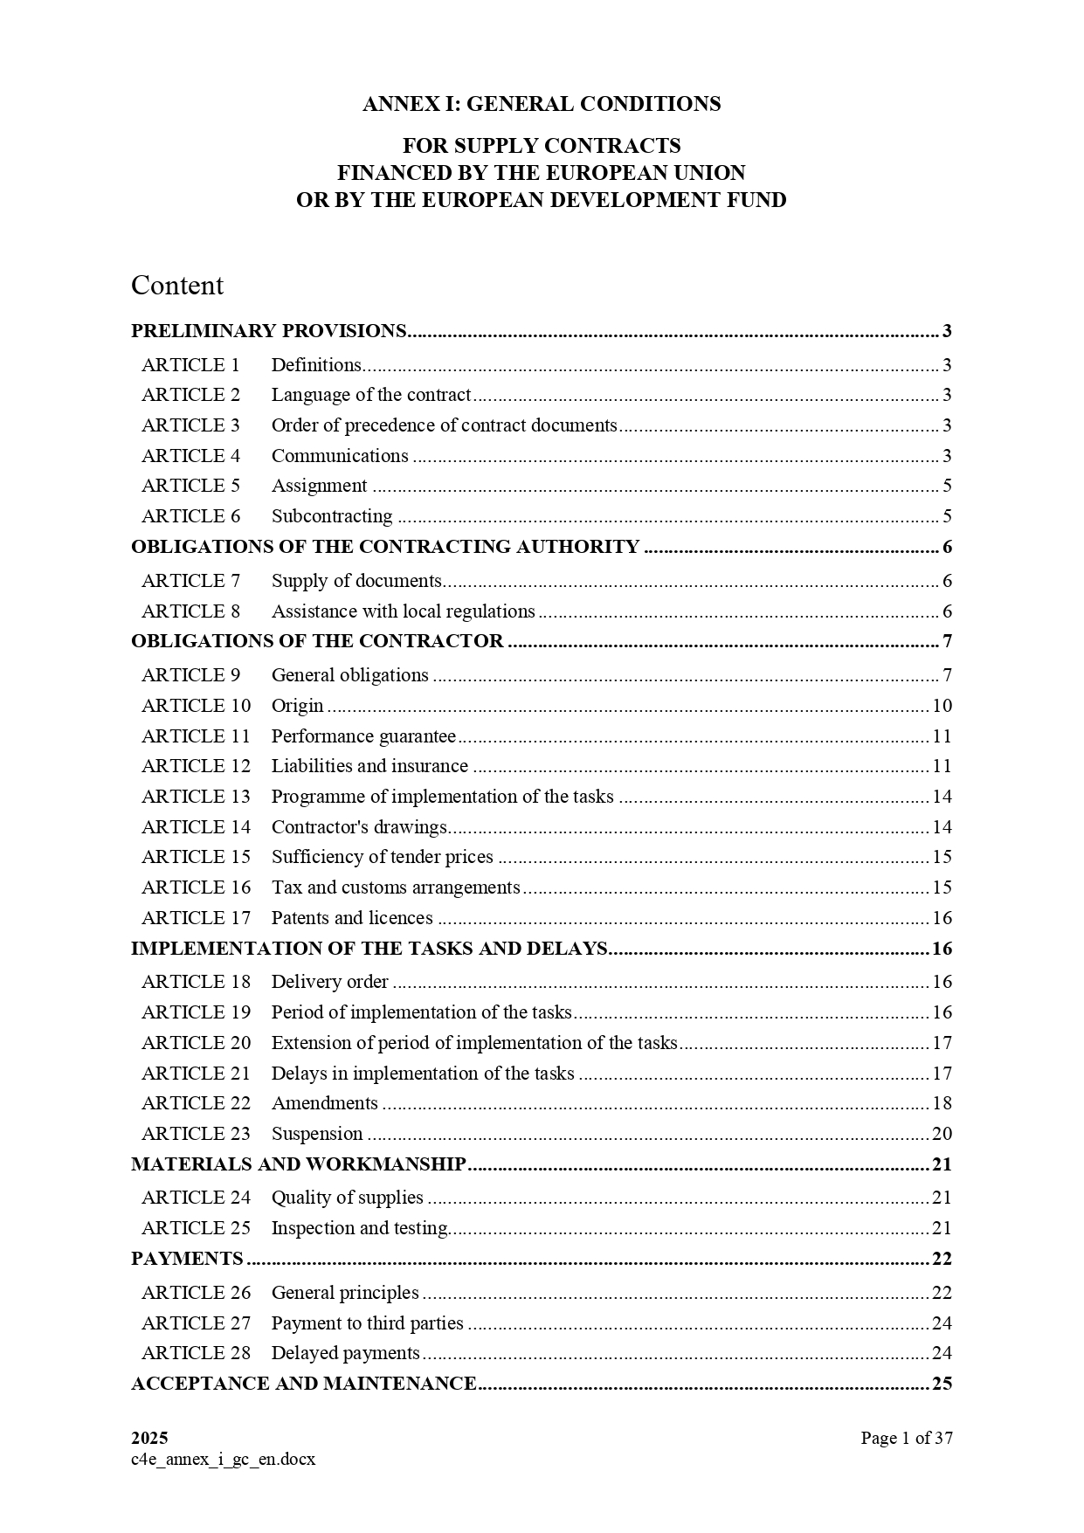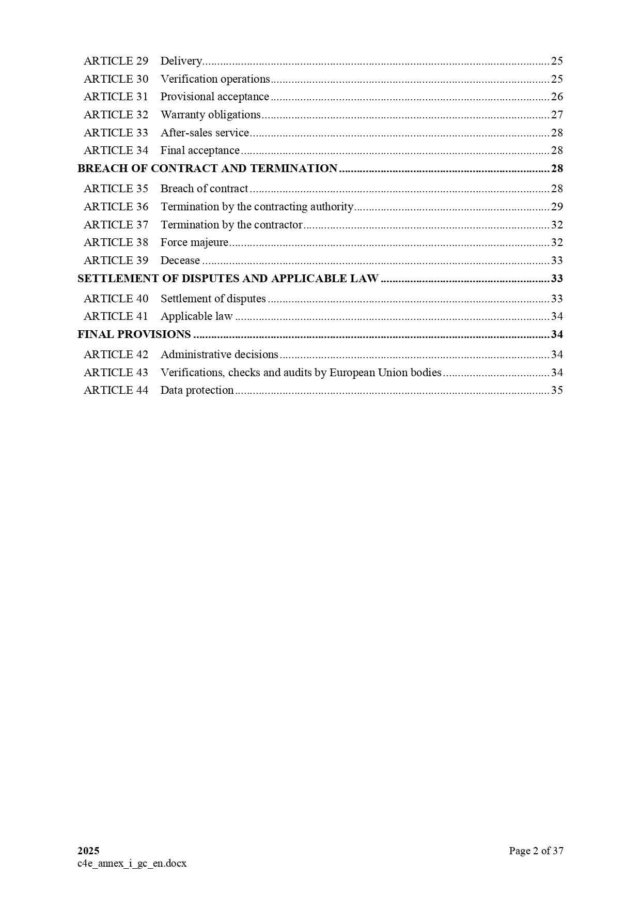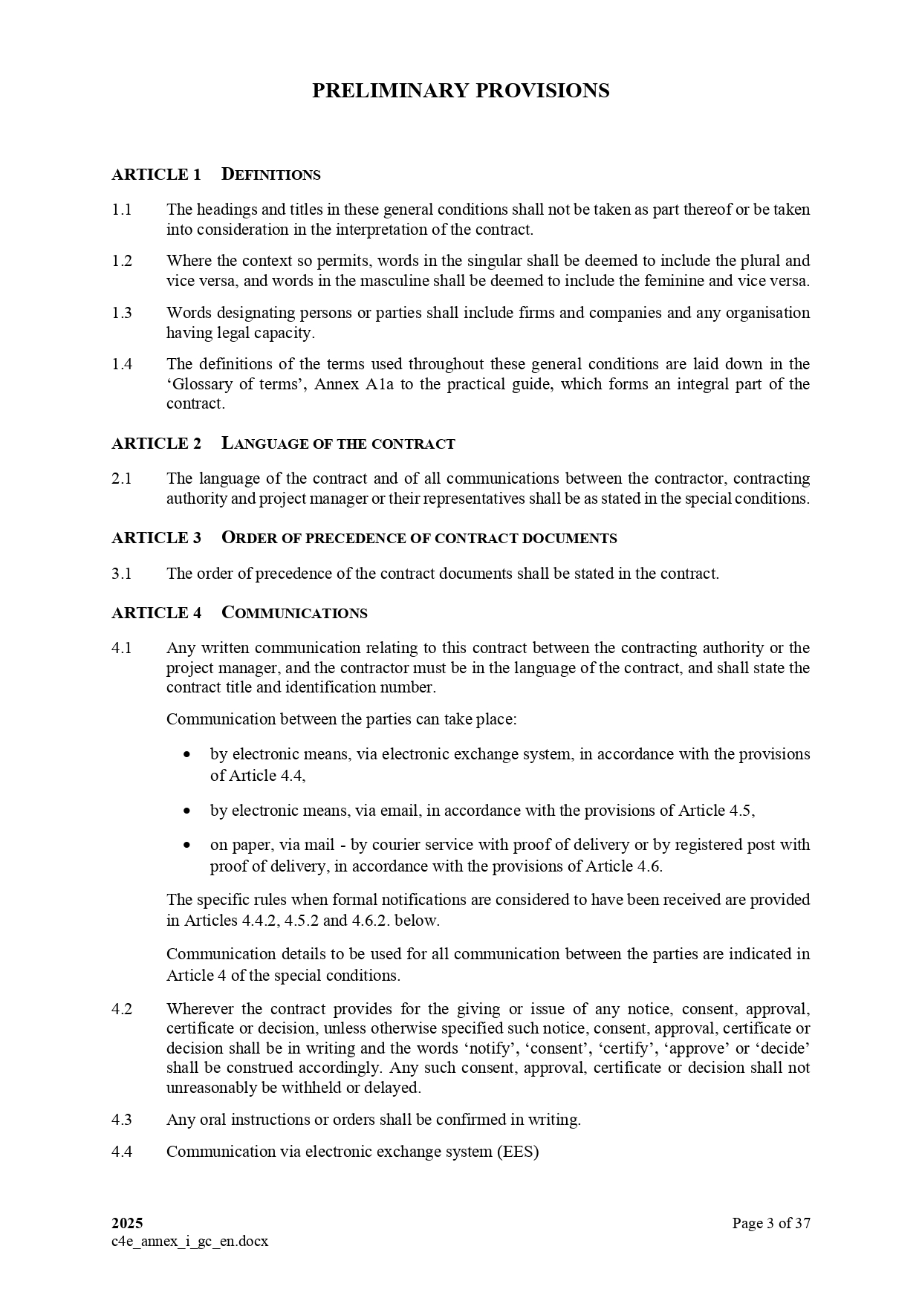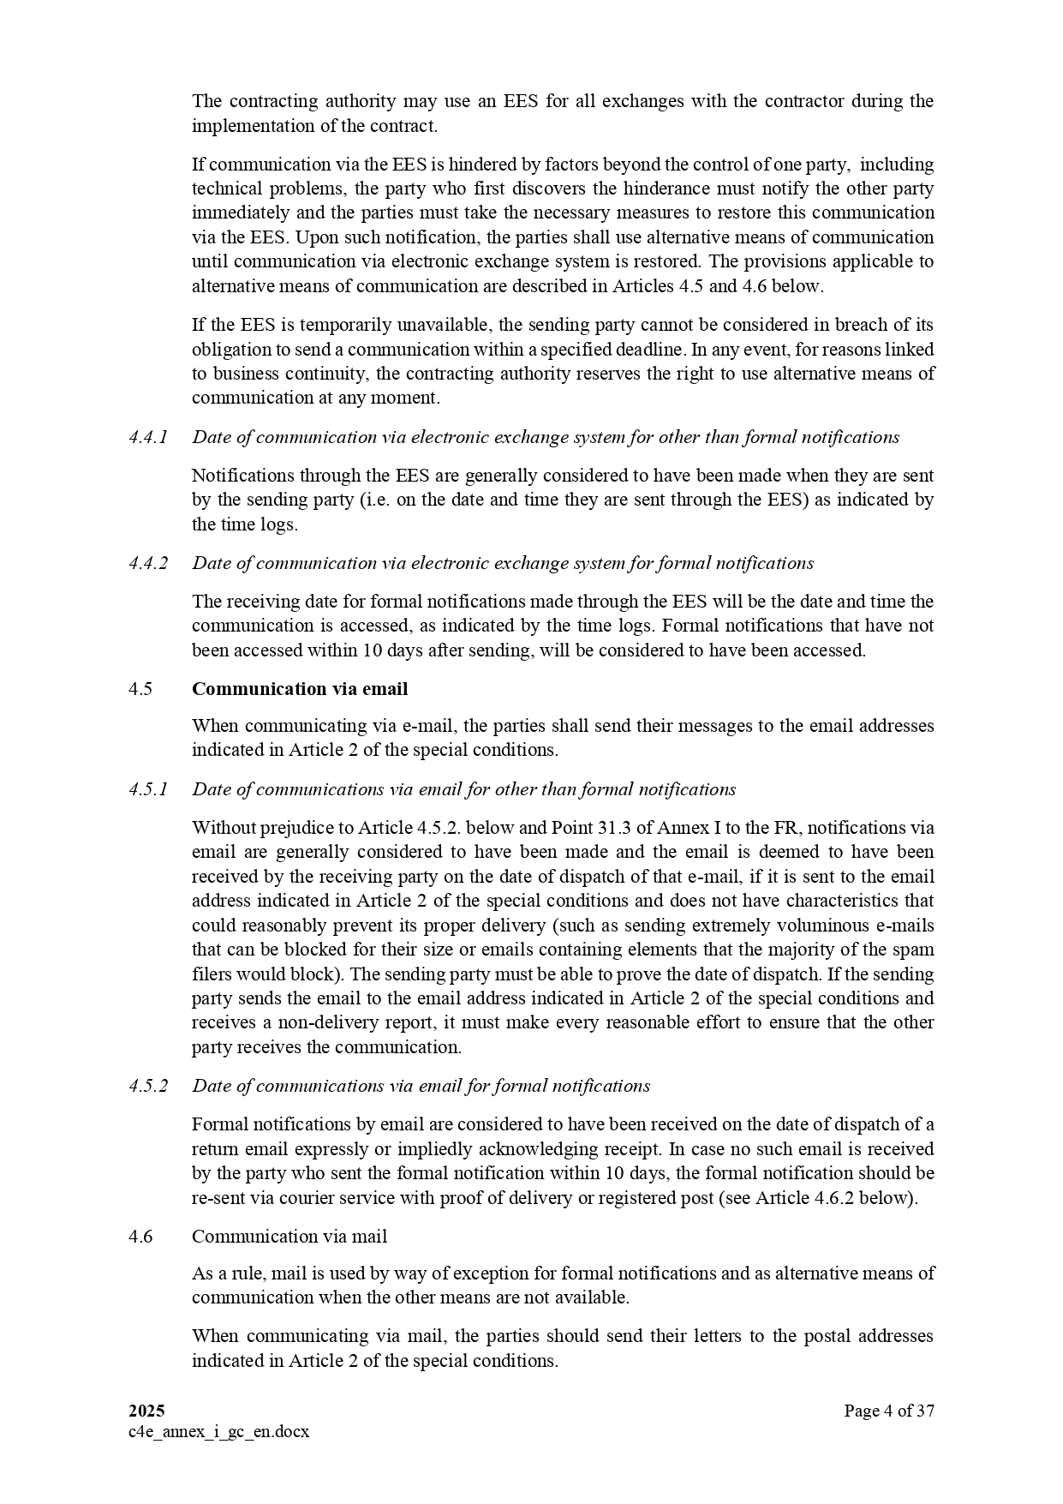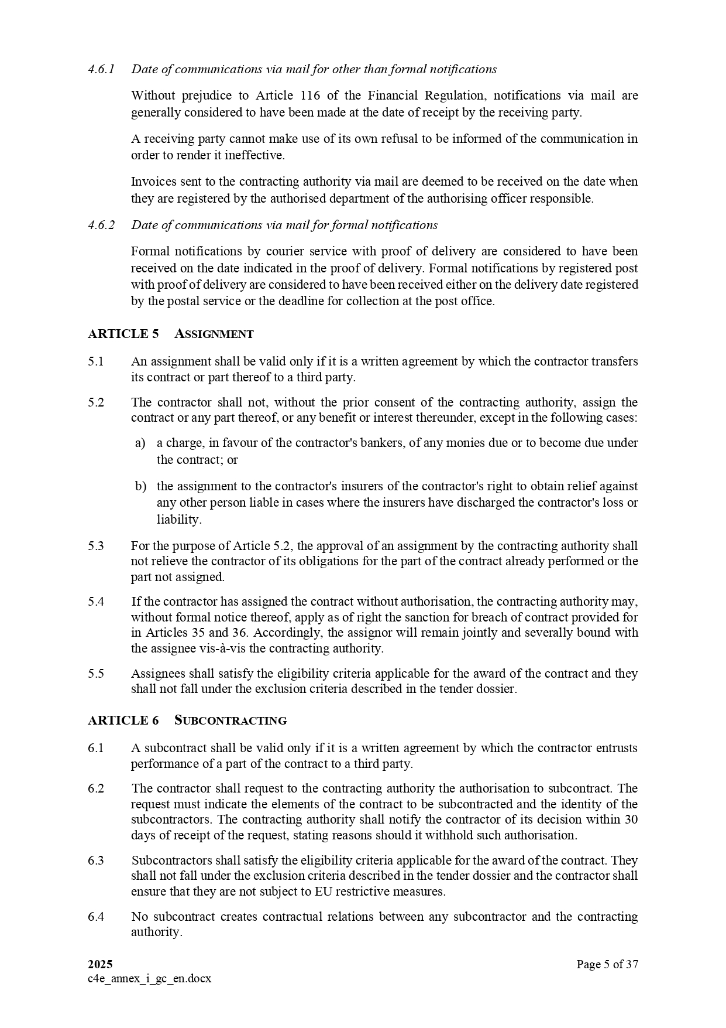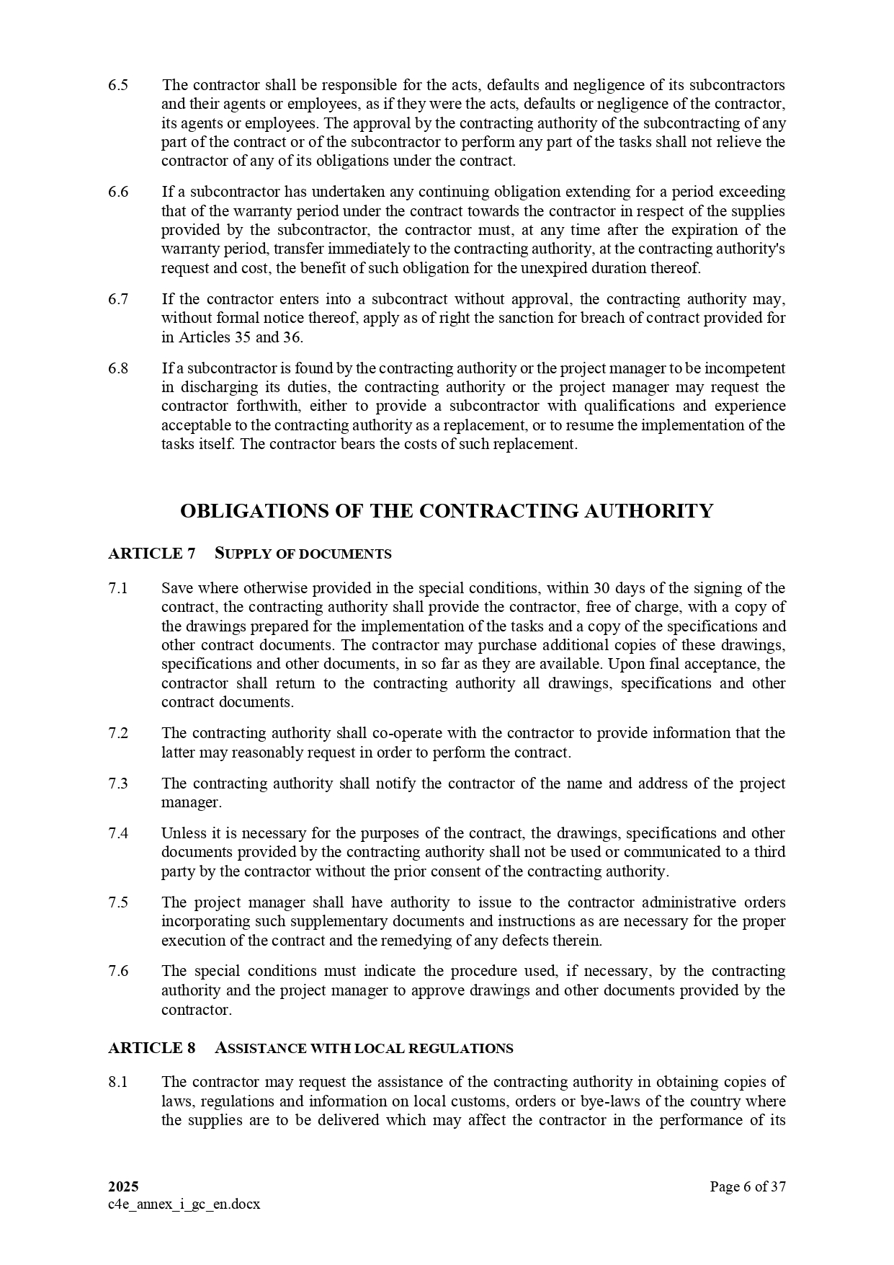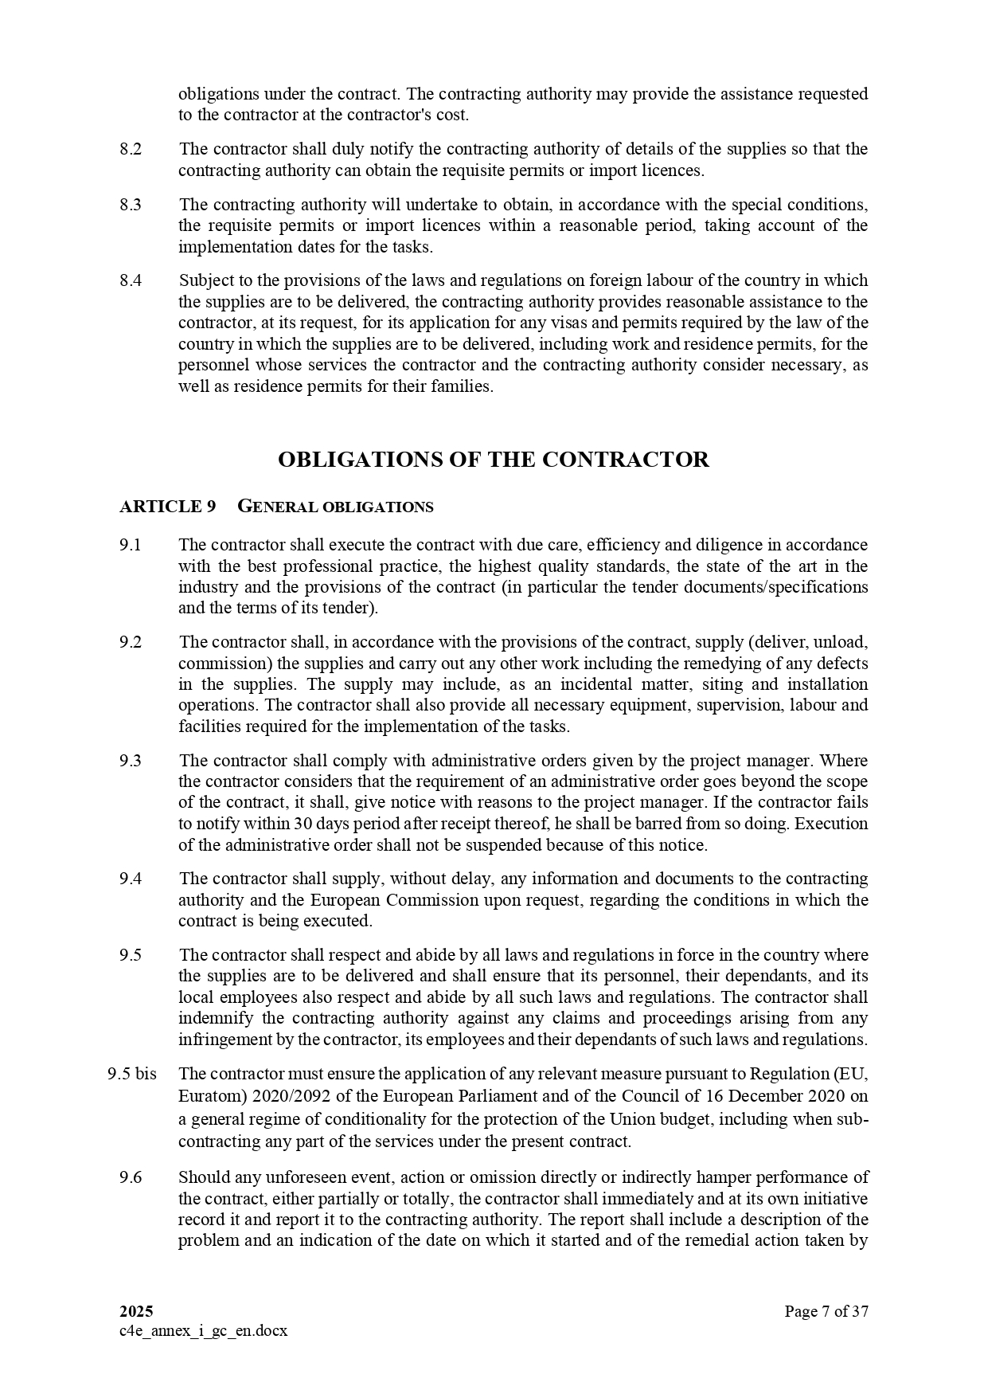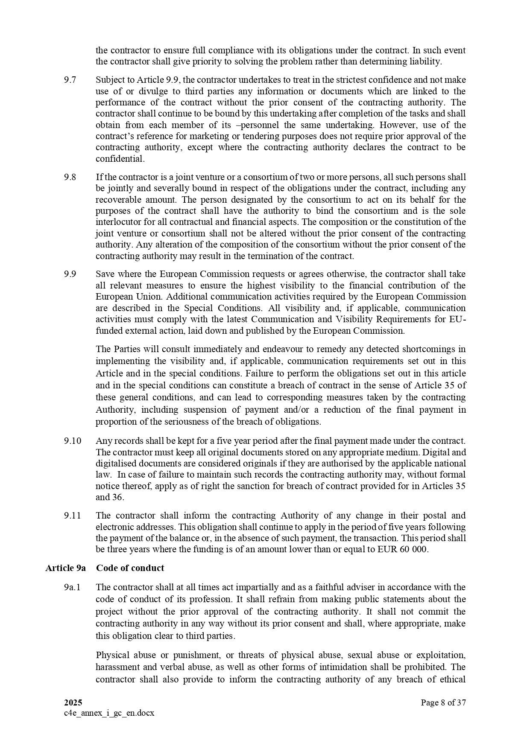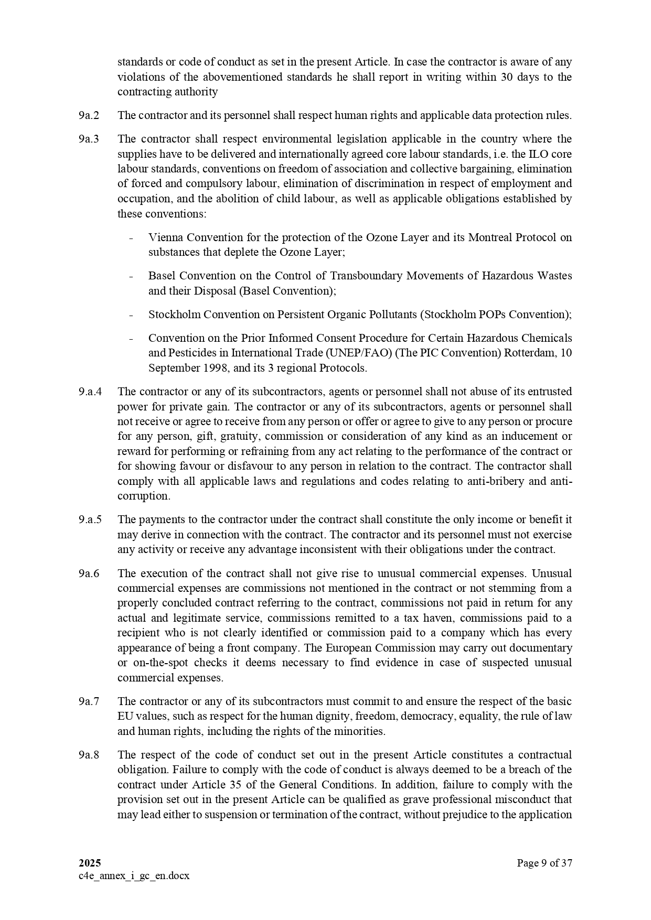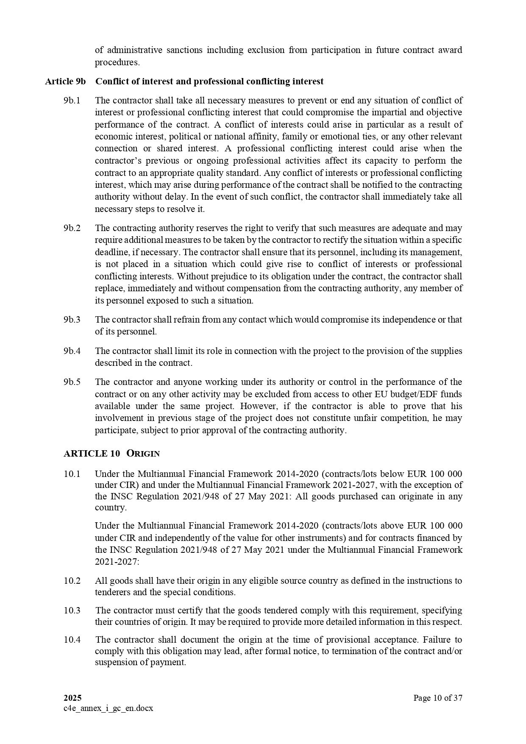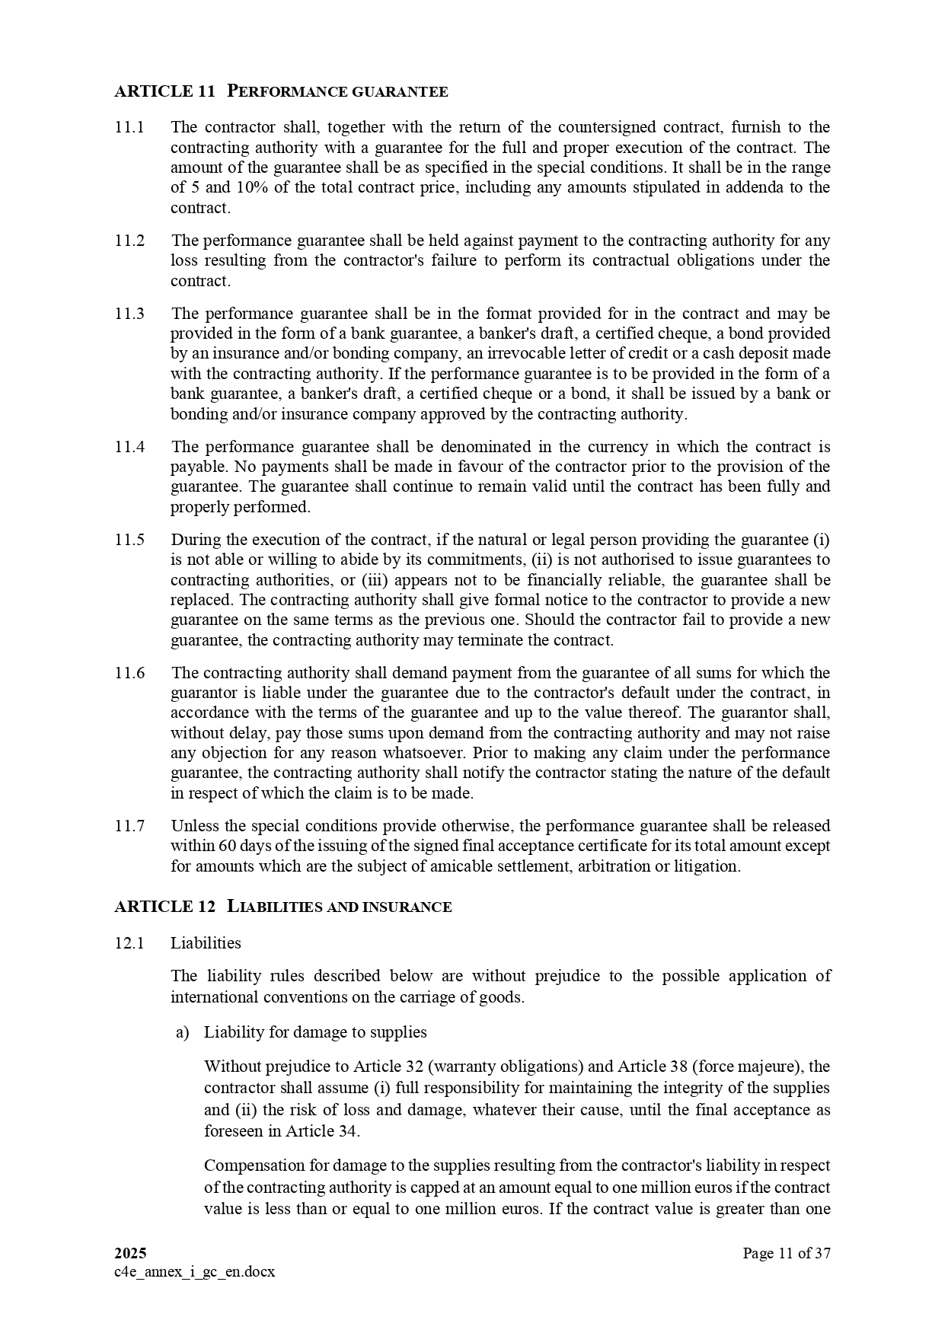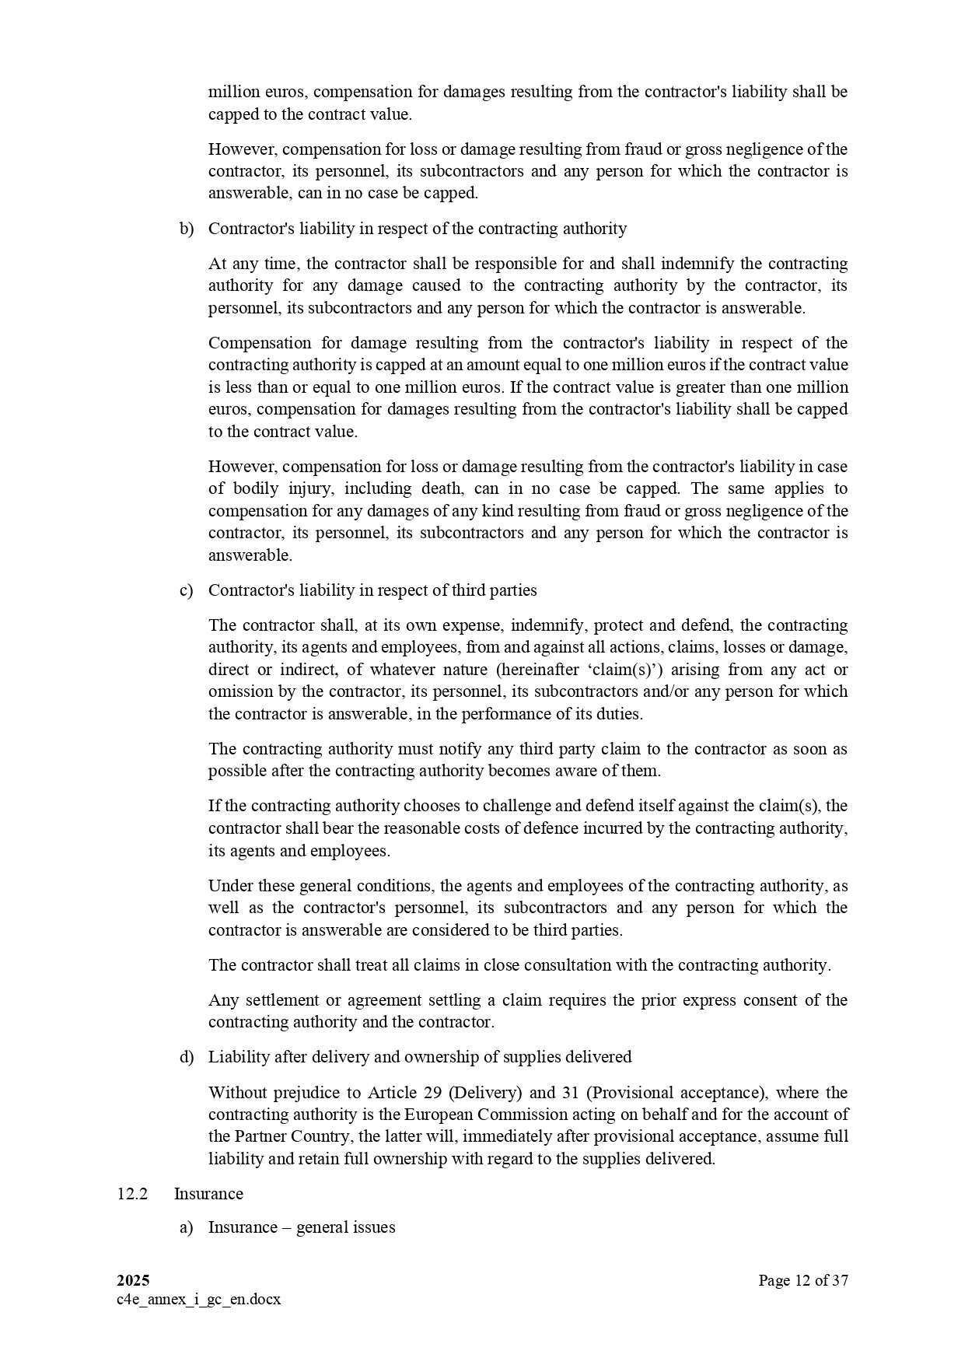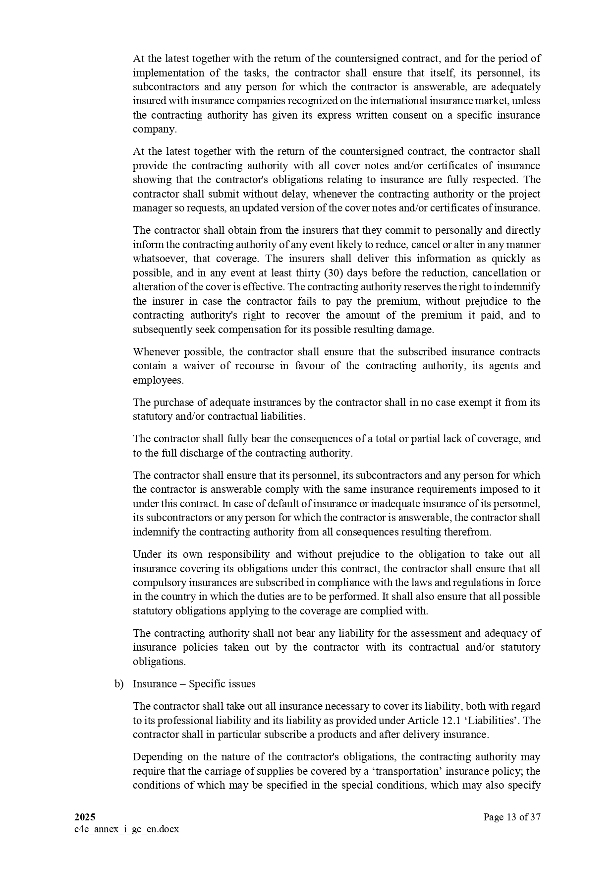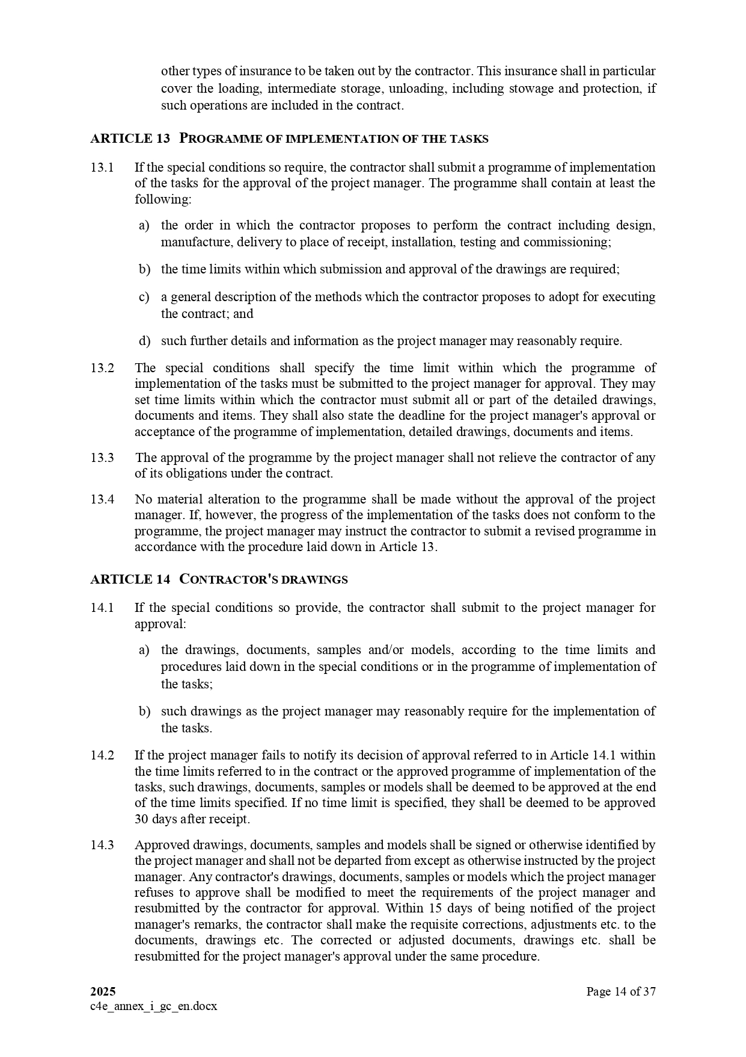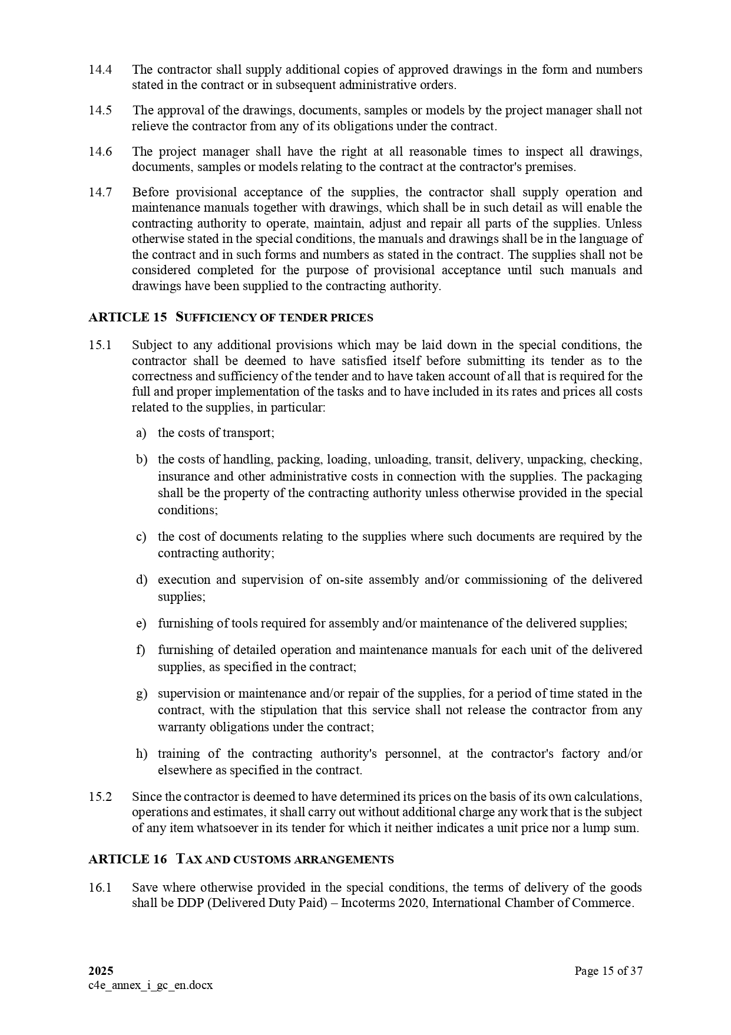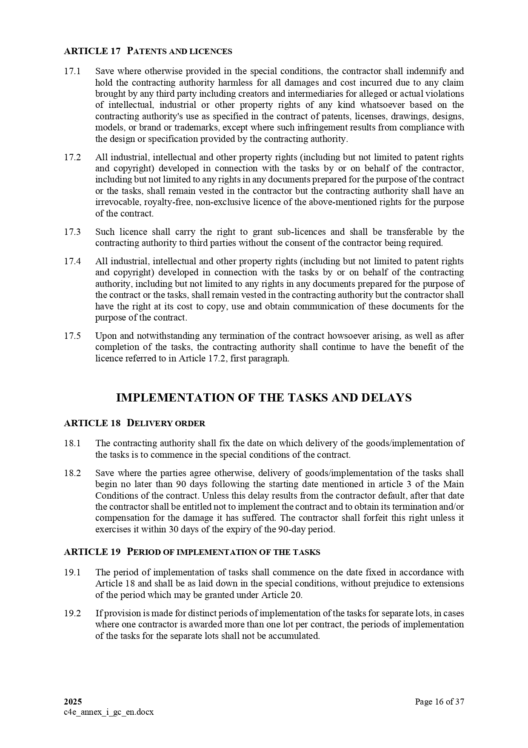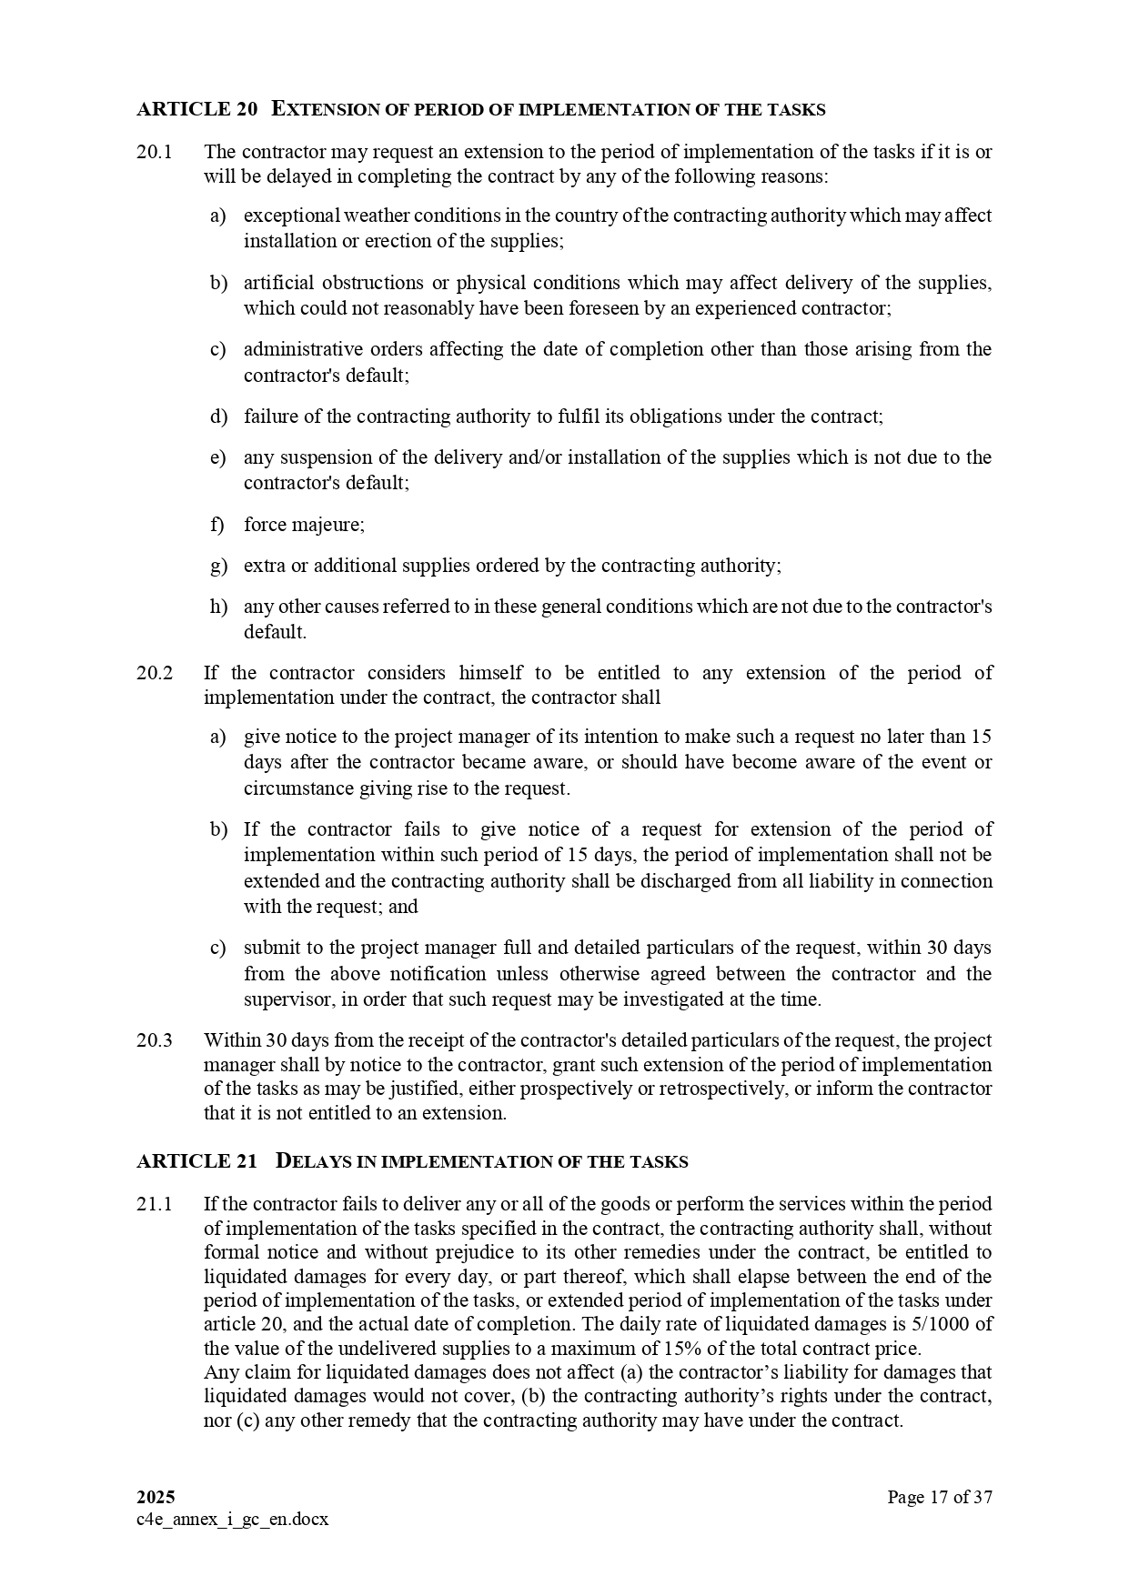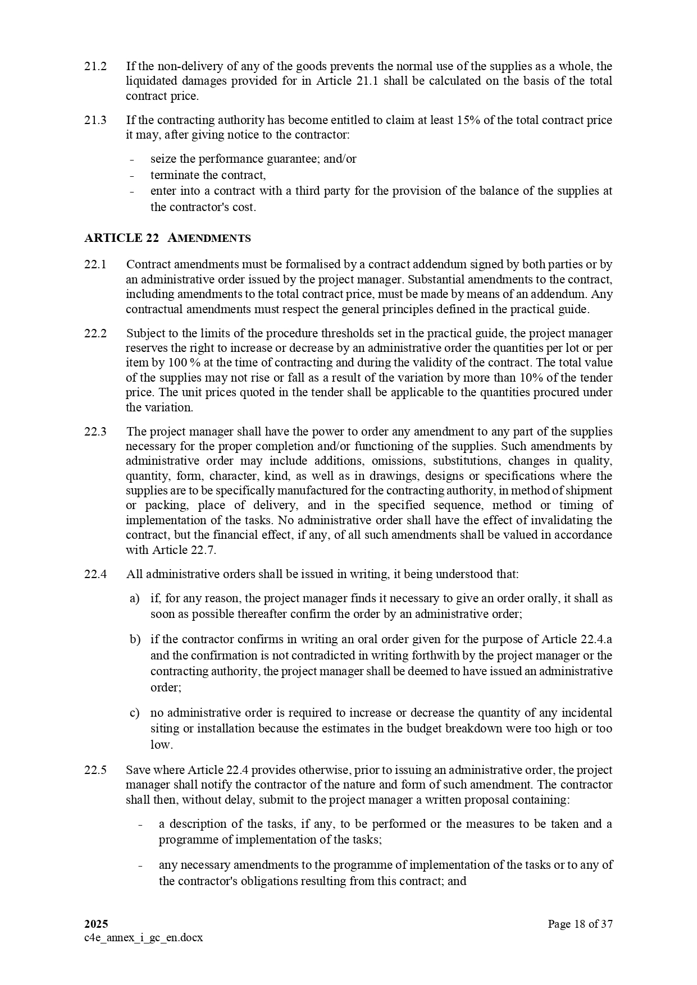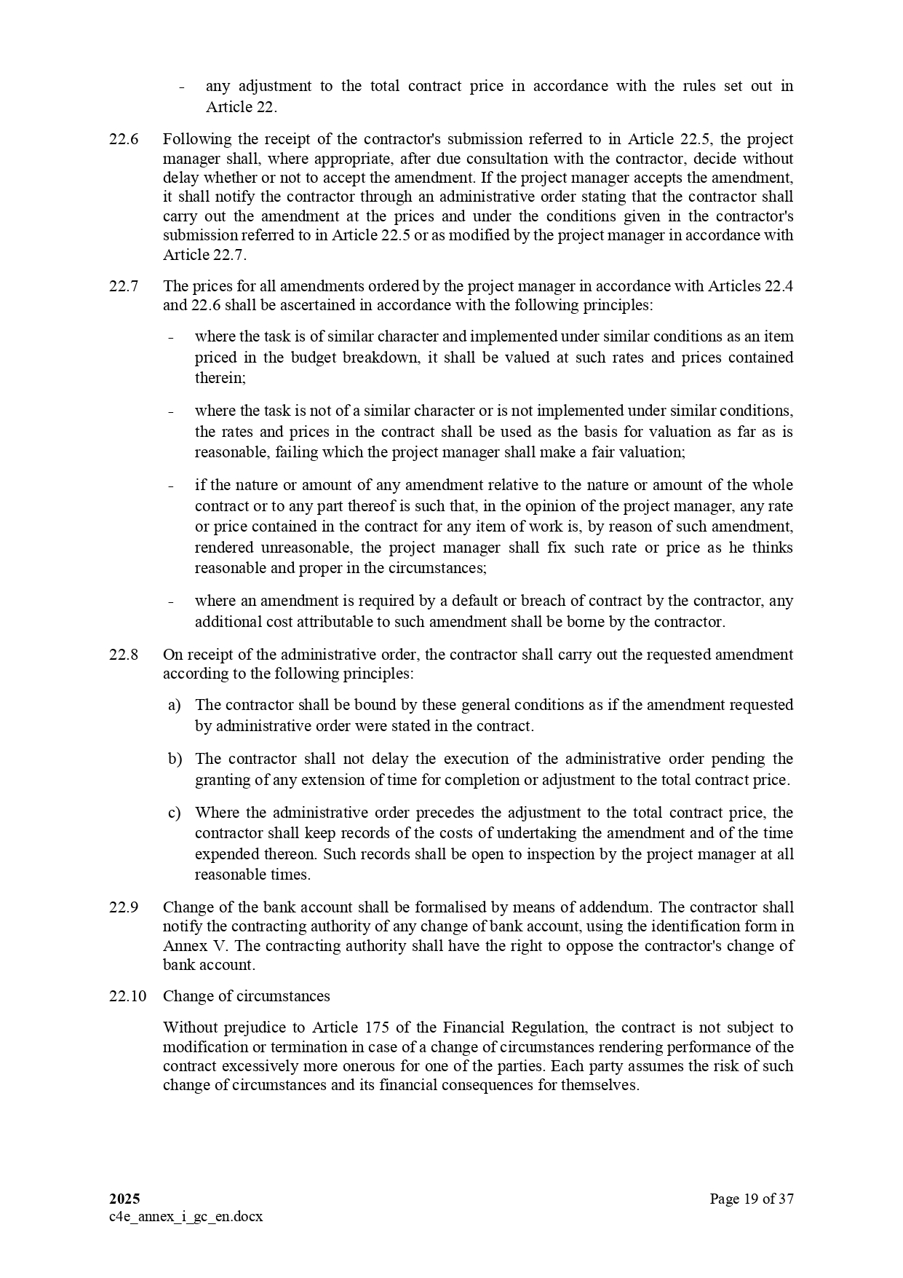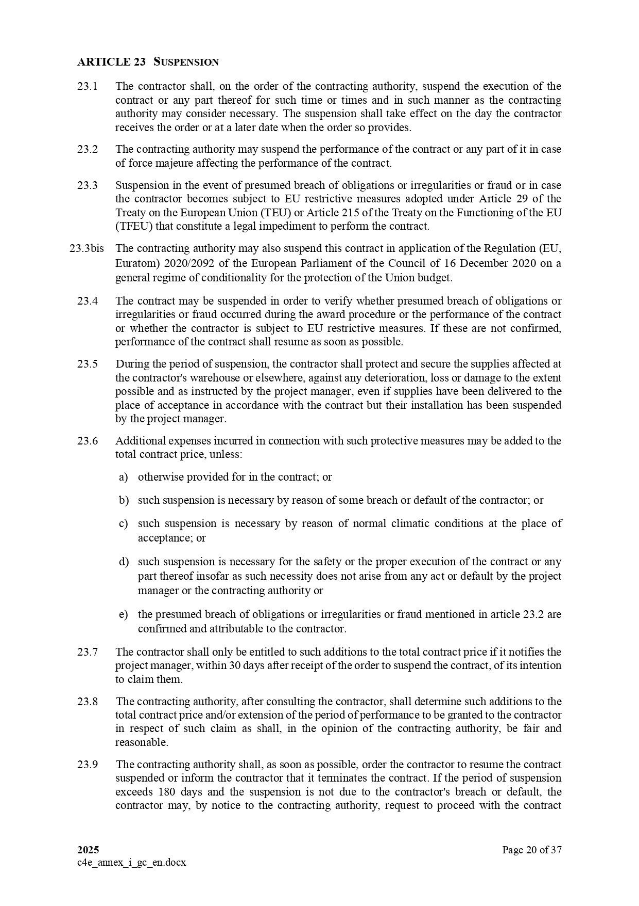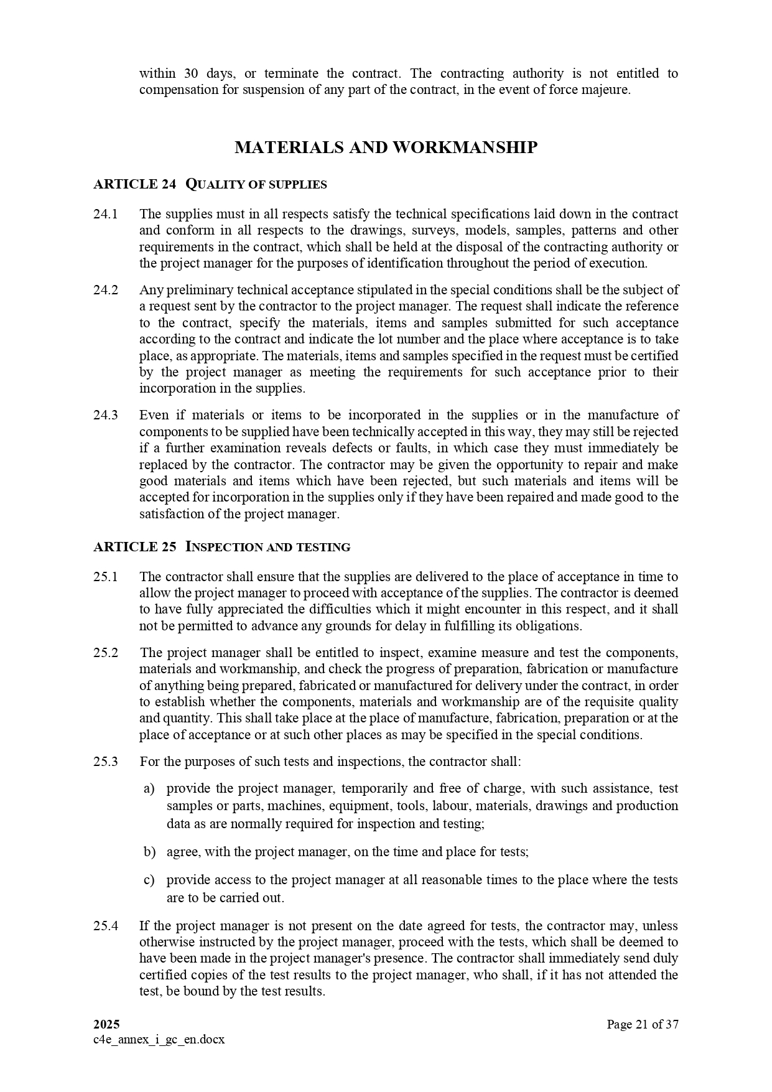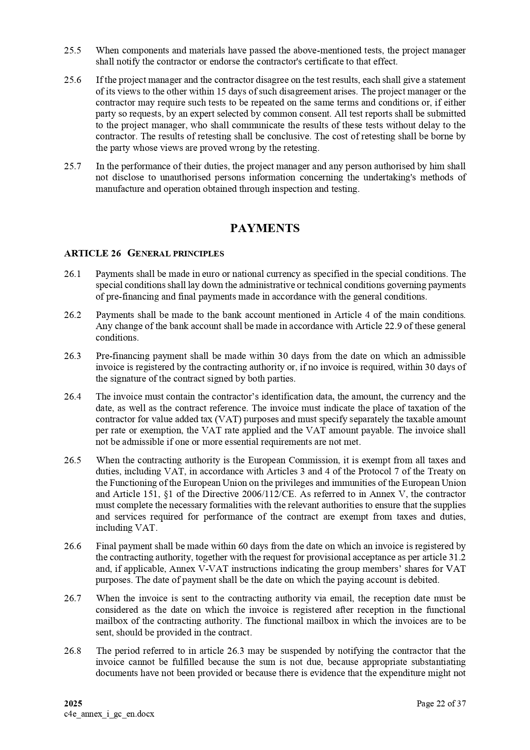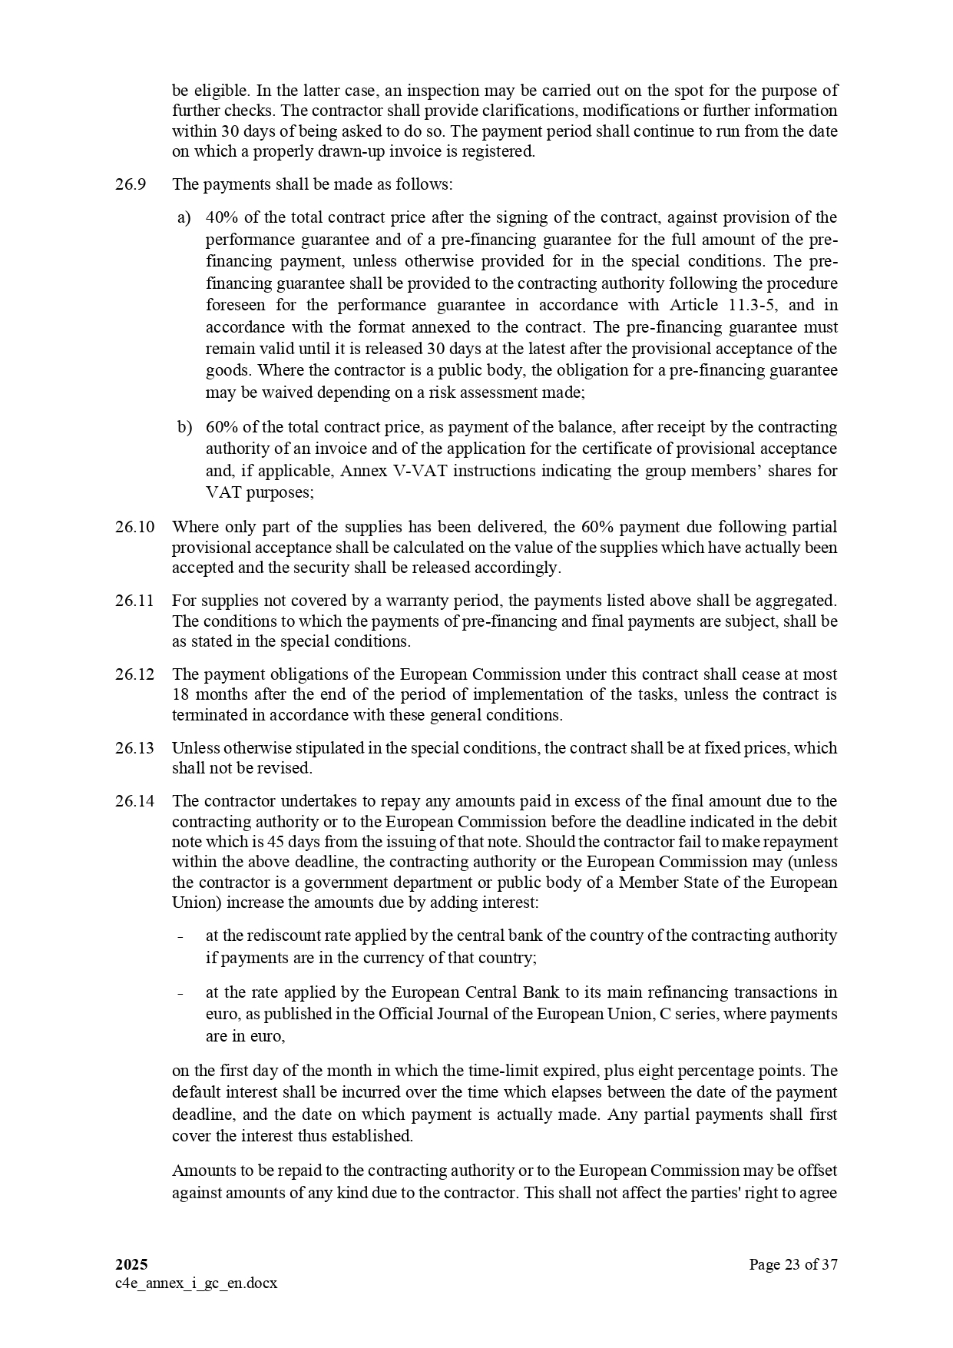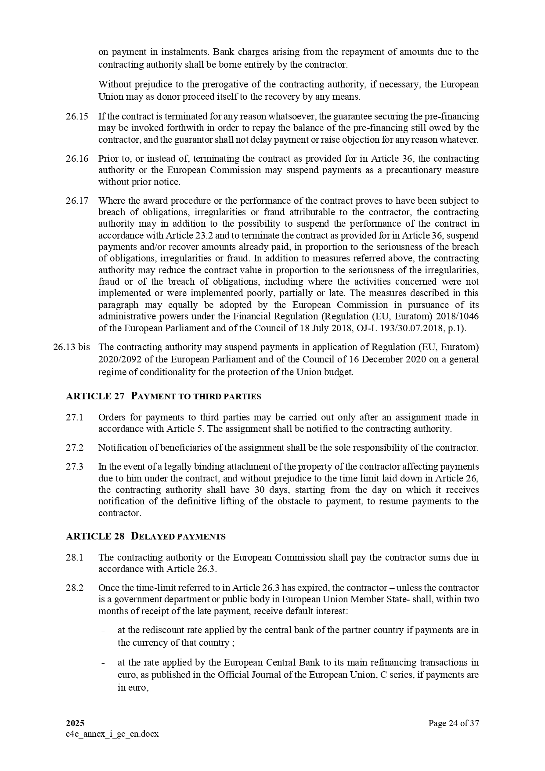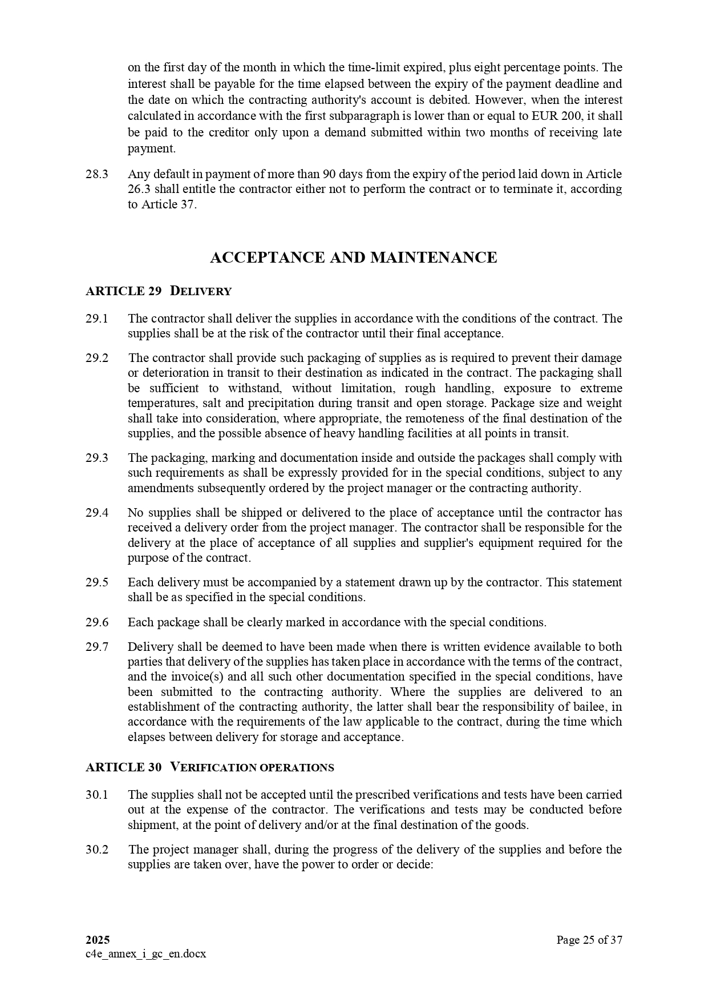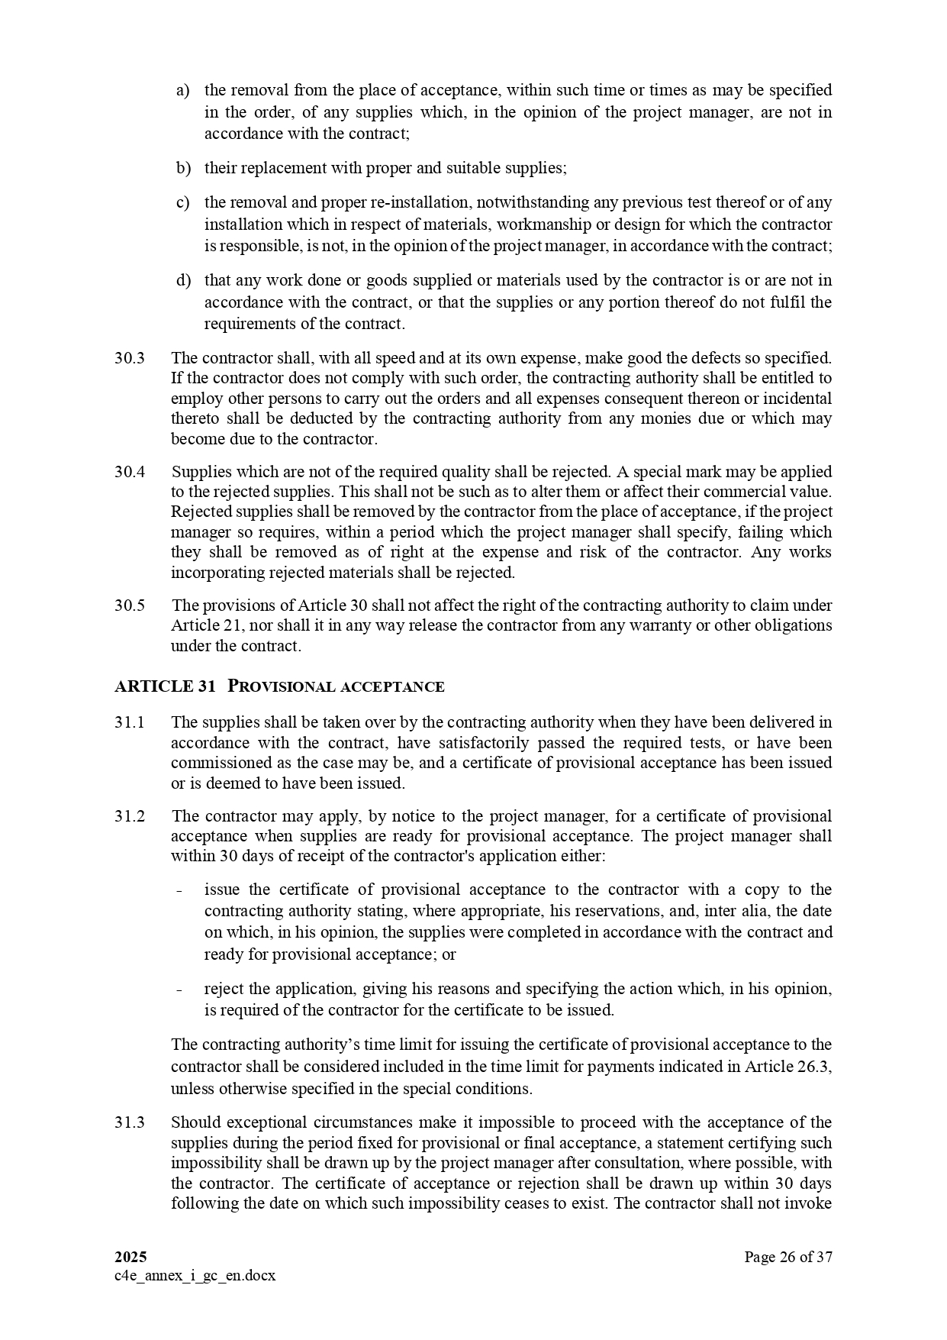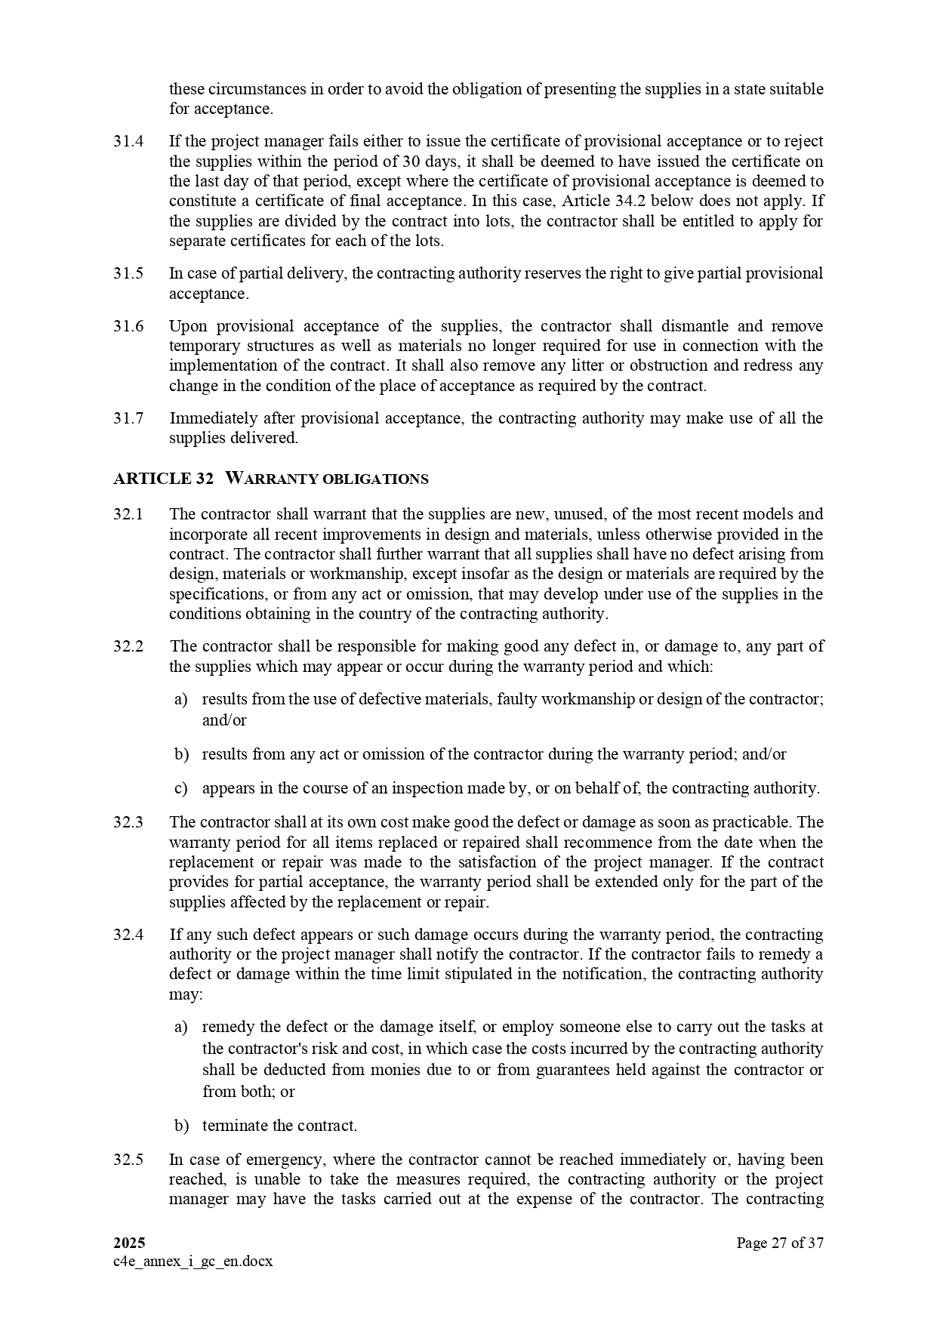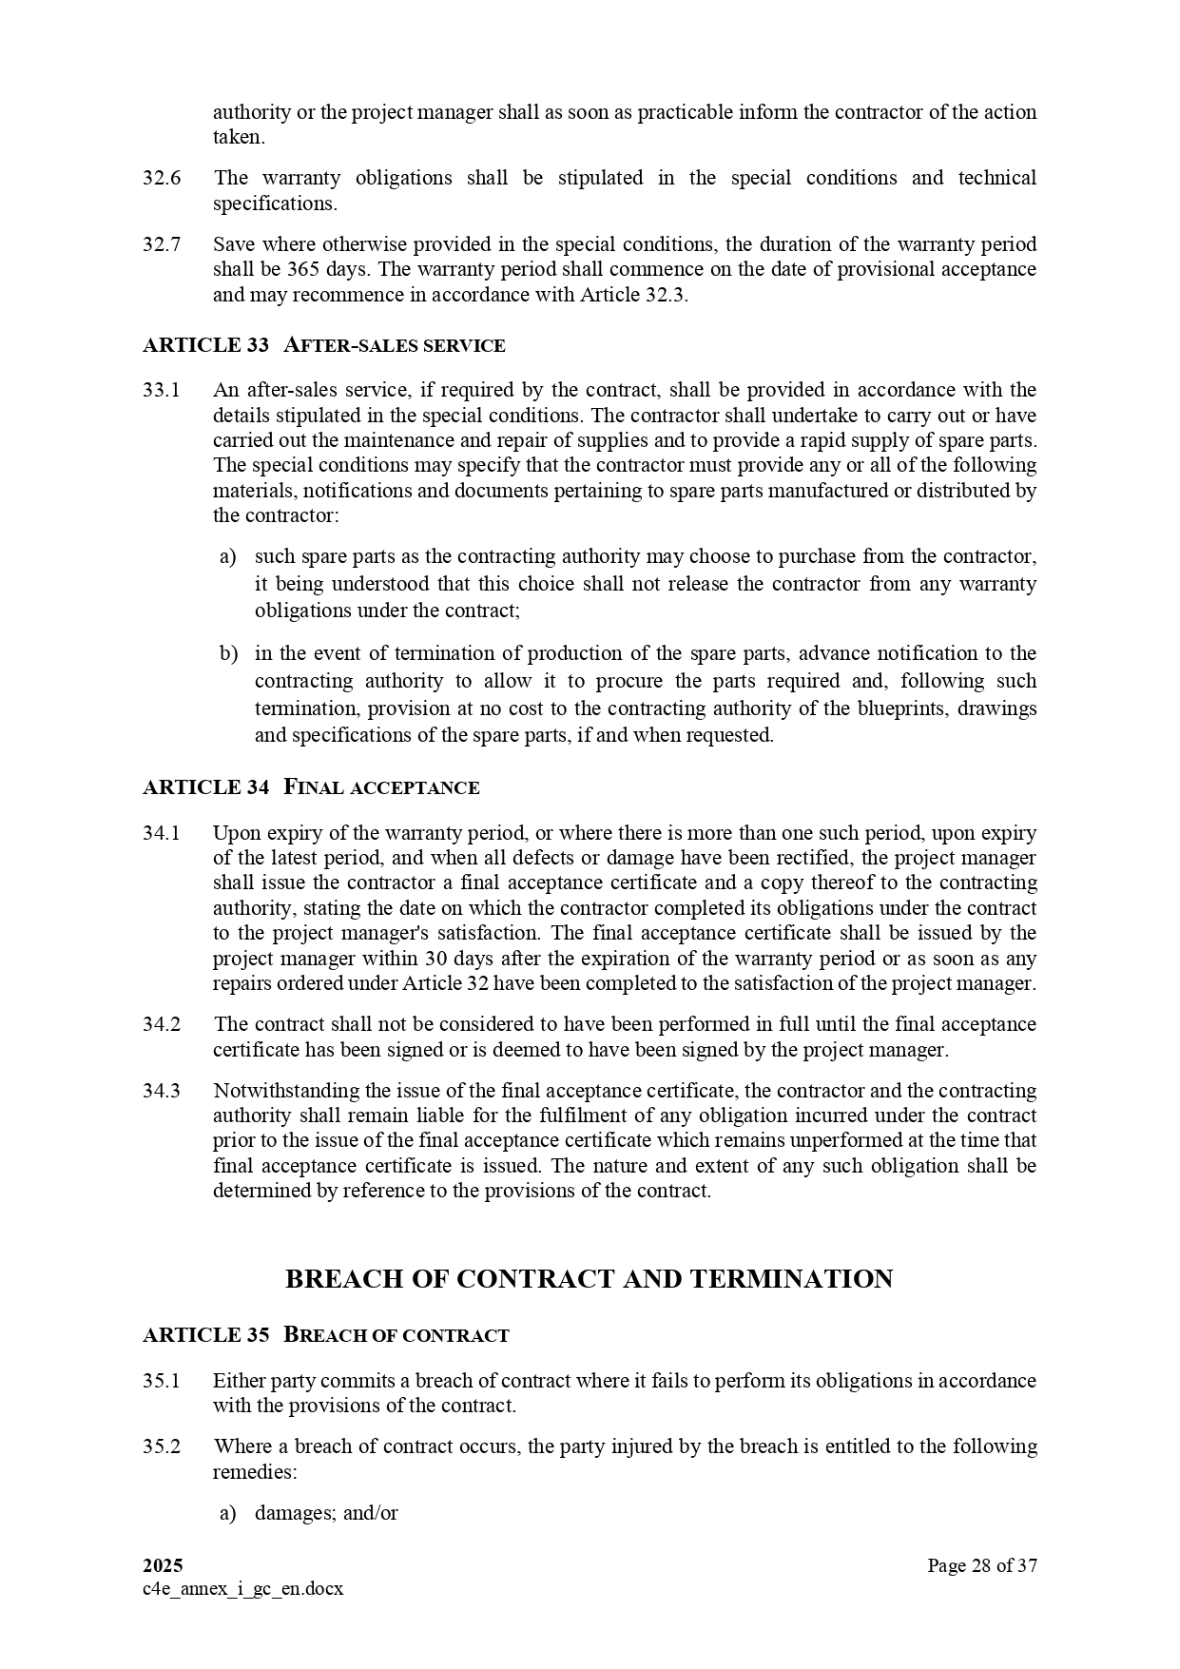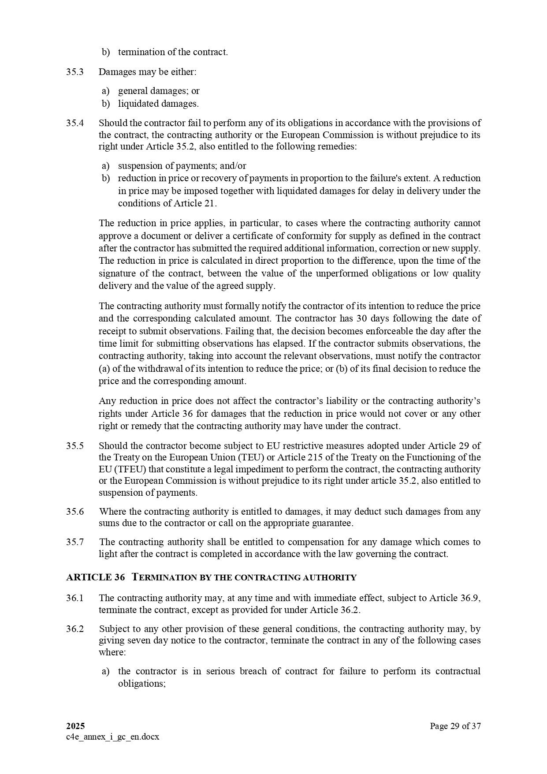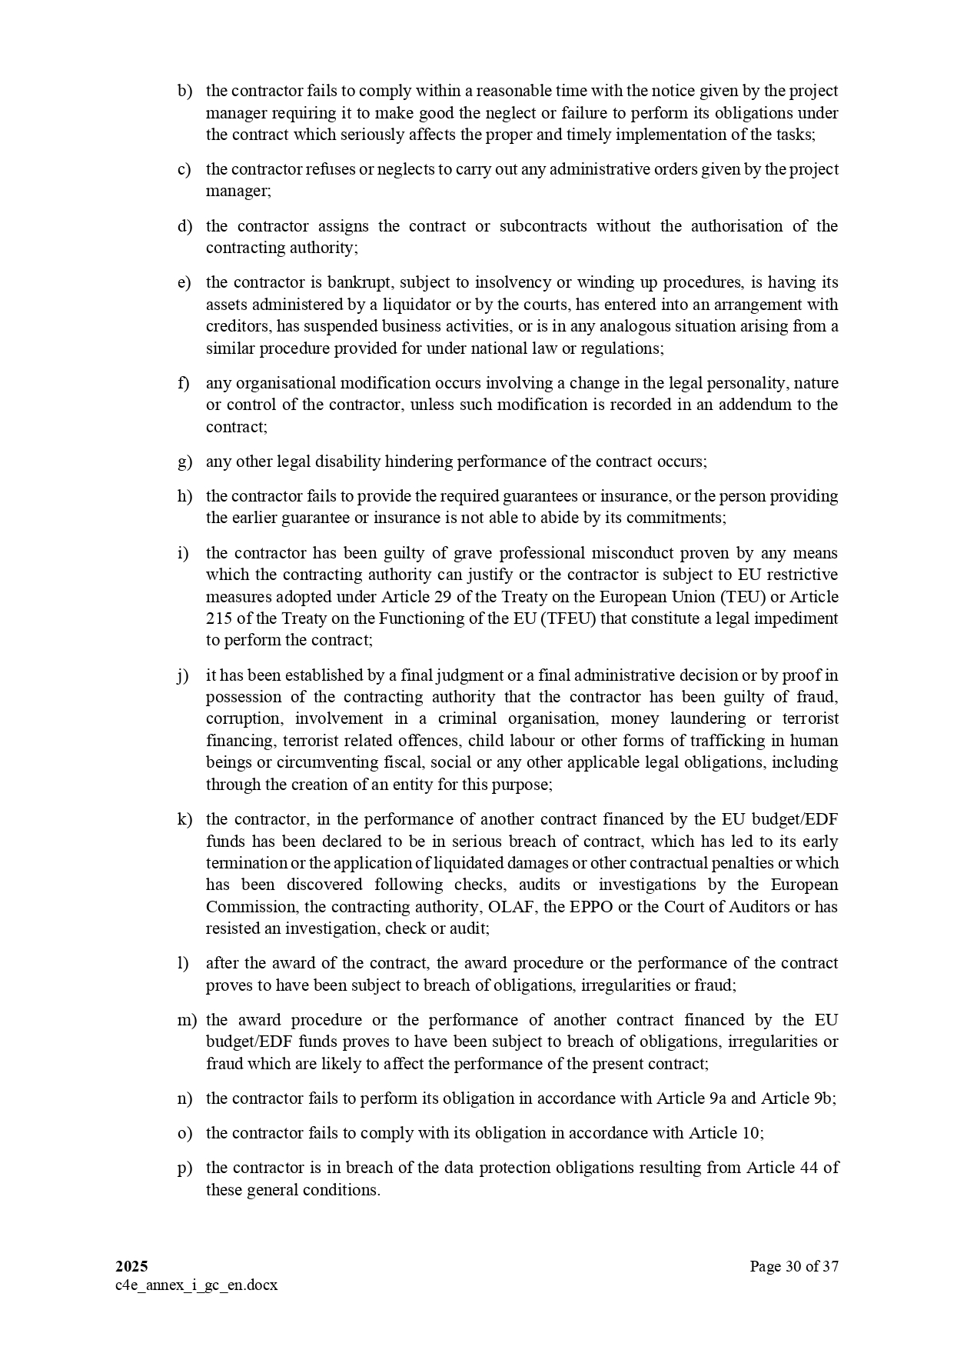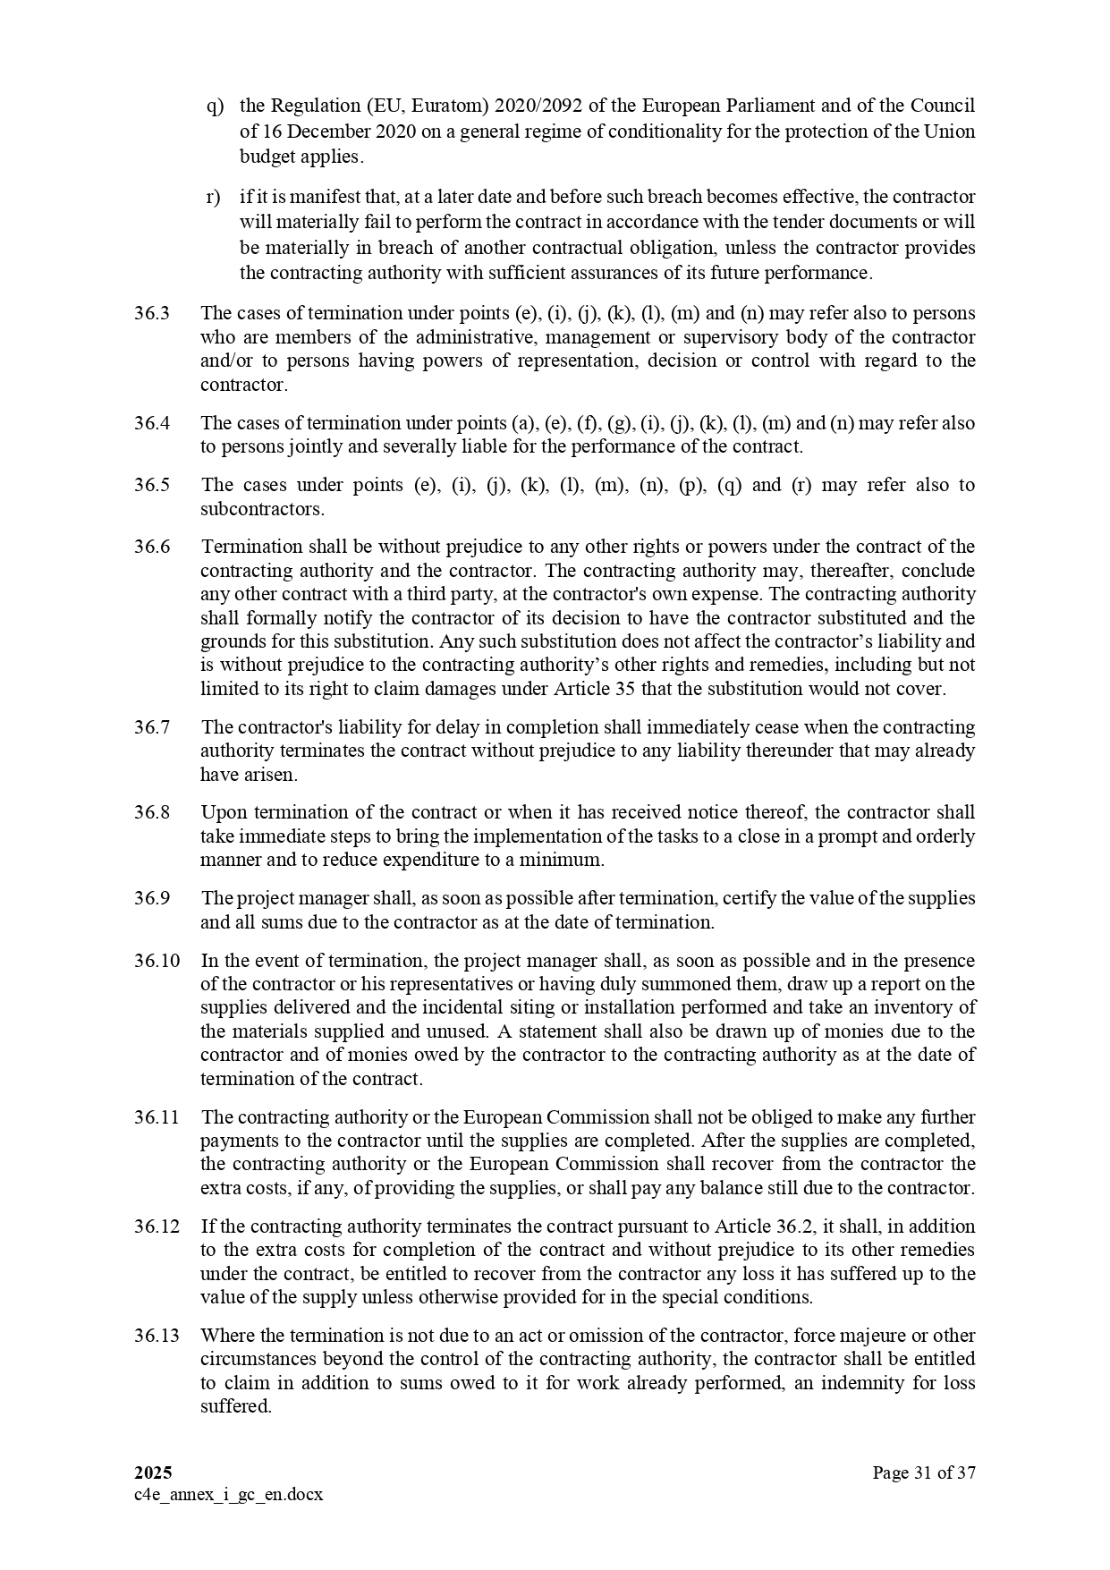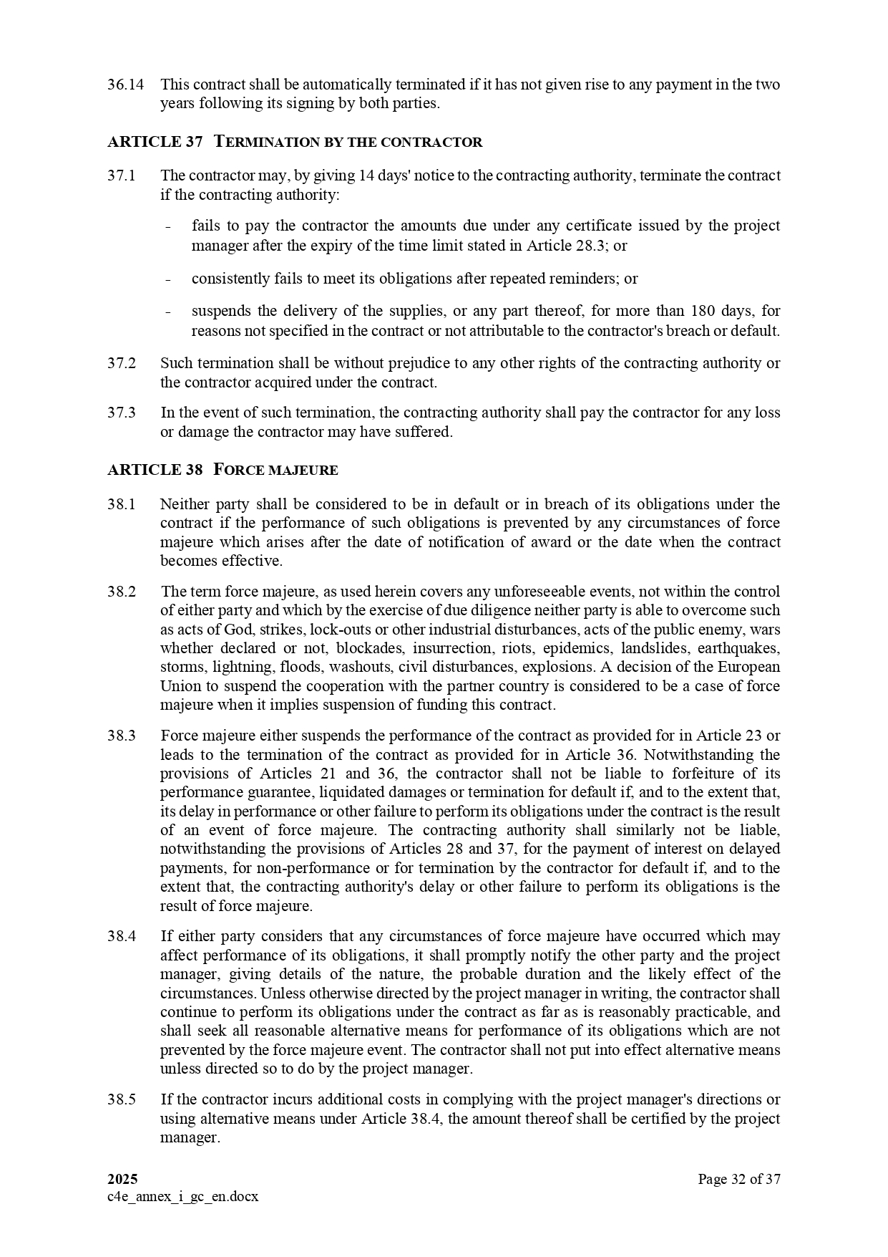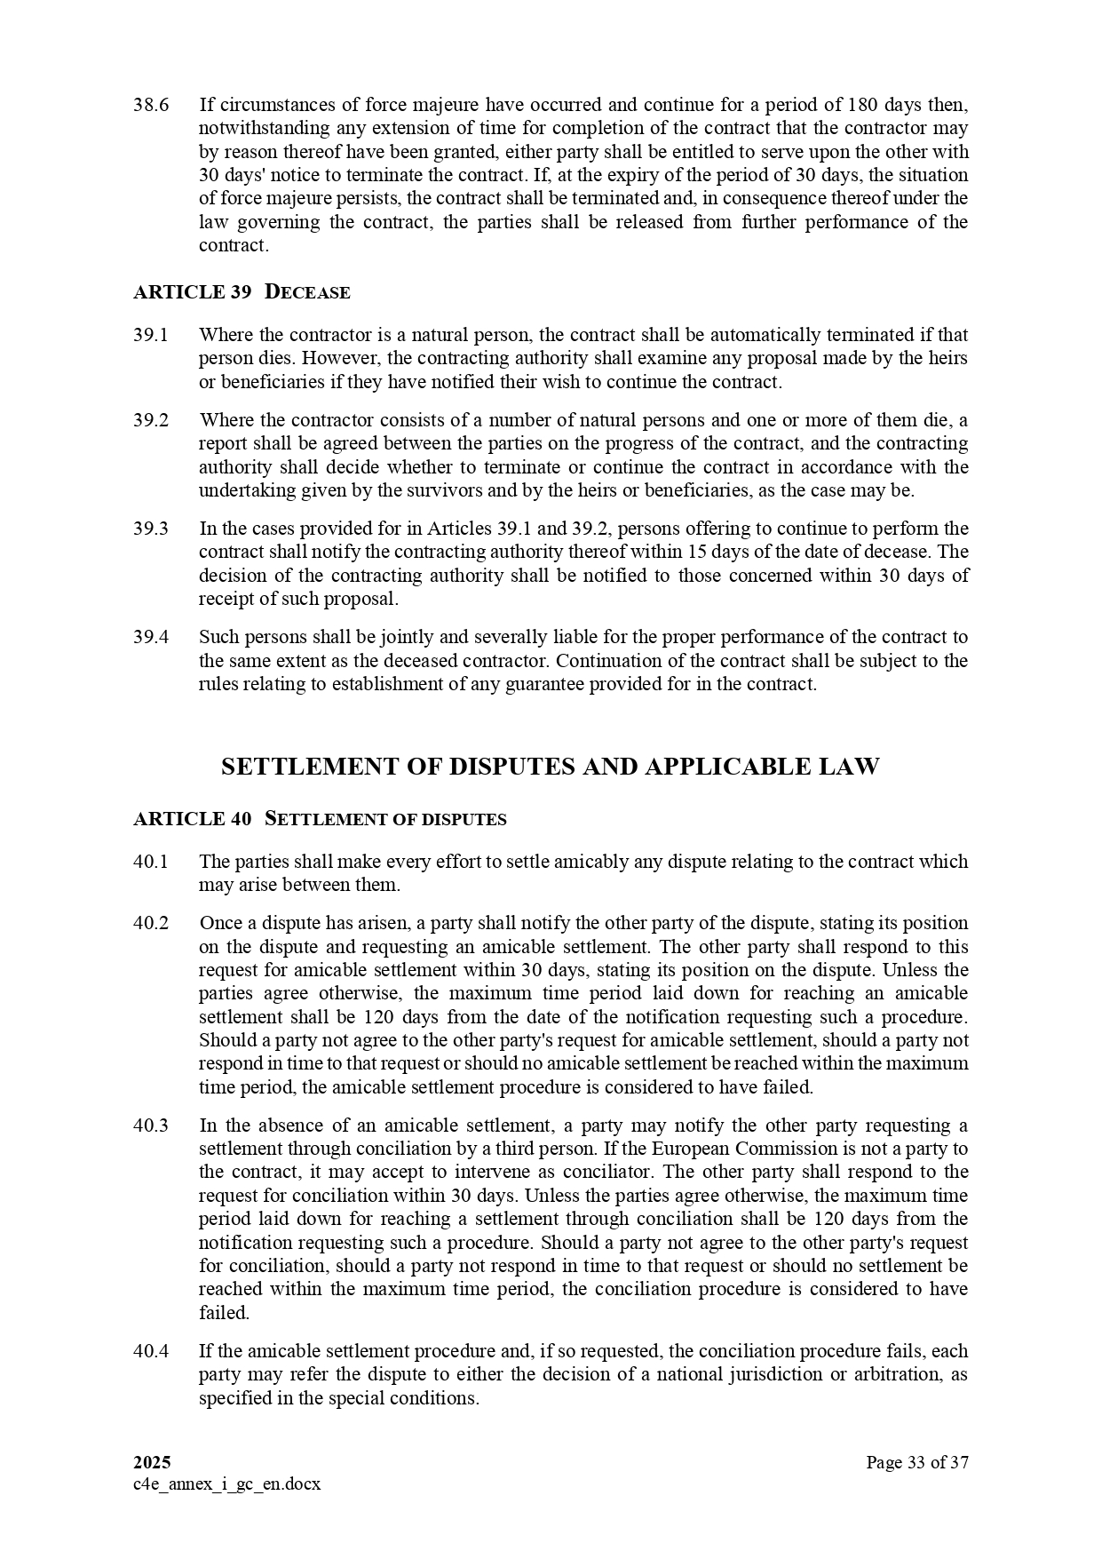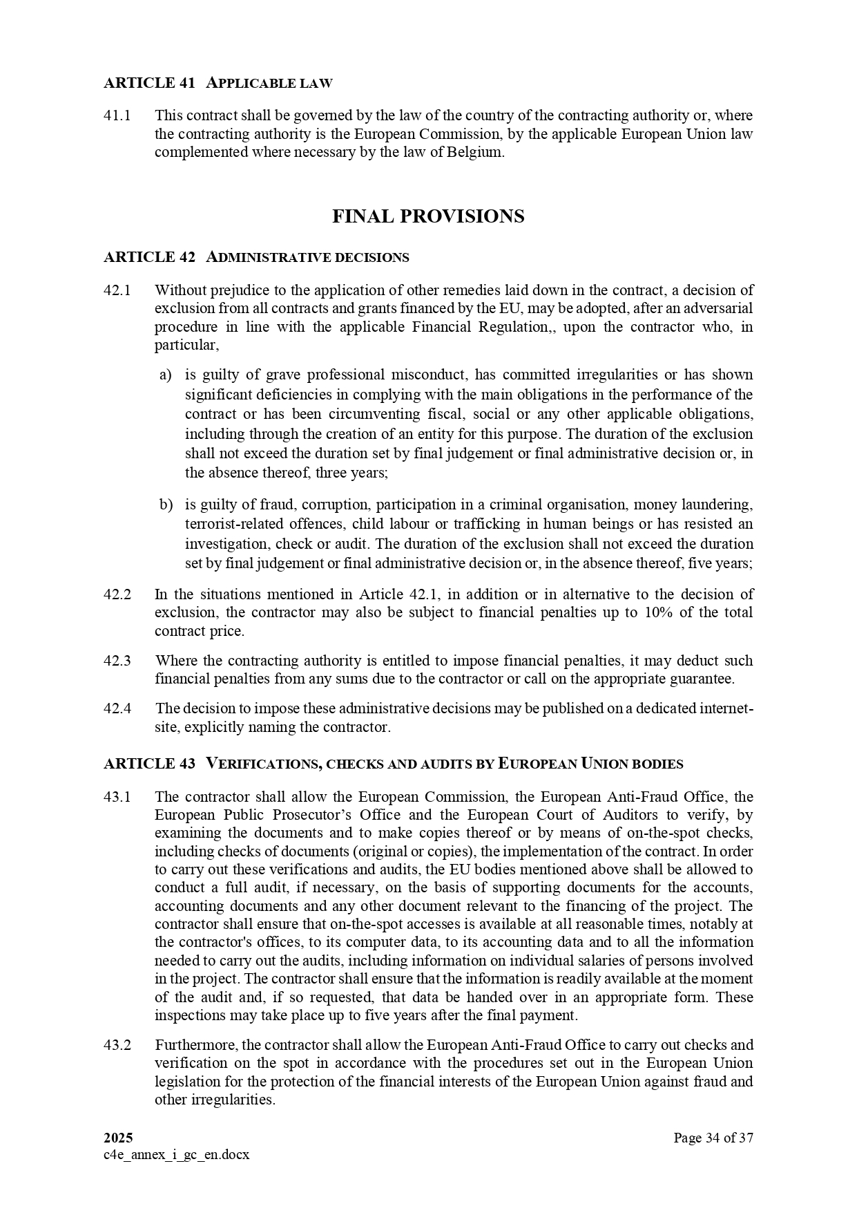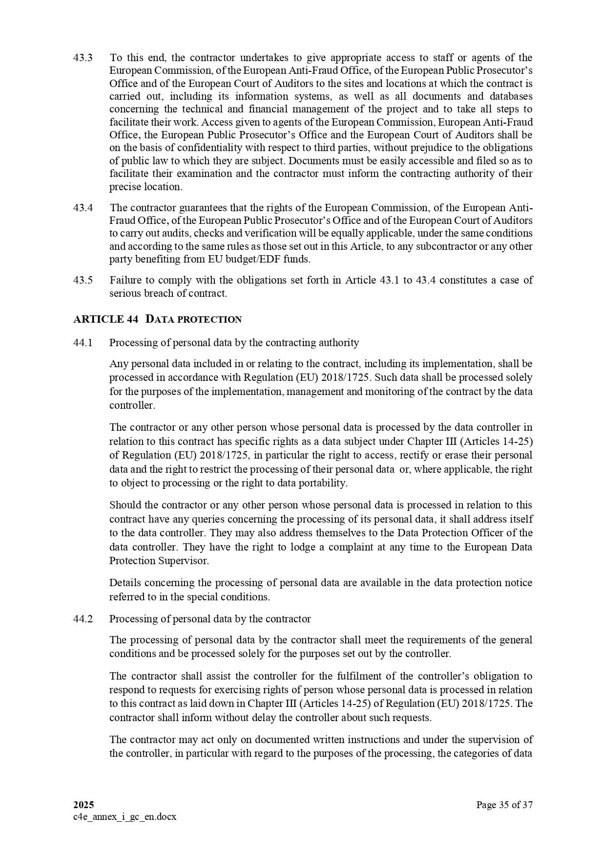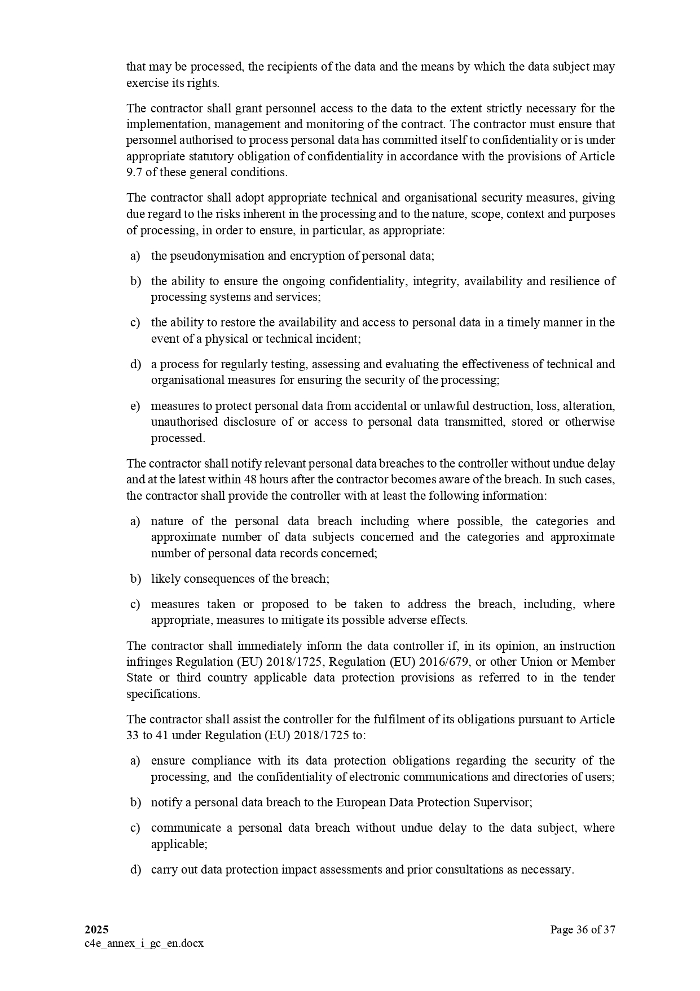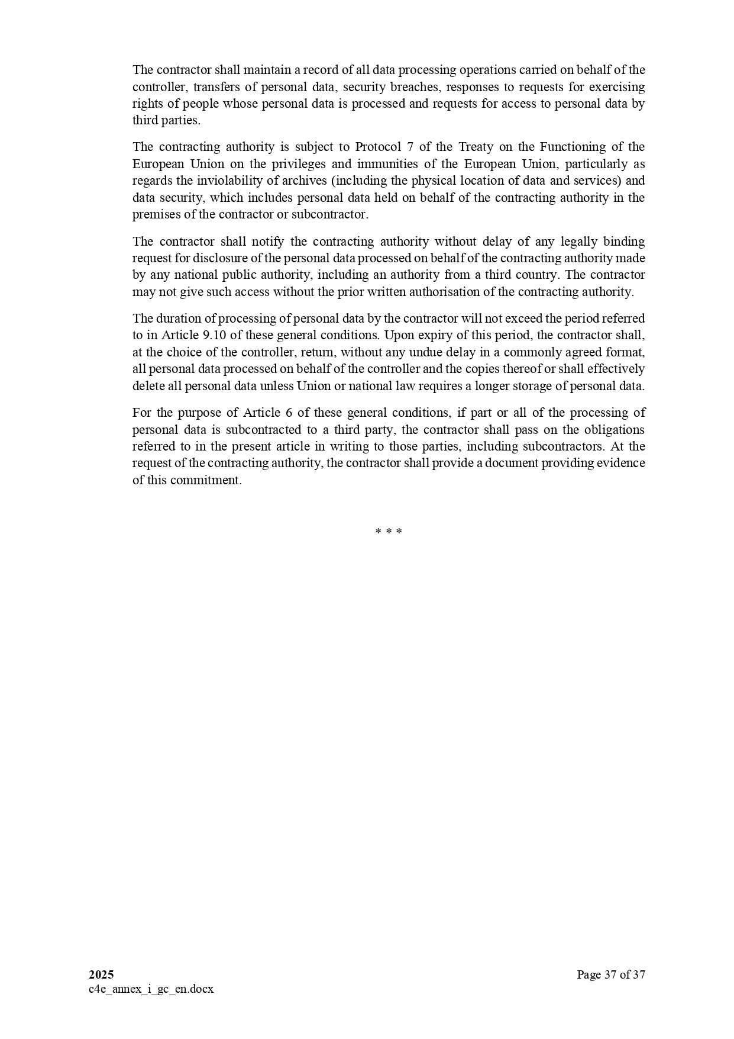

ANNEX II + III: TECHNICAL SPECIFICATIONS + TECHNICAL OFFER

Contract title: Supply of equipment for the fit-out of the COI offices (Horizon 2030). p 1 /…
Publication reference: COI/HORIZON2030/AO/2026/013

Columns 1-2 should be completed by the contracting authority
Columns 3-4 should be completed by the tenderer
Column 5 is reserved for the evaluation committee
Annex III - the contractor's technical offer
The tenderers are requested to complete the template on the next pages:
- Column 2 is completed by the contracting authority shows the required specifications (not to be modified by the tenderer),
- Column 3 is to be filled in by the tenderer and must detail what is offered (for example the words ‘compliant’ or ‘yes’ are not sufficient)
- Column 4 allows the tenderer to make comments on its proposed supply and to make eventual references to the documentation
The eventual documentation supplied should clearly indicate (highlight, mark) the models offered and the options included, if any, so that the evaluators can see the exact configuration. Offers that do not permit to identify precisely the models and the specifications may be rejected by the evaluation committee.
The offer must be clear enough to allow the evaluators to make an easy comparison between the requested specifications and the offered specifications.

1.  Item number | 2.  Specifications required | 3.  Specifications offered | 4.  Notes, remarks,  ref to documentation | 5.  Evaluation committee’s notes
 | LOT 1 — IT and audio-visual equipment
1.1 | Interactive flat-panel display 75" 4K UHD (touch, camera, microphones) (Qty: 2)  Display:  - Screen size: 75-inch TFT LCD with DLED backlighting  - Resolution: 3840 x 2160 (4K UHD)  - Aspect ratio: 16:9  - Brightness: 450 nits (typical)  - Contrast ratio: 5000:1 (typical)  - Viewing angles: 178° horizontally and vertically  - Response time: 6.5 ms  - Backlight lifespan: 50,000 hours  - Surface treatment: 9H hardness, anti-glare  Touch technology:  - Ultra-thin touch technology (IR or Projected Capacitive Touch (PCT))  - 50 simultaneous touch points  - Touch resolution: 32,767 x 32,767  Camera and Audio:  - Built-in 50 MP camera with 4x digital zoom  - Automatic framing with voice tracking technology  - 8 beamforming microphones (up to 8 meters)  - Two built-in 20 W speakers  Connectivity:  - Inputs: 3 x HDMI (4K at 60 Hz), 1 x DisplayPort, 1 x RGB/VGA, 1 x SD/SDHC slot  - Outputs: 1 x HDMI, 1 x audio, 1 x SPDIF  - USB: 5 x Type-A (4 x USB 3.2 Gen 1 SmartPort, 1 x USB 2.0 for system updates), 2 x Type-B, 2 x Type-C (65 W PD and 15 W PD)  - LAN: 2 x RJ45 ports  - RS232 port
1.2 | Laptop (Qty: 23)  General Specifications  - Brand/Model: To be specified by the bidder.  - Processor: Latest Core i7  - RAM: 16 GB, expandable to at least 32 GB  - Storage: 1 TB NVMe SSD  - Graphics Card: Integrated HD graphics card  - Display: 14-inch with built-in camera and microphone  - Screen Resolution: 1920 x 1080  - Audio: Built-in speakers with AUX output  - Keyboard: AZERTY / QWERTY with numeric keypad, spill-resistant  - Pointing device: touchpad  - Battery providing at least 12 hours of battery life  Connectivity:  - Gigabit Ethernet LAN port,  - 1 x dual-band 802.11ac + Bluetooth combo module  - DisplayPort via USB-C  - HDMI  Operating system:  - Windows 11 Pro  Accessories:  - Charger with UK + FR power cables  - Carrying case  - AZERTY/QWERTY wireless mouse and keyboard set  Warranty: Minimum 3 years  Availability: 15 days after order confirmation
1.3 | Monitor 27" (Qty: 19)  Size:  - 27 inches  Resolution:  - Minimum system requirements: 1920 x 1080.  USB Power Delivery  - 65 watts  Connectivity  - DisplayPort  - HDMI  - USB-C / DisplayPort with power delivery (up to 65 W)  - Ethernet (RJ-45)  The following cables should be included.  - 1 x DisplayPort to HDMI cable  - 1 x HDMI to HDMI cable  - 1 x USB-C cable  - UK + FR power cable  Warranty: at least 1 year  Availability: 15 days after order confirmation
1.4 | Monitor 32" (Qty: 3)  Size:  - 32 inches  Resolution:  - Minimum system requirements: 1920 x 1080.  USB Power Delivery  - 65 watts  Connectivity  - DisplayPort  - HDMI  - USB-C / DisplayPort with power delivery (up to 65 W)  - Ethernet (RJ-45)  The following cables should be included.  - 1 x DisplayPort to HDMI cable  - 1 x HDMI to HDMI cable  - 1 x USB-C cable  - UK + FR power cable  Warranty: at least 1 year  Availability: 15 days after order confirmation
1.5 | Multifunction printer and scanner A4/A3 (Qty: 4)  - Multifunction Printer - Color - Laser – A4/A3 (Print, Scan, Copy)  - Resolution up to 4,800 x 1,200 dpi, up to 25 ppm (copying) / up to 25 ppm (printing),  - Capacity: 1,150 sheets, Interfaces: Gigabit LAN / USB host / NFC / USB 3.0, Technology: HyPAS solutions platform,  - Control panel: resistive color touchscreen,  - Print speed: up to 25/12 ppm A4/A3 in color and black-and-white,  - Duplex print speed: up to 25/12 ppm A4/A3 in color and black-and-white  - Copy speed: 25 ppm A4 in color and black-and-white  - Print resolution: 1200 x 1200 dpi (equivalent to 4800 x 1200 dpi),  - Copy resolution: 600 x 600 dpi; Scan resolution: 600 x 600 dpi  - Processor: QorIQ T1024 (Dual Core) 1.0 GHz,  - Memory: Standard 4 GB RAM + 32 GB SSD; Max 4 GB RAM + 32 GB SSD + 320 GB HDD  - Standard interfaces: 1 USB 3.0 port (ultra-high speed), 4 USB 2.0 host ports, Fast Ethernet 10, BaseT/100 BaseTX/1000 BaseT, print server slot, SD card slot, fax card slot, NFC  - Warranty: Minimum 3 years  Compatible ink cartridges included with each printer: 02 Black, 03 Cyan, 03 Magenta, 03 Yellow
1.6 | Screen privacy filter 14" (Qty: 45)  - Size: 14 inches  - Anti-glare  - Blue light filter  - Scratch-resistant
1.7 | External hard drive SSD ≥ 1 TB (Qty: 8)  - Storage type: SSD  - Capacity: at least 1 TB; Interface: USB 3.1 Gen 2 or USB-C; compatible with USB 3.0 and 2.0.  - Transfer speed: at least 500 MB/s for both read and write.  - Physical durability: rugged casing, resistant to shocks, vibrations, and dust.  - Powered via USB,  - Compatible USB-C to USB 3.1 cable included.  - Reinforced protective case included.
1.8 | Ergonomic laptop stand (Qty: 45)  - Made of steel  - Height-adjustable with foldable supports  - With cooling fan  - USB port  - Adjustable size, compatible with laptops up to 16"  - Weight capacity:  - With protective silicone pads
1.9 | Interactive totem 43" (Qty: 1)  Technology:  - Ultra-thin interactive technology (IR recognition or projected capacitive touch (PCT))'-  Display:  -Screen size: 43", Orientation Portrait  -Backlight Type: Direct  -Resolution: 1920 x 1080 pixels (16:9)  -Brightness (Typ., cd/m²): 4000 - (Min., cd/m²): 3000  - Contrast Ratio 1300:1  - Dynamic Contrast Ratio 500,000:1  - Viewing Angle (HxV) 178 x 178  - Response Time (Typ.) 8 ms (G to G BW)  - Surface Treatment 3% Diffusion, QWP (diffusion, quarter-wave plate)  - Local dimming 48 blocks  - Lifespan (Typ.) 50,000 hours  - Operating hours 24 hours and 8 hours  Connectivity:  -Inputs HDMI (2), DP, HDBaseT, USB (2)  Output: Output for external speakers (L/R)  External Control: RS232C Input/Output, RJ45 Input/Output (LAN)  Physical specifications  -Protective Glass: 5 mm (IK 10, protection rating, chemically strengthened, anti-glare)  - Frame Color: Black  Screens Content Managament System (CMS) included  - Content Management System
1.10 | Related services (Lot 1) (Qty: 1)  Delivery DDP to the COI premises; positioning and basic configuration of the IT equipment; user training; commissioning/configuration of the interactive panels and totem after mounting; removal of packaging. The wall-mounting/fixing of the 75" interactive panels and of the totem is carried out by the works contractor and is EXCLUDED from this supply; the supplier coordinates with the works contractor and performs final commissioning once mounted.
 | LOT 2 — Furniture
2.1 | Meeting table for 20 users (Qty: 1)  - Capacity: Seats 20 users  - Shape: Modular design  - Use: Videoconference room  - Tops: minimum 25 mm engineered board, plywood or equivalent stable substrate  -Frames: powder-coated steel, aluminium or engineered structural base with concealed fixings and adjustable levelling feet.  - Cable management: continuous under-table trays, removable access lids/grommets and segregated routes for mains and data.  - Power/data modules: certified modular units, flush or retractable, with final socket quantities and types coordinated with electrical/ICT drawings  - Warranty: at least 1 year  - Availability: 15 days after order confirmation
2.2 | Meeting table for 15 users (Qty: 2)  - Capacity: Seats 15 users  - Shape: Modular design  - Use: Videoconference room  - Tops: minimum 25 mm engineered board, plywood or equivalent stable substrate  -Frames: powder-coated steel, aluminium or engineered structural base with concealed fixings and adjustable levelling feet.  - Cable management: continuous under-table trays, removable access lids/grommets and segregated routes for mains and data.  - Power/data modules: certified modular units, flush or retractable, with final socket quantities and types coordinated with electrical/ICT drawings  - Warranty: at least 1 year  - Availability: 15 days after order confirmation
2.3 | Meeting table for 10 users (Qty: 1)  - Capacity: Seats 10 users  - Shape: Oval or barrel-shaped  - Use: Videoconference room  - Tops: minimum 25 mm engineered board, plywood or equivalent stable substrate  -Frames: powder-coated steel, aluminium or engineered structural base with concealed fixings and adjustable levelling feet.  - Cable management: continuous under-table trays, removable access lids/grommets and segregated routes for mains and data.  - Power/data modules: certified modular units, flush or retractable, with final socket quantities and types coordinated with electrical/ICT drawings  - Warranty: at least 1 year  - Availability: 15 days after order confirmation
2.4 | Meeting table for 6 users (Qty: 2)  - Capacity: Seats 6 users.  - Shape: Oval or barrel-shaped  - Use: Videoconference room  - Tops: minimum 25 mm engineered board, plywood or equivalent stable substrate  -Frames: powder-coated steel, aluminium or engineered structural base with concealed fixings and adjustable levelling feet.  - Cable management: continuous under-table trays, removable access lids/grommets and segregated routes for mains and data.  - Power/data modules: certified modular units, flush or retractable, with final socket quantities and types coordinated with electrical/ICT drawings  - Warranty: at least 1 year  - Availability: 15 days after order confirmation
2.5 | Meeting / conference chair (Qty: 72)  - Frame/base: powder-coated steel, aluminium, reinforced polymer or equivalent commercial-grade construction  - Upholstery material: leather  - High, slightly reclined backrest  - Removable armrest  - Seat height: 430 to 480 mm  - Metal sled-style legs  - Color: black  - With 5 castors/glides selected for laminate flooring, quiet and non-marking  - Minimum user mass rating: 130 kg; 150 kg  - Warranty: at least 1 year  - Availability: 15 days after order confirmation
2.6 | Conference chair with writing tablet (Qty: 34)  - Metal frame  - Upholstery material: leather  - Short backrest  - Fixed metal armrests  - Seat height: 430 to 480 mm  - Metal sled-style legs  - Color: black  - Warranty: at least 1 year  - Availability: 15 days after order confirmation
2.7 | Metal cabinet (Qty: 10)  - Metal cabinet  - Two lockable swinging door  - Dimensions: At least  o Total height: 1850 mm  o Length: 1000 mm  o Width: 455 mm  - With 4 removable shelves  - Warranty: at least 1 year  - Availability: 15 days after order confirmation
2.8 | Office desk (Qty: 4)  - Office Desk / Workstation Desk  - High-quality laminated MDF / particle board minimum 25 mm  - Dimensions: 1500x800x750mm  - Integrated cable management system with cable grommets  - Lockable drawers with smooth-running runners, where applicable  - Warranty: at least 1 year  - Availability: 15 days after order confirmation
2.9 | Ergonomic office chair (Qty: 4)  - Ergonomic Office Chair  - Ergonomic adjustable lumbar support  - Cover material: mesh fabric  - High backrest with adjustable recline  - With an adjustable headrest  - Armrests  - Seat height adjustable from 400 to 480 mm, height adjustment via gas lift, with locking mechanism  - 5-star metal base with sturdy casters  - Color: black  - Warranty: at least 1 year
2.10 | Stainless-steel cabinet for kitchen (Qty: 1)  - Material : Stainless Steel  - Two lockable sliding doors  - Height : a least 150 cm  - Adjustable stainless steel shelves  - Shelves Load Capacity : Minimum 20 kg per shelf, evenly distributed  - High resistance to corrosion, moisture and kitchen chemicals  - Smooth, non-porous and easy-to-clean surfaces
2.11 | Stainless-steel table for kitchen (Qty: 1)  -Stainless steel material  - Dimensions:  - Length: 150 cm  - Height: 85 cm  - With two shelves  - Warranty: at least 1 year  - Availability: 15 days after order confirmation
2.12 | Related services (Lot 2) (Qty: 1)  Delivery DDP to the COI premises; assembly, positioning and installation of furniture; levelling and fixing where required; removal of packaging.
 | LOT 3 — Appliances and accessories
3.1 | Refrigerator ~350 L (Qty: 2)  -Capacity: 350L  - Energy Efficiency Class: A+  - Total no frost & DC centrifugal fan  - Electronic temperature control (External LED display)  - Sky Powerful Interior LED Light  - Reversible door(slot in design)  - Large crisper drawer with humidity control  - Door open alarm  - Power cool function  - Color: Stainless Steel
3.2 | Refrigerator ~450 L (French 4-door) (Qty: 1)  - Capacity: 450L  - Energy Efficiency Class: A+  - French 4 door no frost refrigerator  - Total no frost & DC centrifugal fan  - Electronic temperature control (External LED display)  - Tempered glass shelves  - Sky Powerful Interior LED Light  - Reversible door(slot in design)  - Large crisper drawer with humidity control  - Door open alarm  - Power cool function  - Color: Stainless Steel
3.3 | Microwave oven (Qty: 1)  - Capacity: 30L  - 5 power levels & 10 auto cooking menus  - Airfry & Memory function  - Multi stage cooking/Combi cooking  - Push button touch door
3.4 | Transparent lectern (PMMA) (Qty: 2)  - Lectern / conference podium: Frame made of 15mm- and 6mm-thick transparent PMMA plexiglass + 2mm-thick PMMA front panel  - Transparent  - Dimensions:  o Total height: 115 cm  o Top: 600x435mm  o Base: 510 x 445 mm  - Sign holder: Transparent plexiglass sign for A4 or larger displays, with side or top insertion  - Slanted tabletop with a hole in the left corner for positioning a microphone and cable  - Document retainer strip on the tabletop
3.5 | Standing document display stand (Qty: 3)  - Freestanding display  - Stand: height 1100 mm  - Horizontal A4 poster holder  - Slanted shelf
3.6 | Indoor flag poles (Qty: 12)  - Material: stainless steel  - Adjustable height: 2 to 3 m  - Number of sections: 2 to 3, interlocking  - Features a locking system with a locking button  - Base
3.7 | Related services (Lot 3) (Qty: 1)  Delivery DDP to the COI premises; positioning and installation; removal of packaging.

ANNEX IV : Budget breakdown (Model financial offer)
Nota Bene: All amounts are to be quoted excluding taxes. VAT, if applicable, is to be mentioned separately. Please refer to tender documents, notably the Instructions to tenderers, section 11 Content of tenders.

Page No 1 [of…]

PUBLICATION REFERENCE: COI/HORIZON2030/AO/2026/013 NAME OF TENDERER:
A |  |  | C | D | E
ITEM NUMBER | QUANTITY |  | SPECIFICATIONS OFFERED (INCL. BRAND/MODEL) | UNIT COSTS WITH DELIVERY DDP (COI premises, Ébène) EUR | TOTAL EUR
LOT 1 — IT and audio-visual equipment
1.1 Interactive flat-panel display 75" 4K UHD |  | 2
1.2 Laptop |  | 23
1.3 Monitor 27" |  | 19
1.4 Monitor 32" |  | 3
1.5 Multifunction printer/scanner A4/A3 |  | 4
1.6 Screen privacy filter 14" |  | 45
1.7 External hard drive SSD ≥ 1 TB |  | 8
1.8 Ergonomic laptop stand |  | 45
1.9 Interactive totem 43" |  | 1
1.10 Related services (delivery, config., training, commissioning)
SUBTOTAL LOT 1
LOT 2 — Furniture
2.1 Meeting table for 20 users |  | 1
2.2 Meeting table for 15 users |  | 2
2.3 Meeting table for 10 users |  | 1
2.4 Meeting table for 6 users |  | 2
2.5 Meeting / conference chair |  | 72
2.6 Conf. chair with writing tablet |  | 34
2.7 Metal cabinet |  | 10
2.8 Office desk |  | 4
2.9 Ergonomic office chair |  | 4
2.10 Stainless-steel kitchen cabinet |  | 1
2.11 Stainless-steel kitchen table |  | 1
2.12 Related services (delivery, assembly, installation)
SUBTOTAL LOT 2
LOT 3 — Appliances and accessories
3.1 Refrigerator ~350 L |  | 2
3.2 Refrigerator ~450 L (4-door) |  | 1
3.3 Microwave oven |  | 1
3.4 Transparent lectern (PMMA) |  | 2
3.5 Standing document display stand |  | 3
3.6 Indoor flag poles |  | 12
3.7 Related services (delivery, installation)
SUBTOTAL LOT 3
TOTAL (all lots) — EUR, excl. taxes

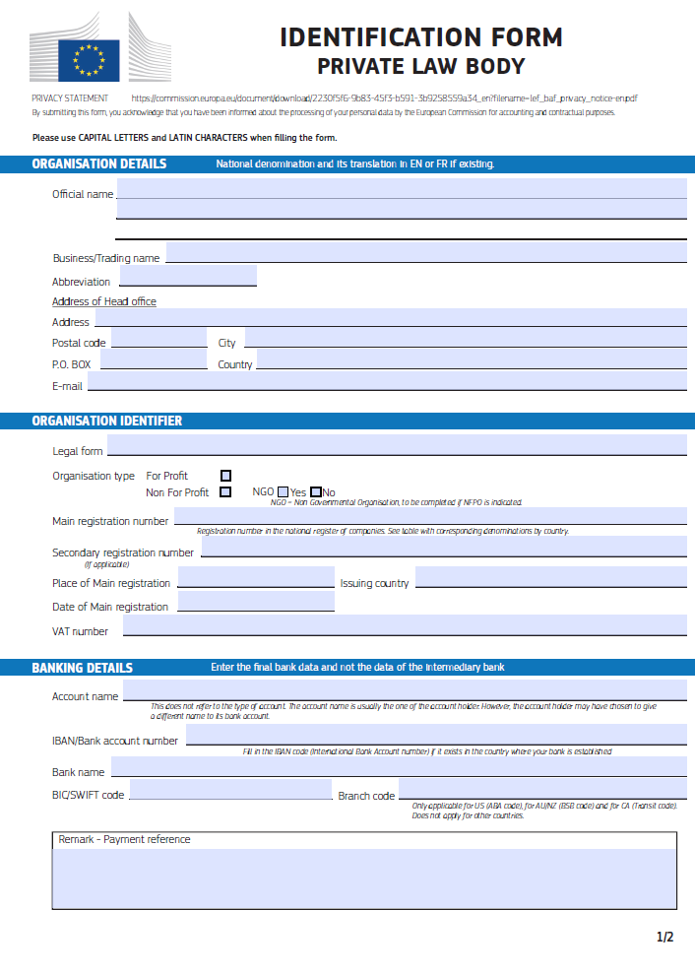

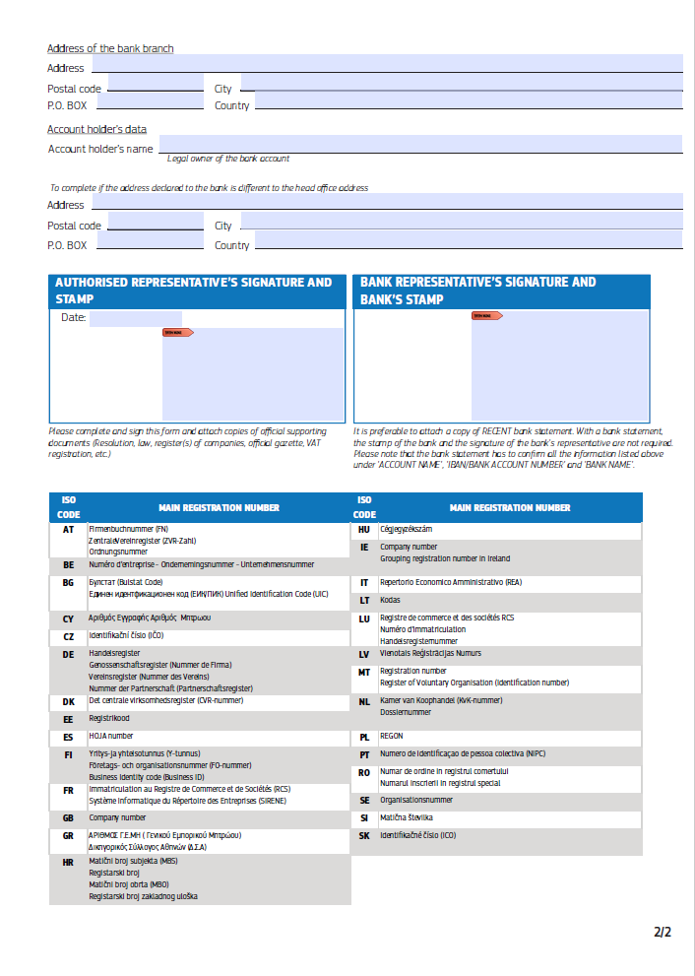

ADMINISTRATIVE COMPLIANCE GRID

Contract title : | Supply of equipment for the fit-out of the COI offices (Horizon 2030). | Publication reference : | COI/HORIZON2030/AO/2026/013

Tender number | Name of tenderer | Is tenderer (consortium) nationality eligible?  (Y/N) | Is documentation complete?  (Y/N) | Is language as required?  (Y/N) | Is tender submission form complete?  (Y/N) | Is tenderer's declaration signed (by all consortium members if a consortium)? (Yes/No/ Not Applicable) | Declaration(s) on honour included? (Yes/No) | Other administrative requirements of the tender dossier?  (Yes/No/Not applicable) | Form FS-PP on financial contributions from non EU Countries  (Yes/No/Not Applicable) | Overall decision?  (Accept / Reject)
1
2
3
4
5
6
7

Chairperson's name
Chairperson's signature
Date

EVALUATION GRID

Contract title : | Supply of equipment for the fit-out of the COI offices (Horizon 2030). | Publication reference : | COI/HORIZON2030/AO/2026/013

Tender No | Name of tenderer | Rules of origin respected?  (additional guidance)  (Y/N) | Economic & financial capacity? (OK/a/b/…) | Professional capacity? (OK/a/b/…) | Technical capacity? (OK/a/b/…) | Compliance with technical specifications? (OK/a/b/…) | Ancillary services as required? (OK/a/b/…/NA) | Subcontracting statement in accordance with art. 6 of the general conditions?  (Y/N) | Other technical requirements in tender dossier?  (Yes/No/Not applicable) | Technically compliant? Y/N) | Justification/  notes:
1
2
3
4

Evaluator's name & signature
Evaluator's name & signature
Evaluator's name & signature
Date

TENDER FORM FOR A SUPPLY CONTRACT

Publication reference:COI/HORIZON2030/AO/2026/013

Title of contract:Supply of equipment for the fit-out of the offices of the Indian Ocean Commission (Horizon 2030)
Place and date
A:The Indian Ocean Commission (COI), Blue Tower, Ebène, Mauritius

One signed form must be supplied (for each lot, if the tender procedure is divided into lots), together with the number of copies specified in the instructions to tenderers. The form must include a signed declaration using the annexed format from each legal entity submitting this tender. Any additional documentation (brochure, letter, etc.) sent with the form will not be taken into consideration. Tenders being submitted by a consortium (i.e. either a permanent, legally-established grouping or a grouping which has been constituted informally for a specific tender procedure) must follow the instructions applicable to the consortium leader and its members. The attachments to this submission form (i.e. declarations, statements, proofs) may be in original or copy. If copies are submitted, the originals must be dispatched to the contracting authority upon request. For economical and ecological reasons, we strongly recommend that you submit your files on paper-based materials (no plastic folder or divider). We also suggest you use double-sided print-outs as much as possible.
Capacity-providing entities
An economic operator (i.e. tenderer) may, where appropriate and for a particular contract, rely on the capacities of other entities, regardless of the legal nature of the links which it has with them. If the economic operator relies on other entities it must in that case prove to the contracting authority that it will have at its disposal the resources necessary for the performance of the contract by producing a commitment by those entities to place those resources at its disposal. Such entities, for instance the parent company of the economic operator, must respect the same rules of eligibility and notably that of nationality as the economic operator relying on them and must comply with the selection criteria for which the economic operator relies on them. For the purpose of the present tender, the data for this third entity for the relevant selection criterion should be included in a separate document. Proof of the capacity will also have to be provided when requested by the contracting authority.
With regard to technical and professional criteria, an economic operator may only rely on the capacities of other entities where the latter will perform the tasks for which these capacities are required.
With regard to economic and financial criteria, the entities upon whose capacity the economic operator relies, become jointly and severally liable for the performance of the contract.

1 SUBMITTED BY (i.e the identity of the tenderer and bank account details)
 | Name(s) of tenderer(s) | Official address, postcode, P.O box, city, country | Legal form | VAT number and/or Registration number (if applicable) | Place of main registration (city and country) and date of registration
Leader
Member
Etc …
 | Account name and account holder name | IBAN/Account number | Currency | BIC/Swift code | Bank name and branch code | Address of bank, P.O box, city, country
Leader

2 CONTACT PERSON (for this tender)
Name
Address
Telephone
E-mail
3 ECONOMIC AND FINANCIAL CAPACITY
Please complete the following table of financial data based on your annual accounts and your latest projections. If annual closed accounts are not yet available for the current year or past year, please provide your amounts based on appropriate statements from banks in the columns marked with **. Figures in all columns must be calculated on the same basis to allow a direct, year-on-year comparison to be made (or, if the basis has changed, an explanation of the change must be provided as a footnote to the table). Any clarification or explanation which is judged necessary may also be provided.
Financial data  Data requested in this table must be consistent with the selection criteria set in the additional information about the contract notice document | 2 years before last year  specify  € | Year before last year  specify  € | Last year  specify  € | Average  € | Past year  € ** | Current year  €**
Annual turnover, excluding this contract
Current assets
Current liabilities
[Current ratio (current assets/current liabilities) | Not applicable | Not applicable |  | Not applicable | Not applicable | Not applicable]

4 PERSONNEL
Please provide the following personnel statistics for the current year and the two previous years.
Annual manpower | Year before past year |  | Past year |  | Current year |  | Period average
 | Overall | Relevant fields | Overall | Relevant fields ¹¹ | Overall | Relevant fields¹¹ | Overall | Relevant fields¹¹
Permanent personnel
Other personnel
Total
Permanent personnel as a proportion of total personnel (%) | % | % | % | % | % | % | % %

5 FIELDS OF SPECIALISATION
Please fill in the table below to indicate any areas of specialist knowledge related to this contract of each legal entity making this tender, by using the names of these specialisation as the row headings and the name of the legal entity as the column headings. Indicate the areas of specialist knowledge each legal entity has by placing a tick () in the box corresponding to the specialisation in which the legal entity has significant experience. Maximum 10 specialisations.
 | Leader | Member 2 | Member 3 | Etc …
Relevant specialisation 1
Relevant specialisation 2
Etc …
6 EXPERIENCE
Please complete a table using the format below to summarise the major relevant supplies carried out over the past 4 years by the legal entity or entities making this tender. The number of references to be provided must not exceed 15 for the entire tender.
Candidates are allowed to refer either to projects completed within the reference period (although started earlier) or to projects not yet completed. Only the part completed during the reference period will be taken into consideration. This part will have to be supported by documentary evidence (approval of report or deliverable, proof of payment, statement or certificate from the entity which awarded the contract) also detailing its value. If a candidate has implemented the project in a consortium, the part that the candidate has successfully completed must be clear from the documentary evidence, together with a description of the nature of the services provided if the selection criteria relating to the pertinence of the experience have been used.
Ref # (maximum 15) | Project title |  | …
Name of legal entity | Country | Overall supply value (EUR) | Part supplied by legal entity EUR | No of personnel provided | Name of client | Origin of funding | Dates | Name of members if any
… | … | … | … | … | … | … | … | …
Detailed description of supply |  |  |  |  |  | Related services provided
… |  |  |  |  |  | …

7 TENDERER’S DECLARATION(S)
As part of their tender, each legal entity identified under point 1 of this form, including every consortium member, must submit a signed tenderer’s declaration using this format.
Additionally, each legal entity identified under point 1 of this form, including every consortium member, as well as each capacity providing entity and subcontractor, must submit the declaration on honour on exclusion and selection criteria (Annex 1)
In response to your letter of invitation to tender for the above contract,
we, the undersigned, hereby declare that:
1 We have examined and accept in full the content of the dossier for invitation to tender No COI/HORIZON2030/AO/2026/013 of 10/09/2026. We hereby accept its provisions in their entirety, without reservation or restriction.
2 We offer to deliver, in accordance with the terms of the tender dossier and the conditions and time limits laid down, without reserve or restriction:
Lot 1: description of supplies with indication of quantities
Lot 2: description of supplies with indication of quantities
Lot 3: description of supplies with indication of quantities
3 The price of our tender excluding spare parts and consumables, if applicable (excluding the discounts described under point 4) is:
Lot 1: insert price
Lot 2: insert price
Lot 3: insert price
4 We will grant a discount of …%, or ………….. in the event of our being awarded lot … and lot … ……….
5 This tender is valid for a period of 90 days from the final date for submission of tenders.
6 No performance guarantee is required for this contract.
7 Our firm/company and our subcontractors has/have the following nationality:
……………………………………………………………………
8 We are making this tender in our own right [as member in the consortium led by name of the leader ] [ourselves]*. We confirm that we are not tendering for the same contract in any other form. [We confirm, as a member in the consortium, that all members are jointly and severally liable by law for the execution of the contract, that the lead member is authorised to bind, and receive instructions for and on behalf of, each member, that the execution of the contract, including payments, is the responsibility of the lead member, and that all members in the joint venture/consortium are bound to remain in the joint venture/consortium for the entire period of the contract’s execution]. [We, the tenderer, confirm that where we rely on the capacities of other entities with regard to the criteria relating to economic and financial capacity, we have the written commitment made by the capacity providing entities that they are jointly liable for the performance of the contract.]
9 We undertake, if required, to provide the proof usual under the law of the country in which we are effectively established that we do not fall into any of the exclusion situations. The date on the evidence or documents provided will be no earlier than 1 year before the date of submission of the tender and, in addition, we will provide a statement that our situation has not altered in the period which has elapsed since the evidence in question was drawn up.
We also undertake, if required, to provide evidence of financial and economic standing and technical and professional capacity according to the selection criteria for this call for tender specified in the additional information about the contract notice. The documentary proofs required are listed in Section 2.6.11. of the practical guide.
10 We agree to abide by the ethics clauses in Clause 24 of the instructions to tenderers and, in particular, have no conflict of interests or any equivalent relation which may distort competition with other tenderers or other parties in the tender procedure at the time of the submission of this form.
We confirm that we, including all consortium members, if any, capacity providing entities and subcontractors are not in the lists of EU restrictive measures (www.sanctionsmap.eu) and we understand that our tender may be rejected, if proved the contrary.
11 We will inform the contracting authority immediately if there is any change in the above circumstances at any stage during the implementation of the tasks. We also fully recognise and accept that any inaccurate or incomplete information deliberately provided in this tender may result in our exclusion from this and other contracts funded by the EU/EDF.
12 We note that the contracting authority is not bound to proceed with this invitation to tender and that it reserves the right to award only part of the contract. It will incur no liability towards us should it do so.
13 We fully recognise and accept that if the above-mentioned persons participate despite being in any of the situations listed in Section 2.4.2.1 and Section 2.4.1 of the practical guide or if the declarations or information provided prove to be false they may be subject to rejection from this procedure and to exclusion decisions and/or financial penalties up to 10 % of the total estimated value of the contract being awarded and that this information may be published on the European Commission website in accordance with the Financial Regulation in force.
14 We are aware that, for the purposes of safeguarding the EU's financial interests, our personal data and those of all entities involved in the performance of the contract may be transferred to internal audit services, to the early detection and exclusion system, to the European Court of Auditors, to the Financial Irregularities Panel, to the European Anti-Fraud Office or to the European Public Prosecutor’s Office.
15 We agree that any arbitral award resulting from this tender will be published on the European Commission’s website after anonymisation.
[* Delete as applicable]
[If this declaration is being completed by a consortium member:
The following table contains our financial data as included in the consortium’s tender form. These data are based on our annual closed accounts and our latest projections. Estimated figures (i.e. those not included in annual closed accounts) are given in italics. Figures in all columns have been provided on the same basis to allow a direct, year-on-year comparison to be made <except as explained in the footnote to the table>.
Financial data  Data requested in this table must be consistent with the selection criteria set in the additional information about the contract notice document | 2 years before last⁵  specify  EUR | Year before last year  specify  EUR | Last year  specify  EUR | Average⁶  EUR | Past year  EUR | Current year  EUR
Annual turnover ⁷, excluding this contract
Current assets⁸
Current liabilities⁹
Current ratio (current assets/current liabilities)

The following table contains our personnel statistics as included in the consortium’s tender form:
Annual manpower | Year before past year |  | Past year |  | Current year |  | Period average
 | Overall | Relevant fields¹¹ | Overall | Relevant fields¹¹ | Overall | Relevant fields ¹¹ | Overall | Relevant fields ¹¹
Permanent personnel ¹²
Other personnel ¹³
Total
Permanent personnel as a proportion of total personnel (%) | % | % | % | % | % | % | % | %
Yours faithfully
Name and first name: …………………………………………………………………
Duly authorised to sign this tender on behalf of:
……………………………………………………………………………………
Place and date: …………………………………………………………….………….
Stamp of the firm/company:
This tender includes the following annexes:
1) Technical offer — completed Annex II+III (Technical specifications / Contractor's technical offer).
2) Financial offer — completed Annex IV (Price schedule / Budget breakdown), DDP, excl. taxes.
3) Declaration on Honour on exclusion and selection criteria (Annex a14a), duly signed.
4) Financial identification form (Annex c4o) and its supporting documents.
5) Description of the warranty conditions (including the commercial warranty).
6) Proof of authorised signature (statutes, power of attorney, notarial act or equivalent).
7) [Where applicable, for a consortium: the consortium agreement and the power of attorney appointing the leader; and the written commitment of any capacity-providing entity.]
ANNEX 1
DECLARATION ON HONOUR ON EXCLUSION AND SELECTION CRITERIA

Declaration on honour on
exclusion criteria and selection criteria
The undersigned [insert name of the signatory of this form], representing:
(only for natural persons) himself or herself | (only for legal persons) the following legal person:
ID or passport number:  (‘the person’) | Full official name:  Official legal form:  Statutory registration number:  Full official address:  VAT registration number:  (‘the person’)

Declaration on honour on exclusion criteria
The person is not required to fill in this Part A of the declaration (Declaration on honour on exclusion criteria) if the same declaration has already been submitted for the purposes of another award procedure of the same contracting authority, provided the situation has not changed, and that the time that has elapsed since the issuing date of the declaration does not exceed one year.
In this case, the signatory declares that the person has already provided the same declaration on exclusion criteria for a previous procedure and confirms that there has been no change in its situation:
Date of the declaration | Full reference to previous procedure

I – Situations of exclusion concerning the person
(to be filled in by all involved entities)

- declares that the person is in one of the following situations: | YES | NO
- it is bankrupt, subject to insolvency or winding-up procedures, its assets are being administered by a liquidator or by a court, it is in an arrangement with creditors, its business activities are suspended or it is in any analogous situation arising from a similar procedure provided for under Union or national law;
- it has been established by a final judgement or a final administrative decision that the person is in breach of its obligations relating to the payment of taxes or social security contributions in accordance with the applicable law;
- it has been established by a final judgement or a final administrative decision that the person is guilty of grave professional misconduct by having violated applicable laws or regulations or ethical standards of the profession to which the person belongs, or by having engaged in any wrongful conduct which has an impact on its professional credibility where such conduct denotes wrongful intent or gross negligence, including, in particular, any of the following:
- fraudulently or negligently misrepresenting information required for the verification of the absence of grounds for exclusion or the fulfilment of eligibility or selection criteria or in the performance of a contract or an agreement;
- entering into agreement with other persons with the aim of distorting competition;
- violating intellectual property rights;
- unduly influence or attempting to unduly influence the decision-making process to obtain Union funds by taking advantage, through misrepresentation, of a conflict of interest involving any financial actors or other persons referred to in Article 61(1) of the EU Financial Regulation;
- attempting to obtain confidential information that may confer upon it undue advantages in the award procedure;
- incitement to discrimination, hatred or violence against a group of persons or a member of a group or similar activities that are contrary to the values on which the Union is founded enshrined in Article 2 TEU, where such misconduct has an impact on the person or entity’s integrity which negatively affects or concretely risks affecting the performance of the legal commitment;
- it has been established by a final judgement that the person is guilty of any of the following:
- fraud, within the meaning of Article 3 of Directive (EU) 2017/1371 and Article 1 of the Convention on the protection of the European Communities' financial interests, drawn up by the Council Act of 26 July 1995;
- corruption, as defined in Article 4(2) of Directive (EU) 2017/1371 or active corruption within the meaning of Article 3 of the Convention on the fight against corruption involving officials of the European Communities or officials of Member States of the European Union, drawn up by the Council Act of 26 May 1997, or conduct referred to in Article 2(1) of Council Framework Decision 2003/568/JHA, or corruption as defined in other applicable laws;
- conduct related to a criminal organisation, as referred to in Article 2 of Council Framework Decision 2008/841/JHA;
- money laundering or terrorist financing, within the meaning of Article 1(3), (4) and (5) of Directive (EU) 2015/849 of the European Parliament and of the Council;
- terrorist offences or offences related to terrorist activities, as defined in Articles 3 to 12 of Directive 2017/541 of the European Parliament and of the Council, respectively, or inciting, aiding, abetting or attempting to commit such offences, as referred to in Article 14 of that Directive;
- child labour or other offences concerning trafficking in human beings as referred to in Article 2 of Directive 2011/36/EU of the European Parliament and of the Council;
- it has shown significant deficiencies in complying with the main obligations in the performance of a contract or an agreement financed by the Union’s budget, which has led to its early termination or to the application of liquidated damages or other contractual penalties, or which has been discovered following checks, audits or investigations by a contracting authority, the European Anti-Fraud Office (OLAF), the Court of Auditors or the EPPO;
- it has been established by a final judgment or final administrative decision that the person has committed an irregularity within the meaning of Article 1(2) of Council Regulation (EC, Euratom) No 2988/95;
- it has been established by a final judgment or final administrative decision that the person or entity has created an entity in a different jurisdiction with the intent to circumvent fiscal, social or any other legal obligations including those related to working rights, employment and labour conditions, in the jurisdiction of its registered office, central administration or principal place of business;.
- (only for legal persons) it has been established by a final judgment or final administrative decision that the person has been created with the intent provided for in point (g).
- the entity or person has intentionally and without proper justification resisted an investigation, check or audit carried out by an authorising officer or its representative or auditor, OLAF, the EPPO, or the Court of Auditors. It shall be considered that the person or entity resists an investigation, check or audit when it carries out actions with the goal or effect of preventing, hindering or delaying the conduct of any of the activities needed to perform the investigation, check or audit. Such actions shall include, in particular, refusing to grant the necessary access to its premises or any other areas used for business purposes, concealing or refusing to disclose information or providing false information.
- declares that, for the situations referred to in points (1) (c) to (1) (i) above, in the absence of a final judgement or a final administrative decision, the person is: | YES | NO
- subject to facts established in the context of audits or investigations carried out by the European Public Prosecutor's Office, the Court of Auditors, or the internal auditor, or any other check, audit or control performed under the responsibility of an authorising officer of an EU institution, of a European office or of an EU agency or body;
- subject to non-final judgments or non-final administrative decisions which may include disciplinary measures taken by the competent supervisory body responsible for the verification of the application of standards of professional ethics;
- subject to facts referred to in decisions of entities or persons being entrusted with EU budget implementation tasks;
- subject to information transmitted by Member States implementing Union funds;
- subject to decisions of the Commission relating to the infringement of Union competition law or of a national competent authority relating to the infringement of Union or national competition law;
- informed, by any means, that it is subject to an investigation by the European Anti-Fraud office (OLAF): either because it has been given the opportunity to comment on facts concerning it by OLAF, or it has been subject to on-the-spot checks by OLAF in the course of an investigation, or it has been notified of the opening, the closure or of any circumstance related to an investigation of the OLAF concerning it.

II – Situations of exclusion concerning natural or legal persons with power of representation, decision-making or control over the legal person and beneficial owners
Not applicable when ‘the person’ is a natural person, a Member State or a local authority. In all other cases to be filled in by all involved entities¹.
- declares that a natural or legal person who is a member of the administrative, management or supervisory body of the above-mentioned legal person, or who has powers of representation, decision or control with regard to the above-mentioned legal person (this covers e.g. company directors, members of management or supervisory bodies, and cases where one natural or legal person holds a majority of shares), or a beneficial owner of the person (as referred to in point 6 of article 3 of Directive (EU) No 2015/849) is in one of the following situations: | YES | NO | N/A
Situation (1)(c) above (grave professional misconduct)
Situation (1)(d) above (fraud, corruption or other criminal offence)
Situation (1)(e) above (significant deficiencies in performance of a contract )
Situation (1)(f) above (irregularity)
Situation (1)(g) above (creation of an entity with the intent to circumvent legal obligations)
Situation (1)(h) above (person created with the intent to circumvent legal obligations)

III – Situations of exclusion concerning natural or legal persons assuming unlimited liability for the debts of the legal person
Not applicable when ‘the person’ is a natural person, a Member State, a local authority or legal persons with limited liability. In all other cases to be filled in by all involved entities¹.

- declares that a natural or legal person that assumes unlimited liability for the debts of the above-mentioned legal person is in one of the following situations [If yes, please indicate in annex to this declaration which situation and the name(s) of the concerned person(s) with a brief explanation]: | YES | NO | N/A
Situation (a) above (bankruptcy)
Situation (b) above (breach in payment of taxes or social security contributions)

IV – Other Grounds for rejection from this procedure
(to be filled in individually by the sole candidate/tenderer or all members in case of a joint request to participate/tender (consortium))

- declares that the above-mentioned person: | YES | NO
- Was previously involved in the preparation of the procurement documents used in this award procedure, where this entailed a breach of the principle of equality of treatment including distortion of competition that cannot be remedied otherwise.
- Has professional conflicting interests which may negatively affect the performance of the contract in accordance with point 20.6 of Annex I of the EU Financial Regulation.
- Is the addressee of a decision prohibiting the award of the contract for having received foreign subsidies distorting the internal market adopted by the Commission.

V – Remedial measures
If the person declares one of the situations of exclusion listed above, it may indicate remedial measures it has taken to remedy the exclusion situation, in order to allow the authorising officer to determine whether such measures are sufficient to demonstrate its reliability. The person or entity shall submit remedial measures that have been assessed by an external independent auditor or be considered sufficient by a decision of a national or Union authority. This is without prejudice to the assessment of the panel referred to in Article 145 of the EU Financial Regulation. This may include e.g. technical, organisational and personnel measures to prevent further occurrence, compensation of damage or payment of fines or of any taxes or social security contributions. The relevant documentary evidence which illustrates the remedial measures taken must be provided in annex to this declaration. This does not apply for situations referred in point (1)(d) of this declaration.

VI–evidence on exclusion criteria
The tender documents set out in detail which involved entities must provide the appropriate evidence to prove that they are not in an exclusion situation referred to in (1) and when the evidence needs to be provided.
The following could serve as evidence:
- For situations described in (1): (a), (c), (d), (f), (g) and (h) above, production of a recent extract from the judicial record is required or, failing that, an equivalent document recently issued by a judicial or administrative authority in the country of establishment of the person showing that those requirements are satisfied.
- For the situation described in point (1) (a), (b), production of recent certificates issued by the competent authorities of the country of establishment. These documents must provide evidence covering all taxes and social security contributions for which the person is liable, including for example, VAT, income tax (natural persons only), company tax (legal persons only) and social security contributions. Where any document described above is not issued in the country concerned, it may be replaced by a sworn statement made before a judicial authority or notary or, failing that, a solemn statement made before an administrative authority or a qualified professional body in its country of establishment.
The person is not required to submit the evidence if it has already been submitted for another award procedure of the same contracting authority. The documents must have been issued no more than one year before the date of their request by the contracting authority and must still be valid at that date.
The signatory declares that the person has already provided the documentary evidence for a previous procedure and confirms that there has been no change in its situation:
Document | Full reference to previous procedure
Insert as many lines as necessary.
The person is not required to submit the evidence if it can be accessed on a national database free of charge.
The signatory declares that the following internet address of the database/identification data provide access to the evidence required.
Internet address of the database | Identification data of the document
Insert as many lines as necessary.

Declaration on honour on selection criteria
In case of a procedure with lots the statements in this part B apply to the lot(s) for which the request to participate/tender is submitted.

I – Selection criteria
Selection criteria applicable to the candidate/tenderer as a whole- Consolidated assessment
(to be filled in ONLY by the sole candidate/tenderer or the group leader in case of a joint request to participate/tender (consortium))
The person, being a sole candidate/tenderer/the group leader of in case of a joint request to participate/tender (consortium), submitting a request to participate/tender for the above procedure

- declares that the candidate/tenderer, including all members of the group in case of a joint request to participate/tender (consortium), subcontractors and entities on whose capacity the candidate/tenderer intends to rely if applicable: | YES | NO | N/A
- fulfils all the selection criteria for which a consolidated assessment will be made as provided in the tender documents.

II - Selection Criteria –professional conflicting interests
(to be filled in by all involved entities)
The person, being a sole candidate/tenderer/ a member of a joint request to participate/tender (consortium)/a subcontractor/ an entity on whose capacity a candidate/tenderer relies to fulfil the selection criteria, submitting/participating in a request to participate/tender for the above procedure:

- declares that the person | YES | NO
- is subject to conflicting interests which may negatively affect the contract performance.

VIII – Evidence on selection criteria
The tender documents set out in detail the evidence and the time frame within which involved entities must provide it in order to prove that the candidate/tenderer fulfils the selection criteria.
Where the evidence is not required to be provided with the request to participate/tender, the person is invited to prepare in advance the documents related to the evidence, since the contracting authority will request the presumed successful tenderer to provide such evidence within a short deadline.
The person is not required to submit the evidence if it has already been submitted for another procurement procedure of the same contracting authority and the documents are still up-to-date.
The signatory declares that the person has already provided the documentary evidence for a previous procedure and confirms that there has been no change in its situation:
Document | Full reference to previous procedure
Insert as many lines as necessary.
The person is not required to submit the evidence if it can be accessed on a national database free of charge.
The signatory declares that the following internet address of the database/identification data provide access to the evidence required.
Internet address of the database | Identification data of the document
Insert as many lines as necessary.

C - Declaration on honour on established debt to the union
(to be filled in by the sole candidate/tenderer or each group member in case of a joint request to participate/tender (consortium))
The person, being a sole candidate/tenderer/a member in case of a joint request to participate/tender (consortium), submitting a request to participate/tender for the above procedure:
- declares that the person, | YES | NO
- has an established debt to the Union, European Atomic Energy Community or an executive agency when the latter implements the Union budget.

Declaration on honour on submitted tender
(to be filled in individually by the sole candidate/ tenderer, or the group leader in case of a joint request to participate/tender (consortium))
In case of a procedure with lots the statements in this part D apply to the lot(s) for which the request to participate/tender is submitted.
- declares that the person: | YES | NO
- [has prepared the submitted tender] [undertakes to prepare the tender (if invited to submit a tender)] in complete independence and autonomously from the other tenders submitted within the same procurement procedure.

The person must immediately inform the contracting authority of any changes in the situations as declared.

The person may be subject to rejection from this procedure and to administrative sanctions (exclusion or financial penalty) if any of the declarations or information provided as a condition for participating in this procedure prove to be false.

Full name Date Signature

Please note that the EU Official Journal contains the official list of entities subject to restrictive measures and, in case of conflict, it prevails over the list of the EU Sanctions Map.
See PRAG Section 2.4.2.3.(1)
It is recommended to use registered mail in case the postmark would not be readable
DDP (Delivered Duty Paid) — Incoterms 2020 International Chamber of Commerce http://www.iccwbo.org/incoterms/
The declaration on honour or the list of debtors confirm the established debt to the Union.
OJ L 205 of 21.11.2018, p. 39
If the tender has been submitted by a consortium, the nationalities of all the consortium members must be eligible.
Applicable only to contracts financed by a basic act under the MFF 2014-2020 (contracts/lots above EUR 100 000 under CIR and independently of the value for other instruments) and to contracts financed by the EINSC Regulation 2021/948 of 27 May 2021 and the Ukraine Facility Regulation (EU) 2024/792 of 29 February 2024 under the MFF 2021-2027.
The selection criteria, in the previous section of this form, have to be met before the technical requirements are assessed.
In case the tenderer is an individual, mention the nationality of the individual.
Add/delete additional lines for members as appropriate. Note that capacity providing entity/ subcontractors are not considered to be a member for the purposes of this tender procedure. Subsequently, the data on capacity providing entities/ subcontractor must not appear in the data related to the economic, financial and professional capacity but on a separate document. If this tender is being submitted by an individual tenderer, the name of the tenderer should be entered as ‘leader’ (and all other lines should be deleted). Any change in the identity of the leader and/or any consortium members between the deadline for receipt of requests to participate indicated in the contract notice and the award of the contract is not permitted without the prior written authorisation of the contracting authority.
Add only the bank account details of the leader to whom payments under the proposed contract should be made in the event that you are awarded the contract.
Natural persons have to prove their capacity in accordance with the selection criteria and by the appropriate means.
If this tender form is submitted by a consortium, the data in the table above must be the sum of the data in the corresponding tables in the declarations provided by the consortium members — see point 7 of this tender form. Consolidated data are not requested for financial ratios.
Last year=last accounting year for which the entity's accounts have been closed.
Amounts entered in the ‘Average’ column must be the mathematical average of the amounts entered in the three preceding columns of the same row.
The gross inflow of economic benefits (cash, receivables, other assets) arising from the ordinary operating activities of the enterprise (such as sales of goods, sales of services, interest, royalties, and dividends) during the year.
A balance sheet account that represents the value of all assets that are reasonably expected to be converted into cash within one year in the normal course of business. Current assets include cash, accounts receivable, inventory, marketable securities, prepaid expenses and other liquid assets that can be readily converted to cash.
A company's debts or obligations that are due within one year. Current liabilities appear on the company's balance sheet and include short term debt, accounts payable, accrued liabilities and other debts.
If this tender is submitted by a consortium, the data in the table above must be the sum of the data in the corresponding tables in the declarations provided by the consortium members — see point 7 of this tender form. Consolidated data are not requested for financial ratios.
Corresponding to the relevant specialisations identified in point 5 below.
Personnel directly employed or otherwise legally contracted by the tenderer on a permanent basis (i.e. under indefinite contracts).
Other personnel directly employed or otherwise legally contracted by the tenderer on a non-permanent basis (i.e. under fixed-term contracts).
add/delete additional lines and/or rows as appropriate. If this tender is being submitted by an individual legal entity, the name of the legal entity should be entered as ‘Leader’ (and all other columns should be deleted).
References must be contracts implemented by the legal entity (or legal entities) submitting the-tender form (with the exception of documented cases of company buyout or universal succession). For framework contracts, only specific contracts corresponding to assignments implemented under such framework contracts will be considered.
Amounts actually paid, without the effect of inflation.
Please note that the EU Official Journal contains the official list of entities subject to restrictive measures and, in case of conflict, it prevails over the list of the EU Sanctions Map.
An “involved entity” is each economic operator involved in the request to participate/tender. This includes the following four categories of economic operators: - sole candidate/tenderer; - group members (including group leader) in case of a joint request to participate/tender (consortium); - identified subcontractors; and - other entities (that are not subcontractors) on whose capacity the candidate/tenderer relies to fulfil the selection criteria.
The declaration under this point (2) is voluntary and it cannot have adverse legal effect on the economic operator until the conditions of Article 143(1) (a) Financial Regulation are met.
The declaration is to be signed with: - Electronic signature (recommended option): In case you have the possibility to sign the declaration using a qualified electronic signature (QES), please have it signed electronically by your authorised representative(s). Please note that only the qualified electronic signature (QES) within the meaning of Regulation (EU) No 910/2014 (eIDAS Regulation) will be accepted. Before sending back your electronically signed document, please check the signature and validity of the certificate with one of the following tools: - DSS Demonstration validation tool available at https://ec.europa.eu/cefdigital/DSS/webapp-demo/validation can help you check the validity of a certificate by indicating the number and type of valid signatures in a document. - EU Trusted List Browser can be consulted in order to check whether the electronic signature provider and the trust service it provides are part of European Union Trusted List: https://esignature.ec.europa.eu/efda/tl-browser/#/screen/home To make sure you use a QES compliant to eIDAS Regulation, you need to check that both the service provider and the qualified certificate generation service used are included in the EU Trusted List Browser. - Handwritten signature: In case you do not have the possibility to sign the declaration using a qualified electronic signature (QES), please fill it in electronically, then print it and have it signed and dated by your authorised representative(s) using a hand-written signature.

