

European Union

PORT SECURITY AND SAFETY OF NAVIGATION IN EASTERN AND SOUTHERN AFRICA AND THE INDIAN OCEAN
No RSO/FED/038-548

TENDER DOSSIER
(Local open tender)

COI/PSSN/AO/2026/005

SUPPLY, DELIVERY, INSTALLATION, TRAINING, MAINTENANCE SERVICES AND AFTER-SALES SERVICE OF AN APPLICATION SOFTWARE FOR VESSEL TRAFFIC MANAGEMENT INFORMATION SYSTEM (VTMIS)

Location : Madagascar, Mozambique, Tanzania

LETTER OF INVITATION TO TENDER

Ébène, 26 May 2026.

Our ref: COI/PSSN/AO/2026/005
Subject : INVITATION TO TENDER FOR: SUPPLY, DELIVERY, INSTALLATION, TRAINING, MAINTENANCE SERVICES AND AFTER-SALES SERVICE OF AN APPLICATION SOFTWARE FOR VESSEL TRAFFIC MANAGEMENT INFORMATION SYSTEM (VTMIS)

Dear Madam/Sir

I am pleased to inform you that your legal entity [the consortium led by you] is invited to take part in the local open procedure for the above supply contract. The complete tender dossier includes:

- Instructions to tenderers
- Draft contract: main and special conditions and annexes:
- General conditions for supply contracts
II. and III. Technical specifications offer
IV. Budget breakdown (model financial offer)
V. Model Performance Guarantee
VI.Tax and customs arrangements
VII.Specified forms and other relevant documents

- Further information
I. Administrative compliance grid
II. Evaluation grid
- Tender form for a supply contract and Declaration on honour on exclusion and selection criteria (annex A14a)

For full information about procurement procedures please consult the practical guide and its annexes, which can be downloaded from the following web page: https://wikis.ec.europa.eu/display/ExactExternalWiki/ePRAG
We look forward to receiving your tender which has to be submitted no later than the submission deadline mentioned in the Contract Notice.
By submitting a tender, you accept to receive notification of the outcome of the procedure by electronic means. Such notification shall be deemed to have been received by you on the date upon which the contracting authority sends it to the electronic address you referred to in your offer.

Yours sincerely,

PART A

Instructions to Tenderers and Contract Notice

INSTRUCTIONS TO TENDERERS
PUBLICATION REFERENCE: COI/PSSN/AO/2026/005
By submitting a tender, tenderers fully and unreservedly accept the special and general conditions governing the contract as the sole basis of this tendering procedure, whatever their own conditions of sale may be, which they hereby waive. Tenderers are expected to examine carefully and comply with all instructions, forms, contract provisions and specifications contained in this tender dossier. Failure to submit a tender containing all the required information and documentation within the deadline specified will lead to the rejection of the tender. No account can be taken of any remarks in the tender relating to the tender dossier; remarks may result in the immediate rejection of the tender without further evaluation.
These instructions set out the rules for the submission, selection and implementation of contracts financed under this call for tenders, in conformity with the practical guide (available on the internet at: https://wikis.ec.europa.eu/display/ExactExternalWiki/ePRAG).

1. Supplies to be provided

The subject of the contract is: SUPPLY, DELIVERY, INSTALLATION, TRAINING, MAINTENANCE SERVICES AND AFTER-SALES SERVICE OF AN APPLICATION SOFTWARE FOR VESSEL TRAFFIC MANAGEMENT INFORMATION SYSTEM (VTMIS) To the ESA-IO region as follows:

Beneficiary Country | Location
Madagascar | Capitainerie du Port-SPAT, Port of Tamatave
Mozambique | Maritime Rescue Coordination Centre, Port of Maputo
Tanzania | Tanzania Port Authority, Information Sharing Centre, Port of Dar Es Salaam

Incoterms for prices are DDP. The implementation period is maximum 5 months

The supplies must comply fully with the technical specifications set out in the tender dossier (technical annex) and conform in all respects with the drawings, quantities, models, samples, measurements and other instructions

Tenderers are not authorised to tender for a variant solution in addition to the present tender.

2. Timetable

 | DATE | TIME*
Clarification meeting / site visit (if any) | Not applicable | Not applicable
Deadline for requesting clarifications from the contracting authority | 04 June 2026 | 04h00pm*
Last date on which clarifications are issued by the contracting authority | 17 June 2026 | -
Deadline for submission of tenders | 25 June 2026 | 12h00*
Tender opening session | 25 June 2026 | 03h30 pm*
Notification of award to the successful tenderer | 15 July 2026** | -
Signature of the contract | 22 July 2026** | -

* All times correspond to the time zone of the country of the contracting authority
** Provisional date

3.Participation

3.1 The eligibility requirements detailed in the Additional information about the contract notice (Annex A5f) or, if applicable, in the Contract Notice (C2), apply to all members of a joint venture/consortium and all subcontractors, as well as to all entities upon whose capacity the tenderer relies for the selection criteria. Every tenderer, member of a joint venture/consortium, every capacity-providing entity, every subcontractor must certify that they meet these conditions. They must prove their eligibility by a document dated less than one year earlier than the deadline for submitting tenders, drawn up in accordance with their national law or practice or by copies of the original documents stating the constitution and/or legal status and the place of registration and/or statutory seat and, if it is different, the place of central administration. The contracting authority may accept other satisfactory evidence that these conditions are met.

3.2 Natural or legal persons are not entitled to participate in this tender procedure or be awarded a contract if they are in any of the situations mentioned in Sections 2.4.1 (EU restrictive measures), 2.4.2.1 (exclusion criteria) or 2.4.2.2(rejection from a procedure) of the practical guide. Should they do so, their tender will be considered unsuitable or irregular respectively. In the cases listed in Section 2.4.2.1 of the practical guide tenderers may also be excluded from EU financed procedures and/or be subject to financial penalties up to 10 % of the total value of the contract in accordance with the Financial Regulation in force. This information may be published on the Commission website in accordance with the Financial Regulation in force. Tenderers must provide declarations on honour that they are not in any of these exclusion situations. Such declarations must also be submitted by all the members of a joint venture/consortium, by any sub-contractor and by any capacity providing entities. Tenderers who make false declarations may also incur financial penalties and exclusion in accordance with the Financial Regulation in force. Their tender will be considered irregular.

The exclusion situations referred to above also apply to all members of a joint venture/consortium, all subcontractors and all suppliers to tenderers, as well as to all entities upon whose capacity the tenderer relies for the selection criteria. In cases of doubt over declarations, the contracting authority will request documentary evidence that subcontractors and/or capacity providing entities are not in a situation that excludes them.

3.3. To be eligible to take part in this tender procedure, tenderers must prove to the satisfaction of the contracting authority that they comply with the necessary legal, technical and financial requirements and have the means to carry out the contract effectively.

3.4 Subcontracting is allowed. The tenderer and, where applicable, entities on whose capacities it has relied with regard to criteria relating to the economic and financial capacity shall be jointly liable for the performance of the contract.

When selecting subcontractors, suppliers should give preference to natural persons, companies or firms of ACP States capable of providing the supplies required on similar terms.

4. Origin

4.1

By derogation, all supplies under this contract may originate in any country.

5. Type of contract

Unit-price

6. Currency

Tenders must be presented in Euro

7. Lots
This tender procedure is not divided into lots.

8. Period of validity

8.1 Tenderers will be bound by their tenders for a period of 90 days from the deadline for the submission of tenders.

8.2 In exceptional cases and prior to the expiry of the original tender validity period, the contracting authority may ask tenderers in writing to extend this period by 40 days. Such requests and the responses to them must be made in writing. Tenderers that agree to do so will not be permitted to modify their tenders and they are bound to extend the validity of their tender guarantees for the revised period of validity of the tender. If they refuse, without forfeiture of their tender guarantees, their participation in the tender procedure will be terminated. In case the contracting authority is required to obtain the recommendation of the panel referred to in Section 2.4.2.1. of the practical guide, the contracting authority may, before the validity period expires, request an extension of the validity of the tenders up to the adoption of that recommendation
8.3 The successful tenderer will be bound by its tender for a further period of 60 days. The further period is added to the validity period of the tender irrespective of the date of notification.

9. Language of tenders

9.1 The tenders, all correspondence and documents related to the tender exchanged by the tenderer and the contracting authority must be written in the language of the procedure, which is English.

If the supporting documents are not written in one of the official languages of the European Union, a translation into the language of the call for tender must be attached. Where the documents are in an official language of the European Union other than English, it is strongly recommended to provide a translation into English, to facilitate evaluation of the documents.

10. Submission of tenders
In order to participate, economic operators will not need to register in the European Commission's Participant Register - an online register of organisations participating in EU calls for tenders or proposals (PIC registration). Therefore, the PIC number will not need to be filled in in the tender form (Annex c4l).

10.1 Tenders must be sent to the contracting authority before the deadline specified in Contract Notice. They must include all the documents specified in point 11 of these Instructions and be sent to the following address
Contracts and Procurement Department
Indian Ocean Commission
Blue Tower, 4th floor
Institute Road, Ebène, Mauritius

If the tenders are hand delivered, they should be delivered to the following address:
Contracts and Procurement Department
Indian Ocean Commission
Blue Tower, 4th floor
Institute Road, Ebène, Mauritius
8h30-16h (from Monday to Friday)

Tenders must comply with the following conditions:

10.2 All tenders must be submitted in one original, marked ‘original’, and two copies signed in the same way as the original and marked ‘copy’.

10.3 The tenders should be submitted:

(a) either by post or by courier service, in which case the evidence shall be constituted by the postmark or the date of the deposit slip

(b) or by hand-delivery to the premises of the contracting authority by the participant in person or by an agent, in which case the evidence shall be constituted by the acknowledgment of receipt.

The contracting authority may, for reasons of administrative efficiency, reject any application or tender submitted on time to the postal service but received, for any reason beyond the contracting authority's control, after the effective date of approval of the short-list report or of the evaluation report, if accepting applications or tenders that were submitted on time but arrived late would considerably delay the evaluation procedure or jeopardise decisions already taken and notified.

10.4 All tenders, including annexes and all supporting documents, must be submitted in a sealed envelope bearing only:

a) the above address;

b) the reference code of this tender procedure, (i.e. COI/PSSN/AO/2026/005);

c) where applicable, the number of the lot(s) tendered for;

d) the words ‘Not to be opened before the tender opening session’ in the language of the tender dossier.

e) the name of the tenderer.

The technical and financial offers must be placed together in a sealed envelope. The envelope should then be placed in another single sealed envelope/package, unless their volume requires a separate submission for each lot.

11. Content of tenders

The tender must include a technical offer and a financial offer, which must be submitted in separate envelopes either by post or by hand delivery.

Failure to fulfil the below requirements will constitute an irregularity and may result in rejection of the tender. All tenders submitted must comply with the requirements in the tender dossier and comprise :

Part 1: Technical offer:

a detailed description of the supplies tendered in conformity with the technical specifications, including any documentation required, including :
  - an installation, configuration, testing and commissioning services;
  - a training proposal (indicate training needs);
  - a proposal for after-sales service over 1 year;

The technical offer should be presented as per template (Annex II+III*, Contractor’s technical offer) adding separate sheets for details if necessary.

Part 2: Financial offer:

A financial offer calculated on a DDP basis for the supplies tendered, including :
  - Financial proposal for installation, configuration, testing and commissioning services;
  - Financial proposal for training;
  - Financial proposal for after-sales services for 1 year;

This financial offer should be presented as per template (Annex IV*, Budget breakdown), adding separate sheets for details if necessary. All amounts are to be quoted excluding taxes. VAT, if applicable, is to be mentioned separately.

In case of doubt about the applicable VAT system, it is the tenderer's responsibility to contact his or her national authorities to clarify the way in which the European Union is exempt from VAT.

Part 3: Documentation:

To be supplied using the templates attached*:
- The "Tender form for a supply contract", together with Annex 1 "Declaration on honour on exclusion criteria and selection criteria", both duly completed, which includes the tenderer’s declaration, point 7, (from each member if a consortium, (if any) )
- Signed originals of the Declaration on honour shall be submitted.
- A completed identification form (see Annex V to the draft contract) and supporting documents to the identification form

To be supplied in free-text format:
- A description of the warranty conditions, which must be in accordance with the conditions laid down in Article 32 of the general conditions.
- A description of the organisation of the commercial warranty tendered in accordance with the conditions laid down in Article 32 of the special conditions
- Duly authorised signature: an official document (statutes, power of attorney, notary statement, etc.) proving that the person who signs on behalf of the company, joint venture or consortium is duly authorised to do so.

Remarks:
Tenderers are requested to follow this order of presentation.
Annex* refers to templates attached to the tender dossier. These templates are also available on: https://wikis.ec.europa.eu/display/ExactExternalWiki/Annexes#Annexes-AnnexesC(Ch.4):Supplies

12. Taxes and other charges

The applicable tax and customs arrangements are the following:

General provisions regarding tax and customs arrangements are attached to the tender dossier.

13. Additional information before the deadline for submission of tenders
The tender dossier should be clear enough so that tenderers do not need to request additional information during the procedure. If the contracting authority, on its own initiative or in response to a request from a prospective tenderer, provides additional information on the tender dossier, it must send such information in writing to all other prospective tenderers at the same time.

Tenderers may submit questions in writing to the following address up to 21 days before the deadline for submission of tenders, specifying the publication reference and the contract title :

Contracts and Procurement Department
Indian Ocean Commission
Blue Tower, 4th floor
Institute Road, Ebène, Mauritius
Email : smc@coi-ioc.org ;
Any clarification of the tender dossier will be communicated simultaneously in writing to all tenderers at the latest 8 days before the deadline for submitting tenders.
Any prospective tenderers seeking to arrange individual meetings with either the contracting authority and/or the European Commission during the tender period may be excluded from the tender procedure.

14. Clarification meeting / site visit

14.1 No information meeting / site visit planned. Visits by individual prospective tenderers during the tender period cannot be organised.

15. Alteration or withdrawal of tenders

15.1 Tenderers may alter or withdraw their tenders by written notification prior to the deadline for submission of tenders. No tender may be altered after this deadline. Withdrawals must be unconditional and will end all participation in the tender procedure.

Any such notification of alteration or withdrawal must be prepared and submitted in accordance with Section 10. The outer envelope must be marked ‘Alteration’ or ‘Withdrawal’ as appropriate.

15.2 No tender may be withdrawn in the interval between the deadline for submission of tenders. and the expiry of the tender validity period. Withdrawal of a tender during this interval may result in forfeiture of the tender guarantee

16. Costs of preparing tenders
No costs incurred by the tenderer in preparing and submitting the tender are reimbursable. All such costs will be borne by the tenderer.

17. Ownership of tenders
The contracting authority retains ownership of all tenders received under this tender procedure. Consequently, tenderers have no right to have their tenders returned to them.

18. Joint venture or consortium

18.1 If a tenderer is a joint venture or consortium of two or more persons, the tender must be a single one with the object of securing a single contract, each person must sign the tender and will be jointly and severally liable for the tender and any contract. Those persons must designate one of their members to act as leader with authority to bind the joint venture or consortium. The composition of the joint venture or consortium must not be altered without the prior written consent of the contracting authority.

18.2 The tender may be signed by the representative of the joint venture or consortium only if it has been expressly so authorised in writing by the members of the joint venture or consortium, and the authorising contract, notarial act or deed must be submitted to the contracting authority in accordance with point 11 of these instructions to tenderers. All signatures to the authorising instrument must be certified in accordance with the national laws and regulations of each party comprising the joint venture or consortium together with the powers of attorney establishing, in writing, that the signatories to the tender are empowered to enter into commitments on behalf of the members of the joint venture or consortium.

19. Opening of tenders

19.1 The purpose of the opening session is to check whether the tenders have been submitted in accordance with the submission requirements of the call for tenders.

19.2 The date and venue of the tender opening session are indicated in the Contract Notice.
Tenderers wishing to attend the opening session, are required to send a request by email to smc@coi-ioc.org no later than two working days before the scheduled start of the opening session. A maximum of two representatives per tender may attend. The representatives will receive an invitation to attend the opening session by email. This invitation will include the instructions on how to attend the opening.

The committee will draw up minutes of the meeting, which will be available on request.

In the case that at the date of the opening session some tenders have not been delivered to the contracting authority but their representatives can show evidence that it has been sent on time, the contracting authority will allow them to participate in the first opening session and inform all representatives of the tenderers that a second opening session will be organised.

19.3 At the tender opening, the tenderers’ names, the tender prices, any discount offered, written notifications of alteration and withdrawal, the presence of the requisite tender guarantee (if required) and such other information as the contracting authority may consider appropriate may be announced.

19.4 After the public opening of the tenders, no information relating to the examination, clarification, evaluation of tenders, or recommendations concerning the award of the contract can be disclosed until after the contract has been awarded.

19.5 Any attempt by tenderers to influence the evaluation committee in the process of examination, clarification, evaluation and comparison of tenders, to obtain information on how the procedure is progressing or to influence the contracting authority in its decision concerning the award of the contract will result in the immediate rejection of their tenders.

19.6 All tenders received after the deadline for submission specified in the contract notice or these instructions will be kept by the contracting authority. The associated guarantees will be returned to the tenderers. No liability can be accepted for late delivery of tenders. Late tenders will be rejected and will not be evaluated.

20. Evaluation of tenders

20.1 Examination of the administrative conformity of tenders

The aim at this stage is to check that tenders comply with the essential requirements of the tender dossier. A tender is deemed to comply if it satisfies all the conditions, procedures and specifications in the tender dossier without substantially departing from or attaching restrictions to them.

Substantial departures or restrictions are those which affect the scope, quality or execution of the contract, differ widely from the terms of the tender dossier, limit the rights of the contracting authority or the tenderer’s obligations under the contract or distort competition for tenderers whose tenders do comply. Decisions to the effect that a tender is not administratively compliant must be duly justified in the evaluation minutes.

If a tender does not comply with the tender dossier, it will be rejected immediately and may not subsequently be made to comply by correcting it or withdrawing the departure or restriction.

20.2 Technical evaluation

After analysing the tenders deemed to comply in administrative terms, the evaluation committee will rule on the technical admissibility of each tender, classifying it as technically compliant or non-compliant.

The minimum qualifications required (see selection criteria in the additional information about the contract notice are to be evaluated at the start of this stage.

Where contracts include after-sales service and/or training, the technical quality of such services will also be evaluated by using yes/no criteria as specified in the tender dossier.

20.3 In the interests of transparency and equal treatment and to facilitate the examination and evaluation of tenders, the evaluation committee may ask each tenderer individually for clarification of its tender including breakdowns of prices, within a reasonable time limit to be fixed by the evaluation committee. The request for clarification and the response must be in writing, but no change in the price or substance of the tender may be sought, offered or permitted except as required to confirm the correction of arithmetical errors discovered during the evaluation of tenders pursuant to Article 20.4. Any such request for clarification must not distort competition. Decisions to the effect that a tender is not technically compliant must be duly justified in the evaluation minutes.

20.4 Financial evaluation
a) Tenders found to be technically compliant will be checked for any arithmetical errors in computation and summation. Errors will be corrected by the evaluation committee as follows:

- where there is a discrepancy between amounts in figures and in words, the amount in words will be the amount taken into account;

- except for lump-sum contracts, where there is a discrepancy between a unit price and the total amount derived from the multiplication of the unit price and the quantity, the unit price as quoted will be the price taken into account.

b) Amounts corrected in this way will be binding on the tenderer. If the tenderer does not accept them, its tender will be rejected.

c) Unless specified otherwise, the purpose of the financial evaluation process is to identify the tenderer offering the lowest price. Where specified in the technical specifications, the evaluation of tenders may take into account not only the acquisition costs but, to the extent relevant, costs borne over the life cycle of the supplies (such as for instance maintenance costs and operating costs), in line with the technical specifications. In such case, the contracting authority will examine in detail all the information supplied by the tenderers and will formulate its judgment on the basis of the lowest total cost, including additional costs.

20.5 Variant solutions
Variant solutions will not be taken into consideration.

20.6 Award criteria

The sole award criterion will be the price. The contract will be awarded to the lowest compliant tender.

Where tenders are of equivalent economic and technical quality, preference will be given to those with the widest participation of ACP States. See further Section 2.6.9. of the practical guide.

  - Documentary evidence for exclusion and selection criteria
Where the documentary evidence submitted is in an official language of the European Union other than the one of the procedure, it is strongly recommended to provide a translation into the language of the procedure, in order to facilitate the evaluation of the documents.
At any time during the procurement procedure and before the award of the contract, the contracting authority may request documentary evidence on compliance with the exclusion criteria and selection criteria (financial, economic, technical and professional capacity) set out in these instructions. Please note that a request for evidence in no way implies that the tenderer has been successful. All tenderers are invited to prepare in advance the documents related to the evidence, since they may be requested to provide such evidence within a short deadline. In any event, the tenderer proposed by the evaluation committee for the award of the contract, will be requested to provide such evidence at short notice.
When requested, regarding the exclusion criteria, the tenderers should be able to provide the documentary proof or statements required under the law of the country in which the company (or, for consortia, each of the companies) is established, to show that it does not fall into any of the exclusion situations listed in Section 2.4.2 of the practical guide.
At any time during the procurement procedure, the contracting authority may request information on natural or legal persons that are members of the administrative, management or supervisory body or that have powers of representation, decision or control, including legal and natural persons within the ownership and control structure and beneficial owners, and appropriate evidence that none of those persons are in one of the exclusion situations referred to in the Declaration on Honour.
This evidence, documents or statements must be dated, no more than one year before the date of submission of the tender. The above-mentioned documents must be submitted for every member of a joint venture/consortium, all subcontractors and every capacity providing entity.
The contracting authority may waive the obligation of any tenderer to submit the documentary evidence referred to above if such evidence has already been submitted for the purposes of another procurement procedure, provided that the issue date of the documents does not exceed one year and that they are still valid. In this case, the tenderer must declare on his/her honour that the documentary evidence has already been provided in a previous procurement procedure and confirm that his/her situation has not changed.
Failure to provide valid documentary evidence at the request and within the deadline set by the Contracting Authority shall lead to the rejection of the tender for the award of the contract, unless the tenderer can justify the failure on the grounds of material impossibility. If the successful tenderer fails to provide this documentary proof or statement or if the successful tenderer is found to have provided misrepresented information, the award will be considered null and void. In this case, the contracting authority may award the tender to the next lowest tenderer or cancel the tender procedure.

21. Notification of award

By submitting a tender, each tenderer accepts to receive notification of the outcome of the procedure by electronic means. Such notification shall be deemed to have been received on the date upon which the contracting authority sends it to the electronic address referred to in the offer.

The contracting authority will inform all tenderers simultaneously and individually of the award decision. The tender guarantees of the unsuccessful tenderers will be released once the contract is signed. The successful tenderer will be informed in writing that its tender has been accepted (notification of award).

22. Signature of the contract and performance guarantee

22.1 The contracting authority reserves the right to vary quantities specified in the tender by +/- 100 % at the time of contracting and during the validity of the contract. The total value of the supplies may not, as a result of the variation rise or fall by more than 10 % of the original financial offer in the tender. The unit prices quoted in the tender shall be used.

22.2 Within 30 days of receipt of the contract signed by the contracting authority, the selected tenderer must sign and date the contract and return it, with the performance guarantee (if applicable), to the contracting authority. On signing the contract, the successful tenderer will become the contractor and the contract will enter into force.
If a tenderer to whom the contract is awarded (any of the group members in case of a consortium) has established debt(s) owed to the Union, the European Atomic Energy Community or an executive agency when the latter implements the Union budget, such debt(s) may be offset, in line with Articles 101(1) and 102 the Financial Regulation and the conditions set out in the draft contract, against any payment due under the contract. The contracting authority will verify the existence of overdue debts of the successful tenderer[s] (any of the group members in case of a consortium), and, if any such debt is found, will inform the tenderer (the leader in case of a consortium who will then have the obligation to inform all other group members before signing the contract) that the debt(s) may be offset against any payment under due the contract.

22.3 If it fails to sign and return the contract and any financial guarantee required within 30 days after receipt of notification, the contracting authority may consider the acceptance of the tender to be cancelled without prejudice to the contracting authority’s right to seize the guarantee, claim compensation or pursue any other remedy in respect of such failure, and the successful tenderer will have no claim whatsoever on the contracting authority.

22.4 The performance guarantee referred to in the general conditions is set at 5% of the amount of the contract. The performance guarantee must be presented in the form specified in the annex to the tender dossier. It will be released within 45 days of the issue of the final acceptance certificate by the contracting authority, except for the proportion assigned to after-sales service. For contracts of EUR 150 000 or below, on the basis of objective criteria such as the type and value of the contract, the contracting authority may decide not to require such a guarantee.

23. Tender guarantee

No tender guarantee is required

24. Ethics clauses and code of conduct

24.1 Absence of conflict of interest and of professional conflicting interest
The tenderer must not be affected by any professional conflicting interest nor any conflict of interest and must have no equivalent relation in that respect with other tenderers or parties involved in the project. Any unduly influence or attempt to unduly influence the evaluation committee or the contracting authority during the process of examining, clarifying, evaluating comparing tenders, any attempt to obtain confidential information or entering into unlawful agreements with competitors will lead to the rejection of its tender and may result in exclusion from future award procedures and/or financial penalties according to the Financial Regulation in force.

24.2 Respect for human rights and EU values as well as environmental legislation and core labour standards

The tenderer must respect environmental legislation and core labour standards: participants that are awarded the contract must comply with the environmental legislation including multilateral environmental agreements, and with the core labour standards as applicable and as defined in the relevant International Labour Organisation conventions (such as the conventions on freedom of association and collective bargaining; elimination of forced and compulsory labour; abolition of child labour).

The tenderer and its personnel must commit to and ensure the respect of basic EU values, the tenderer and its personnel must comply with basic EU values such as respect for human dignity, freedom, democracy, equality, the rule of law and human rights, including the rights of minorities. The tenderer and its personnel must comply with applicable data protection rules and environmental legislation. In particular, tenderers who have been awarded the contract must also comply with multilateral environmental agreements, and with the core labour standards as applicable and as defined in the relevant International Labour Organisation conventions (such as the conventions on freedom of association and collective bargaining; elimination of forced and compulsory labour; abolition of child labour).

The tenderer and its personnel must comply with EU values, such as respect for human dignity, freedom, democracy, equality, the rule of law and human rights, including the rights of minorities.
Zero tolerance for sexual exploitation, abuse and harassment:
The European Commission applies a policy of 'zero tolerance' in relation to all wrongful conduct which has an impact on the professional credibility of the tenderer.
Physical abuse or punishment, or threats of physical abuse, sexual abuse or exploitation, harassment and verbal abuse, as well as other forms of intimidation shall be prohibited.

24.3 Anti-corruption and anti-bribery
The tenderer shall comply with all applicable laws and regulations and codes relating to anti-bribery and anti-corruption. The European Commission reserves the right to suspend or cancel project financing if corrupt practices of any kind are discovered at any stage of the award process or during the execution of a contract and if the contracting authority fails to take all appropriate measures to remedy the situation. For the purposes of this provision, ‘corrupt practices’ are the offer of a bribe, gift, gratuity or commission to any person as an inducement or reward for performing or refraining from any act relating to the award of a contract or execution of a contract already concluded with the contracting authority.

24.4 Unusual commercial expenses
Tenders will be rejected or contracts terminated if it emerges that the award or execution of a contract has given rise to unusual commercial expenses. Such unusual commercial expenses are commissions not mentioned in the main contract or not stemming from a properly concluded contract referring to the main contract, commissions not paid in return for any actual and legitimate service, commissions remitted to a tax haven, commissions paid to a payee who is not clearly identified or commissions paid to a company which has every appearance of being a front company.
Contractors found to have paid unusual commercial expenses on projects funded by the European Union are liable, depending on the seriousness of the facts observed, to have their contracts terminated or to be excluded from future award procedures.

24.5 Breach of obligations, irregularities or fraud
The contracting authority reserves the right to suspend or cancel the procedure, where the award procedure proves to have been subject to breach of obligations, irregularities or fraud. If breach of obligations, irregularities or fraud are discovered after the award of the contract, the contracting authority may refrain from concluding the contract.

25. Cancellation of the tender procedure
If a tender procedure is cancelled, tenderers will be notified by the contracting authority.
If the tender procedure is cancelled before the tender opening session the sealed envelopes will be returned, unopened, to the tenderers.
Cancellation may occur, for example, if:
- the tender procedure has been unsuccessful, namely where no suitable, qualitatively or financially acceptable tender has been received or there has been no valid response at all;
- the economic or technical parameters of the project have changed fundamentally;
- exceptional circumstances or force majeure render normal implementation of the project impossible;
- all technically acceptable tenders exceed the financial resources available;
- there have been breach of obligations, irregularities or frauds in the procedure, in particular where these have prevented fair competition;
- the award is not in compliance with sound financial management, i.e. does not respect the principles of economy, efficiency and effectiveness (e.g. the price proposed by the tenderer to whom the contract is to be awarded is objectively disproportionate with regard to the price of the market.
In no event will the contracting authority be liable for any damages whatsoever including, without limitation, damages for loss of profits, in any way connected with the cancellation of a tender procedure even if the contracting authority has been advised of the possibility of damages. The publication of a contract notice does not commit the contracting authority to implement the programme or project announced.

26. Appeals
Tenderers believing that they have been harmed by an error or irregularity during the award process may file a complaint. See Section 2.12. of the practical guide.

27. Data Protection
Processing of personal data related to this tender procedure by the contracting authority takes place in accordance with the national legislation of the state of the contracting authority and with the provisions of the respective financing agreement.

The tender procedure and the contract relate to an external action funded by the EU, represented by the European Commission. If processing your reply to the invitation to tender involves transfer of personal data (such as names, contact details and CVs) to the European Commission, they will be processed solely for the purposes of the monitoring of the procurement procedure and of the implementation of the contract by the Commission, for the latter to comply with its obligations under the applicable legislative framework and under the financing agreement concluded between the EU and the Partner Country without prejudice to possible transmission to the bodies in charge of monitoring or inspection tasks in application of EU law. For the part of the data transferred by the contracting authority to the European Commission, the controller for the processing of personal data carried out within the Commission is: the head of legal affairs unit of DG International Partnerships.

Details concerning processing of your personal data by the Commission are available on the privacy statement at:
https://wikis.ec.europa.eu/display/ExactExternalWiki/Annexes#Annexes-AnnexesA(Ch.2):General

28. Early detection and exclusion system
The tenderers and, if they are legal entities, persons who have powers of representation, decision-making or control over them, are informed that, should they be in one of the situations of early detection or exclusion, their personal details (name, given name if natural person, address, legal form and name and given name of the persons with powers of representation, decision-making or control, if legal person) may be registered in the early detection and exclusion system, and communicated to the persons and entities listed in the above-mentioned decision, in relation to the award or the execution of a procurement contract.
For more information, you may consult the privacy statement available on http://ec.europa.eu/budget/explained/management/protecting/protect_en.cfm

CONTRACT NOTICE
CALL FOR TENDER: GENERAL INFORMATION
1. Buyer

Official name: Indian Ocean Commission (IOC) _ PORT SECURITY AND SAFETY OF NAVIGATION IN EASTERN AND SOUTHERN AFRICA AND THE INDIAN OCEAN

Postal address: Blue Tower, 3rd floor
Town: Ebène
Postal Code: 72202
E-mail: smc@coi-ioc.org
Internet address: https://www.commissionoceanindien.org
Activity of the contracting authority: Port security and safety of navigation
2. Procedure
2.1. Procedure
Title: Supply, delivery, installation, training, maintenance services and after-sales service of an application software for vessel traffic management information system (VTMIS)
Short description of the contract: Acquisition of an application software for vessel traffic management information system
- INSTALLATION, CONFIGURATION, TESTING AND COMMISSIONING SERVICES
- TRAINING SERVICES
Each beneficiary country (Madagascar, Mozambique, Tanzania) will receive its corresponding share of the above items in accordance with the technical specifications.

Type of procedure: Open
2.1.1. Purpose
Nature of the contract: Supplies
Main classification (CPV code): Not applicable
Additional classification (CPV code ) < [ ][ ][ ][ ] > Not applicable

    - General information
Legal basis:

Regulation (EU, Euratom) 2024/2509 of the European Parliament and of the Council of 23 September 2024 on the financial rules applicable to the general budget of the Union.

Local Law - Procurement award procedure applying to European Union external actions financed from the general budget of the European Union and the European Development Fund (EDF).

2.1.6. Grounds for exclusion

Description: Please consult the procurement documents.

5. Lot

This contract is divided into lots: no

5.1.1. Purpose

Nature of the contract: Supplies

Main classification (CPV code): Not applicable

Additional classification (CPV code): Not applicable

5.1.2. Place of performance

Geographical zone: Madagascar, Mozambique, Tanzania

5.1.3. Estimated duration

Duration: 5 months

5.1.6. General information

Reserved participation: none.

Procurement Project fully financed with EU Funds.

5.1.9. Selection criteria

Criterion:

Type: suitability to pursue the professional activity

Description: Please consult procurement documents.

Type: economic and financial standing

Description: Please consult procurement documents.

Type: technical and professional ability

Description: Please consult procurement documents.

5.1.10. Award criteria

Type: Lowest Price

Description: Please consult procurement documents.

5.1.11. Procurement documents

Languages in which the procurement documents are officially available: English

5.1.12. Terms of procurement
Terms of submission:
Electronic submission: Not allowed
Languages in which tenders or requests to participate may be submitted: English
Deadline for receipt of requests to participate/tenders:
Date: 25/06/2026
Local Time: 12h00 noon
Deadline until which the tender must remain valid: 3 months from the date stated for receipt of tender.
Terms of contract:
Electronic invoicing: not allowed.
Electronic payment will be used.

8. Organisation

8.1 ORG-0001

Official name: Indian Ocean Commission (IOC)

Town: Ébène

Postcode: 72202

Country: Mauritius

Email: smc@coi-ioc.org

Internet address: https://www.commissionoceanindien.org

Roles of this organisation: Buyer (“Buyer” in this context refers to contracting authority)

8.1 ORG-0002

Official name: National court of Mauritius

Town: Port Louis

Country: Mauritius

Roles of this organisation: review organization

Additional information about the Contract Notice

SUPPLY, DELIVERY, INSTALLATION, TRAINING, MAINTENANCE SERVICES AND AFTER-SALES SERVICE OF AN APPLICATION SOFTWARE FOR VESSEL TRAFFIC MANAGEMENT INFORMATION SYSTEM (VTMIS)

Location – Madagascar, Mozambique, Tanzania
- Nature of contract
Unit price
- Programme title
Port Security and Safety of Navigation Programme (PSP) in Southern Africa, Eastern Africa and the Indian Ocean
- Financing
Financing agreement RSO/FED/038-548
- Legal basis, eligibility and rules of origin
The legal basis of this procedure is Annex IV to the Partnership Agreement between the members of the African, Caribbean and Pacific Group of States of the one part, and the European Community and its Member States, of the other part, signed in Cotonou on 23 June 2000 as amended in Luxembourg on 25 June 2005 and in Ouagadougou on 22 June 2010. Reference is made to Annex IV as revised by Decision 1/2014 of the ACP-EU Council of Ministers of 20 June 2014.

Participation in tendering is open on equal terms to all natural and legal persons (participating either individually or in a grouping – consortium – of candidates/tenderers) which are established in one of the Member States of the European Union, ACP States or in a country or territory authorised by the ACP-EC Partnership Agreement under which the contract is financed.
Participation is also open to international organisations.

- Candidature
All eligible natural and legal persons (as per item 4 above) or groupings of such persons (consortia) may participate or tender.
A consortium may be a permanent, legally established grouping or a grouping which has been constituted informally for a specific procurement procedure. All partners of a consortium (i.e., the leader and all other partners) are jointly and severally liable to the contracting authority.
The participation or tender of an ineligible natural or legal person will result in the automatic exclusion of that person. In particular, if that ineligible person belongs to a consortium, the whole consortium will be excluded.
- Number of requests to participate or tenders
No more than one request to participate or tender can be submitted by a natural or legal person whatever the form of participation (as an individual legal entity or as leader or partner of a consortium submitting a request to participate or tender). In the event that a natural or legal person submits more than one request to participate or tender, all requests to participate or tenders in which that person has participated will be excluded.
In case of lots, the candidates or tenderers may submit only one request to participate or tender per lot. Contracts will be awarded lot by lot and each lot will form a separate contract. If the tenderer is awarded more than one lot, a single contract may be concluded covering all those lots.

13. Period of implementation of tasks
5 months after signature of the contract by the two parties.
14. Language of the procedure
All written communications for this tender procedure and contract must be in English.
15. Additional information
Financial data to be provided by the candidate in the request to participate form or in the tender submission form must be expressed in EUR. If applicable, where a candidate refers to amounts originally expressed in a different currency, the conversion to EUR shall be made in accordance with the InforEuro exchange rate of June 2026, which can be found at the following address: http://ec.europa.eu/budget/graphs/inforeuro.html.

SELECTION CRITERIA

16. Selection criteria
Capacity-providing entities
An economic operator (i.e. candidate or tenderer) may, where appropriate and for a particular contract, rely on the capacities of other entities, regardless of the legal nature of the links which it has with them. If the economic operator relies on other entities, it must in that case prove to the contracting authority that it will have at its disposal the resources necessary for the performance of the contract by producing a commitment by those entities to place those resources at its disposal. Such entities, for instance the parent company of the economic operator, must respect the same rules of eligibility and notably that of nationality as the economic operator relying on them and must comply with the selection criteria for which the economic operator relies on them. Furthermore, the data for this third entity for the relevant selection criterion should be included in a separate document. Proof of the capacity will also have to be provided when requested by the contracting authority.
With regard to technical and professional criteria, an economic operator may only rely on the capacities of other entities where the latter will perform the tasks for which these capacities are required.
With regard to economic and financial criteria, the entities upon whose capacity the economic operator relies, become jointly and severally liable for the performance of the contract.
The following selection criteria will be applied to candidates. In the case of requests to participate submitted by a consortium, these selection criteria will be applied to the consortium as a whole if not specified otherwise. The selection criteria will not be applied to natural persons and single-member companies when they are sub-contractors.
The candidate shall not use previous experience which caused breach of contract and termination by a contracting authority as a reference for selection criteria.

The selection criteria for each tender are as follows:
1) Economic and financial capacity of tenderer (based on item 3 of the tender form). In case of tenderer being a public body, equivalent information should be provided. The reference period which will be taken into account will be the last three financial years for which accounts have been closed.
Criterion 1: average annual turnover
- The candidate’s or tenderer’s average annual turnover of the last 3 financial years for which the accounts have been closed must be not less than 450,000.00 EUR.

Criterion 2: assets/liabilities ratio
- Current ratio (current assets/current liabilities) in the last year for which accounts have been closed must be at least 1. In case of a consortium this criterion must be fulfilled by each member of the consortium.

- Professional capacity (based on items 4 and 5 of the request to participate form for service contracts and on items 4 and 5 of the tender form for supply contracts). The reference period which will be taken into account will be the last 3 years preceding the submission deadline.
- Criterion 1: the candidate has, during the current year and the previous two years, on average, at least: 2 personnel directly employed or otherwise legally contracted on a permanent or non-permanent basis in areas of specialist knowledge related to this contract.
Criterion 2: the candidate is not subject to professional conflicting interests which may negatively affect contract performance. The presence of professional conflicting interests shall be examined on the basis of the statements made through the Declarations on Honour and, where applicable, the statements and other documents submitted.
3) Technical capacity (based on item 6 of the request to participate form for service contracts and on item 6 of the tender form for supply contracts).
Criterion:
- The candidate has completed supplies under at least: 2 contracts implemented at any moment during the last four years before submission deadline.
- For each contract, the value of the supplies completed must not be less than 120,000.00 EUR.
- The completed services or supplies are in the domain of VTMIS.
This means that the contract the candidate or tenderer refers to could have been implemented at any time during the indicated period but it does not necessarily have to be completed during that period, nor implemented during the entire period. Candidates or tenderers are allowed to refer either to projects completed within the reference period (although started earlier) or to projects partially implemented during, but not yet completed within the reference period. Only the part completed during the reference period will be taken into consideration. This part will have to be supported by documentary evidence (approval of report or deliverable, proof of payment, statement or certificate from the entity which awarded the contract) also detailing its value. If a candidate has implemented the project in a consortium, the part that the candidate has successfully completed must be clear from the documentary evidence (such as consortium agreement and bank transfers between consortium members), together with a description of the nature of the services provided/supplies delivered.
*****

PART B

Draft contract and special conditions, including annexes

SUPPLY CONTRACT

Financed by Commission financing decision n° RSO/FED/038-548

N° COI/PSSN/CT/2026/005

financed from the EDF
MAIN CONDITIONS

The Indian Ocean Commission, Blue Tower, 3rd Floor, Rue de l'Institut, Ebène, Republic of Mauritius (‘The contracting authority’),
represented for the purposes of the signature of this contract by the authorised representative indicated in the respective field under “SIGNATURES” below
of the one part, and

[Contractor’s full official name]
Legal form: [Contractor’s official legal form]
Registration number: [Contractor’s statutory registration number or ID or passport number]
Official address: [Contractor’s full official address]
VAT: [OPTION for contractors with VAT: VAT registration number]
(‘the contractor’)

represented for the purposes of signing this contract by the authorised representative indicated in the respective field under “SIGNATURES” below,
on the other part,
HAVE AGREED as follows:
1. Subject matter
The title of this contract is: SUPPLY, DELIVERY, INSTALLATION, TRAINING, MAINTENANCE SERVICES AND AFTER-SALES SERVICE OF AN APPLICATION SOFTWARE FOR VESSEL TRAFFIC MANAGEMENT INFORMATION SYSTEM (VTMIS )

The terms and conditions applying to this contract are laid down hereafter and in the special and general conditions and their annexes. They shall be deemed to form and be read and construed as an integral part of this contract in the order described in the special conditions.
2. Contract value
The maximum amount covering all purchases under this contract is [currency] [insert amount (insert amount in words)].
3 Entry into force and duration
This contract enters into force on the date on which the last party signs it.
The maximum duration of this contract is 5 (five) months from the date this contract enters into force.
4. Bank account
Payments shall be made in accordance with the special conditions into the following bank account:
Name of bank: [insert bank name]
Exact denomination of account holder: [full name of account holder]
Bank account number: [insert bank account number].
Signatures
For the contractor |  | For the contracting authority
[electronic signature  contractor] |  | [electronic signature contracting authority]

SPECIAL CONDITIONS FOR EUROPEAN UNION EXTERNAL ACTIONS

Contents

These conditions amplify and supplement the general conditions governing the contract. Unless the special conditions provide otherwise, those general conditions remain fully applicable. The numbering of the articles of the special conditions is not consecutive but follows the numbering of the articles of the general conditions. Exceptionally, and with the approval of the competent European Commission departments, other clauses can be indicated to cover particular situations.

The subject of the contract shall be: Supply, delivery, installation, training, maintenance services and after-sales service of an application software for vessel traffic management information system (VTMIS)

Order of precedence of contract documents

The following documents shall be deemed to form and be read and construed as part of this contract, in the following order of precedence:
- the main conditions;
- the special conditions;
- the general conditions (Annex I);
- the technical specifications (Annex II [including clarifications before the deadline for submission of tenders];
- the technical offer (Annex III [including clarifications from the tenderer provided during tender evaluation]);
- the budget breakdown (Annex IV);
- Model Performance guarantee (Annex V);
- Tax and customs arrangements (Annex VI)
- Specified forms and other relevant documents (Annex VII);
The various documents making up the contract shall be deemed to be mutually explanatory; in cases of ambiguity or divergence, they shall prevail in the order in which they appear above. Addenda shall have the order of precedence of the document they are amending.
Article 2 Language of the contract

2.1 The language used shall be English.
Article 4 Communications
4.1 Communication details

4.4 Communication via electronic exchange system (EES)
An electronic system will be used by the contracting authority and the contractor for all stages of implementation including, inter alia, management of the contract (amendments and administrative orders), reporting (including reporting on results) and payments. The contractor will be required to register in and use the appropriate electronic exchange system to allow for the e-management of the contract.

4.5 & 4.6 Mail or email communication
If communications through the Portal have not been activated or a certain type of communication is not yet supported by the Portal, communications will be sent via email, or, exceptionally, on paper, via mail services, to the following addresses, until communications via the Portal are activated.
For the purpose of this contract, mail or email communications must be sent to the following addresses:
Contracting authority:

Officer in Charge
General Secretariat of the IOC
Blue Tower, 3rd floor, Rue de institute
Ebène, Mauritius
Tél : (230) 402 6100
Email: smc@coi-ioc.org

Contractor (or leader in the case of a joint tender):
[Full name]
[Function]
[Company name]
[Full official address]
Email: [complete]

Article 6 Subcontracting
6.3 When selecting subcontractors the contractor must give preference to natural persons or companies from ACP States capable of implementing the tasks required on similar terms.

Article 9 General obligations
9.9 The contractor shall take all necessary measures to publicise the fact that the European Union has financed or co-financed the assignment. To that end, the contractor shall comply with the applicable Communication and Visibility requirements set out in the Communication and Visibility Manual for EU External Actions, as well as with any additional visibility guidelines established by the Indian Ocean Commission.

In particular, the contractor shall:
(a) Ensure that all reports, publications, press releases, presentations, training materials, and any other deliverables produced under this contract prominently display the EU emblem and the IOC logo, and include the following statement: 'This document was produced with the financial support of the European Union. Its contents are the sole responsibility of the contractor and do not necessarily reflect the views of the European Union or the Indian Ocean Commission.'
(b) Ensure that any event organised under this contract (workshops, seminars, conferences, training sessions) displays the EU emblem and the IOC logo, and acknowledges EU and IOC financing in all related materials and communications.
(c) Inform the contracting authority in advance of any communication or visibility activity planned in relation to this contract and obtain prior approval for any press releases or media communications.

Unless the European Commission or the contracting authority requests otherwise, or unless it would jeopardise the safety of the contractor's staff, the EU and IOC visibility obligations shall apply throughout the duration of the contract.
Article 10 Origin
10.1 By derogation, all supplies under this contract may originate in any country.
Article 11 Performance guarantee
11.1 The amount of the performance guarantee shall be 5% of the total contract price, including any amounts stipulated in addenda to the contract.
Article 12 Liabilities and insurance

12.1(a) The contractor shall be liable for any damage to the supplies caused by any act or omission on its part, including negligence, during the entire period of transport, delivery, installation, testing, and commissioning, until provisional acceptance. The contractor’s liability shall cover the full replacement value of any damaged, lost, or destroyed equipment.
12.1(b) Compensation for damage resulting from the contractor’s liability in respect of the contracting authority shall be capped at an amount equal to the total contract value.
12.2(a) paragraphs 1 and 2 Prior to the signature of the contract, the contractor shall ensure that itself, its personnel, its subcontractors, and any person for which the contractor is answerable, are adequately insured with insurance companies recognised on the international insurance market. The contractor shall provide the contracting authority with all cover notes and/or insurance certificates within fifteen (15) days of signature of the contract, showing that the contractor’s obligations relating to insurance are fully respected.
12.2(b) paragraph 2 Given that the Incoterm applicable to this contract is DDP (Delivered Duty Paid), the contractor shall bear all risks of loss or damage to the supplies until delivery at the final destination in each beneficiary country. The contractor shall therefore provide adequate transport insurance (all-risks coverage) covering all stages of transportation including loading, intermediate storage, transhipment, unloading, stowage and protection, for all modes of transport (sea, air, land) to the three beneficiary countries (Madagascar, Mozambique, Tanzania). The insurance shall cover the full replacement value of the goods plus ten percent (10%). Evidence of transport insurance shall be provided to the contracting authority prior to each shipment.

Article 15 Sufficiency of tender prices
The price of the supplies shall be that shown on the financial offer (specimen in Annex IV).

15.1 The tenderer is deemed to have satisfied itself as to the correctness and sufficiency of the tender prices, which shall cover all its obligations under the contract and all matters and things necessary for the proper delivery, installation, testing, commissioning, training, and maintenance of the supplies.
Article 16 Tax and customs arrangements

16.1 The delivery conditions are DDP.

Article 17 Patents and licences
17.1 By complement to Article 17 of the General Conditions, the following additional provisions shall apply:
17.5 The contractor shall grant to the contracting authority perpetual, irrevocable, royalty-free licences for all VTMIS software, including the core application, all modules, utilities, database management systems, and any middleware or integration components delivered under this contract. Such licences shall cover the use, reproduction, modification, and deployment of the software in all three (3) beneficiary countries (Madagascar, Mozambique, Tanzania) without limitation on the number of users or installations.
17.6 The contractor shall, within thirty (30) days of provisional acceptance, deposit a complete and up-to-date copy of the source code of all bespoke or customised software developed or adapted under this contract with an independent escrow agent mutually agreed upon by the parties. The source code shall be released to the contracting authority in any of the following events: (a) the contractor becomes insolvent, bankrupt, or enters into liquidation; (b) the contractor ceases to provide maintenance and support services for the software; (c) the contractor fails to remedy a material defect within the timeframes stipulated in the warranty provisions (Article 32). The costs of the escrow arrangement shall be borne by the contractor for the duration of the warranty period, and thereafter by the contracting authority.
17.7 The contractor shall deliver, together with the software, complete technical documentation including but not limited to: system architecture documentation, database schema, API documentation, installation and configuration guides, user manuals, and administrator manuals. All documentation shall be delivered in English and shall be updated to reflect the final delivered version of the software.
17.8 The contractor shall ensure an effective knowledge transfer to the technical staff designated by the contracting authority and by the beneficiary countries. This shall include hands-on training sessions covering system administration, routine maintenance, configuration, troubleshooting, and basic customisation. The knowledge transfer plan shall be detailed in the contractor's technical offer.
17.9 For any third-party software components (including but not limited to database management systems, operating systems, and commercial off-the-shelf components) incorporated in the delivered solution, the contractor shall provide evidence of valid licences, confirm their transferability to the contracting authority, and specify the duration, renewal conditions, and associated costs. Annual maintenance and support contracts for third-party components shall be clearly identified and costed separately in the financial offer.

Article 18 Delivery order

18.2 The contracting authority shall inform the contractor by delivery order of the date on which delivery of the goods/implementation of the tasks shall begin.
Article 19 Period of implementation of the tasks
19.1 The time limits for delivery shall be five (5) months from the signature of the contract
The implementation period of tasks shall be Five (5) months.
.
Article 26 General principles of payments
26.1 Payments shall be made in EURO
Payments shall be authorized and made by the PSSN project finance department.

26.5 In order to obtain payments, the contractor must submit to the authority referred to in paragraph 26.1 above:

a) For the 40% pre-financing, the invoice and the pre-financing guarantee for an equivalent amount.
b) For the 60 % balance, the invoice in triplicate together with the request for provisional acceptance of the supplies.

Article 28 Delayed payments

28.2 By derogation from Article 28.2 of the general conditions, once the deadline laid down in Article 26.3 has expired, the contractor shall, upon demand, be entitled to late-payment interest at the rate and for the period mentioned in the general conditions. The demand must be submitted within two months of receiving late payment

Article 29 Delivery
29.1 The Incoterm applicable shall be DDP

29.3 The packaging shall become the property of the recipient subject to environmental considerations
29.4 The place of acceptance of the supplies shall be as follows:

Beneficiary Country | Location
Madagascar | Capitainerie du Port-SPAT, Port of Tamatave
Mozambique | Maritime Rescue Coordination Centre, Port of Maputo
Tanzania | Tanzania Port Authority, Information Sharing Centre, Port of Dar Es Salaam

So each beneficiary country will receive the application software for VTMIS and:

- INSTALLATION. CONFIGURATION, TESTING AND COMMISSIONING SERVICES
- TRAINING SERVICES
- ANNUAL MAINTENANCE SERVICES

Article 31 Provisional acceptance
The certificate of provisional acceptance must be issued using the template in Annex C11.

By derogation from Article 31.2, second paragraph, the contracting authority’s time limit for issuing the certificate of provisional acceptance to the contractor shall not be considered included in the time limit for payments indicated in Article 26.3.

Article 32 Warranty obligations
32.6 Commercial warranty as granted by the manufacturer must remain valid for minimum three years after final acceptance.

32.7 The warranty must remain valid for three years after provisional acceptance.

Article 33 After-sales service
33.1 The supplier must provide on-site support services with technical intervention within 5 days of the call received from the client. Support services should be provided during working hours for one year as from the final acceptance of supplies.
The proportion of the performance guarantee linked to the after sale service is 10%.

Article 40 Settlement of disputes
40.4 Any dispute arising out of or relating to this contract which cannot be settled otherwise shall:
(a) in the case of a national contract, be settled in accordance with the national legislation of the state of the contracting authority; and
(b) in the case of a transnational contract, be settled either:
(i) if the parties to the contract so agree, in accordance with the national legislation of the state of the contracting authority or its established international practices; or
(ii) by arbitration in accordance with the procedural rules on conciliation and arbitration of contracts financed by the European Development Fund, adopted by Decision 3/90 of the ACP-EEC Council of Ministers of 29 March 1990 (Official Journal No L 382, 31.12.1990, Annex a12 to the practical guide).

The jurisdiction conferred under this clause is exclusive and any jurisdiction under a bilateral or multilateral investment treaty, or under the ICSID (International Centre for Settlement of Investment Disputes) rules is explicitly excluded.

Article 44 Data protection

For the purpose of Article 44 of the general conditions, for the part of the data transferred by the contracting authority to the European Commission:
(a) the controller for the processing of personal data carried out within the Commission is the head of legal affairs unit of DG International Partnerships.
(b) the privacy statement is available at https://wikis.ec.europa.eu/display/ExactExternalWiki/Annexes#Annexes-AnnexesA(Ch.2):General]
1. Processing of personal data related to the implementation of the contract by the contracting authority takes place in accordance with the national legislation of the state of the contracting authority and with the provisions of the respective financing agreement.

2. To the extent that the contract covers an action financed by the European Union, the Contracting Authority may share communications related to the implementation of the contract, with the European Commission. These exchanges shall be made to the Commission, solely for the purpose of allowing the latter to exercise its rights and obligations under the applicable legislative framework and under the financing agreement with the Partner country – contracting authority. The exchanges may involve transfers of personal data (such as names, contact details, signatures and CVs) of natural persons involved in the implementation of the contract (such as contractors, personnel, experts, trainees, subcontractors, insurers, guarantors, auditors and legal counsel). In cases where the contractor is processing personal data in the context of the implementation of the contract, he/she shall accordingly inform the data subjects of the possible transmission of their data to the Commission. When personal data is transmitted to the Commission, the latter processes them in accordance with Regulation (EU) 2018/1725 of the European Parliament and of the Council of 23 October 2018 on the protection of natural persons with regard to the processing of personal data by the Union institutions, bodies, offices and agencies and on the free movement of such data, and repealing Regulation (EC) No 45/2001 and Decision No 1247/2002/EC and as detailed in the specific privacy statement published at ePRAG. * * *

ANNEX I

GENERAL CONDITIONS

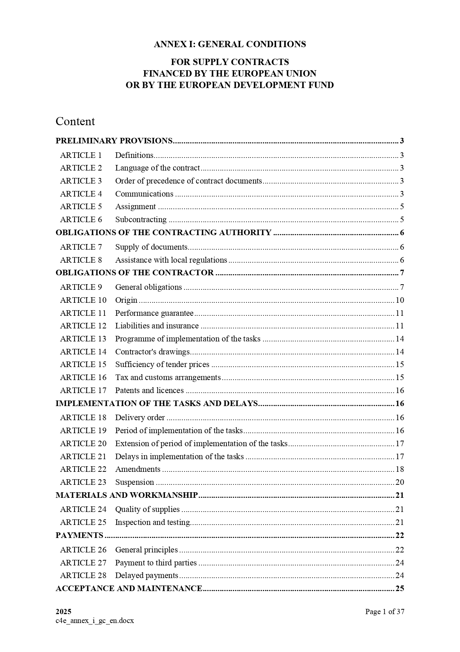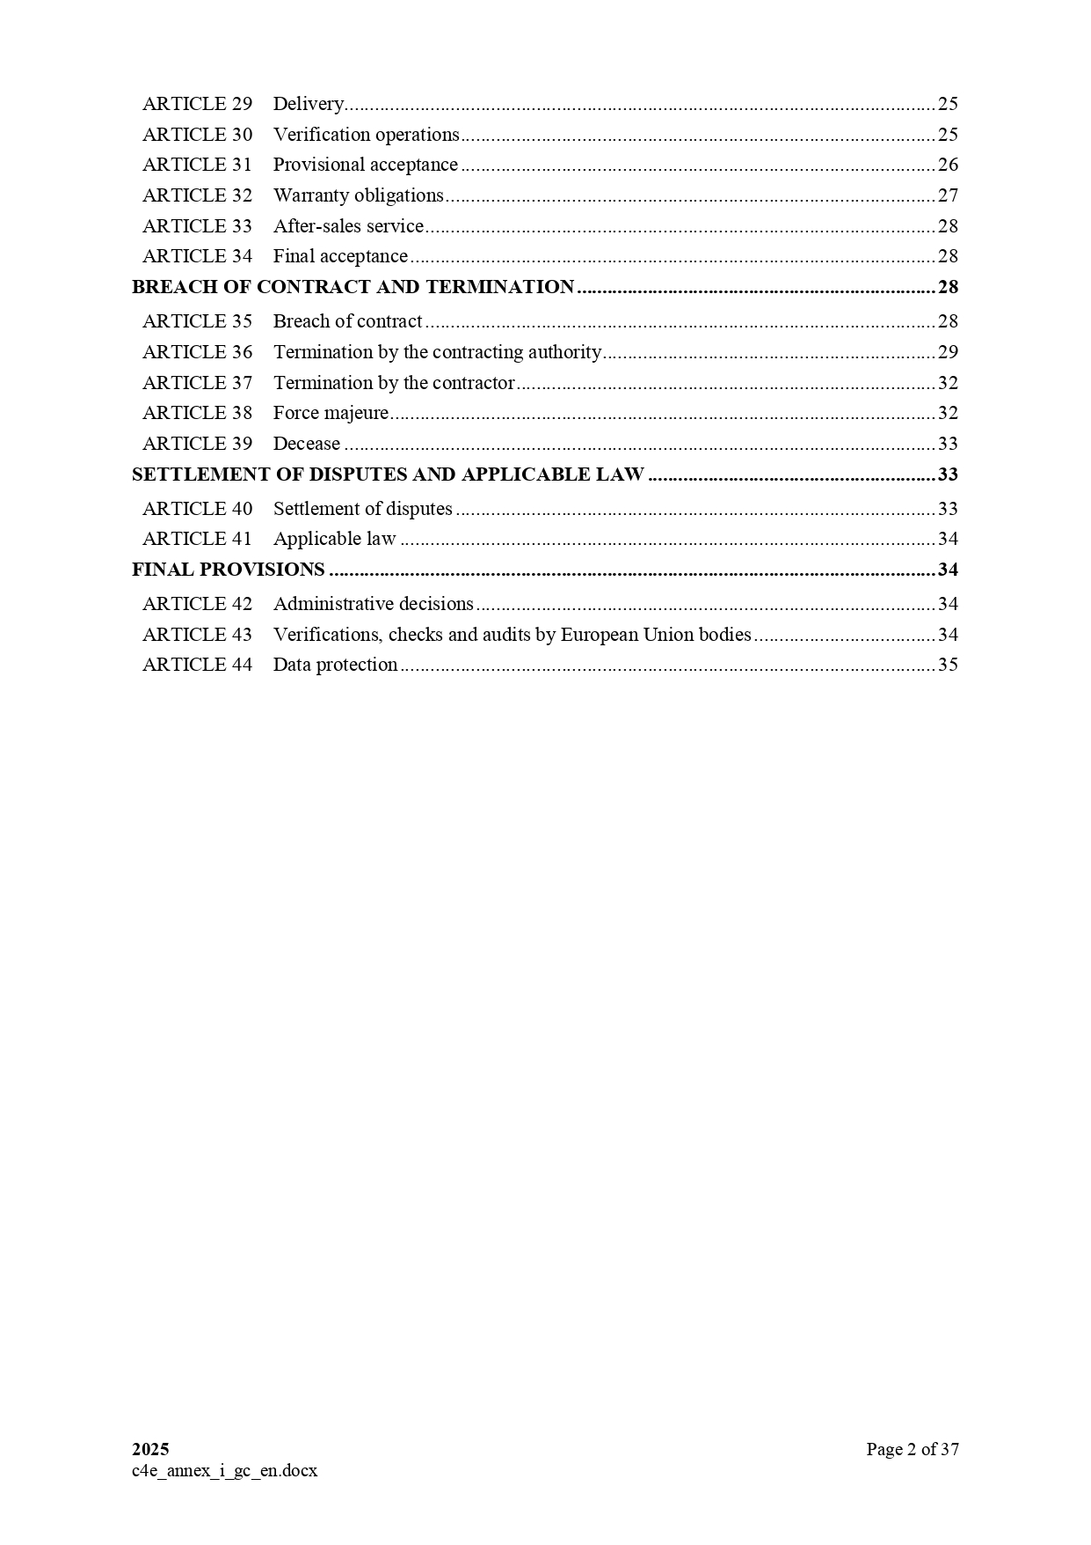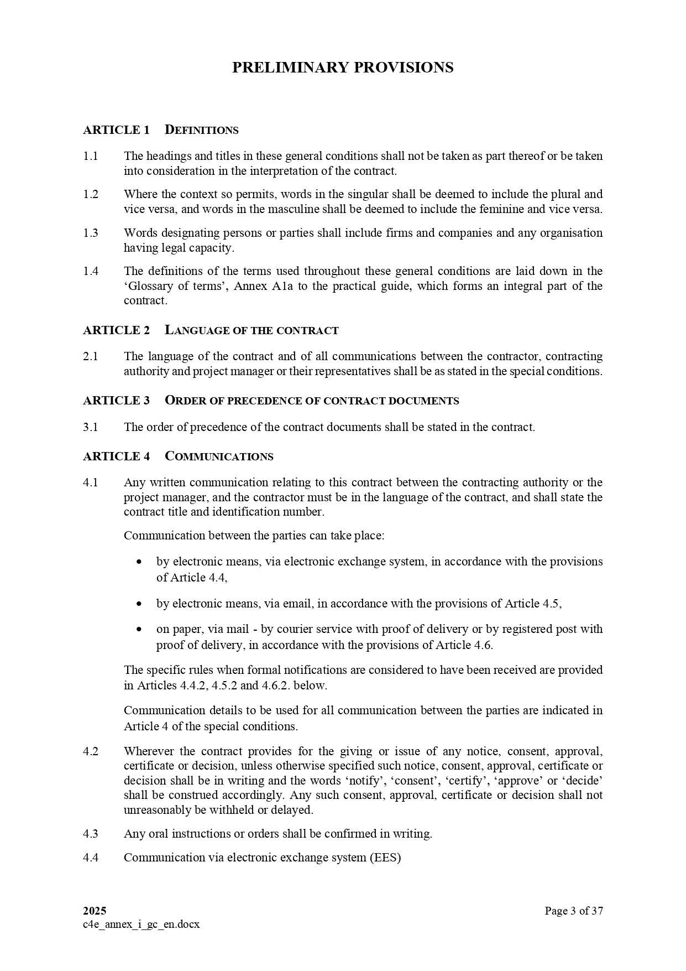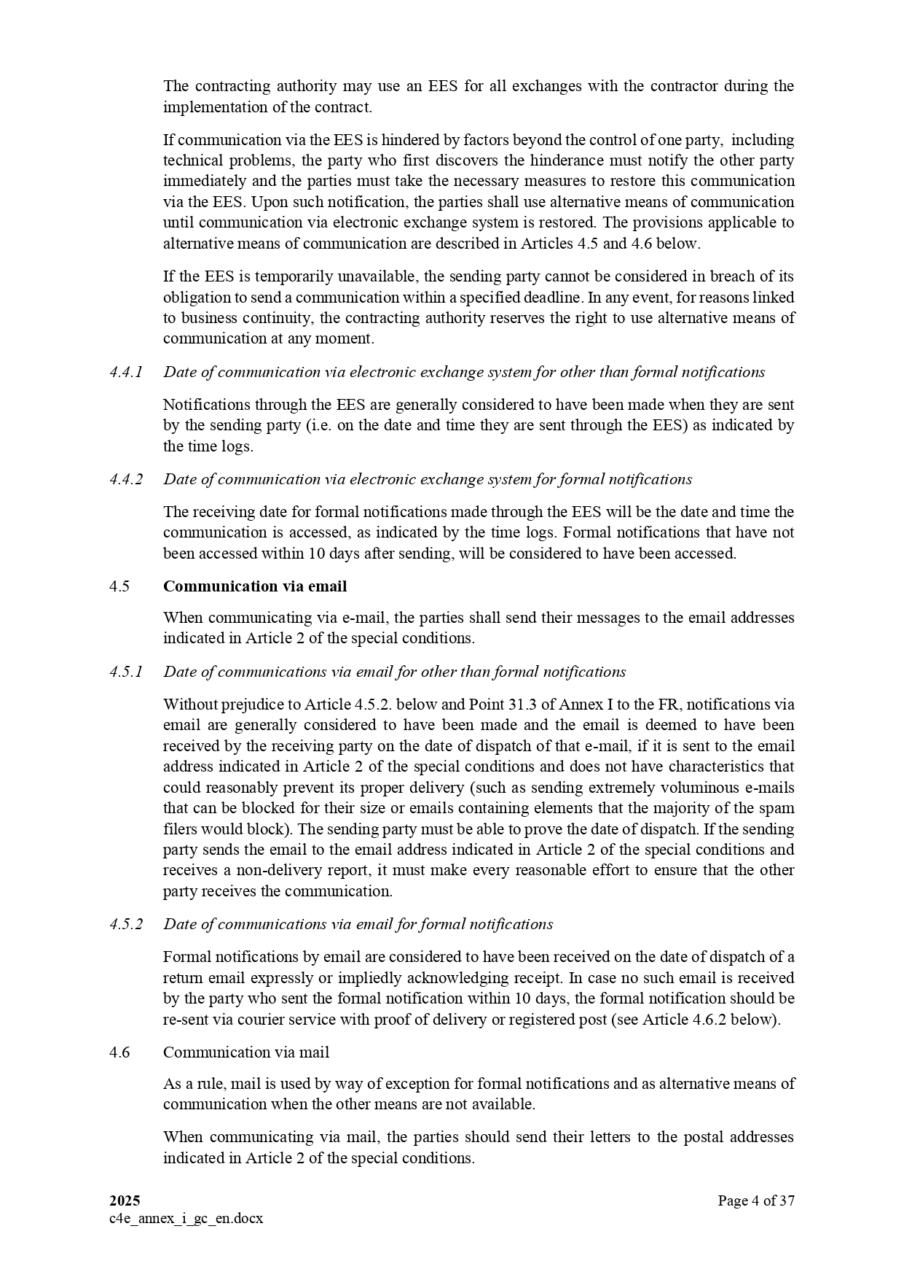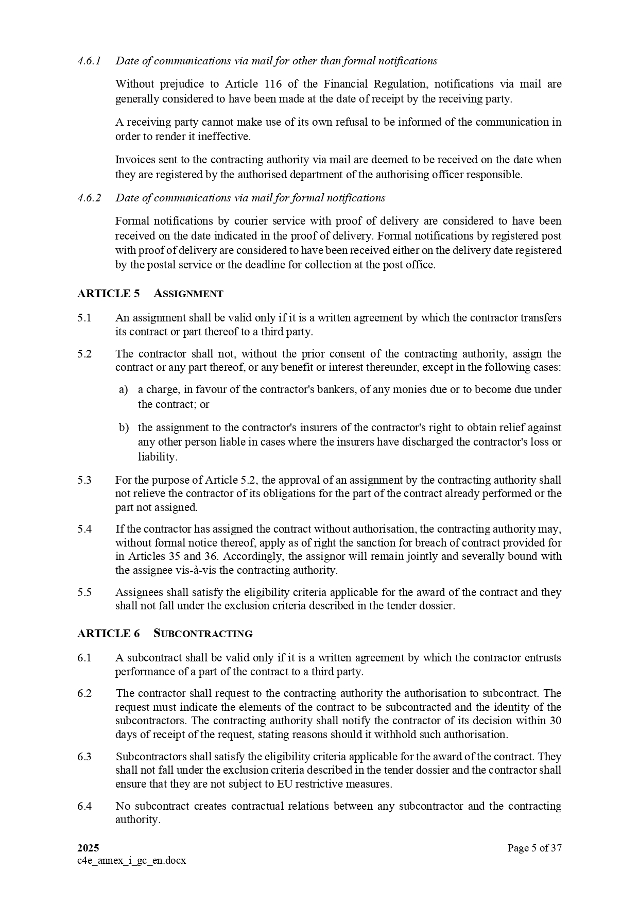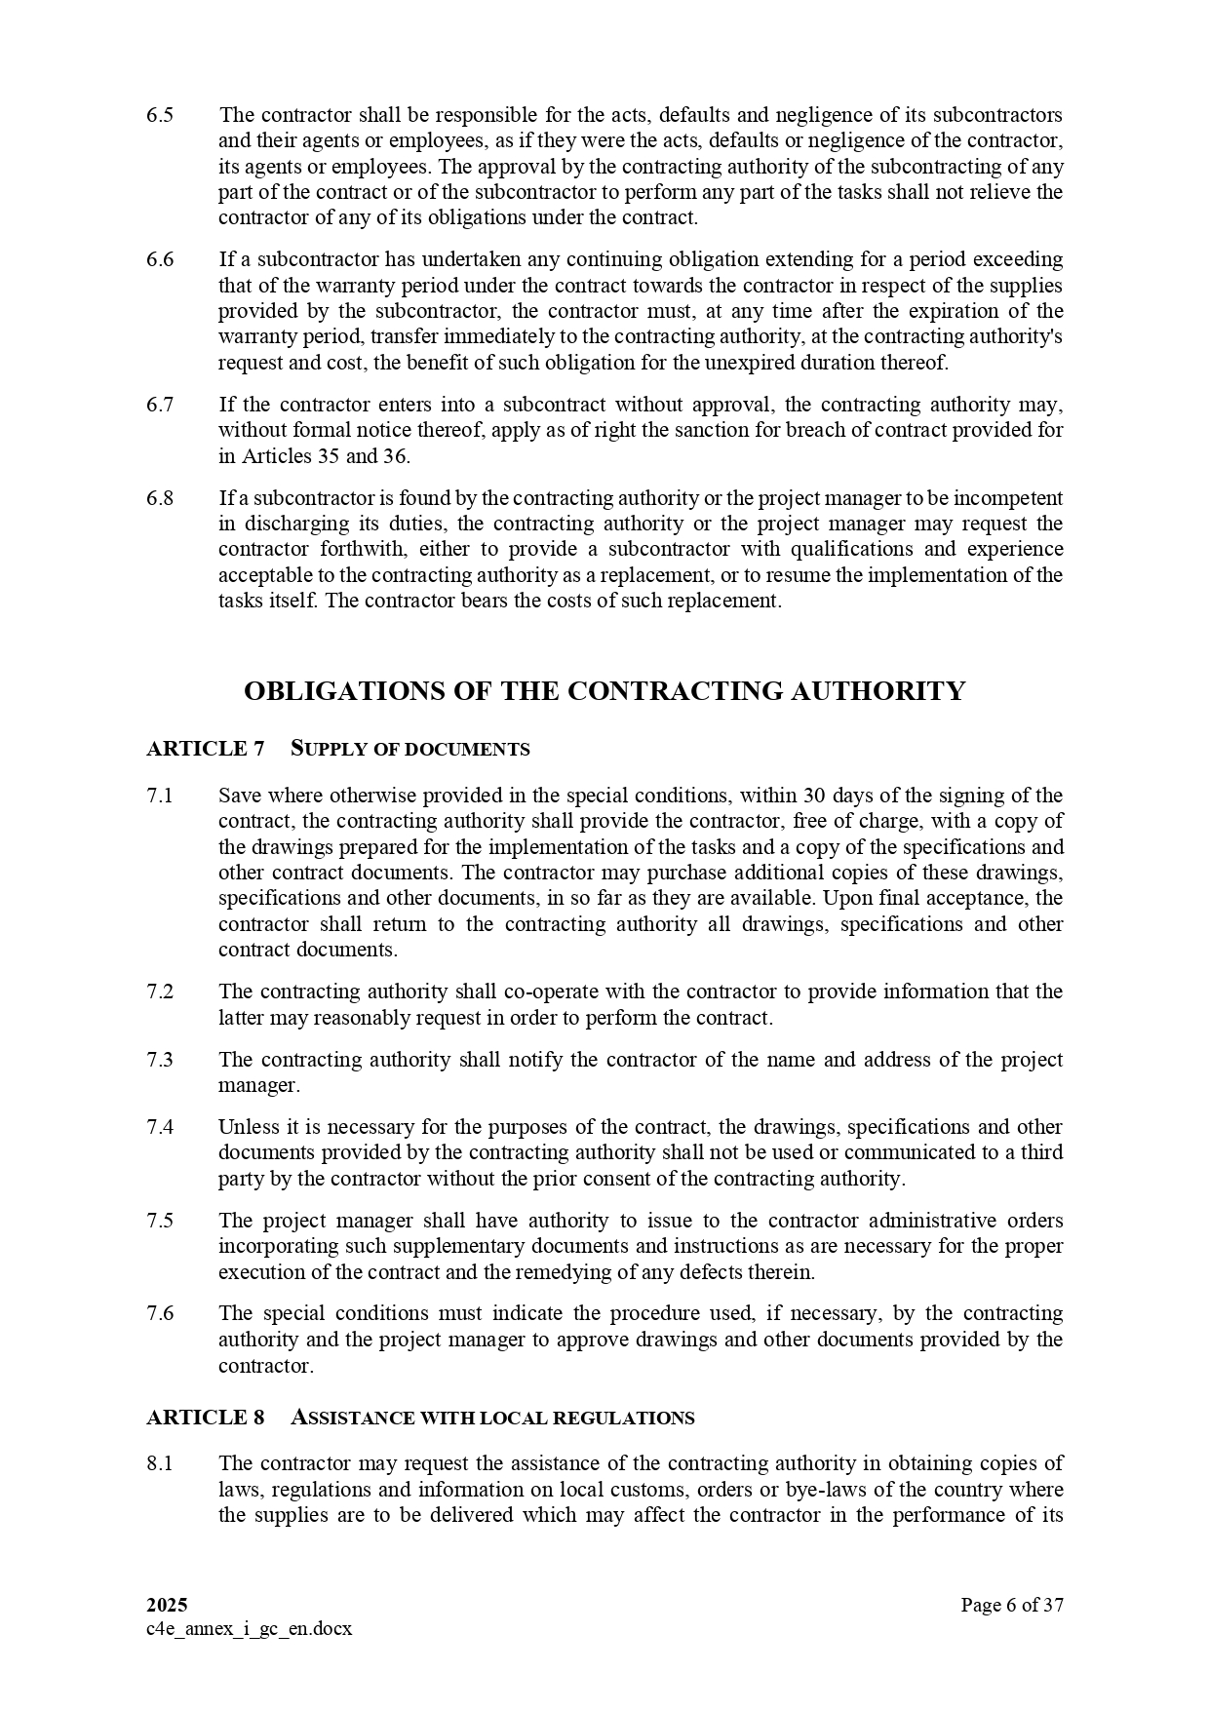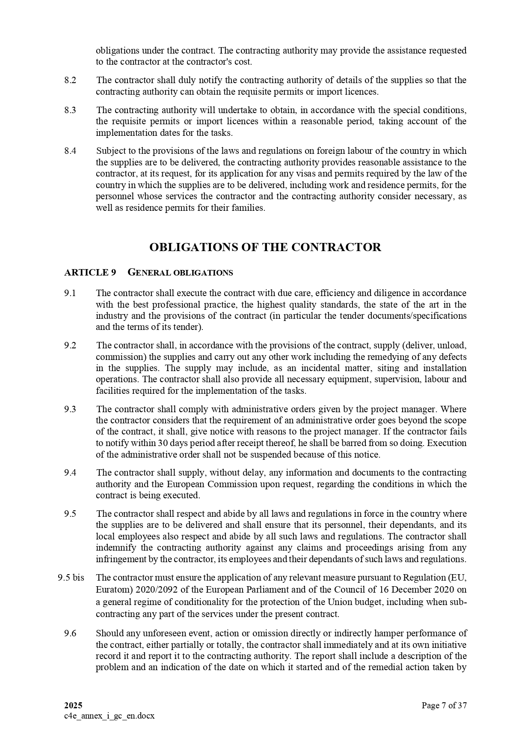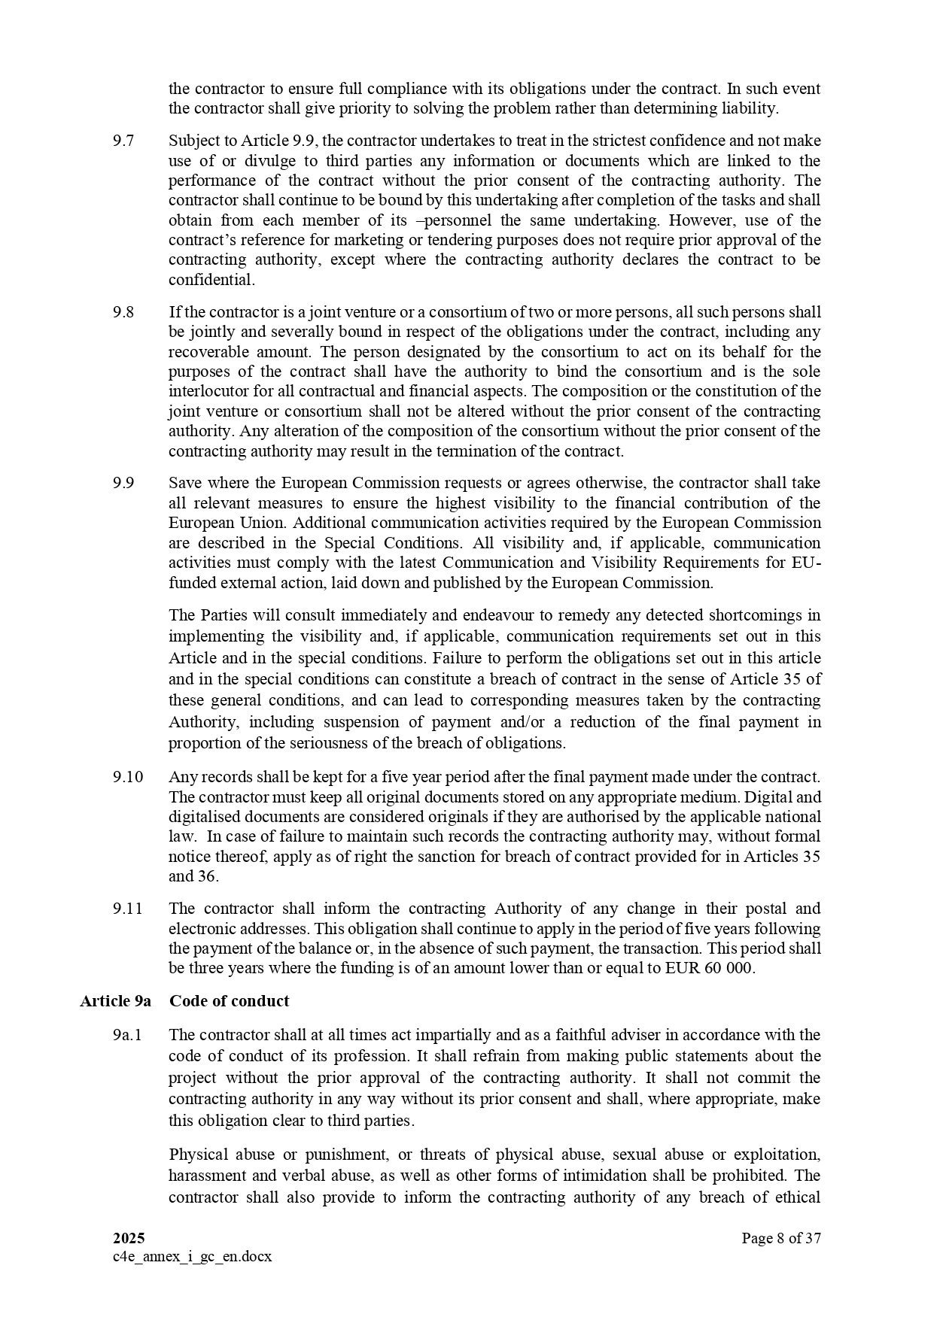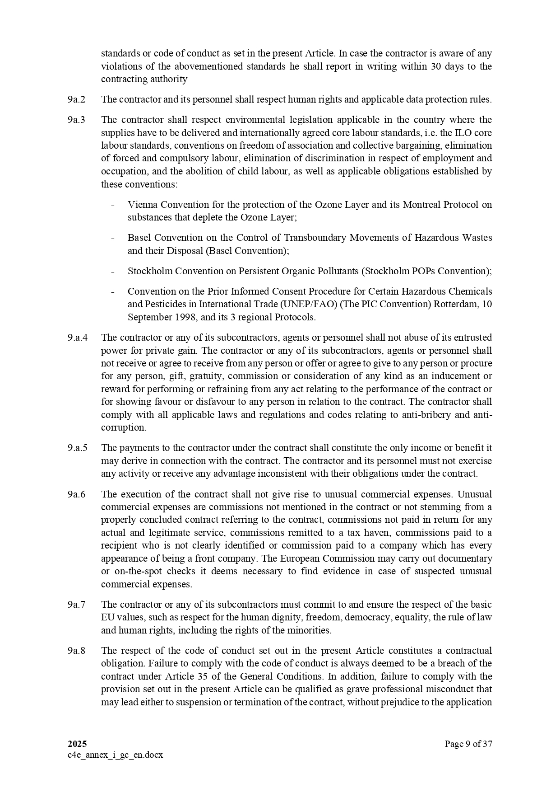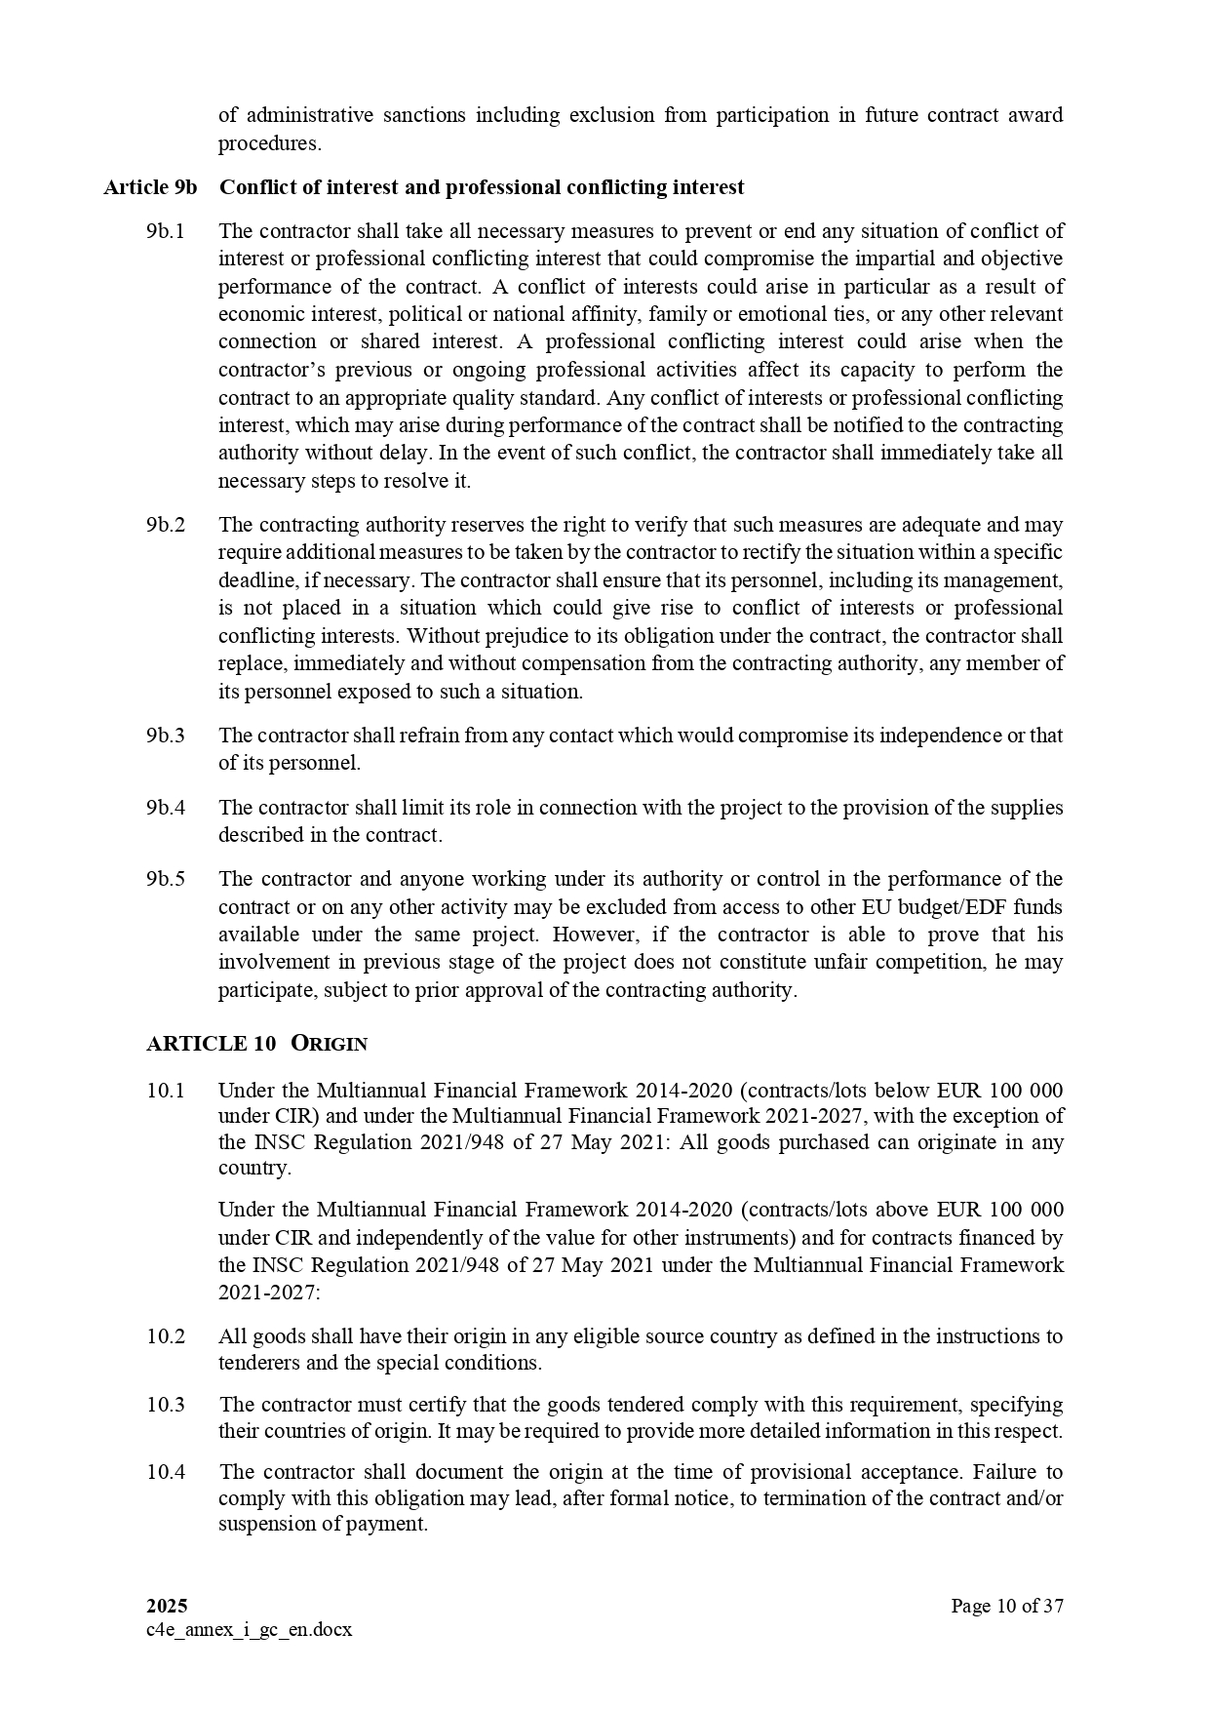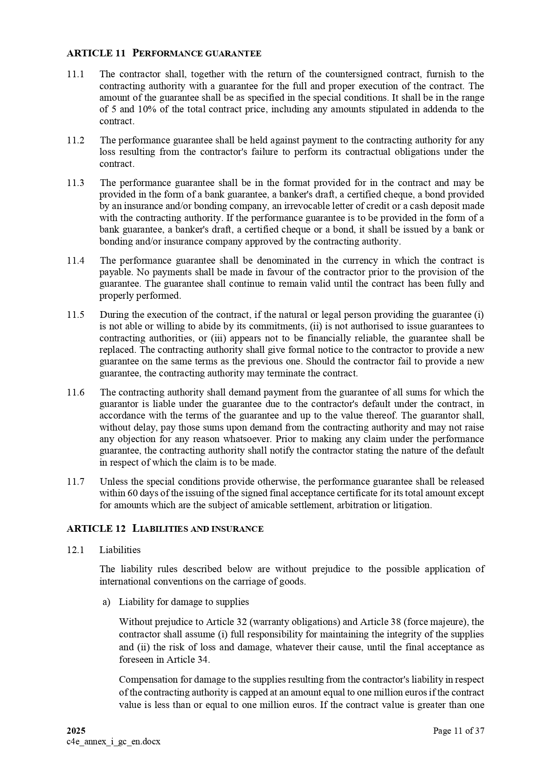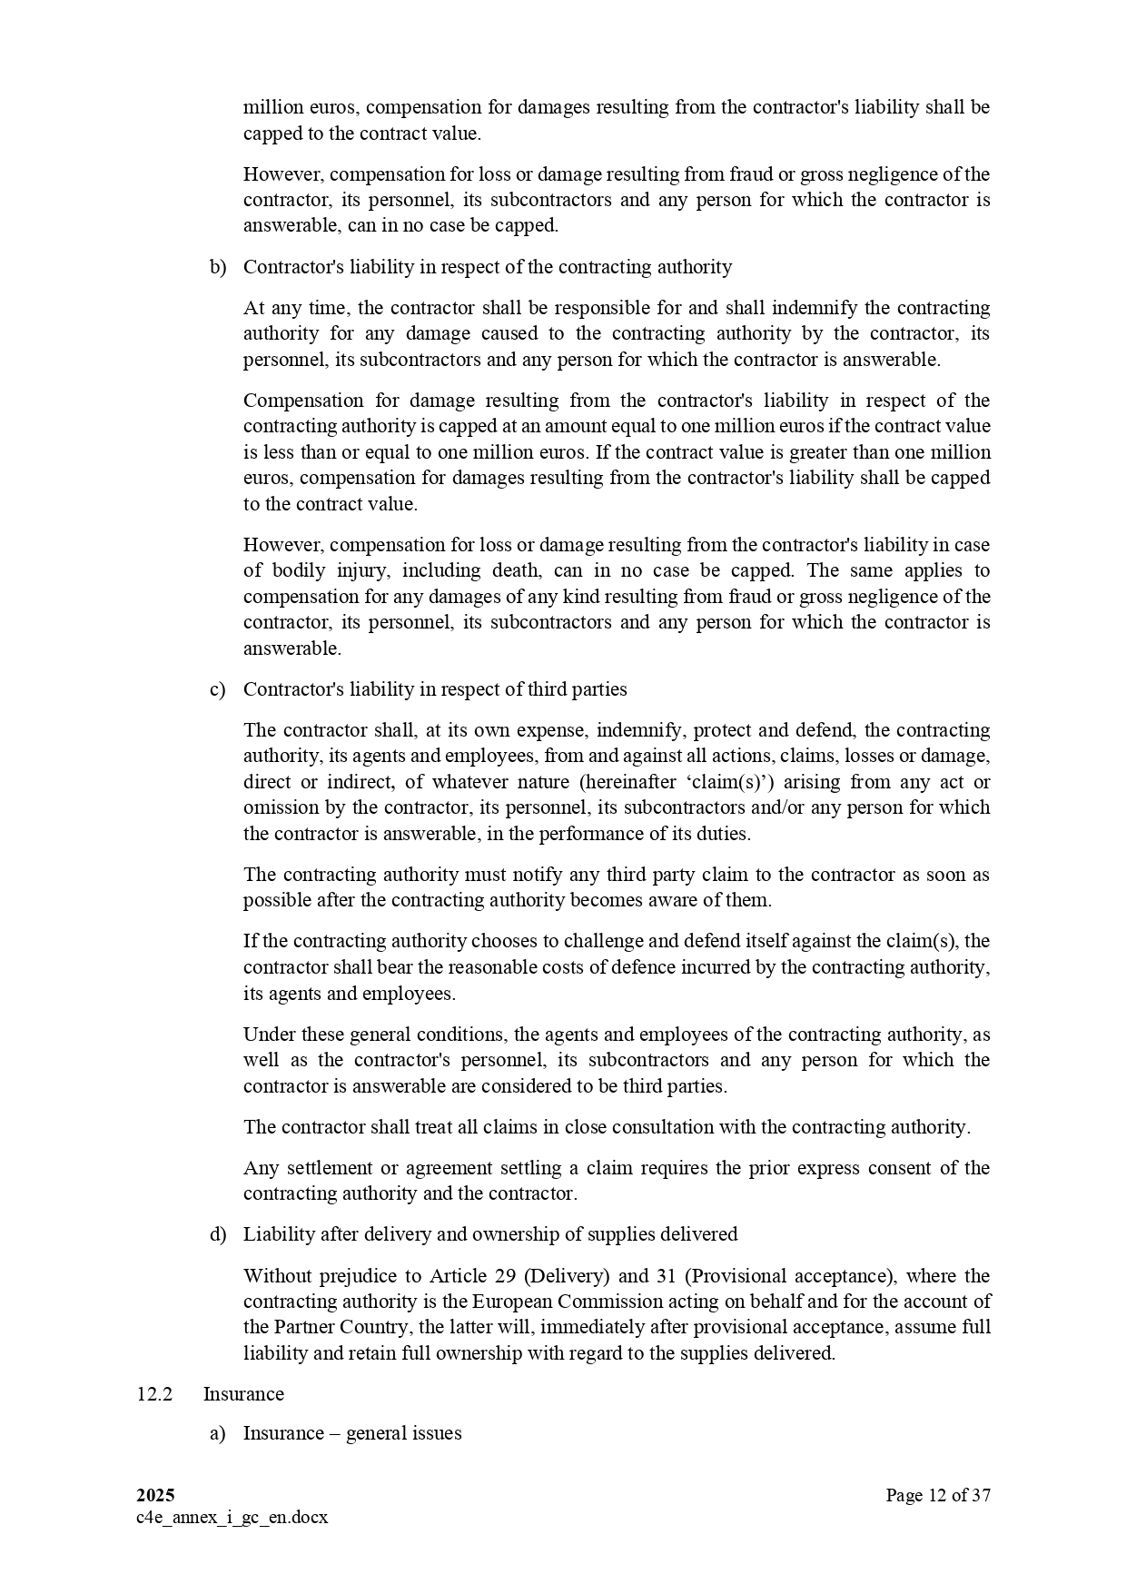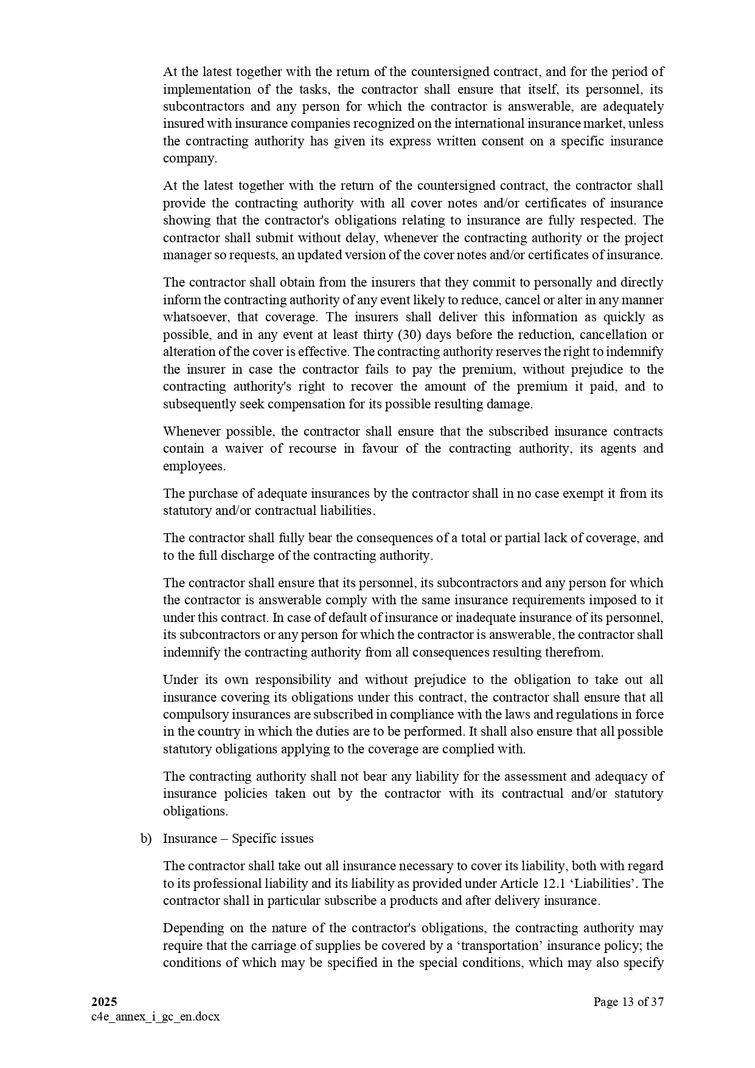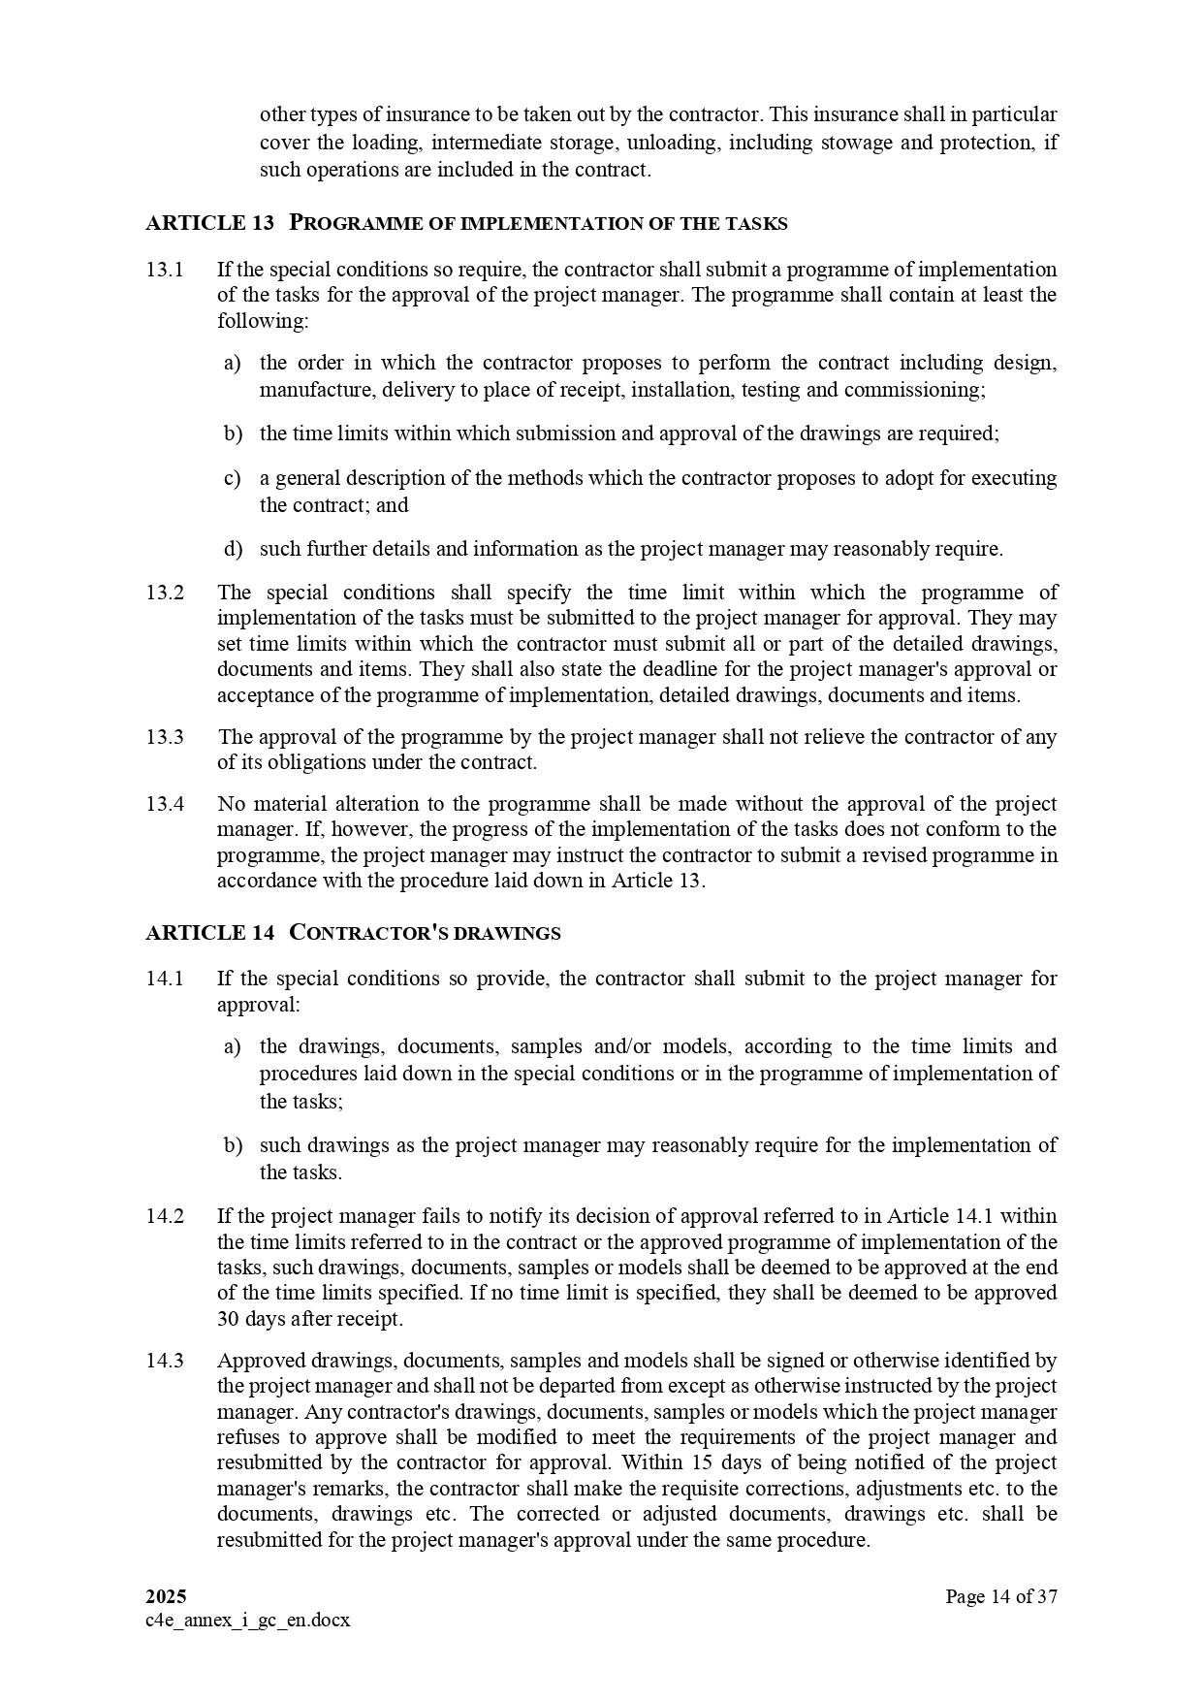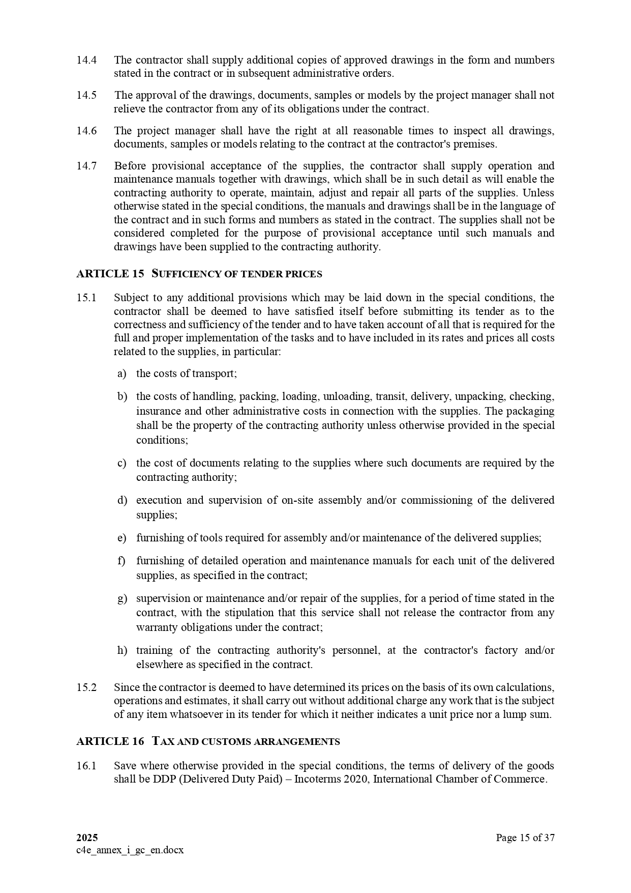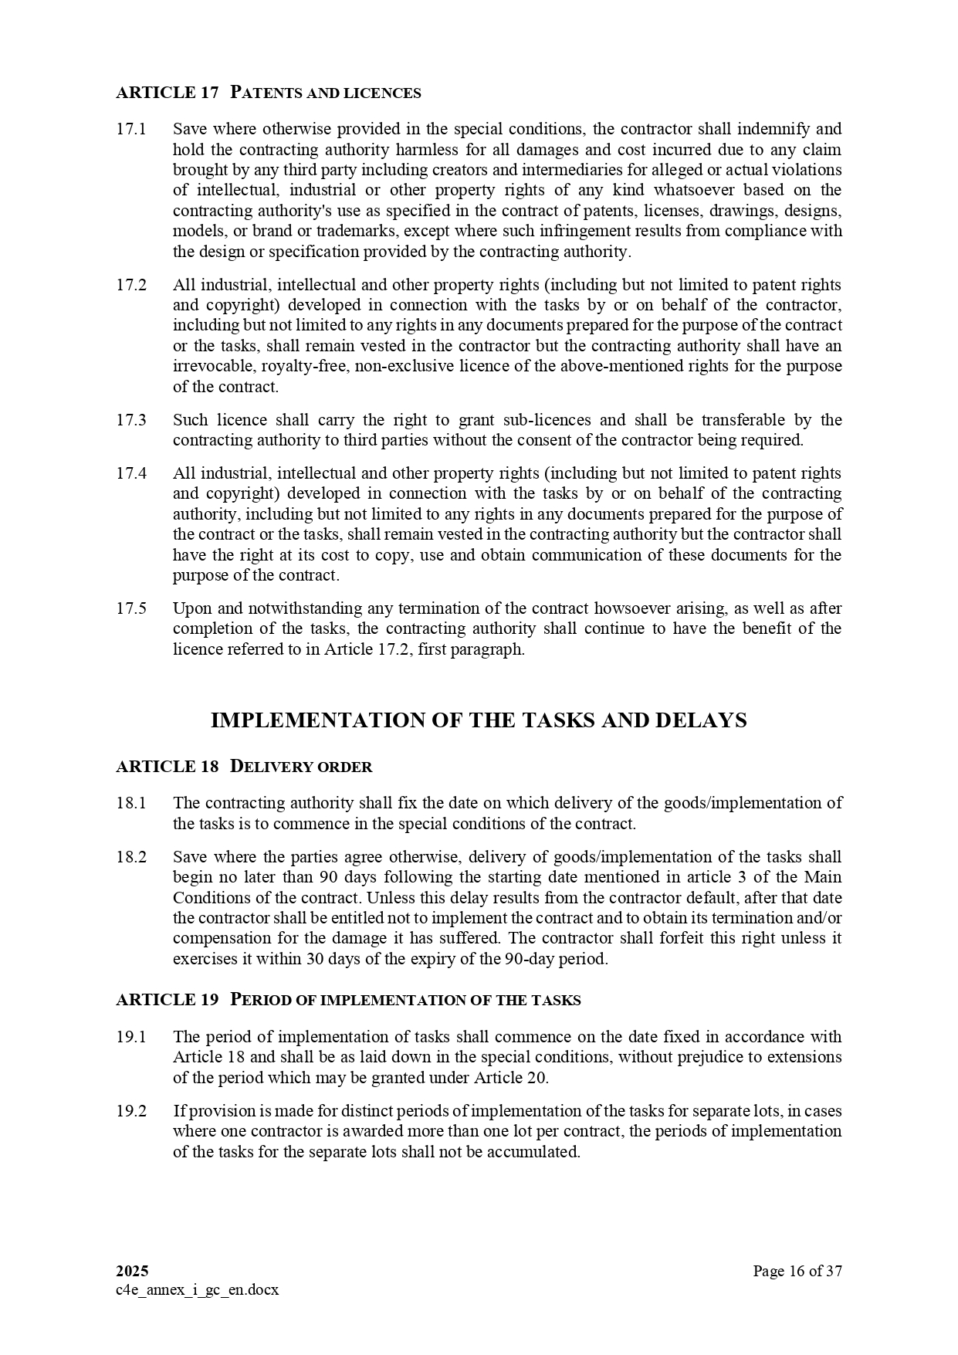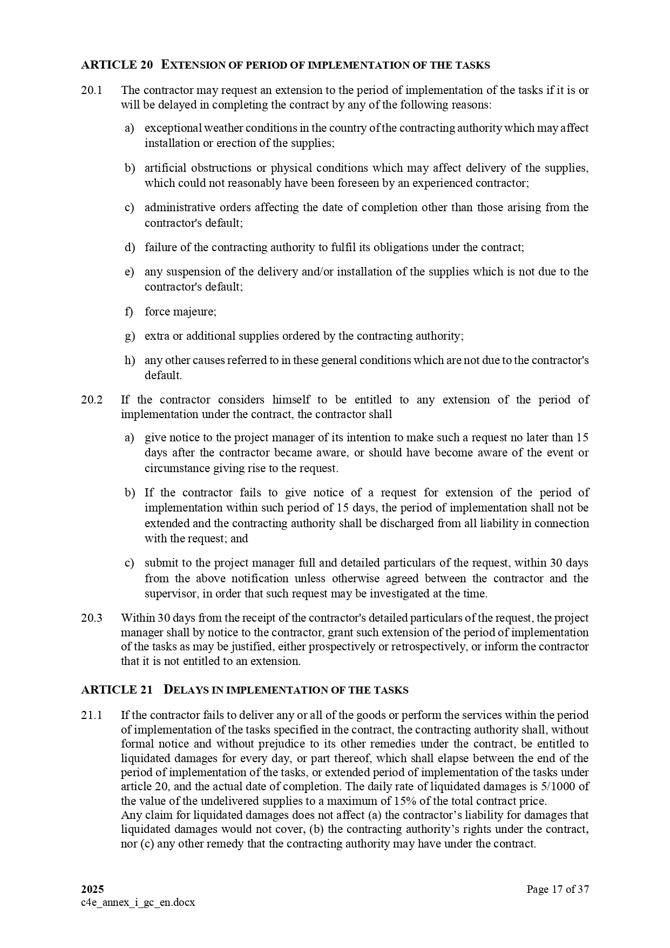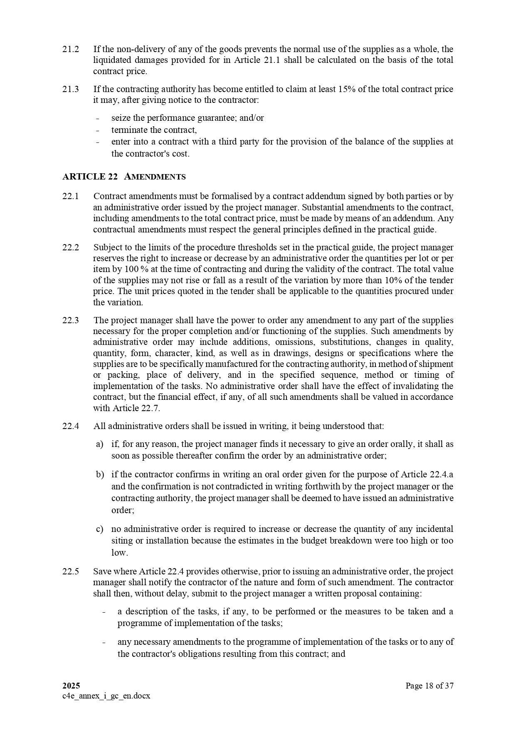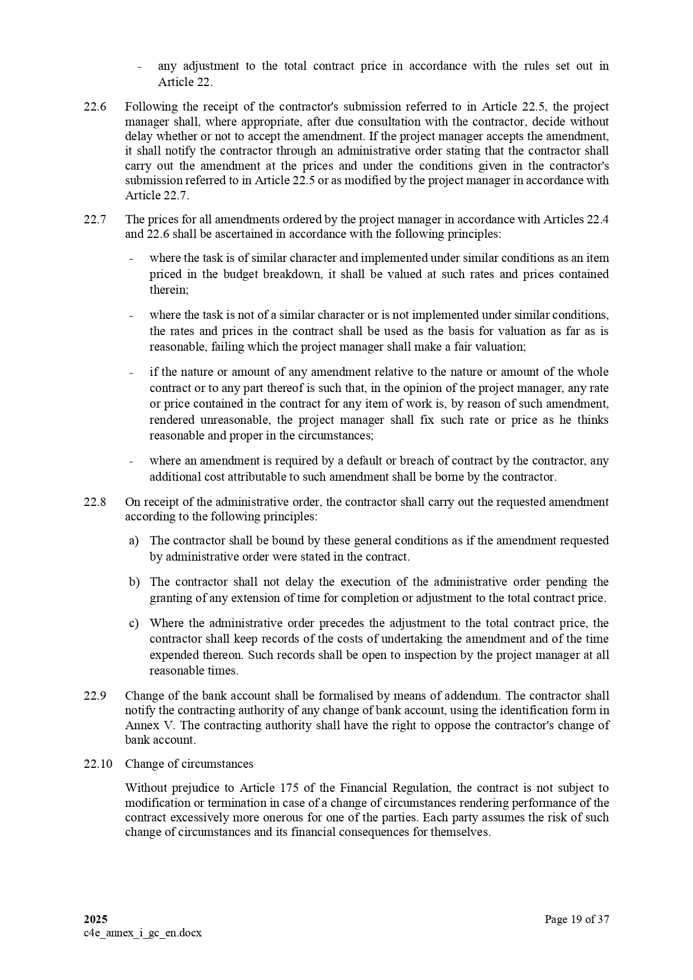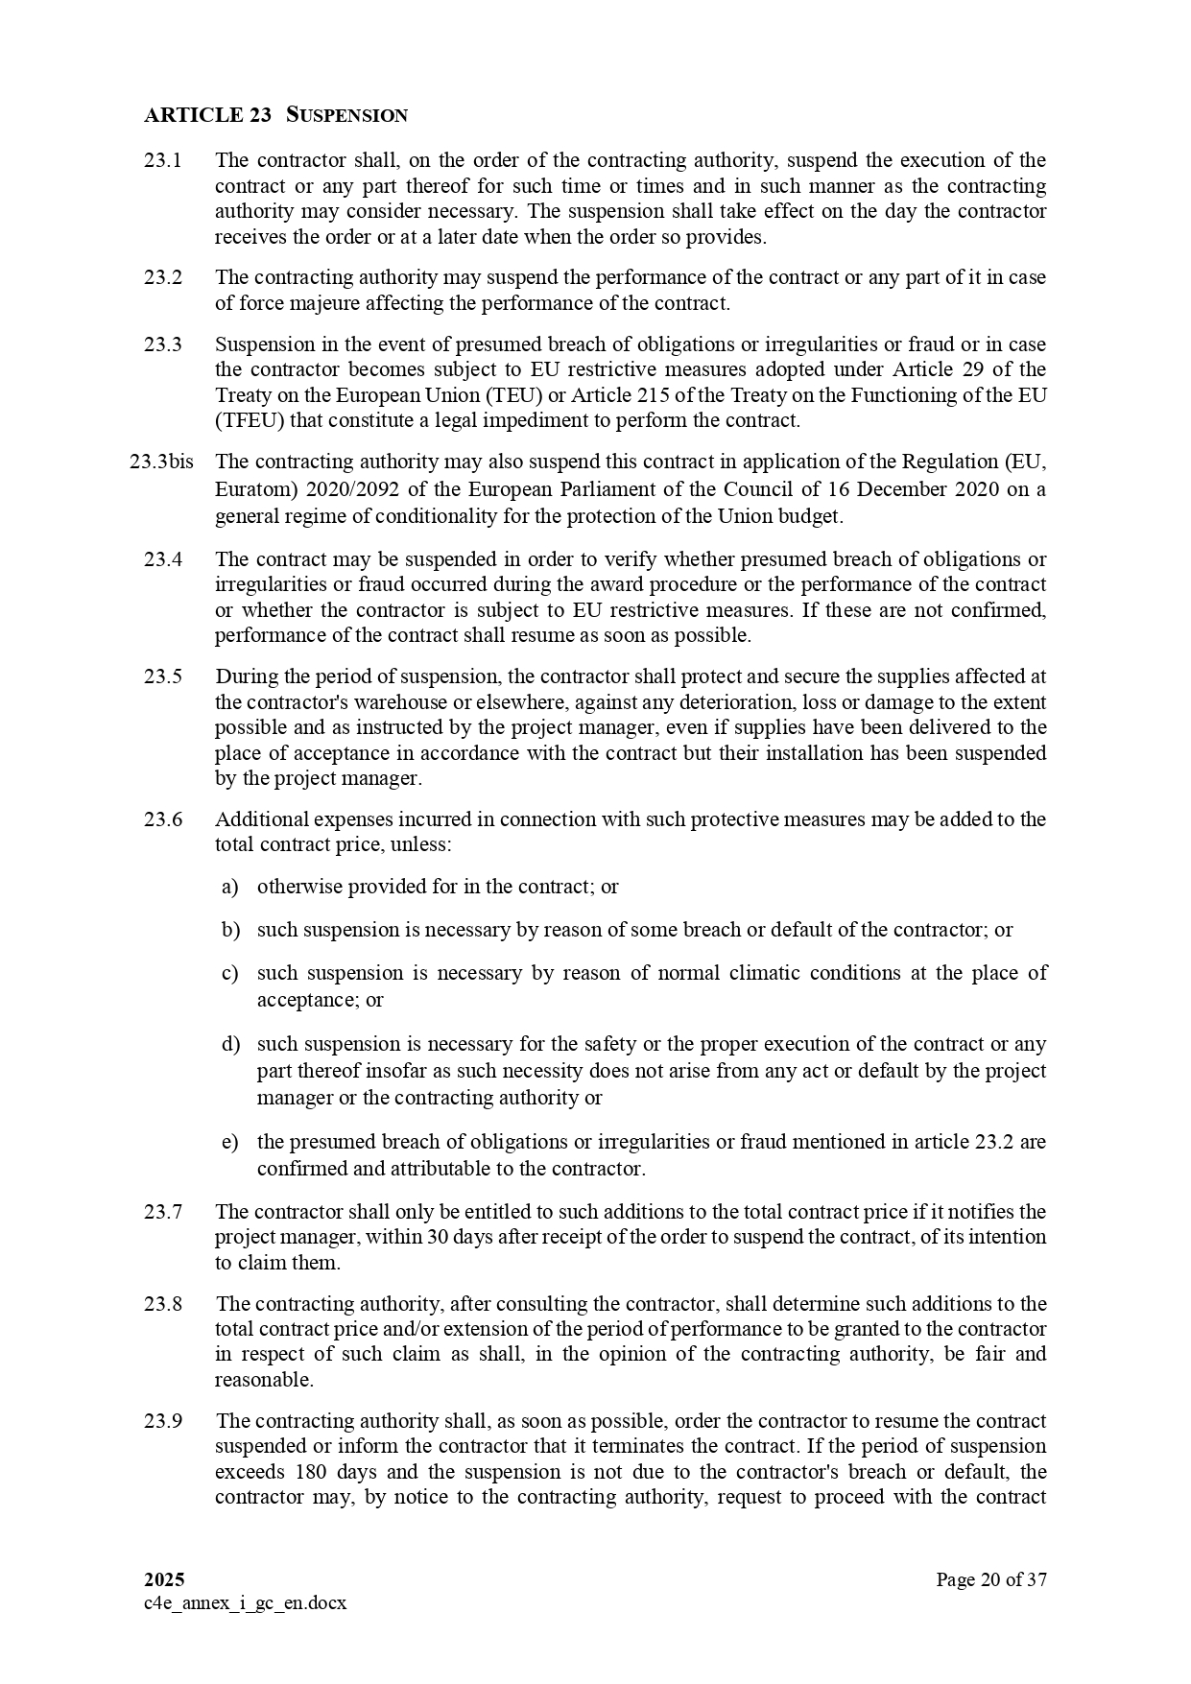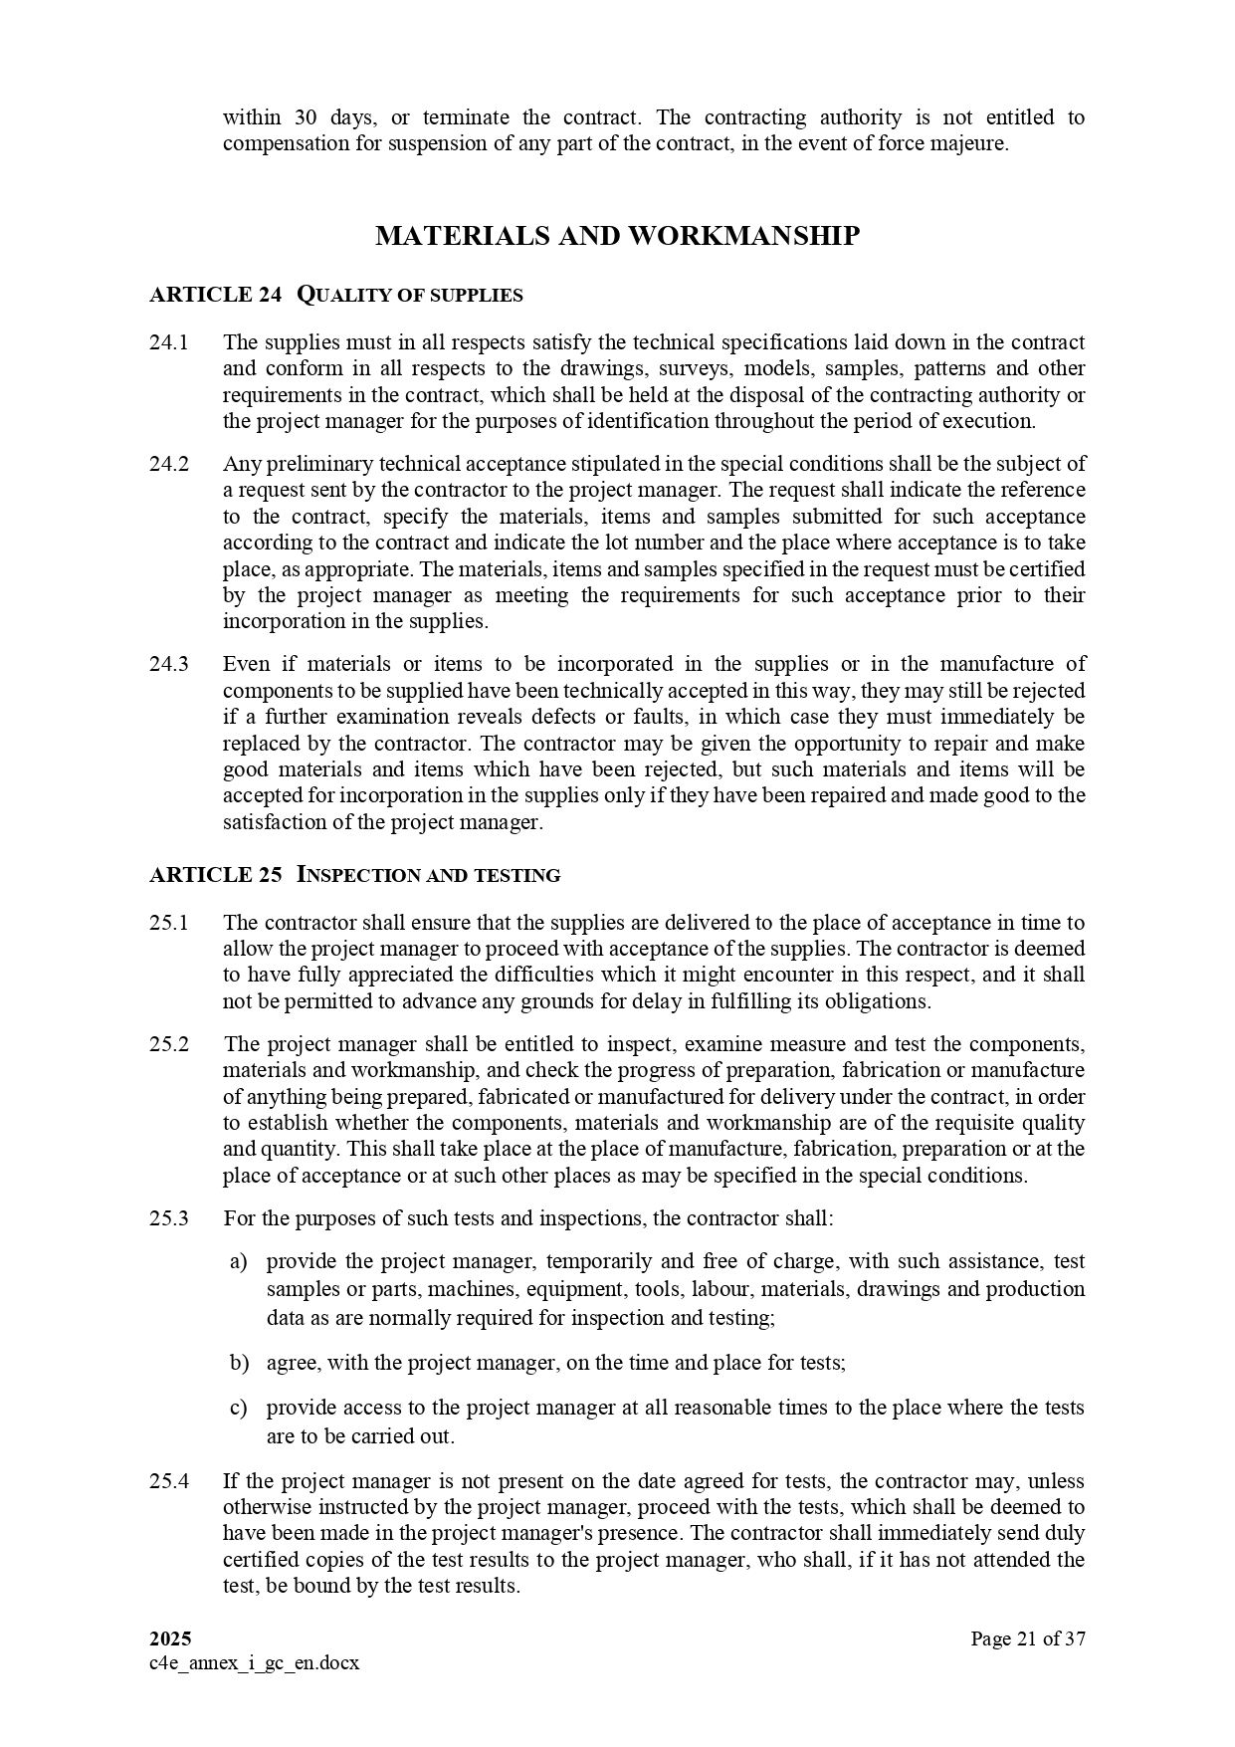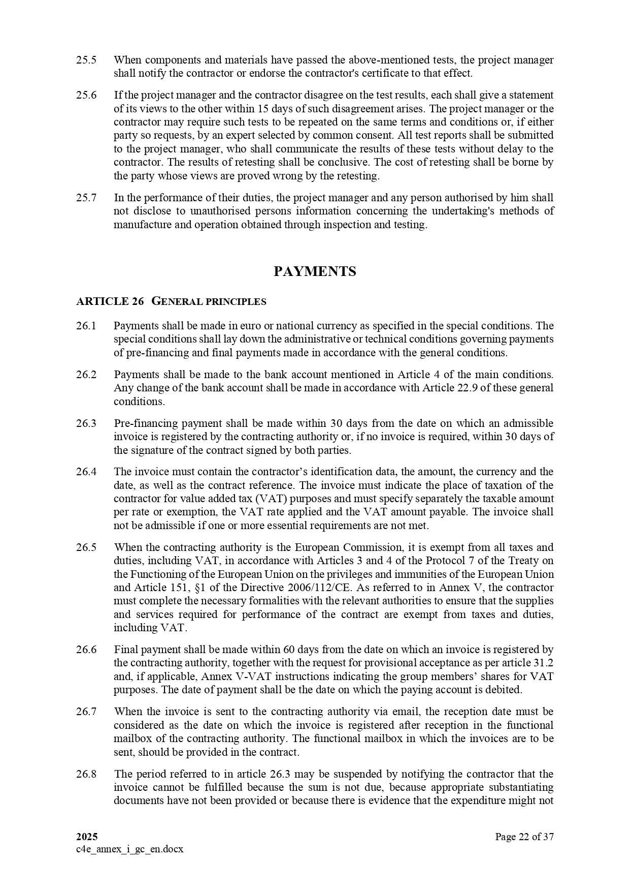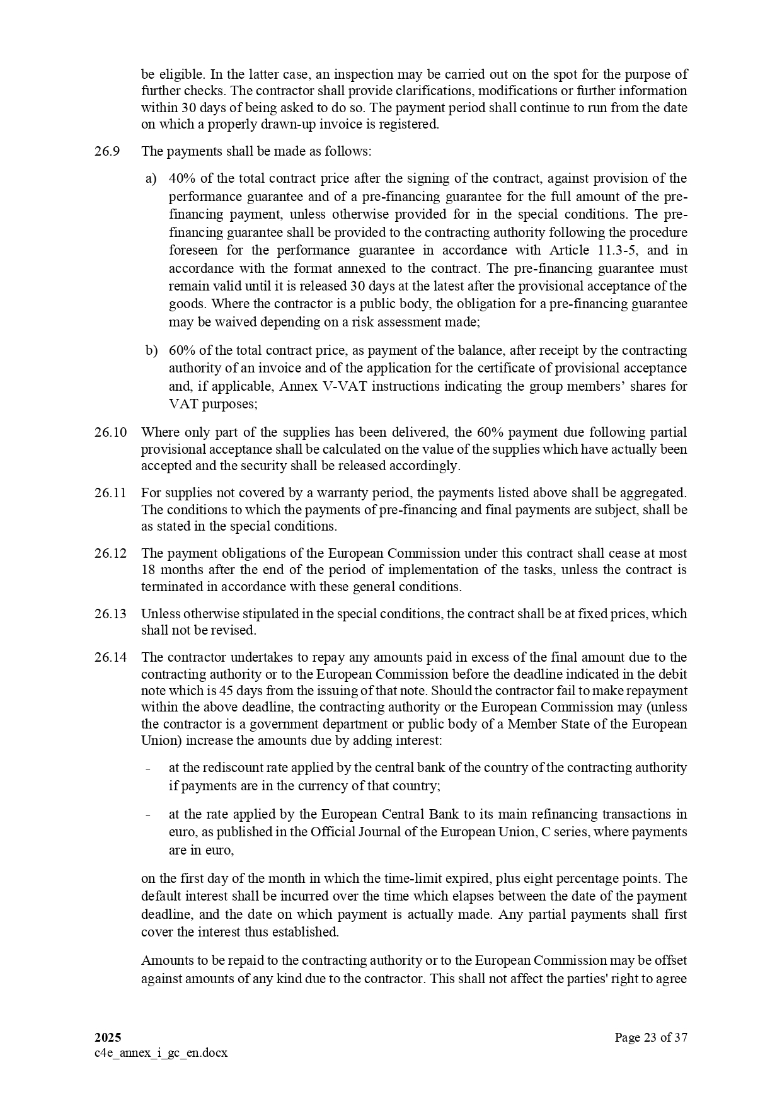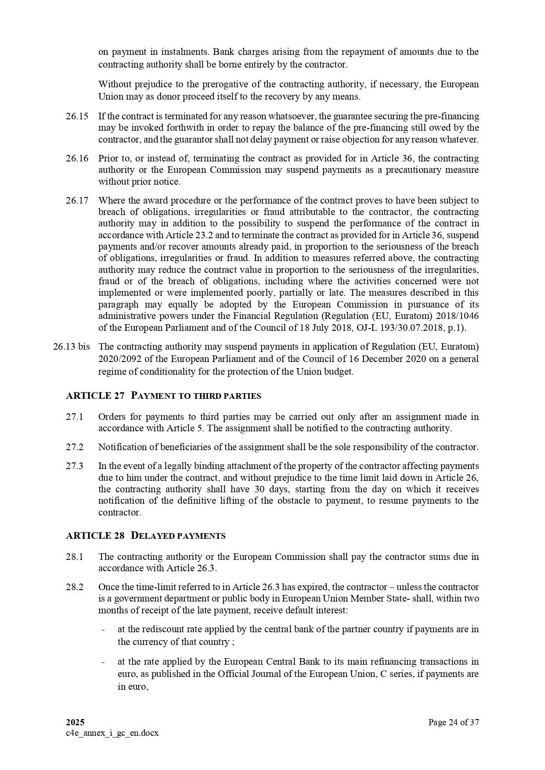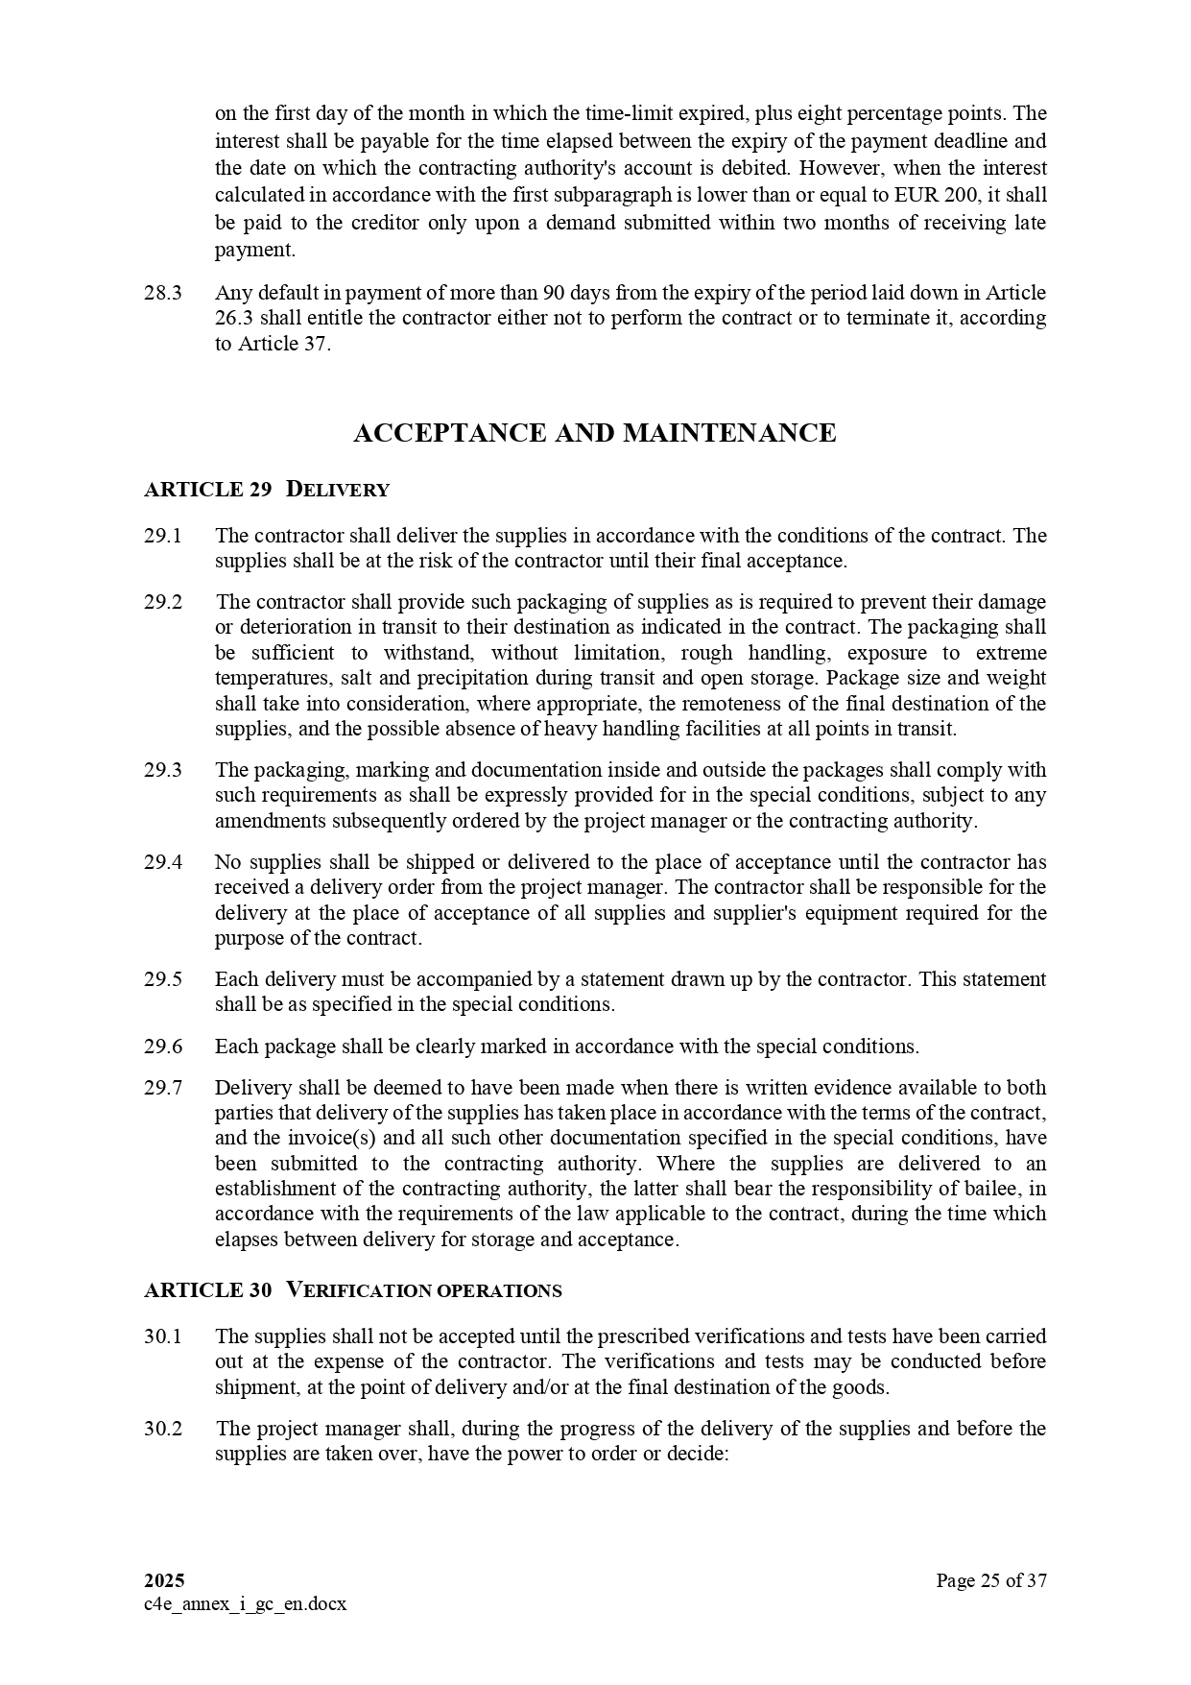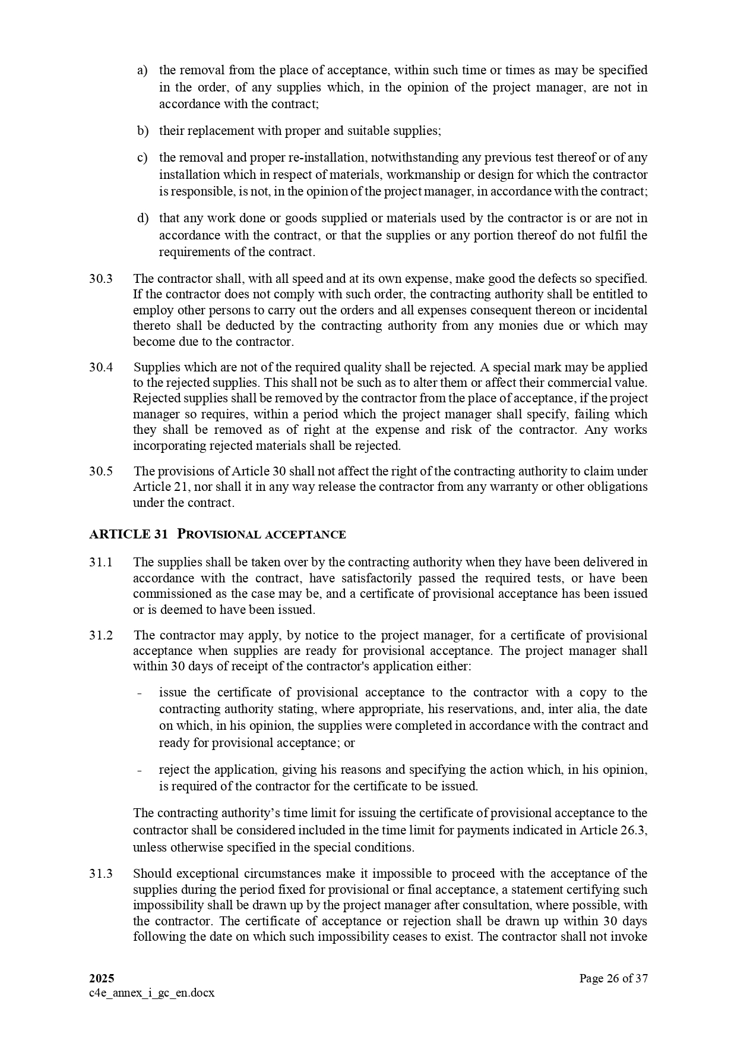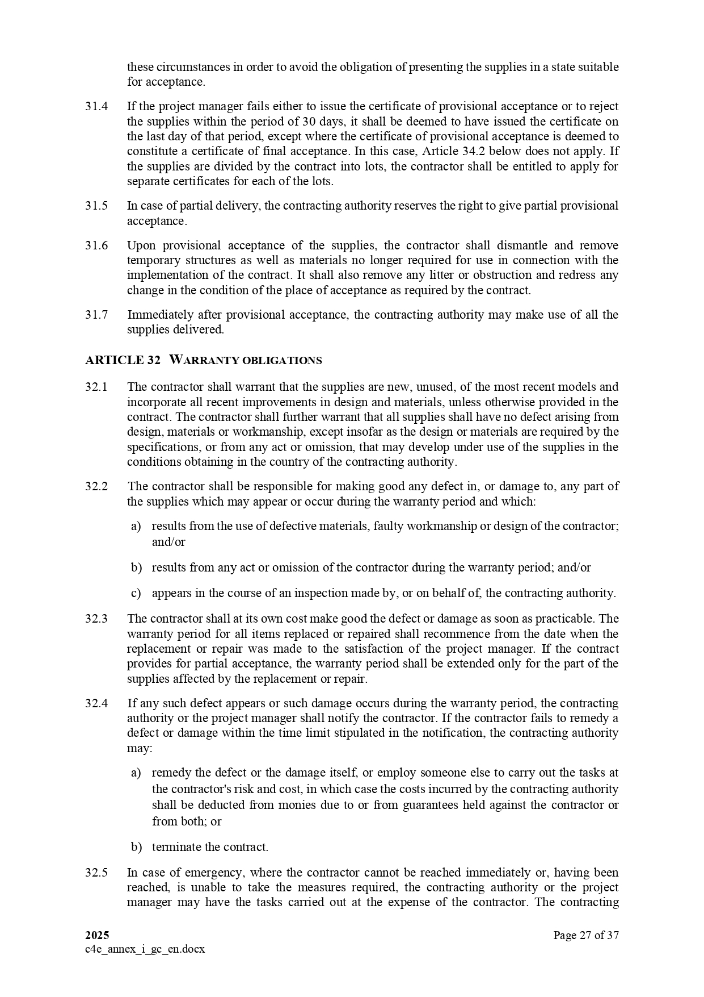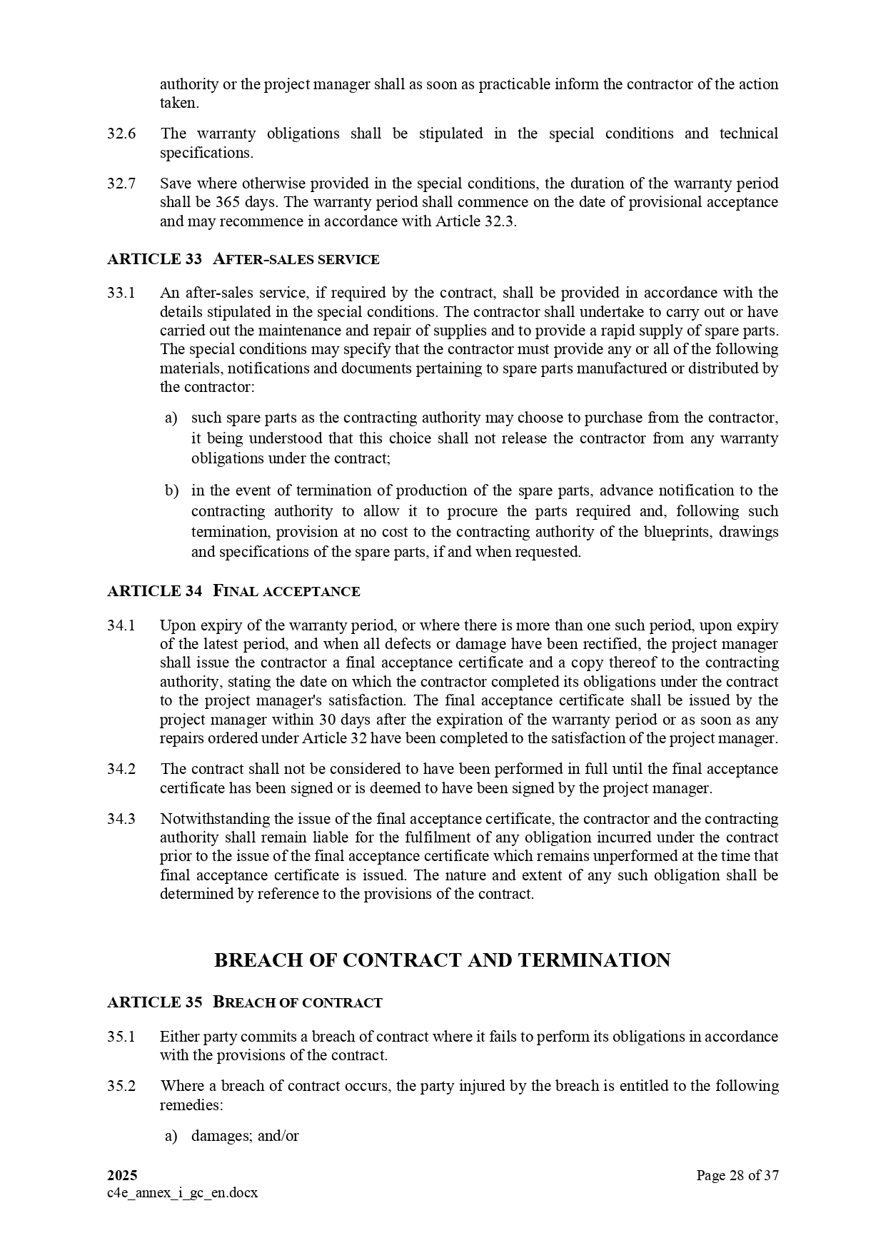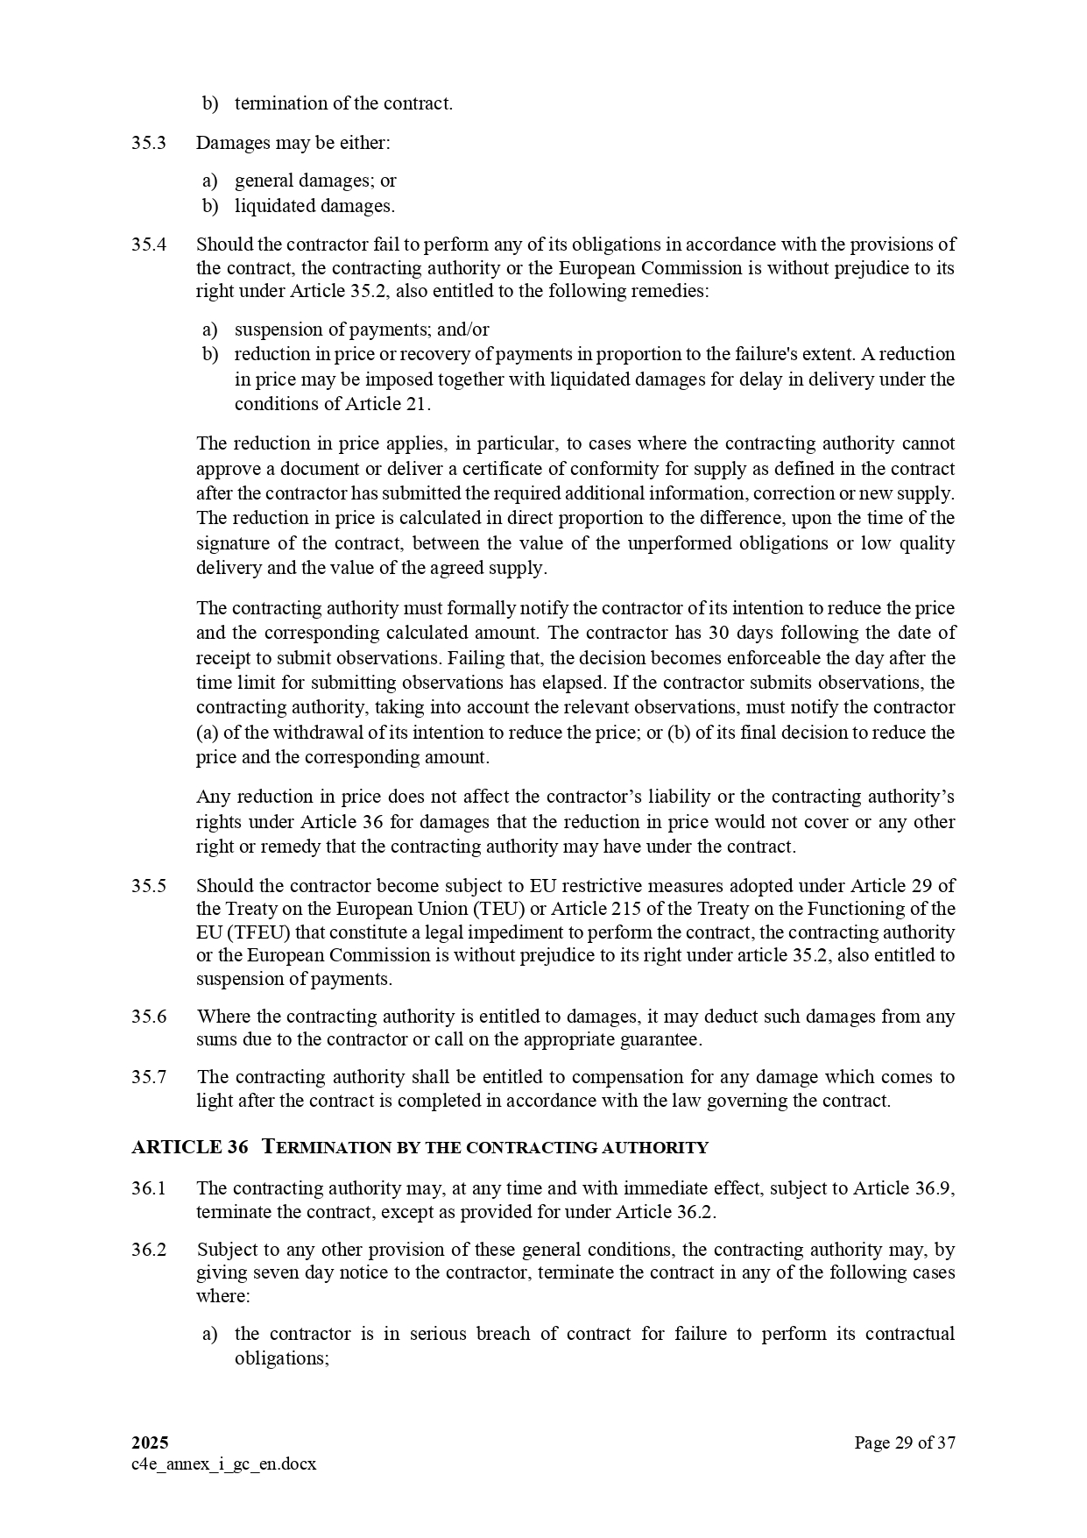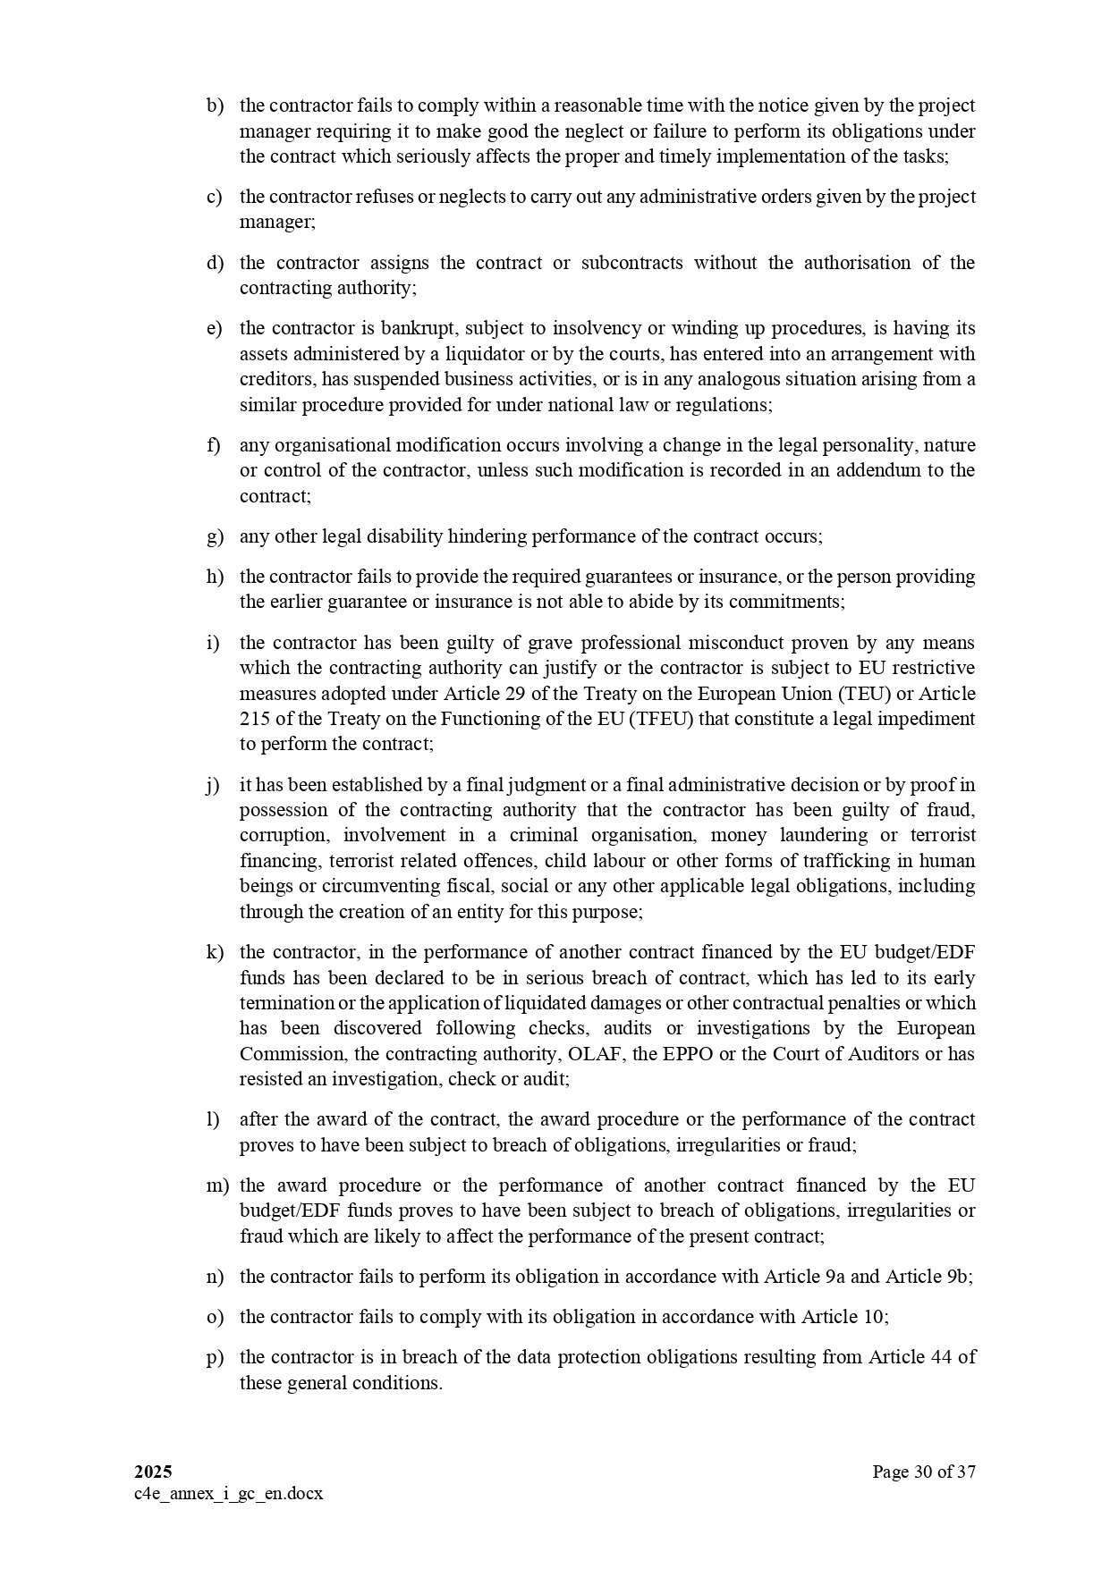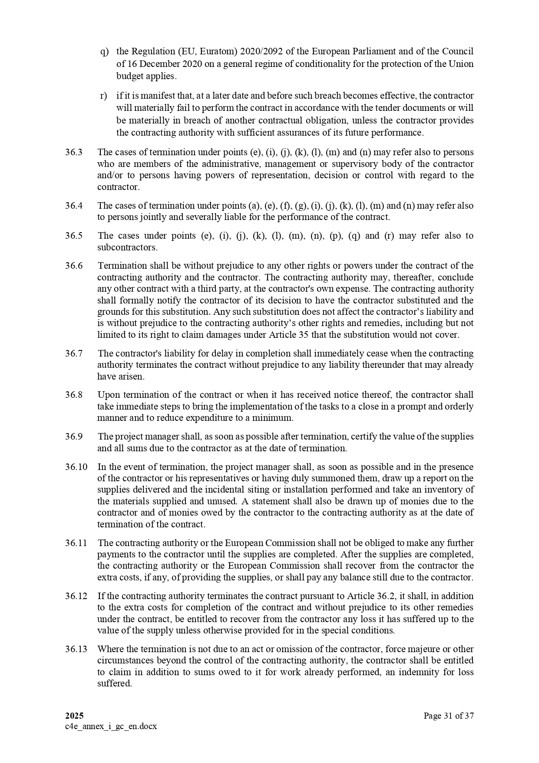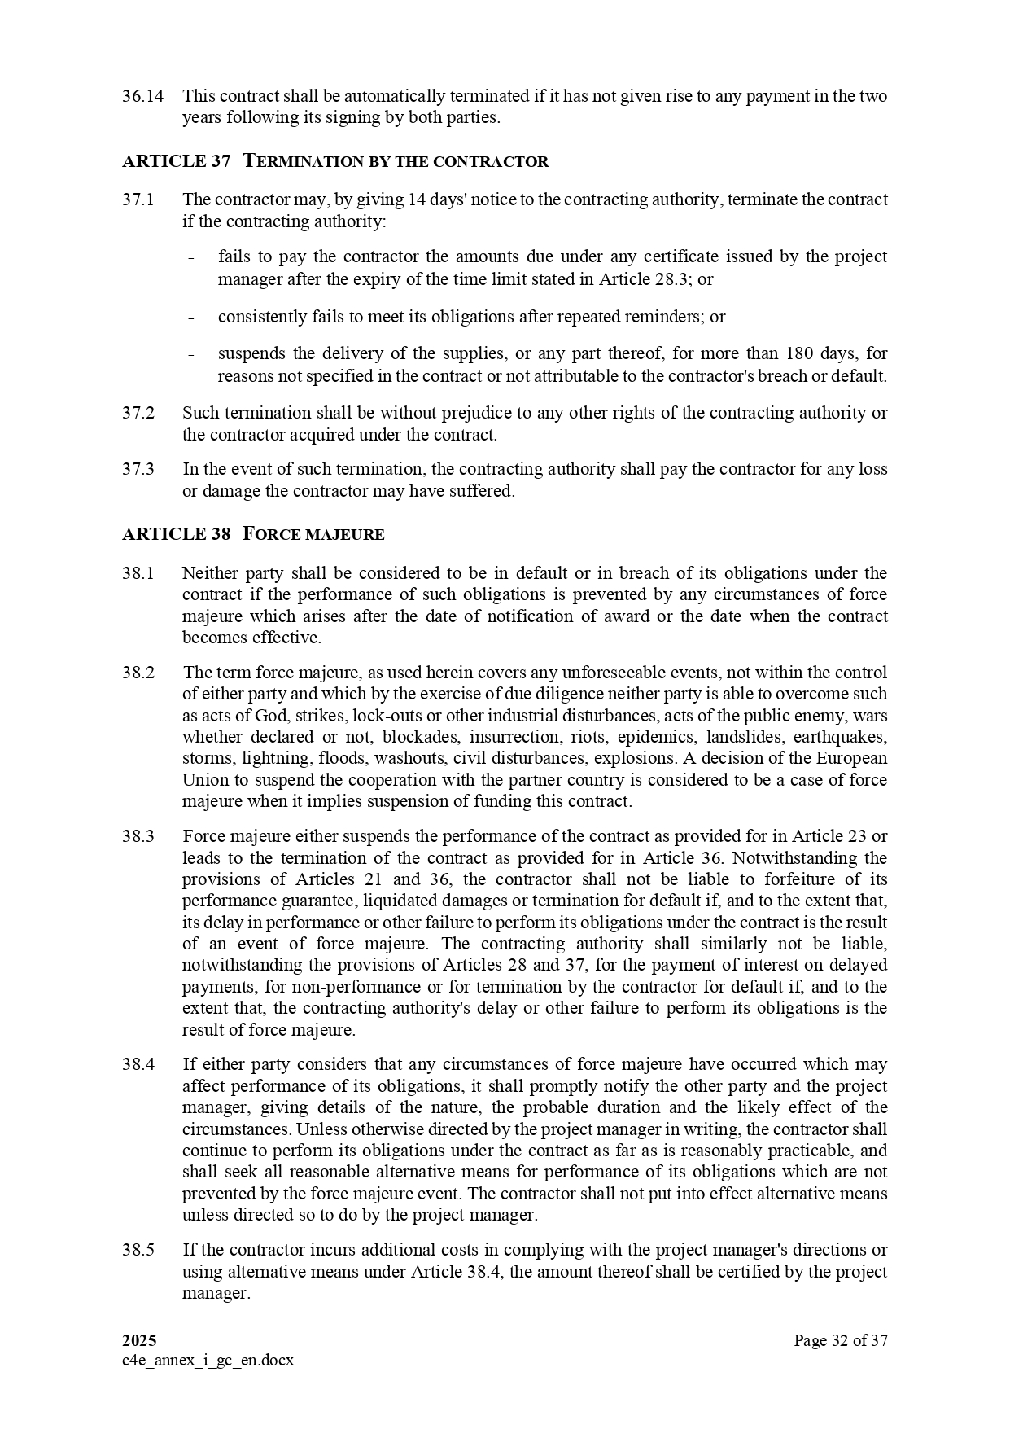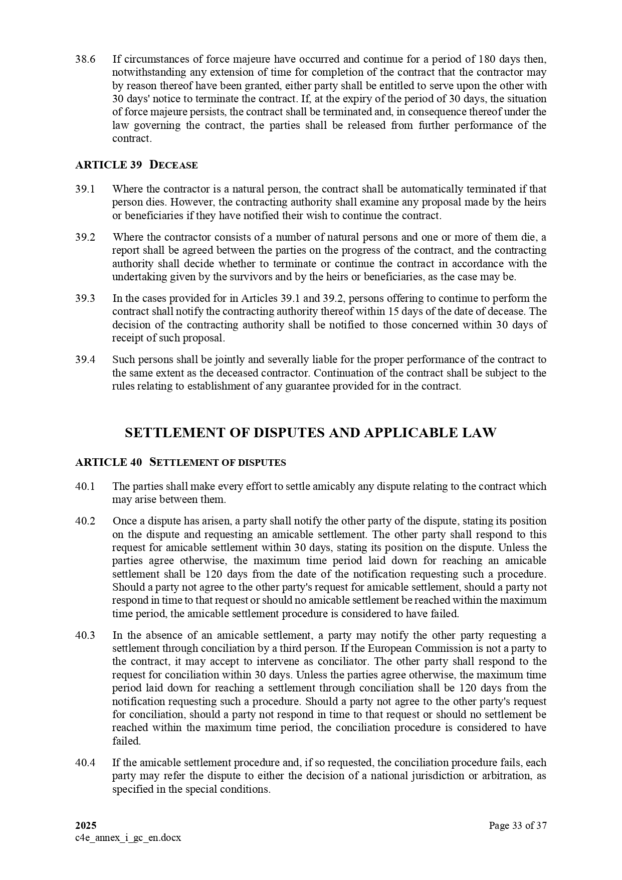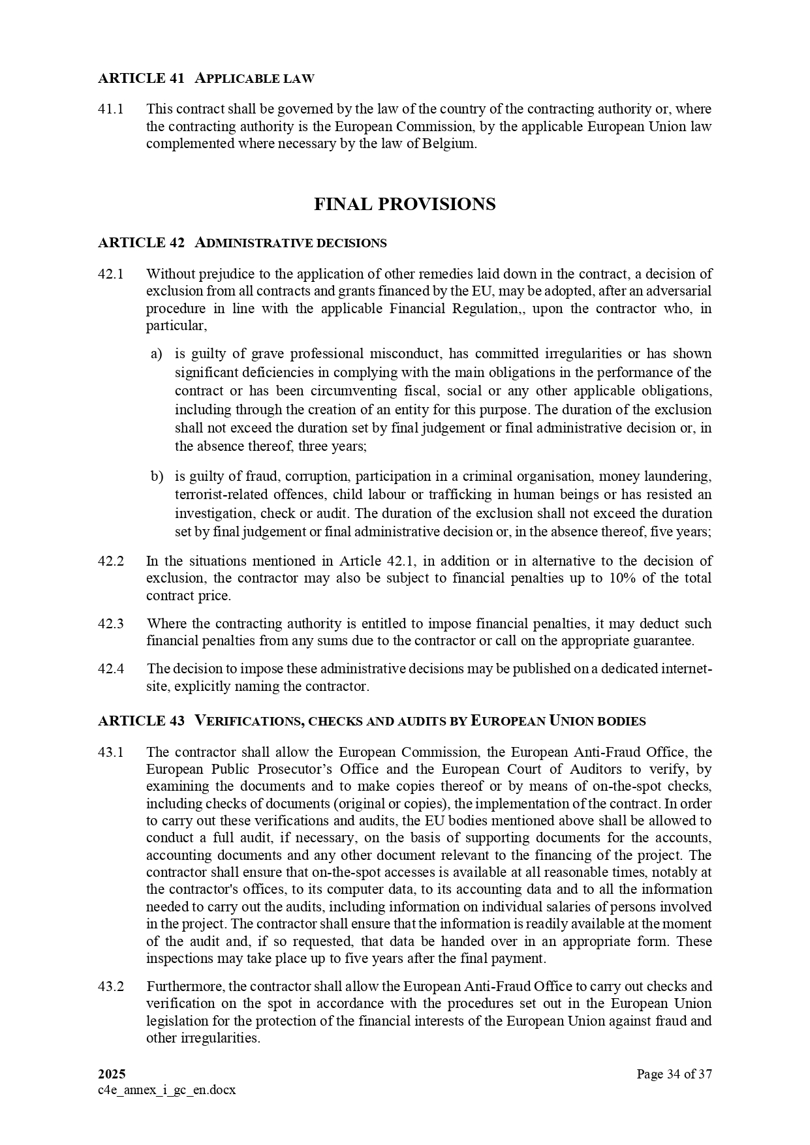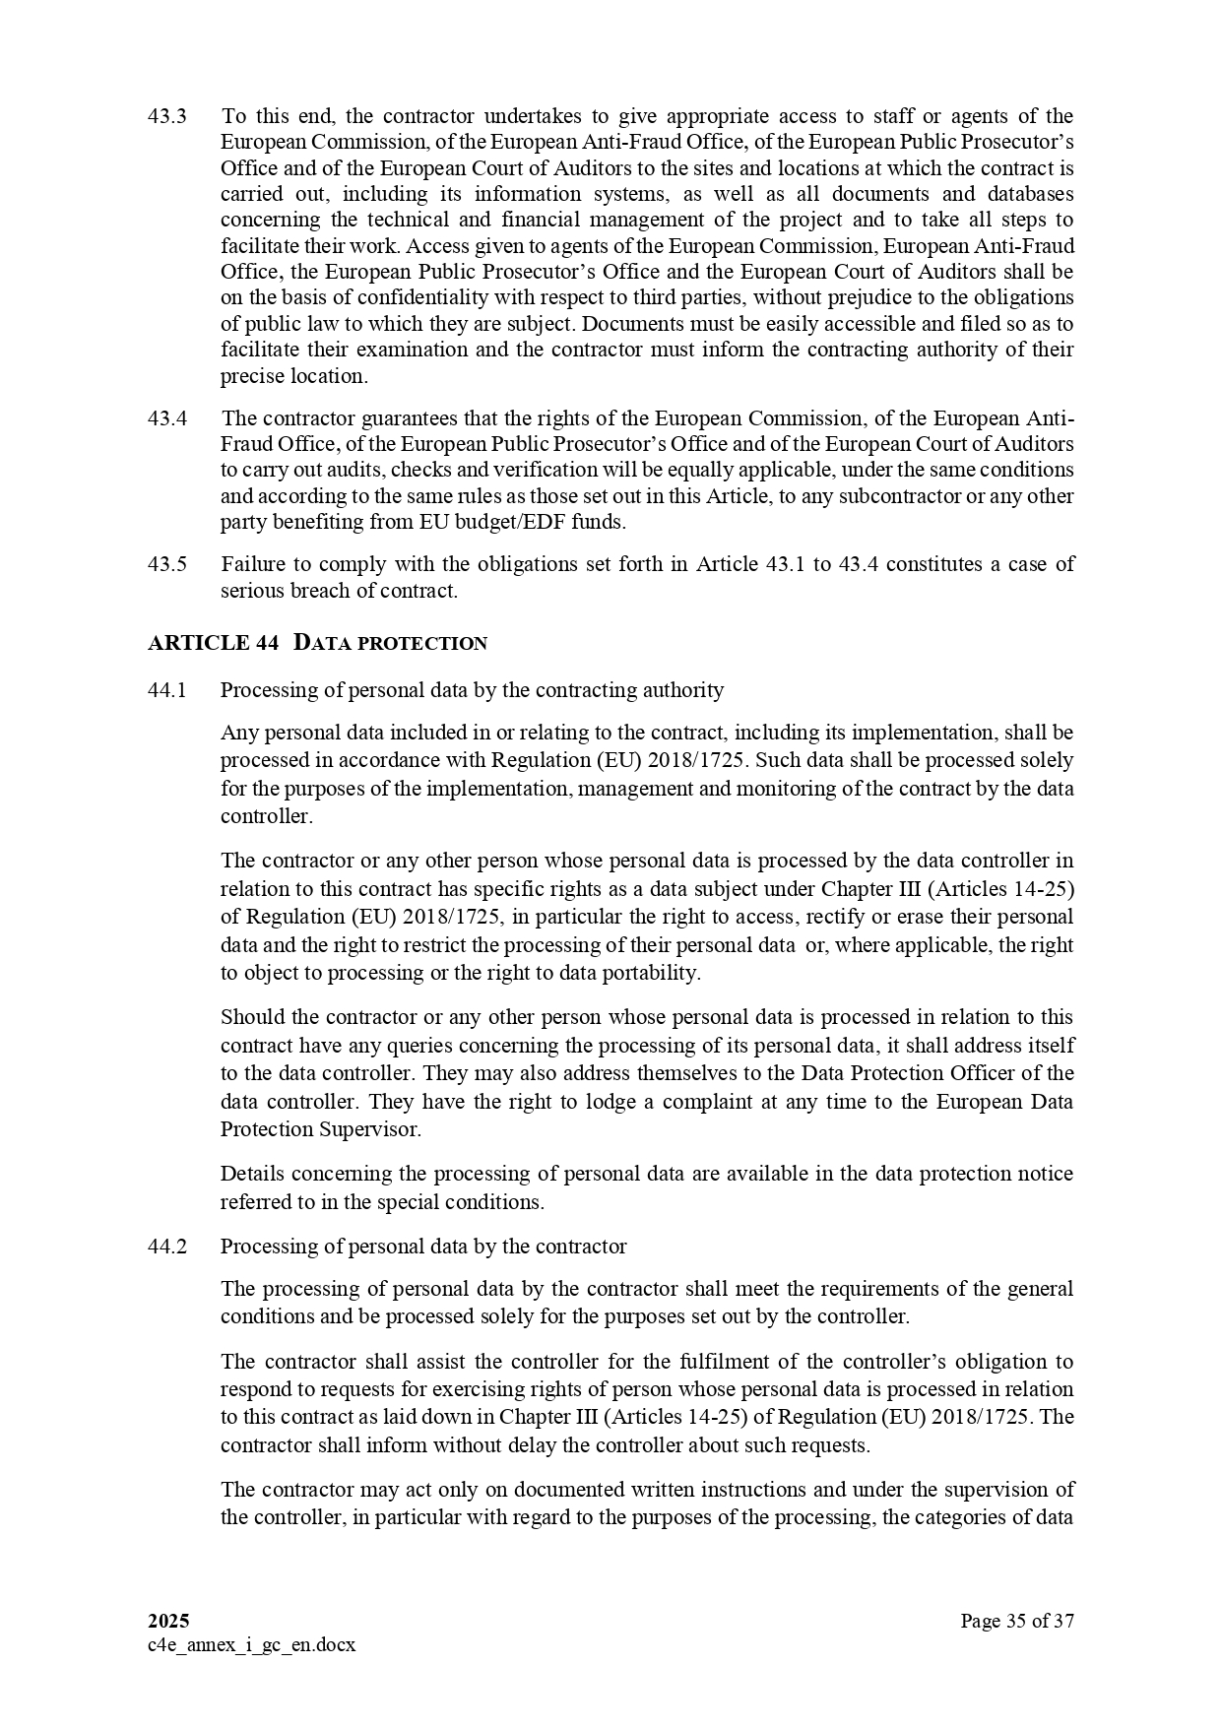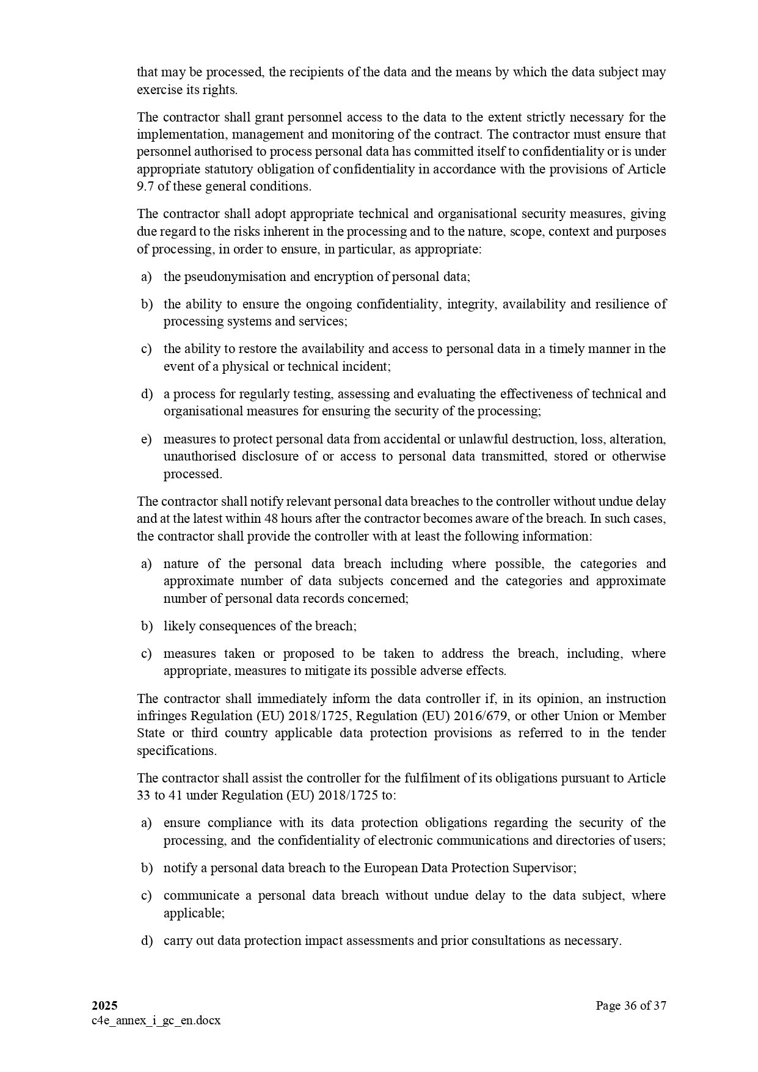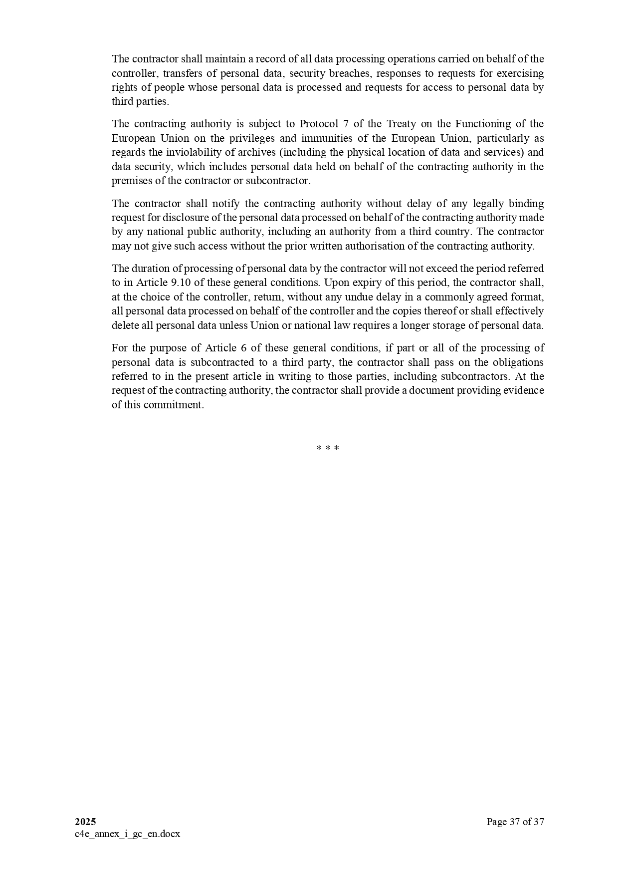

ANNEX II + III: TECHNICAL SPECIFICATIONS + TECHNICAL OFFER

Contract title: " SUPPLY, DELIVERY, INSTALLATION, TRAINING, MAINTENANCE SERVICES AND AFTER-SALES SERVICE OF AN APPLICATION SOFTWARE FOR VESSEL TRAFFIC MANAGEMENT INFORMATION SYSTEM (VTMIS) ."

Publication reference: COI/PSSN/AO/2026/005

Columns 1-2 should be completed by the contracting authority
Columns 3-4 should be completed by the tenderer
Column 5 is reserved for the evaluation committee
Annex III - the contractor's technical offer
The tenderers are requested to complete the template on the next pages:
- Column 2 is completed by the contracting authority shows the required specifications (not to be modified by the tenderer),
- Column 3 is to be filled in by the tenderer and must detail what is offered (for example the words ‘compliant’ or ‘yes’ are not sufficient)
- Column 4 allows the tenderer to make comments on its proposed supply and to make eventual references to the documentation
The eventual documentation supplied should clearly indicate (highlight, mark) the models offered and the options included, if any, so that the evaluators can see the exact configuration. Offers that do not permit to identify precisely the models and the specifications may be rejected by the evaluation committee.
The offer must be clear enough to allow the evaluators to make an easy comparison between the requested specifications and the offered specifications.

1.  Item No | 2.  Min. Specifications Required | 3.  Specifications Offered | 4.  Notes, Remarks,  Ref. to documentation | 5.  Evaluation Committee’s notes
1 | VESSEL TRAFFIC MANAGEMENT INFORMATION SYSTEM APPLICATION SOFTWARE  1.0 CORE FUNCTIONAL COMPONENTS OF THE VTMIS  The VTMIS, designed as a modular application, must include the following mandatory modules or components at a minimum: -  - Vessel Tracking  - Traffic Monitoring & Display  - Communication Systems  - Data Logging & Playback  - Alarms & Warnings  - Search & Rescue (SAR) Support  - Reporting & Analytics  The Software must be fully scalable and based on a Service Oriented Architecture (SOA).
1 | - Vessel Tracking  AIS Reception:  - Real-time reception of AIS data from Class A and B transponders.  - Must monitor VHF channels 87B (161.975 MHz) and 88B (162.025 MHz) simultaneously  AIS Message Decoding:  - Support decoding: Message 1, 2, 3 (Class A position), Message 18 (Class B position), Message 5 (static/voyage data), Message 21 (AtoN reports)  - Must parse and display positions every 2–3 seconds  AIS Antenna Integration:  - Interface with AIS antennas covering up to 40 nautical miles (coastal conditions dependent)  - Ensures coastal coverage  Radar Integration:  - Support X-band (short-range) & S-band (long-range) radars  - Must support NMEA 0183 and proprietary formats  Radar Data Fusion:  - Fuse radar and AIS data into a single display  - Reduce false targets; provide accurate situational awareness  Non-Cooperative Target Detection:  - Track vessels without AIS or in low AIS coverage areas  - Generate unique identifiers for non-cooperative targets  Satellite AIS (S-AIS) Integration:  - Support integration with satellite AIS providers (e.g., Orbcomm, Spire, MarineTraffic)  - Account for higher latency; indicate time delay in display  Satellite Positioning:  - Integration with satellite-based vessel positioning (For regions without AIS/radar coverage)  - Traffic Monitoring & Display  Mapping System:  - Display vessel locations on high-resolution chart interface supporting ENC, S-57/S-63, or equivalent vector charts  Bidders must specify chart source, licenses, and renewal implications.  Chart Layer Management:  - Toggle layers such as bathymetry, landmarks, buoys; use navigation tools (zoom, pan, ruler)  - Operators can measure distances or mark areas of interest  Display Refresh Rate:  - Minimum update every 1–2 seconds (Ensures timely monitoring of vessel movements)  Vessel Information Overlay:  - Display vessel name, MMSI, speed, heading, destination, ETA, draft, and type  - Icons must differentiate vessel types (cargo, tanker, fishing, yachts, etc.)  Vessel Detail Access:  - Clickable vessels to view voyage history, communications, and alerts  - Real-time information display  Geo-Fencing - Virtual Zones:  - Create boundaries around ports, shipping lanes, restricted zones, or hazards  - Configurable for size, shape, speed limits, direction, and permissions  Geo-Fencing - Automated Alerts:  - Trigger alarms when vessels enter/exit virtual zones  - Alerts include restricted-area warnings and proximity notifications  Geo-Fencing - Zone Management:  - Operators can customize rules for each geo-fence  - Includes ETA alerts, speed restrictions, and permissions
1 | - Communication Systems  VHF Radio Integration:  - Real-time integration with VHF radios for vessel communication  - Supports both analogue and Digital Selective Calling (DSC) for distress alerts; radios themselves not included in tender  Channel Management:  - Ability to select channels, including distress channel 16, and use group calling  - Ensures communication with multiple vessels simultaneously  Text Messaging (AIS/Satellite):  - Send text-based messages to vessels via AIS or satellite  - Messages include warnings, instructions, weather alerts, or port directives  Predefined Messaging Templates:  - Use templates for rapid communication. Examples: collision warnings, entry/exit permissions  Message Logging:  - All sent/received messages must be stored and time-stamped (for audit and reporting purposes)  Interoperability with Shore Systems:  - Compatible/Communicate with existing shore-based VTS and communication systems  - Supports integration with both national and regional platforms  Alert Messaging:  - Ability to transmit alerts to vessels  - Includes automated notifications for hazards or operational instructions
1 | - Data Logging & Playback  Historical Data Logging:  - Log vessel positions, radar sweeps, communications, and alarms at predefined intervals (e.g., every 1 second)  - Data stored in a relational database for efficient querying  Storage Duration:  - Retain data for at least 12 months  - Option to archive older data for extended retention; compliant with local regulations  Playback Functionality:  - Reconstruct vessel movements by selecting date/time ranges  - Includes AIS data, radar sweeps, and geofencing events  Multilayer Playback:  - Display layers separately: AIS, radar, geofencing breaches, communication logs  - Operators can pause, rewind, fast-forward, or zoom in; details required from bidders on implementation  Export Options:  - Export playback sessions as video or data in CSV, JSON, XML  - Supports reporting, analysis, and regulatory submissions  Incident Investigation Support:  - Provide tools for reviewing incidents  - Supports compliance auditing, operational review, and historical analysis
1 | - Alarms and Warnings  Collision Detection Alerts:  - Real-time calculation of Closest Point of Approach (CPA) and Time to CPA (TCPA)  - Provide visual and audio alerts for vessels on collision course  CPA/TCPA Threshold Customization:  - Operators can set thresholds for CPA/TCPA. Example: alert when vessels come within 0.5 NM within 10 minutes  Alert Prioritization:  - Categorize collision alerts by risk level  - Low, medium, high priority based on proximity and risk  Weather Alerts Integration  - Real-time integration with meteorological data  - Display wind speed, wave height, visibility, and storm warnings  Automated Weather Alerts:  - Trigger alarms for conditions affecting navigation. Examples: gale-force winds, fog, high waves  Configurable Alert Settings:  - Operators can define which alerts are active and their behaviours  - Supports audio, visual, or combined notifications  Incident Logging:  - Store all alarm events with timestamps  - Supports audit, analysis, and post-incident review
1 | - Search and Rescue (SAR) Support  Last-Known Position Tracking:  - Automatically mark vessel’s last-known position when a distress signal is received  - Use weather and current data to calculate drift patterns  Predictive Tracking:  - Calculate and display likely drift positions of vessels or survivors  - Enhances SAR operational planning and reduces response time  SAR Communication Support:  - Integrated messaging to coordinate SAR operations  - Supports real-time communication between vessels, SAR teams, and shore operators  Incident Coordination:  - Share SAR-related information instantly with all relevant stakeholders  - Enables seamless collaboration among multiple teams and agencies  Multi-Source Integration:  - Combine AIS, radar, geofencing, and satellite data for SAR operations  - Provides comprehensive situational awareness  Visualization Tools:  - Display SAR zones, vessel positions, and predicted drift areas on GIS interface  - Supports real-time decision-making and operational planning  Operational Logs:  - Record all SAR actions, communications, and tracking data  - Ensures auditability and post-incident analysis
1 | - Reporting and Analytics  Traffic Reports:  - Generate detailed reports on vessel traffic in specific areas  - Include vessel types, speeds, routes, congestion points, and compliance with traffic regulations  Incident Reports:  - Predefined templates for documenting collisions, groundings, or environmental incidents  - Include AIS, radar, weather, and communication data  Compliance Tracking Reports:  - Monitor adherence to maritime regulations  - Includes environmental standards and legal compliance  Statistical Analysis Tools:  - Analyse trends in traffic, incidents, and vessel behaviour  - Identify bottlenecks, optimize operations, and enhance safety  Customizable Reports:  - Allow operators to define report parameters and content  - Supports ad-hoc reporting for operational or management needs  Export Options:  - Export reports in multiple formats (PDF, CSV, Excel)  - Supports regulatory submissions and internal review  Automated Scheduling:  - Ability to schedule reports for periodic generation  - Supports routine monitoring and management reporting
1 | 2.0 USER INTERFACE AND EXPERIENCE (UI/UX)  The system's user interface must be designed to prioritize ease of use and clarity. It should present essential information in a clear and organized manner, ensuring that critical data is easily accessible and actionable, even during high-stress situations. Responsiveness is equally important, as delays in system interactions can hinder timely decision-making and impact overall operational efficiency. By combining these elements, the user interface can empower operators to maintain safety, efficiency, and compliance in maritime operations.  Web-Based Access:  - Accessible through standard web browsers on desktop and mobile devices  - Security measures to prevent unauthorized control actions  GIS Support:  - Integrated Geographical Information System (GIS) display  - Supports ENC charts, OGC protocols, Open Street Map, Bing Maps, Google Maps  Day, Dusk, Night Modes:  - Display modes compliant with IEC 61174  - Optimized visibility for different lighting conditions  Customizable Tracks and Workspace:  - User-defined symbols, colours, labels, and workspace layout  - Supports operator preferences  AIS Tracks and Data Display:  - Visualize and manage AIS data from Class A/B vessels, AtoN, SAR, SART, and Base Stations  - Includes external AIS sources connected to national server  Advanced Chart Functions:  - Pan, zoom, measurement, labelling, and advanced search  - Enhances situational awareness and navigation  User-Defined Areas and Alarms:  - Create zones, lines, polygons, circles; configure alarms  - Includes popup/audio alerts for restricted areas, line crossings, ETA alerts, anchor dragging, speed violations  Playback of Historical Data:  - Timeline-based playback with speed controls  - Integrates AIS, radar, geofencing, and communication logs  Intuitive UI:  - Clean navigation, drag-and-drop geo-fencing, shortcut keys  - Ensures rapid task execution and minimal learning curve  Operators’ Console / Large Display Support:  - Compatible with high-resolution monitors and video walls  - Multi-source displays and ergonomic support (hardware not to be supplied)  Multilingual Support:  - At least English and French  - Optional support for additional languages
1 | 3.0 INFORMATION EXCHANGE CAPABILITIES  The VTMIS must be able to seamlessly exchange information with other relevant systems to enhance operational efficiency and improve coordination between maritime stakeholders. This integration ensures that critical data is shared in real-time across various platforms, enabling stakeholders such as port authorities, coast guards, fishing authorities, customs agencies, and law enforcement to make informed decisions quickly and collaboratively.  Interoperability:  - Compatible with AIS, VTS, Customs, and other maritime systems  - Ensures smooth real-time data flow between platforms  Data Sharing:  - Exchange vessel tracking, traffic updates, and compliance data  - Supports operational and regulatory decision-making  Cross-System Alerts:  - Transmit real-time alerts to connected systems  - Covers route deviations, collisions, or regulation breaches  Enhanced Coordination:  - Share vital information with law enforcement, customs, and environmental monitoring systems  - Improves joint operations such as SAR, anti-smuggling, environmental protection  Efficient Resource Allocation:  - Share resource availability data (vessels, personnel)  - Optimizes deployment during high-traffic periods or emergencies  Standardized Integration:  - Preferably via EDI interface; custom-coded integration optional  - Simplifies future upgrades and ensures compatibility  Regional & National Exchange:  - Support data exchange at both national and regional levels. Example: DCoC, CRIMARIO IORIS, MASE’s PFMIS & MCP, port authorities, customs
1 | 3.0 REFERENCE DATABASES  These databases are the foundational data structures necessary for the effective operation of the VTMIS. They serve as a centralised repository for critical information, including vessel details, voyage records, and associated operational data. They ensure data consistency, facilitate seamless information exchange among stakeholders, and support both operational and regulatory requirements.  Vessel Information Database:  - Store master records for commercial, fishing, leisure, cruise, military, and cargo vessels  - Must allow creation and updating of master vessel records by agents  Voyage Information Database:  - Store arrival and departure information per vessel call  - Supports authorizations, inspections, and dynamic voyage data updates  Database Flexibility:  - Customizable schema for different vessel types and operational scenarios  - Enables adaptation to national and port-specific requirements  Historical Data Storage:  - Retain vessel and voyage records for at least 12 months  - Option to archive older data for long-term retention  Data Integrity & Consistency:  - Ensure consistent and accurate data across modules  - Supports operational decision-making and regulatory compliance  Relational Model Support:  - Database must be relational (RDBMS)  - Enables efficient querying and integration with VTMIS modules  Integration with VTMIS Modules:  - AIS, radar, geofencing, communications, SAR, and reporting modules  - Ensures seamless data flow across the system  Access Control:  - Database access aligned with user roles and permissions  - Sensitive data restricted to authorized stakeholders
1 | 4.0 SYSTEM ACCESS AND SECURITY  The VTMIS must ensure that user access to vessel and voyage information is managed based on predefined roles and permissions, centrally administered to maintain control and consistency.  Role-Based Access Control (RBAC):  - Centralised user access based on pre-defined roles  - Stakeholders assigned read-only or write permissions according to responsibilities  Access Rights Matrices:  - Define which stakeholders can create, read, or write data  - Final matrices provided during implementation for each country  Personalized Views:  - Custom dashboards and data views based on roles  - Enables stakeholders to efficiently visualize and manage relevant information  Authentication:  - Strong authentication mechanisms (e.g., two-factor authentication)  - Ensures secure login and prevents unauthorized access  Encryption:  - All communications (vessel, shore, servers) encrypted  - TLS/SSL encryption for AIS, radar, and communication data  Audit Logging:  - Track user activities, data changes, and system access  - Supports compliance, investigation, and reporting requirements  Cybersecurity Compliance:  - Follow ISO 27001, NIST, or equivalent standards  - Ensures protection against cyberattacks and data breaches  Regional and National Access Control:  - Align access rights with national policies for data sharing  - Sensitive data may be restricted from replication across countries  Agent and Regional Centre Views:  - Agents can manage vessel/voyage submissions; regional centres monitor multi-country maritime activity  - Supports operational efficiency and coordinated decision-making
1 | 5.0 COMPLIANCE WITH INTERNATIONAL STANDARDS  The VTMIS software must adhere to the following global maritime laws and best practices:  IMO Guidelines on VTS:  - Align system with International Maritime Organization (IMO) Vessel Traffic Services guidelines  - Ensures operational requirements for monitoring and controlling ship movements are met  SOLAS (Safety of Life at Sea):  - Comply with SOLAS mandates  - Covers vessel safety, AIS usage, and ship traffic management in coastal waters  IALA VTS Standards:  - Conform to International Association of Marine Aids to Navigation and Lighthouse Authorities standards  - Ensures effective traffic management, navigation safety, and communication protocols  Data Protection & Security Standards:  - Compliance with ISO 27001 / NIST for cybersecurity  - Safeguards sensitive maritime data and supports secure operations  Interoperability Standards:  - Use open and standardised protocols for AIS, radar, and EDI data exchange  - Facilitates integration with external national and regional systems  Operational Best Practices:  - Adhere to recognised VTS operational procedures  - Ensures consistency with global maritime safety and efficiency norms
1 | 5.0 LICENCING  The licensing options for the VTMIS, database, and other software utilities required for the implementation of this project must comply with the following requirements.  VTMIS Software License:  - Perpetual license granting indefinite use  - One-time payment; ensures long-term operational control without recurring fees  RDBMS License:  - Perpetual license for the relational database management system  - Must include scalability, security, and integration capabilities  Additional Software Utilities:  - Perpetual licenses for middleware or integration tools  - Includes tools for EDI, reporting, or system integration  Maintenance & Support:  - Annual maintenance contract (Ref. to Item 4 below)  - Covers software updates, patches, technical support; priced separately  License Documentation:  - Detailed description of licensing models must be submitted  - Must include sample agreements and terms for each software component  Upgrade & Version Management:  - Maintenance agreement should include access to upgrades  - Ensures the VTMIS remains compatible with future requirements  License Scope:  - Covers all VTMIS modules, databases, and utilities  - Licenses must allow full operational use in all deployment countries
2 | IMPLEMENTATION SERVICES  The Implementation Services ensure the successful deployment and operational readiness of the VTMIS software, associated databases, and supporting tools, following the regional and national architecture defined for the project.  System Deployment:  - Installation and configuration of VTMIS software, RDBMS, GIS modules, and integration components  - Deployment must comply with national and regional architecture specifications  Hardware Integration:  - Integration with existing AIS, radar, VHF, and satellite systems  - Bidders must ensure seamless compatibility without replacing existing hardware unless explicitly required  Data Migration:  - Import existing vessel, voyage, and historical data into VTMIS databases  - Data integrity and accuracy must be validated; legacy data must remain consistent  Testing & Commissioning:  - Conduct functional, integration, performance, and security testing  - Full verification of system readiness prior to operational deployment  Documentation:  - Delivery of technical manuals, user guides, and system configuration documentation  - Must include operational workflows, architecture diagrams, and troubleshooting procedures  Go-Live Support:  - On-site and remote support during initial operational phase  - Ensure smooth transition and minimal disruption to maritime operations  Bidders are required to submit a detailed deployment methodology and implementation plan as part of their proposal. The plan must include:  - A time-based implementation schedule with clearly defined milestones  - Intermediate progress reports upon the completion of each milestone  - A final implementation report summarising the completion of all tasks and deliverables  Bidders must provide details of the proposed project management and implementation team, including:  - Roles and responsibilities of each team member  - Qualifications and relevant experience of team members  - A clear organisational structure showing how the implementation team will be coordinated  Bidder’s proposal should include technical support throughout the implementation phase, ensuring that all issues or challenges encountered are promptly resolved. Communication channels and escalation mechanisms must be clearly outlined in Bidder’s proposal.
3 | TRAINING SERVICES  Proper training is critical to ensure that all stakeholders can efficiently operate, administer, and maintain the VTMIS.  Operator Training:  - Hands-on training for VTMIS operators  - Coverage: vessel tracking, geofencing, alarms, SAR, GIS interface, reporting  Administrator Training:  - Training for system administrators  - Coverage: access control, database management, backups, configuration  Training Materials:  - Delivery of manuals, SOPs, and e-learning resources  - Materials must be bilingual (English and French) and aligned with operational procedures  Refresher / Advanced Training:  - Periodic sessions for new features or updates to be included under annual maintenance services  Bidders must provide detailed training plan, including schedules and course content for the requested training. The plan should describe the proposed training approach, target audience (operators, administrators, IT staff, etc…), training objectives, duration, and delivery method. The plan shall also include resource mobilisation arrangements for multi-country training delivery.  Training completion reports are mandatory and shall be submitted upon conclusion of each training session. These reports shall include attendance lists, training content delivered, and confirmation of knowledge transfer.  The Tenderer’s financial offer shall be all-inclusive and shall cover all efforts and resources required, including but not limited to:  - Training preparation and delivery;  - Training materials and documentation;  - Labour and trainer expertise;  - International and local travel costs, including air tickets;  - Accommodation costs for deployed trainers;  - Daily subsistence allowance (per diem) or displacement fees for mobilised trainers.  During project implementation, no additional costs related to training delivery, travel, accommodation, or subsistence shall be borne by the Contracting Authority.
4 | ANNUAL MAINTENANCE SERVICES  The Contractor shall provide comprehensive Annual Maintenance Services (AMS) in addition to the standard warranty obligations and are intended to ensure timely intervention within a prescribed response interval following any service request.  The full scope, specifications, and service requirements for the AMS are provided in the Annex to the Technical Specifications, which is an integral part of this tender.  Service Provision:  - AMS shall be primarily delivered remotely, using secure remote access and monitoring tools to diagnose, troubleshoot, and resolve issues.  - In exceptional cases where onsite intervention is required, the Tenderer shall either:  - Appoint a local representative in the country of the installation site, or  - Deploy qualified personnel from another location.  Travel and Deployment Costs:  Costs for air travel, local transportation, accommodation, and per diem for personnel required to perform on-site interventions shall be agreed on a case-by-case basis and will be reimbursed separately by the Contracting Authority.  Service Level Agreement (SLA):  Tenderers shall submit, as a mandatory part of their technical offer, a proposed Service Level Agreement (SLA) model covering all requirements described above, including:  - Remote maintenance response and resolution times;  - Escalation procedures for critical and non-critical faults;  - Preventive and corrective maintenance schedules;  - Onsite intervention conditions, including deployment of local representatives;  - Reporting and documentation requirements  Tenderers shall ensure that their technical and financial offers fully cover all remote maintenance activities. Any proposed on-site support arrangements, including local representatives or escalation procedures, must be clearly described in the technical offer.

ANNEX TO TECHNICAL SPECIFICATIONS

For

APPLICATION SOFTWARE FOR VTMIS

Table of Contents
1.0 INTRODUCTION 6
2.0 VESSEL TRAFFIC MANAGEMENT INFORMATION SYSTEM 7
2.1 About the VTMIS 7
2.2 System Architecture 9
3.0 CORE FUNCTIONAL COMPONENTS OF THE VTMIS 9
3.1 Vessel Tracking 10
3.1.1 Automatic Identification System (AIS) Integration 10
3.1.1.1 AIS Reception Capability 10
3.1.1.2 AIS Message Decoding 10
3.1.1.3 AIS Antennas 10
3.1.2 Radar Data Integration and Processing 10
3.1.2.1 Radar Integration 10
3.1.2.2 Radar Data Formats 11
3.1.2.3 Radar Data Fusion 11
3.1.2.4 Non-Cooperative Target Detection 11
3.1.3 Satellite-Based Tracking 11
3.1.3.1 Integration with Satellite AIS (S-AIS) 11
3.2 Traffic Monitoring and Display 11
3.2.1 Real-Time Traffic Display 12
3.2.1.1 Mapping System 12
3.2.1.2 Vessel Information Overlay 12
3.2.2 Geo-fencing Capabilities 12
3.2.2.1 Virtual Zones 12
3.2.2.2 Automated Alerts 12
3.2.2.3 Zone Configuration 13
3.3 Communication Systems 13
3.3.1 VHF Radio Communication Integration 13
3.3.1.1 Real-Time VHF Communication 13
3.3.1.2 Interoperability 13
3.3.1.3 Channel Management 13
3.3.2 Text Messaging and Alerts 13
3.3.2.1 Digital Messaging 13
3.3.2.2 Predefined Templates 13
3.3.2.3 Message Logging 14
3.4 Data Logging and Playback 14
3.4.1 Historical Data Storage 14
3.4.1.1 Log Data 14
3.4.1.2 Storage Duration 14
3.4.2 Playback Feature 14
3.4.2.1 Incident Reconstruction 14
3.4.2.2 Multilayer Playback 14
3.4.2.3 Export Options 14
3.5 Alarms and Warnings 15
3.5.1 Collision Detection Alerts 15
3.5.1.1 Real-Time Collision Detection 15
3.5.1.2 Threshold Customization 15
3.5.1.3 Alert Prioritization 15
3.5.2 Weather Alerts 15
3.5.2.1 Weather Data Integration 15
3.5.2.2 Automated Alerts 15
3.6 SAR Support 15
3.6.1 Last-Known Position Tracking 16
3.6.1.1 Automated SAR Tools 16
3.6.1.2 Predictive Tracking 16
3.6.2 SAR Communication Support 16
3.6.2.1 Integrated Messaging 16
3.7 Reporting and Analytics 16
3.7.1 Traffic Reports 16
3.7.2 Incident Reports 17
3.7.3 Compliance Tracking Reports 17
3.7.4 Statistical Analysis Tools 17
4.0 USER INTERFACE AND EXPERIENCE (UI/UX) OF THE VTMIS 17
4.1 Web and Mobile Web Access 17
4.2 GIS Support 17
4.2.1 Support for Standard Maps and Protocols 18
4.2.2 Day, Dusk, and Night Modes 18
4.2.3 Customizable Tracks and Workspace 18
4.2.4 AIS Tracks and Data Display 18
4.2.5 Advanced Chart Functions 18
4.2.6 User-Defined Areas and Alarms 18
4.2.7 Playback of Historical Data 19
4.3 Intuitive User Interface 19
4.3.1 Usability 19
4.3.2 Drag-and-Drop Geo-Fencing 19
4.3.3 Real-Time Data Displays 19
4.3.4 Shortcut Keys 19
4.3.5 Clear Data Visualizations 20
4.3.6 Enhanced Efficiency 20
4.4 Operators’ Console and Large Monitoring Display Support 20
4.5 Multilingual Support 20
5.0 INFORMATION EXCHANGE CAPABILITIES 21
5.1 Key aspects of information exchange 21
5.1.1 Interoperability 21
5.1.2 Data Sharing 21
5.1.3 Cross-System Alerts 21
5.1.4 Enhanced Coordination 21
5.1.5 Efficient Resource Allocation 22
5.2 Information exchange with external systems 22
6.0 REFERENCE DATABASES 22
6.1 Vessel Information 22
6.2 Voyage Information 25
7.0 SYSTEM ACCESS AND SECURITY 28
7.1 Access Rights 29
7.2 Personalised Views 31
7.2.1 Role-Specific Dashboards 31
7.2.2 Customizable Data Displays 31
7.2.3 Interactive Views 31
7.2.4 Historical Data and Reporting 31
7.2.5 Agent-Specific Views 32
7.2.6 Regional Centre Views 32
7.3 Security Features 32
7.3.1 Authentication and Role-Based Access 32
7.3.2 Encryption 32
7.3.3 Cybersecurity Protection 32
8.0 COMPLIANCE WITH INTERNATIONAL STANDARDS 32
8.1 IMO Guidelines on VTS 32
8.2 SOLAS (Safety of Life at Sea) 33
8.3 IALA VTS Standards 33
9.0 LICENCING 33
9.1 VTMIS Software 33
9.2 Relational Database Management System (RDBMS) 33
9.3 Other Software Utilities 33
9.4 Software Maintenance and Upgrades 33
9.5 License Documentation 33
10.0 IMPLEMENTATION SERVICES 34
10.1 Deployment Approach 34
10.2 Installation and Configuration 34
10.3 Integration with External Systems 34
10.4 Deployment Methodology and Implementation Plan 35
10.5 Project Management and Team Composition 35
10.6 Support During Implementation 35
10.7 Commissioning and Acceptance 35
11.0 TRAINING SERVICES 36
12.0 MAINTENANCE SERVICES 36
13.0 INSTALLATION LOCATIONS 37

VESSEL TRAFFIC MANAGEMENT INFORMATION SYSTEM

INTRODUCTION

The Indian Ocean Commission (IOC) is spearheading the implementation of the Regional Port Security Programme (PSP) with financial support from the European Union and technical expertise provided by key international organizations, including the International Maritime Organization (IMO), the United Nations Office on Drugs and Crime (UNODC), and INTERPOL. This initiative underscores a collaborative effort to address the critical port and maritime security challenges within the Eastern and Southern Africa and Indian Ocean (ESA-IO) region. The beneficiaries of the PSP programme include Mauritius, Madagascar, Kenya, Mozambique, Tanzania, Seychelles, Namibia, Angola and Comoros.
The overall objective of the programme is to enhance maritime security and safety in the ESA-IO region, aligning with the 2050 African Union Integrated Maritime Strategy (AIMS 2050). AIMS 2050 calls on Africa's coastal states to conduct Port State Control (PSC) and fulfil their responsibilities under Flag State Implementation (FSI) from 2018 onward.
The PSP Programme is designed to function in synergy with regional organizations such as COMESA, EAC, SADC, Port Association of the Indian Ocean Islands (APIOI), and Port Management Association for Eastern and Southern Africa (PMAESA), as well as international stakeholders like CGPCS, EUNAVFOR, and WCO. Furthermore, it builds on the foundation of ongoing projects and initiatives such as MASE, CRIMSON, and CRIMLEA, while leveraging existing mechanisms like the Djibouti Code of Conduct (DCoC). These collaborations ensure a comprehensive and coordinated approach to port and maritime security.
The programme is structured into three primary outcomes: -
- Enhanced capacity of shipping safety authorities in the ESA-IO region
This includes bolstering the operational and technical capabilities of maritime administrations to ensure safer navigation and improved incident response.
- Development of port security legislation and compliance frameworks
This involves establishing robust legal and regulatory structures to enhance security measures across regional ports.
- Implementation of a regional information-sharing mechanism and a cargo and passenger data exchange system
This aims to improve real-time data sharing and collaboration between regional authorities to counter maritime threats effectively.
The PSP Programme focuses on critical areas that have a direct impact on maritime security. These are: -
- Information sharing on maritime freight and passengers
Facilitating seamless communication and data exchange to enhance situational awareness.
- Support for law enforcement and customs services
Strengthening capabilities to combat organized crime and mitigate the risks of terrorism.
- Cargo control, surveillance, and seizure operations
Elevating the capacity to monitor, inspect, and take action against illicit activities in regional waters.
This tender seeks to procure a Vessel Traffic Management Information System (VTMIS) software that aligns with the PSP Programme's objectives. The proposed solution will serve as a vital component in enhancing maritime domain awareness, streamlining information exchange, and reinforcing port security measures across the ESA-IO region
This document details the technical specifications of the VTMIS software which would be deployed in a port of the following countries only: -
- Tanzania;
- Madagascar;
- Mozambique.
At national level, the VTMIS will be accessed by stakeholders, including National Coast Guard (NCG) and other Law Enforcement Authorities (LEA), Maritime Administration Authorities (MAA), Fisheries Department, Tourism Authority, Port Facility Security Officers (PFSO) and Customs among others.
At regional level, the VTMIS will serve as the link bridge to exchange information related to vessels, passengers and cargo between states of the ESA-IO region.

VESSEL TRAFFIC MANAGEMENT INFORMATION SYSTEM

About the VTMIS

The VTMIS is a comprehensive maritime surveillance and traffic management platform designed to enhance the safety, efficiency, and security of vessel navigation within designated maritime zones such as harbours, coastal areas, and inland waterways. As maritime trade continues to grow, so does the complexity of managing vessel traffic, especially in congested and high-risk areas. The VTMIS software addresses these challenges by offering real-time monitoring, data integration, communication tools, and decision-making support for maritime authorities, harbour masters, vessel operators and other players of the maritime sector.
VTMIS plays a crucial role in ensuring maritime safety and regulatory compliance, especially in environments where vessel movements are dense, such as near major ports or busy shipping lanes. By providing real-time tracking and monitoring of vessel movements, the system helps prevent collisions, groundings, and environmental incidents, while also assisting with search and rescue (SAR) operations in emergencies.
Maritime operations are complex, involving numerous stakeholders including port authorities, ship operators, customs and immigration officers, coast guards, environmental regulators, and search and rescue teams. VTMIS serves as a centralized platform that unifies these different entities under a single framework, enabling efficient management of vessel traffic and enhancing situational awareness.
With the growing size of modern ships and the increasing volume of maritime trade, the risks associated with vessel congestion, hazardous weather, and restricted areas have increased significantly. VTMIS software provides maritime authorities with tools to mitigate these risks, and ensuring: -
- Safe navigation through real-time tracking, monitoring, and automated collision detection systems;
- Traffic coordination by ensuring that vessels follow predetermined routes and adhere to port schedules;
- Regulatory compliance by facilitating adherence to international maritime laws, such as the International Maritime Organization’s (IMO), Safety of Life at Sea (SOLAS) convention and local regulations;
- Efficient port operations through integration or information exchange with port management systems, optimizing berth assignments, and minimizing delays.
By ingesting data from various sources such as radar, Automatic Identification Systems (AIS), meteorological systems, and satellite-based communication, the VTMIS software provides operators with a unified real-time operational view of the maritime situation. The VTMIS not only enhances the immediate safety of vessels, but also offers advanced analytics and reporting features for long-term planning and optimization of maritime traffic.
The implementation of an advanced VTMIS is essential for modern maritime operations, as it integrates cutting-edge tracking, communication, and data analysis technologies. These capabilities enable proactive decision-making, effective incident response, and improved regulatory compliance, thereby supporting the overarching goals of maritime security and environmental stewardship.
The key objectives of the VTMIS, which outline its role in advancing maritime operations in high-traffic regions are the following: -
- Improved vessel safety by preventing collisions, monitoring compliance, identifying non-cooperative targets, and providing timely alerts for navigational risks.
- Efficient traffic management by optimizing traffic flow and minimize disruptions by preventing congestion, enabling real-time vessel-to-shore communication, and reducing delays during port operations.

- Environmental protection and compliance by enforcing route compliance, avoiding sensitive areas, and monitoring adherence to environmental regulations on emissions and waste.
- Support for search and rescue, and other emergency operations with accurate positioning, drift prediction tools, and integrated communication for effective coordination.
- Data-Driven decision making through post-incident analysis, regulatory reporting, and long-term traffic optimization for improved safety and infrastructure planning.

System Architecture
The system architecture forms the foundation of the VTMIS software, and its design must ensure reliability, flexibility, and scalability. It must be constructed based on the following principles: -
- Modular Design with separate components for different functions like, but not limited to, vessel tracking, communication, data storage, system administration and reporting.
- Scalability by supporting a growing number of vessels, increased monitoring zones, or additional features as needed, without performance degradation.
- High Availability by incorporating redundancy at all levels, including databases, servers, networks, and power supplies.

CORE FUNCTIONAL COMPONENTS OF THE VTMIS
The VTMIS, designed as a modular application, must include the following mandatory modules or components at a minimum: -
- Vessel Tracking
- Traffic Monitoring & Display
- Communication Systems
- Data Logging & Playback
- Alarms & Warnings
- Search & Rescue (SAR) Support
- Reporting & Analytics
The sub-sections below provide a detailed description of the specifications for each mandatory component of the software. Bidders are encouraged to include descriptions of any additional modules or capabilities offered by their proposed software solution in their technical submission. These additional features will be considered for their potential to enhance the system's functionality and effectiveness.

Vessel Tracking
The Vessel Tracking module is the heart of VTMIS, providing real-time awareness of vessel positions, speeds, and voyage details. The system must combine multiple data sources — AIS, radar, and satellite — to ensure comprehensive maritime domain awareness.
- AIS Integration: The software must decode and display all critical AIS messages, including position reports for Class A and B vessels, static/voyage data, and navigation aids. Updates should occur at least every 2–3 seconds to ensure accurate tracking.
- Radar Fusion: Radar data must be seamlessly fused with AIS information to reduce false targets. Non-cooperative vessels (without AIS) must be tracked and displayed with unique identifiers.
- Satellite Tracking: For offshore and deep-sea regions, satellite AIS data provides extended coverage. The system should clearly indicate any latency inherent to S-AIS feeds and allow integration with satellite communication networks for vessel tracking where coastal AIS and radar are unavailable.
Bidders should describe any additional tracking features or enhancements in their proposal, highlighting how these features improve accuracy, coverage, or operational efficiency.

Traffic Monitoring and Display

The Traffic Monitoring & Display module provides operators with a comprehensive real-time overview of maritime traffic to support situational awareness and safety.

- Real-Time Display: Vessel positions must be displayed on a high-resolution, chart-based interface, supporting recognized electronic chart standards. Operators must be able to toggle layers such as bathymetry, landmarks, and buoys, and access navigation tools for measurements or annotations.
- Vessel Data Overlay: Critical vessel information should be directly visible on the map, and clicking a vessel must provide detailed information including voyage history, communications, and alerts. Icons must clearly differentiate vessel types to simplify monitoring.
- Geo-Fencing: The system must support the creation of virtual boundaries for ports, lanes, restricted areas, or hazards. Entering or leaving these zones must trigger automated alerts, which operators can configure according to rules such as speed limits or permissions.
- Operational Efficiency: These tools enable rapid identification of vessel movements, potential violations, and navigational hazards, improving response times and overall maritime safety.

Bidders should include any additional visualization tools, analytics, or enhanced alerting features, demonstrating how these improve traffic monitoring and operator efficiency.

Communication Systems

The Communication Systems module ensures effective, reliable, and real-time communication between vessels and shore-based operators.

- VHF Radio Integration: Operators must be able to communicate with vessels via the VHF radio interface within the software. The system should support both analog and DSC-enabled radios, ensuring distress alerts are properly handled. Operators must manage channels, including dedicated distress channels and group communications.

- Digital Messaging: The system must allow operators to send text-based messages using AIS or satellite communications. Predefined templates must be provided to speed up standard communications, such as collision warnings or permissions to enter/exit areas.

- Logging and Audit: All communications must be logged with accurate timestamps, allowing for audits, compliance checks, or post-incident reviews.

- Interoperability: Communication must integrate seamlessly with existing shore systems, ensuring smooth data exchange and operational coordination.

- Alert Messaging: The software must support automated alerts to vessels, improving safety and operational efficiency.

Bidders are encouraged to detail any additional communication capabilities, including advanced alerting systems, integration with mobile networks, or other enhancements that improve reliability, coverage, or operational efficiency.

Data Logging and Playback

The Data Logging and Playback module is essential for incident investigation, compliance auditing, and historical analysis.

- Historical Data Storage: The system must log all critical operational data, including AIS vessel positions, radar sweeps, communication exchanges, and alarms at predefined intervals (e.g., every second). Data must be stored in a relational database to allow efficient querying and analysis.
- Playback Features: Operators must be able to reconstruct vessel movements over specified date and time ranges. Playback must be multilayered, showing AIS data, radar returns, geofencing breaches, and communication logs individually or combined.
- Operational Flexibility: The playback must allow pause, fast-forward, rewind, and zooming, enabling detailed analysis of incidents or near-misses.
- Export Capability: Operators must have the ability to export playback sessions in video format or extract raw data in standard formats (CSV, JSON, XML) for reporting, regulatory compliance, or further analysis.
- Incident Review and Compliance: This module underpins investigations and operational assessments, ensuring that historical vessel and traffic data can be reviewed efficiently and accurately.

Bidders are encouraged to detail any additional logging or playback features, such as advanced filtering, automated incident summaries, or integration with external analytics tools to enhance operational efficiency.

Alarms and Warnings

The Alarms and Warnings module ensures that operators can react quickly to potential hazards or incidents, maintaining maritime safety and minimizing risks.

- Collision Detection: The system must continuously calculate CPA and TCPA for all vessels, providing early warning of potential collisions. Alerts must be visual and audible, and operators must have the ability to set thresholds based on local operational procedures. Alerts must also be categorized by risk level to help prioritize operator response.
- Weather Alerts: The system must integrate with real-time meteorological data sources to provide alerts for hazardous weather conditions. Alerts should cover wind, waves, visibility, and storms, helping operators adjust traffic management and navigation strategies accordingly.
- Alert Configuration: Operators must be able to configure which alarms are active, the type of notification (audio/visual), and sensitivity settings. This ensures that alerts are relevant, actionable, and not overwhelming.
- Logging and Audit: All alarms, including collision and weather events, must be logged with timestamps. This data supports compliance reporting, post-incident analysis, and operational improvements.

Bidders are encouraged to propose any additional alerting or predictive features, such as automated risk scoring, alert escalation, or integration with external early-warning systems to enhance operator situational awareness.

SAR Support

The SAR Support module provides a range of tools specifically designed to assist in search and rescue operations, ensuring swift, coordinated, and effective responses during maritime emergencies.

- Last-Known Position Tracking: Upon receiving a distress signal, the system must automatically mark the vessel’s last-known position. Drift patterns must be calculated using real-time weather, current, and tidal data to assist SAR teams in planning rescue routes.
- Predictive Tracking: The software must predict the likely positions of vessels or survivors over time, displaying drift paths and probability zones to help optimize search patterns.
- Communication and Coordination: The system must enable real-time sharing of SAR information between vessels, shore stations, and SAR teams. This includes instant messaging and alerts to all relevant stakeholders to streamline coordination and improve response times.
- Data Integration: The module should integrate all available data sources—including AIS, radar, geofencing breaches, and satellite information—to provide a unified view of the incident.
- Visualization and Planning: SAR zones, predicted drift areas, and active rescue resources must be clearly displayed on the GIS interface. This allows operators to make informed, time-critical decisions.
- Operational Logging: All SAR activities, communications, and tracking data must be recorded for auditing, compliance, and post-incident analysis.

Bidders are encouraged to propose enhanced SAR capabilities, such as automated risk assessment, resource optimization tools, or integration with regional SAR coordination centres, to improve operational efficiency and rescue success rates.

Reporting and Analytics

The Reporting and Analytics module provides data-driven insights to optimize maritime operations, ensure regulatory compliance, and improve safety.

- Traffic Reports: The system must generate comprehensive traffic reports, detailing vessel movements, types, speeds, routes, and congestion points. These reports support route planning, traffic management, and identification of potential bottlenecks.
- Incident Reports: Predefined templates must allow rapid creation of reports for collisions, groundings, environmental pollution, or near-misses. Reports must include all relevant data, such as vessel positions, communication logs, radar data, and weather conditions.
- Compliance Tracking: The system must provide tools to monitor and report on compliance with maritime laws, safety regulations, and environmental standards.
- Statistical Analysis: Built-in statistical tools should analyse trends over time in traffic patterns, incident occurrences, and vessel behaviour. This supports operational optimization, safety improvements, and long-term planning.
- Customization and Export: Operators must be able to customize reports, define reporting parameters, and export them in multiple formats (PDF, CSV, Excel) for analysis, audits, or submissions to authorities.
- Automated Scheduling: The software must support automated report generation at predefined intervals (daily, weekly, monthly), ensuring timely dissemination of operational insights.

Bidders are encouraged to propose enhanced analytics capabilities, such as predictive modelling, AI-based anomaly detection, or dashboard visualizations, to further improve decision-making and operational efficiency.

USER INTERFACE AND EXPERIENCE (UI/UX) OF THE VTMIS

The User Interface (UI) and User Experience (UX) module is critical for effective, high-pressure maritime operations.

- Web and Mobile Access: The VTMIS must be web-based, accessible via desktop and mobile browsers. Mobile access should have restricted functionalities to prevent unauthorized system control.
- GIS Support: The GIS tool must integrate ENC charts and support standard OGC protocols. Integration with Open Street Map, Bing Maps, and Google Maps should provide background visualization. Operators must be able to switch between day, dusk, and night modes for optimal visibility.
- Customizable Workspace: Users should have the ability to customize tracks, symbols, colours, labels, and workspace layout to suit operational needs. AIS data from multiple sources, including vessels, SAR assets, and base stations, must be visualized effectively.
- Advanced Chart Functions: The interface must provide navigational tools such as pan, zoom, labelling, measurement, and advanced search capabilities to enhance situational awareness.
- User-Defined Areas and Alarms: Operators must be able to create virtual zones, lines, polygons, or circles to define operational boundaries. The system should trigger visual and audio alerts for events such as line crossings, restricted area entries, ETA alerts, anchor dragging, or speed limit violations.
- Playback of Historical Data: Historical vessel, radar, geofencing, and communication data must be accessible via a timeline-based playback feature, enabling operators to review incidents or patterns.
- Intuitive UI: The interface must prioritize usability with clean navigation, drag-and-drop geo-fencing, shortcut keys, and clear data visualizations to minimize operator fatigue and ensure rapid task execution.
- Operators’ Console and Large Display Support: The software must support high-resolution monitors and video walls, multi-source displays, and integration with audio systems. Bidders only confirm software compatibility; hardware is not included.
- Multilingual Support: The interface must allow operators to switch between at least English and French. Additional language support is optional but encouraged to accommodate regional users.

Bidders are encouraged to highlight additional UI/UX enhancements, such as customizable dashboards, adaptive alerts, or predictive visualization tools, that improve situational awareness and operational efficiency.

INFORMATION EXCHANGE CAPABILITIES

The Information Exchange module ensures seamless data sharing and operational coordination between maritime stakeholders, both nationally and regionally.

- Interoperability: The system must be compatible with other maritime platforms such as AIS, VTS, port management systems, and customs enforcement tools. This ensures real-time sharing of critical vessel and traffic data.
- Data Sharing: Vessel tracking information, traffic updates, and regulatory compliance data must be exchanged across systems to keep all stakeholders informed with accurate and current data.
- Cross-System Alerts: The VTMIS must transmit alerts in real-time to connected systems for incidents like route deviations, potential collisions, or non-compliance with maritime regulations.
- Enhanced Coordination: Sharing information with law enforcement, customs, environmental agencies, and SAR teams allows for coordinated operations. This is essential for joint missions such as search and rescue, anti-smuggling efforts, and environmental protection actions.
- Efficient Resource Allocation: By sharing data on available resources (such as vessels, personnel, and equipment) the system ensures optimized deployment during emergencies or periods of high traffic.
- Standardized Integration: Integration with external systems should preferably use the VTMIS Electronic Data Interchange (EDI) interface to simplify future upgrades and minimize compatibility challenges. Custom-coded integration is optional but may require additional testing and validation.
- Regional & National Exchange: The system must support data sharing both nationally and regionally, following national data policies. Sensitive information, such as IMO FAL Forms or inspection reports, may be excluded based on jurisdictional guidelines. Bidders must provide detailed descriptions of the proposed software’s integration capabilities.

Bidders are encouraged to highlight additional interoperability or data-sharing features, such as automated notifications, predictive alerts, or cloud-based data distribution, to enhance real-time maritime situational awareness.

REFERENCE DATABASES

The Reference Databases form the backbone of the VTMIS, providing a centralized repository for all critical maritime data. These databases ensure data consistency, reliability, and integrity, enabling seamless information exchange among national and regional stakeholders. They support operational, analytical, and regulatory requirements, and form the foundation for real-time monitoring, vessel traffic management, reporting, and compliance functions.

The database models provided in this section are indicative and must be further refined or customized to meet the specific needs of different vessel types, operational scenarios, and port requirements. The final design of the databases, currently subject to a separate consultancy exercise, will be provided to the successful tenderer for implementation in each country.

Vessel Information

The Vessel Information Database serves as the central repository for all static and identifying data related to vessels operating in the region. It ensures accurate, up-to-date, and consistent records for commercial, fishing, leisure, military, and other specialized vessels. This database supports operational monitoring, regulatory compliance, and information exchange by providing a standardized structure for vessel details that can be integrated with AIS, radar, and other VTMIS modules.

Key requirements include:

- Comprehensive Vessel Details: Identification data (name, MMSI, IMO number), dimensions, type, flag state, ownership, and static characteristics.
- Master Records: The system must support creation and maintenance of master vessel records to avoid duplication, with updates managed by authorized agents.
- Extensibility: The schema must accommodate additional vessel categories or attributes as operational needs evolve.
- Integration: Must support AIS, radar, and satellite feeds for real-time updates of vessel positions and status.

Model tables for the Vessel Information reference database are as follows:

Vessel - Key Details
No. | Field Name | Type | Comment
0 | Vessel Unique Identifier | Text
1 | Name | Text
2 | Call Sign | Text
3 | MMSI No. | Numeric
4 | IMO No. | Numeric
5 | Official Registration No. | Text
6 | Class | Text | Drop down List containing the different classes
7 | Flag State | Text | Drop Down List containing countries
8 | Port of Registration | Text | Drop Down List containing ports
9 | Year Built | Numeric | Drop Down List containing years
10 | Type of Trade | Text | Drop Down List containing types of trade
11 | Type of Service | Text | Drop Down List containing types of service
12 | Type of Vessel | Text | Drop Down list containing vessel types
13 | Other Information | Text
14 | Ship’s Register Cert. | Attachment
15 | Safety Equipment Cert. | Attachment
16 | Safety Radio Cert. | Attachment
17 | Safety Construction Cert. | Attachment
18 | Load Line Cert. | Attachment
19 | Intl. Oil Prevention Pollution Cert. | Attachment
20 | Minimum Safe Manning Cert. | Attachment
21 | Intl. Ship Security Cert. | Attachment
22 | Civil Liability Cert. | Attachment
23 | Vessel and Crew Insurance Cert. | Attachment
24 | Passenger Ship Cert. | Attachment
25 | Power of Attorney | Attachment
26 | Other Information | Text

Vessel - Characteristics (Port Operations)
0 | Vessel Unique Identifier | Text
1 | Gross Tonnage | Numeric
2 | Net Tonnage | Numeric
3 | Dead Weight | Numeric
4 | LOA | Numeric
5 | Max Beam | Numeric
6 | Depth | Numeric
7 | Max Summer Draft | Numeric
8 | Summer Freeboard | Numeric
9 | Max Air Draft | Numeric
10 | Max Capacity | Numeric
11 | Cellular | Text
12 | Number of Hold | Numeric
13 | Number of Hatch | Numeric
14 | Hold Details | Text
15 | Hatch Details | Text
16 | Geared | Text
17 | Gear Details | Text
18 | Vessel Power (Tug) | Numeric
19 | Number of Bow Thrusters | Numeric
20 | Capacity of Bow Thrusters | Numeric
21 | Number of Stern Thrusters | Numeric
22 | Capacity of Stern Thrusters | Numeric
23 | Other Information | Text

Vessel - Contact Details
No. | Field Name | Type | Comment
0 | Vessel Unique Identifier | Text
1 | Phone 1 | Numeric
2 | Phone 2 | Numeric
3 | Inmarsat 1 | Numeric
4 | Inmarsat 2 | Numeric
5 | Fax | Numeric
6 | Telex | Numeric
7 | E-mail | Text
8 | Other | Text

Vessel - Owner Contact Details
No. | Field Name | Type | Comment
0 | Vessel Unique Identifier | Text
1 | Name | Text
2 | Address 1 | Text
3 | Address 2 | Text
4 | Address 3 | Text
5 | Phone | Numeric
6 | Fax | Numeric
7 | E-mail | Text

Vessel - Operator Contact Details
No. | Field Name | Type | Comment
0 | Vessel Unique Identifier | Text
1 | Name | Text
2 | Address 1 | Text
3 | Address 2 | Text
4 | Address 3 | Text
5 | Phone | Numeric
6 | Fax | Numeric
7 | E-mail | Text

Voyage Information

The Voyage Information Database manages dynamic, voyage-specific data for vessels calling at ports, including arrival, departure, and in-port activity details. It provides stakeholders with real-time and historical insights into vessel movements, enabling effective authorization, inspection, and operational oversight. The database structure supports workflow management, reporting, and compliance monitoring, ensuring that voyage information is accurate, complete, and readily accessible to authorized users.

Key requirements include:

- Arrival and Departure Records: Capture ETA, actual arrival/departure times, berth assignments, cargo type, and agent details.
- Authorisation Workflow: Supports stakeholder review and approval processes, recording authorizations and refusals systematically.
- Inspection Records: Enables documentation of inspections, findings, and follow-up actions by relevant authorities.
- Dynamic Updates: Continuously reflects operational changes or deviations, including delays or security events.
- Customizable Views: Provides stakeholders with role-specific views, displaying only information relevant to their responsibilities.
- Data Integrity: Enforces validation rules for accuracy, completeness, and consistency.

Model tables for the Voyage Information reference database are as follows:

Arrivals - Main Voyage Details
No. | Field Name | Type | Comment
0 | Voyage Unique Identifier | Text
0 | Vessel Unique Identifier | Text
1 | Voyage Number | Text | Reference of Agent
2 | Local Agent | Text | Automatic (by login)
3 | Name of Master | Text
4 | Maximum Arrival Draft | Numeric
5 | Arrival Air Draft | Numeric
6 | Port of Arrival | Text | Drop Down List containing ports
7 | Port Facility of Arrival | Text
8 | Port of Origin | Text | Drop Down List containing ports
9 | Last Port of Call | Text | Drop Down List containing ports
10 | Departure Last Port of Call | Date
11 | ETA | Date/Time
12 | ETD | Date/Time
13 | Next Port of Call | Text | Drop Down List containing ports
14 | Port of Destination | Text | Drop Down List containing ports
15 | Purpose of Call | Text
16 | Fuel on Board | Numeric
17 | Fuel Type | Text | Drop Down List containing fuel types
18 | Defective Equipment | Text | Drop Down List of equipment options
19 | Defective Equipment Remarks | Text | Mandatory if defective equipment present
20 | Other Information | Text
21 | IMO FAL Form 1 - General | Attachment
22 | Last Port Clearance | Attachment
23 | Master’s Report | Attachment
24 | Master’ Supplementary Declaration | Attachment
25 | Authorisation to Enter Port | Text | Yes or No (depending on individual authorisations)

Arrivals - Pre-Arrival Information (ISPS Details)
No. | Field Name | Type | Comment
0 | Voyage Unique Identifier | Text
0 | Vessel Unique Identifier | Text
1 | Name of CSO | Text
2 | Name of SSO | Text
3 | Valid ISSC | Text | Yes or No
4 | Date of ISSC Issue | Date
5 | Date of ISSC Expiry | Date
6 | Reason (no valid ISSC) | Text
7 | Approximate Port Call Duration | Numeric | Duration in hours
8 | Vessel Security Level | Numeric
9 | Location of Vessel | Text
10 | SSP (Ship Security Plan) on bord | Text | Yes or No
11 | Other Information | Text
12 | Security Information Form | Attachment

Arrivals – Authorisations
No. | Field Name | Type | Comment
0 | Voyage Unique Identifier | Text
0 | Vessel Unique Identifier | Text
1 | Organisation (1 to X) | Text | Drop Down List of organisations
2 | Name and Surname (1 to X) | Text
3 | Authorisation (1 to X) | Text | Yes or No
4 | Reason for no authorisation (1 to X) | Text
5 | Date and Time (1 to X) | Date/Time
6 | Other Information (1 to X) | Text

Arrivals - Crew and Passenger Details
No. | Field Name | Type | Comment
0 | Voyage Unique Identifier | Text
0 | Vessel Unique Identifier | Text
1 | Number of Crew | Numeric
2 | Number of Passengers | Numeric
3 | No. of Passengers to Disembark | Numeric
4 | No. of Passengers to Embark | Numeric
5 | No. of Passengers in Transit | Numeric
6 | Other Information | Text
7 | IMO FAL Form 5 - Crew List | Attachment
8 | IMO FAL Form 6 - Passenger List | Attachment
9 | Maritime Health Declaration | Attachment
10 | Temperature List (COVID) | Attachment
11 | Vaccination List (COVID) | Attachment

Arrivals - Cargo Details
No. | Field Name | Type | Comment
0 | Voyage Unique Identifier | Text
0 | Vessel Unique Identifier | Text
1 | No. of Mail Bags | Numeric
2 | Cargo (Bill of Lading) | Numeric
3 | Cargo in Transit | Numeric
4 | Deck Cargo for This Port | Numeric
5 | Deck Cargo for in Transit | Numeric
6 | Livestock for this Port | Numeric
7 | Livestock for in Transit | Numeric
8 | Type of Cargo | Text | Drop Down List containing cargo types
9 | Brief Cargo Description | Text
10 | Dangerous Cargo on Board | Text | Yes or No
11 | IMO FAL Dorm 7 - Dangerous Cargo | Attachment
12 | IMO FAL Form 2 - Cargo Declaration | Attachment
13 | IMO FAL Form 3 - Stores Declaration | Attachment
14 | IMO FAL Form 4 - Affects Declaration | Attachment
15 | Parcel List | Attachment
16 | Bonded Store List | Attachment
17 | NIL List | Attachment
18 | Narcotics List | Attachment
19 | Arms and Ammunitions List | Attachment

Arrivals – Inspections
No. | Field Name | Type | Comment
0 | Voyage Unique Identifier | Text
0 | Vessel Unique Identifier | Text
0 | Inspection Unique Identifier | Text
1 | Organisation Name | Text | Drop Down List of organisations
2 | Reason for Inspection | Text | Drop Down List of reasons
3 | Reason Details | Text
4 | Location of Inspection | Text
5 | Boarding Date and Time | Date/Time
6 | Duration | Numeric
7 | Inspection Report | Attachment
8 | Conclusion of Inspection | Text | Drop Down List of conclusions
9 | Reason Details | Text

Database Architecture and Management

The VTMIS reference databases must be designed with a robust, scalable, and secure architecture to ensure reliable storage, retrieval, and management of vessel and voyage data. The database architecture should support efficient integration with all VTMIS modules, provide role-based access control, and facilitate real-time updates, reporting, and historical data analysis. This section outlines the key technical requirements for database structure, security, scalability, and operational management to ensure the system meets both national and regional maritime operational needs.

- Relational Structure: Databases must use a relational model for efficient storage, retrieval, and correlation of vessel and voyage data.
- Scalability: Architecture must support increasing volumes of vessels, voyages, and historical records without performance degradation.
- Security and Access Control: Role-based access rights must ensure users interact only with data authorised for their role.
- Data Retention and Archiving: Historical data must be stored for at least 12 months, with archiving options for longer retention.
- Integration and Interoperability: Must seamlessly integrate with VTMIS modules and external systems via the EDI interface.
- Backup and Recovery: Robust backup and recovery procedures must be implemented to protect against data loss or corruption.

Customization and Regional Deployment

The Reference Databases must be adaptable for each participating country, considering national regulations, operational workflows, and stakeholder requirements.

- Country-Specific Configurations: Core schema is standardized, but fields, validation rules, and access rights may be customised per country.
- Default Language Settings: The system must implement default language settings according to the official language of each country (e.g., French for Madagascar, English for Seychelles, English for Mauritius, etc.), while allowing users to switch to additional languages where applicable.
- Integration with Regional Systems: Must support interoperability with regional maritime information platforms such as CRIMARIO’s IORIS, MASE’s PFMIS, MCP, and other relevant systems.
- Ongoing Updates: Must allow for updates to accommodate changes in regulations, vessel types, workflows, and stakeholder requirements without disrupting operations.

SYSTEM ACCESS AND SECURITY

The VTMIS must ensure that user access to vessel and voyage information is strictly managed based on predefined roles and permissions. Centralized administration of access rights guarantees control, consistency, and security across all stakeholders. Users will be assigned different levels of access depending on their roles, with some granted read-only privileges while others are authorized to create or modify records, such as authorizations or inspection details. For instance, immigration authorities may have read-only access to voyage and crew information, but write access to specific sections like “Authorizations” and “Inspections.” The system must allow customization of access rights for each stakeholder to ensure that users interact only with information relevant to their responsibilities..

- Role-Based Access Control (RBAC)

The VTMIS must implement a robust Role-Based Access Control (RBAC) mechanism to manage system privileges securely and efficiently. Access rights will be assigned based on stakeholder roles, ensuring that users only see and interact with data appropriate to their function. The RBAC model must support dynamic role definitions and hierarchical permissions, enabling granular control over system components such as vessel information, voyage records, reports, and communications. This approach safeguards sensitive maritime data while enabling operational flexibility.

- Access Rights Matrices

For each country, the successful tenderer will be provided with access rights matrices that define which stakeholders can create, read, or modify specific system components. These matrices form the foundation for implementing RBAC within the VTMIS and ensure that access is consistently applied across national and regional deployments. At the regional level, information exchange between countries will adhere to national policies, and not all data will be replicated. For example, attachments related to arrivals and departures, such as IMO FAL Forms or Inspection Reports, may be restricted from regional sharing to maintain data confidentiality. The finalised matrices, detailing precise access levels and permissions for each stakeholder, will be provided during the implementation phase.

- Personalized Views

The system must provide personalized dashboards and views tailored to the roles and permissions of each user. Role-specific dashboards will display tasks requiring immediate attention, such as pending authorizations or inspections. Stakeholders should only access information relevant to their responsibilities, reducing clutter and streamlining operational workflows. Interactive views must allow authorized users to update records, while historical data and reporting functionalities enable stakeholders to generate reports and analyze trends. For example, agents should have comprehensive access to submit and manage vessel and voyage information, while regional centre operators can monitor maritime activity across multiple countries and issue coordinated warnings where necessary.

- Security Features

Cybersecurity is critical for protecting sensitive maritime data from unauthorized access and cyber threats. The VTMIS must incorporate strong authentication mechanisms, such as two-factor authentication, and enforce role-based restrictions for all users. All communications between vessels, shore stations, and servers must be encrypted using industry-standard protocols (e.g., TLS/SSL) to ensure data confidentiality and integrity. The software provider must comply with recognized cybersecurity frameworks and standards, including ISO 27001 and NIST guidelines, to ensure a secure operating environment for all national and regional stakeholders.

COMPLIANCE WITH INTERNATIONAL STANDARDS

The system shall fully align with the International Maritime Organization’s (IMO) guidelines for Vessel Traffic Services (VTS). This includes adherence to operational procedures for monitoring, managing, and controlling ship movements within national and regional waters. The software must enable operators to maintain situational awareness, ensure safe navigation, and coordinate vessel traffic according to internationally recognized VTS practices.

- SOLAS (Safety of Life at Sea)

The VTMIS must comply with the SOLAS convention, which mandates safety measures for ships and maritime operations. This includes proper integration and use of Automatic Identification Systems (AIS), radar, communication tools, and monitoring mechanisms to prevent collisions, groundings, or other maritime incidents. Compliance ensures that both vessels and shore-based authorities operate under internationally accepted safety standards.

- IALA VTS Standards

The system must meet the standards set by the International Association of Marine Aids to Navigation and Lighthouse Authorities (IALA) for effective traffic management, navigation safety, and communication protocols. Adherence to IALA standards ensures consistent operational procedures, uniform reporting formats, and reliable coordination between VTS centres, vessels, and other maritime stakeholders. The software must support best practices for monitoring vessel movements, managing alarms, and providing accurate traffic information in accordance with these standards.

- IMO Guidelines on Vessel Traffic Services (VTS)

The VTMIS must fully align with the International Maritime Organization’s (IMO) guidelines for Vessel Traffic Services (VTS). This includes adherence to operational procedures for monitoring, managing, and controlling ship movements within national and regional waters. The system shall support real-time situational awareness, safe navigation, and coordinated traffic management in accordance with internationally recognized VTS standards, ensuring both vessels and shore authorities operate effectively and safely.

- Data Protection and Security Standards

The software must comply with global data protection and cybersecurity standards to safeguard sensitive maritime information. All data exchanged between vessels, shore stations, and servers must be encrypted using secure protocols, and access must be controlled through role-based mechanisms. The VTMIS provider must demonstrate compliance with recognized frameworks such as ISO 27001, NIST, or equivalent standards, ensuring secure storage, transmission, and processing of vessel and voyage data while preventing unauthorized access or cyber threats.

- Interoperability Standards

The VTMIS must be fully interoperable with other maritime systems, both nationally and regionally, to facilitate seamless data exchange and coordinated operations. This includes compatibility with Automatic Identification Systems (AIS), Vessel Traffic Services (VTS), Customs and Border Protection systems, and other relevant platforms. The software must support open standards and protocols that enable efficient communication, reporting, and integration with external systems, ensuring that stakeholders can exchange vital information in real-time and maintain coordinated maritime operations across multiple jurisdictions.

LICENCING

The VTMIS software, associated databases, and any supporting software utilities must be licensed in a manner that ensures long-term operational control, scalability, and uninterrupted functionality. The licensing model must be clear, transparent, and provide the beneficiary countries with full rights to use, operate, and maintain the system without dependency on recurring fees for core components.

- VTMIS Software License

The VTMIS software must be licensed on a perpetual basis, granting users indefinite and unlimited usage rights for the current version of the application. This approach ensures that beneficiary countries retain full operational control of the system and can plan long-term deployments without concern for periodic licensing costs. Bidders must provide full details of the licensing model, including terms and conditions, limitations, and any exceptions applicable to the proposed software.

- Relational Database Management System (RDBMS)

The RDBMS supporting the VTMIS must also be licensed perpetually. The proposed database system must include all necessary features for scalability, security, integration, and performance to meet the operational demands of the VTMIS. Bidders must confirm that the perpetual license covers all functionalities, including backup, replication, and integration with external systems.

- Additional Software Utilities

Any additional software utilities required for the operation, integration, or enhancement of the VTMIS, such as middleware, reporting tools, or EDI interfaces, must also be licensed on a perpetual basis. Bidders must provide detailed descriptions of these utilities, including their functionality, role within the overall solution, and licensing terms.

- Software Maintenance and Upgrades

While the licenses must be perpetual, bidders are required to offer annual maintenance and support contracts. These contracts should provide access to updates, security patches, bug fixes, and technical support for all licensed components. Maintenance and support services (Refer to section 12 below) must be priced separately and presented clearly as part of the tender submission, ensuring transparency and clarity for budgeting purposes.

- License Documentation

Bidders must provide comprehensive license documentation that includes:
- Detailed descriptions of the licensing models for the VTMIS software, RDBMS, and other software utilities.

- Sample license agreements for each component.
- Clear specifications on permitted usage, transfer rights, and any restrictions.
- Documentation of maintenance, upgrade, and support provisions.

This licensing framework ensures that the VTMIS, its supporting databases, and utilities are fully controllable, secure, and sustainable for long-term operational deployment across national and regional maritime authorities.

As part of their technical submission, bidders are required to provide sample or model licence agreements for all proposed software components, including the VTMIS software, RDBMS, middleware, and any supporting utilities. Failure to submit the required licensing documentation may result in the proposal being considered non-compliant.

IMPLEMENTATION SERVICES

The successful tenderer shall be responsible for the complete implementation of the VTMIS application software in accordance with the technical specifications, approved system architecture, and regional operational requirements. Implementation services shall include installation, configuration, integration, data migration, testing, and commissioning of the system to ensure it is fully operational, secure, and fit for purpose across all beneficiary countries.

- Deployment Approach

The implementation of the VTMIS shall be conducted using a remote deployment model. The successful tenderer shall not be required to physically relocate technical resources to the beneficiary countries. All installation, configuration, and deployment activities shall be performed remotely, using secure access mechanisms provided for this purpose.

The underlying infrastructure required to host the VTMIS for each beneficiary country shall be procured through a separate tender process and deployed as a private cloud platform. The successful tenderer shall install and configure the VTMIS application software, its supporting Relational Database Management System (RDBMS), and all dependent software utilities on this platform to ensure seamless, secure, and reliable operation.

The Indian Ocean Commission (IOC), acting as the overall project manager for this regional initiative, shall provide the successful tenderer with the necessary access rights to the private cloud platforms at each installation site. The IOC shall also facilitate coordination and communications between the successful tenderer, national VTMIS users and operators, and other relevant stakeholders to ensure effective collaboration throughout the implementation phase.

- Hardware Integration

The successful tenderer shall be responsible for integrating the VTMIS software with all relevant hardware systems and data sources, including but not limited to coastal surveillance radars, AIS base stations, communication systems, and any other sensors or maritime information systems identified in the technical specifications.

Hardware integration shall ensure real-time data acquisition, processing, and visualization within the VTMIS, in accordance with performance and availability requirements. The tenderer shall verify compatibility with existing and newly deployed equipment, configure data interfaces, and conduct validation tests to confirm correct and reliable data flows between hardware components and the VTMIS platform.

- Data Migration

Where applicable, the successful tenderer shall perform data migration from existing national or legacy maritime systems into the new VTMIS environment. This shall include the migration of vessel records, historical traffic data, reference databases, and other relevant datasets as identified by the IOC and beneficiary countries.

Data migration activities shall ensure data integrity, accuracy, and completeness. The tenderer shall define and apply appropriate data cleansing, validation, and transformation procedures, and shall conduct verification checks to confirm that migrated data is correctly available and usable within the VTMIS.

- System Configuration and Integration

The successful tenderer shall configure the VTMIS software in accordance with approved technical designs, country-specific operational requirements, and user workflows. This shall include configuration of system parameters, reference databases, user roles and access rights, alerting mechanisms, reporting functions, and interfaces with national and regional maritime information systems.

- Testing and Commissioning

Comprehensive testing shall be conducted to verify the functional correctness, performance, security, and interoperability of the VTMIS prior to commissioning. Testing shall include functional testing, hardware integration testing, data migration validation, cybersecurity testing, and user acceptance testing.

The VTMIS shall be formally commissioned only upon successful completion of all tests and formal acceptance by the IOC and designated national authorities.

TRAINING SERVICES

The successful tenderer shall provide comprehensive training services to ensure that all designated users and technical personnel are fully competent in operating, administering, and maintaining the VTMIS. The training programme shall support effective system adoption, operational sustainability, and long-term capacity building across all beneficiary countries.

Training services shall cover both operational and technical aspects of the VTMIS and shall be delivered in alignment with the system implementation and commissioning phases.

- Training Delivery Approach

Training shall be delivered using a blended approach, combining online and onsite training modalities, as required and agreed with the IOC. Online training may include virtual instructor-led sessions, interactive demonstrations, and remote hands-on exercises using the deployed VTMIS environment. Onsite training sessions may be conducted at designated national or regional locations, where deemed necessary to support operational readiness and practical skill development.

The selected delivery approach for each training activity shall take into account the target audience, training objectives, operational constraints, and logistical considerations. Where appropriate, training sessions may be recorded and made available for future reference.

- Training for Operational Users

Operational user training shall be provided for VTMIS operators, supervisors, and other authorized personnel involved in maritime traffic monitoring and management. This training shall cover system navigation, real-time traffic monitoring, alert and incident management, reporting functions, data analysis, and use of reference databases.

Operational training shall focus on practical, scenario-based exercises reflecting real operational conditions, including routine operations, abnormal situations, and emergency response scenarios.

- Training for System Administrators and Technical Staff

Technical training shall be provided for system administrators and designated IT personnel responsible for system administration and technical management of the VTMIS. This shall include training on system configuration, user and access management, reference database administration, system monitoring, backup and recovery procedures, and basic troubleshooting.

Where applicable, training shall also address hardware integration aspects, data interfaces, and coordination with infrastructure providers managing the private cloud environment.

- Training Materials and Documentation

The successful tenderer shall provide comprehensive training materials to support both online and onsite training delivery. These materials shall include user manuals, administrator guides, training presentations, practical exercises, and system reference documentation.

All training materials shall be provided in electronic format and, where required, adapted to country-specific language requirements as defined by the IOC.

- Knowledge Transfer and Capacity Building

The training programme shall be designed to ensure effective knowledge transfer and sustainable capacity building within beneficiary countries. The successful tenderer shall ensure that designated personnel are sufficiently trained to operate and manage the VTMIS independently following system commissioning.

Where required, the IOC may request the identification and training of key national focal points or trainers to support ongoing national-level training and knowledge dissemination.

MAINTENANCE SERVICES

The successful tenderer shall provide comprehensive maintenance services, including Annual Maintenance Services (AMS), in addition to standard manufacturer warranties. These services are intended to ensure the continuous, reliable, and secure operation of the VTMIS throughout its lifecycle. Maintenance shall cover preventive and corrective measures, software updates, system monitoring, technical support, data integrity, and coordination with infrastructure providers to address any issues affecting system availability and performance.

Maintenance services shall be structured to minimize downtime, ensure compliance with operational requirements, and support the long-term sustainability of the VTMIS in all beneficiary countries.

- Scope of Maintenance Services

The scope of maintenance services shall include, but not be limited to, the following:

- Preventive Maintenance

Preventive maintenance activities shall be carried out regularly to reduce the likelihood of system failures and ensure optimal performance. These activities include:

  - Routine inspection and monitoring of software and hardware components
  - Verification of backup procedures, storage health, and database integrity
  - Application of security patches, firmware, and software updates in a controlled manner
  - Periodic system performance tuning to maintain efficiency

- Corrective Maintenance

Corrective maintenance shall address any faults, failures, or performance issues that arise during the operation of the VTMIS. Activities include:

  - Diagnosis and troubleshooting of incidents affecting servers, NAS, backup software, firewalls, and operator workstations
  - Resolution of software or configuration issues that impair system functionality
  - Coordination for on-site intervention when remote resolution is not possible

- Remote Technical Support

Primary support shall be delivered remotely to ensure rapid response and operational continuity. Qualified engineers must be available 24/7/365 to provide guidance, troubleshoot issues, and coordinate with local operators or infrastructure providers as required.

- On-Site Intervention

Where remote resolution is not possible, on-site interventions shall be arranged via local representatives or approved resources. Travel, accommodation, and per diem for international interventions shall be managed separately and on a case-by-case basis.

- Backup and Disaster Recovery Support

Maintenance services shall include verification of all backup processes, including adherence to 3-2-1 policies, immutable backups, and offsite replication. The tenderer shall support restoration exercises, disaster recovery drills, and verification of data integrity. Continuous monitoring of NAS health, storage availability, and specialized OS operations is required to ensure the system remains resilient.

- System Updates and Maintenance

The successful tenderer shall ensure timely application of operating system, firmware, and software updates, including security patches, performance tuning, and configuration adjustments for backup utilities or related software. All updates shall be verified to maintain compatibility with country-specific configurations and regional deployment standards.

- Reporting and SLA Compliance

The tenderer shall provide periodic reports detailing maintenance activities, incidents, system availability, and compliance with service-level agreements (SLAs). Reports should also recommend preventive measures to optimize system uptime and performance.

Tenderers are required to provide a model Service Level Agreement (SLA) as part of their technical submission. The SLA must clearly define:

- Scope of services, including preventive and corrective maintenance
- Response and resolution times
- Escalation procedures
- Reporting obligations
- Availability guarantees

- Software and Hardware Integration Support

Although the tenderer is not responsible for supplying hardware, maintenance shall include support for integration between the VTMIS software and the underlying infrastructure, including servers, storage systems, network components, and operator consoles. Coordination with infrastructure providers is required to ensure seamless operation, optimal configuration, and effective scaling of system resources when necessary.

- Data Integrity and Migration Support

Maintenance services shall ensure the ongoing integrity, security, and availability of all VTMIS databases. The tenderer shall provide support for:

- Regular preventive checks and validation of backup processes
- Corrective intervention in the event of data corruption, loss, or migration issues
- Assistance with data migrations, including system upgrades and cross-site transfers
- Verification of data integrity following maintenance or migration operations

- Knowledge Transfer and Capacity Building

Maintenance services shall include knowledge transfer to national technical teams to enable them to perform routine preventive maintenance tasks independently. The tenderer shall provide documentation, training, and guidance on troubleshooting procedures, software updates, database administration, and integration tasks, ensuring sustainable operations beyond the contract period.

Bidders are required to include, as part of their technical submission, detailed documentation of the proposed maintenance services, clearly distinguishing between preventive and corrective maintenance activities. This must include sample procedures, schedules, and response protocols, as well as a model Service Level Agreement (SLA) covering all aspects of maintenance, support, reporting, and escalation procedures. Submissions should also provide examples or templates of any relevant maintenance records, monitoring reports, and audit logs to demonstrate compliance with the requirements outlined in this section.

INSTALLATION LOCATIONS
The VTMIS system will be installed in the following locations of the beneficiary countries: -
Beneficiary Country | Location
Madagascar | Capitainerie du Port – SPAT  Port of Tamatave
Mozambique | Maritime Rescue Coordination Centre  Port of Maputo
Tanzania | Tanzania Port Authority – Information Sharing Centre  Port of Dar Es Salaam

Annex III - the Contractor's technical offer

- General Instructions for Completing the Table/Template:

Tenderers must complete the table/template on the following pages in accordance with the instructions below: -

- Column 2 – Minimum Specifications Required
Provided by the Contracting Authority. These entries must not be modified.

- Column 3 – Specifications Offered

Provided by the Contracting Authority. These entries must not be modified.

- Column 4 – Notes, Remarks and Ref. to DocumentationTenderers must provide full details of the items offered. Entries such as “comply,” “compliant,” “yes,” or similar terms alone are insufficient and may result in the item being marked non-compliant. Such terms must be supported by explanatory notes in Column 5.

- Column 5 – Reserved for the evaluation committee

Tenderers may provide comments and references to supporting documentation, if applicable. Any references, particularly if the documentation is extensive, must clearly indicate the specific sections, paragraphs, or pages that substantiate the corresponding entry.

Additional Instructions:

- All submitted documentation must clearly indicate the models offered and any included options (e.g., by highlighting or marking), allowing evaluators to identify the exact configuration.

- Offers that do not clearly specify models, configurations, and specifications may be rejected by the evaluation committee.

- Submissions must provide sufficient detail to enable evaluators to accurately compare the requested specifications with the offered specifications.

- Multi-Country Deployment:

- The project will be deployed in multiple countries, and the list of software and services for each country is identical.

- Tenderers are required to fill the Technical Specifications Table only once.

- In addition to completing the table, Tenderers must indicate clearly for which countries they are submitting their offer.

- Zone Definitions:

- Zone 1: Application Software for VTMIS – Madagascar
- Zone 2: Application Software for VTMIS – Mozambique
- Zone 3: Application Software for VTMIS – Tanzania

- Important Notes:

- The Technical Specifications Table, once completed, will form part of the mandatory technical submission for evaluation.
- Any incomplete, ambiguous, or non-compliant entries may result in rejection of the respective country’s offer.

- Zone Submission Indication Table

- Tenderers must indicate for which countries they are submitting their offer by marking the corresponding countries below.

Zone No. | Country/Deployment Site | Offer Submitted (Yes/No) | Remarks/Notes (if any)
1 | Madagascar
2 | Mozambique
3 | Tanzania

ANNEX IV : Budget breakdown (Model financial offer)

Nota Bene: All amounts are to be quoted excluding taxes. VAT, if applicable, is to be mentioned separately. Please refer to tender documents, notably the Instructions to tenderers, section 11 Content of tenders.

Page No 1 [of…]

PUBLICATION REFERENCE: COI/PSSN/AO/2026/005 NAME OF TENDERER: <name>

A |  | C | D | E
Item number | Quantity | specifications offered (incl brand/model) | UNIT COSTS WITH DELIVERY [DDP]¹ [EUR],  -Madagascar, Capitainerie du Port-SPAT, Port of Tamatave,  - Mozambique,  Maritime Rescue Coordination Centre, Port of Maputo.  - - Tanzania Port Authority, Information Sharing Centre, Port of Dar-Es-Salaam | total  [EUR]
1 | 1
2 Financial proposal for installation, configuration, testing and commissioning services | fft
3 Financial proposal for training | fft
4 Financial proposal for after sales services for 1 year | fft
 |  |  | Total

[DDP (Delivered Duty Paid)][— Incoterms 2020 International Chamber of Commerce http://www.iccwbo.org/incoterms/

ANNEX V: MODEL PERFORMANCE GUARANTEE

ANNEX V: MODEL PERFORMANCE GUARANTEE
To be completed on paper bearing the letterhead of the financial institution
For the attention of
Indian Ocean Commission
referred to below as the ‘contracting authority’
Subject: Guarantee No <insert number>
Performance guarantee for the full and proper execution of contract COI/PSSN/AO/2026/005 SUPPLY, DELIVERY, INSTALLATION, TRAINING, MAINTENANCE SERVICES AND AFTER-SALES SERVICE OF AN APPLICATION SOFTWARE FOR VESSEL TRAFFIC MANAGEMENT INFORMATION SYSTEM (VTMIS )

We the undersigned, <name and address of financial institution>, hereby irrevocably declare that we guarantee as primary obligor, and not merely as a surety on behalf of <contractor's name and address>, hereinafter referred to as ‘the contractor’, payment to the contracting authority of <amount of the performance guarantee>, representing the performance guarantee mentioned in Article 11 of the special conditions of the contract COI/PSSN/AO/2026/005 SUPPLY, DELIVERY, INSTALLATION, TRAINING, MAINTENANCE SERVICES AND AFTER-SALES SERVICE OF AN APPLICATION SOFTWARE FOR VESSEL TRAFFIC MANAGEMENT INFORMATION SYSTEM (VTMIS )concluded between the contractor and the contracting authority, hereinafter referred to as ‘the contract’.
Payment shall be made without objection or legal proceedings of any kind, upon receipt of your first written claim (sent by registered letter with confirmation of receipt) stating that the contractor has failed to perform its contractual obligations fully and properly. We shall not delay the payment, nor shall we oppose it for any reason whatsoever. We shall not under any circumstances benefit from the defences of the security. We shall inform you in writing as soon as payment has been made.
We accept notably that no amendment to the terms of the contract can release us from our obligation under this guarantee. We waive the right to be informed of any change, addition or amendment to the contract.
We note that the guarantee will be released within 60 days of the issue of the final acceptance certificate (except for such part as may be specified in the special conditions in respect of after sales service). [and in any case at the latest on (at the expiry of 18 months after the period of implementation of the tasks)].

Any request to pay under the terms of the guarantee must be countersigned by the head of delegation of the European Union or his designated empowered deputy as per the applicable Commission rules. In case of a temporary substitution of the contracting authority by the Commission, any request to pay will only be signed by the representative of the Commission, namely whether the head of delegation, his designated empowered deputy or the authorised person at headquarters' level.

The law applicable to this guarantee shall be that of the country in which the financial institution issuing the guarantee is established. Any dispute arising out of or in connection with this guarantee shall be referred to the courts of the country in which the financial institution issuing the guarantee is established.

This guarantee shall enter into force and take effect upon its signature.

Done at [insert place], on [insert date]
Signature: [signature]  Name:  [function at the financial institution/bank] | Signature: [signature]  Name:  [function at the financial institution/bank]

VI: Tax and customs arrangements

Tax and customs arrangements
Article 31 from Annex IV to the Cotonou Agreement
- The ACP States shall apply to contracts financed by the Community tax and customs arrangements no less favourable than those applied by them to the most favoured States or international development organisations with which they have relations. For the purpose of determining the most-favoured-nation (MFN) treatment, account shall not be taken of arrangements applied by the ACP State concerned to other ACP States, or to other developing countries.
- Subject to the above provisions the following shall apply to contracts financed by the Community:
- the contract shall not be subject in the beneficiary ACP State to stamp or registration duties or to fiscal charges having equivalent effect, whether such charges already exist or are to be instituted in the future; however, such contracts shall be registered in accordance with the laws in force in the ACP State and a fee corresponding to the service rendered may be charged for it;
- profits and/or income arising from the performance of contracts shall be taxable according to the internal fiscal arrangements of the ACP State concerned, provided that the natural or legal persons who realise such profit and/or income have a permanent place of business in that State, or that the performance of the contract takes longer than six months;
- enterprises which must import professional equipment in order to carry out works contracts shall, if they so request, benefit from the system of temporary admission as laid down by the national legislation of the beneficiary ACP State in respect of the said equipment;
- professional equipment necessary for carrying out tasks defined in a service contract shall be temporarily admitted into the beneficiary ACP State or States in accordance with its national legislation free of fiscal, import and customs duties and of other charges having equivalent effect where these duties and charges do not constitute remuneration for services rendered;
- imports under supply contracts shall be admitted into the beneficiary ACP State without customs duties, import duties, taxes or fiscal charges having equivalent effect. The contract for supplies originating in the ACP State concerned shall be concluded on the basis of the ex-works price of the supplies to which may be added such internal fiscal charges as may be applicable to those supplies in the ACP State;
- fuels, lubricants and hydrocarbon binders and, in general, all materials used in the performance of works contracts shall be deemed to have been purchased on the local market and shall be subject to fiscal rules applicable under the national legislation in force in the beneficiary ACP State; and
- personal and household effects imported for use by natural persons, other than those recruited locally, engaged in carrying out tasks defined in a service contract and members of their families, shall be exempt from customs or import duties, taxes and other fiscal charges having equivalent effect, within the limit of the national legislation in force in the beneficiary ACP State.
- Any matter not covered by the above provisions on tax and customs arrangements shall remain subject to the national legislation of the ACP State concerned.

Annex VII: Specified forms and other relevant documents

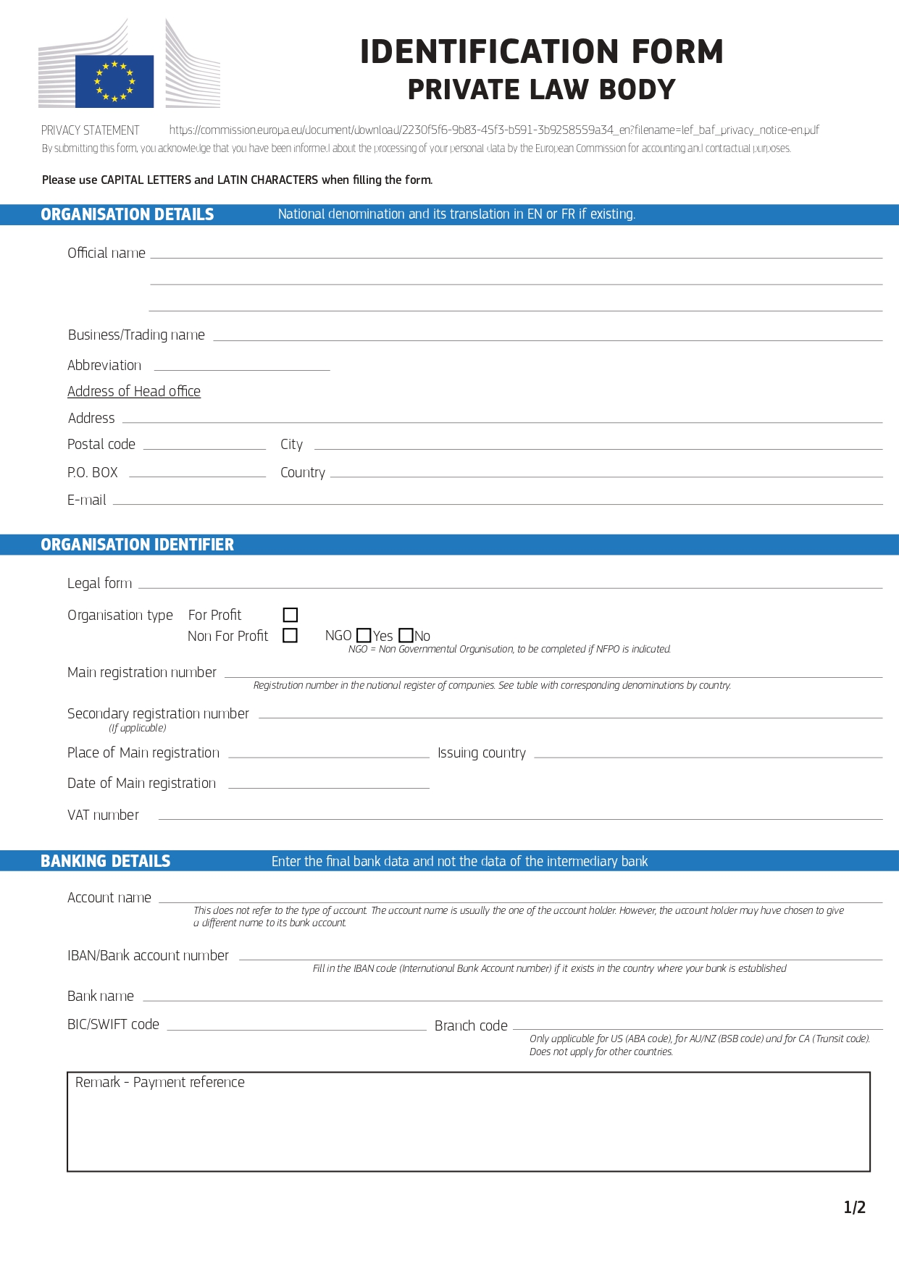

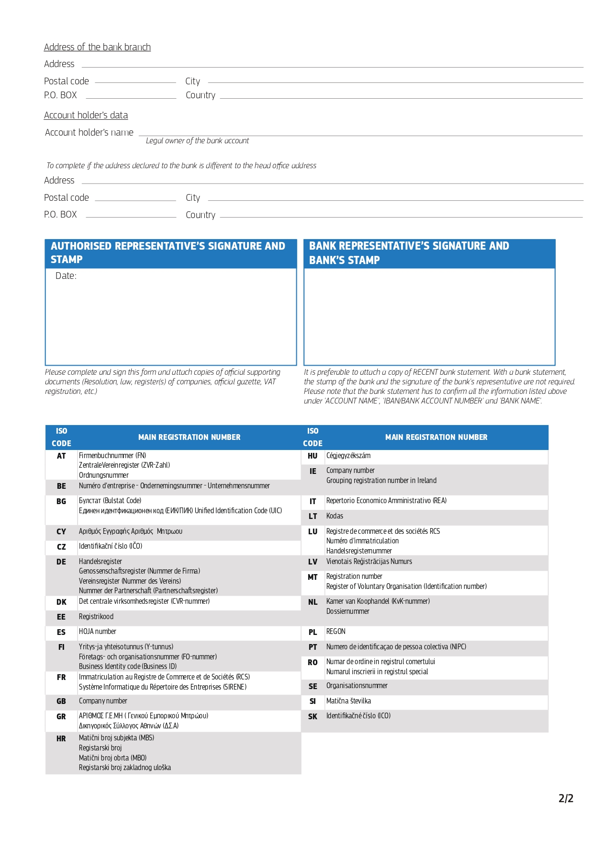

ANNEX V: PRE-FINANCING GUARANTEE FORM
To be completed on paper bearing the letterhead of the financial institution
For the attention of
Indian Ocean Commission
Blue Tower, 3rd Floor, Rue de l’Institut, Ebène, Mauritius
referred to below as the ‘contracting authority’
Subject: Guarantee No <insert number>

Financing guarantee for the repayment of pre-financing payable under contract COI/PSSN/CT/2026/005 SUPPLY, DELIVERY, INSTALLATION, TRAINING, MAINTENANCE SERVICES AND AFTER-SALES SERVICE OF AN APPLICATION SOFTWARE FOR VESSEL TRAFFIC MANAGEMENT INFORMATION SYSTEM (VTMIS) (please quote number and title in all correspondence)
We, the undersigned, <name, and address of financial institution>, hereby irrevocably declare that we guarantee as primary obligor, and not merely as surety on behalf of <contractor's name and address>, hereinafter referred to as ‘the contractor’, the payment to the contracting authority of <indicate the amount of the pre-financing>, corresponding to the pre-financing as mentioned in Article 26.1 of the special conditions of the contract COI/PSSN/CT/2026/005 Supply, delivery, installation, training, maintenance services and after-sales service of an application software for vessel traffic management information system (VTMIS) concluded between the contractor and the contracting authority, hereinafter referred to as ‘the contract’.
Payment shall be made without objection or legal proceedings of any kind, upon receipt of your first written claim (sent by registered letter with confirmation or receipt) stating that the contractor has not repaid the pre-financing on request or that the contract has been terminated. We shall not delay the payment, nor shall we oppose it for any reason whatsoever. We shall not under any circumstances benefit from the defences of the security. We shall inform you in writing as soon as payment has been made.
We accept notably that no amendment to the terms of the contract can release us from our obligation under this guarantee. We waive the right to be informed of any change, addition or amendment of the contract.
We note that the guarantee will be released 30 days at the latest after the provisional acceptance of the goods. . [and in any case at the latest on (at the expiry of 18 months after the period of implementation of the tasks)].

Any request to pay under the terms of the guarantee must be countersigned by the head of delegation of the European Union or his designated empowered deputy as per the applicable Commission rules. In case of a temporary substitution of the contracting authority by the Commission, any request to pay will only be signed by the representative of the Commission, namely whether the head of delegation, his designated empowered deputy or the authorised person at headquarters' level.

The law applicable to this guarantee shall be that of the country in which the financial institution issuing the guarantee is established. Any dispute arising out of or in connection with this guarantee shall be referred to the courts of the country in which the financial institution issuing the guarantee is established.

The guarantee will enter into force and take effect on payment of the pre-financing to the contractor.
Done at [insert place], on [insert date]
Signature: [signature]  Name:  [function at the financial institution/bank] | Signature: [signature]  Name:  [function at the financial institution/bank]

ANNEX A12

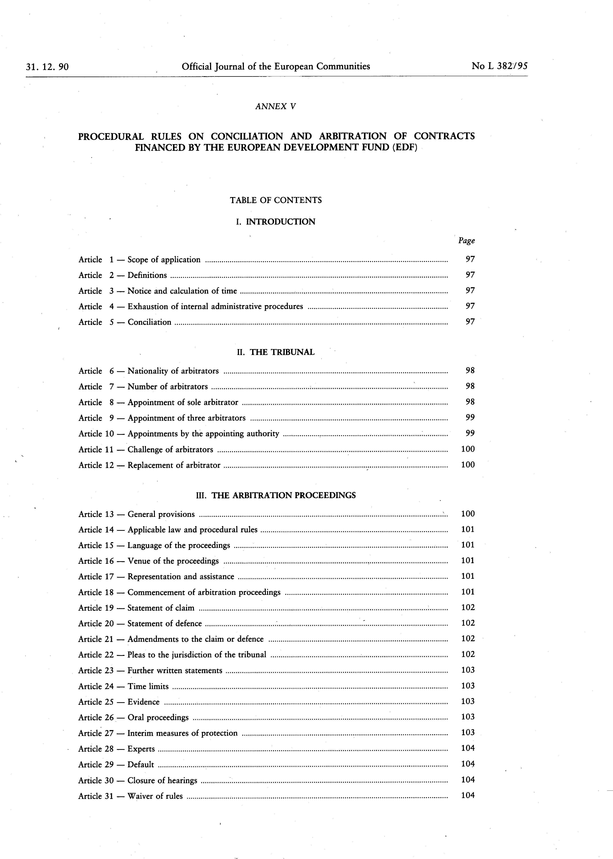

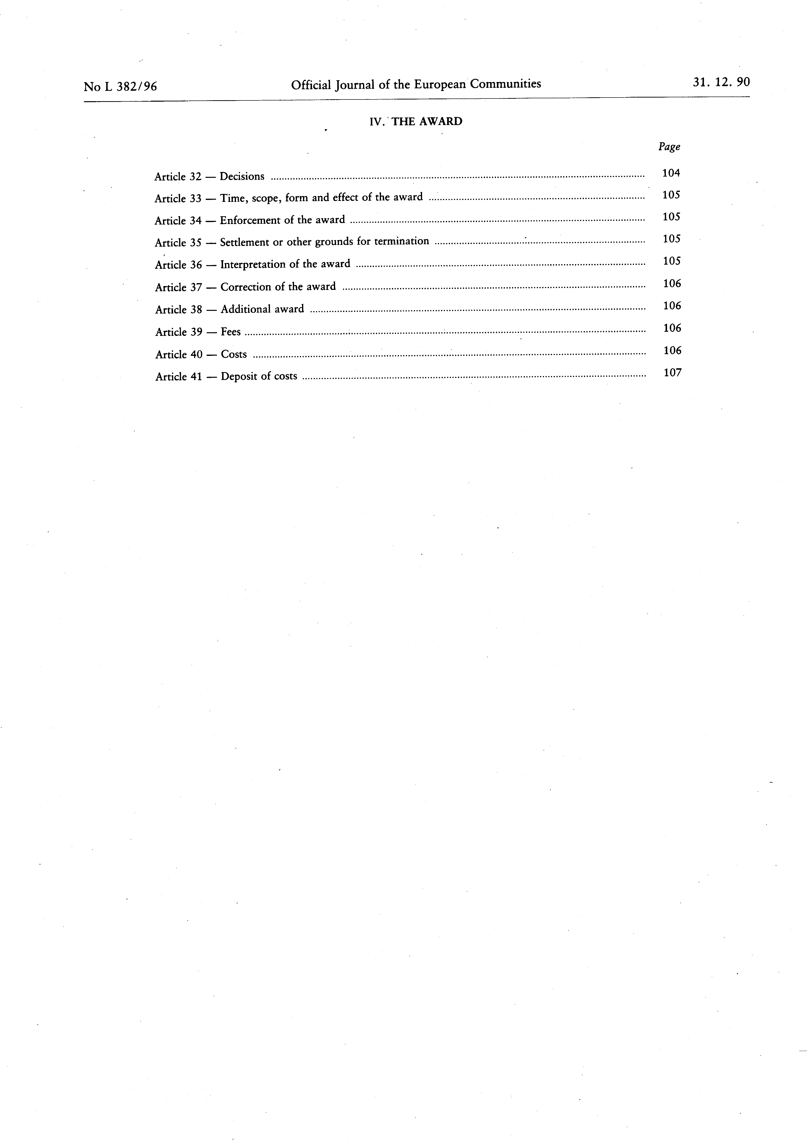

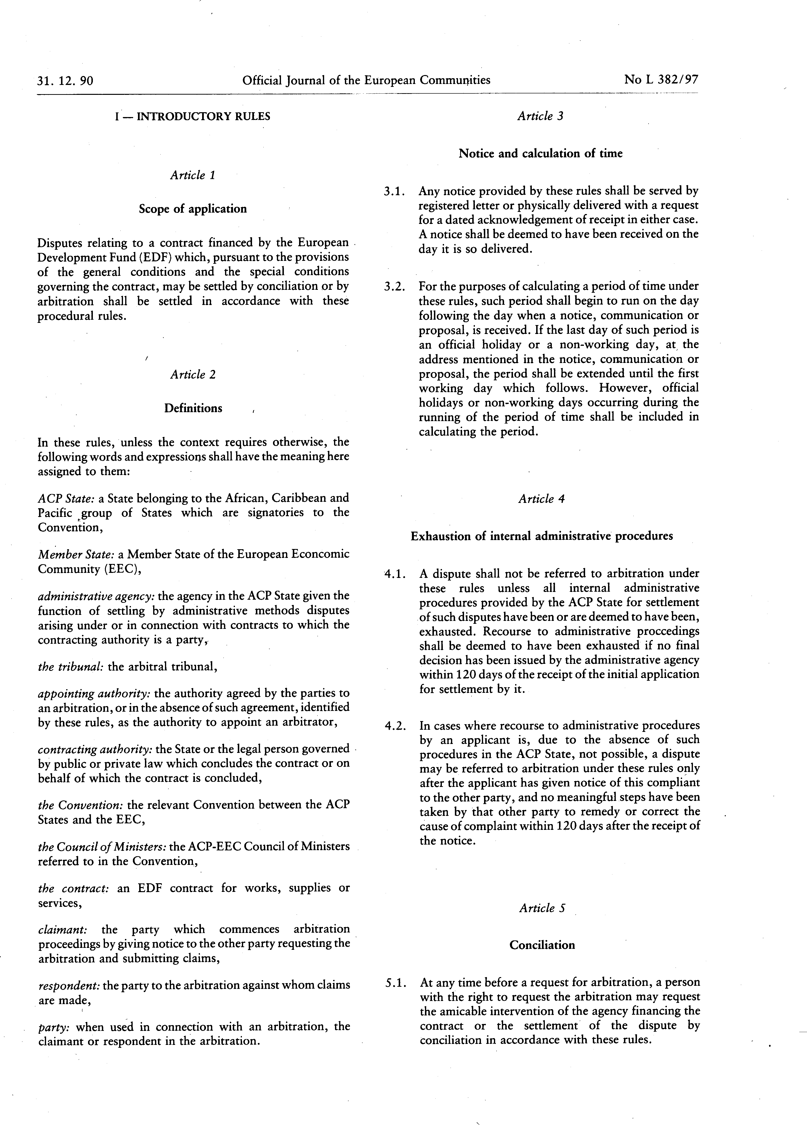

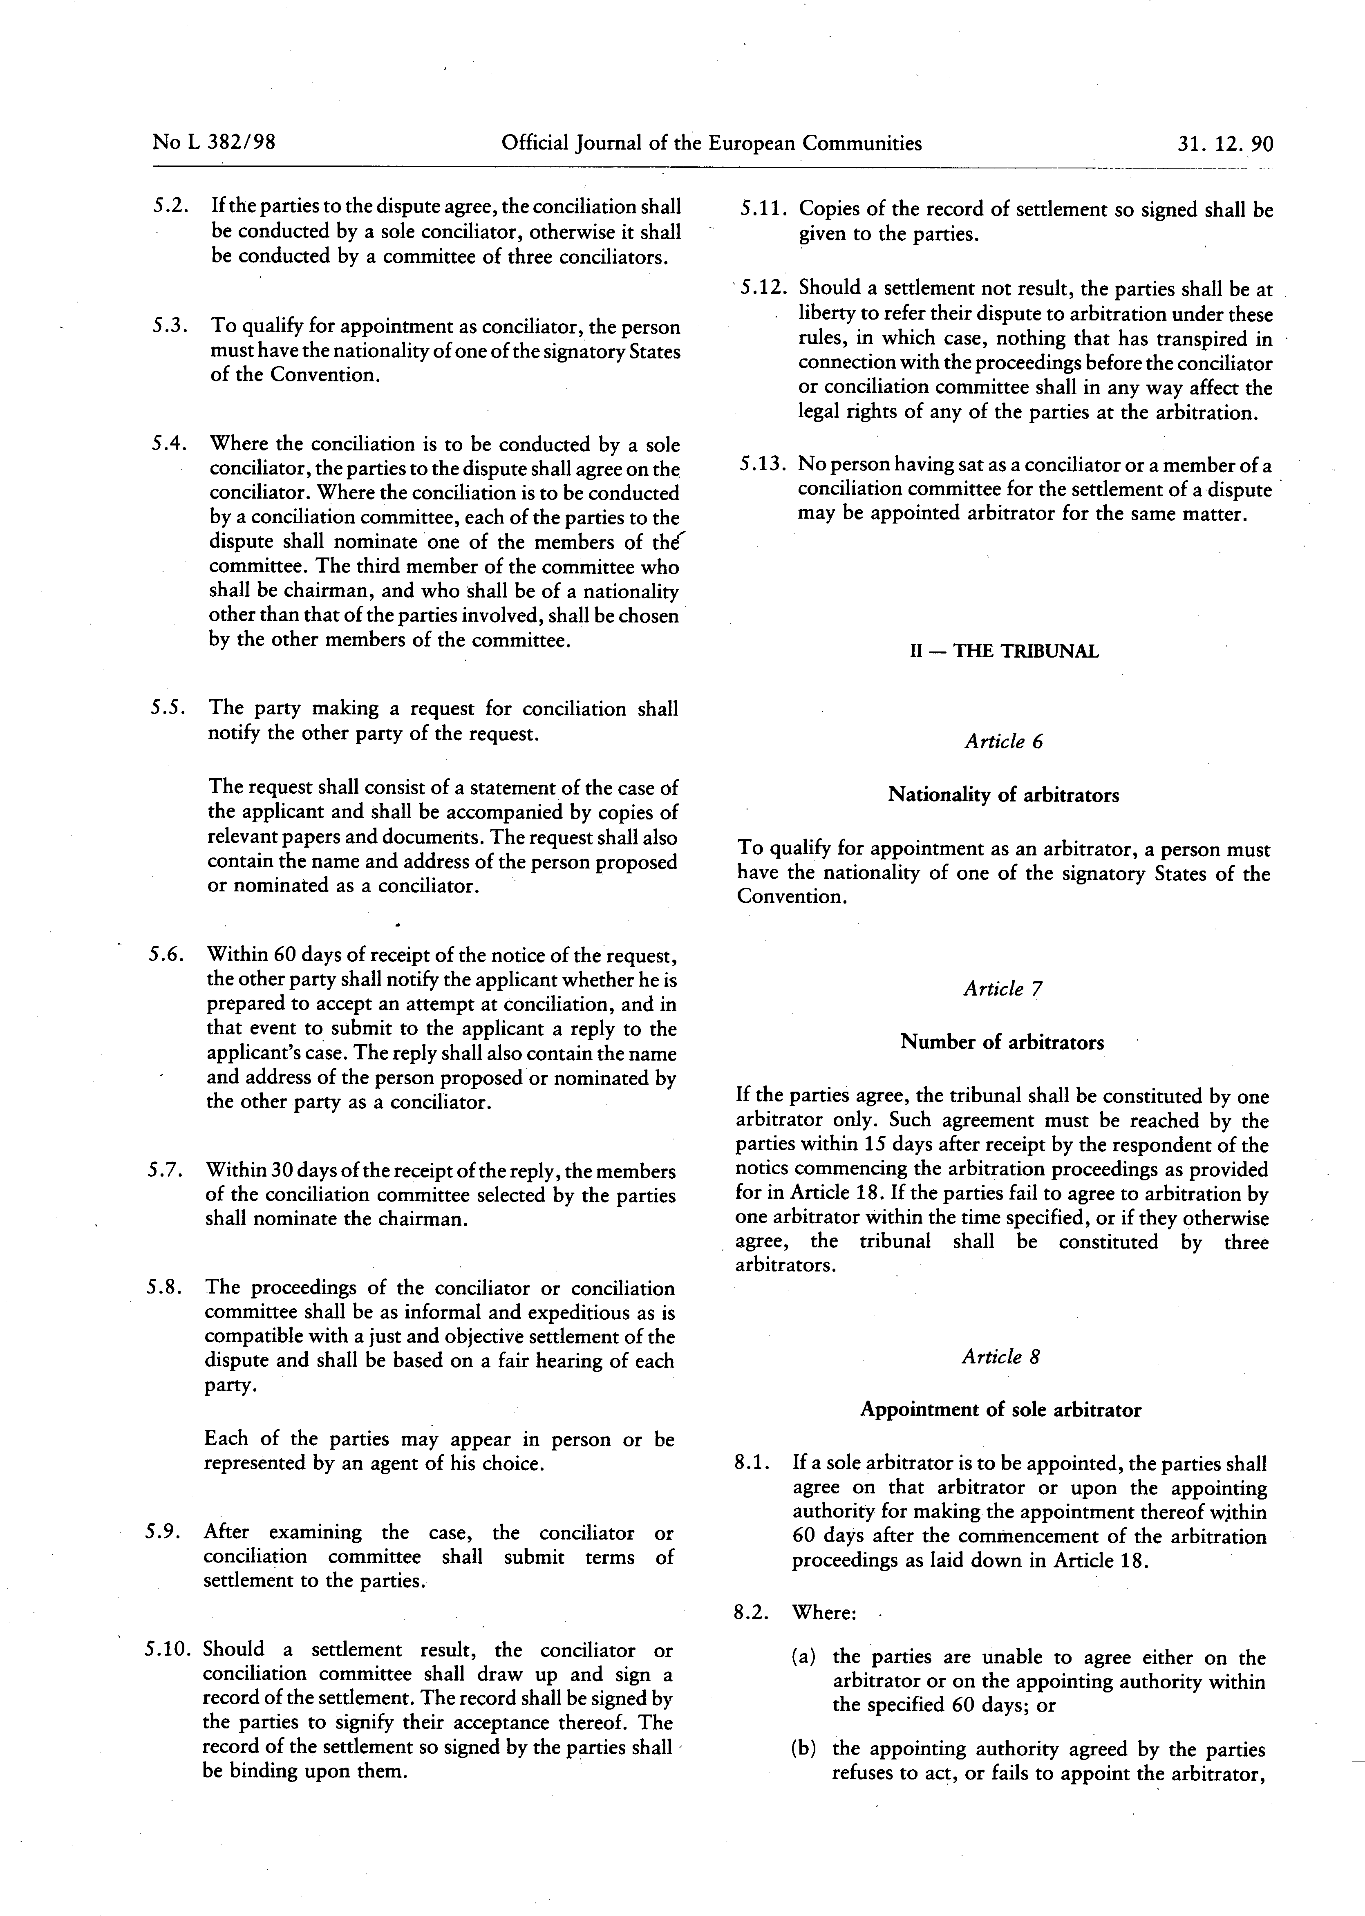

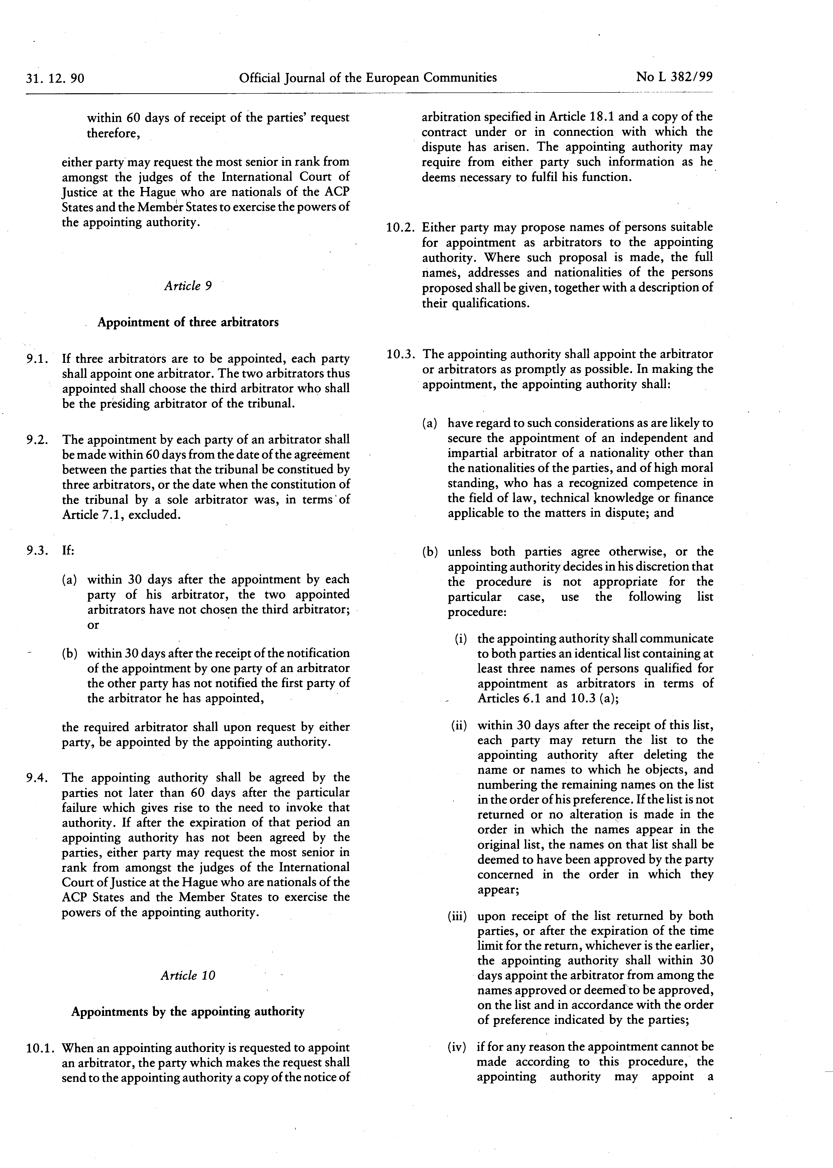

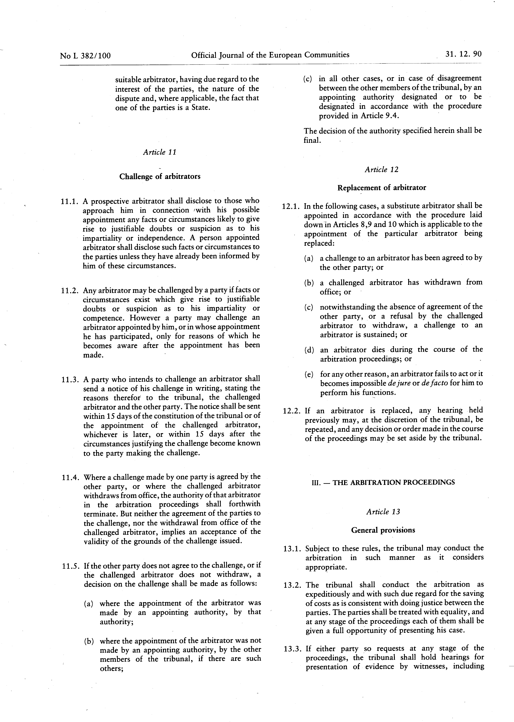

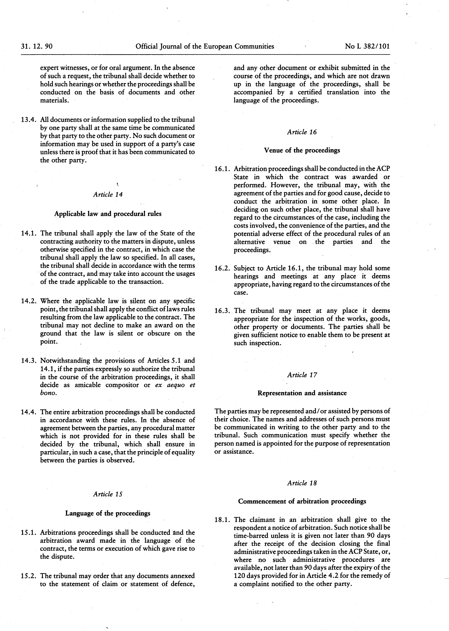

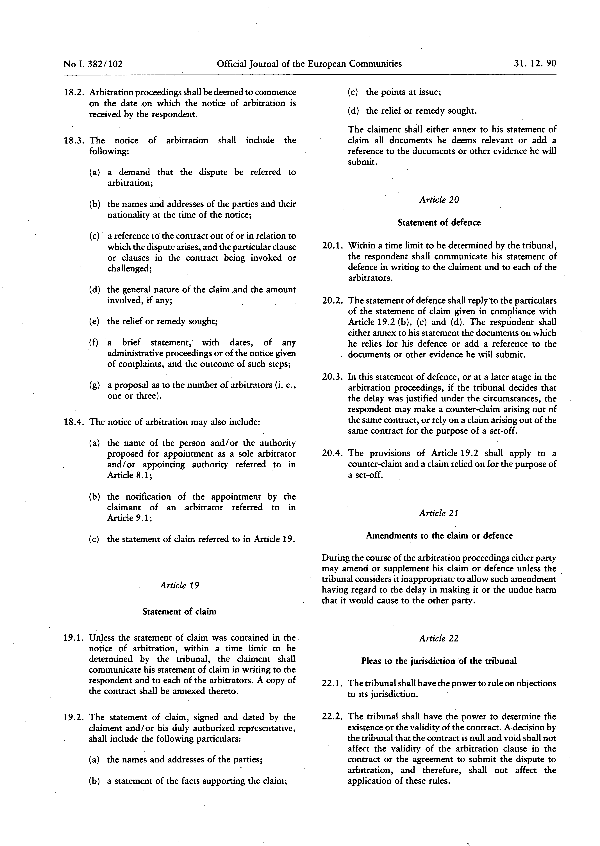

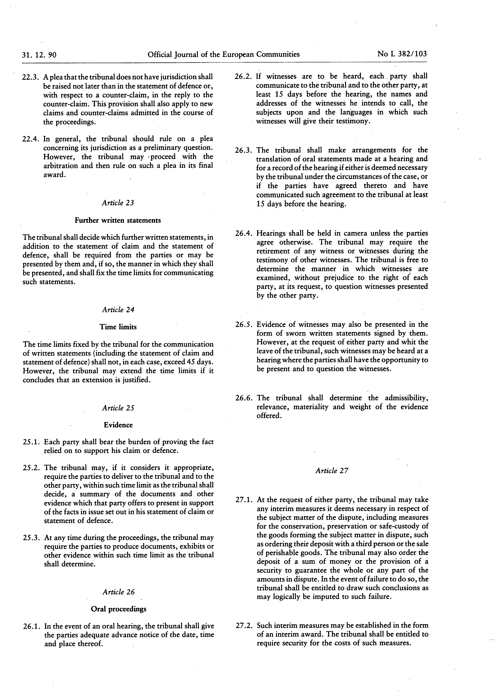

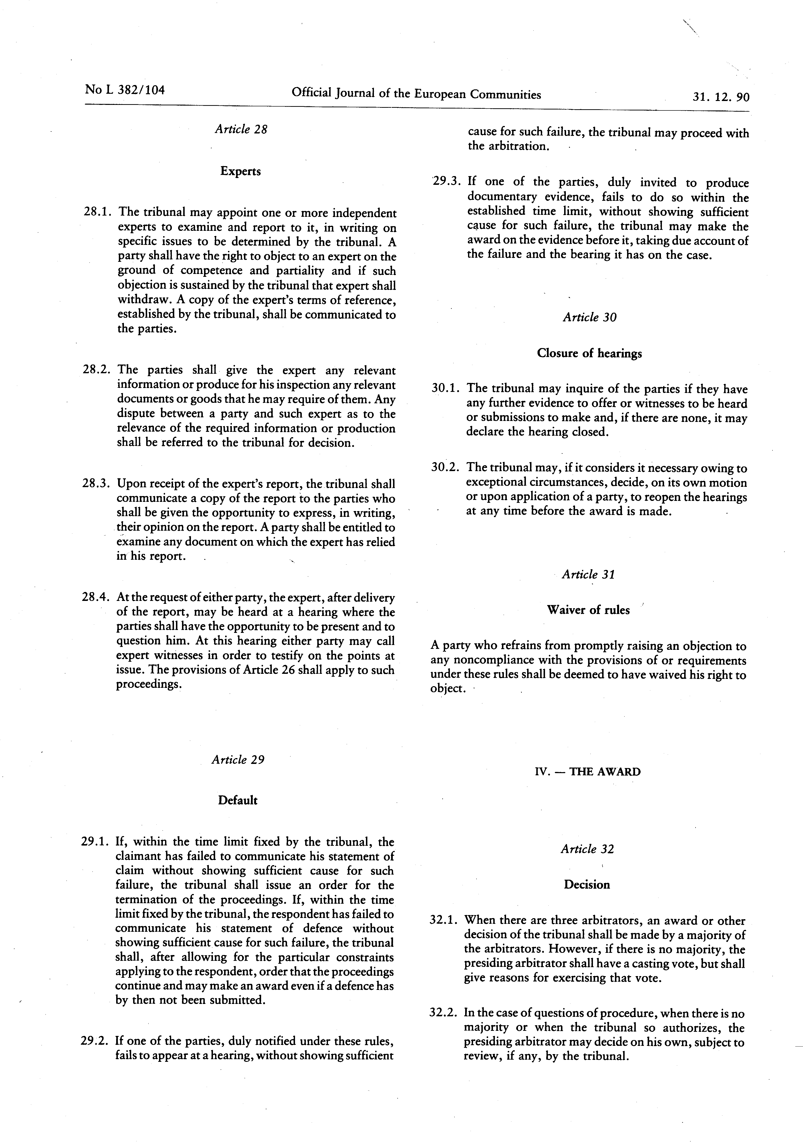

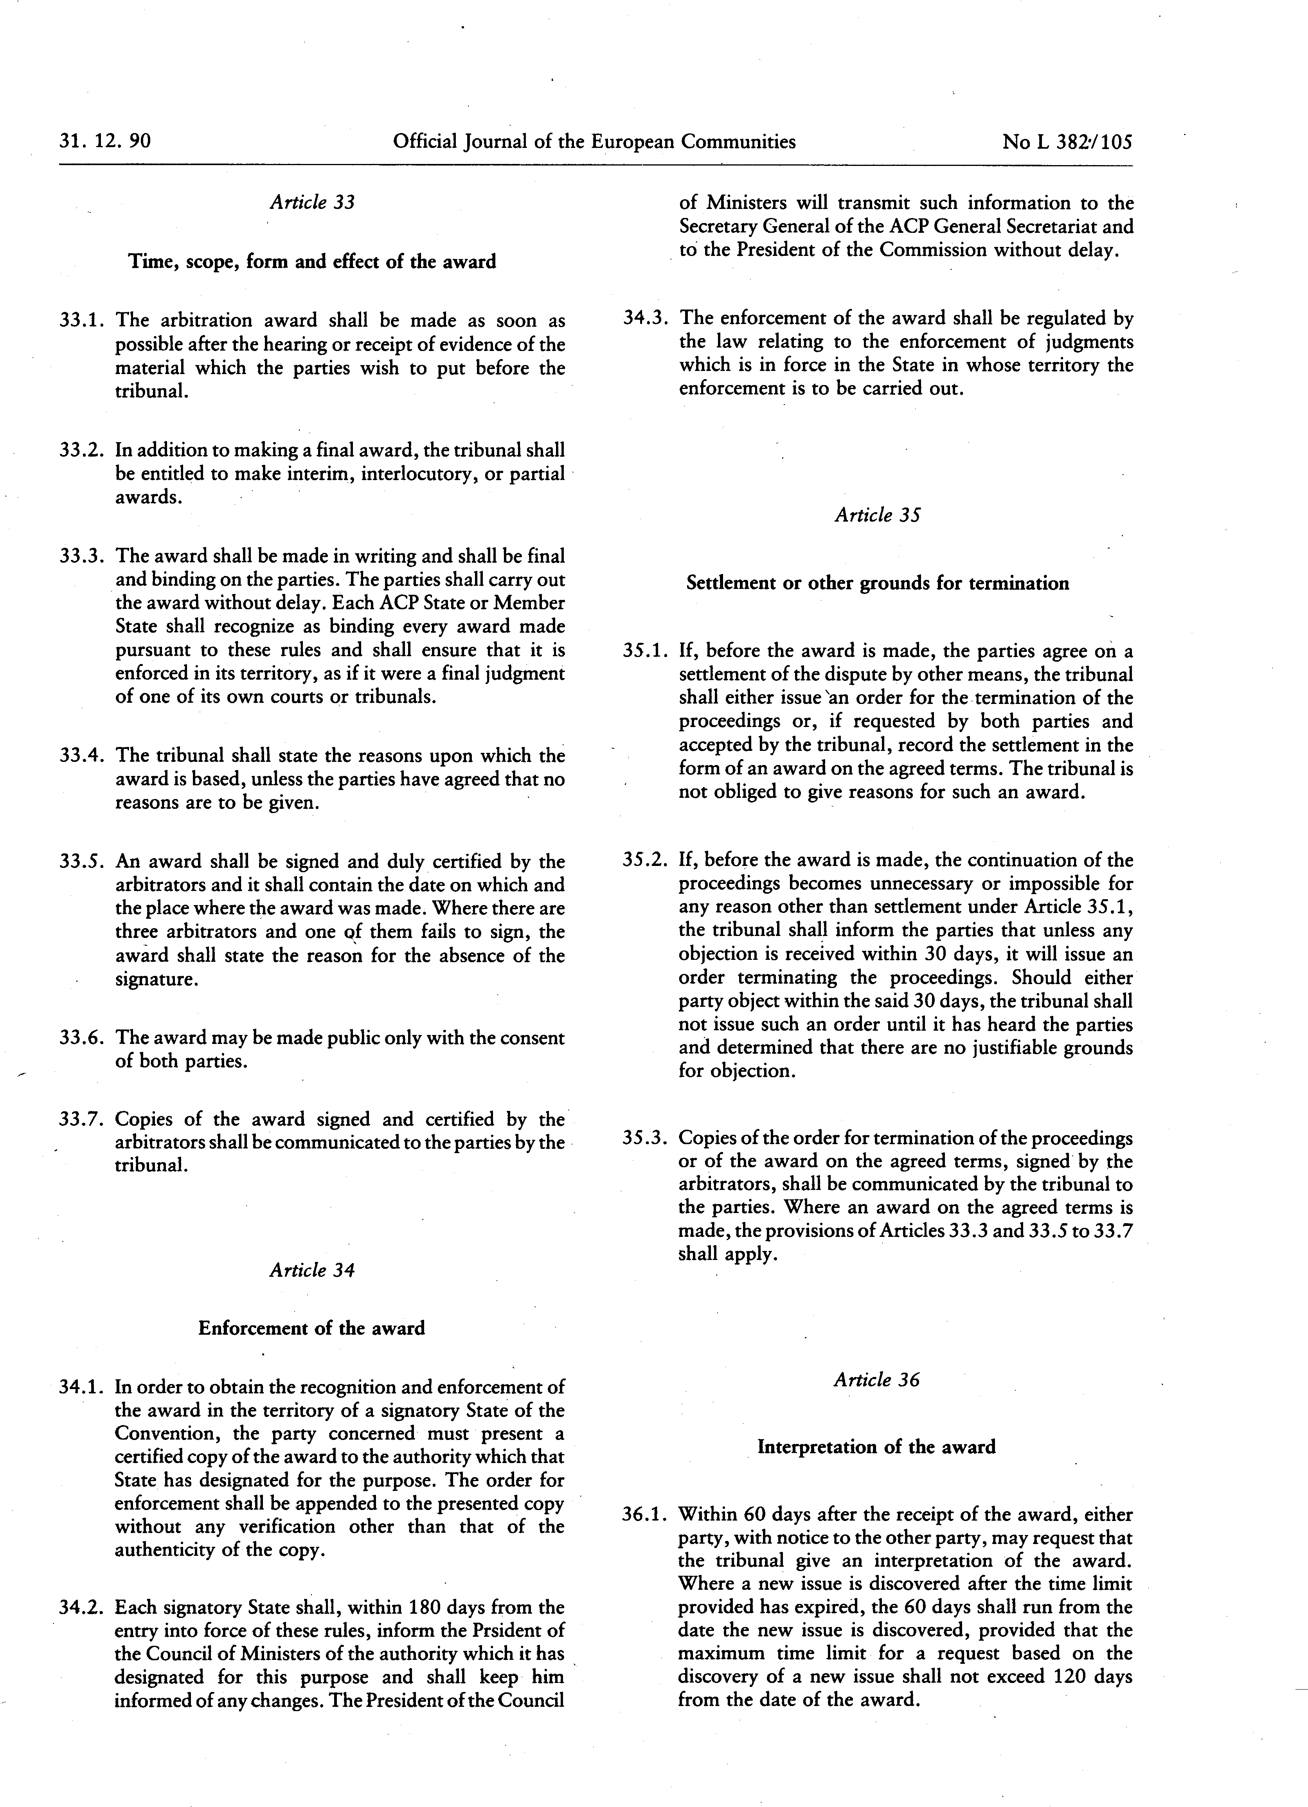

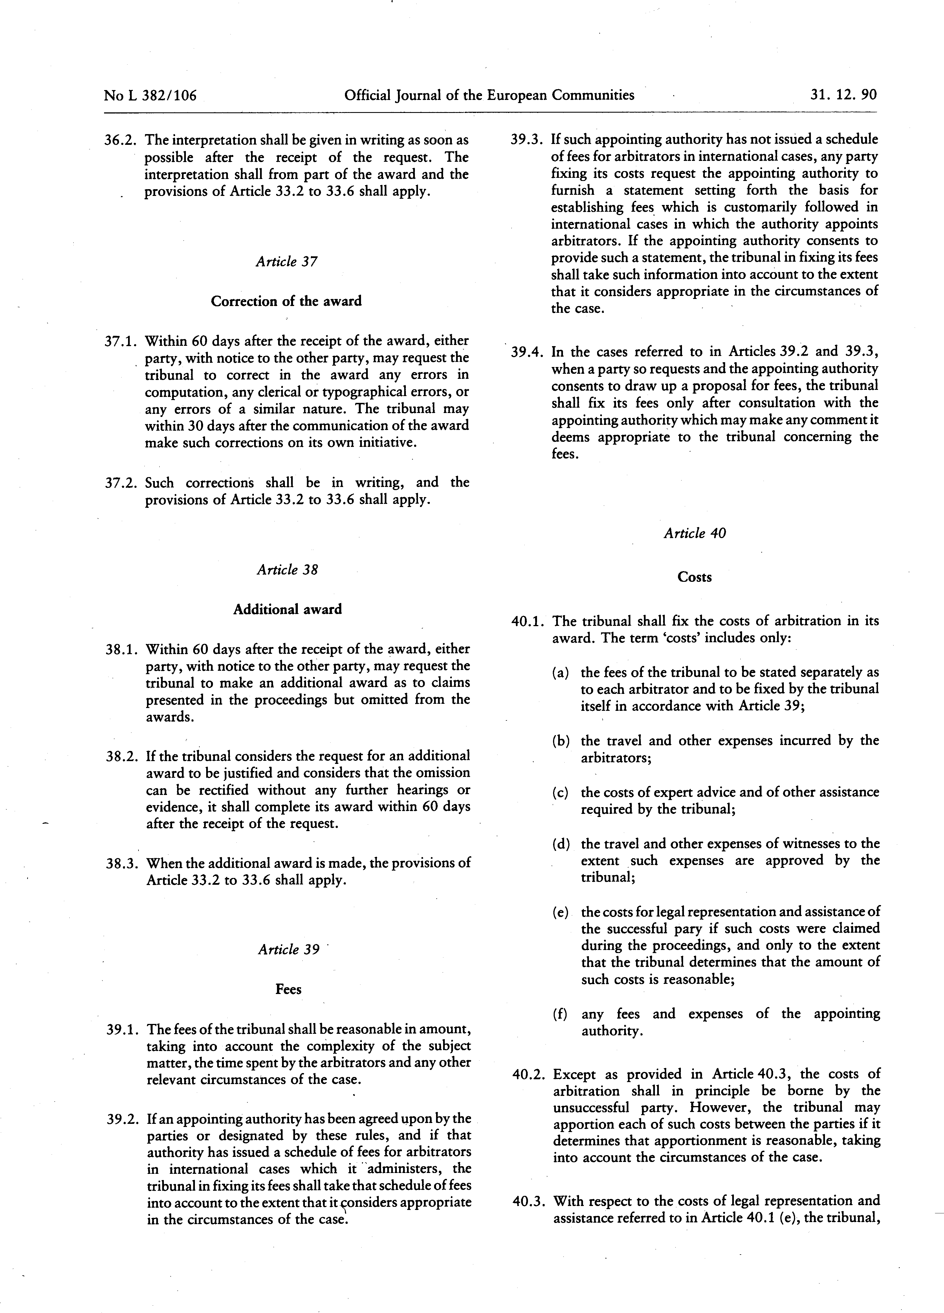

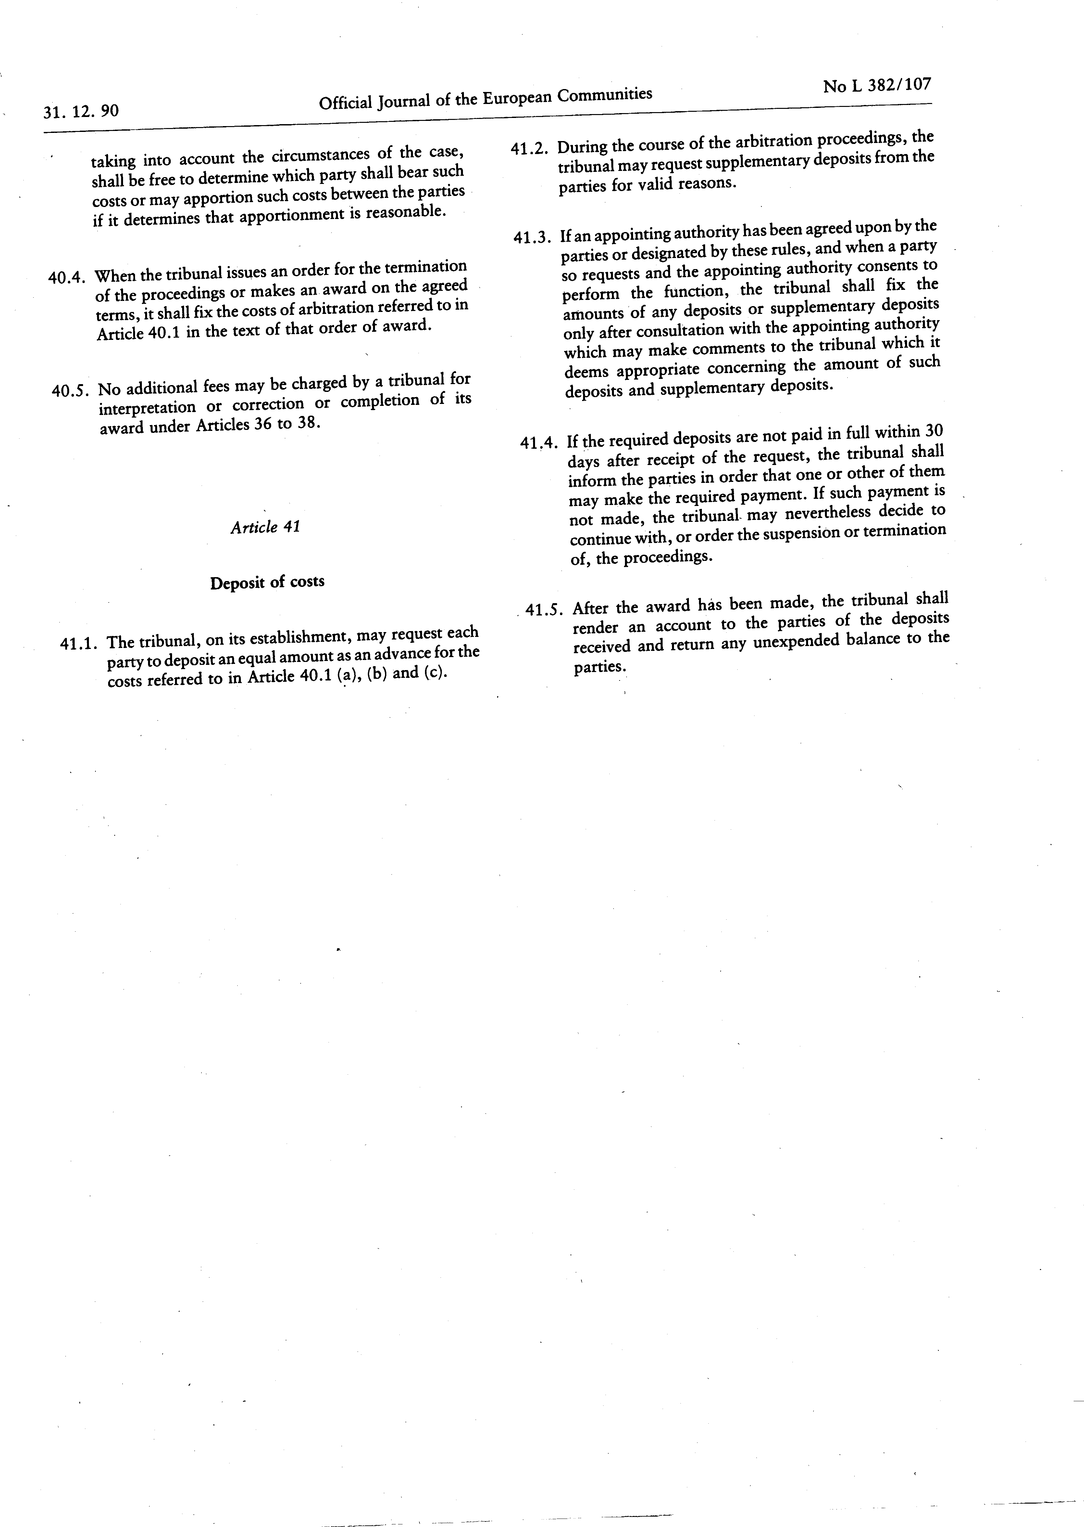

PART C

Others informations

ADMINISTRATIVE COMPLIANCE GRID

Contract title : | SUPPLY, DELIVERY, INSTALLATION, TRAINING, MAINTENANCE SERVICES AND AFTER-SALES SERVICE OF VESSEL TRAFFIC MANAGEMENT INFORMATION SYSTEM (VTMIS) | Publication reference : | COI/PSSN/AO/2026/005

Tender number | Name of tenderer | Electronic submission only: | Is tenderer (consortium) nationality eligible?  (Y/N) | Is documentation complete?  (Y/N) | Is language as required?  (Y/N) | Is tender submission form complete?  (Y/N) | Is tenderer's declaration signed (by all consortium members if a consortium)? (Yes/No/ Not Applicable) | Declaration(s) on honour included? (Yes/No) | Other administrative requirements of the tender dossier?  (Yes/No/Not applicable) | Form FS-PP on financial contributions from non EU Countries  (Yes/No/Not Applicable) | Overall decision?  (Accept / Reject)
1
2
3
4
5
6
7

Chairperson's name
Chairperson's signature
Date

EVALUATION GRID

Contract title : | SUPPLY, DELIVERY, INSTALLATION, TRAINING, MAINTENANCE SERVICES AND AFTER-SALES SERVICE OF AN APPLICATION SOFTWARE FOR VESSEL TRAFFIC MANAGEMENT INFORMATION SYSTEM (VTMIS) | Publication reference : | COI/PSSN/AO/2026/005

Tender No | Name of tenderer | Rules of origin respected?  (additional guidance)  (Y/N) | Economic & financial capacity? (OK/a/b/…) | Professional capacity? (OK/a/b/…) | Technical capacity? (OK/a/b/…) | Compliance with technical specifications? (OK/a/b/…) | Ancillary services as required? (OK/a/b/…/NA) | Subcontracting statement in accordance with art. 6 of the general conditions?  (Y/N) | Other technical requirements in tender dossier?  (Yes/No/Not applicable) | Technically compliant? Y/N) | Justification/  notes:
1
2
3
4

Evaluator's name & signature
Evaluator's name & signature
Evaluator's name & signature
Date

PART D

Tender submission form and Declaration on honour on exclusion criteria and selection criteria

TENDER FORM FOR A SUPPLY CONTRACT

Publication reference: COI/PSSN/AO/2026/005
SUPPLY, DELIVERY, INSTALLATION, TRAINING, MAINTENANCE SERVICES AND AFTER-SALES SERVICE OF AN APPLICATION SOFTWARE FOR VESSEL TRAFFIC MANAGEMENT INFORMATION SYSTEM (VTMIS)<Place and date>

A: INDIAN OCEAN COMMISSION
Blue Tower, 3rd Floor, Rue de l’Institut, Ebène, Mauritius

One signed form must be supplied (for each lot, if the tender procedure is divided into lots), together with the number of copies specified in the instructions to tenderers. The form must include a signed declaration using the annexed format from each legal entity submitting this tender. Any additional documentation (brochure, letter, etc.) sent with the form will not be taken into consideration. Tenders being submitted by a consortium (i.e. either a permanent, legally-established grouping or a grouping which has been constituted informally for a specific tender procedure) must follow the instructions applicable to the consortium leader and its members. The attachments to this submission form (i.e. declarations, statements, proofs) may be in original or copy. If copies are submitted, the originals must be dispatched to the contracting authority upon request. For economical and ecological reasons, we strongly recommend that you submit your files on paper-based materials (no plastic folder or divider). We also suggest you use double-sided print-outs as much as possible.
Capacity-providing entities
An economic operator (i.e. tenderer) may, where appropriate and for a particular contract, rely on the capacities of other entities, regardless of the legal nature of the links which it has with them. If the economic operator relies on other entities it must in that case prove to the contracting authority that it will have at its disposal the resources necessary for the performance of the contract by producing a commitment by those entities to place those resources at its disposal. Such entities, for instance the parent company of the economic operator, must respect the same rules of eligibility and notably that of nationality as the economic operator relying on them and must comply with the selection criteria for which the economic operator relies on them. For the purpose of the present tender, the data for this third entity for the relevant selection criterion should be included in a separate document. Proof of the capacity will also have to be provided when requested by the contracting authority.
With regard to technical and professional criteria, an economic operator may only rely on the capacities of other entities where the latter will perform the tasks for which these capacities are required.
With regard to economic and financial criteria, the entities upon whose capacity the economic operator relies, become jointly and severally liable for the performance of the contract.

1 SUBMITTED BY (i.e the identity of the tenderer and bank account details)
 | Name(s) of tenderer(s) | Official address, postcode, P.O box, city, country | Legal form | VAT number and/or Registration number (if applicable) | Place of main registration (city and country) and date of registration
Leader
Member
Etc …
 | Account name and account holder name | IBAN/Account number | Currency | BIC/Swift code | Bank name and branch code | Address of bank, P.O box, city, country
Leader

2 CONTACT PERSON (for this tender)
Name
Address
Telephone
E-mail
3 ECONOMIC AND FINANCIAL CAPACITY
Please complete the following table of financial data based on your annual accounts and your latest projections. If annual closed accounts are not yet available for the current year or past year, please provide your amounts based on appropriate statements from banks in the columns marked with **. Figures in all columns must be calculated on the same basis to allow a direct, year-on-year comparison to be made (or, if the basis has changed, an explanation of the change must be provided as a footnote to the table). Any clarification or explanation which is judged necessary may also be provided.
Financial data | 2 years before last year  2023  € | Year before last year  2024  € | Last year  2025  € | Average  € | Past year  € ** | Current year  €**
Annual turnover, excluding this contract
Current assets
Current liabilities
[Current ratio (current assets/current liabilities) | Not applicable | Not applicable |  | Not applicable | Not applicable | Not applicable]

4 PERSONNEL
Please provide the following personnel statistics for the current year and the two previous years.
Annual manpower | Year before past year |  | Past year |  | Current year |  | Period average
 | Overall | Relevant fields | Overall | Relevant fields ¹¹ | Overall | Relevant fields¹¹ | Overall | Relevant fields¹¹
Permanent personnel
Other personnel
Total
Permanent personnel as a proportion of total personnel (%) | % | % | % | % | % | % | % %

5 FIELDS OF SPECIALISATION
Please fill in the table below to indicate any areas of specialist knowledge related to this contract of each legal entity making this tender, by using the names of these specialisation as the row headings and the name of the legal entity as the column headings. Indicate the areas of specialist knowledge each legal entity has by placing a tick () in the box corresponding to the specialisation in which the legal entity has significant experience. Maximum 10 specialisations.
 | Leader | Member 2 | Member 3 | Etc …
Relevant specialisation 1
Relevant specialisation 2
Etc …
6 EXPERIENCE
Please complete a table using the format below to summarise the major relevant supplies carried out over the past 3 years by the legal entity or entities making this tender. The number of references to be provided must not exceed 15 for the entire tender.
Candidates are allowed to refer either to projects completed within the reference period (although started earlier) or to projects not yet completed. Only the part completed during the reference period will be taken into consideration. This part will have to be supported by documentary evidence (approval of report or deliverable, proof of payment, statement or certificate from the entity which awarded the contract) also detailing its value. If a candidate has implemented the project in a consortium, the part that the candidate has successfully completed must be clear from the documentary evidence, together with a description of the nature of the services provided if the selection criteria relating to the pertinence of the experience have been used.
Ref # (maximum 15) | Project title |  | …
Name of legal entity | Country | Overall supply value (EUR) | Part supplied by legal entity EUR | No of personnel provided | Name of client | Origin of funding | Dates | Name of members if any
… | … | … | … | … | … | … | … | …
Detailed description of supply |  |  |  |  |  | Related services provided
… |  |  |  |  |  | …

7 TENDERER’S DECLARATION(S)
As part of their tender, each legal entity identified under point 1 of this form, including every consortium member, must submit a signed tenderer’s declaration using this format.
Additionally, each legal entity identified under point 1 of this form, including every consortium member, as well as each capacity providing entity and subcontractor, must submit the declaration on honour on exclusion and selection criteria (Annex 1)
In response to your letter of invitation to tender for the above contract,
we, the undersigned, hereby declare that:
1 We have examined and accept in full the content of the dossier for invitation to tender No <……………………………….> of <date>. We hereby accept its provisions in their entirety, without reservation or restriction.
2 We offer to deliver, in accordance with the terms of the tender dossier and the conditions and time limits laid down, without reserve or restriction, the supplies described in the technical specifications (Annex II + III) for this tender procedure.
3 The price of our tender excluding spare parts and consumables, if applicable, is: <insert price and currency>.
4 Not applicable – this tender procedure is not divided into lots.
5 This tender is valid for a period of 90 days from the final date for submission of tenders.
6 If our tender is accepted, we undertake to provide a performance guarantee as required by Article 11 of the special conditions.
7 Our firm/company [and our subcontractors] has/have the following nationality:
<……………………………………………………………………>
8 We are making this tender in our own right [as member in the consortium led by [< name of the leader >] [ourselves]*. We confirm that we are not tendering for the same contract in any other form. [We confirm, as a member in the consortium, that all members are jointly and severally liable by law for the execution of the contract, that the lead member is authorised to bind, and receive instructions for and on behalf of, each member, that the execution of the contract, including payments, is the responsibility of the lead member, and that all members in the joint venture/consortium are bound to remain in the joint venture/consortium for the entire period of the contract’s execution]. [We, the tenderer, confirm that where we rely on the capacities of other entities with regard to the criteria relating to economic and financial capacity, we have the written commitment made by the capacity providing entities that they are jointly liable for the performance of the contract.]
9 We undertake, if required, to provide the proof usual under the law of the country in which we are effectively established that we do not fall into any of the exclusion situations. The date on the evidence or documents provided will be no earlier than 1 year before the date of submission of the tender and, in addition, we will provide a statement that our situation has not altered in the period which has elapsed since the evidence in question was drawn up.
We also undertake, if required, to provide evidence of financial and economic standing and technical and professional capacity according to the selection criteria for this call for tender specified in the additional information about the contract notice. The documentary proofs required are listed in Section 2.6.11. of the practical guide.
10 We agree to abide by the ethics clauses in Clause 24 of the instructions to tenderers and, in particular, have no conflict of interests or any equivalent relation which may distort competition with other tenderers or other parties in the tender procedure at the time of the submission of this form.
We confirm that we, including all consortium members, if any, capacity providing entities and subcontractors are not in the lists of EU restrictive measures (www.sanctionsmap.eu) and we understand that our tender may be rejected, if proved the contrary.
11 We will inform the contracting authority immediately if there is any change in the above circumstances at any stage during the implementation of the tasks. We also fully recognise and accept that any inaccurate or incomplete information deliberately provided in this tender may result in our exclusion from this and other contracts funded by the EU/EDF.
12 We note that the contracting authority is not bound to proceed with this invitation to tender and that it reserves the right to award only part of the contract. It will incur no liability towards us should it do so.
13 We fully recognise and accept that if the above-mentioned persons participate despite being in any of the situations listed in Section 2.4.2.1 and Section 2.4.1 of the practical guide or if the declarations or information provided prove to be false they may be subject to rejection from this procedure and to exclusion decisions and/or financial penalties up to 10 % of the total estimated value of the contract being awarded and that this information may be published on the European Commission website in accordance with the Financial Regulation in force.
14 We are aware that, for the purposes of safeguarding the EU's financial interests, our personal data and those of all entities involved in the performance of the contract may be transferred to internal audit services, to the early detection and exclusion system, to the European Court of Auditors, to the Financial Irregularities Panel, to the European Anti-Fraud Office or to the European Public Prosecutor’s Office.
15 We agree that any arbitral award resulting from this tender will be published on the European Commission’s website after anonymisation.
[* Delete as applicable]
[If this declaration is being completed by a consortium member:
The following table contains our financial data as included in the consortium’s tender form. These data are based on our annual closed accounts and our latest projections. Estimated figures (i.e. those not included in annual closed accounts) are given in italics. Figures in all columns have been provided on the same basis to allow a direct, year-on-year comparison to be made <except as explained in the footnote to the table>.

Financial data | 2 years before last⁵  2023  EUR | Year before last year  2024  EUR | Last year  2025  EUR | Average⁶  EUR | Past year  EUR] | [Current year  EUR]
Annual turnover ⁷, excluding this contract
Current assets⁸
Current liabilities⁹
[Current ratio (current assets/current liabilities) | Not applicable | Not applicable |  | Not applicable | Not applicable | Not applicable]

The following table contains our personnel statistics as included in the consortium’s tender form:

Annual manpower | Year before past year |  | Past year |  | Current year |  | Period average
 | Overall | Relevant fields¹¹ | Overall | Relevant fields¹¹ | Overall | Relevant fields ¹¹ | Overall | Relevant fields ¹¹
Permanent personnel ¹²
Other personnel ¹³
Total
Permanent personnel as a proportion of total personnel (%) | % | % | % | % | % | % | % | %

Yours faithfully
Name and first name: <…………………………………………………………………>
Duly authorised to sign this tender on behalf of:
<……………………………………………………………………………………>
Place and date: <…………………………………………………………….………….>
Stamp of the firm/company:
This tender includes the following annexes:
<Numbered list of annexes with titles>
ANNEX 1
Declaration on honour on
exclusion criteria and selection criteria
The undersigned [insert name of the signatory of this form], representing:
(only for natural persons) himself or herself | (only for legal persons) the following legal person:
ID or passport number:  (‘the person’) | Full official name:  Official legal form:  Statutory registration number:  Full official address:  VAT registration number:  (‘the person’)

Declaration on honour on exclusion criteria
The person is not required to fill in this Part A of the declaration (Declaration on honour on exclusion criteria) if the same declaration has already been submitted for the purposes of another award procedure of the same contracting authority, provided the situation has not changed, and that the time that has elapsed since the issuing date of the declaration does not exceed one year.
In this case, the signatory declares that the person has already provided the same declaration on exclusion criteria for a previous procedure and confirms that there has been no change in its situation:
Date of the declaration | Full reference to previous procedure

I – Situations of exclusion concerning the person
(to be filled in by all involved entities)

- declares that the person is in one of the following situations: | YES | NO
- it is bankrupt, subject to insolvency or winding-up procedures, its assets are being administered by a liquidator or by a court, it is in an arrangement with creditors, its business activities are suspended or it is in any analogous situation arising from a similar procedure provided for under Union or national law;
- it has been established by a final judgement or a final administrative decision that the person is in breach of its obligations relating to the payment of taxes or social security contributions in accordance with the applicable law;
- it has been established by a final judgement or a final administrative decision that the person is guilty of grave professional misconduct by having violated applicable laws or regulations or ethical standards of the profession to which the person belongs, or by having engaged in any wrongful conduct which has an impact on its professional credibility where such conduct denotes wrongful intent or gross negligence, including, in particular, any of the following:
- fraudulently or negligently misrepresenting information required for the verification of the absence of grounds for exclusion or the fulfilment of eligibility or selection criteria or in the performance of a contract or an agreement;
- entering into agreement with other persons with the aim of distorting competition;
- violating intellectual property rights;
- unduly influence or attempting to unduly influence the decision-making process to obtain Union funds by taking advantage, through misrepresentation, of a conflict of interest involving any financial actors or other persons referred to in Article 61(1) of the EU Financial Regulation;
- attempting to obtain confidential information that may confer upon it undue advantages in the award procedure;
- incitement to discrimination, hatred or violence against a group of persons or a member of a group or similar activities that are contrary to the values on which the Union is founded enshrined in Article 2 TEU, where such misconduct has an impact on the person or entity’s integrity which negatively affects or concretely risks affecting the performance of the legal commitment;
- it has been established by a final judgement that the person is guilty of any of the following:
- fraud, within the meaning of Article 3 of Directive (EU) 2017/1371 and Article 1 of the Convention on the protection of the European Communities' financial interests, drawn up by the Council Act of 26 July 1995;
- corruption, as defined in Article 4(2) of Directive (EU) 2017/1371 or active corruption within the meaning of Article 3 of the Convention on the fight against corruption involving officials of the European Communities or officials of Member States of the European Union, drawn up by the Council Act of 26 May 1997, or conduct referred to in Article 2(1) of Council Framework Decision 2003/568/JHA, or corruption as defined in other applicable laws;
- conduct related to a criminal organisation, as referred to in Article 2 of Council Framework Decision 2008/841/JHA;
- money laundering or terrorist financing, within the meaning of Article 1(3), (4) and (5) of Directive (EU) 2015/849 of the European Parliament and of the Council;
- terrorist offences or offences related to terrorist activities, as defined in Articles 3 to 12 of Directive 2017/541 of the European Parliament and of the Council, respectively, or inciting, aiding, abetting or attempting to commit such offences, as referred to in Article 14 of that Directive;
- child labour or other offences concerning trafficking in human beings as referred to in Article 2 of Directive 2011/36/EU of the European Parliament and of the Council;
- it has shown significant deficiencies in complying with the main obligations in the performance of a contract or an agreement financed by the Union’s budget, which has led to its early termination or to the application of liquidated damages or other contractual penalties, or which has been discovered following checks, audits or investigations by a contracting authority, the European Anti-Fraud Office (OLAF), the Court of Auditors or the EPPO;
- it has been established by a final judgment or final administrative decision that the person has committed an irregularity within the meaning of Article 1(2) of Council Regulation (EC, Euratom) No 2988/95;
- it has been established by a final judgment or final administrative decision that the person or entity has created an entity in a different jurisdiction with the intent to circumvent fiscal, social or any other legal obligations including those related to working rights, employment and labour conditions, in the jurisdiction of its registered office, central administration or principal place of business;.
- (only for legal persons) it has been established by a final judgment or final administrative decision that the person has been created with the intent provided for in point (g).
- the entity or person has intentionally and without proper justification resisted an investigation, check or audit carried out by an authorising officer or its representative or auditor, OLAF, the EPPO, or the Court of Auditors. It shall be considered that the person or entity resists an investigation, check or audit when it carries out actions with the goal or effect of preventing, hindering or delaying the conduct of any of the activities needed to perform the investigation, check or audit. Such actions shall include, in particular, refusing to grant the necessary access to its premises or any other areas used for business purposes, concealing or refusing to disclose information or providing false information.
- declares that, for the situations referred to in points (1) (c) to (1) (i) above, in the absence of a final judgement or a final administrative decision, the person is: | YES | NO
- subject to facts established in the context of audits or investigations carried out by the European Public Prosecutor's Office, the Court of Auditors, or the internal auditor, or any other check, audit or control performed under the responsibility of an authorising officer of an EU institution, of a European office or of an EU agency or body;
- subject to non-final judgments or non-final administrative decisions which may include disciplinary measures taken by the competent supervisory body responsible for the verification of the application of standards of professional ethics;
- subject to facts referred to in decisions of entities or persons being entrusted with EU budget implementation tasks;
- subject to information transmitted by Member States implementing Union funds;
- subject to decisions of the Commission relating to the infringement of Union competition law or of a national competent authority relating to the infringement of Union or national competition law;
- informed, by any means, that it is subject to an investigation by the European Anti-Fraud office (OLAF): either because it has been given the opportunity to comment on facts concerning it by OLAF, or it has been subject to on-the-spot checks by OLAF in the course of an investigation, or it has been notified of the opening, the closure or of any circumstance related to an investigation of the OLAF concerning it.

II – Situations of exclusion concerning natural or legal persons with power of representation, decision-making or control over the legal person and beneficial owners
Not applicable when ‘the person’ is a natural person, a Member State or a local authority. In all other cases to be filled in by all involved entities³⁵.
- declares that a natural or legal person who is a member of the administrative, management or supervisory body of the above-mentioned legal person, or who has powers of representation, decision or control with regard to the above-mentioned legal person (this covers e.g. company directors, members of management or supervisory bodies, and cases where one natural or legal person holds a majority of shares), or a beneficial owner of the person (as referred to in point 6 of article 3 of Directive (EU) No 2015/849) is in one of the following situations: | YES | NO | N/A
Situation (1)(c) above (grave professional misconduct)
Situation (1)(d) above (fraud, corruption or other criminal offence)
Situation (1)(e) above (significant deficiencies in performance of a contract )
Situation (1)(f) above (irregularity)
Situation (1)(g) above (creation of an entity with the intent to circumvent legal obligations)
Situation (1)(h) above (person created with the intent to circumvent legal obligations)

III – Situations of exclusion concerning natural or legal persons assuming unlimited liability for the debts of the legal person
Not applicable when ‘the person’ is a natural person, a Member State, a local authority or legal persons with limited liability. In all other cases to be filled in by all involved entities³⁵.

- declares that a natural or legal person that assumes unlimited liability for the debts of the above-mentioned legal person is in one of the following situations [If yes, please indicate in annex to this declaration which situation and the name(s) of the concerned person(s) with a brief explanation]: | YES | NO | N/A
Situation (a) above (bankruptcy)
Situation (b) above (breach in payment of taxes or social security contributions)

IV – Other Grounds for rejection from this procedure
(to be filled in individually by the sole candidate/tenderer or all members in case of a joint request to participate/tender (consortium))

- declares that the above-mentioned person: | YES | NO
- Was previously involved in the preparation of the procurement documents used in this award procedure, where this entailed a breach of the principle of equality of treatment including distortion of competition that cannot be remedied otherwise.
- Has professional conflicting interests which may negatively affect the performance of the contract in accordance with point 20.6 of Annex I of the EU Financial Regulation.
- Is the addressee of a decision prohibiting the award of the contract for having received foreign subsidies distorting the internal market adopted by the Commission.

V – Remedial measures
If the person declares one of the situations of exclusion listed above, it may indicate remedial measures it has taken to remedy the exclusion situation, in order to allow the authorising officer to determine whether such measures are sufficient to demonstrate its reliability. The person or entity shall submit remedial measures that have been assessed by an external independent auditor or be considered sufficient by a decision of a national or Union authority. This is without prejudice to the assessment of the panel referred to in Article 145 of the EU Financial Regulation. This may include e.g. technical, organisational and personnel measures to prevent further occurrence, compensation of damage or payment of fines or of any taxes or social security contributions. The relevant documentary evidence which illustrates the remedial measures taken must be provided in annex to this declaration. This does not apply for situations referred in point (1)(d) of this declaration.

VI–evidence on exclusion criteria
The tender documents set out in detail which involved entities must provide the appropriate evidence to prove that they are not in an exclusion situation referred to in (1) and when the evidence needs to be provided.
The following could serve as evidence:
- For situations described in (1): (a), (c), (d), (f), (g) and (h) above, production of a recent extract from the judicial record is required or, failing that, an equivalent document recently issued by a judicial or administrative authority in the country of establishment of the person showing that those requirements are satisfied.
- For the situation described in point (1) (a), (b), production of recent certificates issued by the competent authorities of the country of establishment. These documents must provide evidence covering all taxes and social security contributions for which the person is liable, including for example, VAT, income tax (natural persons only), company tax (legal persons only) and social security contributions. Where any document described above is not issued in the country concerned, it may be replaced by a sworn statement made before a judicial authority or notary or, failing that, a solemn statement made before an administrative authority or a qualified professional body in its country of establishment.
The person is not required to submit the evidence if it has already been submitted for another award procedure of the same contracting authority. The documents must have been issued no more than one year before the date of their request by the contracting authority and must still be valid at that date.
The signatory declares that the person has already provided the documentary evidence for a previous procedure and confirms that there has been no change in its situation:
Document | Full reference to previous procedure
Insert as many lines as necessary.
The person is not required to submit the evidence if it can be accessed on a national database free of charge.
The signatory declares that the following internet address of the database/identification data provide access to the evidence required.
Internet address of the database | Identification data of the document
Insert as many lines as necessary.

Declaration on honour on selection criteria
In case of a procedure with lots the statements in this part B apply to the lot(s) for which the request to participate/tender is submitted.

I – Selection criteria
Selection criteria applicable to the candidate/tenderer as a whole- Consolidated assessment
(to be filled in ONLY by the sole candidate/tenderer or the group leader in case of a joint request to participate/tender (consortium))
The person, being a sole candidate/tenderer/the group leader of in case of a joint request to participate/tender (consortium), submitting a request to participate/tender for the above procedure

- declares that the candidate/tenderer, including all members of the group in case of a joint request to participate/tender (consortium), subcontractors and entities on whose capacity the candidate/tenderer intends to rely if applicable: | YES | NO | N/A
- fulfils all the selection criteria for which a consolidated assessment will be made as provided in the tender documents.

II - Selection Criteria –professional conflicting interests
(to be filled in by all involved entities)
The person, being a sole candidate/tenderer/ a member of a joint request to participate/tender (consortium)/a subcontractor/ an entity on whose capacity a candidate/tenderer relies to fulfil the selection criteria, submitting/participating in a request to participate/tender for the above procedure:

- declares that the person | YES | NO
- is subject to conflicting interests which may negatively affect the contract performance.

VIII – Evidence on selection criteria
The tender documents set out in detail the evidence and the time frame within which involved entities must provide it in order to prove that the candidate/tenderer fulfils the selection criteria.
Where the evidence is not required to be provided with the request to participate/tender, the person is invited to prepare in advance the documents related to the evidence, since the contracting authority will request the presumed successful tenderer to provide such evidence within a short deadline.
The person is not required to submit the evidence if it has already been submitted for another procurement procedure of the same contracting authority and the documents are still up-to-date.
The signatory declares that the person has already provided the documentary evidence for a previous procedure and confirms that there has been no change in its situation:
Document | Full reference to previous procedure
Insert as many lines as necessary.
The person is not required to submit the evidence if it can be accessed on a national database free of charge.
The signatory declares that the following internet address of the database/identification data provide access to the evidence required.
Internet address of the database | Identification data of the document
Insert as many lines as necessary.

C - Declaration on honour on established debt to the union
(to be filled in by the sole candidate/tenderer or each group member in case of a joint request to participate/tender (consortium))
The person, being a sole candidate/tenderer/a member in case of a joint request to participate/tender (consortium), submitting a request to participate/tender for the above procedure:
- declares that the person, | YES | NO
- has an established debt to the Union, European Atomic Energy Community or an executive agency when the latter implements the Union budget.

Declaration on honour on submitted tender
(to be filled in individually by the sole candidate/ tenderer, or the group leader in case of a joint request to participate/tender (consortium))
In case of a procedure with lots the statements in this part D apply to the lot(s) for which the request to participate/tender is submitted.
- declares that the person: | YES | NO
- [has prepared the submitted tender] [undertakes to prepare the tender (if invited to submit a tender)] in complete independence and autonomously from the other tenders submitted within the same procurement procedure.

The person must immediately inform the contracting authority of any changes in the situations as declared.

The person may be subject to rejection from this procedure and to administrative sanctions (exclusion or financial penalty) if any of the declarations or information provided as a condition for participating in this procedure prove to be false.

Full name Date Signature

ANNEX – MODEL PROVISIONAL / FINAL ACCEPTANCE CERTIFICATE
(delete not applicable)
Contract No ………… Title ……………………………………………………
Contractor: ……………… Beneficiary: ………………
………………………… …………………………
Item | qty | Description | Delivery | [Installation] | [Spare Parts] | [Consumables] | [(Manuals] | [Training] | Remarks
1 | <…> | <………………>
2 | <…> | <………………>
3 | <…> | <………………>
4 | <…> | <………………>

Provisional: All of the above mentioned items have been delivered, installed, tested and found compliant with the technical specifications of the supply contract. The contractor has also demonstrated that the obligations in the Communication and Visibility Manual have been complied with Article 9.9 of the general conditions.
Final: The contractor has remedied any defect or damage occurred during the warranty period, as specified in the contract.
(delete not applicable)
Date of acceptance: ………………
The contractor The beneficiary
Name Name
Signature ……………… Signature ………………
The project manager (contracting authority)
Name
Signature ………………

Please note that the EU Official Journal contains the official list of entities subject to restrictive measures and, in case of conflict, it prevails over the list of the EU Sanctions Map.
See PRAG Section 2.4.2.3.(1)
The currency of tender shall be the currency of the contract and of payment
It is recommended to use registered mail in case the postmark would not be readable
Regulation (EU, Euratom) 2024/2509 of the European Parliament and of the Council of 23 September 2024 on the financial rules applicable to the general budget of the Union (recast), PE/99/2023/REV/1, OJ L, 2024/2509, 26.9.2024, ELI: http://data.europa.eu/eli/reg/2024/2509/oj.
Provided it is a freely convertible currency.
<DDP (Delivered Duty Paid)> - Incoterms 2020 International Chamber of Commerce - http://www.iccwbo.org/incoterms/
OJ L 205 of 21.11.2018, p. 39
This mention has to be inserted only where required, for example where the law applicable to the guarantee imposes a precise expiry date or where the guarantor can justify that he is unable to provide such a guarantee without expiry date.
The name(s) and position(s) of the persons signing on behalf of the guarantor must be shown in printed characters. Can be signed using a Qualified Electronic Signature (QES). Please note that only the qualified electronic signature (QES) within the meaning of Regulation (EU) No 910/2014 (eIDAS Regulation) will be accepted.
The name(s) and position(s) of the persons signing on behalf of the guarantor must be shown in printed characters. Can be signed using a Qualified Electronic Signature (QES). Please note that only the qualified electronic signature (QES) within the meaning of Regulation (EU) No 910/2014 (eIDAS Regulation) will be accepted.
This mention has to be inserted only where required, for example where the law applicable to the guarantee imposes a precise expiry date or where the guarantor can justify that he is unable to provide such a guarantee without expiry date.
The name(s) and position(s) of the persons signing on behalf of the guarantor must be shown in printed characters. Can be signed using a Qualified Electronic Signature (QES). Please note that only the qualified electronic signature (QES) within the meaning of Regulation (EU) No 910/2014 (eIDAS Regulation) will be accepted.
The name(s) and position(s) of the persons signing on behalf of the guarantor must be shown in printed characters. Can be signed using a Qualified Electronic Signature (QES). Please note that only the qualified electronic signature (QES) within the meaning of Regulation (EU) No 910/2014 (eIDAS Regulation) will be accepted.
If the tender has been submitted by a consortium, the nationalities of all the consortium members must be eligible.
Applicable only to contracts financed by a basic act under the MFF 2014-2020 (contracts/lots above EUR 100 000 under CIR and independently of the value for other instruments).
The selection criteria, in the previous section of this form, have to be met before the technical requirements are assessed.
In case the tenderer is an individual, mention the nationality of the individual.
Add/delete additional lines for members as appropriate. Note that capacity providing entity/ subcontractors are not considered to be a member for the purposes of this tender procedure. Subsequently, the data on capacity providing entities/ subcontractor must not appear in the data related to the economic, financial and professional capacity but on a separate document. If this tender is being submitted by an individual tenderer, the name of the tenderer should be entered as ‘leader’ (and all other lines should be deleted). Any change in the identity of the leader and/or any consortium members between the deadline for receipt of requests to participate indicated in the contract notice and the award of the contract is not permitted without the prior written authorisation of the contracting authority.
Add only the bank account details of the leader to whom payments under the proposed contract should be made in the event that you are awarded the contract.
Natural persons have to prove their capacity in accordance with the selection criteria and by the appropriate means.
If this tender form is submitted by a consortium, the data in the table above must be the sum of the data in the corresponding tables in the declarations provided by the consortium members — see point 7 of this tender form. Consolidated data are not requested for financial ratios.
Last year=last accounting year for which the entity's accounts have been closed.
Amounts entered in the ‘Average’ column must be the mathematical average of the amounts entered in the three preceding columns of the same row.
The gross inflow of economic benefits (cash, receivables, other assets) arising from the ordinary operating activities of the enterprise (such as sales of goods, sales of services, interest, royalties, and dividends) during the year.
A balance sheet account that represents the value of all assets that are reasonably expected to be converted into cash within one year in the normal course of business. Current assets include cash, accounts receivable, inventory, marketable securities, prepaid expenses and other liquid assets that can be readily converted to cash.
A company's debts or obligations that are due within one year. Current liabilities appear on the company's balance sheet and include short term debt, accounts payable, accrued liabilities and other debts.
If this tender is submitted by a consortium, the data in the table above must be the sum of the data in the corresponding tables in the declarations provided by the consortium members — see point 7 of this tender form. Consolidated data are not requested for financial ratios.
Corresponding to the relevant specialisations identified in point 5 below.
Personnel directly employed or otherwise legally contracted by the tenderer on a permanent basis (i.e. under indefinite contracts).
Other personnel directly employed or otherwise legally contracted by the tenderer on a non-permanent basis (i.e. under fixed-term contracts).
add/delete additional lines and/or rows as appropriate. If this tender is being submitted by an individual legal entity, the name of the legal entity should be entered as ‘Leader’ (and all other columns should be deleted).
References must be contracts implemented by the legal entity (or legal entities) submitting the-tender form (with the exception of documented cases of company buyout or universal succession). For framework contracts, only specific contracts corresponding to assignments implemented under such framework contracts will be considered.
Amounts actually paid, without the effect of inflation.
Please note that the EU Official Journal contains the official list of entities subject to restrictive measures and, in case of conflict, it prevails over the list of the EU Sanctions Map.
An “involved entity” is each economic operator involved in the request to participate/tender. This includes the following four categories of economic operators: - sole candidate/tenderer; - group members (including group leader) in case of a joint request to participate/tender (consortium); - identified subcontractors; and - other entities (that are not subcontractors) on whose capacity the candidate/tenderer relies to fulfil the selection criteria.
The declaration under this point (2) is voluntary and it cannot have adverse legal effect on the economic operator until the conditions of Article 143(1) (a) Financial Regulation are met.
The declaration is to be signed with: - Electronic signature (recommended option): In case you have the possibility to sign the declaration using a qualified electronic signature (QES), please have it signed electronically by your authorised representative(s). Please note that only the qualified electronic signature (QES) within the meaning of Regulation (EU) No 910/2014 (eIDAS Regulation) will be accepted. Before sending back your electronically signed document, please check the signature and validity of the certificate with one of the following tools: - DSS Demonstration validation tool available at https://ec.europa.eu/cefdigital/DSS/webapp-demo/validation can help you check the validity of a certificate by indicating the number and type of valid signatures in a document. - EU Trusted List Browser can be consulted in order to check whether the electronic signature provider and the trust service it provides are part of European Union Trusted List: https://esignature.ec.europa.eu/efda/tl-browser/#/screen/home To make sure you use a QES compliant to eIDAS Regulation, you need to check that both the service provider and the qualified certificate generation service used are included in the EU Trusted List Browser. - Handwritten signature: In case you do not have the possibility to sign the declaration using a qualified electronic signature (QES), please fill it in electronically, then print it and have it signed and dated by your authorised representative(s) using a hand-written signature.

