TERMS OF REFERENCE

For

PROCUREMENT OF ICT INFRASTRUCTURE
FOR
VTMIS

Table of Contents

1.0 Introduction 3
1.1 The Indian Ocean Commission 3
1.2 Port Security Programme 3
1.3 The Vessel Traffic Management Information System 4
1.4 ICT Infrastructure for VTMIS 6
2.0 Technical Specifications for ICT Infrastructure for the VTMIS 8
2.1 Server 8
2.2 Operating System 9
2.3 Backup System 9
2.4 Server Console 10
2.5 Networking & Security 11
2.5.1 Switch 11
2.5.2 Firewall 12
2.6 Operators Workstations 12
2.6.1 Workstation PC 13
2.6.2 High-resolution displays 13
3.0 Quantities & Delivery 14
4.0 Installation & Commissioning 15
4.1 Installation 15
4.1.1 Physical installation 15
4.1.2 Server OS installation and configuration 15
4.1.3 Firewall installation and configuration 17
4.1.4 Workstation installation and configuration 17
4.2 Commissioning, Acceptance and Warranty 17
5.0 System Training 18
6.0 Maintenance Service 18

Introduction

The Indian Ocean Commission

The Indian Ocean Commission (IOC) is an intergovernmental organization comprising five island Member States: Comoros, France (on behalf of Réunion), Madagascar, Mauritius, and Seychelles. Established by the Port Louis Declaration (1982) and formalized under the Victoria Agreement (1984), the IOC is the only African regional organization composed exclusively of islands.
The IOC promotes regional solidarity and cooperation across key sectors such as ecosystem preservation, maritime safety, renewable energy, public health, entrepreneurship, and culture, with support from international partners. It plays a strategic role in supporting its Member States through collective action that adds value, respects complementarity, and aligns with Sustainable Development Goals (SDGs).
Over its 35-year history, the IOC has expanded its scope beyond its Member States to include Eastern and Southern Africa, as well as island nations on Africa's western coast. Recognized for its expertise, the IOC continues to grow in political stature and global partnerships, welcoming observer members since 2016.
The IOC remains a pivotal force, guiding the collective action of a region vulnerable by nature yet ambitious by choice.

Port Security Programme

The IOC is implementing the regional PSP programme with funding from the European Union and technical support from the International Maritime Organization (IMO), the United Nations Office on Drugs and Crime (UNODC) and INTERPOL.
The programme is working closely with regional organisations (COMESA, EAC, SADC, APIOI, PMAESA), international organisations (CGPCS, EUNAVFOR, WCO), ongoing projects and programmes (MASE, CRIMSON, CRIMLEA), existing mechanisms (DCoC) and other key players in the field.
The result areas of the programme are: -
- Enhanced capacity of shipping safety authorities in the ESA-IO region
- Development of port security legislation and related compliance framework
- Implementation of a regional information sharing mechanism and a cargo and passenger data exchange system
The programme focuses on key areas aimed at enhancing maritime security and efficiency. These include information sharing on maritime freight and passengers, support for law enforcement and customs services and enhanced cargo control, surveillance, and seizure operations:

The Vessel Traffic Management Information System

The Vessel Traffic Management Information System (VTMIS) is a combination of Vessel Traffic Service (VTS) and Management Information System (MIS). VTMIS is not just an extension of the VTS, but an advanced integrated solution suitable for monitoring and surveillance purposes. The range of its functions, interfacing with sensors and system flexibility, integrated services for direct sharing of VTS data or access to certain subsystems makes it a highly efficient and configurable solution for small, medium sized and large ports and harbours.
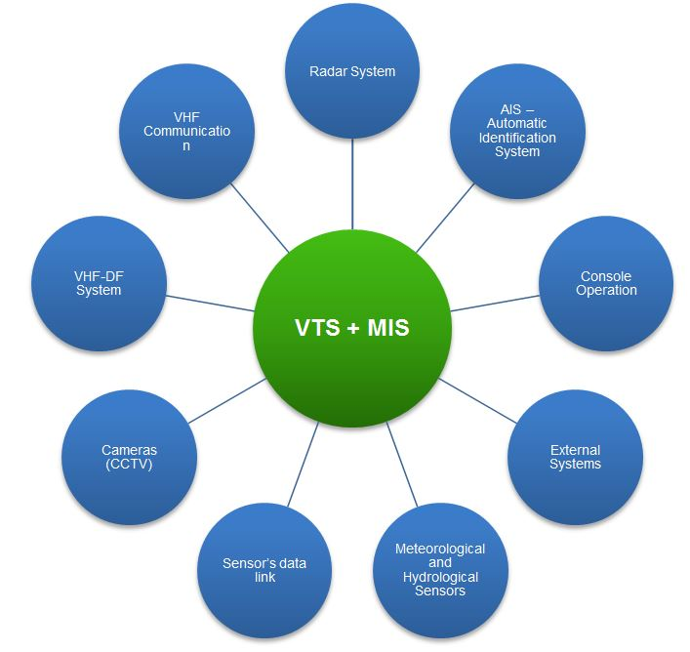
Diag. 1 – Subsystems of the integrated VTMIS solution
VTMIS interfaces and/or incorporates with other telematics resources to allow allied services and other interested agencies in the direct sharing of VTS data or access to certain subsystems in order to increase the effectiveness of port or maritime activity operations as a whole.

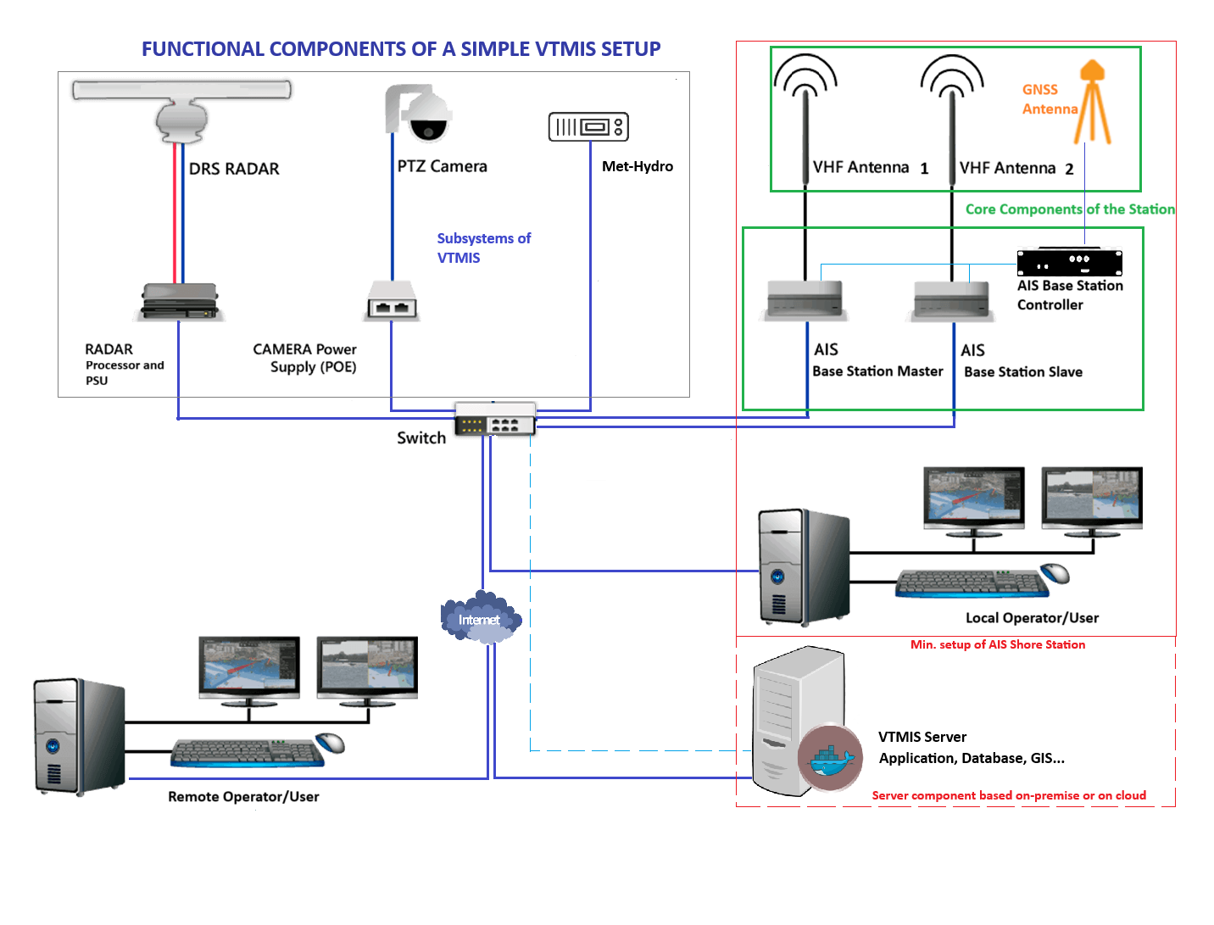
Diag. 2 – Components of a simple integrated VTMIS solution

The VTMIS solution comprises the following components: -
- AIS Shore Station, including base stations, base station controllers, antennas, connectivity equipment, and accessories.

- VTMIS application software along with the host IT infrastructure.

- Operators' consoles, consisting of workstations with consoles and wall-mounted large-format displays.

- Connectivity equipment such as switches, firewalls, and internet routers.

- Optional subsystems, including CCTV, coastal radar, and meteorological-hydrological sensors.
The implementation of a VTMIS solution aims to achieve several critical objectives. It enables the monitoring of all IMO regulations within the VTMIS area, along with the identification and tracking of vessels and other navigational objects. The system facilitates the efficient utilization of port infrastructure and enhances traffic control to improve overall traffic efficiency. Additionally, it supports the detection of illegal activities, including terrorism, piracy, illegal immigration, illegal fishing, and smuggling, while also providing collision avoidance measures. The VTMIS solution assists in search and rescue operations and coastguard activities, ensures the storage of VTS data for administrative purposes and incident analysis, and contributes to environmental protection.
A VTMIS offers a range of essential features to its users, including support and control for radar, AIS, CCTV, RDF, and Meteorological Hydrological sensors. It enables multi-radar and multi-sensor (radar and AIS) tracking integration, as well as multi-AIS data filtering and integration. The system allows for manual or automatic target acquisition, identification, and drop, along with radar video presentation and AIS dynamic and static data display. It supports the transmission and reception of AIS text telegrams and provides target manoeuvre prediction, even in radar “shadow areas.”
The system includes advanced zone configuration capabilities, such as traffic, guard, auto-acquisition, and responsibility zones, alongside comprehensive alarms management for navigation and sensor alerts. It features record and playback functionality, extensive chart capabilities with editing and S-57 support, and full diagnostics for the system and sensors.
Users or groups of users of the VTMIS can be from various departments, including: -
- Port Authorities
- Cargo Handling Authorities
- MRCC (Maritime Rescue Control Centre)
- Maritime Administration
- Coast Guard
- Customs and Immigration
- Fisheries Authorities
- Ship Agents

ICT Infrastructure for VTMIS

The Vessel Traffic Management Information System (VTMIS) depends on robust hardware and IT infrastructure for seamless operation. As a web-based application, the VTMIS is centrally installed on dedicated back-office servers, eliminating the need for any front-end application setup on user or operator workstations. The system is accessed directly through the web browsers of workstations, enhancing ease of use and reducing deployment complexity.
Within the scope of this project, the ICT infrastructure will be designed and configured as a private cloud system to provide a centralized, scalable, and secure platform for VTMIS operations. This tender focuses on procuring the necessary hardware and software components to establish the private cloud platform.

The key Features of the ICT Infrastructure are: -

- High Availability and Redundancy
The ICT infrastructure integrates high-availability (HA) servers (VM’s) configured in clustered or failover setups to ensure uninterrupted operations. Redundant hardware components, including power supplies, storage systems, and network interfaces, are deployed to eliminate single points of failure. Advanced virtualization technologies enable dynamic resource allocation, scalability, and efficient system utilization.
- Centralized Management and Monitoring
A centralized management console and KVM-over-IP provide secure, local and remote access for monitoring and managing servers and devices. This setup enables real-time troubleshooting and maintenance, ensuring the infrastructure's reliability and operational efficiency.
- Uninterrupted Power Supply
High-capacity modular UPS systems are required to be deployed to guarantee continuous power during outages, with integration to backup generators for extended operation. This ensures that the VTMIS remains operational under all circumstances.
- Enterprise-Grade Operating Systems
The infrastructure operates on enterprise-grade operating systems tailored for mission-critical environments. These systems are configured with robust security measures to mitigate cyber threats and ensure system integrity.
- Database Management System (RDBMS)
A robust relational database management system (e.g., PostgreSQL or Microsoft SQL Server) underpins the data storage and retrieval processes. This system supports high-performance query optimization and offers comprehensive backup and recovery solutions to safeguard critical data.
- Resilient Network Architecture
The network is built on redundant pathways with load balancing to ensure continuous data flow. Secure communication is maintained through firewalls, intrusion detection and prevention systems (IDS/IPS), and VPNs, protecting the system from external threats.
- Security Measures
Multi-factor authentication (MFA), role-based access control (RBAC), and regular security audits safeguard the infrastructure against unauthorized access and cyberattacks. Compliance with maritime cybersecurity standards further enhances system reliability.
- Scalability and Future Readiness
The ICT infrastructure is designed for modular expansion, enabling seamless integration of emerging technologies and accommodating growing operational demands.
This resilient, secure, and efficient ICT infrastructure will serve as the backbone of the VTMIS, ensuring reliable support for maritime safety, real-time vessel tracking, and optimized operational efficiency. The proposed private cloud system will provide a state-of-the-art platform for enhancing maritime domain awareness and operational effectiveness across all beneficiary countries.
The VTMIS system will have to be compatible with all existing information exchange systems and mechanisms used in the region, including IORIS. Regarding the AIS data flow, the software will ensure that this can be fed into IORIS. Whether the individual eligible countries decide to place their AIS data flow into IORIS, will remain prerogative of the same eligible countries.

Technical Specifications for ICT Infrastructure for the VTMIS

Server
The server is the core component and backbone of the Vessel Traffic Management Information System, hosting the web-based application and ensuring seamless operation. Powered by either Windows or Linux Server OS and utilizing Internet Information Services (IIS) or Apache for web services, the server provides a reliable platform for processing real-time maritime data, managing system communication, and delivering secure access to users via web browsers. Designed with component-level redundancy, it ensures continuous availability by mitigating single points of failure in critical hardware elements such as power supplies, storage, and network interfaces. This robust architecture supports 24/7 operations, ensuring the reliability and efficiency required for critical maritime management tasks.
The minimum technical specifications of the server are as follows: -
No. | Description | Specifications required
1 | Equipment Brand and Model | To be specified.  The equipment model must be the latest one, supporting at least 2 CPU’s.
2 | Form Factor | 1U or 2U, 19” rack mountable.
3 | CPU | Intel Xeon Silver 4314 2.4GHz 16C/32T or better
4 | RAM | Min. 32 GB RAM
5 | Hard Disks | 2 x 512 GB SSD hot plug disks configured in RAID 1 for OS and related utilities  3 x 1 TB SAS 10,000 rpm SFF configured in RAIS 5 for data
6 | RAID Controller | RAID Array controller must be inbuilt
7 | Network | At least 2 x 1,000 Mbps network interfaces inbuilt
8 | Graphics | Graphics card inbuilt with VGA/DP/HDMI ports available
9 | Power | Hot plug PSU for redundancy
10 | Accessories | Power cords, rack mount kit
11 | Warranty | 3 Years
12 | Others | A technical brochure for the proposed equipment model and type must be provided. The brochure should clearly demonstrate compliance with all the specified requirements outlined above.

Operating System

The operating system to be deployed on the VTMIS server hardware is a robust and enterprise-grade platform designed for mission-critical applications. The Server OS offers enhanced performance, advanced security features, and seamless integration with secured web services to support the web-based VTMIS application. Its support for virtualization, scalability, and efficient resource management ensures optimal utilization of server hardware. Additionally, the operating system’s comprehensive security measures, including advanced threat protection and access controls, align with the operational requirements of this tender, ensuring reliable and secure system performance.
The requirements for the OS are as follows: -
No. | Description | Specifications required
1 | Operating System | Windows Server 2025 or Linux Enterprise OS
2 | Edition | Standard Edition with support for virtualisation
3 | Virtualisation Support | Enterprise level hypervisor capable
4 | File System | Enterprise level file system with resiliency and scalability features (e.g. NTFS, EXT4, XFS)
5 | Licensing | OS must be licensed for 16 Cores and 10 CALs (Client Access Licenses) for connected users/devices.

Backup System
The backup system, comprising a high-capacity tape drive, is a critical element of the ICT infrastructure supporting the Vessel Traffic Management Information System (VTMIS). The system is designed to ensure reliable data protection through automated backup scheduling and efficient data management. To enhance data security and compliance with best practices, backup cartridges will be stored off-site, providing an additional layer of redundancy against data loss caused by hardware failures, cyber threats, or other unforeseen incidents. This backup solution is integral to maintaining the integrity and availability of VTMIS data, ensuring rapid recovery and continuity of operations in line with the requirements of this tender.
The minimum technical specifications of the Backup System are as follows: -
No. | Description | Specifications required
1 | Equipment Brand and Model | To be specified.
2 | Form Factor | 1U, 19” rack mountable.
3 | Type | LTO Drive Standalone
4 | Transfer Rate | 300 MB/s Native
5 | Interface | 6 GB/s SAS
6 | WORM Capability | Yes
7 | Encryption Capability | AES 256-Bit
8 | Capacity | 15 TB Compressed 2.5:1
9 | Power | To be specified
10 | Backup Software | The proposed tape drive system must include a fully compatible backup software. This software should support the following key features: -  - Seamless integration with the tape drive hardware and the provided Server operating system.  - Support for standard backup formats and protocols, ensuring data portability and long-term accessibility.  - Automated backup scheduling to streamline data protection without manual intervention.  - Incremental, differential, and full backup options to optimise storage usage and backup times.  - Built-in encryption features to secure data during backup and storage.  - Role-based access controls (RBAC) to restrict unauthorized access to backup configurations and files.  - Comprehensive backup retention policies to manage storage capacity effectively.  - Indexing and search functionality for quick retrieval of backed-up data.  - Fast and reliable restoration of individual files, folders, or entire systems.  - Disaster recovery support to ensure rapid system restoration in case of critical failures.  - Configuration options for exporting data to offsite storage locations, ensuring redundancy and compliance with disaster recovery requirements.
11 | Accessories | Power cords, rack mount kit,  10 x 15TB RW Data Cartridge.
12 | Warranty | 3 Years
13 | Others | A technical brochure for the proposed equipment model and type must be provided. The brochure should clearly demonstrate compliance with all the specified requirements outlined above.

Server Console
The rack mount server console system is another essential component of the VTMIS infrastructure, providing centralized access and control over the server environment. This compact, rack-mounted unit integrates a keyboard, video monitor, and mouse (KVM) to enable on-site system administrators and support engineers to perform real-time monitoring, troubleshooting, and configuration tasks directly from the server rack. The system’s design ensures efficient on-site management, reducing response times and enhancing the reliability and performance of the VTMIS server(s).
The minimum technical specifications of the Server Console are as follows: -
No. | Description | Specifications required
1 | Equipment Brand and Model | To be specified.
2 | Form Factor | 1U, 19” rack mountable.
3 | Functionalities | Keyboard, Video, Mouse
4 | Display Type/Size | 17” LCD WXGA
5 | Max. Display Resolution | 1600 x 1200
6 | Pointing Device | 3 Button touch pad with scroll keys
7 | Keyboard | Qwerty UK
8 | Ports | 1 x Display Port, 2 x USB Ports
9 | Accessories | Power cord and adaptor, connecting cables, rack mount kit.
10 | Warranty | 3 Years
11 | Others | A technical brochure for the proposed equipment model and type must be provided. The brochure should clearly demonstrate compliance with all the specified requirements outlined above.

Networking & Security
The networking and security component is a critical pillar of the VTMIS infrastructure, ensuring seamless communication and robust protection of data across the system. This component includes high-performance network switch, firewall, and intrusion detection and prevention system (IDS/IPS) to establish secure, high-speed connectivity between server(s), workstations, operators’ consoles and external systems. Advanced security features such as Virtual Private Networks (VPNs), multi-factor authentication (MFA), and role-based access control (RBAC) safeguard sensitive data and prevent unauthorized access. Designed to provide redundancy, scalability, and resilience, this component ensures uninterrupted data flow and compliance with cybersecurity standards, aligning with the operational and safety requirements of the VTMIS.

Switch
The minimum technical specifications of the networking switch are as follows: -
No. | Description | Specifications required
1 | Equipment Brand and Model | To be specified.
2 | Form Factor | 1U, 19” Rack Mountable
3 | Type | Layer 2 Manageable Switch
4 | Ports | - 24x ports 10/100/1000BASE-T Ports;  - 4x 1G/10G SFP ports;  - Others: To be specified by bidder.
5 | PoE | Must support PoE Standards IEEE 802.3af, 802.3at
6 | Power Supply | 2 x PSU for redundancy.
7 | Switching Capacity | 128Gbps
8 | Accessories | Power Cords, Rack mount kit.
9 | Warranty | 3 Years
10 | Others | A technical brochure for the proposed equipment model and type must be provided. The brochure should clearly demonstrate compliance with all the specified requirements outlined above.

Firewall
The minimum technical specifications of the Firewall appliance are as follows: -
No. | Description | Specifications required
1 | Form Factor | 1U, 19” Rack Mountable
2 | Throughput | 7.4 Gbps
3 | IPS | 500 Mbps
4 | NGFW | 360 Mbps
5 | Threat Protection | 250 Mbps
6 | Switching Capacity | 128Gbps
7 | Updates | Threat feeds and IPS should be configured for automatic updates to the firewalls on at least 4 hrs interval basis.
8 | Ports | - USB Port;  - Console Port;  - 2x GE RJ45 MGMT/DMZ Ports;  - 2x GE RJ45 WAN Ports;  - 2x GE RJ45 HA Ports;  - 14x GE RJ45 Ports;  - 2x GE RJ45/SFP Shared Media Pairs
9 | Power Supply | 2 x PSU for redundancy.
10 | Accessories | Power Cords, Rack mount kit.
12 | Licences | The equipment must be supplied with update services for Firmware OS for the 4 years from supply.
13 | Others | A technical brochure for the proposed equipment model and type must be provided. The brochure should clearly demonstrate compliance with all the specified requirements outlined above.

Operators Workstations
The operator workstations, also referred to as consoles, form an integral part of the VTMIS infrastructure, providing operators with the necessary tools to monitor, manage, and respond to maritime activities in real time. Each console is equipped with high-performance hardware (PC) and dual high-resolution displays, enabling the visualization of complex data and vessel traffic patterns. The workstations access the central VTMIS system, hosted on the server, via a secure web browser interface. Ergonomically designed and configured with role-based access control (RBAC), these consoles ensure operators can perform critical tasks efficiently and securely, facilitating the safe and effective management of maritime operations in compliance with the requirements of this tender.

Workstation PC
The minimum technical specifications of the Workstation PC are as follows: -
No. | Description | Specifications required
1 | Equipment Brand and Model | To be specified.
2 | Format | Tower Format
3 | CPU | 14th Generation Core i7 Intel processor
4 | RAM | 32 GB DDR5 ECC upgradable to 128 TB
5 | Hard Disk | 512 GB SSD
6 | Network | Dual Gigabit Ethernet ports
7 | Graphics | Graphics card inbuilt with UHD support and at least 4 GB DDR6 dedicated memory
8 | Audio | Inbuilt audio with internal speaker
9 | Ports | To be specified by Bidder.
10 | Operating System | Windows 11 Professional Edition
11 | Accessories | Power cords
12 | Warranty | 3 Years
13 | Others | A technical brochure for the proposed equipment model and type must be provided. The brochure should clearly demonstrate compliance with all the specified requirements outlined above.

High-resolution displays

The minimum technical specifications of the workstation displays are as follows: -
No. | Description | Specifications required
1 | Equipment Brand and Model | To be specified.
2 | Size | At least 27” IPS Panel
3 | Resolution | Native resolution: 2560 x 1440 (2K)
4 | Aspect Ration | 16:9
5 | Brightness | 300 nits
6 | Contrast Ratio | Static: 3000:1  Dynamic: 10000000:1
7 | Colour Depth | At least 16 million colours supported
8 | Viewing angle | Vertical: 178°  Horizontal: 178°
9 | Features | On-screen controls, Anti-glare
10 | User Control Menu Options | Menu, Power, Management, Information, Input, Colour, Image, Brightness, Exit.
11 | Physical Characteristics | Height adjustable, Pivot rotation
12 | Ports | DP, HDMI, USB, audio speaker
13 | Warranty | 3 Years
14 | Others | A technical brochure for the proposed equipment model and type must be provided. The brochure should clearly demonstrate compliance with all the specified requirements outlined above.

Quantities & Delivery
The Infrastructure equipment will be delivered to 6 locations throughout the ESA-IO region as follows: -
No. | Country | Installation Site
1 | Kenya | Kenya Port Authority, Port of Mombassa
2 | Madagascar | Capitainerie du Port-SPAT, Port of Tamatave
3 | Mauritius | National Coast Guard, Port Louis
4 | Mozambique | Maritime Rescue Coordination Centre, Port of Maputo
5 | Seychelles | National Coast Guard, Mahé
6 | Tanzania | Tanzania Port Authority, Information Sharing Centre, Port of Dar-Es-Salaam
The quantities required per beneficiary country for each of the requested items are summarised in the table below: -
No. | Item Description | Total Qty | Remarks
1 | Server | 12 | 2 units for each beneficiary country.
2 | Operating System | 6 | 1 unit for each beneficiary country.
3 | Backup System | 6 | 1 unit (1 x Tape Drive + 10 x Tape Cartridges) for each beneficiary country.
4 | Server Console | 6 | 1 unit for each beneficiary country.
5 | Switch | 6 | 1 unit for each beneficiary country.
6 | Firewall | 6 | 1 unit for each beneficiary country.
7 | Operators Workstations | 6 | 1 unit (1 x Workstation PC + 2 x High Resolution Displays) for each beneficiary country.
The IOC, serving as the overall project manager for this regional initiative, will provide the successful tenderer with the necessary access to the private cloud platform for each installation site. Additionally, the IOC will facilitate all required communications between the successful tenderer, the users/operators of the VTMIS in each beneficiary country, and other stakeholders as needed. This coordination will ensure smooth interactions and effective collaboration throughout the implementation process, supporting the successful execution of the project.

Installation & Commissioning

Installation
This project is a turnkey solution, requiring that all components of the ICT Infrastructure of the VTMIS are fully operational upon the installation and configuration at each site. The installation sites are located at the main commercial port as indicated in Section 3 above.
Bidders are required to provide a detailed project implementation plan for the operationalisation of the ICT Infrastructure of the station. Any risks foreseen and their mitigation strategy should be detailed.

Physical installation
Except for the operators' workstations, all rack-mountable items specified in this tender must be installed in an equipment rack. A 42U rack will be provided at the installation site in each beneficiary country for the successful bidder to install the server, backup system, server console, switch, and firewall.
The provided rack will include an online UPS with a minimum capacity of 6 KVA to ensure a stable and reliable power supply, as well as protection for all installed equipment. Additionally, a power distribution unit (PDU) with adequate electrical connection points will be supplied to meet the power requirements of the equipment.

Server OS installation and configuration
The operating system will be installed and configured as the backbone of the VTMIS infrastructure, leveraging a private cloud environment to ensure scalability, security, and centralized management.
This service should include: -
- OS Installation

- Installation of OS on the servers (Ref. Section 2.1 above), configured to function as a private cloud platform with redundancy;
- Partitioning of the system to allocate adequate storage for the operating system, virtual machines, and application data.
Note: Instructions for partitioning requirements, if any, will be provided to the successful bidder to ensure optimal storage allocation.

- Private Cloud Configuration

- Deployment of virtualization platform, enabling the creation and management of virtual machines to host the VTMIS application and related services;
- To set up a private cloud environment to centralize resources, improve scalability, and optimize server utilization.

- Server Roles and Features

- Configuration of Web Server for secure hosting of the web-based VTMIS application.
- Configuration of DNS and DHCP roles for efficient network management within the private cloud.

- Security and Access Control

- Installation of SSL certificates to secure web services and encrypt communications.

Note: SSL certificates for each beneficiary country will be supplied to the successful bidder.
- Backup and Disaster Recovery

- Configure Tape drive system for backups and offsite storage;
- Configure the backup software supplied with the Backup System (Ref. Section 2.3 above);
- Implement recovery options for seamless restoration of services in case of system failures.

- Testing and Optimization

- End-to-end testing of server roles, virtualized environments, and private cloud configurations.
- Optimisation of performance through resource monitoring and load balancing within the private cloud infrastructure.
The successful bidder must ensure that the Server OS delivers a robust, secure, and scalable platform tailored for the VTMIS, while leveraging private cloud capabilities for enhanced operational efficiency and reliability.

Firewall installation and configuration
The successful bidder must ensure that the firewall appliance provides a robust and secure environment for the VTMIS, protecting maritime operations and sensitive data from evolving cyber threats.

Workstation installation and configuration
The installation and configuration of operators' workstations are critical to ensuring the smooth operation of the VTMIS. The following tasks should be performed by the successful bidder: -
- Assemble the workstation hardware at the designated locations in the control room;
- Ensure all components, including dual high-resolution displays, are securely installed and positioned ergonomically for operator use;
- Install and configure the Windows 11 Pro OS and apply system updates/security patches to ensure the workstations are fully up-to-date;
- Connect workstation to the VTMIS network;
- Configure network settings (IP addresses, DNS settings, gateway, etc…) as per the system design;
- Test and configure the designated web browser to access the VTMIS application hosted on the central server;
- Implement necessary browser security settings and certificates for secure communication;
- Install any additional software tools required for maritime operations and monitoring.
- Conduct functional tests to ensure that the workstation can access the VTMIS application seamlessly.
- Prepare documentation for workstation configuration and troubleshooting procedures.

Commissioning, Acceptance and Warranty
After the successful installation and configuration of the ICT Infrastructure, the system will undergo a formal commissioning process. This process will include the verification and assessment of the system's functionality, performance, and compliance with the project requirements to ensure it meets the agreed-upon specifications and objectives.
Upon successful commissioning, system acceptance reports will be jointly signed as part of the project completion process.
The warranty will take effect from the date of system acceptance. The submission of a warranty certificate for each item is mandatory at project completion.
Bidders are required to provide a model of their warranty agreement as part of their proposal, clearly specifying the coverage details, including parts, labour, transport, and other applicable terms, for the requested warranty period.

System Training
As part of the project deliverables, comprehensive training on the ICT Infrastructure must be provided to the designated personnel. The training program should ensure that operators, technicians, and administrators acquire the necessary skills to effectively operate, manage, and maintain the infrastructure.
Bidders must submit detailed training plans as part of their proposal, including schedules, training methodologies, and comprehensive course content. These plans should ensure flexibility to accommodate the specific needs of each installation site.
The training can be conducted on-site or online for each installation location. The sessions should be tailored to meet the specific needs of the operating environment. A training schedule will be developed in consultation with the client to ensure the availability of the designated personnel.

Maintenance Service
All items requested in this tender form part of a mission-critical system that requires an availability rate of over 95% throughout the year. In addition to the standard warranty services provided for the hardware items delivered, a guaranteed service agreement will be established with the successful bidder to ensure optimal performance and minimize downtime. The service agreement must guarantee the following: -
- A response time of no more than 4 hours from the time the fault is reported.
- On-site visit by a qualified engineer for troubleshooting within 4 hours of the fault report.
- Replacement of critical faulty parts or equipment on the same business day.
- Replacement of non-critical parts or equipment on the next working day following the fault report.
- Availability of on-call engineer(s) on a 24/7/365 basis to ensure immediate support.
Bidders are required to provide a model of their service level agreement (SLA) as part of their proposal. This agreement must detail the scope of support, response times, and other relevant service terms to meet the critical maintenance needs of the system.

