

European Union

PORT SECURITY AND SAFETY OF NAVIGATION IN EASTERN AND SOUTHERN AFRICA AND THE INDIAN OCEAN
No RSO/FED/038-548

TENDER DOSSIER
(Local open tender)

COI/PSSN/AO/2025/010

SUPPLY, DELIVERY, INSTALLATION, AND AFTER-SALES SERVICE OF ICT INFRASTRUCTURE FOR VTMIS

Location: Kenya, Madagascar, Mauritius, Mozambique, Seychelles, Tanzania

LETTER OF INVITATION TO TENDER

Ébène, 23 June 2025

Our ref: COI/PSSN/AO/2025/010
Subject : INVITATION TO TENDER FOR SUPPLY, DELIVERY, INSTALLATION, AND AFTER-SALES SERVICE OF ICT INFRASTRUCTURE FOR VTMIS

Dear Madam/Sir

I am pleased to inform you that your legal entity is invited to take part in the local open procedure for the above supply contract. The complete tender dossier includes:

- Instructions to tenderers and contract notice
- Draft contract: main and special conditions and annexes:
- General conditions for supply contracts
II. and III. Technical specifications offer (to be tailored to the specific project)
IV. Budget breakdown (model financial offer)
V. Forms
- Further information
I. Administrative compliance grid
II. Evaluation grid
- Tender form for a supply contract and Declaration on honour on exclusion and selection criteria (annex A14a)

For full information about procurement procedures please consult the practical guide and its annexes, which can be downloaded from the following web page: https://wikis.ec.europa.eu/display/ExactExternalWiki/ePRAG

We look forward to receiving your tender which has to be submitted no later than the submission deadline mentioned in the Contract Notice.

By submitting a tender, you accept to receive notification of the outcome of the procedure by electronic means. Such notification shall be deemed to have been received by you on the date upon which the contracting authority sends it to the electronic address you referred to in your offer.

Yours sincerely,

PART A

Instructions to Tenderers and Contract Notice

INSTRUCTIONS TO TENDERERS
PUBLICATION REFERENCE: COI/ PSSN /AO/2025/010
By submitting a tender, tenderers fully and unreservedly accept the special and general conditions governing the contract as the sole basis of this tendering procedure, whatever their own conditions of sale may be, which they hereby waive. Tenderers are expected to examine carefully and comply with all instructions, forms, contract provisions and specifications contained in this tender dossier. Failure to submit a tender containing all the required information and documentation within the deadline specified will lead to the rejection of the tender. No account can be taken of any remarks in the tender relating to the tender dossier; remarks may result in the immediate rejection of the tender without further evaluation.
These instructions set out the rules for the submission, selection and implementation of contracts financed under this call for tenders, in conformity with the practical guide (available on the internet at: https://wikis.ec.europa.eu/display/ExactExternalWiki/ePRAG).

1. Supplies to be provided

1.1 The subject of the contract is: Supply, delivery, installation, and after-sales service of of the following supplies :

- Twelve (12) Server
- Six (6) Operating System
- Six (6) Backup System
- Six (6) Server Console
Networking & Security:
- Six (6) Switch
- Six (6) Firewall
Operators Workstations:
- Six (6) Workstation PC
- Six (6) High-resolution displays

To the ESA-IO region as follows:

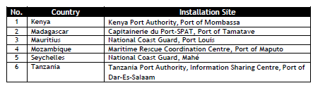

Incoterms for prices are DAP. The implementation period is maximum TWO HUNDRED AND FORTY (240) days

1.2 The supplies must comply fully with the technical specifications set out in the tender dossier (technical annex) and conform in all respects with the drawings, quantities, models, samples, measurements and other instructions

1.3 Tenderers are not authorised to tender for a variant solution in addition to the present tender.

2. Timetable
 | DATE | TIME*
Clarification meeting / site visit (if any) | Not applicable | Not applicable
Deadline for requesting clarifications from the contracting authority | 02 July 2025 | 04h00pm
Last date on which clarifications are issued by the contracting authority | 15 July 2025 | -
Deadline for submission of tenders | 23 July 2025 | 12h00
Tender opening session | 23 July 2025 | 03h30 pm
Notification of award to the successful tenderer | 06 August 2025** | -
Signature of the contract | 16 August 2025** | -

* All times correspond to the time zone of the country of the contracting authority
** Provisional date

3. Participation

3.1 The eligibility requirements detailed in the Additional information about the contract notice (Annex A5f) or, if applicable, in the Contract Notice (C2), apply to all members of a joint venture/consortium and all subcontractors, as well as to all entities upon whose capacity the tenderer relies for the selection criteria. Every tenderer, member of a joint venture/consortium, every capacity-providing entity, every subcontractor must certify that they meet these conditions. They must prove their eligibility by a document dated less than one year earlier than the deadline for submitting tenders, drawn up in accordance with their national law or practice or by copies of the original documents stating the constitution and/or legal status and the place of registration and/or statutory seat and, if it is different, the place of central administration. The contracting authority may accept other satisfactory evidence that these conditions are met.

3.2 Natural or legal persons are not entitled to participate in this tender procedure or be awarded a contract if they are in any of the situations mentioned in Sections 2.4.1 (EU restrictive measures), 2.4.2.1 (exclusion criteria) or 2.4.2.2(rejection from a procedure) of the practical guide. Should they do so, their tender will be considered unsuitable or irregular respectively. In the cases listed in Section 2.4.2.1 of the practical guide tenderers may also be excluded from EU financed procedures and/or be subject to financial penalties up to 10 % of the total value of the contract in accordance with the Financial Regulation in force. This information may be published on the Commission website in accordance with the Financial Regulation in force. Tenderers must provide declarations on honour that they are not in any of these exclusion situations. Such declarations must also be submitted by all the members of a joint venture/consortium, by any sub-contractor and by any capacity providing entities. Tenderers who make false declarations may also incur financial penalties and exclusion in accordance with the Financial Regulation in force. Their tender will be considered irregular.

The exclusion situations referred to above also apply to all members of a joint venture/consortium, all subcontractors and all suppliers to tenderers, as well as to all entities upon whose capacity the tenderer relies for the selection criteria. In cases of doubt over declarations, the contracting authority will request documentary evidence that subcontractors and/or capacity providing entities are not in a situation that excludes them.

3.3. To be eligible to take part in this tender procedure, tenderers must prove to the satisfaction of the contracting authority that they comply with the necessary legal, technical and financial requirements and have the means to carry out the contract effectively.

3.4 Subcontracting is allowed. The tenderer and, where applicable, entities on whose capacities it has relied with regard to criteria relating to the economic and financial capacity shall be jointly liable for the performance of the contract.

When selecting subcontractors, suppliers should give preference to natural persons, companies or firms of ACP States capable of providing the supplies required on similar terms.
4. Origin

4.1 Goods originating in the EU include goods originating in the Overseas Countries and Territories.

Tenderers must provide an undertaking signed by their representative certifying compliance with this requirement. The tenderer is obliged to verify that the provided information is correct. Otherwise, the tenderer risks to be excluded because of negligently misrepresenting information.

4.2 When submitting tenders, tenderers must state expressly that all the goods meet the requirements concerning origin and must state the countries of origin. They may be asked to provide additional information in this connection.
5. Type of contract

Unit-price

6. Currency

Tenders must be presented in Euro

7. Lots
This tender procedure is not divided into lots.

8. Period of validity

8.1 Tenderers will be bound by their tenders for a period of 90 days from the deadline for the submission of tenders.

8.2 In exceptional cases and prior to the expiry of the original tender validity period, the contracting authority may ask tenderers in writing to extend this period by 40 days. Such requests and the responses to them must be made in writing. Tenderers that agree to do so will not be permitted to modify their tenders and they are bound to extend the validity of their tender guarantees for the revised period of validity of the tender. If they refuse, without forfeiture of their tender guarantees, their participation in the tender procedure will be terminated. In case the contracting authority is required to obtain the recommendation of the panel referred to in Section 2.4.2.1. of the practical guide, the contracting authority may, before the validity period expires, request an extension of the validity of the tenders up to the adoption of that recommendation.
8.3 The successful tenderer will be bound by its tender for a further period of 60 days. The further period is added to the validity period of the tender irrespective of the date of notification.

9. Language of tenders

9.1 The tenders, all correspondence and documents related to the tender exchanged by the tenderer and the contracting authority must be written in the language of the procedure, which is English.

If the supporting documents are not written in one of the official languages of the European Union, a translation into the language of the call for tender must be attached. Where the documents are in an official language of the European Union other than English, it is strongly recommended to provide a translation into English, to facilitate evaluation of the documents.

10. Submission of tenders

10.1 Tenders must be sent to the contracting authority before the deadline specified in Contract Notice. They must include all the documents specified in point 11 of these Instructions and be sent to the following address
Contracts and Procurement Department
Indian Ocean Commission
Blue Tower, 4th floor
Institute Road, Ebène, Mauritius

If the tenders are hand delivered, they should be delivered to the following address:
Contracts and Procurement Department
Indian Ocean Commission
Blue Tower, 4th floor
Institute Road, Ebène, Mauritius
8h30-16h (from Monday to Friday)

Tenders must comply with the following conditions:

10.2 All tenders must be submitted in one original, marked ‘original’, and two copies signed in the same way as the original and marked ‘copy’.

10.3 The tenders should be submitted:

(a) either by post or by courier service, in which case the evidence shall be constituted by the postmark or the date of the deposit slip

(b) or by hand-delivery to the premises of the contracting authority by the participant in person or by an agent, in which case the evidence shall be constituted by the acknowledgment of receipt.

The contracting authority may, for reasons of administrative efficiency, reject any application or tender submitted on time to the postal service but received, for any reason beyond the contracting authority's control, after the effective date of approval of the short-list report or of the evaluation report, if accepting applications or tenders that were submitted on time but arrived late would considerably delay the evaluation procedure or jeopardise decisions already taken and notified.

10.4 All tenders, including annexes and all supporting documents, must be submitted in a sealed envelope bearing only:

a) the above address;

b) the reference code of this tender procedure, (i.e. COI/ PSSN /AO/2025/010);

c) where applicable, the number of the lot(s) tendered for.

d) the words ‘Not to be opened before the tender opening session’ in the language of the tender dossier.

e) the name of the tenderer.

The technical and financial offers must be placed together in a sealed envelope. The envelope should then be placed in another single sealed envelope/package, unless their volume requires a separate submission for each lot.

11. Content of tenders

The tender must include a technical offer and a financial offer, which must be submitted in separate envelopes either by post or by hand-delivery.

Failure to fulfil the below requirements will constitute an irregularity and may result in rejection of the tender. All tenders submitted must comply with the requirements in the tender dossier and comprise :

Part 1: Technical offer:

a detailed description of the supplies tendered in conformity with the technical specifications, including any documentation required, including :
  - a training proposal (indicate training needs);
  - proposal for after-sales service over 1 year;

The technical offer should be presented as per template (Annex II+III*, Contractor’s technical offer) adding separate sheets for details if necessary.

Part 2: Financial offer:

A financial offer calculated on a DAP basis for the supplies tendered, including :
  - Financial proposal for training
  - Financial proposal for after-sales services for 1 year

This financial offer should be presented as per template (Annex IV*, Budget breakdown), adding separate sheets for details if necessary. All amounts are to be quoted excluding taxes. VAT, if applicable, is to be mentioned separately.
In case of doubt about the applicable VAT system, it is the tenderer's responsibility to contact his or her national authorities to clarify the way in which the European Union is exempt from VAT.

Part 3: Documentation:
To be supplied using the templates attached*:
- The "Tender form for a supply contract", together with Annex 1 "Declaration on honour on exclusion criteria and selection criteria", both duly completed, which includes the tenderer’s declaration, point 7 from each member if a consortium, and capacity-providing entities or subcontractors (if any).
Signed originals of the Declaration on honour shall be submitted.
To be supplied in free-text format:
- A description of the warranty conditions, which must be in accordance with the conditions laid down in Article 32 of the general conditions.
- A description of the organisation of the commercial warranty tendered in accordance with the conditions laid down in Article 32 of the special conditions
- Duly authorised signature: an official document (statutes, power of attorney, notary statement, etc.) proving that the person who signs on behalf of the company, joint venture or consortium is duly authorised to do so.

Remarks:
Tenderers are requested to follow this order of presentation.
Annex* refers to templates attached to the tender dossier. These templates are also available on: https://wikis.ec.europa.eu/display/ExactExternalWiki/Annexes#Annexes-AnnexesC(Ch.4):Supplies

12. Taxes and other charges

The applicable tax and customs arrangements are the following:

General provisions regarding tax and customs arrangements are attached to the tender dossier.

13. Additional information before the deadline for submission of tenders
The tender dossier should be clear enough so that tenderers do not need to request additional information during the procedure. If the contracting authority, on its own initiative or in response to a request from a prospective tenderer, provides additional information on the tender dossier, it must send such information in writing to all other prospective tenderers at the same time.

Tenderers may submit questions in writing to the following address up to 21 days before the deadline for submission of tenders, specifying the publication reference and the contract title :

Contracts and Procurement Department
Indian Ocean Commission
Blue Tower, 4th floor
Institute Road, Ebène, Mauritius
Email : smc@coi-ioc.org ;
Any clarification of the tender dossier will be communicated simultaneously in writing to all tenderers at the latest 8 days before the deadline for submitting tenders.

Any prospective tenderers seeking to arrange individual meetings with either the contracting authority and/or the European Commission during the tender period may be excluded from the tender procedure.

14. Clarification meeting / site visit

14.1 No information meeting / site visit planned. Visits by individual prospective tenderers during the tender period cannot be organised.

15. Alteration or withdrawal of tenders

15.1 Tenderers may alter or withdraw their tenders by written notification prior to the deadline for submission of tenders. No tender may be altered after this deadline. Withdrawals must be unconditional and will end all participation in the tender procedure.

Any such notification of alteration or withdrawal must be prepared and submitted in accordance with Section 10. The outer envelope must be marked ‘Alteration’ or ‘Withdrawal’ as appropriate.

15.2 No tender may be withdrawn in the interval between the deadline for submission of tenders. and the expiry of the tender validity period. Withdrawal of a tender during this interval may result in forfeiture of the tender guarantee

16. Costs of preparing tenders
No costs incurred by the tenderer in preparing and submitting the tender are reimbursable. All such costs will be borne by the tenderer.

17. Ownership of tenders
The contracting authority retains ownership of all tenders received under this tender procedure. Consequently, tenderers have no right to have their tenders returned to them.

18. Joint venture or consortium

18.1 If a tenderer is a joint venture or consortium of two or more persons, the tender must be a single one with the object of securing a single contract, each person must sign the tender and will be jointly and severally liable for the tender and any contract. Those persons must designate one of their members to act as leader with authority to bind the joint venture or consortium. The composition of the joint venture or consortium must not be altered without the prior written consent of the contracting authority.

18.2 The tender may be signed by the representative of the joint venture or consortium only if it has been expressly so authorised in writing by the members of the joint venture or consortium, and the authorising contract, notarial act or deed must be submitted to the contracting authority in accordance with point 11 of these instructions to tenderers. All signatures to the authorising instrument must be certified in accordance with the national laws and regulations of each party comprising the joint venture or consortium together with the powers of attorney establishing, in writing, that the signatories to the tender are empowered to enter into commitments on behalf of the members of the joint venture or consortium.

19. Opening of tenders

19.1 The purpose of the opening session is to check whether the tenders have been submitted in accordance with the submission requirements of the call for tenders.

19.2 The date and venue of the tender opening session are indicated in the Contract Notice.
Tenderers wishing to attend the opening session, are required to send a request by email to smc@coi-ioc.org no later than two working days before the scheduled start of the opening session. A maximum of two representatives per tender may attend. The representatives will receive an invitation to attend the opening session by email. This invitation will include the instructions on how to attend the opening.

The committee will draw up minutes of the meeting, which will be available on request.
In the case that at the date of the opening session some tenders have not been delivered to the contracting authority but their representatives can show evidence that it has been sent on time, the contracting authority will allow them to participate in the first opening session and inform all representatives of the tenderers that a second opening session will be organised.

19.3 At the tender opening, the tenderers’ names, the tender prices, any discount offered, written notifications of alteration and withdrawal, the presence of the requisite tender guarantee (if required) and such other information as the contracting authority may consider appropriate may be announced.

19.4 After the public opening of the tenders, no information relating to the examination, clarification, evaluation of tenders, or recommendations concerning the award of the contract can be disclosed until after the contract has been awarded.

19.5 Any attempt by tenderers to influence the evaluation committee in the process of examination, clarification, evaluation and comparison of tenders, to obtain information on how the procedure is progressing or to influence the contracting authority in its decision concerning the award of the contract will result in the immediate rejection of their tenders.

19.6 All tenders received after the deadline for submission specified in the contract notice or these instructions will be kept by the contracting authority. The associated guarantees will be returned to the tenderers. No liability can be accepted for late delivery of tenders. Late tenders will be rejected and will not be evaluated.

20. Evaluation of tenders

20.1 Examination of the administrative conformity of tenders

The aim at this stage is to check that tenders comply with the essential requirements of the tender dossier. A tender is deemed to comply if it satisfies all the conditions, procedures and specifications in the tender dossier without substantially departing from or attaching restrictions to them.

Substantial departures or restrictions are those which affect the scope, quality or execution of the contract, differ widely from the terms of the tender dossier, limit the rights of the contracting authority or the tenderer’s obligations under the contract or distort competition for tenderers whose tenders do comply. Decisions to the effect that a tender is not administratively compliant must be duly justified in the evaluation minutes.

If a tender does not comply with the tender dossier, it will be rejected immediately and may not subsequently be made to comply by correcting it or withdrawing the departure or restriction.

20.2 Technical evaluation

After analysing the tenders deemed to comply in administrative terms, the evaluation committee will rule on the technical admissibility of each tender, classifying it as technically compliant or non-compliant.

The minimum qualifications required (see selection criteria in the additional information about the contract notice are to be evaluated at the start of this stage.

Where contracts include after-sales service and/or training, the technical quality of such services will also be evaluated by using yes/no criteria as specified in the tender dossier.

20.3 In the interests of transparency and equal treatment and to facilitate the examination and evaluation of tenders, the evaluation committee may ask each tenderer individually for clarification of its tender including breakdowns of prices, within a reasonable time limit to be fixed by the evaluation committee. The request for clarification and the response must be in writing, but no change in the price or substance of the tender may be sought, offered or permitted except as required to confirm the correction of arithmetical errors discovered during the evaluation of tenders pursuant to Article 20.4. Any such request for clarification must not distort competition. Decisions to the effect that a tender is not technically compliant must be duly justified in the evaluation minutes.

20.4 Financial evaluation
a) Tenders found to be technically compliant will be checked for any arithmetical errors in computation and summation. Errors will be corrected by the evaluation committee as follows:

- where there is a discrepancy between amounts in figures and in words, the amount in words will be the amount taken into account;

- except for lump-sum contracts, where there is a discrepancy between a unit price and the total amount derived from the multiplication of the unit price and the quantity, the unit price as quoted will be the price taken into account.
b) Amounts corrected in this way will be binding on the tenderer. If the tenderer does not accept them, its tender will be rejected.
c) Unless specified otherwise, the purpose of the financial evaluation process is to identify the tenderer offering the lowest price. Where specified in the technical specifications, the evaluation of tenders may take into account not only the acquisition costs but, to the extent relevant, costs borne over the life cycle of the supplies (such as for instance maintenance costs and operating costs), in line with the technical specifications. In such case, the contracting authority will examine in detail all the information supplied by the tenderers and will formulate its judgment on the basis of the lowest total cost, including additional costs.

20.5 Variant solutions
Variant solutions will not be taken into consideration.

20.6 Award criteria
The sole award criterion will be the price. The contract will be awarded to the lowest compliant tender.

Where tenders are of equivalent economic and technical quality, preference will be given to those with the widest participation of ACP States. See further Section 2.6.9. of the practical guide.

  - Documentary evidence for exclusion and selection criteria

At any time during the procurement procedure and before the award of the contract, the contracting authority may request documentary evidence on compliance with the exclusion criteria set out in these instructions.

The contracting authority may request information on natural or legal persons that are members of the administrative, management or supervisory body or that have powers of representation, decision or control, including legal and natural persons within the ownership and control structure and beneficial owners, and appropriate evidence that none of those persons are in one of the exclusion situations referred to in the Declaration on Honour.

At any time during the procurement procedure and before the award of the contract, the contracting authority may request documentary evidence on compliance with the exclusion criteria and selection criteria (financial, economic, technical and professional capacity) set out in these instructions. Please note that a request for evidence in no way implies that the tenderer has been successful. All tenderers are invited to prepare in advance the documents related to the evidence, since they may be requested to provide such evidence within a short deadline. In any event, the tenderer proposed by the evaluation committee for the award of the contract, will be requested to provide such evidence at short notice.
When requested, regarding the exclusion criteria, the tenderers should be able to provide the documentary proof or statements required under the law of the country in which the company (or, for consortia, each of the companies) is established, to show that it does not fall into any of the exclusion situations listed in Section 2.4.2 of the practical guide.
At any time during the procurement procedure, the contracting authority may request information on natural or legal persons that are members of the administrative, management or supervisory body or that have powers of representation, decision or control, including legal and natural persons within the ownership and control structure and beneficial owners, and appropriate evidence that none of those persons are in one of the exclusion situations referred to in the Declaration on Honour.

This evidence, documents or statements must be dated, no more than one year before the date of submission of the tender.
The above-mentioned documents must be submitted for every member of a joint venture/consortium, all subcontractors and every capacity providing entity.

The contracting authority may waive the obligation of any tenderer to submit the documentary evidence referred to above if such evidence has already been submitted for the purposes of another procurement procedure, provided that the issue date of the documents does not exceed one year and that they are still valid. In this case, the tenderer must declare on his/her honour that the documentary evidence has already been provided in a previous procurement procedure and confirm that his/her situation has not changed.

Where the documentary evidence submitted is in an official language of the European Union other than the one of the procedure, it is strongly recommended to provide a translation into the language of the procedure, in order to facilitate the evaluation of the documents.

Failure to provide valid documentary evidence at the request and within the deadline set by the Contracting Authority shall lead to the rejection of the tender for the award of the contract, unless the tenderer can justify the failure on the grounds of material impossibility.
If the successful tenderer fails to provide this documentary proof or statement or if the successful tenderer is found to have provided misrepresented information, the award will be considered null and void. In this case, the contracting authority may award the tender to the next lowest tenderer or cancel the tender procedure.

21. Notification of award

By submitting a tender, each tenderer accepts to receive notification of the outcome of the procedure by electronic means. Such notification shall be deemed to have been received on the date upon which the contracting authority sends it to the electronic address referred to in the offer.

The contracting authority will inform all tenderers simultaneously and individually of the award decision. The tender guarantees of the unsuccessful tenderers will be released once the contract is signed. The successful tenderer will be informed in writing that its tender has been accepted (notification of award).

22. Signature of the contract and performance guarantee

22.1 The contracting authority reserves the right to vary quantities specified in the tender by +/- 100 % at the time of contracting and during the validity of the contract. The total value of the supplies may not, as a result of the variation rise or fall by more than 10 % of the original financial offer in the tender. The unit prices quoted in the tender shall be used.

22.2 Within 30 days of receipt of the contract signed by the contracting authority, the selected tenderer must sign and date the contract and return it, with the performance guarantee (if applicable), to the contracting authority. On signing the contract, the successful tenderer will become the contractor and the contract will enter into force.
If a tenderer to whom the contract is awarded (any of the group members in case of a consortium) has established debt(s) owed to the Union, the European Atomic Energy Community or an executive agency when the latter implements the Union budget, such debt(s) may be offset, in line with Articles 101(1) and 102 the Financial Regulation and the conditions set out in the draft contract, against any payment due under the contract. The contracting authority will verify the existence of overdue debts of the successful tenderer[s] (any of the group members in case of a consortium), and, if any such debt is found, will inform the tenderer (the leader in case of a consortium who will then have the obligation to inform all other group members before signing the contract) that the debt(s) may be offset against any payment under due the contract.

22.3 If it fails to sign and return the contract and any financial guarantee required within 30 days after receipt of notification, the contracting authority may consider the acceptance of the tender to be cancelled without prejudice to the contracting authority’s right to seize the guarantee, claim compensation or pursue any other remedy in respect of such failure, and the successful tenderer will have no claim whatsoever on the contracting authority.

22.4 The performance guarantee referred to in the general conditions is set at 5% of the amount of the contract. The performance guarantee must be presented in the form specified in the annex to the tender dossier. It will be released within 60 days of the issue of the final acceptance certificate by the contracting authority, except for the proportion assigned to after-sales service. For contracts of EUR 150 000 or below, on the basis of objective criteria such as the type and value of the contract, the contracting authority may decide not to require such a guarantee.

23. Tender guarantee

No tender guarantee is required

24. Ethics clauses and code of conduct

24.1 Absence of conflict of interest and of professional conflicting interest
The tenderer must not be affected by any professional conflicting interest nor any conflict of interest and must have no equivalent relation in that respect with other tenderers or parties involved in the project. Any unduly influence or attempt to unduly influence the evaluation committee or the contracting authority during the process of examining, clarifying, evaluating comparing tenders, any attempt to obtain confidential information or entering into unlawful agreements with competitors will lead to the rejection of its tender and may result in exclusion from future award procedures and/or financial penalties according to the Financial Regulation in force.

24.2 Respect for human rights and EU values as well as environmental legislation and core labour standards

The tenderer must respect environmental legislation and core labour standards: participants that are awarded the contract must comply with the environmental legislation including multilateral environmental agreements, and with the core labour standards as applicable and as defined in the relevant International Labour Organisation conventions (such as the conventions on freedom of association and collective bargaining; elimination of forced and compulsory labour; abolition of child labour).

The tenderer and its personnel must commit to and ensure the respect of basic EU values, the tenderer and its personnel must comply with basic EU values such as respect for human dignity, freedom, democracy, equality, the rule of law and human rights, including the rights of minorities. The tenderer and its personnel must comply with applicable data protection rules and environmental legislation. In particular, tenderers who have been awarded the contract must also comply with multilateral environmental agreements, and with the core labour standards as applicable and as defined in the relevant International Labour Organisation conventions (such as the conventions on freedom of association and collective bargaining; elimination of forced and compulsory labour; abolition of child labour).

The tenderer and its personnel must comply with EU values, such as respect for human dignity, freedom, democracy, equality, the rule of law and human rights, including the rights of minorities.
Zero tolerance for sexual exploitation, abuse and harassment:
The European Commission applies a policy of 'zero tolerance' in relation to all wrongful conduct which has an impact on the professional credibility of the tenderer.
Physical abuse or punishment, or threats of physical abuse, sexual abuse or exploitation, harassment and verbal abuse, as well as other forms of intimidation shall be prohibited.

24.3 Anti-corruption and anti-bribery
The tenderer shall comply with all applicable laws and regulations and codes relating to anti-bribery and anti-corruption. The European Commission reserves the right to suspend or cancel project financing if corrupt practices of any kind are discovered at any stage of the award process or during the execution of a contract and if the contracting authority fails to take all appropriate measures to remedy the situation. For the purposes of this provision, ‘corrupt practices’ are the offer of a bribe, gift, gratuity or commission to any person as an inducement or reward for performing or refraining from any act relating to the award of a contract or execution of a contract already concluded with the contracting authority.

24.4 Unusual commercial expenses
Tenders will be rejected or contracts terminated if it emerges that the award or execution of a contract has given rise to unusual commercial expenses. Such unusual commercial expenses are commissions not mentioned in the main contract or not stemming from a properly concluded contract referring to the main contract, commissions not paid in return for any actual and legitimate service, commissions remitted to a tax haven, commissions paid to a payee who is not clearly identified or commissions paid to a company which has every appearance of being a front company.
Contractors found to have paid unusual commercial expenses on projects funded by the European Union are liable, depending on the seriousness of the facts observed, to have their contracts terminated or to be excluded from future award procedures.

24.5 Breach of obligations, irregularities or fraud
The contracting authority reserves the right to suspend or cancel the procedure, where the award procedure proves to have been subject to breach of obligations, irregularities or fraud. If breach of obligations, irregularities or fraud are discovered after the award of the contract, the contracting authority may refrain from concluding the contract.

25. Cancellation of the tender procedure
If a tender procedure is cancelled, tenderers will be notified by the contracting authority.
If the tender procedure is cancelled before the tender opening session the sealed envelopes will be returned, unopened, to the tenderers.
Cancellation may occur, for example, if:
- the tender procedure has been unsuccessful, namely where no suitable, qualitatively or financially acceptable tender has been received or there has been no valid response at all;
- the economic or technical parameters of the project have changed fundamentally;
- exceptional circumstances or force majeure render normal implementation of the project impossible;
- all technically acceptable tenders exceed the financial resources available;
- there have been breach of obligations, irregularities or frauds in the procedure, in particular where these have prevented fair competition;
- the award is not in compliance with sound financial management, i.e. does not respect the principles of economy, efficiency and effectiveness (e.g. the price proposed by the tenderer to whom the contract is to be awarded is objectively disproportionate with regard to the price of the market.
In no event will the contracting authority be liable for any damages whatsoever including, without limitation, damages for loss of profits, in any way connected with the cancellation of a tender procedure even if the contracting authority has been advised of the possibility of damages. The publication of a contract notice does not commit the contracting authority to implement the programme or project announced.

26. Appeals
Tenderers believing that they have been harmed by an error or irregularity during the award process may file a complaint. See Section 2.12. of the practical guide.

27. Data Protection
Processing of personal data related to this tender procedure by the contracting authority takes place in accordance with the national legislation of the state of the contracting authority and with the provisions of the respective financing agreement.
The tender procedure and the contract relate to an external action funded by the EU, represented by the European Commission. If processing your reply to the invitation to tender involves transfer of personal data (such as names, contact details and CVs) to the European Commission, they will be processed solely for the purposes of the monitoring of the procurement procedure and of the implementation of the contract by the Commission, for the latter to comply with its obligations under the applicable legislative framework and under the financing agreement concluded between the EU and the Partner Country without prejudice to possible transmission to the bodies in charge of monitoring or inspection tasks in application of EU law. For the part of the data transferred by the contracting authority to the European Commission, the controller for the processing of personal data carried out within the Commission is the head of legal affairs unit of DG International Partnerships.

Details concerning processing of your personal data by the Commission are available on the privacy statement at:
https://wikis.ec.europa.eu/display/ExactExternalWiki/Annexes#Annexes-AnnexesA(Ch.2):General

28. Early detection and exclusion system
The tenderers and, if they are legal entities, persons who have powers of representation, decision-making or control over them, natural or legal person that assumes unlimited liability for the debts, natural or legal person who is essential for the award or the implementation of the legal commitment, beneficial owner or any affiliate of the tender, are informed that, should they be in one of the situations of early detection or exclusion, their personal details (name, given name if natural person, address, legal form) may be registered in the early detection and exclusion system, and communicated to the persons and entities listed in the above-mentioned decision, in relation to the award or the execution of a procurement contract.
For more information, you may consult the privacy statement available on http://ec.europa.eu/budget/explained/management/protecting/protect_en.cfm

CONTRACT NOTICE
CALL FOR TENDER: GENERAL INFORMATION
1. Buyer

Official name: Indian Ocean Commission (IOC)_ PORT SECURITY AND SAFETY OF NAVIGATION IN EASTERN AND SOUTHERN AFRICA AND THE INDIAN OCEAN

Postal address: Blue Tower, 3rd floor
Town: Ebène
Postal Code: 72202
E-mail: smc@coi-ioc.org
Internet address: https://www.commissionoceanindien.org
Activity of the contracting authority: Port security and safety of navigation
2. Procedure
2.1. Procedure
Title: Supply, delivery, installation, and after-sales service of ICT infrastructure for VTMIS.
Short description of the contract: Acquisition of
- Twelve (12) Server
- Six (6) Operating System
- Six (6) Backup System
- Six (6) Server Console
Networking & Security:
- Six (6) Switch
- Six (6) Firewall
Operators Workstations:
- Six (6) Workstation PC
- Six (6) High-resolution displays

Type of procedure: Open
2.1.1. Purpose
Nature of the contract: Supplies
Main classification (CPV code): Not applicable
Additional classification (CPV code ) Not applicable

    - General information
Legal basis:

Regulation (EU, Euratom) 2024/2509 of the European Parliament and of the Council of 23 September 2024 on the financial rules applicable to the general budget of the Union.

Local Law - Procurement award procedure applying to European Union external actions financed from the general budget of the European Union and the European Development Fund (EDF).

2.1.6. Grounds for exclusion

Description: Please consult the procurement documents.

5. Lot

This contract is divided into lots: no

5.1.1. Purpose

Nature of the contract: Supplies

Main classification (CPV code): Not applicable

Additional classification (CPV code): Not applicable

5.1.2. Place of performance

Geographical zone: Kenya, Madagascar, Mauritius, Mozambique, Seychelles, Tanzania

5.1.3. Estimated duration

Duration: 8 months

5.1.6. General information

Reserved participation: none.

Procurement Project fully financed with EU Funds.

5.1.9. Selection criteria

Criterion:

Type: suitability to pursue the professional activity

Description: Please consult procurement documents.

Type: economic and financial standing

Description: Please consult procurement documents.

Type: technical and professional ability

Description: Please consult procurement documents.

5.1.10. Award criteria

Type: Price

Description: Please consult procurement documents.

5.1.11. Procurement documents

Languages in which the procurement documents are officially available: English

5.1.12. Terms of procurement
Terms of submission:
Electronic submission: Not allowed
Languages in which tenders or requests to participate may be submitted: English
Deadline for receipt of requests to participate/tenders:
Date: 23/07/2025
Local Time: 12h00
Deadline until which the tender must remain valid: 3 months from the date stated for receipt of tender.

Terms of contract:
Electronic invoicing: not allowed.
Electronic payment will be used.

Additional information about the Contract Notice

SUPPLY, DELIVERY, INSTALLATION, AND AFTER-SALES SERVICE OF ICT INFRASTRUCTURE FOR VTMIS
Location : Kenya, Madagascar, Mauritius, Mozambique, Seychelles, Tanzania
- Nature of contract:
Unit price
- Programme title

PORT SECURITY AND SAFETY OF NAVIGATION IN EASTERN AND SOUTHERN AFRICA AND THE INDIAN OCEAN
- Financing
Financing agreement RSO/FED/038-548
- Legal basis, eligibility and rules of origin
The legal basis of this procedure is Annex IV to the Partnership Agreement between the members of the African, Caribbean and Pacific Group of States of the one part, and the European Community and its Member States, of the other part, signed in Cotonou on 23 June 2000 as amended in Luxembourg on 25 June 2005 and in Ouagadougou on 22 June 2010. Reference is made to Annex IV as revised by Decision 1/2014 of the ACP-EU Council of Ministers of 20 June 2014.

Participation in tendering is open on equal terms to all natural and legal persons (participating either individually or in a grouping – consortium – of candidates/tenderers) which are established in one of the Member States of the European Union, ACP States or in a country or territory authorised by the ACP-EC Partnership Agreement under which the contract is financed.
Participation is also open to international organisations.

All supplies under this contract must originate in one or more of these countries.

For UK candidates or tenderers: Please be aware that following the entry into force of the EU-UK Withdrawal Agreement* on 1 February 2020 and in particular Articles 127(6), 137 and 138, the references to natural or legal persons residing or established in a Member State of the European Union and to goods originating from an eligible country, as defined under Regulation (EU) No 236/2014** and Annex IV of the ACP-EU Partnership Agreement***, are to be understood as including natural or legal persons residing or established in, and to goods originating in, the United Kingdom ****. Those persons and goods are therefore eligible under this call.

* Agreement on the withdrawal of the United Kingdom of Great Britain and Northern Ireland from the European Union and the European Atomic Energy Community.
** Regulation (EU) No 236/2014 of the European Parliament and of the Council of 11 March 2014 laying down common rules and procedures for the implementation of the Union's instruments for financing external action.
*** Annex IV to the ACP-EU Partnership Agreement, as revised by Decision 1/2014 of the ACP-EU Council of Ministers (OJ L196/40, 3.7.2014).
**** Including the Overseas Countries and Territories having special relations with the United Kingdom, as laid down in Part Four and Annex II of the TFEU.]

- Candidature
All eligible natural and legal persons (as per item 4 above) or groupings of such persons (consortia) may participate or tender.
A consortium may be a permanent, legally established grouping or a grouping which has been constituted informally for a specific procurement procedure. All partners of a consortium (i.e., the leader and all other partners) are jointly and severally liable to the contracting authority.
The participation or tender of an ineligible natural or legal person will result in the automatic exclusion of that person. In particular, if that ineligible person belongs to a consortium, the whole consortium will be excluded.

- Number of requests to participate or tenders
No more than one request to participate or tender can be submitted by a natural or legal person whatever the form of participation (as an individual legal entity or as leader or partner of a consortium submitting a request to participate or tender). In the event that a natural or legal person submits more than one request to participate or tender, all requests to participate or tenders in which that person has participated will be excluded.
In case of lots, the candidates or tenderers may submit only one request to participate or tender per lot. Contracts will be awarded lot by lot and each lot will form a separate contract. If the tenderer is awarded more than one lot, a single contract may be concluded covering all those lots.

- Sub-contracting
Sub-contracting is allowed.

13. Period of implementation of tasks
Two hundred and forty (240) days after signature of the contract by the two parties

14. Language of the procedure
All written communications for this tender procedure and contract must be in English.

15. Additional information
Financial data to be provided by the candidate in the request to participate form or in the tender submission form must be expressed in EUR. If applicable, where a candidate refers to amounts originally expressed in a different currency, the conversion to EUR shall be made in accordance with the InforEuro exchange rate of July 2025, which can be found at the following address: http://ec.europa.eu/budget/graphs/inforeuro.html.

SELECTION CRITERIA

16. Selection criteria
Capacity-providing entities
An economic operator (i.e. candidate or tenderer) may, where appropriate and for a particular contract, rely on the capacities of other entities, regardless of the legal nature of the links which it has with them. If the economic operator relies on other entities, it must in that case prove to the contracting authority that it will have at its disposal the resources necessary for the performance of the contract by producing a commitment by those entities to place those resources at its disposal. Such entities, for instance the parent company of the economic operator, must respect the same rules of eligibility and notably that of nationality as the economic operator relying on them and must comply with the selection criteria for which the economic operator relies on them. Furthermore, the data for this third entity for the relevant selection criterion should be included in a separate document. Proof of the capacity will also have to be provided when requested by the contracting authority.
With regard to technical and professional criteria, an economic operator may only rely on the capacities of other entities where the latter will perform the tasks for which these capacities are required.
With regard to economic and financial criteria, the entities upon whose capacity the economic operator relies, become jointly and severally liable for the performance of the contract.
The following selection criteria will be applied to candidates. In the case of requests to participate submitted by a consortium, these selection criteria will be applied to the consortium as a whole if not specified otherwise. The selection criteria will not be applied to natural persons and single-member companies when they are sub-contractors.
The candidate shall not use previous experience which caused breach of contract and termination by a contracting authority as a reference for selection criteria.
The selection criteria for tenderers are as follows:
1) Economic and financial capacity (based on item 3 of the tender form). In case of tenderer being a public body, equivalent information should be provided. The reference period which will be taken into account will be the last three financial years for which accounts have been closed.
Criterion 1: average annual turnover
The candidate’s or tenderer’s average annual turnover of the last 3 financial years for which the accounts have been closed must be not less than 450,000.00 EUR.

Criterion 2: Assets/liabilities ratio
Current ratio (current assets/current liabilities) in the last year for which accounts have been closed must be at least 1. In case of a consortium this criterion must be fulfilled by each member of the consortium.

2) Professional capacity (based on items 4 and 5 of the request to participate form for service contracts and on items 4 and 5 of the tender form for supply contracts). The reference period which will be taken into account will be the last 3 years preceding the submission deadline.
Criterion 1: the candidate has, during the current year and the previous two years, on average, at least: 2 personnel directly employed or otherwise legally contracted on a permanent or non-permanent basis in areas of specialist knowledge related to this contract.
Criterion 2: the candidate is not subject to professional conflicting interests which may negatively affect contract performance. The presence of professional conflicting interests shall be examined on the basis of the statements made through the Declarations on Honour and, where applicable, the statements and other documents submitted.
3) Technical capacity (based on item 6 of the request to participate form for service contracts and on item 6 of the tender form for supply contracts).
Criterion:
- The candidate has completed supplies under at least: 2 contracts implemented at any moment during the last four years before submission deadline.
- For each contract, the value of the supplies completed must not be less than 120,000.00 EUR.
- The completed services or supplies are in the domain of ICT infrastructure for VTMIS.
This means that the contract the candidate or tenderer refers to could have been implemented at any time during the indicated period but it does not necessarily have to be completed during that period, nor implemented during the entire period. Candidates or tenderers are allowed to refer either to projects completed within the reference period (although started earlier) or to projects partially implemented during, but not yet completed within the reference period. Only the part completed during the reference period will be taken into consideration. This part will have to be supported by documentary evidence (approval of report or deliverable, proof of payment, statement or certificate from the entity which awarded the contract) also detailing its value. If a candidate has implemented the project in a consortium, the part that the candidate has successfully completed must be clear from the documentary evidence (such as consortium agreement and bank transfers between consortium members), together with a description of the nature of the services provided/supplies delivered.

PARTICIPATION
18. Requests to participate format and details to be provided

Requests to participate must be submitted using the request to participate form, the format and instructions of which must be strictly observed. The request to participate form is available from the following Internet address:
https://wikis.ec.europa.eu/display/ExactExternalWiki/Annexes
The request to participate must be accompanied by a declaration on honour on exclusion and selection criteria using the template available from the following Internet address:
https://wikis.ec.europa.eu/display/ExactExternalWiki/Annexes#Annexes-AnnexesA(Ch.2):General
Any documentation (brochure, letter, etc.) sent with a request to participate in addition to what has been requested will not be taken into consideration.

19. How requests to participate may be submitted

Requests to participate must be submitted in English exclusively to the contracting authority in a sealed envelope.
- Either by post or by courier service, in which case the evidence shall be constituted by the postmark or the date of the deposit slip, to:
Procurement Department
Indian Ocean Commission
3rd Floor, Blue Tower Building
Rue de l’Institut, Ebene, Mauritius
+230 402 61 00
smc@coi-ioc.org

- OR hand delivered by the participant in person or by an agent directly to the premises of the contracting authority in return for a signed and dated receipt, in which case the evidence shall be constituted by this acknowledgement of receipt, to:
Procurement Department
Indian Ocean Commission
4th Floor. Blue Tower Building
Rue de l’institut, Ebène, Mauritius
Tel: +230 402 61 00
Opening hours: Monday to Friday, 09:00am – 04:00pm

The contract title and publication reference (see contract notice) must be clearly marked on the envelope containing the request to participate and must always be mentioned in all subsequent correspondence with the contracting authority.
Requests to participate submitted by any other means will not be considered.
- Deadline for submission of requests to participate
The candidate’s attention is drawn to the fact that there are two different systems for sending requests to participate: one is by post or private mail service, the other is by hand delivery.
In the first case, the request to participate must be sent before the date and time-limit for submission, as evidenced by the postmark or deposit slip, but in the second case it is the acknowledgment of receipt given at the time of the delivery of the request to participate that will serve as proof.
The deadline for submission of requests to participate can be found in the contract notice.
Any request to participate sent to the contracting authority after this deadline will not be considered. The contracting authority may, for reasons of administrative efficiency, reject any request for participation submitted on time but received, for any reason beyond the contracting authority's control, after the effective date of approval of the short-list report, if accepting requests to participate that were submitted on time but arrived late would considerably delay the evaluation procedure or decisions already taken and notified.
- Clarifications on the contract notice
Any request for clarifications must be made in writing through the F&T Portal. This concerns request for clarifications about the contract notice and also request for clarifications about the content of the document called “Additional information to the contract notice.” F&T Portal login is required to be able to create and submit a question. Clarifications can be requested by clicking “Create a question” in the Questions & Answers tab at the latest 21 days before the deadline for submission of requests to participate stated in the contract notice.
Clarifications will be published on F&T Portal at the latest 8 days before the deadline for the submission of requests to participate. The website will be updated regularly and it is the candidates responsibility to check for updates and modifications during the submission period.
22. Outcome of the evaluation
By submitting a request to participate candidates accept to receive notification of the outcome of the procedure by electronic means. Such notification shall be deemed to have been received on the date upon which the contracting authority sends it to the electronic address referred to in the request to participate form.
23. Alteration or withdrawal of requests to participate
Candidates may alter or withdraw their requests to participate by written notification prior to the deadline for submission of requests to participate. No requests to participate may be altered after this deadline.
Any such notification of alteration or withdrawal shall be prepared and submitted in accordance with precedent item. The outer envelope (and the relevant inner envelope if used) must be marked ‘Alteration’ or ‘Withdrawal’ as appropriate.
***

PART B

Draft contract and special conditions, including annexes

SUPPLY CONTRACT

Financed by Commission financing decision n° RSO/FED/038-548

N° COI/PSSN/CT/2024/010

financed from the edf
MAIN CONDITIONS

The Indian Ocean Commission, Blue Tower, 3rd Floor, Rue de l'Institut, Ebène, Republic of Mauritius (‘The contracting authority’),
represented for the purposes of the signature of this contract by the authorised representative indicated in the respective field under “SIGNATURES” below
of the one part, and

[Contractor’s full official name]
Legal form: [Contractor’s official legal form]
Registration number: [Contractor’s statutory registration number or ID or passport number]
Official address: [Contractor’s full official address]
VAT: [OPTION for contractors with VAT: VAT registration number]
(‘the contractor’)

represented for the purposes of signing this contract by the authorised representative indicated in the respective field under “SIGNATURES” below,
on the other part,
HAVE AGREED as follows:
1. Subject matter
The title of this contract is: SUPPLY, DELIVERY, INSTALLATION, AND AFTER-SALES SERVICE OF ICT INFRASTRUCTURE FOR VTMIS

The terms and conditions applying to this contract are laid down hereafter and in the special and general conditions and their annexes. They shall be deemed to form and be read and construed as an integral part of this contract in the order described in the special conditions.
2. Contract value
The maximum amount covering all purchases under this contract is [currency] [insert amount (insert amount in words)].]
3 Entry into force and duration
This contract enters into force on the date on which the last party signs it.
The maximum duration of this contract is [insert number] [days/weeks/months/years] from the [date this contract enters into force] [later date between the following two dates: the date the contract is signed by the last contracting party, and DD_MM_YY] [date notified by the contracting authority with at least 7 days notice and in any case no sooner than the date of entry into force and no later than 3 months after the signature of this contract.
4. Bank account
Payments shall be made in accordance with the special conditions into the following bank account:
Name of bank: [insert bank name]
Exact denomination of account holder: [full name of account holder]
Bank account number: [insert bank account number].
Signatures
For the contractor |  | For the contracting authority
[electronic signature  contractor] |  | [electronic signature contracting authority]

SPECIAL CONDITIONS FOR EUROPEAN UNION EXTERNAL ACTIONS

Contents

These conditions amplify and supplement the general conditions governing the contract. Unless the special conditions provide otherwise, those general conditions remain fully applicable. The numbering of the articles of the special conditions is not consecutive but follows the numbering of the articles of the general conditions. Exceptionally, and with the approval of the competent European Commission departments, other clauses can be indicated to cover particular situations.

The subject of the contract shall be: the supply, delivery, installation, training, maintenance services and after-sales service of the following supply: vessel traffic management information system (VTMIS)

- Twelve (12) Server
- Six (6) Operating System
- Six (6) Backup System
- Six (6) Server Console
Networking & Security:
- Six (6) Switch
- Six (6) Firewall
Operators Workstations:
- Six (6) Workstation PC
- Six (6) High-resolution displays

Order of precedence of contract documents

The following documents shall be deemed to form and be read and construed as part of this contract, in the following order of precedence:
- the main conditions;
- the special conditions;
- the general conditions (Annex I);
- the technical specifications (Annex II [including clarifications before the deadline for submission of tenders and minutes from the information meeting/site visit];
- the technical offer (Annex III [including clarifications from the tenderer provided during tender evaluation]);
- the budget breakdown (Annex IV);
- [specified forms and other relevant documents (Annex V)];
The various documents making up the contract shall be deemed to be mutually explanatory; in cases of ambiguity or divergence, they shall prevail in the order in which they appear above. Addenda shall have the order of precedence of the document they are amending.
Article 2 Language of the contract

2.1 The language used shall be English.
Article 4 Communications
4.1 Contact persons

4.4 Communication via electronic exchange system (EES)
An electronic system will be used by the contracting authority and the contractor for all stages of implementation including, inter alia, management of the contract (amendments and administrative orders), reporting (including reporting on results) and payments. The contractor will be required to register in and use the appropriate electronic exchange system to allow for the e-management of the contract.

4.5 & 4.6 Mail or email communication
If communications through the Portal have not been activated or a certain type of communication is not yet supported by the Portal, communications will be sent via email, or, exceptionally, on paper, via mail services, to the following addresses, until communications via the Portal are activated.
For the purpose of this contract, mail or email communications must be sent to the following addresses:
Contracting authority:

Officer in Charge
General Secretariat of the IOC
Blue Tower, 3rd floor, Rue de institute
Ebène, Mauritius
Tél : (230) 402 6100
Email:

Contractor (or leader in the case of a joint tender):
[Full name]
[Function]
[Company name]
[Full official address]
Email: [complete]

Article 6 Subcontracting
6.3 When selecting subcontractors the contractor must give preference to natural persons or companies from ACP States capable of implementing the tasks required on similar terms.]

Article 10 Origin

10.1
Goods originating in the EU includes goods originating in the Overseas Countries and Territories.
Article 11 Performance guarantee
11.1 The amount of the performance guarantee shall be 5% of the total contract price, including any amounts stipulated in addenda to the contract.

Article 16 Tax and customs arrangements
16.1 The delivery conditions are DAP.
Article 18 Delivery order

18.2 The contracting authority shall inform the contractor by delivery order of the date on which delivery of the goods/implementation of the tasks shall begin.
Article 19 Period of implementation of the tasks
19.1 The time limits for delivery shall be<insert date and time>.
The implementation period of tasks shall be Eight (8) months.
.
Article 26 General principles of payments
26.1 Payments shall be made in EURO
Pre-financing is not applicable to this contract
Payments shall be authorized and made by the he PSSN project finance department.

26.9 In order to obtain payments, the contractor must forward to the authority referred to in paragraph 26.1 above:

a) For the 100 % balance, the invoice(s) in two(2) copies and the application for the certificate of provisional acceptance, and if applicable, the certificates of origin for the supplies delivered and Annex V - VAT instructions indicating the group members shares for VAT purposes.

Article 28 Delayed payments

28.2 By derogation from Article 28.2 of the general conditions, once the deadline laid down in Article 26.3 has expired, the contractor shall, upon demand, be entitled to late-payment interest at the rate and for the period mentioned in the general conditions. The demand must be submitted within two months of receiving late payment

Article 29 Delivery
29.1 The Incoterm applicable shall be DAP

29.3 The packaging shall become the property of the recipient subject to environmental considerations
29.4 The place of acceptance of the supplies shall be

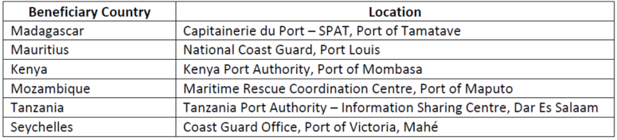
Article 31 Provisional acceptance
The certificate of provisional acceptance must be issued using the template in Annex C11.

By derogation from Article 31.2, second paragraph, the contracting authority’s time limit for issuing the certificate of provisional acceptance to the contractor shall not be considered included in the time limit for payments indicated in Article 26.3.

Article 32 Warranty obligations
32.6 Commercial warranty as granted by the manufacturer must remain valid for a minimum of two years after final acceptance.

32.7 The warranty must remain valid for two years after provisional acceptance.

Article 33 After-sales service
33.1 The supplier must provide on-site support services with technical intervention within 5 days of the call received from the client. Support services should be provided during working hours for one year as from the final acceptance of supplies.
The proportion of the performance guarantee linked to the after-sale service is 10%.

Article 40 Settlement of disputes
40.4 Any dispute arising out of or relating to this contract which cannot be settled otherwise shall:
(a) in the case of a national contract, be settled in accordance with the national legislation of the state of the contracting authority; and
(b) in the case of a transnational contract, be settled either:
(i) if the parties to the contract so agree, in accordance with the national legislation of the state of the contracting authority or its established international practices; or
(ii) by arbitration in accordance with the procedural rules on conciliation and arbitration of contracts financed by the European Development Fund, adopted by Decision 3/90 of the ACP-EEC Council of Ministers of 29 March 1990 (Official Journal No L 382, 31.12.1990, Annex a12 to the practical guide)

The jurisdiction conferred under this clause is exclusive and any jurisdiction under a bilateral or multilateral investment treaty, or under the ICSID (International Centre for Settlement of Investment Disputes) rules is explicitly excluded.

Article 44 Data protection

For the purpose of Article 44 of the general conditions, for the part of the data transferred by the contracting authority to the European Commission:
(a) the controller for the processing of personal data carried out within the Commission is the head of legal affairs unit of DG International Partnerships.
(b) the privacy statement is available at https://wikis.ec.europa.eu/display/ExactExternalWiki/Annexes#Annexes-AnnexesA(Ch.2):General]

1. Processing of personal data related to the implementation of the contract by the contracting authority takes place in accordance with the national legislation of the state of the contracting authority and with the provisions of the respective financing agreement.

2. To the extent that the contract covers an action financed by the European Union, the Contracting Authority may share communications related to the implementation of the contract, with the European Commission. These exchanges shall be made to the Commission, solely for the purpose of allowing the latter to exercise its rights and obligations under the applicable legislative framework and under the financing agreement with the Partner country – contracting authority. The exchanges may involve transfers of personal data (such as names, contact details, signatures and CVs) of natural persons involved in the implementation of the contract (such as contractors, personnel, experts, trainees, subcontractors, insurers, guarantors, auditors and legal counsel). In cases where the contractor is processing personal data in the context of the implementation of the contract, he/she shall accordingly inform the data subjects of the possible transmission of their data to the Commission. When personal data is transmitted to the Commission, the latter processes them in accordance with Regulation (EU) 2018/1725 of the European Parliament and of the Council of 23 October 2018 on the protection of natural persons with regard to the processing of personal data by the Union institutions, bodies, offices and agencies and on the free movement of such data, and repealing Regulation (EC) No 45/2001 and Decision No 1247/2002/EC and as detailed in the specific privacy statement published at ePRAG.

ANNEX I

GENERAL CONDITIONS

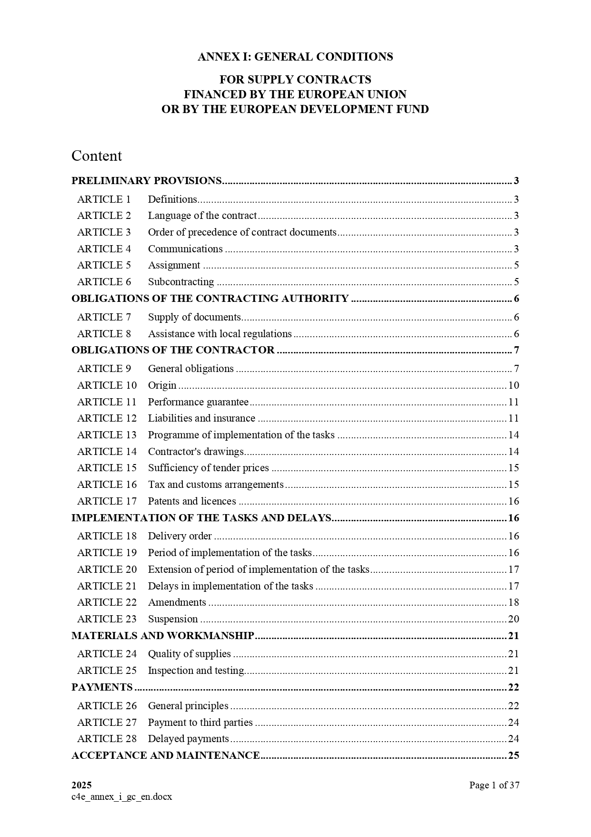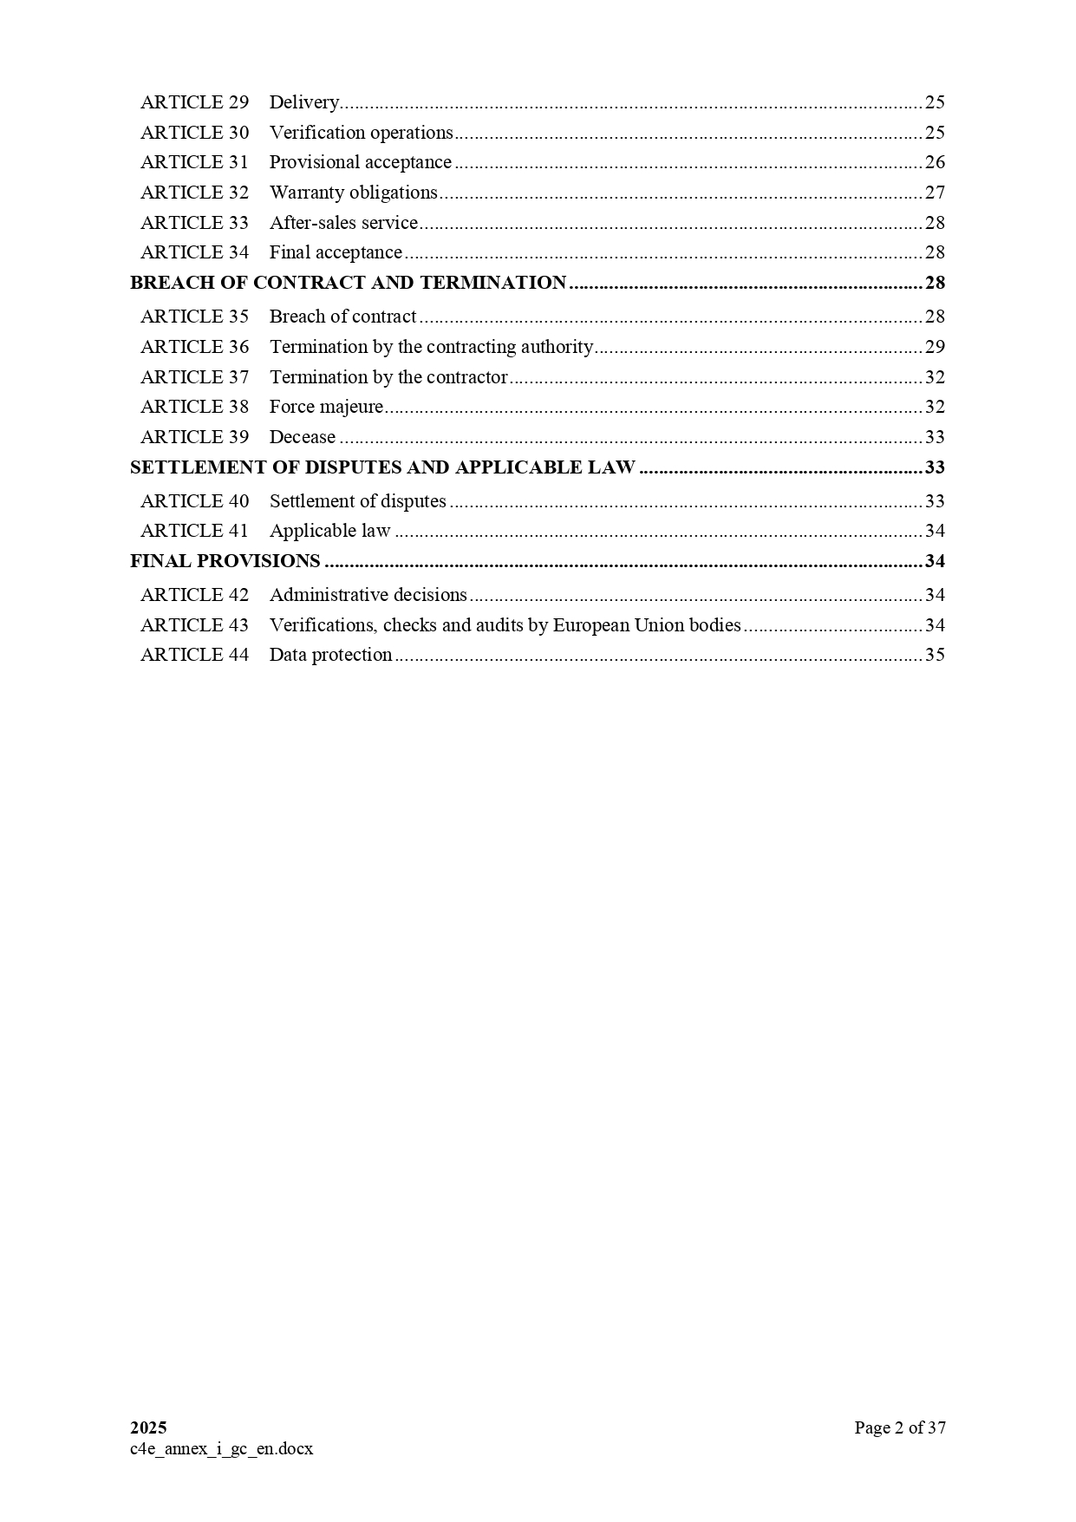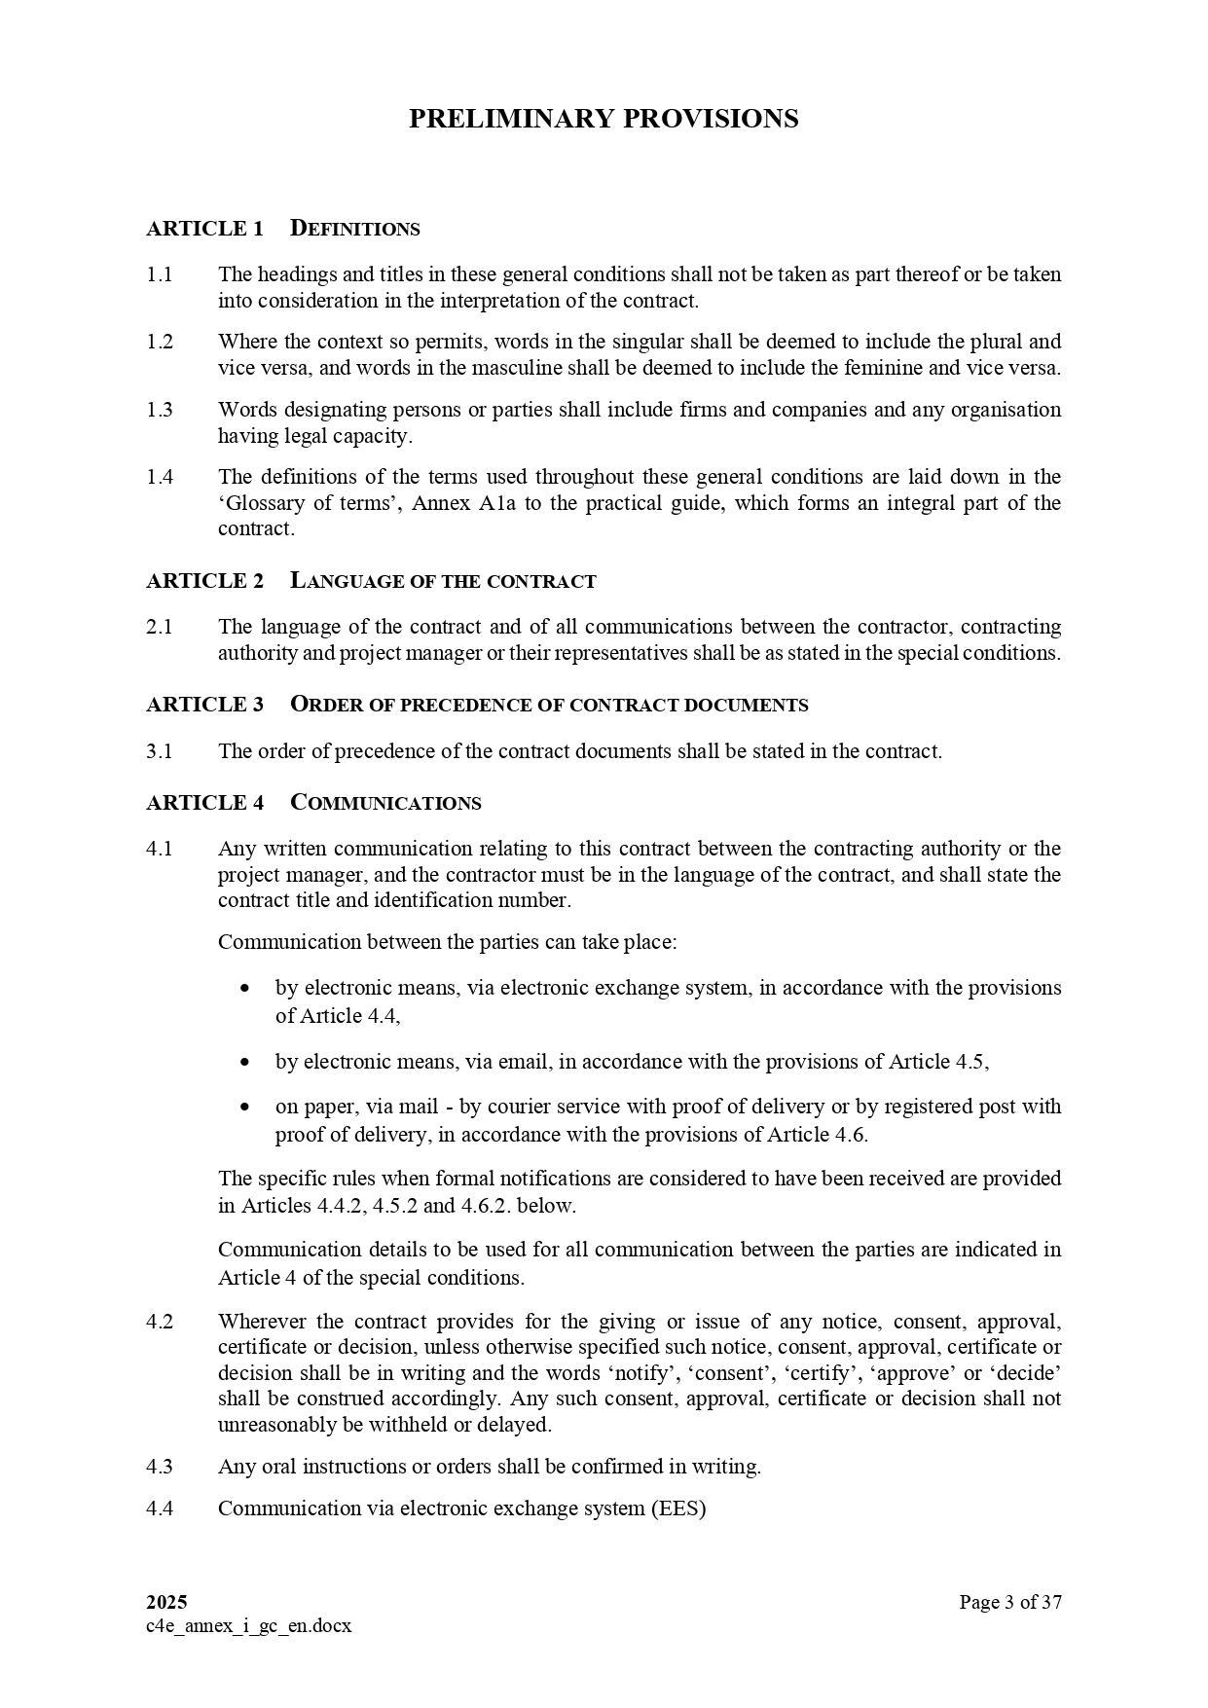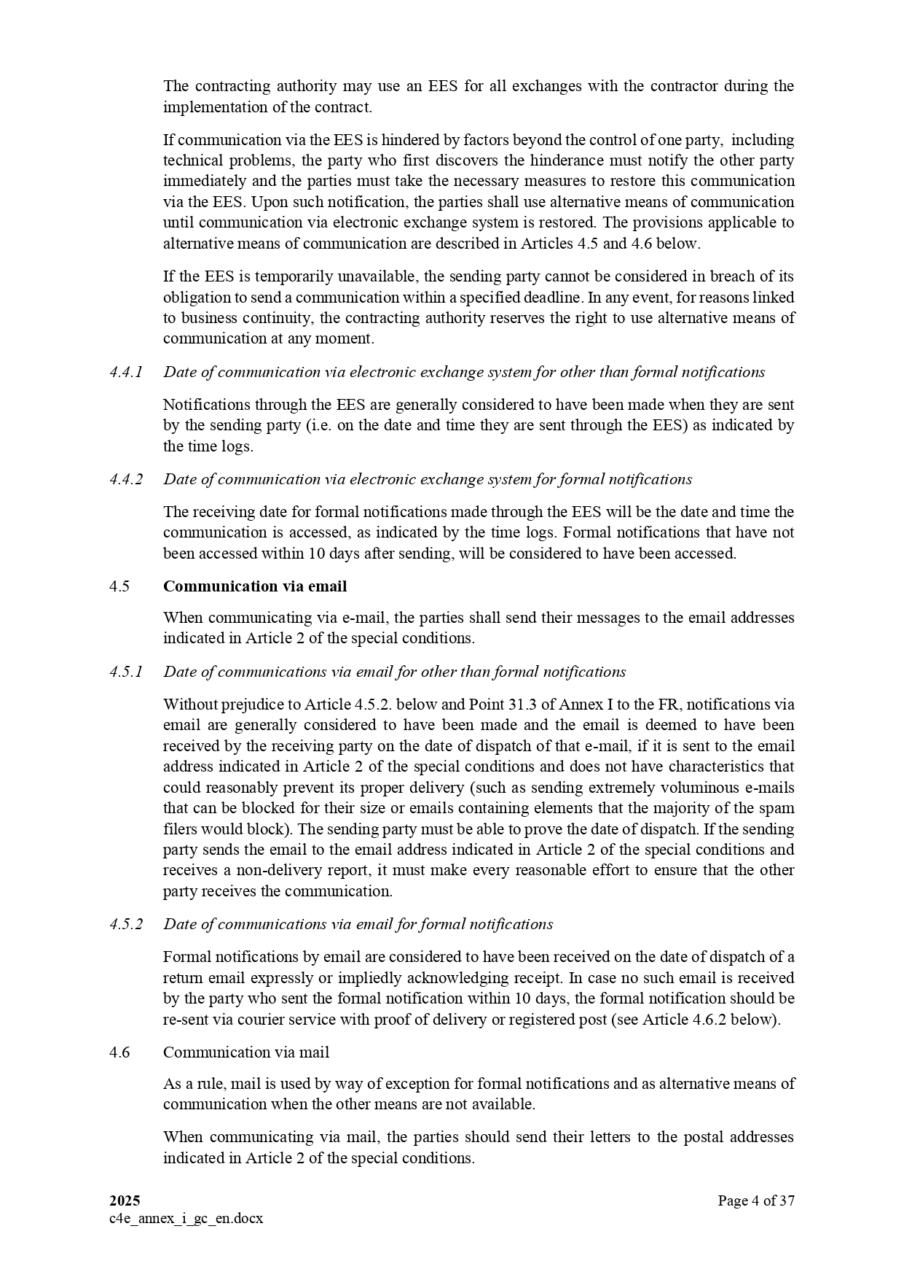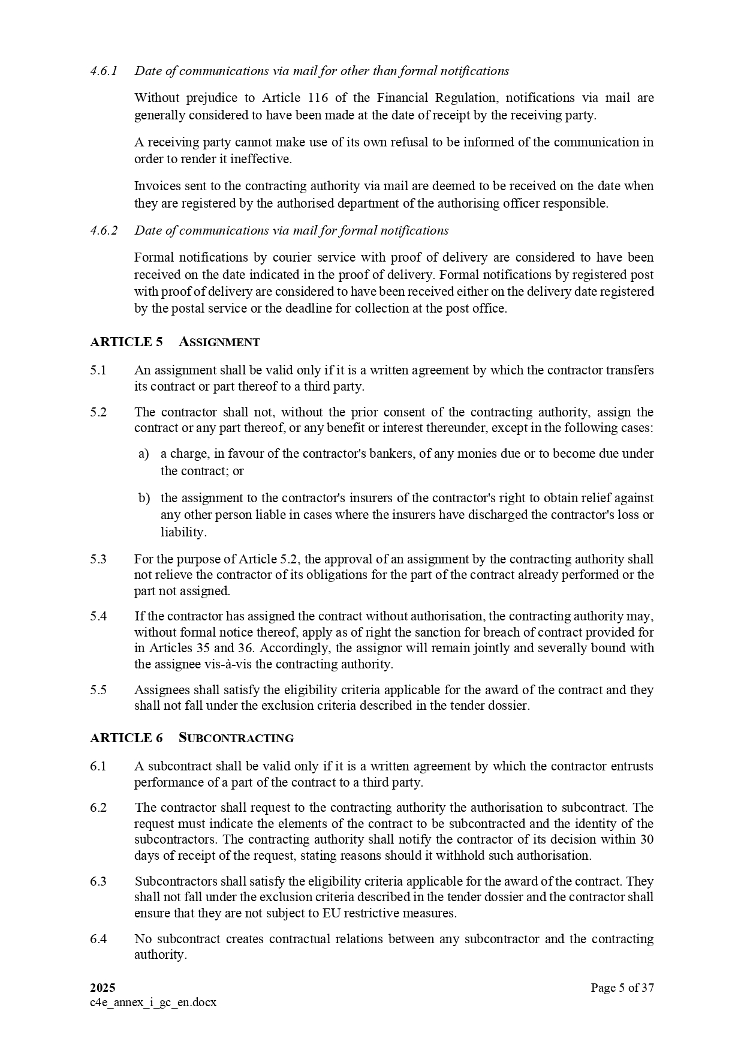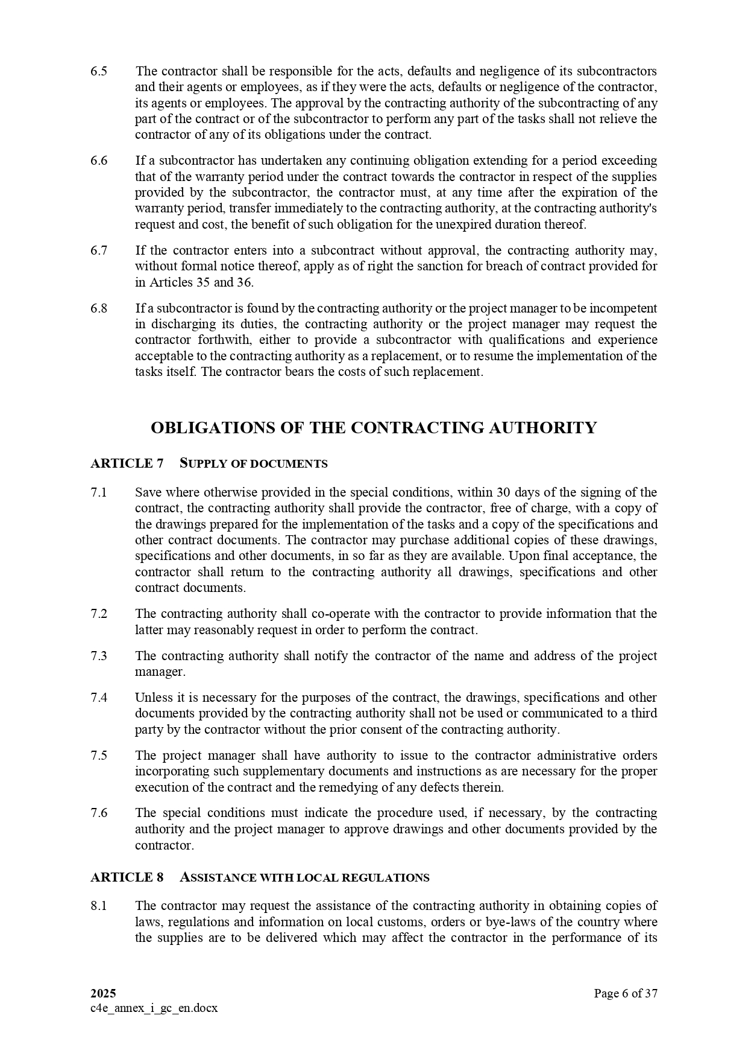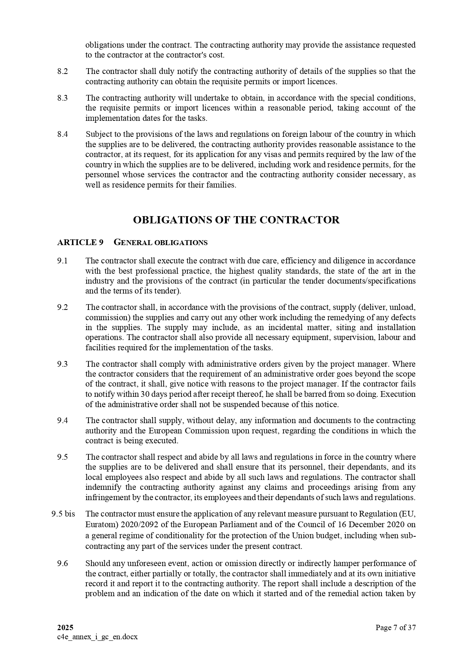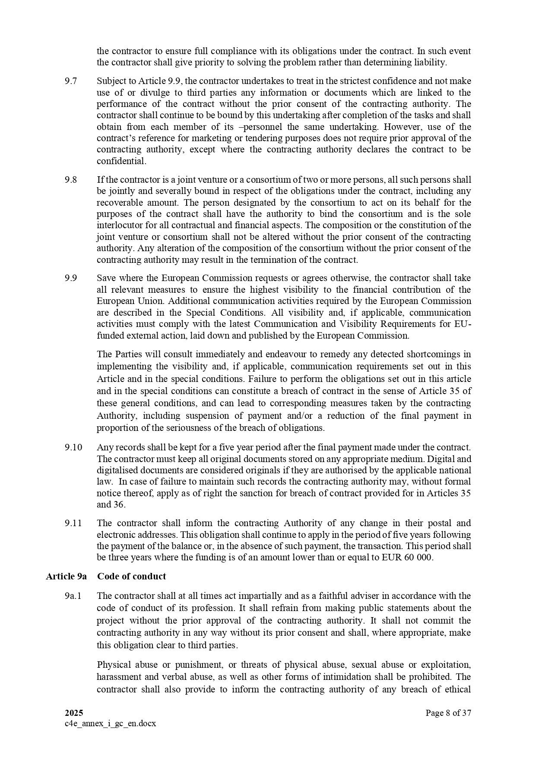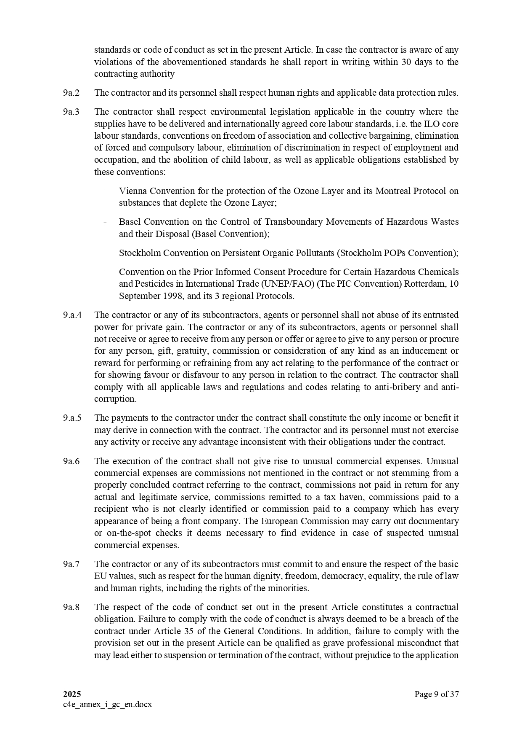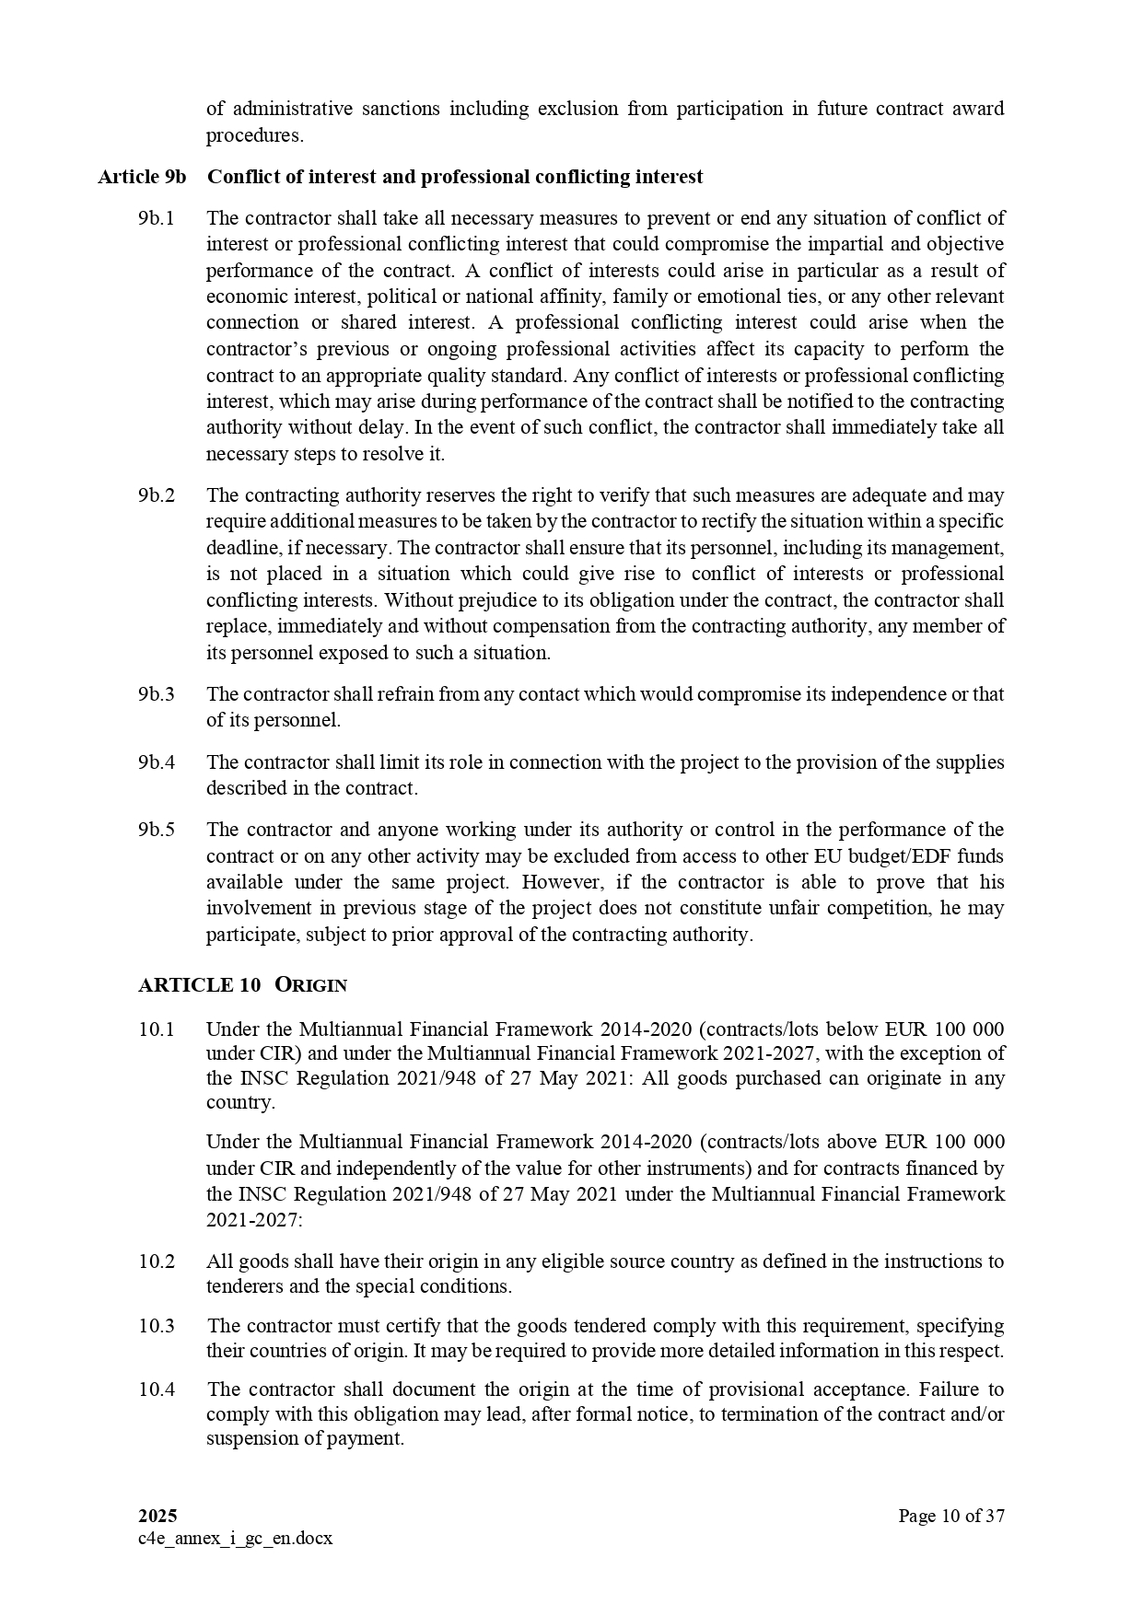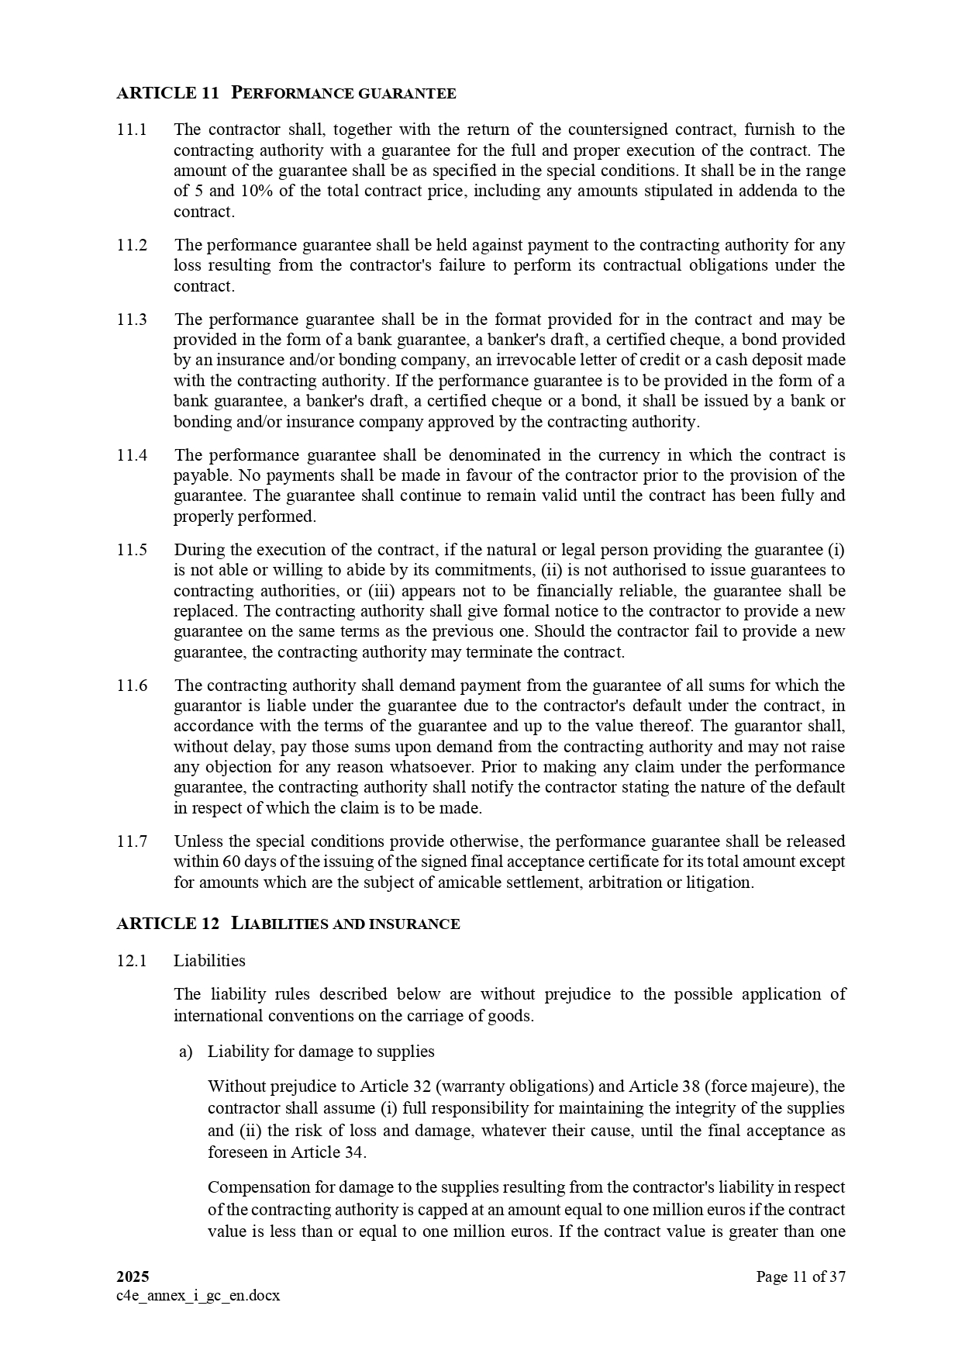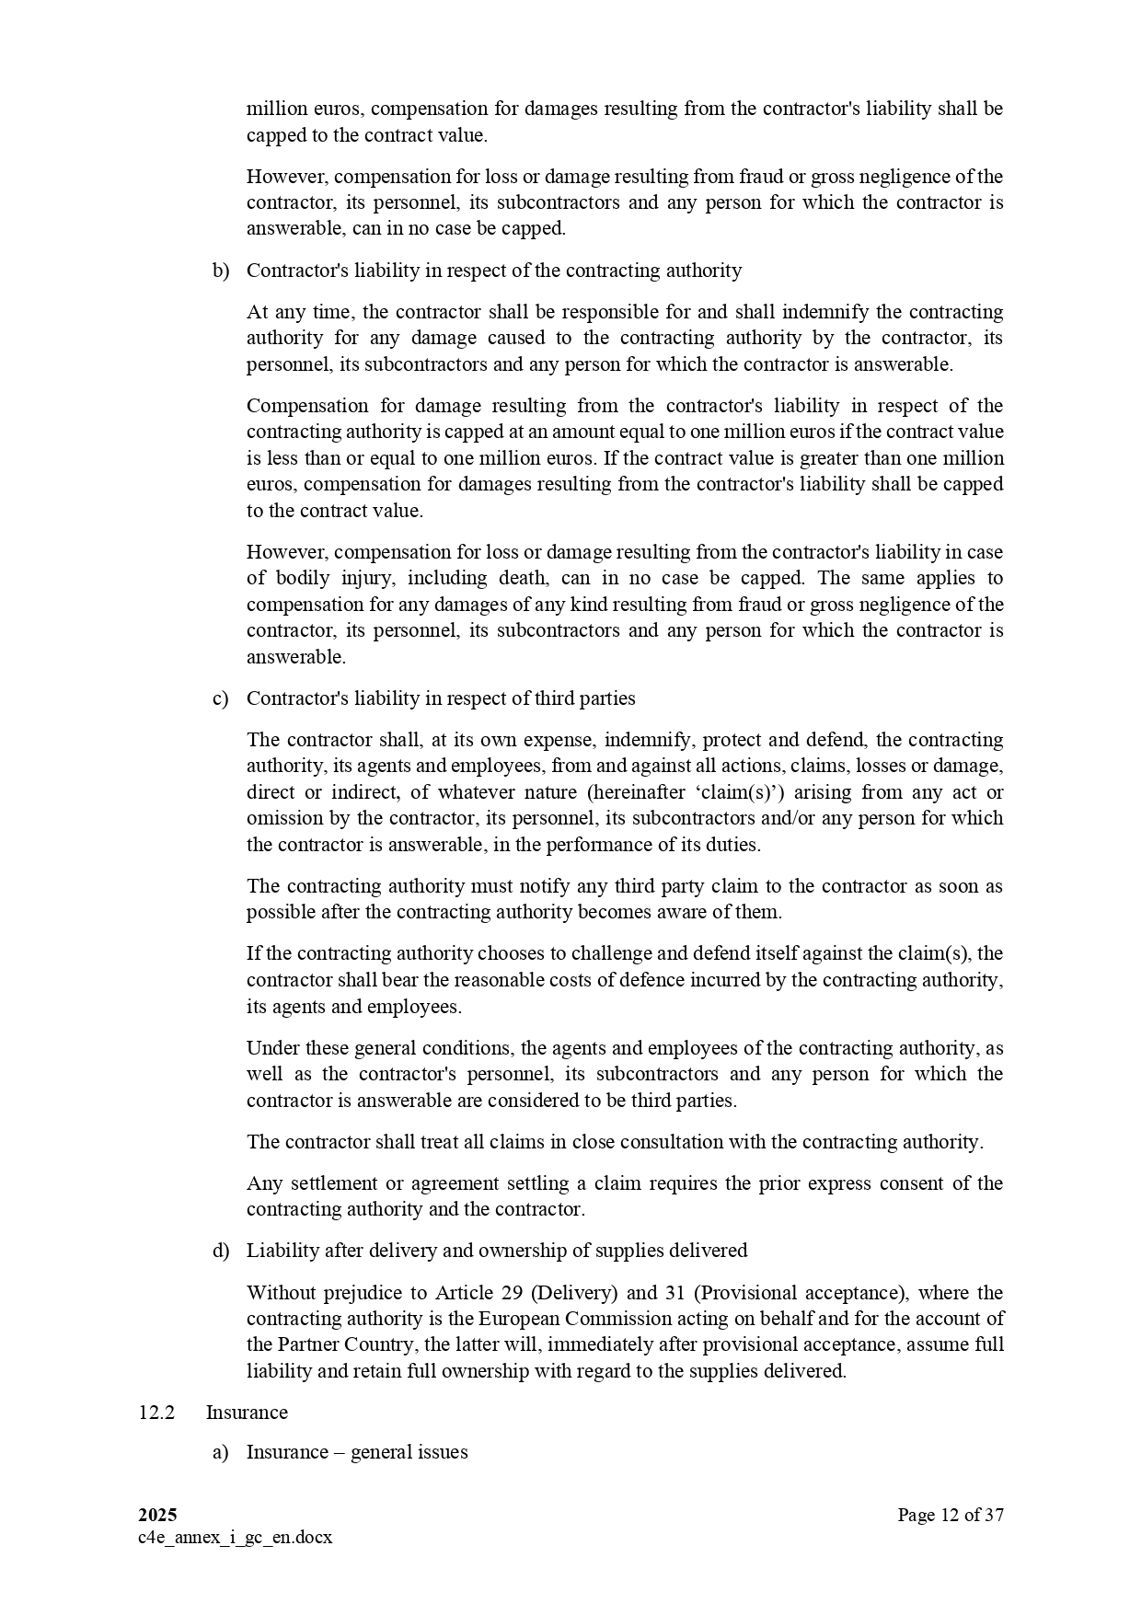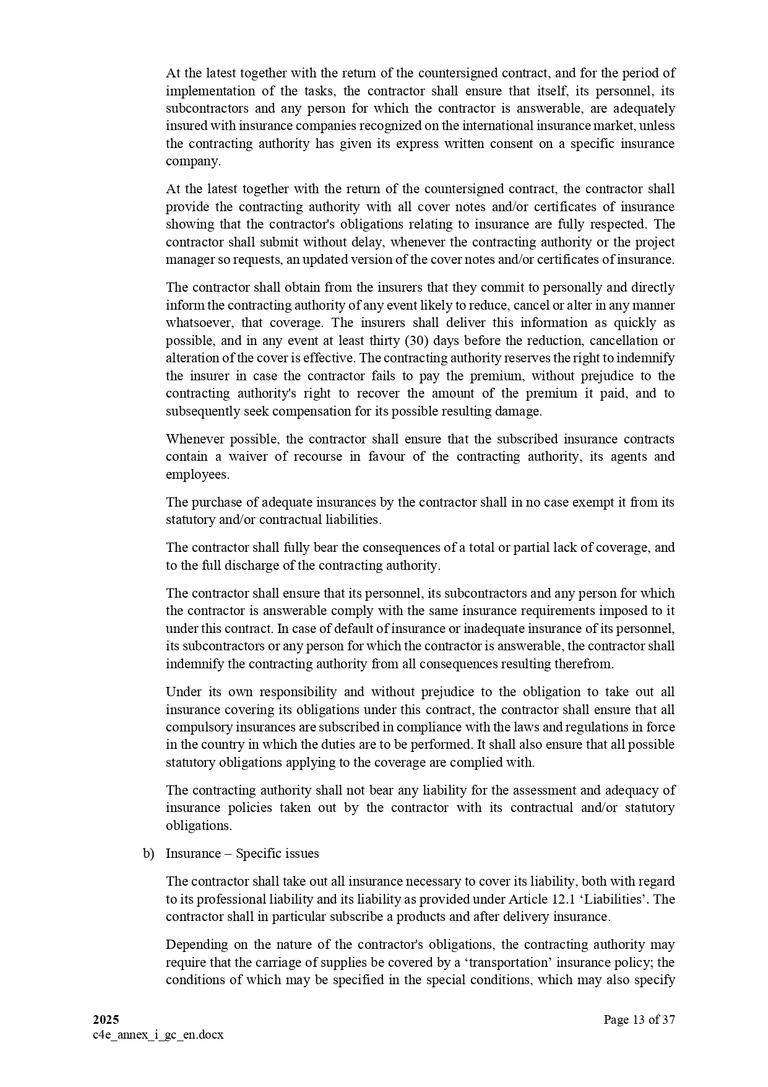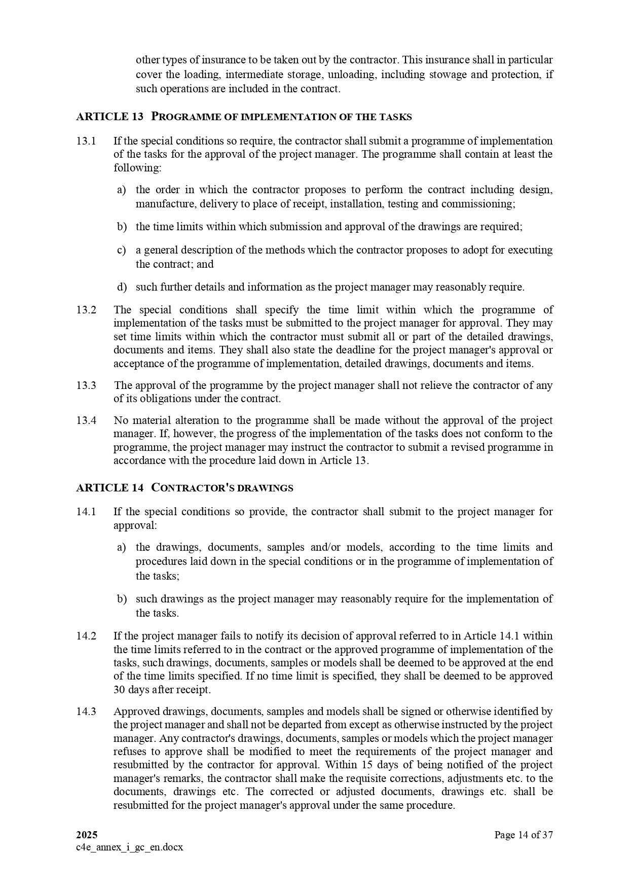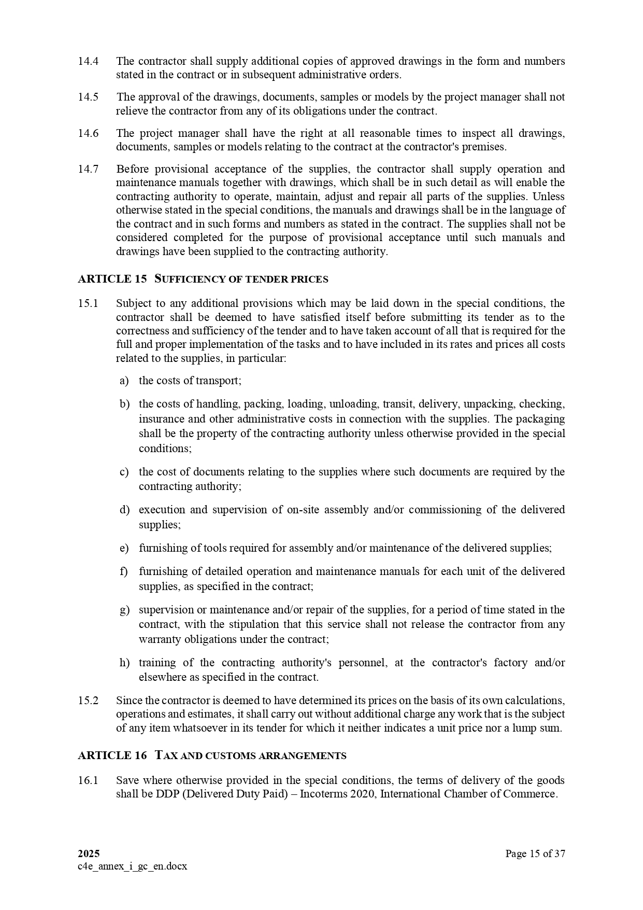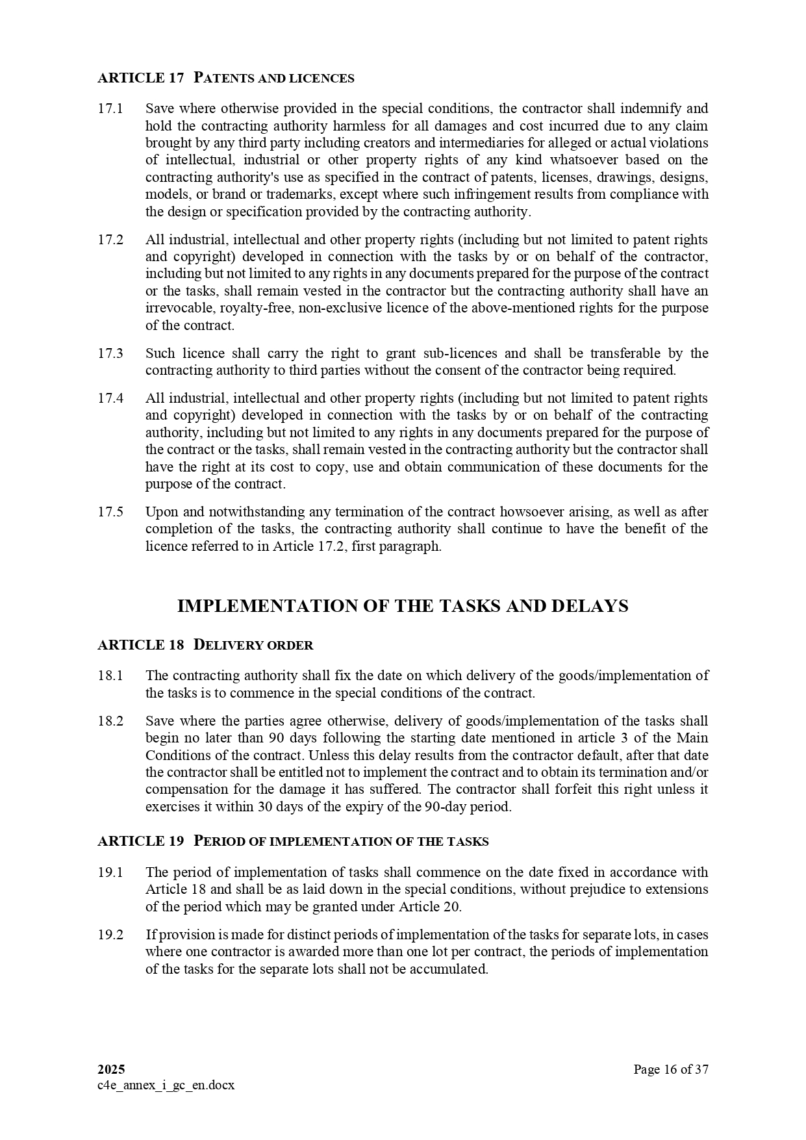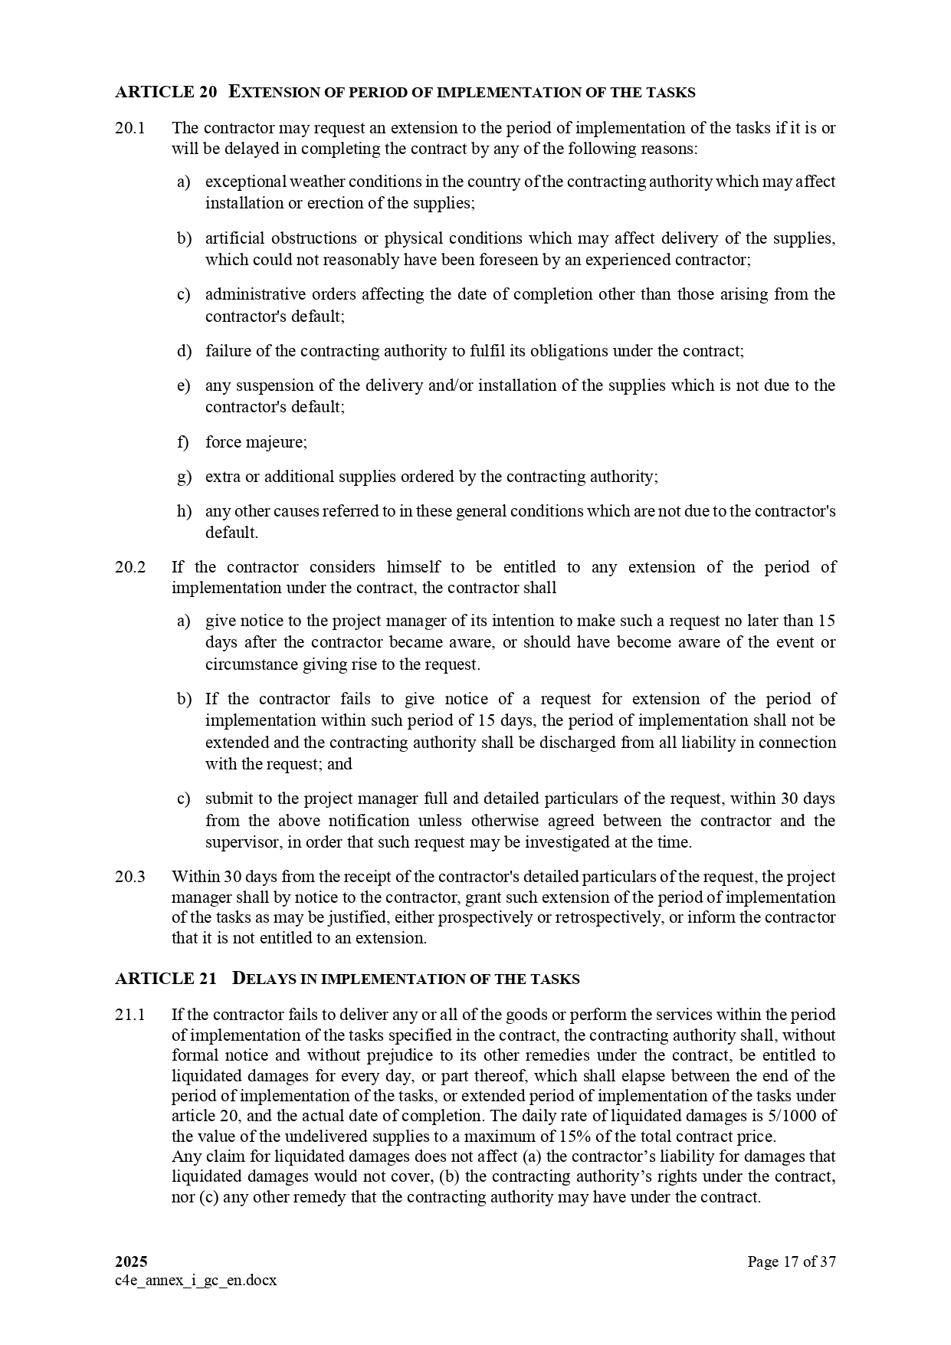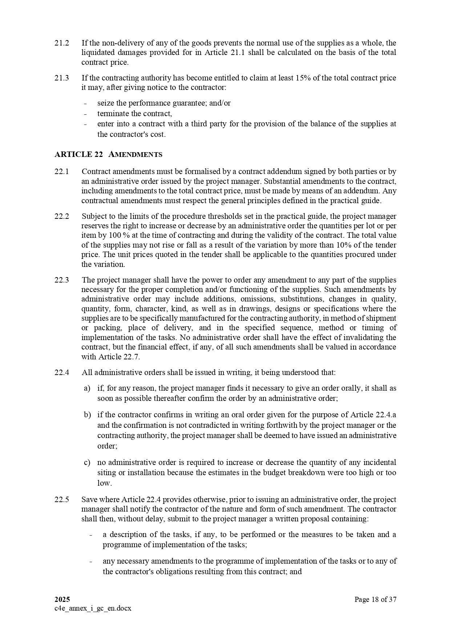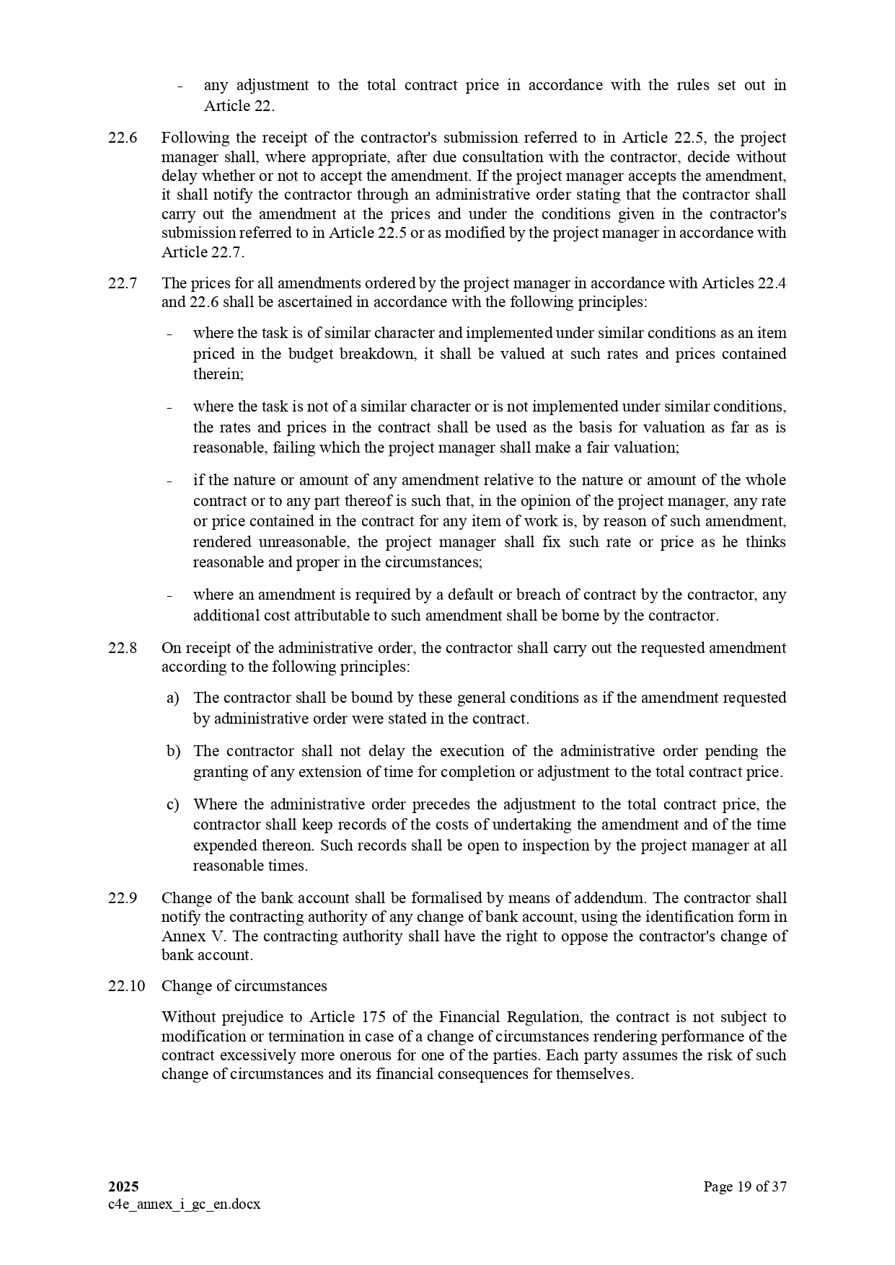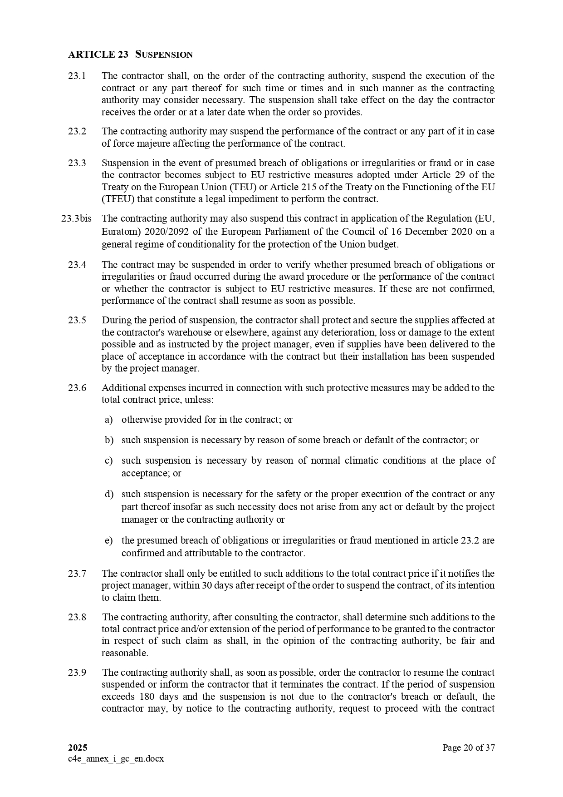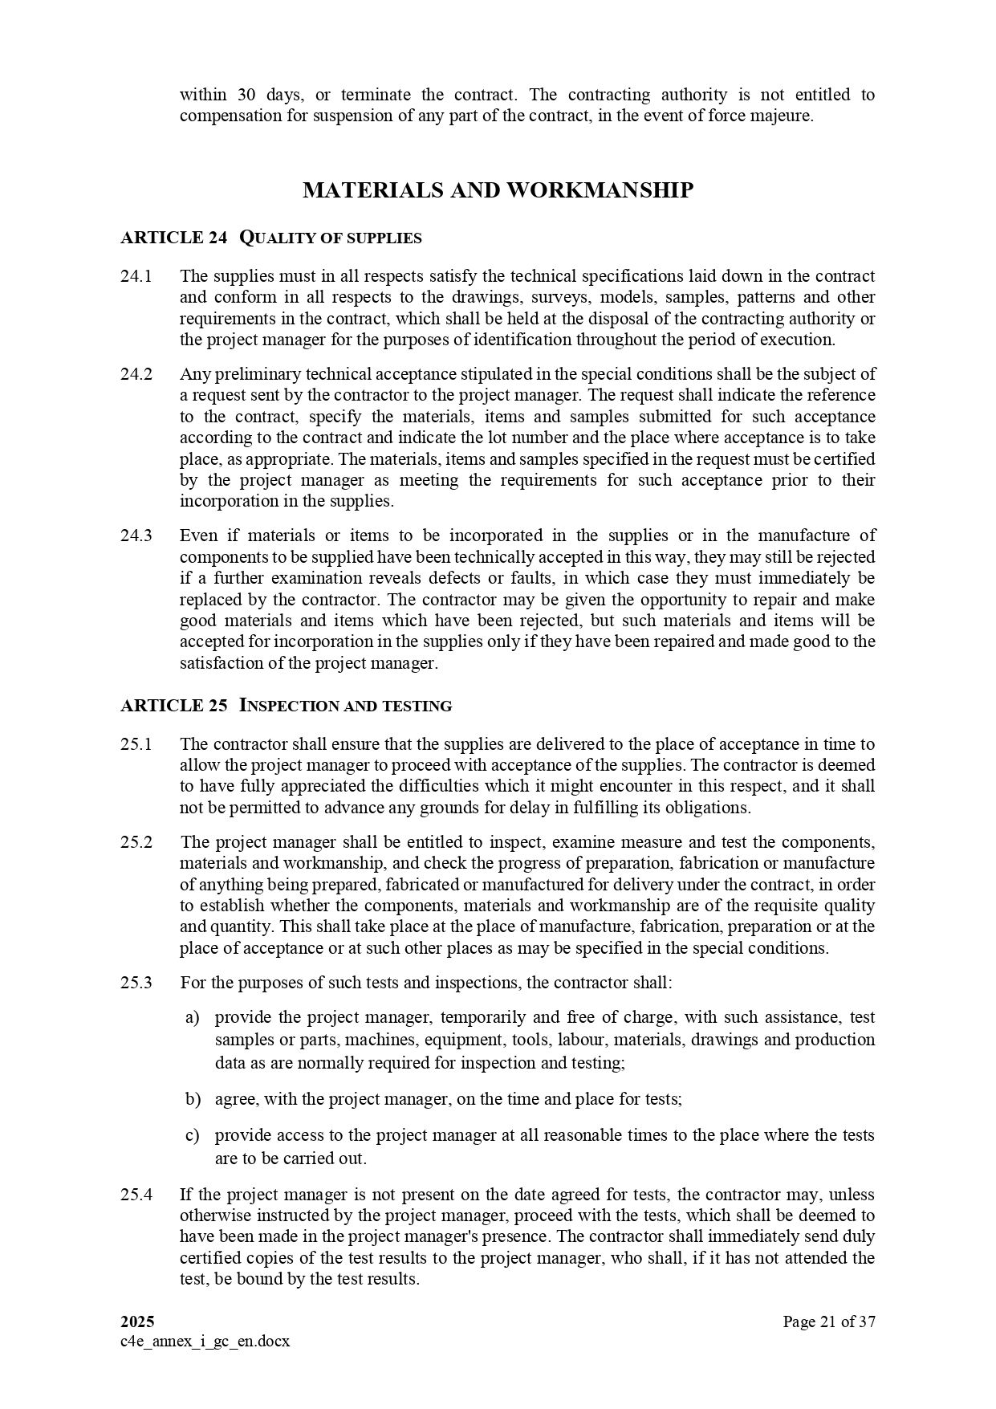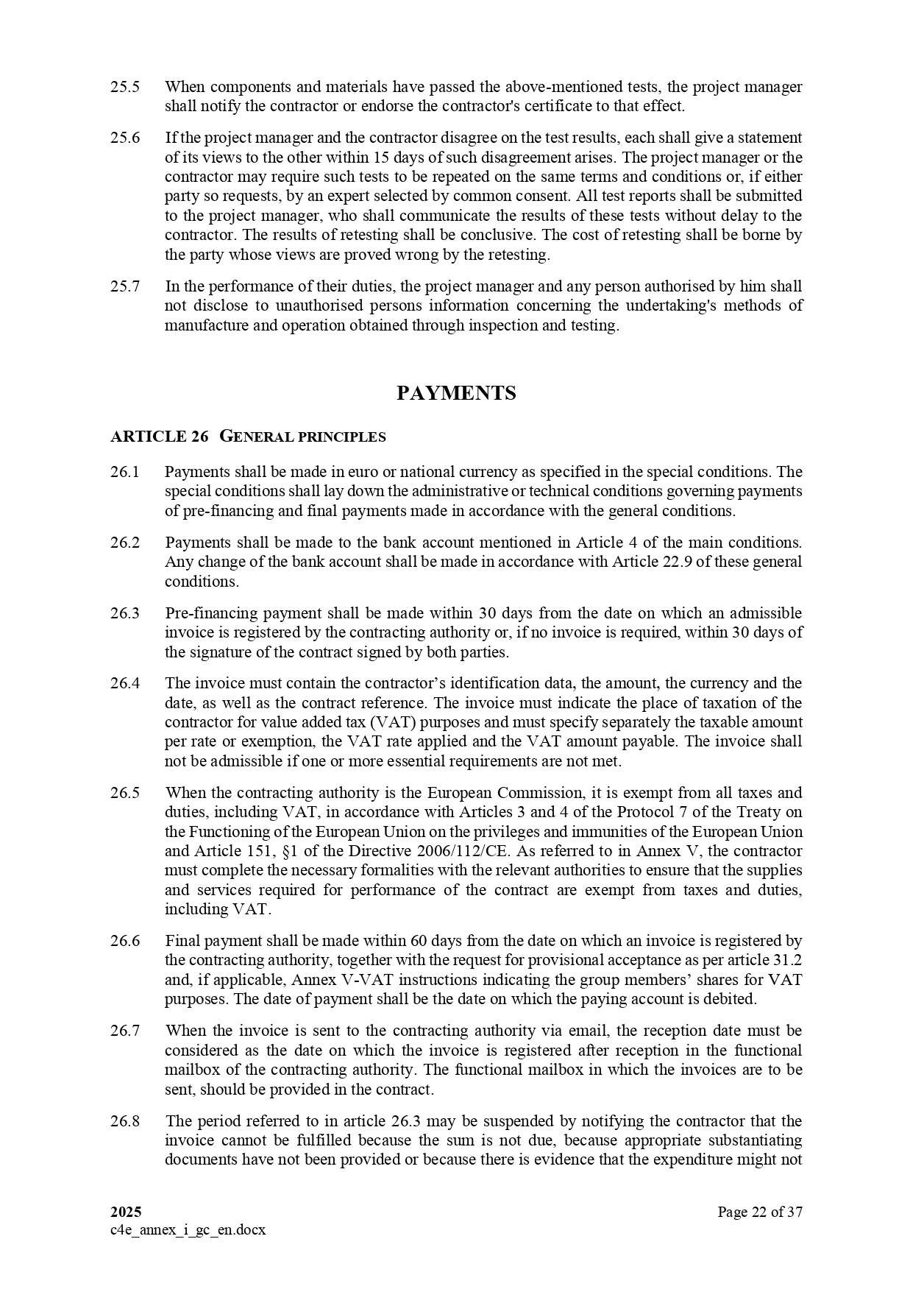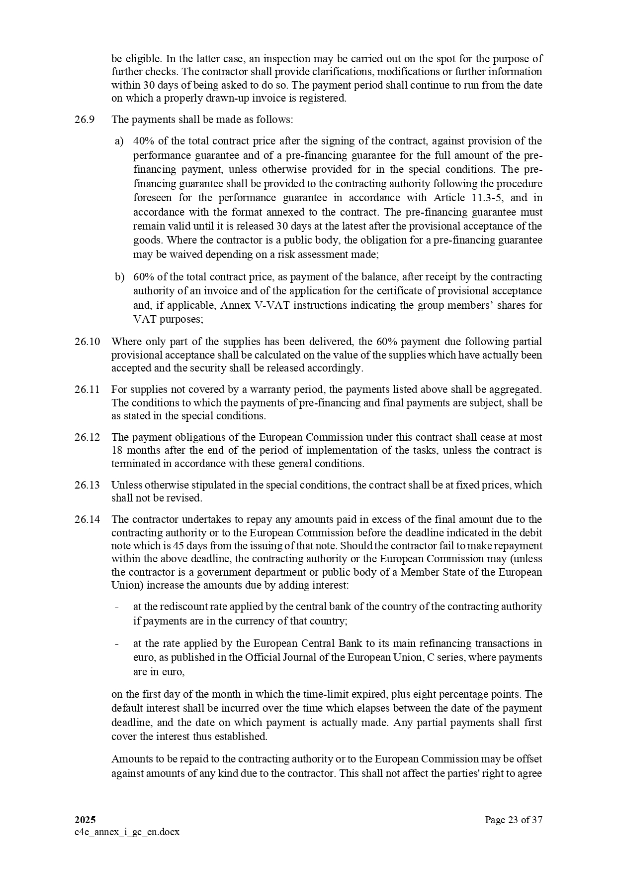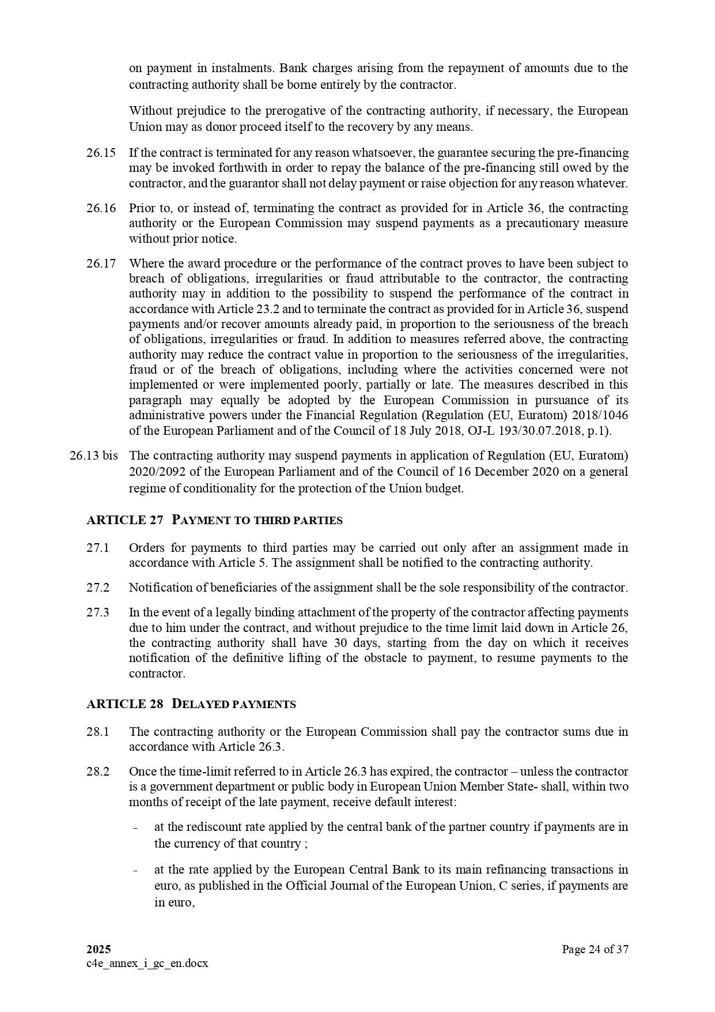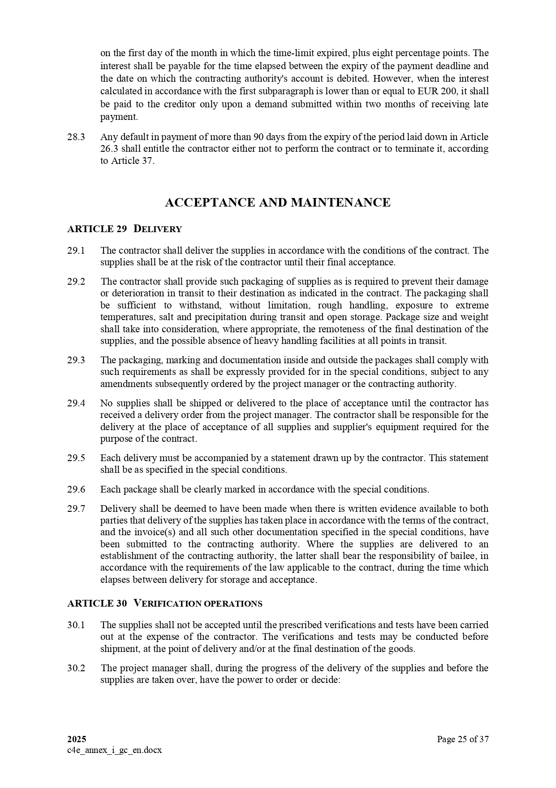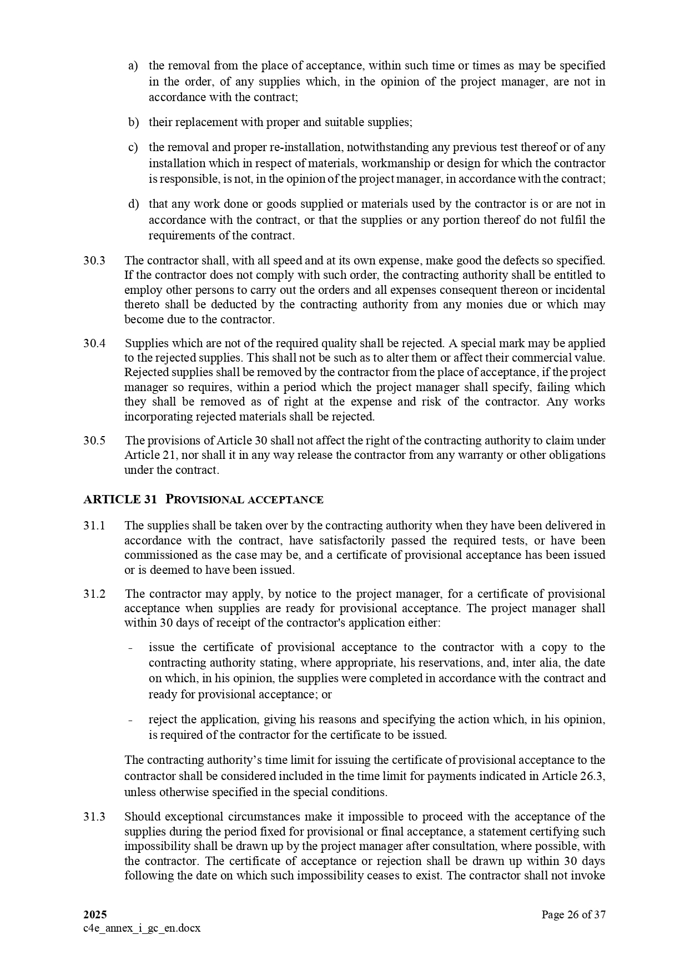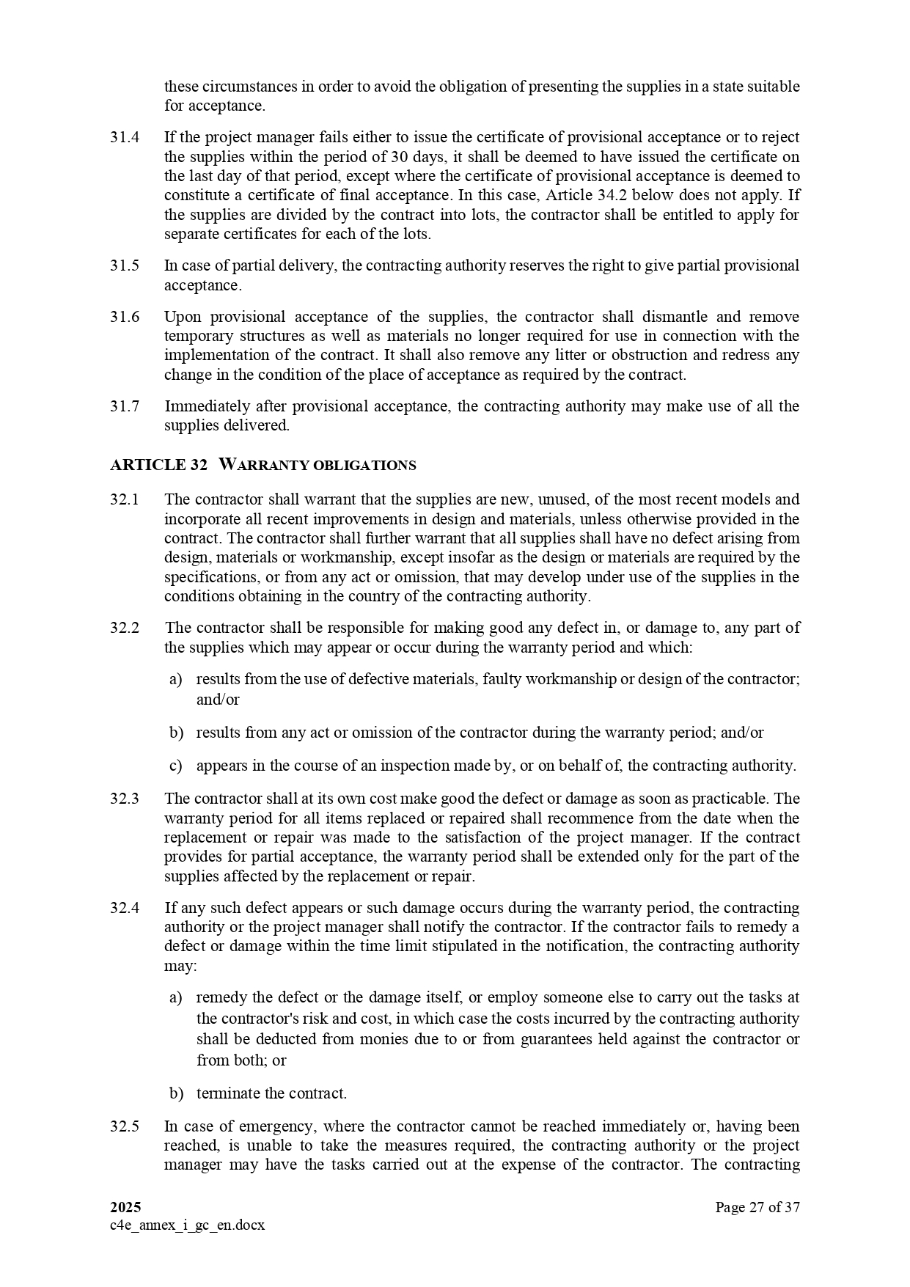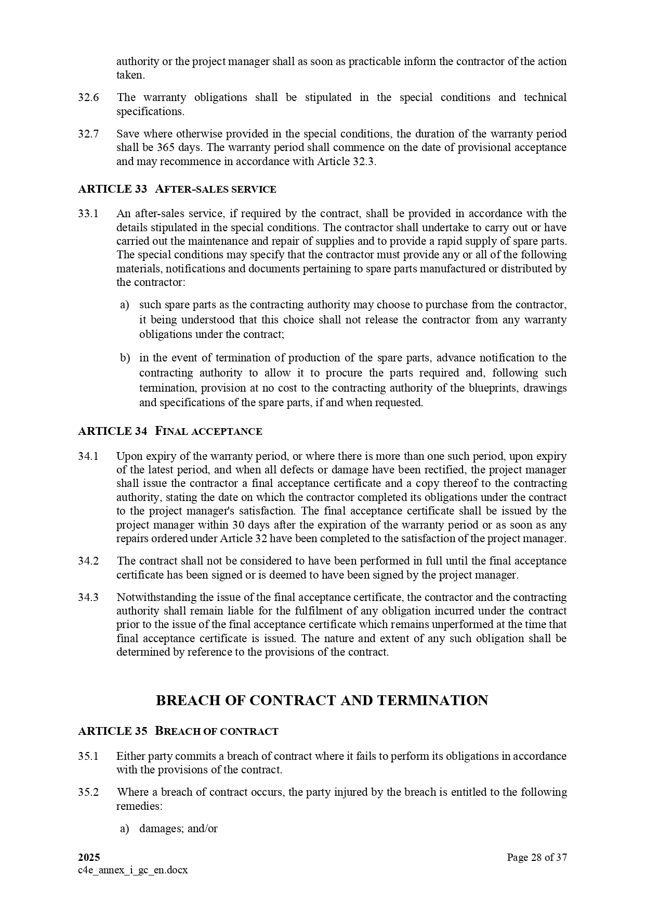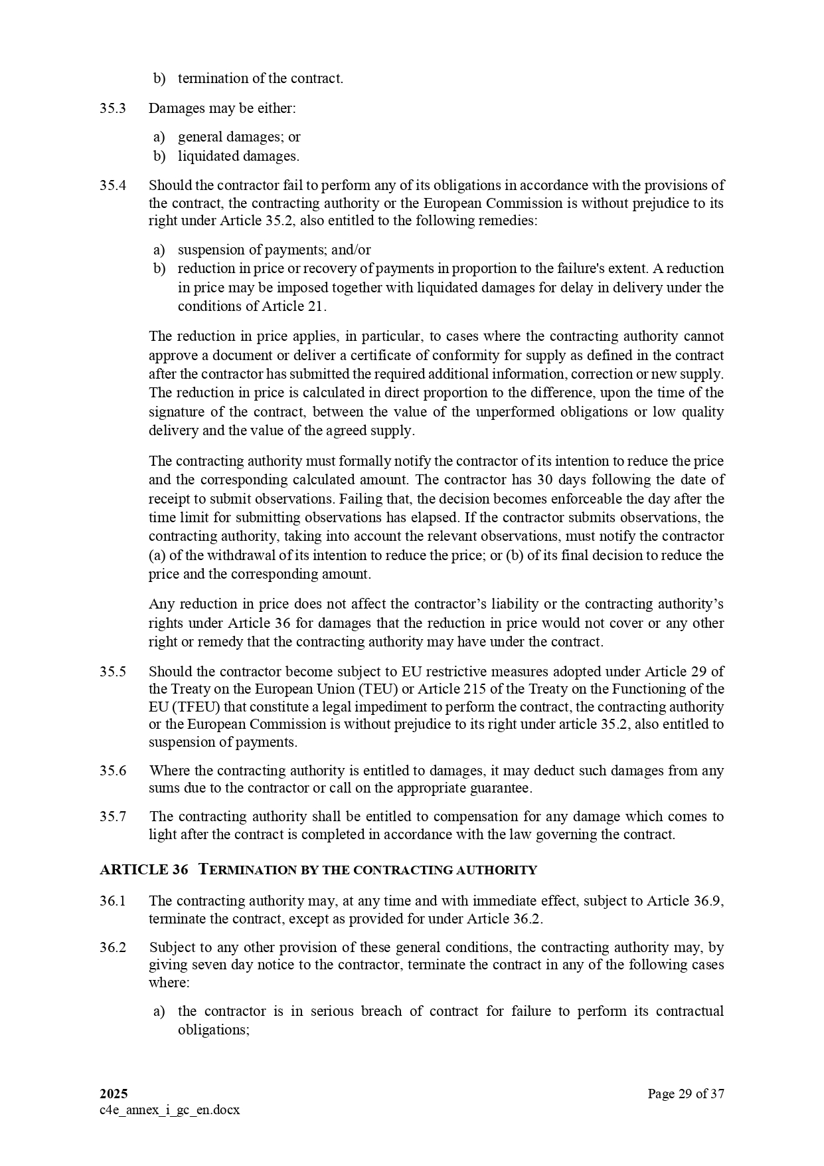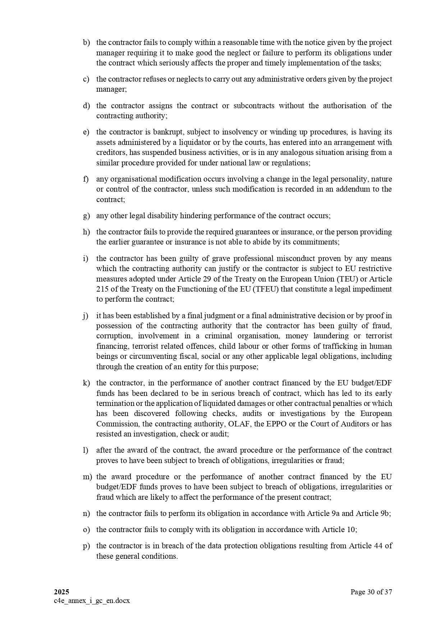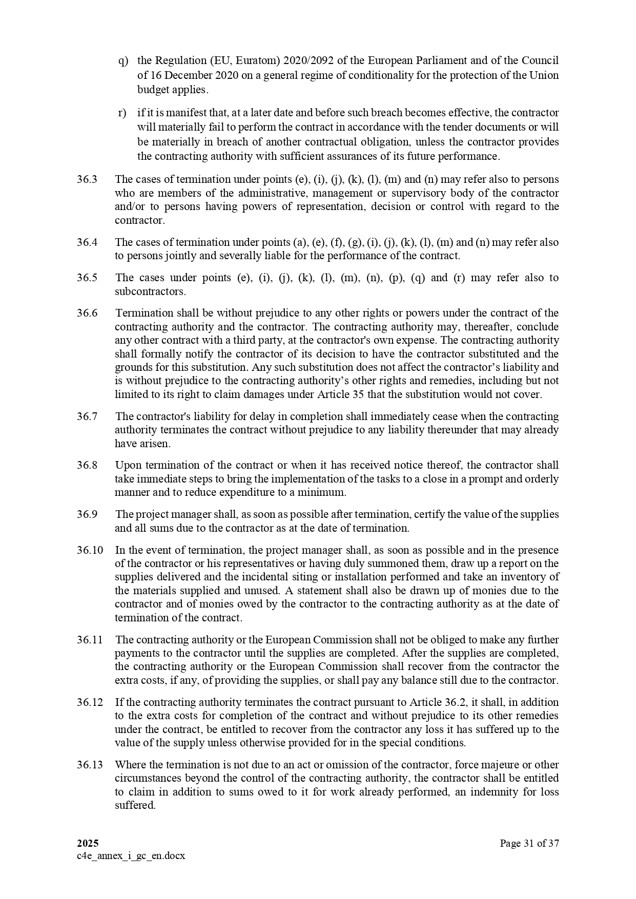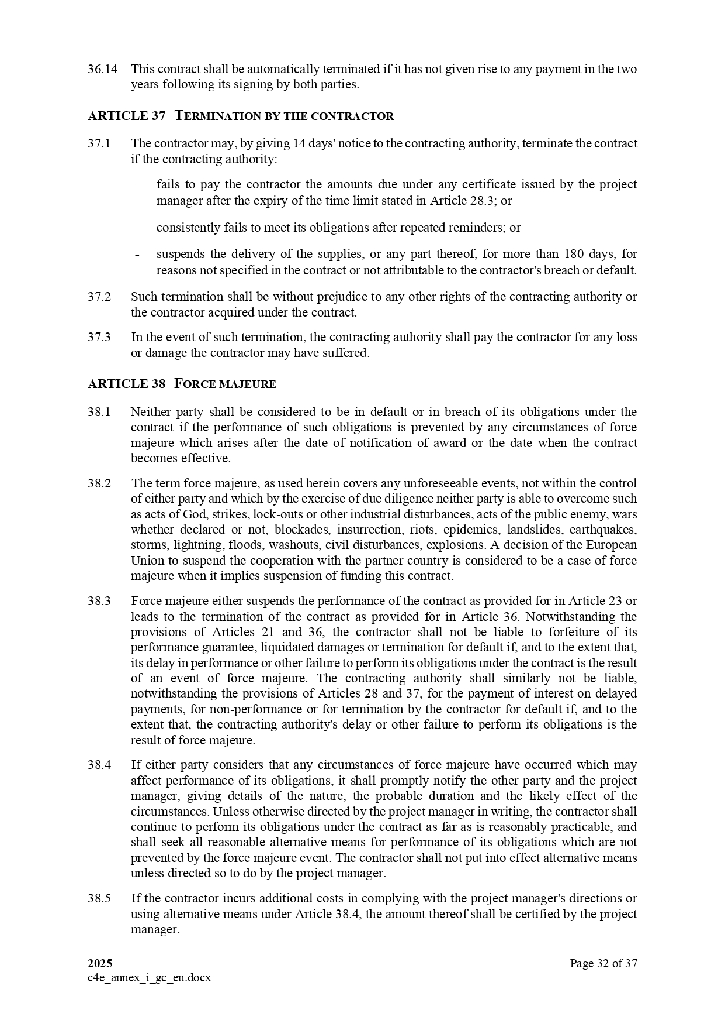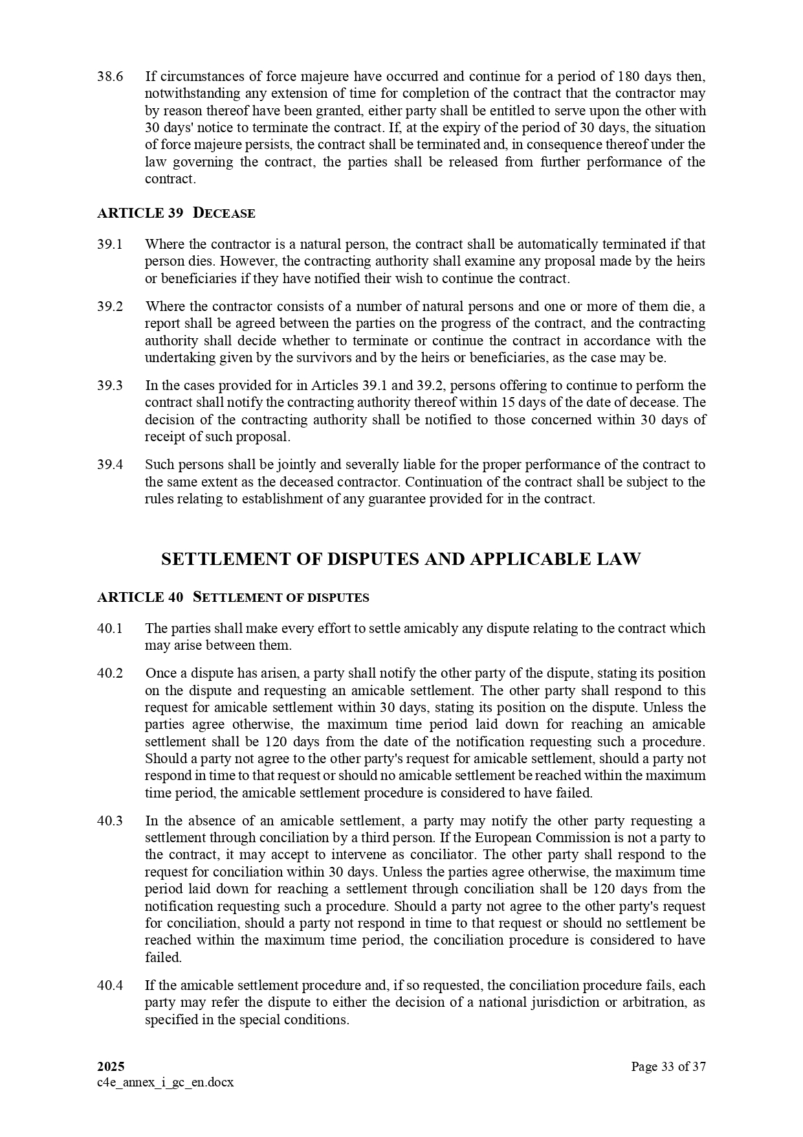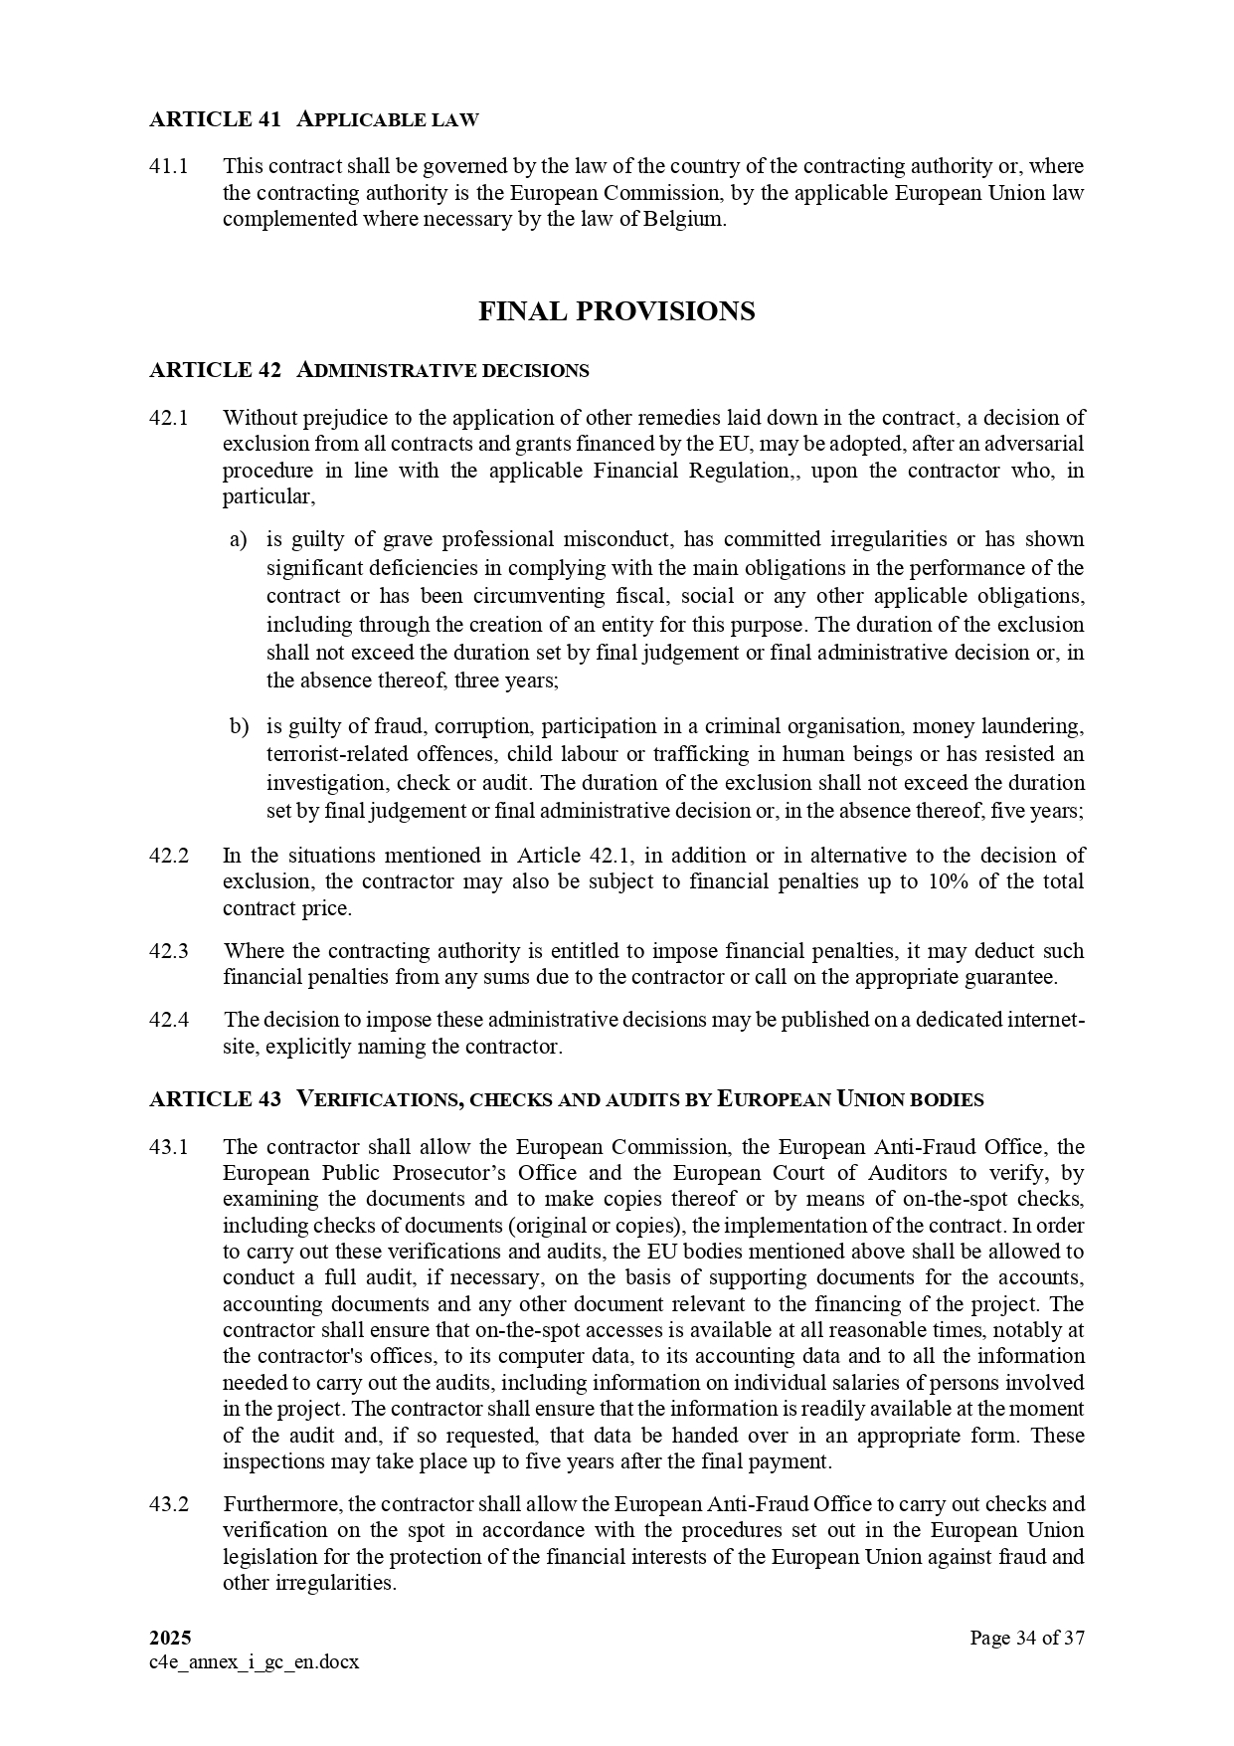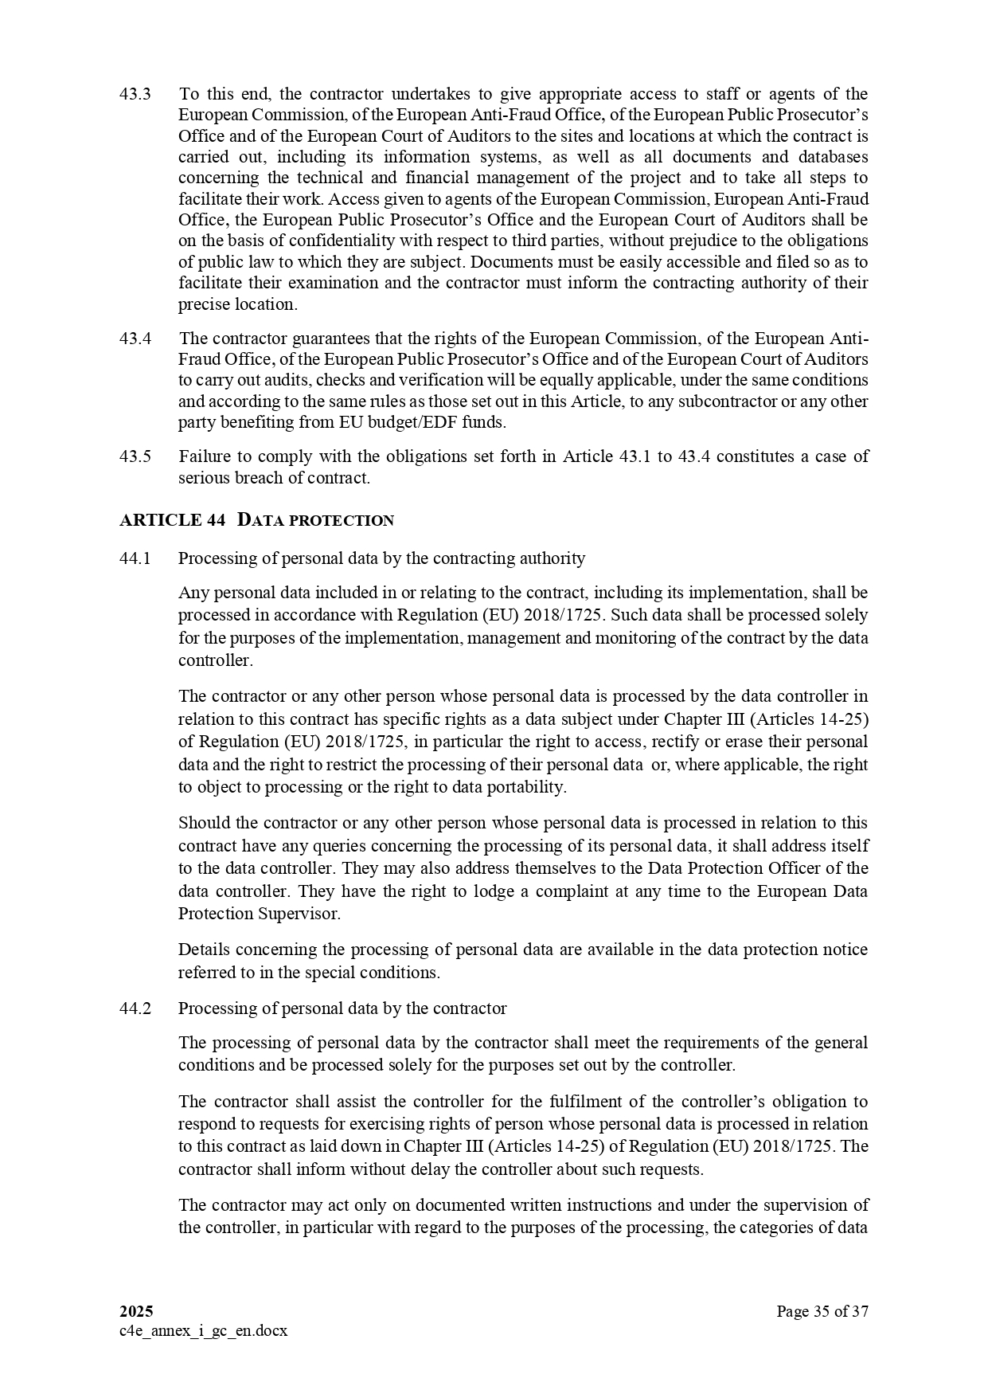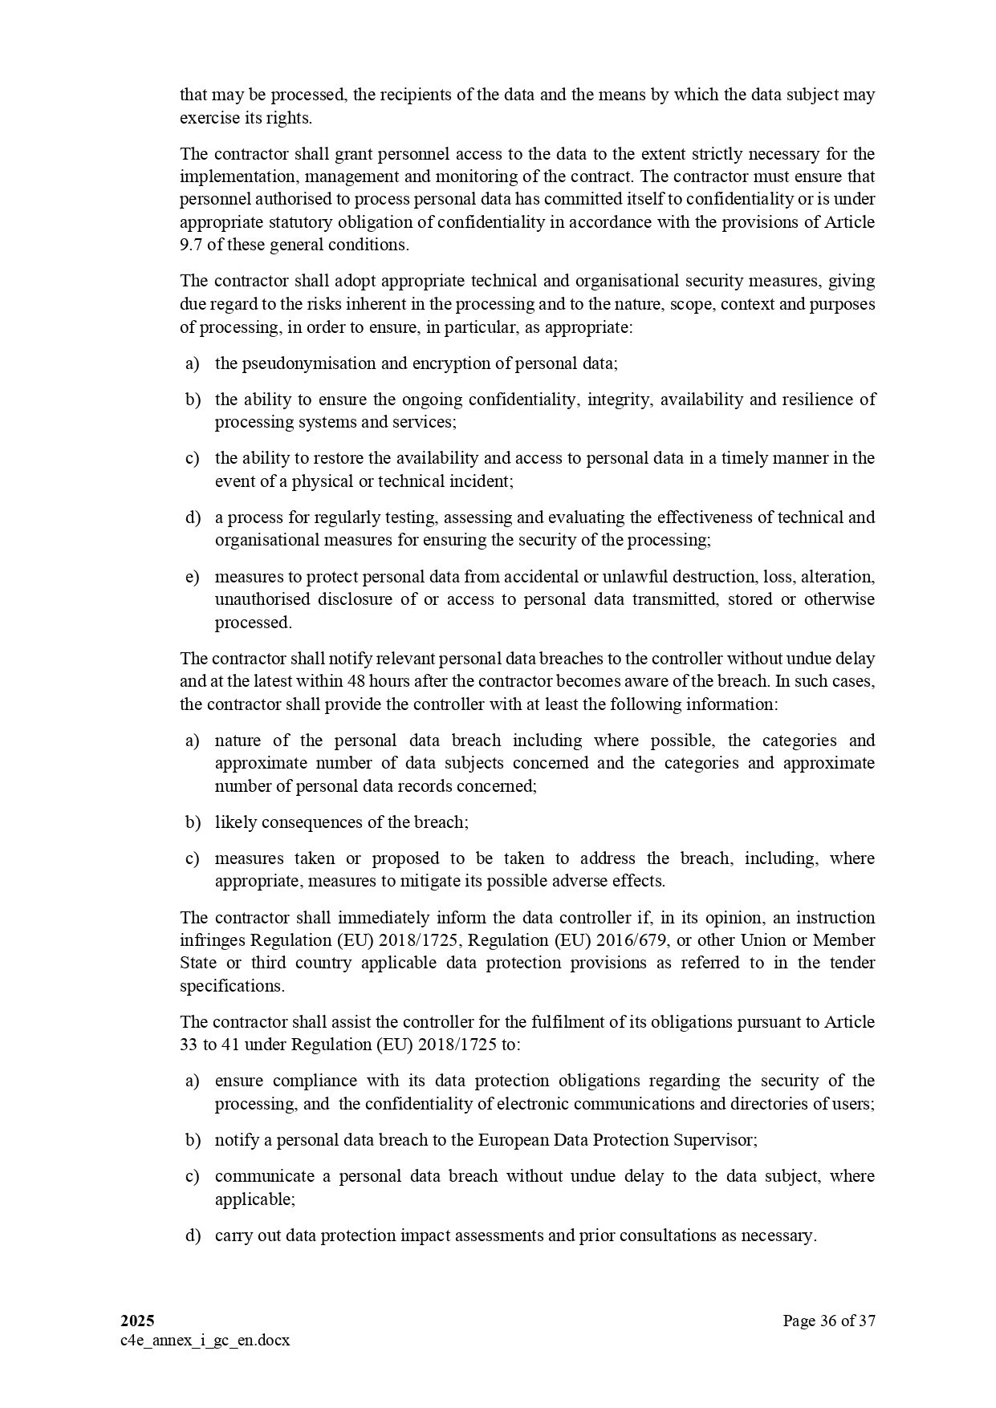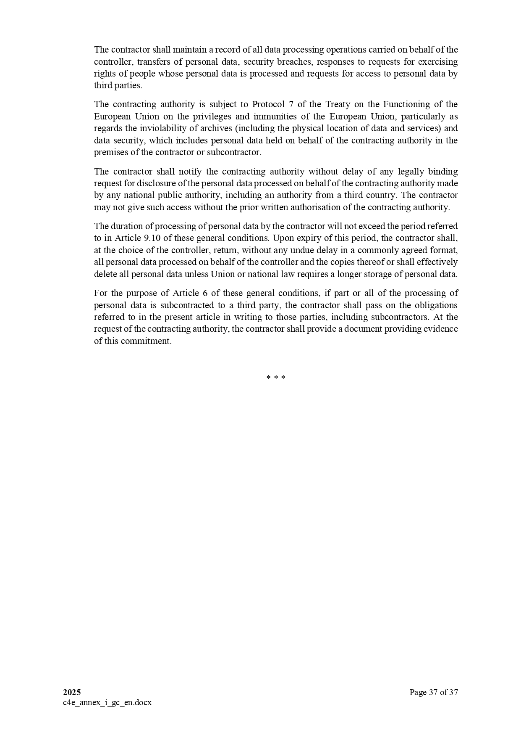

ANNEX II + III: TECHNICAL SPECIFICATIONS + TECHNICAL OFFER

Contract title: SUPPLY, DELIVERY, INSTALLATION, AND AFTER-SALES SERVICE OF ICT INFRASTRUCTURE FOR VTMIS

Publication reference: COI/PSSN/AO/2025/010

Columns 1-2 should be completed by the contracting authority
Columns 3-4 should be completed by the tenderer
Column 5 is reserved for the evaluation committee

Annex III - the contractor's technical offer

The tenderers are requested to complete the template on the next pages:

- Column 2 is completed by the contracting authority shows the required specifications (not to be modified by the tenderer),
- Column 3 is to be filled in by the tenderer and must detail what is offered (for example the words ‘compliant’ or ‘yes’ are not sufficient)
- Column 4 allows the tenderer to make comments on its proposed supply and to make eventual references to the documentation

The eventual documentation supplied should clearly indicate (highlight, mark) the models offered and the options included, if any, so that the evaluators can see the exact configuration. Offers that do not permit to identify precisely the models and the specifications may be rejected by the evaluation committee.
The offer must be clear enough to allow the evaluators to make an easy comparison between the requested specifications and the offered specifications.

1.  Item  Number | 2.  Specifications Required | 4.  Specifications Offered | 4.  Notes, remarks,  ref to documentation | 5.  Evaluation Committee’s notes
1.1 | SERVER  Technical specification :  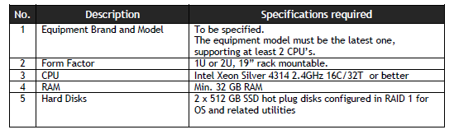  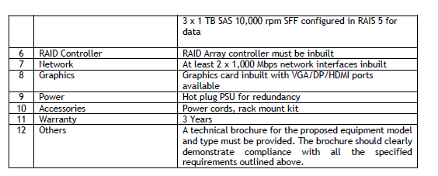
1.2 | Operating System  Technical specification :  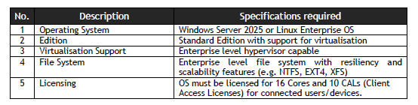
1.3 | Backup System  Technical specification :  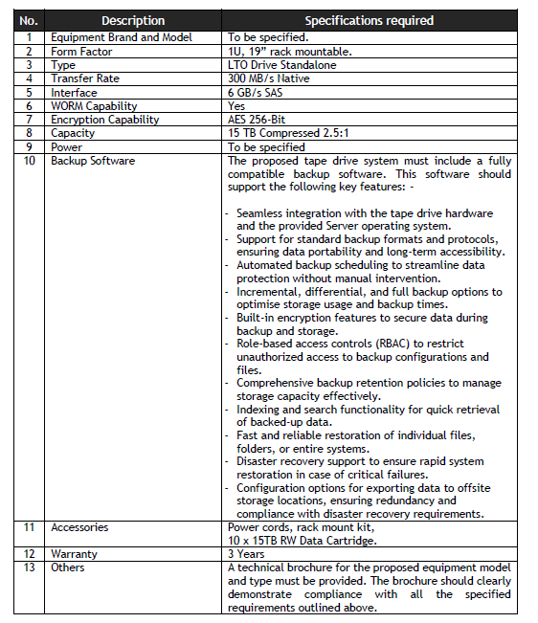
1.4 | Server Console  Technical specification :  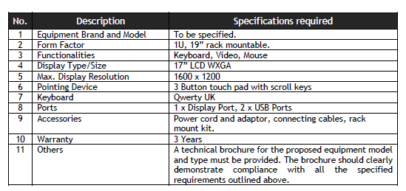
1.5 | Switch  Technical specification :  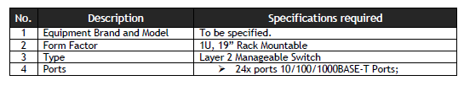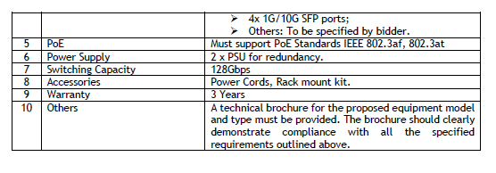
1.6 | Firewall  Technical specifications :  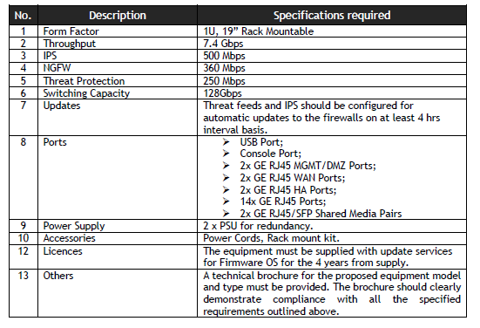
1.7 | Workstation PC  Technical specifications :  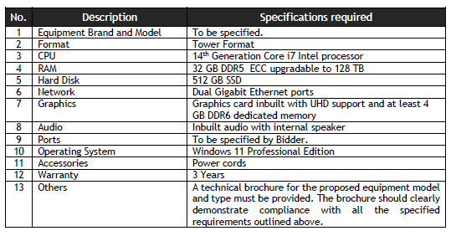
1.8 | High-resolution displays  Technical specifications :  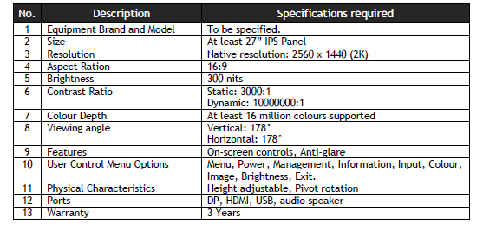  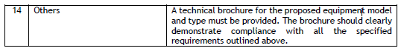
1.9 | After sale service on all items: for one(1) year as from final acceptance

ANNEXE IV: Budget breakdown (Model financial offer)

Page n° 1 [de…]

PUBLICATION RÉFÉRENCE : COI/ PSSN /AO/2025/010 NAME OF TENDERER: <nom>

 | A |  | C | D | E
 | Item number | Quantity | specifications offered (incl brand/model) | Unit costs with delivery [EUR]1  Delivery for:  -kenya:  Kenya Port Authority, Port of Mombassa  - MADAGASCAR :  Capitainerie du Port-SPAT, Port of Tamatave  - MAURICE :  National Coast Guard, Port Louis  - MOZAMBIQUE :  Maritime Rescue Coordination Centre, Port of Maputo  - SEYCHELLES :  National Coast Guard, Mahé  - TANZANIA :  Tanzania Port Authority, Information Sharing Centre, Port of Dar-Es-Salaam | total  [EUR]
1.1 |  | 12
1.2 |  | 06
1.3 |  | 06
1.4 |  | 06
1.5 |  | 06
1.6 |  | 06
1.7 |  | 06
1.8 |  | 06
1.9 (After sale service) |  | FFT
 |  |  |  | Total

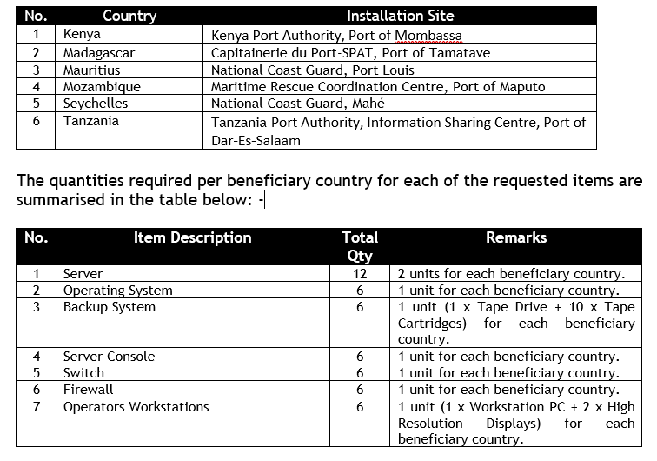

Annex V: Specified forms and other relevant documents

Tax and customs arrangements
Article 31 from Annex IV to the Cotonou Agreement
- The ACP States shall apply to contracts financed by the Community tax and customs arrangements no less favourable than those applied by them to the most favoured States or international development organisations with which they have relations. For the purpose of determining the most-favoured-nation (MFN) treatment, account shall not be taken of arrangements applied by the ACP State concerned to other ACP States, or to other developing countries.
- Subject to the above provisions the following shall apply to contracts financed by the Community:
- the contract shall not be subject in the beneficiary ACP State to stamp or registration duties or to fiscal charges having equivalent effect, whether such charges already exist or are to be instituted in the future; however, such contracts shall be registered in accordance with the laws in force in the ACP State and a fee corresponding to the service rendered may be charged for it;
- profits and/or income arising from the performance of contracts shall be taxable according to the internal fiscal arrangements of the ACP State concerned, provided that the natural or legal persons who realise such profit and/or income have a permanent place of business in that State, or that the performance of the contract takes longer than six months;
- enterprises which must import professional equipment in order to carry out works contracts shall, if they so request, benefit from the system of temporary admission as laid down by the national legislation of the beneficiary ACP State in respect of the said equipment;
- professional equipment necessary for carrying out tasks defined in a service contract shall be temporarily admitted into the beneficiary ACP State or States in accordance with its national legislation free of fiscal, import and customs duties and of other charges having equivalent effect where these duties and charges do not constitute remuneration for services rendered;
- imports under supply contracts shall be admitted into the beneficiary ACP State without customs duties, import duties, taxes or fiscal charges having equivalent effect. The contract for supplies originating in the ACP State concerned shall be concluded on the basis of the ex-works price of the supplies to which may be added such internal fiscal charges as may be applicable to those supplies in the ACP State;
- fuels, lubricants and hydrocarbon binders and, in general, all materials used in the performance of works contracts shall be deemed to have been purchased on the local market and shall be subject to fiscal rules applicable under the national legislation in force in the beneficiary ACP State; and
- personal and household effects imported for use by natural persons, other than those recruited locally, engaged in carrying out tasks defined in a service contract and members of their families, shall be exempt from customs or import duties, taxes and other fiscal charges having equivalent effect, within the limit of the national legislation in force in the beneficiary ACP State.
- Any matter not covered by the above provisions on tax and customs arrangements shall remain subject to the national legislation of the ACP State concerned.

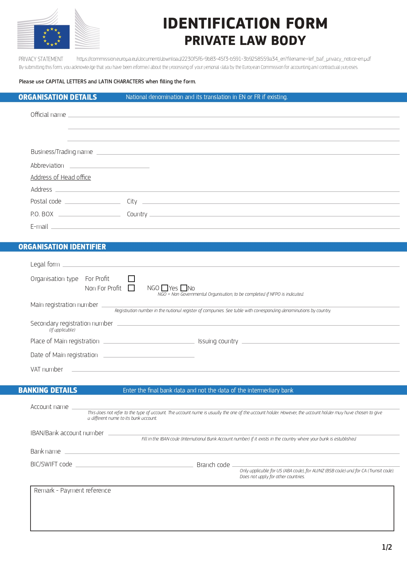

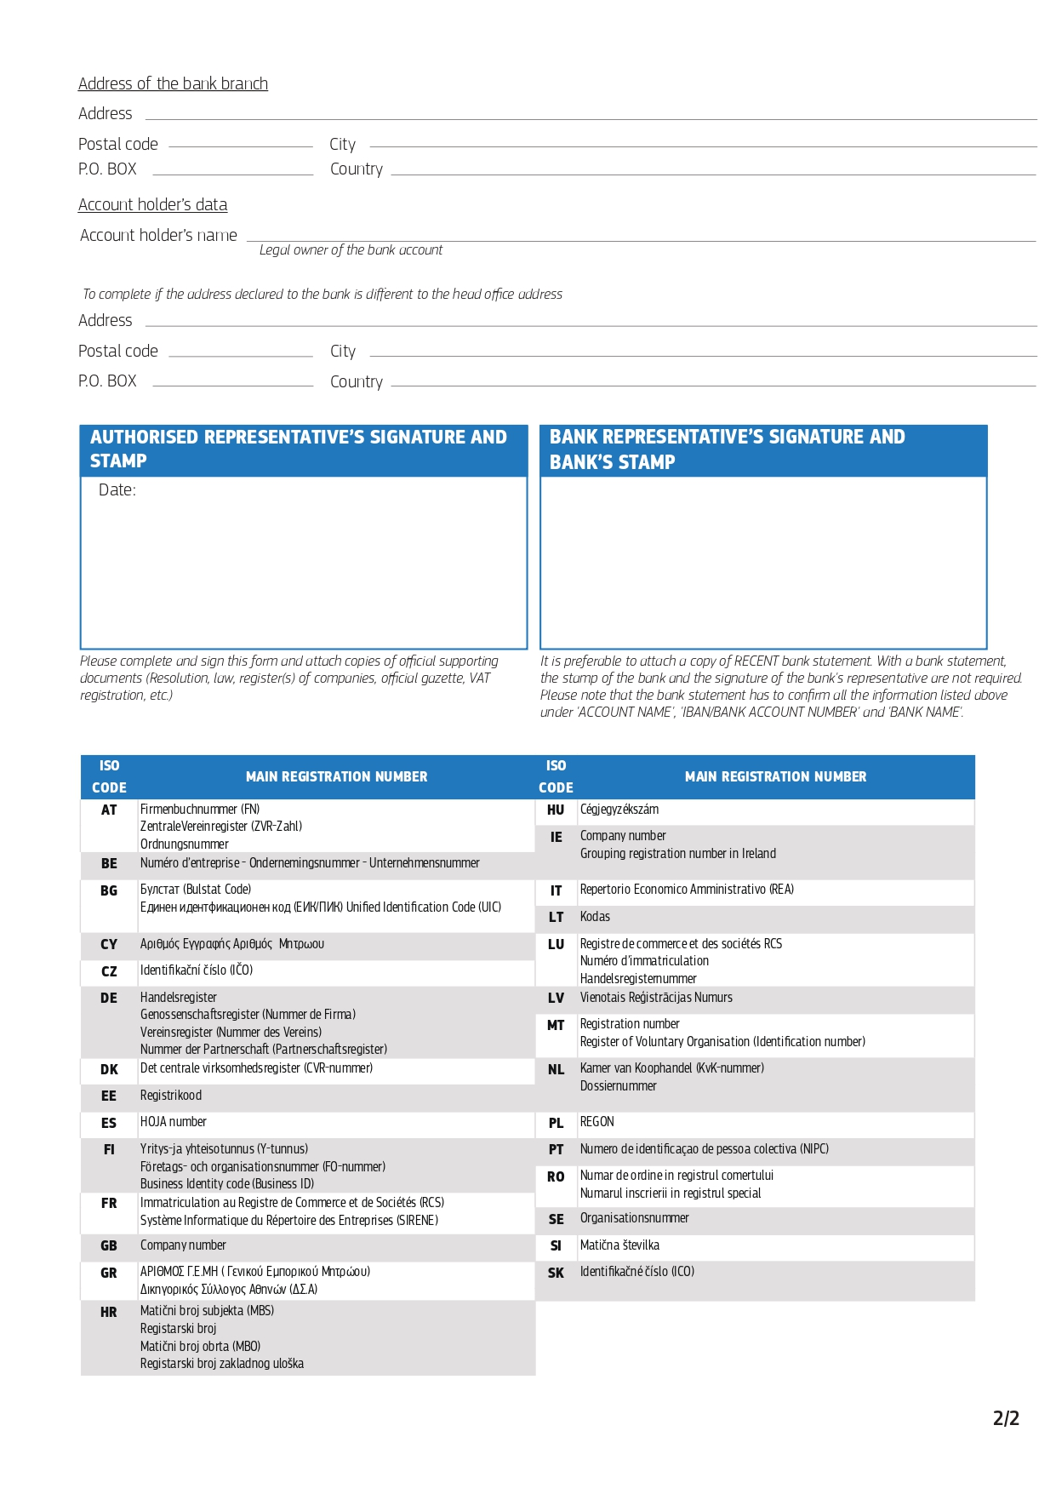

PART C

Others informations

ADMINISTRATIVE COMPLIANCE GRID
Contract title : | SUPPLY, DELIVERY, INSTALLATION, AND AFTER-SALES SERVICE OF ICT INFRASTRUCTURE FOR VTMIS | Publication reference : | COI/RDRM/AO/2024/010

Tender number | Name of tenderer | Electronic submission only: Original tender guarantee included? (Yes/No) | Is tenderer (consortium) nationality eligible?  (Y/N) | Is documentation complete?  (Y/N) | Is language as required?  (Y/N) | Is tender submission form complete?  (Y/N) | Is tenderer's declaration signed (by all consortium members if a consortium)? (Yes/No/ Not Applicable) | Declaration(s) on honour included? (Yes/No) | Other administrative requirements of the tender dossier?  (Yes/No/Not applicable) | Form FS-PP on financial contributions from non EU Countries  (Yes/No/Not Applicable) | Overall decision?  (Accept / Reject)
1
2
3
4
5
6
7

Chairperson's name
Chairperson's signature
Date

EVALUATION GRID

Contract title : | SUPPLY, DELIVERY, SITING AND INSTALLATION, COMMISSIONING AND AFTER-SALES SERVICE OF EQUIPMENT TO STRENGTHEN EARLY WARNING SYSTEMS IN SEYCHELLES | Publication reference : | COI/RDRM/AO/2024/010

Tender No | Name of tenderer | Rules of origin respected?  (additional guidance)  (Y/N) | Economic & financial capacity? (OK/a/b/…) | Professional capacity? (OK/a/b/…) | Technical capacity? (OK/a/b/…) | Compliance with technical specifications? (OK/a/b/…) | Ancillary services as required? (OK/a/b/…/NA) | Subcontracting statement in accordance with art. 6 of the general conditions?  (Y/N) | Other technical requirements in tender dossier?  (Yes/No/Not applicable) | Technically compliant? Y/N) | Justification/  notes:
1
2
3
4

Evaluator's name & signature
Evaluator's name & signature
Evaluator's name & signature
Date

PART D

Tender submission form and Declaration on honour on exclusion criteria and selection criteria

TENDER FORM FOR A SUPPLY CONTRACT

Publication reference: COI/ PSSN /AO/2025/010
SUPPLY, DELIVERY, INSTALLATION, AND AFTER-SALES SERVICE OF ICT INFRASTRUCTURE FOR VTMIS
<Place and date>
A: INDIAN OCEAN COMMISSION
Blue Tower, 3rd Floor, Rue de l’Institut, Ebène, Mauritius

One signed form must be supplied (for each lot, if the tender procedure is divided into lots), together with the number of copies specified in the instructions to tenderers. The form must include a signed declaration using the annexed format from each legal entity submitting this tender. Any additional documentation (brochure, letter, etc.) sent with the form will not be taken into consideration. Tenders being submitted by a consortium (i.e. either a permanent, legally-established grouping or a grouping which has been constituted informally for a specific tender procedure) must follow the instructions applicable to the consortium leader and its members. The attachments to this submission form (i.e. declarations, statements, proofs) may be in original or copy. If copies are submitted, the originals must be dispatched to the contracting authority upon request. For economical and ecological reasons, we strongly recommend that you submit your files on paper-based materials (no plastic folder or divider). We also suggest you use double-sided print-outs as much as possible.
Capacity-providing entities
An economic operator (i.e. tenderer) may, where appropriate and for a particular contract, rely on the capacities of other entities, regardless of the legal nature of the links which it has with them. If the economic operator relies on other entities it must in that case prove to the contracting authority that it will have at its disposal the resources necessary for the performance of the contract by producing a commitment by those entities to place those resources at its disposal. Such entities, for instance the parent company of the economic operator, must respect the same rules of eligibility and notably that of nationality as the economic operator relying on them and must comply with the selection criteria for which the economic operator relies on them. For the purpose of the present tender, the data for this third entity for the relevant selection criterion should be included in a separate document. Proof of the capacity will also have to be provided when requested by the contracting authority.
With regard to technical and professional criteria, an economic operator may only rely on the capacities of other entities where the latter will perform the tasks for which these capacities are required.
With regard to economic and financial criteria, the entities upon whose capacity the economic operator relies, become jointly and severally liable for the performance of the contract.

1 SUBMITTED BY (i.e the identity of the tenderer and bank account details)
 | Name(s) of tenderer(s) | Official address, postcode, P.O box, city, country | Legal form | VAT number and/or Registration number (if applicable) | Place of main registration (city and country) and date of registration | PIC number
Leader
Member
Etc …
 | Account name and account holder name | IBAN/Account number | Currency | BIC/Swift code | Bank name and branch code | Address of bank, P.O box, city, country
Leader

2 CONTACT PERSON (for this tender)
Name
Address
Telephone
E-mail
3 ECONOMIC AND FINANCIAL CAPACITY
Please complete the following table of financial data based on your annual accounts and your latest projections. If annual closed accounts are not yet available for the current year or past year, please provide your amounts based on appropriate statements from banks in the columns marked with **. Figures in all columns must be calculated on the same basis to allow a direct, year-on-year comparison to be made (or, if the basis has changed, an explanation of the change must be provided as a footnote to the table). Any clarification or explanation which is judged necessary may also be provided.
Financial data | 2 years before last year  2022  € | Year before last year  2023>  € | Last year  2024>  € | Average  € | [Past year  € ]** | [Current year  €]**
Annual turnover, excluding this contract
Current assets
Current liabilities
[Current ratio (current assets/current liabilities) | Not applicable | Not applicable |  | Not applicable | Not applicable | Not applicable]

4 PERSONNEL
Please provide the following personnel statistics for the current year and the two previous years.
Annual manpower | Year before past year |  | Past year |  | Current year |  | Period average
 | Overall | Relevant fields | Overall | Relevant fields ¹¹ | Overall | Relevant fields¹¹ | Overall | Relevant fields¹¹
Permanent personnel
Other personnel
Total
Permanent personnel as a proportion of total personnel (%) | % | % | % | % | % | % | % %

5 FIELDS OF SPECIALISATION
Please fill in the table below to indicate any areas of specialist knowledge related to this contract of each legal entity making this tender, by using the names of these specialisation as the row headings and the name of the legal entity as the column headings. Indicate the areas of specialist knowledge each legal entity has by placing a tick () in the box corresponding to the specialisation in which the legal entity has significant experience. Maximum 10 specialisations.
 | Leader | Member 2 | Member 3 | Etc …
Relevant specialisation 1
Relevant specialisation 2
Etc …
6 EXPERIENCE
Please complete a table using the format below to summarise the major relevant supplies carried out over the past 3 years by the legal entity or entities making this tender. The number of references to be provided must not exceed 15 for the entire tender.
Candidates are allowed to refer either to projects completed within the reference period (although started earlier) or to projects not yet completed. Only the part completed during the reference period will be taken into consideration. This part will have to be supported by documentary evidence (approval of report or deliverable, proof of payment, statement or certificate from the entity which awarded the contract) also detailing its value. If a candidate has implemented the project in a consortium, the part that the candidate has successfully completed must be clear from the documentary evidence, together with a description of the nature of the services provided if the selection criteria relating to the pertinence of the experience have been used.
Ref # (maximum 15) | Project title |  | …
Name of legal entity | Country | Overall supply value (EUR) | Part supplied by legal entity EUR | No of personnel provided | Name of client | Origin of funding | Dates | Name of members if any
… | … | … | … | … | … | … | … | …
Detailed description of supply |  |  |  |  |  | Related services provided
… |  |  |  |  |  | …

7 TENDERER’S DECLARATION(S)
As part of this tender, each legal entity identified under point 1 of this form, including every consortium member, must submit an updated notification or declaration on foreign financial contributions received in the last three years using the Form FS-PP available in https://eur-lex.europa.eu/legal-content/EN/TXT/PDF/?uri=CELEX:32023R1441 (Annex II).
If the procurement procedure is divided into lots, the obligation to notify or declare will apply where the estimated value of the procurement exceeds EUR 250 million and the value of the lot or the aggregate value of all the lots to which the tender applies is equal to or greater than EUR 125 million.
Main subcontractors or main suppliers must also submit an updated notification or declaration on foreign financial contributions received in the last three years using the Form FS-PP. A subcontractor or supplier shall be deemed to be main where their participation ensures key elements of the contract performance and in any case where the economic share of their contribution exceeds 20 % of the value of the submitted tender.]
As part of their tender, each legal entity identified under point 1 of this form, including every consortium member, must submit a signed tenderer’s declaration using this format.
Additionally, each legal entity identified under point 1 of this form, including every consortium member, as well as each capacity providing entity and subcontractor, must submit the declaration on honour on exclusion and selection criteria (Annex 1)
In response to your letter of invitation to tender for the above contract,
we, the undersigned, hereby declare that:
1 We have examined and accept in full the content of the dossier for invitation to tender No <……………………………….> of <date>. We hereby accept its provisions in their entirety, without reservation or restriction.
2
We offer to deliver, in accordance with the terms of the tender dossier and the conditions and time limits laid down, without reserve or restriction:
<description of supplies with indication of quantities>
3 The price of our tender excluding spare parts and consumables, if applicable (excluding the discounts described under point 4) is:
<insert price and currency>

4 We will grant a discount of [<…>%], or [<…………..>] [in the event of our being awarded lot … and lot … ………].
5 This tender is valid for a period of 90 days from the final date for submission of tenders.
6 If our tender is accepted, we undertake to provide a performance guarantee as required by Article 11 of the special conditions.
7 Our firm/company [and our subcontractors] has/have the following nationality:
<……………………………………………………………………>
8 We are making this tender in our own right [as member in the consortium led by [< name of the leader >] [ourselves]*. We confirm that we are not tendering for the same contract in any other form. [We confirm, as a member in the consortium, that all members are jointly and severally liable by law for the execution of the contract, that the lead member is authorised to bind, and receive instructions for and on behalf of, each member, that the execution of the contract, including payments, is the responsibility of the lead member, and that all members in the joint venture/consortium are bound to remain in the joint venture/consortium for the entire period of the contract’s execution]. [We, the tenderer, confirm that where we rely on the capacities of other entities with regard to the criteria relating to economic and financial capacity, we have the written commitment made by the capacity providing entities that they are jointly liable for the performance of the contract.]
9 We undertake, if required, to provide the proof usual under the law of the country in which we are effectively established that we do not fall into any of the exclusion situations. The date on the evidence or documents provided will be no earlier than 1 year before the date of submission of the tender and, in addition, we will provide a statement that our situation has not altered in the period which has elapsed since the evidence in question was drawn up.
We also undertake, if required, to provide evidence of financial and economic standing and technical and professional capacity according to the selection criteria for this call for tender specified in the additional information about the contract notice. The documentary proofs required are listed in Section 2.6.11. of the practical guide.
10 We agree to abide by the ethics clauses in Clause 24 of the instructions to tenderers and, in particular, have no conflict of interests or any equivalent relation which may distort competition with other tenderers or other parties in the tender procedure at the time of the submission of this form.
We confirm that we, including all consortium members, if any, capacity providing entities and subcontractors are not in the lists of EU restrictive measures (www.sanctionsmap.eu) and we understand that our tender may be rejected, if proved the contrary.
11 We will inform the contracting authority immediately if there is any change in the above circumstances at any stage during the implementation of the tasks. We also fully recognise and accept that any inaccurate or incomplete information deliberately provided in this tender may result in our exclusion from this and other contracts funded by the EU/EDF.
12 We note that the contracting authority is not bound to proceed with this invitation to tender and that it reserves the right to award only part of the contract. It will incur no liability towards us should it do so.
13 We fully recognise and accept that if the above-mentioned persons participate despite being in any of the situations listed in Section 2.4.2.1 and Section 2.4.1 of the practical guide or if the declarations or information provided prove to be false they may be subject to rejection from this procedure and to exclusion decisions and/or financial penalties up to 10 % of the total estimated value of the contract being awarded and that this information may be published on the European Commission website in accordance with the Financial Regulation in force.
14 We are aware that, for the purposes of safeguarding the EU's financial interests, our personal data and those of all entities involved in the performance of the contract may be transferred to internal audit services, to the early detection and exclusion system, to the European Court of Auditors, to the Financial Irregularities Panel, to the European Anti-Fraud Office or to the European Public Prosecutor’s Office.
15 We agree that any arbitral award resulting from this tender will be published on the European Commission’s website after anonymisation.
[* Delete as applicable]
[If this declaration is being completed by a consortium member:
The following table contains our financial data as included in the consortium’s tender form. These data are based on our annual closed accounts and our latest projections. Estimated figures (i.e. those not included in annual closed accounts) are given in italics. Figures in all columns have been provided on the same basis to allow a direct, year-on-year comparison to be made <except as explained in the footnote to the table>.

Financial data | 2 years before last⁵  <2022  EUR | Year before last year  2023  EUR | Last year  2024  EUR | Average⁶  EUR | Past year  EUR] | [Current year  EUR]
Annual turnover ⁷, excluding this contract
Current assets⁸
Current liabilities⁹
[Current ratio (current assets/current liabilities) | Not applicable | Not applicable |  | Not applicable | Not applicable | Not applicable]

The following table contains our personnel statistics as included in the consortium’s tender form:

Annual manpower | Year before past year |  | Past year |  | Current year |  | Period average
 | Overall | Relevant fields¹¹ | Overall | Relevant fields¹¹ | Overall | Relevant fields ¹¹ | Overall | Relevant fields ¹¹
Permanent personnel ¹²
Other personnel ¹³
Total
Permanent personnel as a proportion of total personnel (%) | % | % | % | % | % | % | % | %

Yours faithfully
Name and first name: <…………………………………………………………………>
Duly authorised to sign this tender on behalf of:
<……………………………………………………………………………………>
Place and date: <…………………………………………………………….………….>
Stamp of the firm/company:
This tender includes the following annexes:
<Numbered list of annexes with titles>
ANNEX 1
Declaration on honour on
exclusion criteria and selection criteria
The undersigned [insert name of the signatory of this form], representing:
(only for natural persons) himself or herself | (only for legal persons) the following legal person:
ID or passport number:  (‘the person’) | Full official name:  Official legal form:  Statutory registration number:  Full official address:  VAT registration number:  (‘the person’)

Declaration on honour on exclusion criteria
The person is not required to fill in this Part A of the declaration (Declaration on honour on exclusion criteria) if the same declaration has already been submitted for the purposes of another award procedure of the same contracting authority, provided the situation has not changed, and that the time that has elapsed since the issuing date of the declaration does not exceed one year.
In this case, the signatory declares that the person has already provided the same declaration on exclusion criteria for a previous procedure and confirms that there has been no change in its situation:
Date of the declaration | Full reference to previous procedure

I – Situations of exclusion concerning the person
(to be filled in by all involved entities)

- declares that the person is in one of the following situations: | YES | NO
- it is bankrupt, subject to insolvency or winding-up procedures, its assets are being administered by a liquidator or by a court, it is in an arrangement with creditors, its business activities are suspended or it is in any analogous situation arising from a similar procedure provided for under Union or national law;
- it has been established by a final judgement or a final administrative decision that the person is in breach of its obligations relating to the payment of taxes or social security contributions in accordance with the applicable law;
- it has been established by a final judgement or a final administrative decision that the person is guilty of grave professional misconduct by having violated applicable laws or regulations or ethical standards of the profession to which the person belongs, or by having engaged in any wrongful conduct which has an impact on its professional credibility where such conduct denotes wrongful intent or gross negligence, including, in particular, any of the following:
- fraudulently or negligently misrepresenting information required for the verification of the absence of grounds for exclusion or the fulfilment of eligibility or selection criteria or in the performance of a contract or an agreement;
- entering into agreement with other persons with the aim of distorting competition;
- violating intellectual property rights;
- unduly influence or attempting to unduly influence the decision-making process to obtain Union funds by taking advantage, through misrepresentation, of a conflict of interest involving any financial actors or other persons referred to in Article 61(1) of the EU Financial Regulation;
- attempting to obtain confidential information that may confer upon it undue advantages in the award procedure;
- incitement to discrimination, hatred or violence against a group of persons or a member of a group or similar activities that are contrary to the values on which the Union is founded enshrined in Article 2 TEU, where such misconduct has an impact on the person or entity’s integrity which negatively affects or concretely risks affecting the performance of the legal commitment;
- it has been established by a final judgement that the person is guilty of any of the following:
- fraud, within the meaning of Article 3 of Directive (EU) 2017/1371 and Article 1 of the Convention on the protection of the European Communities' financial interests, drawn up by the Council Act of 26 July 1995;
- corruption, as defined in Article 4(2) of Directive (EU) 2017/1371 or active corruption within the meaning of Article 3 of the Convention on the fight against corruption involving officials of the European Communities or officials of Member States of the European Union, drawn up by the Council Act of 26 May 1997, or conduct referred to in Article 2(1) of Council Framework Decision 2003/568/JHA, or corruption as defined in other applicable laws;
- conduct related to a criminal organisation, as referred to in Article 2 of Council Framework Decision 2008/841/JHA;
- money laundering or terrorist financing, within the meaning of Article 1(3), (4) and (5) of Directive (EU) 2015/849 of the European Parliament and of the Council;
- terrorist offences or offences related to terrorist activities, as defined in Articles 3 to 12 of Directive 2017/541 of the European Parliament and of the Council, respectively, or inciting, aiding, abetting or attempting to commit such offences, as referred to in Article 14 of that Directive;
- child labour or other offences concerning trafficking in human beings as referred to in Article 2 of Directive 2011/36/EU of the European Parliament and of the Council;
- it has shown significant deficiencies in complying with the main obligations in the performance of a contract or an agreement financed by the Union’s budget, which has led to its early termination or to the application of liquidated damages or other contractual penalties, or which has been discovered following checks, audits or investigations by a contracting authority, the European Anti-Fraud Office (OLAF), the Court of Auditors or the EPPO;
- it has been established by a final judgment or final administrative decision that the person has committed an irregularity within the meaning of Article 1(2) of Council Regulation (EC, Euratom) No 2988/95;
- it has been established by a final judgment or final administrative decision that the person or entity has created an entity in a different jurisdiction with the intent to circumvent fiscal, social or any other legal obligations including those related to working rights, employment and labour conditions, in the jurisdiction of its registered office, central administration or principal place of business;.
- (only for legal persons) it has been established by a final judgment or final administrative decision that the person has been created with the intent provided for in point (g).
- the entity or person has intentionally and without proper justification resisted an investigation, check or audit carried out by an authorising officer or its representative or auditor, OLAF, the EPPO, or the Court of Auditors. It shall be considered that the person or entity resists an investigation, check or audit when it carries out actions with the goal or effect of preventing, hindering or delaying the conduct of any of the activities needed to perform the investigation, check or audit. Such actions shall include, in particular, refusing to grant the necessary access to its premises or any other areas used for business purposes, concealing or refusing to disclose information or providing false information.
- declares that, for the situations referred to in points (1) (c) to (1) (i) above, in the absence of a final judgement or a final administrative decision, the person is: | YES | NO
- subject to facts established in the context of audits or investigations carried out by the European Public Prosecutor's Office, the Court of Auditors, or the internal auditor, or any other check, audit or control performed under the responsibility of an authorising officer of an EU institution, of a European office or of an EU agency or body;
- subject to non-final judgments or non-final administrative decisions which may include disciplinary measures taken by the competent supervisory body responsible for the verification of the application of standards of professional ethics;
- subject to facts referred to in decisions of entities or persons being entrusted with EU budget implementation tasks;
- subject to information transmitted by Member States implementing Union funds;
- subject to decisions of the Commission relating to the infringement of Union competition law or of a national competent authority relating to the infringement of Union or national competition law;
- informed, by any means, that it is subject to an investigation by the European Anti-Fraud office (OLAF): either because it has been given the opportunity to comment on facts concerning it by OLAF, or it has been subject to on-the-spot checks by OLAF in the course of an investigation, or it has been notified of the opening, the closure or of any circumstance related to an investigation of the OLAF concerning it.

II – Situations of exclusion concerning natural or legal persons with power of representation, decision-making or control over the legal person and beneficial owners
Not applicable when ‘the person’ is a natural person, a Member State or a local authority. In all other cases to be filled in by all involved entities³⁵.
- declares that a natural or legal person who is a member of the administrative, management or supervisory body of the above-mentioned legal person, or who has powers of representation, decision or control with regard to the above-mentioned legal person (this covers e.g. company directors, members of management or supervisory bodies, and cases where one natural or legal person holds a majority of shares), or a beneficial owner of the person (as referred to in point 6 of article 3 of Directive (EU) No 2015/849) is in one of the following situations: | YES | NO | N/A
Situation (1)(c) above (grave professional misconduct)
Situation (1)(d) above (fraud, corruption or other criminal offence)
Situation (1)(e) above (significant deficiencies in performance of a contract )
Situation (1)(f) above (irregularity)
Situation (1)(g) above (creation of an entity with the intent to circumvent legal obligations)
Situation (1)(h) above (person created with the intent to circumvent legal obligations)

III – Situations of exclusion concerning natural or legal persons assuming unlimited liability for the debts of the legal person
Not applicable when ‘the person’ is a natural person, a Member State, a local authority or legal persons with limited liability. In all other cases to be filled in by all involved entities³⁵.

- declares that a natural or legal person that assumes unlimited liability for the debts of the above-mentioned legal person is in one of the following situations [If yes, please indicate in annex to this declaration which situation and the name(s) of the concerned person(s) with a brief explanation]: | YES | NO | N/A
Situation (a) above (bankruptcy)
Situation (b) above (breach in payment of taxes or social security contributions)

IV – Other Grounds for rejection from this procedure
(to be filled in individually by the sole candidate/tenderer or all members in case of a joint request to participate/tender (consortium))

- declares that the above-mentioned person: | YES | NO
- Was previously involved in the preparation of the procurement documents used in this award procedure, where this entailed a breach of the principle of equality of treatment including distortion of competition that cannot be remedied otherwise.
- Has professional conflicting interests which may negatively affect the performance of the contract in accordance with point 20.6 of Annex I of the EU Financial Regulation.
- Is the addressee of a decision prohibiting the award of the contract for having received foreign subsidies distorting the internal market adopted by the Commission.

V – Remedial measures
If the person declares one of the situations of exclusion listed above, it may indicate remedial measures it has taken to remedy the exclusion situation, in order to allow the authorising officer to determine whether such measures are sufficient to demonstrate its reliability. The person or entity shall submit remedial measures that have been assessed by an external independent auditor or be considered sufficient by a decision of a national or Union authority. This is without prejudice to the assessment of the panel referred to in Article 145 of the EU Financial Regulation. This may include e.g. technical, organisational and personnel measures to prevent further occurrence, compensation of damage or payment of fines or of any taxes or social security contributions. The relevant documentary evidence which illustrates the remedial measures taken must be provided in annex to this declaration. This does not apply for situations referred in point (1)(d) of this declaration.

VI–evidence on exclusion criteria
The tender documents set out in detail which involved entities must provide the appropriate evidence to prove that they are not in an exclusion situation referred to in (1) and when the evidence needs to be provided.
The following could serve as evidence:
- For situations described in (1): (a), (c), (d), (f), (g) and (h) above, production of a recent extract from the judicial record is required or, failing that, an equivalent document recently issued by a judicial or administrative authority in the country of establishment of the person showing that those requirements are satisfied.
- For the situation described in point (1) (a), (b), production of recent certificates issued by the competent authorities of the country of establishment. These documents must provide evidence covering all taxes and social security contributions for which the person is liable, including for example, VAT, income tax (natural persons only), company tax (legal persons only) and social security contributions. Where any document described above is not issued in the country concerned, it may be replaced by a sworn statement made before a judicial authority or notary or, failing that, a solemn statement made before an administrative authority or a qualified professional body in its country of establishment.
The person is not required to submit the evidence if it has already been submitted for another award procedure of the same contracting authority. The documents must have been issued no more than one year before the date of their request by the contracting authority and must still be valid at that date.
The signatory declares that the person has already provided the documentary evidence for a previous procedure and confirms that there has been no change in its situation:
Document | Full reference to previous procedure
Insert as many lines as necessary.
The person is not required to submit the evidence if it can be accessed on a national database free of charge.
The signatory declares that the following internet address of the database/identification data provide access to the evidence required.
Internet address of the database | Identification data of the document
Insert as many lines as necessary.

Declaration on honour on selection criteria
In case of a procedure with lots the statements in this part B apply to the lot(s) for which the request to participate/tender is submitted.

I – Selection criteria
Selection criteria applicable to the candidate/tenderer as a whole- Consolidated assessment
(to be filled in ONLY by the sole candidate/tenderer or the group leader in case of a joint request to participate/tender (consortium))
The person, being a sole candidate/tenderer/the group leader of in case of a joint request to participate/tender (consortium), submitting a request to participate/tender for the above procedure

- declares that the candidate/tenderer, including all members of the group in case of a joint request to participate/tender (consortium), subcontractors and entities on whose capacity the candidate/tenderer intends to rely if applicable: | YES | NO | N/A
- fulfils all the selection criteria for which a consolidated assessment will be made as provided in the tender documents.

II - Selection Criteria –professional conflicting interests
(to be filled in by all involved entities)
The person, being a sole candidate/tenderer/ a member of a joint request to participate/tender (consortium)/a subcontractor/ an entity on whose capacity a candidate/tenderer relies to fulfil the selection criteria, submitting/participating in a request to participate/tender for the above procedure:

- declares that the person | YES | NO
- is subject to conflicting interests which may negatively affect the contract performance.

VIII – Evidence on selection criteria
The tender documents set out in detail the evidence and the time frame within which involved entities must provide it in order to prove that the candidate/tenderer fulfils the selection criteria.
Where the evidence is not required to be provided with the request to participate/tender, the person is invited to prepare in advance the documents related to the evidence, since the contracting authority will request the presumed successful tenderer to provide such evidence within a short deadline.
The person is not required to submit the evidence if it has already been submitted for another procurement procedure of the same contracting authority and the documents are still up-to-date.
The signatory declares that the person has already provided the documentary evidence for a previous procedure and confirms that there has been no change in its situation:
Document | Full reference to previous procedure
Insert as many lines as necessary.
The person is not required to submit the evidence if it can be accessed on a national database free of charge.
The signatory declares that the following internet address of the database/identification data provide access to the evidence required.
Internet address of the database | Identification data of the document
Insert as many lines as necessary.

C - Declaration on honour on established debt to the union
(to be filled in by the sole candidate/tenderer or each group member in case of a joint request to participate/tender (consortium))
The person, being a sole candidate/tenderer/a member in case of a joint request to participate/tender (consortium), submitting a request to participate/tender for the above procedure:
- declares that the person, | YES | NO
- has an established debt to the Union, European Atomic Energy Community or an executive agency when the latter implements the Union budget.

Declaration on honour on submitted tender
(to be filled in individually by the sole candidate/ tenderer, or the group leader in case of a joint request to participate/tender (consortium))
In case of a procedure with lots the statements in this part D apply to the lot(s) for which the request to participate/tender is submitted.
- declares that the person: | YES | NO
- [has prepared the submitted tender] [undertakes to prepare the tender (if invited to submit a tender)] in complete independence and autonomously from the other tenders submitted within the same procurement procedure.

The person must immediately inform the contracting authority of any changes in the situations as declared.

The person may be subject to rejection from this procedure and to administrative sanctions (exclusion or financial penalty) if any of the declarations or information provided as a condition for participating in this procedure prove to be false.

Full name Date Signature

ANNEX V: MODEL PERFORMANCE GUARANTEE
To be completed on paper bearing the letterhead of the financial institution
For the attention of
<name and address of the contracting authority>
refered to below as the ‘contracting authority’
Subject: Guarantee No <insert number>
Performance guarantee for the full and proper execution of contract <contract number and title> (please quote number and title in all correspondence)

We the undersigned, <name and address of financial institution>, hereby irrevocably declare that we guarantee as primary obligor, and not merely as a surety on behalf of <contractor's name and address>, hereinafter referred to as ‘the contractor’, payment to the contracting authority of <amount of the performance guarantee>, representing the performance guarantee mentioned in Article 11 of the special conditions of the contract <contract number and title> concluded between the contractor and the contracting authority, hereinafter referred to as ‘the contract’.

Payment shall be made without objection or legal proceedings of any kind, upon receipt of your first written claim (sent by registered letter with confirmation of receipt) stating that the contractor has failed to perform its contractual obligations fully and properly. We shall not delay the payment, nor shall we oppose it for any reason whatsoever. We shall not under any circumstances benefit from the defences of the security. We shall inform you in writing as soon as payment has been made.

We accept notably that no amendment to the terms of the contract can release us from our obligation under this guarantee. We waive the right to be informed of any change, addition or amendment to the contract.

We note that the guarantee will be released within 60 days of the issue of the final acceptance certificate (except for such part as may be specified in the special conditions in respect of after sales service). [and in any case at the latest on (at the expiry of 18 months after the period of implementation of the tasks)].

The law applicable to this guarantee shall be that of the country in which the financial institution issuing the guarantee is established>]. Any dispute arising out of or in connection with this guarantee shall be referred to the courts of the country in which the financial institution issuing the guarantee is established.

This guarantee shall enter into force and take effect upon its signature.

Done at [insert place], on [insert date]
Signature: [signature]  Name:  [function at the financial institution/bank] | Signature: [signature]  Name:  [function at the financial institution/bank]

ANNEX A12

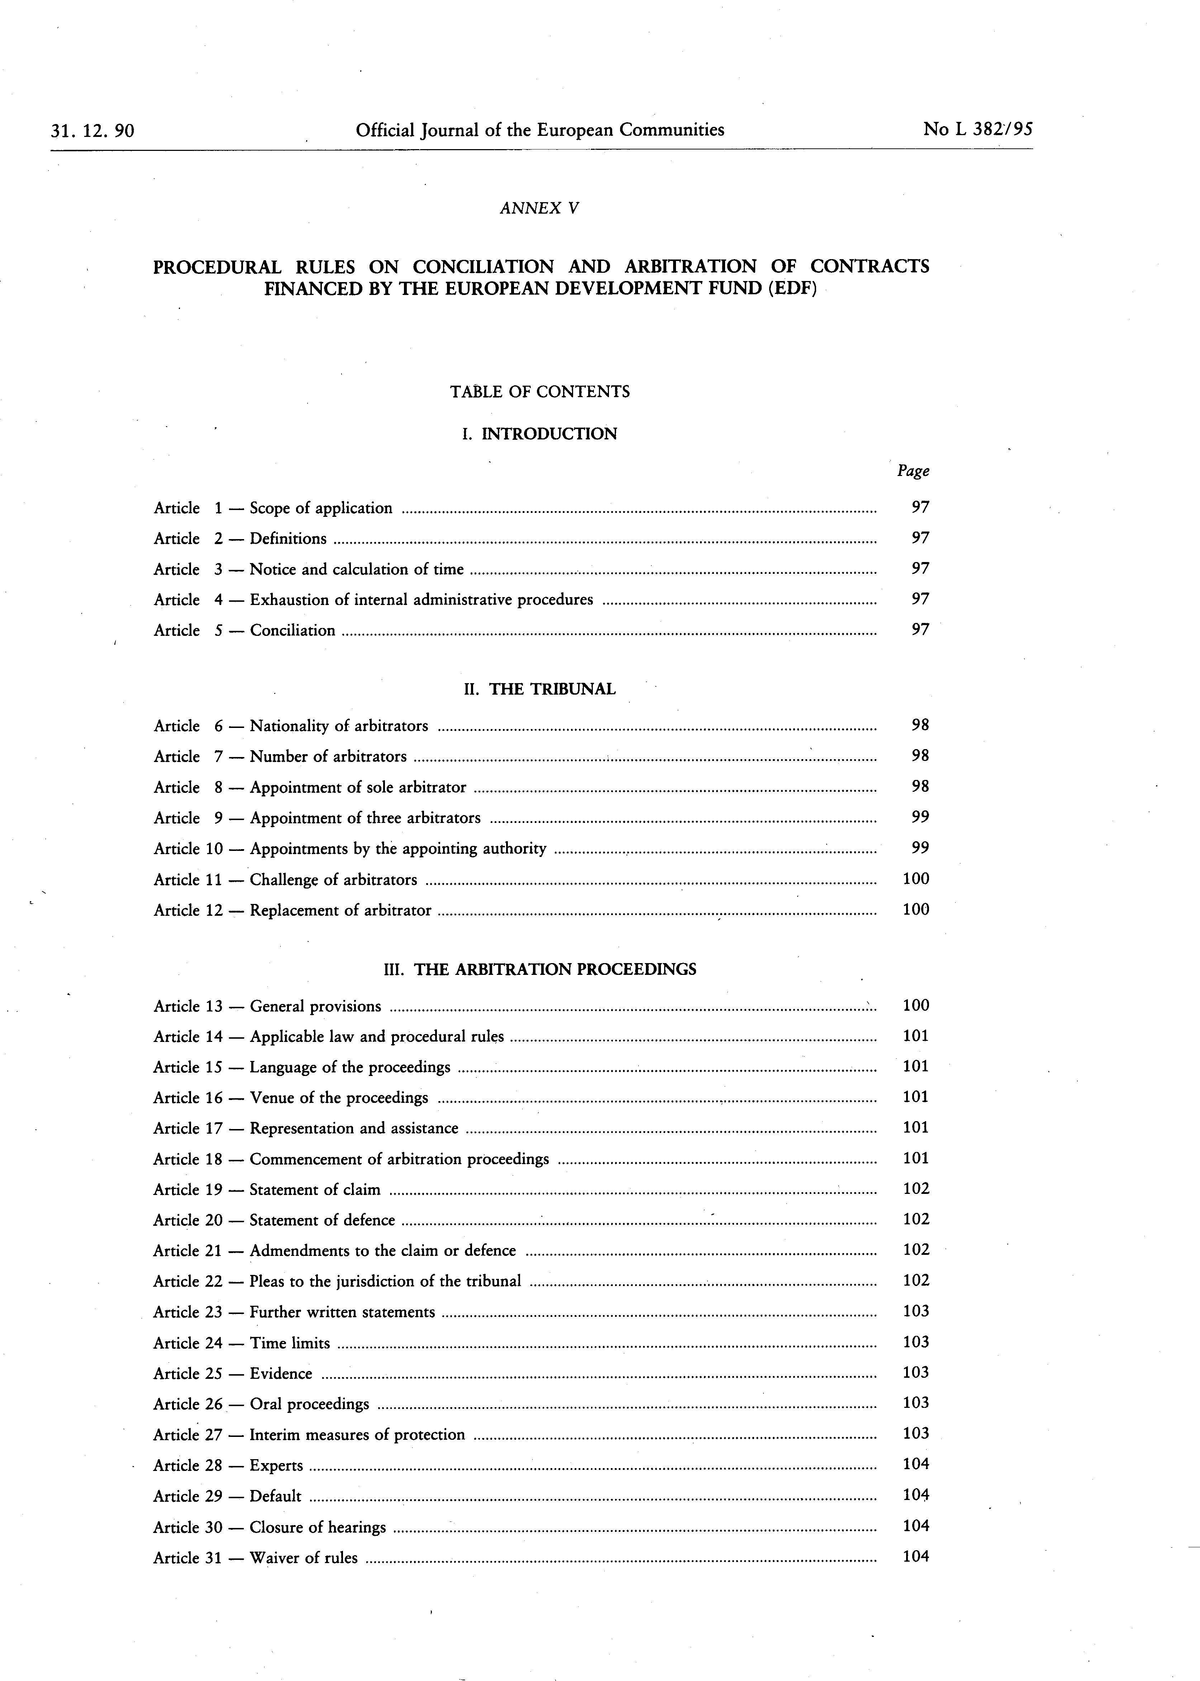

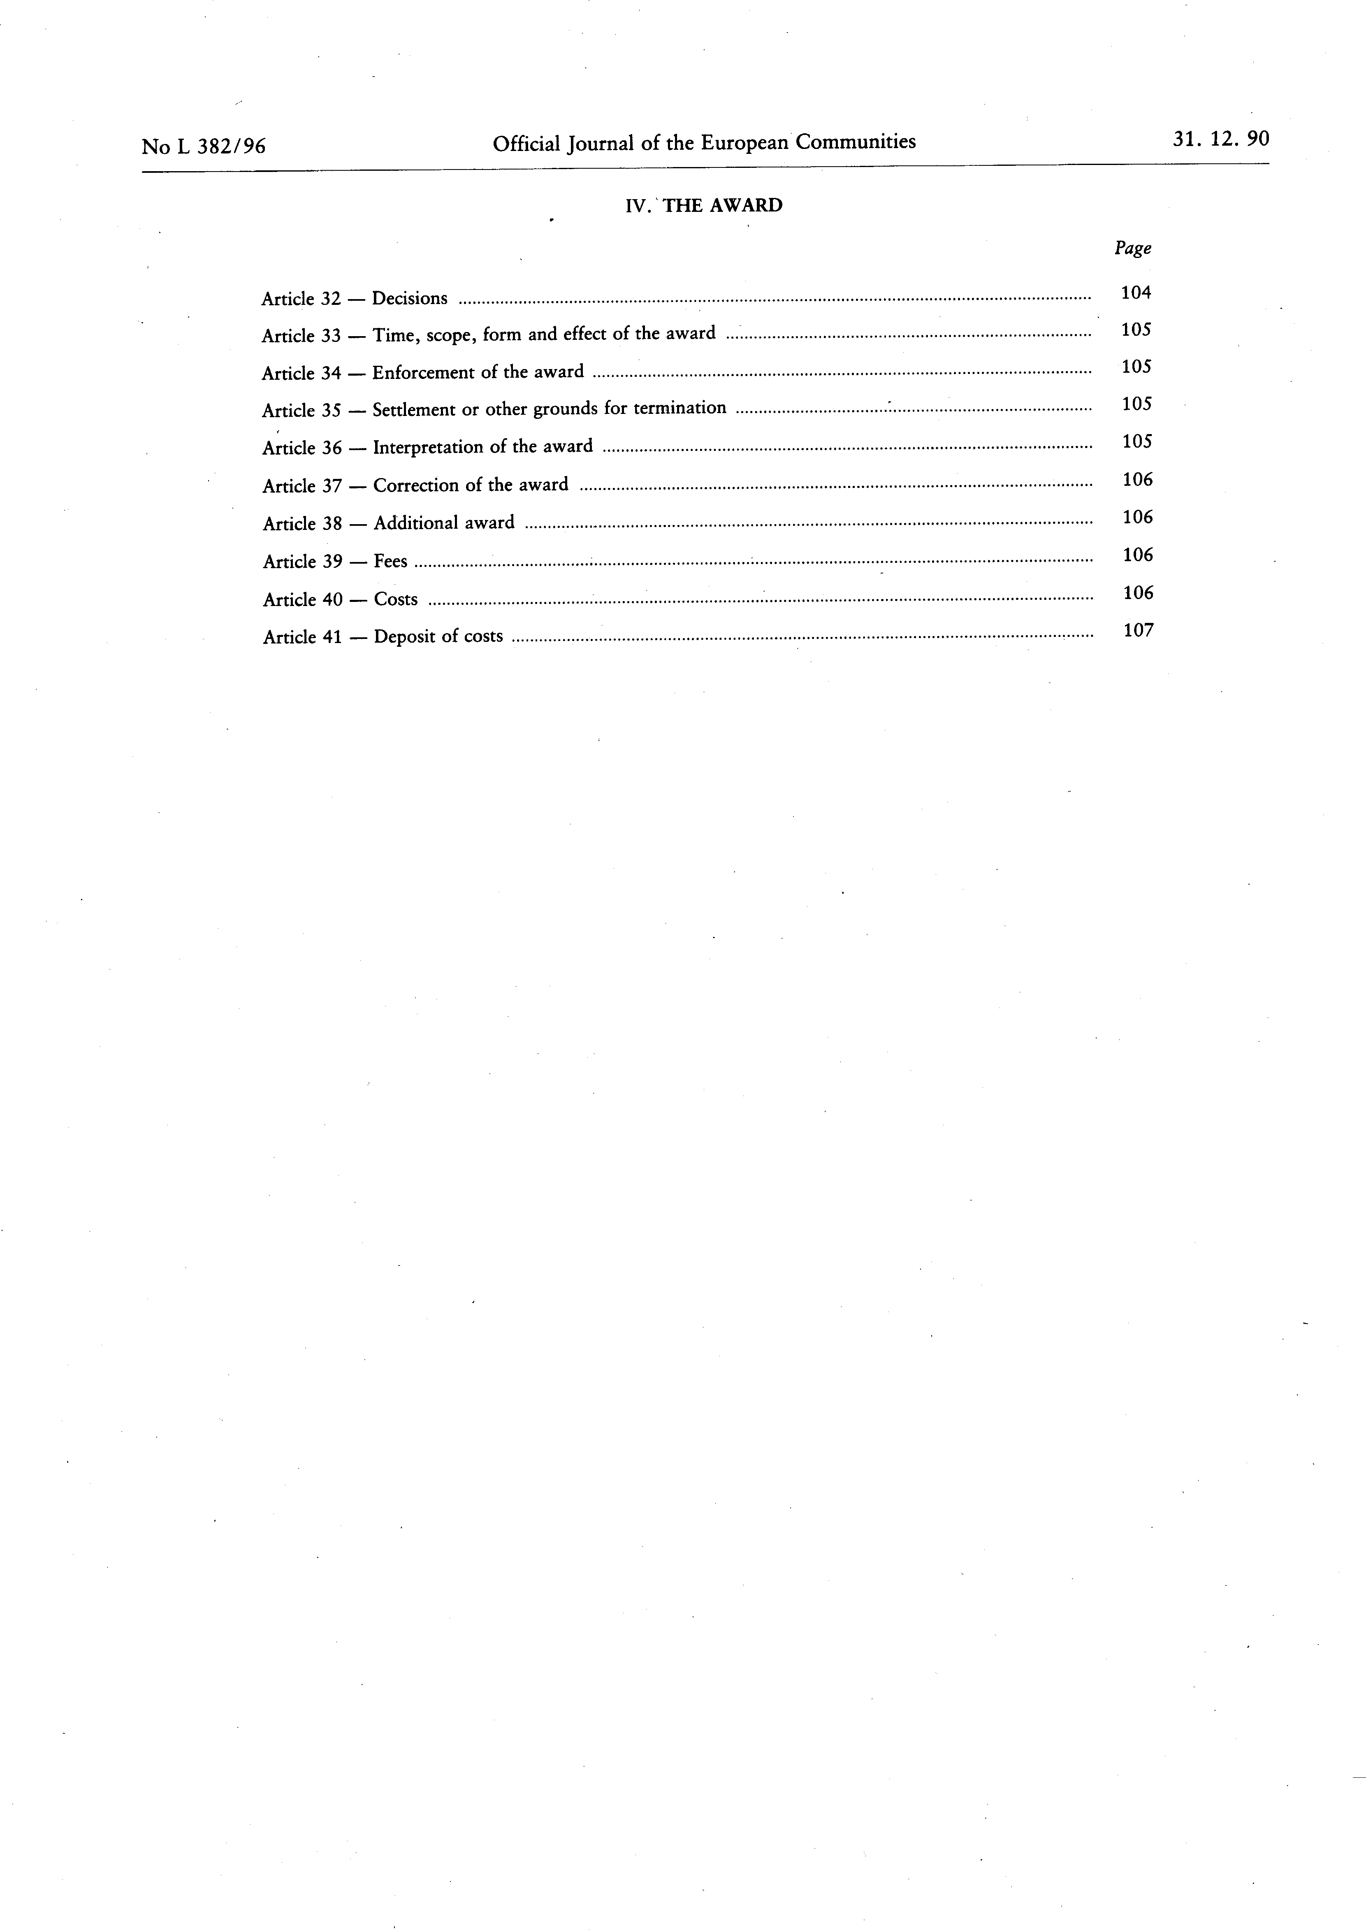

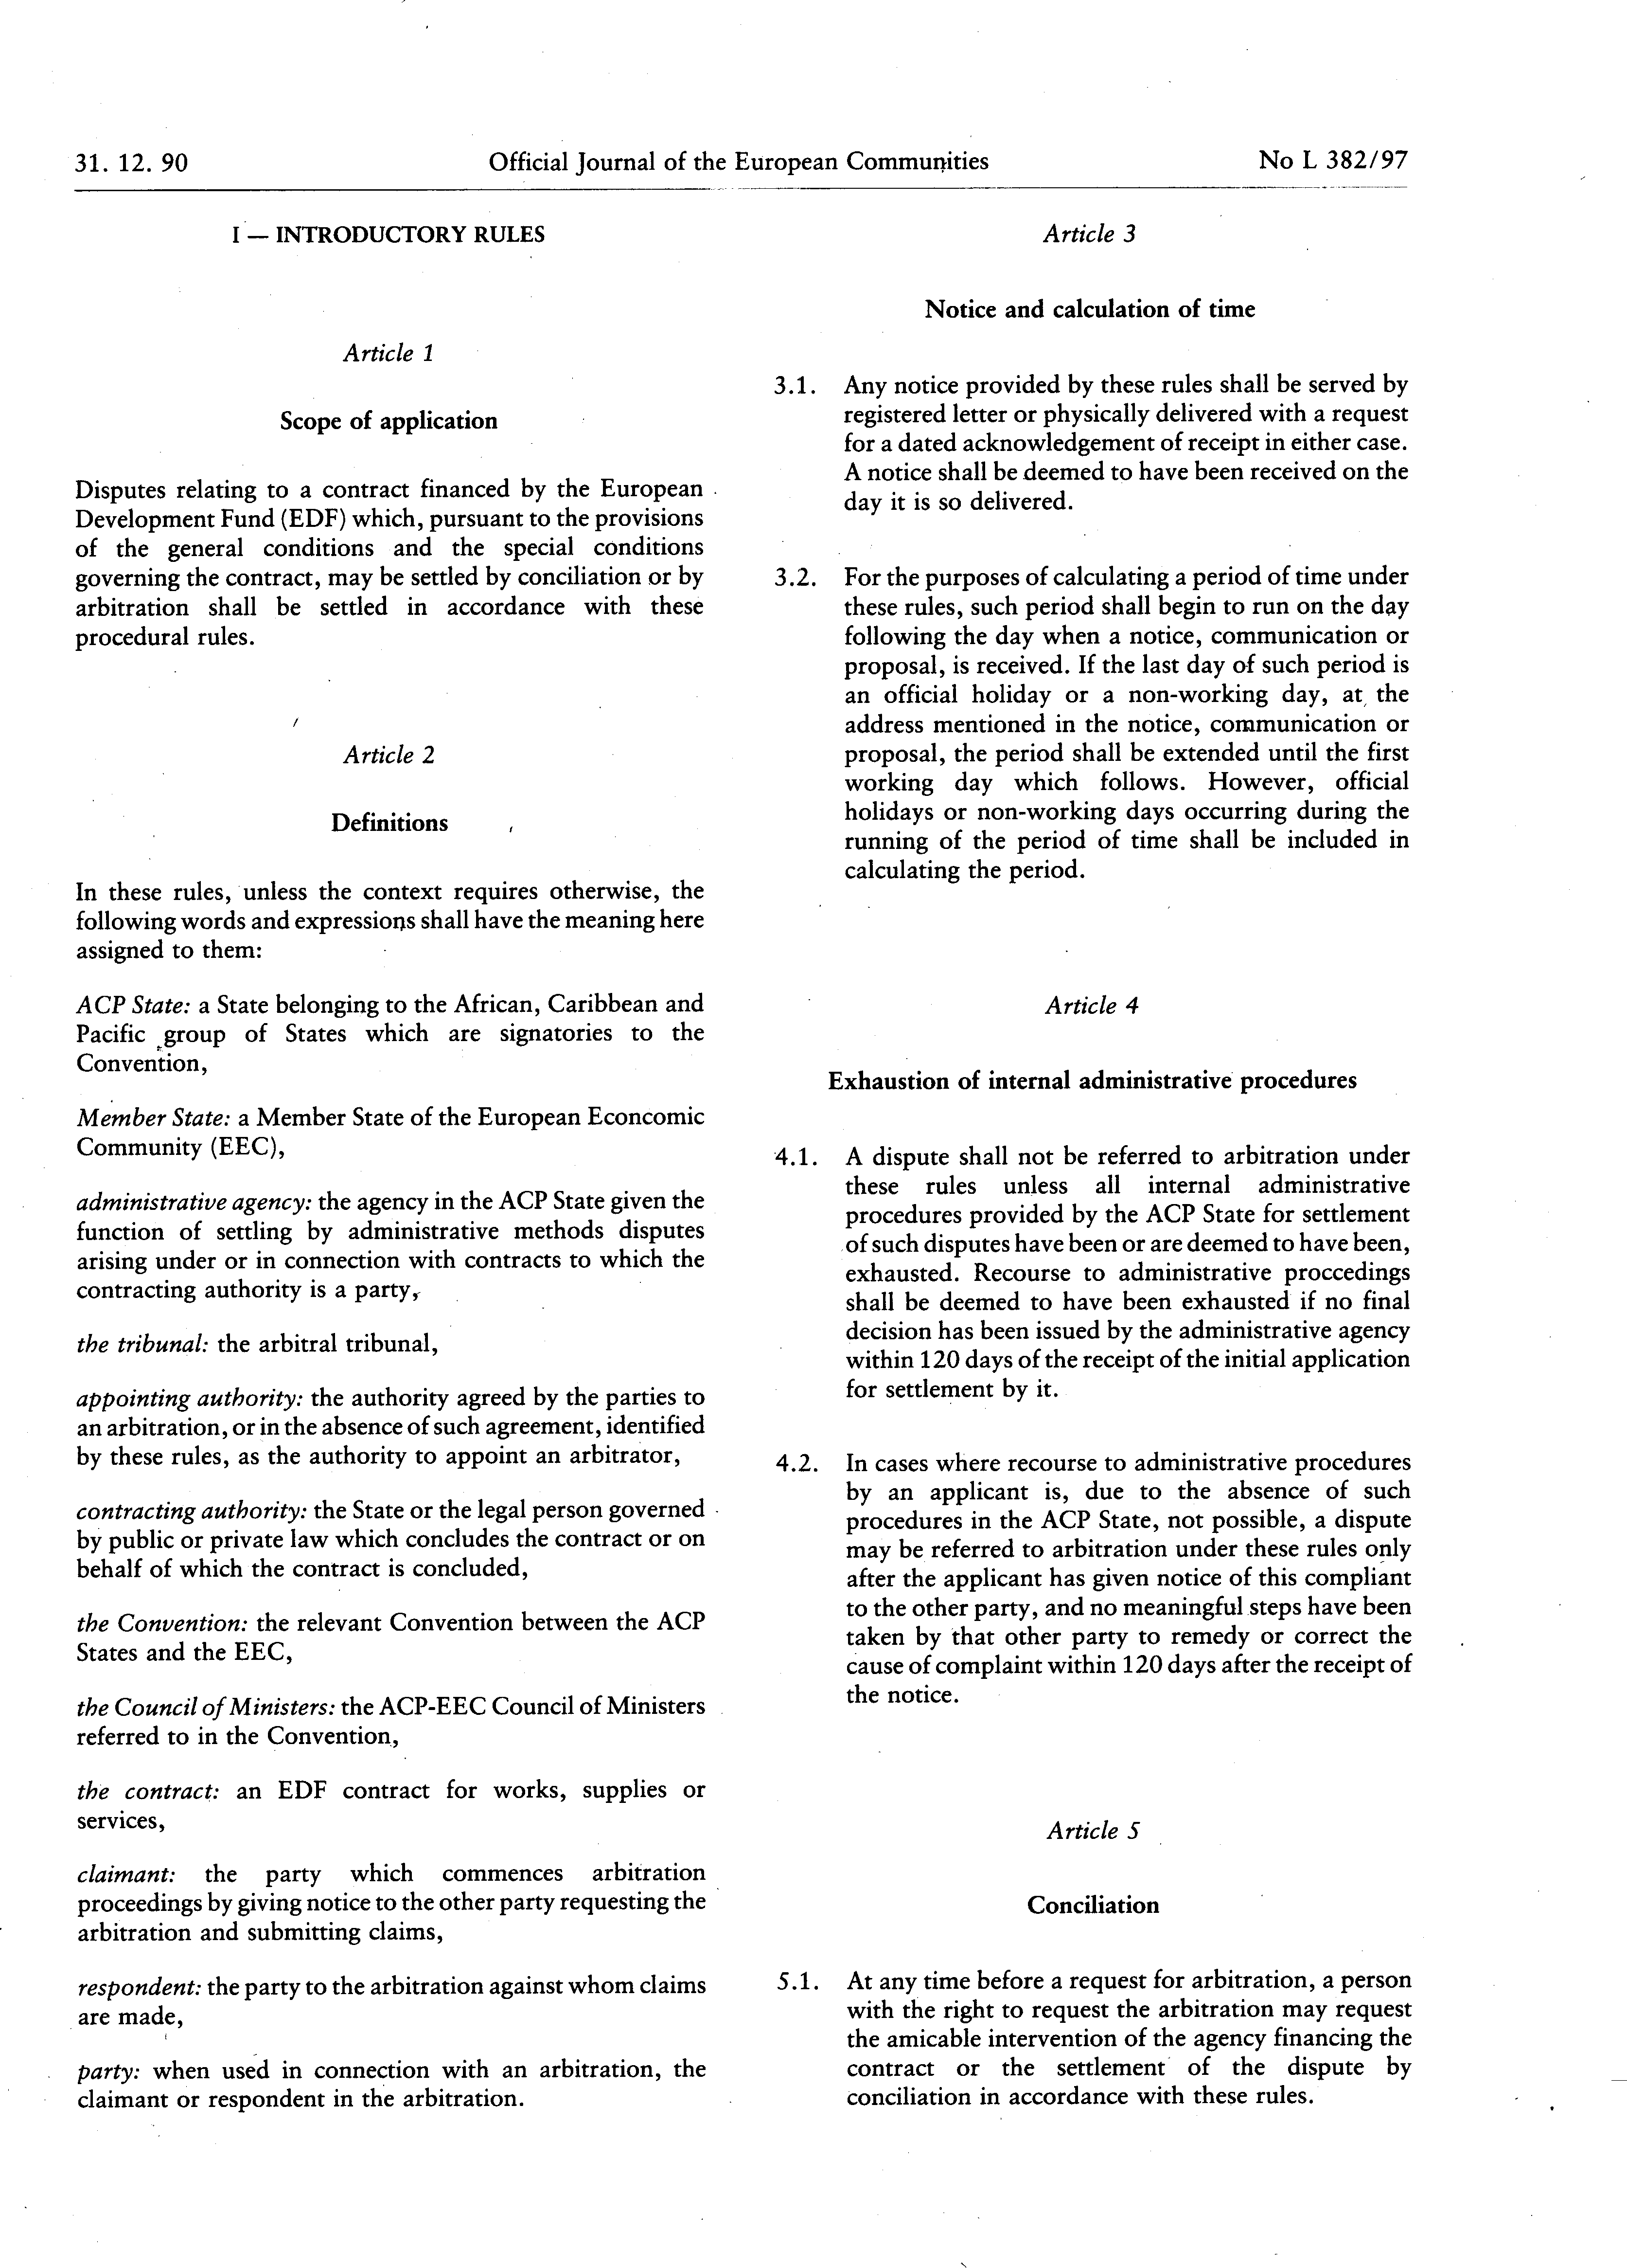

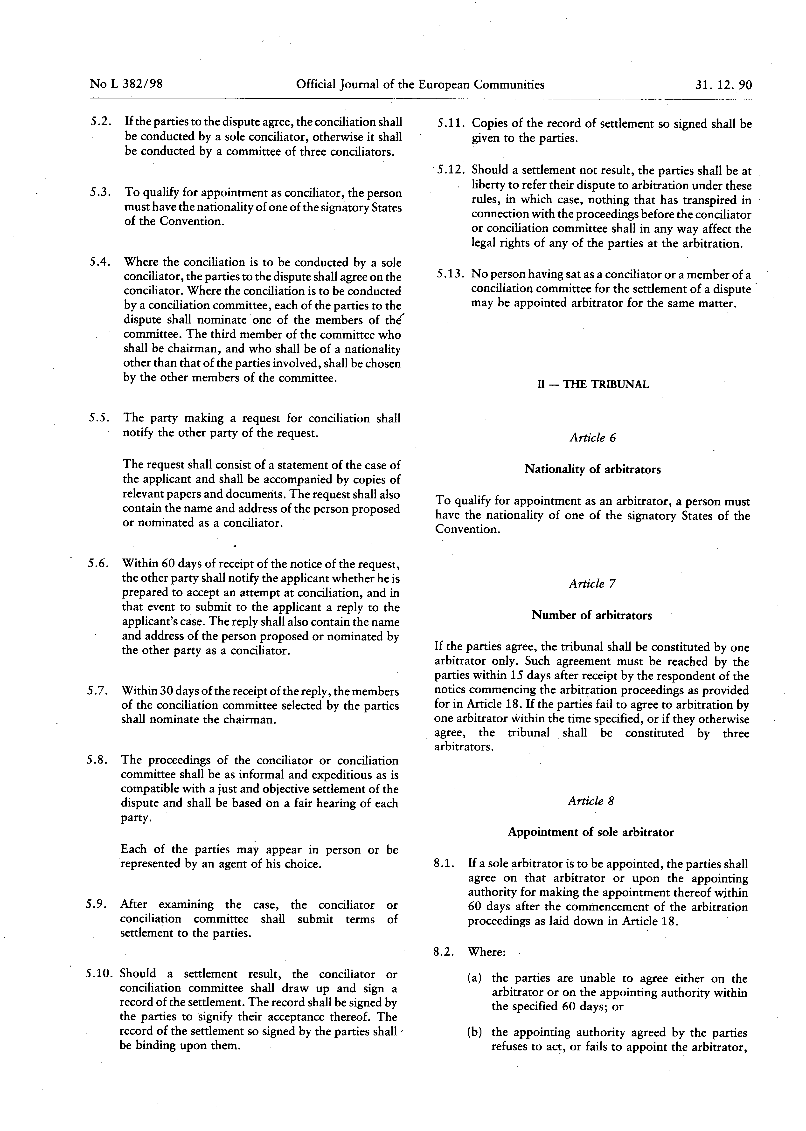

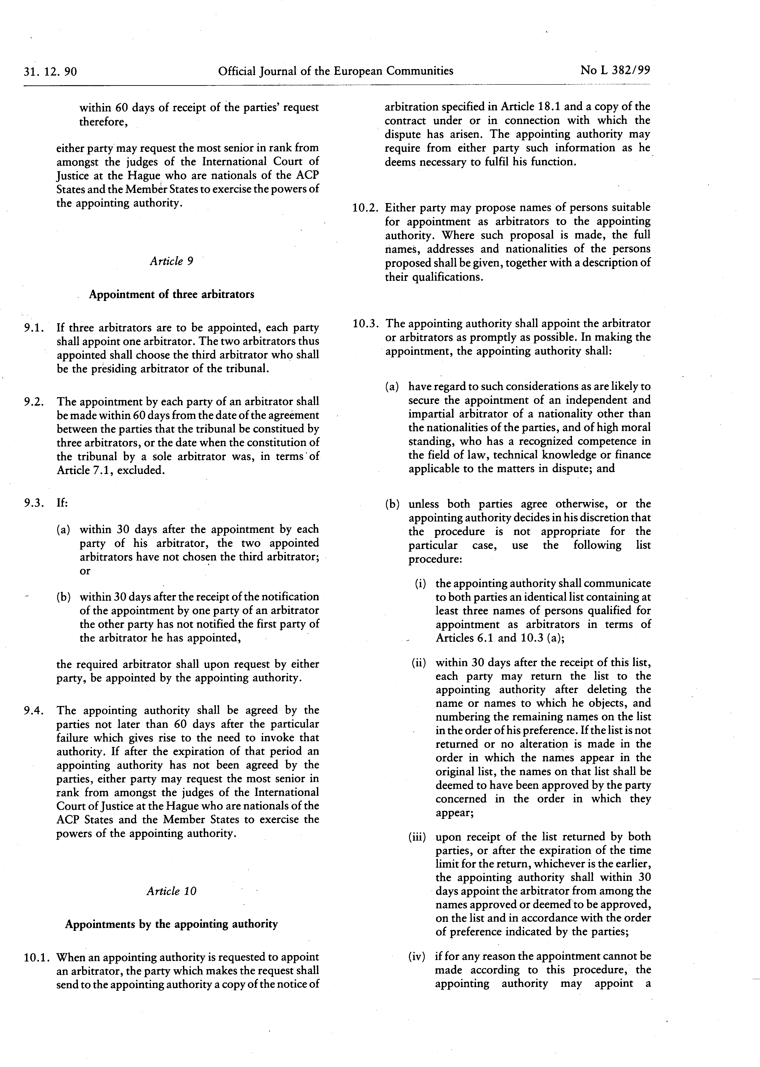

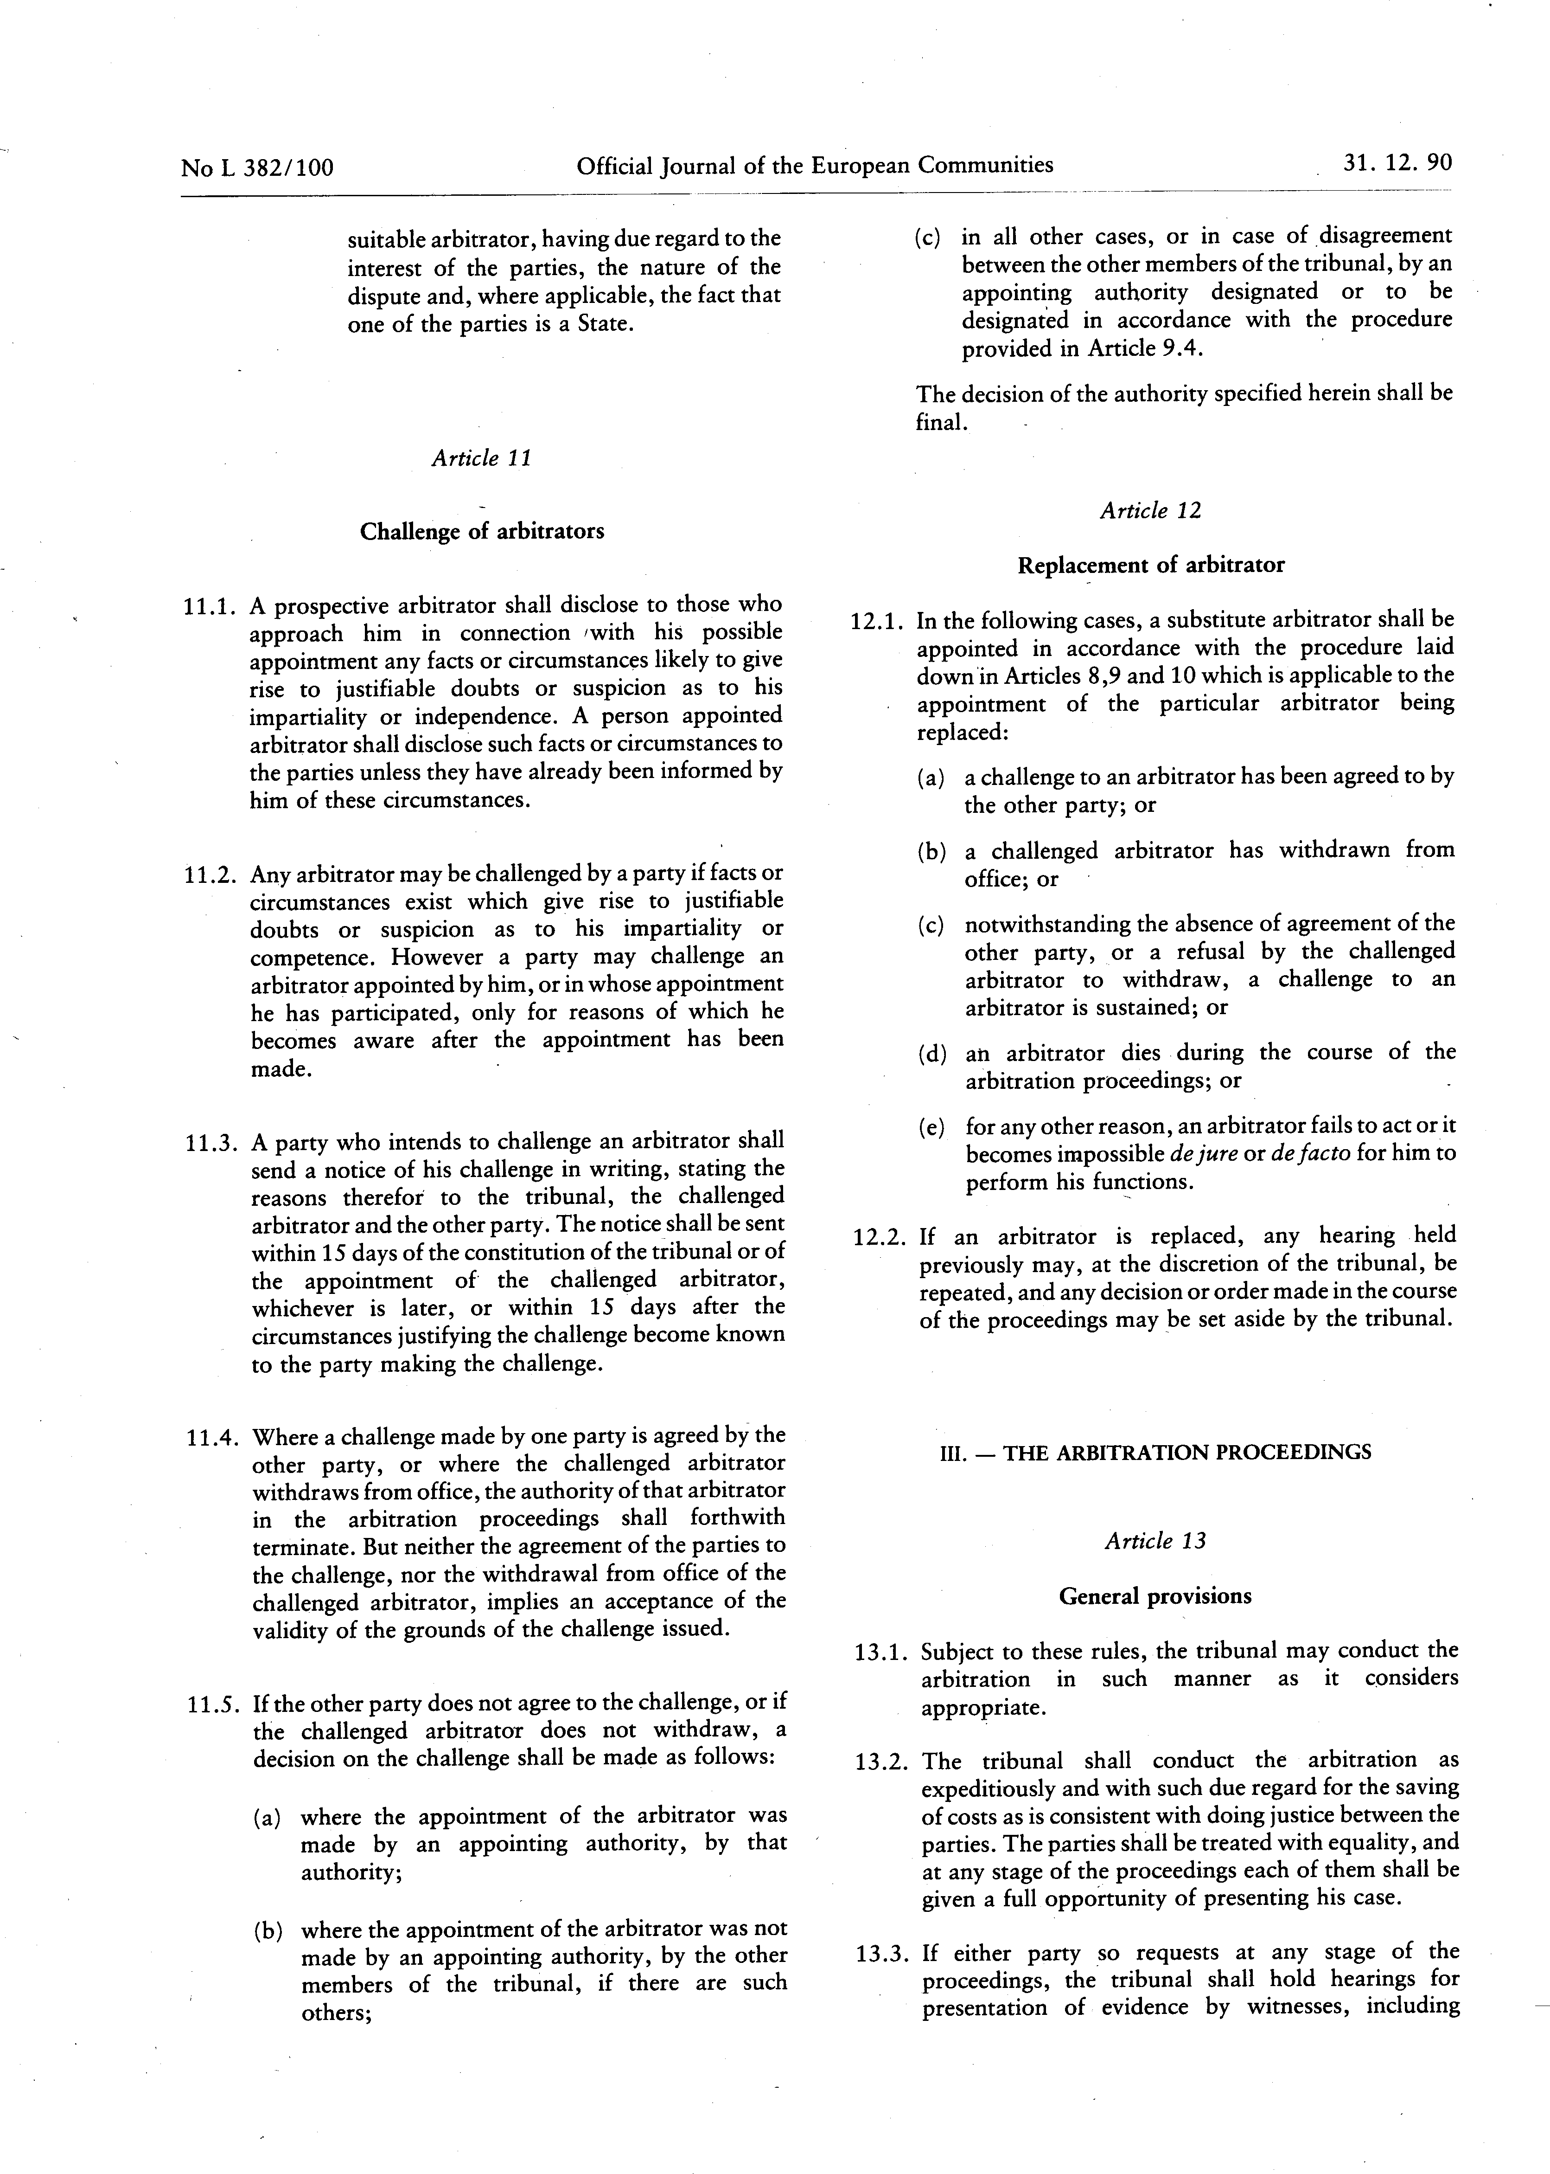

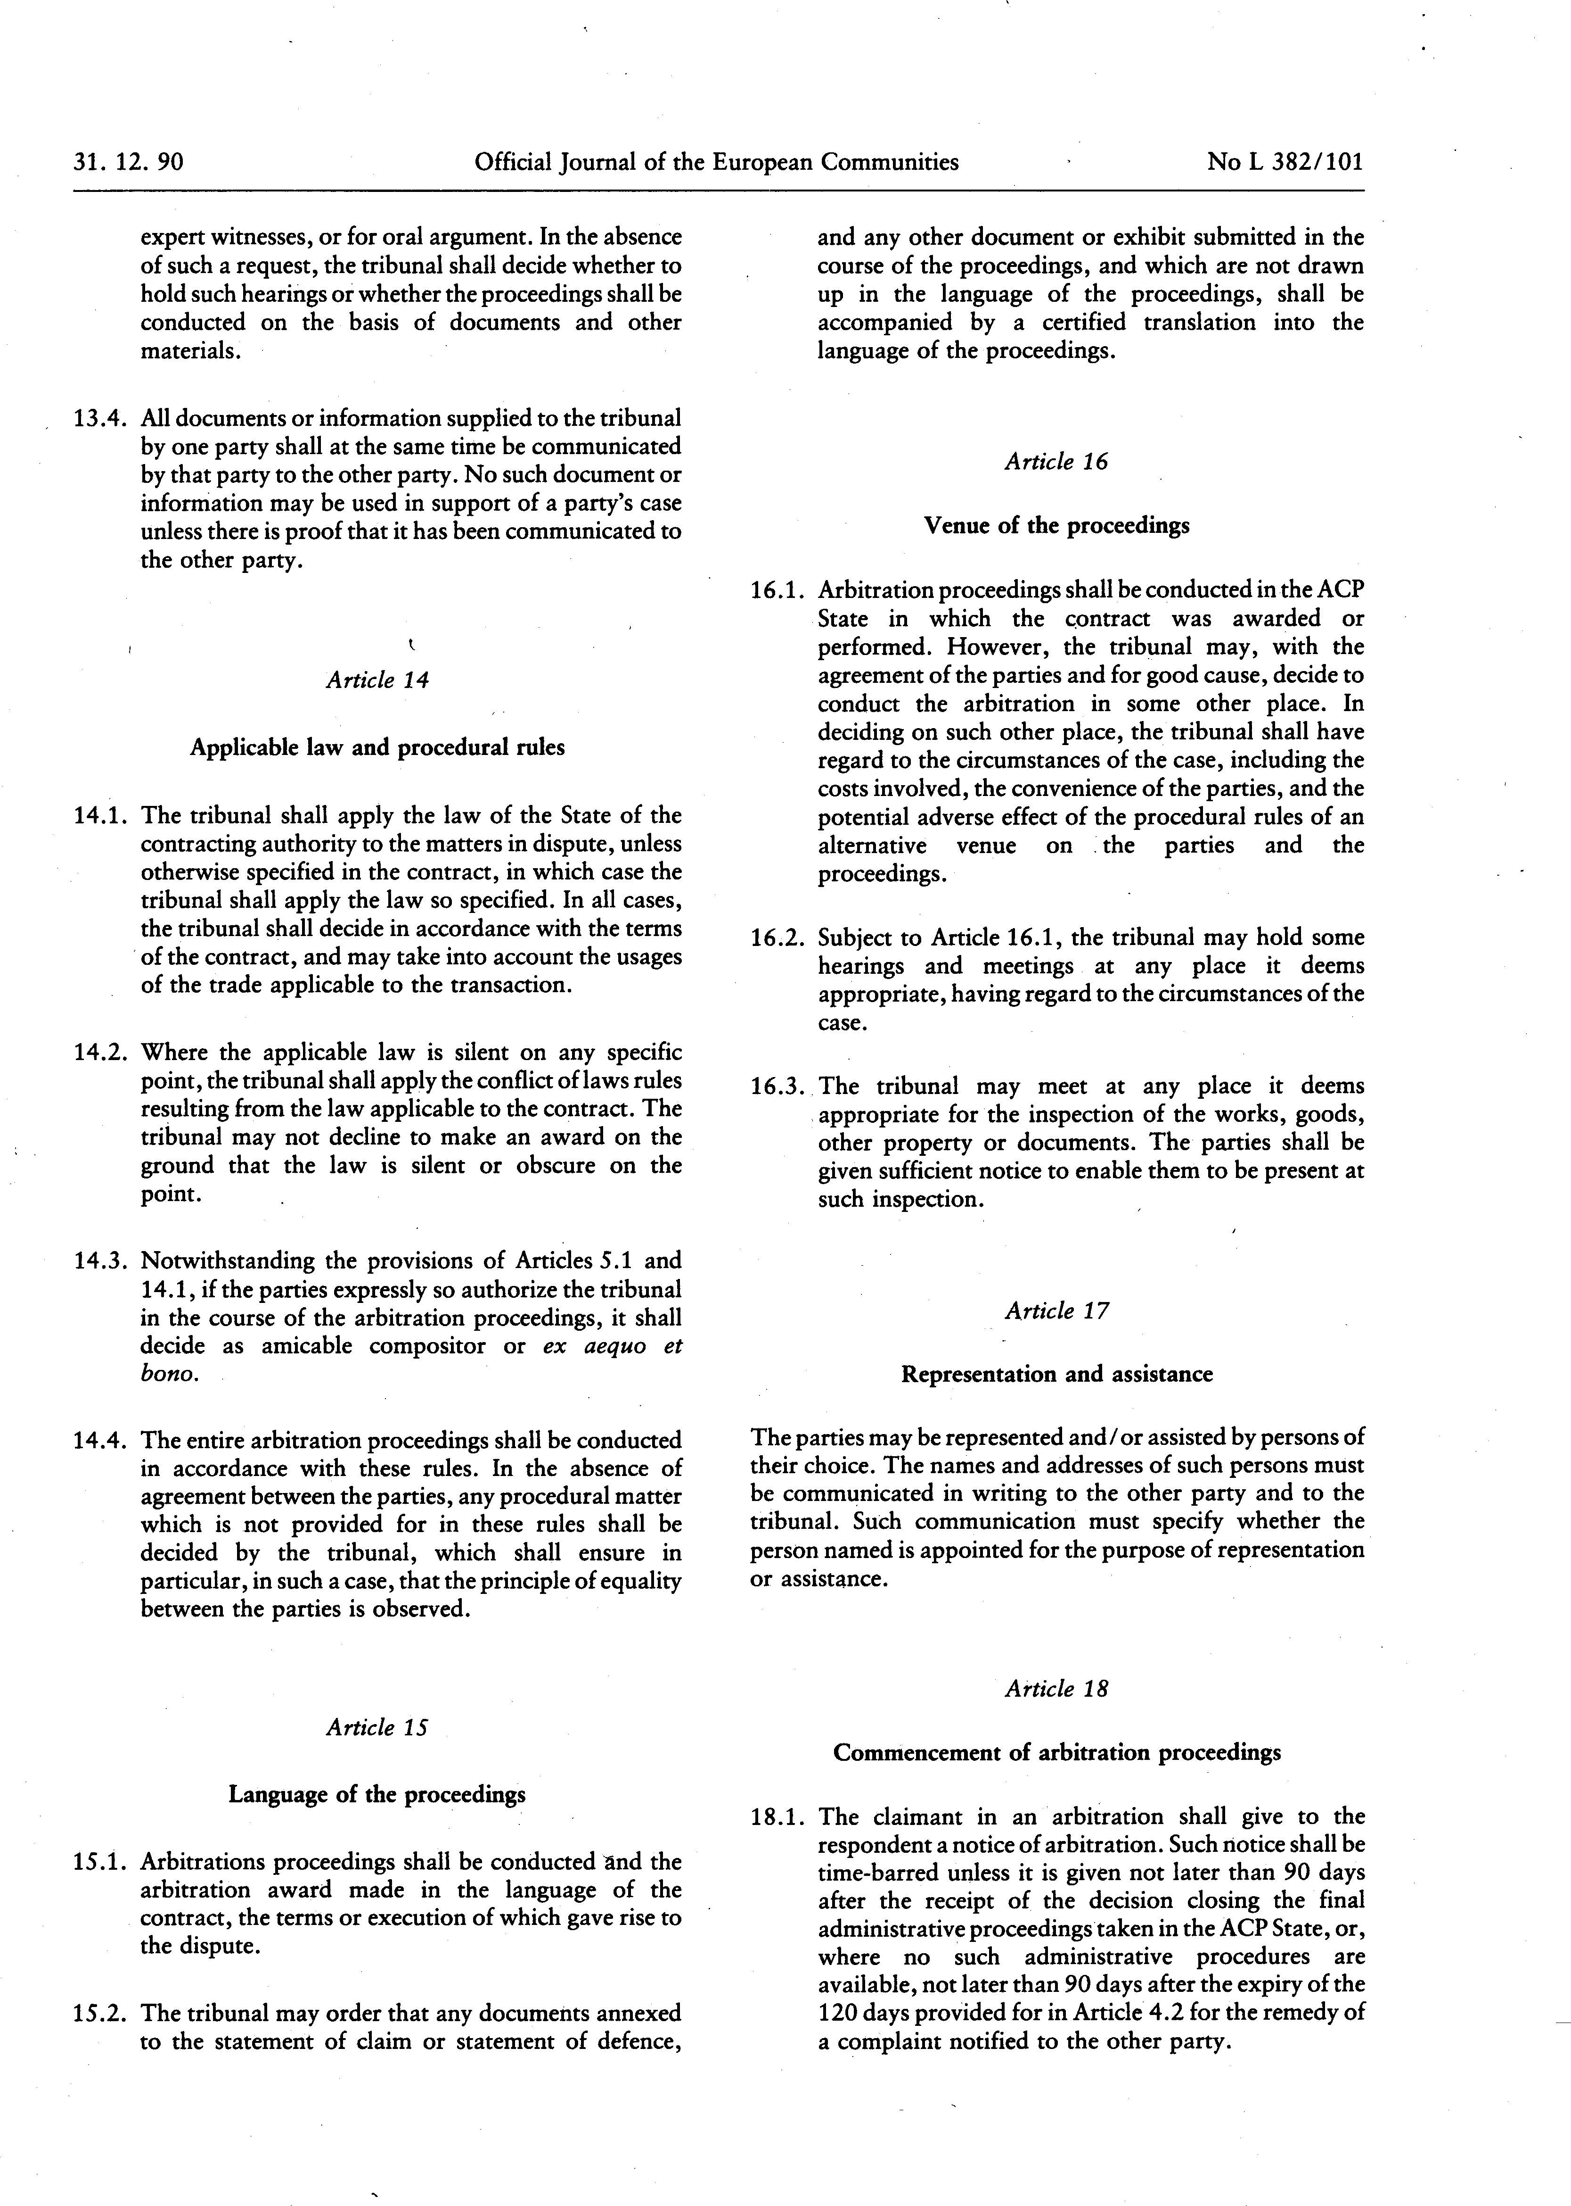

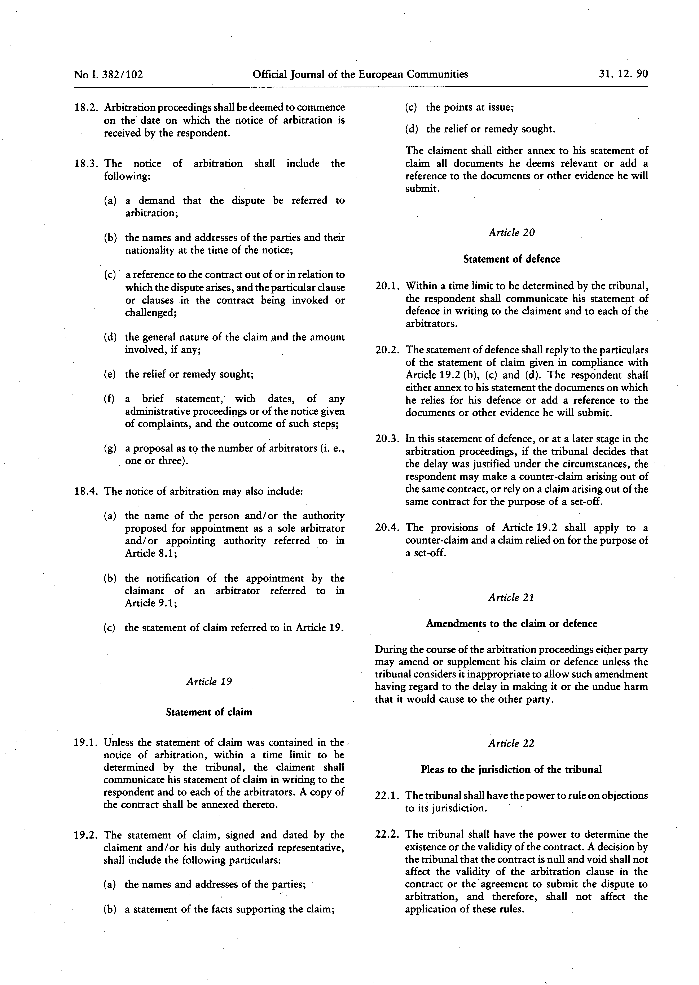

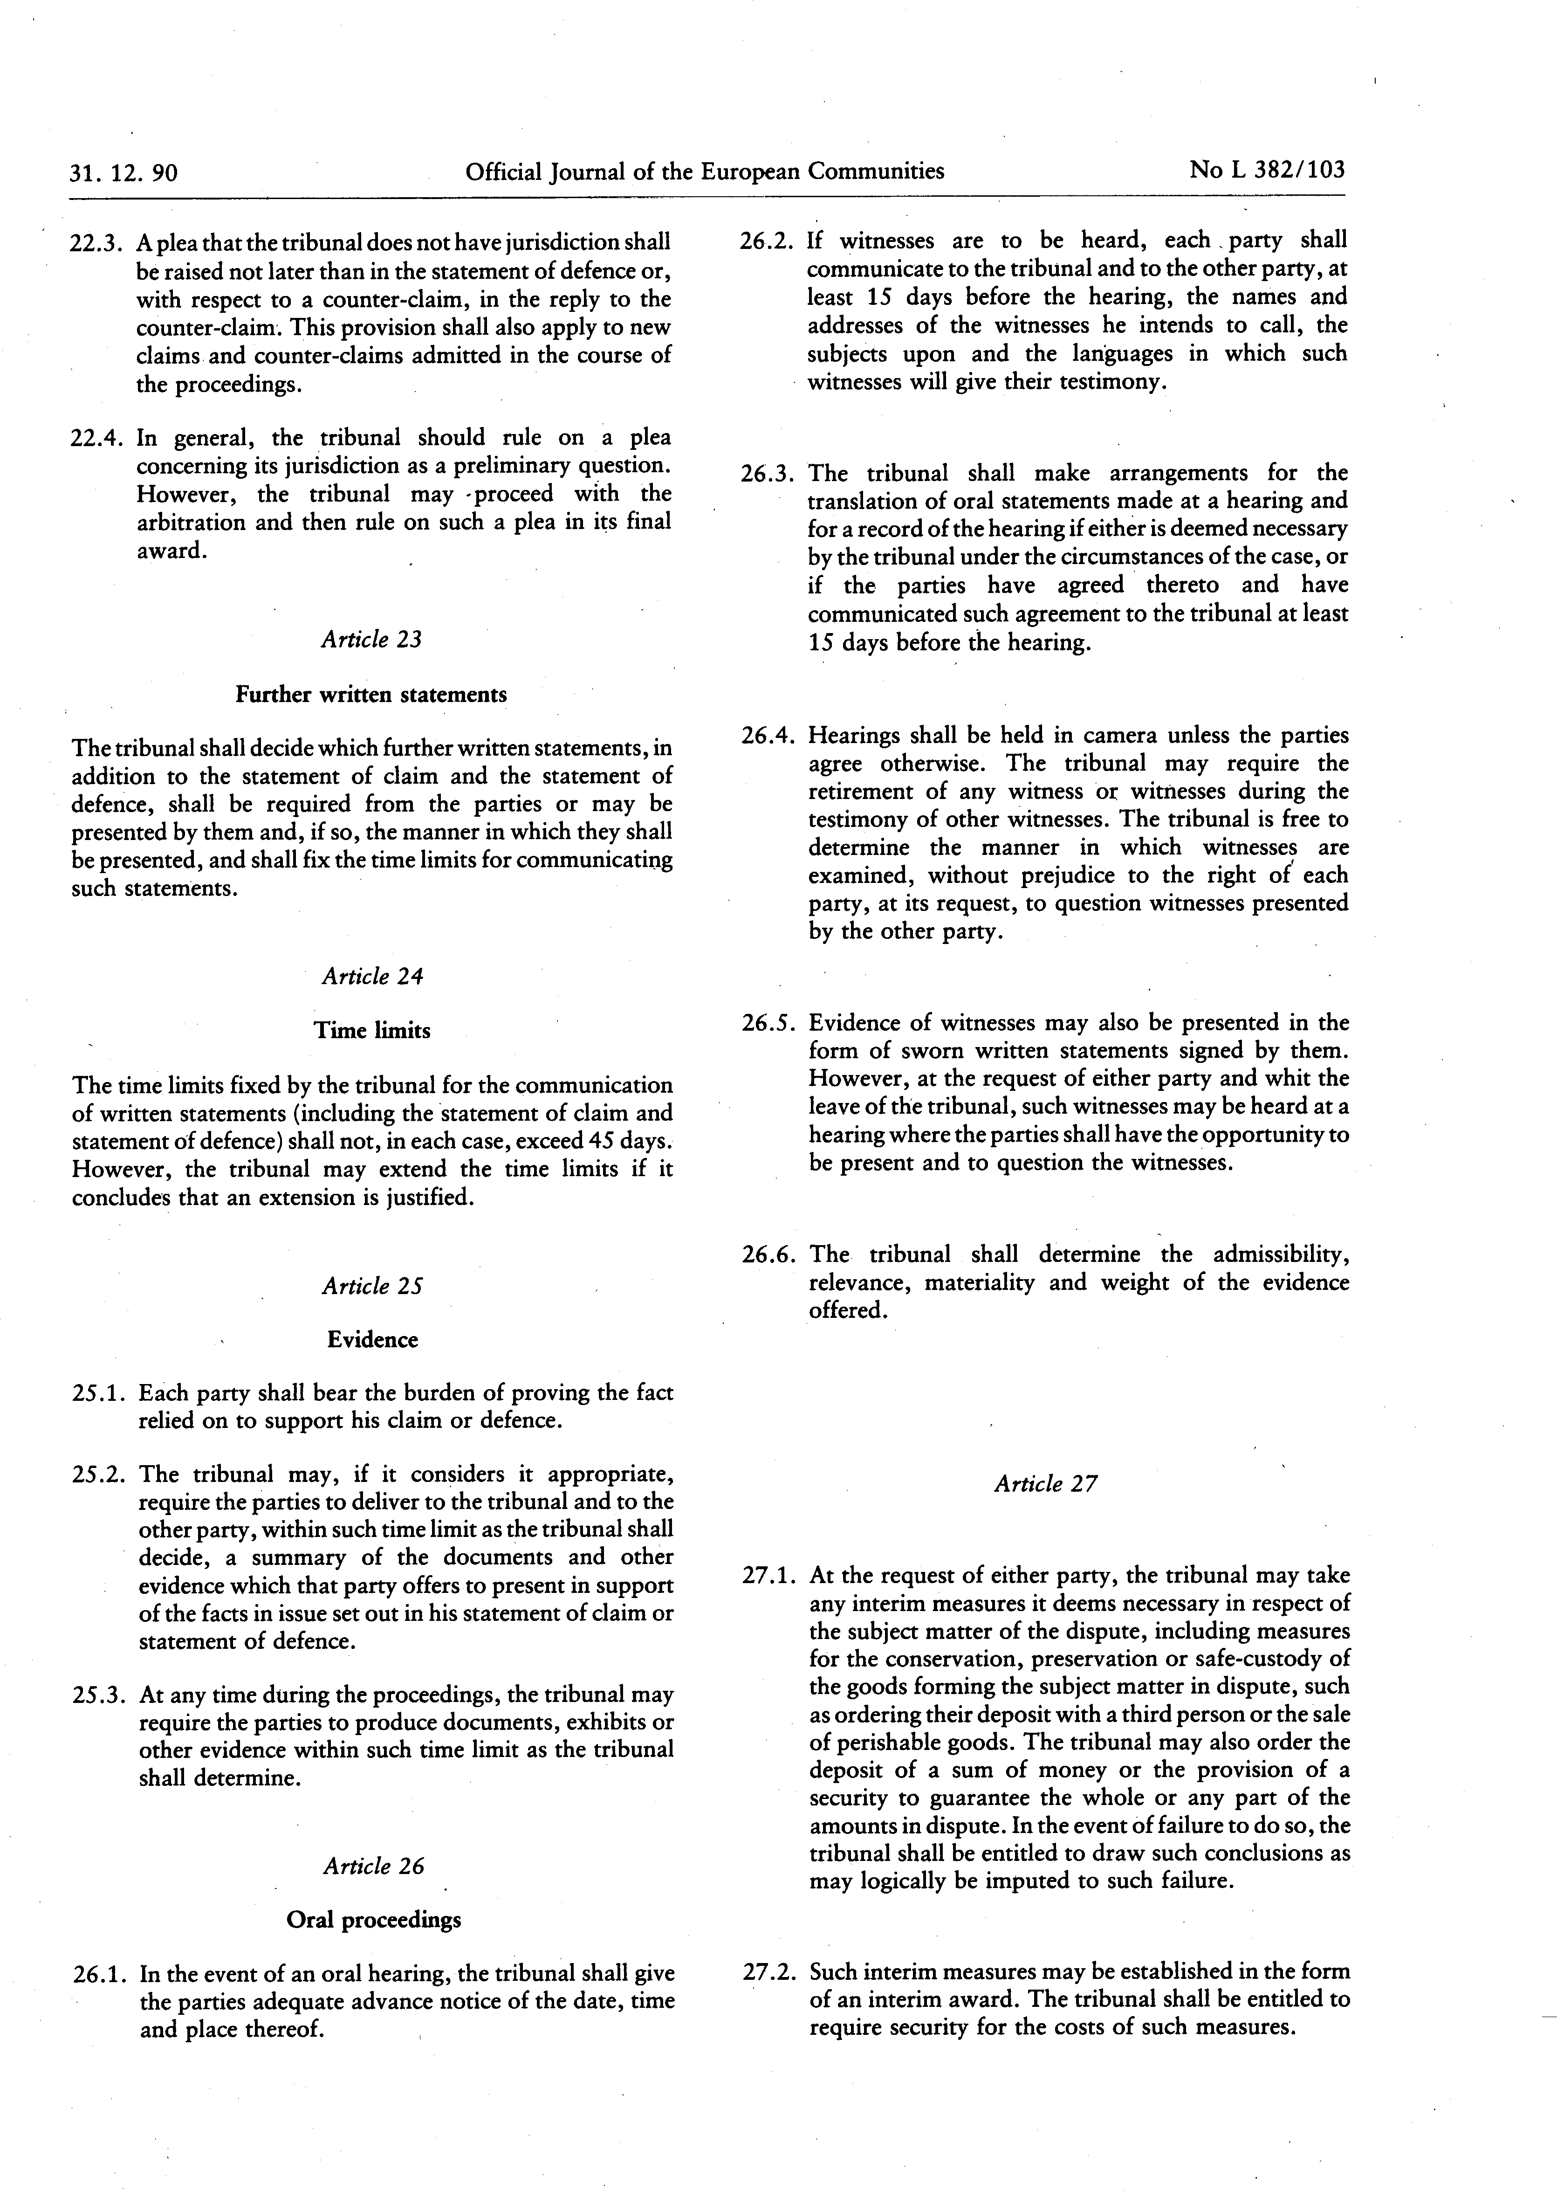

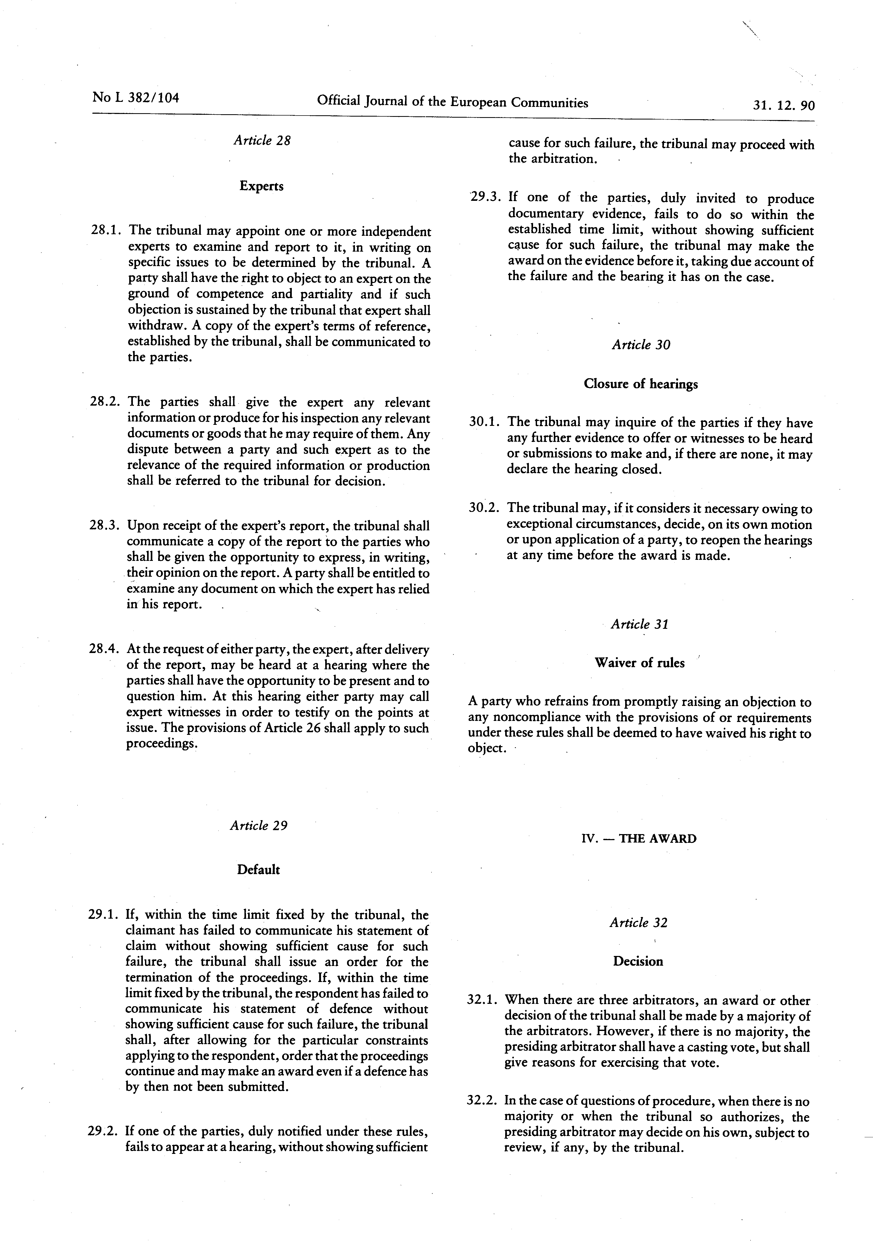

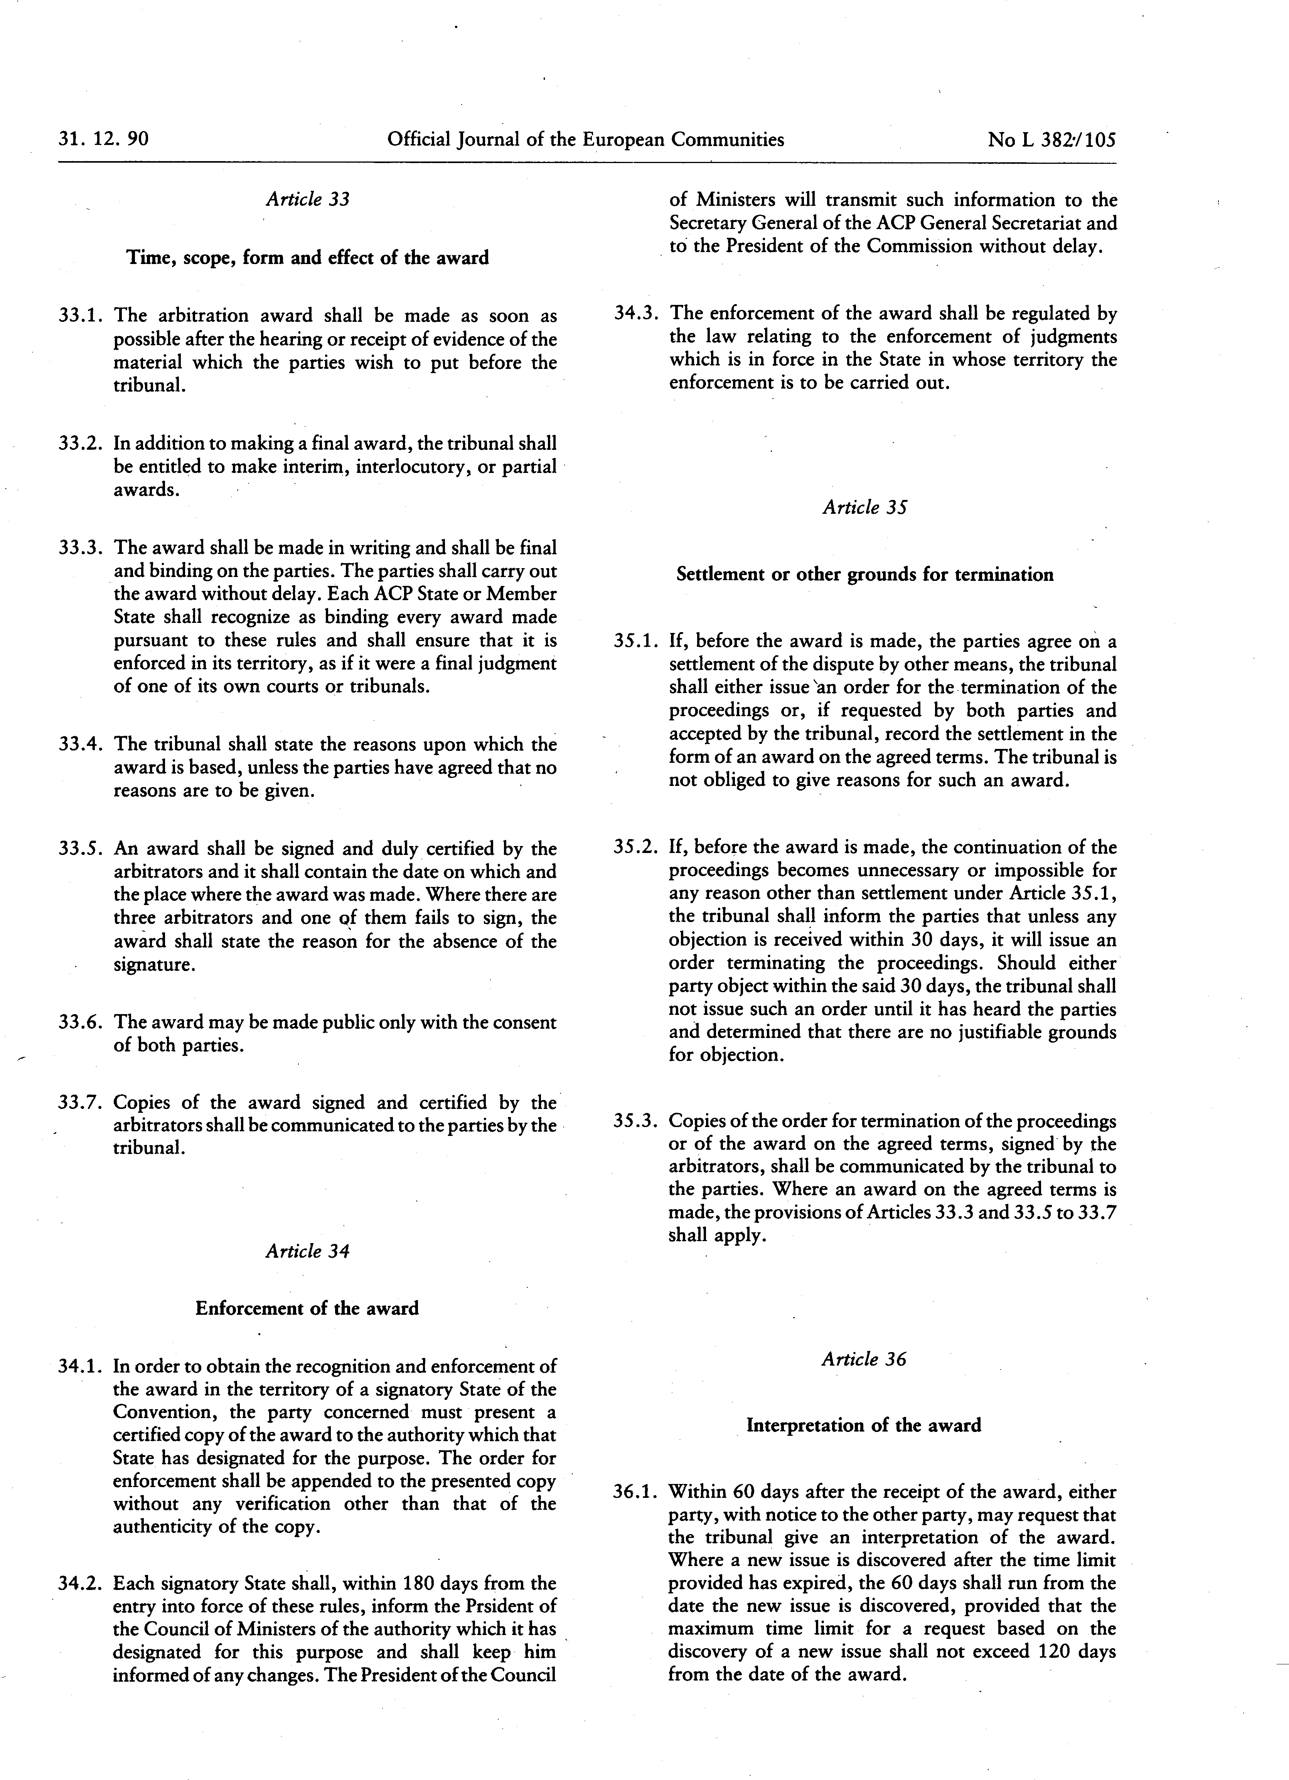

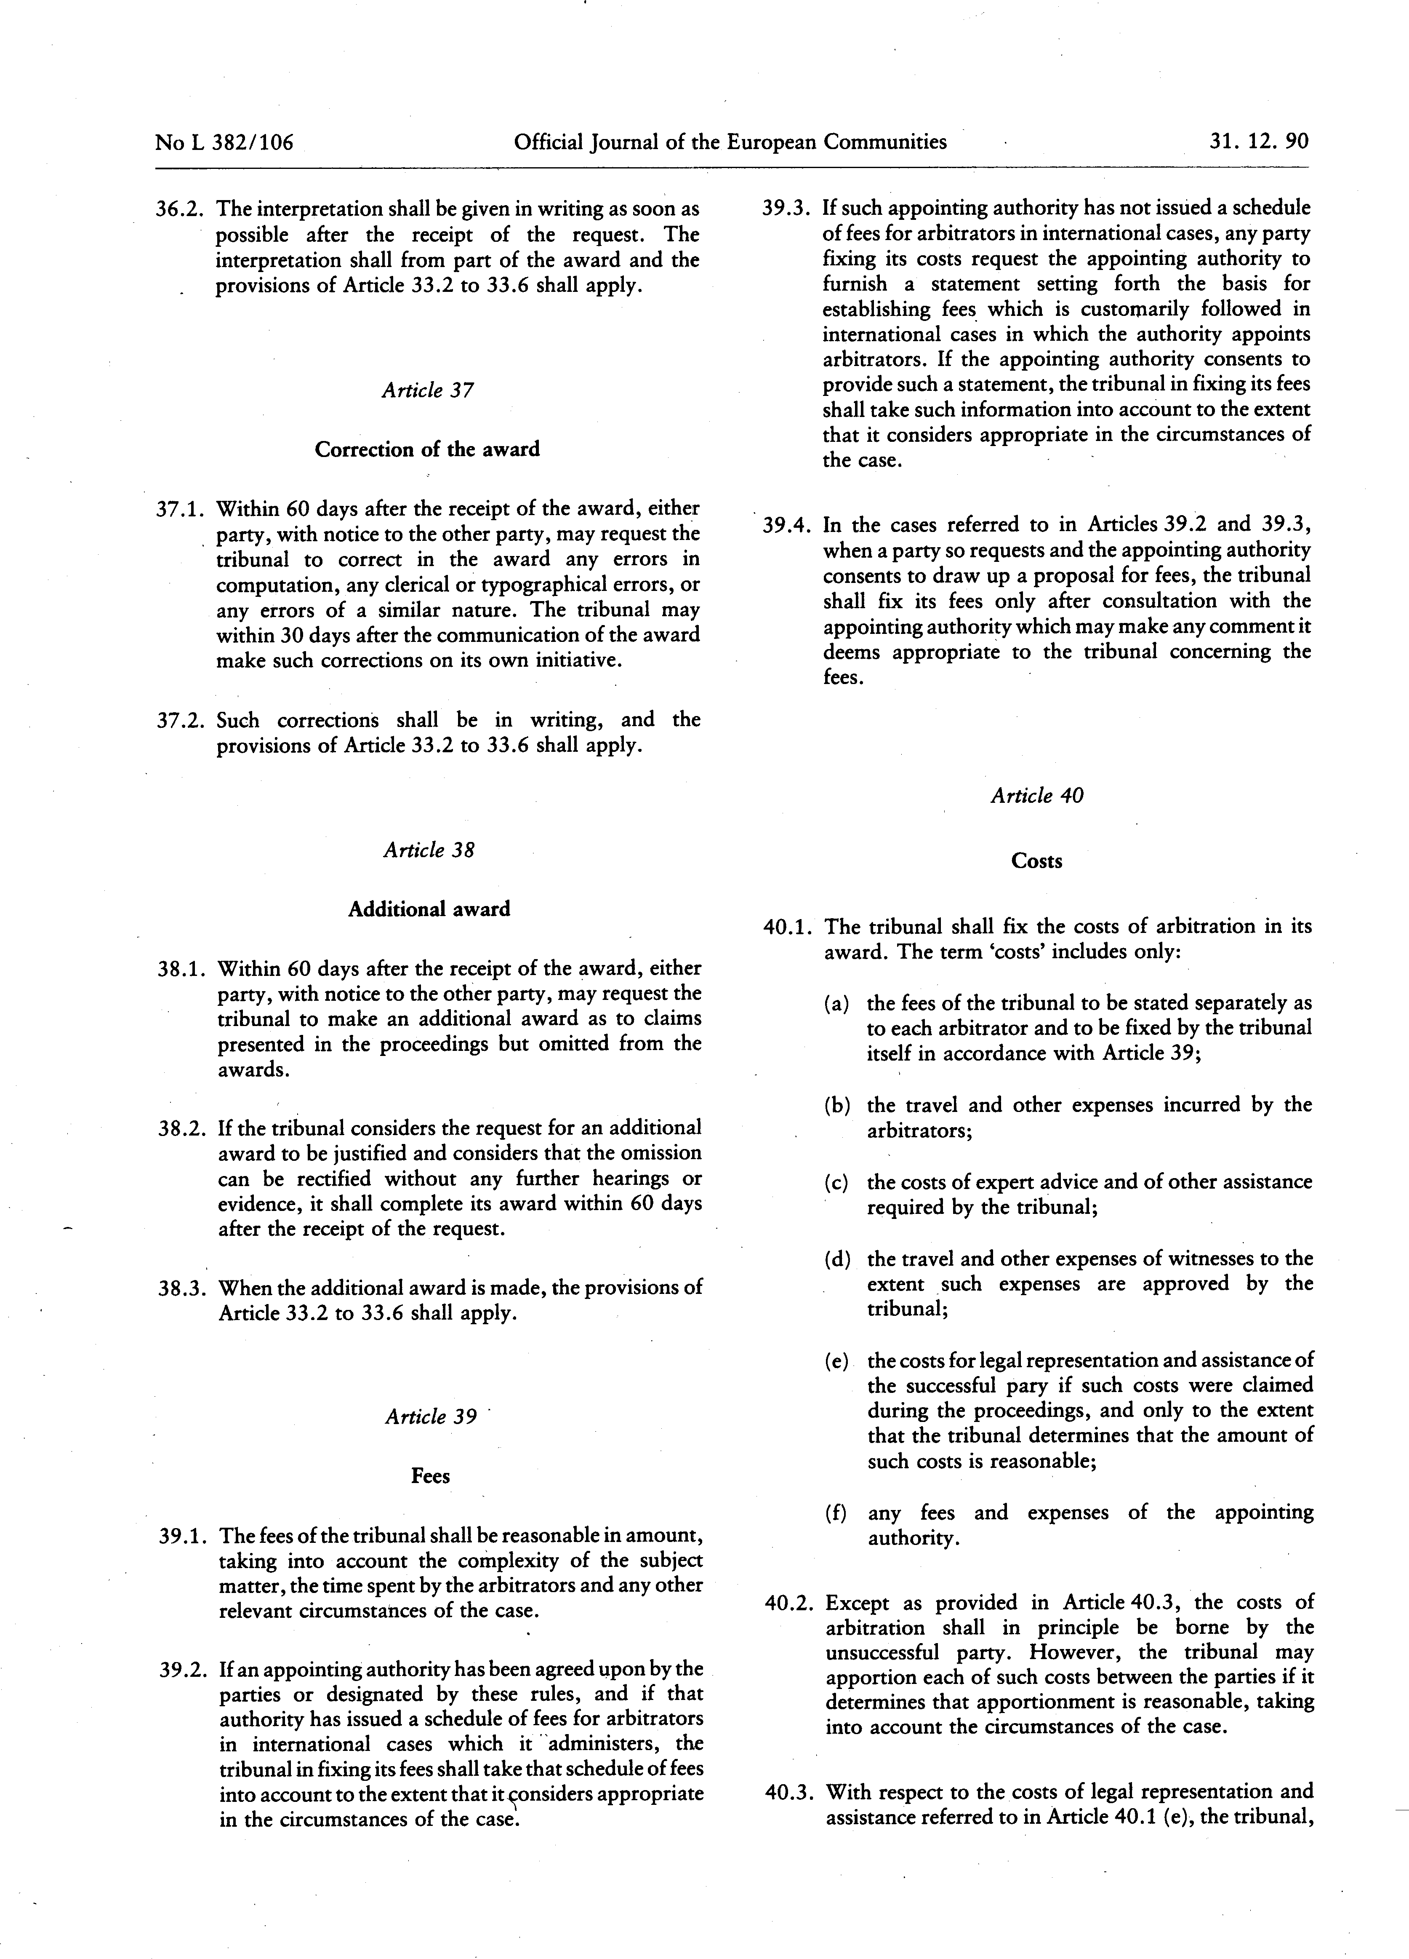

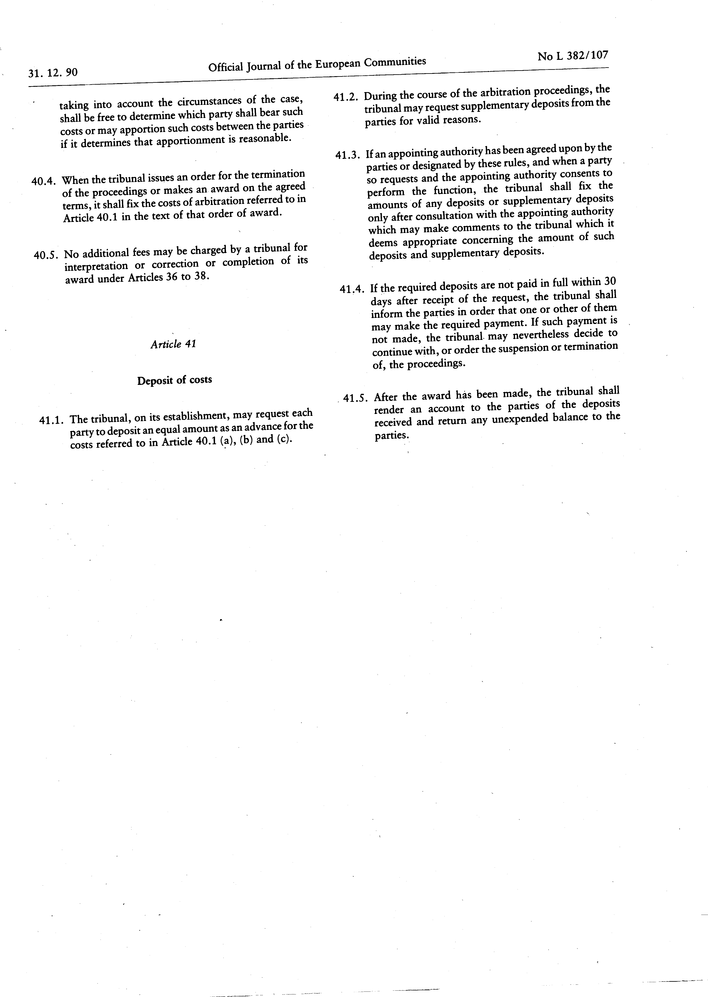

Please note that the EU Official Journal contains the official list of entities subject to restrictive measures and, in case of conflict, it prevails over the list of the EU Sanctions Map.
See PRAG Section 2.4.2.3.(1)
The currency of tender shall be the currency of the contract and of payment
It is recommended to use registered mail in case the postmark would not be readable
Regulation (EU, Euratom) 2024/2509 of the European Parliament and of the Council of 23 September 2024 on the financial rules applicable to the general budget of the Union (recast), PE/99/2023/REV/1, OJ L, 2024/2509, 26.9.2024, ELI: http://data.europa.eu/eli/reg/2024/2509/oj.
It is recommended to use registered mail in case the postmark would not be readable.
https://ec.europa.eu/info/funding-tenders/opportunities/portal/screen/home
Provided it is a freely convertible currency.
<DDP (Delivered Duty Paid)>/<DAP (Delivered At Place)> - Incoterms 2020 International Chamber of Commerce - http://www.iccwbo.org/incoterms/
OJ L 205 of 21.11.2018, p. 39
If the tender has been submitted by a consortium, the nationalities of all the consortium members must be eligible.
Applicable only to contracts financed by a basic act under the MFF 2014-2020 (contracts/lots above EUR 100 000 under CIR and independently of the value for other instruments).
The selection criteria, in the previous section of this form, have to be met before the technical requirements are assessed.
In case the tenderer is an individual, mention the nationality of the individual.
PIC number not applicable in indirect management where the Partner Country makes the payments. See section 10, annex c4b.
Add/delete additional lines for members as appropriate. Note that capacity providing entity/ subcontractors are not considered to be a member for the purposes of this tender procedure. Subsequently, the data on capacity providing entities/ subcontractor must not appear in the data related to the economic, financial and professional capacity but on a separate document. If this tender is being submitted by an individual tenderer, the name of the tenderer should be entered as ‘leader’ (and all other lines should be deleted). Any change in the identity of the leader and/or any consortium members between the deadline for receipt of requests to participate indicated in the contract notice and the award of the contract is not permitted without the prior written authorisation of the contracting authority.
Add only the bank account details of the leader to whom payments under the proposed contract should be made in the event that you are awarded the contract.
Natural persons have to prove their capacity in accordance with the selection criteria and by the appropriate means.
If this tender form is submitted by a consortium, the data in the table above must be the sum of the data in the corresponding tables in the declarations provided by the consortium members — see point 7 of this tender form. Consolidated data are not requested for financial ratios.
Last year=last accounting year for which the entity's accounts have been closed.
Amounts entered in the ‘Average’ column must be the mathematical average of the amounts entered in the three preceding columns of the same row.
The gross inflow of economic benefits (cash, receivables, other assets) arising from the ordinary operating activities of the enterprise (such as sales of goods, sales of services, interest, royalties, and dividends) during the year.
A balance sheet account that represents the value of all assets that are reasonably expected to be converted into cash within one year in the normal course of business. Current assets include cash, accounts receivable, inventory, marketable securities, prepaid expenses and other liquid assets that can be readily converted to cash.
A company's debts or obligations that are due within one year. Current liabilities appear on the company's balance sheet and include short term debt, accounts payable, accrued liabilities and other debts.
If this tender is submitted by a consortium, the data in the table above must be the sum of the data in the corresponding tables in the declarations provided by the consortium members — see point 7 of this tender form. Consolidated data are not requested for financial ratios.
Corresponding to the relevant specialisations identified in point 5 below.
Personnel directly employed or otherwise legally contracted by the tenderer on a permanent basis (i.e. under indefinite contracts).
Other personnel directly employed or otherwise legally contracted by the tenderer on a non-permanent basis (i.e. under fixed-term contracts).
add/delete additional lines and/or rows as appropriate. If this tender is being submitted by an individual legal entity, the name of the legal entity should be entered as ‘Leader’ (and all other columns should be deleted).
References must be contracts implemented by the legal entity (or legal entities) submitting the-tender form (with the exception of documented cases of company buyout or universal succession). For framework contracts, only specific contracts corresponding to assignments implemented under such framework contracts will be considered.
Amounts actually paid, without the effect of inflation.
Please note that the EU Official Journal contains the official list of entities subject to restrictive measures and, in case of conflict, it prevails over the list of the EU Sanctions Map.
An “involved entity” is each economic operator involved in the request to participate/tender. This includes the following four categories of economic operators: - sole candidate/tenderer; - group members (including group leader) in case of a joint request to participate/tender (consortium); - identified subcontractors; and - other entities (that are not subcontractors) on whose capacity the candidate/tenderer relies to fulfil the selection criteria.
The declaration under this point (2) is voluntary and it cannot have adverse legal effect on the economic operator until the conditions of Article 143(1) (a) Financial Regulation are met.
The declaration is to be signed with: - Electronic signature (recommended option): In case you have the possibility to sign the declaration using a qualified electronic signature (QES), please have it signed electronically by your authorised representative(s). Please note that only the qualified electronic signature (QES) within the meaning of Regulation (EU) No 910/2014 (eIDAS Regulation) will be accepted. Before sending back your electronically signed document, please check the signature and validity of the certificate with one of the following tools: - DSS Demonstration validation tool available at https://ec.europa.eu/cefdigital/DSS/webapp-demo/validation can help you check the validity of a certificate by indicating the number and type of valid signatures in a document. - EU Trusted List Browser can be consulted in order to check whether the electronic signature provider and the trust service it provides are part of European Union Trusted List: https://esignature.ec.europa.eu/efda/tl-browser/#/screen/home To make sure you use a QES compliant to eIDAS Regulation, you need to check that both the service provider and the qualified certificate generation service used are included in the EU Trusted List Browser. - Handwritten signature: In case you do not have the possibility to sign the declaration using a qualified electronic signature (QES), please fill it in electronically, then print it and have it signed and dated by your authorised representative(s) using a hand-written signature.
Guidance on the verification of financial guarantees can be found in chapter 9.1 of the INTPA Companion. In indirect management, the contracting authority should seek guidance from the European Commission before accepting a financial guarantee.
This mention has to be inserted only where required, for example where the law applicable to the guarantee imposes a precise expiry date or where the guarantor can justify that he is unable to provide such a guarantee without expiry date.
The name(s) and position(s) of the persons signing on behalf of the guarantor must be shown in printed characters. Can be signed using a Qualified Electronic Signature (QES). Please note that only the qualified electronic signature (QES) within the meaning of Regulation (EU) No 910/2014 (eIDAS Regulation) will be accepted.
The name(s) and position(s) of the persons signing on behalf of the guarantor must be shown in printed characters. Can be signed using a Qualified Electronic Signature (QES). Please note that only the qualified electronic signature (QES) within the meaning of Regulation (EU) No 910/2014 (eIDAS Regulation) will be accepted.

