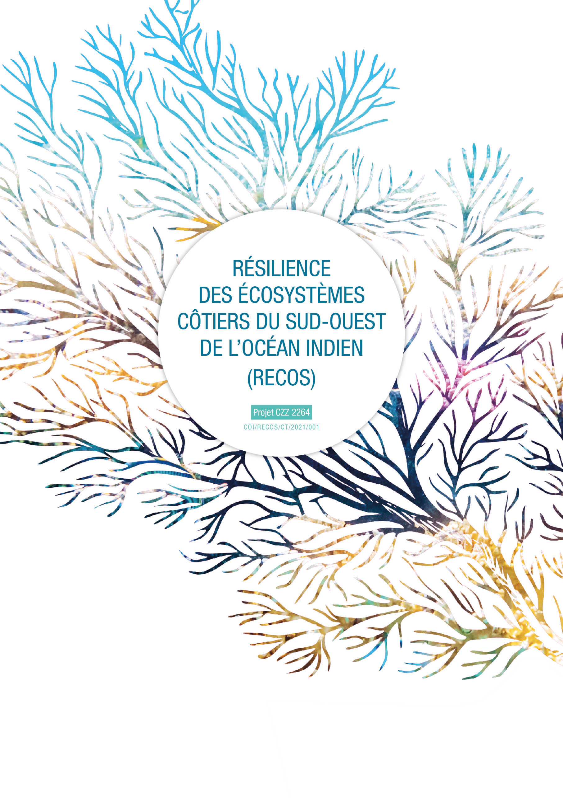

TERMS OF REFERENCES
DEVELOPMENT OF INTEGRATED COASTAL ZONE MANAGEMENT PLAN IN THE DISTRICT OF BLACK RIVER, REPUBLIC OF MAURITIUS

- CONTENTS

1. CONTENTS 1
2. LIST OF ABREVIATIONS 2
3. BACKGROUND INFORMATION 3
3.1 The Indian ocean Commission and the RECOS project 3
3.2. Context of the activity: support from RECOS project to the Mauritian government for the development of an ICZM plan at district level 4
3.2.1 Regional ICZM context 4
3.2.2 Support to the Mauritian government for the development of an ICZM plan at district level 5
4. DESCRIPTION OF THE ASSIGNMENT 6
4.1. Objective of the assignment 6
4.2.1 Phase 1 – Collection and centralisation of the existing information about coastal zones, at national and district levels 7
4.2.2 Phase 2 – Review, consolidation and finalisation of the initial methodology outline for the establishment of ICZM action plan at District level 8
4.2.3 Phase 3 – Implementation of the methodology in the District of Black River 9
4.2.4 Phase 4 – Evaluation and review of the methodology for its adoption at national level 10
5. GENERAL TIME SCHEDULE AND BUDGET 10
6. PERSONNEL IN THE FIELD (PROFESSIONAL EXPERIENCES AND QUALIFICATIONS) 11
7. CONDITIONS OF ASSIGNEMENT 11
8. ANNEXES 12

- LIST OF ABREVIATIONS
AFD Agence Française de Développement
COI Commission de l’océan Indien
GEF Global Environmental Fund
FFEM Fond Français pour l’Environnement mondial
ICZM Integrated Coastal Zone Management
RECOS Resilience of Coastal Ecosystems of the South-West Indian Ocean
UNDP United Nations Development Programme

- BACKGROUND INFORMATION

The Indian ocean Commission and the RECOS project

The Indian Ocean Commission (COI) is an intergovernmental organisation which brings together five member states: the Union of the Comoros, France in respect of Reunion, Madagascar, the Republic of Mauritius, and the Republic of Seychelles.

The only regional organisation in Africa composed exclusively of islands, it defends the specificities of its member states on the continental and international stages. Benefiting from the active support of around ten international partners, the COI gives substance to regional solidarity through cooperation projects covering a wide range of sectors: Preservation of ecosystems, sustainable management of natural resources, maritime security, entrepreneurship, public health, renewable energies or even culture.

This “Resilience of Coastal Ecosystems of the South-West Indian Ocean” (RECOS) project co-financed. by the French Development Agency (AFD) and the French Fund for the Global Environment (FFEM), participates in the diversified action of the COI in favour of a sustainable and resilient environment.

The overall objective of the project is to strengthen the resilience of coastal populations to the effects of climate change by restoring the services provided by coastal ecosystems.
The specific objectives to achieve this are:
- Strengthen regional and national governance of coastal and marine ecosystems in the Indian Ocean.
- Implement innovative, varied, and replicable projects for the restoration and sustainable use of coastal and marine ecosystems by relying on scientific working groups.

To achieve its objectives, the RECOS project is structured around four components which are implemented using an integrated approach. These are shown in the figure below:
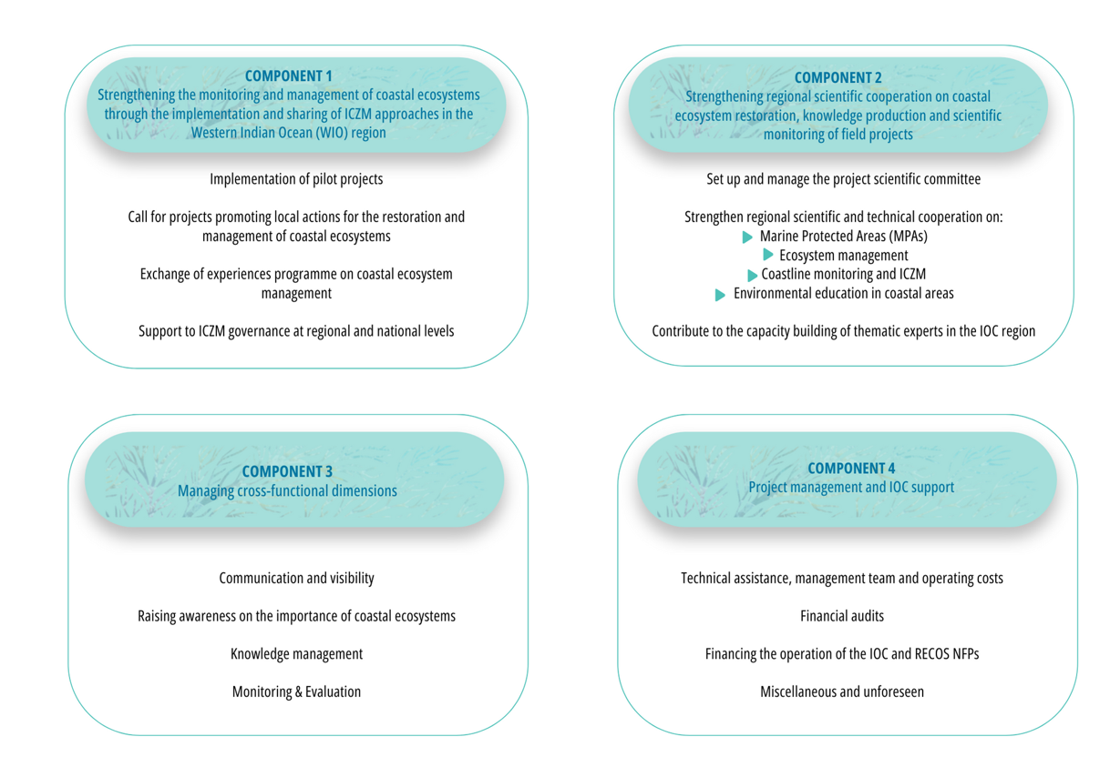

3.2. Context of the activity: support from RECOS project to the Mauritian government for the development of an ICZM plan at district level

Regional ICZM context

The coastal zones constitute important components of the natural and cultural heritage of the Western Indian Ocean region. But the pressures on coastal and marine areas are increasing, resulting from biodiversity loss, pollution, degradation due to growing intensity of human settlement and unsustainable socio-economic activities, natural disasters, climate change including sea level rise affecting especially low-lying areas and small island States. Recognizing these threats, and the principles upon which integrated coastal zone management is founded, an ICZM protocol has been developed by the Nairobi Convention.
This ICZM protocol has been adopted by the Contracting Parties during the last Conference of Plenipotentiaries on the 12thSeptember 2023. The final text of the Protocol on Integrated Coastal Zone Management is in Annex I. This protocol recalls definitions, objectives, and principles of ICZM. It also describes obligations of the Parties and the adopted regional Frameworks and Instruments.

Support to the Mauritian government for the development of an ICZM plan at district level

Being a Nairobi Convention contracting Party, the Republic of Mauritius adopted this ICZM protocol and thus commits to the obligations, amongst which Mauritius should take appropriate measures to ensure implementation of integrated coastal zone management and develop and adopt procedures and mechanisms needed at the national level to facilitate compliance and enforcement of this Protocol.
One objective of the RECOS project is to support the ICZM governance at Nairobi Convention and national levels. During the feasibility study of the RECOS project in 2018, the Mauritian party through the Ministry of Environment, Solid Waste Management and Climate Change requested that the RECOS project finance the development of Integrated Coastal Zone Management (ICZM) plans for the districts of Pamplemousse, Rivière du Rempart, Flacq, Grand Port and Savanne. Indeed, Mauritius has a national ICZM plan established in 2009 that needs to be updated to take into consideration the issues related to climate change, which were not taken into consideration at the time.
Since the feasibility study, a project financed by the Global Environmental Fund (GEF) and implemented by the United Nations Development Programme (UNDP) between 2016 and 2021 with the Mauritian government “Mainstreaming Marine Biodiversity” provided for a plan for the southwest area (District of Rivière Noire) of Mauritius and for Rodrigues. The products of this project were supposed to provide the baseline for the development of ICZM plans for the five coastal districts of Mauritius.
In 2023, regarding the absence of the data that an environmental, economic and social diagnosis carried out by the Mainstreaming Biodiversity project was to provide, this activity has since been reviewed with the Ministry of Environment, Solid Waste Management and Climate Change, so that the emphasis is placed on the development of a methodology and its testing on a single district with the intention that it becomes the standard methodology at the level of the Mauritius ICZM committee and therefore for all projects/initiatives working on the development of such plans in the future.
In December 2023, the Ministry of Environment, Solid Waste Management and Climate Change made the decision to develop this methodology in the Black River District rather than in the district of Grand Port, one of the 5 initially districts identified, proposed in August 2023 by the IOC to the Mauritius ICZM Committee. Data from the Mainstreaming Biodiversity project already mentioned would also be made available.
This document describes the Terms of References for a consultancy, supported by the RECOS project, that aims to reach this objective in testing the developed methodology on the Black River District.

- DESCRIPTION OF THE ASSIGNMENT

Objective of the assignment
The objective of this contract is the formulation of a methodology for the development of ICZM plan, and its testing on the coastal district of Black River with the intention that it becomes the standard methodology at the level of the Mauritius ICZM committee and therefore for all projects/initiatives working on the development of such plans in the future.
More specifically, the Consultant will provide a technical assistance to the Ministry of Environment, Solid Waste Management and Climate Change to develop a methodology, then implement it in order to develop an ICZM Plan for the district of Black River, Mauritius, using a participatory and consultative approach which will ensure that thematic eight (8) of the Mauritius Environment Masterplan is fully integrated into the legal and administrative planning framework.
The consultant will facilitate and animate this concertation process in order to develop an ICZM Plan for the District of Black River, validated by all stakeholders of the District development and aligned with the national strategies and frameworks.

  - Assignment scope of work
The coastal zone is one of Mauritius’ greatest cultural, environmental, and economic assets. However, the evolution of the coastline is considered as one of the most dynamic processes affecting this area. Integrated Coastal Zone Management (ICZM) has been identified as one of the approaches to tackle related issues like land management, natural resource management and conservation, tourism, poverty, etc., in the long term, to:
- Balance cultural, environment, socio-economic and recreational objectives;
- Reduce ecosystem degradation;
- Conserve and maintain existing ecosystems from potential climate change impacts.

The terms of reference are designed for the process of formulation of these plans to be consultative and iterative, through the engagement of local authorities, communities and other key stakeholder’s participation in decisions.
This section presents the detailed phases and activities proposed to deliver the final expected output:
Phase 1 – Collection and centralisation of the existing information about coastal zones, at national and district levels.
Phase 2 – Development of a methodology for the establishment of an ICZM action plan at District level.
Phase 3 – Implementation of the methodology on the District of Black River.
Phase 4 – Evaluation and review of the methodology for its adoption at national level.

Phase 1 – Collection and centralisation of the existing information about coastal zones, at national and district levels

Deliverable: Inception report, including a review of existing documentation, information and data about ICZM in Mauritius
Timeline: Signature + 2 month (including 0,5 month for validation process)
This first phase will aim at establishing a review of all existing and necessary documentation in order to assess:
- The national framework and strategy in term of national ICZM: this will allow to align the methodology with the national frameworks including the relevant legal and strategic context and parameters of the process (including the roadmap to formally adopt an ICZM action plan);
- The available datasets and documentation about the national coastal and marine environment and socio-economics;
- The existing dataset at coastal district levels;
- The actual knowledge gaps at national and district levels;
- All necessary information that could be required to develop the methodology.

This assessment will allow to define the anchoring of this consultancy with the ICZM national committee: governance frameworks, national anchoring of the district committee, including the relevant legal and strategic context and parameters of the process (including the roadmap to formally adopt the document).
The assessment of the existing data and information at district level will enlighten the perimeter and level of the preliminary diagnosis phase that will be the first step of the methodology. This diagnosis should include a statement of the coastal and marine environment and an assessment of the landscape of the District in terms of resources (human, material, knowledge, financial), of key actors, and distribution of powers and strategic roles on social dimensions.
At the end of this 1st phase, the consultant will need to provide an inception report including:
- A work plan for the implementation of phases 2; 3 and 4 of this assignment. This workplan should describe in detail the action plan, the mean and human resources who will be engaged at each step, the different consultation and validation processes.
- A review of existing documentation at national and coastal District levels.
- The assessment of existing knowledge and gaps.

The collect of existing information and data will be supported by the Ministry of Environment, Solid Waste Management and Climate Change and facilitated by RECOS project. This phase will include a preliminary meeting with a representative of the Ministry of Environment. The deliverables of this 1st phase will be presented to the national ICZM committee.

Phase 2 – Review, consolidation and finalisation of the initial methodology outline for the establishment of ICZM action plan at District level

Deliverable: a fully documented methodology for the establishment of ICZM action plans applicable to any district of the Republic of Mauritius, including a validated template for standardised ICZM action plans.
Timeline : validation of phase 1 + 2 months (including 0,5 month for validation process)
This methodology should be aligned with all relevant national strategies and political and legal frameworks identified through phase 1 and developed from the Methodology outline provided at time of the submission to the RECOS project call for proposals.
The methodology should respond to the objectives, principles of the ICZM protocol of the Nairobi Convention.
The methodology should also include at least the following main activities:
- Conducting a preliminary site integrated diagnosis, based on existing documentation and data (including the data from the Mainstreaming Biodiversity project to be provided by the Ministry of Environment, Solid Waste Management and Climate Change). This diagnosis should be conducted on environment, social, cultural and economic aspects. It should lead to a mapping of key activities, actors, past, current and future initiatives, the identification of knowledge gaps, main issues of territorial development.
This diagnosis must be based on a consultative and integrative approach, with a validation by all stakeholders and including sensitisation actions.

- Setting up of a consultation platform: this platform should be built through the District Council and be inclusive and multidisciplinary, with a proper representation of all key stakeholders. The governance, functioning, representativity of this platform must result from the recommendations resulting from the territorial diagnosis.

- Developing a concerted and validated ICZM action plan: the methodology must describe the means and work to be deployed to ensure the representativeness and involvement of key stakeholders during this process. The perimeter, structure and level of detail and content of the standardised action plan should be defined and well documented. It will have to be built on the principles of a logical framework and include, at least: assessment of issues, changes to be done, definition of targets, objectives, concrete and accurate activities with definition of responsibilities and means, timeframe and indicators for monitoring and evaluation purposes.
The methodology should also explore the realistic level of details associated to the proposed activities in the action plan (i.e.: cost-benefit analysis, Terms of reference? Technical specifications? Directives to how implement the actions required?)

A template of a consolidated action plan will be presented to the National ICZM committee for validation. The methodology will propose a validation process at district level and national level.

- Implementation of an ICZM action plan at District level: this chapter will propose a methodology and recommendations for building the good conditions for a successful and long-term implementation of the action plan, including:
  - Process and means to anchor implementation responsibilities.
  - Capacity building for key stakeholders (set up an adapted training programme)
  - Search for opportunities to implement the action plan (fundings, partnerships…)
  - Set up a monitoring & evaluation mechanism and reporting system anchored at national level.

This methodology should take into consideration cross-cutting issues, such as:
- Capacity building: principles needs from various stakeholders should be assessed during the different steps of the methodology, and actions proposed to address them.

- Gender: this should be considered in the methodology from the initial diagnosis until the implementation of the action plan. Gender indicators should be defined in the action plan.

- Science based approach: any stage described through the methodology should be based on science and avoid subjective considerations. The activities that should be proposed during the development of an action plan should prioritize nature-based solutions and demonstrate limited environment and social risks.

- The indicators: The development of a set of indicators for the district action plan allowing reporting and aggregation at national level environmental and social indicators. The set of indicators proposed will fall under the Nairobi Convention ICZM protocol categories of indicators (see Annex I). They should also be based on those that been already developed under other initiatives (e.g., Mainstreaming marine biodiversity project; SAPPHIRE project).

The methodology will propose means, tools and indicators that can respond to national needs and facilitate the process of development, implementation, and evaluation of future ICZM actions plans.

Phase 3 – Implementation of the methodology in the District of Black River

Deliverables:
- Deliverables resulting from the implementation of the methodology on Black River: diagnosis, meeting reports, draft action plan before validation at national level, and all documentation described in the methodology.
- An assessment of the results of the implementation of the methodology on the Black River District, including lessons learnt, recommendations, and a reviewed methodology.

Timeline: 17,5 months

The objective of this phase is to test the methodology to be able to adjust it and strengthen it to make it the most adapted to other Mauritian coastal districts.

The consultant will implement strictly on the District of Black River all steps of the methodology, means and tools developed and validated through phase 2, including its approved coordination and validation processes. Through an iterative process, the results and lessons learnt will be documented for each step of the implementation, to propose adjustments, recommendations, and an improved version of the methodology developed on phase 2.

Phase 4 – Evaluation and review of the methodology for its adoption at national level

Deliverable: Recommendations for the adoption of the methodology at national level.

Timeframe: validation of phase 3 + 1,5 month

The objective of this phase is to set up the conditions for the adoption of the methodology as standard methodology for the elaboration of ICZM district plans in other coastal districts of the republic of Mauritius.

This objective could be achieved through consultations at different levels and a restitution workshop for policy makers and implementing agencies that will lead to a set of recommendations for the adoption of the methodology at national level.

  - Responsibility of the consultant

In taking on this assignment, the Consultant responsibility is to:
  - Ensure to dedicate all necessary human resources for the timely completion of the assignment;
  - Carry out the relevant field visits to ensure the smooth implementation of activities;
  - Collect and work with the existing data, with no obligation to produce new one, unless deem necessary for the successful testing/implementation of its methodology;
  - Lead all necessary consultation processes at national, local and sectoral levels to reach the objectives defined in this document;
  - Develop appropriate management and planning tools to enable sound integrated coastal zone management;
  - Organise, coordinate, compile and submit in a timely fashion all expert’s work;
  - Comply with RECOS project environmental and social norms presented in its “Plan d’engagement environmental et social” through the engagement taken when signing the COI “Déclaration d’intégrité, d’éligibilité et de responsabilité environnementale et sociale”. (Annex 3)
- GENERAL TIME SCHEDULE AND BUDGET
The Consultant activities are expected to last up to twenty-three (23) months from the contract signature. The proposed plan and methodology for the implementation of activities must be proposed by the Consultant in his technical proposal. This plan will have to be validated with the ICZM committee and may be subject to amendment depending on the results gathered from the implementation of phase 1.
The maximum budget for this contract is EUR 150,000.

- PERSONNEL IN THE FIELD (PROFESSIONAL EXPERIENCES AND QUALIFICATIONS)
To ensure the projects sustainability it is vital that the qualified bidder can:
- Confirm its ability to engage at the local level;
- Ensure to dedicate all necessary human resources for the timely completion of the assignment;
- Provide the services of an expert or team that could demonstrate previous experiences in the following fields of competencies: environment, geography/sociologic and economy.
- Show expertise in sustainable development (preferably in Mauritius) and ability to work with a wide range of stakeholders.

The CV of the respective expert(s) assigned to this assignment by the Consultant must be provided.

Language of assignment: English for all written reports and outputs. Consultations in the field might require knowledge of French and Creole. The Consultant should ensure and demonstrate that such competencies are available within the team.
Working conditions: based in Mauritius. Ideally in the District targeted.
- CONDITIONS OF ASSIGNEMENT
For the assignment, a Steering Committee will be set up under the aegis of the Ministry of Environment, Solid Waste Management and Climate Change to oversee this assignment.
7.1. Coordination
1) Steering committee, composed of:
- Ministry of Environment, Solid Waste Management and Climate Change (representative of the RECOS national focal point)
- COI, RECOS project
- Representative of district coordinating body defined in the methodology.
Role: review and validation of outputs and ensure good working conditions (access to all existing information, data and relevant contacts at national level)
2) A coordination body at the district level will be proposed in the methodology to take on at minima the following role: providing support on proposed works; providing inputs/views on technical reports; facilitating consultative meetings.

7.2. Validation process
A process for the validation of deliverables expected from this assignment (i.e.: Inception report, Diagnosis report, Methodology and tools, final report…) will be defined in concertation with the Ministry of Environment during the inception phase.
If the deliverables must be validated by the management committee, it is not expected from this assignment that the results of specific activities, such as the Black River ICZM action plan, will be validated at the national level.
However, the Consultant will have to propose in its methodology a national validation and endorsement process for the coastal ICZM plans.

7.3. Reports requirements
All reports and maps shall be submitted in soft copy. The soft copy should not be secured with password(s) to allow reviewing, printing or copy and paste of extract from the reports.
The reports and documentation should be submitted in electronic format, in both editable Microsoft Office Word version and in pdf version. All the final versions of the reports and documentation should also be dispatched to the Project Manager in 3 original USB keys. There shall be no security restrictions on printing/editing in the deliverables.
The language of the assignment shall be in English. All the outputs and deliverables shall be written in English language and should be presented in a format acceptable by the Technical Committee under the aegis of the Ministry of Environment, Solid Waste Management and Climate Change.
All deliverables/documents/maps shall become the co-property of the Government of Mauritius, the COI and of the financial partners AFD and the FFEM.
- ANNEXES
- Annex I – Final Act of the Protocol on Integrated Coastal Zone Management (Nairobi Convention)
- Anne II - ICZM context in Mauritius

Annexe I – Final Act of the Protocol on Integrated Coastal Zone Management (Nairobi Convention)
https://drive.google.com/file/d/1xyBbHnlxOsz2YznUOrhCMNlF4Z6fAurl/view?usp=sharing
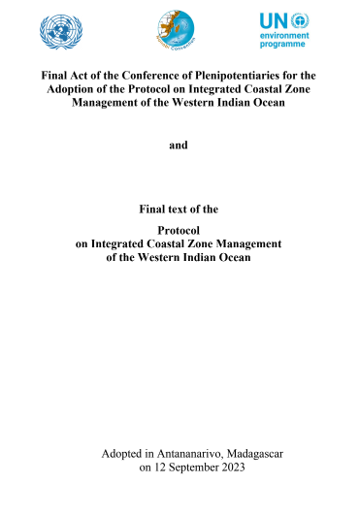
Annexe II – ICZM context in Mauritius

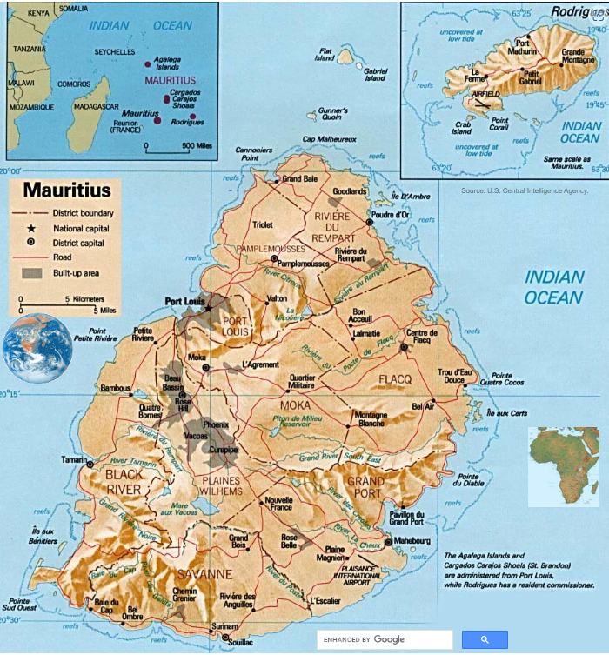
The Republic of Mauritius is one of the islands in the Western Indian Ocean. With a total land area of 2,040 km², the state is classified as a Small Island Developing State (SIDS) and is also one of 25 internationally recognised biodiversity hotspots. The tropical climate, topography and history of isolation have resulted in the evolution of a diverse biota with a high degree of endemism. Terrestrial biodiversity depends on the forest. However, much of the existing forest has been lost : forest clearance and degradation has already affected more than 90% of Mauritius' land surface. Marine biodiversity is in better shape, but it is also under threat. Extensive reef systems surround all the islands of the archipelago.
Most of the usable land in Mauritius has been allocated to production. Despite significant degradation and transformation in many areas, the coastal ecosystems and adjacent landscapes retain their basic ecological functions. The coastal strip provides prime land for housing, recreation and tourism, while the seascapes form the basis of the food supply through fishing and the country's main tourist attraction - beaches, water sports and related activities. Lagoon habitats are particularly important in this respect. They contribute to the overall productivity of coastal waters by supporting a variety of habitats, including salt marshes, seagrass beds and mangroves.
Mauritius' marine ecosystems are inhabited by more than 200 species of corals, 4,000 species of fish, and thousands of other aquatic animals and plants. Meanwhile, the coral reefs that shelter the lagoons, as well as the beaches, seagrass beds, estuaries and mangroves of the island, are now threatened by the degradation of the fauna and flora. Mauritius is notably affected by the phenomenon of coral bleaching, which sees the degradation of about 40% of the stations due to their increased vulnerability to the effects of climate change.
Coastal zones of Mauritius
The coastal zone of Mauritius is a key resource that supports various economic activities, such as recreation, tourism, fisheries, trade and industry. It is estimated that the economic value of the coastal zone is more than 1 trillion rupees (ICZM Framework, 2010). Approximately 20% of the population reside in the coastal areas.
Section 49 of the Environment Protection Act 2002 defines the coastal zone as follows:
1. any area which is situated within 1 kilometre, or such other distance as may be prescribed from the high water mark, extending either side into the sea or inland;
2. includes-
• coral reefs, reef lagoons, beaches, wetlands, hinterlands and all islets within the territorial waters of Mauritius and Rodrigues;
• any estuary or mouth of a river and that part of a river, stream or canal which lies within 1 kilometre from the outermost point of its bank on the sea at high tide;
• the islands of Agalega and Saint Brandon, and other outer islets.
CHARACTERISTICS OF THE COASTAL AND MARINE RESOURCES OF MAURITIUS ISLAND
- 15 of the 49 islets around mainland Mauritius are declared as national parks or nature reserves
- 406 ha coastal wetlands in Mauritius
- Three Ramsar sites (Rivulet Terre Rouge Bird Sanctuary, Blue Bay Marine Park and Pointe d’Esny Ramsar
- Site), covering 401 ha
- Two marine parks (Blue Bay and Balaclava) and six fishing reserves proclaimed around the island
- Live coral reef cover varies from 0.6% to 23% as a proportion of the whole lagoon
- Mangrove propagation program started in 1995 by the Fisheries Division. Around 386,750 mangroves
- plants were planted near the coast during the period 2012-2017 and the area covered was
- approximately 19.9163 ha
- 606 ha of Pas Geometriques including plantation (241 ha of Casuarina and mixed plantation) coastal forest cover.
- 7000 ha of terrestrial areas and 9100 ha of marine areas are protected.
- The marine biodiversity consists of some 1,656 known species
- 163 species of hard corals in 40 genera of hard corals
- Some 340 species of fish, out of which 42 are of economic importance
- 160 genera of marine algae identified in coastal waters
- 200 species of seabirds reported

Tourism and fishing, developed thanks to the Mauritian coastline, are essential sources of income for the island and its population. The island is densely populated and despite the diversification of the economy, the State is highly dependent on its natural resources for its economic activities. The Mauritian lagoon provides a direct and indirect livelihood for many families through the various food resources it provides for artisanal fishing. However, global warming, overfishing and pollution, among other things, are leading to the degradation of the island's fauna and flora and the bleaching and decay of the corals. The Mauritian coastline with its white sandy beaches is also a cultural feature of the island, promoted worldwide for the tourism industry. Numerous hotels, apartment complexes and privatised areas are scattered along the Mauritian coastline, leaving only 14% of the total coastline accessible to the public as "public beaches".
The coastal zone is important not only for providing income, but also protecting the island from impacts of waves from the ocean during storm surges and other adverse climatic conditions. Intense pressure from sea and land-based activities (construction, sewage disposal, industry and agriculture) is having a negative impact on the coastal zone. The situation is exacerbated by sea level rise and storm surges and thus putting at risk the coastal inhabitants and their properties, as well as the coastal resources. Addressing environmental problems which affect the coastal zone is therefore of a very high priority. Les “Assises de l’Environnement” assessed the major concerns that affect the coastal and marine environment:
- Sea level rise is contributing to the aggravation of coastal erosion. Over the last decade, an accelerated sea level rise of over 5.0 mm per year has been observed;
- Construction of hard structures such as walls, concrete jetties, groynes, along the shoreline causing beach erosion;
- Inadequately planned development in prime coastal areas;
- Degradation of the coastal ecosystems (corals, seagrass, mangroves, wetlands);
- Marine litter and microplastics;
- Oil spill;
- Inadequate zoning of the lagoon, leading to conflict in use (e.g. aquaculture and nautical activities) • Seine/large/gill net fishing and their impacts on marine biodiversity;
- Need for capacity and resources for enforcement;
- Need for more awareness on the importance and protection of the coastal zone ;
- Need for appropriate database to enhance integrated coastal zone management ;
- Inappropriate measures for beach protection in terms of aesthetics and for promoting tourism ;
- Sedimentation and pollution from land-based activities.

Existing National Strategies and Policies
The Government adopted the National Environment Policy (NEP) in 2007 and the National Environmental Strategies (NES) in 1999, which was reviewed in 2008. These documents established a clear policy framework and set appropriate environmental objectives and strategies including coastal zone management.
An Integrated Coastal Zone Management (ICZM) Division was set up within the Ministry of Environment in the year 2000. The Environment Protection Act was amended in 2002 to include the setting up of an ICZM Committee comprising Government bodies, parastatal organisations, local authorities, private sector and NGOs to oversee the management of the coastal zone. The Beach Authority was set up in 2002 to look into the sustainable management of the public beaches, including provision and maintenance of amenities, demarcation of swimming zones, and maintenance of the public spaces, amongst others. There are currently 130 proclaimed public beaches in Mauritius, with a total sea frontage of around 48 km and total area of around 327 hectares.
An Oil Spill Contingency Plan was developed in 2003 to address the occurrence of oil spills, including collection, disposal, cleaning, and rehabilitation measures.
A study on Environmentally Sensitive Areas (ESAs) was carried in 2009, which identified 14 types of ESAs and which proposed management strategies including setbacks for development.
An ICZM Framework was developed in 2010, comprising a strategy, policy, institutional and legal framework. Action and Area Plans for 6 pressure zones, namely Grand Baie, Poudre d’Or, Belle Mare, Le Morne, south and east coasts of Rodrigues were also developed to manage the areas and to guide development in a sustainable manner.
A Disaster Risk Reduction Strategic Framework and Action Plan was developed in 2012 to address issues of flooding related to climate change impacts.
In terms of regulation, the primary legislative framework for environmental protection in the Republic of Mauritius is the Environment Protection Act (EPA) 2002. The Act was subsequently amended in 2008. It declares that every person in Mauritius shall use his best endeavours to preserve and enhance the quality of life by caring responsibly for the natural environment of Mauritius.

OVERVIEW OF NATIONAL POLICIES AND OTHER INITIATIVES IN MAURITIUS

- Mauritius ICZM Framework, ICZM Strategy, ICZM legislative and Policy Framework (2009)
- Black River ICZM District plan (2021)
- Mauritius Biodiversity Strategy and Action Plan (NBSAP) 2017 – 2025
- Maritime Zones (Conduct of Marine Scientific Research) Regulations 2017
- National Disaster Risk Reduction and Management Act 2016
- Fisheries and Marine Resources Act 2007
- Environment Protection Act 2002 (amendé en 2019)
- The Environment Protection Act 1991
- Fisheries and Marine Resources Act 1998

In 2022, the Ministry of Environment, solid Waste management and Climate change published a Master Plan for the environment in the Republic of Mauritius for the next Decade (2020-2030) (ANNEXE 1). This Master Plan establishes the foundation to support the country’s transition to a green and clean society. It constitutes a blueprint to guide policymakers and the civil society in adopting a sustainable pathway for the next decade and aims to adapt our lifestyle, institutions, legislation and economic development to the fast-changing global realities and specific socio-economic and environmental conditions of Mauritius and Rodrigues.
The Environment plan proposes a vision for Mauritius :
« An inclusive, high income and green society forging ahead together, supported by a comprehensive approach that addresses priority issues and embraces innovative approaches”.
The coastal zones and marine environment is one of the height thematic areas that were identified as challenges to be resolved in the formulation of the Master Plan. The targeted outcome proposed for this thematic is:
“A coastal zone resilient to natural hazards, climate change and anthropogenic impacts, where a right balance is struck between our coastal ecosystems and development and where the right of the public to enjoy their natural heritage is protected and marine resources including biodiversity are preserved so as to allow the sustainability of livelihoods.”
Several policy orientations and strategies are proposed to achieve this long term objective.
the Ministry of Environment, solid Waste management and Climate change, under its ICZM Division, is proposing to develop ICZM action plans in the coastal Districts of Mauritius in order to implement the Master plan.

The Republic of Mauritius comprises the main island of Mauritius (1,865 km²) covered by this consultancy, and Rodrigues (109 km2) and the outer islands which are not covered by this work.
Henintsoa Laingo, “Îles Maurice : les lagons et l’écosystème côtier menacés,” Le Nouvel Afrik, 7 janvier 2020. [Online] https://www.afrik.com/iles-maurice-les-lagons-et-l-ecosysteme-cotier-menaces
"IOC countries - GCRMN report recommendations," Indian Ocean Commission, 2017. [Online] https://www.commissionoceanindien.org/wp-content/uploads/2020/06/LOW-RES-COI-R%C3%A9cifs-coralliens-PAYS-DE-LA-COI-fr.pdf
1Islets and Offshore Unit. Available at http://npcs.govmu.org/English/Documents/Islet.pdf
NWFS Consultancy (2009). Environmentally Sensitive Areas Classification Report, Republic of Mauritius. Final Report.
Ramsar Sites Information Service. 2019. Available at https://rsis.ramsar.org/ris-search/?f[0]=regionCountry_en_ss%3AMauritius&pagetab=1
Marine Conservation Division. Available at: http://oceaneconomy.govmu.org/English/Departments/Albion%20Fisheries%20Research%20Centre%20(AFRC)/Marine%20Conservation/Pages/default.aspx
Ministry of Agro-Industry and Food Security. National Biodiversity Strategy and Action Plan 2017-2025. May 2017.
Environment Statistics 2018. Stats Mauritius. Government of Mauritius. http://statsmauritius.govmu.org/English/StatsbySubj/Documents/Digest/Environment/Digest_Env_Yr17.pdf
MAIFS Pers comm.
Republic of Mauritius (RoM), 2017. National Biodiversity Strategy and Action Plan 2017 – 2025, p. 22. Available on: https://www.cbd.int/doc/world/mu/mu-nbsap-v2-en.pdf
Fenner D., et al., 2004. A checklist of the corals of the island state of Rodrigues, Mauritius. Journal of Natural History, Volume 38, Issue 23 & 24, pp 3091 – 3102.
RoM, 2017. National Biodiversity Strategy and Action Plan 2017 – 2025, p. 22.
Republic of Mauritius (RoM), 2010. Mauritius Strategy for Implementation National Assessment Report, p. 38. Available on: https://sustainabledevelopment.un.org/content/documents/1255Mauritius-MSI-NAR2010.pdf
RoM, 2010. Mauritius Strategy for Implementation National Assessment Report, p. 38.
"The Context", MRU2025. [Online]. https://mru2025.org/mauritius-coastal-development

