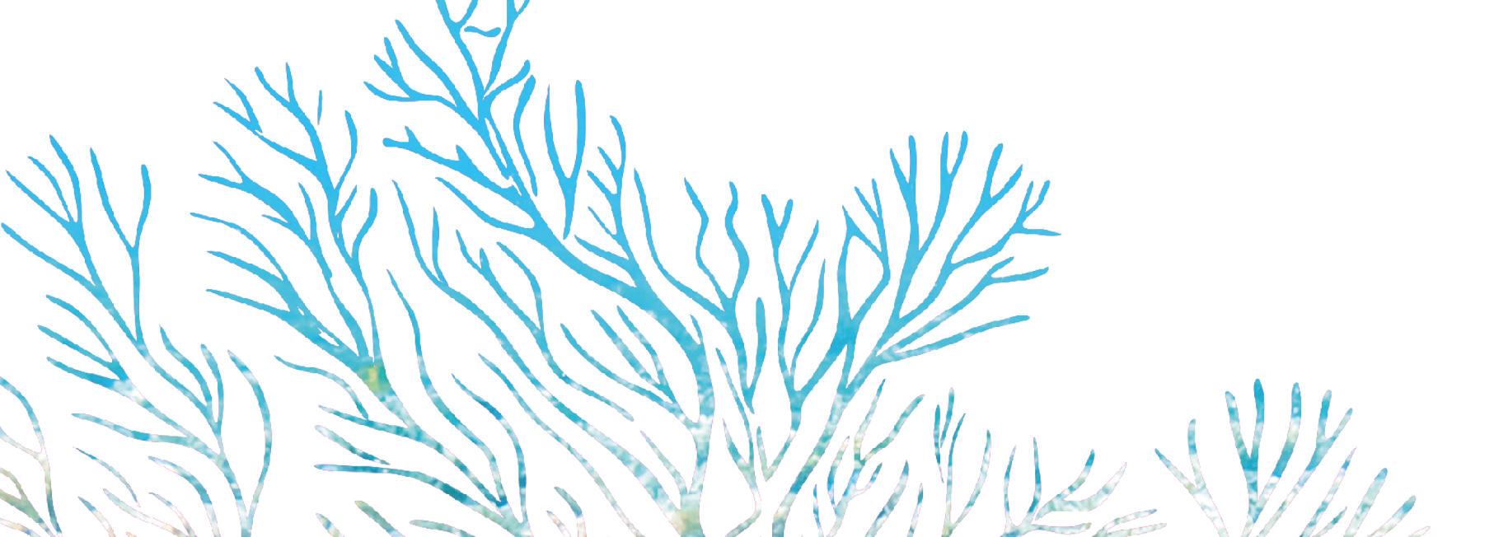

CALL FOR PROPOSALS
ANNEX I - CONCEPT GRANT APPLICATION NOTE

CONCEPT NOTE
[Tick the appropriate box]

BATCH 1 : Integrated Coastal Zone Management (ICZM) in the IOC member States.

BATCH 2 : Research & Development (R&D) on the resilience of coastal populations and
ecosystems.

GENERAL INFORMATION
PROJECT NAME
PROPOSAL NUMBER | Leave the box blank. To be filled by RECOS project
GRANT MAIN APPLICANT | Name of organisation:  Type of legal entity:  Name of contact person:  Email:  Phone number :  Postal address :
GRANT CO-APPLICANT(S) | [Add as many lines as necessary]  Name of organisation 2:  Type of legal of entity:  Name of contact person:  Email:  Phone number :  Postal address :  Name of organisation 3:  Type of legal of entity:  Name of contact person:  Email:  Phone number :  Postal address :
THEME(S)  (Tick one or more boxes) | Integrated Coastal Zone Management (ICZM) Planification, Governance and Implementation  Marine Protected Areas Management  Conservation and Restoration of Marine and Coastal Ecosystems  Observation and Management of the coastal zone  Environmental Education in Coastal areas
IMPLEMENTATION SITE(S) | [Indicate country(ies) and region(s) of project implementation]
PROJECT DURATION
TOTAL BUDGET (€)
REQUESTED GRANT AMOUNT (€):
GRANT BENEFICIARY’S CONTRIBUTION | Financial contribution  Amount :…………………………€  In-kind contribution (to be detailed in the full project proposal)

- RELEVANCE OF THE PROJECT (maximum 2 pages)
- Relevance to the specific objectives/sectors/themes/priorities of this call for proposals

- Describe the relevance of the project to the objective(s) and priority(ies) of the call for proposals.

- Describe the relevance of the project to any specific theme/sector/area and any other specific needs indicated in the guidelines for the call for proposals, e.g. local ownership, etc.

- Describe what specific outputs referred to in the guidelines of the call for proposals will be addressed.

- Relevance to the particular needs and constraints of the target country(ies), target region(s) and/or sectors concerned

- Define the site's vulnerability to climate change.

- Provide a description of the current specific situation in the target country(ies) or region(s) and/or sectors (include, if possible, quantified analysis data).

- Define the issues to be addressed by the project.

- Refer to any significant plans, undertaken at national, regional and/or local level, relevant to the project and describe how the project will relate to these plans.

- Where the project is a continuation of a previous project, indicate clearly how it will combine with the activities and/or results of the previous project; refer to the main conclusions and recommendations of any evaluations.

- Where the project is part of a wider programme, provide a clear explanation of how is its integrated to that programme and/or how it is coordinated with this programme or with any other planned project. Specify possible synergies with other initiatives.

- PROJECT OBJECTIVES
Define a general objective as well as specific objectives for the project.

- DESCRIPTION OF THE ACTION
[1 page max]
Provide a brief information on the type of activities proposed, specifying the related outputs and outcomes.
Include a description of the main stakeholders and an indicative timetable.

- MONITORING & EVALUATION
Briefly describe the mechanism that will be implemented for monitoring and evaluating the project.

- BUDGET
 | Budget RECOS (EUR) | Budget TOTAL (EUR)
Component 1 (Title)
Component 2 (Title)
Component 3 (Title)
TOTAL

