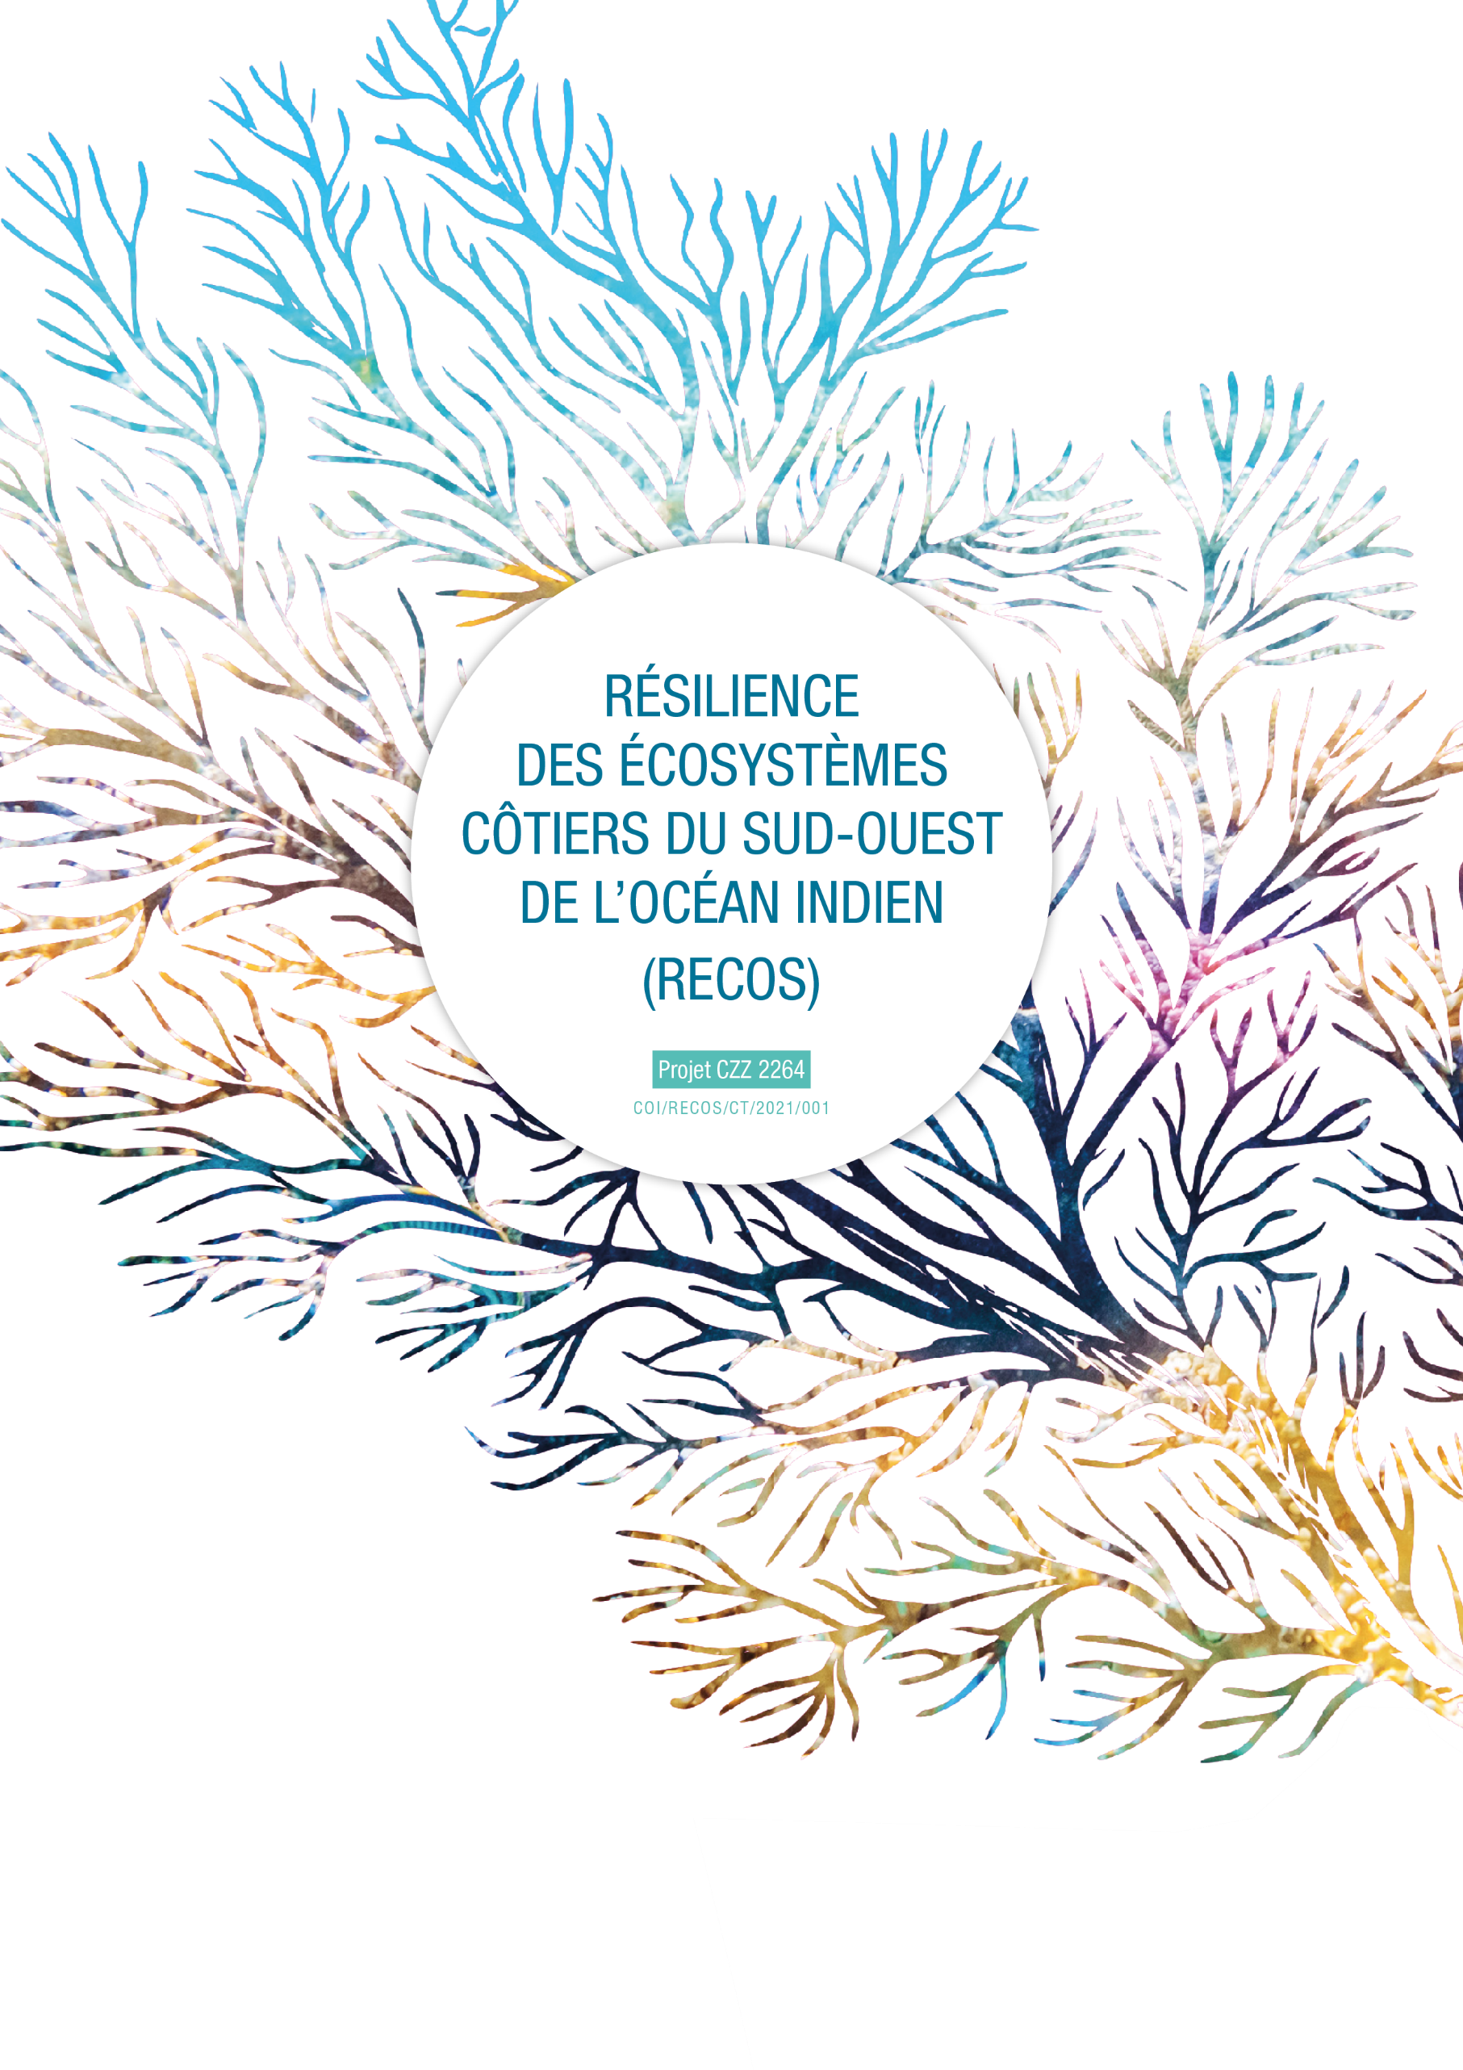

THE EXHANGE OF EXPERIENCES PROGRAMME ON COASTAL ECOSYSTEMS MANAGEMENT
Attachment 1 – APPLICATION FORM
APPLICANT IDENTITY :
Applicant / applicant organisation | Name of the applicant organisation or applicant for the exchange
Full contact details: | Postal address :  E-mail address :  Telephone number :
Name of the exchange :
Themes concerned by the exchange :  (tick the theme(s) concerned) | - Strengthening the scientific component of the RECOS project:  MPA/LMMA management  Management and restoration of marine and coastal ecosystems (mangroves, seagrass, coral reefs)  Land-sea integration, ICZM approach  Coastal and marine environmental education  - Contribute to the implementation of pilot sites and projects identified in the framework of the RECOS call for projects:  Indicate here the title of the project you are contributing to :
Peer actor sharing his experience details : | Name and contact details
Travel details : | Country/city of origin :  Country/city of destination :  Planned dates of travel :  Number of people participating in the trip :  Total estimated budget (€) :
First exchange of experiences operation | Yes | Indicate the date and title of the previous exchange :  No
How you heard about RECOS and its exchange programme:

JUSTIFICATION OF THE APPLICATION :

Use as much space as necessary to argue your answers

1- How are you involved in integrated coastal ecosystem management (IZCM) ?
Specify the nature of your structure, your functions, your missions, your experience, and the link with the RECOS project themes.

2- What expertise do you need? On what subject? Why do you need it?
Specify why the expertise you are looking for is necessary for the implementation of your project.

3- How did you identify the peer actor that would be sharing his experience? How does its expertise correspond to your needs? Justify also that you cannot find this specific expertise closer to you (out of concern for your carbon footprint).

4- What are the main aims of this exchange? What will be the benefits of this operation, and for whom?
Specify the expected results and the beneficiaries (at local, national and/or regional level).

5- Agenda of the operation:
Detail the activities planned in consultation with the peer actor:

DATE | PLACE | PERSONS MET / VISITED SITES
Departure from the country :

Arrival in the host country :

Day 1 :

Day 2 :

Day 3 :

Day X : (add as many lines as days of travel)

1- Persons that benefit from the funding of the exchange:
Total number of people to travel: ............
SURNAME AND NAME  (as indicated on the identity document to be used for travel) | FONCTION | JUSTIFICATION FOR PARTICIPATION IN THE TRIP | ID CARD OR PASSPORT (NUMBER) | EXPIRATION DATE OF ID CARD OR PASSPORT

2- Estimated budget for the travel operation:
1. TRAVEL COSTS
Type of costs | Detail | Itinerary (place of departure, place of arrival, flight plan, etc.). | Unit cost | Number of travellers | Total cost
Plane | Departure flight
 | Return flight
Car/Boat | Departure journey
 | Return journey
SUBTOTAL

- ACCOMMODATION AND MEAL COSTS
Type of costs | Cost per night/day per person | Number of nights | Number of host people | Total cost
Accommodation
Meal
SUBTOTAL

- PURCHASE OF SMALL ITEMS*
Type of costs | Number of units | Unit cost | Justification | Total cost
Equipement 1
Equipement 2
As many lines
as equipment
SUBTOTAL
*the need for this equipment for this exchange operation must be justified
- ON SITE TRANSPORT
Type of costs | Unit cost per day | Number of units | Total cost
Car/motorcycle/boat rental
Fuel
Other additional costs
SUBTOTAL

- ADMINISTRATIVE COSTS
Type of costs | Unit cost | Number of person concerned | Total cost
Visa
Insurance
Other
SUBTOTAL

TOTAL COSTS (1+2+3+4+5)

