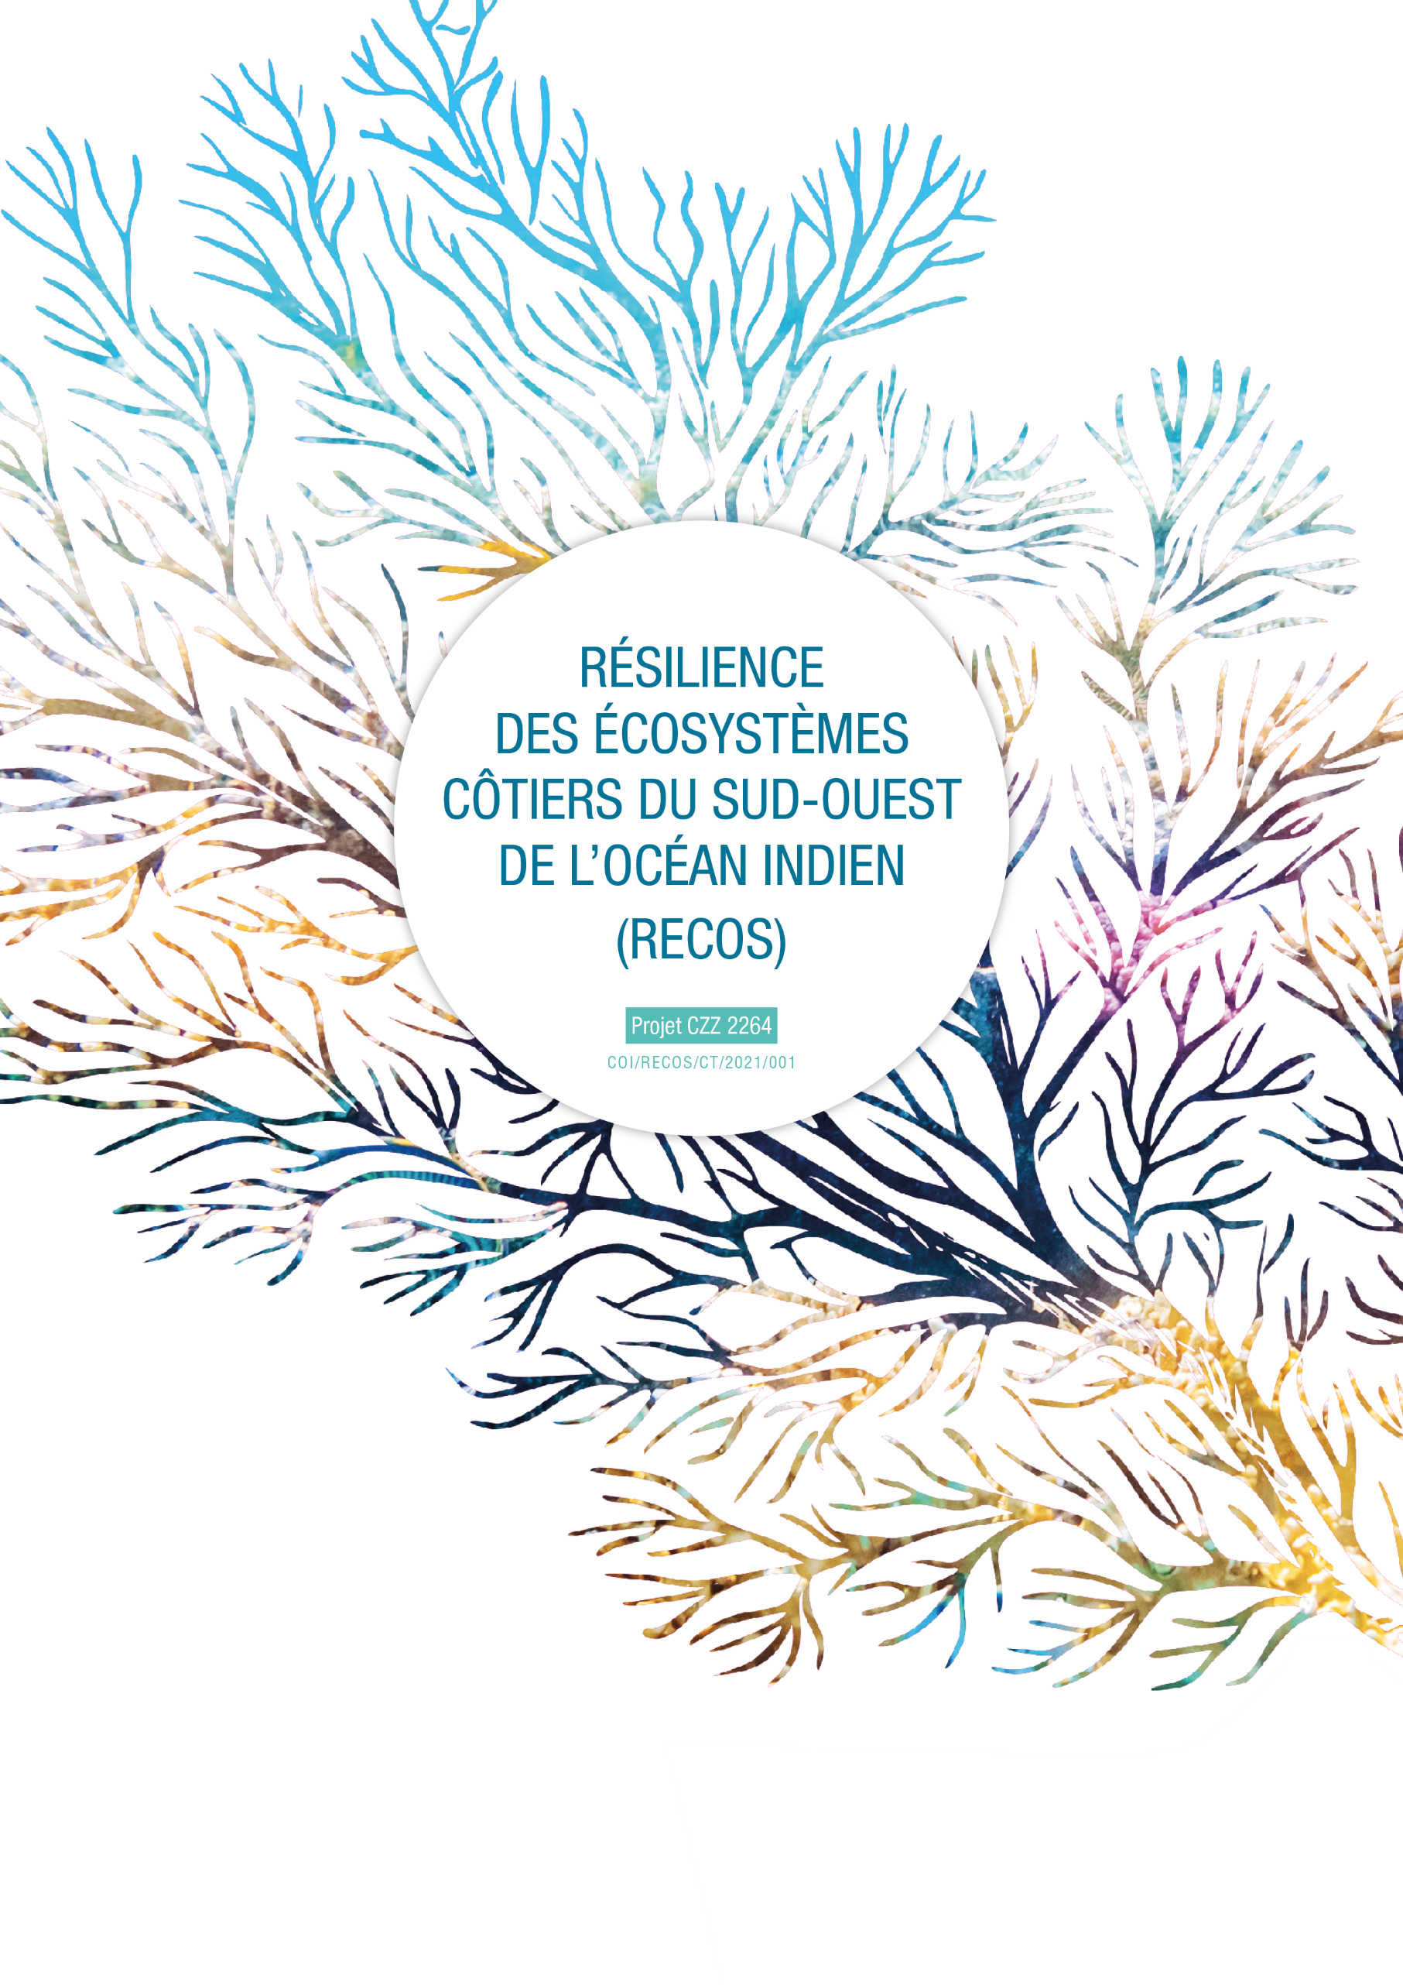

^

THE EXHANGE OF EXPERIENCES PROGRAMME ON COASTAL ECOSYSTEMS MANAGEMENT
Attachment 1 – APPLICATION FORM
APPLICANT IDENTITY :
Applicant / applicant organisation | Name of the applicant organisation or applicant for the exchange
Full contact details: | Postal address :  E-mail address :  Telephone number :
Name of the exchange :
Expertise concerned by the exchange :  (tick the theme(s) concerned) | - Strengthening the scientific component of the RECOS project:  MPA/LMMA management  Management and restoration of marine and coastal ecosystems (mangroves, seagrass, coral reefs)  Land-sea integration, ICZM approach  Coastal and marine environmental education  - Contribute to the implementation of pilot sites and projects identified in the framework of the RECOS call for projects:  Indicate here the title of the project you are contributing to :
Peer actor sharing his experience details : | Name and contact details
Travel details : | Country/city of origin :  Country/city of destination :  Planned dates of travel :  Number of people participating in the trip :  Total estimated budget (€) :
First exchange of experiences operation | Yes | Indicate the date and title of the previous exchange :  No
How you heard about RECOS and its exchange programme:

JUSTIFICATION OF THE APPLICATION :

Use as much space as necessary to argue your answers

1- How are you involved in integrated coastal ecosystem management (IZCM) ?
Specify the nature of your structure, your functions, your missions, your experience, and the link with the RECOS project themes.

2- What expertise do you need? On what subject ? Why do you need it?
Specify why the expertise you are looking for is necessary for the implementation of your project.

3- How did you identify the peer actor that would be sharing his experience? How does its expertise correspond to your needs?

4- What will be the benefits of this operation, and for whom?
Specify the expected results and the beneficiaries (at local, national and/or regional level).

5- Agenda of the operation :
Detail the activities planned in consultation with the expertise provider

DATE | PLACE | PERSONS MET / VISITED SITES
Departure from the country :

Arrival in the host country :

Day 1 :

Day 2 :

Day 3 :

Day X : (add as many lines as days of travel)

1- Persons that benefit from the funding of the exchange :
Total number of people to travel: ............
SURNAME AND NAME  (as indicated on the identity document to be used for travel) | FONCTION | JUSTIFICATION FOR PARTICIPATION IN THE TRIP | ID CARD OR PASSPORT (NUMBER) | EXPIRATION DATE OF ID CARD OR PASSPORT

2- Estimated budget for the travel operation:
Details of the costs to be covered | Unit | # Number of units | Unit price | Total amount | TOTAL amount (Euro)
1. Travel
2.1 International travel
Flight details
2.2 On site travel (inter island flights, boat/car hire, fuel, taxi …)
…..
……
Subtotal Travel:
2. Daily allowances: (one line per visited country)
….
Subtotal daily allowances

3. Purchase of small equipment*.
3.1 Furniture
3.2 Other (to detail)
……
Subtotal of small equipment

GENERAL TOTAL :
*the need for this equipment for this expertise exchange operation must be justified

