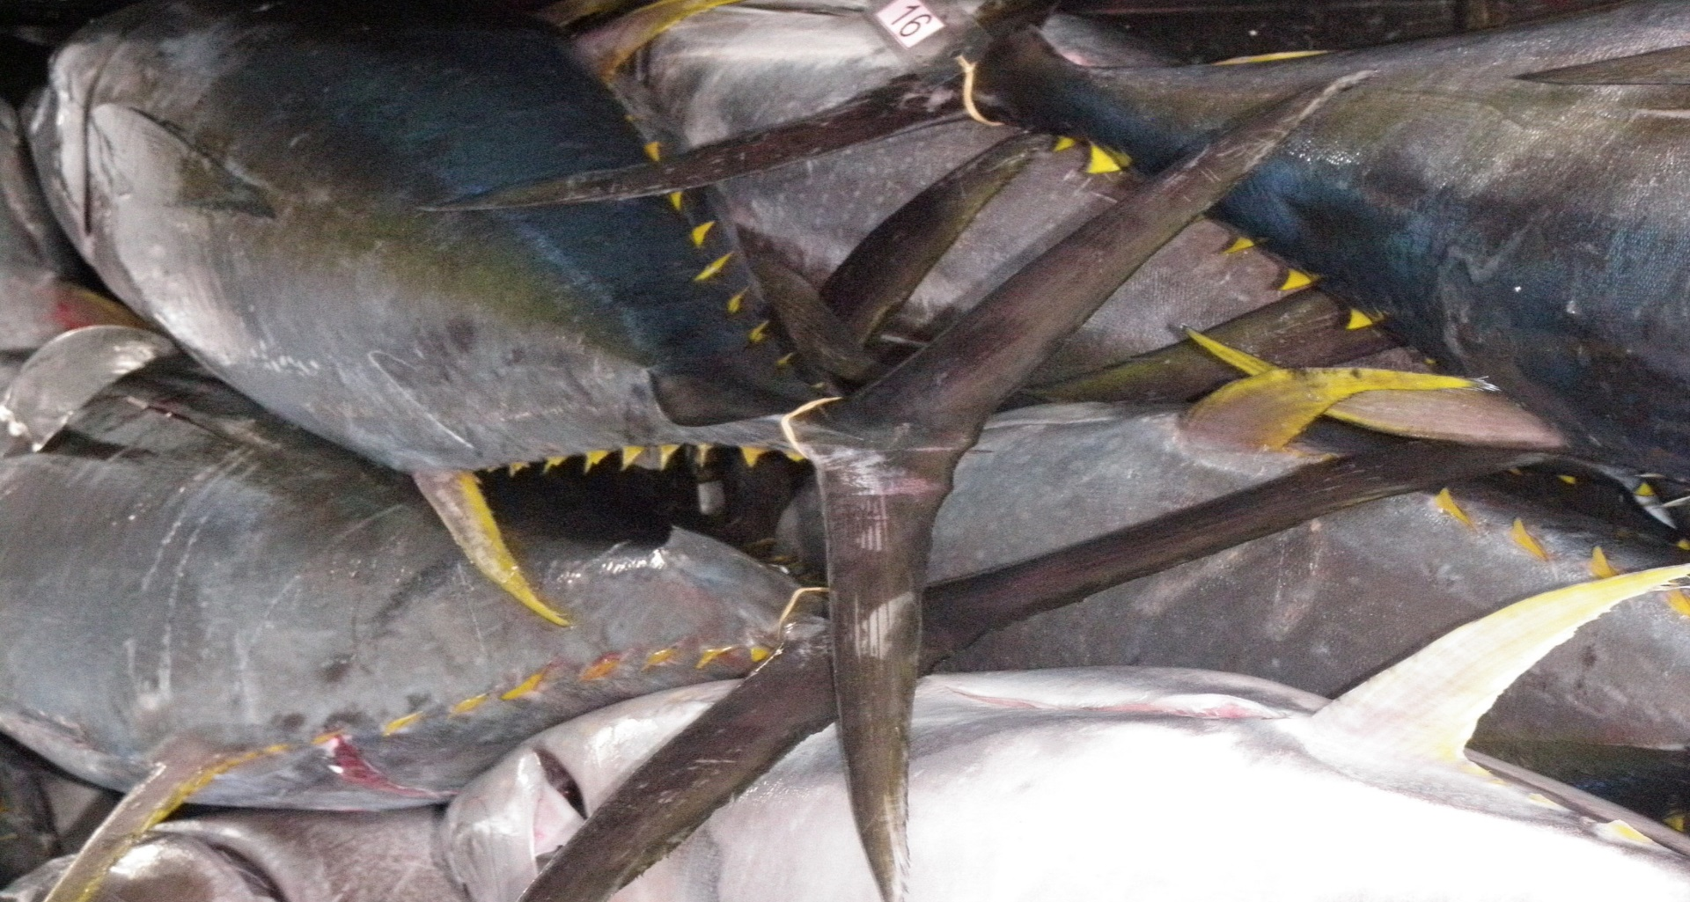
History
THE SOUTH WEST INDIAN OCEAN FISHERIES FRAMEWORK AGREEMENT
Since its establishment, misconceptions have existed of the South West Indian Ocean Fisheries Commission (SWIOFC). At its first session, one member sought a Compliance Committee, only possible if members can make mandatory decisions. In part, this may be traced to differing expectations during the negotiation of the SWIOFC from 2000 to 2005. Some parties wished it to be a binding fisheries instrument and others were concerned over the impact of such instrument over their freedom to manage resources within their Exclusive Economic Zone (EEZ) in the way that they wished to.
SWIOFC is an FAO Article VI regional fisheries body (RFB). It is advisory and largely acts on soft peer-pressure. Members cannot bind themselves in a decision. The small Commission Secretariat is supported by FAO with part-time technical and administrative contributions. FAO provides for a session of the Commission and of its Scientific Committee once every two years, in the FAO language of the members – English and French. Members fund their own attendance to sessions and subsidiary meetings, and contribute in kind by hosting the sessions on a voluntary and rotational basis.
The Commission has succeeded largely through the strong support of its members, partners and other collaborative projects such as Sida, SWIOFP, EAF-Nansen, SWIOFish1, WWF, WB and IOC. Partners and projects supported the attendance of the members to the meetings and funded the cost of SWIOFC’s working parties. The SWIOFC had a performance evaluation in 2012. The evaluation showed its achievements (high attendance and participation, high-level fisheries forum for facilitating collaboration and cooperation) as well as its limitations (lack of resources, need to re-enforce the Secretariat, lack of MCS promotion, inability to promote significant capacity building). Members had a strong sense of ownership and wished to locate the Secretariat in a member country instead of at the FAO Subregional Office in Zimbabwe.
In 2015 through its Working Party on Collaboration and Cooperation in Tuna Fisheries (WPCTF), the Commission received two proposals for arrangements/agreements from AU-IBAR/WWF, and from the newly launched SWIOFish1 project. The Commission faced difficulty with two proposals advocating different trajectories. It passed these back to the WPCCTF and its Task Force which was at the time developing minimum terms and conditions (MTC) for foreign fishing access in the SWIO region, to be harmonised.
Convergence of two proposals
Common elements of the two proposals were consolidated and linked to the ongoing MTC process.The resulting proposal had some preliminary text for a binding subsidiary arrangement on coordination and cooperation of shared stocks and fisheries of common interest. It needed to be lodged institutionally. Four
options were proposed : within the SWIOFC; within SWIOFC developed into an FAO Article XIV body, as an agreement outside the UN system, or through revival of the defunct Western Indian Ocean Tuna Organization (WIOTO).
Apart from the unrealistic WIOTO option, the WPCCTF was unable to decide on the three remaining options because of the obligations and consequences involved. It requested further information from the Task Force and partners on: financial implications; option details; analysis of costs against benefits; a reviewed agreement text and; a road map before it would be able to make substantive recommendations to the Commission.
Table 1 Summary of SWIO aggregated landed value of tuna fisheries (mean annual for 2007-2016 in million USD)

Tuna fisheries | SWIO | DWFF | Entire  SWIO
Industrial purse seine | 143.3 | 440.7 | 584.0
Industrial longline | 86.9 | 639.5 | 726.4
Semi-industrial longline | 1.1 | 283.5 | 284.6
Coastal / Artisanal fisheries | 442.3 |  | 442.3
Total | 674 | 1364ª | 2037
SWIO catch excluding coastal and artisanal fisheries |  |  | 231.3^{b}
Percent stake of SWIO states in value of industrial fisheries (^{b}/ª) |  |  | 17%
Potential licence revenue (10% of ^{b}) |  |  | 23.1
A thorough analysis of the institutional context was undertaken and legal text for an agreement as a possible first negotiating text was produced. Significant information and perspectives on the institutional arrangement and structure was provided, as well as a budget of a possible secretariat that would implement an agreement.
Since the region is mostly composed of developing countries with scarce resources and numerous regional membership costs, it would be difficult to proceed with a new arrangement unless the likely benefits were very clear.
A subsequent cost benefit analysis, examined the catch of tuna by purse seine, industrial and semi-industrial longline, and coastal/artisanal fisheries in the Western Indian Ocean (WIO) and more particularly the southwest Indian Ocean (SWIO) region. From IOTC data, the catches and their weighted landed first market value (from market sources such as Infopeche etc) averaged over 10 years (2007-2016), were enumerated.
The analysis looked at licence revenue obtained by those SWIO countries that allow foreign fishing by purse seiners, industrial and semi-industrial longliners. It used transparent and well-publicised information from the EU Fisheries Partnership Agreement (FPA) as well as information for Distant Water Fishing Nations (DWFNs) under bilateral or private agreements (both non-transparent) using their nominal vessel catch rates as obtained from IOTC.
The analysis proposed a business model to maximise the profitability and sustainability of shared tuna resources, looked at a preliminary and operative phase, conceived and costed an establishment of technical and administrative staff. It also examined financing, projected budget and benefits over 5 and 15 years.
Example of an existing FFA – the Forum Fisheries Agency
In their reviews and analyses, the authors of the previous mentioned documents considered the South Pacific Forum Fisheries Agency (SP-FFA) as a model for a South West Indian Ocean Fisheries Framework Agreement (SWIO-FFA).

SP-FFA was established 40 years ago under a Convention signed by Pacific Island countries (including Australia and New Zealand) to help sustainably manage their fishery resources within their Exclusive Economic Zones (EEZs). SP-FFA is an advisory body providing expertise, technical assistance and other support to its members who make sovereign decisions about their tuna resources while also participating in regional decision-making on tuna management through agencies such as the Western and Central Pacific Fisheries Commission (WCPFC).

SP-FFA has ensured through regional cooperation that all Pacific countries benefit significantly from licencing the sustainable use of tuna – worth over $3 billion a year – important for many people’s livelihoods in the Pacific. With approximately 80 staff and a business-orientated approach, SP-FFA’s focus is on:

- Fisheries management – providing policy and legal frameworks for the sustainable management of tuna
- Fisheries development – developing the capacity of members to sustainably harvest, process and market tuna to create livelihoods
- Fisheries operations – supporting monitoring, control and surveillance of fisheries as well as treaty administration, information technology and vessel registration and monitoring.
- Corporate services - supporting the organisation's work through administration, human resources, budgeting and other corporate functions.

Its governance, administrative and financial management are autonomous and follow international best practice. Since its formation it has achieved consistent organisational growth albeit dependent on external financial support from Australia, New Zealand and partner NGOs.
SP-FFA assisted the establishment of the Parties to the Nauru Agreement (PNA), an arrangement between 8 Pacific States that together control about 80% of the total purse catch of the region. The other 9 Pacific States share the remaining 20% and continue to pursue their economic interest and development of their offshore fisheries through the SP-FFA.
What an agreement could give to the SWIO
Modelled largely on SP-FFA, a SWIO-based arrangement would look at possibly including other existing regional programmes (e.g. RFSP) and be largely financed by cost-recovery, including innovative financing through sustainability labels, to retain membership fees at a minimum.
It would cater for the needs of foreign-licencing (Comoros, France, Kenya, Madagascar, Mauritius, Mozambique, Seychelles and Tanzania) and non-licencing countries ( Maldives, Somalia, South Africa, Yemen) in a cooperative technical assistance model.
The cost-benefit analysis showed that from recoveries of licencing alone, there could be an increase of $21-26 million annually to SWIO coastal states from the concerted regional approach of an agreement.
The proposed business model aims at maximising profitability and sustainability of tuna wealth. Its mission is conservation of tuna resources along with the maximisation of sustainable financial and economic benefits for its members. Distinct from IOTC, which is focused on the scientific aspects of stocks management, the business model puts heavy emphasis on the socioeconomic factors of fisheries management and development. The model proposed is significantly smaller than SP-FFA and calculated to cost $6 per tonne of tuna caught against $25 for SP-FFA because of a much smaller proposed staff and infrastructure.
It has a proposed budget, financial projection and estimate of the enhancement of the financial and economic impacts of the agreement based on value-adding as opposed to increasing the catch. These are somewhat constrained by a lack of consistent national data but indicate, nevertheless, significant economic benefits that could accrue to an SWIO-FFA even in the first 5 years. From information on status and value of tuna fisheries in the SWIO region projections of the benefits that could be derived such an arrangement were made. Over 15 years, starting with an overall annual existing estimated benefit of $30 million, these could be increased to $143 million through smart licencing, domestication of foreign fleets, sustainable management and modernisation of the semi-industrial longline fisheries, elimination of discards, greater utilization of bycatch and improvement of coastal and artisanal tuna value chains. All SWIO states would benefit from such an arrangement based on their differing geo-economic features, development needs and aspirations.
This contrasts to a proposed flat fee of $10,000 annually per SWIO-FFA Party, $900k to S1.5 million for a secretariat annually in the early phase of operationalising the arrangement and $3.0 million after 5 years when it is fully operational. Significant benefits would accrue not only to licencing countries, but also those with large coastal fisheries (Maldives and Yemen), or intending to further develop their tuna fisheries (most if not all SWIO coastal states) from the information, technical and legal advice, regulatory support, intelligence, innovation and common voice of such an arrangement.
A proposed agreement takes shape
The current orientation of a negotiating text is presented below:
Institutional context:
The arrangement is expected to be outside of the FAO because it will be difficult for FAO to support negotiation of another Article XIV body dealing with tuna because of the management mandate of the Indian Ocean Tuna Commission (IOTC). Also, FAO advised that SWIOFC could not be host to a binding agreement. An independent advisory intergovernmental agency along the line of SP-FFA or an agreement with binding CMMs like SIOFA was proposed.
Table 2. Loss of tuna longliner licence fees due to lack of regional information, cooperation and transparency
Particulars | Unit | Value
Ex-vessel weighted mean price of longline caught tuna | USD/ tonne | 5131
Usual monthly access fee | USD | 2500
Potential fishing period | days | 20
Mean catch per fishing day | tonnes | 1.26
Potential catch per month | tonnes | 25.2
Catch value | USD | 129301
Potential licence fee/month | USD | 12930
Foregone licence revenue per vessel per month | USD | 10430

Preamble:
The parties intend to maximise economic and social benefits from fisheries of common interest and jointly commit themselves to long term sustainable use. Copious references are made to legally binding and voluntary international and regional instruments to which the parties adhere.
Scope/Application:
The scope has differed along the deliberation process. Initially marine resources within national jurisdiction, it was placed legally to fisheries, persons and fishing vessels under national jurisdiction and nationals (persons and vessels) fishing beyond national jurisdiction. In an advisory FFA context, this is proposed to extend to tuna in the EEZ and high seas of the SWIO. The possibility has also been left open for providing services to other shared fisheries, later.
States/Parties/membership:
Originally considering only seven foreign licencing SWIO countries, it was gradually extended to all SWIOFC members. France and South Africa are considered analogous to the important role that Australia and New Zealand play in technical, surveillance and financial support of the SP-FFA.
Objectives:
Objectives have been adapted along the way. Initially to harmonise development and management of common fisheries, provide a framework, enhance members influence and decision-making in IOTC, SIOFA and SWIOFC, stimulate the economy, and promote awareness of responsible fisheries the legal text now emphasises primarily coordination and cooperation among the members along much the same objectives adding harmonisation of national fisheries policy and legislation. Later suggestions place emphasis on accelerating development of the inshore and offshore tuna fishing industry of members, and strengthening their ability to get better deals from DWFN and multinationals across the tuna value chain.
International legal instruments and Conservation, Management measures:
Detailed legal text is included to spell out protection of the sovereignty of Parties, and ensure the strength and compatibility of CMMs under a binding agreement.
Cooperation with other bodies:
From early general text, the proposed agreement now goes into the detail of how parties coordinate and cooperate between themselves, other states, RFBs and RECs. Among other things, it includes the ability to produce binding Minimum Terms and Conditions (MTCs) for foreign fishing access, trade, investment, and technical assistance.
Internal arrangements/ meetings of parties /decisions:
SWIOFC would co-exist with the new instrument. Provision is made for an annual Meeting of Parties and extraordinary meetings with organisation to be made by SWIOFC under a Service Agreement or back to back, if practicable. Decisions are primarily by consensus. Decision other than on matters of substance {with decision of whether a matter is of substance treated as a matter of substance}, is by a simple or 2/3 majority. The Agreement shall have its own Rules of Procedures, Financial Regulations and Budget approved by the Parties as of its First Meeting.
Functions of the meetings of Parties:
The binding agreement text has elaborate inclusion of the functions of the Meetings of Parties, giving it significant power and responsibility.
Reservations, Amendment, Withdrawal, Termination, Depository:
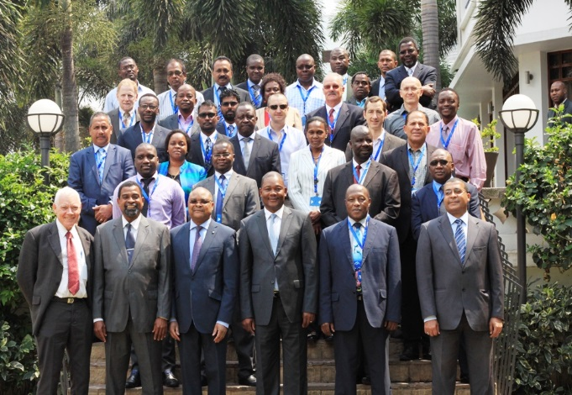
Administrative arrangements for Reservations, Amendments, Withdrawal, Termination and Depository are included. The text binding agreement text does not allow any reservations or exceptions.
Fig 1. The tenth anniversary of the SWIOFC, Maputo, October 2015
Dispute settlement:
Dispute settlement is by peaceful means of negotiation and conciliation. However, the text also provides for a graduated process, separating technical disputes (resolved through an adhoc technical panel) from differences in interpretation of the agreement or of other disagreements that eventually would be submitted to a judicial panel for a binding decision based on UNCLOS or the Fish Stocks agreement.
Signature, Ratification, Acceptance, Approval, Accession, Entry into force:
Depending of the requirement of SWIOFC countries, there can be a formal ratification process with the agreement coming into force 60 days after the third ratification. In the situation of an advisory framework agreement, there would be signing of the agreement without ratification (like SP-FFA).
Conclusion
Through discussions over several years, SWIOFC members have been examining options for a broader response to their needs. SWIOFC was unable to respond to their requirement for a binding protocol for Minimum Terms and Conditions (MTC) for foreign-fishing access. The difficulty has arisen from differing requirements of members and the extent of information at their disposal.
The need for a collaborative focus of SWIO States on tuna was evidenced by the establishment of the WPCCTF. This has been, to all accounts, a most successful subsidiary structure that has galvanised SWIOFC members’ positions within the IOTC, assisted their adherence to CMMs and IOTC reporting obligations, spawned the Maputo and Zanzibar declarations, and developed guidelines of MTCs for foreign fishing access – soon to be adopted. The WPCCTF has been the launch-pad for a new arrangement.
A process of ensuring that all SWIOFC members are involved and onboard has taken place. There are clear orientations for the instrument, a negotiating text and ample evidence that such a cooperation agreement could provide benefits way surpassing Party contributions by multiples of 2 – 20. Options have been examined for the process of establishment, the size and nature of the secretariat over the short and possible long-term periods, the membership, with enough information for each country to have a fair indication of its benefits. There are funding partners and other interests ready to support the process towards an agreement. It remains for members to decide to start the process of negotiation.
The members of SWIOFC will be meeting at the 10th Session in Maldives. Will they have the foresight to take a crucial first step and agree to start negotiations towards this new instrument.
Policy Brief
produced by
Aubrey Harris
SWIOFish1 Consultant

This could be also demonstrated to FAO and partners, if members were to provide voluntary contributions as endorsed at the 7th SWIOFC Session, 2015, and in the Zanzibar Declaration of 2014.
In July 2015, following signature of a hosting agreement in November 2014, the SWIOFC Secretariat was relocated to Maputo, Mozambique.
JR Payet 2017. Processing with technical discussions on the framework Agreement for Cooperation on fisheries of common interest for the South West Indian Ocean (SWIO) countries and fisheries accord for share stocks (African Union/WWF) under the common process and driven by SWIOFish1/SWIOFC. Report of January 2017 prepared for SWIOFish1/IOC project funded by the World Bank
J Swan 2017. Legal, Policy, Institutional and budgetary implications of formulating, adopting and implementing a regional fisheries cooperation and coordination agreement by the South West Indian Ocean range states. Report of December 2017 prepared for the SWIO Regional Sustainable Fisheries Project 40001192 of WWF MCO funded by NORAD.
S Sweenarain 2018. Cost-Benefit Analysis and sustainable financing of a Regional Fisheries Framework Agreement for the shared tuna fisheries resources in the South West Indian Ocean Basin. Report of October 2018 to the SWIOFish1/IOC project funded by the World Bank.
The Indian Ocean Commission’s Regional Fisheries Surveillance Programme
Secretariat costs were estimated for a slim Secretariat like the SIOFA model, and for a more comprehensive technical team. The Secretariat would develop strategic plans, work programs and donor funding initiatives immediately on set-up. The members would unlikely be able to set-up the Secretariat, even after agreeing to and paying contributions. There will clearly be need of the support of partner/s through the negotiation process and establishment of a Secretariat.
The data and information presented in this Policy Brief are sourced from the three documents referred to. It was not a requirement of this consultancy to verify the data and information in these documents. Several minor errors were encountered in the cost-benefit analysis but none were indicative of any fundamental problem with the data which was said to be from the IOTC database, or of its summation, analysis and reporting.

