


Building Regional Resilience through Strengthened Meteorological, Hydrological and Climate Services in the Indian Ocean Commission Member Countries (Hydromet Project)
Annex 3 Economic Assessment
March 2020

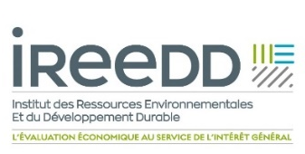
AFD/DOE/CLI-DCP-2017-060
Contract #: CZZ2152-MS-2019-03



This technical assistance operation is financed by the Agence Française de Développement (AFD) as part of the Adapt'Action Facility. This Facility, launched in May 2017, supports African countries, LDCs and SIDS in the implementation of their commitments under the Paris Climate Agreement, through the financing of studies, capacity-building and technical assistance, particularly in the adaptation sector. The authors assume full responsibility for the content of this document. The opinions expressed do not necessarily reflect those of AFD or its partners.
TABLE of CONTENTS
Acronyms and abbreviations iv
Introduction 1
Chapter 1 Economic Analysis 2
1.1 Methodology Approach 2
1.2 Climate Services Provided by the Project and Associated Benefits 2
1.2.1 Disaster risk reduction through Early Warning Systems 3
1.2.2 Agriculture and Food Security 5
1.2.3 Other sectors 6
1.2.4 SWIO-RAFI Initiative 6
1.2.5 Benefits retained for the Cost-Benefit Analysis 9
1.3 Madagascar: Climate Risks and Socio-Economic Profile 9
1.3.1 Agriculture and Food Security 10
1.3.2 Water Supply Sector 11
1.3.3 EWS Benefits 12
1.3.4 Expected benefits of agri-sector climate services 14
1.4 Union of the Comoros: Socio-economic profile and climate risk 15
1.4.1 Agriculture and Food Security 16
1.4.2 Fisheries Sector 17
1.4.3 EWS Benefits 18
1.4.4 Expected benefits of agri-climatic services 21
1.5 Seychelles: Climate Risks and Socio-Economic Profile 23
1.5.1 Tourism sector 23
1.5.2 Agriculture and fisheries sector 24
1.5.3 EWS Benefits 26
1.5.4 Expected benefits of agri-climatic services 29
1.6 Mauritius: Climate Risks and Socio-Economic Profile 30
1.6.1 Tourism sector 31
1.6.2 Agriculture sector 31
1.6.3 EWS Benefits 32
1.6.4 Expected benefits of agri-climatic services 35
1.7 Costs of the Hydromet Project 36
1.7.1 Investment Costs 36
1.7.2 Operating Expenses 36
1.7.3 Total Cost by State 36
1.8 Cost Benefit Analysis and Results 37
1.8.1 Assumptions of the economic calculation 37
1.8.2 Sensitivity Analysis 38
Chapter 2 Business model 40
2.1 Value-Chain, service delivery and value generation 40
2.1.1 Service production 40
2.1.2 Users and value generation 41
2.1.3 Public services users 41
2.1.4 Private sector and potential clients for hydro-meteorological services 41
2.2 The impact of the Hydromet project on the budget of NMHS 42
2.3 Conclusion 45
Annex 1 Economic assessment of the benefits 46
Annex 2 Key Resources 49

Acronyms and abbreviations
AAB Average Annual Benefits
AAL Average Annual Losses
CBA Cost-Benefit Analysis
DRR Disaster Risk Reduction
EWS Early Warning System
GFCS Global Framework for Climate Services
IOC Indian Ocean Commission
NMHS National meteorological and climatological services
NPV Net Present Value
NTC Non-Tropical Cyclone
SWIFO-RAFI Southwest Indian Ocean Risk Assessment Financing Initiative
TP Tropical Cyclone

Introduction
The Hydromet project development objective is to strengthen the regional and national communities’ resilience and adaptive capacity to climate change impacts by improving the National Meteorological and hydrological services.
Improved climate data and early-warning systems supplied by the Hydromet project to the island states will help to support a better planning in view of adapting to climate change events in the region. Availability of such data will allow local governments to take necessary adaptation decisions, in different areas but particularly in urban planning, economic sectors (tourism, agriculture, industries), and social sectors, thereby assisting highly vulnerable communities with some 28,8 million people who are exposed in the IOC island states. Main benefits of the project include improved hydro-meteorological equipment’s, knowledge, and decision-making process, improved infrastructure planning, improved adaptive capacity of communities and reduced socio-economic losses.
The following economic analysis compares cost of the project with part of the benefits, the ones that we have been able to quantify and monetized, based on reliable data. Of course, the hydromet project present larger benefits for the four countries, but these benefits could not be monetized because of the lack of reliable data. These benefits will be described in sections below.
The objective was to assess the economic benefit of the project using a cost-benefit analysis.
Methodological approach and assumptions are discussed in section 1.1. Climate services and benefits from Hydromet presented in section 1.2. After a short description of each country risk profile and benefit from the project assessed in section 1.3 to section 1.6, costs of the project are detailed in section 7 and results presented in section 1.8. Sensitivity is analysed in section 1.9.
Based on SWIO-RAFI risk disaster analysis, in which the population affected by all hazards has been estimated at 14.4 million people and the physical damages related resulting from climate related events has been estimated at USD 13.4 billion, the Annual Average Benefits attached an EWS in terms of costs avoided has been assessed to be around USD 14 million for the entire IOC region.
On the other hand, using data from the FAO and relying on assumption from academic experience, the Annual Average Benefit from agro-climate services have been estimated at USD 29,93 million per year for the period 2026-2030 to up to 89,8 million per year for the period 2041 to 2070, for the four countries.
The NPV of the project is estimated at USD 956 Million at 5% discounting rate. Sensitivity analysis shows that NPV is still positive (USD 643 Million) even if benefits assess are 30% lower than expected. From an economic point of view, investing in the Hydromet project is worthwhile.

Chapter 1 Economic Analysis

Methodology Approach
The methodological approach adopted for the economic analysis of the Hydromet project is based on a cost-benefit analysis (CBA) of the investments needed to provide enhanced weather and climates services. The expected benefits of the project are compared with the project costs over a 50-year time horizon. The CBA is the most relevant economic tool for assessing the economic profitability of the Hydromet project but has the limitation of retaining only quantifiable and monetizable benefits.
The investment, operating and equipment renewal costs associated with project components 1, 2, and 3 are detailed in Chapter 5 of the feasibility study.
Section 1.2 presents the services provided by the Hydromet project, the benefits associated with these services and the assumptions used for the monetary valuation of the benefits that could be valued in this study.
Sections 1.3, 1.4, 1.5, and 1.6 present the risk profile of each State and the services provided by the Hydromet Project.
The main cost elements of the project are presented in Section 1.7 - Hydromet Project Costs.
The CBA results are presented in Section 1.8 - Results of the cost-benefit analysis.

Climate Services Provided by the Project and Associated Benefits
The benefits associated with the climate services of the Hydromet project are numerous. The data and information collected by the project will be transformed into services adapted (trends, projections, economic analyses, agro-climatic advice, community services, etc.) to the economic sectors and end users. Climate services will be addressed to the priority areas recommended by the Global Framework for Climate Services (GFCS), namely the sectors of:
- disaster risk reduction;
- agriculture and food security;
- energy;
- health; and
- water resources.
Some services, intended for the private sector, may be marketed. There are many examples of agro-climatic services. Other services are more related to the production of public services and, as such, must be provided by the States. By way of illustration, Early Warning Services (EWS) for extreme weather events make it possible to preserve physical damage, injuries, human lives, etc., and it is up to States to set up these services and guarantee free access to them.
The benefits associated with the Hydromet project go beyond this, since they also allow public decision-makers to better integrate adaptation to climate change into their land use planning policies; public decision-makers, with better climate information, can make informed decisions.
The meteorological services provided by the Hydromet project to the 4 IOC States are therefore numerous and will contribute to improving climate change adaptation in all economic sectors. However, it was not planned in this study to quantify all the benefits of the project, but to focus on two sectors of activity per country, according to the following two criteria:
- The economic and social weight of the sector measured by its contribution to GDP and employment; and
- The national priority that each state gives to economic sectors.
The aggregate data collected as part of the consultation missions made it possible to quantify and monetise the associated benefits of the Hydromet Project in terms of:
- The establishment of an Early Warning Service (EWS) in each State to reduce the costs associated with losses caused by extreme weather events. The monetary valuation of these costs will be based mainly on the quantitative data provided by the SWIO-RAFI initiative (section 1.2.1 - Disaster Risk Reduction - DRR).
- The development of climate services up to the end user contributing to optimising production yields in economic sectors such as agriculture. The monetary valuation of these benefits based on FAO data and the results of field experiments evaluated in the context of academic work (section 1.2.2 - Agriculture and food security).
In section 1.2.3 - Other potential beneficiary sectors of weather and climate services, we discuss, without counting them, the economic sectors that can benefit from climate services.
The results of the SWIO-RAFI climate risk loss modelling will support the evaluation of part of the benefits of the Hydromet project, the benefits associated with an Early Warning Service (EWS). These results will be discussed in section 1.2.4 - The SWIO-RAFI initiative.
In section 1.2.5 - The benefits retained for the CBA, we present a balance of the quantified benefits that have been included in the cost-benefit analysis.
The reduced scope of quantified benefits associated with the Hydromet project, and the conservative economic assumptions used for the economic analysis, lead to results that can be considered conservative, since they are based on a minimal estimate of the project's benefits.

Disaster risk reduction through Early Warning Systems
Feedback on the establishment of early warning systems (EWS) shows that these systems are effective in extending the lead times for emergency planning and enabling rapid decisions to be made that protect human lives and livelihoods in the short and longer term. In the short term, EWS can be used to secure all or part of the population and to protect certain assets. In the longer term (e.g. a drought forecast of several weeks) they make it possible to anticipate, for example, agricultural planning (by adjusting the crop calendar) or the implementation of health services.
The contribution of an EWS to damage mitigation is well described in the academic literature, highlighting a correlation between preparedness for natural disasters and the effectiveness of mitigation measures.
Schroter et al (2008), on watersheds in Spain and Austria, present results in which they assess a correlation between preparedness and effectiveness of mitigation measures to reduce flash flood damage. Based on a survey of potential users of an EWS, respondents were asked: "Suppose you received an alert shortly before the flood occurred, what percentage could you reduce the damage caused by the floods?". The authors show that when information on the arrival of the flood was available within twelve hours before, it would be possible to reduce the costs of the damage caused by 60%, while for one hour the damage reduction would be 20%.
More recently, B.S.H.H.M. Fakhruddin and L. Schick (2019), evaluate and quantify, based on experience feedback on losses associated with cyclone Evan in 2012 on the island of Samoa, the costs that could have been avoided with an EWS. The authors estimate that 81.45% of the all the losses and damages caused by Cyclone Evan could have been avoided if efficient and strong early warning services had been implemented in Samoa at the time of impact.
The table below lists the benefits associated with an EWS, by impact type.
Type of Impact | Without EWS | With EWS
Natural, Physical and Economic | Damage to homes, loss of property | Damage to homes avoided in some cases and damage to property avoided on time.
Natural, Physical and Economic | Agriculture: crop damage, loss or damage to tools and equipment | Agriculture: crop damage avoided, where possible, by early harvesting. Damage to tools and equipment avoided
Natural, Physical and Economic | Fishing: Damaged fish, fishing infrastructure, nets and other fishing equipment | Fishing: Fish harvesting, removal of nets and equipment (70% reduction in damage)
Natural, Physical and Economic | Livestock: Loss or damage to most poultry, farm animals, fodder and straw | Livestock: Poultry, farm animals, fodder and straw are secured (45% damage reduction)
Natural, Physical and Economic | Offices and schools: Loss of cash, damage to equipment and furniture | Offices and schools: No loss of cash, equipment and protected furniture (15% reduction in damage)
Human | Loss of human life | Losses of human life avoided
Human | Injuries, bodily injuries | Injuries and injuries prevented
Human | Populations exposed to various diseases due to insufficient or non-existent preparation | Diseases prevented through increased preparedness measures
Social | Trauma for affected persons and their relatives | Trauma reduction through anticipation and preparation measures
Source: Bapon S.H.M. Fakhruddin and Lauren Schick, 2019, “Benefits of economic assessment of cyclone early warning systems - A case study on Cyclone Evan in Samoa”, in Progress in Disaster Science
Regardless of the delay variable and the effectiveness of the alert message delivery, our assessment of the benefits of national meteorological and climatological services (NMHSs) for the 4 States will be based on the assumption that the alert system contributes to improving the effectiveness of mitigation measures by reducing the cost of damage that will occur during a natural disaster, but also to anticipating the organization of emergency and relief measures.
We will use the hypothesis of B.S.H.H.M. Fakhruddin and L. Schick (2019), namely 5% of the cost of damage for estimating the monetary valuation of avoided costs on physical damage. This conservative assumption is relied on data from the ‘Samoa Post-Disaster Needs Assessment of the Cyclone Evan event in 2012’ that have been used to assess damage information. The assumption relies on stakeholders’ consultations and interviews.

Agriculture and Food Security
The agricultural sectors and farmers in the 4 states are potential beneficiaries of the climate services provided by the Hydromet project. In Madagascar, the sector contributes directly to nearly 20% of national wealth (GDP) and employs nearly 70% of the population. In Mauritius, although the sector does not account for as much GDP, 2.8%, interviews with the Principal Research Scientist of the Food and Agriculture Research Extension Institute (FARES) confirmed the usefulness and value of agrometeorological services for farmers. In the Comoros, agriculture contributes 30% to GDP and employment 57% of the population. In the Seychelles, agriculture, forestry, and fishing contributes to 2% to the GDP and employment was reported by the world at 4.09% in 2015. Expectations regarding agro-climatic services were expressed in all countries during local consultations.
Agriculture and food security are dependent on weather and climate conditions through extreme events such as droughts and heat waves, floods and storms. Climate-related natural disasters, such as droughts or floods, can wipe out crops, cause food insecurity, destroy key livelihoods, drive many people to migrate and lead to slower economic growth.
Adverse weather and climate conditions have a direct impact on agricultural productivity, livelihoods, water security, land use, agricultural marketing systems, market instability, food prices and economic and trade policies. In addition, smallholder farmers, pastoralists and communities dependent on food crop production are highly vulnerable to these impacts. Extreme events, climate variability and long-term climate change pose significant challenges to agriculture and food security.
The Hydromet project provides an opportunity to integrate climate information into agricultural development by fully integrating climate services into practices and policies that support development choices in agriculture and food security. To achieve this decision-making capacity, States must accelerate the creation of climate services applications to support this integration. This last point is provided for in component 3 of the Hydromet programme.
There are many examples of agrometeorological services and evaluations of expected benefits are the subject of academic work. For example, a pilot study was carried out to assess the economic impact of weather-based agricultural advisory services provided to 15 of the 127 units of the Ministry of Land's Agrometeorological Advisory Service (AAS) in India for 6 seasons (3 summers and 3 winters between 2003 and 2007). The main crops selected for the study included food grains, oilseeds, cash crops, fruit and vegetable crops. The sample included 80 farmers, including 40 farmers benefiting from agro-climatic advisory services and 40 farmers not benefiting from the services. The results obtained show that the farmers benefiting from the services achieved a net profit of +10 to +15% and a 2-5% reduction in the cost of cultivation.
We will use the conservative assumption of a 10% increase in yields to quantify the potential benefits associated with the agro-climatic services that the Hydromet project would provide to the different agricultural sectors of the States.

Other sectors

Health
The health and safety of individuals is closely linked to weather and climate conditions. Extreme weather events such as heat waves, cyclones, floods, and droughts have direct and indirect impacts on people's health. They directly influence the spread of infectious, waterborne or waterborne diseases (diarrhoea, malaria, etc.), and indirectly affect ecosystems essential to the health of populations (water resources, agricultural production). These phenomena are a major challenge in terms of public health and the effectiveness of health care services.
The development of enhanced meteorological services such as in the Hydromet project improves the resilience of the health sector, directly and indirectly by improving the resilience of key public health sectors such as agriculture or water resources management.

Water Resources
Water resources management is closely linked to climate variability and climate change.
Enhanced meteorological services such as those proposed under the Hydromet project provide many benefits in the context of integrated water resources management: improved weather forecasting for all stakeholders in the sector, improved short- and long-term decision-making, improved efficiency in terms of sustainable resource use, disaster risk management, optimization of agricultural production, drinking water supply and sanitation, etc.

Energy Sector
The energy sector is a driving force for economic and social development and a significant part of GDP. Greenhouse gas emission reduction targets are expected to significantly increase the demand for renewable energy, as well as energy efficiency requirements. Renewable energy sources such as solar, wind, hydropower, but also distribution systems and traditional energy sources are very sensitive to extreme weather events.
Access to energy is a major challenge in IOC countries, particularly in Madagascar where only 24% of the population has access to electricity. The establishment of enhanced weather services and an early warning system can address some of the challenges facing the energy sector as the frequency of extreme weather events increases. It will increase the resilience of the sector and support the development of the renewable energy sector, which is particularly sensitive to climate change.

SWIO-RAFI Initiative
The SWIO-RAFI Initiative (South West Indian Ocean Risk Assessment and Financing Initiative, 2017) is a joint initiative of the World Bank Group (WBG), the Indian Ocean Commission (IOC) and the four participating island states, namely Comoros, Madagascar, Mauritius and Seychelles.
The initiative modelled climate risks and assessed the cost of mean annual damage (or mean annual loss) caused by several hazards. We use these studies to estimate the costs of avoidable damage with an early warning system (EWS) and enhanced weather services. To this end, several meetings with key country stakeholders and discussions with the formulation team made it possible to assess how and to what extent an EWS built as part of the Hydromet project contributes to improving the effectiveness of climate change adaptation measures.
For each State, a Risk Profile is associated with an estimate of the Average Annual Losses (AAL) per hazard and return period. The AALs associated with each risk profile are losses resulting from direct physical damage to buildings and infrastructure caused by climatic events. These damages are valued at the cost of restoring or replacing the damaged property, but do not include other losses such as the value of lost production or business interruption i.e. indirect losses.
We will retain these models:
- Losses associated with tropical cyclones (Tropical Cyclone -TC) which include losses caused by wind, flooding due to excessive rainfall, and storms; and
- Losses associated with extra-cyclonic (or Non-Tropical Cyclone flood - NTC) floods caused by flooding due to excessive rainfall.
The total value of exposed assets is estimated at USD 77 billion. These assets consist of physical assets; whose vulnerability depends on the nature of the building materials. The buildings have been grouped by economic sector.
- Residential: individual and collective, apartment, house, etc.
- Commercial: Accommodation (Hotels); businesses (stores, etc.)
- Industrial: General industrial building (e. g. factory)
- Infrastructure: bus stations, rail terminals, airports, seaports, public services, road networks
- Public: health, educational, religious, emergency services, public facilities.
The losses will therefore be much higher in areas where the frames are made of wood than in areas where the frame is made of concrete.
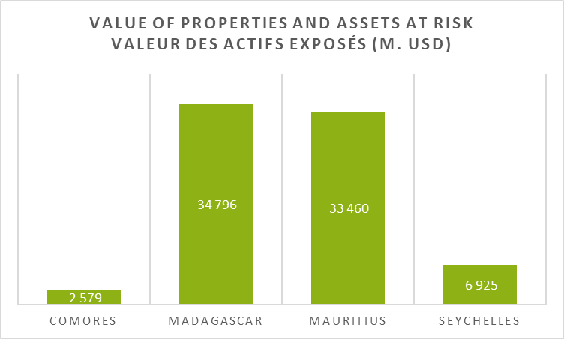
The details of the value of properties and assets at risk by State are shown in the figure below.
Figure 1: Value of properties and assets at risk by states

The Average Annual Losses (AAL), for all countries, all hazards combined and for all return periods, are estimated at USD 251.45 million, divided into USD 222.13 million for ground losses and USD 29.32 million for emergency management costs.
SWIO Island  State or  Territory | Probability of Exceedance | AAL |  | 0,1 |  | 0,04 |  | 0,02 |  | 0,01 |  | 0,004 |  | 0,002
Mean Return Period (years): |  |  |  |  | 10 |  | 25 |  | 50 |  | 100 |  | 250 |  | 500
Damages costs
Comoros | Ground-up Loss (M USD) | 5,62 |  | 9,66 |  | 15,34 |  | 22,06 |  | 52,97 |  | 159,13 |  | 270,57
Comoros | Emergency Loss (M USD) | 0,46 |  | 1,11 |  | 3,53 |  | 5,07 |  | 12,18 |  | 36,60 |  | 62,23
Madagascar | Ground-up Loss (M USD) | 100,59 |  | 255,41 |  | 491,65 |  | 668,02 |  | 928,81 |  | 1296,27 |  | 1910,15
Madagascar | Emergency Loss (M USD) | 23,14 |  | 58,72 |  | 113,07 |  | 154,10 |  | 213,64 |  | 298,64 |  | 440,14
Mauritius | Ground-up Loss (M USD) | 113,12 |  | 160,33 |  | 429,62 |  | 883,37 |  | 2030,47 |  | 3812,42 |  | 5905,76
Mauritius | Emergency Loss (M USD) | 5,16 |  | 14,49 |  | 98,81 |  | 203,18 |  | 467,01 |  | 876,86 |  | 1358,32
Seychelles | Ground-up Loss (M USD) | 2,80 |  | 8,20 |  | 13,35 |  | 18,13 |  | 26,17 |  | 33,49 |  | 39,90
Seychelles | Emergency Loss (M USD) | 0,56 |  | 1,82 |  | 3,07 |  | 4,17 |  | 6,02 |  | 7,70 |  | 9,18
 | Total (USD Million) | 251,45 |  | 509,74 |  | 1168,45 |  | 1958,10 |  | 3737,27 |  | 6521,11 |  | 9996,25
 | Emergency Loss (M USD) | 222,13 |  | 433,60 |  | 949,96 |  | 1591,58 |  | 3038,43 |  | 5301,31 |  | 8126,38
 | Emergency Loss (M USD) | 29,32 |  | 76,14 |  | 218,48 |  | 366,51 |  | 698,85 |  | 1219,80 |  | 1869,87

Reading note: Catastrophe risk models have been developed for the following hazards: tropical cyclone (including wind, storm surge, and precipitation hazards) and non-tropical cyclone flooding. The models have been validated using available reported data on the intensity of the event—wind speed, peak ground acceleration—and reported direct losses. While the catastrophe risk models could be refined further, particularly through an enhanced exposure database, the validation process has shown that the direct losses modelled and those reported were generally consistent patterns.
The probability of exceeding, which is the inverse of the return period, expresses the probability of occurrence of the hazard. For example, the probability of a loss of $1.958 billion occurring is 2%.

Benefits retained for the Cost-Benefit Analysis
Finally, the elements that have been quantified and monetised as well as the assumptions used for the CBA are presented in the table below:
Type of service | Description | Benefit type | Quantifiable data source | Hypothesis Adopted
Public services | EWS | Costs avoided | SWIO-RAFI + Local consultations | 5% of avoided damage (*) to property, and 10% on emergency services
Private services | Marketable agro-climatic services | Improving yields in the agricultural sector | FAO + Academic literature + Consultations | 10% yield gain in agricultural production (**)
Public policies | Adaptation of public strategies and policies | Adaptation to climate change | Not quantified | -
(*) Source: Bapon S.H.M. Fakhruddin and Lauren Schick, 2019, “Benefits of economic assessment of cyclone early warning systems - A case study on Cyclone Evan in Samoa”, in Progress in Disaster Science
(**) Source: S. Mittal, V. K. Hariharan, 2018, “Mobile-based climate services impact on farmers risk management ability in India”, Climate Risk Management, Volume 22, 2018, Pages 42-51

Madagascar: Climate Risks and Socio-Economic Profile
Overview of the country's economy
Population (2017); (of which 69% live in rural areas) | 25,5 million
Economic growth (2017) | 4,2 %
Inflation (2017) | 8,3%
GDP, USD 2017 | 11 465 million
Agriculture, (% GDP 2017) | 19.9%
Industries (% GDP 2017) | 22.5%
Services (% GDP 2017) | 44.1%
Employment in the Agricultural Sector, (% of GDP 2017) | 68.4%
Employment in the Industrial Sector, (% of GDP 2017) | 7.3%
Employment in the Services Sector, (% of GDP 2017) | 24.3%
GINI index (World bank estimate, 2012) | 42.6
Source: World Bank 2017, World development indicators and Madagascar Systematic Country Diagnostic
Madagascar is the fourth largest island in the world and is home to a diverse range of unique species and ecosystems that are highly vulnerable to current and future climate regimes. The country has one of the highest poverty rates in Africa, with 81 per cent of the population living on less than $1.25 a day.
The tertiary sector has been the main driver of economic growth since 2015, particularly services. In this sector, trade is dynamic with an increase of 4.1% in 2017, which should continue in 2018 to reach 4.5%.
Among the other driving sectors of the Malagasy economy, industry, which contributes 22.5% of the country's wealth, and agriculture (mainly rainfed), fisheries and livestock, which are based on natural resources and are very sensitive to climate change.
The economic dynamic over the last few years has been positive. Economic growth rose from 2.3% in 2013 to 4.2% in 2017, with the services sector as the main driver.
The two sectors of the Malagasy economy that have been selected for focus because of the vulnerability of the potential beneficiaries of these sectors are: i) the agriculture sector, mainly because of its impact in terms of food security (cf. section 1.3.1 - The Agriculture Sector); and ii) the drinking water sector because only 20% of the population has access to piped network water and 50% of the population has access to safe water (cf. Section 1.3.2 - The Water Supply Sector). For these two sectors, we present the issues in the sections below.

Agriculture and Food Security
Climate Change Impacts
In Madagascar, the 2014 and 2015 cyclones devastated more than 40,000 hectares of rice fields, destroyed two water reservoirs and carried large volumes of sediment into the fields. Houses, schools and clinics were damaged or destroyed and the few paved roads in the region were nothing more than a succession of gaping holes. Most of the trails have become impassable and dangerous. Crop losses resulted in an immediate increase in inflation, which reached 7.9% in March 2015, up from an average of 6% in 2014.
According to the World Bank report, Madagascar's climatic conditions are both an opportunity and a risk to the performance of the agricultural sector. On the one hand, the country's unique climate has favoured the development of certain cash crops such as vanilla, cloves and other spices. The significant increase in vanilla prices boosted export revenues in 2017, allowing the Central Bank to accumulate more foreign exchange reserves than expected. On the other hand, the severe drought of 2017, combined with cyclones, reduced the supply of locally produced rice by about 20%, and contributed to a contraction of about 6.6% in the agricultural sector in 2017.
Agricultural Sector
In Madagascar, nearly 80% of the population is engaged in agricultural activities. Between 2014 and 2017, the agricultural sector contracted by an average of 0.8% per year. This is due, among other factors, to low agricultural productivity, due to insufficient use of modern technology, lack of connectivity between markets, to facilitate the transport of goods and highly fluctuating weather conditions. Apart from agricultural work, rural households have few alternative activities that can generate sufficient income to mitigate the impact of crop failures and weather shocks.
Malagasy agriculture
Malagasy agriculture is characterized by a predominance of small farms. 70% of farmers have an annual cultivated area of less than 1.5 ha. Agriculture is also the main source of employment at the national level, employing nearly 85% of the working population. Agricultural techniques are traditional cultivation, breeding and processing techniques. Overall, the productivity of the agricultural sector therefore remains low and the country regularly experiences serious food crises.
Agriculture is also a family agriculture, essentially oriented towards production for self-consumption, since about 75% of the food production of rural households is self-consumed. Thus, family farms produce primarily for their own consumption, and the production strategies developed by heads of household aim to ensure that food needs are met, which is often considered to be a limit or even a brake on economic growth.
The agricultural sector has been selected as a risk sector because of its importance in terms of food security. With 25% of the rural population in food insecurity, the subject is a national concern and priority for the Malagasy government. In addition, over the past 20 years, Madagascar has been hit by 35 cyclones, 8 floods and 5 periods of severe droughts (three times more than in the past 20 years), causing damage estimated at nearly $1 billion ‘(USAID, 2016) and affecting food security, drinking water supply and irrigation, public health systems, environmental management and quality of life.
The table below puts climate risks and their potential impacts in the agricultural sector into perspective.
Climate Consequences and Impacts on Agricultural Production
Climate Change Consequences | Potential Impacts
- Temperature increase | - Crop destruction and lower yields
- Increased rainfall during the rainy season | - Higher evapotranspiration rate; reduced soil moisture rate and soil degradation
- Increased rainfall during the rainy season | - Increased irrigation needs, especially for rice cultivation
- Reduction of rainfall during the dry season - worsening of the drought period | - Increased health risks and diseases
 | - Increased sedimentation, erosion and siltation; increased risks on the plains
 | Increased livestock mortality
- Increase in cyclonic intensity | - Destruction of agricultural production and public infrastructure and disruption of supply chains

Potential direct beneficiaries of the project: About 2.5 million farms (including 99% of family farms - households - that farm more than 95% of the cultivated land) and own more than 97% of the livestock.⁹
Potential indirect beneficiaries of the project: Farmers' families, almost 80% of the population living in rural areas, representing approximately 20 million inhabitants. Benefits in terms of food security insurance for households consuming agricultural products.

Water Supply Sector
According to UNICEF Madagascar, limited access to safe drinking water and poor sanitation and hygiene practices are responsible for chronic malnutrition and diarrhoea among children under five. Only 45% of the population has access to drinking water, 20% to running water and 50% to safe water. Surface water (rivers) and rainfall are the main sources of water for agricultural use, but also for household consumption.
Climate variability will have a significant impact on water resources. Reduced rainfall and rising temperatures will exacerbate shortages and increase the demand for irrigation water. Poor management of water infrastructure and increasing demand for drinking water should contribute to the increased vulnerability of people and sectors dependent on water.
The table below puts climate risks and their potential impacts in the water sector into perspective.

Climate Change Consequences and Potential Impacts on water resources
Climate Change consequence | Potential impacts
- Increased temperatures  - Reduced rainfall and increased drought conditions  - Increased intensity of cyclones | - Reduction of key water points; draining of swamps and rivers during the dry season  - Reduced river flows, resulting in reduced access to water supplies for drinking, sanitation and energy generation, and reduced water quality  - Cyclone-induced destruction of water infrastructure and flood induced water quality reductions due to increased sedimentation

Potential beneficiaries of the project: 55% of the population without access to drinking water. This population, which takes directly from the environment, is extremely vulnerable to water quality, which is very quickly polluted during extreme events. Cases of disease spread are very frequent during the occurrence of extreme events. Access to an EWS makes it possible to anticipate and prepare for relief operations and the provision of drinking water.
Potential indirect beneficiaries: Subject to a policy of developing access to drinking water in Madagascar, the whole population through better management of water resources.

EWS Benefits
Beyond these two economic sectors presented above, all other economic sectors are affected by the hazards of climate change. Estimates of Average Annual losses (AAL) resulting from climate hazards for Madagascar are presented in the figure below, by exposure sector and by hazard.
- The AALs associated with tropical cyclones (TCs), including associated rainfall and marine submersions, are estimated at USD 87.14 million and represent the major part of the risks incurred in Madagascar (85.6% of total estimated losses);
- AALs associated with extra-cyclonic floods, or Non-Tropical Cyclone (NTC), are estimated at USD 13.45 million, and represent 13.2% of the estimated damage in Madagascar.
Figure 2 : Distribution of Average Annual Losses (AAL) in Madagascar by sector (left) and by hazard (right)

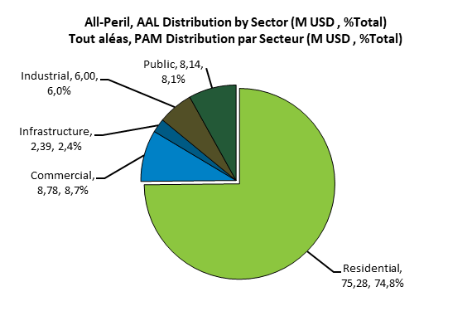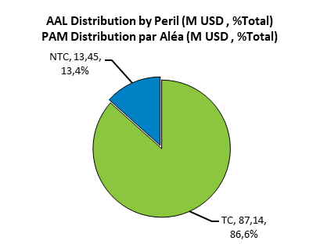
Source: SWIO-RAFI, 2017
The damage caused by the various hazards is mainly in the residential sector, mainly due to the precariousness of traditional habitats. According to the UN HABITAT III report¹¹, the proportion of the urban population living in slums is estimated at 72%. This proportion varies from city to city. In Antananarivo, informal settlements reach 60% to 70% of construction. In coastal secondary cities, such as Manakara, 75% of the houses built are mostly of the traditional type and not very decent (2007). Then in Moramanga, nearly 65% of households live in precarious and unstructured housing.
The geographical distribution of mean annual losses is shown in the figure below:
Figure 3 : Geographical distribution of physical losses due to climatic hazards, Madagascar
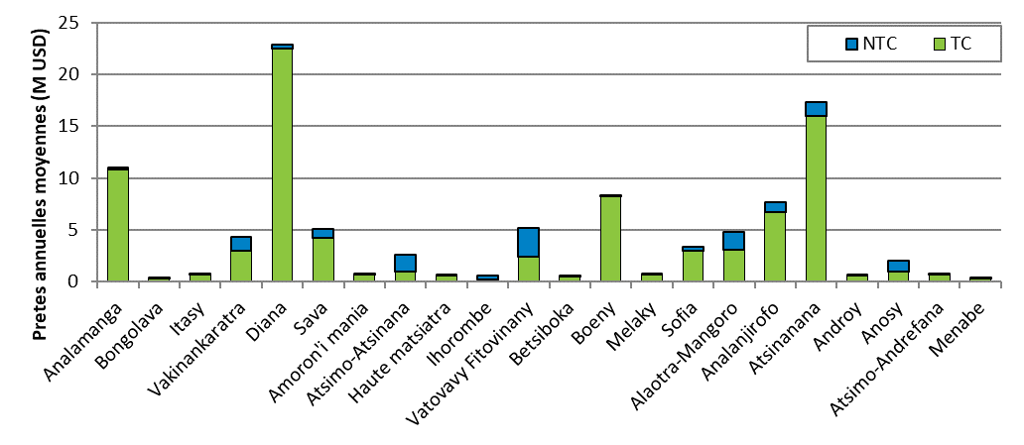
Source: SWIO-RAFI, 2017
The highest losses, all hazards combined, are in the Diana area, in the north of the island, for about 30% of the AAL, followed by Atsinanana in the east. The most affected sectors are the residential sector, followed by trade and industry.
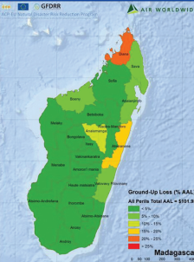
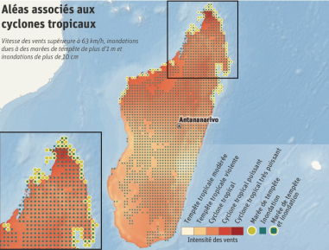
Figure 4 : Ground up losses due to climatic hazards, Madagascar
Source: SWIO-RAFI, 2017

The table below shows the mean annual losses, by climatic hazard and return period for Madagascar.
Probability of Exceedance: | AAL (PAM) | 0.1 | 0.04 | 0.02 | 0.01 | 0.004 | 0.002
Return period (year): | AAL (PAM) | 10 | 25 | 50 | 100 | 250 | 500
Risk Profile: All Modelled Hazards
Physical Loss (M USD) | 100.6 | 255.4 | 491.7 | 668.0 | 928.8 | 1,296.3 | 1,910.2
(% Total Exposure Value) | 0.3% | 0.7% | 1.4% | 1.9% | 2.7% | 3.7% | 5.5%
Urgent Costs (M USD) | 23.1 | 58.7 | 113.1 | 154.1 | 213.6 | 298.6 | 440.1
Hazard: Tropical Cyclone (TC)
Physical Loss (M USD) | 87.1 | 224.0 | 433.0 | 585.0 | 813.0 | 1,150.0 | 1 740.0
(% Total Exposure Value) | 0.3% | 0.6% | 1.2% | 1.7% | 2.3% | 3.3% | 5.0%
Urgent Costs (M USD) | 20.0 | 51.5 | 99.6 | 135.0 | 187.0 | 265.0 | 401.0
Hazard: Extra-cyclonic flooding (NTC Flood)
Physical Loss (M USD) | 13.4 | 31.4 | 58.7 | 83.0 | 115.8 | 146.3 | 170.2
(% Total Exposure Value) | <0.1% | <0.1% | 0.2% | 0.2% | 0.3% | 0.4% | 0.5%
Urgent Costs (M USD) | 3.1 | 7.2 | 13.5 | 19.1 | 26.6 | 33.6 | 39.1
Madagascar suffers on average, each year, a loss of nearly 100 million USD, all hazards combined. In addition to these losses, there are expenses incurred for emergency measures of nearly USD 23 million. But losses can be much higher. 87% of these losses are caused by tropical cyclones, and the rest by floods. But the losses could be much higher. For example, a 100-year tropical cyclone could cause damage of up to 800 million USD (Red value in the table). In this case, the costs of emergency measures could amount to USD 187 million.
Based on the assumptions presented above for the Hydromet project, the avoided costs associated with an EWS would be 5% on the value of physical losses on the ground and 10% on emergency costs. The benefits evaluated are presented in the table below.
Table 1: Estimate of the average annual profits associated with an EWS in Madagascar
Assumptions made about EWS benefits
Reduction of physical losses (USD million) (M USD) |  | 5,0%
Cost savings on emergency measures (USD million) (M USD) |  | 10,0%
Average Return Period: |  | AAL
Average annual benefits
Madagascar | Ground-up Loss (USD) | 5 029 586
Madagascar | Emergency Loss (USD) | 2 313 610
For all contingencies combined, the average annual profits of EWS-Hydromet for Madagascar are estimated at USD 5.029 million for physical losses avoided and USD 2.313 million for costs avoided on emergency measures.

Expected benefits of agri-sector climate services
The average value of Madagascar's agricultural production, as an annual average over the last 5 years 2011-2016, is estimated at USD 4.359 billion (World Bank, 2017).
Following B.S.H.H.M. Fakhruddin and L. Schick (2019), damage reduction due to early waring depends of lead times. In the agriculture sector, lead time associated to damage reduction is presented in the table below.
Agriculture | Lead time | Actions taken to reduce damage
Agriculture | 24h | Agriculture implements and equipment removed
Agriculture | 48h | Nurseries and seed beds saved, 50% of crop harvested, and agriculture and implements and equipment removed
Agriculture | up to 7 days | Nurseries and seed beds saved, fruit trees harvested, 100% of crop harvested, and agriculture and implements and equipment removed
We have adopted the most conservative to assess the benefit from climate service: the base of agricultural production likely to benefit from climate services will represents, in our model:
- 5% of total agricultural production from 2026 to 2030;
- 10% of total agricultural production from 2031 to 2041; and
- 15% of total agricultural production from 2041 to 2071.
The base for agricultural production that can benefit from climate services is estimated at approximately USD 435 000 between 2031 and 2041 (see table 2).
Table 2: Value of agricultural production in Madagascar and assessment of the production base benefiting from climate services, for the period 2031 to 2041
 | Value of annual agricultural production, in thousands of USD | Base of agricultural production benefiting from climate services [Hyp: 10% of total production, 5% of farmers] | Base of agricultural production benefiting from climate services [Hyp: 10% of total production, 10% of farmers] | Base of agricultural production benefiting from climate services [Hyp: 10% of total production, 15% of farmers]
 |  | 2026-2030 | 2031-2041 | 2041-2070
2011 | 4 493 404 | 224 670 | 449 340 | 674 011
2012 | 4 906 523 | 245 326 | 490 652 | 735 978
2013 | 4 115 121 | 205 756 | 411 512 | 617 268
2014 | 4 351 658 | 217 583 | 435 166 | 652 749
2015 | 4 106 115 | 205 306 | 410 612 | 615 917
2016 | 4 184 208 | 209 210 | 418 421 | 627 631
Average | 4 359 505 | 217 975 | 435 950 | 653 926
Source: IREEDD calculation based on FAO data, annual agricultural production values have been adjusted by the market price index (FAO)
The benefits that can be associated with an agro-climatic service have been assessed through academic experiments described above. We have assumed a 10% improvement in production yields (see above), which would lead, all other things being equal, to a 10% increase in the value of production.
Under these assumptions, the value of agricultural profits attributable to Hydromet would be:
- USD 21.8 million per year from 2026 to 2030;
- USD 43.5 million per year from 2031 to 2040; and
- USD 65.4 million per year from 2041 to 2070.

Union of the Comoros: Socio-economic profile and climate risk
Country Economic Overview
Population (2017) | 814 000
Economic Growth (2017) | 3%
Inflation (2017) | -0,3%
GDP, USD 2017 | 1 068 million
Agriculture (% GDP 2017) | 30%
Industry (% GDP 2017) | 12%
Services (% GDP 2017) | 53%
Jobs in agriculture (% total jobs 2017) | 57%
Jobs in industry (% total jobs 2017) | 14%
Jobs in services (% total jobs 2017) | 29%
GINI Index (*) (2013) | 45,3
(*) Gini index measures the extent to which the distribution of income among individuals or households within an economy deviates from a perfectly equal distribution (equal to 1).
Source: World bank, Word development indicators
The Union of the Comoros is an island state of 814,000 inhabitants, and the Comoros is particularly vulnerable to climate change. Comoros is densely populated with nearly 400 inhabitants per km². More than half of the population (53%) is under 20 years of age.
Nearly 18 % of the population lives below the international poverty line of $1.9 per capita per day (World Bank, 2017). Poverty varies from one island to another in the archipelago, it is higher in rural areas and on the island of Mohéli. Inequalities are significant, with a Gini index of 44.9.
The country's economic dynamics are positive with GDP growth of 2.7% in 2017. However, this growth is tending to slow down: it was 10% in 2000 and 4.5% in 2013.
The Comoros' economy is not very diversified and is among the most dependent on food imports in the world. Trade and public services (mostly corresponding to trade and hotel and catering activities) account for half of the economy in terms of GDP. The service sector is tending to increase its importance in the Comorian economy, with growth of 4.7% in 2017. At the same time, the agricultural sector (including fishing activity) grew by 1.8%. Agriculture, which contributes 30% of the country's wealth, is based on natural resources and is therefore very sensitive to climate change. The industry is mainly made up of small agri-food establishments, which are largely dependent on agricultural production.
The sectors of the Comoros economy that have been selected for focus are agriculture and fisheries, mainly because of their impacts in terms of food security, and to GDP, but also because they are priority sectors for the Comoros.

Agriculture and Food Security
In the Comoros, nearly 57% of the population is engaged in agricultural activities. Agriculture is mainly built around small family farms whose production is mainly for domestic consumption. Despite the strong presence of the agricultural sector, the country meets most of its food needs through imports. Almost 40% of all imports are foodstuffs.
Food and market gardening production accounts for 80% of agricultural production and 47% of the sector's value added. Livestock accounts for 11% of the sector's added value, characterised mainly by ruminants and poultry.
In addition, three cash crops are grown on the archipelago: vanilla, cloves and ylang-ylang. These products represent 70% of exports.
Agricultural productivity in the Comoros is lower than in many other developing countries with similar agro-climatic conditions. The small size of the plots limits the implementation of more productive agricultural techniques. The low connectivity between the three islands results in high transport costs. This and the lack of other support infrastructure (such as storage, cold storage, etc.) limit the development of agriculture.
The Comoros has one of the fastest deforestation rates in Africa, particularly in Anjouan, in order to recover and create new agricultural plots.
The agricultural sector, mainly rainfed, is extremely vulnerable to climate change, as rising temperatures have increased groundwater salinity levels in recent years and have had a negative impact on crop growth cycles.
Table 4: Climate risks and potential impacts on agricultural production
Climate change consequence and potential impacts on agricultural production
Climate Change consequences | Potential Impact
- Temperature increase  - Change in precipitation regime  - Increase in groundwater salinity  - More intense tropical cyclones  - Sea level rise and erosion | - Crop destruction and lower yields  - Rising irrigation needs  - Destruction of agricultural production  - Loss of coastline  - Losses in coastal field
Source: Contributions Determined at the National level of the Union of the Comoros, Ministry of Production, Environment, Energy, Industry and Handicrafts, 2015; Towards a more united & prosperous union of Comoros, Systematic country Diagnostic, the Word Bank, 2019
Potential direct beneficiaries of the project:
- Approximately 464,000 inhabitants engaged in agricultural activities, representing 57% of the population.
- Improved yields for cash crop producers (Ylang, vanilla, cloves), whose exports provide 80% of their foreign exchange earnings.
Potential indirect beneficiaries of the project: Food security assurance for households consuming agricultural products, i.e. the entire Comorian population (814,000, 71% of whom live in rural areas), covering 60% of the country's food needs. According to FAO, in 2010, 33% of the population was in absolute food poverty.

Fisheries Sector
The traditional fishing sector accounts for nearly 10% of agricultural GDP. Although the Comoros has an exclusive economic zone (EEZ) of 126 km², fishing activity is rather artisanal. 16,400 tonnes of fish were caught in 2017. Fishing plays an important role in the country's food security: almost all the fish is consumed on the island.
The marine and coastal environment has a morphological diversity composed of sandy beaches, mangroves, meadows and coral reefs, with a varied biodiversity.
Traditional fishing is mainly carried out by pirogue, locally known as "Ngalawas" (50% of the fleet). Pirogue fishing is limited to the coastal waters of the reef ecosystem due to technological constraints. Motorized vessels (32% of the fleet) from 6 to 7 meters are also used, which can reach the FCDs (fish concentration devices) off the coral reef. Semi-industrial fishing is developing through the introduction of more modern vessels (18% of the fleet).
Tunas are the main resource of the local fishery. Fishing on foot is also practised, mainly for octopus.
Climate Change impacts on Fisheries sector
Climate change consequences | Potential Impacts
Temperature increase | Lower yields
More intense tropical cyclones | Decrease in yields - material damage, decrease in the number of days at sea
Ocean acidification | Impact on the development of plankton and coral reefs
Source: Contributions Determined at the National level of the Union of the Comoros, Ministry of Production, Environment, Energy, Industry and Handicrafts, 2015.
Towards a more united & prosperous union of Comoros, Systematic country Diagnostic, the Word Bank, 2019

Potential direct beneficiaries of the project:
8,500 people directly employed in the traditional and artisanal fishing sector. 24,000 people in indirect employment (processing, distribution, marketing). In total, 30% of Comorians are dependent on the fishing sector, whether it is their main activity or a partial activity in addition to agricultural activities.
Potential Indirect Beneficiaries of the Project:
Food security assurance for the entire population, which consumes almost all the fish produced on the island and for which fish consumption represents 70% of animal protein intake¹³ and amounts to 29.5 kg/head/year.

EWS Benefits
Estimates of Average annual losses (AAL) of physical damage resulting from climatic hazards for the Comoros are presented in the figure below, by exposure sector and by hazard.
The AALs associated with tropical cyclones (TCs), including associated rainfall and marine submersions, are estimated at US$ 3.63 million and represent the major part of the risks incurred in the Union of the Comoros (64.6% of total estimated losses);
AALs associated with extra-cyclonic floods, or Non-Tropical Cyclone (NTC), are estimated at USD 1.99 million, and represent 35.4% of the estimated damage in the Union of the Comoros.
Figure 5 : Distribution of Average Annual Losses (AAL) in the Comoros by economic sector (left) and by hazard (right)
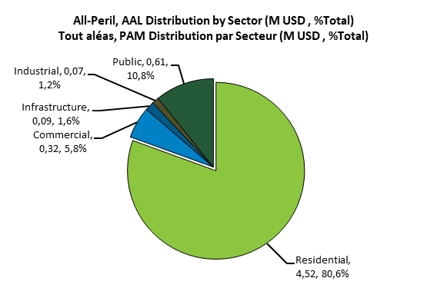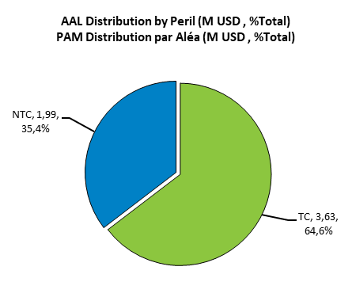
Source: SWIO-RAFI, 2017
As in Madagascar, the damage caused by the various hazards is mainly in the residential sector, and for the same reasons of precariousness of traditional habitats. According to the HABITAT III report¹⁴ on the Union of the Comoros, 60% of the housing stock is precarious construction and only 10% of the housing complies with the regulations.
The geographical distribution of mean annual losses is shown in the figure below:
Figure 6 : Geographical distribution of mean annual physical losses, Union of the Comoros
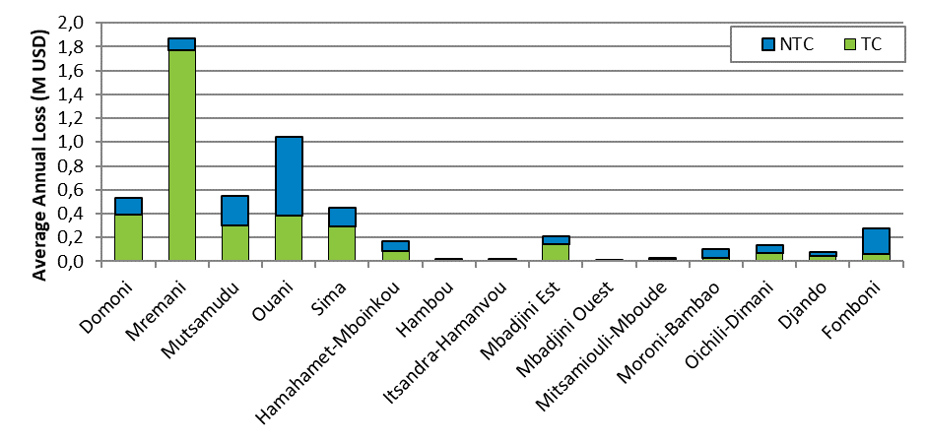
The table below shows the mean annual losses, by climatic hazard and return period for the Union of the Comoros.
Probability of exceedance: | AAL/  PAM | 0,1 | 0,04 | 0,02 | 0,01 | 0,004 | 0,002
Return period (year): | AAL/  PAM | 10 | 25 | 50 | 100 | 250 | 500
Risk Profile: All modelled hazards
Physical Loss/Pertes physiques (M USD) | 5,6 | 9,7 | 15,3 | 22,1 | 53,0 | 159,1 | 270,6
(% Total Exposure Value/Total de la valeur exposée) | 0,2% | 0,4% | 0,6% | 0,9% | 2,1% | 6,2% | 10,5%
Urgent Costs/Coûts des urgences (M USD) | 0,5 | 1,1 | 3,5 | 5,1 | 12,2 | 36,6 | 62,2
Hazard: Tropical Cyclone (TC) / Aléa : Cyclone Tropical (TC)
Physical Loss/Pertes physiques (M USD) | 3,6 | 4,8 | 8,6 | 13,7 | 43,0 | 147,6 | 258,2
(% Total Exposure Value/Total de la valeur exposée) | 0,1% | 0,2% | 0,3% | 0,5% | 1,7% | 5,7% | 10,0%
Urgent Costs/Coûts des urgences (M USD) | 0,0 | 0,0 | 2,0 | 3,1 | 9,9 | 33,9 | 59,4
Hazard: Non-Tropical Cyclone Flood / Aléa : Inondations extra-cyclonique (NTC Flood)
Physical Loss/Pertes physiques (M USD) | 2,0 | 4,8 | 6,8 | 8,4 | 10,0 | 11,5 | 12,4
(% Total Exposure Value/Total de la valeur exposée) | 0,1% | 0,2% | 0,3% | 0,3% | 0,4% | 0,4% | 0,5%
Urgent Costs/Coûts des urgences (M USD) | 0,5 | 1,1 | 1,6 | 1,9 | 2,3 | 2,7 | 2,9

The Union of the Comoros suffers on average, each year, a loss of nearly 5.6 million USD, all hazards combined. In addition to these losses, there are expenses incurred for emergency measures of nearly USD 0.5 million.
These annual losses correspond to average losses. When an individual hazard occurs, the damage can be significantly higher. For example, a 100-year tropical cyclone could cause damage of up to 43 million (Red value in the table). In this case, the costs of emergency measures could amount to USD 10 million.
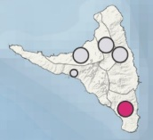
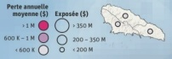
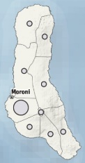
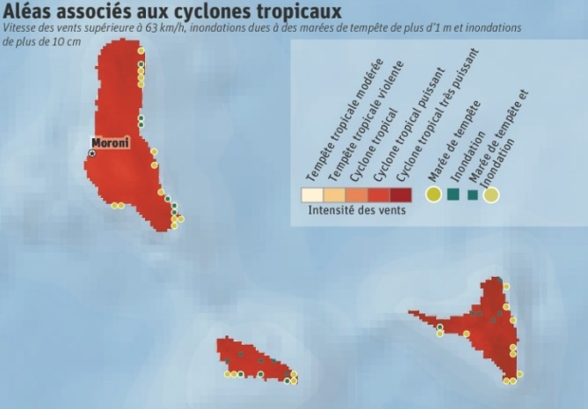
Source: SWIO-RAFI, 2017
Figure 7 :Flood-related disasters (left) and AAL associated with tropical cyclones (right)
Geographically, Anjouan is the island most exposed to flood loss risks, with a mean annual loss of USD 1.3 million, representing 66% of total flood losses. In Anjouan, the city of Ouani is the most exposed, with mean annual losses estimated at USD 660,000. Grande Comores and Mohéli are also exposed to the same flood risks, respectively for USD 335,0000 and 330,000.
As for tropical cyclones, the annual average direct losses are estimated at USD 3.6 million.
Based on the assumptions presented above for the Hydromet project, the avoided costs associated with an EWS would be 5% on the value of ground assets and 10% on emergency costs. The benefits evaluated are presented in the table below.
Table 5: Estimate of the mean annual profits associated with an EWS in the Union of the Comoros
Assumptions made about EWS benefits
Reduction of physical losses (USD million) |  | 5,0%
Cost savings on emergency measures (USD million) |  | 10,0%
Average Return Period: |  | AAL
Average annual benefits
Union of the Comoros | Ground-up Loss (USD) | 280 809
Union of the Comoros | Emergency Loss (USD) | 46 122
All contingencies combined, the average annual benefits of EWS-Hydromet for the Union of the Comoros are estimated at USD 0.28 million for the physical losses avoided and USD 0.046 million for the costs avoided on emergency measures.

Expected benefits of agri-climatic services
The value of agricultural production in the Union of the Comoros, as an annual average over the last 5 years 2011-2016, is estimated at USD 85.9 million.
The agricultural production base eligible for climate services is assumed to represent 10% of total agricultural production. The base for agricultural production that can benefit from climate services is estimated at approximately USD 8.6 million.
Table 5: Value of agricultural production in the Union of the Comoros and assessment of the production base benefiting from climate services
 | Value of annual agricultural production, in thousands of USD | Base of agricultural production benefiting from climate services [Hyp: 10% of total production, 5% of farmers] | Base of agricultural production benefiting from climate services [Hyp: 10% of total production, 10% of farmers] | Base of agricultural production benefiting from climate services [Hyp: 10% of total production, 15% of farmers]
 |  | 2026-2030 | 2031-2041 | 2041-2070
2011 | 87 059 | 4 353 | 8 706 | 13 059
2012 | 87 568 | 4 378 | 8 757 | 13 135
2013 | 83 594 | 4 180 | 8 359 | 12 539
2014 | 85 587 | 4 279 | 8 559 | 12 838
2015 | 85 161 | 4 258 | 8 516 | 12 774
2016 | 86 532 | 4 327 | 8 653 | 12 980
Average | 85 917 | 4 296 | 8 592 | 12 888
Source: IREEDD calculation based on FAO data, annual agricultural production values have been adjusted by the market price index (FAO).
The benefits that can be associated with an agro-climatic service, assuming a 10% improvement in production yields (see above), would lead, all other things being equal, to a 10% increase in the value of production.
Under these assumptions, the value of agricultural profits attributable to Hydromet would be:
- USD 0.4 million per year from 2026 to 2030;
- USD 0.9 million per year from 2031 to 2040; and
- USD 1.3 million per year from 2041 to 2070.

Seychelles: Climate Risks and Socio-Economic Profile
Overview of the country's economy
Population (2018) | 96 762
GDP growth (2018) | 3.6%
Inflation (2018) | 3.7%
GDP, current USD 2018 | 1.590 billion
Agriculture, forestry, and fishing, value added (% of GDP 2018) | 2.0 %
Industry (% of GDP 2013) | 10.9 %
Services (% of GDP 2013) | 70.4 %
Employment in agriculture, % of total (2011) | 3.6 %
Employment in industry, % of total (2011) | 17.9 %
Employment in services, % of total (2011) | 78.2 %
Unemployment, % of total labour force (2011) | 4.1 %
GINI index (World bank estimate, 2013) | 46.8
Source: World bank, Word development indicators
The Seychelles archipelago is the most extended of the Indian ocean, it is made up of 115 islands, over and exclusive economic zone covering 1.374 million square kilometres.
The tertiary sector is the main driver of the country’s economy, as it represents more than 70% of GDP. The tourism sector is very competitive, with a share of 24% of GDP, and has shown rapid growth in terms of supply and demand in the past years. It generates 232.8 M per year and employs 25,8% of the active population.
Agriculture and fishing are contributing to a lesser extent to GDP (2%). This does not include industrial fisheries and related activities which would increase this share of GDP to an estimated 7-8% of total.
The two sectors that have been selected for the focus on their vulnerability and the stakes linked to climate change are the tourism sector, given its role as a key sector of the economy and its particular exposure to climate change (cf. 1.5.1 - The tourism sector), and the fishing industry (cf. 1.5.2 The fishing industry).

Tourism sector
Tourism is the main driver of the Seychelles’ economy. It contributes to more than 24% of GDP and employs 25% of the population.
The effects of climate change on the tourism sector are expected to be largely negative, in terms of direct physical losses but also in terms of indirect impacts, such as impacts on the natural environment.
Tourism sector, workers, business companies, and tourists appears to be the major beneficiaries from an EWS that would be implemented. Most of recreative activities are related to the sea for which weather forecast and warning services are needed to optimize the organization of the activities, avoid damages and save lives.
The country’s major economic pillar is the tourism (the services sector) that generates, directly and indirectly, for around 70% of the GDP of the country and employs 78% of the population. Visitor numbers in 2018 were 361,844 (more than 3.5 times the resident population), a 3% increase over 2017.
Tourism sector has been selected because of its high contribution to the economy and for the potential beneficiaries from an EWS:
- High direct contribution to GDP: US$0.27 billion (24.8% of Seychelles total) (WB, 2011)
- Direct contribution to employment: 11,000 (25.8% of Seychelles total) (WB, 2011)
- Impact of CC on Tourism sector
- Potential Beneficiaries’ from EWS implementation:
  - Direct beneficiaries: Hotels, business in all recreative activities related to the sea, workers in the sector, etc.
  - Indirect beneficiaries: 303,000 visitors in 2016.
- Many buildings and infrastructures of the tourism sector that are exposed to flood hazard given their location in hazard prone areas. According to UNDP, in Mahé, Praslin and La Digue islands, 87 touristic buildings are located in flood prone areas and 126 are located in tsunami exposed areas.
Climate change consequences and potential impacts on the tourism sector
Climate change consequences | Potential impacts
- Increased intensity of tropical cyclones  - Increased occurrence of flash floods, sometimes leading to landslides  - Storm surge | - Most hotels located in coastal lowlands are exposed to flood hazard, and can be subject to destruction of infrastructure  - Loss of revenue due to the interruption of activities during extreme events  - Loss of natural environment: indirect impacts on tourism

Potential direct beneficiaries of the project: 437 active accommodation establishments
Potential indirect beneficiaries of the project: 25 500 workers that directly and indirectly work in the tourism sector

Agriculture and fisheries sector
Agriculture, forestry and fishing (i.e. the primary sector) accounts for 2% of GDP. The agricultural sector has lost most of its economic importance over the past decades. Despite its low share in Seychelle’s GDP, the agricultural sector remains important in terms of local consumption: In 2011, 29% of crops consumed were produced locally (9 147 tons over 30 341 tons consumed), the main crops being banana, lettuce, cabbage, eggplant, chilies, cucumber, tomatoes and pawpaw. 37% of the meat consumed is produced locally, the main livestock being cattle, chicken and beef (1 393 tons of meat over 5 156 tons consumed).
According to the census of agriculture conducted in 2011, there are in total approximately 17 380 agricultural holdings in Seychelles, including 16 500 households that are producing crops for their own consumption, 350 that are producing crops and selling any surplus and 530 farms that are producing mainly for sale. The clear majority of livestock and vegetable and root crops are hold by these farms.
The fishery sector is a strong economic pillar, accounting for 5% of GDP, 7% of employment and 35% of total exports. The Indian Ocean Tuna canning factory is the largest employer of the sector, with a workforce of 2 300 workers.
Seychellois have one of the highest levels of fish consumption per capita in the world, approximately 57 kg per annum, with fisheries products accounting for up to 50 percent of the total protein consumed. Most of this is supplied by Seychelles’ artisanal fishery, which lands about 4,000 tons of fish per year. Among the contribution of fisheries to the economy there is also a food security issue.
Fisheries are vulnerable to the effects of climate change and variability. According to world Bank, fishing vessels and equipment have been highly damaged or lost during past events. Fisheries have suffered the greatest economic losses due to extreme rainfalls events in the periods 1997-1998 and 1998-2000, according for 45% of the total estimated losses.
The implementation of early warning systems would allow fishermen to adapt fish harvesting time, and to remove the equipment in case of extreme events, in order to avoid losses.
Fisheries sector in Seychelles is driven by the industrial and semi-industrial activities, which would not be interested by climate services or EWS since they are autonomous with their own meteorological services.
Artisanal fishermen are the potential beneficiaries from an EWS and climate services. Artisanal catch is estimated around 3,632 Mt in 2013; and represent around 100 registered vessels in the SFA (Seychelles Fishery Authority).
Employment in the sector
The SFA’s latest report (2014) estimates that direct and indirect employment in fisheries and related sectors is about to be between 5,000 – 6,000 people in 2014, representing around 10% of total formal employment in the country. Note that this estimate also includes people employed by the Authority as well as in fish processing, export activities, net repairs, ship handling, stevedoring, etc…
The Indian Ocean Tuna (IOT) canning factory was by far the largest single employer, with a workforce of approximately 2,300 workers of which over 70% were foreign nationals. The number of full and part-time commercial fishers varied between 1,300 and 1,400 primarily due to seasonal mobility associated with the sector.
In 2014, approximately 150 people were directly employed in the sea cucumber fishery as divers, skippers and apprentices. The Seychelles Fishing Authority employed 123 people. During 2014, a maximum of 45 Seychellois seamen made at least one trip on board purse seiners (16 aboard Spanish vessels and 29 aboard French vessels).
The focus has been put on the fisheries sector because of its important contribution to the economy, even if the industrial and semi-industrial fishing activities might not be interested by a national service of a warning system. The potential beneficiaries which are the artisanal activities are very vulnerable to climate hazards and their activities could be optimized (information of alternative areas for fishing in case of bad weather) and life secured (information and forecast on bad weather) with an EWS:
- Contribution to GDP: 5.78 M USD (SFA, 2013, valued at 2019 USD)
- Employment: 5000 to 6000 (2013, for the whole sector)
- Impact of CC on Tourism sector
- Potential Beneficiaries’ from EWS implementation:
  - Direct beneficiaries: Around 100 Artisanal fishermen
  - Indirect beneficiaries: Restaurants potential buyers of the artisanal production
Consequences of climate change and potential impacts on the fishing sector
Climate change effects | Potential impacts
- Increased intensity of tropical cyclones  - Increased occurrence of flash floods, sometimes leading to landslides  - Storm surge  - Harmful algal blooms (HABs) are intensifying in parallel with climate change | - Damage to infrastructure (fishing vessels, equipment)  - Loss of revenues  - Algal Blooms endanger human health, the environment and fishing sector in Seychelles
Potential direct beneficiaries of the project:
- 17 350 agricultural holdings, including 530 farms that are producing crops for commercial purposes, and 16 850 households that produce crops mainly for their own consumption.
- Stakeholders of the fishing sector: mainly artisanal fishermen and semi- industrial fisheries: 5000-6000 people employed in the sector (2014).
Potential indirect beneficiaries of the project: The population of Seychelles, approximately 97 000 people (food security issue and economic issue).

EWS Benefits
Assessment of the Average Annual Losses (AAL) on the ground-up resulting from climate hazards for the Seychelles are presented in the following, per sector and per hazard.
- AAL from tropical cyclone (TC), including associated precipitation and marine submersions, are estimated at 0.35 million USD and represent 12.4% of the total estimated losses;
- AALs associated with extra-cyclonic floods, or Non-Tropical Cyclone (NTC), are estimated at USD 2.45 million, and represent the largest part of the estimated losses in the Seychelles (87.6%).
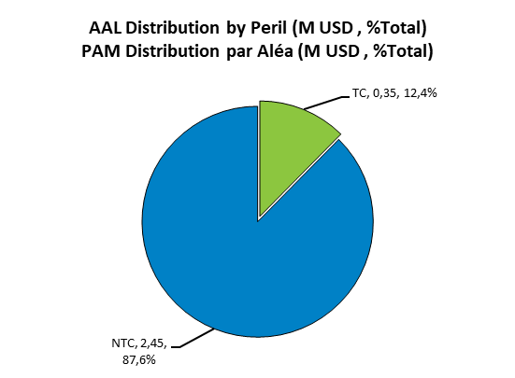
Figure 7: Distribution of AAL by sector (left) et hazard (right) in Seychelles

Just over half (52.9%) of the damage caused by the various hazards is mainly in the residential sector. The commercial sector, which includes hotels, is the second most affected by hazards with nearly 1 million USD of AAL, representing 35% of total AAL.
The geographical distribution of mean annual losses is shown in the figure below:
Figure 8: Spatial distribution of AAL for Seychelles by region
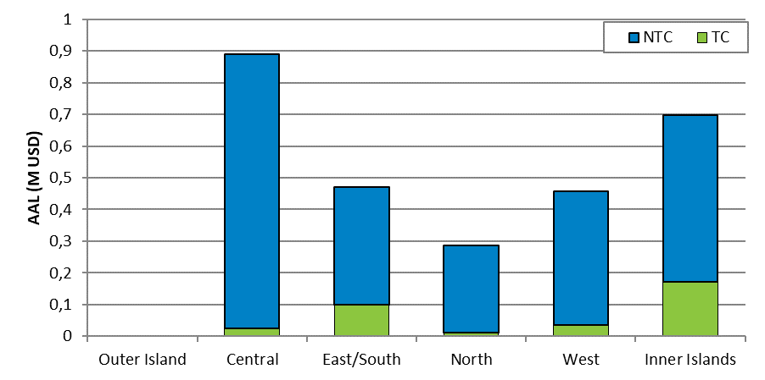
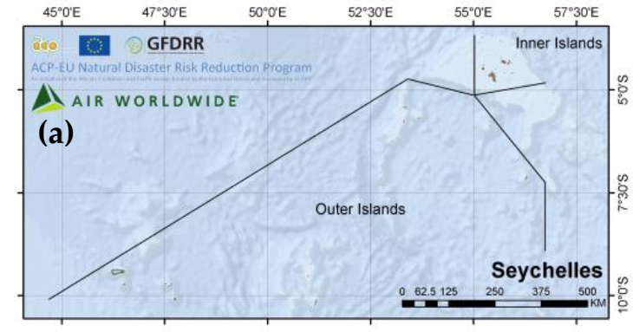
Figure 9: Geographical distribution of AALs associated with TC hazards (left) and NTC (right)
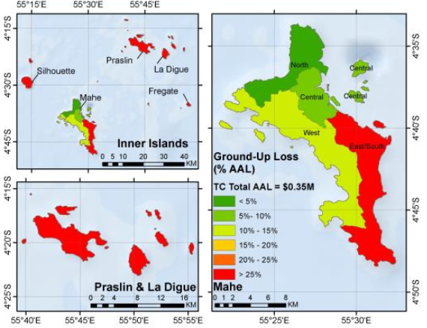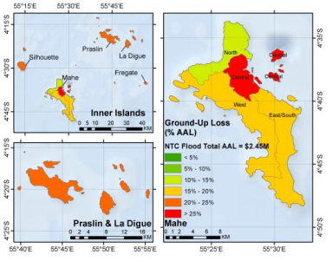
The geographical distribution of losses associated with the different hazards is shown in the figures below.
Results from SWIO-RAFI suggest that Mahé has the greatest risks for NTC flood-related losses, representing 79% of Seychelles’ average loss per year. The Central region of Mahé has the highest Average Annual Losses of USD 870 000.
As for tropical cyclones, the annual average direct losses are estimated at USD 3.6 million.
The table below shows the mean annual losses, by climatic hazard and return period for Seychelles.
Probability of Exceedance: | AAL(PAM) | 0,1 | 0,04 | 0,02 | 0,01 | 0,004 | 0,002
Return period (year): | AAL(PAM) | 10 | 25 | 50 | 100 | 250 | 500
Risk Profile: All Modelled Perils
Physical Loss (M USD) | 2,8 | 8,2 | 13,4 | 18,1 | 26,2 | 33,5 | 39,9
(% Total Exposure Value) | <0.1% | 0,1% | 0,2% | 0,3% | 0,4% | 0,5% | 0,6%
Urgent Costs (M USD) | 0,6 | 1,8 | 3,1 | 4,2 | 6,0 | 7,7 | 9,2
Hazard: Tropical Cyclone (TC)
Physical Loss (M USD) | 0,3 | 0,3 | 2,2 | 4,8 | 10,2 | 14,9 | 19,5
(% Total Exposure Value) | <0.1% | <0.1% | <0.1% | <0.1% | 0,1% | 0,2% | 0,3%
Urgent Costs (M USD) | 0,0 | 0,0 | 0,5 | 1,1 | 2,4 | 3,4 | 4,5
Hazard: NTC Flood
Physical Loss (M USD) | 2,5 | 7,9 | 11,1 | 13,4 | 15,9 | 18,6 | 20,4
(% Total Exposure Value) | <0.1% | 0,1% | 0,2% | 0,2% | 0,2% | 0,3% | 0,3%
Urgent Costs (M USD) | 0,6 | 1,8 | 2,6 | 3,1 | 3,7 | 4,3 | 4,7

On average, Seychelles suffers a loss of nearly USD 2.8 million each year, all hazards combined. In addition to these losses, there are expenses incurred for emergency measures of nearly USD 0.6 million.
These annual losses correspond to average losses. When an individual hazard occurs, the damage can be significantly higher. For example, a 100-year flood could cause damage of up to USD 15.9 million (value in red in the table). In this case, the costs of emergency measures could amount to USD 3.7 million.
Based on the assumptions presented above for the Hydromet project, the avoided costs associated with an EWS would be 5% on the value of physical losses on the ground and 10% on emergency costs. The benefits evaluated are presented in the table below.

Table 7: Estimate of the average annual profits associated with an EWS in the Seychelles
Assumptions made about EWS benefits
Reduction of physical losses (USD million) | 5,0%
Cost savings on emergency measures (USD millions) | 10,0%
Average Return Period: |  | PAM
Average annual profits
Seychelles | Ground-up Loss (USD) | 140 000
Seychelles | Emergency Loss (USD) | 56 452
All contingencies combined, the average annual benefits of EWS-Hydromet for the Seychelles are estimated at USD 0.140 million for the physical losses avoided and USD 0.056 million for the costs avoided on emergency measures.

Expected benefits of agri-climatic services
The average value of Seychelles' agricultural production, as an annual average over the last 5 years 2011-2016, is estimated at USD 6.1 million.
The agricultural production base eligible for climate services is assumed to represent 10% of total agricultural production. The base for agricultural production likely to benefit from climate services is estimated at approximately 0.3 M. USD.
Table 8: Value of agricultural production in Seychelles and assessment of the production base benefiting from climate services
 | Value of annual agricultural production, in thousands of USD | Base of agricultural production benefiting from climate services [Hyp: 10% of total production, 5% of farmers] | Base of agricultural production benefiting from climate services [Hyp: 10% of total production, 10% of farmers] | Base of agricultural production benefiting from climate services [Hyp: 10% of total production, 15% of farmers]
 |  | 2026-2030 | 2031-2041 | 2041-2070
2011 | 6 194 | 310 | 619 | 929
2012 | 6 528 | 326 | 653 | 979
2013 | 6 104 | 305 | 610 | 916
2014 | 6 411 | 321 | 641 | 962
2015 | 5 800 | 290 | 580 | 870
2016 | 5 786 | 289 | 579 | 868
Average | 6 137 | 307 | 614 | 921
Source: IREEDD calculation based on FAO data, annual agricultural production values have been adjusted by the market price index (FAO)
The benefits that can be associated with an agro-climatic service, assuming a 10% improvement in production yields (see above), would lead, all other things being equal, to a 10% increase in the value of production.
Under these assumptions, the value of the agricultural profits attributable to Hydromet would be approximately:
- USD 0.03 million per year from 2026 to 2030;
- USD 0.06 million per year from 2031 to 2040; and
- USD 0.1 million per year from 2041 to 2070.

Mauritius: Climate Risks and Socio-Economic Profile
Overview of the Country’s Economy
Population (2018) | 1 265 303
GDP, current USD 2017 | 14.220 billion
GDP growth (2018) | 3.8%
Inflation (2018) | 3.2%
Agriculture, (% of GDP) 2018 | 2.8%
Industry (% of GDP 2018) | 17.6%
Services (% of GDP 2018) | 67.4%
Employment in agriculture, % of total (2018) | 7.1%
Employment in industry, % of total (2018) | 27.1%
Employment in services, % of total (2018) | 65.8%
GINI index (World bank estimate, 2012) | 35.8
Source: World bank, Word development indicators

The two main islands of Mauritius are: the main island of Mauritius and the island of Rodrigues. It covers a surface of 2040 square meters.
Mauritius’ economy, initially based on sugarcane production, shifted to a service-oriented economy starting in the late 1970s. It is now nominated by the service sector which represents 67% of GDP, with a large part of financial services, ICT and tourism. The tourism industry, which accounts for 8% of GDP and 10% of total employment in 2017 is one of the main drivers of the economy of the country.
Agriculture has been a driver of the economic development of Mauritius, but its contribution to GDP has been constantly declining since the 1970s. Today, it contributes to 2.8% of GDP and 7.1% of employment, the main production being sugarcane.
The two sectors that have been selected for the focus on their vulnerability and the stakes linked to climate change are the tourism sector, given its role as a key sector of the economy and its particular exposure to climate change (cf. 1.6.1 - The tourism sector), and the agriculture sector (cf. 1.6.2 - The agriculture sector).

Tourism sector
Tourism is a key economic pillar for Mauritius, accounting for 8% of GDP, 10% of employment and 8% of investment in 2017. Mauritius accounts for 111 hotels in operation and registered more than 1.3 million tourist arrivals in 2017.
Given its close relationship to the environment and climate, tourism is a highly climate-sensitive economic sector. Most hotels and touristic infrastructure are located on the coastline, and thus directly exposed to flooding, sea level rise, beach erosion and tropical cyclones.
The coastal adaptation is necessary, as much revenues from the sector and jobs are at risk if beaches continue to erode. The deterioration of the coral reef and the natural environment is also a huge stake for the sector.
The implementation of an Early Warning system could help the tourism sector to prevent extreme weather events such as flash floods, cyclones and storm surge and avoid losses of infrastructure and enhance the security of tourists and people working in the sector. In a medium/long term, reinforced meteorological services could help to prevent coastal erosion.
Climate change consequences and potential impacts on the tourism sector
Climate change effects | Potential impacts
- Increased intensity of tropical cyclones  - Increased occurrence of flash floods, sometimes leading to landslides  - Storm surge leading to coastal erosion | - Most hotels located in coastal lowlands are exposed to flood hazard and can be subject to destruction of infrastructure.  - Hotels located near the beach face huge erosion risk in the medium/long term.  - Loss of revenue due to the interruption of activities during extreme events  - Loss of natural environment: indirect impacts on tourism
Potential direct beneficiaries of the project: Stakeholders of the tourism sector: 111 hotels in operation (2017), 30 919 people employed in large establishments of the tourism sector (food services, hotels, travel and other services) .
Potential indirect beneficiaries of the project: Tourists visiting Mauritius: In 2017, 1.3 million of tourist arrivals were recorded.

Agriculture sector
Agriculture contributes to 2.8% of GDP and 7.1% of employment. With 86 000 ha of land, it covers 42% of total land area (FAO estimates 2015). It is dominated by sugar cane cultivation, which covers 54,000ha of land.
Mauritius is a net food importer (imports represent 77% of food requirements). Nevertheless, the sector still plays a vital role within the economy, with a significant economic, social and environmental impact. It provides direct employment to 44 200 persons. 8000 small producers are cultivating 8 200 ha of land to produce on average 110 000 tons of crops that are consumed on the domestic market. Around 5000 farmers are active in the livestock sector, producing milk and meat.
Food crops are essentially rain fed, thus, a decrease in precipitations induced by climate change will be a challenge to ensure adequate water supply for the agriculture.
The main changes in climate that will impact the agriculture sector are temperature rise, increasingly variable rainfall, droughts, climate extremes, and sea level rise. These hazards generate direct and indirect negative consequences for the sector such as changes in soil moistures, increased risk of flooding and soil erosion, salinization of water in coastal areas, heat stress on crops and lower productivity.
The implementation of an EWS and climate services could help to prevent or reduce the negative impacts of extreme events in the short or medium terms, by providing farmers with information to guide decision, for example early harvesting or moving the equipment and livestock to safety. It could also benefit to the sector in the long term, by helping to adapt the agricultural calendar to the seasonal changes.

Climate change consequences and potential impacts on the agriculture sector
Climate change consequences | Potential impacts
- Increased intensity of tropical cyclones  - Increased occurrence of flash floods, sometimes leading to landslides  - Storm surge | - Damage to infrastructure  - Damage to crops (cash crops and food crops), losses of livestock  - Food security issue
Potential direct beneficiaries of the project: Farm operators and people working in the agricultural sector: 8000 operators in the crop sector, 5000 in the livestock sector, 44 200 direct workers.
Potential indirect beneficiaries of the project: Families of farmers and in a larger extent, population of Mauritius (food security issue and economic issue) which represents a total of 1.2 million people.

EWS Benefits
Estimates of Average annual losses (AAL) resulting from climate hazards for Mauritius are presented in the figure below, by exposure sector and by hazard.
The AALs associated with tropical cyclones (TCs), including associated rainfall and marine submersions, are estimated at USD 90.69 million and represent the major part of the risks incurred in Mauritius (80.2% of total estimated losses);
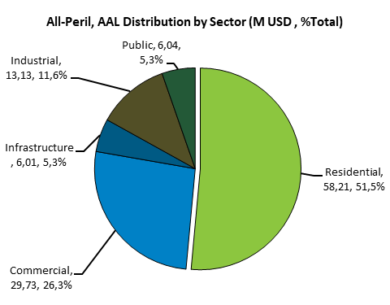
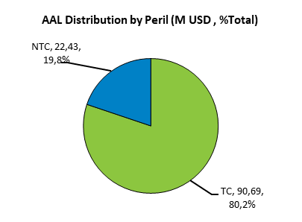
AALs associated with extra-cyclonic floods, or Non-Tropical Cyclone (NTC), are estimated at USD 22.43 million, and represent 19.8% of the estimated damage in Mauritius.

Half of the losses associated with the various hazards are in the residential sector. The commercial sector, which includes hotel infrastructure, accounts for nearly 30% of losses. The clear majority, 80%, of the damage is caused by tropical cyclones. The geographical distribution of mean annual losses is shown in the figure below:
Figure 10& 11: Distribution of Average Mean Annual Losses (AMAL) in Mauritius by sector (left) and by hazard (right))
Figure 12: Geographical distribution of flood-related losses
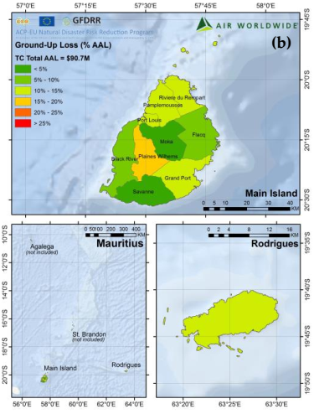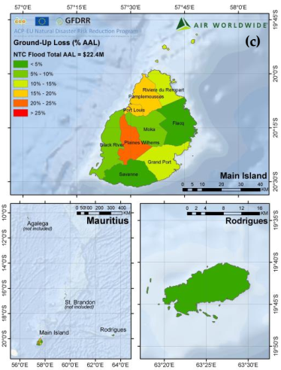

Figure 13: Geographical distribution of tropical cyclone hazard losses
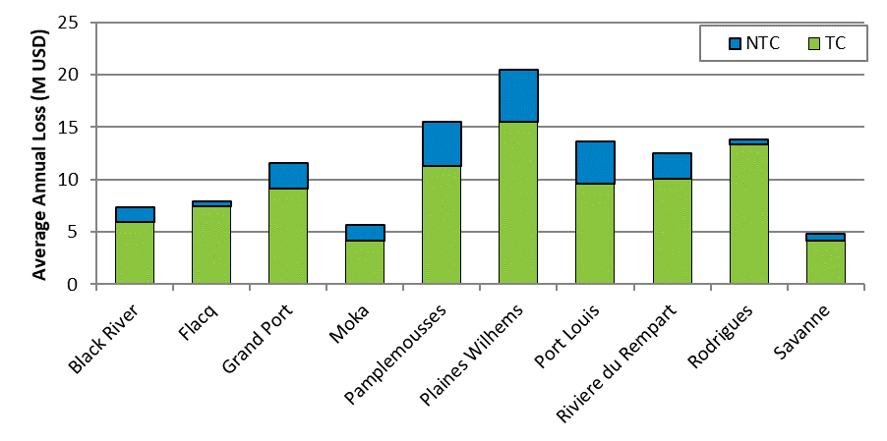
Source: SWIO-RAFI, 2017

The table below shows the Average Annual Losses, by climatic hazard and return period for Mauritius.
Probability of Exceedance: | AAL (PAM) | 0,1 | 0,04 | 0,02 | 0,01 | 0,004 | 0,002
Return Period (year): | AAL (PAM) | 10 | 25 | 50 | 100 | 250 | 500
Risk Profile: All Modelled Perils
Physical Loss (M USD) | 113,1 | 160,3 | 429,6 | 883,4 | 2 030,5 | 3 812,4 | 5 905,8
(% Total Exposure Value) | 0,3% | 0,5% | 1,3% | 2,6% | 6,1% | 11,4% | 17,7%
Urgent Costs (M USD) | 5,2 | 14,5 | 98,8 | 203,2 | 467,0 | 876,9 | 1 358,3
Risk Profile: Tropical Cyclone
Physical Loss (M USD) | 90,7 | 97,3 | 329,1 | 757,3 | 1 880,7 | 3 632,9 | 5 702,3
(% Total Exposure Value) | 0,3% | 0,3% | 1,0% | 2,3% | 5,6% | 10,9% | 17,0%
Urgent Costs (M USD) | 0,0 | 0,0 | 75,7 | 174,2 | 432,6 | 835,6 | 1 311,5
Risk Profile: NTC Flood
Physical Loss (M USD) | 22,4 | 63,0 | 100,5 | 126,1 | 149,7 | 179,5 | 203,5
(% Total Exposure Value) | <0.1% | 0,2% | 0,3% | 0,4% | 0,4% | 0,5% | 0,6%
Urgent Costs (M USD) | 5,2 | 14,5 | 23,1 | 29,0 | 34,4 | 41,3 | 46,8

Mauritius suffers on average, each year, a loss of nearly 113 million USD, all hazards combined. In addition to these losses, there are expenses incurred for emergency measures of nearly USD 5.2 million. But the losses could be much higher. For example, a 100-year tropical cyclone could cause damage of up to USD 1,880 million (red value in the table). In this case, the costs of emergency measures could amount to USD 433 million.
Based on the assumptions presented above for the Hydromet project, the avoided costs associated with an EWS would be 5% on the value of physical losses on the ground and 10% on emergency costs. The benefits evaluated are presented in the table below.
Table 7 : Estimate of the average annual profits associated with an EWS in Mauritius
Assumptions made about EWS benefits
Reduction of physical losses (USD million) | 5,0%
Cost savings on emergency measures (USD millions) | 10,0%
Average Return period: |  | PAM
Annual Average Benefits
Mauritius | Ground-up Loss (USD) | 5 655 953
Mauritius | Emergency Loss (USD) | 515 856

For all contingencies combined, the average annual benefits of EWS-Hydromet for Mauritius are estimated at USD 5.6 million for physical losses avoided and USD 0.5 million for costs avoided on emergency measures.

Expected benefits of agri-climatic services
The average value of Mauritius' agricultural production, as an annual average over the last 5 years 2011-2016, is estimated at USD 1.5 billion.
The agricultural production base eligible for climate services is assumed to represent 5% of total agricultural production. This hypothesis has not been documented as the literature focuses on work limited to geographically bounded experimental areas. To our knowledge, there is no assessment of the potential for the dissemination of climate services at the national level.
The base for agricultural production likely to benefit from climate services is estimated at approximately 153 M. USD.
Table 8 : Value of agricultural production in Mauritius and assessment of the production base benefiting from climate services
 | Value of annual agricultural production, in thousands of USD | Base of agricultural production benefiting from climate services [Hyp: 10% of total production, 5% of farmers] | Base of agricultural production benefiting from climate services [Hyp: 10% of total production, 10% of farmers] | Base of agricultural production benefiting from climate services [Hyp: 10% of total production, 15% of farmers]
 |  | 2026-2030 | 2031-2041 | 2041-2070
2011 | 1 561 224 | 78 061 | 156 122 | 234 184
2012 | 1 711 110 | 85 555 | 171 111 | 256 666
2013 | 1 672 764 | 83 638 | 167 276 | 250 915
2014 | 1 481 351 | 74 068 | 148 135 | 222 203
2015 | 1 327 556 | 66 378 | 132 756 | 199 133
2016 | 1 431 297 | 71 565 | 143 130 | 214 695
Average | 1 530 884 | 76 544 | 153 088 | 229 633
Source: Calculated by Ireedd according to FAO data, the annual values of agricultural production have been adjusted by the market price index (FAO)
The benefits that can be associated with an agro-climatic service have been assessed through academic experiments described above. We have assumed a 10% improvement in production yields (see above), which would lead, all other things being equal, to a 10% increase in the value of production.
Under these assumptions, the value of agricultural profits attributable to Hydromet would be:
- USD 7.7 million per year from 2026 to 2030;
- USD 15.3 million per year from 2031 to 2040; and
- USD 23.0 million per year from 2041 to 2070.

Costs of the Hydromet Project

Investment Costs
The project's investment costs, totalling 70.066 million USD, are presented in the table below by expenditure line and funder (for further detail see the feasibility study)
By expenditure line | TOTAL | AFD | EU | GCF | GVNT
Investment costs and project implementation/Coûts d'investissement et mise en œuvre du projet (USD)
GCF Component 1 | 9 586 000 | 779 000 | 0 | 8 807 000 | 0
GCF Component 2 | 40 723 500 | 316 7000 | 0 | 36556500 | 1 000 000
GCF Component 3 | 16 120 000 | 862 000 | 6 000 000 | 9258000 | 0
PMU | 3 637 000 | 600 000 | 0 | 3037000 | 0
sub-total/sous-total | 70 066 500 | 5 408 000 | 6 000 000 | 57 658 500 | 1 000 000

These investments are planned over a period of 5 years, and the estimated disbursements, by line, are presented in the table below.

Investment planning (5 years) (USD) | TOTAL | 2021 | 2022 | 2023 | 2024 | 2025
Investment costs and project implementation (USD)
Observation System/Système d'observation | 22 153 500 | 2 577 500 | 16 805 500 | 2 170 500 | 300 000 | 300 000
Information System/ Système d'information | 12 520 000 | 2 940 000 | 8 615 000 | 965 000 | - | -
Institutional and Training Reinforcement/Renforcement instit & training | 11 636 000 | 3 484 000 | 4 270 000 | 1 736 000 | 1 123 000 | 1 023 000
Project management/Gestion de projet | 5 837 000 | 1 085 000 | 1 135 000 | 2 213 000 | 702 000 | 702 000
Agri-Services/Services agro | 7 930 000 | 1 690 000 | 3 165 000 | 1 575 000 | 1 200 000 | 300 000
Other services/Autres services | 9 990 000 | 2 000 000 | 3 350 000 | 3 380 000 | 1 180 000 | 80 000
sub-total/sous-total | 70 066 500 | 13 776 500 | 37 340 500 | 12 039 500 | 4 505 000 | 2 405 000

Operating Expenses
Operating expenses consist of renewal and maintenance operations and human resources. According to a benchmark from similar projects in Africa, the World Bank proposed O&M costs between 6% and 9% in its economic studies for GCF (Burkina Faso, Mali). In the South-East Asia, the observed O&M costs after implementation of project is about 7%. We used 7% of the value Observation system and information system to calibrated O&M for the Hydromet project.

Operating Costs (Operation & Maintenance) | TOTAL (USD) | 2021 | 2022 | 2023 | 2024 | 2025
Operation and maintenance (Human resources) | 4 573 000 | - | 180 000 | 1 356 000 | 1 508 000 | 1 529 000
Operation and maintenance (Maintenance contract) | 3 421 000 | - | 290 000 | 978 000 | 1 073 000 | 1 080 000
sous-total | 4 573 000 | - | 470 000 | 2 334 000 | 2 581 000 | 2 609 000

The first services would be operational from 2022, and operating costs are progressive. However, due to the rigour of the CBA calculation, the first expected benefits are only calculated from 2026 onwards.

Total Cost by State
The total cost of the project, consisting of investment and operating costs, amounts to USD 78.060 million, broken down by component and State as follows.

 |  | Implementation phase
Costs of the Hydromet project (USD) | TOTAL | 2 021 | 2 022 | 2 023 | 2 024 | 2 025
Investment costs and implementation
Observation sytems | 22 153 500 | 2 577 500 | 16 805 500 | 2 170 500 | 300 000 | 300 000
Information systems | 12 520 000 | 2 940 000 | 8 615 000 | 965 000 | - | -
Capacity building & training | 11 636 000 | 3 484 000 | 4 270 000 | 1 736 000 | 1 123 000 | 1 023 000
Management | 5 837 000 | 1 085 000 | 1 135 000 | 2 213 000 | 702 000 | 702 000
Agri-climatic services | 7 930 000 | 1 690 000 | 3 165 000 | 1 575 000 | 1 200 000 | 300 000
Others sector's services | 9 990 000 | 2 000 000 | 3 350 000 | 3 380 000 | 1 180 000 | 80 000
Sub-total | 70 066 500 | 13 776 500 | 37 340 500 | 12 039 500 | 4 505 000 | 2 405 000
 | 70 066 500 | 13 776 500 | 37 340 500 | 12 039 500 | 4 505 000 | 2 405 000
Operation and maintenance costs
Operation and maintenance (including Human resources) | 7 994 000 | - | 470 000 | 2 334 000 | 2 581 000 | 2 609 000
Sub-total | 7 994 000 | - | 470 000 | 2 334 000 | 2 581 000 | 2 609 000
 | 7 994 000 | - | 470 000 | 2 334 000 | 2 581 000 | 2 609 000
Total costs | 78 060 500 | 13 776 500 | 37 810 500 | 14 373 500 | 7 086 000 | 5 014 000

Cost Benefit Analysis and Results

Assumptions of the economic calculation
The table below summarises the costs and benefits of the Hydromet project, as presented above.
Table 10 : Reminder of the costs and benefits of the Hydromet project/Rappel des coûts et bénéfices du projet Hydromet
Costs of the Hydromet Project (USD) | TOTAL
Investment costs and project implementation (over the 5 years of the implementation phase) | 70 066 500
Annual operating costs (Operation & Maintenance) | 7 994 000
Total Costs | 78 060 500
Benefits of the Hydromet Project (USD) | Annual
Avoided costs associated with EWS | 14 038 440
Madagascar | 7 343 196
Comores | 326 931
Seychelles | 196 505
Maurice | 6 171 809
Agri-Climate Services/Services Agro-climatiques (USD) | 59 824 427
Madagascar | 43 595 049
Comores | 859 169
Seychelles | 61 372
Maurice | 15 308 836
Total profits | 73 862 867

See annex for the presentation of the economic assessment of the benefits derived from Agro-climatic services and EWS.
The assumptions used for the economic calculation are as follows :
- Discount rate: Benchmark of previous CBA of similar projects shows the following discounting rates have been used to assess the project: 5% (baseline reference) 8%, 10%, 15% and 20% to assess the sensitivity of economic profitability. We will use those rates to evaluate the Hydromet project.
- Time Horizon: The time horizons in the literature for climate services CBAs range from 10 to 80 years. Our evaluation of cost avoided with an EWS is based on the SWIO-RAFI exposure, in which return period of hazard range from 10 years to 500 years, we used a 50-year time horizon for our study to integrate the benefits of investment on a long period.
The Net Present Value of the program, within the very limited scope of the benefits we were able to quantify, is USD 956 million for a discount rate of 5% and remains positive for a discount rate of 20%.
The sensitivity of this result to changes in the discount rate is shown in the figure and table below.
Considering the benefits that have not been quantified, the Hydromet project can be considered economically profitable.
Figure 14 : Sensitivity of Hydromet's profitability to the discount rate

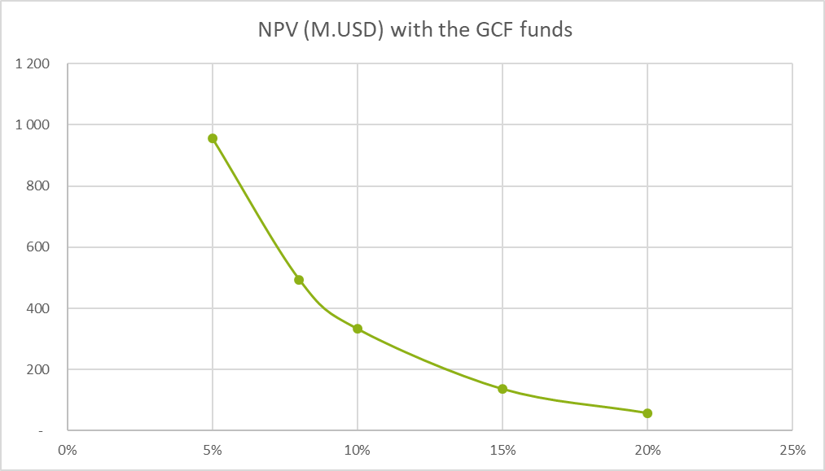

1.8.2 Sensitivity Analysis
As indicated above, the benefits evaluated correspond to a lower limit of expected benefits. The table below shows the sensitivity of the project's profitability to a variation, increase and decrease in profits. The table below shows the evolution of NPV for increased/decreased profits of 15% and 20%. The programme's profitability is maintained, even with benefits 30% lower than expected.
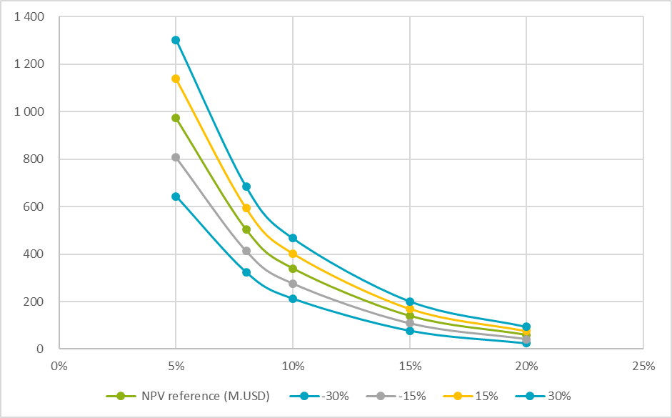

Discounting rate | NPV (in million USD)
5% | 956
8% | 493
10% | 332
15% | 136
20% | 57

Chapter 2 Business model

2.1 Value-Chain, service delivery and value generation
The generation of hydromet services benefits is a “value chain” linking the production and delivery of services to user decisions and the outcomes and values resulting from those decisions. The value chain presented in the figure below is used by WMO to illustrate the production and delivery of the entire suite of met/hydro services provided by NMHSs.
Figure 12 : Simplified schematic of the met/hydro services value chain
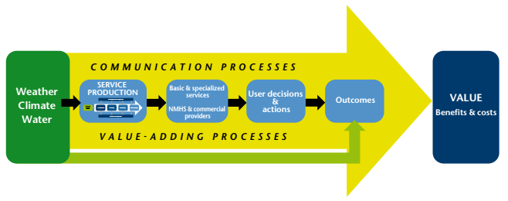
Source: Valuing Weather and Climate: Economic Assessment of Meteorological and Hydrological Services
Potential value is added at each link of the chain moving from left to right as services are received by users and incorporated into or considered in decisions.

2.1.1 Service production
Two broad categories of services will be provided by the Hydromet project.
- Basic services: Those services are generally provided at public expense to discharge a government’s sovereign responsibility for protection of life and property, for the general safety and well-being of the national community. Most countries place high priority on the provision of warning services enabling communities to prepare for, and minimize the impacts of, extreme hydrometeorological phenomena such as tornadoes, storms, hurricanes, heatwaves, wildfires, ﬂoods and droughts. One of the major benefits from the Hydromet project is to upgrade and refine the warnings from general cautionary advice to a detailed, location-specific, model-based forecasts of hazard evolution, expected impacts or consequences and precautions for particular vulnerable segments of society. The economic analysis has been able to evaluate these annual average losses to approximatively USD 14 million for the four countries.
- Special services: Those services beyond the basic services aimed at meeting the needs of specific users and user groups and that may include provision of specialized data and publications, their interpretation, distribution and dissemination. Special services often go well beyond the simple dissemination of information to include consultative advice or scientific investigation into particular meteorological and hydrological phenomena and events or their impacts. For example, working with Devon City Council and transportation consultants in the U.K., the Met Office was able to streamline maintenance routes into groups with similar road weather hazards; this streamlining was done based on an analysis of the climate, and resulted in reducing the number of routes from 48 to 38 and saving £ 20 000 per route in terms of reduced mileage, fuel, ﬂeet and labour costs (Met Office, 2011). With regards to the Hydromet project, for the four countries, increased agriculture productivity linked to agroclimate services have been evaluated at USD 29,93 million per year for the period 2026-2030 to up to 89,8 million per year for the period 2041 to 2070.

2.1.2 Users and value generation
The hydrometeorological service production system is typically managed within the domain of government-supported NMHS. Outputs from this system (Figure 12 : Simplified schematic of the met/hydro services value chain) are distributed through two streams, one delivering basic services through traditional or social mass media, emergency service organizations and public sector agencies; the other providing specialized services through private sector providers or commercial arms of NMHSs.
While the public service users of the basic services are the most important in terms of users, it is important to include and consider the role of private sector players in the production and delivery of knowledge, as that may be an important vehicle for the creation of value and revenue generation for the NMHS.
NOTE: The term “users” is usually taken to embrace the entire user community, albeit often with emphasis on the general public and other consumers of the “basic service”. The terms “client” and “customer” have been mostly reserved for the users of specialized products and services, especially those provided on a commercial basis.

2.1.3 Public services users
The public services are free access services provided by the public institutions.
- Raw data on open access. At present there is no connection between supply and demand for climate services so that what is supplied does not match what is demanded and potential demand for services is not fully developed. The expected benefits are to strengthen significantly the market for climate services, providing cutting-edge customised information services and adaptation solutions to a range of end-users in the business domain. This will lead to the extension of the chain value of the raw data provided by the hydromet project.
- The best-known public customer of NMHS is the aviation sector. The service rendered through the provision of forecasts of weather elements en route of the craft and at the different aerodromes concerned, is a sine qua non of safe flying. Due to the high commercial visibility and exigencies of airline companies, most NMHSs do have cost recovery formulae in this field. In some cases, this exercise is performed by the central government or the airport authorities which levy a certain airport landing tax inclusive of the cost for the provision of meteorological information. In other cases, separate organizations (e.g. ASECNA) cater for the sole need of the aviation sector and operate on a distinctly commercial basis.

2.1.4 Private sector and potential clients for hydro-meteorological services
- The agricultural sector is definitely an important partner of the NMHS. The farmer needs to make use not only of day-to-day weather forecasts but also of climate data and forecasts from weeks to months and—even better—seasons in advance. Although this latter lead-time may, to many, seem a new concept, it is already in practice within several NMHSs. In fact, climate prediction, even a single season in advance, allows not only for advanced planning involving storage and harvest time but also the crucial question of strategic price negotiation with customers and investment or reinvestment and developmental planning.
For the four countries the annual increase of productivity of the agriculture sector have been assessed to around USD 29.9M between 2026 and 2030, USD 59.8M between 2031 and 2041 and USD 89.7M between 2041 and 2070.
The marine sector relies heavily on meteorological information, mainly because of safety at sea resulting from correct forecast and timely warnings about hazardous weather.

- The insurance sector has a positive attitude towards cost-recovery manoeuvres by NMHSs. In the case of accidents, whether on land, air or at sea, whether under a slight rain or under gusty conditions and heavy downpours, insurance companies feel it more appropriate to apply a benefit-sharing fee in return for climate data. This benefit-sharing has been emphasised during the meeting with the insurance company in Seychelles.

- The tourist industry is also an acquired customer. Tourists need to be well looked after, as they form the pillars of one of the most important industries in the Indian Ocean Area. The health and safety of the tourist becoming more important. NMHSs can provide abundant data to hotels about the correct amount of time to spend on the beach (to avoid excessive UV-B radiation), ideal sites to visit (weather dependent), the need to avoid dehydration (because of the climate again). The safety and well-being of the tourist become of prime importance during adverse weather about which hotels and other stake-holders need to be notified in advance.

- The water-management sector relies heavily on climate forecasts for deciding planning strategies. Prediction of abundant rainfall may permit the water sector to effect a continued supply to the consumer (increased revenue), while an expected drought or deficit in rainfall may force the water sector to curtail supply. Although, in real terms, this implies reduced income, it may in fact translate into important long-term benefits through proper planning.

2.2 The impact of the Hydromet project on the budget of NMHS
Table 5 present the current budgets of the four countries NMHS, split between a) salaries, wages and bonusesand in-kind contributions and b) Operation and Maintenances costs.
Table 5 : Budget of the NMHS
Current budget of NMS (USD) (*) | Total | Salaries | O&M
 | M$ | M$ | M$
Madagascar | 1.12 | 0.84 | 0.28
Comores | 0.45 | 0.34 | 0.11
Seychelles | 1.12 | 0.56 | 0.56
Mauritius | 3.92 | 1.568 | 2.352
Total | 6.61 | 3.30 | 3.30
Source : Countries NMHS (collected during consultations).
Table 6 presents sources of funding split between government and non-government resources. Mauritius is the only NMHS that has a significant source of non-government funding.
Table 6 : Mains source of fundings of NMHS
Main sources of funding | Total | Gov. | Non-Gov. (2020)
 | M$ | M$ | M$ | % (*)
Madagascar | 1.12 | 1.10 | 0.02 | 2%
Comores | 0.45 | 0.45 | 0.00 | 0%
Seychelles | 1.12 | 1.12 | 0.00 | 0%
Mauritius | 3.92 | 3.14 | 0.78 | 20%
Total | 6.61 | 5.80 | 0.81
Source : WMO
The Hydromet project will generate new costs on budgets of NMHS. Table 7 presents the impact of the Hydromet project in terms of costs of each NMHSt, with the following assumptions:
Assumptions on Salaries:
The USD 1.53M (table7) are national in kind contributions to the project, in other words, the time invested by NHMSs’ employees towards project implementation. These costs have been assumed split equally (USD 0.38M per country) between countries. 50% of theses costs are assumed to be new costs generated from the Hydromet project (namely, whereby countries would choose to hire half of the 15 people trained under Hydromet and integrate these into their staff).
Taking example of Madagascar case, the final budget for Salaries is the sum of USD 1.12M (currently) plus ½ of USD 0.38M (Hydromet impact), which equal USD 1.3 M.
Assumptions on Operations and Maintenances costs:
These costs are O&M costs taking into account new and old investments. Some of the old equipment will be entirely replaced by new ones which lead to total replacement of old O&M costs. Based on broad current equipment assessment, we assumed that for:
- Madagascar, all equipment are renewed, and O&M costs are reduced and become USD 0.27M per year for the new Hydromet project’s equipment;
- Comoros, all equipment are renewed, and O&M costs become USD 0.27M per year for the new Hydromet project’s equipment;
- Seychelles, 50% of the equipment are renewed, final O&M costs are equal to : (0.56x50%) + 0.27)= USD 0.55M per year;
- Mauritius, 50% of the equipment are renewed, final O&M costs are equal to : (2.35x50%) + 0.27)= USD 1.45M per year.
Table 7 present the budgets of NMHS after the implementation of the Hydromet project.
Table 7 : Impact of Hydromet on national Budgets of NMHS
Impact of Hydromet on national Budget of NMS | Total | Salaries | O&M
 | M$ | M$ | M$
Madagascar | 0.65 | 0.38 | 0.27
Comores | 0.65 | 0.38 | 0.27
Seychelles | 0.65 | 0.38 | 0.27
Mauritius | 0.65 | 0.38 | 0.27
Total | 2.61 | 1.53 | 1.08

Table 8 : Impact of Hydromet on national Budgets of NMHS
Futur budget of NMS | Total | Salaries and treatments  and in kind | O&M
 | M$ | M$ | M$
Madagascar | 1.30 | 1.03 | 0.27
Comores | 0.80 | 0.53 | 0.27
Seychelles | 1.30 | 0.75 | 0.55
Mauritius | 3.21 | 1.76 | 1.45
Total | 6.60 | 4.07 | 2.54

Impacts in % | Total | In kind | O&M
- | % | % | %
Madagascar | 16% | 23% | -4%
Comores | 78% | 57% | 141%
Seychelles | 16% | 34% | -2%
Mauritius | -18% | 12% | -39%
Total | -0,1% | 23% | -23%

Note to reader
The results presented in the tables above must be interpreted according to the assumption of equal distribution of the costs of O&M among the 4 countries. This assumption is a theoretical assumption, which does not engage the States in their business plan and in their respective budgets. The distribution of equipment and O&M funding will require agreement between the States; the distribution of O&M costs between member states of the RCC will have to take into account the means and budgetary capacities of each of the States to cover the costs of O&M expenses. The share of O&M costs between RCC member states will be formalised in the RCC multi-lateral agreement signed under Activity 1.1.2 of the Hydromet project (see Funding Proposal and Annex 2).

Based on the theoretical analysis above, the overall additional O&M costs of the equipment to be set up by Hydromet will not be significant if one looks at the combined budget of the four beneficiary NHMSs. However, looking at each country individually, it appears that for Comoros, the project would have significant impact on its NMHS budget (+78% increase) if Comoros has to cover 25% of the total O&M costs for all equipment established by Hydromet – therefore the issue of cost distribution would need to be tackled at the onset of project implementation.
For the other three countries, the project will not have significant impact on NMHS budget, at less than 20% increase in budget needs. The incremental changes in the budget could be sustained by public funding without significant difficulties. An alternative strategy could be the development of non-government funding to support NMHS budget, as detailed below
Switch from government funding to non-government funding
Assuming, for each country a 10% increase of non-government funding during the 2030 and 2040 and +20% from 2041 to 2070, the following table highlights how public finance towards NHMSs could be significantly reduced.
 |  |  |  |  | Prospective : Hypothèses de progression de la part du financement non-public
Current sources of funding | Total | Gov. | Non-Gov. (2020) |  | Gov | Non-Gov. (2030) |  | Gov | Non-Gov. (2040)
 | M$ | M$ | M$ | % (*) | M$ | M$ | % (*) | M$ | M$ | % (*)
Madagascar | 1,30 | 1,28 | 0,03 | 2% | 1,14 | 0,16 | 12% | 0,88 | 0,42 | 32%
Comores | 0,80 | 0,80 | 0,00 | 0% | 0,72 | 0,08 | 10% | 0,56 | 0,24 | 30%
Seychelles | 1,30 | 1,30 | 0,00 | 0% | 1,17 | 0,13 | 10% | 0,91 | 0,39 | 30%
Mauritius | 3,21 | 2,56 | 0,64 | 20% | 2,24 | 0,96 | 30% | 1,60 | 1,60 | 50%
Total | 6,60 | 5,94 | 0,67 |  | 5,28 | 1,33 |  | 3,96 | 2,65
In the long run, by 2040, the hydromet project could help countries to switch significantly from public finding to non-public funding.
Within our assumptions, the NHMS of Mauritius could cover its budget with up to 50% of non-government funding, 32% for Madagascar, and 30% for Seychelles and Comoros.

2.3 Conclusion
The four countries benefiting from the Hydromet project will be able to build sustainable, long-term business models from the reliable operation of strengthened hydromet systems and recover the costs of operation and maintenance of the services from their commercial revenues and through national budget support. Budget funding analysis shows that, if O&M costs are shared equally, the impact of the Hydromet project will be easly handled by all countries, except for Comoros. Hence, fair cost allocation of the project’s O&M costs between countries will be critical to alleviate financial pressures on Comoros’ NHMS. In the long run, development of commercial revenues can replace public funding by non-public finding of NMHS, to almost 50% of the NHMS’s budget in the four countries.
Operation and maintenance, including maintaining qualified staff for operation, will be an agreed function, which will meet such costs from its own revenues, and/or through innovative financing mechanisms such as private sector engagement or public private participation, and/or through pricing of the hydromet products for profit-generating sectors, both public and private.
More importantly, this project will help to improve service delivery to key national and sub-national stakeholders, thus creating additional demand and facilitating increased budget support.

Annex 1 Economic assessment of the benefits
Benefits in the agriculture sector derived from climate service
For each State, based on FAO data from 2011 to 2016, we have estimated the value of the average annual agricultural production.
The results are shown in the tables below. The average annual production of Madagascar amounts to US$4 359 million, Comoros to US$85 million, Seychelles to US$6 million and Mauritius to US$1 530 million.
The purchase of climate services presupposes that farmers have access to the Internet and the equipment that enables them to adapt agricultural production to the vagaries of the climate, which limits the possibility of using and benefiting from climatic services.
As we were unable to find solid references to support our hypotheses on the penetration rate of climate services in the agricultural sector, and in order not to overestimate the benefits of agro-climatic services, we used a proxy, the Internet penetration rate in the States.
The internet penetration rate in Madagascar is around 6%, in Comoros 7%, in Seychelles 64% and 70 in Mauritius.
Finally, we have retained the following conservative assumptions:
- 5% of total agricultural production from 2026 to 2030;
- 10% of total agricultural production from 2031 to 2041; and
- 15% of total agricultural production from 2041 to 2071.

Benefits derived from an EWS
The table below presents the damage assessments associated with the climate hazards assessed under SWIO-RAFI. Each probability of excess, i.e. for each return period, is associated with a loss of ground assets and a cost of emergency measures.
SWIO Island  State or  Territory | Exceedance Probability: | AAL (PAM) | 0,100 | 0,040 | 0,020 | 0,010 | 0,004 | 0,002
Mean Return Period (years): |  | AAL (PAM) | 10,00 | 25,00 | 50,00 | 100,00 | 250,00 | 500,00
Damages costs
Comoros | Ground-up Loss (M USD) | 5,70 | 8,40 | 12,50 | 18,10 | 48,40 | 148,00 | 258,70
Comoros | Emergency Loss (M USD) | 1,30 | 1,90 | 2,80 | 4,00 | 11,10 | 34,00 | 59,50
Madagascar | Ground-up Loss (M USD) | 101,90 | 244,40 | 446,80 | 600,90 | 826,70 | 1 176,20 | 1 745,00
Madagascar | Emergency Loss (M USD) | 23,30 | 56,00 | 102,60 | 138,20 | 189,00 | 270,50 | 401,40
Mauritius | Ground-up Loss (M USD) | 113,20 | 145,20 | 356,80 | 800,60 | 1 906,50 | 3 642,30 | 5 730,40
Mauritius | Emergency Loss (M USD) | 26,00 | 33,40 | 82,10 | 184,10 | 438,50 | 837,70 | 1 318,00
Seychelles | Ground-up Loss (M USD) | 2,80 | 8,60 | 12,20 | 14,80 | 17,90 | 21,00 | 23,40
Seychelles | Emergency Loss (M USD) | 0,60 | 2,00 | 2,80 | 3,40 | 4,10 | 4,80 | 5,40
 | Total (USD Million) | 274,80 | 499,90 | 1 018,60 | 1 764,10 | 3 442,20 | 6 134,50 | 9 541,80
 | Emergency Loss (M USD) | 223,60 | 406,60 | 828,30 | 1 434,40 | 2 799,50 | 4 987,50 | 7 757,50
 | Emergency Loss (M USD) | 51,20 | 93,30 | 190,30 | 329,70 | 642,70 | 1 147,00 | 1 784,30
Source: SWIO-RAFI, 2017
The following assumptions have been made for the valuation of avoided costs associated with an EWS. A 5% reduction in asset losses and a 10% reduction in emergency response costs.
 | Assumptions
Ground-up Loss (M USD) | 5%
Emergency Loss (M USD) | 10%

The results are presented in the table below.
SWIO Island  State or  Territory | Exceedance Probability: | AAL | 0,10 | 0,04 | 0,02 | 0,01 | 0,00 | 0,00
Mean Return Period (years): |  | AAL | 10,00 | 25,00 | 50,00 | 100,00 | 250,00 | 500,00
Benefit from EWS
Comoros | Ground-up Loss (USD) | 280 809 | 483 046 | 766 891 | 1 102 967 | 2 648 729 | 7 956 361 | 13 528 457
Comoros | Emergency Loss (USD) | 46 122 | 110 993 | 352 770 | 507 365 | 1 218 415 | 3 659 926 | 6 223 090
Madagascar | Ground-up Loss (USD) | 5 029 586 | 12 770 703 | 24 582 517 | 33 401 099 | 46 440 591 | 64 813 746 | 95 507 665
Madagascar | Emergency Loss (USD) | 2 313 610 | 5 872 480 | 11 307 248 | 15 409 505 | 21 363 672 | 29 864 323 | 44 013 526
Mauritius | Ground-up Loss (USD) | 5 655 953 | 8 016 302 | 21 481 179 | 44 168 535 | 101 523 686 | 190 620 841 | 295 287 760
Mauritius | Emergency Loss (USD) | 515 856 | 1 448 555 | 9 881 342 | 20 317 526 | 46 700 896 | 87 685 587 | 135 832 370
Seychelles | Ground-up Loss (USD) | 140 052 | 410 146 | 667 660 | 906 530 | 1 308 323 | 1 674 470 | 1 995 195
Seychelles | Emergency Loss (USD) | 56 452 | 182 056 | 307 123 | 417 004 | 601 829 | 770 256 | 917 790
 | Total (USD Million) | 14 038 440 | 29 294 282 | 69 346 730 | 116 230 531 | 221 806 141 | 387 045 511 | 593 305 852
 | Ground-up Loss (USD) | 11 106 400 | 21 680 198 | 47 498 247 | 79 579 131 | 151 921 329 | 265 065 419 | 406 319 076
 | Emergency Loss (USD) | 2 932 040 | 7 614 084 | 21 848 483 | 36 651 400 | 69 884 812 | 121 980 093 | 186 986 775

The average annual value of avoided costs amounts to USD 14.038 million, with USD 11.106 million for avoided costs on land assets and USD 2.932 million for emergency measures.

Annex 2 Key Resources
- https://agritrop.cirad.fr/575694/1/document_575694.pdf
- https://www.banquemondiale.org/fr/news/feature/2015/12/04/building-madagascars-climate-resiliency-to-ensure-food-security-and-preserve-livelihoods
- https://data.worldbank.org/indicator/NV.AGR.TOTL.ZS?locations=MU&most_recent_year_desc=true
- https://gfcs.wmo.int/sites/default/files/Priority-Areas/Agriculture and food security/GFCS-AGRICULTURE-FOOD-SECURITY-EXEMPLAR-14147_fr.pdf
- https://gfcs.wmo.int/food_and_security
- http://admin.indiaenvironmentportal.org.in/files/file/Agrometeorological.pdf
- ..\..\..\..\..\..\..\..\Downloads\1-s2.0-S2212096316300523-main.pdf
- https://reader.elsevier.com/reader/sd/pii/S2212096316300523?token=B6BF9AC0AF3FF95EE8C5AFFB34B21C7CED928FF2BF09CAC8F70466E758CBF9AB575F6CA04A966251C95DC67AFF18F97A
- https://www.sciencedirect.com/science/article/pii/S2212096316300523
- https://www.unisdr.org/files/43291_frenchsendaiframeworkfordisasterris.pdf
- https://library.wmo.int/doc_num.php?explnum_id=4575
- https://library.wmo.int/index.php?lvl=notice_display&id=20377 - .XXIZMigzaUl
- https://public.wmo.int/fr/ressources/bulletin/pr%C3%A9visions-et-alertes-ax%C3%A9es-sur-les-impacts-des-pays-pr%C3%AAts-%C3%A0-faire-face-aux
- https://www.desinventar.net/

The South West Indian Ocean Risk Assessment and Financing Initiative (SWIORAFI) is a joint initiative between the World Bank Group (WBG), the Indian Ocean Commission (IOC), and the five participating Island States of the Comoros, Madagascar, Mauritius, Seychelles and the Archipelago of Zanzibar—a semi-autonomous Region of Tanzania. SWIO RAFI has developed risk profiles at national level for each country, including robust catastrophe risk modelling for each country. We relied on these modelling to conduct the economic assessment of the Hydromet project, because it was the unique country-specific catastrophe risk models for tropical cyclone (wind and storm surge), flood, and earthquake and tsunami developed under this initiative. Other data collected were too scattered and not reliable to quantify and monetized in terms of benefits.
See Value of Agricultural Production: http://www.fao.org/faostat/en/#data/QV/metadata
Jacks, E., Ferree, J. (2007) Socio-Economic Impacts of Storm-based Warnings, AMS Second Symposium on Policy and Socio-economic Research ; Klafft, M., Kräntzer, T., Meissen, U., Voisard, A. (2009) Early warning systems in practice: performance of the SAFE system in the field. In Proceedings of the 17th ACM SIGSPATIAL International Conference on Advances in Geographic Information Systems (GIS '09). ACM, New York, NY, USA, 436-439; Rogers D, Tsirknov V. Costs and benefits of early warning systems. Global Assessment Report on Disaster Risk Reduction; 2010 GAR 69358
Schröter K. et al. ; 2008; “Effectiveness and Efficiency of Early Warning Systems for Flash-Floods (EWASE)”, First CRUE ERA-Net Common Call Effectiveness and Efficiency of Non-structural Flood Risk Management Measures
Bapon S.H.M. Fakhruddin and Lauren Schick, 2019, “Benefits of economic assessment of cyclone early warning systems - A case study on Cyclone Evan in Samoa”, in Progress in Disaster Science
Interviews conducted with Mr. Alfaz ATAWN, by Fady Hamadé and Lino Naranjo, on Monday 1st August 2019
The total value of the assets exposed has been revised to adjust the results of the SWIO-RAFI initiative to the scope of the Hydromet services. The following elements have been revised: the losses modelled for earthquakes (EQ) caused by earthquakes and the losses for the territory of Zanzibar.
The following 8 classes of materials have been selected: Wood Frame, Low-Rise / Wood Frame, Multi-Story / Traditional Wood / Traditional Earthen / Masonry/Concrete, Low-Rise / Masonry/Concrete, Multi-Story / Steel Frame, Low-Rise / Steel Frame, Multi-Story
Banque Mondiale, 2018, « Perspectives économiques à Madagascar : une croissance soutenue mais qui doit bénéficier davantage aux plus pauvres »
Sourisseau et al., 2014, « Les agricultures familiales à Madagascar : un atout pour le développement durable », Cirad
Unicef, Programme WASH, Défis et opportunités des enfants à Madagascar, Contexte : https://www.unicef.org/madagascar/media/1241/file
Bapon S.H.M. Fakhruddin and Lauren Schick, 2019, “Benefits of economic assessment of cyclone early warning systems - A case study on Cyclone Evan in Samoa”, in Progress in Disaster Science
Methodology for the monetary valuation of agricultural benefits: We retained the conservative hypothesis that only 10% of annual agricultural production could benefit from climate services. Based on the average value of production calculated over the last 5 known years (4.359 Billion dollars, 2011 to 2016); only 435 million benefited from a 10% increase in productivity. The benefit thus associated with the development of climate services, evaluated at 43.5 million dollars is a lower bound of the benefits which the Malagasy agricultural sector could derive from the Hydromet project.
Trade and public services represent the service sector and is an important component of any country’s economy. The service sector accounts for a significant proportion of GDP in most countries, including low income countries, where it frequently generates over 50% of GDP. The process of development usually coincides with a growing role of services in the economy (alongside a reduced role for agriculture). Thus, services constitute an increasing percentage of GDP in nearly all developing countries. Services contributed 47% of growth in Sub-Saharan Africa over the period 2000-2005, while industry contributed 37% and agriculture only 16%. Recent growth in Africa is due to services as much as natural resources or textiles (even in countries benefiting from trade preferences in these products).
Jean-Christophe Comte et al., 2016, “Challenges in groundwater resource management in coastal aquifers of East Africa: Investigations and lessons learnt in the Comoros Islands, Kenya and Tanzania”, in Journal of Hydrology: Regional Studies,
FAO, Cadre de programmation pays 2014-2019 pour l’union des Comores
Methodology for the monetary valuation of agricultural benefits: We retained the conservative hypothesis that only 10% of annual agricultural production could benefit from climate services. Based on the average value of production calculated over the last 5 known years (4.359 Billion dollars, 2011 to 2016); only 435 million benefited from a 10% increase in productivity. The benefit thus associated with the development of climate services, evaluated at 43.5 million dollars is a lower bound of the benefits which the Malagasy agricultural sector could derive from the Hydromet project.
STB (2011) Seychelles 2012-2020 Tourism Master Plan, Beau Vallon.
WTTC (2012) Travel & Tourism Economic Impact 2012: Seychelles, WTTC, London
Annual report 2014, Economic contribution of the Fisheries sector.
While for Stephen Pratt, direct contribution is assessed to be about 36,6% To GDP (Tourist spending as percentage of GDP, source: Stephen Pratt, 2015, “The economic impact of tourism in SIDS”, in Annals of Tourism Research.)
UNDP Disaster risk profile for Seychelles, Potentially impacted buildings by category for flood prone areas (p.108 of the report)
Source: Seychelles National bureau of Statistics, monthly accommodation services survey, 2014
Source: National bureau of Statistics, Seychelles Agricultural Census 2011
Source: Ministry of fisheries and agriculture, Seychelles national agricultural investment plan
The ministry of Finance, Trade and Economic Planking, Republic of Seychelles, THIRD SOUTH WEST INDIAN OCEAN FISHERIES GOVERNANCE AND SHARED GROWTH PROJECT (SWIOFish3); Process Framework for SWIOFish3 Project, 2017
A.W. Griffith, C.J. Goblera, 2019, “Harmful algal blooms: A climate change co-stressor in marine and freshwater ecosystems”, Journals & Books. Harmful algal blooms (HABs) are intensifying in parallel with climate change. Climate change will have many effects on freshwater and marine environments. These effects, along with nutrient pollution, cause harmful algal blooms which occur more often and more intense. Algal blooms endanger human health, the environment and the fisheries sector in Seychelles.
Methodology for the monetary valuation of agricultural benefits: We retained the conservative hypothesis that only 10% of annual agricultural production could benefit from climate services. Based on the average value of production calculated over the last 5 known years (4.359 Billion dollars, 2011 to 2016); only 435 million benefited from a 10% increase in productivity. The benefit thus associated with the development of climate services, evaluated at 43.5 million dollars is a lower bound of the benefits which the Malagasy agricultural sector could derive from the Hydromet project.
Republic of Mauritius, Handbook of statistical data on tourism 2017
Source: National climate change adaptation policy framework for republic of Mauritius
Methodology for the monetary valuation of agricultural benefits: We retained the conservative hypothesis that only 10% of annual agricultural production could benefit from climate services. Based on the average value of production calculated over the last 5 known years (4.359 Billion dollars, 2011 to 2016); only 435 million benefited from a 10% increase in productivity. The benefit thus associated with the development of climate services, evaluated at 43.5 million dollars is a lower bound of the benefits which the Malagasy agricultural sector could derive from the Hydromet project.
https://library.wmo.int/doc_num.php?explnum_id=3314

