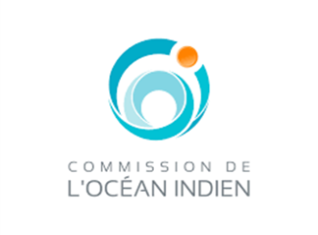


Building Regional Resilience through Strengthened Meteorological, Hydrological and Climate Services
in the Indian Ocean Commission Member Countries (Hydromet Project)

FEASIBILITY REPORT (FINAL)

March 2020



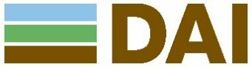
AFD/DOE/CLI-DCP-2017-060
Contract #: CZZ2152-MS-2019-03


This technical assistance operation is financed by the Agence Française de Développement (AFD) as part of the Adapt'Action Facility. This Facility, launched in May 2017, supports African countries, LDCs and SIDS in the implementation of their commitments under the Paris Climate Agreement, through the financing of studies, capacity-building and technical assistance, particularly in the adaptation sector. The authors assume full responsibility for the content of this document. The opinions expressed do not necessarily reflect those of AFD or its partners.
Table of Contents
Acronyms and abbreviations iv
Glossary of key terms viii
Executive Summary ix
Introduction xiii
Chapter 1 Climate change risks, impacts and vulnerability 1
1.1 Overview of regional climatic events and parameters 1
1.1.1 Regional severe events 1
1.1.2 Regional precipitation and temperature evolution 3
1.1.3 Impact of climate change on Tropical cyclones 4
1.2 Comoros 5
1.2.1 Climate risk profile 5
1.2.2 Climate vulnerability 8
1.3 Madagascar 11
1.3.1 Climate risk profile 11
1.3.2 Climate vulnerability 14
1.4 Mauritius 16
1.4.1 Climate risk profile 16
1.4.2 Climate vulnerability 20
1.5 Seychelles 22
1.5.1 Climate risk profile 22
1.5.2 Climate vulnerability 26
Chapter 2 Institutional frameworks, Policies and Projects 29
2.1 Regional level 29
2.1.1 Policies and strategies 29
2.1.2 SWIOCOF 29
2.1.3 SARCOF 30
2.1.4 NCOF 32
2.1.5 User-interface platform 33
2.1.6 Regional baseline projects 34
2.2 Comoros 35
2.2.1 Policies and strategies on climate services and DRR 35
2.2.2 Institutions and mandates of NMHSs and DRR institutions 37
2.2.3 Baseline projects 43
2.3 Madagascar 44
2.3.1 Policies and strategies 44
2.3.2 Institutions and mandates of NMHSs and DRR institutions 46
2.3.3 Baseline projects 54
2.4 Mauritius 55
2.4.1 Policies and strategies 55
2.4.2 Institutions and mandates of NMHSs and DRR institutions 57
2.4.3 Baseline projects 61
2.5 Seychelles 62
2.5.1 Policies and strategies 62
2.5.2 Institutions and mandates of NMHSs and DRR institutions 65
2.5.3 Baseline projects 72
Chapter 3 Assessment of meteorological institutions and existing climate services in SWIO region 74
3.1 Comoros 78
3.1.1 Assessment of NHMS 78
3.1.2 Assessment of existing climate services users and platforms 79
3.1.3 Assessment of EWS, End-users and Case Studies 80
3.1.4 SWOT analysis 96
3.2 Madagascar 98
3.2.1 Assessment of NMHS 98
3.2.2 Assessment of existing climate services users and platforms 99
3.2.3 Assessment of EWS, End-users and Case Studies 102
3.2.4 SWOT analysis 112
3.3 Mauritius 114
3.3.1 Assessment of NHMS 114
3.3.2 Assessment of existing climate services users and platforms 116
3.3.3 Assessment of EWS, End-users and Case Studies 117
3.3.4 SWOT analysis 126
3.4 Seychelles 127
3.4.1 Assessment of NHMS 127
3.4.2 Assessment of existing climate services users and platforms 129
3.4.3 Assessment of EWS, End-users and Case Studies 131
3.4.4 SWOT analysis 141
Chapter 4 Recommendations 143
4.1 Recommendations to improve institutional capacities and NFCS for NMHS 143
4.1.1 All countries 143
4.1.2 Comoros 144
4.1.3 Madagascar 144
4.1.4 Mauritius 145
4.1.5 Seychelles 145
4.2 Recommendations to modernise NMHS equipment and skills 145
4.2.1 Comoros 145
4.2.2 Madagascar 146
4.2.3 Mauritius 146
4.2.4 Seychelles 147
4.3 Recommendations to improve EWS and relevance to Sector Users 148
4.3.1 All countries 148
4.3.2 Comoros 149
4.3.3 Madagascar 149
4.3.4 Mauritius 150
4.3.5 Seychelles 150
4.4 Recommendations to improve communications with End Users 150
4.4.1 All countries 150
4.4.2 Comoros 151
4.4.3 Madagascar 152
4.4.4 Mauritius 152
4.4.5 Seychelles 153
4.5 Recommendations to improve regional cooperation and synergies with other initiatives 153
4.6 Additional recommendations 154
4.6.1 Comoros 154
4.6.2 Madagascar 154
4.6.3 Seychelles 154
Chapter 5 Action Plan 155
5.1 Project rationale 155
5.2 Project description and theory of change 156
5.2.1 Theory of Change 156
5.2.2 Project Framework 160
5.2.3 Summary of equipment and technical training at regional level and per country 177
5.3 Project Budget per activity 182
5.3.1 Overall budget by component and source of funding (in USD) 182
5.3.2 O&M costs 184
5.4 Project indicators 184
5.5 Overall project benefits 192
5.5.1 Overview of benefits 192
5.5.2 Summary of the CBA 192
5.6 Implementation arrangements 193
5.6.1 Roles and responsibilities 193
5.6.2 Contracts and flow of funds 197
5.6.3 Profiles of PMU staff 198
Chapter 6 Conclusions and Recommendations 202
Appendix 1 Technical specification of project interventions 203
Equipment and infrastructure 203
Infrastructure works 206
Information system 206
R&D development 207
Technical capacity building 207

Acronyms and abbreviations
ACMAD | African Centre of Meteorological Application for Development
AfDB | African Development Bank
ARPEGE | Action de Recherche Petite Echelle Grande Echelle
ASECNA | Agency for the Safety of Air Navigation in Africa and Madagascar
AWS | Automatic Weather Station
CCVA | Climate change vulnerability risk assessment
CP | Command Post
CRS | Catholic Relief Services
CS | Climate Services
DEM | Digital Elevation Model
DRR | Disaster Risk Reduction
ECMWF | European Centre for Medium-Range Weather Forecasts
EE | Executing Entity
EOP | Emergency Operations Procedures
ESA | European Space Agency
EWS | Early Warning Services
FP | Funding Proposal
FS | Feasibility Study
GCF | Green Climate Fund
GCM | Global Climate Models
GETI | Global Education and Training Institute (of UNDRR)
GFCS | Global Framework for Climate Services
GFDRR | Global Facility for Disaster Reduction and Recovery
GFS | Global Forecast System
GIS | Geographic Information System
GRC | Gestion des Risques et des Catastrophes
HFA | Hyogo Framework for Action
IAEA | International Atomic Energy Agency
INDC | Intended Nationally Determined Contributions
INGC | Instituto Nacional de Gestao de Calamidades, Mozambique
IN-MHEWS | International Network for Multi-Hazard Early Warning Systems
IOC | Indian Ocean Commission
ITCZ | Intertropical Convergence Zone
IWRM | Integrated Management of Water Resources
JRC | Joint Research Centre (European Commission)
PEIDs | Petits Etats Insulaires en Développement
PMA | Pays Moins Avancés
MHEWS | Multi-Hazard Early Warning Systems
MSLP | Mean Sea Level Pressure
NAP | National Adaptation Plan
NAPA | National Adaptation Programme of Action
NFCS | National Framework for Climate Services
NMHS | National Hydro Meteorological Services
NOAA | National Oceanic and Atmospheric Administration
NTWC | National Tsunami Warning Centre
PDNA | Post Disaster Needs Assessment
PIROI | Indian Ocean Regional Intervention Platform of the International Red Cross and Red Crescent Movement
PMU | Project Management Unit
RCOF | Regional Climate Outlook Forum
RCMP | Royal Canadian Mounted Police
RIMES | Integrated Multi-Hazard Early Warning System for the Afro-Asian Region
RPSC | Regional Project Steering Committee
RSMC | Regional Specialized Meteorological Centre
RTSP | Regional Tsunami Service Providers (India)
TAHMO | Trans-African Hydro Meteorological Observatory
SADC | Southern African Development Community
SARCOF | Southern African Regional Climate Outlook Forum
SWIO – RAFI | Southwest Indian Ocean Risk Assessment
SWIO | South West Indian Ocean
SWIOCOF | South West Indian Ocean Climate Outlook Forum
SWOT | Strengths, Weaknesses, Opportunities and Threats
UIP | User-Interface Platform
UNDAC | United Nations Disaster Assessment and Coordination
UNDRR | United Nations Office for Disaster Risk Reduction (formerly known as UNISDR)
UNFCCC | United Nations Framework Convention on Climate Change
VCA | Vulnerability and Capacity Assessment
VDA | Village Development Association
VMM | Veille météorologique mondiale
WMO | World Meteorological Organization

Comoros
ANACM | Agence Nationale de l’Aviation Civile et de la Météorologie
CATI | Cellule d’Analyse et de Traitement de l’Information
CGC | Corps des Gardes Côtes
CIGRC | Commission Insulaire de Gestion des Risques de Catastrophes
CMS | Comoros Meteorological Service
CNDO | Centre national des données et informations océanographiques
CNGRC | Commission Nationale de Gestion des Risques de Catastrophes
CRC | Croix Rouge Comorienne
COSEP | Centre des Opérations de Secours et de la Protection Civile
DAC | Direction de l’Aviation Civile
DGF | Direction Générale des Forêts
DGS | La Direction Générale de la Santé
DGSC | Direction Générale de la Sécurité Civile
DM | Direction de la Météorologie
DNS | Direction Nationale de la Santé
DTM | Direction des transports maritimes
MAPE | Ministère de l’Agriculture, de la pêche et de l’environnement
MATU TT | Ministère de l’aménagement du territoire, de l’urbanisme et des transports terrestres
MESR | Ministère de l’enseignement supérieur et de la recherche
MIDAT | Ministère de l’intérieur, de la décentralisation et de l’aménagement du territoire
MPTENI | Ministère des Postes télécommunications, de l’économie numérique et de l’information
MSSPSPG | Ministère de la santé, protection sociale et prise en compte du genre
MTMA | Ministère des transports maritimes et de l’aviation
OVK | Observatoire du Volcan Karthala
PNPRRC | Plateforme nationale pour la prévention des risques de catastrophes
PRP | Plan de Relèvement Précoce
PSS | Plans de Secours Spécialisé
SNRRC | Stratégie Nationale de Réduction des Risques de Catastrophes aux Comores
SOGEM | Société de Gestion de l’Eau de Mohéli
UCEA | Union des Comités de l’Eau d’Anjouan
UCEM | Union des Comités de l’Eau de Mohéli
UDC | Université des Comores

Madagascar
AD2M | Appui au Développement des Régions Melaky et Menabe
APIPA | Autorité de Protection contre les Inondations de la Plaine d’Antananarivo
BCPR | Bureau for Crisis Prevention and Recovery
BNGRC | Bureau National de Gestion des Risques et des Catastrophes
CCGRC | Comité Communal de Gestion des Risques et Catastrophes
CDGRC | Comité District de Gestion des Risques et Catastrophes
CERVO | Centre d’Etude et de Réflexion de Veille et d’Orientation
CIL | Centre des infrastructures et de la logistique
CISRI | Climate Information Services Research Initiative
CLGRC | Comité Local de Gestion des Risques et Catastrophes
CNA | Centre national Anti-acridien
CNES | Centre National d’Etudes Spatiales (National Centre for Space Studies)
CNGRC | Conseil National de Gestion des Risques et Catastrophes
CPC | Corps de Protection Civile (Civil Protection Corps)
CPGU | Cellule de prévention et de gestion des urgences
CRIC | Comité de Réflexion des Intervenants en Catastrophes
CRM | Croix Rouge Malgache
CTD | Collectivité territoriale décentralisée
DAPV | Direction de l’agriculture en appui à la production végétale
DEM | Directorate of Meteorological Operations
DGM | Direction Générale de la Météorologie
DHRD | Directorate of Hydro-meteorological Research and Development Department
DMA | Directorate of Applied Meteorology
DREEH | Direction régionale de l’Eau, de l’Energie et des hydrocarbures
GTCS | Groupe de Travail Climat Santé
EMMO/REG | Etat-Major mixte de l’Armée malgache
IOGA | Institut et Observatoire de Géophysique d’Antananarivo
MAEP | Ministère de l’Agriculture, de l’Élevage et de la Pêche
MATHTP | Ministère de l’aménagement du territoire, de l’habitat et des travaux publics
MCC | Ministère de la Communication et de la Culture
MDN | Ministère de la Défense Nationale
MEDD | Ministère de l’Environnement et du Développement Durable
MEEH | Ministère de l’Energie, de l’Eau et des Hydrocarbures
MENETP | Ministère de l’Education Nationale et de l’Enseignement Technique et Professionnel
MESRS | Ministère de l’Enseignement Supérieur et de la Recherche Scientifique
MID | Ministère de l’Intérieur et de la Decentralisation
MPPSPF | Ministère de la Population, de la Protection Sociale et de la Promotion de la Femme
MPTDN | Ministère des Postes, des Télécommunications et du Développement Numérique
MSP | Ministère de la Santé Publique
MSPP | Ministère de la Sécurité publique & police
MTTM | Ministère des Transports, du Tourisme et de la Météorologie
NAPIHMS | National Action Plan for the Improvement of Hydro-meteorological Services
NHMSUG | National Hydro-Meteorological Services Users Group
ONE | Office National de l’Environnement
ORSEC | Plan d’ORanisation des SECours
PACARC | Amélioration des capacités d’adaptation et de résilience des communautés rurales face au CC
PHSP | Plateforme humanitaire du secteur privé
PNGRC | Politique Nationale de Gestion des Risques et des Catastrophes
PNRRC | Plateforme Nationale pour la Reduction des Risques et des Catastrophes
PRADA | Adaptation des chaînes de valeur agricoles au changement climatique (GIZ project)
SAHH | Service d’Appui à l’Hydrologie et l’Hydrogeologie
SNGRC | Stratégie nationale de gestion des risques de catastrophes
SNPS | Stratégie nationale pour la protection sociale
SPCR | Madagascar’s Strategic Programme for Climate Resilience
SURECa | Service des Urgences et de Riposte

Mauritius
CCD | Climate change division (referring to Min of Environment)
ICZM | Integrated coastal zones management division (referring to Min of Environment)
LDA | Land drainage authority (referring to NDU)
LEOC | Local emergency operation commands
MAI | Ministry of Agro-industry and Food Security
MoDHAEC | Ministry of Defence, Home Affairs and External Communications
MEPU | Ministry of Energy and Public Utilities
MESWMCC | Ministry of Environment, Solid Waste Management and Climate Change
MHLUP | Ministry of Housing and Land Use Planning
MMS | Mauritius Meteorology Services (referring to Min of Environment)
MOI | Mauritius Oceanography Institute
MNICD | Ministry of National Infrastructure and Community Development
NDRRMC | National disaster risk reduction management center (referring to Ministry of Local Government, Disaster and Risk Management)
NDS | National Disasters Scheme
NDU | National development unit (referring to Prime ministry)
NEOC | National emergency operations command
NIWRM | National Integrated water resources management Plan
NPC | National Parks Council (referring to Min of Agro-industry)
NPS | National Planning Scheme
NRPP | National Risk Prevention Plan
OPS | Outline Planning Scheme (at district level)
PLFRP | Port Louis Flood Response plan
REOC | Rodrigues emergency operations command
RID | Risk Information Document
SCD | Shelf continental department (referring to MofD&R)
SCCOP | Self-Safe Community Operation Plan
WRU | Water Resources Unit

Seychelles
DA | District Administrator
DRDM | Department of Risk and Disaster Management
NCEP | National Center for Environmental Prediction
RGMC | Regional Specialized Meteorological Centre
SMA | Seychelles Meteorological Authority

Glossary of key terms
Climate services (based on GFCS and WMO definitions): CS equip decision-makers in climate-sensitive sectors with better information to help society adapt to climate variability and change. They are produced based on high quality climate-related data (for temperature, rainfall, wind, etc.), risk maps, vulnerability assessments, long-term projections and scenario. These data are sometimes combined with socio-economic variables (e.g. agricultural production, human settlement maps) to produce services tailored to users’ needs. These meteorological and non-meteorological variables are transformed into usable products, like agricultural advisories for farmers, which are produced using seasonal forecasts (climate information) combined with knowledge of the growing seasons and crops in a specific area. The service must respond to user needs, must be based on scientifically credible information and expertise, and requires appropriate engagement between the users and providers.
Users of climate services (based on WMO definition): Recipients of climate information, such as trend projections and forecasts of various climate and weather parameters, who interpret, analyse and process it in light of sector-specific knowledge in order to produce a useable, tailored and integrated climate service that can be communicated to end-users. Users are partners of NMHS to produce CS; they are in charge of processing climate information (input) to produce sector-tailored climate services (output).
End-users of climate services: It is a mix of stakeholders from the national, sub-national and community levels. Each user can derive a benefit – potential or actual – in using climate services. Final- or end-users of climate services often do not need climate information/data, but a finished useable climate advisory service or product that they can input into their decision-making. End-users encompasses farmers, fishermen, vulnerable communities, etc., as well as national decision-makers and planners who need finished climate information products at longer timescales (climate projections).
NHMS: This term is used throughout the report to refer to both meteorological AND hydrological institutions/services (whether they are part of the same institution e.g. in Madagascar or separated entities e.g. in Mauritius). When we refer to one institution specifically, we will use the terms meteorological services or hydrological services.

Executive Summary
This Feasibility Study (FS) is written in support to the Funding Proposal submitted to the Green Climate Fund, entitled “Building Regional Resilience through Strengthened Meteorological, Hydrological and Climate Services in the Indian Ocean Commission (IOC) countries” – namely project Hydromet. This FS and Funding Proposal were prepared in agreement with the governments of Comoros, Madagascar, Mauritius and Seychelles, the IOC (the project Executing Entity) and the AFD (Accredited Entity for this project and which provided financial support for the development of these studies and proposal). The development objective of this project is to enhance adaptative capacity and climate resilience of communities and economic sectors in 4 countries of the SWIO region. To enable sustained economic growth, foster climate change adaptation and improve livelihoods, the proposed project will implement interventions that will strengthen the technical capacities of hydro-meteorological institutions to monitor weather, climate and hydrological data, and to produce timely, locally-relevant climate services (CS) that respond to user needs. While important, strengthening the technical capacities of hydro-meteorological institutions is not sufficient to adequately support the production of climate services that adequately equip decision makers with essential tools and knowledge to help adaptation to climate variability and change in climate-sensitive sectors and communities. Hence, the proposed project will also support institutional strengthening, organisational efficiency (including financial), service delivery, and stakeholder engagement for CS co-production. This will be achieved through various interventions implemented at regional and national level in the SWIO region.
Climate risks and vulnerability
The SWIO region has been recognised as a ‘climate hotspot’ due to its high exposure to climate-related hazards including tropical cyclones, heavy rainfalls, storm surges and droughts. The SWIO-RAFI study, led by the World Bank in 2017, indicated that over the last 50 years, Comoros, Madagascar, Mauritius and Seychelles have been affected by more than 100 natural disasters, 94 of them related to hydro-meteorological phenomena. The population affected by these hazards was estimated at 14.4 million people across the four counties, and the physical damage resulting from climate events was estimated at USD 13.1 billion. The affected population and physical damages resulting from climate-related hazards are likely to rise in the coming years, as both the frequency and the intensity of these hazards are expected to increase in the context of climate change.
Despite very different socio-economic contexts – with Comoros and Madagascar classified as Least Developed Countries, Mauritius as upper-middle income country and Seychelles as high-income country – the economy and populations of these four islands are extremely vulnerable to climate-related hazards. In Comoros and Madagascar, the population is highly reliant on agriculture and fisheries, two key economic sectors which are severely affected by increased temperature, tropical cyclones, sea level rise and coastal erosion, as well as changes in sea temperature. In Mauritius and Seychelles, the economy is highly depending on tourism, which is also threatened by tropical cyclones, increased occurrence of floods and flash floods, landslides, and storm surges resulting in coastal erosion. In all countries, other key sectors are also affected by climate-related impacts including health, water and disaster risk reduction.
These four islands are also characterised by microclimates, which makes it all the more difficult to predict climate-related hazards and therefore implement risk mitigation or avoidance measures. More precisely, there is a lack of locally-relevant climate and weather information to inform decision-making processes, a limited production and dissemination of climate services that can help reduce risk exposure and vulnerability among communities and sectors and limited cooperation at the regional level to monitor risk and share risk-related information in the SWIO countries. As a result, Comoros, Madagascar, Mauritius and Seychelles are increasingly vulnerable to the impact of climate change.
Climate services in the SWIO region
Climate-related losses and damages can be reduced or even avoided through the provision of weather and climate information. Such information can equip decision-makers with essential tools and knowledge to help adaptation to climate variability and change in climate-sensitive sectors and communities. Climate services are increasingly useful in the context of climate change, to enable risk preparedness, and to improve mitigation and response to increasing climate vulnerability and extremes. Studies have demonstrated that a better access to relevant climate information contribute to reduce vulnerability.
There are currently several barriers to producing timely, accurate, and user-friendly weather and climate services in the SWIO region. Nonetheless, the governments of Comoros, Madagascar, Mauritius and Seychelles recognize the importance of CS to reduce the impacts of climate hazards on communities and economic sectors. At the regional level, the Indian Ocean Commission (IOC) – of which these four countries are members – has adopted a climate change adaptation strategy that advocates strengthening forecasting and climate anticipation capabilities, increasing the capacity of all actors, and disseminating climate information more broadly. At the national level, the hydrometeorological services of the four countries have engaged in several initiatives to improve the production and delivery of CS to vulnerable communities and sectors. For example, ANACM in Comoros is currently implementing a project to improve water resources data management with support from UNDP and GCF; DGM in Madagascar is developing agricultural advisory services with support from the GIZ; in Mauritius, the LDA is in the process of mapping all flooded and vulnerable areas to improve land use planning with the support of AFD; finally, in Seychelles, the IAEA is supporting the government to better detect harmful algal blooms, which are detrimental to the fishery sector.
Despite these existing initiatives, which are often limited to one sector or region of a country, both the IOC and the governments of the four above-mentioned countries lack the financial resources, expertise and robust institutions to foster regional cooperation for risk monitoring and forecast, and strengthen the national hydro-metrological services at scale, in order to effect a paradigm shift towards climate resilience and adaptive capacities among communities in the SWIO region.
Request for GCF support
GCF investment is therefore requested to achieve a transformative impact on monitoring and managing climate, weather and hydrological risks in the short-, medium-, and long-term, facilitate growth in key climate sensitive sectors like food security, water, health, energy and disaster risk reduction and enable adaptation to climate change impacts. In particular, GCF resources will be deployed across 3 components that will enable the paradigm shift:
Component 1: Capacity building, institutional development and regional cooperation
Under this component, a Regional Climate Centre (RCC) will be established; and Regional and National Frameworks for Climate Services (RFCS & NFCS) developed. This will: i) facilitate information, experience and knowledge sharing within the SWIO region for risk prevention/mitigation; ii) harmonize processes to monitor climate-related risks and disseminate alerts; iii) support co-development of regional climate change models and projections; and iv) support cost efficiency by sharing facilities (i.e. regional training center and regional lab for the maintenance and regular calibration of hydrometeorological equipment). The RFCS is the basis under which IOC member states develop their own NFCS and adopt a common risk culture that reinforces weather data collection and information sharing to better understand and monitor main hazards for the region (i.e. tropical cyclones with violent winds and heavy rain, etc.). The organisation of this framework will capitalise on the existing regional organisation implemented for the cyclone forecast (Tropical Cyclone Committee TCC) knowing that this TCC maintains a Tropical Cyclone Operation Plan (TCOP) recording all the international arrangements regarding the information and data sharing. These frameworks will establish a common methodology in the SWIO region for weather, climate monitoring and forecasts – based on WMO standards –, procedures to co-produce CS with the users of these services, package and disseminate them, and protocols to systematically include users’ feedback in the production of CS.
Finally, the hydro-meteorological services in the four target countries will be strengthened, with a focus on streamlining roles and responsibilities, enhancing staffing and skills through core trainings, improve working environment (to retain skilled staff), fostering collaboration between meteorological and hydrological institutions (where such institutions are separated) and DRR institutions, and improving their financial efficiency. This work will result in robust NHMS, following WMO recommendations to support the transition of the meteorological services into autonomous entities.
Component 2: High-quality climate-related data, and improved climate risk assessments and climate change projections
This component essentially engages technical expertise on observations and monitoring, data management, ICT and forecasting to support the modernization of hydro-meteorological data collection infrastructure, management and access to information systems for optimal utilization in the SWIO region. Hydro-meteorological equipment in the four target countries will be improved, based on country-specific needs which have been identified during the Project Proposal Development phase (PPD). At the regional level, a regional maintenance lab will be established to facilitate the maintenance and calibration of hydrometeorological equipment; and the regional training center based in Mauritius will be refurbished. Research and development capacities will also be strengthened through trainings, which will essentially take place at the regional level and target staff members from the meteorological and hydrological services. Training will focus on: i) improved daily forecast (short-term at J+3) and intra-seasonal forecasts; ii) enhance climate change predictions/models for short- to long-term (6 months to 30 years) at regional level and downscaled at country-level/ local level where possible; iii) support production of hydrological models; and iv) support production of agricultural advisories. At the national level, users of CS will also be engaged through this component as results of the downscaled forecasts and climate change predictions will be used to co-produce climate hazard maps and vulnerability assessments. These will be developed in consultation with key sectors and communities to identify risk-prone areas for selected hazards and level of vulnerability among local communities. Such maps will be useful tools to develop, for example on-the-ground intervention plans and early warning, under Component 3. Moreover, short- and long-term forecasts produced under Component 2, including climate change projections, will be shared on an online platform supported under Component 3 of the project.
Component 3: Enhanced use of climate services for climate change adaptation and disaster risk reduction at national and regional level
Under this component, short- and long-term climate products and services will be co-developed in a participatory way. These CS will be defined based on end-users consultations and they will target key priority areas of the GFCS with a focus on 2 key economic sectors per country (as identified in the project Economic Analysis, Annex 3a). The CS will include long-term climate change adaptation plans for key economic sectors, for example tourism, agriculture or fisheries; as well as enhanced early warnings disseminated to the most vulnerable people. Producers and users of climate services will work together to develop these products to ensure they are packaged according to users’ needs, understandable and use the most efficient dissemination channels. The emphasis will be on setting up a feedback loop to ensure users’ feedback on the CS are collected and integrated to improve such services. Finally, to facilitate access to CS and the implementation of a feedback loop, users from climate-sensitive sectors will be trained to understand and use CS efficiently and invited to attend NCOF and SWIOCOF and to actively engage on the UIP, strengthened under this Component 3.
Project Implementation and Budget
The proposed Hydromet project has a total budget of USD 78,060,500 over a period of 5 years, with an expected total lifespan of 50 years. It will be implemented by the IOC, with support from the meteorological and hydrological departments on the four target countries as well as other relevant institutions as indicated in the project framework (Chapter 5). To implement this project, a GCF grant of USD 59,592,500 is solicited. In addition to the requested funding to the GCF, AFD and E.U. will contribute at USD 11,500,000 Moreover, the project secured co-finance from the beneficiary governments of USD 6,889,000.
The economic and financial analysis developed for the proposed project (Annex 3a) indicates that high returns on investment can be expected, especially in terms of reduced economic losses linked to climate-related hazards and enhanced agricultural production from the delivery of reliable agrometeorological services. For example, in Comoros, an EWS as proposed under the Hydromet project would provide an average benefit of USD 0,280 M as well as benefits up to USD 0,86 M in the agricultural sector from the production of related CS. In Madagascar, an EWS as proposed under the Hydromet project would provide an average benefit of USD 5,029 M per year; in addition, USD 43,5 M in agricultural benefits can be expected from the production of CS in agriculture. In Mauritius, an EWS would provide an average benefit of USD 5,5 M per year and, in Seychelles this benefit would be of USD 0,140 M per year.
In addition to its economic viability, the Hydromet project is an innovative initiative in the SWIO region. There is yet no consolidated approach for climate services in the region that contribute to reducing disaster risks and fostering climate change adaptation using a mix of regional and national-level interventions. Besides the need to strengthen hydro-meteorological equipment and approach to produce and disseminate reliable CS in each target country, the region as a whole would benefit from harmonization of processes and enhanced communication and knowledge sharing. Regarding technical improvements, the regional framework would benefit from two key activities that are currently not done by the four countries. It relies to (i) calibration and maintenance facilities for all the specialised hydro-meteorological equipment (current and future) of the four countries and (ii) development of numerical weather prediction at lowest spatial scale as possible and at all time scale (nowcasting, daily forecast, monthly forecast, seasonal forecast and climatic forecast).
The investment proposed through the Hydromet project is sustainable both economically and institutionally, as well as technically feasible as demonstrated in this FS. It will also generate strong economic, environmental and social benefits, and include gender-related considerations (see Annex 8). The governments of the four target countries have committed to sustain and maintain the equipment, staffing and services established under the Hydromet project, including the shared facilities which will be set up under the RCC. A draft business model is also presented in the economic and financial analysis (see Annexe 3a) and will be further detailed under the Hydromet project to ensure future investments in CS from public and private sectors. The proposed projects will also secure the livelihoods of many people in the four countries, for example directly benefiting to those depending on agriculture, fisheries and tourism; and indirectly benefiting to the whole population of these four islands.
In this context, support from the GCF is key to help countries in the SWIO region deliver high quality, timely available, and understandable climate services that will support sustained economic growth and improved livelihoods in the context of climate change. GCF investments will have long-term impacts as countries in the region will be able to sustain and upscale project interventions, which will place them in a better position to adapt to the impacts of climate change on their people and economy.

Introduction
The island states located in the South West Indian Ocean (SWIO) are particularly vulnerable to climate-related hazards and climate change. These countries have been identified as ‘climate hotspots’ because of their high exposure and vulnerability to climate-related risks including coastal erosion, hydro-meteorological hazards, sea-level rise and saline intrusion, and temperature variability, among others. A study conducted by the World Bank in 2017, the Southwest Indian Ocean Risk Assessment (SWIO - RAFI), confirmed an increased frequency and intensity of extreme weather events in this region. Over the last 50 years, Comoros, Madagascar, Mauritius and Seychelles have been affected by more than 100 natural disasters, 94 of them related to hydro-meteorological phenomena. The population affected by these hazards was estimated at 14.4 million people across the four countries, and the physical damage resulting from climate events was estimated at USD 13.1 billion.
In Comoros, the World Bank estimated an average annual direct loss of USD 5.7 million due to floods and tropical cyclones. Tropical cyclones represent the largest risk with 64% of direct annual losses. In Madagascar, 35 cyclones, 8 floods and 5 severe droughts were noted over the past 20 years, causing damages of over USD 1 billion and affecting food security, water availability, health care and livelihood conditions. In Mauritius, SWIO RAFI indicates a combined USD 110 million in direct losses from earthquakes, floods and tropical cyclones each year. Finally, in Seychelles, the DaLA (Damage, Loss, and Needs Assessment, 2013) produced by the Government of Seychelles finds that Cyclone Felleng caused an estimated loss of USD 8.4 million, equivalent to 0.77% of the country’s GDP.
Comoros, Madagascar, Mauritius and Seychelles are committed to reducing the vulnerability of their population to climate-related hazards. Their commitments are reflected in their adoption of key documents and policies, including NDCs, NAPAs, the Paris Climate Agreement, and national climate change and DRR strategies. These countries have set up targets for disaster risk reduction and aim to put in place effective early warning and risk response systems. Improving hydro-meteorological services is therefore an undeniable necessity to enhance disaster risk management and to ensure sustainable and harmonious development in the SWIO region. More specifically, hydro-meteorological information is essential to ensure the safety of goods, people, and the environment on the one hand, and the sustainability and profitability of any public or private investment on the other hand.
To support the production of hydro-meteorological information that can contribute to reducing vulnerability, strengthening infrastructure and capacity for data collection and interpretation is key. This approach is essential to promote the stability and social cohesion that are essential for peace and economic growth. More specifically, the strengthening of infrastructure and capacity to collect and interpret hydro-meteorological information is essential to produce and disseminate effective early warnings (for example, to anticipate floods or ensure food security) and to inform decision-making in key climate-sensitive sectors such as agriculture & food security, health, water, and disaster risk reduction. These sectors are defined as priority areas in the Global Framework for Climate Services (GFCS) supported by the World Meteorological Organisation (WMO).
The GFCS is a global partnership of governments and organisations that produce and use climate information and services. It seeks to enable researchers and the producers and users of information to join forces to improve the quality and quantity of climate services worldwide, particularly in developing countries.
The GFCS implementation plan, adopted by the World Meteorological Congress in 2014, provides guidelines to promote effective collaboration with global, regional and national stakeholders and efforts. By providing individuals, communities, and the private sector with weather and climate information they can understand and act on, they will be empowered to prepare and act before a disaster strikes and in turn will significantly reduce losses.
To provide communities with integrated weather and climate information, National Hydrological and Meteorological Services (NMHSs) need to develop capacity along the entire service delivery chain. By doing so, they will improve targeted impact-based forecasting, timely dissemination of accurate and easily understandable information, and delivery to the public and other sectors. The adoption of such a robust approach is identified as a high priority in the WMO Guidelines on Multi-hazard Impact-based Forecast and Warning Services (2015, WMO-No 1150) as well as in the Multi-hazard Early Warning Systems: A Checklist (2018), which supports the Sendai Framework for Disaster Risk Reduction 2015-2030 (United Nations, 2015).
Within this context and in line with Decision 10d of the 33rd Council of Ministers of the Indian Ocean Commission (IOC), following IOC request, the Agence Française de Développement (AFD – French Development Agency) has decided to finance a Feasibility Study and a Funding Proposal for the project entitled: “Building Regional Resilience through Strengthened Meteorological, Hydrological and Climate Services in the Indian Ocean Commission (IOC) countries” – namely project Hydromet.
The project rationale is to assist all four states in moving towards the production and dissemination of climate services that allow the development of responses to mitigate those impacts.
It is designed with end users in mind, thereby placing significant resources on addressing end-user needs. Conceived by the IOC, the Hydromet concept was presented to AFD in 2018 and received its support. A Concept Note was then developed and has already been received and amended by the Green Climate Fund (GCF), who has issued a positive opinion on the project.
Based on positive GCF feedback, IOC with support from AFD decided to develop a full-scale Funding Proposal (FP) and complementary annexes. The process started in May 2019 with the aim to submit this project to the GCF in 2020. The project preparation team was commissioned under the AFD Adapt’Action Facility. The consultants carried out in-country consultations and field visits between May and September 2019, including a series of workshops with relevant government and sector representatives to gather feedback on initial project interventions.
- A project kick-off meeting was organised on 09 May 2019 in Mauritius;
- A week-long mission took place between 10-17 May 2019 to meet country partners in Comoros, Madagascar and Mauritius and introduce the work of the consultants (the team met representatives from Mauritius and Seychelles during the kick-off meeting in Mauritius);
- A 4-week mission spread over 24 June – 03 August 2019 was organised in Comoros, Madagascar, Mauritius and Seychelles to collect data to prepare the FS and complementary studies;
- A 2-week mission was organised in the four countries between 26 August and 10 September to discuss FS findings with all relevant parties during national pre-validation workshops;
- A 1-month mission conducted by WMO consultants in the four target countries to develop project interventions linked to strengthening hydrological monitoring (linked to HYCOS project) in June 2019; and
- A regional final validation workshop was organised by IOC in Mauritius on 26 and 27 November, to finalise project interventions and validate the Funding Proposal.
Regular communications with AFD and the IOC Secretariat were organised at various stages of the feasibility study.
The Hydromet Project aims to bolster climate resilience and adaptive capacities among communities by developing national hydro-meteorological services, through strengthening regional cooperation and climate knowledge sharing, and with an overall focus on improving and scaling up climate services (CS) delivery and Multi-Hazard Impact-based Forecast and Warning Services (EWS) in the IOC countries. Led by the Indian Ocean Commission, this project will be co-financed, among others, by the AFD and the European Union; in addition, a close partnership with the WMO has been established to benefit from their expertise in climate services and early warning systems. Yet, a co-financing from the Green Climate Fund is necessary to amplify the transformational character of this project.
This Feasibility Study (FS) has been prepared in support of the Hydromet project. It represents a detailed framework for identifying climate hazards and climate change threats, assessing strength and weaknesses in NMHS and the current development of CS, and highlighting corresponding strategies to improve climate services and increase the resilience of the population in the IOC region.
The study begins with a description of the baseline context in the four target countries (Chapter 1). Thereafter, a detailed presentation of regional and national institutions, plans relevant to climate change, hydrological and meteorological services is provided, along with a presentation of relevant initiatives/projects in the region (Chapter 2). The next chapter examines NMHS and DRR institutions and DRR processes in the four target countries, through a critical review and using real-life case studies of recent disasters (Chapter 3). Based on this critical analysis, a comprehensive suite of recommendations for improving climate services and enhancing the resilience of the region to climate change impacts is provided, based on the WMO GFCS main pillars (Chapter 4). The Feasibility Study concludes with an action plan to implement Hydromet in the SWIO region (Chapter 5).

Chapter 1 Climate change risks, impacts and vulnerability

1.1 Overview of regional climatic events and parameters
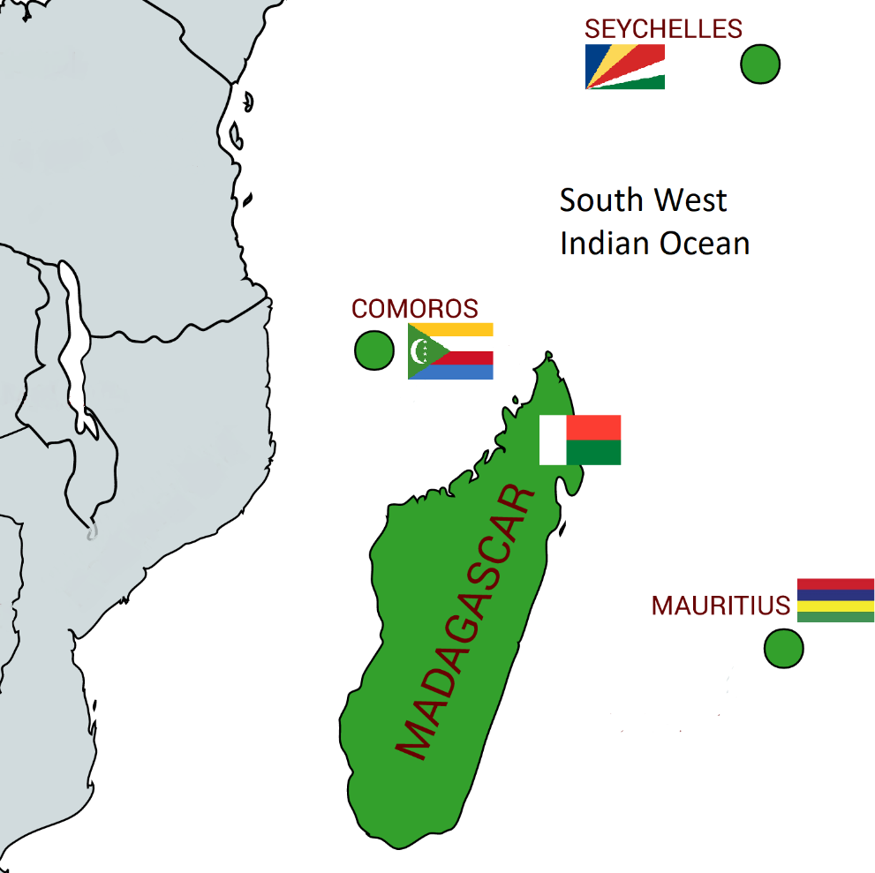
Figure 1: Countries of the SWIO region, member states of IOC

1.1.1 Regional severe events

Tropical cyclones
Tropical cyclones (TC) are the most frequent catastrophic hazard in the SWIO region and have been responsible for significant historical economic losses and casualties, particularly in the island nations of Madagascar and Mauritius. In terms of tropical cyclone formation, the Southwest Indian basin is one of the most active areas in the world. Not only are tropical cyclones more frequent in this ocean basin, but they are also more intense than in other parts of the world. On average, 13 tropical cyclones with wind speeds exceeding 63 km/h form here each year. The SWIO cyclone season begins November 15 and ends April 30 of the following calendar year.
The historical record of tropical cyclones in the SWIO region, which is based on information from local meteorological agencies (e.g., RSMC La Reunion, Australian Bureau of Meteorology (BoM), Joint Typhoon Warning Center (JTWC)) includes 847 events that took place between the years 1950 and 2014 (Figure 2).
In this study developed for the World Bank, the related effects of cyclones like wind, precipitation and flooding and storm surges has been analysed with the following results.
While the historical record includes nearly 850 tropical cyclone events, many of these storms are bypassing or cause little damage. Events are documented when they impact a population center or cause physical damage. These documented events are then further classified as “catastrophic” if they are reported with ≥10,000 people affected, at least $10M USD in losses, or ≥10 deaths.

Figure 2: Figure 2 Storm tracks by Saffir-Simpson category for the 65-year historical record
The distribution of total events and catastrophic events (demarcated with parentheses) are provided in Table 1. Between 1950 and 2015, Madagascar has the highest tropical cyclone event count at 59, of which 48 entries are considered catastrophic events. During this same period, Mauritius, Comoros, and Seychelles experienced 19, 7, and 1 catastrophic event(s), respectively
Table 1 Number of recorded tropical cyclone events for each SWIO island nation, by decade. Events considered to be “catastrophic” are provided in parentheses

Non-Tropical Cyclones
Regular precipitation, or non-tropical cyclone (NTC) rainfall, induced flood events are significant throughout the SWIO region. Characterizing NTC hazard is particularly important for characterizing the flooding risk in countries that are rarely subjected to tropical cyclones, such as Comoros, and Seychelles. In the same study for the World Bank that the one for Tropical Cyclone they calibrated daily precipitation for each country using past reports of significant NTC flooding and subsequently applied to determine whether a spatiotemporal precipitation pattern is likely to cause flooding.
The non-tropical cyclone flood consequence database contains information gathered from publicly available sources about the impacts of 67 events. The distribution of total events and catastrophic events (demarcated with parentheses) are provided in Table 2. Between 1970 and 2015, Mauritius and Seychelles have the highest non-tropical cyclone flooding event count at 20 and 22, respectively, of which 9 entries in Mauritius and 1 entry in Seychelles are considered catastrophic events. During this same period, Madagascar and Comoros experienced 9 and 2 catastrophic events, respectively.
Table 2 Number of recorded non-tropical cyclone flooding events for each SWIO island nation, by decade. Events considered to be “catastrophic” are provided in parentheses.
On the top of the list of these events, the most serious damages have been done by the following marquee historical events:
Table 3 Selected marquee historical events organized by peril.

1.1.2 Regional precipitation and temperature evolution
We refer on the following pictures on data available on the climate change knowledge portal of the World Bank.

Precipitation
Comparing the two periods 1961-1990 and 1991-2016, an increase of precipitation during the rainy season is noted while a decrease of precipitation is noted during the dry season. It implies an increase of drought and flooding.
Figure 3: Average Monthly Rainfall of the Indian Ocean Watershed (World Bank)
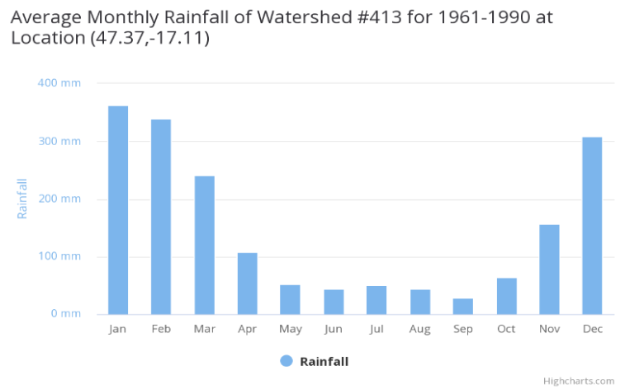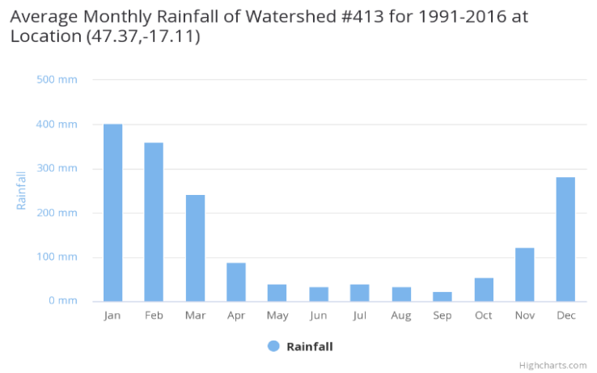

Temperature
Comparing the three period periods from 1931-1930 to 1991-2016, an increase of maximum temperature in January-March is observed from 23.5 to 24° during the last period.
The minimum temperature observed in July is less impacted with values around 18.7 from 1931 to 1990 and 18.9° in the period 1991-2016.
Figure 4: Average Monthly temperatures of the Indian Ocean Watershed (World Bank)
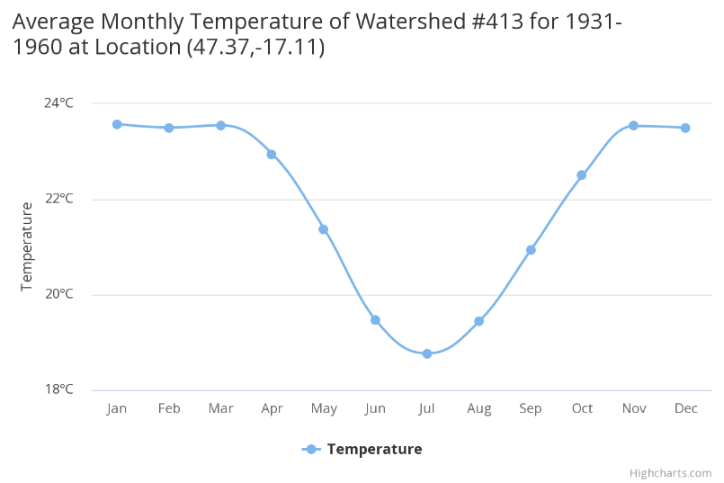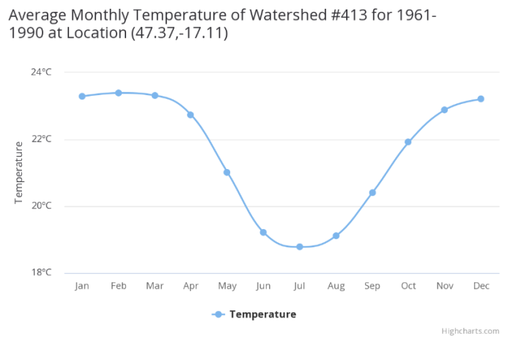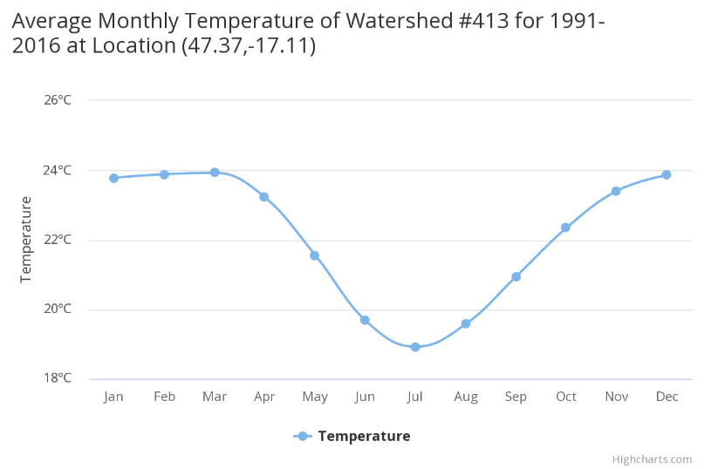

1.1.3 Impact of climate change on Tropical cyclones
Many studies have been done on this topic and the most recent is the one called “Projected changes in tropical cyclones over the South West Indian Ocean under different extents of global warming “.
In this paper an ensemble of very high-resolution climate model simulations of present-day climate, and projections of future climate change over southern Africa, has been analysed and the main results are a decrease of the number of tropical cyclones with a light decrease of the intensity as we can see on the following picture.
Figure 5 Median of simulated maximum wind speed per latitude (as indicated) over the South West Indian Ocean (35◦E–80◦E) relative to present simulated maximum, for 1.5 ◦C warming (solid black line), 2 ◦C warming (broken black line) and 3 ◦C warming (broken grey line).

1.2 Comoros
The Union of the Comoros is a group of islands with an area of 2,235 km² located between Madagascar and Mozambique, north of the Mozambique Channel. In 2018, the country had a population of 845,477 (71.2% living in rural areas).
The islands of the Comoros are volcanic with a total of 340 km of coastline. Grande Comore is the largest island, with a generally rocky surface, shallow soils and no permanent streams. Mohéli, the smallest of the three islands, includes a large plateau, fertile valleys and hills covered with thick forests. The Anjouan terrain is dominated by the central volcano of Mount Ntingui. Soil coverage is being depleted in some areas due to erosion.
Ranked as a low-income country by the World Bank, Comoros has an economy that is largely based on subsistence agriculture and fisheries and is heavily dependent on foreign aid. The country's economic development has been hampered by general political instability.

1.2.1 Climate risk profile
The climate of the Comoros, specifically the type of maritime tropical, presents local contrasts marked by microclimates, due to the influence of typography on the different climatic components, in particular rainfall. This tropical climate is characterized by two main seasons: a hot and humid season (rainy season) marked by heavy rains and sometimes hurricanes with average temperatures of around 27°C; and another dry and cool season less humid than the previous one and with average temperatures of 23 to 24°C and an almost permanent wind, trade winds or sea breeze.

Temperature
According to studies conducted in Comoros by C. McSweeney and al, it is noted that the average annual temperature increased by 0.9°C from 1960 to 2000, with an average rate of 0.19°C per decade. This temperature increase was faster in March-April and May, at a rate of 0.22°C per decade.
The following figures show an upward trend in maximum temperatures over the last four decades (1960-2000). It appears that the minimum temperature shows a greater upward trend compared to the maximum temperature.
Figure 6 Maximum temperatures (1960-2000) (C. McSweeney et al)
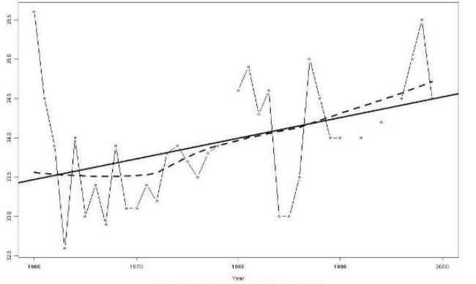
Figure 7 Minimum temperatures 1960-2000 (C. McSweeney , M. New)
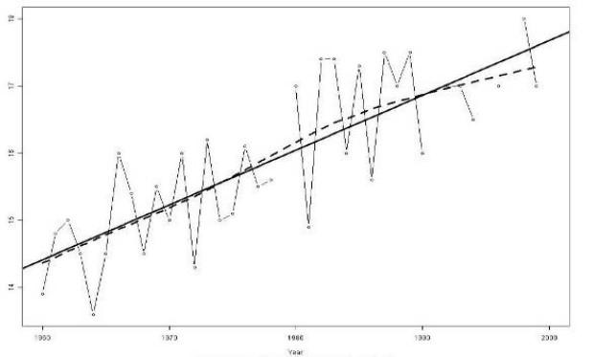

Precipitations
An analysis of daily (2008-2016) and monthly (1901-2015) rainfall data from Moroni (Southwestern Greater Comoros) and daily rainfall data from Ouani (North-eastern Anjouan) is available for the frequency of rainy dry periods and extreme rain events.
Monthly data are suitable for extended dry periods and daily data are useful for extreme events. The main conclusions are summarized below.
Monthly rainfall data for Moroni, collected in 12-month totals and classified for the entire rainfall record, indicate Feb 1999, Nov 2003, Dec 2007 and Jan 2013 as the driest 4 months over the entire period. Since 1960, there has also been a clear trend towards drier conditions from season to season, throughout the annual moving average. The study also confirms an increasing frequency of extreme phenomena trends (more dry periods over the last 2 decades).
It is therefore reasonable to conclude that the Comoros already has more extreme rainfall patterns and that its baseline over the last two or three decades is therefore already based on increased climate variability and climate change.

Analysis of daily rain data
A set of daily rainfall data over 9 years was analysed for Moroni and Hahaya in Grande Comore and Ouani in Anjouan. This makes it possible to evaluate sub-monthly precipitation patterns.
There is no obvious trend in the number of dry days or maximum number of consecutive dry days over the last 9 years. However, there is an upward trend in the number of consecutive 10-day dry periods in a year over the past 9 years.
The above analysis was repeated for the actual dry days, meaning the days when precipitation minus evapotranspiration is <0 mm/d, which is a more useful indicator for agriculture. In this analysis, the longest effective dry period consecutive to Moroni increased to 54 days and Ouani to 92 days, although that of Hahaya remained at 155 days.
It should be noted, as mentioned above, that the 4 driest periods recorded since 1960 have been observed over the past 16 years. As such, these dry day periods are part of a growing trend towards drought in precipitation. Daily rainfall data were not available until 1998, but it is likely that dry periods were less extreme before that date, based on monthly data.

Analysis of extreme rainfall
The frequency and intensity of extreme rainfall events were also analysed over the past nine years.
Extreme precipitation can last more than a day. Tropical storms and cyclones can sometimes last more than two to three days, spread over three to four or more calendar days. The daily analysis was therefore undertaken not only over one day, but also over two days, three days, four days and five days.
The heavy rainfall analysis determined that the maximum daily rainfall was 423 mm in Moroni, 197 mm in Hahaya and 347 mm in Ouani - all in different years. The Moroni rains took place in April 2012 and were one of the heavy rainy days that caused the April 2012 floods, which caused extensive damage on the three islands, but were particularly extreme in southern Greater Comoros, seriously damaging the water supply to the city of Moroni for a period of 2 months.
The April 2012 rains lasted 6 consecutive days with rainfall > 100 mm/d, for a total of more than 1250 mm, more than the annual average in some parts of the country.
Analysis of the high daily precipitation shows that the maximum annual precipitation is greater than 100 mm/day over 8 years over the last 9 years at the three stations. There has been no obvious upward trend over the past 9 years, but this is clearly a significant amount of water, especially considering the 3-day total for the 3 sites of > 200 mm, which highlights the persistent and continuous risk of flash flooding in the Comoros.
A specific review of the global climate model (GCM) forecasts for Mutsamudu in Anjouan a 5% reduction in annual precipitation by 2065, but most importantly a reduction of up to 80% in dry season precipitation (June to October) and 100% increases in monthly precipitation for some GCM forecasts during some months of the wet season.
Global Climate Model forecasts suggest that precipitation intensity will increase during the wettest months. The most likely climate change scenario is therefore an increase in extreme precipitation events, which is consistent with climate change forecasts more generally. The Comoros can therefore expect more frequent and intense rainfall than at present, although rainfall data already confirms that the Comoros has experienced greater climate variability since the 1990s.

Sea level rise
Different studies show an accelerated rise in sea level due to the rise in ocean temperature, which will have repercussions on coastal erosion. Sea level rise is particularly high in the southwestern part of the country.
A study conducted by Hamid Soulé and Ahmed Abdoulkarim to assess the vulnerability of the Comorian population to various hydro-meteorological and geological hazards, taking into account the characteristics and specificities of each of the islands, produced a mapping of ocean upwelling at island level (Figure 8)
Figure 8 Map of ocean upwellings in the Comoros islands
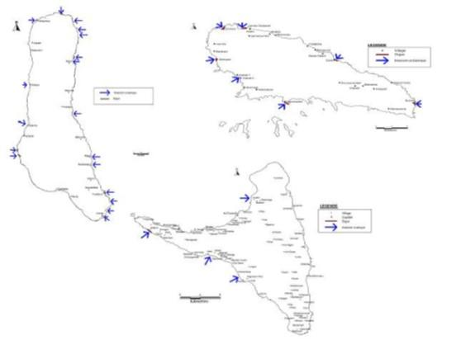

1.2.2 Climate vulnerability
As previously mentioned, Comoros' economy is largely based on subsistence agriculture and fisheries – sectors that are highly sensitive to climate hazards and variability. The country is highly exposed to various hazards, which will increase in the context of climate change, including: rising temperatures, changing rainfall and wind patterns, increased intensity of tropical cyclones, ocean acidification and rising sea levels. Their effects are exacerbated by key environmental problems such as deforestation, which promotes soil degradation, erosion and landslides. This has had a significant negative impact on the country's main economic activities, food security and people's living conditions.
The impacts of climate change affect all economic sectors in Comoros.
Below is an overview of vulnerability in the following sectors: agriculture (and fisheries), health, and water resources. These sectors are identified as priority intervention areas for the provision of climate services in the Global Framework for Climate Services (GFCS) . In addition to these sectors, the GFCS also highlights the importance of disaster risk reduction (see Chapter 2 and 3 of this FS); as well as the energy sector. It should be noted that the sectors presented below have been identified as priorities in various national studies, strategies and policies, including the NAPA (2006), the ACCLIMATE analysis conducted by the IOC (2011), the Second National Communication on Climate Change (2012) and a recent AFD analysis (2018). The Economic and Financial Study (see Annexes) provides more information on vulnerability in the agriculture and fisheries sectors.
It should also be noted that Comoros' limited capacity to adapt is linked to: (i) the high poverty rate of the population, many of whom live in precarious conditions; (ii) infrastructure constraints; and (iii) weak institutional capacities. The most vulnerable socio-economic groups, according to the NAPA (2006), are subsistence farmers and fishermen, who together constitute more than 70% of the working population; they are also the two groups most affected by poverty.

Agriculture and fisheries
Agriculture has traditionally been an important part of the Comorian economy, employing 54.9% of the population and accounting for 30% of GDP. It is mainly present on the island of Anjouan. Important agricultural products include vanilla, cloves, ylang-ylang (perfume essence), coconut, bananas, and cassava. Currently, national agricultural production is not sufficient to meet domestic needs and 40% of all imports are food imports. Agricultural production is likely to decline further, given the vulnerability of this sector to changes in temperature and rainfall, extreme events and sea level rise (leading to soil erosion and salinisation). This would potentially have serious impacts in Comoros, where half the population is food insecure.
The following hazards and climatic variations have already affected the agricultural sector for several years: decrease in rainfall, droughts and the shift in the rainy season. The impacts of these hazards, including water stress, soil and coastal erosion, soil salinisation, and flooding, particularly affect food and cash crops. Changes in rainfall patterns have detrimental effects on crop production, which is mostly rainfed. These include, for example, banana, cassava, and tomato production. Some studies indicate that in the long term, coastal areas may no longer be suitable for banana and tomato production due to rising temperatures. Climate change is also leading to the emergence of new insect pests, particularly on cassava, banana and papaya crops, as well as market gardening.
Cash crops, such as ylang ylang and vanilla, are also affected by climate change. For example, the presence of ylang ylang mainly in coastal areas makes it highly vulnerable to seawater rise and soil salinisation. A decrease or loss of production would result in a significant loss of income for producers of this cash crop. However, there are some opportunities related to climate change, such as the possibility of producing fruit in some regions of Mohéli due to the presence of higher temperatures.
Regarding fisheries, it should be noted that nearly 65% of Comoros' population lives in coastal areas and depends on fishing as their main source of food and income. This activity is affected by rising seas and rising temperatures, including surface waters, ocean acidification and changes in seawater salinity, as well as increasing intensity of extreme events. In 20 years, the sea level has already risen by 30-40m, leading to significant coastal erosion in Comoros. The modification and reduction of marine habitats is already being observed, due to changes in temperature and ocean acidification, the impacts of which are exacerbated by human activities such as dumping waste into the sea.
Rising temperatures can also increase post-harvest losses, while the multiplication of extreme events such as cyclones and storms prevent sea outings and can cause damage/loss of equipment and infrastructure.
Climate change is causing the proliferation of toxic algae and the disappearance of nursery areas for marine wildlife, including corals and mangroves. The latter are particularly threatened by upwelling oceanic water, which leads to the salinisation of soils in coastal areas.

Water resources
Although water resources are present in all of the Comorian islands, only Mohéli and Anjouan have permanent watercourses; Grande Comores has underground reserves. On the three islands, the distribution and quality of water presents challenges - only 23% of Comoros' population has access to drinking water. These challenges are exacerbated by climate change.
In particular, water availability and quality are affected by changes in precipitation (quantity and distribution), rising temperatures, rising sea levels (which lead to salinisation of aquifers in coastal areas), and the frequency of extreme events (which destroy water-related infrastructure). For example, rising temperatures and increased rainfall variability pose risks to groundwater supplies in Grande Comores due to more intense evapotranspiration and decreased recharge of underground aquifers.
Sea level rise leads to saline intrusion, which can reach up to 2 km inland and contaminate aquifers in coastal areas. Finally, decreased rainfall has a negative impact on the hydrographic networks in Mohéli and Anjouan. For example, on Mohéli, the number of permanent watercourses decreased from 49 in 1950 to 10 in 2009.

Health
This sector is sensitive to changes in temperature and rainfall, the multiplication of extreme events, and sea level rise.
The multiplication of flood risks and soil salinisation are changing waterborne diseases by developing conditions favourable to the spread of their vectors. Extreme hazards such as cyclones can destroy water supply and sanitation infrastructure, leading to an increase in vector-borne and water-related diseases such as cholera. The expected rise in temperatures will lead to more frequent cases of dehydration, especially in people at risk such as children, the elderly and the sick. This impact of climate change is also already having an influence on malaria – its incidence has reportedly increased in Comoros, and its geographical prevalence could extend, particularly to high altitude areas previously spared. Many communities in Comoros are all the more vulnerable to this type of disease because they are poor and have limited access to health care services; it should be noted that the quality of health care available in Comoros is low.
Finally, a possible reduction in agricultural, livestock and fisheries production due to climate change could increase food insecurity and lead to an increase in diseases directly related to food, such as cardiovascular diseases and diabetes. Chronic malnutrition particularly affects the poorest, due to the inaccessibility or rising cost of foodstuffs that must be imported (due to the decline in national production), such as meat.

1.3 Madagascar
The Republic of Madagascar is an island nation with an estimated population of 27 million (as at 2019). Madagascar is divided into six provinces (or faritany): Antananarivo, Antsiranana, Fianarantsoa, Mahajanga, Toamasina, and Toliara. Each province is further divided into 22 regions (or Faritra), 118 districts, 1,557 communes and 17,500 fokontany.
Covering a total area of 587,041 km², the island of Madagascar is located in the southwestern Indian Ocean, 400 km from the southeast coast of the African continent (across the Mozambique Channel). Madagascar is characterised by narrow plains and low plateaus along the coast (50 km wide along the eastern coast and 100-120 km wide on the western coast), contrasting with the high plateaus and (often steep) mountains in the centre of the island. The capital, Antananarivo (formerly Tananarive), is located on the island's central plateau. The country is home to many inland lakes and rivers.
Ranked as a low-income country by the World Bank, Madagascar’s economy is largely based on agriculture, and is heavily dependent on foreign aid. The country's economic development has been hampered by general political instability, particularly during the 2009-2014 period.

1.3.1 Climate risk profile
Madagascar is a large island located almost entirely in the tropics. A mountain range located between 1200 and 1500 meters above sea level extends from north to south of the island along its entire length. The geographical situation, its relief, the influence of the sea and wind conditions are at the origin of very variable climatic conditions in the island characterized by two main seasons:
- A dry season from May to October;
- A rainy season from November to April.
From May to October, the climate is affected by high southeast trade winds. During this season, the eastern part of the island benefits from a humid and windy climate, while the western part struggles with a dry leeward climate. During the hot summer season, anticyclones in the Indian Ocean region weaken and the trade winds become less regular, but the eastern part of Madagascar remains under its influence.

Temperature
Regarding temperature, the annual average is between 14°C and 27.5°C. In coastal areas, temperatures vary depending on latitude, and range from 27°C to 23°C from north to south. The west coast is warmer than the east coast by 1°C to 3°C. Across the plateau, average annual temperatures range from 14°C to 22°C. The average temperature reaches its lowest in July throughout the country; the maximum occurs in January and February for most regions except in a few parts of the Highlands and northwest where it is observed in November.
The General Directorate of Meteorology (DGM) reported that temperatures in Madagascar have steadily increased since 1970. Between 1961 and 2005, 17 of the 21 weather stations recorded statistically significant increases in daily minimum temperatures in all seasons. Several stations also indicated an increase in the daily maximum temperature. This seems to be a trend, since the DGM records an average temperature increase of 1% per year. Global warming, which began in 1950 in the south (over 0.2°C in 2000) and gradually spread to the north of the country, is reflected in the rise in extreme temperatures.
Droughts are common in southern Madagascar: the hottest and driest part of the island receives less than 400 mm of rainfall per year. Prolonged dry periods are caused by large-scale disruptions in atmospheric circulation. Droughts quickly lead to water shortages and harvests and seriously threaten the food security of rural households. According to the World Food Programme in Madagascar, in recent years, droughts have caused widespread failure of maize crops in the southern regions, affecting more than 230,000 children under five years of age.³²
Temperature projections
The results of the global climate model do show an increase in temperature, but this is not consistent over the territory:
- The largest increase in the South: from 1.6°C to 2.6°C
- A smaller increase along the coasts: from 1 1°C to 1.8°C
- An increase between 1.3°C and 2.5°C over the rest of the island.
These increases in average temperature will undoubtedly lead to an increase in the duration of drought periods with a very significant impact except on the coasts.

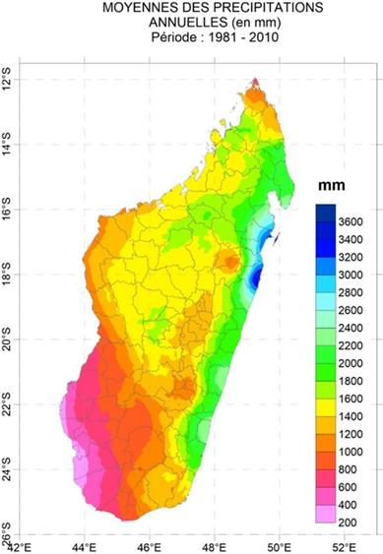
Precipitations
Figure 9 Précipitation annuelles à Madagascar
Rainfall varies from 350 mm on the southwest coast to nearly 4,000 mm in Antongil Bay and Tsaratanana Massif. See Figure 9 above:
The DGM reports that precipitation patterns are becoming increasingly variable and that drought has become more frequent. The average rainfall over the last decade has been between 1000 and 1200 mm. The frequency of cyclones remained almost stable, but their intensity has increased, affecting larger areas.
Projections from the Global Climate Model (GCM) show the following results:
- General increase between months January to April;
- From May to June, decrease in the far south, and increase in the rest of the island;
- From July to September, increase in the northern, north western and highland parts, and decrease in the eastern and south eastern parts;
- In October, decrease over the far southeast and an increase over the rest of the island;
- From November to December, there would be a general increase, except for some uncertainties in the far south and far north.

Cyclones
Madagascar has one of the highest cyclone risks among African countries, with an average of 3 to 4 cyclones affecting the country each year. The tropical cyclone season (November to March) systematically has serious consequences: crop losses, floods and outbreaks of waterborne diseases, coastal degradation and disruption of marine ecosystems, damage to essential infrastructure and services such as water and electricity and, in some cases, victims. In recent years, several damaging cyclones have hit the country.

Sea level rise
The GCM shows an accelerated rise in sea level due to the rise in ocean temperature, which will have repercussions on coastal erosion. Sea level rise is particularly high in the southwestern part of the country.

1.3.2 Climate vulnerability
According to the 2017 World Risk Index, Madagascar is the 8th most exposed country to climate change. Classified as a least developed country, it is highly exposed to a variety of hazards, which will increase in the context of climate change, including: rising temperatures, changing rainfall patterns, rising sea levels, and increasing frequency and intensity of tropical cyclones. For example, some 50 cyclones have hit Madagascar in the past 15 years, affecting more than 10 million people. This has had a significant negative impact on the country's main economic activities, food security and people's living conditions.
The impacts of climate change affect all the economic sectors in Madagascar. Below is an overview of vulnerability in the following sectors: agriculture (and fisheries), health, and water resources. These sectors are identified as priority intervention areas for the provision of climate services in the GFCS. In addition to these sectors, the GFCS also emphasises the importance of risk reduction (see Chapters 2 and 3 of this FS); as well as energy.
It should also be noted that the sectors presented below have been identified as priorities in various national studies, strategies and policies, including the NAPA (2006), the National Climate Change Policy (NCCP, 2011), the ACCLIMATE report (2011), the Environmental Research Master Plan related to Climate Change 2015-2019, and the Third National Communication on Climate Change (2017). The Economic and Financial Assessment provides more information on vulnerability in the agricultural and water sectors (see Annexes).

Agriculture and fisheries
Agriculture traditionally constitutes an important part of the Malagasy economy, employing 74.4% of the population and contributing 20% of GDP. Important agricultural products include coffee, vanilla, sugar cane, cloves, cocoa, rice, cassava, beans, bananas, and groundnuts.
In general, food crops have low productivity for a variety of reasons including climate shocks, low use of agricultural inputs, poor or inappropriate environmental practices, and anthropogenic pressure on soils. This results in significant food insecurity in the country, especially in the regions of Atsimo Atsinanana (>60%), SAVA, Sofia, and Vatovavy Fitovinany (around 40%).
Being mainly rainfed, agriculture is particularly vulnerable to climate variability and change, which is felt in the form of droughts, water deficits, floods, rising temperatures and irregular rainy seasons. Rice production, for example, which accounts for 60% of cultivated land and 87% of farms, is particularly affected by climatic hazards, including floods linked to cyclonic episodes. As a result, yields are already falling, particularly in the eastern, central, north-eastern and north-western regions of the country. It should be noted that floods, often associated with cyclonic events and extreme rainfall, often occur just before the harvest period, and can result in the loss of nearly half of the fields. In the south of the country, crops are mainly affected by droughts, the occurrence and duration of which are increasing, as well as by the disruption of rainfall patterns with the late arrival of the rainy season and irregular rainfall. These phenomena are particularly challenging agricultural calendars.
Climatic hazards affect both food crops such as maize, beans and cassava and cash crops such as sugar cane and vanilla, the latter being important for the national economy and particularly sensitive to the wind gusts that accompany cyclones.
Madagascar has more than 5,000 km of coastline, which houses 65% of the total population. Madagascar's poorest populations live in coastal areas, particularly in the east and south of the country. These depend mainly on agriculture and the exploitation of coastal resources. The availability of these resources is directly affected by cyclones (which mainly affect the east coast), variations in sea temperatures, ocean acidification, and floods that cause sudden desalination of the sea.
Fishing is also prevalent in Madagascar. Traditional fishing, which is the main occupation of populations in coastal areas, is experiencing a reduction in productivity due to the degradation of marine ecosystems, particularly corals and mangroves. This degradation is due to the combined actions of people and climate change. The result is a reduction in the available fish resources, particularly for shrimp fishing, for example - the main export product from fishing in Madagascar. In addition, there has been an increase in the intensity of tropical cyclones, sea storms and swells. This particularly affects small fishermen, who cannot then go to sea even though they are totally dependent on fishing as a source of food and income. These fishermen also suffer from physical harms (loss of boats/vessels, destruction of homes).

Water resources
Vulnerability to climate change in the water sector is important for two main reasons: (i) high dependence of key economic activities on water supply; and (ii) reduced access to safe drinking water for urban and rural populations, with 51% of the population having access to an improved drinking water source - only 35% in rural areas.
Climate change affects the quality and quantity of water available in different ways: i) a decrease in the availability of water resources, particularly due to irregular rains and droughts; ii) destruction of or damage to water infrastructure, particularly during strong swells, floods and cyclones, which can potentially lead to the contamination of water resources; iii) a decrease in the quality of available water caused by floods, droughts (increased salinity), and degradation and erosion of watersheds; and iv) increased variability in the availability of water resources from one region of the country to another and according to how they are affected by climate change.
It should be noted that hydrological and agricultural drought has been observed for more than 20 years, particularly through the drying up of water sources and the disappearance of wetlands throughout the country, and a decrease in rainfall that mainly affects the south of the country. Finally, in terms of quality, higher temperatures coupled with more frequent flooding contribute to the proliferation of microbes and bacteria in the water, which increases health risks.

Health
Madagascar's public health sector is considered highly sensitive to climate change, including rising temperatures, heavy rainfall causing flooding and the resulting presence of standing water. The latter can cause disease epidemics with high morbidity rates or increase the frequency of these diseases and their area of proliferation.
The main diseases whose incidence is linked to climate change are malaria, the Rift Valley fever (according to the Working Group on Climate and Health – GTCS) and diarrhoeal diseases. Malaria, for example, is on the rise from February to May (rainy season), although it is present all year round in Madagascar. Variations in temperature and humidity due to climate change are helping to redistribute the prevalence of malaria in every region of the country.
Similarly, rising temperatures are already leading to an increase in diseases linked to rising blood pressure, influenza and diarrhoeal diseases. It should also be noted that there are increased risks of malnutrition and cardiovascular diseases following the expected drop in productivity in the agricultural sector. High poverty rates, as well as their geographical isolation, make access to health care difficult, which increases their vulnerability to the negative impacts of climate change on health.

1.4 Mauritius
The Republic of Mauritius is an island nation with an estimated population of 1.3 million in 2019. It includes the Island of Mauritius, Rodrigues Island, Agalega, Tromelin, Cargados Carajos, and the Chagos Archipelago including, among others, Diego Garcia.
Located in the southwest Indian Ocean, Mauritius is 2,040 km² in total. The main island (Mauritius) is approximately 800 km east of Madagascar. Rodrigues is about 550 km east, the Cargados Carajos are about 400 km northeast, and the Agalega Islands are about 930 km north of the main island. The main island is volcanic and surrounded by coral reefs.
Mauritius is considered an upper middle-income country. The country does not rely heavily on overseas aid and has developed a mixed economy based on manufactured exports, agriculture, tourism, and financial services. Despite its relative wealth compared to other countries in the region, it is important to note both Mauritius’ high debt levels, and high vulnerability to climate shocks due to its size and exposure to hazards.

1.4.1 Climate risk profile
The Republic of Mauritius enjoys a mild tropical maritime climate with a warm humid summer extending from November to April and a relatively cool dry winter from June to September. The adverse impacts of climate change are already being experienced in terms of temperature rise, decrease in rainfall amount, sea level rise, accentuated beach erosion and increase in frequency and intensity of extreme weather events such as flash floods. Climate records over the period 1951-2014 show a significant warming trend of about 1.2°C and a decreasing trend in rainfall amount of about 8%. Over the same period, the central plateau, the main recharge zone of the island has witnessed a decrease in annual precipitation from a maximum of 4000 mm/year to 3800 mm/year with drying being more pronounced to the north and west.
Sea level rise has been observed to be accelerating at an average rate of 5.6 mm/year in the last decade. The Republic of Mauritius is also situated in the tropical cyclone belt of the South Western Indian Ocean (SWIO) where rapid formations of intense tropical cyclones have been observed.

Temperature
The mean temperature over Mauritius is 24.7°C during summer and 21.0°C during winter. The temperature difference between the two seasons is relatively small, it varies from place to place and is usually larger over coastal areas when compared to the Central Plateau.
Climate records over the period 1951-2014 show a significant warming trend of about 1.2°C in Mauritius and Rodrigues. Analysis of temperature records indicate that the observed rate of temperature change is on average 0.020°C/yr and 0.023°C/yr for Mauritius for the period 1951-2014 and for Rodrigues for the period 1961-2014 respectively. Projections made on the basis of RCP 4.5 and RCP 8.5 (the business as usual scenario and the worst-case scenario respectively) indicate an increase in temperature of up to 2 °C over both Mauritius and Rodrigues for the period 2051-2070.
Figure 10 Temperature Projections for Mauritius (10a) and Rodrigues (10b) for RCP 4.5 and RCP 8.5 (Source: Mauritius’ Third National Communication Report 2016)
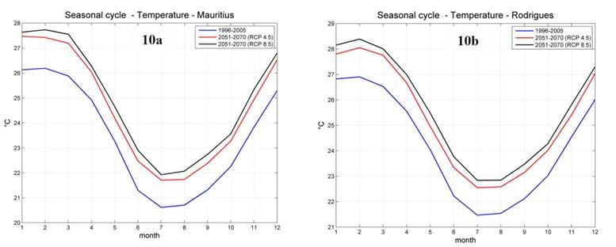

Precipitations
Analysis of rainfall over the period 1951 -2014 shows a decreasing trend in rainfall amount of about 8% for Mauritius. For Rodrigues, which is a water scarce island, a downward trend has also been observed in the rainfall.
The mean monthly rainfall for the period 1981-2010, as shown in the following table, gives mean monthly, seasonal and annual rainfall for the period 1981-2010 over Mauritius. February is the wettest month and October is the driest.
Table 4 Mean monthly and seasonal rainfall in mm over Mauritius (1981-2010)
January | February | March | April | May | June | July | August | September | October | November | December | Summer | Winter | Annual
268 | 335 | 264 | 210 | 148 | 110 | 129 | 105 | 100 | 76 | 79 | 175 | 1 331 | 668 | 1 999
Source: Mauritius Meteorological Services
The following figure shows long-term variations in annual rainfall over Mauritius, the trend and the 5-year moving average (red). The data indicate a steady decreasing trend over the period 1904 to 2015.
Figure 11 Long-term annual rainfall (blue dots), trend (black continuous line), and 5-year moving average (red line) over Mauritius (1904-2015) (Source: Mauritius’ Third National Communication Report 2016)
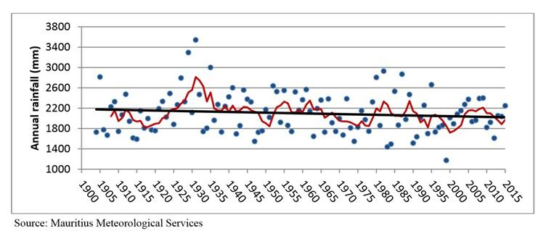
However, projections for RCP 4.5 and RCP 8.5 scenarios, does not show significant variation with respect to the present rainfall pattern (Figure 12b). Nevertheless, for Mauritius, the precipitation seasonal cycle shows an increase in monthly precipitation during the period from May to October as depicted at Figure 12a for Mauritius.
Figure 12 Precipitations Projections for Mauritius (10a) and Rodrigues (10b) for RCP 4.5 and RCP 8.5 (Source: Mauritius’ Third National Communication Report 2016)
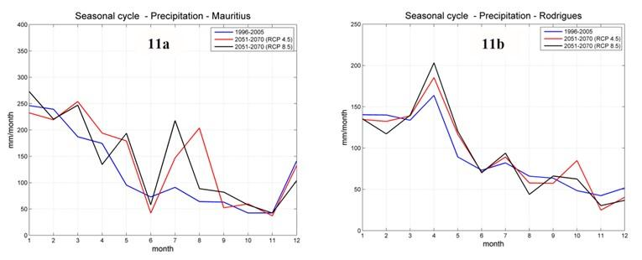

Cyclones
The Republic of Mauritius is located in the cyclone belt of the SWIO. Cyclone season is from November to mid-May. However, tropical cyclones have formed, on some occasions, outside the official cyclone season. Studies conducted by the Mauritius Meteorological Services (MMS) using data for the cyclone seasons 1975-76 to 2014-15 show that the:
- mean number of named tropical storms/cyclones in the SWIO has not changed
- frequency of storms reaching at least tropical cyclone strength has increased
- rate of intensification of tropical storms has increased, and a higher number of explosive intensifications has been observed over the last 15 years
- no change in latitudinal cyclogenesis has been observed

Sea level rise
Sea level rise has been observed to be accelerating in the last decade at an average rate of 5.6 mm/yr compared to the global value of 3.2 mm/yr. The average yearly sea level for the period (1987 to 2011) along with the trend line and the 2-year moving average for Mauritius and Rodrigues are shown in following figures. The data series are divided into the period when sea level is decreasing (blue) and when it is increasing (red).
Figure 13 Average yearly sea level (in blue) when decreasing and (in red) when increasing, with trend line and 2-year moving average for Mauritius (1987- 2011) (Source: Mauritius’ Third National Communication Report 2016)
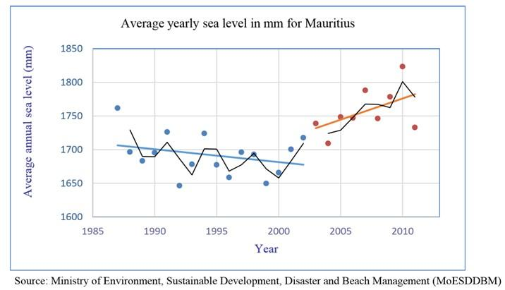
Figure 14 Average yearly sea level (in blue) when decreasing and (in red) when increasing, with trend line and 2-year moving average for Mauritius (1987- 2011) (Source: Mauritius’ Third National Communication Report 2016)
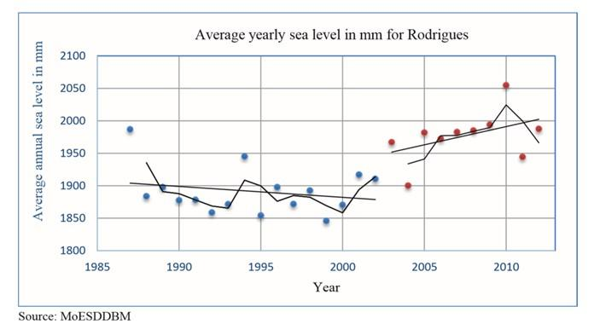

1.4.2 Climate vulnerability
Mauritius’ upper middle-income status is particularly threatened by climate change due to its small island status. Although the country diversified its economy, expanding from an economy largely focused on sugar production before 1980, to a mixed economy based on manufactured exports, agriculture, tourism, and financial services, sugar still generates approximately 17% of export earnings, and occupies approximately 80% of the total arable land. The tourism industry is also key to Mauritius’ economy and a priority sector for future economic development for the government (see Financial and Economic Assessment, Annexes to the FS).
Mauritius is affected by various climate-related hazards and change, which are already threating livelihoods and key economic sectors. Rising temperatures and sea level, reduced precipitation and more frequent droughts, and increased rainfall variability with heavy rainfall episodes (leading to flash floods and landslides), are important threats, along with more frequent extreme events like storm surges and cyclones.
Below is an overview of climate change related vulnerability in four key sectors, namely: agriculture and fisheries, health, water resources, and tourism. Three of these sectors are identified as priority areas in the GFCS, which also notes disaster risk reduction (DRR) and energy as key sectors; tourism was added due to its significance for the national economy. The sectors presented below have also been defined as priority areas for adaptation measures through several studies, strategies and national plans including: ACCLIMATE (2011), the National Climate Change Adaptation Policy Framework for the Republic of Mauritius (2012), and Mauritius’s Second and Third National Communications (2011; 2016). Further details on climate change vulnerability for the tourism and agriculture/fisheries sectors in Mauritius are available in the Financial and Economic Assessment (see Annexes).

Agriculture
Agriculture is practiced over more than half of Mauritius’ territory, especially through sugar cane production. This cash crop is particularly water-demanding; hence, its growth is affected by water stress. However, it is possible to develop multiple climate-resilient crop cultivars for sugarcane, such as drought tolerant cultivars, as well as cultivars more resilient to cyclones and floods. As a result, this crop is less vulnerable to climate change than food crop production in Mauritius.
However, the rest of agriculture in Mauritius focusing on the production of vegetables, fruits and livestock serving to supply domestic food markets, is very sensitive to shifts in temperature and rainfall patterns. Extreme events (such as cyclones and high winds) result in productivity decreases and crop losses; these also severely damage farm buildings, harvests and livestock. Increase in temperature causes shifts in agricultural zones, reduce soil moisture and generate heat stresses, which all lead to lower crop productivity. Reduced precipitation and extended droughts accelerate soil erosion, along with heavy rainfall events, which also lead to floods and declining yields in Mauritius. Insects and pests on crops are also expected to increase due to temperature rise. Finally, sea level rise leads to soil salinisation and coastal floods, which in turn reduce productivity along the coast.
These climate-related hazards and extreme events are expected to increase in frequency and intensity in the coming decades. As a result, a decrease in food-crop production is expected, which could have serious impacts on nutrition and health. This will have a greater impact on lower-income individuals and households because of the high price of imported goods in Mauritius and the unpredictability of local production.
Regarding fisheries, climate change impacts on ocean fisheries, on the one hand, are not well known and likely mostly indirect. Changes in sea temperature, for example, could result in a shift in fish habitats and migration, affecting off-shore pelagic species like tuna. Ocean acidification will also affect the development of marine plankton and, thus, modify food chains for many pelagic species.
On the other hand, artisanal fishing is more directly threatened by climate change. Threats on habitats such as coral bleaching and the death of coral reefs are noted due to increasing sea surface temperature. Likewise, climate change impacts on mangroves affect fish reproduction and fish stocks. Finally, algal bloom is already a growing problem for Mauritius’ artisanal fishery, which is causing mass mortality of corals and fish and could become more frequent due to changes in sea temperature and components. Due to climate change, shifts in production, altered growth rates, stock migration and depletion are already noted.

Water resources
Water management in Mauritius is challenging due to reduced water stock. Water availability and quality are affected by more frequent heavy rainfall events, which reduce water catchment capacity. Changes in river flows and ground water have already been observed, especially in the central plateau of Mauritius, which encompasses Mauritius’ largest water catchment. This region has been particularly affected by a significant decrease in rainfalls. In fact, a decreasing trend in annual precipitation of about 8% has been observed in a comparison of the periods 1951-60 and 1998-2008. The dry transition months between winter and summer are also becoming longer. Reduced precipitation combined with increased evapotranspiration – due to higher temperatures – threaten the quality and availability of freshwater. With climate change likely to cause a reduction in the longer-term trend in precipitation, utilisable water resources in Mauritius may decrease by up to 13% by 2050. This will be a growing problem in Mauritius, accentuated by increasing demand from the growing population and tourism sector.

Health
The linkages between climate change and health issues are complex – further studies are needed to better understand the consequences of climate change on health. However, several consequences are already foreseen. For example, there is a correlation between increased temperatures in Mauritius and more frequent respiratory or cardio-vascular diseases, as well as increased transmission on vector-borne diseases. Moreover, diseases related to the deterioration of water quality, such as gastroenteritis (linked to dehydration or contaminated water), are becoming more frequent. Studies have indicated that vector-borne and infection diseases spread faster during floods; furthermore, the occurrence of Chikungunya and dengue are correlated to changes in temperature, precipitation and humidity. For example, in 2011, 2014 and 2015 in Mauritius, outbreaks of Chikungunya fever and epidemics of dengue were observed; this correlated with gradual temperature increases. Finally, rainfall pattern changes including more frequent droughts and heavy rainfall events are increasingly affecting food production which, in turn, impact food security, with associated risks of malnutrition. Mauritius’ Third National Communication (2016) underlines that severe climate change impacts on the health sector will result in higher health costs.

Coastal zones, tourism and infrastructures
Coastal areas in Mauritius are key to support many economic activities, including fisheries (described previously) and tourism. About 20% of the population resides in coastal areas, which generated about 36% of GDP in 2011, essentially through tourism activities. However, coastal areas are particularly affected by erosion, with a noted 10-15m coastline retreat depending on the area. Beach erosion directly affects tourism activities, for example through the deterioration of reef quality. In the North East, large hotels are resorting to artificially replenishing their beaches with sand to combat erosion. This could result in a reduction in tourism and associated income.
Moreover, continuous sea level rise, and stronger or more frequent extreme events like heavy rainfalls will cause increasing damage and loss of key infrastructure supporting tourism activities, including water reservoirs, overhead cables for electricity supply, roads, buildings and hotels; the latter are often built on the coastline, at less than 2m above sea level. Finally, part of Mauritius’ main harbour is already flooded on a regular basis during extreme climate events such as cyclones.

1.5 Seychelles
Seychelles is a 455 km², 115-island archipelago in the southwest Indian Ocean, located about 1,100 km northeast of Madagascar. It is made up of two main groups of islands: the Mahé group of more than 40 central, mountainous granitic islands and a second group of more than 70 outer, flat, coralline islands”. The estimated population is 96,000 in 2019.
Seychelles is divided into 25 administrative divisions: Anse aux Pins, Anse Boileau, Anse Etoile, Anse Royale, Au Cap, Baie Lazare, Baie Sainte Anne, Beau Vallon, Bel Air, Bel Ombre, Cascade, Glacis, Grand Anse Mahe, Grand Anse Praslin, Inner Islands, La Rivière Anglaise, Les Mamalles, Mont Buxton, Mont Fleuri, Plaisance, Pointe Larue, Port Glaud, Roche Caiman, Saint Louis, Takamaka. The country is considered a high-income country, with an economy that relies on tourism and fisheries – in particular tuna. Despite its relative wealth compared to other countries in the region, it is important to note both its high debt levels, and its high vulnerability to shocks due to its size and exposure to hazards. In 2019, government gross debt is estimated to stand at 54.5% of GDP in Seychelles (ranking 88th out of 187 countries). It should also be noted that Seychelles’ reliance on tourism and tuna also makes it particularly vulnerable to external economic shocks.

1.5.1 Climate risk profile
The climate of the Seychelles archipelago is strongly influenced by the ocean, especially through changes in monsoonal winds, ocean currents and sea surface temperature patterns, hence a tropical maritime climate.
In Seychelles two distinct seasonal patterns associated with the wind regime dominate: i) the south-east monsoon which blows from May to September associated with the dry season; and ii) the north-west monsoon from November to March associated with the wet season and also the Tropical Cyclone Season over the Southwest Indian Ocean. Synoptically, the main systems which govern weather over these parts of the world are primarily the Inter-Tropical Convergence Zone. Hence, complex and highly interactive processes control the Seychelles climate system. The interactions among these various processes are indeed difficult to predict, not least because they may occur on widely differing temporal scales, but also because of the relatively microscopic size but extensive spatial distribution of the islands in the Seychelles archipelago.
Detailed observational data in Seychelles are available since the opening of the International Airport in July 1971, but rainfall data are available for more than 100 years. Paleo-climatological evidence from sea-bed cores of the last 20,000 years indicates that there may have been drastic climatic variations within the Seychelles region, mainly associated with changes in rainfall.

Temperature
The temperature varies between 25°C and 26°C in July and August, and between 27°C and 28°C in March and April. Near sea-level, the maximum temperature is about 4°C higher than at higher altitude, reaching an average of 31°C at mid-day in April.
The warmer, wet season during north-west monsoon months of November to March produces prolonged sunshine with extreme maximum temperatures of up to 34°C on the coasts, and which may be broken by short heavy bursts of rainfall. From May to September, cool and dry conditions are accompanied by extreme minimum temperatures of up to 19°C, with cooler nights and lower humidity particularly at high altitude. There is an average of seven hours of sunshine each day throughout the year. The average maximum temperature is 29.90C; average minimum of 24.60C with average humidity at 80%.
A range of seven General Circulation Models (GCMs) at 5° (~500 km) resolution were employed to assess the regional climate change patterns (Chang Seng, 2007) and models suggest the following:
- Air temperature for both Mahé and Aldabra area is very likely to warm by +3.0°C;
- The relative warming will occur mainly during the cooler southeast monsoon;
- The warming ranges are from +0.4° to 0.7°, 0.9° to 1.4° and 1.8° to 2.9° C respectively for the years 2025, 2050 and 2100
Figure 15 Observed (1972-1990) and Composite Model Scenarios for Average Maximum Temperature Values (˚C) for the Years 2025, 2050 and 2100 at the International Airport, Mahé, Seychelles for the B2 Mid-range Emission with Mid –range Climate Sensitivity (Source: Seychelles’ Second National Communication, 2010)
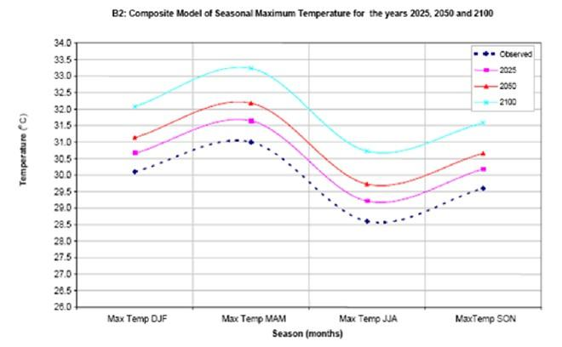

Precipitations
The topography of the Seychelles strongly influences rainfall patterns. The rainfall varies according to the height above sea level, and ranges from 76.2 mm in July to 404.8 mm in January. The mean annual rainfall total for Mahé is 2369.4 mm over the coastal areas but it is expected to exceed that amount over most of the hilly interiors. Rainfall also tends to be higher on the west facing slopes and ridges of La Misere, since most rainfall occurs during the Northwest monsoon. The heavy downpour normally occurs mainly from late December to the beginning of January.
Figure 16 Annual Rainfall Distribution for January and July over Mahé (Source: Seychelles’ Second National Communication, 2010)
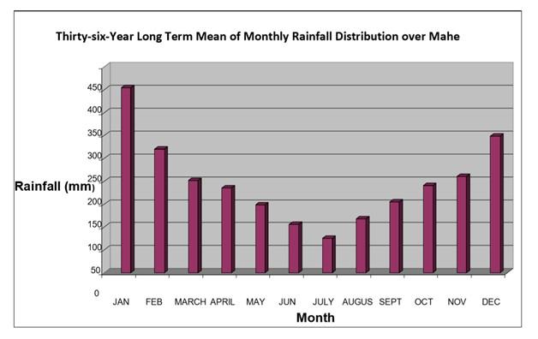
Analysis of rainfall for January, the month of maximum rainfall, indicates variability throughout the last 36 years. It reveals three remarkable peaks in 1974, 1991 and 2005 respectively with 10 years of rainfall above the 400 mm average for that month. On the opposite, July the month of lowest rainfall depicts a decreasing trend having 17 years of rainfall equal and below 50 mm. The analysis does clearly indicate that the El Nino and Southern Oscillation (ENSO) phenomenon is just one of several factors influencing climate variability in the Seychelles.
Figure 17 Annual Rainfall Distribution for January and July over Mahé (Source: Seychelles’ Second National Communication, 2010)
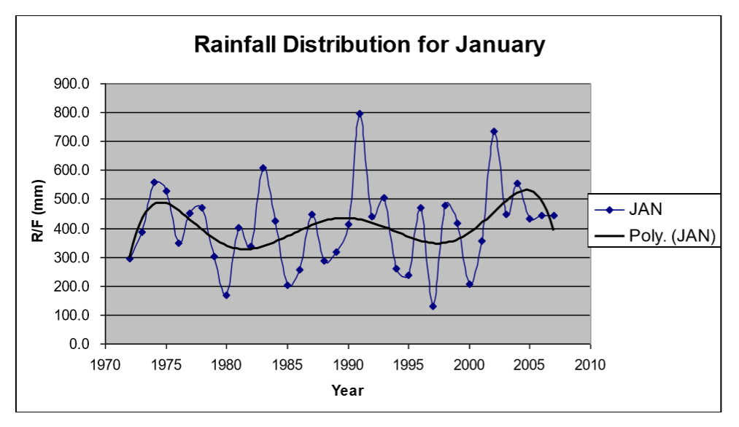 | 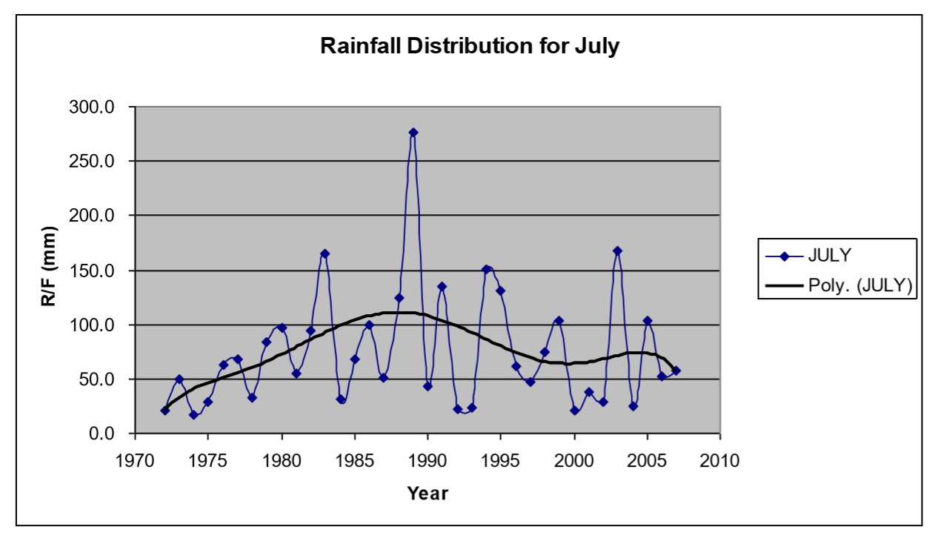
According to several independent regional climate change projections from Multi-Model Ensembles, the following trends can be summarized:
- Likely extremes of low rainfall in the dry season with a deficit of -12.7 % (-9.9 mm) in rainfall for the year 2025, and a decrease of -36.3 % (-31.1 mm) in the year 2100;
- In contrast, the likely extremes of wet conditions are likely to be characterized by an increase of +5.9 % (+19 mm) for the year 2025, +9.3 % (+25.4 mm) for the year 2050 and +12.4% (+38.6 mm) for the year 2100.
- On an annual basis it is 89 % likely that the rainfall rate will be greater and equal to +0.5 mm per day by the year 2100. The certainty lowers to 45-50% that the seasonal rainfall will increase in the rainy season of up to +1.0 mm per day by the year 2100. This informs us that rainfall is more likely to increase in the southern summer and decrease during southern wintertime.
Figure 18 Observed (1972-1990-Grey Colour) and Composite Model Scenarios of the Seasonal Precipitation Values (mm) for the International Airport for the Years 2025, 2050, and 2100 for B2 Midrange Emission for mid-range Climate Sensitivity (Source: Seychelles’ Second National Communication, 2010)
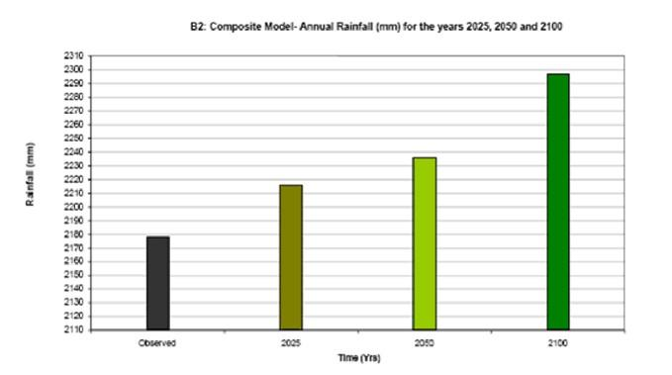

Cyclones
The Seychelles is vulnerable to a range of natural hazards, including tropical cyclones, coastal floods, and storm surge.
The Seychelles are indirectly affected by tropical cyclones via the intensification of the intertropical convergence zone (ITCZ) and spiral rain bands associated with cyclone passing south of the islands. Chang-Seng established that Seychelles has its fair share of cyclonic impacts through intense rain equivalent to rain rates in the inner core of tropical cyclone through the spiral rain band which can give rain rates equivalent to the inner structure of cyclone. It was also shown that tropical cyclone by-track characterizes the preceding rainfall in the Seychelles at both event and seasonal time scales. Furthermore, it was shown that tropical cyclone generated swells and storm surge have significant wider basin impact, posing a risk to maritime users within the archipelago.
Tropical cyclones, combined with wind, flood, and storm surge hazards, have generated significant damage in recent years. In 2013, Tropical Storm Felleng brought heavy rainfall, which led to severe flooding and landslides causing damages and losses.
Additionally, in April 2016, Tropical Cyclone Fantala passed near the Seychelles’ Farquhar Group, causing widespread damage to nearly all buildings and significantly impacting communities and livelihoods in the archipelago.

Sea level rise
The mean elevation of the coastal plateau of the granitic islands is 2-10 m, whereas the coral islands vary from 1.8 metres to 9 metres above sea level. Ste Pierre is the most uplifted reef in the Seychelles group, being surrounded by cliffs of up to 10 metres. Sea level monitoring data for the Seychelles is limited. Data is available from 1993 to present and are not consistent.
Chang-Seng suggests an annual sea level trend anomaly of +1.46 mm (± 2.11 mm) per year on Mahé Island, which is very close to Ragoonaden’s estimate of +1.69 mm/year. Church et al. using tide gauge data combined with TOPEX/Poseidon satellite altimetry data from 1950-2001 estimated the rate of relative sea-level rise of 0.5 ± 0.5 mm/yr for Pointe Larue, Mahé (Seychelles), which is lower than proposed earlier. Against the global mean sea level rise (1961 to 2003) of 1.8 ± 0.5 mm/year (Bindoff et al.), these results appear in line with the global average increase in sea level.

1.5.2 Climate vulnerability
Seychelles’ high-income status is particularly threatened by climate change, due to its small island status and economic reliance on tourism, followed by the fisheries sector (particularly tuna). As a country comprised of small islands with a concentration of development on the low-lying coastal areas, Seychelles is particularly vulnerable to sea level rise, among other climate change impacts.
Below is an overview of climate change threats on four key sectors, namely: agriculture and fisheries, health, water resources, and tourism. Three of these sectors are identified as priority areas in the GFCS, which also notes disaster risk reduction (DRR) and energy as key sectors; tourism was added due to its significance for the national economy. The sectors presented below have also been defined as priority areas for adaptation measures through several studies, strategies and national plans including: Seychelles National Climate Change Strategy (2009), ACCLIMATE (2011), and the Second National Communication (2011). Further details on climate change vulnerability for the tourism and agriculture/fisheries sectors in Seychelles are available in the Financial and Economic Assessment (see Annexes to the FS).

Agriculture and fisheries
Seychelles’ agricultural sector is small, with a GDP contribution of only 2%. Key agricultural products include: coconuts, cinnamon, vanilla, sweet potatoes, cassava (manioc, tapioca), copra, and bananas. With such a small-scale industry, the country heavily relies on food imports to feed its population. Nonetheless, agriculture is extremely vulnerable to climate change. For example, increased temperatures have an impact on the spread of diseases and pests. More frequent strong winds and changing rainfall patterns with more frequent extreme rainfall events leading to floods and extended period of droughts, also have detrimental impacts on agriculture. It is noted that extreme rainfall events have already caused significant crop losses in recent years. Sea level rise is of concern given that most of the agricultural activity takes place along the coast (due to strong relief inland). It is negatively affecting crop production through soil salinisation and coastal flooding. Finally, livestock is also negatively impacted by increased temperatures and the spread of diseases.
Climate change also threatens fisheries, a major pillar of the economy of Seychelles (after tourism) and a key to food security. Artisanal fishing is especially vulnerable to climate change as, for example, the degradation of coral reef habitat generates a reduction in fish stock. The degradation of mangroves resulting from coastal erosion and extreme events also generate a loss in terms of fish stocks. Changes in ocean temperature and chemistry affect the distribution of fish species and fish reproduction. Reduced productivity in fisheries can result in increased market fish prices, and could generate nutrition issues for socio-economic groups who could not afford increased prices for this food product.

Water resources
Water supply in Seychelles comes essentially from rivers, combined with some groundwater extractions and desalination plants. River flows are climate-sensitive and can fall drastically during prolonged droughts. Expected changes in rainfall patterns (in particular, decreased rain during the dry southeast monsoon) and temperatures (which will increase rates of evapotranspiration) will have negative consequences on water supply as this will result in decreased stream flow and groundwater recharge. In addition, more frequent extreme rainfall events will result in greater surface runoff and, therefore, less water capture. Water scarcity due to climate change will be exacerbated through greater demand from the growing population and the tourism industry.

Health
In the context of climate change and rising temperatures, Seychelles could become a malaria-prone country – a disease currently not present on the islands. An upsurge of other diseases could also be observed. For example, Seychelles could face more frequent outbreaks of Chikungunya; like Mauritius, the country faced a Chikungunya outbreak in 2006, which was facilitated by changes in temperature and rainfall patterns. In fact, warmer temperatures, as expected in Seychelles, create the ideal conditions for the rise of Chikungunya disease. Likewise, the country has faced multiple outbreaks of dengue, also closely related to changes in temperature, precipitation and humidity. Finally, impacts of climate change on agriculture and fisheries will result in additional negative effects on health through malnutrition.

Coastal zones, infrastructure and tourism
The tourism sector employs 26% of the population, and accounts for more than 55% of GDP. To illustrate the significant weight of the tourism sector, in 2016 Seychelles hosted over 300,000 visitors in addition to its resident population of 96,000. Seychelles’ coastal areas are key for the tourism sector, but they are extremely vulnerable to climate change. Major threats include sea level rise, storm surges, increased sea surface temperatures and coastal flooding. This vulnerability is emphasised by the fact that the country is mostly comprised of coastal areas, where 90% of the population and infrastructures are located.
Coastal flooding and landslides have become common in Seychelles, especially due to heavy rainfall events. For example, the Mahé group consists of narrow coastal areas and steep mountains and is particularly vulnerable to these hazards, which tend to occur more frequently as short, intense rainfalls increase in frequency. The negative impacts of floods are accentuated by a lack of appropriate drainage and high-density development. Sea level rise, on the other hand, is already destabilising the coastline with serious impacts on infrastructure such as roads and hotels. Storm surges, generated by severe storms, can also cause significant coastal damage. Given that Seychelles was not considered to be prone to cyclones, most infrastructure was not built to withstand such events. Yet, in the context of climate change, more extremes such as storms, cyclones and high winds are expected to affect the country, with potential serious damage to coastal infrastructure, such as tourist hotels, roads, harbours, industry and power plants.
As tourism activities and infrastructure are essentially located in coastal areas, the impacts of climate-related hazards and climate change on the coastal areas of Seychelles are expected to be largely negative from an economic view point, also through their impacts on the natural environment, for example by degrading coral reefs and damaging the coastline.

Chapter 2 Institutional frameworks, Policies and Projects
This chapter provides an overview of existing policies and strategies that relate to climate services, disaster risk reduction and climate change in the SWIO region and at national level in Comoros, Madagascar, Mauritius and Seychelles. It includes a description of the legal frameworks and key supporting institutions involved in the production and dissemination of CS, as well as the main processes to disseminate climate related-information, including early warnings (EW). For each country, the chapter includes an overview of the main ongoing or planned projects supporting climate services.

2.1 Regional level

2.1.1 Policies and strategies
The IOC Member States have developed a joint adaptation strategy at the regional level: Document cadre pour la stratégie régionale d’adaptation au changement climatique des pays membres de la Commission de l’Océan Indien 2012-2020. This strategy aims at strengthening regional cooperation, fostering a shared understanding of regional issues, and improving the coordination of actions. To reach these aims, the strategy advocates strengthening forecasting and climate anticipation capabilities, to increase the capacity of all actors, and to more broadly disseminate climate information.

2.1.2 SWIOCOF
Regional Climate Outlook Forums (RCOFs) produce consensus-based, user-relevant climate outlook products in real time to reduce climate-related risks and support sustainable development for the coming season in sectors of critical socioeconomic significance for the region in question. Typically, sectors that are engaged in the RCOFs include:
- Agriculture and food security
- Water resources
- Energy production and distribution
- Public health
- Disaster risk reduction and response
- Outreach and communication
- Other sectors such as tourism, transportation, urban planning, etc. are increasingly involved.
The South West Indian Ocean Climate Outlook Forum (SWIOCOF) is coordinated by the African Centre of Meteorological Application for Development (ACMAD) in Niamey, Niger. It covers Comoros, Madagascar, Mauritius, La Réunion (France), and Seychelles, and is open to neighbouring countries as well, including Mozambique, South Africa and Tanzania. The IOC has supported the organisation of SWIOCOF since 2017, providing funding and logistic support. The forum is organised once a year – in September – and gathers representatives of the meteorological services from IOC member countries. Through this forum, countries’ scientists collaborate to produce seasonal outlooks for the SWIO region, which are disseminated at national level by the national meteorological services (NMSs).

2.1.3 SARCOF
The Southern African Regional Climate Outlook Forum (SARCOF) is coordinated by the Southern African Development Community (SADC) Climate Services Centre (CSC) in Gaborone, Botswana. The principal goal of the Climate Services Centre is to reduce negative impacts from climate extremes, such as droughts and floods. SARCOF covers all SADC Member States: Angola, Botswana, Comoros, Democratic Republic of Congo, Eswatini, Lesotho, Madagascar, Malawi, Mauritius, Mozambique, Namibia, Seychelles, South Africa, Tanzania, Zambia and Zimbabwe.
The climate across the member states of Southern Africa differs (Figure 19), yet they experience climate effects that affect the region as a whole. Consequently, climate monitoring is considered a united effort.
Figure 19 Climate classification for SADC
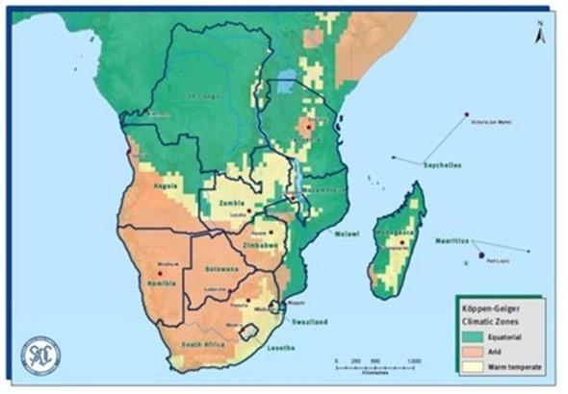
Source: SADC
SADC contributes to SARCOF by bringing together scientists from the Member States’ NMHS’s with those from the SADC Climate Service Centre and the Intergovernmental Authority on Development’s Climate Prediction and Application Centre. Through this forum, collaboration leads to the development of Regional Climate Outlook Bulletins. These are medium-range (10 to 14 days) and long-range (three to six months) and are disseminated to local communities by the respective member state NMHSs. These bulletins provide valuable information on progress and potential hazards of the climate system in Southern Africa (Figure 20 and Figure 21).
Figure 20 Rainfall Outlook for January, February, March 2019
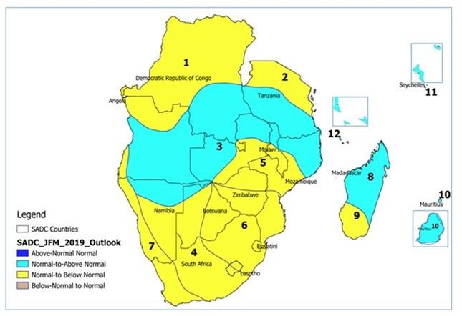
Figure 21 Temperature Outlook for January, February, March 2019
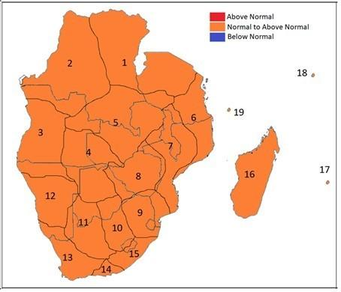
SADC also supports member countries individually: for example, in Madagascar the SADC supported the first National Outlook Forum in October 2015 and helps provide outputs such as those illustrated in Figure 22.
Figure 22 Example of SARCOF support to Madagascar
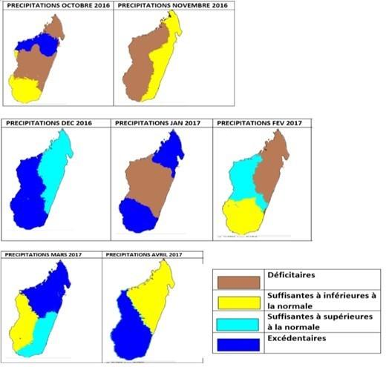

2.1.4 NCOF
At National level, the National Climate Outlook Forum has the following objectives:
- Ensure that climate information products, including their uncertainties and limitations, are regularly communicated, interpreted and understood by users;
- Discuss user views, and based on their feedback to make this climate information accessible, user-friendly and applicable;
- Provide an institutional platform for understanding risks and opportunities of past, current and future climate information; and for inter-agency coordination of policies, sectoral plans and programs linked to potential impacts of hydro-meteorological hazards;
- Evolve a culture of working together through joint climate information interpretation sessions for managing risks in various climate-sensitive sectors, like agriculture, irrigation, disaster risk reduction and health
The link between global, regional and national COF could be schematized as represented in Figure 23 below like it is organized in India for example.
The main role of NCOF is to organise the discussions with the national stakeholders and provide services through national adaptation of the data produced at global and regional level. This adaptation will use techniques like model downscaling to deliver services as precise as possible to the national stakeholders.
In the region, the NCOFs of the four countries has been set-up in 2016 and are organised on a yearly basis since.
Figure 23 Links between COFs at different scales
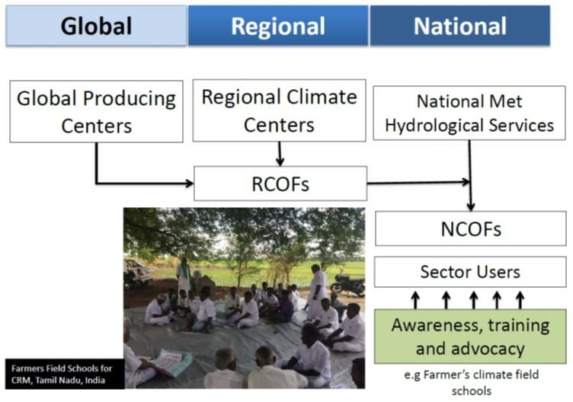
The NCOF aims at encompassing representatives from key organizations such as World Meteorological Organization (WMO) and key stakeholders from climate sensitive sectors such as agriculture and food production, water management, health, energy, tourism and disaster management to discuss climate services and their benefits at the national level. It downscales Seasonal Outlook (Rainfall and Temperature Outlook) at national level with a grid of around 10 km.
The Forum can serve as an opportunity to investigate pathways to integrate the seasonal outlook into sector planning based on its applicability; to achieve this, NCOF needs to become an annual operational activity which links the seasonal climate outlooks and other climate information being generated by the NMHS with stakeholder institutions, and their decision-making processes in order to improve application of climate information, particularly the seasonal climate outlooks.
NCOF can be used as a key mechanism for IOC member states to regularly engage, interact and coordinate among the NMHS and key stakeholder agencies in responding to seasonal climate, their extremes and variability. It can facilitate a dialogue process that focuses on the application of probability in seasonal forecasts to communicate uncertainties in climate risk management in the priority areas and provide a platform for regular evaluation of the seasonal forecast, its uptake, application and value-added results. In the IOC region, the four NCOF (Madagascar, Comoros, Seychelles and Mauritius) will benefit from the BRIO project (Building Resilience in the Indian Ocean) that trains meteorologists of the four countries to downscale the climatic outlook during two years until mid-2020.

2.1.5 User-interface platform
At the moment, the main User Interface Platform (UIP) available at the regional level is the Regional Climate Portal, which was developed by DI4 and IOC. The Portal is hosted by Seychelles (SMA) since August 2019. The platform is already used by Météo France La Reunion and IOC to disseminate climate-related information following SWIOCOF.
In addition, in the IOC region, WMO has set-up in 1993 a Regional Specialized Meteorological Center – Tropical Cyclone Center at La Réunion (TC-RSMC) with the vocation to permanently monitor the cyclonic activity on its area of responsibility in the Southwest Indian Ocean (from 30 degrees East to 90 degrees East, between the equator and 40 degrees South). This operational mission, under the responsibility of the Tropical Cyclone Committee, is accomplished mainly through the development and dissemination of expert information on the cyclonic activity and the tropical low-pressure systems. This information, including analyses and forecasts, is provided through various bulletins, including the following main production:
- All year round once a day at 12 UTC: A Daily Tropical Weather Activity Monitoring Bulletin (named “ITCZ”). It includes a well-informed analysis of the weather situation and its expected evolution (if necessary) and concludes with an evaluation of the risk of formation of a tropical depression (cyclogenesis) in the next five days.
- In case of ongoing cyclone activity on the basin: Different types of bulletins are issued in addition to the “ITCZ”, generally 4 times a day (sometimes less, especially when it is a low-intensity ) at 00, 06, 12- and 18-hours UTC.

2.1.6 Regional baseline projects
The table describes regional initiatives which bear relevance to this project.
Table 5 Regional baseline projects
Name | Date | Funding entity | Description: purpose, key activities and location
Building Resilience in the Indian Ocean (BRIO) | 2018-2020 | AFD | Existing climate models do not cover most of the South-West Indian Ocean area. The BRIO project aims to develop high-resolution climate projections that will extend up to 2100. Thus, the climate model will reveal long-term trends in temperature, rainfall, and cyclonic activity. It is a valuable aid to IOC member states to understand the implications of climate change for human and animal health, food security, water supplies, soil erosion and natural hazards. BRIO’s objectives are to: i) train experts in different countries of the zone to develop skills in the exploitation of data sets from all available simulations (ALADIN, CMIP6, and other available regional simulations); (ii) define and generate climate products or services based on the datasets created (in line with the needs of national users); and iii) provide countries in the region with high-resolution regional climate simulations based on the ALADIN-climate model.  The proposed project will use the methodologies and output of BRIO to improve climate change projections in the SWIO region (see Activity 2.3.2).
World Hydrological Cycle Observing System (WHYCOS) | 2017-2019 | WMO | World Hydrological Cycle Observing System aims to strengthen national capacities in basic observation, foster basin-wide, regional and international cooperation and promote the free exchange of hydrological data. It is implemented through regional components called HYCOS projects, which adopt a bottom-up approach focused on user requirements and aim to improve the technical and institutional capacities of NMHSs.  A HYCOS for the Indian Ocean region is currently being prepared. In addition, the existing SADC-HYCOS project covers Mauritius, in addition to Angola, Botswana, DRC, Eswatini, Lesotho, Malawi, Mozambique, Namibia, South Africa, Tanzania, Zambia, Zimbabwe.  The proposed projects integrate HYCOS’ study recommendations in terms of equipment need for hydrology monitoring (see Activity 2.1.1) and training (Activity 2.3.3).
Satellite & Weather Information for Disaster Resilience in Africa (SAWIDRA) | Ongoing | ACMAD | The main objective of this project is to improve the core capabilities of National and Regional Climate Centers (RCCs) to develop climate services that meet the needs of disaster risk management agencies and socio-economic sectors. The project has already organised regional consultations and interactions between weather experts and disaster risk management experts in selected regions (East, West, Central, and Southern Africa) during seasonal forecast fora. ACMAD has done the same exercise during the South West Indian Ocean region during SWIOCOF-8 (South Western Indian Ocean Climate Outlook Forum, held in Mauritius from 23 to 27/09/2019), which aims to determine the expected hazards and potential impacts in relation to the seasonal forecast developed during the pre-forum and the forum theme, as input into updating their contingency and preparedness plan. During this SWIOCOF-8, ACDMAD worked with representatives of DRR institutions, meteorological services and the health sector to enhance understanding of seasonal forecasts, share experience in health risk management and facilitate decision-making based on seasonal forecasts in the health sector.  The proposed project will build on the methodologies and results from SAWIDRA to improve CS in the health sector (see Activity 3.1.2).

2.2 Comoros

2.2.1 Policies and strategies on climate services and DRR
Comoros has ratified 6 of the 18 International Human Rights Instruments. It is also a party to international agreements on: Biodiversity, Climate Change, Climate Change-Kyoto Protocol, Desertification, Endangered Species, Hazardous Wastes, Law of the Sea, Ozone Layer Protection, Ship Pollution, Wetlands. Finally, the country is signatory of the Hyogo and Sendai Multilateral Agreements.

Relevant UNFCCC-related policies
Comoros submitted its NAPA in November 2006. The NAPA followed a participatory process and noted Comoros’ high vulnerability to the impacts of climate change due to both environmental and socioeconomic factors. The NAPA notes the adverse effects on agriculture and fisheries and emphasised the need to set up a “coordination and implementation communication structure”, including establishing and further developing early warning systems.
Several of the NAPA’s priority projects relate to climate services: in particular, ‘Early warning’, which ‘aims at setting-up surveillance and warning system on the risky climate situations, on the entire national territory.’
Comoros is currently developing its National Adaptation Plan (NAP), a process which started in 2014. This plan, still under development (as of August 2019), seeks to build on existing policies like the Accelerated Growth and Sustainable Development Strategy 2015-2019, which emphasises the importance of adaptation measures for the agricultural sector. Comoros’ NAPA remains the main strategy regarding climate change adaptation, until the finalisation and adoption of the NAP.
Comoros submitted its INDC on 17 September 2016, and ratified the Paris agreement on 23 November 2016, at which point its INDC became its NDC – this NDC has not been modified since. Within this document, Comoros’ priority actions target the water and agriculture sectors, aim to integrate adaptation into sectoral policies, and to reduce vulnerability through poverty reduction (particularly noting the vulnerabilities of rural communities and farmers to climate change). Priorities include, for example: i) by 2020, 66%, and by 2030, 100%, of the population has access to potable water; ii) by 2030, 100% of farmers have a water management system and use techniques and varieties adapted climate change; and iii) development of an effective cross-sectoral early warning system.
To accomplish these goals, the NDC identifies the following priority adaptation projects and their associated sectors:
- Capacity Building and Resilience of the Agricultural Sector to Climate Change in the Comoros (CRCCA) - Agriculture: Reducing the Vulnerability of Agricultural Systems to Climate change and climate variability
- Capacity building in water resources management for adaptation to climate change (ACCE) - Water: reducing CC risks to daily life and impacts on water resources
- Support Programme to the Union of Comoros to Strengthen Resilience to Climate Change (AMCCA) - Integration: improving the integration of climate change into strategies, projects and mechanisms for planning, coordination and monitoring
- Joint water adaptation programme: reducing the risks related to climate change on daily life and the impacts on water resources at 5 pilot sites
- Rehabilitation of watersheds, forests and adaptive livelihoods - Coastal areas: building resilience in the Comoros by rehabilitating watersheds, forests and diversifying livelihoods
- Resilience to risks from climate variability and change - Risks: strengthening adaptation and capacity resilience of the most vulnerable communities to the risks of disasters related to climate change and variability in the Comoros
The NDC also notes that to achieve these objectives, Comoros will need to access international finance, including through the Green Climate Fund, and that due to current limitations on access to data its INDC will need to evolve as more data becomes available.

National policies and strategies
The Meteorology section of Comoros’ Strategic Plan 2017-2020 notes the current lack of stations, difficulties delivering services on time, and lack of capacity in the department. It aims to address this by i) significantly improving infrastructure and networks; ii) significantly improving data quality and timeliness of services offered; iii) enhancing the quality of alerts for different risks; iv) strengthening staff technical and managerial skills; and v) strengthening contributions to enhance regional and global exchange of meteorological data.
In addition, key outputs of the UNDP/GEF 2019 Annual Work Plan for the Project to Strengthen Comoros’ Resilience to Disaster Risks related to Climate and Climate Variability include: i) a programme to strengthen the technical and operational capacity of the General Directorate of Civil Security, the Technical Department of Meteorology, the Observatory of the Volcano Karthala, the Directorate of Agriculture, Environment, and Forestry, Port and Maritime Authorities and other key national institutions with a focus on emergency preparedness and climate-related disaster response; ii) an efficient system for transmitting early warnings of climate-related disasters in the three islands; iii) update and improve risk and vulnerability assessments as well as maps of local communities and socio-economic infrastructure by integrating more accurate meteorological, hydrological and climate information; and iv) improved Meteorological Monitoring Network.

2.2.2 Institutions and mandates of NMHSs and DRR institutions
This section presents the institutional, legal and functional framework for risk management and hydro-meteorological services in Comoros.

Hydro-meteorological services
According to Decree No. 17-024/PR of 06/03/2017, the Meteorology Department is a department of the National Agency for Civil Aviation and Meteorology (ANACM), which is an agency with the status of an administrative establishment under public law with legal personality and administrative and financial autonomy.
The missions of the Meteorology Department are defined by Article 13 of Order No. 17-022/VP-MTPTTIC of 13/04/2017, implementing the above Decree for the organisation and functioning of the ANACM. The organisation chart is as follows:
Figure 24 Organigramme ANACM
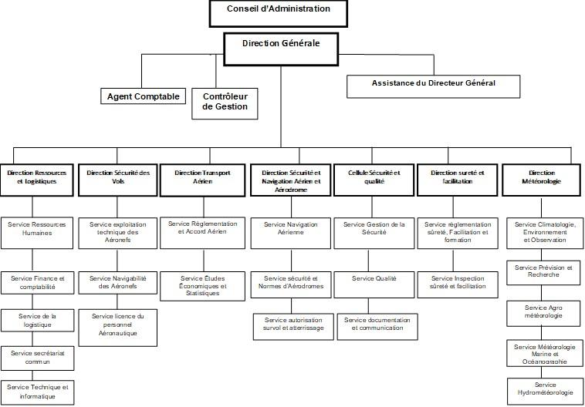
The Meteorological Directorate's mission includes: (i) carrying out activities relating to weather, climate and climate information and forecasts and the evolution of the climate system; (ii) implementing the State's policy on the meteorological security of persons and property; (iii) developing and managing the country's observation networks other than those of the Airport (for which ASECNA is responsible); and (iv) contributing to the prevention and management of natural disasters.
The Meteorology Department is composed of five different departments:
1) Department of Climatology, Environment and Observation;
2) Forecasting and Research Department;
3) Agrometeorology Department;
4) Hydro-meteorology Department;
5) Marine Meteorology and Oceanography Department.
Concerning hydrology, the main legal framework is the 1994 Water Law, which was reviewed in 2015 (but still not validated). The Hydro-meteorology Department has a broad mandate that includes hydrological observations (including water level and flow), groundwater and water quality analysis, climatology, hydrological forecasting (drought, floods), disaster risk prevention and reduction, and research. This service shares data with other stakeholders in water resource management, including the National Society of Water, which oversees water exploitation and distribution, attached to MAPE, and local water committees.

DRR institutions
The institutional and legal framework for risk management is in line with international commitments to achieve the Millennium Development Goals and the Disaster Risk Reduction Strategy of African and Arab countries, and at the national level with the Poverty Reduction Strategy. Two decrees issued in 2012 specify the operational elements, one (March 2012) creating the General Directorate of Civil Security (DGSC) and the other (Sept 2012) creating the National Platform for Disaster Risk Reduction (PNPRRC).
The policy document is the National Strategy for Disaster Risk Reduction in the Comoros (SNRRC), finalised in May 2015 as part of the programme entitled: "Integration of Disaster Risk Reduction into Poverty Reduction Policies in the Union of the Comoros" funded by the Global Facility for Disaster Risk Reduction and Recovery (GFDRR), is the result of a consultation commissioned by UNDP on behalf of the Directorate General of Civil Security.
The risk management system of the Union of the Comoros is organised around 3 structures with strategic, decision-making, and operational functions: (i) the National Disaster Risk Management Commission (CNGRC) for the strategic and decision-making aspect; (ii) the General Directorate of Civil Security (DGSC); and (iii) the Coordination Centre for Rescue Operations and Preparedness (COSEP) for the operational aspects.
CNGRC
The purpose of the CNGRC is to ensure the direction of civil protection operations, the coordination of the resources to be deployed and the adequacy of exceptional measures to be adopted in the event of a disaster. It is activated by its President and operates at the headquarters of COSEP, which oversees the Island-specific Disaster Risk Management Commission (CIGRC) – i.e. island-specific arm of the CNGRC. The CNGRC is composed as follows:
- Secretary General of the Government,
- a representative of the General Directorate of Civil Security,
- the Director of Civil Protection
- the Director of the Karthala Volcanic Observatory,
- the Head of the Weather Forecasting Department,
- the Chief of Staff of the National Development Army,
- the secretary general of the Comorian Red Crescent,
- the Director of Civil Aviation and Meteorology,
- the Director of Maritime Transport,
- the General Directors of the relevant sectoral and transversal ministries.

DGSC
The DGSC is a crisis management platform, founded by decree on 9 March 2012, under the supervision of the Ministry of Civil Security. The platform is responsible for implementing the national disaster risk management (DRM) policy, promoting risk prevention, coordinating crisis management between different actors, and organising the protection and defence of people, property and the environment during crises. This Directorate is also responsible for informing the Ministry of Civil Protection of any situation justifying emergency measures, as well as for participating in the protection and safeguarding of the population and national heritage in civil defence circumstances
To this end, the DGSC proposes methods for intervention on the ground in the event of a crisis and coordinates the implementation of national assistance and relief resources for the population and ensures the management of relief operations and feedback. Finally, it defines and supports the implementation of regional and international cooperation actions in the field of civil protection.
The DGSC has an information service and public relations department which is responsible for public relations, and for ensuring the implementation of the strategy and procedures for informing and raising awareness among the population, as well as for preparing and disseminating alert bulletins at national level. It also has a Sub-Directorate for Studies and Prevention, an Analysis and Information Processing Unit (CATI), a Sub-Directorate for Resources and Logistics, and a Fire Brigade Group, which includes one unit per island. CATI works in partnership with various public and private services and specialised centres, from which it receives information on disaster risk prevention and management. This allows CATI to have an up-to-date, geo-referenced database that can be used as a decision support tool for the DGSC.
COSEP
COSEP is the operational centre for crisis management, which coordinates, manages, monitors and mobilises disaster response and relief resources (human and material, local and national, public and private).
Amongst other considerations, it ensures the centralisation of information relating to crisis preparation and management, the monitoring and updating of contingency plans (national and specialised by sector), the mobilisation of various actors and resources in support of crisis management.
The animation of the CATI for the analysis and processing of information, particularly during crises, and the activation of the Crisis Command Post (PC) as soon as necessary in the operational room. In addition to these structures, there is a national multisectoral platform for disaster risk reduction and prevention (PNPRRC), created in 2012.
This platform is responsible for the integration, prevention and risk reduction within policies, development plans and strategies, good governance and poverty reduction, as well as for validating the national programme for disaster risk reduction and prevention. The PNPRRC is also responsible for facilitating resource mobilisation for risk reduction and post-disaster rehabilitation and development, as well as promoting risk culture education in schools. As a multi-sectoral platform, the PNPRRC facilitates cooperation between institutions working in the field of disaster risk reduction. This platform is made up of the National Commission, the national coordination and their respective representation at the regional level (for each island).

Local Coordination
The DGSC is represented on each island by a regional directorate (DRSC) which includes a rescue coordination service, a prevention and study service, a resources and logistics service, a fire department and a rescue coordination service (SCOSEP). In addition, the DRSC includes representatives of the island's administration (sectoral focal points), the army and police, island councils, municipalities and villages, associations and organisations working for the Royal Canadian Mounted Police (RCMP), representatives of civil society development partners. An Island Disaster Risk Management Council (CIGRC) is also in place at the government level of each island (Anjouan, Mohéli).
Finally, there is a regional commission and local committees for each island, which are responsible for collecting and analysing risk data and implementing risk prevention and reduction programmes.

Operationalisation
Figure 25 represents the institutional actors involved in risk management. The operational processes are explained below this diagram.
Figure 25 GRC aux Comores
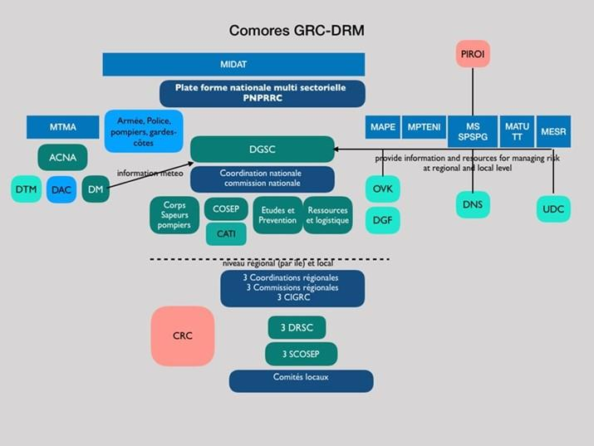
As indicated above, the DGSC coordinates the risk management process with the help of the branches of the other departments involved, according to the needs and types of risks. This risk management process includes several elements described below.
Information flow: The meteorological services transmit risk information to the DGSC and the Ministry of the Interior in charge of triggering the alert. There are Specialised Relief Plans (SRPs) for each of the main risks (cyclone, tsunami, Karthala, storms); these plans have been implemented by civil security and supported by UNDP and the World Bank with a breakdown by island.
The Karthala Volcano Observatory (KVO) oversees monitoring Karthala, alerting and supporting crisis management in the event of an eruption. The Karthala Volcano Eruptions Relief Plan, known as the Karthala Plan, was established in October 2004 (OVK, 2004). It plans the various emergency relief procedures to be undertaken to deal with the consequences of a volcanic eruption that could cause loss of life and loss of property. No revisions or simulations of the response plan have been carried out since 2004.
The General Directorate of Forestry (DGF) is responsible for issuing forest fire alerts to the DGSC.
Mobilisation of means of action for the activation of plans: The DGSC relies primarily on the resources and means of the Ministry of the Interior, Civil Security and Fire Brigade, which are present on each island for the land component. Regarding interventions at sea, a body of coastguards representing the State at sea was created in 2010 by decree within the Army with a central command to ensure the maritime surveillance of waters under Comorian sovereignty. This body is responsible for the protection of persons and property (marine rescue), environmental protection, police missions at sea and controls hydrographic and oceanographic activities. A specialised Tsunami relief plan was developed as part of a project entitled "Capacity Development for Natural and Climate Disaster Risk Management in the Union of the Comoros" by COSEWIC with support from UNDP (Nov 2011).
The General Directorate of Health (la Direction Générale de la Santé, DGS) has its own contingency plan for cyclone risks for each of the Comoros islands. National and island committees for the management and coordination of health sector emergencies and disasters were established in 2012. The "external" partners involved in health actions and likely to intervene in support of crisis management are resident actors (WHO, UNFPA, UNICEF, Comorian Red Crescent (CRCO), Qatari Red Crescent (CRQ), Canadian Red Crescent and Caritas Comores) and non-resident actors UNAIDS, UNHCR, FAO, WB, IOC, and WFP.
The Comorian Red Crescent (CRC), which supports the Comorian State in health and disaster risk management, has a network through its local offices and can mobilise up to 3000 people on the 3 islands. In the contingency plan, CRC provides first aid, emergency shelter, water and sanitation, food distribution, and health support services. It also provides training for managers in disaster risk reduction every two years as part of the Regional Disaster Response Team programme led by PIROI. Finally, village communities (the basis of the social structure of the Comoros) are active during and after crises in recovery operations and are the local relay for the resources provided by the diaspora.
Action plans: The national contingency plan created in 2008, with the assistance of OCHA, is the main management tool for emergency response. This plan organises the necessary crisis management arrangements for all relevant actors and stakeholders. This plan focuses on the 3 main hazards: volcanic eruption, epidemiological crisis and tropical disturbances. It is updated on a regular basis (every year or two years). Then, there are the emergency organisation plans - ORSEC plans - which specify the measures to be taken on each island in the event of an emergency. Finally, there are specific contingency plans: Karthala, Tsunami and Cyclone/tropical storms defining the command organisation for the different alert levels.
These existing plans were amended by the Early Recovery Plan (ERP) carried out with the assistance of UNDP and OCHA and based on the 2012 post-disaster assessment reports prepared by the UNDAC team, the World Bank delegation, the Comorian Red Crescent and the Red Crescent Movement, NGOs, civil society organisations and the private sector.
Concerning the alert system: The alert system is based on 4 categories - from blue to red - defining a different level of crisis characterisation (see Table 6). For each level and according to the hazard considered, the various national or local authorities that must participate in emergency management have a role defined in the 2011 National Contingency Plan.
Table 6 Four early warning classes in Comoros
Class | Alert |  | Threat level | Institution in charge of raising the alert
1 |  | Bleu: situation de routine | minimum | COSEP et comité de veille concerné (selon la nature du risque)
2 |  | Jaune : situation anormale qui fait appel à une vigilance | intermediate | COSEP- Comité national. Ministère de l’intérieur. DGSC
3 |  | Orange : déclarée en situation d’urgence nécessitant des dispositions | high | Comité national. Ministère de l’intérieur
4 |  | Rouge : niveau maximum entraînant l’activation des moyens opérationnels | maximum | Comité national. Présidence. Ministère de l’intérieur

The cyclone alert is broadcasted by the National Weather Service via multiple channels (telephone, radio, broadcasting). Local media (Radio Gazia and El Watan newspaper) are essential channels for the dissemination of the alert or instructions; this method of dissemination is included in the contingency plans.
Finally, there is an action plan to be adopted in the case of a cyclone alert, within 24 hours of the alert, within 48 hours including crisis management time during the event, and within two weeks of the event and concerning actions until the situation returns to normal.

2.2.3 Baseline projects
The table below describes national initiatives which bear relevance to this project.
Table 7 Baseline projects in Comoros
Project Details | Description: purpose, key activities (relating to Hydromet) and location | Complementarity with Hydromet
“Ensuring climate resilient water supplies in the Comoros Islands” (FP094)  2018-2026  Funding entities: UNDP, GCF  Budget: US$ 60.8m | Contributions to improving water resource data management through installation of 10 hydrological (surface water) gauging stations in Anjouan and Mohéli and 30 groundwater piezometers on Grande Comore and 13 across Anjouan and Mohéli. All water related monitoring stations will be coupled with the existing synoptic stations (4), automatic weather stations (10) or with the 90 rain gauges already installed. Technicians will be trained on monitoring system operation and management. Data will be captured, processed, and shared by the Directorate of Meteorology. A simple flood alert early warning system using total rainfall and rainfall intensity from selected automated rainfall gauges will be developed to provide a flood risk warning system for each island. This will be connected to the mobile phone system and provide SMS flood warning messages. | The equipment installed for water monitoring will be completed by additional hydrological stations through the proposed project Activity 2.1.1; training provided, and data and climate services developed by this project, will be complemented by the proposed project Activity 2.1.2 to upscale impacts in terms of improved flood risk management and resilience in Comoros.
“Strengthening Comoros Resilience Against Climate Change and Variability Related Disaster”  2018-2023  Funding entities: UNDP, UNISDR, PASDTR, Qatar, China (US$ 8.5m proposed GEF LDCF Grant pending)  Budget: US$ 36.3m | Strengthening institutional, policy and regulatory frameworks to integrate climate and disaster risks into planning, improve knowledge and understanding of key climate drivers and natural disasters, and strengthen community resilience to climate-induced disaster risks.  The project will develop climate modelling and provide Early Warning System messages for cyclone-related climate disasters. The climate products developed will support the integration of climate risks into all sectors including but not limited to the water sector in Comoros. | The proposed Hydromet project will enhance the results of this project by providing downscaled climate change projections and improving EW for cyclones.
“Ensuring climate resilient water supplies in the Comoros Islands” (FP094)  2018-2026  Funding entities: UNDP, GCF  Budget: US$ 60.8m | Contributions to improving water resource data management through installation of 10 hydrological (surface water) gauging stations in Anjouan and Mohéli and 30 groundwater piezometers on Grande Comore and 13 across Anjouan and Mohéli. All water related monitoring stations will be coupled with the existing synoptic stations (4), automatic weather stations (10) or with the 90 rain gauges already installed. Technicians will be trained on monitoring system operation and management. Data will be captured, processed, and shared by the Directorate of Meteorology. A simple flood alert early warning system using total rainfall and rainfall intensity from selected automated rainfall gauges will be developed to provide a flood risk warning system for each island. This will be connected to the mobile phone system and provide SMS flood warning messages. | The equipment installed for water monitoring will be completed by additional hydrological stations through the proposed project Activity 2.1.1; training provided, and data and climate services developed by this project, will be complemented by the proposed project Activity 2.1.2 to upscale impacts in terms of improved flood risk management and resilience in Comoros.

In addition, Comoros is a beneficiary country of a multi-country climate change mitigation project for which the GCF has approved funding of US$ 165m (across 29 countries), with a total project value of US$ 765m.

2.3 Madagascar

2.3.1 Policies and strategies
Madagascar has ratified 13 of the 18 International Human Rights Instruments. It is also party to international agreements on: Biodiversity, Climate Change, Climate Change-Kyoto Protocol, Desertification, Endangered Species, Hazardous Wastes, Law of the Sea, Marine Life Conservation, Ozone Layer Protection, Ship Pollution, and Wetlands. Finally, the country is signatory of the Hyogo and Sendai Multilateral Agreements.

Relevant UNFCCC-related policies
Madagascar submitted its National Adaptation Programmes of Action (NAPA) in December 2006. The NAPA targets the following five priority sectors: agriculture and livestock, public health, water resources, coastal zones and forestry. Several of the NAPA’s priority projects relate to climate services, particular ‘Support to the intensification of crop and livestock production’ as improvements in climate services and development of agroclimatic products will help farmers plan and select appropriate agricultural practices and crops.
Madagascar is currently developing its National Adaptation Plan (NAP), a process which started in 2011. This plan, still under development (as of August 2019), will focus on agriculture, climate risk management, coastal zone management, forests and biodiversity, human health, infrastructure, and water resources. Madagascar’s NAPA remains the main strategy with regards to climate change adaptation, until the finalisation and adoption of the NAP.
Madagascar submitted its Intended Nationally Determined Contributions (INDC) on 24 September 2015, and ratified the Paris agreement on 21 September 2016, at which point its INDC became its NDC – this NDC has not been modified since. The NDC notes that while adaptation and mitigation have different goals, the two can be mutually reinforcing – for example, ecosystem-based adaptation measures like reforestation and development of mangrove swamps support mitigation efforts by acting as carbon sinks. Madagascar can therefore contribute to mitigation efforts while addressing its adaptation needs.
By 2030, Madagascar aims to reduce its GHG emissions by 30 MtCO₂ compared to business as usual, which represents 14% of its current national emissions. However, Madagascar’s NDC states that this commitment is contingent on financial support from the international community.
To accomplish this, Madagascar’s NDC includes the following measures of particular relevance to the Hydromet project:
- Increasing renewable energy supply from 35% to 79%.
- Improving energy efficiency.
- Large-scale implementation of conservation and climate-smart agriculture and agroforestry.
- Reforestation of 270,000ha with indigenous species.
- Enhanced monitoring of forests and grasslands.
To implement these measures, Madagascar’s priority actions before 2020 in its NDC of particular relevance to the Hydromet project (particularly project outcomes around climate services, EWS, and sector-specific climate risk management plans for agriculture and water) include:
- Multi-hazard early warning systems primarily that mainly consider cyclones, floods, drought and the public health surveillance;
- Effective application of existing or newly established sectorial policies: flood and cyclone-resistant hydro-agricultural infrastructures standards, cyclone resistant buildings standards, flood-resistant terrestrial transport infrastructure standards, local for climate hazard community guideline for Water-Sanitation-Hygiene;
- Development of Resilient Agriculture Integrated Model pilot projects/programmes (combination of watershed management, selected/adapted varieties, locally-produced compost, rehabilitation of hydro-agricultural infrastructures, input access facilitation system, conservation agriculture, and agroforestry) or "climate-smart agriculture";
- Promotion of intensive/improved rice farming system and rain-fed rice farming technique;
- Formulation and implementation of the National Strategy for Integrated Water Resources Management; and
- Contribution to the finalisation of the “National framework for meteorological services” for which Madagascar has committed to the World Meteorological Organisation.
Actions it intends to take before 2030 include:
- Real-time monitoring of climate information;
- Effective implementation of multi-hazard early warning systems, including cyclones, floods, food security, drought, hunger, health and phytosanitary monitoring;
- Widespread application of Resilient Agriculture Integrated Models in major agricultural centre, cash crop zones, extensive livestock farming areas, priority areas for fisheries, mangroves, as well as drought hotspots;
- Sustainable and integrated water resources management, particularly in sub-arid areas and those vulnerable to drought periods;
- Strengthen and upgrade casualty multi-hazard early warning systems including the aspects of phytosanitary, agricultural, drought and food security monitoring; and
- Sustainable and integrated water resources management, especially in sub-arid areas and those vulnerable to drought periods.

National policies and strategies
Climate change-related policies and strategies are essentially coordinated by Bureau National de Coordination des Changements Climatiques et REDD+ (BN-CCCREDD+). It was created in 2016 and is attached to the Ministry of Environment, Ecology and Forests. BN-CCCREDD+ has a mission to lead national efforts for climate change adaptation and mitigation, as well as to oversee the preparation of the country’s REDD+ programme and its implementation.
The Government of Madagascar has identified as priority “the strengthening of the National Early Warning System and the improvement of the production and access to weather, water, and climate services” in the key national strategies such as the 2015-2019 National Development Plan (NDP), the National Climate Change Management Policy (NCCMP, 2012), and the National Strategy for Disaster Risks Management (NSDRM, 2016-2020).
The NSDRM 2016-2020 aims to better strengthen the state's interventions, including disaster risk identification, assessment and monitoring, and to strengthen early warning systems, by:
- Strengthening the technical, material and financial capacity of institutions and other stakeholders in risk and disaster reduction.
- Identifying and assess risks at both the national and local levels, so that their profile contributes adequately to the decision-making of stakeholders.
- Building the capacity of key data collection structures.
- Strengthening and relaying the national multi-risk early warning system by community-based Farmer Organisations.
- Strengthening Madagascar's participation in DRR in a framework of bilateral, sub-regional, regional and international cooperation.

2.3.2 Institutions and mandates of NMHSs and DRR institutions
This section presents the institutional, legal and functional framework for risk management and hydro-meteorological services in Madagascar.

Hydro-meteorological services
The current institutional and legal framework for the Directorate General of Meteorology are articulated in ARRETE N° 22.785/2015/MTTM, Articles 81 to 98 stipulating the missions and structures of central services and regional services in the Ministry of Tourism, Transport and Meteorology. As a central Direction of the Ministry, DGM has no legal neither financial autonomy. The DGM is responsible for:
- Providing weather information to various public and private services.
- Ensuring that meteorology serves the public interest through a sustainable development approach.
- Ensuring the proper implementation of provisions of international conventions on meteorology.
Figure 26 illustrates the current organisation chart of DGM reported in the DGM strategic plan (2016-2020) based on ARRETE N° 22.785/2015/MTTM.
Figure 26 Organisational chart of the Direction Générale Météorologique (DGM)
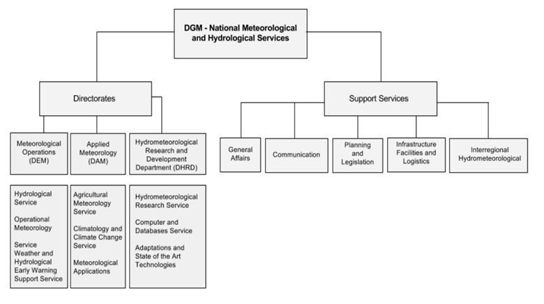
DGM-Directorates
The DGM is in charge of the National Meteorological and Hydrological Services, has three main Directorates and five supporting services.
Directorate of Meteorological Operations (DEM): In charge of the meteorological activities related to weather forecasting, hydrological forecasting and early warning operations. DEM includes the following three services:
- Hydrological Service
- Operational Meteorology
- Weather and Hydrological Early Warning Support Service
Directorate of Applied Meteorology (DMA): In charge of the administrative and technical coordination for the use, application and integration of weather, climate and hydrological information in socio-economic development and climate change adaptation and resilience. DMA encompasses the following three services:
- Agricultural Meteorology Service
- Climatology and Climate Change Service
- Meteorological Applications Service
Directorate of Hydro-meteorological Research and Development Department (DHRD): In charge of the innovation strategy and policy and the development, piloting, and implementation of research programs based on the socio-economic sector needs and the national commitment to the WMO programs and initiatives. DHRD is also responsible for research in modelling and forecasting and developing tools for accessing and sharing data and information within the DGM. DHRD includes the following services:
- Hydro-meteorological Research Service
- Computer and Databases Service
- Adaptations and State of the Art Technologies
In addition, DGM has several services:
- General Affairs Service: This service is in charge of human resources legislation and regulations, administrative, financial management, and accounting of Public operations.
- Communication Service: Responsible for the collection, exploitation and dissemination of information to the Ministry of Transport and Meteorology; and external communications of the NMHS.
- Planning and Legislation Service: Responsible for the NMHS project programming; budgeting programming of the NMHS directorates and services coherence and synergy of meteorology projects with the National Development Plan; coordination and monitoring of asset management of the NMHS Madagascar, and handling of legal affairs;
- Infrastructure Facilities and Logistics Service (CIL): Responsible for standardization, calibration, maintenance and servicing of instruments and meteorological and hydrological equipment; management of equipment, instruments, equipment and infrastructure of the NMHS; maintenance and repair of vehicles, buildings and infrastructure of the NMHS.
- Interregional Hydro-meteorological Services: Responsible for the representation of the Directorate General of Meteorology at the interregional level and support of operationalization of all Regional Services.
With regards to hydrology, a specialised service is attached to DGM as mentioned above. The main legal framework is the “Code de l'eau” and related decrees of application, which clearly determine the mandate of the national hydrological service, namely: hydrological observations of water level and flow, climatological observations, assessment of water resources (quantity and quality), hydrological forecasts and alerts production (for droughts, floods and flows), and disaster risk prevention. Figure 27 illustrates which institutions contribute to the production and sharing of water-related information. In addition to the hydrological service, SAHH (service d’appui à l’hydrologie et l’hydrogéologie), based at MEEH, has mandate to monitor ground water (quantity and quality).

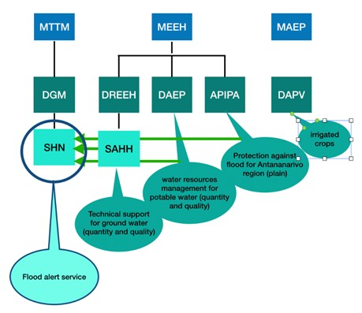
DRR institutions
Figure 27 Information flow regarding hydrology
The DRR policy of Madagascar refers directly to the Prime Ministry. The policy is aligned with Sendai international Commitment (March 2015). The Disaster Risk Management in Madagascar is implemented according to Law No. 2015-031 (February 2016), the National policy for DRM (Politique Nationale de Gestion des Risques et des Catastrophes - PNGRC) and referring decrees. Under these legal frameworks, DRM institutions have been set up and their roles and responsibilities defined.
Furthermore, the Law No. 2017-028 on the National Policy on Social Protection and the National Strategy for Social Protection (SNPS 2018) foster the development of national social safety nets reactive to shocks and aiming (i) by 2019 to develop and pilot "shock-responsive social protection" approaches adapted to the different intervention zones and different types of shocks, and (ii) from 2020, after the evaluations of the pilot projects, to gradually scale up these approaches.
The National strategy for disaster management (Stratégie nationale de gestion des risques de catastrophes- SNGRC) validated in September 2016 is a main pillar for sustainable development. The SNGRC has been based on four (04) strategic axes:
- AXIS 1: Greater political commitment in the DRR, taking into account the different specificities of the assets and issues involved, improving resilience.
- AXIS 2: Improved governance of the DRR at all levels.
- AXIS 3: Capacities of the actors in the field of DRR and coordination strengthened.
- AXIS 4: Knowledge management practice for the benefit of the DRR.
At the strategic level, three institutions are noted:
CNGRC – Conseil National de Gestion des Risques de Catastrophe
The CNGRC (National Council for Risk and Disaster Management) is a consultation and decision-making structure at the highest national level. It intervenes in the organisation of the protection of the population and the environment in the event of disaster occurrence. Its main tasks are to implement the DRM strategy, supervise BNGRC, make strategic decisions for DRM including calling for international support during crisis, and ensure the mobilisation of relevant ministries while implementing DRM measures.
CPGU – Cellule de prevention et gestion des urgences
This structure provides a technical assistance to Prime Minister and CNGRC for implementing DRR and is in charge of communication with other institutions at national level involved in this process. Moreover, CPGU is in charge of elaborating, monitoring and actualising DRR policies and strategy, integrating DRR in existing sectorial policies, providing Risk profiles, reinforcing prevention and mitigation actions within sectorial policies, and declaring official urgency situation and if necessary call for international help (financial and technical assistance from national and international partners).
PNRRC - Plateforme nationale pour la reduction des risques et des catastrophes
The platform serves as a forum for all stakeholders to share information and experience on risk and disaster management. It is a place of capitalisation and sharing of experiences and achievements in DRR, in terms of good practices and lessons learned. It is also the place to improve the environment of the DRR in Madagascar, to propose update of the National Strategy of Risk Management and Catastrophes (SNGRC) as well as to discuss DRR strategies with international partners.
With regards to the operationalisation of disaster risk management, the following institutions play a key role:
BNGRC – Bureau National de Gestion des Risques et Catastrophes
BNGRC is the operational arm of CNGRC. This key institution is the national authority for the management, coordination and follow-up of all activities related to the DRM and Disaster Risk Reduction (DRR) in Madagascar (Loi 2014-018 et 2014-020), under the authority of the Ministry of Domestic Affairs. The mandate of BNGRC includes the promotion of risk prevention, preparedness and mitigation among relevant institutions and agencies, including local governments and NGOs, the provision of technical assistance to local governments in implementing their action plan for DRM, the provision of advice, recommendations and guidelines for contingency plan, commanding the national emergency operational centre (CERVO) during crisis, and compiling information before, during and post crisis. In addition, BNGRC updates its National Contingency Plan on cyclones and floods annually, in a collaborative way by consulting all stakeholders involved in DRR/DRM interventions. This plan highlights all processes to follow during cyclone events. It benefits from lessons learned from previous crises through its annual update.
CRIC – Comité de réflexion des intervenants en catastrophe
The CRIC is a national collaborative platform in charge of technical coordinating of on-the-ground interventions during crisis, acting under BNGRC authority. This platform facilitates information exchange, join lessons learning process, sharing of recommendations and coordination of every institutions involved in DRM. Run by the BNGRC, the CRIC encompasses 7 commissions: 3 operational commissions (Logistics/Infrastructure/Monitoring and evaluation) and 4 thematic commissions (health, agriculture, education, sciences) that are implemented through a large participative approach in the following areas:
- Vulnerability risk assessment in order to implement sectorial development action plans
- Early Warning System activation, monitoring and evaluation
- Information management related to emergency situation during preparation, during event and after crisis.
- Evaluation of implemented actions, and recommendations for Contingence plan improvement.
- Dissemination of information and good practices coming from international partners.
CRIC’s mandate is also to provide technical assistance to BNGRC through designing and developing documents and technical tools to support and guide DRM interventions, monitoring and evaluation of previous DRR actions undertaken and documenting positive experiences, and developing recommendations to improve future risk prevention and response.
CERVO – Centre d’études, de réflexion, de veille et d’orientation
CERVO operates under the BNGRC. The CERVO is the focal point for all warnings and disaster information. CERVO’s team has been recently reinforced with new competencies: agriculture, DRM specialist, GIS specialist, spatial analyst, and drone specialist. CERVO implements early warning systems (see following paragraph). Finally, CERVO focuses on research activities, together with University of Antananarivo and other institutions. Research focuses on risk prevention (‘retex’ – return on experiences, contingency plan, sectoral data improvement).
At the local level:
Though decentralization is underway in Madagascar, there is yet no legislation guiding the DRM process at regional and local levels. However, several committees are in place to coordinate local-level interventions. Local operational coordination is done at the district level, under the coordination of the District Risk Management and Disaster Management Committees (CDGRC). The Regional Risk Management Committee (comité regional de gestion risques de catastrophes – CRGRC) ensures the overall coordination of the CDGRCs, the centralisation of information and the making of major decisions. These CRGRC have been established in the 22 regions of Madagascar. They are headed by the Prefect and the Regional Chief. A firefighter and a civil protection unit are also in place and ready to intervene within each regional headquarters. As soon as an alert is released at the national level, the regional committees are in charge of disseminating risk information at district and village (fokontany) level to warn the population and give the rules of conduct to be maintained. During the acute emergency phase, local and district committees are reinforced by central BNGRC teams. The most active partners at the regional and district level, especially during the emergency phase, provide support to local coordination at their convenience.
Figure 28 is an illustration of the disaster risk management process in Madagascar (more detailed in Section 3.2.3 – country case study), from national to regional levels.
Figure 28 Institutional chart of DRM in Madagascar
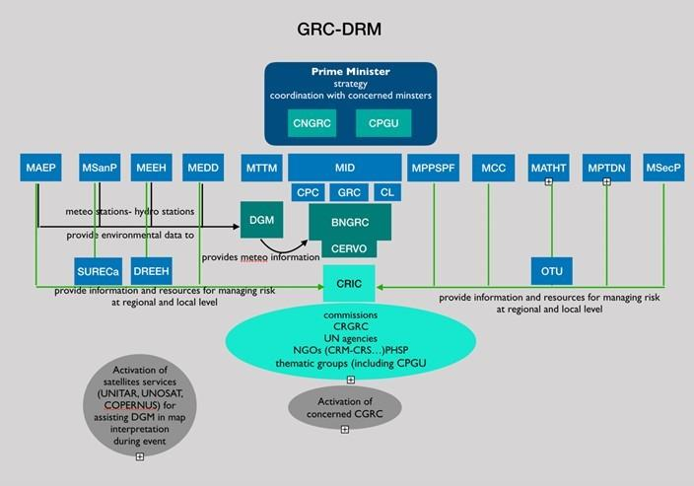
Disaster risk management process
Within BNGRC, CERVO is the pillar and focal point for all warnings and disasters information. As long as the disaster is predictable, all the warnings provided by the different warning systems (APIPA, DGM, Early Warning System for the Great South, firefighters, IOGA, etc.) are centralised within the CERVO / BNGRC which, according to the gravity or the imminence of the event, decides to diffuse or not to all the actors concerned (Authorities at different levels, Rescue Services, Partners, Media). Depending on the source and the nature of the disaster, the alert can pass through the Ministry concerned for evaluation and validation and the latter sends it to the BNGRC. This is the case for epidemic alerts and alerts related to the locust attack.
During a crisis, BNGRC is in charge of operational management of action, including command of the National Center for Emergency Operations (Crisis Staff), liaison between CNGRC and local decision and action levels; coordination between the various ministerial or local executive committees, support Prime Minister’s decision and mobilisation of relevant partners for DRR meetings. It receives CRIC’s technical assistance to perform these tasks.
CERVO is in charge of permanent watch on the crisis situation as soon as BNGRC activates the Crisis Command post (CP). CERVO’s tasks include:
- Ensure the collection, processing and analysis of data and all relevant information concerning serious events threatening civil security.
- Prepare a daily bulletin in the form of situation reports, flash bulletins or any other document that provides information on the evolution of the crisis situation and which is intended for all relevant authorities and partners.
- Propose actions to be undertaken as the prioritization of immediate intervention zones according to the different means available.
- Ensure the dissemination of information and decisions of the BNGRC to decision-makers and information relay.
Figure 29 Common mechanism to alert for any disasters
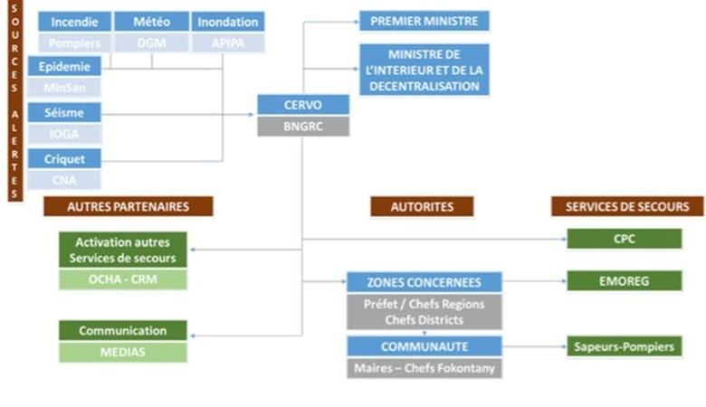
Cyclone and tsunami alerts come directly from DGM to CERVO. DGM disseminates pre-alerts and updates on climate-related hazards progress to BNGRC via CERVO, on an hourly basis or more frequently if a significant evolution in the event is noted (see Figure 30). Based on feedback from CERVO / BNGRC, a "state of alert” may be declared by the relevant authorities that allow them to apply restrictive measures.

Figure 30 Functional relation between meteo information and Risk management (DRM)
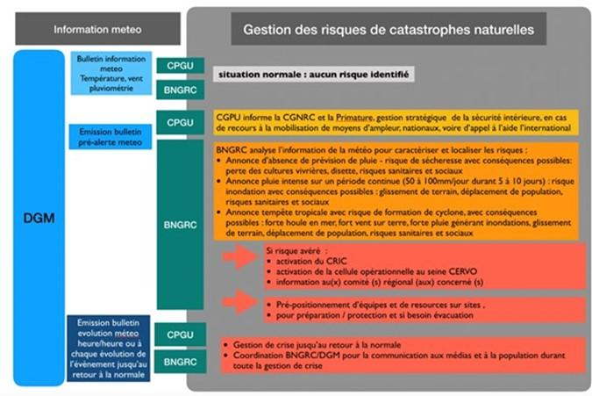
There are 7 major risks that have been clearly identified in Madagascar, with dedicated institutions in charge of knowledge, information, risk assessment, monitoring and forecasting of the hazards:
- FLOODS: DGM is assisted by APIPA for flood by monitoring rivers catchments in the plain around Antananarivo. There is no reliable monitoring on other rivers catchments prone to flood in the others flood regions (North, North East and West) specially regarding rivers catchments near main urbanised areas (Nosy Be and Antsinanana in the North as tourism areas, Mahajunga and Morandava and Toliana on the West coast, and Taomasina on the East coast).
- DROUGHTS: DGM provides data on rainfall over the 5 to 10 previous years, mainly for the rainy period between October and March in the great south (3 regions). There is no reliable monitoring on the 3 main rivers catchments in the Great South for water resource availability regarding agriculture irrigation to prevent from drought.
- CYCLONES: DGM is responsible for Cyclone information and knowledge and alert to the BNGRC.
- EPIDEMICS: DGS is responsible for five major groups of major epidemic threats that may interest Madagascar, namely: malaria; epidemic diarrhea like cholera; severe respiratory infections represented by pandemic influenza and MERS-CoV; viral haemorrhagic fevers and arboviroses, including dengue, chikungunya or Rift Valley Fever (RVF).
- LOCUST ATTACKS (criquets): the CNA is responsible for locusts that may destroy harvests.
- EARTHQUAKES: IOGA is responsible for earthquake
- FOREST FIRES: the DGF is responsible for Forest fire information
Regarding preparedness and response capacity, together with dissemination and communication there are 3 specific contingency plans regarding main important hazards which may damage the country: drought; cyclones, tropical storms and floods; and epidemic alerts (not detailed here).
Drought contingency plans are prepared for the Great south region: the DGM provides data on rainfall over the 5 to 10 previous years, mainly for the rainy period between October and March. In case of low rainfall during this period before the crop season, the alert must be activated by BNGRC/CERVO for the 3 regions (CRGRC) and the local directions of concerned sectors: DR for water and sanitation, DR for education, DR for public infrastructure and works, Office régional de nutrition, DR protection et affaires sociales, DR santé publique, DR developpement rural, together with the present partners on site Unicef and WFP/FAO.
Cyclone and flood contingency plans are prepared for 16 regions prone to cyclones and floods: The DGM provides information on the potential cyclones 3 days before possible occurrence over Madagascar (i.e. 1500 to 2000 km away from the coasts). A 4-class alert system is operated (green/yellow/red/blue) and presented in the following table 8.
Table 8 4-class alert system for cyclones
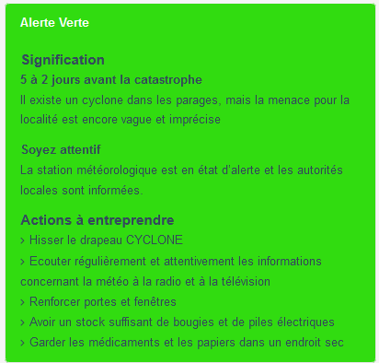 | 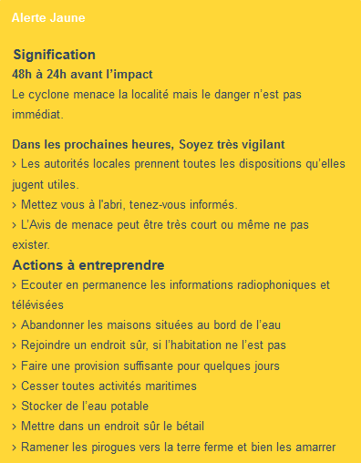
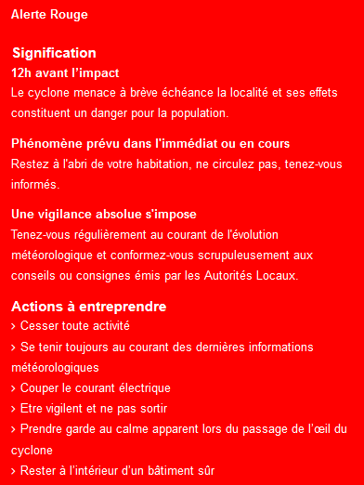 | 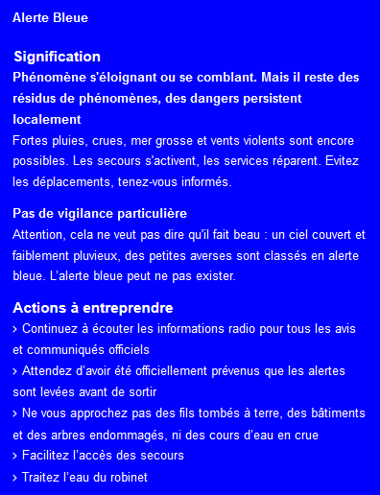

2.3.3 Baseline projects
The table below describes national initiatives which bear relevance to this project.
Table 9 Baseline projects in Madagascar
Name | Purpose, key activities (relating to Hydromet) and location | Complementarity with Hydromet
« Adaptation des chaînes de valeur agricoles au changement climatique (PrAda) »  (Adaptation of agricultural value chains to climate change)  2017-2022  Funding entity: GIZ | Under this project, agricultural value chain players will benefit from better access to agrometeorological and agricultural advisory services, which allows them to adapt production to climate change. In addition, the project also aims to improve structural framework conditions. These include the development of a quality agricultural policy, the organisation of actors and cooperation between them. Access to operating resources is simplified and production techniques are adapted. Finally, the project supports the establishment of climate risk insurance. DAPV is working with GIZ on PRADA project which aims at translating climate information into agrometeorological advisories and disseminate them at the local level using mobile phones. | The agriculture-related data and climate services developed by this project will be complemented and upscaled in other regions, for other crop varieties and using different communication means to increase outreach through the proposed Hydromet project. Note that agriculture was selected as one of the key sectors for Madagascar.
« Projet d’Amélioration des Capacités d’Adaptation et de Résilience des Communes Rurales face aux Changements Climatiques (PACARC) »  2016-2021  Funding entity: PNUD-FEM | PACARC contributes to implementing the NAPA. It aims to enhance adaptive capacity among vulnerable communities of Androy, Anosy, Atsinanana, Analamanga et Atsimo Andrefana ; climate variability and change are already affecting their livelihoods. Through PACARC, the following interventions will be implemented : i) strengthening of adaptative capacity among institutions ; ii) production and dissemination of hydrological and agrometeorological information to help decision-making processes ; and iii) implementaiton of adaptation technologies in selected municipalities. | The proposed project will build on PACARC interventions to strengthen to production and dissemination of hydrological and agrometeorological information in other communities not targeted by this project.

In addition, Madagascar is a beneficiary country of four current projects for which the GCF has approved funding of USD 686.1 million, with total project values of USD 2.4 billion.

2.4 Mauritius

2.4.1 Policies and strategies
Mauritius has ratified 12 of the 18 International Human Rights Instruments. It is also a party to international agreements on: Antarctic-Marine Living Resources, Biodiversity, Climate Change, Climate Change-Kyoto Protocol, Desertification, Endangered Species, Environmental Modification, Hazardous Wastes, Law of the Sea, Marine Life Conservation, Ozone Layer Protection, Ship Pollution, Wetlands. Finally, the country is signatory of the Hyogo and Sendai Multilateral Agreements.

Relevant UNFCCC-related policies
As Mauritius is not classified as a LDC, it has not submitted a National Adaptation Programme of Action (NAPA). The country has however started its National Adaptation Plan (NAP) process.
Mauritius submitted its INDC on 28 September 2015, and ratified the Paris agreement on 22 April 2016, at which point its INDC became its NDC – this NDC has not been modified since. Within this document, Mauritius’ priority adaptation actions include:
      - Infrastructure: protection of infrastructure against climate change calamities enhanced
      - Disaster Risk Reduction Strategy: to understand disaster risk, implement disaster risk strategy, strengthen management of related governance, and invest in resilience.
      - Coastal Zone Management: to improve awareness, enhance rehabilitation, and strengthen regulatory framework for protection of beach, dunes and vegetation.
      - Water Resources Management: improve forecasting, management, protection and quality of water resources, including upgrading and building of new treatment plants and reservoirs and reducing water losses in the distribution system.
      - Rainwater Harvesting: procurement and installation of rainwater harvesting systems and improvement in policy, legal, and regulatory water framework in mainland Mauritius, Rodrigues, and other outer islands.
      - Desalination: small desalination projects, especially for Rodrigues island.
In addition, Mauritius’ key mitigation activities identified in the NDC include:
- smart use of marine resources;
- expansion in solar, wind and biomass energy production and other renewable energy sources;
- sustainable consumption and production in all sectors of the economy;
- gradual shift towards the use of cleaner energy technologies, such as LNG, among others;
- modernisation of the national electricity grid through the use of smart technologies, which is a prerequisite to accelerate the uptake of renewable energy;
- efficient use of energy through the deployment of appropriate technologies in all sectors of the economy and awareness raising on energy conservation;
- sustainable transportation, including promotion of energy efficient mass transportation systems based on hybrid technologies and cleaner energy sources;
- climate smart agriculture including bio-farming;
- sustainable and integrated waste management, including waste to energy;
- sustained tree planting programme within the context of the cleaner, greener and safer initiative; and
- leapfrog to low global warming potential refrigerants.
The NDC also notes that to achieve these objectives, Mauritius will need to access international finance.

National policies and strategies
Mauritius’ National Climate Change Adaptation Policy Framework aims to mainstream climate change adaptation in policies, strategies and plans. It includes a National Climate Change Adaptation Policy, a Climate Change Adaptation Strategy and Action Plan, and a Climate Change Adaptation Investment Plan. The adaptation policy focuses on agriculture, water, fisheries, ecosystems, protection of human settlements and infrastructure, and capacity building to “understand, analyse and pre‐empt” climate change impacts “in a timely manner”. It notes the importance of information gathering and regional and international collaboration to implement its adaptation goals.
The framework notes that “more detailed analysis is available for the island of Mauritius” and that “specific considerations are made for Rodrigues”, but data gaps mean that not all islands are addressed equally.
Mauritius has also developed Technology Action Plans for Climate Change Adaptation and Mitigation. For adaptation, these include, in the agriculture sector, integrated pest management and micro-irrigation, in the water sector, rainwater harvesting, hydrological models, and desalination technology, and in the coastal zone, dune and vegetation restoration, rock revetments, and wetland protection.
Mauritius’ National Disasters Scheme (NDS) 2015 takes a multi-agency approach to DRR “based upon comprehensive multi-hazard mapping for the country”. It includes protocols for issuing warnings and mandates to collect and provide data – for example, on the approach of a cyclone, collecting data from extensometers (1.6.7(b)), during heavy/torrential rainfall and flooding, collecting rainfall data from automatic weather stations (2.3.1(c)(v)), and during drought, providing data on irrigation water allocation to different users and on reservoir water usage/storage (5.5.8-5.5.9).
In addition, in July 2013 Mauritius established a Climate Change Information Centre which “aims to become a regional Climate Change Information Hub for the Eastern African Region in the near future”.

2.4.2 Institutions and mandates of NMHSs and DRR institutions
This section provides an overview of the institutional, legal and operational frameworks for DRR and NMHS in Mauritius.

Hydro-meteorological services
The Mauritius Meteorological Services (MMS) is under the Ministry of Local Government, Disaster and Risk Management. Its mission is to provide accurate and timely weather and climate information and meteorological products for the general welfare of the citizens of the Republic of Mauritius.
Regarding to its legal framework, MMS has a legal and financial autonomy with the responsibility for the provision of weather, climate services and warnings for hydro-meteorological hazards and tsunamis. MMS is committed to provide services complying with customer, statutory and regulatory requirements, including WMO and ICAO, and to continually improve the effectiveness of the QMS so as to ensure its continuing suitability for meeting the need and aspiration of our customers. It is also committed to fostering a conducive work environment using modern technology that will enable the MMS to achieve its mission, objectives and goals. A Quality Policy is under action and is reviewed on 3 yearly basis or earlier whenever there are changes in the business environment.
Figure 31 Organigram of MMS
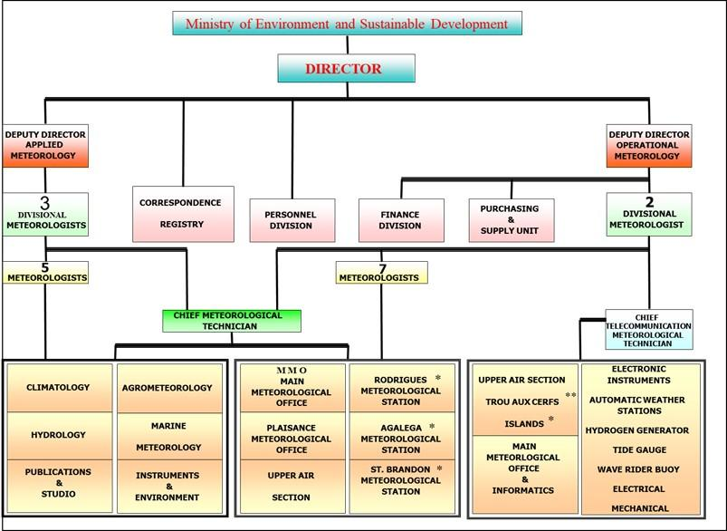
MMS has the following offices along the country:
- Main Meteorological Office at Vacoas;
- Aeronautical Met. Station at Plaisance;
- Agalega Meteorological Station;
- St. Brandon Meteorological Station;
- Rodrigues Meteorological Station.
According to its organigram (Figure 31) MMS has the following main sections:
- Applied: Hydro-meteorology, Marine Meteorology, Climatology, Agro-meteorology, Publication and Public Awareness.
- Operational: Atmospheric sounding (Upper air), Instruments, Main Meteorological Office, Aeronautical Met. Station at Plaisance, Rodrigues Meteorological Station, Agalega Meteorological Station, St. Brandon Meteorological Station.
- Electronics: Informatics, Communications, Automatic weather stations and Hydrogen generators.
With regards to hydrology, and in terms of legal framework, it should be noted that there is no Water law in Mauritius but, since 2015, the National integrated water resources management Plan (NIWRM) is implemented under the responsibility of MEPU (for Mauritius and five other islands).
The Ministry of Energy and Public Utilities (MEPU) is responsible for the water sector. It formulates policy and strategy for the mobilization and conservation of water resources and management of supply and distribution of water. It is also responsible for implementation of projects for the construction of reservoirs and related infrastructure. The Water Resources Unit (WRU) attached to the MEPU oversees hydrological services for electricity production (dams), potable water consumption and agriculture irrigation. The WRU is responsible for the assessment, monitoring, mobilisation, control, development, management and conservation of water resources in Mauritius.
In Mauritius, 55% of domestic water uses comes from ground water and the rest from surface water through 6 reservoirs and 1 dam at Bagatelle. The water resources availability in Mauritius is highly depending on rainfalls. As WRU oversees providing water for human activities including agriculture, domestic use, and industry, its ability to understand and monitor rainfall is critical. To support this, MMS provides monthly rainfall forecast divided on 9 geographical sectors (not related to water catchments) to WRU, which also monitors 150 gauging stations for surface water, and 260 piezometers for boreholes in ground water. Finally, WRU receives information on water monitoring made by the sugar cane industry (which has its own monitoring station network).

DRR institutions
The DRR policy of Mauritius refers directly to Ministry of Local Government, Disaster and Risk Management. Aligned with the Sendai Framework (March 2015), this policy follows the National Disaster Risk Reduction and Management Act (NDRRM Act, 2016). Under these legal frameworks, DRM institutions have been set up and their roles and responsibilities defined. The NDRRM Act (2016) aims at a “continuous and integrated multi sectorial, multi-disciplinary process of planning, organising coordinating and implementing measures for: preventing and reducing the risk of disasters; mitigating the adverse impacts of disasters; disaster preparedness; rapid and effective response to disaster; and managing post disaster activities, including post-disaster recovery and rehabilitation”.
The key strategic DRR institutions in Mauritius are:
- The National Disaster Risk Reduction and Management Council (NDRRM Council): in charge of the formulation of the NDRRM policy, as well as the oversight and the implementation of the national strategic framework and action plan, which aims to substantially reducing disaster risk-related mortality, the number of affected people, economic losses and damages to critical infrastructure by 2030. The Council also ensures that DRR is mainstreamed into all sectorial policies. There are one Council for Mauritius and one for Rodrigues.
- The National Disaster Risk Reduction and Management Centre (set up in 2013) is the body that acts as the main institution for the Republic of Mauritius for the planning, organizing, coordinating and monitoring of disaster risk reduction and management activities at all levels. The NDRRM Centre coordinates with all stakeholders to ensure that risk reduction and preparedness planning is included at all levels of the country, from individuals and communities, to Government policy and strategy. The NDRRM Centre insures the implementation of the National Strategic framework and National Plan. The Centre works in close collaboration with MMS, which is in charge of developing and improving warnings and advisories systems for all natural hazards affecting Mauritius.
In terms of operationalising DRR in Mauritius, the following institutions play a key role:
- The National Emergency Operating Command (NEOC) is established within the NDRRM Center and is activated whenever a disaster or any major crisis is imminent. The NEOC is a multi-agency, comprising representatives from ministries, emergency services, NGOs and private sectors. It is the main coordinating body during the preparedness, response and recovery phases of any disaster or crisis. The commissioner of Police leads disaster response operations jointly with the Ministry of Local Government, Disaster and Risk Management, and other agencies as needed according to the circumstances.
- The National Crisis Committee meets at the specific request of the Director General of the NDRRM Center, based on the assessment of the severity of expected disaster. The committee shall take decisive actions to safeguard the life of persons in danger, including evacuation of persons at risk owing to age or some disability, women, children and persons detained in an institution.
- The Mauritius Police Force leads disaster response operations.
- The Ministry of Public Infrastructure and Land Transport oversees monitoring landslides.
- The Mauritius Fire and Rescue Service provides capacity and resources in search and rescue operations for all types of disaster.
Coordination at local level
There are 12 Local Emergency Operations Command (LEOC) at district level, headed by the Mayor/President of District Council. In addition, the REOC – Rodrigues Emergency Operations Command – has been established for Rodrigues with the support of NDRRM Center. With a view of engaging the local communities in disaster preparedness and response, the Fire and Rescue Service is currently setting up a volunteer fire and rescue service jointly with the local authorities. Figure 32 indicates key DRR institutions in Mauritius including their relationships.
Figure 32 Institutional chart of DRM in Mauritius (source NDS 2015)
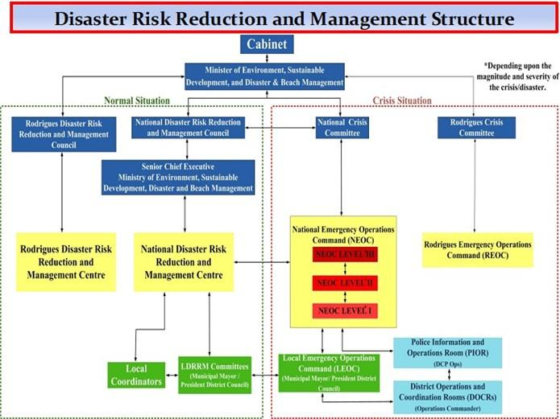
Under the National Disasters Scheme (NDS) for NDRRM, there are 8 emergency schemes dedicated to 7 specific risks:
- Cyclone: MMS releases the alerts.
- Heavy rainfalls/flooding emergency: MMS provides general flood warnings with emphasis on flooding risks in known low-lying and poorly drained areas.
- Tsunami: The Regional Tsunami Service Providers (RTSP) from India, Indonesia and Australia will provide tsunami advisories to the National Tsunami Warning Centres (NTWC) of the Indian Ocean countries, including Mauritius. As soon as a Tsunami advisories is received from the RTSPs, MMS will activate the Tsunami Warning System while taking into consideration the degree of risk as well as the time factor. In virtue of its geographical location, Mauritius, Rodrigues and the Outer Islands have a lead-time of 4-7 hours before tsunami waves are likely to reach their coasts generated from either the Sumatra or the Makran source.
- High waves resulting of storm surge strong wind: MMS issues warning for high waves arising from heavy swells which has originated far from the region or due to storm surge arising from a distant storm/cyclone. As far as practicable, about 24 hours in advance, a Special Communiqué is issued to inform the public of any impending high waves based on observation available.
- Water crisis (Drought): a national water crisis emergency scheme has been formulated with the collaboration of all concerned stakeholders. The MEPU is the main warning/alerting agency in case of a water crisis situation, based on monthly rain forecast given by MMS and water resource availability given by WRU.
- Landslides: The Ministry of Public Infrastructure and Land Transport (MPI) is responsible for the monitoring of landslides in the 3 landslide-prone regions: Chitrakoot, QuatreSoeurs and Vallée Pitot. MPI works on close collaboration with concerned local authorities, MMS and NDRRMC to inform the public about the risk and to undertake surveys for updating the list of landslide-prone regions in Mauritius. The landslides warning system is based on MMS rain forecast in case of continuous rainfall.
In addition to these special schemes, an 8th scheme specific to Port Louis has been developed: the Port Louis Flood response plan (PLFRP), which is activated in case of MMS alert bulletin of heavy rains.
Each of the schemes described above provides detailed instruction of what to do for general risk preparedness, before a crisis, during a crisis, and after a crisis. The schemes delineate roles, responsibilities and coordination between all relevant stakeholders involved in risk management.

2.4.3 Baseline projects
The table below describes national initiatives which bear relevance to this project.
Table 10 Baseline projects in Mauritius
Name | Description: purpose, key activities (relating to Hydromet) and location | Complementarity with Hydromet
“ER2C Mauritius”  2018 - Dec 2019  Funding Entity: AFD (Adapt’Action)  Budget: EUR 682,988 | Provides a gap analysis of the NDRMMC and Pathways to Sendai Implementation (DRRM Strategic framework, action plan and policies); includes a study of community risk perception; support the updating of the IDF curves for flood forecasting working with MMS and WRU; has identified land drainage priority measures in 6 priority sites for flood risk reduction | The flood forecasting conducted through this project, as well as the gaps identified in data gathering and analysis (and recommendations to fill these gaps), will inform the hydrology training and equipment to be set up under this project; and serve as a basis to produce additional flood hazard maps in Mauritius (see Activity 3.2.5).
“Emergency Alert System”  2018-2020  Funding Entity: NEF  Budget: | Support to establish a reliable system and its infrastructure to disseminate warnings and alerts to maximise number of people receiving information within reasonable timeframe, and using various channels such as mobile phone and landlines, TV and radio and the Internet. In addition to the equipment, training is also provided to operate the system. | This system will be used and complete to disseminate climate-related alerts, which accuracy and timeliness will be improved through the proposed project.
“Land Drainage Master Plan”  Planned to start late 2019 for 15 months  Funding Entity: AFD  Budget: EUR 1,5 million | The LDMP will include a: a) detailed inventory of the infrastructure and hydraulic diagnosis on the island drainage infrastructure and mapping of all flooded and vulnerable areas on the basis of field surveys; b) technical and economic comparison between different levels of protection scenarios and recommendations for optimal design drainage network frequency and c) studies will be produced in the most critical sites using an integrated ridge-to-reef approach. At the national scale, a detailed map of vulnerable areas will be produced. A set of specific structural and non-structural measures in each of the local critical sites. | The flood forecasting and flood hazard maps produced through this project will be complemented by the proposed Hydromet project, which will build on data and training in hydrology conducted by this initiative.
“Doppler radar and capacity building”  Radar in operation in April 2019, capacity building until April 2022  Funding entity: JICA  Budget: JPY 261.7m | Strengthening the capacity of the MMS for disseminating more accurate and timely meteorological information to disaster-related organisations and the public through capacity development in the areas of meteorological observation, analysis, and the dissemination of forecasts, warnings and other information.  The S-Band Doppler Solid State Radar Project consisted of two phases, the acquisition and installation of the “S-Band Doppler Solid State Radar” as well as the construction of a new tower at Trou aux Cerfs which will house the new Radar and its communication systems.  Installation of the radar was completed in April 2019 and the calibration process is ongoing. | Both the capacity building and equipment provided through this project will serve as a basis to build on for the proposed project; the radar installed under the proposed project (see Activity 2.1.1) will complement this JICA initiative.

In addition, Mauritius is a beneficiary country of three current projects for which the GCF has approved funding of 557.8 million, with total project values of 1.7 billion.

2.5 Seychelles

2.5.1 Policies and strategies
Seychelles has ratified 14 of the 18 International Human Rights Instruments. It is also a party to international agreements on: Biodiversity, Climate Change, Climate Change-Kyoto Protocol, Desertification, Endangered Species, Hazardous Wastes, Law of the Sea, Marine Dumping, Ozone Layer Protection, Ship Pollution, Wetlands. Finally, the country is signatory of the Hyogo and Sendai Multilateral Agreements.

Relevant UNFCCC-related policies
As Seychelles is a high-income country, it has not submitted a National Adaptation Programme of Action (NAPA) nor is it preparing a National Adaptation Plan (NAP).
Nonetheless, Seychelles submitted its INDC on 25 September 2015, and ratified the Paris agreement on 29 April 2016, at which point its INDC became its NDC – this NDC has not been modified since. Seychelles’ adaptation contribution within this document will cost at least USD 295 million to implement. It recommends further research to understand the impacts of a changing climate on “cyclone patterns, ocean and air currents, and…other climate phenomena such as El Niño.”
The INDC also notes the impact climate change will have on fisheries, infrastructure, and tourism, among other sectors. Key vulnerabilities identified include the lack of protection for critical infrastructure, significant development in the coastal area (particularly for tourism), water security, food security (both due to impacts on fisheries and reliance on imported food), and disaster preparedness (including the need for research and resources to “predict, prevent and respond to disasters”).
To meet these adaptation requirements, the INDC proposes, amongst other measures:
- Critical Infrastructure: Climate change adaptation to be mainstreamed in all sectors with critical infrastructure; planning process for all new developments, with associated improvements in the building codes and their rigorous enforcement
- Tourism: Greater co-management of the sector by the Ministry of Tourism and Department of Risk and Disaster Management as well as with the Ministry of Environment, Energy and Climate Change
- Food Security: A sustainable modern agriculture supported by new and innovative technologies across all food production supply and value chains, and by skilled and qualified human resources and integrated with the Blue Economy and Seychelles Strategic Plan 2015
- Biodiversity: Fully implemented Seychelles Biodiversity Strategy and Action Plan; fully implemented and enforced Biodiversity Law; fully bio-secure border
- Water Security: Fully integrated approach to water security that addresses issues such as ecosystem health, waste management, water treatment and supply, sewage, agriculture, etc
- Energy Security: More resilient energy base with greater innovation of renewable energy where practicable; efficient fuel-based land transport and more use of electric vehicles charged with renewable energy technology; strengthened cooperation between Government entities
- Health: Health sector able to respond to population increase and its additional climate-related health burden; exploration of relevant potential science and technology innovations
- Waste: Waste managed according to strict hierarchy and waste policy fully implemented; exploration of relevant potential science and technology innovations
To implement these measures, the NDC notes the need for further research and improved technological capacity, including the necessity to undertake “climate change modelling and risks, monitoring of climate change impacts and implementation of adaptation measures.”
As for its mitigation commitments in the NDC, Seychelles aims to reduce emissions by 122.5 ktCO_{2e} in 2025 and 188 ktCO_{2e} in 2030 relative to baseline emissions. Its mitigation efforts will focus on the Energy (public electricity generation and demand side management, and land transport), and Waste (solid waste management) sectors – LULUCF is excluded. The cost of meeting these mitigation targets was estimated to be at least USD 309 million, which Seychelles aims to meet “partly through domestic funding and conditional on international climate financing including through the Green Climate Fund among others.”

National policies and strategies
The Seychelles Coastal Management Plan 2019–2024 aims to protect the coastal zone in the face of climate change and development pressures. It identifies five priorities for coastal management: (i) monitoring and research; (ii) coastal infrastructure; (iii) risk-based land planning; (iv) capacity building; and (v) awareness raising. Particularly relevant actions under these priorities include “monitoring flooding and erosion events, mapping benthic habitats and monitoring water quality…[to] enable better understanding of coastal risks, [and] allow a proactive approach toward coastal effects” and “technical training, promoting cross-sectoral collaboration, or international collaboration to promote best practices”.
The Coastal Management Plan emphasises the need to understand the key characteristics of coastal systems – such as wave propagation, sediment transport, and flooding – and to undertake special delimitation of coastal zones to develop a tailored approach to each coastal system. It notes the need for more monitoring and research to understand these unique characteristics and the underlying causes of current and future coastal problems. It emphasises that green and blue infrastructure or ecosystem-based adaptation (for example, dune and vegetation restoration) is preferred where possible, rather than the use of hard infrastructure. It also notes the importance of risk-based land planning, based on a strong understanding of exposure and vulnerability to hazards.
Seychelles has a National Climate Change Strategy (2009), although this strategy is now 10 years old. The Seychelles Climate Change Policy (currently under development) provides for an update to the Climate Change Strategy. The current strategy notes that a key impediment to implementing adaptation measures is a lack of domestic capacity.

2.5.2 Institutions and mandates of NMHSs and DRR institutions
This section provides an overview of the institutional, legal and operational frameworks for DRR and NMHS in Seychelles.

Hydro-meteorological services
The Seychelles Meteorological Authority was established on the 19th of November 2015 as a corporate body having transitioned from Seychelles National Meteorological Services (SNMS) through the enactment of the Meteorological Act of 2015 as the sole recognised national service provider on meteorological and climate services in Seychelles.
Before that, SNMS was established in 1972 at Port Victoria by the British Sailors to provide marine weather services to the ships leaving and coming into the Seychelles. However, with the setting up of the Seychelles International Airport, it was moved to the airport premises to provide Aviation weather services to aircrafts leaving and coming to Seychelles. Since then it has evolved to provide a wider range of services including public weather and early warning services, agriculture, marine, agro-meteorology, hydro-meteorology among others. Previously SNMS was a service under the Department of Environment and Climate Change with the director of the service reporting directly to the Permanent Secretary Department of Energy and Climate Change. SNMS has of 2017 transitioned to a quasi-independent Authority, with the nomination of a Chief Executive Officer (CEO) – SMA - with the enactment of the Meteorology Act of 2015.
Figure 33 Organigram of SMA
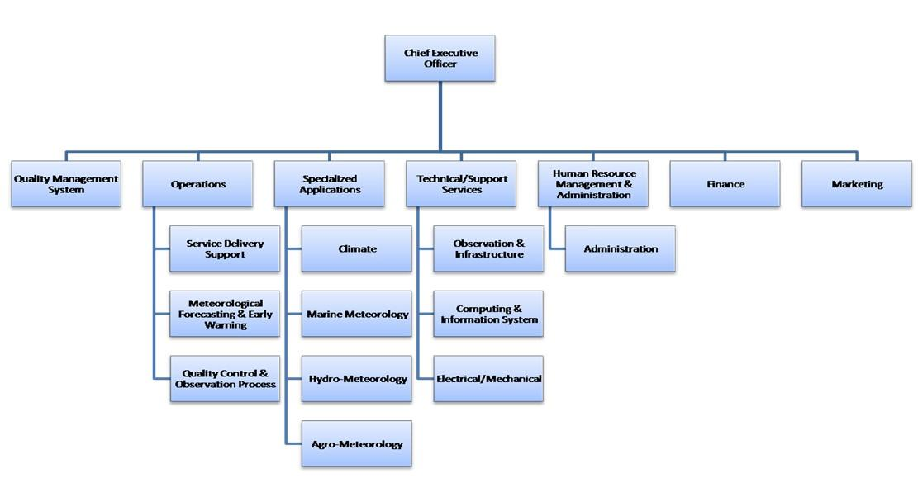
Under the Meteorology Act of 2015, the new proposed governance structure is as shown in Figure 33. This governance structure fits with a process model of the organisation where there are four main process groups namely:
- Leadership and Management
- Operations Centre
- Specialized Applications
- Technical/Support Services.
With regards to hydrology, it should be noted that there is no water law in Seychelles, but a national water policy, which has been implemented since 2017 (MEECC-PUC July 2017). The policy focuses on water resources protection and integrated water resources management (IWRM). The legal framework regarding water resources preservation depends on the Environment law of 2016 regarding providing data on water catchments, together with urbanism land planning on the main islands.
The only state-owned enterprise related to water management is the Public Utility Corporation (PUC), which is under the Ministry of Environment, Energy and Climate Change (MEECC). PUC is mandated to manage the electricity, water and sewerage systems, water production and distribution facilities. PUC is responsible for the treatment and distribution of potable water. Similarly, it is mandated to ensure the safe production and distribution of the indispensable fossil fuel energy and electricity. PUC, therefore, play a major role in providing reliable utilities and infrastructure that resist to damages that may be caused by natural hazards such as storm surges, floods, landslides and tsunamis. PUC has driven several major investments in exploring new water sources, upgrading and extending pipes networks in various parts of the country and guaranteeing continuous supplies of potable water to the local households and population, as well as the tourism establishments. The service reservoirs are instrumental in sustaining supply and altogether provide a total storage capacity of 238,000 m3 scattered all around the island. To supply the 25 districts with potable water and safe sewage treatment, there are 2 major dams (located at Rochons -district Mont fleuri, and La Gogue - District Anse Etoile), 4 desalination plants, several water treatment systems, and 80 pumping stations.
There are 5 main rivers in Seychelles, but none of them are monitored regarding hydrology. PUC is in charge of providing hydrological data actualisation every year but the latest data from the hydrological yearbook go back to 1999. Although PUC – through its Water Resources Unit (WRU) – is responsible for hydrological services, their scope is currently limited to the provision of drinking water through the distribution network.
PUC has created a rivers committee, which receives and approves requests for water use.
At present, the existing hydrological observation stations on Seychelles’ 5 rivers do not work and the available data on the river and river flow are also limited. Among the 5 rivers controlled by the PUC, two are now polluted (e-coli) and the withdrawal is limited until the quality is approved for domestic use.
There are neither data on seasonal variations of river flows, nor capacity to identify some intermittent streams that surface during heavy rains. Maps and data monitoring data not available to prevent flooding and there is no historical data on the maximum height some of these rivers have already reached.

DRR institutions
The Government of Seychelles has been placing great emphases on disaster and risk reduction, and has been a strong advocate of climate change adaptation, locally and globally. To support risk and disaster management, Seychelles has developed the National Risk and Disaster Management Policy (NRDM Policy; 2008) and the Disaster and Risk Management Bill/Act (2014). This Act aims to achieve sustainable development in line with Seychelles Vision 2020 and Seychelles Sustainable Development Strategy (SSDS) 2012-2020. This will be achieved through strengthening of national capacities to reduce risk and build community resilience to disasters.
Whilst there is no specific DRR/DRM/CCA investment policies, there are some initiatives and projects to address DRR and CCA through public investments in Seychelles, including: i) the institutionalisation of disaster risk management through the creation of the Department of Risk and Disaster Management (DRDM); ii) the institutionalisation of climate change by creating the Division of Climate Change, Adaptation and Information; iii) setting up early warning systems for tsunamis and weather through the Meteorological Services and Climate Change, Adaptation and Information Divisions; and iv) enforcing stringent planning processes for any form of construction or infrastructure developments requiring the approval of the Seychelles Planning Authority.
Institutional structures engaged in DRR implementation
The main ministries working with DRR and CCA are Ministry of Environment and Energy, Ministry of Land Use and Habitat, and Ministry of Community Development, Social Affairs and Sports. The Ministry of Environment, Energy is the body responsible for designing and coordinating risk and disaster reduction policy and action plans. The key National disaster risk reduction management-institutions in Seychelles at strategical level are following the same vision: to minimize the impacts of climate change through concerted and proactive action at all level of society.
- The National Disaster Committee (NDC) was created in Seychelles in 1995. The NDC is under the chairmanship of the Principal Secretary of the President’s Office; and it comprises members such as the Principal Secretaries of Key ministries as well as high-ranking officers in charge of the essential services such as Met Office, Police and Defence Force, environment, etc. Its prime objectives are prevention and preparation of National Disaster Response Plan (NDPR). The President sometimes chairs the meetings of the NDC whenever the situation is catastrophic and warrants such high-level strategic leadership.
- The Department of Risk and Disaster Management (DRDM) of Seychelles was created in 2004 as the National Disaster Secretariat for the NDC (the tsunami impacted Seychelles this year). In 2008, DRDM was moved under the Ministry of Environment. From December 2016 the President of the Republic upgraded DRDM to a Department. DRDM is targeting to become an Agency in order to fully accomplish its goals. The DRDM is a fully-fledged risk and disaster management national coordinating body and its functions are guided and supported by the National Risk and Disaster Management Policy (finalized in April 2008) under the United Nations funded project.
- National emergency operations command (NEOC) relies on DRDM and is activated in case of national importance event to coordinate local DEOCs.
Figure 34 Institutional chart of DRDM in Seychelles
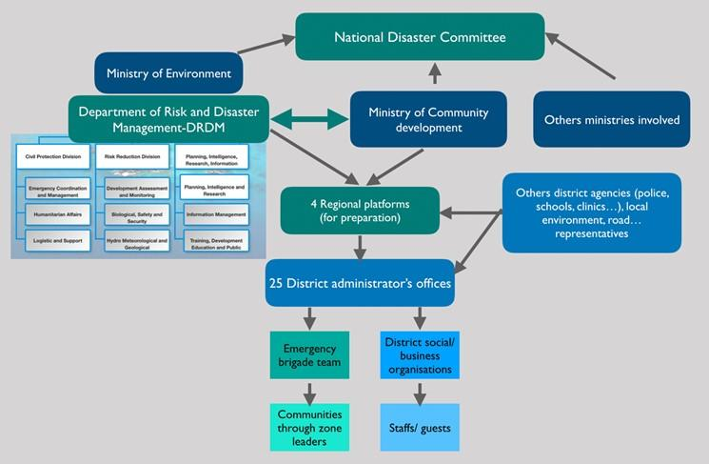
There are 4 regional platforms in Seychelles: Southwest platform, East platform, Central/North platform and Praslin/La Digue platform. The regional platforms act as the focal point of coordination for disaster preparedness between local districts and national government when necessary. The roles of the platforms are to primarily manage and organize district disaster preparedness activities at district level. Each platform is headed by a coordinator, usually a District administrator from one of the districts and committee members representing the following organizations:

- Department of Community Development
- Police Department
- Ministry of Health
- Fire Service Department
- Land Transport Division
- Red Cross Society of Seychelles
- Department of Environment
At district level, the district office is the local level branch office of the government. It is headed by a district administrator (DA) with other support staff, responsible for the governance of districts. The district administrator is the focal person for managing and coordinating emergency response operations at district level. During an emergency, one of the key responsibilities of the DA is to act as the early warning system for districts i.e. the DA will receive official notification from DRDM and in turn, be responsible to alert and activate all office staff, the emergency brigade and social/business organisations at district level.
Operational level in case of emergency situation and coordination at local level
- District emergency operation centre (DEOC): For emergency response of national, regional, and localized disasters such as tsunami, cyclone, heavy raining causing flash flooding, water logging and landslide floods, the DA’s office is generally used to conduct field-based operations and becomes the district emergency operations centre (DEOC) for the district disaster management committee. In situations where the district office lies in predicted risk areas, alternative identified DEOC sites will be used as a backup location. DEOC preparedness includes a set of equipment’s in case of intervention (work equipment, safety wears, telecom, computers, kitchen facilities, first aid medical kit...) and maintenance of stocking for these items during normal times and for directing setup of these items when the DEOC is activated.
- Emergency Brigade is a key organization to implementing disaster preparedness and response activities based in each district. It is a voluntary organization and one of the main roles of this organization is to assist the district administrator’s office during arising emergency situations. It is generally comprised of 15 volunteers with 1 member as team leader. The team leader acts as overall group coordinator and works under the DAs directive during response of that district. The backup for the team leader is the assistant team leader.
- Social/Business Organisations: These comprise of active community-based organizations such as the Red Cross Society of Seychelles, hotels, restaurants, telecommunication businesses, disabled people’s group, youth action teams, parents committee, senior citizens group, sports committee, eco-tourism committee and other volunteer organizations. They are an important community resource assisting with disaster preparedness initiatives and field emergency response operations when needed and at the request of the DA.
There are other structures contributing to the DRR policy implementation:
- The Early Warning Centre at the Seychelles National Meteorological Service (SNMS) issues advisories and warnings during the disaster to warn people of the on-going heavy rains and of locations that are considered dangerous.
- National Flood Task Force (NFTF). In the past the President convened extraordinary Cabinet meetings (like in the case of DaLA to review the situation on the ground. This situation had led to the establishment of a more permanent National Flood Task Force (NFTF) to enable high-level coordination among ministries and agencies and to mitigate the impact of any possible secondary disasters.
- National Disaster Relief Fund (NDRF). Seychelles also set up a National Disaster Relief Fund (NDRF) in order to raise funds both locally and internationally (for both monetary and in-kind contributions) for the families who were left without a home during the floods, those who will need to repair their homes, as well as for the surrounding infrastructure.
- National contingency plan and District disaster response plan (DDRP):
There are District Tsunami, Cyclone and Flood Disaster Response plans, elaborated in a joint initiative of the Department of Risk and Disaster Management (DRDM), Government of Seychelles and the United Nations Development Programme (UNDP) to strengthen community-based disaster preparedness and emergency response in Seychelles (designed in 2008). The district contingency planning process was implemented together with the design of an early warning system, capacity assessment study, risk assessment study, national contingency plans and public awareness campaigns to help the Government and people of Seychelles successfully handle disaster situations with a minimum loss of human life and financial infrastructure.
There are 25 District Disaster Plans (Mahé, La Digue and Praslin districts) and additionally 1 plan for Silhouette Island. They formalise the district contingency planning process specifically for disasters relating to tsunamis, cyclones and floods given the historical occurrence of these in Seychelles and related risks associated to them. This district contingency plan meets the following objectives:
- To provide districts and first level field responders with a useful guide on how to effectively prepare for and respond to emergencies and disasters arising from tsunami, cyclone and flooding in their areas.
- To improve preparedness of local communities through mitigation tools such as risk and vulnerability analysis and developing a structure for maintaining a record of resource registers and databases.
- To sequentially outline and clearly describe the standard operating procedures for the different components of disaster preparedness and response.
- To ascertain existing emergency response practices of stakeholders, resources available, evaluate requirements, agree on changes and integrate into plan.
- To clearly distinguish and standardize the roles and responsibilities of district disaster management stakeholders in disaster preparedness and response.
- To develop a framework for future ongoing appraisal and improvement of plan to reflect current circumstances.
As with all operational documents, with the evolution of time and experienced events, these DDP will have to be periodically updated to reflect overall changes in society and the working environment. A large part of the future success and effectiveness of this plan will rest largely on the enthusiastic contributory and ongoing participatory efforts of the users at community level.
Implementation of Early Warning Systems
The District Administrator will officially receive an alert in the form of an SMS from the DRDM and in the expected event of flooding, cyclone, or tsunami. The different levels of warnings that will be issued, implications and actions to be followed are organised per scenario. These are based on and consistent with the procedures developed for the national contingency plans. We provide below the example for tsunamis.
Table 11 Early warning system for tsunami
Warning Levels | Interpretation/ scenario | Actions to be taken by DA branch office | Actions recommended for the public
Green. Advisory. | Very small possibility of destructive local tsunami. Waves below 0.5 m. There will be no significant impact. | 1. Media will alert and advise local population. In addition, DRDM to inform all district offices through SMS. If SMS not available use any quick multiple media means such as land/mobile phones, fax.  2. DA to inform emergency brigade, other social and voluntary organizations, specially targeted groups such as fishermen, maritime users and members of the public in their district through SMS, telephone and word of mouth. | 1. Standby and stay alert. No significant damage expected. Take precautions if you live in coastal areas. Listen to official broadcasts in radio and TV.
Yellow. Advisory | Waves between 0.5 and 1 m. Moderate damage to coastline. Possibility of destructive local tsunami within 100 km of epicentre. | 1. Notification continues as described in Green level.  2. The DA is in touch with other agencies by telephone to liaise and have standby measures for transport, security, and shelter to evacuate public if advised to do so by DRDM.  3. District office along with emergency brigade prepares population in vulnerable coastal areas to evacuate if needed. | 1. If your house/office is in a dangerous coastal area or floodable area, take precautions or evacuate temporarily if the authorities ask to do so  2. Protect your home and assets by turning of the gas, water connections.  3. Listen to the official broadcasts on radio and TV.
Warning Level 1. Orange | Waves between 1.0 and 2.0 m. Impact, damage and flooding on coastal areas. Risk of a destructive tsunami. | 1. Immediate triggering of district emergency response plan and procedures.  2. As district focal point, DA convenes emergency response meetings, at DA’s office or other point. Start to plan evacuation, relief, search and rescue, rapid assessment team etc 2. DA’s emergency brigade team jointly with the police to evacuate endangered population immediately. | Listen to the official broadcasts on radio and TV. Do not stay on the coast to watch the tsunami you and your family could drown and die. Evacuate the area immediately if you live in a dangerous coastal area. Go to rest centres (shelters) or relatives’ houses if indicated by the Government. Protect your belongings: car, boats, etc. Protect your animals/pets. Protect your valuables and important documents. Go back home only when the authorities tell you to do so.
Warnings level 2 RED | Waves over 2.0 m. Possibility to have an ocean wide tsunami. Similar damage in Seychelles to that with the 2004 tsunami or worse. High waves impacting severely on the coasts and settlements there. Areas flooded. Risk of injured and drowned people on the coasts. | 1. Immediate triggering of district emergency response plan and procedures.  2. As district focal point, the DA convenes emergency response meetings, at DA’s office or Safe backup location. Start to plan evacuation, relief, search and rescue, rapid assessment team etc  2. DA’s emergency brigade team jointly with the police to evacuate endangered population immediately. | Listen to the official broadcasts on radio and TV. Do not stay on the coast to watch the tsunami you and your family could drown and die. Expect severe damage at least like the damage from the 2004 tsunami. Evacuate immediately if you live in a coastal or low area. Go to safe relatives’ houses or shelters. Protect your house and belongings. Protect your car/boat and your animals/pets. Bring with you important documents. Do not go back until the authorities recommend you to do so.

2.5.3 Baseline projects
Table 12 Baseline projects in Seychelles
Project Details | Description: purpose, key activities (relating to Hydromet) and location | Complementarity with Hydromet
“SeyCCAT (Seychelles’ Conservation and Climate Adaptation Trust)”, 2015-present, NatureVest (the conservation impact investing unit of The Nature Conservancy) and the Government of Seychelles  Budget: funded by a sovereign US$15m Blue Bond | SeyCCAT is an independent, nationally based, public-private trust fund, established through the Conservation and Climate Adaptation Trust of Seychelles Act of 2015. It “strategically invests in ocean stakeholders to generate new learning, bold action and sustainable blue prosperity in Seychelles.” On-going projects include Blue Grants Fund #1: empower the fisheries sector with robust science and knowhow to improve governance, sustainability, value and market options. | Information and climate services generated by Hydromet can be used to support these efforts to empower the fisheries sector with robust science, by providing the necessary information on which to base decisions and further innovation. Fisheries were indeed selected as a key climate-sensitive sector in Seychelles for the development of tailored CS.
“Seychelles Water & Sanitation Project (SWSP)”, also called “Project Neptune”, 2008-202, AFD, European Investment Bank, European Development Fund, African Water Facility, and Government of Seychelles  Budget: EUR 65m | A 20-year investment plan to meet water demand on Mahé, Praslin, and La Digue to 2030, specifically targeting the threat posed by the lack of proper sanitation facilities on La Digue. It also includes refurbishment and upgrading of 4 desalination plants; non-revenue water (NRW) reduction programme; rehabilitation of 2 main water treatment plants and 8 measuring weirs; resource efficiency programmes; capacity building programme for Public Utilities Corporation; and development of sanitation master plan. | Meeting water demand requires a greater understanding of water supply. Hydromet will help provide this information through trainings in hydrology and development of flood hazard maps, as well as forecasting and climate change projections that can allow for early action to maintain consistent supply.
“Seychelles Ocean Temperature Network”, 2012-present, Gov./SFA | Established as part of the Enabling Activities for Seychelles’ Second National Communication. Aims to “promote collaboration in ocean temperature monitoring and access to data [which is available online] based on the use of in situ temperature loggers deployed across the Seychelles archipelago.” | Further development of data of regional interest can support these efforts to monitor and make available publicly data regarding ocean temperatures.
“Monitoring of Algal Bloom”, IAEA | The IAEA has been supporting member states (including Seychelles) through its technical cooperation programme to detect harmful algal blooms using nuclear technology. | Information and climate services produced by Hydromet could be used, along with this data on algal blooms, to release appropriate EW to the fishery sector about algal blooms; and to understand and address the causes of these blooms, including through observation of correlated hydro-meteorological phenomena and algal blooms.

In addition, Seychelles has received readiness assistance of USD 339,300 (of the approved 903,000) from the GCF.

Chapter 3 Assessment of meteorological institutions and existing climate services in SWIO region
This chapter provides a critical analysis of the meteorological institutions presented in Chapter 2, with regards to their capacity to produce and disseminate reliable, timely and understandable CS. The results of this analysis are illustrated in case studies, through which concrete DRR interventions in Comoros, Madagascar, Mauritius and Seychelles are scrutinised. Each analysis ends with a SWOT analysis, which provides an overview of the strengths, weaknesses, opportunities and threats to reducing the vulnerability to climate-related hazards in Comoros, Madagascar, Mauritius and Seychelles. Some of the weaknesses and threats identified through the SWOT analysis are similar to all four countries; all of these are pointing to the development of recommendations at regional and national levels, which will be presented in Chapter 4.
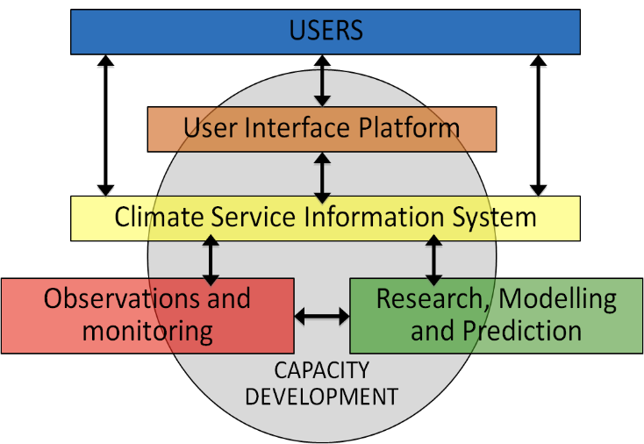
Methodology used for the analysis NMHS assessment - First, this chapter provides an assessment of the national meteorological services, presented in Chapter 2, and the climate services they produce. This assessment is based on a framework which integrates two existing schemas: the five pillars of the GFCS and WMO’s four categories of NMHS. The GFCS is an UN-led initiative spearheaded by WMO to guide the development and application of science-based climate information and services in support of decision-making in climate sensitive sectors. The GFCS defines five core functions (pillars) that NMHS should perform:
Figure 5 The five pillars of the Global Framework for Climate Services (GFCS)

Figure 35 The five pillars of the Global Framework for Climate Services (GFCS)
- Observations and Monitoring
- Research, Modelling and Prediction
- Climate Service Information System
- User Interface Platform
- Capacity Development.
WMO’s NMHS Categories specify criteria that a NMHS must satisfy to be placed within one of four different categories:
- Basic Climate Services
- Essential Climate Services
- Full Climate Services
- Advanced Climate Services
The five GFCS pillars (Figure 35) represent a very broad outline of a theory of change. WMO posits that the capacity of a NMHS to deliver effective climate services improves as it becomes better able to perform more in these five functions. Four of the five pillars represent a rough progression in terms of capacities that the NMHS has and outputs that it produces, though the progression is not simple and some of the capacities can be developed out of sequence. A NMHS needs reliable equipment to be able to collect data on the national environment and needs to maintain the quality of that data, as measured under the Observations and Monitoring pillar. The NMHS also needs to apply research to these data to make predictions about weather and climate variables, as documented under the Research and Predictions pillar. The resulting forecasts and predictions are a necessary input into the Climate Services Information System pillar and the User Interface Platform pillar. However, the latter two pillars also require a rather independent set of investments in two-way communication with users of climate information that is needed to produce information that is useful for applications. The fifth pillar, Capacity Development, documents the resources that are needed to make the work done under the other four pillars possible, and therefore progress under this pillar is likely to be necessary for progress under the other pillars to occur.
Yet the GFCS offers limited guidance on the level at which a NMHS should perform each of the functions or how they can acquire capacity to perform them. The criteria that a NMHS must satisfy to be placed into one of the four WMO categories partially fill this gap, offering more specific guidance. The categories reflect incremental steps toward a more complete climate information service but are not organized by GFCS pillars.
In the proposed framework, we consider the WMO criteria applied to classify NMHS into the categories as the objectives that NMHS should strive to achieve and assign each objective to one of the five GFCS pillars according to the function, which the attainment of each objective helps to perform. For example, the first row in Table 13 lists the criteria that correspond to the Basic Climate Services category (category 1) for each of the five GFCS pillars. We assign the criterion that requires an adequate observing system as an objective to be achieved under the Observations and Monitoring pillar. The criterion that requires conducting weather forecasts and warnings is an objective to be achieved under the Research, Modelling, and Predictions pillar, and so on. A NMHS that operates an adequate observing system is placed in category 1 for the Observations and Monitoring Pillar, though it also could be associated with category 2 or 3 under each of the other pillars. A NMHS that operates an expanded observation network is classified in category 2 under the Observations and Monitoring pillar. Note that Table 13 only provides an example. The full framework assigns multiple criteria to each category under each pillar.
Table 13 An example of the five GFCS pillars combined with WMO Categories (only three shown) with some of the associated criteria
 | Observations & Monitoring | Research, Modelling & Predictions | Climate Service Information System | User Interface Platform | Capacity Development
Cat 1  Basic | Operate and maintain adequate national observing systems, suitable for basic hydro-meteorological purposes | Participate in funded research projects and field experiments | Conduct basic climate diagnostics and analysis | Interacts with users, to meet requests (for weather forecasts and information and for basic climatology questions) | Participate in training, as required, for data management, QMF, data rescue, basic analysis (using, e.g., CDMS)
Cat 2  Essential | Operates expanded surface climate and weather observation network | Participate in national and international collaborative climate science and research initiatives. | Conduct advanced statistical analysis (diagnostics; homogeneity testing and adjustment; regression, development of climate indices, etc.) | Interact with users in one or more sectors to identify their requirements for, and provide advice on, climate information and products for their application | Participate in training for climate services specialties
Cat 3  Full | Adopt long- term strategy for managing observing network and its change | Conduct or participate in research and field experiment | Develop and/or provide, in a multi-disciplinary context, specialized (tailored) climate analysis, prediction and monitoring products, | Provide climate information relevant to policy development and National Action Plans | Conduct, or provide expertise to, training of climate services and prediction specialists

On the table 14 below, a summary of the assessment for the four countries is presented, based on WMO categories of NHMS. The full assessment is detailed in the following sections.
Table 14 Summary of NMHS assessment
GFCS Pillar | NMHS Category | Comoros | Madagascar | Mauritius | Seychelles
1  O&M | 1
1  O&M | 2
1  O&M | 3
2  R&P | 1
2  R&P | 2
2  R&P | 3
3  CIS | 1
3  CIS | 2
3  CIS | 3
4  UIP | 1
4  UIP | 2
4  UIP | 3
5  CDV | 1
5  CDV | 2
5  CDV | 3

DRR assessment - Secondly, this chapter provides an analysis of disaster risk management - with a focus on EWS - in the four countries. The section is prepared based on the WMO Multi-Hazard Early Warning System checklist. This checklist is a key outcome of the first Multi-Hazard Early Warning Conference, which was organized by the partners of the International Network for Multi-Hazard Early Warning Systems (IN-MHEWS) from 22 to 23 May 2017 in Cancún, Mexico. It is the internationally accepted basis for early warning system design. The checklist is structured around the four elements of early warning systems, as depicted in Figure 36. Likewise, this study used the four elements of an early warning system, and the corresponding checklist of key topics within them, as a basis for research.
Figure 36 The four elements of an early warning system
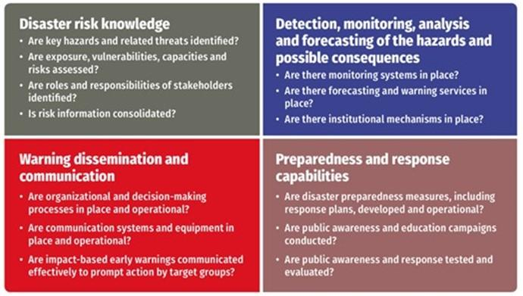
These four elements came to prominence at the World Conference on Disaster Reduction in Kobe, Japan 18-22 January 2005, where the Hyogo Framework for Action 2005-2015 (HFA) was agreed (the predecessor to the Sendai Framework 2015-2030). Just prior to the 10-yearly World Conference, on 26 December 2004, the Indian Ocean Tsunami led to the loss of about 230,000 people. Consequently, the international disaster reduction and development community responded by committing considerable funds into the creation of an Indian Ocean tsunami early warning system. As countries subsequently reported on their progress regarding commitments under the HFA, it became clear that early warning systems were receiving significant attention and much more than other aspects of the HFA such as reducing underlying drivers of risk. More recently, investments in early warning systems are often a driver in the strengthening of hydro-met services. However, it is also clear that despite advances in detection, monitoring, analysis and other technical aspects of early warning, there remains one element of the system that is often neglected: the last mile.
This study is conscious of this gap, and so has focused as much attention on the experience of user communities and sectors as possible. Indeed, the survey tools and methodology deployed in this study focus more purposefully on the end-user than the WMO checklist, despite the WMO checklist recognising the importance of end-to-end people centred approaches. Investing in necessary strengthening of elements of early warning such as observation networks and data processing without appropriate attention on the end-user and last mile will undoubtedly render the early warning system defunct.
Country Case Studies – Thirdly, this chapter incorporates case studies of recent disaster experiences in the respective countries. The case studies were developed through consultations in country based on a semi-structured template that used the WMO MHEWS Checklist as a framework, supplemented by secondary literature. The case studies are introduced at the beginning of each country assessment. Then issues of importance from these case study experiences are included within each of the sub-sections that deal with the four elements of the MHEWS within each country. In this way, the study intends to ensure that actual recent practice, rather than intent, is a key feature of the critical analysis. In turn this approach strengthens the recommendations made.

3.1 Comoros

3.1.1 Assessment of NHMS

Pillar 1: Observation and Monitoring
The ANACM meets only some of the criteria for Category 1 for the Observation and Monitoring pillar. It can meet the criteria required for Category 2 by improve coverage of upper air observation stations, strengthening station inspection, and backing up climate data regularly.
Strengths: The Comoros Met stations are manned by trained observers, and coverage of surface stations is at least one station every 50 km. It uses basic quality control procedures. ANACM is on the way to upgrade its synoptic network through a UNDP project
Weaknesses: The number of surface station are too sparse for a NMHS Category 2 and ANACM has no upper air station neither doppler radar and it does not backup climate data often and has not digitized many of its climate data. It doesn’t maintain electronic climate database and has no access to computing capacity for data collection, storage, and transmission.

Pillar 2: Modelling and Prediction
The main reason why the ANACM does not meet the requirements for a Category 1 NMHS in the Research, Modelling and Predictions pillar is that the NMHS is not involved in any research projects and experiments in which the staff participate except for the BRIO project since June 2019.
Based on available data, the NMHS would need to expand the time range and the updates of seasonal forecasts in order to fully satisfy the requirements for a Category 1 service. The NMHS should improve human and technological research capacity, and expand the range of weather, seasonal, and monthly forecasts in order to satisfy the criteria of a Category 2 NMHS in Research and Predictions.
Strengths: ANACM fulfils some research and prediction criteria for a Category 1 NMHS, such as providing weather forecasts for up to 3 days and seasonal rainfall forecasts.
Weaknesses: ANACM does not participate in any research program. The NMHS needs to improve access to research resources, and the range of forecast products as well as the human and technological capacities to produce them to meet the requirements for a Category 2 service.

Pillar 3: Climate Services Information System
The ANACM fulfils partially the criteria for a Category 1 NMHS for Climate Services Information System. There are aspects within the two categories that are not fully met, such as range of forecast products and access to software for computing climate statistics. The NMHS should expand the range of products and improve the information that it communicates to users of climate information on its dissemination media to move up to a Category 3 NMHS for Climate Services Information System.
Strengths: At a governance level, the ANACM has clear policy guidelines on the provision of Climate Information Services and provides data free of charge to government ministries (in charge of agriculture, DRR, and environment) and education institutions. Staff produce most basic climate statistics for major climate variables. ANACM performs statistical analyses and contributes to national early warning systems through early warning information and advisories.
Weaknesses: ANACM should improve capacity to produce basic climate statistics and seasonal outlooks. ANACM does not perform homogenization of climate data. The range of seasonal outlooks is limited, and the webpage does not provide sufficient specialized products. The web page is not frequently updated

Pillar 4: User Interface Platform
ANACM partially fulfils the criteria for a Category 1 NMHS for the User Interface Platform pillar. To move to a Category 2 NMHS, it would need to improve its documentation of user needs and feedback, incorporate feedback into a redesign of products, enhance the training of users and improve the website.
Strengths: Together with a strategic plan and procedure for user engagement, some staff members have been trained to interact with users (mainly from the agricultural sector) around requests for seasonal forecasts and basic climatological queries. Such interactions have occurred in the past two years. ANACM has started the process for National Framework for Climate Services (NFCS).
Weaknesses: ANACM does not document feedback from users of climate information, has no formal procedure in place to co-produce climate information with users, and it has not signed an MOU with some sectors. The website communicates no basic climate information to users. ANACM has not produced tailored products in response to user’s requests even for Agriculture, Water and Health sectors.

Pillar 5: Capacity Development
ANACM does not fulfil the criteria for a Category 1 NMHS for Capacity Development. To satisfy the criteria, the NMHS would need to establish a formalized governance structure with a financial autonomy, expand participation in the national policy process, and strengthen human and technological capacity.
Strengths: ANACM participates in climate related policies and plans. Staff have basic training in essential meteorological services. It has some staff with a range of specializations including Numerical Weather Prediction (NWP). Staff have some access to software tools for weather and climate forecasting and there is some training conducted for entry and mid-level meteorological technicians
Weaknesses: The Met department of ANACM has no formalized governance structure. Human and technological capacities are limited. Most staff have access to very basic computing resources and no internet capacity. There are weaknesses in staff qualifications with more staff with MSc’s and PhDs required. The internet connection speed does not meet the Category 1 requirement of 1 Mbps. The NMHS does not have high performance computing capacity.

3.1.2 Assessment of existing climate services users and platforms
Regarding access to climate services, the World Meteorological Organisation (WMO), through the GFCS, has prioritised several sectors including water, agriculture and fisheries for food security, health and disaster risk reduction.

Water resources management for potable water, domestic uses
The management of water resources for all uses is based on the General Directorate of Water, Mines and Energy - DGEME, a national operator for water services, MAMWE (National Society for Water and Electricity Support) and local island management structures: SOGEM (Mohéli Society of Water Management), UCEA (Union Committee of Anjouan Water) and UCEM (Union Committee of Mohéli Water).
There is no water resource monitoring system for all uses or knowledge of the hydrological functioning of rivers and aquifers that could contribute to the establishment of a flood warning system or risk of flooding for populations. It should also be noted that access to drinking water is still very limited, not exceeding 15% in some rural areas. A UNDP-FVC project (see 2.2.3, baseline projects) plans to move to a 51% access rate for the 60,000 households concerned in the 139 villages on the 3 islands. This project also includes an urban drainage component to reduce the risk of flooding and a hydro-meteorological equipment component on water courses.

Agriculture and fisheries for food security
In the Comoros, it is estimated that 41% of the rural population are poor and 79% of the poor are farmers. For this group, family livelihoods and food security are based on small-scale agriculture and livestock, food crops (bananas, cassava, sweet potatoes, coconuts, rice) and cash crops (cloves, ylang-ylang, vanilla, black pepper). Agriculture is essentially rainfed; access to water for agriculture is difficult because the reservoirs are primarily dedicated to drinking water for domestic consumption and are therefore located near urban centres. There is no service dedicated to agriculture which relates to precipitation forecasting or its absence, temperature and humidity with data localisation at a relevant scale given the island reliefs (notably Grande Comore).
Concerning the fisheries sector, there is no efficient marine weather service to alert fishing communities in the event of strong winds or swells. There is a cyclone alert system, which allows fishermen to keep their boats ashore. But little trust in weather forecasts means that local fishermen do not necessarily comply with ANACM alerts. However, some fishermen have a good knowledge of the weather phenomena (movement of clouds, colour of the sea and sky, etc.) that allows them to predict extreme events and warn their community members. There also is not an effective communication system to warn vessels already at sea of risks. As a result, Comoros has about 20 deaths at sea per year. It also reflects an important need to raise awareness among this very poor socio-economic group; it should be noted that, in this context of extreme poverty, even in the event of an alert, fishermen will often go to sea to provide an income for their families.

Health
Fundamentally, climatic conditions influence health status (see section 1.1 Climate Vulnerability). The General Directorate of Health (DGS) has a budget dedicated to crisis management and a cyclone contingency plan to manage health emergencies during the crisis and its post-crisis consequences, such as waterborne diseases linked to the disruption of water and sanitation services. The health sector is also widely supported by humanitarian associations, in particular the CRC, which has a network of local actors and volunteers of more than 3000 people on the three islands to intervene in the event of a humanitarian crisis (health, nutrition or climate risk).
The health sector is one of the first actors to be informed and mobilised in the event of a crisis. Mechanisms are in place to mobilise international humanitarian actors in the event of a crisis that exceeds the response capacities of the Comorian State (particularly in the context of heavy flooding).

Disaster risk reduction
The Union of the Comoros has a national risk reduction strategy since 2015, which illustrates the political will to make progress in disaster risk reduction. The national risk reduction strategy is aligned with the Comoros' Poverty Reduction Strategy. However, there is not yet a legal framework for risk management that would provide a budgetary and financial framework to ensure the means of intervention. However, the legal framework for risk management is reflected in the Environment Act and Health Act.
The DGSC has a national contingency plan and specific information support mechanisms to issue an alert for each of the major risks identified (earthquake, volcanic eruption, cyclone, tsunami, storms, forest fires) and specialised plans for the main risks (cyclone, tsunami, Karthala, storms).
A population alert system is operational with the capacity to go on the ground in villages (in support of the CRC) to set up prevention, protection and even evacuation actions in the event of a cyclone. There is also a coast guard service for surveillance and response at sea, and a fire brigade to support civil security for shore-based interventions (one for each island).
There is a long history of work between the weather service and the CRC in terms of risk reduction, particularly in the area of prevention. The CRC is a member of the PIROI network (Indian Ocean Regional Response Platform) and receives bulletins from Météo France covering the entire western Indian Ocean area (Météo France la Réunion), which provides a complementary source of information to the Comoros weather, particularly in the event of a major cyclonic event.
The most frequent events are heavy rains, strong winds and floods, especially flash floods, but for these events there is no information and warning service. Nor are there any risk vulnerability studies or hazard-based mapping of risk areas.

3.1.3 Assessment of EWS, End-users and Case Studies

Case Study - Cyclone Kenneth, 24-25 April 2019
Cyclone Kenneth struck Comoros during the night of 24 to 25 April 2019. According to sources including the Multi Sector Response Plan, across Comoros the cyclone left 7 dead, 182 injured, 19,372 displaced, and 345,000 people (about 43% of the population) affected. The damage to agriculture and livestock was very significant, up to 90% in some localities. Impacts included crop damage and salinization of soils affecting agriculture. Nearly 4,500 houses were destroyed and over 7,000 houses damaged. Additionally, nearly 150 water tanks, used as potable water supply, were destroyed or damaged with contamination of domestic water supply. Schools were badly affected too with 465 classrooms damaged, of which 213 were destroyed, disrupting education for about 44,800 pupils between the ages of 3 and 18. Power was lost across the whole grid. Impacts have also been noted to include disturbance of land, sea and air transport, degradation of coastal and marine biodiversity caused by terrigenous deposition and inevitably by wave action also. The budget to meet the needs across sectors was estimated at over USD $28 million. Heaviest losses were on the island of Grande Comore. Figure 37 shows areas most affected, and Table 11 provides more detail on sectoral impacts.
Figure 37 Impacts of cyclone Kenneth in Comoros
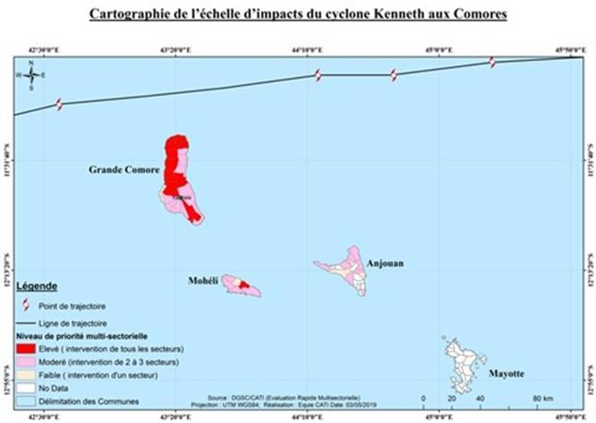

Table 15 Cyclone Kenneth sector impacts
Sectors | Total population affected | Estimated Recovery Budget total per sector (USD)
Food security and livelihoods | 200 000 | 12.221.000
Health/Nutrition | 80% of total population affected (276,000 people) | 886. 925
Education/Protection | 44 800 | 2.685.863
Shelters and Non-Food Items (NFI) | 19 372 | 3.010.322
Wash | 191 880 | 850.000
Energy |  | 2.750.000
Telecommunications |  | 5.625.000
Total |  | 28.029.110
Source: Government of Comoros Multi-Sector Response Plan Following the Passage of Tropical Cyclone Kenneth, 4 May 2019

Disaster Risk Knowledge
Past disasters have driven awareness regarding exposure to various natural hazards. For example, corroborating literature and information in Section 2.1 (climate risk profile), the following hazards were referred to by various stakeholders during this study:
- Strong wind is a hazard especially significant for fishermen and is also recognized as a contributing factor in the drying up of soil and hence presents agricultural risk too (e.g. to young yam, potato, sweet potato, cassava plants). Cyclone was not considered a pressing threat until Cyclone Kenneth in 2019 on account of the last cyclone experience dating back to 1959. Now cyclone risk is elevated;
- Drought conditions leading to food insecurity in this largely agriculturally-based economy where commonly found rain water harvesting is for non-agricultural purposes (especially potable resources) leaving agriculture as rain-dependent;
- Volcanic eruptions of Karthala, such as occurred in 2005 (April and November), 2006 and 2007. The 2005 eruptions resulted in the accumulation of several centimetres of ash, especially at higher elevations.
- Dengue fever, and other health risks, are also of concern according to local community members in Nioumamilima;
- Observed erosion and salt water intrusion on account of sea level rise may be present;
- Heavy rainfall of 776mm in one night on 20 April 2012 (equivalent to an accumulation of rain occurring every day during the entire month of January) led to severe flooding in Grande Comore. The implications of a very poor drainage system in urban areas exacerbates the risk of flood, as was observed in Moroni. Heavy rain has also triggered landslide, as observed in south-east Grande Comore, and hinders navigation at sea on account of poor visibility according to fishermen interviewed in Foumbouni.
An example of a rudimentary approach to mapping is shown in Figure 38, highlighting in very broad terms areas affected by the April 2012 floods.
Figure 38 Flood map by COSEP
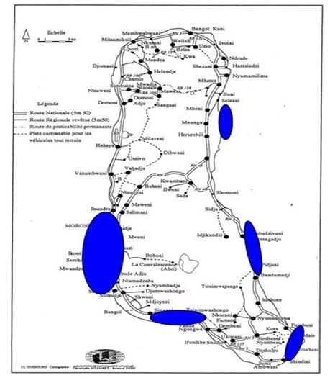
Source: COSEP, illustrated in Directorate of European Affairs (2013)
More nuanced and detailed risk assessment processes appear to have been deployed through a hazard mapping exercise undertaken on a pilot basis in four districts of Moroni with the technical assistance of UN-Habitat. In this case, stakeholders identified risks and proposed mitigation measures, such as for improved stormwater drainage, waste treatment and with respect to land use (although these have not been funded). Similar exercises were conducted in Fomboni in Mohéli with the intention to also carry out the exercise in Anjouan. Funding has been sought from GEF to extend the project across Moroni.
Also representing a more thorough approach to risk assessment, across its’ international network the Red Cross Red Crescent uses a vulnerability and capacity assessment (VCA) methodology to identify risks at a local community level. Typically, these tend to emphasise disaster preparedness measures, such as stockpiling and evacuation planning. In Comoros, it is unclear what actions VCA has initiated.
Disaster risk knowledge is also strengthened in Comoros through climate studies. For example, in the project on climate resilient water supplies for Comoros, it is noted how daily rainfall analysis demonstrates climate change has had a significant impact on rainfall variability in the last decade, including the worst drought and worst flood to date. The NAPA identifies 19 climate change impacts of which the most acute is considered to be drought, whilst heavy rains, cyclones and sea level rise were also identified.

Insights from the case study
The Comoros cyclone season is from October to May. Tropical cyclones and associated floods are often referred to as constituting the most significant disasters in Comoros, generating an average yearly direct cost of climate-related impacts of around USD $5.7 million. Between 1911 and 1961, the archipelago experienced 23 cyclones, an average of one cyclone every two years.
Figure 39 Cyclone tracks near Comoros between 1976 and 2010
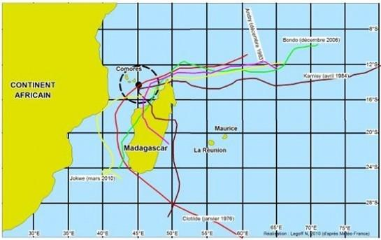
Source: CMRS Data in Directorate of European Affairs, 2013, April 2012 Floods in Comoros
It is understood that there is now a tendency for higher intensity cyclones in the south-west Indian Ocean on account of climate change.
However, Cyclone Kenneth is considered the first major event to affect the Comoros archipelago since 1959, in terms of commonly held views on cyclone events as expressed during fieldwork by multiple stakeholders, especially local community members. Consequently, the risk from cyclones and the dangers they present were either not known or not taken seriously by members of the public ahead of Cyclone Kenneth’s impact. Now, with the recent Cyclone Kenneth experience itself, perceptions of cyclone risk are likely fully heightened.

Critical analysis
Despite many examples of loss and damage caused by different disaster experiences over recent years, and climate change studies indicating disaster-related implications, there are very limited examples of detailed risk assessments and risk maps in Comoros that could guide disaster risk reduction decision making. This deficiency is widely recognisable and noted by, for example, UNDP.
The type of mapping shown in Figure 40, whilst depicting general areas of greatest exposure (in this case to floods), does not indicate levels of susceptibility or sensitivity of different people, different buildings, different services. The level of risk to floods in any given location, is not uniform. Likewise, it is clear that Comoros has been aware of its general exposure to cyclones and has developed a contingency plan to manage such a disaster event. What appears to be absent is a detailed understanding on all the elements of cyclone-related exposure, sensitivity and capacity, and consequently what can be done beyond disaster preparedness and response to reduce risk to future events through development processes.
Furthermore, a significant value in risk assessment is derived through the process of undertaking the assessment in a participatory and multi-sectoral way, as this can foster shared learning and greater understanding leading to the development of more sustainable and effective resilience measures.
Finally, it appears unlikely that risk assessment approaches (such as those mentioned above) are being deployed as an integral part of local and national development decision making. Their absence is a missed opportunity for developing a solid understanding of local risks and vulnerabilities as a basis to ensure early warning is suitably targeted to help vulnerable groups and sectors and suitably disseminated in ways that are most likely to result in action.

Detection, Monitoring, Analysis and Forecasting of the Hazards and Possible Consequences
Previous projects focusing on disaster prevention, especially tropical cyclones, have supplied CMS with equipment for data collection, weather forecasting and warning dissemination. However, in 2002 this equipment was transferred to Hahaya airport which is under the responsibility of the Agency for the Safety of Air Navigation in Africa and Madagascar (ASECNA) to provide weather forecasts for civil aviation. Today, equipment and staff trained by various projects are now dedicated primarily to the needs of civil aviation.
In addition to information received by ASECNA, Comoros benefits from information from the La Reunion Tropical Cyclone Centre (Regional Specialized Meteorological Centre for the South-West Indian Ocean). Furthermore, three-day weather forecasts are regularly provided by the Regional Integrated Multi-Hazard Early Warning System for the Afro-Asian Region (RIMES) based in Bangkok, Thailand which also provides alerts in case of tsunamis.
On account of deficiencies in the technical capacities of the CMS for detection, monitoring, analysis and forecasting, the regional partners mentioned above are relied upon for early warning by important national disaster management actors. For example, RCRC in Comoros benefit from information generated by these partners which is shared through the PIROI network. Yet they also note the incapability of the warning system to predict the local impacts of heavy rain for flash flood and landslide, despite this being a major risk.

Insights from the case study
Comoros benefitted from the detection and warning of Cyclone Kenneth’s threat provided by partners in the region.
Figure 40 Cyclone Kenneth’s track
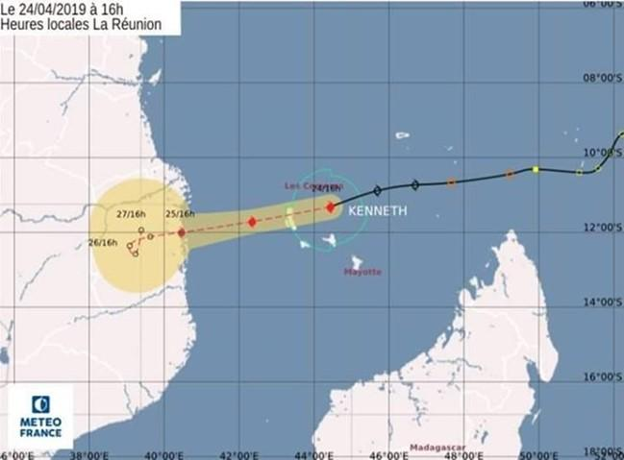
Detection, monitoring, analysis and forecasting of hazards, like Cyclone, Kenneth, is not only a technical matter for hydro-meteorological agencies. Traditional knowledge plays a very significant role. For example, fishermen explain how they “read” the weather according to cloud conditions over the volcano, the stars at night, and by the fish they catch at depths of 200m (that appears to relate to water currents, which themselves are responses to weather conditions). Anecdotal evidence suggests that trust in these signs as shared by experienced community members is greater than trust in met services forecasts and warnings.

Critical analysis
Despite the country’s heavy bias of meteorological capability geared towards aviation needs, CMS is nevertheless responsible for preparing advisories for dissemination to national and local authorities as well as to community leaders. CMS must therefore rely on the meteorological centre at Hahaya Int. Airport managed by ASECNA. Furthermore, CMS can only receive data through the Internet at a very low speed. This data, however, does not meet national needs and CMS has practically no technical means for the acquisition of real-time data and data processing.
For an agricultural-based economy, there are pressing needs for improvements in weather forecasting and for seasonal outlooks. Improvements in these services would support farm management decisions, such as what to plant and when, and what to protect, how and when. The lack of tailored meteorological services to farmers and extension services means that stakeholders operate in a vacuum without access to quality information that could help inform decision making.
Although gaps in the technical and scientific detection architecture are clear to see, it is important to recognise that traditional knowledge plays a very significant role in how end user communities, such as agricultural and fishing communities, interpret conditions and determine whether there is cause for concern and a need to take remedial actions. As trust in traditional knowledge can often be much stronger than trust in information provided by non-local sources like government hydro-meteorological services, it is clear that this has very significant implications for the development and functioning of an effective early warning system that inspires action amongst end users.

Warning Dissemination and Communication
The CMS has the responsibility for providing alerts concerning cyclones, floods, rain storms and earthquakes. CMS also has the national responsibility for providing alerts on tsunamis, dangerous waves and the movement of volcanic ash, however, observations of these phenomena are absent.
“Special bulletins” form the backbone of the alert warning message service. According to protocol, they are developed and disseminated through various channels to various stakeholders. Commonly cited methods of dissemination referred to by government and non-government interviewees include radio, TV, mobile phone, and at the local level, the use of megaphones and flags.
Alert levels are a key feature of the communication, as indicated in Table 16.
Table 16 Example alert levels
Niveau d’Alerte | Qui peut déclencher | Quand il doit être déclenché | Niveau de menace
I | Centre de veille  Secteur Concerné  DGSC | L’alerte bleue caractérise une situation normale | MINIMUM
II | Centre de veille  Secteur Concerné  DGSC  MININTER/Autorité Insulaire | Situation anormale qui fait appel à une vigilance. cette phase de l’alerte n’est pas diffusée auprès du Public | INTERMEDIAIRE
III | Centre de veille  Secteur Concerné  DGSC  MININTER/Autorité Insulaire | L’alerte orange est diffusée en situation d’urgence nécessitant des dispositions. un message spécifique est destiné à la population | HAUT
IV | Centre de veille  Secteur Concerné  DGSC  MININTER/Autorité Insulaire | L’alerte Rouge est le niveau maximum entrainant l’engagement des moyens opérationnels pour répondre à la crise | MAXIMUM
V | Secteur Concerné  DGSC  MININTER/Autorité Insulaire | La levée de l’alerte ou le retour à un niveau d’alerte inferieure doit être communiqué à la population, bien que l’on maintienne la surveillance | MINIMUM
Source : National Contingency Plan 2017-2018
With respect to radio, CMS provides the special bulletins directly to the radio stations. Presenters then share this in both French and the Comorian language. The use of mobile phones is also quite common and especially used for transmitting SMS messages. It appears Comoros is benefitting from development of telecommunications through two operators (Comores Telecom and Telma). It is claimed there is now 100% national coverage.
The RCRC volunteers can play an important role in dissemination as they are from the respective communities and are already present in most communities across all islands. Training provided at a regional level via PIROSANTER in Reunion seeks to exploit the potential of the extensive RCRC network as an important player in the early warning dissemination and communication process. On account of this, RCRC views cyclone, volcano and health alert systems to be relatively efficient. However, their ability to warn of flash flood and landslide is weak, as the detection of such localised risks is lacking.
Flags are often a feature of the warning communication, for example a colour coding system that warns fishermen of sea conditions.
Although Comoros has well developed procedures and protocols to respond to emergencies, (for example, the Cyclone Special Relief Plan), the quality of the implementation of the plans is not uniform (see Table 17).
Table 17 Quality of alerts
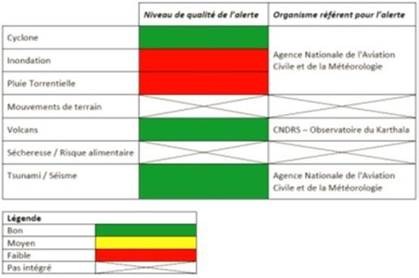

Insights from the case study
A phase of warning dissemination and communication can be thought of as beginning about a week before Cyclone Kenneth struck Comoros. Official accounts indicate a clear outworking of pre-determined protocol and communities across the islands receiving timely warning of the pending powerful storm.
7 days prior: Comoros Meteorological Service issued the first warning (based on information provided by Météo France). In accordance with protocol, COSEP informed the Ministry of Interior, who has responsibility for triggering an official warning, and focal points convened from key sectors (including health, education, army, gendarmerie, national environment directorate).
4 days prior: A meeting was held with sectors to mobilize available resources and to discuss the emergency strategy.
3 days prior: Further convening of the key stakeholders occurred and updates on the cyclone were provided by a CMS technician every 2 hours. At this stage Mayors were alerted and civil protection, with support from the RCRC and NGOs, began issuing warnings directly to the public with the use of megaphones. Advice was provided to protect homes (e.g. sand bags on roofs), prune trees (presumably for dangerous branches), avoid going out to sea, shelter animals, and store food. Communities were encouraged to identify the most vulnerable homes.
2 days prior: The public warning continued, and civil protection sought to ensure they prioritised communities who did not have power, and hence were less likely to hear warnings issued via radio, TV or mobile phone.
1 day prior: By this stage the country had mobilized 550 army personnel, 200 police, and 150 gendarmerie. In addition, many local volunteers had been mobilised. Forced evacuations by COSEP of some most at-risk families begun, such as on the coast at Fomboni where a strong storm surge was expected.
In Handsindsy the men received the warning but did not pass this information on to the women. Some residents in Vouvouni heard the warning messages but did not take preparedness action. This despite Vouvouni being a highly flood-prone community that suffered significantly from the April 2012 floods (and was even experiencing challenges of water-logged roads during the time of the field visit due to unseasonal heavy rainfall). Known high exposure to flooding was not enough to prompt action on hearing Cyclone Kenneth warning messages.

Critical analysis
This study, that included a focus on the experience of some local communities affected by Cyclone Kenneth, would dispute the findings of the earlier study that indicates that the quality of the cyclone alert system is good. This study found that even if the alert procedures were followed, this did not necessarily result in the intended benefits for reasons outlined below.
Several challenges exist with respect to using radio as a means of warning dissemination. The radio broadcasters can have difficulty understanding the message they are conveying to the population, with implications regarding clarity of the message. Additionally, not all community members have access to a radio. Those that do have a radio rely upon power supply which can be lacking or very intermittent at the best of times and certainly not dependable in an emergency.
Power supply also plays a very significant role with respect to mobile phone connectivity. Additionally, mobile phone range is not sufficient for reaching fishing crafts at relatively large distances from shore.
For end-user dissemination of warning messages, it is not sufficient to rely upon technical solutions. Instead, the sharing of warning messages through face-to-face communication is a commonly held preference. In addition, it appears that the trust held in the person responsible for delivering the message to end users by the community is highly important. Paraphrasing one community member from Hansindsy, “Rumours do not lead to action. Trusted sources are vital.” Therefore, whilst there may be some benefit from COSEP and other officials driving through communities declaring warnings with the use of megaphones, the best way to ensure messages are taken seriously is to have the messages relayed by respected local voices, such as mayors, women’s association leaders, fishing unions and others.

Figure 41 CMS discussing with community members in Hansindsy
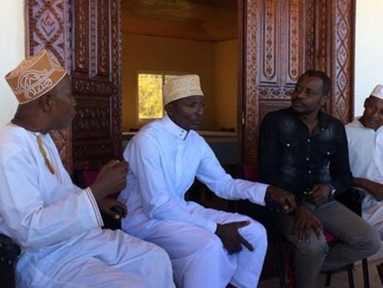
Photo: Paul Venton (DAI)

Preparedness and Response Capabilities
The National Contingency Plan indicates several areas where weaknesses in the preparedness and response capabilities of Comoros exist. For example, with respect to legislation, there is no specific regulation on national emergency coordination in certain areas (e.g. education and protection). Whereas it is noted that poor cross-sector coordination is preventing an adequate humanitarian response and leading to an increase in losses.
The Contingency Plan also refers to inadequately trained personnel at all levels, no capacity to store humanitarian food and non-food items, and therefore a dependence on external resources for stock mobilization, purchase and pre-positioning.

Insights from the case study
There was a serious under-appreciation regarding the scale of the threat from the cyclone. A lack of cyclone experience and a lack of trust in the message were at the heart of the lack of action. This was then compounded by a sense that there is a lack of ways that people and property could be protected anyway. With hindsight, people recognize that they could have protected some assets, such as by moving them to safer locations.
According to all local accounts, the actions taken among local communities to prepare for Cyclone Kenneth were reactions to observed deteriorating conditions. They were not precautionary based on early warning messages.
As conditions deteriorated, fishermen in Fomboni in south-east Grande Comore protected their boats. But this protection was based on earlier experiences weathering storm conditions, and not accounting for the severity of Cyclone Kenneth with high wind speed and a significant storm surge of between 3 and 6 meters, as forecasted. Consequently, even “protected” boats suffered loss and damage. For example, boats in Fomboni were pulled on to a beach, protected by a rock outcrop. Yet the storm waves breached the outcrop for the first time in living memory, leading to the loss and damage of many boats. Of the 45 motorised boats within Fomboni, only 17 were not lost or damaged.
Figure 42 Protected areas for boats in Fomboni (to the left of the low-lying rock outcrop)
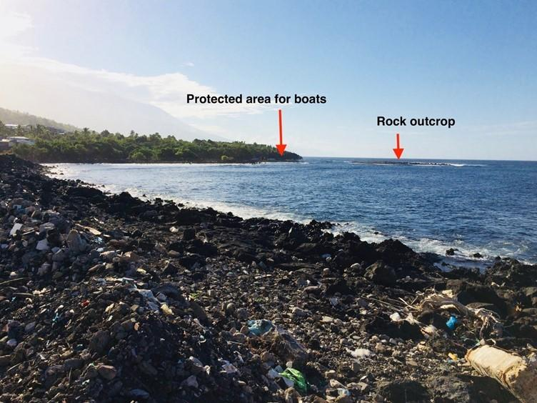
Photo: Paul Venton (DAI)
The storm surge also over-topped and destroyed the dyke that was intended to protect the town. Buildings were destroyed, including some concrete buildings. Water entered the hospital, but patients had been evacuated to safer locations, most likely their own homes or the concrete homes of neighbours.
One man interviewed, who lives near the hospital in Fomboni and has a shop on the waterfront, lost all valuables from the shop in its’ exposed location. He had not heard advance warning of the cyclone. With hindsight, if he had known what was in store, he would have protected the shops’ stock of valuable items.
Figure 43 Damaged coastal property next to shop in Fomboni
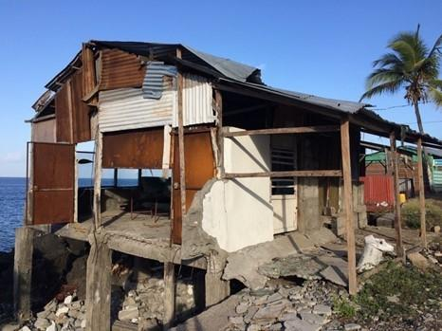
Photo: Paul Venton (DAI)
In Vouvouni, according to anecdotal evidence, 70% of the buildings are of corrugated iron construction. Also, of significance with respect to flooding, water is easily able to enter homes on account of their low floors and due to poor drainage. Consequently, Cyclone Kenneth destroyed or damaged many buildings as roofs were blown off and homes were flooded. In addition, falling trees caused damage and disruption. During the night, people residing in weak and damaged buildings took refuge in stronger people’s homes. Deteriorating conditions forced their reactive response to deal with the unfolding disaster.
In more northerly areas of Grande Comore there are many accounts of agriculture-related damages, with losses to bananas, cassava, sweet potatoes and other crops, plus to livestock. Not only does this directly affect farmers, but the lack of produce resulted in rising prices for commodities now only available in short supply. Under such circumstances, the poor and those without strong social networks likely suffer worst. It was not only agriculture-related losses that were suffered in northerly areas. Northerly areas also expressed how they had experienced losses to boats and dykes, many households lost their roofs, and trees were also blown down.
As Cyclone Kenneth made impact, the local community members, particularly young men, can be considered as the dominant first responders. Local groups set to work clearing roads, such that within about 24 hours road access was restored. Such groups also took the lead in clearing debris in fields.
A very clear trait for social cooperation, solidarity and support was demonstrated during and in the aftermath of the cyclone. In particular, it was very common for community members with concrete houses to provide shelter to others who had lost their own homes, especially when corrugated metal roofs were blown off. Furthermore, for several households, co-habiting arrangements were still necessary at the time of the fieldwork, over 2 months since Cyclone Kenneth. Similarly, those who still had potable water provided this to those who had lost access to their own supply. Fishermen too, through local unions, are cooperating to share the use of non-damaged boats and rebuild damaged ones.
Figure 44 Vouvani, where neighbours are still providing shelter for community members who lost their homes, such as this college teacher who has a wife and five children.
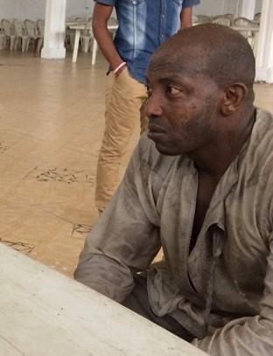
Photo: Paul Venton (DAI)
From the government side, the pre-determined contingency planning procedures were important, allowing key stakeholders to take emergency action. A rapid needs assessment began in the morning following the cyclone with the mobilization of 16 inter-agency teams across Grande Comore, Mohéli and Anjouan. According to the emergency authorities, over the course of the coming days and weeks the worst affected were provided food (rice), health kits, and shelter. However, several community members report how they are still waiting for assistance, or in one example how the only external assistance came from the RCRC with a food distribution several weeks after the cyclone. In Anjouan, like elsewhere, the cyclone destroyed much of the various crops. Some, like banana, have been re-planted but will take around 2 years before their produce will be available for harvest. In the meantime, with no signs of government support, local people are facing a pending food gap crisis.

Critical analysis
The largest and most frequently cited gap in the Comoros early warning system relates to inadequacy in the warning service driving actions that would prevent or reduce loss. Of course, challenges exist across all other elements of the early warning system too, but even when a risk is known, an accurate warning is developed and is disseminated in good time, as occurred in the case of Cyclone Kenneth, it is very apparent that this does not lead to adequate action. Therefore, investing in better observation capability alone without sufficient investment in local user engagement processes will be futile from an early warning system perspective.
What effort that has been directed at improving early warning in Comoros appears to have focused on “upstream” aspects of the hydro-meteorological value chain. Consequently, projects that have sought to build competence tend to under emphasise the need to build end user capacity. And should end-user capacity building feature in project activities, there is a strong likelihood that the emphasis is on explaining to end users what the alert system is and what should be done when an alert is received. By contrast, what is needed is a system based on strong engagement between producers and users of warning information, where users play a vital role in product design and dissemination preferences, and trust between stakeholders is built.
The emphasis on disaster management in Comoros is heavily weighted towards preparedness and response. A paradigm shift towards risk reduction and resilience building as a development priority has not taken hold. This perspective is captured in the Sendai Framework which expands the notion of disaster risk reduction beyond preparedness and response capability to encompass, under Priority 4, the vital need to ‘build back better’ in recovery, rehabilitation and reconstruction.
In the case of Cyclone Kenneth, many aspects of a lack of investment in DRR for resilience can be recognized in the findings of the multi-sectoral rapid damage and needs assessment that took place in the immediate aftermath of the cyclone. This is because the reality of what was “at risk” before the cyclone was actually then demonstrated when the cyclone occurred. Similarly, disaster losses indicate where resilience was lacking. A consideration of those losses provides clues regarding resilience building needs. For example, based on known losses through Cyclone Kenneth alone, resilience building can be drastically improved in terms of people’s personal safety, house design, land use planning, water supply and sanitation (for example, the city of Moroni operates with a single water pumping station and inadequate stormwater collection and drainage – see Figure 45), education and school safety, multi-purpose evacuation shelters, ecosystem protection as a disaster and climate resilience strategy, agriculture, health, continuity in energy supply, infrastructure such as road design, and financing for recovery.
Figure 45 Flooding from heavy downpour in Moroni
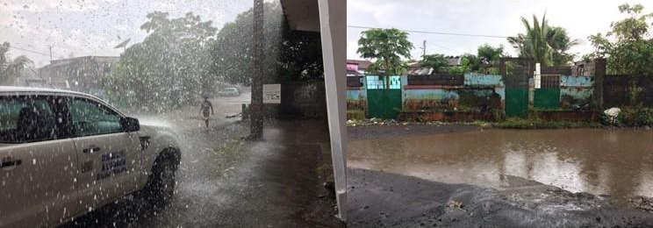
Photos: Paul Venton (DAI)
On Grande Comore, there is no permanent river or truly structured stormwater collection network. Overall, stormwater collection is provided by gullies in rural and natural areas and by diffuse runoff (roads, gutters, embankments, etc.) in the case of landscaped areas. Sometimes, stormwater is collected by gutters and pipes and discharged to the shoreline.
The absence of resilience building as a development concern is already noticeable in how some aspects of Cyclone Kenneth recovery and reconstruction is taking shape.
With the assistance of others, such as family members living in France, many people have already rebuilt their homes. However, these appear to be built in the same locations and to the same specifications as those damaged or destroyed. In effect, the risk has been rebuilt. It is understood that UNDP has a project to build 150 houses across the three islands, but these are of metal construction, not concrete. It is worthwhile noting that roof shape and construction techniques can help considerably in building resilience against strong winds. Where cost remains a critical impediment to safe shelter, it is not always inevitable that non-concrete construction has to be weak and likely to suffer failure.
Figure 46 Metal house by coast in Foumbouni
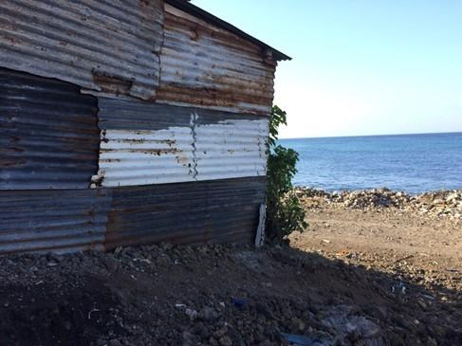
Photo: Paul Venton (DAI)
Similarly, despite the catastrophic failure of coastal defences, there are calls from the local population for them to be rebuilt. The coastal defence had probably offered a false sense of security, encouraging homes, businesses and even the hospital (in Foumbouni) to be located very close to the sea. Such calls for the reconstruction of engineered defences would suggest that local people do not anticipate a similar storm in the near future, or the benefits of restoring “business-as-usual” outweigh the perceived threats. Yet climate change effects on sea level and cyclone severity for Comoros would suggest that greater caution would be prudent.
Figure 47 Damaged coastal defence leaving coastal buildings close to sea unprotected
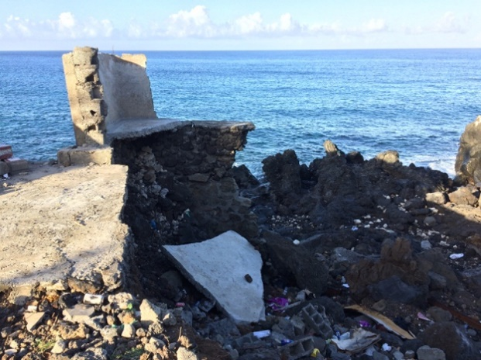
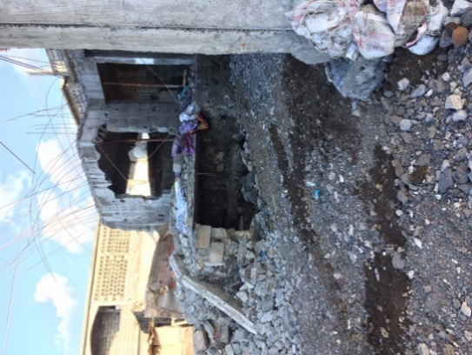
Photos: Paul Venton (DAI)

Existing local arrangements would provide a strong basis for embedding DRR and EWS awareness and activities. For example, Comoros benefits from well organised Village Development Associations (VDAs) that implement local development initiatives. VDA’s can consist of several branches, including for women’s support, youth, and community development, and are often important channels through which projects and organisations engage with communities. For example, in the Bandasamlini area the Community Based Organisations (CBO) ‘Groupement Bandasamlini’ is active in supporting a range of community development issues. Farmers associations, women’s associations and fishing unions are also integral and important community structures.
Similarly, the Red Crescent offer an extensive network of local community volunteers across Comoros. As integral members of their community, they can provide a locally appropriate and year-round service. This has been especially well demonstrated through their support in public health programmes. The presence of this existing local network of volunteers is very significant, as it differs from project-based initiatives where intended contributions become obsolete over time as they are not embedded in normal community decision-making processes.

3.1.4 SWOT analysis
Table 18 SWOT analysis of DRR in Comoros
 | Strengths | Weaknesses | Opportunities | Threats
NHMS | System of broadcasting forecasts and warnings in place.  CMS protocol for sharing information with COSEP in place.  Met stations manned by trained observers. | Weak links between CMS and users of climate information services.  Lack of tailored weather, water and climate services including adequate early warning that provide decision makers at all levels with information essential for mitigation of extreme events and adaptation to a changing climate.  Gaps in monitoring capacity, inadequate stations network.  Climate data not digitalised nor backed up often.  Staff qualification at CMS weak with limited MSCs and PhDs.
DRR institutions | Developed procedures and protocols to respond to emergencies.  Existing SNRRC (2015) linked to development and poverty reduction strategies.  CRC with local resources (volunteers’ team and coordination capacity, food stocks) in the 3 islands and working in cooperation with DGSC for warning and preparedness.  CRC benefiting from large experience in humanitarian actions. | Lack of budget to implement/support the SNRRC.  Inadequate framework for national emergency coordination in some sectors (e.g. education).  Lack of legal framework to allocate dedicated budget and resources to DGSC.  Absence of comprehensive and participatory risk assessment products and processes.  Lack of environmental data and hazard maps to understand risks including location and evolution.  Lack of information and communication tools to advice the population of the existing risks and increase risk culture and awareness.  For marine sector: lack of hydrography and oceanography data and maps for coast guards warning and intervention.
Sector CS users | At the national government level, multi-sector cooperation in the face of an emergency/ existence of a multi-sectoral coordination platform (PNRRC).  Data provided by CMS to government ministries for free. | Inadequate mainstreaming of climate change and disaster risk management (DRM) in development policy and planning.  Inadequate dissemination of services to fishermen, particularly at distance offshore.  ANACM website not up to date to provide relevant information to users.  Lack of procedure to co-produce climate information and collect users’ feedback.  No procedure to develop CS that responds to users’ needs even for key sectors like agriculture or fisheries. | FAO / Ministry of Agriculture technicians could act as intermediaries in the dissemination of early warning and forecasting.  Potential for payment for services by fishing unions. | Lack of appreciation amongst sector users and end users of the possible benefits of hydro-meteorological services.
Last Mile/Gender aspects | Local community cooperation and solidarity.  Village Development Associations (VDAs), Community Based Organisations (CBOs), local community women’s associations, farming associations and fishing unions are strong entry points for embedding DRR and EWS in local development plans.  Widespread network of Red Crescent volunteers across Comoros. | Little public awareness of how to adapt to climate change. | RCRC are establishing local offices around the country with potential as a forum for co-production. | Perception of low confidence in early warning among population.  Sense of lack of viable preparedness and response options.  Significance of traditional knowledge perceived by national agencies as less important in early warning than scientific knowledge.
Other | Vital partnerships with international and regional partners. | Weak understanding of water resources vulnerability to climatic extremes.  Lack of decentralized level capacity (regions, districts, municipalities and decentralized sectoral ministries) to manage climate and disaster risks.  ANACM can only receive data through the Internet at a very low speed. | Important synergies exist with various projects (see section 2.2.3). ANACM can be strengthened by optimising opportunities where projects can offer mutual support to increase benefits. | Very little interest focused on prevention and disaster risk reduction.

3.2 Madagascar

3.2.1 Assessment of NMHS

Pillar 1: Observation and Monitoring
The DGM meets only some of the criteria for Category 1 for the Observation and Monitoring pillar. It can meet the criteria required for Category 2 by improving the coverage of ground and upper air observation stations, strengthening station inspection, and backing up climate data regularly.
Strengths: The DGM Met stations are manned by trained observers, and there are 23 surface stations spread along the country. It uses basic quality control procedures. DGM is on the way to upgrade its synoptic network through GIZ and UNDP projects, as well as SADC. For example, meteorological stations to detect thunder storms have been operationalised thanks to support from Medair NGO. These stations receive pictures similar to those received from radars. Trainings targeting meteorologists on how to operationalise the stations have been completed in November 2019.
Weaknesses: The number of surface station are too sparse for a NMHS Category 1 and DGM has no upper air station neither doppler radar and it does not backup climate data often and has not digitized many of its climate data. It does not maintain an electronic climate database and has no access to computing capacity for data collection, storage and transmission.

Pillar 2: Modelling and Predictions
The main reason why the DGM does not meet the requirements for a Category 1 NMHS in the Research and Predictions pillar is that the NMHS is involved in a limited number of research projects and experiments. For example, the BRIO project since June 2019, SAWIDRA from the AfDB which is being developed, the Pilot Project on Climate resilience focusing on climate trends and future climate projections (funded by the World Bank), and C-Rise on sea-level rise implemented by NOC/UK, among others.
Based on available data, the NMHS would need to expand the range of seasonal forecasts in order to fully satisfy the requirements for a Category 1 service. The NMHS should improve human and technological research capacity, and expand the range of weather, seasonal, and monthly forecasts in order to satisfy the criteria of a Category 2 NMHS in Research and Predictions.
Strengths: DGM with its R&D department, fulfils some research and prediction criteria for a Category 1 NMHS, such as providing weather forecasts for up to 3 days and seasonal rainfall forecasts.
Weaknesses: DGM does not participate in any research program. The NMHS needs to improve access to research resources, and the range of forecast products as well as the human and technological capacities to produce these, in order to meet the requirements for a Category 2 service.

Pillar 3: Climate Services Information System
The DGM fulfils partially the criteria for a Category 1 NMHS for Climate Services Information System. There are aspects within the two categories that are not fully met, such as range of forecast products and access to software for computing climate statistics. The NMHS should expand the range of products and improve the information that it communicates to users of climate information on its dissemination media to move up to a Category 3 NMHS for Climate Services Information System. At least DGM should provide climate information relevant to policy development and National Action Plans on the five pillars of GFCS.
Strengths: At a governance level, the DGM provides data free of charge to government ministries and education institutions. Staff produce most basic climate statistics for major climate variables. DGM performs statistical analyses and contributes to national early warning systems through early warning information and advisories. DGM performs a web portal ((http://www.meteomadagascar.mg/maproom)well updated and it has a climatic portal to help different sectors in the use of long-term climate change impacts.
Weaknesses: DGM has no clear policy guidelines on the provision of Climate Information Services and it should improve capacity to produce basic climate statistics and seasonal outlooks. DGM does not perform homogenization of climate data. The range of seasonal outlooks is limited, and the webpage does not provide sufficient specialized products.

Pillar 4: User Interface Platform
DGM partially fulfils the criteria for a Category 1 NMHS for the User Interface Platform pillar. In order to move to a Category 2 NMHS, it would need to improve its documentation of user needs and feedback, incorporate feedback into a redesign of products, enhance the training of users and improve the website.
Strengths: With a procedure for user engagement, some staff members have been trained to interact with users around requests for seasonal forecasts and basic climatological queries. Such interactions have occurred in the past two years. DGM has started the process for National Framework for Climate Services (NFCS). DGM co-produces weather bulletins with the health and agriculture sectors. MoUs have been signed in this regard. The TV bulletin system has been renewed recently.
Weaknesses: DGM does not document feedback from users of climate information. The website communicates basic climate information to users. DGM has not produced tailored products in response to user’s requests in all priority areas of the GFCS.

Pillar 5: Capacity Development
DGM does not fulfil the criteria for a Category 1 NMHS for Capacity Development. To satisfy the criteria, the NMHS would need to establish a formalized governance structure with a financial autonomy, expand participation in the national policy process, and strengthen human and technological capacity.
Strengths: DGM participates in climate related policies and plans. Staff have basic training in essential meteorological services. It has some staff with a range of specializations including NWP. Staff have some access to software tools for weather and climate forecasting and there is some straining conducted for entry and mid-level meteorological technicians
Weaknesses: The DGM has no formalized governance structure. Human, and technological capacities are limited. There are weaknesses in staff qualifications with more staff with MSc’s and PhDs required.

3.2.2 Assessment of existing climate services users and platforms
WMO has prioritized several sectors for the provision of climate services, including water, agriculture and fisheries for food security, health and disaster risk reduction.

Water resources management for potable water, domestic uses
The supply of drinking water covers about 52% of the total population in 2015 (82% in urban areas, 35% in rural areas.) Approximately 12% of the total population has access to health facilities in 2015 (18% in urban areas and 9% in urban areas). Despite these numbers, Madagascar has significant potential in terms of water resources. Yet, these are under increasing pressure because of population growth, urbanization, and expansion of agriculture, deforestation, climate change. As a result, the following consequences are noted:
- the resource becomes scarce as groundwater resources are drying up;
- the quality of the resource deteriorates, which is accentuated by upstream pollution (often related to poor sanitation, the use of inputs or pesticides, etc.); and
- the use of the resource is confrontational: conflicts of use, mainly between irrigators and drinking water supply in rural areas.
As presented in Chapter 2, DGM has some capacity to monitor water resources, including: rainfall forecast, temperature, wind and humidity (for evapotranspiration). However, hydrological monitoring is weak and there is a limited understanding of water catchments dynamic to provide reliable information to integrated resource water management decision making process while including flood risk reduction in water management.

Agriculture and fisheries for food security
Nearly 32% of Malagasy people are undernourished over the period 2010-2012, particularly in the south with 47% of children under 5 suffering from chronic malnutrition.
With the support of DGM weather information, the DAPV (Direction de l’Agriculture en appui à la production végétale, attached to MAEP) is providing farmers with crops calendars for the rainy season for each type of culture and for each region. These calendars are sent to the regional direction of agriculture in charge of informing farmers. However, there is a lack of downscaled forecasts and climate data at district level to provide accurate information to farmers, in support to decision-making processes. Moreover, regarding drought threat monitoring, there is no reliable monitoring on the 3 main rivers catchments in the Great South for water resource availability.
Fisheries and aquaculture, still underdeveloped and mainly for local consumption, are experiencing strong growth and are the second largest export earnings of the primary sector, especially shrimps, tuna, lobster and crab. DGM delivers weather data to fishermen on: wind, size and direction of waves, and swell/storm surge. Cyclones and tropical storms are the main hazards affecting the fishery sector and resulting in destruction of equipment and infrastructure, loss of boats but also loss of lives, in particular for small-scale fishermen. As for farming, there is a lack of downscaled data, which would be very useful for fishermen who fish locally. According to fishery department, it is critical to focus on the small-scale fishermen alert system, because large industry and private sector have their own information system. Several projects currently work with small-scale fishermen to disseminate weather information and train on responses and should, therefore, be scaled up.
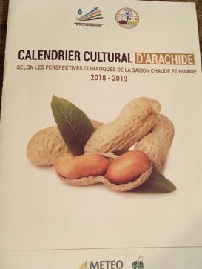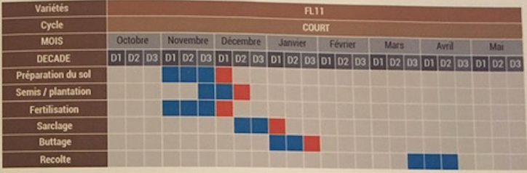
Figure 48 Example of cropping calendar for groundnuts in relevant regions

Health
Climate conditions affect health in various ways, including:
- heat wave: weakening of the most fragile population (elderly, children, people affected by respiratory diseases, dehydration, ...)
- peak of air pollution due to high heat in urban areas: respiratory diseases
- cyclones, floods and droughts that disrupt or create a break in access to vital needs (water, food) endangering the health or even the life of population with the appearance of vector-borne diseases (malaria, ...) and waterborne diseases (diarrhoea, cholera ...).
The Directorate-General for Health has a budget dedicated to crisis management and a contingency plan in the event of a cyclone to manage health emergencies during the crisis and its post-crisis consequences (often water-related diseases related to break of the water & sanitation services).

Disaster risk reduction
According to experience and observation, the most important direct losses that Madagascar experienced from disaster events are those that occur after cyclones.
Cyclone and storm surge alert: There is a contingency plan for Cyclone and tropical storm. DGM send a message to direction of ministries and the communication is broadcasted at TV and radio but most remote people don’t have access. Small-scale fishermen have a very limited access to climate information and alerts because they do not listen to national TV and radio (which are currently the main channel used to disseminate information) as often there is no electricity in the households. They are also located in remote areas with limited telecom options. This issue is however being addressed in the South of the country, where project PrAdA improve access to meteorological information to small fishermen.
Flood risk reduction: APIPA (Autorité pour la Protection contre les Inondations de la Plaine d’Antananarivo) is in charge of hydrology monitoring over the plain along Antananarivo (Ikopa, Mamba and Sisaony rivers), drainage system monitoring (including buffer basins) and flood alert for the 30 local cities belonging to Great Tana area.
- Regarding prevention and protection, the plain (which is a polder) is protected by dikes, dam and drainage network system (with pumping stations) to protect from rivers flood.
- APIPA oversees monitoring the system, cleaning of the canals and reinforcement of the dikes if needed.
- The flood alert equipment consists of 18 automatic rainfall and / or flow measurement stations in the Ikopa watershed above Bevomanga (4,300 km2). These stations are connected by radio to a central data acquisition and processing station at the APIPA office where the central station collects data every hour and uses them to forecast the floods of the Ikopa and Sisaony rivers in their crossings of the agglomeration. The service delivers a warning alert to the population and rescue services 24 hours before a flood threat. This system is also used to improve drainage system management (channels drainage network and valves, pumping system, dams and dikes).
There are no other equivalent structures and equipment on the other catchments prone to flood, mainly in the North of the country and upstream to main cities. 16 regions prone to flood have been identified but there is no risk vulnerability assessment, no hazards maps neither risk map elaborated with concerned cities and others local authorities.
For flood related to cyclone and storm events, it is taken into account in the dedicated contingency plan, for warning the population 3 days before the potential hazard, but there is no monitoring on the field regarding water basin evolution.
Drought and food security: In the most drought-prone areas, surveys are implemented on the field among vulnerable population twice a year to alert when the families are forced to sell their goods to buy food for avoiding starving. The government may organise food distribution with humanitarian partners within the CRIC, or it can implement prevention action plan regarding agriculture activities (trees planting …). Madagascar country has joined ARC insurance (32 African countries): the government pay the insurance contribution to receive funds to give to people, in case of drought.
Landslide: DGM works on crossing data on flood/precipitation and soil moisture and geological structure to produce hazard maps. There are already hazards maps made for the hills here around Antananarivo and the work needs to be extended to the entire Malagasy plateau for risk landslide.

3.2.3 Assessment of EWS, End-users and Case Studies
In recent years, several damaging cyclones have hit the country.
- In 2000, three cyclones (Eline, Gloria and Hudah) caused extensive flooding in their areas of impact and the downstream watersheds (as noted in Section 2).
- In 2004, cyclones Elita and Gafilo caused an estimated 2.3% loss in GDP. Elita killed 363 people and affected one million people, causing economic damages of over US$250 million.
- In 2017, cyclone Enawo affected over 430,000 people with a potential economic loss equivalent to 4% of GDP.
- In 2018, two tropical cyclones, Ava and Eliakim, left 23 people dead and more than 20,000 displaced.

Disaster Risk Knowledge
Madagascar has experienced many disaster events and ranks amongst the ten countries most vulnerable to extreme weather events. Furthermore, it is experiencing more intense climate-related disasters each year. Between 1990 and 2013, 63 major climate-related disasters were recorded, impacting more than 13 million people, over half of the Madagascar population. These experiences lead to high levels of familiarity on disaster across the country.
Figure 49 Major climate-related disasters
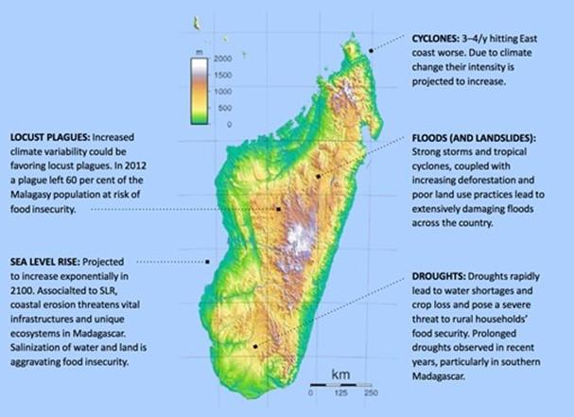
Source: Madagascar Strategic Programme for Climate Resilience, 2017
It is known that over the past 30 years, the average annual number of cyclones affecting Madagascar has not changed (3 or 4 a year), but the number of intense cyclones has increased. Between 1980 and 1993, the most affected areas were the East Central, the West Central and part of the Highlands with cyclones bringing average wind speeds of 120 km/h. Then, in accordance with Direction Générale de la Météorologie (DGM) observations, from 1994 onwards, cyclones have affected most of Madagascar and the worst affected area has migrated northward, mainly to the northeast, where average winds 150km/h have been observed. This trend has resulted in increased loss of life. Indeed, Madagascar is among the 10 countries in the world where the death index related to tropical cyclones is the highest, and the country experiences frequent wide spread damage to infrastructure and property. Recent research suggests that while the frequency of cyclones will not change along this part of the southern Indian Ocean, their intensity is projected to increase.
Cyclone season is between November and April with the most active period being between mid-December and mid-March. Cyclones have resulted in serious impacts, to include:
- crop loss
- severe flooding
- waterborne diseases’ outbreaks
- coastal degradation and disruption of marine ecosystems
- damage to critical infrastructure and services such as water and electricity
- human casualties
Additionally, intense rainfall caused by strong storms and tropical cyclones, coupled with increasing deforestation and poor land use practices, have led to damaging floods and landslides across the country. The most damaging were those caused by tropical cyclone Elita. Flood conditions are exacerbated in urban areas by a lack of solid waste management. For example, it is a persistent concern that rubbish blocks drainage channels and efforts to clear drains are sporadic and incomplete. Flooding in adjacent communities is a common occurrence and causes a high incidence of water-borne disease.
Figure 50 Litter piles up in the Reunion Kely district, one of the poorest in the capital, Antananarivo, January 2019
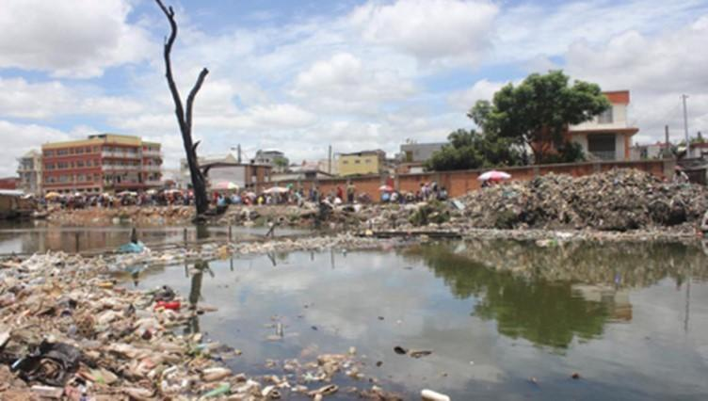
© RFI/Laetitia Bezain
Intense drought over recent years and decades has led to high levels of food insecurity and poverty, especially in the south, impacting more than 3.5 million people. The increasing irregularities in rainfall patterns and other climate parameters key for productive rain-fed and/or irrigated crops make livelihoods mainly based on agriculture ever more precarious.
According to the Government of Madagascar, the four most harmful risks associated with the effects of climate change are: floods, drought, high winds (cyclones) and locust invasions.
Experiences with disasters and concerns over climate change have led to the development of some improved understanding on how climate variables can lead to disaster risk. For example, data on precipitation, soil moisture and geological structure has been used to develop landslide risk maps for some hilly areas. Over 70 percent of settlements in the capital Antananarivo are informal, below living standards and located in risk-prone and environmentally degraded areas. The unplanned and unmanaged nature of the rapid expansion of cities and the increasing frequency and intensity of weather events is a risk-multiplying equation. While erratic and intense rainfall is expected to increase, water drainage and sanitation systems in cities are damaged or not fit to the increasingly extreme storms.
In 2016, the Global Facility for Disaster Reduction and Recovery (GFDRR) and the World Bank published a “Disaster Risk Profile of Madagascar”, as part of the Southwest Indian Ocean Risk Assessment and Financing Initiative, based on risk modelling in three hazards: cyclones, floods and earthquakes. Data on exposure of infrastructure (including public facilities, residential construction and transport infrastructure – roads, ports, airports, etc.-) were combined with data on hazards and vulnerability provided by the Government of Madagascar (GoMc). These were used for risk analysis and made available to end-users in an open data geospatial risk platform. The analysis suggests that, on average, Madagascar experiences over USD $100 million in combined direct losses from earthquakes, floods and cyclones each year. Tropical cyclones are by far the most significant risk in this study, causing approximately 85% of the annual average loss.
DGM works with the European Space Agency – Centre National D’Etudes Spatiales / French Space Agency (ESA-CNES) members. In this way they have been able to access raw and processed satellite images for real-time flood mapping.
At the local community level, risk mapping (i.e. Community Capacity and Vulnerability Assessments – CCVAs) also leads to improved knowledge and understanding amongst stakeholders involved.
Above examples aside, mapping of socio-economic vulnerabilities and climate risk is identified as deficient within Madagascar’s Strategic Programme for Climate Resilience (SPCR).

Figure 51 Loss in infrastructure combined from cyclones, flood and earthquake
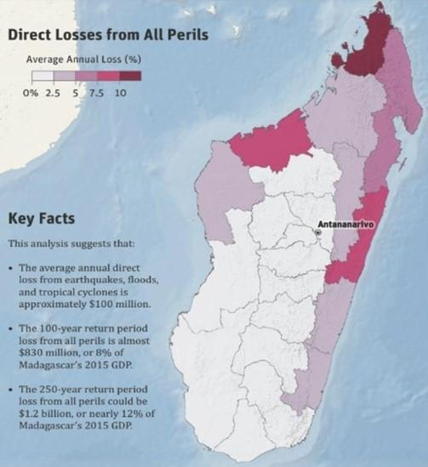
Source: GFDRR-WB, 2016. Madagascar Disaster Risk Profile.

Critical analysis
According to the Technical Report into the Assessment of Hydro-meteorological Services, flood hazard maps (and flood forecasts and early warning) are among the most solicited information by key user sectors. However, despite being vital for flood hazard management, currently these maps do not respond well to user needs.
Figure 52 Users' information needs
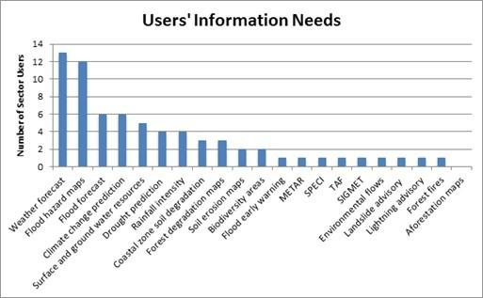
Source: Technical Synthesis Report into the Assessment of Hydro-meteorological Services and Recommendations for their Improvement. World Bank Group, January 2017
In particular, there is a need to extend landslide risk mapping to the entire Madagascar Plateau.

Detection, Monitoring, Analysis and Forecasting of the Hazards and Possible Consequences
A lack of weather stations and hydrological monitoring has made it impossible to monitor many important regions of Madagascar and populations especially vulnerable to climatic hazards. For example, in the past there were some landslide tracking stations, but now heavy rains are not monitored in landslide-prone areas, soil moisture conditions are not known in agricultural areas, warning signs of flooding are not properly detected and forecasted. As a result, many potentially fatal hazards have not been anticipated and foreseeable consequences have not been mitigated.
Detection, monitoring, analysis and forecasting of hazards and possible consequences are present only in some region; however, these systems are not homogeneous according to regions.
For example, three watersheds have monitoring systems suited to the detection of floods. Two of these have been equipped by CPGU; one in the Antananarivo area, and the other near Toliara. While CPGU was responsible for installing the necessary hydrological monitoring equipment, the meteorological service collects and exploits the data. Unfortunately, maintenance of the equipment is a challenge. Additionally, data collection is not easy. Data stations require manual collection of data, yet they are sometimes difficult to reach. CPGU has provided bikes to aid data collection, yet distance, road condition and poor weather all hinder the collection process.
Whilst scientific means to forecast hazardous events is weak, it is important to recognise that communities, such as farmers, have their own belief/weather prediction systems. Even if official warnings were technically possible, local user groups will not necessarily take heed. Indeed, international evidence suggests it highly likely that official warnings will not be effective in fostering action.
Key climate information to share with fishermen are wind, size of wave, and swell/storm surge.

Insights from the case study
Tropical Cyclone Ava was born from a low-pressure weather system located about 2,000km off the northeast coast of Madagascar since 27 December 2017. It then intensified into a Tropical Cyclone by the time of its landfall. However, Cyclone Ava’s strength was higher than expected because initial forecasts had estimated Ava would land at the Moderate Tropical Storm stage. The storm surge threat was monitored by the European Commission Joint Research Centre (JRC).

Critical analysis
Weather forecasting and risk prediction needs to be refined/downscaled to become more useful for users. However, there is concern that downscaled information is expensive and, therefore, access for users can sometimes be at cost. It is already possible to get more refined information e.g. from Météo France, but the problem is that it is expensive.
As climate conditions change, local user groups such as fishermen, are noticing that signs of pending weather have changed. They are less able to recognise signs and forecast conditions. This may open up new opportunities for collaboration between scientific forecasting approaches and traditional knowledge on forecasting. The hydro-meteorological community needs local insight and cooperation for a warning system to work, and local community user groups may increasingly value the services provided by official sources.

Warning Dissemination and Communication
The DGM has a weather communication unit (see Section 3.1) that supports the broadcasting of weather information and alerts via radio, television, telephone, fax, and internet. In addition, Madagascar has organisational and decision-making processes in place. For example, as soon as there is an indication of the probability of an event, the CRIC is activated (see part 3.1 for CRIC presentation). This is a platform that brings together key actors needed for coordination during an emergency and to determine whether to deploy a field response team (e.g. BNGRC CPGU, relevant government departments, WFP, UNICEF, UN OCHA, NGOs, Red Cross).
Once pre-alert information of an event is forecast, DGM begins issuing regular bulletins to CPGU (Risk Management Operational Cell). The frequency is related to the type of hazard (possibly every hour). In turn, CPGU produces briefing notes for the Prime Minister to report on the situation and crisis management measures. To alert regional entities, BNGRC sends information to RCMP regional committees who relay information to districts and Fokoutani. In turn the public are warned and provided with rules of behaviour to adopt.
The experience is varied among different sectors with respect to receiving forecasts and warnings (see Table 19. But a common denominator is the lack of capability to provide warnings to specific user groups, services and communities.
Table 19 Summary of dissemination to some sectors
Sector | Product | Frequency | Dissemination method | Key issue
Health | Newsletter | 2 weeks | Email
 | Alerts |  | Public media
Maritime | Bulletin |  |  | Lack of dissemination to specific services and users
 | Alerts |  | Public media
In-land transport | Alerts |  |  | Lack of dissemination to specific services and users
Agriculture | Bulletin | 2 weeks / monthly | ?? | Too technical. Lack of drought warning for user groups

The health sector receives weather prediction newsletters from DGM every 2 weeks via email. However, for fast onset climate extremes, like cyclones, these are only disseminated via public media. No specific alert is sent. However, a platform has been set up to disseminate climate services specifically towards the health sector.
For the maritime sector, DGM sends a meteorological bulletin to various users including Agence Portuaire Maritime et Fluviale (APMF), Centre de Fusion d’information maritime (CFIM), etc. These users will then disseminate these bulletins widely using national radio channels. The local population is used to listen to the radio for weather-related information and risk alerts. However, small-scale fishermen do not always have access to radio due to their limited access to electricity; this can also be due to their location in remote areas with no communication means. Hence, there are difficulties to reach them with relevant weather-related information and alerts.
Similar to the maritime sector, the in-land transport sector receives information from DGM. However, they do have not enough capacity to further relay the dissemination of alerts towards all users of land transport. For example, when they receive an alert, they directly inform the ‘gare routière’ (bus station). However, for those who have already taken to the road, there is no way to communicate with them because of a lack of connectivity in the country.
The agriculture sector (MAEP) receives meteorological news in the form of a bulletin every 2 weeks or on a monthly basis (depending on types of crops and cultural practices) for each region of the country. The Ministry of Agriculture has recently set up decentralised services, but these are not yet functional. The intention is that these will disseminate relevant agrometeorological information to communities. Currently though, the regional climate bulletins are considered too technical to be used as agricultural climate advisories and they are not disseminated to the farming community themselves. A further weakness exists in the fact that it is not possible to provide specific drought warnings. Overall, small-scale farmers, a critical segment of Madagascar’s economy and society, do not receive information that would help them in making decisions, such as when to sow seeds ahead of the rainy season.
This gap is being addressed through the GIZ project, PRADA (with partners including DGM, MAEP, FIFAI, TAHMO). Through this project, farmers can call a mobile phone hotline for free up to six times per month. When they call, they will receive an approximately 2-minute long recorded monthly information message in Malagasy relevant to their region. In this manner, farmers can receive weather information, advice on the type of cultivation and other agricultural practices.
However, some challenges will still remain. For example, GIZ estimate that only about 30% of the rural population have access to a mobile phone and power supply affects usability. Furthermore, the messages would ideally be translated into the various local dialects. High levels of illiteracy rule out sending text messages. For the system to maximise its potential, further efforts to ensure information is shared more broadly are required. Such as through relaying information during community meetings, displaying posters, and by connecting the service with local radio which is more accessible than mobile phones to rural communities (estimated at about 56%). Finally, the project needs to develop a sustainability mechanism to ensure the system is operational when the project ends (e.g. sell information to private companies).

Insights from the case study
The various government departments began sectoral information-sharing meetings before the arrival of Tropical Cyclone Ava. The Malagasy authorities issued a red alert (imminent threat) for the regions of Analanjirofo, Atsinanana and Alaotra Mangoro for 4 to 5 January, and Vatovavy Fitovinany for 5 to 6 January. In addition, several districts were placed on yellow and green alert.

Critical analysis
Whilst protocol exists for the dissemination of warning information through the described decision-making process, it is a generally held view that information is not properly disseminated and does not adequately reach end-users.
The current DGM weather forecasting service provides only basic qualitative weather forecast such as strong wind, low temperature, high chance of rainfall, low visibility etc. It is not able to provide impact-based early warning communicated effectively to target user groups and communities.
There is a heavy reliance among sector departments on receiving warning information via public media, through TV and radio (but not through local radio transmitted in local languages). For example, DGM does not currently send weather forecasts and warnings to the Direction for Communication at MAEP who could then share this with the various services and regional units of the Fishery Department. The lack of tailoring to sector needs is a serious impediment to the effectiveness of any required preparedness measures needed.
The tourism sector is keen to receive information.

Preparedness and Response Capabilities
BNGCR is responsible for crisis/disaster management, from warning through to response, including responsibility with respect to food security. Contingency plans exist for each sector. For example, when there is an alert of a disease outbreak, the health sector will ensure that local clinics have sufficient medicine supplies.
Cyclones are the main hazard affecting the fishery sector in Madagascar. Impacts typically include damage or destruction of equipment and infrastructure and loss of boats (see Disaster Risk Knowledge). Small-scale fishing communities are most at risk, and their lives are in danger. However, even if warning messages reach such communities, it is likely that the warning will go unheeded. Mainly, this is due to two reasons. Firstly, as fishing is so vital for food and income, some will consider the risks are outweighed by the necessity to take to the sea. Secondly, official warnings are likely not to be trusted. Instead, fishermen tend to rely more on their own observations of conditions. If an official cyclone warning is issued but the sky is clear, they are likely to assume that the warning is false. In addition, a warning or forecast that is not totally accurate will undermine trust, even though this level of accuracy is unrealistic. A lack of trust in official warnings is shared by other local communities too, such as farmers. Consequentially, a trait for local people not to respond to warnings, of all types (e.g. cyclone, flood, landslide), is a common tendency.
Landslide alert system is based on experience (soils are crumbly - soil saturation, house weight). The local authorities are informed and organise the evacuation of populations to reduce the load on fragile soils and to shelter people.

Insights from the case study
At the time of the first Tropical Cyclone Warning, the government’s response was to activate the National Contingency Plan via the National Office of Risk and Disaster Management (BNGRC) and the Country Humanitarian Team (HCT). The following activities were then jointly conducted by BNGRC, HCT and the relevant ministries.
- Pre-deployment of BNGRC teams, each accompanied by a Civil Protection Corps Unit; the team that went to Toamasina (the cyclone's entry point) in particular was accompanied by the Office of the United Nations Resident Coordinator, through OCHA
- Activation of all Operational Crisis Management Centres, at the BNGRC level and at the decentralized level where these centres are available (Toamasina, Brickaville and Analamanga)
- The dissemination of vigilance instructions and appropriate behaviours at each administrative level, with a particular focus on communication on flood and landslide alertness
- Activation of satellite support (UNITAR, UNOSAT, COPERNICUS) to have a map analysis of the expected potential consequences
- Activation of all Regional Disaster Risk Management Committees (CRGRC).
- Conducting evaluations through the existing mechanism, and three aerial survey assessments of the affected areas: the first two funded by UNICEF on ECHO funds, and technically supported by OCHA for the South-East, West and Northwest, and the third funded by Ambatovy for the East Zone.
- CRIC regular meetings, usually every two days, to define the strategy for response, prioritization of needs assessments, cross-sector coordination of these responses
Tropical Cyclone Ava was the first cyclone of the 2017-2018 southern season of the Indian Ocean. The system peaked at Category 2 with sustained winds of 150 km/h and gusts of up to 190 km/h. Heavy rain associated with Ava was recorded since 3 January in the north, north-east and east, and preventive evacuations began in Brickaville on 4 January. The cyclone actually made landfall on the coast of Madagascar on 5 January 2018 near Toamasina, after remaining for several hours near St. Mary's Island during the previous night. From landfall, the cyclone arced through eastern Madagascar, before leaving the country across Mananjary district, spreading heavy rains to the highlands and the south-east.
According to the official Situation Report, 51 people lost their lives and 22 went missing. In addition, damage to property affected 160,000 people forcing 54,000 people to evacuate their homes. Of these, there were estimated to be over 6,000 displaced children. Food security was seriously threatened with an estimated 42,000 households needing assistance to revive their agricultural activities and restore their destroyed livelihoods. The cyclone caused other forms of damage. For example, health infrastructure was damaged, including Basic Health Centres and a district hospital. Administration staff housing was also affected or destroyed. For the education sector, many schools were badly affected and even collapsed. It was reported that 512 classrooms were destroyed. Furthermore, 77 damaged classrooms were themselves used as a shelter, clearly indicating inadequacy in this arrangement. During the first day of the cyclone's entry, BNGRC describes the most urgent activities as the reinforcement of alerts, the evacuation of people living in areas at risk, and the care of evacuees in the accommodation sites.
The main impact of Cyclone Ava was from the flooding, although wind damage occurred, and the heavy downpours also triggered mudslides (Figure 53). The Northeast and East coasts had already received a lot of rain during the last three months of 2017, and so the ground was less able to absorb the heavy rains, exacerbating flood risk. Away from the coast too, Antananarivo was not spared the effects of flooding.

Figure 53 Heavy rainfall from Cyclone Ava over Madagascar
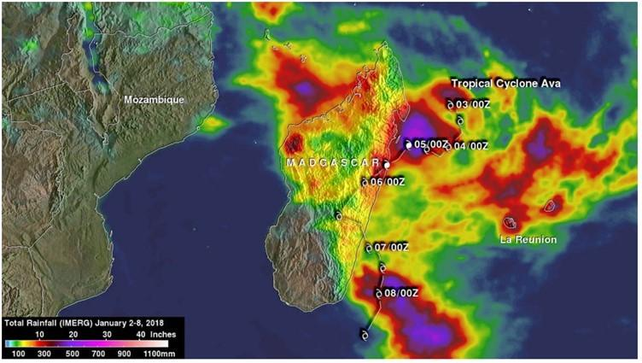
Source: NASA
Although the government reports that pre-positioned stocks of aid were available in Antananarivo, Toamasina and major cities on the east and south-east coasts, roads were rendered impassable. This meant that basic needs could not be easily delivered or medicines, vaccines and other health inputs. The phone network was also knocked out, hampering response by disrupting communication channels.
In the Situation Report, it is reported how various needs are to be met by different agencies through the distribution of assorted items – for example, tarpaulins, health kits, kitchen items, buckets, even cash transfers. What is not known, is the extent with which this assistance was provided, whether it did meet needs sufficiently for all affected people, and the contribution this made towards recovery. Similarly, it was also noted that assistance was needed to help vulnerable households access safe land, but the likelihood of progress seems low.
Important assistance on the ground was provided by various non-governmental organisations, such as the Malagasy Red Cross (e.g. disinfection of contaminated wells), Catholic Relief Services and Helvetas Swiss Intercooperation (e.g. water sanitation and health kits distribution). Such organisations can target the most vulnerable based on pre-existing knowledge and data on who is most at risk. Therefore, strong collaboration and coordination with local authorities and partners is highly beneficial. Helvetas note participation in simulation exercises conducted by the BNGRC in November 2017 and how such exercises should be systematized. Building on such initiatives, experience demonstrates the need to strengthen local authorities’ response capabilities and partnerships between NGOs (such as UNICEF, Malagasy Red Cross, MEDAIR) and local authorities.

Critical analysis
In practice, the outworking of contingency plans is rudimentary. Mainly, warning messages are disseminated through national media, and therefore they do not reach all user groups and lack tailoring to suit specific needs. Sectors do not work directly with local communities. At best they have decentralised units, but nevertheless, they do not communicate directly with local communities.
There is a strong need to sensitize user groups about weather alerts and provide training. Likewise, producers need to better understand the needs and perspectives of local users. Despite the clear need to bridge the gap between producers of official warnings and user communities, there is a lack of engagement and feedback from user communities to producers. This perpetuates the challenges associated with helping to ensure warnings lead to preparedness and response.

3.2.4 SWOT analysis
Table 20 SWOT analysis of DRR in Madagascar
Stakeholder | Strengths | Weaknesses | Opportunities | Threats
NHMS | Existing hydro-meteorological services with competencies and equipment (to be reinforced).  Vital partnerships with international and regional partners.  Met stations manned by trained observers | Lack of tailored weather, water and climate services including adequate early warning to provide decision makers at all levels with information essential for mitigation of extreme events and adaptation to a changing climate. For Madagascar, this includes a need to strengthen drought monitoring and forecasting capability.  Lack of downscaling of data to refine adequate forecast at local scale.  Limited information on future climate conditions, including lack of downscaling to local scale.  Lack of understanding in hydro-meteorological services of the user’s needs.  Lack of effective communication between sector users and hydro-meteorological services providers. No proactive engagement with users takes place.  Gaps in monitoring capacity, inadequate stations network.  DGM primarily acts as a data provider, rather than a service provider, for example information can be too technical for user communities understanding and application in decision making.  DGM has limited number of staff, and limited skilled staff with MSCs and PhDs.  Challenges in collecting manual data, for example, on account of distance and poor road conditions.  Inadequate maintenance of observation equipment.  Weak backup and digitalised data. | The National Action Plan for the Improvement of Hydro-meteorological Services (Plan d’Action National pour l’Amelioration des Services Hydrométéorologiques – PANASH, 2016) included a component (iv) on National Hydro-Meteorological Services Users Group (NHMSUG) establishment and training to tackle user-provider related challenges (see Section 3.5.3). However, it is unclear whether this plan is still current.  Madagascar is on its way to initiate the establishment of the National Framework of Climate Services (NFCS) with assistance of the Global Framework of Climate Services. The NFCS will be used as a platform for the establishment of NHMSUG.  National Determined Contributions define, as a priority action before 2020, the development of multi-risk Early Warning Systems.
DRR institutions |  | Inadequate urban planning (in a rapid urbanization process, with unfit land-use planning, proliferation of informal settlements in risk-prone areas, and magnification of vulnerability to climate impacts in urban settings).  Poorly maintained drainage infrastructure in urbanized areas (with lack of sewage system).  Inadequate mainstreaming of climate change and disaster risks management (DRM) in development policy and planning.  Lack of decentralized level capacity (regions, districts, municipalities and decentralized sectoral ministries) to manage climate and disaster risks.  No dedicated budget for autonomous management and investment.  Insufficient flood and landslide hazard maps, forecasts and warnings. | Historically, Madagascar has focused on ex-post response and recovery efforts, but the country has grown aware of the need to invest in disaster preparedness, mitigation and prevention.
Sector CS users | DGM provides data free of charge to government ministries  DGM has a climate portal to help sector users using long-term climate change projections for decision-making (MAPROOM et RIMES).  Some staff members of DGM are trained to interact with users to produce seasonal forecasts. | Lack of a coordination mechanism between users of hydro-meteorological services to streamline their needs.  Inadequate dissemination of services to fishermen, particularly at distance offshore.  Not enough specialised products available to users on the webpage.  DGM does not have a process to collect and use feedback from CS users, nor to co-produce climate information with all relevant sector-users. | The tourism sector has expressed interest in paying for hydro-meteorological information, as they recognise the potential benefits. | Lack of effort to systematically apply climate information in production and service sectors despite recurrent and increasingly extreme weather events as planners, policy makers and policies do not make it a priority. Efforts are ad hoc, and lack coordination.  Lack of appreciation amongst sector users and end users in the possible benefits of hydro-meteorological services, and hence information deemed too expensive.  Significance of traditional knowledge perceived by national agencies as less important in early warning than scientific knowledge.
Last Mile/Gender aspects |  |  |  | Perception of low confidence in early warning among population.
Other |  |  | Important synergies exist with various projects. Hydro-meteorological services can be strengthened by optimising opportunities where projects can offer mutual support to increase benefits (see section 3.5.3).  Changing weather patterns may open opportunity for new appreciation of the services provided by hydro-meteorological services.

3.3 Mauritius

3.3.1 Assessment of NHMS

Pillar 1. Observation and Monitoring
The Mauritius Meteorological Service (MMS) meets the criteria required for Category 1 for the Observation and Monitoring pillar and partially meets the criteria for Category 2. The small size of the country has partly helped in meeting the station density conditions. MMS still need to improve the density of upper air stations adding at least one in Agalega and in Rodrigues.
Strengths: MMS meets all the conditions required for Category 1 NMHS, except for the density of upper air stations and frequency of data backup. Most of the Mauritius stations are manned by trained observers. The Agency maintains electronic backup of data and backs up data at least every week. It has good stations density with at least one station every 20 km and uses CDT for quality control of station observations. A good number of stations that are Class III and above are inspected every year. MMS has performed basic station needs assessment and has strategic plans for station expansion. MMS has a doppler radar for the main island.
Weaknesses: The main weakness is that MMS does not back up climate data often enough. There is no doppler radar at Rodrigues island.

Pillar 2. Modelling and Predictions
The main reason why MMS does not meet the requirements for a Category 1 NMHS in the Research and Predictions pillar is that the NMHS is not involved in any research projects and experiments in which the staff participate except for the BRIO project since June 2019.
The NMHS could fully meet Category 1 and 2 requirements by developing human resources (through academic and technical training), increasing participation in research, and improving technological capacity. The NMHS could meet the criteria for Category 3 by investing much more in improvements along the same lines (as above) as well as greatly expanding the range of climate products that it produces.
Strengths: MMS provides weather forecasts for up to 10 days and seasonal rainfall outlooks. Staff produce and disseminate a ten-day weather forecast, as well as monthly and seasonal forecast with an assessment of uncertainties associated with the seasonal forecast. They have enough access to the internet.
Weaknesses: The NMHS lacks adequate staffing capacity in terms of higher academic qualifications and a range of specializations. Staff participation in research is not enough for Category 2, and the range of climate information products is limited.

Pillar 3: Climate Services Information System
MMS partially fulfils the criteria for a Category 2 NMHS for the Climate Services Information System pillar. The NMHS should improve the range of climate information products that it produces, the frequency with which it produces seasonal forecasts, and the availability of products on its website to fully meet the criteria for Category 3.
Strengths: At a governance level, MMS has clear policy guidelines on the provision of Climate Information Services and provides data free of charge to government ministries and education institutions. Staff produce basic climate statistics for major climate variables and seasonal forecasts for rainfall. MMS has a website with basic climate information. The NMHS produces advanced climate products in various formats and contributes to national early warning systems through early warning information and advisories.
Weaknesses: The NMHS should expand the range of basic products and improve access to software needed to produce them. The NMHS does not responds to all user needs and must produce and/or refine products in response to user feedback in the next years. The NMHS does not perform homogenization of climate data

Pillar 4: User Interface Platform
MMS partially fulfils the criteria for a Category 3 NMHS for the User Interface Platform pillar. There are however aspects within each category that are not fully met. For example, no staff members of the NMHS are trained in climate services/user engagement. The NMHS should expand its interaction with the sectors, enhance its procedures for gathering feedback from users about information products and services, and improve the website to provide access to national observations and forecast information for any national interactive media outlet in order to meet Category 3 criteria.
Strengths: MMS have in place a set of strategic plans and procedures, ensuring users of weather forecasts and climate information are engaged. Users have been engaged in the past two years. MMS produces some tailor-made products to the agricultural sector.
Weaknesses: No staff are trained to engage with users and provide Climate Information Services. Procedures for collecting feedback could be improved and website could be strengthened. Access to national observations and forecast information, via website and API, for use by national interactive media outlets is not provided

Pillar 5: Capacity Development
MMS partially fulfils criteria for a Category 2 NMHS for the Capacity Development pillar. To be categorized as a Category 2 NMHS, MMS would need to strengthen governance, improve the qualifications of the staff in specialized areas, and strengthen its training program. It should invest in technological capacity, including software, and higher speed internet. The NMHS would need further improvements along the same lines, also including high performance computing, in order to satisfy criteria for a Category 3 NMHS.
Strengths: MMS has a formalized governance structure with a status of an independent body under a ministry. An adequate number of senior meteorologists have MSc or PhD degrees. Staff have basic training in most essential services. The NMHS has staff who are educated in management. Most staff have access to basic computing resources and 1 Mbps internet capacity.
Weaknesses: The NMHS’s participation in national climate related policies and plans is limited. The training program has weaknesses towards the enrolment of all stakeholders in the best use of climate services. Access to software should be improved.

3.3.2 Assessment of existing climate services users and platforms
With regards to the priority sectors identified in the GFCS, the present situation for Mauritius is detailed below.

Water resources management for potable water, domestic uses
Water resources management refers to WRU with a priority given to domestic use. The level of access to water is rated at 100%. However, the demand in domestic water is increasing, not because of demography which is quite stable in Mauritius (0,4%), but because of tourism, with more than 1.4 million tourists coming every year and the country’s goal to go up to 2 million tourists per year. Yet, at the moment, there is a lack of monitoring of surface water resource and the relation between rainfall and water catchment; such information is critical to anticipate water availability, and to get prepared in case of flash flood.

Agriculture and fisheries for food security
Agriculture in Mauritius is characterised still by sugar cane mono-production. The sugar cane industry monitors water resources for irrigation, using its own hydrological stations which data are shared with WRU.
Regarding fisheries, there is no marine meteorological forecast provided to fishermen, and limited capacity within MMS to produce localised forecasts around the island. Such information is critical given that wind speed and direction, and waves direction and height may be radically different from one side to the other side of the island.

Health
Health is also an important climate-sensitive sector in Mauritius; however, there is no specific communication of climate services and products from MMS to the health sector.

Disaster risk reduction
Overall, Mauritius does not have a strong basis to produce accurate, reliable and understandable climate services to users and end-users. A key problem is the lack of cohesive central database in which hydro-meteorological data – which is generated in quantity in Mauritius – could be stored and made accessible to all relevant authorities. At present, such data is scattered across ministries and institutions, making access difficult. Moreover, quantitative data on the extent of damages caused by any hazard – necessary to support DRR strategies – are not systematically centralised and archived.
With the setting up of a National Disaster Risk Reduction and Management Centre in 2013, a central disaster database is expected to be created. In terms of public awareness, the science behind all natural hazards likely to affect Mauritius is now taught at both primary and secondary education. Yet, additional training materials and further public awareness need to be developed mainly for torrential rains. A complementary “public alert system” based on information given by the general public on site and send to NDDRMC through mobile phone application may be an opportunity to both (i) make people aware at local scale and (ii) facilitate the feedback of information from the field at the early start of the event.
The Government is, nonetheless, making progress integrating climate change-related information into sectoral policies; in particular, efforts are made to ensure that human settlements are planned correctly and take into consideration disaster risk and the enforcement of building codes. Besides, there are general regulations (such as environmental impact assessments), including disaster risk reduction measures in the development of major infrastructures. However, the enforcement of these regulations is not always stringent.
Finally, there are Emergency Operations Procedures (EOP) in place for all the major hazards likely to affect the Republic of Mauritius. The lack of resources and capacities at local scale (local authorities) to implement them is a major challenge, as risk management is most effective at local level. Relief funds are in place and assistance is provided only on an ad hoc basis to those individuals in need. In this context, risk information document to inform citizen and private project operators to better understand the risk and economic consequences for them, to better respect buildings constraints and to implement buildings specification to reduce run off in urbanised areas (for inland flooding or coastal inundation and erosion) would be a first step towards facilitating the implementation of DRR at the local level.

3.3.3 Assessment of EWS, End-users and Case Studies

Case Study - Cyclone Gelena, 9-10 February 2019
Cyclone Gelena was the 9th storm of the 2018–19 South-West Indian Ocean cyclone season, one of the most active seasons on record (since 1967).
In the morning of 6th February 2019, Gelena developed into the Southwestern Indian Ocean and a warning was issued by the La Reunion Tropical Cyclone Center. After an initial erratic movement, Gelena headed South-eastward. During the morning of 8th February, the Mauritius Meteorological Service (MMS) released its’ first cyclone warning, indicating the possibility of a heavy swell with waves of 5-6 meters and advising the public to take preliminary precautions. On 10th February, Gelena passed by the island of Rodrigues, with gusts up to 160km/h. Gusts had been forecasted to reach up to 165km/h.
Figure 54 Path of Tropical Cyclone Gelena, February 2019
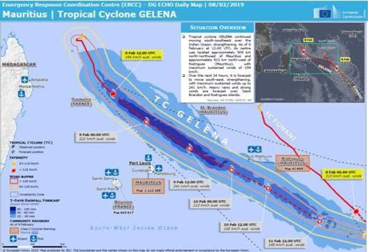
The cyclone destroyed 90 percent of the Rodrigues electricity grid and as a consequence the 40,000 inhabitants were left without electricity. Gelena forced the evacuation of more than 140 people to shelters. Most of the damage that occurred was due to fallen trees that led to blocked roads; there were also severed power cables, telephone lines and widespread flooding was reported. It is estimated that Gelena caused around $1 million in damages.

Disaster Risk Knowledge
According to the World Risk Report 2019, Mauritius is ranked 16th in terms of global disaster risk and 10th with respect to exposure to natural hazards. The National Disaster Risk Reduction and Management Centre (NDRRMC) established the main natural hazards to be:
- Tropical Cyclones
- Storm Surges
- Heavy Rains and Flash Floods
- Landslide
- Sea Level Rise and Coastal Inundation
The main hazards identified through ER2C with respect to climate change in coastal areas supplements this list with the inclusion of coastal erosion, as well as including marine (coastal) inundation (e.g. through storm swell and storm surge overtopping defences) and inland flooding.
Overall it appears that tropical cyclone (with storm surge and flooding) and flash floods are commonly referred to as the most important. However, this perspective is likely to vary among different groups. For example, fisheries rate hazardous sea conditions as a main cause of concern.
Disaster risk knowledge in Mauritius has strengthened in recent times. After a deadly flash flood on 30th March 2013 in Port Lois, the government of Mauritius claims to have taken more control of disaster risk management activities, reorganizing the entire system and promoting studies of risk assessment in many economic and social activities. Consequently, risks are considered known with respect to flooding, landslide and coastal inundation. An example of this improvement in knowledge includes a project to produce flood risk maps for 15 zones under the National Adaptation Plan and supported by the Green Climate Fund (GCF).
However, disaster risk knowledge is far from comprehensive and some gaps remain mainly on account of a lack of historical information. Also, the risk assessment processes referred to in this study are predominantly technical reports that appear to lack an integration of different perspectives – such as the varying risks, vulnerabilities and capacities of different groups such as women, the elderly, poor / marginalized, and tourists. This was also noted by the ER2C Study on Risk Perception Among the Population, as was the need for generating better risk projections in the future under the ER2C Gap Analysis.
Since 2016, the NDRRMC has developed activities to improve the level of knowledge and awareness of disaster risk across different sectors. For example:
- Mauritius: Disaster Risk Reduction - Workshop for the Implementation of the Sendai Framework - Port Louis, 4-6 May 2016.
- Training of Trainers for the Implementation of the Sendai Framework - Port Louis, June 2017
- The Business Case for Disaster Risk Reduction: Make Your Business Disaster and Climate Resilient - 2017
- Post Disaster Needs Assessment (PDNA) Training, National Disaster Risk Reduction and Management Centre (NDRRMC), 8 - 12 Oct 2018
- Workshop on Urban Risk Reduction and Making Cities Resilient: Towards the development and implementation of a local disaster risk reduction strategy
- UN Office for Disaster Risk Reduction, Office in Incheon for Northeast Asia and Global Education and Training Institute for Disaster Risk Reduction (UNDRR ONEA-GETI); National Disaster Risk Reduction and Management Centre (NDRRMC), Quatre Bornes, 2 - 4 Jul 2019
Risk information is consolidated in the National Emergency Operation Center which holds responsibility for response and recovery activities during a hazardous event according with different levels of significance as defined in the contingency plans.

Insights from the case study
The Mauritius cyclone season is from November 1st to May 15th. Tropical cyclones are referred to as constituting by far the most significant disasters in Mauritius. Although, on average, a direct impact of a tropical cyclone occurs only every 5 years, Mauritius experiences some of the effects (wind, rain, swells) almost annually. According to the Word Bank, with a population of 1.3 million and 70% of the population living in Metropolitan areas, a Severe Tropical Cyclone like Gelena can produce average direct losses of over $91 million USD and additional emergency costs over $21 million USD.
The level of concern about the possible impacts of cyclones (and other potentially devastating events) among citizens and vulnerable sectors of the economy is considered low. ER2C found this concern to be linked with a lack of understanding, information and unpredictability, coupled with a lack of a culture of safety where vulnerable groups would feel confident that they know what is to be done and the will and capacity exists to fulfil this in practice.

Critical analysis
In general, the interviewed sector users during this study considered the level of disaster risk knowledge in Mauritius to be good. However, more must be done with respect to hazard and risk mapping development and the inclusion of refined criteria on vulnerability, such as how vulnerability differs according to social status and gender.
After the deadly floods of 2013, there is an effective involvement of the government to increase the country’s capacity to cope with natural hazards and the effects of climate change. However, as tourism has become one of the main economic drivers of the country, there is an interest to portray a good image of safety. For this reason, institutions and some economic sectors are reluctant to provide information that could be understood as weaknesses of the system.
Although the future scenarios of climate change point to more intense cyclones, there is some concern about people’s awareness of cyclone risk. Mauritius has not been directly struck by a severe cyclone for the last several years, creating a false sense of security especially amongst the younger generation.

Detection, Monitoring, Analysis and Forecasting of the Hazards and Possible Consequences
The Mauritius Meteorological Service (MMS), is a well-organized center with existing monitoring tools. These comprise a network of about 30 weather stations, including AWS (6 in the metropolitan area of Port Louis) and 23 more rain gauge stations (see Figure 55). Monitoring facilities include a recently operational radar station in Trou Aux Cerfs in the highland area of the island. One of the main weaknesses is the lack of numerical weather prediction methods. La Reunion Center of Météo-France, as the RSMC, analyses and disseminates advisories pertaining to informations for tropical storms/ cyclones in the SWIO basin.
The MMS has a very well-organized system for forecasts and warnings. However, forecasting is generalized across island. Warnings are classified according to; Cyclones, Torrential Rains (Floods), Tsunami and High Waves. Cyclone warnings follow the below classification:
Class I: Issued 36 to 48 hours before Mauritius or Rodrigues is likely to be affected by gusts reaching 120 km/h.
Class II: Issued to allow, as far as practicable, 12 hours of daylight before the occurrence of gusts of 120 km/h.
Class III: Issued to allow, as far as practicable, 6 hours of daylight before the occurrence of gusts of 120 km/h.
Class IV: Issued when gusts of 120 km/h have been recorded in some places and are expected to continue.
Termination: Issued when there is no longer any risk of gusts exceeding 120 km/h.
Figure 55 Rainfall stations in Mauritius
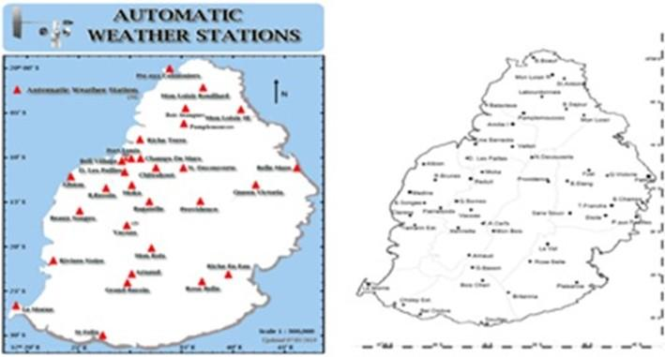

Insights from the case Study
Cyclone Gelena was detected by the La Reunion Tropical Cyclone Center prompting the Mauritius Meteorological Service (MMS) to release a cyclone warning. This indicated the possibility of a heavy swell with waves of 5-6 meters and advised the public to take preliminary precautions. Further localization of forecasting and warning is called for. For example, swell height is likely to be different in the north of the island to the south of the island, yet the forecast is uniform. This lack of localization impinges on fishermen’s decision-making abilities.
The highest gusts recorded in Rodrigues were on 10th February; 126 Km/h in Pointe Canon, and 120 Km/h in Montagne du Sable.

Critical Analysis
MMS would benefit to strengthen its own numerical prediction system.
The acquisition of a meteorological radar would allow the MMS with the potential for high capacity in detection and monitoring, but this capacity needs to be improved by the development and/or introduction of advanced analysis techniques to make it more efficient.
As a general characteristic, the regional cooperation and interchange among the IOC member countries could be strengthened. Sometimes countries act more as competitors than as partners. This issue needs to be overcome to maximise the benefits of regional integration.
Although the warning system is supported by a comprehensive set of protocols involving a wide range of institutions and is strictly controlled by the MMS and the government, there is still room for improvement; some sector users referred to the need to make the warnings more understandable, mostly to the public, and to improve institutional cooperation.
Mauritius is self-sufficient in vegetable production and its’ economy is strongly dependent on sugar cane. Therefore, there are pressing needs for improvements in weather forecasting, seasonal outlooks and climate change assessments for agricultural decision making. However, tailored meteorological services to agriculture, and other economic sectors, including with respect to warnings of pending hazards, is still weak and sometimes lacking access to quality information.
The cyclone warning classifications could be improved to be based only with respect to wind speed, storm surge height and likely damage. This would do away with a requirement to raise a warning to a Class III because of how much daylight there remains (currently a Class II is raised to a Class III when only 6 hours of light remains). Also, a colour coding system would help ensure warning classification is more broadly understood. This could be adopted across hazard types (e.g. flood).

Warning Dissemination and Communication
Mauritius benefits from comprehensive organizational and decision-making processes once a warning has been released. The MMS has the responsibility for providing alerts concerning cyclones, floods, heavy rains, high waves and tsunamis. Warnings are automatically sent to the National Disaster Risk Reduction and Management Centre (NDRRMC) who activate the National Emergency Operations Command (NEOC) according to the level of the emergency.
Level I: Monitoring of situation by NDRRMC staff
Level II: Monitoring by NRRMC staff assisted by representatives from main first responders (Police, MRFS + others depending upon situation)
Level III: Full scale activation with all designated NEOC Members
NEOC is comprised of the main economic, social and governmental institutions of the country with a representative of the MMS. They have the responsibility to take all the action required to cope with the emergency and control the protection and recovery actions. The government is very strict in these issues and sometimes people who do not obey NEOC measures can be punished with fines.
Communications are mainly based on SMS, phone and email. The participation of the Special Mobile Force, a paramilitary police force in NEOC, provides additional capacities of communications in case of needs. For the public, dissemination and communication take place via radio and TV. The institutional use of social media, such as Twitter and Facebook, is forbidden.
Figure 56 Mauritius National Emergency Operational Centre
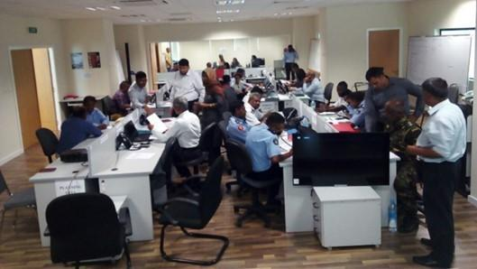

Insights from the case Study
La Reunion Centre at 06:00 UTC 6th February 2019 forecasted a rapid intensification and a movement South-eastward. The advisory, issued to alert of pending danger, stated:
“THE INHABITANTS OF RODRIGUES ISLAND ARE INVITED TO CLOSELY MONITOR THE EVOLUTION OF GELENA, A DIRECT IMPACT OF THE SYSTEM BEING POSSIBLE SATURDAY, ONLY TWO DAYS AFTER FUNANI.”
Therefore, a phase of warning dissemination and communication can be thought of as beginning on 6th February, four days before Cyclone Gelena struck Rodrigues. Interviews indicate a clear outworking of pre-determined protocol. Through this system, communities received timely warning and the public were kept informed of Gelena’s progress via public radio broadcast, newspapers and TV.
It should be noted that Rodrigues was already under cyclone warning of TC FUNANI from 05-07 Feb. It would have been confusing for the public to have two cyclone warnings at the same time. Once warning for FUNANI was waived a warning for GELENA was issued.
MMS follows the situation closely whenever a storm is threatening one of its islands.
A Class II was activated for Mauritius and Rodrigues on 8th February and a full activation of the NEOC for Rodrigues appears to have been carried out - leading to the evacuation of people and protective measures undertaken. Local accounts suggest that events on the ground were more serious than the official class of emergency. For example, people were evacuating their homes before the level of warning reached a corresponding level.
On February 8th the MMS generated its’ own warning for Mauritius and for Rodrigues every 6 hours. Seven advisories for Mauritius and fourteen for Rodrigues were released before the termination of the event on February 10th (see Figure 57).
Figure 57 Example of Cyclone Gelena MMS Warning Bulletin
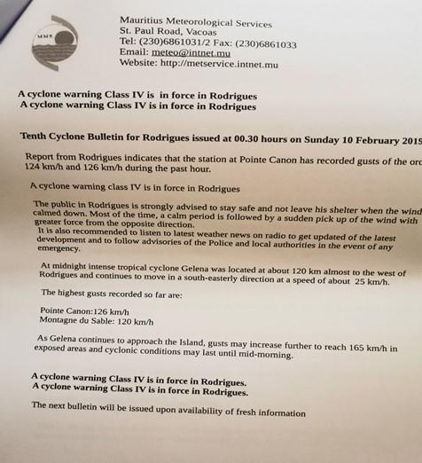

Critical analysis
Although the information obtained about the quality of the cyclone warning system can be considered as good to very good, several challenges exist.
For example, challenges exist with respect to using radio and TV as a means of warning dissemination. Dissemination of warnings this way relies upon power supply, which can be lacking or very intermittent during a cyclone emergency. As for other countries in the region affected by cyclones, power supply also plays a very significant role with respect to mobile phone connectivity. Additionally, mobile phone range is not sufficient for reaching fishing crafts at relatively large distances from shore.
The information provided by the key actors involved in generating and disseminating warning presents a picture of an almost perfect system. However, the opinion of some user communities in sectors such as fisheries and sugarcane, is different, arguing that improvements are needed in availability and understandability. For example, around 3,000 artisanal boats and 100 semi-industrial boats face difficulties accessing information when they fish from 1 mile up to 4 miles off the shore.
In 2017, according to the World Bank, about the 55% of the population had access to the internet and this percentage was growing rapidly. We can assume that this proportion is significantly higher in 2019, especially among young people.
There is not an institutional social media system in place. This is inconvenient not only because it wastes an additional dissemination tool, but because it opens this field to the uncontrolled dissemination of fake and unreliable information from non-official sources, misleading the people. Managing fake emergency warnings and impacts can be a very important but time-consuming activity for an emergency operations centre.

Preparedness and Response Capabilities
In 2015 the NDRRMC published a 311 pages report with the National Disasters Scheme which constitutes the general plan of action and measures for the nation. The document defines roles, responsibilities and actions before, during and after an emergency. It is classified according to hazard categories:
- Cyclone Emergency Scheme
- Heavy Rainfall/Torrential Rain/Flooding Emergency Scheme
- Landslide Emergency Scheme
- Tsunami Emergency Scheme
- High Waves Emergency Scheme
- Water Crisis Emergency Scheme
- Earthquake Emergency Scheme
- Port-Louis Flood Response Plan
Mauritius has conducted several initiatives to promote awareness. For example, since 2017 NDRRMC has conducted public awareness campaigns for events such as cyclones, tsunami and flooding. Additionally, meteorology is included in the primary and secondary school programs. The MMS has its own plans of capacity building and public education. For example, a function of the NDRRMC is to facilitate and coordinate regular training, drills and simulation exercises to test the adequacy of disaster response plans. These plans are likely to focus on the aspects of the Community Disaster Response Programme which covers basic community preparedness training in areas such as first aid, fire safety and water rescue.
Broadly speaking, public awareness of disaster risk seems to be high. TV and newspapers usually include material regarding climate or weather issues. However, as noted earlier, there is some concern about the risk awareness of young people who may be less aware of disaster risk.

Insights from the case Study
With a relatively low population and due to an adequate warning system from La Reunion Centre, preparedness actions were achievable and subsequently a rapid response was initiated from the government. The evacuation of 464 people from vulnerable metal houses occurred which appears prudent as nine such houses were destroyed. It was reported that there were only 4 injuries. Yet it is also clear that community centres, designated as evacuation shelters, may not be adequate. Understandably, local people find community shelters less favourable than finding refuge with friends and neighbours where such options are available and appear safe.
The government rapidly disbursed Rs 35 million for repair works to be carried out in Rodrigues. Teams from the Central Electricity Board and the Special Mobile Force were deployed on the island to repair the electricity grid and to undertake another emergency works. Indeed, electricity was restored throughout Rodrigues within a week. Additionally, on 15th February, the Prime Minister’s Relief Fund was opened for voluntary contributions from the public, intended to provide financial assistance to victims affected by cyclones and other calamities to repair damaged houses and improve related infrastructures. Furthermore, in May, Saudi Arabia donated USD 10 Million to support Mauritius “due to the cyclones that recently caused extensive damage and severe loss to the country.” The donation will fund projects in the shelter, health and food sectors to assist with rapid interventions to address the after-effects of the cyclone.

Critical Analysis
It is undeniable the great effort that the government of Mauritius has made in recent years to enhance its preparedness and response capability in the face of increasing exposure to natural hazards in a changing climate. However, while the main effort is devoted to the improvement of the technical capacity of the MMS with a stable system with clear protocols on what should be done in each emergency level, there are still gaps in how the final users of warning information could be effectively engaged in a system that takes into account their real needs and perspectives. There are also other concerns, such as the case of ‘whole of island impact’ from a large cyclone. In this situation, there would be a risk of major ramifications on account of break down in provision of shelter, food, fuel and telecommunications for the affected.
It is still a challenge for Mauritius to link its’ DRR policies to structural and non-structural measures to enhance the economic, social, health and cultural resilience of persons, communities and their assets, as well as the environment. Additionally, more is needed to empower women and persons with disabilities and other vulnerable groups to publicly lead and promote socially equitable and universally accessible response, recovery, rehabilitation and reconstruction approaches in order to fulfil Priority 3 and 4 of the Sendai Framework.
This study recognizes how the realignment of the NDRRM policy, strategic framework and action plan in accordance with the Sendai Framework provides a strong basis to ensure all aspects of DRR are fully addressed. For example, by emphasizing holistic ecosystem-based approaches to manage multiple disaster and climate risks on a sustainable basis.

3.3.4 SWOT analysis
Table 21 SWOT analysis of DRR in Mauritius
Stakeholders | Strengths | Weaknesses | Opportunities | Threats
NHMS | MMS has a strong institutional organisation.  MMS has monitoring, forecast and warning capability.  Good monitoring capability, adequate stations network and radar system.  MMS has a protocol to share information with the National Disaster Risk Reduction and Management Centre (NDRRMC) by email and fax.  Capacity building programs for the work force in place.  MMS has an independent status under a ministry. | Warning system not totally focused on users.  MMS does not have full working force coverage overnight and early in the morning.  Lack of localised data especially for rainfalls, which cause floods and flash floods.  Lack of hydrological monitoring to defi7ne and set up alert gauging stations location related to rainfall concentration time within the upper catchment, and flood propagation time (downstream)  Gaps in the acquisition of advanced analysis techniques for radar information.  Deficiency in producing climate-related risk projections for the future with actionable implications for development agendas.  Limited specialised staff of MMS. |  | Deficiencies in regional cooperation on EWS and DRR.  No full use of social media as a form of information dissemination in institutions.  Existence of non-official source of meteorological information.
DRR/EWS institutions | A Disaster Risk Management Act regulates the main activities in disaster risk management.  There is a Strategic Action Plan for the National Disaster Risk Management Policy in place.  Public awareness campaigns on cyclone, flooding and tsunami, including educational efforts developed on a regular basis in schools. | Some gaps in the knowledge base on hazards. Risk studies incomplete or lacking.  Lack of vulnerability and risk assessment of people and assets.  Lack of gender considerations in risk management. | A land drainage master plan is being developed by LDA. | The sharing of false information on emergencies via social media by the public.
Sector CS users | 10-day weather forecasts disseminated by MMS, as well as monthly and seasonal forecasts.  Data provided free of charge to government ministries.  MMS has a website and a mobile app to share basic climate information. | Meteorological services to agriculture and other economic sectors still weak.  Products need to be refined/diversified to respond to users’ needs.  No process to collect and use feedback from users. | Strong economic development of the tourism and other sectors create new needs in weather services.  Interest in ensuring all GCFS stakeholder groups are supported, plus tourism. | Lack of safety and sustainability culture results in tendency to under-estimate negative impacts of short-term development actions.  Tourism strategy to reach 2 million visitors by 2030 may result in more people and activities on the most vulnerable areas (with negative impacts on people security and environment preservation).
Last Mile/Gender aspects | Awareness raising campaigns implemented by LDA to keep drain systems unclogged and reduce flood risks.  Local population (villages) are aware of local risk, based on past experiences and show high solidarity in case of event before, during (to shelter others most vulnerable families) and after to help each over for recovery | Lack of local, timely, impact-based warning in particular for floods and flash floods. | Public awareness of disaster risk is high for cyclones. | Current weak perception of risk among youth.  Limited public trust in MMS forecasts.
Other | Risk education is promoted on a regular basis in schools. | Dissemination mechanisms of warnings highly vulnerable to power supply shortage. | Strong perception in government of the needs to strengthen country coping capacity on hazards.  High national and international perception on risk increase with climate change scenarios. | Highly vulnerable ecosystems.  High vulnerability to negative impacts of climate change.

3.4 Seychelles

3.4.1 Assessment of NHMS

Pillar 1: Observation and Monitoring
The Seychelles Meteorological Agency (SMA) meets the criteria required for Category 2. The small size of the country has partly helped in meeting the station density conditions. SMA still needs to improve the density of upper air stations.
Strengths: SMA meets all the conditions required for Category 2 NMHS. Most of the Seychelles stations are manned by trained observers. The Agency maintains electronic backup of data and backs up data at least every week. It has good stations density with at least one station every 20 km and uses CDT for quality control of station observations. A good number of stations that are Class III and above are inspected every year. SMA has performed basic station needs assessment and has strategic plans for station expansion.
Weaknesses: The main weakness is that MMS does not back up climate data often enough. SMA has no doppler radar for the main island.

Pillar 2: Modelling and Predictions
The main reason why SMA does not meet the requirements for a Category 1 NMHS in the Research and Predictions pillar is that the NMHS is not involved in any research projects and experiments in which the staff participate except for the BRIO project since June 2019.
The NMHS could fully meet Category 1 and 2 requirements by developing human resources (through academic and technical training), increasing participation in research, and improving technological capacity. The NMHS could meet the criteria for Category 3 by investing much more in improvements along the same lines (as above) as well as greatly expanding the range of climate products that it produces.
Strengths: SMA provides weather forecasts for up to 10 days and seasonal rainfall outlooks. Staff produce and disseminate a ten-day weather forecast, as well as monthly and seasonal forecast with an assessment of uncertainties associated with the seasonal forecast. They have enough access to the internet.
Weaknesses: Seasonal outlooks do not include temperature. The NMHS lacks adequate staffing capacity in terms of higher academic qualifications and a range of specializations. Staff participation in research is not enough for Category 2, and the range of climate information products is limited.

Pillar 3: Climate Services Information System
SMA partially fulfils the criteria for a Category 2 NMHS for the Climate Services Information System pillar. The NMHS should improve the range of climate information products that it produces, the frequency with which it produces seasonal forecasts, and the availability of products on its website to fully meet the criteria for Category 3.
Strengths: At a governance level, SMA has clear policy guidelines on the provision of Climate Information Services and provides data free of charge to government ministries and education institutions. Staff produce basic climate statistics for major climate variables and seasonal forecasts for rainfall. SMA has a website with basic climate information. The NMHS produces advanced climate products in various formats and contributes to national early warning systems through early warning information and advisories.
Weaknesses: The NMHS should expand the range of basic products and improve access to software needed to produce them. The NMHS does not responds to all user needs and must produce and/or refine products in response to user feedback in the next years. The NMHS does not perform homogenization of climate data

Pillar 4: User Interface Platform
SMA partially fulfils the criteria for a Category 3 NMHS for the User Interface Platform pillar. There are however aspects within each category that are not fully met. For example, no staff members of the NMHS are trained in climate services/user engagement. The NMHS should expand its interaction with the sectors, enhance its procedures for gathering feedback from users about information products and services, and improve the website to provide access to national observations and forecast information for any national interactive media outlet in order to meet Category 3 criteria.
Strengths: SMA has in place a set of strategic plans and procedures, ensuring users of weather forecasts and climate information are engaged. Users have been engaged in the past two years. SMA has signed MOUs with some sectors and has procedures in place to co-produce climate information with multiple sectors. The NMHS has a website that provides updated climate information.
Weaknesses: No staff are trained to engage with users and provide Climate Information Services. Procedures for collecting feedback could be improved and website could be strengthened. Access to national observations and forecast information, via website and API, for use by national interactive media outlets is not provided

Pillar 5: Capacity Development
SMA partially fulfils criteria for a Category 2 NMHS for the Capacity Development pillar. To be categorized as a Category 2 NMHS, SMA would need to strengthen governance, improve the qualifications of the staff in specialized areas, and strengthen its training program. It should invest in technological capacity, including software, and higher speed internet. The NMHS would need further improvements along the same lines, also including high performance computing, in order to satisfy criteria for a Category 3 NMHS.
Strengths: SMA has a formalized governance structure with a status of an independent body under a ministry. An adequate number of senior meteorological technicians have MSc or PhD degrees. Staff have basic training in most essential services. The NMHS has staff who are educated in management. Most staff have access to basic computing resources and 1 Mbps internet capacity.
Weaknesses: The NMHS’s participation in national climate related policies and plans is limited. The training program has weaknesses. Access to software should be improved.

3.4.2 Assessment of existing climate services users and platforms
Referring to the priority sectors identified by WMO, to provide climate services to end users, the present situation for Seychelles is detailed in the following part:

Water resource management for potable water, domestic uses
Water supply in Seychelles is primarily from river sources, combined with groundwater extraction and desalination plants in some locations. Whilst river water is abundant the steep topography and low retention of the soil and rock, the flow in these streams is erratic and falls to very low values during prolonged periods of drought. Groundwater extractions have not been successful in view of the narrow coastal plateau. Desalination plants have been installed to meet shortfall in demand during the dry season. Water distribution on the three main islands is extensive, serving more than 87% of the population with treated water supply. Despite these efforts, the Seychelles will face serious water shortages in the near future primarily due to a lack of adequate resources to invest in appropriate reservoirs and growing demand mainly related to raise in tourism
Despite those risks, there is no tool in place to identify user needs and respond with relevant hydrological data, products and services.

Agriculture and fisheries for food security
The National Food Security Strategy 2008-2011 was formulated in 2008 in response to the food crisis of 2007-2008 that occurred in the Seychelles. A review of this document was initiated in October 2010 and the revised Food Security Strategy covers the period 2012-2015. The Seychelles recognizes that food security is a pre-requisite for national socio-economic stability and growth and also highlights priority investment areas in the agricultural sub-sectors of crop and livestock development. It is also recognized that food imports will continue to provide a substantial portion of foods consumed locally and hence, should not be ignored as a major component in national food and nutrition security until the local agricultural sector develops to reduce the need for some imported foods and that fish provides a substantial portion of the protein component of the Seychellois diet.
Agriculture is less than 3% of the Seychelles GDP, but because of global food crisis, the issue of national food security has taken the highest priority in Seychelles. Risk of disease introduction of pandemic proportions is a serious threat, especially when it is linked to climate factors. Rainfall has caused significant agricultural losses to crops in the last few years (Payet, 2005). Indeed, livelihood systems in small islands are already vulnerable to climate change, especially in terms of crop failure and loss of livestock due to either extended droughts or persistent floods. Furthermore, on average many small island states import more than 30% of their cereal consumption needs, and in many cases more than 50% of total food supply is imported.
Yet, there are no specific climate services dedicated to agriculture.
There are 3 types of fisheries:
- industrial fisheries activity is implemented by international seiners (Thai Union): they develop their own information system to get weather forecast and other services (localisation of tuna fish schools)
- semi-industrial: 44 vessels to 12m60 to 20m are fishing tunas with long lines: SFA is producing data from remote system trying to disseminate information to the vessels. Because of the large economic exclusion zone, vessels are going very far away. They have satellite on board to get informed on sea surface temperature and weather (wind and waves direction and intensity). Sea cucumber diving is also a very important activity that is highly regulated, and divers have compulsory insurance because it is very deep and dangerous.
- Artisanal fisheries: about 100 native fishermen (no foreigners) are doing trap fisheries (coastal fishes, mangroves). Concerning local artisanal fishing, rainwater affects local fishing, with massive inflows of fresh water during heavy rains, and sediment, which can affect artisanal fisheries and aquaculture. There is also a strong difference in temperature between fresh water which is cold and warm sea. And since 2 years they experience also algal bloom.
Fisheries are extremely sensitive to climate variability and change. In Seychelles, the fisheries sector constitutes the second major pillar of the economy and contributes significantly to food security. The sector is dominated, economically, by the industrial purse-seine tuna fishery and production of canned tuna; the artisanal fisheries sub-sector plays a vital role for food security and employment. Severe degradation of coral reef habitat occurred in the wake of the 1998 coral bleaching event.
Loss of structural complexity and slow recovery at some sites has affected reef fish biomass, suggesting possible lag effects on reef fisheries. However, coral reef fisheries are of relatively minor importance in value and volume compared to the demersal line fishery based on the extensive banks of Seychelles, for which the effects of climate change are less immediate.
Regarding climate services to the fisheries, the met services deliver marine forecast to fishermen on harbour, but they do not have relevant equipment to warn fishermen on sea.

Health
Major tropical diseases such as malaria, leishmaniasis, yellow fever, sleeping sickness and bilharziasis are as yet non-existent in the Seychelles.

Disaster risk reduction
Contingency plans for each type of risk and disaster are coordinated at district level, with a high involvement of local communities (NGOs, population). The main problem is that although flood is one of the main and frequent risk for the population, there is no rivers hydrology monitoring available for settling relevant alert system with high water thresholds referring to water catchment hydraulic behaviour (together with rain fall continuous monitoring on the water catchment).

3.4.3 Assessment of EWS, End-users and Case Studies

Case Study – Flash Flood 28th May 2019
On 28th May 2019, heavy rains accompanied by a thunderstorm developed into the Intertropical Convergence Zone and were experienced over the main island of Seychelles in southeast Mahé. The storm triggered flash floods and unleashed strong winds. Whilst the event caused localized flooding, disruption to traffic and resulted in some damage, it was not especially severe and is not presented as an example of a major storm. Rather, the event is used to demonstrate the operation of the heavy rain warning service.
The heavy downpour and greater impacts especially occurred in Anse Royale district. This was the most affected area where 173.6mm of rain fell in only a few hours (Figure 58) which is above the long-term average of 145mm for the whole month of May.
Figure 58 Weather chart 28th May 2019, 10:00LT
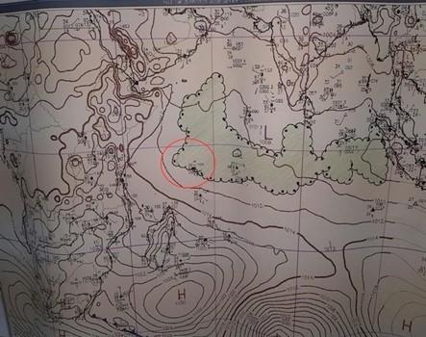
Figure 59 Daily rainfall May 2019 against long term mean (yellow line)
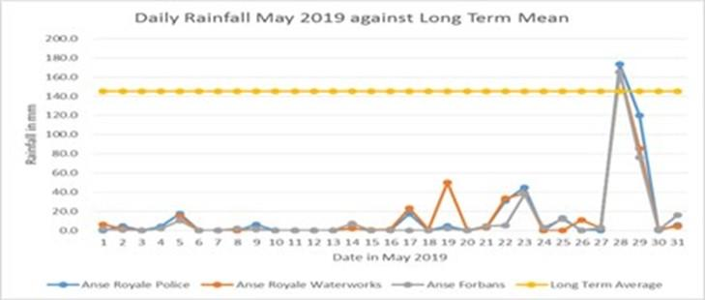
International models suggested flooding could occur, but uncertainty by forecasters meant that no warning was issued until flood reports were received.

Disaster Risk Knowledge
Due to its geographical location and geology, the Seychelles is less exposed to major natural hazards than most of the neighbouring countries, such as Mauritius, La Réunion, Comoros, Madagascar or even the countries of the African continent. Nevertheless, Seychelles has experienced several major events in recent decades in relation to the main natural hazards the country is exposed to; floods (flash floods), landslide, tsunami, damaging winds and tropical cyclones. For example, heavy rains 27th and 28th January 2013 resulting from tropical cyclone Felleng caused severe flooding and landslides, particularly in three districts on the southeast coast of Mahé.
However, tropical cyclones reaching the Seychelles are rare, mainly due to the country’s proximity to the Equator. Intense tropical cyclones Bondo in 2006 and Fallan in 2019 are examples of a direct impact, but these only significantly affected the Farquhar islands in the far south of Seychelles. Tsunami impacts are also rare. The Indian Ocean Tsunami of December 2004 resulted in two deaths in Seychelles and damage to property and coastal infrastructure. Highest flood levels recorded were over 4.4m above mean sea level.
Flash floods affecting the coastal lowlands and plains of the granitic islands are considered the most significant hazard for their frequency, although a systematic lack of records and studies about impacts undermines knowledge on relative significance. Of concern too is the risk of landslide, rockfall and treefall also stemming from heavy rainfall events. According to UNDP, of the 89 significant events from 1862, heavy rainfall and floods are by far the more frequent hazards.
Figure 60 Landslide on steep slope of Mahé island
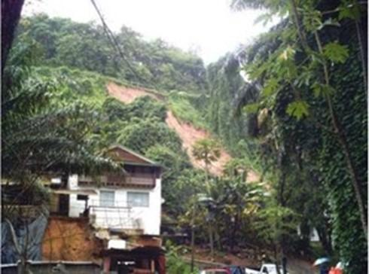
Source: Department of Risk and Disaster Management
Figure 61 Distribution of landslide events on Mahé
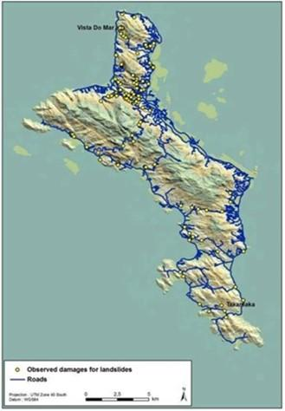
Source: Department of Risk and Disaster Management
Seychelles has a very low mortality rate due to natural disasters. Partially, this is linked with the relative lack of occurrence of significant hazard events and may also be due to low levels of exposure of the population. Many islands are sparsely populated and some nearly unoccupied. For the same reason, historical records about disaster impacts are scarce and incomplete.
Concerns about natural disaster and climate-related risks are mainly linked to economic activities, but knowledge about them is incomplete and requires improvement. For example, in the tourist sector on Praslin island, some areas are suffering coastal erosion. Consequently, some owners of beach facilities have built sea walls as protective measures. Yet there is a lack of comprehensive study and understanding about the changing coastal processes, usually attributed to sea level rise but likely also linked with the health of marine ecosystems, and the implications of these on beach erosion and how man-made structures interfere with these processes and may undermine coastal resilience.
There have been efforts to strength disaster risk knowledge through studies in partnership with international institutions. For example, in 2008 UNDP developed a comprehensive study on risk assessment in the Seychelles and the World Bank and the European Union supported a government report about the major flash flood of 27th January 2013.

Insights from the case Study
Floods in Seychelles generally occur from December to March, during the NW monsoon which delivers 60% to 70% of the total yearly rainfall. Peak occurrence is in January and February, but events can occur throughout the year, as evidenced by the intense rainfall and flooding in May 2019.
Social awareness of flash flood as a risk exists, but this does not significantly influence behaviour, especially with respect to land use. For example, a lack of buildable land has led to construction on steep slopes, in the absence of flood and landslide risk analysis. Not only does a lack of risk knowledge encourage unsafe building, but it also leads to a lack of integration of disaster risk mitigation measures within such environments, such as protection of natural areas for water absorption, storage and soil stabilisation, adequate storm drainage, and maintenance of culverts to avoid the accumulation of debris. It is plausible that such deficiencies aggravated the scale of flooding in May 2019.

Critical analysis
Despite examples of loss and damage through disaster occurrences in recent years, and concerns over the effects of climate change on extreme events, there is a limitation on risk assessments and mapping that would guide climate and disaster resilience decision making.
The prioritization of climate and disaster resilience is low, as efforts targeted at reducing impact from disaster events is not perceived as a pressing threat to short-term economic gains, such as for coastal tourism. This needs to be remedied by better linking risk awareness and remedial actions with these economic needs and agendas. Ensuring that ecosystem-based resilience measures are elevated in importance as crucial to sustainable coastal development is needed.

Detection, Monitoring, Analysis and Forecasting of the Hazards and Possible Consequences
The Seychelles Meteorological Authority (SMA) is currently under the direction of the Ministry of Environment, Energy and Climate Change. It operates one meteorological station, located at the Mahé airport, and a network of rain gauges over the islands. SMA does not have the capability to run its’ own forecast models, but duty forecasters have access to six international models (i.e. European Centre for Medium-Range Weather Forecasts (ECMWF), Action de Recherche Petite Echelle Grande Echelle (ARPEGE), National Centers for Environmental Prediction (NCEP) for the Indian Ocean, Global Forecast System (GFS) Medium Range Forecast, NCEP precipitation probability from Regional Specialized Meteorological Centre (RSMC) Pretoria, National Oceanic and Atmospheric Administration (NOAA) – precipitation estimate).
Monitoring, forecast and warning capacity are based in the use of the workstation system and software developed by Météo-France called “SYNERGIE” that offers a wide range of possibilities: displaying all the available meteorological information with the possibility of overlaying objective analyses. SMA does not have meteorological radar and does not develop its own forecast models.
SMA issues warnings for different weather hazards (heavy rains, strong winds, swells), whereas tropical cyclones warning are fully dependent of La Reunion Regional Centre.

Insights from the case study
Interpretation and comparison of the international models mentioned above were made on 27th May 2019. Most of them indicated convergence in the proximity and increase in the precipitation over the next 24 to 48hrs period. But duty forecasters were not confident enough at that time to issue a warning. Mainly this was because similar weather patterns were forecasted previously, and no major event was observed.
However, during the morning of 28th May, active clouds started to appear on the satellite images, and this was later superimposed on the 10:00LT MSLP chart (Figure 62). Yet, even with the support of satellite images, it was still difficult to decide whether a warning was necessary.
It was not until the SMA started to receive information of cases of flooding, particularly from Anse Royale district, that it was decided to release a warning. Therefore, strictly speaking there was not an early warning of the flash flood of the 28th May 2019.
Figure 62 24-hour rainfall analysis
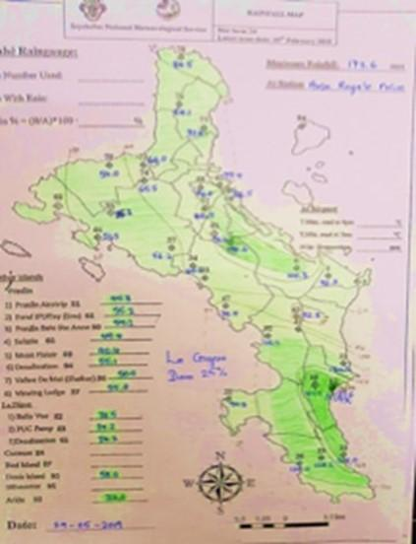

Critical Analysis
The SMA suffers important technological gaps in detection, monitoring, analysis and forecasting of hazards that prevent an effective warning service. Timely impact-based forecasting and warning for specific parts of the country and their respective communities is needed.
The observational network is insufficient. Investments are needed in the creation of a new meteorological station, but also in the modernization of the current rain gauge stations. A radar system would benefit the Seychelles as the country does not have an effective radar coverage.
The heavy rain warning service in the Seychelles is undermined by these gaps in capacity together with a limitation in the sophistication of display software and warning preparation.
Most of the personnel are not native to the islands, and so their engagement is short-term before they return to their home countries and other meteorological services. Very crucially, there exists a strong need for training and capacity building of staff coupled with active policies to maintain a stable work force.

Warning Dissemination and Communication
Early warning is shared with the media and the Department of Risk and Disaster Management (DRDM) by email and fax. In addition, a telephone call is always given to the Principal Secretary in charge of DRDM to notify that the warning is being issued. The DRDM then has responsibility to activate the protocols across the 26 districts of Seychelles (Figure 63) via text message (SMS) (Figure 64). DRDM generates a “Bulletin” with all the available information. This is disseminated to the district administrator (DA) within the local level government branch offices via SMS. The DA has responsibility for governance at district level, and acts as the focal point for managing and coordinating emergency response operations.
Figure 63 Administrative Districts in Seychelles
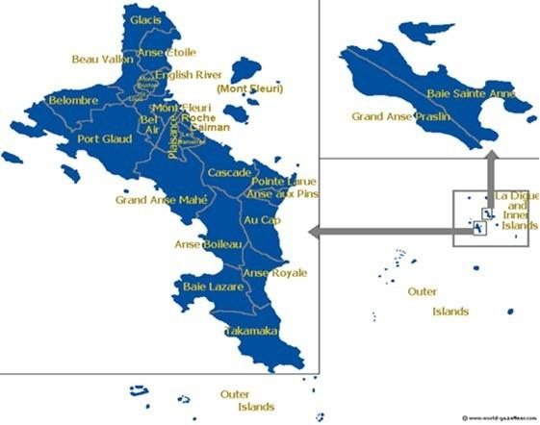
Figure 64 Example of a warning SMS received by District Administrators
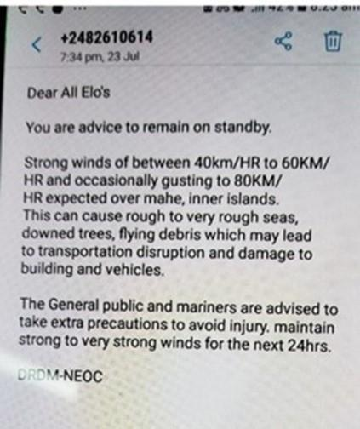
The action taken at district level is crucial to the success of the warning system. One of the key responsibilities of the DA is to ensure the alert bulletin is properly disseminated and activates office staff, the emergency brigade, businesses and the public. The different levels of warnings issued, implications and actions to be followed are summarized in Table 22.
Table 22 Warning levels and actions for Districts
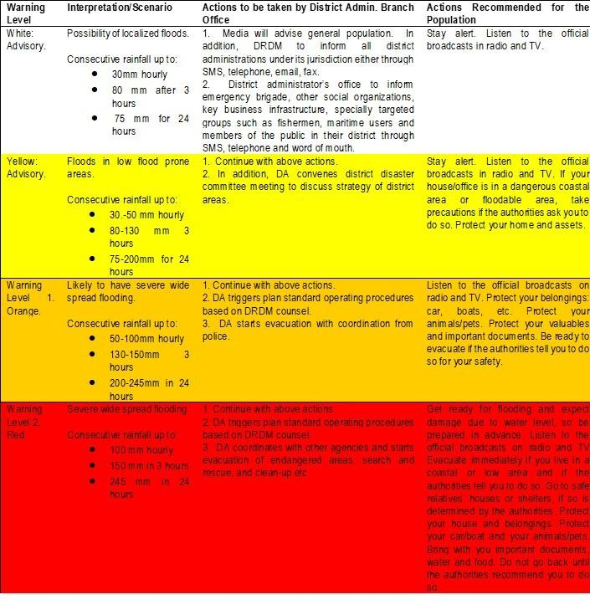

Insights from the case study
Although the established protocol was followed, and a warning was sent at 1435LT (1035UTC) on 28th May 2019 to the DRDM and the media, the SMA failed to release an early warning; this factor made the dissemination and communication system totally inefficient. DRDM and the districts had to manage the event in a reactive way. Fortunately, it was a short event lasting less than an hour.
Figure 65 Warning released by the SMA at 14:35LT on 28th May
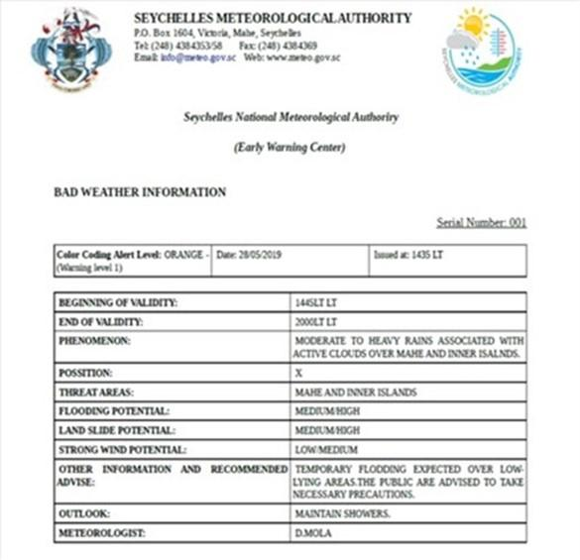

Critical Analysis
Dissemination of warnings relies upon power supply, which can be lacking or very intermittent during a rapid onset emergency, such as a cyclone, flood or earthquake, in affected areas. The use of SMS in cellular phones and emails could be very susceptible to disruption due to loss of power or connectivity.
It is not known the extent with which warnings are considered as comprehensive and useful amongst different target user groups. For instance, is the tabular information useful, is the layout and content of SMS based warning messages salient? Moreover, there are important gaps in the dissemination of the information in some important sectors such as the fisheries. For example, there is no way to ensure information reaches small boat fishermen, so they tend to rely more on their personal experience than in the SMA warning.
Overall, there appears some lack of confidence in the capacity of the SMA to provide timely and reliable products and services suited to warn of an emergency.

Preparedness and Response Capabilities
The Disaster Risk Management Act (2014) regulates the main activities in disaster risk management. The Act established the creation of a National Disaster Risk Management Fund for recovery efforts and the adoption and promotion of preventative measures. A Strategic Action Plan was developed from the National Disaster Risk Management Policy and published in the Official Gazette and approved by all stakeholders during a workshop held on 13th November 2014.
More recently, in 2018, the Seychelles District Flooding Disaster Response Plan designated a line management structure for managing and implementing disaster preparation. It defined seven regional platforms (North, South, East, West, Central 1, Central 2, and Inner Island Praslin/La Digue platforms). The roles of the platforms are to manage and organize district disaster preparedness activities. The regional platforms act as the focal points for coordination of disaster preparedness between local districts and national government. Each platform is headed by a coordinator, usually a Councillor from each Region responsible for the Environment and Emergency Committee members representing the following organisations:
  - Department of Community Development
  - Police Department
  - Ministry of Health
  - Fire Service Department
  - Land Transport Division
  - Red Cross Society of Seychelles
  - Department of Environment
DRDM works closely with public and private schools across the country to better prepare them to respond to disasters. Through this activity, respective disaster and risk emergency management teams of each school are brought together so that they can discuss and share ideas with one another. A one-day workshop was organised in May 2017 by the division in collaboration with the Ministry of Education to introduce “Schools Emergency Preparedness and Management”. However, these activities seem not to be held on a regular basis. In addition, according to the organizational structure, DRDM has a department of “Training Development Education and Public Education” that, for example, develops web-based initiatives and links with local radio.

Insights from the case study
Although this study was not provided with access to specific data on damage due to the May 2019 floods, it appears impacts were limited to the flooding of fields, disruption of traffic and some damage to infrastructure.
Figure 66 Example of damaging impacts caused by the 28th May Flash Flood
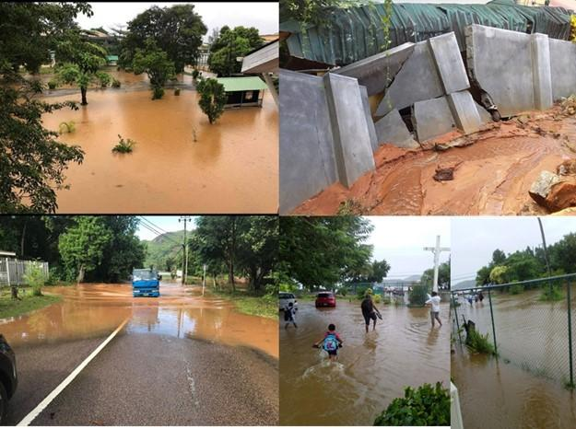

Critical Analysis
The flash flood event 28th May in Mahé was underestimated by the SMA, leading to failures in the dissemination and communication of a warning early enough to enable the disaster risk management system the chance to prepare accordingly. This kind of situation, where the time to warn of a potentially hazardous flood event is extremely short, is relatively frequent in Seychelles. Aside from tropical cyclones, the mesoscale convective systems embedded into the Intertropical Convergence Zone (ITCZ) could develop strong convection and heavy rains in a very short time. Future contingency plans must better consider these kinds of events. Beyond the acquisition of a radar or other monitoring facilities, it is evident that staff expertise to interpret and initiate a timely warning communication system is needed. Under such an improved system, user communities such as the fisheries sector could be better able to monitor the impacts of flooding on pollution levels entering the sea, as well as ensuring the safety of fishermen.
A National Contingency Plan to coordinate preparedness and response capabilities of different sectors is still to be completed. As well as the key economic sectors, such as tourism and fisheries, there are also calls for strengthening agricultural climate risk management services, such as through weather-index based insurance products. While national plans for floods benefit from a well-structured system, other hazards remain less well defined. There is a need for better integration of the hazard concerns and knowledge into the development plans, providing a balance between environmental, social and economic considerations. A better strategic planning for education and awareness in risk reduction matters is a must. This is also important in light of the likelihood of the spread of false information through social media in the event of an emergency.
The current capacity of different sectors to ensure that information reaches all users and leads to preparedness and response actions is still limited not only by technological weakness but also seemingly by coordination amongst stakeholders. The need for government strengthening of preparedness and response capabilities extends to the local district level.

3.4.4 SWOT analysis
Table 23 SWOT analysis of DRR in Seychelles
Stakeholders | Strengths | Weaknesses | Opportunities | Threats
NHMS | SMA is recognized by the government as the only source of meteorological forecast and warning in the country.  SMA has monitoring, forecast and warning capacity, based on the use of a workstation system and software developed by Météo-France.  SMA develops its duties over a continual 24/7 basis.  SMA has its own system of broadcasting forecasts and warnings to the media. | Gaps in monitoring capacity, inadequate stations network; especially no monitoring of hydrology data.  Lack of radar observation in place.  Instability in the hydro-meteorological work force.  Gaps in hydro-meteorological services work force expertise.  Climate data should be backed up more often. |  | Deficiencies in regional cooperation on early warning and disaster risk reduction
DRR/EWS institutions | SMA has a protocol to share information with the Department of Risk and Disaster Management (DRDM) by email and fax.  A Disaster Risk Management Act regulates the main activities in disaster risk management.  Strong engagement of the government regarding safety for residents and tourists.  There is a Strategic Action Plan for the National Disaster Risk Management Policy in place.  There is a management plan for district disaster preparedness activities in place.  Alert systems are in place for main risks. | Gaps in hazards knowledge base. Risk studies are incomplete, lacking or in need of updating.  Risk management not fully included in regulations on urban development policies.  Deficiencies in local government disaster risk management and response capacity, including with respect to EWS.  Lack of gender considerations in risk management.  Educational efforts are not developed on a regular basis nor in a multi-sectoral way. | The CMP enhances a ridge to reef approach for water catchment monitoring and management.  A new climate change policy is being developed and support could be provided to update the climate change adaptation strategy once the policy is finalised.  The implementation of the Seychelles development strategy could be supported to better integrate sectors (agriculture) and mainstream adaptation and disaster risk reduction measures. | The sharing of false information on emergencies via social media by the general public.
Sector CS users | SMA provides 10-day forecasts and seasonal rainfall outlooks.  Climate data are provided free of charge to government ministries.  Climate information is co-produced with users in various sectors.  Real engagement from fishery sector (SFA) with capacity to collaborate for monitoring on sea. | Climate products need to be more diversified and refine to respond to users’ needs.  User feedback not collected to improve CS.  Lack of information on water catchment from ridge to reef necessary for all the users, including SFA for aquaculture and outlet coming into the sea/lagoon. | Development of the tourism and fisheries industry creates new needs in weather services. | Perception of low confidence in early warning among population.
Last Mile/Gender aspects |  | EW system not totally focused on users, difficult to understand.  Lack of local, timely, impact-based warning.  Lack of sustained engagement with community-based organisations (CBOs) and other important local stakeholders.
Other | Environmental policy mainstreams ecological functions of environment, risk and disaster reduction, and nature-based solutions for adaptation. | Dissemination mechanisms of warnings vulnerable to power supply disruption.  Pressures on water resources increase with tourism. | Strong perception of the needs to strengthen country coping capacity on hazards.  Relations between Seychelles and EU on environmental issues have intensified.  High national and international perceptions on risk increase with climate change scenarios.  Environmental protection is considered a cultural value. | High vulnerability to negative impacts of climate change scenarios.  Highly vulnerable ecosystems.

Chapter 4 Recommendations
The recommendations provided in this section are based on the various analysis conducted under chapter 3. Recommendations have been formulated to address gaps in the production and dissemination of timely, efficient climate services that respond to ‘end-users’ needs, in Comoros, Madagascar, Mauritius and Seychelles. These gaps have been underlined in the SWOT analysis, conducted after each case study. These recommendations will be presented as actionable interventions in the next chapter. It should be noted that some of the recommendations, though application at national scale, are applying to all four countries. Moreover, the study identifies several initiatives at IOC level, which could be strengthened or scaled up to foster climate services in the region. These opportunities include:
- establishing an RCC and RFCS, following WMO recommendations;
- strengthening the existing SWIOCOF;
- fostering the regional UIP; and
- building on past/ongoing regional projects, for example: BRIO.
Details on these recommendations are provided below.

4.1 Recommendations to improve institutional capacities and NFCS for NMHS

4.1.1 All countries
There is no climate services framework in Comoros and Seychelles, while in Madagascar and Mauritius these are draft and not yet implemented. It is therefore recommended to strengthen or develop country-specific National CS frameworks (NCSF) in each target country, in line with the regional CS framework. Of importance is to ensure these frameworks emphasise a comprehensive approach to the management of climate and disaster risk covering mitigation, preparedness, response and recovery (overcoming a dominant paradigm which focuses on preparedness and response capability).
All economic sectors are vulnerable to climate hazards and climate change in the four target countries, as demonstrated in section 2.2. Some sectors are particularly vulnerable due to their significant role in the countries’ economy and reliance of the population. It is therefore recommended to undertake a scoping exercise to determine opportunities and entry points for building climate and disaster resilience within 2 main sectors per country (as identified in the financial analysis, see Annexes and in accordance with GFCS). Based on the result of the scoping analysis, it is recommended that the project provides support towards the development of integrated risk management plans for these sectors and critically also for land use planning and building permits (especially with respect to urbanisation), coastal zone management and Integrated Water Resource Management (IWRM) (all fully encompassing environmental conservation with respect to climate and disaster risk), plus energy supply continuity. This will only be a start, as efforts will be needed on a continuous basis across all sectors to expand and improve risk management across all sectors and taking account of changing conditions.
Improve institutional arrangements of the met services to maintain a stable work force in view of high turnover (i.e. there is a shortage of native skilled human resources in fields related to environmental management in Seychelles). This also includes the need to improve financial efficiency and identify additional sources of funding for the met services to retain staff and to maintain/update their equipment necessary to the production of high-quality climate data.
Collect feedback on dissemination and communication services amongst user groups and develop processes and options to continuously strengthen the system to be user-friendly, so that services provided inform decision-making and render beneficial outcomes.

4.1.2 Comoros
Establish coordination and collaboration between sector users and the meteorological and hydrological services providers to improve understanding of users’ needs among the NHMS, enhance data quality and strengthen services to meet sector needs (e.g. through NCOF).
Specifically, the following actions must be undertaken to strengthen ANACM:
- ANACM should attempt to participate in more research projects with in-country or international research institutions;
- The NMHS should build research capacity by recruiting more staff with PhDs and providing them with resources needed, such as online access to literature;
- Establish a formalized, written governance structure;
- Expand participation in national policy processes;
- Recruit more staff with MSc and PhD degrees;
- Establish a protocol for training required of different staff members;
- Train staff in data rescue;
- Recruit more highly qualified management staff with adequate profiles to contribute to the production of climate services.
- Strengthened IT resources and systems, as well as set up electronic data base with regular backup.
- Establish a protocol for training required of different staff members, including further staff training, staff qualifications

4.1.3 Madagascar
The establishment of the National Hydro-Meteorological Services Users Group (NHMSUG) requires an inclusive participatory process to ensure its’ ownership by the sector users and hydro-meteorological services providers. This process is going to take time and needs upstream work for capacity building of sector users. This was recommended for inclusion as one of the key activities of the National Action Plan for the Improvement of Hydro-meteorological Services (NAPIHMS) with a proper timeline and budget. This platform could be the basis for establishing and running co-production of forecast and warning services workshops to ensure that services are developed as fit-for-purpose and lead to action.
Climate-sensitive sectors should be informed of all climate-related risks and consulted to ensure the production of climate services and alerts that respond to their needs. At the moment, only some sectors – e.g. health and agriculture – are consulted through the NCOF. Hence it is recommended to invite all climate-sensitive sectors, including for example the fisheries sector (national and regional units) as well as relevant representatives of local fishermen, to the NCOF to disseminate information, train on how to interpret weather forecast and alerts and to collect feedback on climate services and early warnings.
Specifically, the following actions must be undertaken to strengthen DGM:
- Establish a formalized, written governance structure;
- Expand participation in national policy processes;
- Recruit more staff with MSc and PhD degrees;
- DGM should attempt to participate in more research projects with in-country or international research institutions;
- The NMHS should build research capacity by recruiting more staff with PhDs and providing them with resources needed, such as online access to literature;
- Train staff in data rescue;
- Recruit more highly qualified management staff.
- Strengthened IT resources, systems and set up a data base with regular backups.
- Establish a protocol for training required of different staff members, including further staff training, staff qualifications

4.1.4 Mauritius
Specifically, the following actions must be undertaken to strengthen MMS:
- Participate in at least two research programs;
- Improve the capacity of staff to participate in research projects;
- Recruit more staff with PhD degrees, develop staff through studies towards higher degrees such as a PhD and training in a range of specializations, such as seasonal prediction, Agrometeorology, hydro-meteorology, etc.;
- Expand participation in national climate related policies and plans;
- Strengthen the training program, especially to include training for entry-level meteorological technicians;
- Expand the range of specializations represented among the staff, including climate, seasonal prediction, Agromet, Hydromet, and NWP;
- Strengthen the training program to include training for mid-level meteorological technicians.

4.1.5 Seychelles
Specifically, the following actions must be undertaken to strengthen SMA:
- Expand participation in national climate related policies and plans;
- Strengthen the training program, especially to include training for entry-level meteorological technicians;
- Improve access to software for computation and display of basic climate statistics.
- Expand the range of specializations represented among the staff, including climate, seasonal prediction, Agromet, Hydromet, and NWP;
- Strengthen the training program to include training for mid-level meteorological technicians;
- Strengthen formal partnership and data sharing policies with end users.

4.2 Recommendations to modernise NMHS equipment and skills
Following the assessment done and described in chapter 1, the recommendations are the following:

4.2.1 Comoros

Strengthen observational network:
- Add at least one upper air observation station;
- Set-up a doppler radar for Grande Comore;
- Set-up marine observing systems (buoy, wave radars and tide gauges)
- Strengthen station inspection;
- Back up climate data at least every month;
- Conduct data rescue;
- Increase the number of surface stations;
- Backup of data climate data at least every week;
- Use advanced quality control tools;
- Perform basic station needs assessments.

Strengthen information system:
- Incorporate remote sensing data to enhance station observation, through doppler radar and satellite data acquisition;
- Improve access to software tools for weather and climate forecasting, including statistical and dynamical downscaling;
- Provide seasonal temperature outlooks;
- Improve access to software for computation and display of basic climate statistics.
- Perform homogenization of climate data;
- Upgrade telecommunications systems.

4.2.2 Madagascar

Strengthen observational network:
- Add at least one upper air observation station;
- Set-up a doppler radar for the area of Antananarivo;
- Strengthen station inspection;
- Back up climate data at least every month;
- Conduct data rescue.
- Increase the number of surface stations;
- Backup of data climate data at least every week;
- Use advanced quality control tools;
- Perform basic station needs assessments.

Strengthen information system:
- Incorporate remote sensing data to enhance station observation, for e.g. through doppler radar.
- Provide a weather forecast for up to 10 days;
- Expand the range of seasonal and monthly forecast products and communicate uncertainties;
- Improve access to software tools for weather and climate forecasting, including statistical and dynamical downscaling;
- Invest in internet faster than 10 Mbps and upgrade telecommunications systems.

4.2.3 Mauritius

Strengthen observational network:
- Add 3 new upper air stations;
- Set-up a doppler radar for Rodrigues island;
- Backup of data climate data at least every week;
- Set-up marine observing systems (buoy, wave radars and tide gauges)

Strengthen information system:
- Enhance the existing satellite data reception and processing system.
- Improve access to software for computation and display of basic climate statistics.
- Improve access to software tools for weather and climate forecasting, including statistical and dynamical downscaling;
- Strengthen IT resources to include faster internet.
- Invest in high performance computers;
- Expand the range of basic climate statistics and variables for which they are produced;
- Perform homogenization of climate data.
- Expand the range of seasonal outlooks and increase the frequency with which they are produced;
- There is scope to strengthen the production of advanced climate information products in different tabular and graphical formats;
- Provide more specialized (tailored) climate analysis, prediction and monitoring products, on seasonal to climate change time scale for major sectors on the website.
- Expand the range of seasonal and monthly forecasts, especially to include temperature;
- Communicate uncertainty of seasonal forecasts to users;
- Improve access to computers connected to a higher speed internet, with Mbps greater than 100 Mbps.
- Invest in capacity to run climate models, including the needed technological capacity such as high-performance computers.

4.2.4 Seychelles

Strengthen observational network:
- Set-up a doppler radar for Mahé island;
- Set-up marine observing systems (buoy, wave radars and tide gauges)
- Backup of data climate data at least every week.
- Expand the number of water gauge monitoring stations

Strengthen information system
- Enhance the existing satellite data reception and processing system.
- Expand the range of seasonal outlooks to include temperature
- Expand the range of seasonal and monthly forecasts, especially to include temperature;
- Communicate uncertainty of seasonal forecasts to users;
- Improve access to software tools for weather and climate forecasting, including statistical and dynamical downscaling;
- Improve access to computers connected to a higher speed internet, with Mbps greater than 100 Mbps.
- Invest in capacity to run climate models, including the needed technological capacity such as high-performance computers;
- Expand the range of basic climate statistics and variables for which they are produced;
- Perform homogenization of climate data.
- Expand the range of seasonal outlooks and increase the frequency with which they are produced;
- There is scope to strengthen the production of advanced climate information products in different tabular and graphical formats;
- Provide more specialized (tailored) climate analysis, prediction and monitoring products, on seasonal to climate change time scale for major sectors on the website.

4.3 Recommendations to improve EWS and relevance to Sector Users

4.3.1 All countries
For all countries, improving hazard information requires the combined improvement of both meteorological data and analysis to provide weather forecast and climate change trends prediction, together with hydrology data and analysis regarding water catchment behaviour (for floods and droughts) in relation with rainfall as water resources recharge. Therefore, we recommend the following:
Set up or strengthen EWS for key climate-related threats in each target country. This requires a better understanding of risks. For this, hydrology unit and meteorological services must work together along with DRR institutions to produce hazard maps related to intensity of event (return period of flood).
Develop risk assessments on priority sites (related to population safety) for all hazards. The level of risk can change depending on the actual impacts and consequences of hazards. Therefore, the risk assessment must include an assessment of the population’s coping and adaptive capacities. These assessments should be used to identify the location of vulnerable groups, critical infrastructure and assets, to design evacuation strategies including evacuation routes and safe areas, and to expand warning messages to include possible impacts.
Invest in sustained processes of participatory and multi-sectoral climate and disaster risk assessment and mapping as an integral part of local and national development planning processes (in accordance with priority hazards and priority sectors and regions within the respective countries). Methodologies that incorporate ecosystem-based assessment, as well as social and economic dimensions, should be selected (for example, see the EbA Guidebook). For example, in Comoros climate and disaster risk assessment and mapping could build on the UN-HABITAT risk assessment undertaken in Moroni.
Share risk maps and vulnerability assessments with public and ministries/institutions to guide decision making e.g. land planning and land development schemes to avoid building on vulnerable areas (avoid increasing vulnerability for people and goods), and to preserve natural space providing ecological services.
Currently, there are a limited number of climate services provided to users and end-users (sectors and communities). Moreover, when information is shared, and warning disseminated, these are not readily acted upon. Hence, it is recommended to run co-production of forecast and warning services workshops for producers and users to ensure that services are developed as fit-for-purpose and lead to action. For example, see the USAID supported Mercy Corps-led Climate Information Services Research Initiative (CISRI) which has generated knowledge and evidence, through studies, research, and briefs, about the factors that determine the effectiveness of climate services in contributing to end users’ livelihoods. The CISRI learnings find that end users can be supported to access, understand, and act on climate information by mainstreaming participatory and user-centered planning, design, and communication processes into climate services.
Use local people – community leaders, citizens, associations - as «hazard watchers» on flood-prone rivers to monitor « real time» events and contribute to defining and refining alert system on rivers.
Develop skills at the community and individual level for understanding forecasts and alerts in order to be efficient when warning occurs.
Ensure that traditional knowledge is valued and incorporated into processes for developing an improved warning service in each country. For, f example, through participatory risk assessment processes and through co-production of forecast and warning services.
Inform people about safety options for risk reduction and health care by indicating where evacuation areas are located and by raising awareness of pathways to avoid loss and damages to goods and properties during a hazard.
There is currently limited communication and exchange between the producers of climate services and the end-users. Hence, it is recommended to develop a regional protocol ensuring such interaction as well for systematic feedback from user groups on the use of warning services, according to WMO criteria on effectiveness. This protocol could be included in the regional CS framework and applied as relevant to member countries with respect to their national specificities.
Strengthen local level capacity (regions, districts, municipalities and decentralized sectoral ministries) to manage climate and disaster risks, including full participation in the development and implementation of strengthened early warning.

4.3.2 Comoros
Support training of the sector users to develop their capacity in data analysis and modelling.
Conduct a gap analysis of climate and disaster related legislation to provide the basis for strengthening the ability to promote climate and disaster resilience across sectors (based on improved data).
Undertake an assessment to determine options and viability for the development of multi-purpose evacuation shelters during cyclones.
There is limited capacity to develop weather forecasts that are appropriate to the agriculture sector, which is key to the economy of Comoros. Hence, it is recommended to investigate means to strengthen forecasting, seasonal outlooks and warning for agricultural stakeholders including agricultural extension services and farmers (in partnership with FAO and Ministry of Agriculture).

4.3.3 Madagascar
Both the BNGR and the DGM play a crucial role in risk reduction. Given BNGR’s role to disseminate risk alerts, it is recommended to strengthen the collaboration between BNGRC and DGM to aid clarity in risk understanding and communication, including with decision makers.
Water resource management is vital in Madagascar for many sectors as well as the safety and well-being of the population (see section 2.2). However, floods are an issue in many parts of Madagascar causing significant damage to infrastructure, agriculture, transport, etc. Therefore, it is recommended to strengthen flood forecasting and service delivery. This may require amendment of ARRETE N° 22.785/2015/MTTM. Improvements in flood monitoring can be used as a basis to enhance storm drainage capacity and upstream water resource management such as through ecosystem protection and restoration. The strengthening of flood forecasting and service delivery should be implemented based on collaboration between DGM, PRIMATURE (CNGRC) as the lead institution for flood disaster risk management, Ministère de la Défense (Corps de Protection Civile - CPC), and Ministère de l’intérieur (Bureau National de la Gestion des Catastrophes-BNGRC), and other relevant entities such as local government, businesses and communities.
Build on the current collaboration with APIPA to replicate this experience to expand hydromet services for disaster risk reduction and recovery to other flood risk hazard risk areas in Madagascar.
Improve drought monitoring and forecasting capability with products and services that ultimately support farmers in making climate and disaster resilient decisions (for example, on what to plant and when) in light of weather, seasonal outlook, climatic and extreme event information.

4.3.4 Mauritius
Tourism and agriculture are key to the economy. In this context it is recommended to improve tailored warning to agriculture and tourism amongst other key economic sectors, and in alignment with GFCS.
Evaluate and improve the effectiveness of the cyclone, and other hazards, warning classification system considering regional and international best practice.
Floods, in particular flash floods, are significant risks in Mauritius. It is therefore recommended to strengthen early warning and forecasting capacity for heavy rains and likely flood impacts for specific locations (in accordance with risk maps).
Improve response plans for first responders (Police, SMF, MFRS, Local Authorities).
Develop and test protocol for evacuation, including mass evacuation.
Develop products and services tailored to the needs of agriculture with respect to weather, seasonal outlook, climatic and extreme event information, including drought related warning.

4.3.5 Seychelles
The continued development of the tourism sector and fisheries industry creates new needs in weather services. In this context it is recommended to improve tailored warning to fisheries and tourism amongst other key economic sectors, and in alignment with GFCS.
For the fisheries sector, develop marine meteorological forecasts for fishermen, together with localised forecast around the islands, including wind speed and direction, waves’ direction and height
In the tourism sector, develop a marine weather forecast information providing information on wind speed and direction, wave direction and height at local scale (East coast and West coast at least).

4.4 Recommendations to improve communications with End Users

4.4.1 All countries
In all four countries, weather bulletin, seasonal forecasts and warnings are often not reaching the most vulnerable communities and people. This is particularly the case in Comoros and Madagascar with regards to remote communities or specific socio-economic groups like fishermen and small-scale farmers, and with respect to social status such as gender. To improve the outreach of CS, it is recommended to undertake an assessment to determine the best communication means to disseminate forecasts and alerts (for example, using radio, pictures or mobile phones – text or voice messages – instead of written manuals or reports; and which language to use) through analysing how these are used, constraints in use (for example, power supply and gender differentiated access to information sources), along with options for improving the use of these communication means. See table 24 for an overview of existing EWS in place in each country.
Trust in forecasts and warnings is often low. For example, some fishing communities in Comoros and Madagascar tend to rely on their own experience and forecasting methods rather than information from the meteorological services. Through a series of consultations in each target country, it would be important to determine who the key trusted stakeholders/leaders are at the local level that could be a conduit for sharing warning messages with the local community in ways that foster action. For example, the mayor, traditional village chief, religious leader, youth network, women association, elders’ network, fishermen union. In addition, determine how to convince these stakeholders of the importance in collaborating on this topic.
Table 24 Description of EWS in place in each country
hazards | Comoros | Madagascar | Mauritius | Seychelles
Cyclone (with heavy wind and rainfall)
Heavy rains causing flooding
Tsunami, high waves, storm surge causing marine inundation | originating from earth quakes | n/a
Heavy rainfall causing landslides
Coastal erosion (caused by waves)
Drought |  |  |  | n/a
Earthquake / volcano |  |  |  | n/a
Health epidemic |  |  | n/a | n/a
Locust plagues / agriculture | n/a |  | n/a | n/a
Forest fire (increased by strong wind) |  |  | n/a | n/a
Note: Dark purple indicates EWS and emergency schemes are in place; light purple indicates only EWS are in place; white indicates not-relevant threat for the country.
Build the capacity of sector users to improve their understanding of their data and information needs, coordinate data requests from the meteorological and hydrological services providers, avoid duplication of data analysis, and share information products relevant to the sector.
Develop a public awareness strategy and campaign on disaster and climate risk so user communities understand the risks and can factor these in decision-making over different timescales.
Organise ‘risk management/crisis drill tests’ in vulnerable areas to train people on how to react before, during and after a crisis.

4.4.2 Comoros
Investigate methods to improve dissemination of warnings that fill gaps in service, such as for more remote communities, amongst groups without access to radios and mobile phones, or are marginalised from having good access to information in other ways. For example, this could include consideration of disseminating warning messages by mosques.
Outreach towards fishermen is particularly difficult in Comoros due to their lack of communication means. Hence it is recommended to conduct an assessment to determine methods to ensure that fishermen at sea are able to receive adequate weather warnings.
Local Red Crescent volunteers play a significant role at the local level, notably to disseminate risk alerts. However, they are often not trained to advise communities on how to respond to such alerts. It is recommended to foster the partnership between Red Crescent volunteers and CMS and train the Red Crescent to act as local intermediaries for CMS. This partnership could be part of co-production of forecasting and warning services or simply as a means to bolster dissemination of warnings according to pre-determined protocol. The partnership could also take advantage of the Red Crescent’s intention to develop a stronger network of local offices around the country.
Specifically, the following actions must be undertaken:
- Provide a weather forecast for up to 10 days;
- Conduct more training to explain to users how to access and use climate information products;
- Improve and update regularly the ANACM web page to provide tailored climate analysis, prediction and monitoring products, on seasonal to climate change time scale for major sectors;
- Broaden the range of seasonal forecasts and advanced climate information products in different formats.
- Document, in writing, feedback that users have about the climate information produced.
- Archive, in written form, the feedback and comments of users on the climate information they receive to assess the usefulness of this information, as well as to identify ways to improve this information;
- Document user feedback in writing in order to assess the usefulness and effectiveness of the information and services provided, and to identify pathways for improvements;
- Establish a mechanism for incorporating user feedback into the redesign of the information provided.

4.4.3 Madagascar
Conduct an assessment to determine methods to ensure that fishermen at sea are able to receive adequate weather warnings.
Specifically, the following actions must be undertaken:
- Provide seasonal temperature outlooks;
- Improve access to software for computation and display of basic climate statistics.
- Improve the DGM web page to provide tailored climate analysis, prediction and monitoring products, on seasonal to climate change time scale for major sectors;
- Broaden the range of seasonal forecasts and advanced climate information products in different formats;
- Document, in writing, feedback that users have about the climate information produced.
- A written assessment of user information requirements;
- Document user feedback in writing in order to assess the usefulness and effectiveness of the information and services provided;
- Establish a mechanism for incorporating user feedback into the redesign of the information provided;
- Conduct more training to explain to users how to access and use climate information products;
- Improve the website to include a broader range of advanced climate information products.

4.4.4 Mauritius
There is limited awareness of cyclone risks in Mauritius especially among the young generation. It is therefore recommended to design programmes to raise awareness on cyclone risk, including for young people.
In search of better communication channels to disseminate alerts, it is recommended to review the introduction of social media-based channels for warning dissemination and communication and ensure the Emergency Operations Centre has the capacity and procedures to manage fake information shared on social media.
Specifically, the following actions must be undertaken:
- Train staff to engage with users and provide Climate Information Services.
- Formal training in climate services/user engagement.
- Conduct surveys of various users, including government departments and ministries, to collect feedback about the interpretation and usefulness of climate forecasts and other information products;
- Expand interaction with sectors through MOUs;
- Develop website and API tools to provide easier access to national observation and forecast information.

4.4.5 Seychelles
Undertake an assessment to determine constraints in use of mobile phones and email (in particular with respect to power supply continuity during emergency) and options for strengthening dissemination and communication.
DRDM and SMS to develop a strategy for managing the proliferation of false information that is often shared during emergency contexts so that search and rescue operations are not unduly hampered.
DRDM public education initiatives need to be improved and stimulated to effectively reach the public attention. This includes further strengthening and sustaining outreach through schools and education.
Specifically, the following actions must be undertaken:
- Train staff to engage with users and provide Climate Information Services.
- Formal training in climate services/user engagement.
- Conduct surveys of various users, including government departments and ministries, to collect feedback about the interpretation and usefulness of climate forecasts and other information products;
- Expand interaction with sectors through MOUs;
- Develop website and API tools to provide easier access to national observation and forecast information.

4.5 Recommendations to improve regional cooperation and synergies with other initiatives
There is currently no consolidated approach for climate services in the IOC , although the region as a whole would benefit from harmonization of processes and enhanced communication and knowledge sharing. Hence, it is recommended to develop a regional framework for climate services for IOC member states. This framework could be used to align existing/new national climate services frameworks of member states, thereby ensuring harmonization across countries.
Regarding technical improvements, the regional framework would benefit from two key activities that are currently not done by the four countries. It relies to (i) calibration and maintenance facilities for all the specialised hydro-meteorological equipment (current and future) of the four countries and (ii) development of numerical weather prediction at lowest spatial scale as possible and at all time scale (nowcasting, daily forecast, monthly forecast, seasonal forecast and climatic forecast). To achieve this goal, it is recommended to set up a regional maintenance and calibration laboratory in one of the four countries and to share regional computing facilities with the creation of a NWP regional team following the BRIO project.

4.6 Additional recommendations

4.6.1 Comoros
Avoid implementing a strategy to (re)build damaged infrastructure, such as built sea defences, in the absence of a thorough analysis of coastal risk and the likely benefits of developing a more cost-effective approach to coastal resilience utilising ecosystem services as well as man-made structures.
Improve flood management. This will require a better understanding of hydrology in watersheds. To achieve this, it will be necessary to: i) improve water monitoring in watersheds (equipment, capacity building); ii) develop hazard maps to identify vulnerable areas; and iii) assess vulnerability at the local level to develop flood vulnerability maps. Based on these maps. Flood management strategies can then only be prepared which will include land management approaches, sustainable urban development, drainage systems, ecosystem-based solutions, etc.

4.6.2 Madagascar
Strengthen storm drainage based on improved awareness of heavy rainfall and knowledge on areas and elements at risk.

4.6.3 Seychelles
Given the key role of the tourism sector for Seychelle’s economy and its’ reliance on coastal zone, provide support to implement Seychelles’ Coastal Management Plan.
Create incentives for consumers applying for insurance / bank loans to adopt resilient building concepts.
Integrate Hydromet applications in line with the new national Seychelles integrated emergency management plan (draft under approval in Oct 2019) and its priority activities.
Develop a new CC adaptation strategy dedicated to agriculture sector in line with the new SSDS (Seychelles Strategy development).

Chapter 5 Action Plan

5.1 Project rationale
Climate services equip decision-makers with essential information to help adaptation to climate variability and change in climate-sensitive sectors and communities. Climate services are increasingly useful in the context of climate change, to enable risk preparedness, and to improve mitigation and response to, for example, extreme climate events such as cyclones which are more frequent and severe. Studies have demonstrated that a better access to relevant climate information contribute to reduce vulnerability; such information can be used to guide choices and decision-making in climate-sensitive sectors. For example, in agriculture, climate services can guide choices of crop varieties, adjust sowing calendar, and develop resilient practices which all contribute to increase agricultural productivity, thereby reducing farmers’ vulnerability to climate change. This has been demonstrated in various projects, like in Ghana, where farmers have experienced 30 to 80% increased yield per acre, or USD 75 to USD 125 per acre in revenue after receiving climate-related information through mobile phone and adjusting their agricultural practices accordingly
Yet, at the moment, access to climate services in the SWIO region is limited. For example, in Madagascar, most farmers do not receive agrometeorological information, which are key to guide sowing dates or prepare for cyclones or floods. In this context, strengthening climate services will have a transformative impact on preventing or mitigating climate risk impacts in the near- to long-term, as well as facilitate economic growth or reduce losses in key climate sensitive sectors, as agriculture and fisheries, water management, and health. These sectors, along with disaster risk reduction and energy, have been identified as priority areas for climate services within the GFCS.
The GFCS implementation plan, adopted by the World Meteorological Congress in 2014, provides guidelines to promote effective collaboration with global, regional and national stakeholders in order to improve the production and delivery of climate services. The GFCS is built around 5 pillars (see Figure 35), namely:
- User Interface Platform: a structured means for users, climate researchers and climate information providers to interact at all levels;
- Climate Services Information System: the mechanism through which information about climate (past, present and future) will be routinely collected, stored and processed to generate products and services that inform often complex decision-making across a wide range of climate-sensitive activities and enterprises;
- Observations and Monitoring: to ensure that climate observations and other data necessary to meet the needs of end-users are collected, managed and disseminated and are supported by relevant metadata;
- Research, Modelling and Prediction: to foster research towards continually improving the scientific quality of climate information, providing an evidence base for the impacts of climate change and variability and for the cost-effectiveness of using climate information;
- Capacity Development: to address the capacity development requirements identified in the other pillars and, more broadly, the basic requirements for enabling any Framework related activities to occur.
The proposed Hydromet project is aligned with, and fully support the implementation of, the GFCS in the SWIO region (see Chapter 3 and Figure 35).

5.2 Project description and theory of change
Providing timely, accurate, and user-friendly weather and climate services in countries of the SWIO region is key to initiate a paradigm shift to help Comoros, Madagascar, Mauritius and Seychelles adapt to climate change. However, there are several barriers to initiate this shift, as underlined in the SWOT analysis (see Chapter 3) and in Figure 67. To overcome these barriers, recommendations were identified in Chapter 4. Implementing these recommendations will have a transformative impact on reducing disaster risk and fostering adaptation to climate change. Hence, it is proposed to implement the Hydromet project, which will strengthen climate change resilience and adaptive capacities in the SWIO region. This will be achieved through the enhancement of regional cooperation and knowledge sharing in the SWIO, the strengthening of national hydro-meteorological services (NHMS) to produce targeted, impact-based forecasts, and the timely dissemination of accurate and easily understandable climate services (CS), including early warnings, in IOC member countries. These countries have been identified as "climate change hot spots" due to their high exposure to natural hazards including cyclones, sea level rise and erosion, rising temperatures and changes in rainfall patterns with more frequent droughts and heavy rains.
Three key components have been identified to address barriers to improving climate services and support climate change adaptation in Comoros, Madagascar, Mauritius and Seychelles, namely:
- Capacity building, institutional development and regional cooperation
- Improved monitoring, risk analyses and forecasting
- Strengthened climate services delivery and early warning systems at national and regional level
The project theory of change (see Figure 68) demonstrates how the proposed project components will address barriers to climate services improvements and initiate a paradigm shift towards improved livelihoods and economic growth in Comoros, Madagascar, Mauritius and Seychelles, which will be achieved through regional- and national-level interventions.

5.2.1 Theory of Change
Baseline problems: Comoros, Madagascar, Mauritius and Seychelles are ‘climate hotspots’ because of their high exposure and vulnerability to climate related hazards. These countries are particularly affected by tropical cyclones, heavy rainfall events (leading to flood, flash floods and landslides), droughts, storm surges and sea-level rise. Tropical cyclones (TC) are the most frequent catastrophic hazards in the SWIO region and have been responsible for significant historical economic losses and casualties. Over the past decades, these hazards have affected approx. 14.4 million people across the four counties, and the physical damage resulting from these events was estimated at 13.1 billion USD.
Climate change problem: Scientific data confirms changes in climate already observed in the SWIO region, including more floods and droughts based on a comparison of periods 1961-1990 and 1991-2016, as well as increased temperature. Climate change will increase the frequency and/or intensity of climate-related hazards and extremes in the SWIO region such as storms, heavy rainfall events and violent winds. As a result, the climate hazards-related losses and damages experienced in the region will increase, with detrimental impacts on economic growth and the livelihoods of vulnerable communities.
Solution: Improving and modernising hydromet systems and services and fostering collaboration for climate risk monitoring and management at the regional scale will enable countries of the SWIO region to better forecast hazards and provide users – including communities and sectors – with accurate, timely weather, climate and hydrological information.
Barriers:
At the regional level, IOC and its member countries do not have a regional framework and facilities to harmonise risk monitoring and forecasting processes, collaborate and synergise efforts for climate risk prediction, downscale climate change impacts from the regional to the national level, and share risk-related information and risk management experience. At national level, the NMHS of these four countries have limited institutional, financial and technical capacities to monitor climate and weather data, and to produce locally-relevant forecasts to inform decision-making processes. This is particularly the case in Comoros and Madagascar due to the limited number of surface and upper air stations. Institutional weaknesses have also been noted in the NMHS of the four countries along with limited staffing, as indicated in Annexe 2. As a result, there is limited production and timely dissemination of user-centred climate services including impact-based forecasts (IBF) and EWS that can help reduce risk exposure and vulnerability among communities and economic sectors; this is exacerbated by a lack of updated climate change projections downscaled at the level of each country. Finally, there are limited interactions between the producers and users of weather and climate services, and no feedback loop implemented to ensure the production of relevant, high-quality and accurate climate services. The financial resources to overcome these barriers are also not enough or not available within the IOC and the concerned countries, because of their LDC/SIDS status and climate change-related threats on their economy, highly dependent on climate-sensitive sectors.
Project activities to overcome barriers and catalyse a transformational change: The three complementary components of Hydromet project are designed to achieve the paradigm shift of improved monitoring and managing climate, weather and hydrological risks in the short-, medium-, and long-term, that will facilitate growth in key climate sensitive targeted sectors (agriculture, fishing and tourism), and enable resilience and adaptation to climate change impacts. This project provides an opportunity for countries to leverage each other’s strengths, deploy complementary field of expertise and risk management capacity, and capitalize on successful regional and national initiatives. The regional scope of this project, fostered by IOC, underpins its success to improve climate risk prediction, and promote climate-resilient socio-economic growth in the long-term. The IOC is the only regional institution created and financed by island states of the South-West Indian Ocean Region; it already leads regional initiatives for climate risk management. Through its regional status, IOC will foster increased collaboration among the target countries for climate-related risk monitoring.

The 3 proposed components of Hydromet, as detailed in the ToC and in the project framework (see 5.2.2), directly relate to the GFCS five pillars and priority areas, as illustrated in Figure 67.
Figure 67 Correlation between Hydromet components and the GFCS

Figure 68 Project theory of change

5.2.2 Project Framework
PROJECT OBJECTIVE: Enhance climate change resilience and adaptive capacities of communities through the strengthening of national hydro-meteorological services (NHMS), the enhancement of regional cooperation and knowledge sharing, and the production of efficient climate services (CS) in IOC member countries
PARADIGM SHIFT OBJECTIVE: Increased climate-resilient sustainable development
GCF FUND-LEVEL IMPACT:
A1.0 Increased resilience and enhanced livelihoods of the most vulnerable people, communities and regions
A2.0 Increased resilience of health and well-being, and food and water security
Component 1. Capacity building, institutional development and regional cooperation
Output 1.1 A Regional Climate Centre and frameworks for Climate Services (CS) established in the SWIO region | Output description: RCCs, established according to WMO standards, are centres of excellence, holding regional responsibilities (not to duplicate or replace the responsibilities of NHMS). RCCs typically develop regional climate products, as well as implement training and capacity building interventions at the regional scale. The climate products include long-range forecasts which can be used as decision-making tools for climate change adaptation and disaster risk reduction. With these products, countries in the RCC region are able to deliver better climate services to national users. The RCCs constitute integral components of WMO's Global Data Processing and Forecasting System (GDPFS) underpinning the generation of climate information products by the NMHSs. A brochure to establish and run a RCC is available on WMO website and will be used as basis to design the RCC for the IOC member states.
Activity | Description | Sub-activities | Deliverables
1.1.1 Develop regional and national frameworks for climate services (RFCP-CS & NFCP-CS) | The RFCS will be developed based on the WMO GFCS and serve as an umbrella under which each partner country will develop its own national framework for climate services. The RFCS will include the following elements:  - a common regional methodology and rule book (based on international WMO standards) for weather monitoring, forecast and climate monitoring for long term prediction at regional and downscaled level, relevant to the nature of hazards and resilient responses.  - regional protocols to disseminate weather- and climate-forecasts to relevant users and provide decision makers with the information they need for long time planning.  - a protocol for member countries to ensure a systematic collection and integration of user feedback to co-produce and improve climate services.  - A draft profile of an RCC which will be established under Activity 1.1.2.  The RFCS will also promote the role of the UIP and SWIOCOF (to be strengthened under Activities 3.3.3 & 3.3.4) as communication platforms to disseminate regional climate products developed by the RCC, national climate products developed by the NMHS, and to facilitate communication and knowledge exchange among the RCC member countries.  Based on the RFCS, NFCS in the four target countries will be developed (none existing currently). These frameworks will also promote NCOFs as complementary forums to SWIOCOF/SARCOF in terms of calendar and content/activities. National frameworks will follow the broad guidelines from the RFCS – especially to harmonize process and equipment for climate data monitoring among countries – but be country-specific. Ultimately, the RFCS and NFCS will contribute to develop a common risk culture in the IOC region that reinforces weather data and information sharing in order to better understand and monitor main hazards for the region (i.e. cyclones, storms with heavy wind and heavy rain). | 1.1.1.1 Organise consultations with stakeholders in IOC, NMHSs, DRR institutions, climate sensitive sectors to develop the RFCS.  1.1.1.2 Organise a regional workshop to validate the RFCS.  1.1.1.3 Once the RFCP-CS is validated, design the NFCS following the guidelines of the RFCS.  1.1.1.4 Organise 4 national workshops to present and validate the NFCS in Comoros, Madagascar, Mauritius and Seychelles.  Responsible parties:  - Leader: IOC with the Support of PMU expertise to recruit an expert (meteorologist/climate services expert)  - Beneficiary supervision and validation: RCC and NMHS  - Stakeholders to be involved and consulted: DRR institutions, climate sensitive sectors | RFCS and NFCS
1.1.2 Design the legal, institutional, financial and organisational strategy to establish the RCC within IOC | RCCs, established according to WMO standards, are centres of excellence, holding regional responsibilities (not to duplicate or replace the responsibilities of NMHS). RCCs typically develop regional climate products, as well as implement training and capacity building interventions at the regional scale. The climate products include long-range forecasts which can be used as decision-making tools for climate change adaptation and disaster risk reduction. With these products, countries in the RCC region can deliver better climate services to national users. The RCCs constitute integral components of WMO's Global Data Processing and Forecasting System (GDPFS) underpinning the generation of climate information products by the NMHSs.  The RCC will be established under the aegis of IOC. Based on the RCC profile prepared under Activity 1.1.1, a complete strategy to establish the RCC of the SWIO region will be developed, based on WMO guidelines to establish RCC; and based on an analysis of strategies of other existing RCC, to identify legal, institutional and financial settings that would better suit the targeted region.  The RCC strategy will confirm and define the details of the following regional elements:  - Which country will have the administrative and logistic responsibilities for the RCC, under the aegis of IOC;  - IOC’s role in the organisation of the SWIOCOF every year will be strengthened;  - technical expertise and responsibilities to prepare climate products will be shared between RCC and member countries. For regional products, a ‘regional expert team’ will be set up, composed of selected hydro-meteorologists from the RCC member states.  The RCC established under this activity will provide the following regional services and facilities to IOC member states: i) regional training and capacity building in the 2 training centers of the region – one to be established under the proposed project (Activity 2.2.1); ii) calibration and maintenance services for the hydro-meteorological equipment (Activity 2.2.2); iii) production of user-tailored, long-range climate products to benefit key climate-sensitive sectors (see Activity 2.3.2); iv) dissemination of these long-range products within member states via the UIP and SWIOCOF (Activities 3.3.3 & 3.3.4); and v) experience and knowledge sharing for adaptation and risk reduction via SWIOCOF and the UIP. Key sectors in the beneficiary countries members of the RCC will be able to use the climate products, prepared by the RCC, as decision-making tools to develop climate-resilient strategies and guide investments. This will be done by ensuring that the climate products developed within the RCC – either at IOC level or in a specific NMHS of the region with the relevant equipment and expertise (to be determined in the RCC strategy) – are co-produced with users in climate-sensitive sector and national sectoral experts (e.g. agronomist to develop agro-meteorological bulletins) – see Output 2.3.  The RCC strategy will also identify if new staff members should be recruited to run the RCC; and, if so, how they will be paid in the long term (see below). RCC staff members will receive basic trainings on CP-CS under Activity 1.3.2.  Once the RCC strategy is approved by all member states, they will also agree on how each member state will financially contribute to the running costs of the RCC beyond the project’s lifetime – e.g. finance for the maintenance laboratory, training center (Activity 1.1.3), sharing O&M costs of the hydrometeorological equipment, sharing costs of UIP (Activity 3.3.3) and SWIOCOF (Activity 3.3.4). A regional business model will also be developed to identify additional sources of funding for the RCC from public and private sectors through sale of regional CP-CS (see potential for return on investment in Annex 3a). | 1.1.2.1 Design the RCC’s strategy, based on WMO standards for Climate Centers, in collaboration with IOC and RCC future member states. The strategy will include type and number of staff members needed, roles and responsibilities of the RCC, membership specificities for meteorological services and definition of their relation to the RCC, etc.-  1.1.2.2 Organise a validation workshop with IOC and the proposed member states of the RCC to validate the proposed strategy and institutional organigramme, as well as regional services to be delivered by the RCC (e.g. equipment calibration and maintenance). At the end of the workshop formal agreement will be reached between IOC and RCC member states.  1.1.2.3 Develop a business model/cost-recovery plan that underlines how the regional services – agreed upon under sub-activity 1.1.2.2 – will be financed from national contributions and other potential sources.  1.1.2.4 Present and validate the ‘regional business model’ of the RCC during a participative workshop.  Responsible parties:  - Leader: IOC with the Support of PMU expertise to recruit an institutional/legal expert and an economist  - Beneficiary supervision and validation: IOC and meteorological services of the RCC member countries  - Stakeholders to be involved and consulted: meteorological services of the RCC member countries | 1 RCC
1.1.3 Design the strategy of the regional laboratory for maintenance and annual calibration of equipment, and the strategy of the regional training center | A strategy to set up a calibration and maintenance laboratory will be developed, especially to determine where the laboratory should be established (cost-efficiency and other aspects will be considered), how it will be run and funded (by consulting all countries), and what equipment will be needed to maintain and calibrate the hydromet equipment of the region, including those provided under Output 2.1. Moreover, a strategy to strengthen and improve operationalisation of the training center (currently based in Mauritius) will be developed, ensuring that training performed in Mauritius is complementary to training performed in La Reunion. | 1.1.3.1 Review existing training center strategy and equipment and identify gaps  1.1.3.2 Work with IOC and the staff members of the meteorological services in the four countries to design/strengthen strategies of the maintenance lab and training center.  Responsible parties:  - Leader: IOC with the Support of PMU expertise to recruit 2 experts specialised in maintenance & operation of observing networks; and hydro-meteorology training working with IOC and NMHSs  - Beneficiary supervision and validation: NMHS  Stakeholders to be involved and consulted: meteorological services and staff members of the training center in La Reunion
1.1.4 Prepare a strategy to improve Regional Numerical Weather Prediction | This strategy aims to ensure the harmonization of climate products across countries, based on international WMO standards. This strategy will be done at the regional level for the RCC to define a global view of NWP. However, the output of the NWP will be used at national level in the countries to improve the climate services they produce and disseminate within their territories. | 1.1.4.1 Prepare a regional strategy to improve Numerical Weather Prediction, in collaboration with representatives of the national meteorological services of each country and external expertise as needed (e.g. Météo-France La Réunion).  1.1.4.2 Design the down scaling strategy for each country including the computing facilities.  1.1.4.3 Organise a regional workshop with the representatives of the national meteorological services of each country and Météo-France La Réunion to validate the strategy.  Responsible parties:  - Leader: IOC with the Support of PMU expertise to recruit a consultant (meteorologist)  - Beneficiary supervision and validation: IOC and meteorological services in each country  Stakeholders to be involved and consulted: IOC and meteorological services
Output 1.2 Institutional arrangements and operational and financial strategy of NMHS strengthened | Output description: Based on the assessment of meteorological services conducted in Feasibility Study, Chapter 3, on the assessment of hydrological services, conducted in the HYCOS project Annex, and on an analysis of the institutional, financial and operational settings of the NMHS in each target country (to be conducted under this Activity), a plan to strengthen NMHS will be proposed in each country.  The purpose of this plan is to improve organisational arrangements of NMHS in order to streamline roles and responsibilities within these services, improve their working environment (to retain and attract skilled staff) and improve their financial efficiency and cash flow. This work will result in a robust institutional strategy for each NMHS (either one or 2 institutions per country, if hydrology is separated from the meteorological services), which includes a cost-recovery/business plan. The business plan will be prepared at the same time as the regional business model (developed under Activity 1.1.2) to clearly define what services can be sold at regional level (benefiting the RCC) and what services can be sold at national level (benefiting NHMS); the business plan will ensure sufficient public and private finance to continue the production and dissemination of high-quality climate-related data beyond the project lifetime. An overview of the business plan for NMHS is provided in the corresponding Annex 3a, suggesting how CS could be commercialised.  Where possible, the updated strategy of the NMHS will follow WMO recommendations to become autonomous entities.
1.2.1 Strengthen the institutional, operational and financial strategy of NMHSs for each target country | The purpose of the strategy is to improve efficiency within NMHSs with particular attention given to retaining skilled staff (hired and/or trained under this project). For this, institutional settings will be improved in order to streamline the role and responsibilities of staff members (existing and newly hired under Activity 1.3.3).  The strategy will also strengthen the operationalisation of NMHS to meet WMO’s requirements for category 3 NMHS. For example, FS, Chapter 3 indicates the following needs to be addressed:  - establish a formal written governance structure for DGM (Madagascar) and ANACM (Comoros);  - ensure participation of the NMHS in research projects (4 countries – to be done under Output 2.3);  - established procedure to collect users’ feedback on CP-CS (4 countries – to be done through the NFCS and UIP); and  - improve dissemination of forecasts and national observations on website (4 countries – to be done under Component 3).  All these elements will be included in the NMHS strategy and implemented under Component 1, 2 and 3 of the proposed project.  Other recommendations from the FS point to the need for capacity building and staffing - which will be addressed under Activity 1.3.1 and 1.3.2.  The institutional strategy will also strengthen the collaboration between meteorological, hydrological, DRR services and sectoral ministries and provide guidelines for NMHS’ contribution to the production of climate-related policies and strategies.  As part of this strategy, an in-depth analysis of cash flow will be performed to develop a business model with a cost-recovery plan for each NMHS. The business-model is key to ensure the long-term maintenance of the NMHS, the use/sustainability of new equipment and software (maintenance cost, license renew), and yearly organisation of NCOF (which are promoted in the NFCS developed under Activity 1.1.1). The business model will take into account economic growth/avoided costs expected through the project in climate-sensitive sectors (see Economic Analysis Annex 3a); it will also identify sources of funding for the NMHS through public fund and sale of CP-CS. | 1.2.1.1 Update the capacity assessment conducted in Annex 2 (FS, Chapter 3)  1.2.1.2 Investigate through consultations with relevant stakeholders the collaboration between met, hydro, and DRR services and identify pathways to increase collaboration and improve communication  1.2.1.3 Analyse cash-flows within NMHS and national markets to identify potential buyers of CP-CS and willingness to pay, price elasticity (in public and private sector), as well as other sources of finance to support the production of CP-CS in the long-term.  1.2.1.4 Develop, present and validate the recommendations for institutional and financial strengthening with a business model that is aligned with each country’s reality/context – e.g. from centralised to decentralised models – during 4 national workshops.  Responsible parties:  - Leader: IOC with the Support of PMU expertise to recruit 1 institutional expert and 1 economist  - Beneficiary supervision and validation: the NMHS of each country  Stakeholders to be involved and consulted: NMHS, stakeholders from the private sectors | Robust institutional strategies with detailed business and cost-recovery plans for each NMHS
1.2.2 Design the transition support plan of each NMHS, DRR institutions and relevant sectoral ministries | The transition support plans are developed to prepare, support, and help individuals, teams, and organizations (met. services and main stakeholders) in the implementation phase of the proposed project; these plans will enable organizational change based on the needs required by the project. For the purpose of Hydromet project, the plans will be developed for the meteorological and hydrological services, DRR institutions and sectoral ministries in GFCS priority areas, in all 4 target countries. | 1.2.2.1 Define measurable stakeholder gains (inside and outside the met services) through consultations with these stakeholders, and create a roadmap for their achievement  1.2.2.2 Track assumptions, risks, dependencies, costs, returns on investment, dis-benefits and cultural issues  1.2.2.3 Organise workshops to inform various stakeholders of the reasons for the change, the benefits of successful implementation, as well as a detailed plan of what the changes will entail of the change and their key role in the process.  1.2.2.4 Design an effective education, training and/or skills upgrading scheme for the organisation (transition support plans)  Responsible parties:  - Leader: IOC with the Support of PMU expertise to recruit 1 expert in production and sale of CP-CS (e.g. from MF, UKmet, etc.)  - Beneficiary supervision and validation: NMHS in each country  Stakeholders to be involved and consulted: NMHS and DRR institutions in each country
Output 1.3 Improved staffing of the RCC, NMHS and other relevant institutions | Output description: An assessment of the meteorological services of the four target countries has been conducted in the FS, Chapter 3 (Annex 2); and of the hydrological services in the Annex regarding the HYCOS project. Based on these assessments, it is recommended to improve risk understanding among NMHS and sectoral institutions. Hence, relevant trainings will be implemented for staff members of the RCC and staff members of NHMS; training will be extended to staff members of other institutions which are potential users of CS, such as DRR institutions, and sectoral ministries. The training programme will cover basics on climate services, risk prediction models, and risk exposure of population and sectors; with regards to risk exposure, the training will use the hazard maps and vulnerability assessments prepared under Activities 2.3.5 and 2.3.6. The training programme will be conducted by national universities (e.g. Université des Comores in Moroni), national training center (e.g. GIS training center in Seychelles) and institutions located nearby the SWIO region (e.g. RHYMES team).  FS Chapter 3 also indicates a need to hire more qualified staff (MSC’s and PhDs) in the meteorological services. If new staff are to be recruited, there will be commitment from the government to keep new staff on board beyond project lifetime, through signing work contract.
1.3.1 Recruit new staff members for the RCC and meteorological services | Staffing needs will be identified for each meteorological service and has been identified for the RCC under Activity 1.2.1. For example, the FS identified the need for meteorological services to hire more staff with MSC’s and PhD’s to meet the requirements of WMO NMHS Category 3. If new staff is to be recruited – which will be decided by each NMHS at project onset –, it would require commitment and investment from national government to sustain the positions beyond project completion. | 1.3.1.1 Assess staffing needs for the RCC and in each meteorological service to contribute to the production of improved and new weather/ seasonal forecasts and climate projections.  1.3.1.2 National meteorological services and IOC recruit new staff members (if needed) with required expertise  Responsible parties:  - Leader: IOC with the Support of PMU expertise to recruit a consultant (hydromet expert)  - Beneficiary supervision and validation: IOC/RCC and meteorological services to be nominated for each country  Stakeholders to be involved and consulted: IOC and meteorological services to be nominated for each country for need assessment
1.3.2 Train/update training for new/existing staff | The training will cover basics on climate services, risk prediction models, and risk exposure of population and sectors; with regards to risk exposure, the training will use the hazard maps and vulnerability assessments prepared under Activities 2.3.5 and 2.3.6. The training will not only target staff members of the meteorological services and RCC, but also staff in hydrology services, in DRR and climate-sensitive sectors of the GFCS. It will be implemented by national/regional universities, research institutions and academics with a priority given to those located within or nearby the SWIO region (e.g. Indian Ocean-based consultants working on RIMES). | 1.3.2.1 Identify relevant training programmes in national/regional institutions  1.3.2.2 Train existing staff within these programmes.  Responsible parties:  - Leader: IOC with the Support of PMU expertise to recruit a consultant (hydromet expert); national or regional universities/research center/academics etc. to conduct basic trainings  - Beneficiary supervision and validation: RCC, NMHS, DRR institutions and climate-sensitive sectors of the GFCS  Stakeholders to be involved and consulted: RCC, NMHS, DRR institutions and climate-sensitive sectors of the GFCS for training need assessment
Output 1.4 Detailed design, technical specification, system integration and tendering process of Project Activities prepared | Output description: Each country will have at the end of the project a full integrated information system from local observation to climatic services using global data, telecom system, NWP, forecaster expertise, historical data storage, end-user’s coproduction and dissemination of services. Hence, the existing systems will be modernised based on WMO standards. System integration development and institutionalization in government agencies will ensure sustained project development outcomes. The priority activity is to ensure the integration of various project subcomponents and activities into a unified observing, weather, climate and hydrological forecasting and delivery system.
1.4.1. Conduct baseline studies on CP-CS use in each beneficiary country | The studies will be conducted to assess access to and use of CP-CS at baseline in the following sectors: agriculture and fisheries (Comoros and Madagascar); agriculture and tourism (Mauritius); fisheries and tourism (Seychelles); as well as access to early warnings for cyclones and other extremes in all countries. This will build understanding of current CP-CS outreach in each target countries, and how these are used, in order to inform the development of the detailed system (1.4.2) as well as to identify pathway to increase CP-CS outreach through the proposed project.  Baseline levels will be re-assessed at project mid- and end-term to demonstrate changes achieved through the project. | 1.4.1 Conduct surveys in each country to assess access to CP-CS  Responsible parties:  - Leader: IOC with the Support of PMU expertise to recruit a consultant (hydromet expert);  - Beneficiary supervision and validation: NMHS  Stakeholders to be involved and consulted: NMHS, DRR institutions, climate-sensitive sectors of the GFCS and targeted communities/private sector stakeholders receiving/using CP-CS
1.4.2. Produce a detailed design and system integration for each NMHS | This activity will include the development of the detailed system integrating all project activities, the preparation of an implementation plans and technical specifications and tender documents for equipment and services.  The systems integration will help to develop new information products and services and operationalizing their production.  Implementation support will be provided to NMHS team for effective functioning of the global system.  In addition, the system integration will ensure functional compatibility of the modernized meteorological and hydrological systems with the global/regional systems as recommended by WMO and with the existing systems installed at each NMHS. | 1.4.2.1 Detail the design of each piece of the system with at least: Global data, Local observation, Telecom system, Data check and storage, Numerical Weather Prediction (NWP), Forecaster system, Climatology, End-user’s production, Dissemination,  1.4.2.2 Prepare the technical specification of the different systems to be procured  Responsible parties:  - Leader: IOC with the Support of PMU expertise to recruit a firm (specialised in provision of hydro-meteorological equipment) which will be responsible for Activity 1.4.1; 1.4.2; 2.1.1; and 2.1.2)  - Beneficiary supervision and validation: NMHS in each country  Stakeholders to be involved and consulted: NMHS in each country
1.4.3 Ensure full system integration from observation stations to delivery of CP-CS to end-user | This activity includes the development of step-by-step practices and procedures for system integration and coordination of project activities.  The observation and monitoring network and remote sensing equipment will be modernised/ completed with harmonized equipment for all met services to facilitate information exchange (Activity 2.1.1).  In addition, IT systems will be upgraded accordingly with WMO standards (Activity 2.1.2).  It is expected that this activity will include the active participation of experts from developed NMHS, which are directly involved or well familiar with operational aspects of production and service delivery of meteorological and hydrological products and actively involved in the development of WMO programs. | 1.4.3.1 Conduct capacity gap analysis of IT system in each country  1.4.3.2 Design the proper technical integration of the different systems from previous activity to make the global system as efficient as to disseminate services including: Data exchange, Product and services exchange, agreements between institutions to contract on data and services  Responsible parties:  - Leader: IOC with the Support of PMU expertise to recruit a firm (specialised in provision of hydro-meteorological equipment) which will be responsible for Activity 1.4.1; 1.4.2; 2.1.1; and 2.1.2)  - Beneficiary supervision and validation: NMHS in each country  Stakeholders to be involved and consulted: NMHS in each country
Component 2. High-quality climate-related data, and improved climate risk assessments and climate change projections
Output 2.1 Enhanced hydro-meteorological observing, monitoring, and impact forecasting services | Output description: This output supports the modernization of data collection infrastructure, management and access to information systems for optimal utilization; reinforcement of hydrological and hydrological capacities to monitor water catchment in the most exposed areas.
Activity | Description | Sub-activities | Deliverables
2.1.2 Modernise/upgrade information system for telecom, forecast, climatology | Based on a capacity gap analysis, modernize/upgrade the IT systems accordingly to WMO standards. | In the four countries the following systems will be updated and/or set-up by the firm hired under Activity 1.4.1 working with NMHS:  2.1.2.1 Data collecting system  2.1.2.2 Automatic Meteorological Switching System  2.1.2.3 Computing centre  2.1.2.4 Storage and archive of national data  2.1.2.5 Forecaster workstation  2.1.2.6 Climatological Database Management System  2.1.2.7 End user production system  Responsible parties:  - Leader: IOC with the Support of PMU expertise to recruit a firm (specialised in provision of hydro-meteorological equipment) which will be responsible for Activity 1.4.1; 1.4.2; 2.1.1; and 2.1.2)  - Beneficiary supervision and validation: NMHS in each country  Stakeholders to be involved and consulted: NMHS in each country | New/upgraded information systems
Output 2.2 Regional facilities for maintenance and training established | Output description: A maintenance and calibration lab will be established as part of the RCC in one of the RCC member states. Training on maintenance and calibration will be provided in the regional lab established to maintain hydromet equipment. In addition, the existing regional training lab in Mauritius will be refurbished and its equipment improved; this lab will be run as part of the RCC by Mauritius (based on the strategy developed under Activity 1.1.3).
2.2.1 Establish a maintenance and calibration laboratory | A regional maintenance laboratory will be built and equipped to do support maintenance work and calibration on the new acquired hydromet equipment, following the strategy developed under Activity 1.1.3. This will serve to avoid current extra cost sending the sensors or other equipment with a limited lifetime and in need of regular maintenance overseas for maintenance (typically Kenya or South Africa at present). | 2.2.1.1 Build the laboratory (infrastructure) based on strategy developed under Activity 1.1.3  2.2.1.2 Provide all equipment that are required based on the laboratory strategy and gap analysis developed under Activity 1.1.3  Responsible parties:  - Leader: IOC with the Support of PMU expertise to recruit a firm (specialised in provision of hydro-meteorological equipment) which will be responsible for Activity 1.4.1; 1.4.2; 2.1.1; and 2.1.2); and a firm for building the building  - Beneficiary supervision and validation: NMHS in each country  Stakeholders to be involved and consulted: NMHS in each country | 1 regional calibration center
2.2.2 Refurbish regional training center of Mauritius to train observers and forecasters | The training center will be complementary to the existing training center in La Reunion. It will be upgraded following the strategy developed under Activity 1.1.3. | 2.2.2.1 Buy and install relevant equipment, for example, forecaster workstation and telecom system to train forecaster (to be determined in the laboratory strategy developed under Activity 1.1.3)  Responsible parties:  - Leader: IOC with the Support of PMU expertise to recruit a firm (specialised in provision of hydro-meteorological equipment) which will be responsible for Activity 1.4.1; 1.4.2; 2.1.1; and 2.1.2)  - Beneficiary supervision and validation: NMHS in each country  Stakeholders to be involved and consulted: NMHS in each country | 1 refurbished training center
Output 2.3 R&D capacities enhanced to improve understanding of climate and disaster risks on communities and sectors | Output description: Staff members of relevant services will be trained to enhance their capacity to produce: i) improved local forecast (alerts and short-term forecasts at J+3); ii) climate change predictions/models for medium- to long-term (up to end of century) at regional level and downscaled at country-level/ local level where possible; iii) flood-propagation models; and iv) agro-meteorological products. The trainings and R&D activities will be organised at the RCC in Madagascar, or in the regional labs of Mauritius, or La Reunion with support from MétéoFrance. The FS (Chapter 3) underlines a need for such technical trainings in all NMHS of the region.  This Output will also support the production of climate hazard maps and climate vulnerability maps; such tools have been identified as necessary in the project FS (see Chapter 4) to enhance understanding of climate-related risks on population and assets in the four target countries and to guide decision-making processes in climate-sensitive sectors.
2.3.1 Organise training to improve downscaling of meteorological data and impact-based forecasts | This activity will serve to improve the production of short-term ‘day-to-day’ forecasts and alerts in each target country (see Activity 3.1.1). Moreover, staff members of NMHS will be trained to produce impact-based forecasts (IBF) to translate hydromet hazards into sector and location-specific impacts. This is key to enable mitigation response from the government. Both daily forecasts and IBF will benefit from high-quality data which are produced and collected with the equipment established under Activity 2.1.1 and 2.1.2. | 2.3.1.1 Conduct dynamic downscaling of numerical weather prediction using Limited Area Model (LAM) like Arome or WRF to get a spatial resolution of about 1km. These LAM will use assimilation techniques to use the new observing data acquired through Activity 2.1.1  2.3.1.2 Conduct statistical downscaling using Artificial Intelligence techniques (deep learning) to adapt the numerical weather prediction combining them with observing data with IoT data analytic capability  2.3.1.3 Conduct training on the importance of IBF to understand hazards’ impacts on sectors and locations  Responsible parties:  - Leader: IOC with the Support of PMU expertise to work with relevant experts (e.g. staff of training laboratory in La Reunion and Mauritius)  - Beneficiary supervision and validation: meteorological services in each country  Stakeholders to be involved and consulted: meteorological services in each country
2.3.2 Organise training and R&D activities on climate modelling capacity | R&D activities like regional downscaling and national calibration of the different models will be performed at regional level with representatives of each country’s meteorological services. The production of downscaled climate change models will use BRIO outputs and be based on BRIO methodologies. Based on the downscaled climate change models, sectoral models and impact assessments will be prepared to anticipate climate change impacts in each country. The climate change models and projections as well as the sectoral models and impact assessments will be shared on the UIP.  The implementation of these downscaled and sectoral models will be done at national level under component 3. | 2.3.2.1 Produce atmospheric models using dynamic downscaling and ensemble forecast  2.3.2.2 Produce downscaled climatic change models with ensemble forecast at country level based on the regional models produced under BRIO  2.3.2.3 Share downscaled forecasts and CC predictions on the online platform  2.3.2.4 Produce sectoral models and impact assessments to anticipate the climate impacts in each country (e.g. urban hydrology, pollution, agrometeorology, sea state, coastal erosion)  Responsible parties:  - Leader: IOC with the Support of PMU expertise to work with relevant experts (e.g. staff of training laboratory in La Reunion and Mauritius)  - Beneficiary supervision and validation: meteorological services in each country  Stakeholders to be involved and consulted: meteorological services in each country
2.3.3 Organise training on hydrological modelling for flood prevision (i.e. flood propagation model) | Annex 2, the FS, Chapter 3 has identified gaps in monitoring hydrology data, hydrology expertise and predicting floods in the four target countries. This is also underlined in the HYCOS study (Annex 22). Hence, the training will target the staff members of the national hydrological services in the four target countries. The purpose of the training is to: i) improve knowledge of hydrological processes in water catchments; ii) improve knowledge of different types of flood that can occur on different types of water catchments; iii) monitor flood risk on key water catchments using the hydrological equipment established under Activity 2.1.1; iv) understand how to set up a flood risk alert system for one/several specific water catchments (which will be set up under Activity 3.1.2); v) understand urban flood risks based on IDF curves; and vi) learn how to produce flood hazard maps and flood vulnerability assessments (see Activity 2.3.5 and 2.3.6). | 2.3.3.1 Design and implement relevant training in one of the regional center or at national level  Responsible parties:  - Leader: IOC with the Support of PMU to recruit hydrologist  - Beneficiary supervision and validation: hydrological services in each country  Stakeholders to be involved and consulted: hydrological services in each country
2.3.4 Organise training to produce seasonal agrometeorological bulletins downscaled at national, regional and local level (if possible) | Annex 2, the FS, Chapter 3 has identified gaps in producing seasonal agrometeorological forecast at local level especially for Comoros, Madagascar and Mauritius, where agriculture is key for the economy.  This activity will serve to downscale the production of seasonal forecast by:  - training experts of the target countries to develop skills in the downscaling of the global seasonal forecasts.  - defining and generating by countries' experts climate products or services from datasets created (in line with the needs of national users).  - providing countries in the region with high-resolution regional seasonal forecast.  In Madagascar, the training will use the methodologies and complement the PrAdA project (see baseline projects).  The forecasts will be packaged according to users’ needs and disseminated under Activity 3.1.1. | 2.3.3.1 Develop specific training for agrometeorologists and implement it  Responsible parties:  - Leader: IOC with the Support of PMU expertise to work with relevant experts (e.g. staff of training laboratory in La Reunion and Mauritius)  - Beneficiary supervision and validation: meteorological services and agriculture sector in the target countries  Stakeholders to be involved and consulted: agriculture services in each country
2.3.5 Develop hazards maps (cartes d’aléas) | As a base to improve climate risk understanding among staff members of NMHS, DRR institutions and CP-CS users, and to serve as decision-making tools for disaster risk reduction and climate change adaptation (see Component 3), hazard maps, which take into account climate change impacts on return period/intensity of selected hazards, will be produced in selected areas of the four target countries. The production of the maps will rely on enhanced climate and weather monitoring (Activity 2.1.1) and improved, downscaled climate change projections (2.3.2).  As rainfall induced floods are significant throughout the SWIO region (related to tropical cyclones or not), flood risk maps will be prepared for the four countries, focusing on selected vulnerable areas. In Mauritius, this process will build on ER2C and the Land Master Plan initiatives (see Baseline projects) and complement the flood maps developed by LDA and Audit of Rivers (Min. Envir) under these 2 initiatives.  In addition to floods, the following maps will be produced:  - droughts for Comoros (relevant to agriculture in Anjouan) and Madagascar (also relevant to agriculture); and  - coastal erosion for Mauritius and Seychelles (relevant to tourism and urban development planning).  The hazard maps will serve to indicate the location, frequency (probability of occurrence taking into account climate change) and intensity of hazards. These maps will be useful to develop risk prevention plans (see Component 3). The maps will be produced by the NMHS with technical support from institutions in charge of hydrology and hazard maps and shared regionally on the UIP (see Activity 3.3.3). | 2.3.5.1 Integrate or review existing hazard maps (if existing)  2.3.5.2 Identify areas most affected by the selected hazard in each country based on existing maps (if any), consultations with relevant stakeholders, scientific sources, etc.  2.3.5.3 Conduct consultations with stakeholders and community members in these areas to understand frequency and intensity of selected hazards  2.3.5.4 Develop or update hazard maps using the monitoring equipment established under Activity 2.1.1, based on return period of the hazards considering climate change impacts, and based on stakeholder consultations conducted under 2.3.5.3  2.3.5.5 Present and validate the maps during national workshop  2.3.5.6 Share maps on the UIP established under activity 3.3.3.  Responsible parties:  - Leader: IOC with the Support of PMU expertise to recruit hydro-meteorologist/climate change experts (1 consultant per country)  - Beneficiary supervision and validation : NMHS and DRR institutions in each country  - Stakeholders to be involved and consulted: NMHS and DRR institutions and sectors in each country | 2 hazard maps per country
2.3.6 Develop climate vulnerability maps | Based on the hazard maps produced under Activity 2.3.5, a mapping exercise for climate-risk vulnerability – of people and assets – will be conducted in a participative way with the NMHS, local authorities of risk-prone areas, public and private sector representing agriculture/fisheries, tourism, health, water sectors and at-risk communities. The purpose will be to identify main assets and most vulnerable people affected by the selected hazards (selected under Activity 2.3.5) from a local point of view and based on how people/assets were affected during past events. This all-inclusive process will draw on local experiences and perspectives in order to capture current risks; such process will also contribute to awareness-raising among diverse stakeholders and encourage their involvement in DRR processes (including through the provision of feedback on climate products). Once the vulnerability assessments and maps are finalized and validated, training will be implemented for NMHS, stakeholders from climate-sensitive sectors and local authorities in the selected vulnerable areas for which the maps were developed to raise understanding of risk exposure at the local level, and future risks taking into account climate change projections (downscaled under Activity 2.3.2). The hazard maps will be useful to inform the NAP development process in the four countries, or their update (see Activity 3.2.2.). | 2.3.6.1 Conduct vulnerability assessments in areas most affected by selected hazards (at least 2 areas per country)  2.3.6.2 Develop vulnerability maps  2.3.6.3. Organise workshops to raise awareness of climate-related vulnerability and shifts in the context of climate change  2.3.6.4 Share maps on the UIP established under activity 3.3.3.  Responsible parties:  - Leader: IOC with the Support of PMU expertise to recruit a climate change expert  - Beneficiary supervision and validation: NMHS, DRR institutions and sectors in each country  - Stakeholders to be involved and consulted: NMHS, DRR institutions, sectors and vulnerable communities in each country | 1 climate vulnerability map per country
Component 3. Enhanced use of climate services for climate change adaptation and disaster risk reduction at national and regional level
Output 3.1 Production and dissemination of immediate CS improved at regional and national level | Output description:  Under this output, CS will be improved or developed, and better disseminated. This is made possible as meteorological and hydrological data monitoring has been improved under Component 2, and the capacity to predict climate-related risks enhanced through trainings and R&D. These services will help decision-makers and communities to prepare for and respond to climate-related hazards and to adapt to short-term climate variability.
Activity | Description | Sub-activities | Deliverables
3.1.1 Set up protocol to produce and deliver improved daily weather bulletin, impact-based forecasts, seasonal forecasts, and agricultural advisories | The FS (Annex 2, Chapter 3) has identified needs to improve the production and delivery of weather bulletin, IBF (to understand hazards’ impacts), seasonal forecasts, and other weather products among the population of the four target countries.  This activity will improve the production and delivery of weather forecasts, which are used by all for ‘everyday life’ in the four target countries, and IBF which support risk prevention. The accuracy of these forecasts will be enhanced, thanks to a production of high-quality climate data, under Outcome 2. Under this activity, staff members of the national meteorological services – which has been trained under activity 2.3.1 for the downscaling of meteorological data and production of IBF – will receive support from a communication expert to prepare, package and disseminate their forecasts using relevant communication channels – including television, radio, and the website of the meteorological services - to ensure user-friendly format and wide outreach.  In addition, in Comoros (Anjouan), Madagascar and Mauritius (where agriculture is a key activity – see Annex 2, FS, Chapter 1, and Annex 3a, Economic Analysis) –, agricultural advisories will be prepared by staff members of the meteorological services – trained under Activity 2.3.4 –, the ministry of agriculture, and representatives of farming communities to provide feedback on the format of the advisories and best communication channels. Where possible, the project will build on existing initiatives like PrAdA in Madagascar, by diversifying the type of crops for which agricultural calendars are produced, by upscaling success and by diversifying communication means used to disseminate agricultural advisories. | 3.1.1.1 Conduct surveys among population to identify best ways to package/prepare the forecasts to be disseminated among the public in each country in particular farmers in Comoros, Madagascar and Mauritius, fishermen in Comoros and Seychelles, and the tourism industry in Seychelles and Mauritius.  3.1.1.3 Support the national meteorological services to format their forecasts adequately for each communication channel – using local languages as appropriate.  3.1.1.4 Prepare agricultural advisories through a participative process  3.1.1.5 Identify best communication channels and language/ format for farmers in Comoros, Madagascar and Mauritius  3.1.1.6 Disseminate the advisories using best communication channels  3.1.1.7 Disseminate all weather bulletins and advisories on the UIP to collect users’ feedback  Responsible parties:  - Leader: IOC with the Support of PMU expertise to recruit a communication consultant  - Beneficiary supervision and validation: meteorological services and ministry of agriculture in each country  Stakeholders to be involved and consulted: meteorological services and population including farmers (for surveys on packaging information and bets dissemination channels) in each country | Agricultural advisories
3.1.2 Set up protocol to strengthen early warning dissemination for key sectors and among the public | Thanks to the equipment installed under Component 2, NMHS will be able to forecast climate-related hazards earlier and more accurately. This activity will focus on improving alerts for climate-related risks in the four target countries. A presentation and assessment of how alerts are currently disseminated to vulnerable sectors (of the GFCS areas) and to the public has been conducted in Annex 2, the FS, Chapter 2 and 3. The assessment underlines problems to issue timely warnings, that have a wide outreach in the four target countries (see Case Studies in Chapter 3 for concrete examples).  To address this problem, end user’s in-depth analysis will be performed at national scale in each country to ensure the perfect adequacy between needs and solutions while packaging EW. Consultations will be organised with vulnerable socio-economic groups in each country to identify best communication means to disseminate warnings – including cellphone, radio and trusted local stakeholders/leaders. Once channels have been identified, stakeholders e.g. at radio or national TV, or even community leads will be trained to disseminate user-friendly warnings in local languages.  In addition to strengthening early warning for cyclones in the four target countries to ensure a wider outreach, the following early warnings will be established or strengthened, to target these specific groups:  - in Comoros: EW for farmers and fishermen (using specific communication channels to reach these groups) focusing on heavy rainfalls (complementing and building on ‘Ensuring climate resilient water supplies in the Comoros islands’ UNDP-GCF project) and storms  - in Madagascar: EW for farmers and fishermen (using specific communication channels to reach these groups and building on PrAdA in Madagascar) focusing on heavy rainfalls and storms  - in Mauritius: EW for farmers and stakeholders in the tourism and health (using specific communication channels to reach these groups – based on methodologies and outputs from project SAWIDRA for health) focusing on heavy rainfalls, heat waves and storms  - in Seychelles: public and stakeholders in tourism for heavy rainfalls and storms (e.g. through cell phone app); specific warnings for fisheries for storms and algal blooms (building on IAEA ‘Monitoring of Algal Bloom’ initiative). | 3.1.2.1 Identify how to best package EW information in user-friendly format through surveys with the public, and with specific targeted vulnerable groups/sectors in each country.  3.1.2.2 Train stakeholders in identified best dissemination channels for the public and for the targeted groups (e.g. radio/TV presentations/community leaders) to disseminate warnings  Responsible parties: communication consultant hired under 3.1.1  - Leader: IOC with the Support of PMU expertise to recruit a communication consultant  - Beneficiary supervision and validation: NMHS, DRR and targeted sectoral institutions in each country  - Stakeholders to be involved and consulted: NMHS, DRR institutions and population (for surveys) in each country | Strengthened EWS in each country
Output 3.2 Short- and long-term risk reduction and adaptation plans improved or developed based on high quality climate data, risk /vulnerability assessments and climate change projections | Output description:  Component 2 supports the production of high quality, accurate climate data for example on temperatures, rainfalls and winds, risk maps and vulnerability assessment as well as climate change projections. These outputs will be used to inform the design of short- and long-term risk management and adaptation plans that will contribute to enhance climate resilience in the beneficiary countries.
3.2.1 Improve data sharing and coordination with emergency services for on-the-ground interventions at national and local levels | Strengthening the collaboration between NMHS and DRR institutions was a recommendation identified in Annex 2, the FS, Chapter 4. Such collaboration will be fostered in the four countries under this project’s (see Activity 1.2.1). Through case studies, the FS has also underlined problems linked to disaster risk management in the four countries (see SWOT analysis, Annex 2, the FS, Chapter 3); it underlines communication gaps between NMHS, DRR institutions and on-the-ground interventions services as well as highlights difficulties of emergency services – e.g. Red Cross/Crescent – to reach local communities especially in remote location.  On a national level, this activity will first review existing emergency response plans and communication processes between relevant stakeholders with a view to improve them to guide quick on-the-ground interventions to mitigate risk impacts.  Because disaster risk response happens at the local level, the national response plans will be downscaled in 2 pilot areas per country selected based on the vulnerability maps produced under Activity 2.3.3. At this level, it is not always possible for emergency services to reach the populations. Hence, key stakeholders to involve in risk prevention and response at the local level, i.e. local volunteers or trusted local stakeholders/leaders who can facilitate emergency responses at the local level, will be identified. Their capacity to understand risk warnings and alerts, to provide advises on risk prevention and to react during/after a hazard will be strengthened through trainings.  This activity, piloted at the local level in 2 vulnerable areas, will demonstrate how to downscale national emergency response plans at the local level to improve risk prevention, mitigation and recovery, to be replicated in other vulnerable sites. | Sub-activities  3.2.1.1 Working with NMHS, DRR institutions and emergency services, identify pathways to improve communication and coordinate interventions among these services  3.2.1.2. Conduct local assessment of on-the-ground intervention organisations including local community leaders, red cross/crescent, NGOs in 2 pilot sites per country  3.2.2.3 Update national and develop local emergency response plans working in partnership with DRR institutions, emergency response services and local stakeholders  3.2.2.4 Train local stakeholders in the selected pilot sites on risk prevention, mitigation and recovery  3.2.2.5 Develop disaster risk reduction products – e.g. flyers in local languages, display signs and pictures – to place in strategic public spaces of the selected pilot sites to inform communities of DRR measures  Responsible parties:  - Leader: IOC with the Support of PMU expertise to recruit a DRR consultant  - Beneficiary supervision and validation: DRR institutions and emergency services  - Stakeholders to be involved and consulted: DRR institutions, emergency services and population (for surveys) in each country | National and local emergency response plans
3.2.2 Update long term climate change adaptation plans responding to the needs of each country | Comoros, Madagascar and Mauritius are in the process of developing their NAP, which will be finalised in 2020. Based on the high-quality climate data and projections produced under Component 2 (in particular Output 2.3), the NAPs will be updated.  In Seychelles, where no NAP is being developed, the project will support the implementation of the R&D component of the existing Coastal Management Plan (based on hazard maps developed under Activity 2.3.5) and update the national climate change strategy (in support to the new climate change policy to be validated in 2019).  The plans will be shared on the UIP (Activity 3.3.3). | 3.2.2.1 Update NAPs in Comoros, Madagascar and Mauritius  3.2.2.2 In Seychelles, work with the Climate Change Department to implement the CMP and update the national climate change strategy  Responsible parties:  - Leader: IOC with the Support of PMU expertise to recruit a climate change adaptation consultant  - Beneficiary supervision and validation: Ministry of Environment/ climate change units; relevant sectoral ministries (e.g. agriculture)  Stakeholders to be involved and consulted: Ministry of Environment/ climate change units; relevant sectoral ministries (e.g. agriculture) | Updated NAPs and climate change strategies
Output 3.3 Training and improved communication with users and end-users of CS established | Output description: A major issue for the effective production of CS is a lack of understanding of users’ needs and limited capacity to produce user-friendly CS by the NMHS (see FS, Chapter 3 SWOT analysis and Chapter 4 Recommendations). Likewise, understanding of CS – including how to interpret them and use them to inform decision-making processes – is limited among users and end-users communities; access to these services is also limited. Under this activity, staff members of NMHS and of the RCC will be trained and sensitise to better understand needs among the users of CS and to better package their climate-related information products. Users – DRR institutions, stakeholders in climate-sensitive sectors – as well as end-users – selected community members, NGOs, volunteer organisation – will also receive trainings to be able to use CS adequately. Finally, communication platforms will be strengthened to ensure a continuous interaction between all stakeholders and ensure a production of CS that evolve based on users’ needs.
3.3.1 Train staff members of NMHS and in the RCC on how to package climate-related information in a user-friendly way | Workshops with NMHS and CP-CS users in priority areas of the GFCS will be organised to ensure better packing of climate-related products prepared by the NMHS including sector-tailored forecasts and EW. At least 15 members of each NMHS will be trained. | 3.3.1.1 Develop training programme on packaging and communicating climate-related information  3.3.1.2. Identify stakeholders within key institutions of provider and user of CP-CS to invite at workshop  3.3.1.3 Organise workshops to facilitate discussions between producer and users of CP-CS and identify ways to package CP-CS so that they are understandable and useful.  Responsible parties:  - Leader: IOC with the Support of PMU expertise and communication consultant hired under Activity 3.1.1  - Beneficiary supervision and validation: NMHS and CP-CS users  Stakeholders to be involved and consulted: NMHS, DRR institutions and relevant sectoral organisations
3.3.2 Train knowledge brokers – including NGOs, red crescent/cross, local leaders and extension officers – and representatives of sectors in the GFCP-CS areas (public and private organisations) on how to interpret and use CP-CS for decision-making | Key knowledge broker institutions for risk prevention and response at the local level will be identified in each country. Their capacity to understand risk warnings and alerts, to provide accurate advices on risk prevention and to react during/after a hazard will be strengthened through trainings. | 3.3.2.1 Identify local ‘knowledge brokers’ in risk prevention  3.3.2.2 Develop a training programme for knowledge brokers on how to interpret and use CP-CS for decision-making  3.3.2.3 Organise a workshop to train knowledge brokers  3.3.2.4 Prepare and disseminate knowledge material (also on the UIP)  Responsible parties:  - Leader: IOC with the Support of PMU expertise and communication consultant hired under Activity 3.1.1  - Beneficiary supervision and validation: DRR institutions  Stakeholders to be involved and consulted: DRR institutions and knowledge brokers
3.3.3 Strengthen the User Interface Platform (UIP) | The project will strengthen the existing Regional Climate Portal developed by IOC and hosted by Seychelles (SMA) since August 2019. The platform, which is regional and will be a key communication tool for the RCC (see Activity 1.1.2), is already used by MF and IOC to disseminate climate-related information following SWIOCOF. Through Hydromet project, the platform will serve to facilitate access to CP-CS (weather bulletin, seasonal forecasts, alerts, climate change projects and vulnerability assessments), including those produced during SWIOCOF and NCOF, within and between countries. The products developed under Output 2.3 – the climate-related hazards maps and vulnerability maps – will also be shared on the platform, as well as the updated, downscaled climate change projections produced under the same Output. The platform will target stakeholders working in the GFCP-CS priority areas (from public and private sectors, e.g. ministries, business, researchers, etc.) to provide them with decision-making support tools or with climate-related information that can be used to produce targeted CP-CS. For this purpose, the information will be packaged according to their needs.  The platform will be designed to include a page where users of CP-CS can provide feedback on the services they receive (Annex 2, the FS, Chapter 3 has identified a lack of feedback loop between NMHS and users of climate services). | 3.3.3.1 Identify gaps/weaknesses in the design/operationalisation of the existing Regional Climate Portal.  3.3.3.2 Conduct interviews with users of the platform to identify gaps/weaknesses in information provided (packaging, content, ‘usability’)  3.3.3.3 Develop and implement a communication strategy to improve the platform which include tool to collect users’ feedback on CP-CS.  Responsible parties:  - Leader: IOC with the Support of PMU expertise and communication/IT consultant hired under Activity 3.1.1  - Beneficiary supervision and validation: RCC, NMHS, CP-CS users  - Stakeholders to be involved and consulted: meteorological services and platform users | 1 strengthened regional UIP
3.3.4 Support SWIOCOF to ensure the active participation of climate services users | SWIOCOF is a yearly event convened by IOC (September). Its efficiency will be assessed by a meteorologist expert and recommendations will be made to improve its impact, in particular to enhance its complementarity with NCOF/SARCOF. This assessment will seek to assess SWIOCOF, so it can provide CP-CS users with relevant and action-oriented seasonal information; and offer a platform for users to provide feedback on CP-CS including early warning systems (improvement to be made based on assessment of existing process in SWIOCOF). The lessons learned collected from users will be shared on the online platform from Activity 3.3.3. To note that a funding strategy to maintain SWIOCOF beyond the proposed project’s lifetime will be developed under Activity 1.2.1. | 3.3.4.1 Conduct capacity gap analysis on SWIOCOF to identify pathways for improvements  3.3.4.2. Identify how to best complement SARCOF and NCOFs  3.3.4.3 Design a strategy for IOC to improve SWIOCOF with a view to enhance users’ implication in the forum.  Responsible parties:  - Leader: IOC with the Support of PMU expertise to recruit a meteorologist expert  - Beneficiary supervision and validation: IOC/RCC, CP-CS users  Stakeholders to be involved and consulted: SWIOCOF participants | Strengthened SWIOCOF

5.2.3 Summary of equipment and technical training at regional level and per country
To achieve the proposed Theory of Change, several interventions were identified in Chapter 4, Recommendations. Based on the recommendations formulated under Chapter 4, the tables below provide an overview of the interventions needed to achieve the paradigm shift for each country, including the recommended number of items, and costs. The Budge (Annex 4) has been developed based on these estimated quantities and costs.
Note that the tables below are non-exhaustive : they do not include technical assistance costs (e.g. institutional strengthening and regional strategy) nor PMU costs. These table serve to detail in the FS document the budgeting rationale for technical equipment, construction works, technical training and systems, based on the needs assessment carried out during the feasibility study.
Table 25 Regional needs
Equipment | Quantity | Cost per unit | Total cost
Training Center equipment | 1,00 | $ 700 000 | $ 700 000
Regional Maintenance workshop equipment | 1,00 | $ 800 000 | $ 800 000
R & D capacity support | Quantity | Cost per unit | Total cost
Training on downscaling of meteorological data | 1,00 | $ 500 000 | $ 500 000
Training on climate modelling capacity | 1,00 | $ 700 000 | $ 700 000
Training on hydrologic modelling for flood prevision (i.e. flood propagation model) | 1,00 | $ 500 000 | $ 500 000
Training to produce seasonal agrometeorological bulletins downscaled at national, regional and local level (if possible) | 1,00 | $ 500 000 | $ 500 000
Systems | Quantity | Cost per unit | Total cost
Digital platform to disseminate end-user’ services | 1,00 | $ 2 500 000 | $ 2 500 000

Table 26 Needs for Comoros
Training | Quantity | Cost per unit | Total Cost
Further education (including agrometeorology and flood risk management) | 15,00 | $ 24 000 | $ 360 000
Diploma courses (including agrometeorology and flood risk management) | 15,00 | $60 000 | $900 000
Construction | Quantity | Cost per unit | Total Cost
Rehabilitation of meteorological building in Moroni | 1,00 | $800 000 | $ 800 000
Equipment | Quantity | Cost per unit | Total Cost
Sub-synoptic rainfall network in flood risk areas | 45,00 | $15 000 | $675 000
Manual water level gauge | 75,00 | $500 | $ 37 500
Automatic water level gauge | 15,00 | 5 000 | $75 000
ADCP | 1,00 | $50 000 | $50 000
Manual current meter | 1,00 | $6 000 | $6 000
Floating boats | 1,00 | $ 20 000 | $ 20 000
Piezometer | 2,00 | $ 20 000 | $ 40 000
Chemical water measurements | 1,00 | $ 10 000 | $ 10 000
Wave buoys | 3,00 | $ 100 000 | $ 300 000
Réseau foudre | 1,00 | $ 300 000 | $ 300 000
Automatic weather stations for airport (Anjouan - Moheli) | 2,00 | $ 480 000 | $ 960 000
Upper air radiosonde system | 1,00 | $ 240 000 | $ 240 000
AMSS | 1,00 | $300 000 | $ 300 000
Data center | 1,00 | $ 200 000 | $ 200 000
Central information and processing system | 1,00 | $ 300 000 | $ 300 000
National network of agrometeorological stations | 10,00 | $ 15 000 | $ 150 000
Radar doppler | 1,00 | $ 2 500 000 | $ 2 500 000
Systems | Quantity | Cost per unit | Total cost
Data collection system | 1,00 | $ 300 000 | $ 300 000
Forecast system | 2 | 150,000 | 150,000
Climatological database system | 1 | 300,000 | 300,000
Public weather services | 1 | 500,000 | 500,000
Television production systems | 1 | 400,000 | 400,000
Numerical weather production (downscaling) | 1 | 300,000 | 300,000
R & D (production of risk map for the following) | Quantity | Cost per unit | Total cost
Flood forecast | 2,00 | $150 000 | $ 300 000
Sea pollution | 2,00 | $ 150 000 | $ 300 000
Costal erosion | 2,00 | $ 150 000 | $ 300 000
Food security | 2,00 | $ 150 000 | $ 300 000

Table 27 Needs in Madagascar
Training | Quantity | Cost per unit | Total cost
Further education (including agrometeorology and flood risk management) | 15,00 | $ 24 000 | $ 360 000
Diploma courses (including agrometeorology and flood risk management) | 15,00 | $ 60 000 | $ 900 000
Equipment | Quantity | Cost per unit | Total cost
Sub-synoptic rainfall network in flood risk areas | 75,00 | $ 15 000 | $ 1 125 000
Manual water level gauge | 450,00 | $ 500 | $ 225 000
Automatic water level gauge | 60,00 | $ 5 000 | $ 300 000
ADCP | 1,00 | $ 50 000 | $ 50 000
Manual current meter | 24,00 | $ 6 000 | $ 144 000
Floating boats | 2,00 | $ 20 000 | $ 40 000
Piezometer | 2,00 | $ 20 000 | $ 40 000
Chemical water measurements | 1,00 | $ 10 000 | $ 10 000
Material for hydro lab | 1,00 | $ 10 000 | $ 10 000
Upper air radiosonde system | 1,00 | $ 240 000 | $ 240 000
AMSS | 1,00 | $ 300 000 | $ 300 000
Data center | 1,00 | $ 200 000 | $ 200 000
Central information and processing system | 1,00 | $ 300 000 | $ 300 000
National agrometeorological station network | 50,00 | $ 15 000 | $ 750 000
Radar doppler | 1,00 | $ 2 500 000 | $ 2 500 000
Construction | Quantity | Cost per unit | Total cost
Radar Tower | 1,00 | $ 500 000 | $ 500 000
System | Quantity | Cost per unit | Total cost
Data collection system | 1,00 | $ 300 000 | $ 300 000
forecast system | 2,00 | $ 150 000 | $ 300 000
Climatological database system | 1,00 | $ 600 000 | $ 600 000
Public weather services | 1,00 | $ 600 000 | $ 600 000
Numerical weather prediction (downscaling) | 1,00 | $ 300 000 | $ 300 000
R & D (production of risk map for the following) | Quantity | Cost per unit | Total cost
Flood prediction | 3,00 | $ 150 000 | $ 450 000
Food security | 3,00 | $ 150 000 | $ 450 000

Table 28 Needs in Mauritius
Training | Quantity | Cost per unit | Total cost
Further education (including agrometeorology and flood risk management) | 15,00 | $ 24 000 | $ 360 000
Diploma courses (including agrometeorology and flood risk management) | 15,00 | $ 60 000 | $ 900 000
Equipment | Quantity | Cost per unit | Total cost
Réseau national d'observation synop aws | 4,00 | $ 60 000 | $ 240 000
Sub-synoptic rainfall network in flood risk areas of Port Louis, Cottage | 20,00 | $ 15 000 | $ 300 000
Manual water level gauge | 75,00 | $ 500 | $ 37 500
Automatic water level gauge | 15,00 | $ 5 000 | $ 75 000
ADCP | 1,00 | $ 50 000 | $ 50 000
Manual current meter | 1,00 | $ 6 000 | $ 6 000
Floating boats | 1,00 | $ 20 000 | $ 20 000
Piezometer | 2,00 | $ 20 000 | $ 40 000
Chemical water measurements (WRU) | 1,00 | $ 10 000 | $ 10 000
Wave radar for Maurice Nord, Rodrigues Nord et Agalega | 3,00 | $ 36 000 | $ 108 000
Mareograph - agalega st brandon | 2,00 | $ 36 000 | $ 72 000
lighting network Rodrigues | 1,00 | $ 36 000 | $ 36 000
Upper air radiosonde system Agalega, et Saint Brandon et st Rodrigues | 3,00 | $ 240 000 | $ 720 000
AMSS | 1,00 | $ 300 000,00 | $ 300 000
Data center | 1,00 | $ 200 000,00 | $ 200 000
Central information and processing system | 1,00 | $ 300 000,00 | $ 300 000
National network of agrometeorological stations | 50,00 | $ 15 000 | $ 750 000
Radar doppler Rodrigue | 1,00 | $ 2 500 000 | $ 2 500 000
Construction | Quantity | Cost per unit | Total cost
Radar tower | 1,00 | $ 500 000 | $ 500 000
System | Quantity | Cost per unit | Total cost
Data collection: 30 AWS | 1,00 | $ 300 000,00 | $ 300 000
Forecast system | 2,00 | $ 300 000,00 | $ 600 000
Climatological database system | 1,00 | $ 500 000,00 | $ 500 000
Extension of the public weather services using social networks | 0,50 | $ 600 000,00 | $ 300 000
Numerical weather prediction (downscaling) | 1,00 | $ 300 000,00 | $ 300 000
Alert numerical prediction | 12,00 | $ 60 000,00 | $ 720 000
R & D (production of risk map for the following) | Quantity | Cost per unit | Total cost
Flood prediction | 3,00 | $ 150 000 | $ 450 000
Sea pollution (dispersion pollutant) | 1,00 | $ 150 000 | $ 150 000

Table 29 Needs in Seychelles
Training | Quantity | Cost per unit | Total cost
Further education (including agrometeorology and flood risk management) | 15,00 | $ 24 000 | $ 360 000
Diploma courses (including agrometeorology and flood risk management) | 15,00 | $ 60 000 | $ 900 000
Construction | Quantity | Cost per unit | Total cost
Radar tower | 1,00 | $ 500 000 | $ 500 000
New building for the meteorological offices | 1,00 | $ 1 000 000 | $ 1 000 000
Equipment | Quantity | Cost per unit | Total cost
Sub-synoptic rainfall network in flood risk areas | 25,00 | $ 15 000 | $ 375 000
Manual water level gauge | 75,00 | $ 500 | $ 37 500
Automatic water level gauge | 15,00 | $ 5 000 | $ 75 000
ADCP | 1,00 | $ 50 000 | $ 50 000
Manual current meter | 1,00 | $ 6 000 | $ 6 000
Floating boats | 1,00 | $ 20 000 | $ 20 000
Piezometer | 2,00 | $ 20 000 | $ 40 000
Chemical water measurements | 1,00 | $ 10 000 | $ 10 000
Wave buoy | 3,00 | $ 36 000 | $ 108 000
Automatic observation system for airport - Praslin | 1,00 | $ 480 000 | $ 480 000
Upper air radiosonde system | 1,00 | $ 240 000 | $ 240 000
AMSS | 1,00 | $ 300 000 | $ 300 000
Data center | 1,00 | $ 200 000 | $ 200 000
Central information and processing system | 1,00 | $ 300 000 | $ 300 000
Radar doppler | 1,00 | $ 2 500 000 | $ 2 500 000
System | Quantity | Cost per unit | Total cost
Data collection | 1,00 | $ 300 000 | $ 300 000
Forecast system | 2,00 | $ 150 000 | $ 300 000
Climatological database system | 1,00 | $ 600 000 | $ 600 000
Public weather services | 1,00 | $ 600 000 | $ 600 000
Numerical weather prediction (downscaling) | 1,00 | $ 300 000 | $ 300 000
Alert numerical prediction (pollution, marine and food security) | 2,00 | $ 150 000 | $ 300 000
R & D (production of risk maps for the following) | Quantity | Cost per unit | Total cost
Coastal erosion | 3,00 | $ 150 000 | $ 450 000

In order to operationalise the equipment and systems identified for each country, to perform R&D activities and produce CP-CS, additional interventions – including institutional strengthening, strategy design and project management capacity, will be required.
The project framework includes all the interventions needed to support the project’s paradigm shift towards improved livelihoods and economic growth in Comoros, Madagascar, Mauritius and Seychelles.
In the project framework, the interventions from the 5 categories identified above are presented under the 3 key complementary project components proposed in the Theory of Change, along with other relevant interventions that will support climate change adaptation in the four beneficiary countries.

5.3 Project Budget per activity
For the establishment of this budget, the ‘pari passus’ approach was used to ensure shared cost of project interventions among the 3 funding entities: GCF, AFD and the E.U. The exception is the new building in Seychelles and the O&M running costs, which are covered by the government funds except for Comoros and Madagascar, where we ask for a GCF budget to some O&M costs

Overall budget by component and source of funding (in USD)

See detailed Budget (Annex 4) for a breakdown of the budget per country.

5.3.2 O&M costs
The figures contained in the Budget table under Activity 2.1 Enhanced hydro-meteorological observing, monitoring, and impact forecasting services indicate the resources that will need to be made available for O&M activities for 10 years. Values have been estimated based upon best operational practice in the region and globally as well as benchmarks with the projects of strengthening NMHS like in Indonesia, India for the main projects. The O&M budget will be about 7% of the equipment investment that is budgeted under activity 2.1. This leads to an annual amount of around 3M$ for the four countries. This budget is partly composed by new wages to handle the new systems installed and by spare parts and firm maintenance contract on the new systems.
This would cover the expected lifetime of the equipment including bundled service and maintenance contracts together with incorporation of provision for purchasing spare parts.
This estimation operation and maintenance budget will be updated during project implementation, based on a more detailed examination of current human and financial resources, as well as an accurate estimate of the required increases needed for effective operation and maintenance. With support from the NPCs, the four government would furthermore establish an expenditure monitoring system for the hydro- met services to allow an effective tracking of the resources allocated and spent for operation and maintenance.
During the five years of the implementation of the project, the O&M budget following the equipment installation is about 6M$ and should partly be taken in charge by GCF for Comoros and Madagascar while the governments of Mauritius and Seychelles will take care of O&M budget. Regarding the actual recurrent budget of Comoros and Madagascar, it is difficult for them to take care of this O&M budget at the beginning of the project. However, they stated that they can support the hiring of new staff like it is planned and will need that the costs of spare parts and firm interventions on the different systems installed should be taken in charge by GCF funds during the project. Then, during the project, and as stated by the economic analysis, they could support all O&M costs.

5.4 Project indicators
The project has formulated result indicators and project performance indicators to measure the overall project progress in achieving its objective to strengthen the climate resilience of vulnerable communities and economic sectors of Comoros, Madagascar, Mauritius and Seychelles.
The anticipated benefits of the proposed project to end beneficiaries will include:
- receiving direct agricultural advises on cropping calendar and best varieties, droughts, heavy rainfalls and other extremes;
- receiving ‘safety at sea’ alerts and warnings on algal blooms episodes;
- receiving early warnings for cyclones;
- accessing more accurate, locally-relevant weather bulletins; and
- receiving adequate preparedness advises and emergency support before, during and after climate-related hazards.
All together, these benefits will enable climate change adaptation, risk prevention and protection of assets and livelihoods in the four target countries. The expected total number of beneficiaries benefitting from reduced vulnerability to climate change is estimated to be 19,453,286 from a total population of 29,241,477 across the four islands; of which at least 50% will be women beneficiaries. Direct project beneficiaries were estimated at 21% of the total population (6,054,909 people); and additional indirect beneficiaries at 46% (13,398,377 people).
Beneficiary calculation
Indirect beneficiaries will benefit from enhanced access to improved weather forecasts and early warnings messages. According to WMO, best communication channels to reach users and end-users of CP-CS are web portals and mobile apps, SMS and radio programmes. Hence, to estimate access to improved forecasts and alerts, we will use the proportion of the population, in each country, with access to cell phone, a radio or Internet.

In Comoros, 60% of the population has a cellphone subscription; the Internet penetration rate is estimated at 8.5%; and in 2014, 56% of the population had a radio. Acknowledging that some people may have more than one cellphone subscription, but given the percentage of people with a radio, it is reasonable to estimate that 60% of the population of Comoros has access to a communication channel to receive forecasts and alerts; this ratio corresponds to a total number of 507,286 people.
In Madagascar, 40% of the population has a cellphone subscription; the Internet penetration rate is estimated at 10%; and, in 2008, 65% of the population had a radio. Based on this, it is reasonable to estimate that 65% of the population of Madagascar has access to a communication channel to receive forecasts and alerts; this ratio corresponds to a total number of 17,550,000 people.
In Mauritius, cellphone and Internet subscription cover more than 100% of the population. Acknowledging that some people may have more than one subscription but given the high rate of cellphone subscriptions at 151% of the population in 2018, it is relevant to assume 100% of the population of Mauritius has access to at least one communication channel to receive forecasts and alerts; this corresponds to a total number of 1,300,000 people.
Likewise, in Seychelles, Internet access services and cellphone subscriptions are well above 100% of the population; therefore, it is relevant to assume 100% of the population of Seychelles has access to a communication channel to receive forecasts and alerts; this corresponds to a total of 96,000 people
The proportion of the population working in the tourism sector in Mauritius and Seychelles are also considered as indirect beneficiaries of the proposed project, being less affected by economic losses if climate-related risks are better anticipated in the tourism sector. However, these people have likely access to cellphone or the Internet; therefore, we assumed they are included in the previous calculation.
It is also relevant to assume that 50% of direct beneficiaries will be women, given the proportion of women in the total population of the four target countries.
After deducting the number of direct beneficiaries from the indirect beneficiaries’ calculation above, the estimated indirect beneficiaries of the proposed project comes to 13,398,377 people, which is 46% of the total population over the 4 islands; of which 50% women.
Direct beneficiaries are those who will benefit from sector-specific CP-CS, which will enable climate-resilient decision-making and climate risk management. The direct beneficiaries have been calculated as the proportion of the population working in agriculture and fisheries with access to relevant communication channels:
In Comoros, 481,922 (57% of pop.) people are working in agriculture and fisheries, out of which 60% have access to communication means. We therefore consider that 289,153 people will be direct beneficiaries of the project, as they will receive tailored CP-CS to improve agricultural and fishing activities and reduce losses and damages from natural hazards.
In Madagascar, about 70% of the population is working in agriculture and fisheries. Given the size of the country, it is unlikely that agricultural advises, seasonal forecasts and alerts reach all farmers, therefore we estimate that approximately 30% of the population engaged in this sector could be reached (that is 18,900,000 people), out of which an estimated 65% have access to communication means. We therefore consider that 5,670,000 people will be direct beneficiaries of the project, as they will receive tailored CP-CS to improve agricultural and fishing activities and reduce losses and damages from natural hazards.
In Mauritius, 92,300 people (7,1% of the population) working in agriculture and fisheries, with access to communication means (100%), are considered as direct beneficiaries.
In Seychelles, 3,456 people (3,6%) working in fisheries, with access to communication means (100%), are considered as direct beneficiaries.
The estimated direct beneficiaries are 6,054,909 people, which is 21% of the total population over the 4 islands; of which 50% women.
The estimated number of beneficiaries per country is:
Country | Total Population | Total Population with access to communication channels | Total DIRECT beneficiaries |  |  | Total INDIRECT beneficiaries
Country | Total Population | Total Population with access to communication channels | Total (male and female) | % total population | Of which female | Total (male and female) | % total population | Of which female
Comoros | 845,477 | 507,286 | 289,153 | 34% | 144,577 | 218,133 | 60% | 109,067
Madagascar | 27,000,000 | 17,550,000 | 5,670,000 | 21% | 2,835,000 | 11,880,000 | 65% | 5,940,000
Mauritius | 1,300,000 | 1,300,000 | 92,300 | 7.10% | 46,150 | 1,207,700 | 100% | 603,850
Seychelles | 96,000 | 96,000 | 3,456 | 3.60% | 1,728 | 92,544 | 100% | 46,272
Sub-TOTAL : | 29,241,477 | 19,453,286 | 6,054,909 | 21% | 3,027,455 | 13,398,377 | 46% | 6,699,189
Grand Total |  | Total direct and indirect beneficiaries | 19,453,286
Grand Total |  | % total population | 66.53%
Grand Total |  | of which female | 9,726,643

Table 30 Project Result Indicators
Expected Outcomes | Indicator | Means of Verification (MoV) | Baseline | Target |  | Assumptions
 |  |  |  | Mid-term) | Final | Assumptions
A5.0 Strengthened institutional and regulatory systems for climate-responsive planning and development | A5.1 Institutional and regulatory systems that improve incentives for climate resilience and their effective implementation | Assessment of regulatory frameworks of NMHS, of RFCS and NFCSs | Regulatory systems are not in place or inadequate | n/a | A strong institutional strategy is in place for each NMHS; a RFCS established at regional level and a NFCCS is developed for each country | NMHS are willing to participate to the development of regulatory frameworks and CP-CS
A6.0 Increased generation and use of climate information in decision-making | A6.1 Use of climate information products/services in decision-making in climate sensitive sectors | Survey among sectors and end-users | A baseline study of CP-CS use in each target country will be undertaken under Activity 1.4.1 | 1 additional key sectors use CP-CS in each country | 2 additional key sectors use CP-CS in each country | NMHS, DDR institutions and sectors work together to co-produce user-friendly CP-CS
A7.0 Strengthened adaptive capacity and reduced exposure to climate risks | A7.1 Use by vulnerable households, communities, businesses and public-sector services of Fund-supported tools instruments, strategies and activities to respond to climate change and variability | Surveys among selected communities and sectors | Use of fund-supported tools is 0 at baseline | 10% of target population (50% male and 50% female) | 46% of pop. (50% male and 50% female) | The CP-CS developed during the project are still being used/maintained beyond the project’s lifetime
A7.0 Strengthened adaptive capacity and reduced exposure to climate risks | A7.2 Number of males and females reached by [or total geogrpahic coverage of] climate-related early warning systems and other risk reduction measures established/strengthened | Surveys | A baseline study of CP-CS use in each target country will be undertaken under Activity 1.4.1 | +10% of the defined baseline (50% male and 50% female) | +40% baseline (50% male and 50% female) | Warnings reach relevant population using adequate dissemination channels
A8.0 Strengthened awareness of climate threats and risk-reduction processes | A8.1 Number of males and females made aware of climate threats and related appropriate responses | Surveys | A baseline study of CP-CS use in each target country will be undertaken under Activity 1.4.1 | +10% baseline (50% male and 50% female) | +40% baseline (50% male and 50% female) | Interactions between CP-CS providers and end-users is effective, through the UIP, NCOF, SWIOCOF and other means

Table 31 Project performance indicators
Expected Results | Indicator | Means of Verification (MoV) | Baseline | Target |  | Assumptions
 |  |  |  | Mid-term | Final
1.1 A Regional Climate Centre and R/NFCS established | Number of RCC established  Number of RFCS  Number of NFCS | Review of the RCC strategies and of the frameworks | 0 | 1 RCC  1 RFCS  4 NFCS | 1 RCC  1 RFCS  4 NFCS  1 detailed regional business model | Partner countries agree on a strategy to set up each key component of the RCC, and to maintain the RCC functions beyond project’s lifetime
1.2 Institutional arrangements and operational and financial strategy of NMHS strengthened | Number of NMHS institutional and operational strategies developed, including business models | Review of the strategies | 0 | 4 institutional strategies | 4 institutional strategies  4 detailed business models | NMHS are willing to strengthen their organization
1.3 Improved staffing of the RCC, NMHS and other relevant institutions | Number of staff members recruited and trained | Surveys; review of training material and training attendance lists | 0 | 40 | 60 (at least 15 per country) | Skilled/trained staff is retained
1.4 Detailed Design and System Integration of Project Activities | Number of system integration designed | Review of the system integration design | 0 | 4 | 4 | System integrator has been chosen in year 1
2.1 Enhanced hydro-meteorological observing, monitoring, and impact forecasting services | Number of networks set up  Number of information system established | Survey | 0  20 | 4  25 | 8  28 | From 20 existing systems along the four countries, at the end of the project 28 will be renewed or set-up
2.2 Regional facilities for maintenance and training established | Number of facilities established or refurbished | Review of the facilities | 1 training center |  | 1 maintenance center  1 refurbished training center | Agreement is achieved at the regional level to provide for the facilities’ running cost beyond project’s lifetime
2.3 R&D capacities enhanced to improve understanding of climate and disaster risks on communities and sectors | Number of staff trained on NWP downscaling  Number of staff trained on dynamic downscaling and ensemble forecasts  Number of staff trained on hydrology  Number of staff trained on downscaling seasonal forecasts  Number of hazard maps developed  Number of vulnerability maps developed | Training attendance lists  Review of hazard and vulnerability maps | 0 | 2 staff per country trained in each topic  1 multi-stakeholder workshop organised in each country to develop maps  1 hazard map developed in each country  1 climate vulnerability map developed in each country | 4 staff members trained in each country in each topic  3 multi-stakeholder workshops organised in each country  At least 2 hazard maps and climate vulnerability maps developed in each country | Trained staff members are retained in the NMHS  Staff members of NMHS collaborate with DRR institutions and CP-CS users to increase risk understanding
3.1 Production and dissemination of CP-CS improved | Number of CP-CS developed  Number of people with improved access to EW  Users’ satisfaction of the products received | Survey among population  Survey in the agriculture, tourism and fisheries sector  Review of the CP-CS | To be determined at baseline | Locally-relevant weather bulleting delivered daily  + 10% baseline with improved EW access in each country  + 10% baseline regarding users’ satisfaction | Locally-relevant weather bulleting delivered daily  Agricultural advisories disseminated to farmers  + 50% baseline with improved EW access in each country  Baseline +50% regarding users’ satisfaction | NMHS and users collaborate to produce user-friendly CP-CS ; feedback loop is implemented
3.2 Short- and long-term risk reduction and adaptation plans improved or developed | Number of national emergency response plans improved  Number of local emergency response plans developed  Number of adaptation policies updated | Review of the emergency plans  Review of the adaptation policies | National emergency plans in place (with flaws)  NAP under development  National adaptation strategy (to be updated in Seychelles) | 4 national emergency response plans improved | 4 national emergency response plans improved  8 local emergency response plans developed  4 adaptation plans/strategy updated | NAPs are ready to be updated (after 5 years of development)
3.3 Training and improved communication with users and end-users of CP-CS established | Number of staff members of NMHS trained to package CP-CS according to users’ needs  Number of users trained to use CP-CS  Number of interaction platform enhanced  Users’ satisfaction of UIP and SWIOCOF  Number of users attending SWIOCOF | Review of training programme and attendance list  Surveys among users  Review of SWIOCOF attendance list | 1 UIP to be strengthened  SWIOCOF to be strengthened | + 20% baseline regarding users’ satisfaction | 1 UIP strengthened  1 SWIOCOF per yr. with active participation of users  Baseline +50% regarding users’ satisfaction of the UIP and SWIOCOF  Baseline +50% regarding users’ attendance to SWIOCOF | The UIP and SWIOCOF provide products that respond to users’ needs

5.5 Overall project benefits

5.5.1 Overview of benefits
The benefits associated with the climate services of the Hydromet project are numerous. The data and information collected by the project will be transformed into services tailored to the economic sectors and end users (e.g. trends, projections, economic analyses, agro-climatic advice, community services, etc.). Climate services will be addressed to the priority areas recommended by the Global Framework for Climate Services (GFCS), namely in the following sectors:
- Disaster risk reduction: the contribution of EWS to damage avoidance is well described in the academic literature, highlighting a correlation between preparedness for natural disasters - which can be supported by timely, efficient EWS - and the effectiveness of mitigation measures.
- Agriculture and food security: provision of climate services that support development strategies in agriculture and food security such as the provision of agro-advisory message which have been demonstrated to correlate with yield and harvesting increases
- Health: directly by avoided spread of infectious, or waterborne diseases (diarrhoea, malaria, etc.) and indirectly by avoided impacts on ecosystems essential to the health of populations (water resources, agricultural production)
- Water resources: improved short- and long-term decision-making, improved efficiency in terms of sustainable resource use, disaster risk management (flood/drought), optimization of agricultural water use, drinking water supply and sanitation, etc.
The benefits associated with the Hydromet project go beyond this, since they also allow public decision-makers to better integrate adaptation to climate change into their land use planning policies; public decision-makers, with better climate information, can make informed decisions. Moreover, some services, intended for the private sector, may be commercialised (e.g. agro-climatic services).

5.5.2 Summary of the CBA
Under the economic assessment assumptions, the expected benefits of the project have been compared with the project costs over a 50-year time horizon. Cost Benefit Analysis is the most relevant economic tool for assessing the economic profitability of the Hydromet project but has the limitation of retaining only quantifiable and monetary benefits. Two main benefits were therefore quantified: a) the avoided costs associated with losses caused by extreme weather events through the establishment of an Early Warning Service (EWS) in each country and b) development of agro-climate services aimed at end-users contributing to optimising production yields in economic sectors such as agriculture. The reduced scope of quantified benefits associated with the Hydromet project, and the conservative economic assumptions that have been used for the economic analysis, lead to results that can be considered conservative, since they are based on a minimal estimate of the project benefits.
Based on SWIO-RAFI risk disaster analysis, in which the population affected by all hazards has been estimated at 14.4 million people and the physical damages related resulting from climate related events has been estimated at USD 13.4 billion during the 1964–2014 period, the Annual Average Benefits attached to the EWS in terms of costs avoided has been assessed to be around USD14 million for the entire IOC region.
On the other hand, using data from the FAO and assumptions from academic experience, the Annual value of agricultural profits attributable to Hydromet has been estimated at: USD 0.4 million per year from 2026 to 2030 to USD 1.3 million per year from 2041 to 2070 in Comoros; USD 21.8 million per year from 2026 to 2030 to USD 65.4 million per year from 2041 to 2070 in Madagascar; USD 7.7 million per year from 2026 to 2030 to USD 23.0 million per year from 2041 to 2070 in Mauritius; and USD 0.03 million per year from 2026 to 2030 to USD 0.1 million per year from 2041 to 2070 in Seychelles.
The NPV of the project is estimated at USD 956 Million using a 5% discounting rate; the cost-benefit ratio is 7.2. Sensitivity analysis shows that NPV is still positive (USD 643 Million) even if benefits assessed are 30% lower than expected and the cost-benefit ratio is still over 1 (at 7.2).
From an economic point of view, the Hydromet project is a worthwhile investment. Please refer to Annex 3a for futher details on the economic and financial benefits to be generated by the Hydromet project.

5.6 Implementation arrangements
The project will be implemented through different entities whose roles and responsibilities are detailed below.
AFD will be the Accredited Entity (AE), and as such will be responsible for overseeing the project formulation, start-up, implementation, evaluations (including monitoring and evaluation (M&E) reports, mid-term review and terminal evaluation) and closure. AFD will oversee reporting to the Green Climate Fund (GCF) and to the EUD.
The Indian Ocean Commission (IOC) will be the Executing Entity (EE). The EE will assume overall responsibility for the effective delivery of the required inputs in order to achieve the expected project outputs. To fulfil its role, the EE will set up a Project Management Unit (PMU). The PMU will be recruited by IOC based on a competitive process (the staff members’ profiles are presented below). The PMU will be established at the regional level in IOC’s headquarters. It will be headed by a Regional Project Coordinator (RPC). The EE will assume overall responsibility for the effective delivery of the required inputs in order to achieve the expected project outputs.
The National meteorological and hydrological services (NMHS) will be the National Executing (NE) entities within each beneficiary country. The NMHS with the support of EE, through the PMU team, will be responsible of the project implementation, progress and national goal achievements. Each NE will designate a National Focal Point (NFP), which is a permanent staff member of NMHS to coordinate the project implementation.
To maintain permanent contact with the beneficiary countries, National Project Coordinators (NPCs) will be recruited as part of the PMU the EE and the NE. NPCs will be based in each beneficiary country; within the National Meteorological Services, namely Comoros Meteorological Services, General Directorate of Meteorology in Madagascar, Mauritius Meteorological Services and Seychelles Meteorological Authority. The full-time dedicated National Project Coordinators (NPCs) will provide technical assistance to the RPC and facilitate daily project execution and follow-up. The recruitment of NPCs stems from the fact that these countries are distant from the country in which the EE is based and that the RPC will not travel to all beneficiary countries on a sufficiently regular basis to follow up on project implementation. The NFPs and NPCs will be responsible for daily execution and follow up of the project, they will liaise with relevant national implementation partners, for example within sectoral ministries and disaster risk reduction (DRR) institutions, organise workshops or meetings with regards to project activity, as relevant, and organise and convene the National Project Steering Committees (NPSC set up twice a year). The NFPs will chair the NPSC. IOC – with the assistance of the Project Management Unit – will manage the overall execution of the project.

5.6.1 Roles and responsibilities
The various project delivery stakeholders’ roles, mandates, and governance structure is described and illustrated below:
- AFD: as the AE for the proposed project, has a strong and established experience working in IOC countries. Its regional headquarters are based in La Réunion, while regional and national AFD offices are present in Mauritius; covering Mauritius and Seychelles, in Comoros and Madagascar. Moreover, AFD has already four projects/programmes approved by GCF Board (FP021, 42, 95 and 119). As the AE, AFD will manage the funds for the implementation of the project. AFD will have a quality assurance role involving AFD staff in Paris headquarters and at the regional level, within AFD agency in Mauritius (where the IOC has its headquarters), Port Louis and when deemed relevant Madagascar and Comoros offices’ .This quality assurance role will also be ensured through the Regional Project Steering Committee (RPSC) (see below for details on the function of the RPSC) which will contribute to AFD objectives and provide independent project oversight and monitoring functions. Together, AFD and the RPSC will ensure that appropriate project milestones are managed and completed, for example by reviewing progress against set up targets and providing recommendations to set the project back on track if needed. Project quality assurance must be independent of the Project Management function; therefore, the RPSC cannot delegate any of its quality assurance responsibilities to PMU and to the Regional Project Coordinator (RPC). As an Accredited Entity to the GCF, AFD is required to deliver GCF-specific oversight and quality assurance services including oversight of project completion and oversight on project reporting.

- IOC will be the EE as the regional organization of which Comoros, Madagascar, Mauritius and Seychelles are members. IOC will execute project activities with the support of the Project Management Unit to be implemented and hosted by IOC headquarter within its sustainable environment and climate change department. An IOC Project Manager (PM) will be assigned by the Secretary General of the IOC at the project start. The IOC already managed several projects with a portfolio of above USD 100 million relating to climate and environment amongst others. The IOC has proven experience in project management with different development partners (including the regional EU-funded ISLANDS and AFD-funded ACCLIMATE multi-year projects). Currently, two other initiatives involving IOC and dealing with Hydromet and Climate Services are under construction:
  - EU the Intra ACP Climate Services Programme: a large programme supported by the EU and the S-ACP involving regional cooperation for the improvement of climate services and related applications; in agreement with the EU. The IOC component of this initiative will be directly integrated in the regional Hydromet Project (funds delegated to AFD);
  - HYCOS project: a regional project supported by WMO, involving national hydrological and meteorological services and aiming at improving the hydrological observation system. The IOC HYCOS identified project is also a full part of the current project.
IOC has also undertaken a process to become a GCF Regional Accredited Entity. As part of this endeavour, IOC has received financial support from the GCF, as well as technical punctual support from AFD’s climate change division, to align its procedures with GCF accredited entities requirements e.g. for auditing and procurement. Additionally, IOC is receiving EU support under the INCA (institutional capacity building) programme, which is aimed at strengthening the institutional capacity of IOC to plan, identify, implement and evaluate projects and programmes to align with the EU 9 pillars. AFD will support IOC in the implementation of the organizational actions already identified within the INCA program.

- Project Management Unit (PMU): a regional PMU will be established by IOC in its headquarters and will work under the responsibility of the IOC Project Manager (PM). The PMU, which will be constituted of a skilled company or of consortium of skilled companies, will be recruited by IOC based on an international competitive process. The PMU will be headed by a Regional Project Coordinator (RPC). The PMU will support the EE in coordinating between the project Accredited Entity, beneficiary countries, and the various partners, as well as in overseeing the implementation of the project activities. The following staff members will form the PMU:
- Regional Project Coordinator (RPC): will lead in a full-time employee of the PMU. The RPC should have strong technical expertise and capacity in the management of large scale, multi-country projects. The RPC will be responsible for the overall project implementation and coordination at regional level. Amongst its mandate the RPC will: i) lead and manage the PMU; ii) liaise with and report to IOC PM iii) liaise and coordinate with the NPC for specific interventions to each beneficiary country and/or at the regional level, iv) provide administrative and technical expertise; v) be responsible for the day-to-day implementation and management of the project, and vi) serve as the focal point for interactions between the project stakeholders and partner organisations (e.g. government departments, NGOs, civil society groups) and vii) co-chair the RPSC. Full-time and part-time Officers will provide the administrative, logistical and financial support/expertise to the project and will work under the direct supervision of the RPC.

- National Project Coordinators (NPCs): will be hired by the EE and NE with the support of the PMU/RPC. The NPCs will be based in each of the four beneficiary countries and are mandated to support NMHS Focal Points to reach the project goals and objectives. The NPCs will act under the overall guidance and supervision of the RPC. NPCs will be based within the National Meteorological Services, namely Comoros Meteorological Services, General Directorate of Meteorology in Madagascar, Mauritius Meteorological Services and Seychelles Meteorological Authority. The full-time dedicated NPCs will ensure smooth, efficient daily project implementation and to achieve national goals, to manage and coordinate with all national stakeholders and beneficiaries, and to liaise with and report continuously to the RPC and PMU. The NPC should be able to deliver technical expertise. NPCs should act to facilitate daily project execution and follow-up, in close collaboration with NMHS team through a designated Focal Point (FP) or a Project Team to be nominated by each NMHS at the start of the project. NPCs’ mandate will include inter alia; i) to liaise with relevant national implementation partners, for example within sectoral ministries and disaster risk reduction institutions, ii) to organise workshops or meetings with regards to project activity, as relevant, iii) and to convene the National Project Steering Committees, chaired by the NMHS.

The additional identified profiles to be members of the PMU based at the IOC office are as follow:
  - Hydro-meteorologist experts: A part-time staff member with technical expertise in hydro-meteorology will also be recruited to develop ToRs and call for tenders for technical activities, review applications, and to supervise and advise the RPC on the implementation of technical project activities.
  - Environmental and Social Officer: to ensure the inclusion of environmental and social safeguards into the project,
  - Financial Officer: to ensure proper accountability and transparency of project expenditures
  - Procurement Officer: to supervise the procurement process, manage the consultants and equipment’s acquisition contracts,
  - Monitoring and Evaluation Officer to supervise technical and financial project implementation and to draft evaluation and monitoring reports
  - Communication Officer to develop, disseminate and archive communication material related to the projects
  - Administrative Officer to support project implementation and conduct daily administrative tasks
  - In addition to the PMU, a pool of experts with diverse skills will be pre-identified and solicited on an ad hoc basis by the EE to review and assess application and candidate profiles proposed in the offers submitted in response to calls for tenders. The purpose of mobilisation of these experts will be to advise IOC on best candidate/service provider to hire for the project execution.

- Regional project steering committee (RPSC) will be established, coordinated and chaired by IOC. The RPSC will convene at least once a year. The Committee will include as permanent members: the Regional Project Coordinator; the National Focal Points (FP), and ii) the “Permanent Liaison Officers” (OPLs) from Comoros, Madagascar, Mauritius, Seychelles and Reunion Island (fifth member of IOC). The RPSC can invite additional participants as observing and advisory members among whom: the four National Project Coordinators; ii) the four National Designated Authorities; a representative from AFD; as well as a representative of the EU Commission in Mauritius. A gender balance should be ensured whenever possible. The mandate of the RPSC will involve providing broad strategic oversight, direction and technical advice amongst: i) overseeing project implementation; ii) redefining or readjusting project activities, when necessary; and ii) reviewing/validating annual work-plans and project reports. The RPSC will meet at least once a year – with ad hoc meetings held as and when necessary – to discuss the project main performance indicators and provide strategic guidance. It will also be a platform for sharing lessons learnt and good practices among IOC member states.

- National project steering committee (NPSC) will be convened by the NPC and chaired by the Focal Point representing the NMHS. The NPSC will be responsible for coordination and oversight of activities being delivered by national involved stakeholders. The NPSC will be held twice a year, in order to take stock of progress accomplished during project implem expenditure monitoring system entation, identify any issues, and, if need be, raise and address them with the PMU. All stakeholders involved in project implementation during the 6-month reporting period will be invited to attend the meeting and report progress on specific activities they are involved in. The NDA will also attend the NPSC. If deemed necessary, the RPC and the EE – PM could be invited to participate to NPSC at least to once year. The NPSC meeting minutes will be produced by the NPC and shared with the RPC to report lessons learnt, problems and successes at the regional level and to enable adjustments in national implementation as needed. Based on NPSC decisions, the RPC may be asked to carry out additional in-country missions to address specific requirements.
While IOC, with support from the PMU, will be responsible for day-to-day execution of the project, overall coordination with other GCF-funded projects and climate change related initiatives will be undertaken by the countries’ National Designated Authorities (NDAs) for the GCF in particular through their implication in the NPSC. It is proposed that the NDAs also sit on the Regional Project Steering Committee (see below) in an advisory capacity, to foster country ownership.

Figure 69 Implementation arrangements
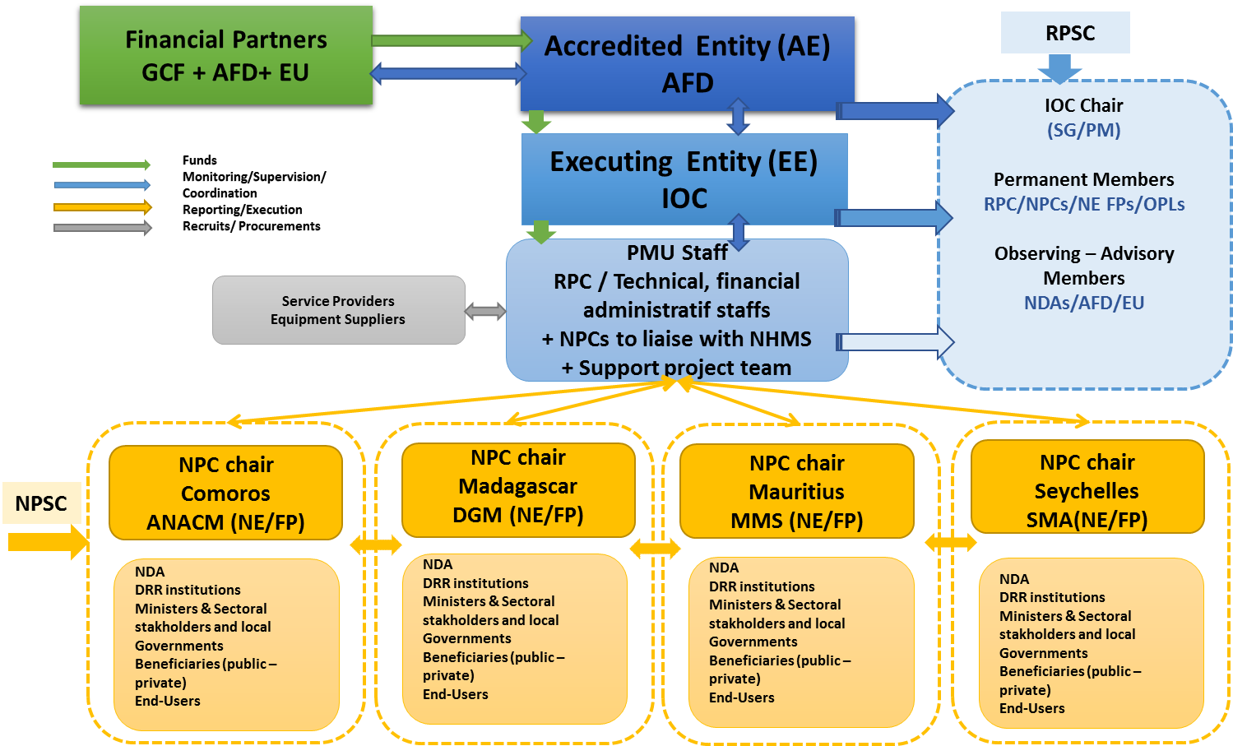

5.6.2 Contracts and flow of funds
A financing convention will be signed between AFD and IOC to establish the terms and conditions of the cooperation and define clear roles and responsibilities for both parties. The details of contracts and flow of funds will be agreed upon through this convention. As the AE, AFD will disburse funding received from the GCF and the EU according to the disbursement schedule of the convention, to the EE for the purposes of undertaking the project. As IOC is in the process of acquiring GCF accreditation, it will benefit from capacity development in the project from acting as EE.
Figure 70 The flow of funds in the proposed project.
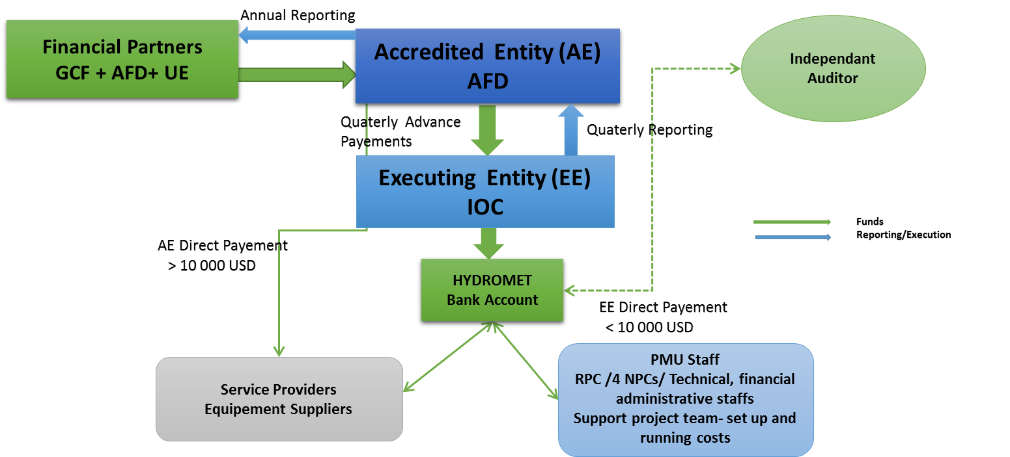

5.6.3 Profiles of PMU staff
Brief description of expected experience and expertise of specialised staff members of the PMU
Regional project coordinator (RPC)
The project will be seeking a full-time RPC, based at IOC in Mauritius. The role of the RPC will be to manage the PMU and to manage and supervise project implementation. More specifically, the RPC will be in charge of:
- Managing staff members located in the regional PMU as well as the national project coordinators, based in Comoros, Madagascar and Seychelles.
- Overseeing the day-to-day activities of the PMU related to the management and implementation of the Project, including procurement, project monitoring and evaluation, financial management, progress and financial reporting, leading staff of the PMU;
- Overall supervision of project activities (from Mauritius and with at least one trip per year in the 3 other countries for project site visits);
- Participate and represent the PMU as non decision-making member in the Project Steering Committee (PSC) and serve as secretary of the committee;
- Undertake external high-level communication (with support from the Communication Officer);
- Prepare, or as appropriate supervise the preparation of, progress reports, annual reports, project completion report and other reports that may be required by AFD;
- Prepare, or as appropriate supervise the preparation of, annual work plans and budgets and present to AFD and the PSC for approval;
- Supervise PMU staff in the performance of their respective duties;
- Ensure the efficient functioning of the PMU, including good collaboration with national stakeholders in the beneficiary countries;
- Represent the PMU and the project in general to national and international audiences;
- Lead the development of work plans, workshops and periodical work sessions and meetings for the unit and hold orientation seminar for his team members from the project to clarify the project objective and methodology;
- Working with the Financial Officer, ensure proper management of funds, including accounting, financial control and audit procedures acceptable to AFD;
- Working with the Procurement Officer, ensure clarity and efficiency in the procurement of goods, works and services in accordance with AFD guidelines including submission of annual financial audit to AFD.
The RPC will have the following experience and qualification:
- A Master degree, preferably in environmental science, meteorology, hydrology or similar;
- At least 10 years’ experience in project management, ideally related to climate change adaptation, disaster risk reduction, or climate services;
- Proven experience and technical ability to manage a large project;
- Experience in the management of multi-country projects will be an asset;
- A good knowledge of the SWIO region, in particular the four beneficiary countries;
- Effective interpersonal, management and negotiation skills proven through successful interaction with stakeholders, including senior government officials, regional/local authorities, experts and NGOs/communities;
- Demonstrated ability in team management and collaboration; and
- Fluency in English and French.
National project coordinators
The project will be seeking 3 full-time NPC, based respectively in Comoros, Madagascar and Seychelles. Under the supervision of the RPC, the NPC will manage and supervise daily project implementation in their respective country and liaise on a regular basis with national stakeholders involved in the project, including the NFP, the meteorological services, DRR institutions and other relevant sectoral ministries or organisations. More specifically, the NPC will be in charge of:
- Overseeing the day-to-day project activities including monitoring and evaluation, and project progress;
- Supervise the work of national and international consultants and firms, hired to implement project activities in his country;
- Report any issues/problems related to project implementation to the RPC;
- Prepare progress reports, annual reports, project completion report and other reports that may be required by the RPC;
- Implement annual work plans with support from the PMU;
- Ensure good collaboration and communication about the project with national stakeholders; and
- Represent the PMU and the project at the country level;
The NPC will be a technical person, and will have the following experience and qualification:
- A master’s degree in environmental science, meteorology, hydrology or similar;
- At least 5 years’ experience in project management, ideally related to climate change adaptation, disaster risk reduction, or climate services;
- A good knowledge of the country of duty (Comoros, Madagascar or Seychelles);
- Effective interpersonal, management and negotiation skills proven through successful interaction with stakeholders, including senior government officials, regional/local authorities, experts and NGOs/communities; and
- Fluency in English and French.
E&S Officers
The project will hire a regional E&S Officer, based at the PMU in Mauritius, and 4 national E&S Officers based in the beneficiary countries. They will be in charge of ensuring the inclusion of environmental and social safeguards during the first 3 years of the project of the project (while the equipment is being installed). In particular the E&S Officers will ensure the implementation of the Environmental and Social Management Framework, detailed in the Environmental and Social Impact Assessment (Annex 6). As part of his tasks, the E&S Officer will oversee project implementation to ensure they are social and environmentally sustainable and comply with the AFD and GCF social and environmental safeguards policies and internationally recognized best practices. The Officers will work closely and coordinate with the RPC and their NPC (for the national officers) and national institutions responsible for environmental safeguards in the four target countries, as needed, to accomplish these functions. They will report to the RPC and closely coordinate with NPC to ensure project compliance with national environmental and social regulations. More specifically, the E&S Officer will be in charge of:
- Reviewing the Environmental and Social Management Framework to organise a work plan incorporating the action priorities and analysis identified in the ESIA Annex (6), divided into country-level agendas for Comoros, Madagascar, Mauritius and Seychelles;
- Ensure the implementation of the project Environmental and Social Management Framework;
- Provide technical expertise on key issues related to environmental and social impact assessment and on sustainability risks in the preparation, implementation and supervision of project interventions as identified in the Environmental and Social Management Framework taking into consideration best industry practices and standard;
- Identify all key potential social and environmental impacts and risks of a project and ensure that their magnitude and significance are well understood;
- Incorporate into the project intervention effective and feasible measures to avoid, minimize, and mitigate the adverse environmental and social impacts;
- Coordinate with NPC and RPC to ensure implementation of mitigation measures;
- Local travel, when required, particularly to supervise the installation of large infrastructure (e.g. radar tower); and
- Report on and disseminate good practices and generated knowledge.
The E&S Officers will have the following qualification and experience:
- A master’s degree in environmental science, engineering, environmental management or equivalent;
- 3-5 years’ experience working on project management to identify environmental/social risk and issues and develop mitigation measures to ensure compliance with good international industry practice;
- Fluency in English; knowledge of French is preferable (required in the 2 French-speaking countries).
Hydromet expert
This part-time expert will be based at IOC and support the RPC in his daily project management tasks. In particular, the expert will:
- Develop ToR and procurement plans related to technical project interventions;
- Review applications submitted to implement technical project interventions (e.g. establishment of weather stations), with help from the external pool of consultants;
- Supervise project activities that relate to hydro-meteorological equipment and technical trainings; and
- Produce progress report with regards to the implementation of technical interventions.
- The Hydromet expert will have the following experience and qualification:
- A master’s degree in environmental science, meteorology, hydrology or similar;
- Experience in the management of projects focusing on meteorological, hydrological and climate services;
- A good knowledge of the SWIO region, in particular the four beneficiary countries; and
- Fluency in English and French.
Gender specialist
The project will seek an external consultant, specialised in socioeconomic and gender-focused analysis; gender mainstreaming activity design; and, implementation and gender-responsive policy delivery, for the Project Management Unit (PMU) of IOC Hydromet Project. Tasks will include the following:
- Reviewing Gender Action Plan to organise a work plan incorporating the action priorities and analysis identified in the Gender Annex (8), divided into country-level agendas for Comoros, Madagascar, Mauritius and Seychelles;
- Finalising, in collaboration with PMU and with budgetary demarcation, the gender-responsive steps of the Plan to be mobilised such as: gender clauses in the functioning of the Regional Climate Change Centre (RCCC) and Regional Climate Services Strategy (RCSS), developing gender case studies (1 in each of the 4 countries), organising Gender and Climate Services workshop with relevant stakeholders, etc.;
- Preparing progress reports, annual reports, completion reports (and other relevant reporting) related to the design, organisation and implementation of every gender activity undertaken;
- Liaising with the PMU on the day-to-day activities related to the management and implementation of the Project as well as regular communication of progress to PMU leader;
- Working to ensure gender mainstreaming and representation in beneficiaries identified of climate service products as well as better dissemination;
- Engaging with relevant government departments/ministries for the mobilisation of the Gender Action Plan in all four countries;
- Undertaking external communication of gender-related outcomes (with support from the Communication/Outreach consultant/officer);
- In-country missions, when required, particularly for the organization of the Gender and Climate Services workshop.
The gender consultant will have the following qualification:
- Advanced university degree in international development/area studies/gender studies/social sciences;
- 3 – 5 years’ experience in gender and socioeconomic analysis, as well as designing and delivering gender-responsive activities for climate change adaptation/services projects;
- Previous experience with Green Climate Fund and Agence Française de Développement requirements on gender-responsive implementation, social development and inclusion policies, and socioeconomic analysis is an asset;
- Previous experience in least developed countries and small island developing states, preferably in the Indian Ocean region;
- Previous experience of engaging government institutions as well as a range of stakeholders;
- Effective interpersonal, management and negotiation skills proven through successful interaction with stakeholders, including senior government officials, regional/local authorities, experts and NGOs/communities;
- Ability to work in time-pressured contexts and deliver quality products, as well as effective teamwork and collaborative capacities;
- Excellent drafting and reporting skills in English, with working knowledge of French.
Chapter 6 Conclusions and Recommendations
Comoros, Madagascar, Mauritius and Seychelles are among the most exposed countries to natural hazards, especially tropical cyclones, droughts, heavy rainfalls, storm surges and sea-level rise. These conditions are further enhanced by climate change, which results in increasing threats on livelihoods and economic growth in the small island states of the SWIO region.
Adapted, understandable and timely available climate services can contribute to reduce economic losses linked to climate-related hazards, reduce impacts on livelihoods and increase the resilience to climate change. However, at the moment, there is a lack of accurate and user-friendly climate services to inform decision-making processes in the SWIO region. To produce such services, the governments of Comoros, Madagascar, Mauritius and Seychelles currently lack the financial resources to establish relevant observation infrastructure, proper communication systems and data storage and management facilities, to develop adequate, downscaled hydrological models, and to invest in trainings and capacity building to support improvements in the production and dissemination of CS.
Nonetheless, these countries, with the support of the international community, have already made efforts to improve CS (see baseline projects sections under Chapter 2). However, GCF funding is necessary to support the incremental cost of climate change adaptation and effect a paradigm shift towards climate-resilient development in the four countries. This will be achieved through investing GCF resources in (i) the reinforcement of institutional and technical capacity of hydro-meteorological services at regional and national level; and (ii) the production of CS that adequately address urgent needs of economic sectors and communities in terms of food security, health, water management and disaster risk reduction. The proposed project, as demonstrated in this study, is technically feasible, cost-efficient and sustainable through a strengthening of the regional and national hydro-meteorological institutions. The governments of the four target countries have also committed to sustain and maintain the services developed through this project in the long-term, while economy of scale is supported through setting up an RCC together with regional hydro-meteorological facilities. The proposed interventions are also non-regret climate change adaptation measures with strong environmental and social benefits.
In sum, GCF funding is required to help Comoros, Madagascar, Mauritius and Seychelles achieving real progress in the delivery of high quality and timely available information, giving them better opportunities to improve their economic situation and be in a better position to deal with expected climate change impacts.

Appendix 1 Technical specification of project interventions
This section describes, in general, the technical aspects of the interventions to be supported by this regional project. It encompasses the main recommendations of HYCOS experts assessed by WMO experts for the hydrological part of the project. In this feasibility study, we are not dealing with final specifications of the different systems but with the global specifications to answer the needs of the four different countries.

Equipment and infrastructure
The design of the system duly considers the value chain of hydromet services and aims at strengthening end-to-end hydromet systems from observation networks, data management and information systems, forecasting systems to service delivery. The Indian Ocean Hydro-Met Program therefore targets in its project design: (i) institutional strengthening and capacity building; (ii) infrastructure and network improvements at scale and; (iii) supporting sustainable weather and climate service improvements.
While addressing institutional strengthening and capacity building for the four countries at the national scale, the project will focus on five main “weather, water and climate information value chains” which are particularly relevant for adapting the four countries economy and livelihoods to increased climate risks, which were identified in workshops with the national key beneficiaries on August and September 2019 in the four countries:
- Early warning for surface runoff related-floods in urban and peri-urban zones highly populated and subjected to recurrent phenomena such as: Antananarivo, Moroni, Port-Louis and Mahé. It will allow a synergy with ongoing projects for rainfall measurement supported by UNDP for Comoros and Madagascar, allowing this regional project to concentrate more specifically on runoff conditions;
- Monitoring the food security and nutrition situation in the rural zones of Madagascar and Comoros including agrometeorology modelizations of yield and crop disease;
- Delivery of tailored agro-meteorological services for highly productive agricultural zones where the relative variability of rainfall is high and where agro-meteorological stations already exist, and producers organized to take advantage of the dissemination of agro-climatological services such as: sugar cane in Mauritius, staple crops like millet, maize and sorghum and rice cultivation for Madagascar and Comoros, etc;
- Monitoring sea state and coastal erosion of the four countries with new observing systems to be implemented and adapted modelizations for coastal erosion on chosen location in each country.
- For specific catchment where the people and goods are the most vulnerable in each country, development of knowledge for better adaptation to climate change for structures sizing and risk management since there is an underlying trend for increased runoff coefficient in Indian Ocean region due to soil crusting in relation with notably anthropogenic activities and modifications of rainfall conditions impacting vegetation cover. This leads to reconsider: return periods for extreme events, intensity/duration/frequency (IDF) curves, runoff coefficient in the watersheds, and updating of rating curves for priority hydrological stations.
The design of the observation networks necessary to reinforce the existing national ones in the four countries will need to consider automation and telemetry systems and be significantly enhanced by installing:
- Automatic Weather Stations (AWSs), agro-met stations, rain gauges, lightning detectors, standard equipment, power supply, telecoms for field stations, etc.), buoys, tide gauges
- Data Collection Platforms (DCP) and specialized hydrological equipment (see HYCOS proposal attached).
Both AWS and DCP’s telemetry facilities will allow:
- Real time or near real time transmission of field data to NMHS, speeding up the preparation and delivery process of information to users;
- Facilitate and secure data storage (both in-situ and in the national data bases); and
- Remote control for maintenance activities.
The initial requirements in terms of works and equipment have been identified during project preparation as a first approach responding to anticipated requirements of the users and keeping the technology as simple as possible to ensure resistance to extreme climate conditions and reducing as much as possible operation and maintenance cost with minimal technical complexity. These requirements will be refined and specified during the project.
The data obtained from the enhanced observation networks will be quality assured by establishing calibration facility at regional level and will feed into the data management and forecasting systems, where modernizing Information and Communications Technology (ICT) infrastructure is at its core. In this matter, the project will consider the best affordable ways to improve and adapt existing communication infrastructure and protocols
The project aims at improving lead-time and accuracy of weather, climate and hydrological forecasts and developing and improving basic and specialized information products in an efficient and effective manner.
By leveraging regional and global resources, for example, by participating in WMO Severe Weather Forecasting and Demonstration Project (SWFDP), introducing Numerical Weather Prediction (NWP) and developing forecast accuracy verification system, the four NMHSs will jointly develop (i) flood and drought forecasting, (ii) sea state and coastal erosion monitoring and forecast and (iii) yield and crop disease monitoring and forecast. Development, dissemination and utilization of climate information products will be particularly emphasized under the National and Regional Framework for Climate Services, which empowers demand driven climate services for sectorial users as well as end-users down to the community.
The seamless operation and cooperation among four countries involved will be ensured and streamlined by developing and operationalizing regional NWP downscaling strategy, strengthening information exchange platform already in use and hosted by SMA.
The design of the observation networks will consider automation and telemetry systems and be significantly enhanced by installing:

Automatic Weather Stations (AWSs)
Such a station records, stores and transmits data measured in-situ by a large variety of sensors for:
- temperature
- wind speed and direction
- Relative humidity
- atmospheric pressure
- solar radiation
- sunshine duration
- Rainfall intensity
- visibility
- cloud height
The number of additional AWS to be installed should be carefully looked at considering the synergy with UNDP projects at Comoros and Madagascar and HYCOS diagnosis.

Agroclimatic Stations
Such a station measures the main agroclimatic parameters such as:
- wind speed and direction
- rainfall amount and intensity
- pressure
- relative humidity
- temperature
- solar radiation
- sunshine duration
- soil temperature
- soil moisture
The station is powered by solar panels and its data-logger stores and processes the data. Moreover, a telemetry system could be connected so that data can be remotely accessed through mobile SMS or other form of messages in real time.

Standard rain gauges
The ordinary rain gauge used for daily readings usually takes the form of a collector above a funnel leading into a receiver. In Indian Ocean region the size of the receiving area is generally 400 cm2. The standard high above the ground for the receiving surface is 1m.

Buoys, tide gauges
These buoys will implement sensors to measure the following parameters:
- Waves height and direction
- Sea Surface temperature
- Air temperature
- Pressure
- Humidity

Doppler radar for precipitation
As the one already in operation at Mauritius island, these doppler radars will insure an extensive spatial coverage of the measurement of rainfall rate.

Lightening detector
A lightning detector is a device that detects lightning produced by thunderstorms. Ground- based detectors calculate the direction and severity of lightning from the current location using radio direction-finding techniques together with an analysis of the characteristic frequencies emitted by lightning. The low frequency sensors detect the electromagnetic phenomenon in the 0 to 350 kHz band and each sensor detects lightning in a maximum radius of 1 000 km. Through GPS synchronized clock the detection has a millisecond precision. Moreover, the sensors provide information about intensity and direction of impacts. Information from field sensors can be concentrated at the main meteorological office and this allows calculation of impact location with accuracy within one km.

Flash Flood Guidance Systems
Lightning detection and doppler radar data will be used as a proxy for rainfall and for detecting severe weather. This will help forecasters at NMHSs to identify where high intensity rainfall may fall, improving their ability to use the flash flood guidance system and provide more accurate rainfall predictions. Flash Flood Guidance System (FFGS) is developed and sustained by WMO, to issue real-time risk maps using all available local data. The FFGS provides a tool-box, capacity building materials and technical products: real-time data including satellite, radar and gauged-based precipitation estimates, soil moisture, flash flood threats (both current and forecast), model-based rainfall forecasts (to 24 hours), and snow areal coverage/water equivalent/melt, and landslide hazard threat. This system is fed by participating countries and numerical weather prediction from leaders in digital forecasting (such as ECMWF, Météo-France, US NWS).
Currently FFGS is implemented in the South African Region and it should be extended to the SWIO region.

Hydrological stations
As stated in the HYCOS assessment (see Annex 22), the four countries need the following type of equipment:
- Gauging scale
- Automatic limnigraph
- ADCP
- Suspended-sediment samplers
- Inflatable motor boat
- Piezometer
- GPS
More details about the equipment and technical specifications could be found in the Guide to Hydrological Practices, WMO-No 168 (2008) and the Guide to Climatological Practices, WMO-No 100 (2011).

Infrastructure works
There are no works foreseen for the GCF-financed portion of the project. The refurbishment of the four NMHSs premises, the implementation of a new building for SMA would be supported by the Government co-financing.
The installation of the hydro-met equipment across existing and new stations in the country will be conducted by the suppliers of the equipment to be procured as “equipment, installation and training”.

Information system
All the following systems should follow the WMO Volume I: General Meteorological Standards and Recommended Practices, (WMO Publication No. 49).

Data Collection Platform (DCP)
A universal web-based data collection system that will allow real-time data collection of any type of automatic weather and hydrological station, including equipment procurement, transportation, installation, commissioning, plant revenue and site, factory and site trainings and warranty services.

Automated Message Switching System (AMSS)
Web-based Automatic Message Switching System, including equipment supply, transportation, installation, commissioning, factory and site revenue, plant and site training, and warranty services.

Forecaster workstation
Web-based weather forecasting systems, including equipment procurement, transportation, installation, commissioning, plant and site revenue, on-site training and warranty services.

Climatological Database Management System
Web-based integrated system that facilitates the effective archival, management, analysis, delivery and utilization of a wide range of integrated climate data, including equipment procurement, transportation, installation, commissioning, plant and site revenue, on-site training and warranty services.

Production and dissemination system
Systems for publishing and disseminating meteorological information to the public and to various web-based economic actors, including production and dissemination facilities for early warning information, including equipment supply, transportation, installation, commissioning, factory and site revenue, on-site training and warranty services. Such a system should include a dedicated early warning module and related services.
This system a TV report production system except for Seychelles where there is an up to date system in operation.

R&D development
R&D activities is needed to perform regional downscaling and national calibration of the different models at regional and national levels. The production of downscaled climate change models will use BRIO’s outputs and be based on BRIO methodologies. Based on the downscaled climate change models, sectoral models and impact assessments need to be prepared to anticipate climate change impacts in each country:
- In Comoros: Agrometeorology, Sea state, Coastal erosion;
- In Madagascar: Agrometeorology, Sea state, Coastal erosion;
- In Mauritius: Urban hydrology, Sea state, Coastal erosion;
- In Seychelles: Urban hydrology, Sea state, Coastal erosion.

Technical capacity building
Technical capacity is one of the most important issues of the project. It will notably ensure that the project investment is giving the best return as possible in terms of:
- New field equipment:
- Installation
- Operation
- Maintenance
- Control
- ICT infrastructure
- Web technology
- Data base operation and maintenance
- Quality control
- Hydromet services preparation and delivery
- regular bulletins
- seasonal forecasts
- long-term forecast
- warnings, etc.
Field and office training sessions, workshops and specialized lectures will be organized taking advantage of all available national and regional expertise. The planning of activities will ensure regular support to trainees all along the duration of the project.
To understand “service delivery”, one must first understand what is commonly meant by “service”, which this Strategy defines as a product or activity that meets the needs of a user or can be applied by a user. To be effective, services should be a continuous, cyclic process for developing and delivering user- focused services. It is further defined in four stages (Source WMO Strategy for Service Delivery and its Implementation Plan).

https://public.wmo.int/en/bulletin/what-do-we-mean-climate-services
IPCC, 2014. Climate Change 2014: Impacts, Adaptation and Vulnerability – AR5. Chapter B: Regional Aspects, Chapter 29.
This include the national meteorological and hydrological services, which are separated institutions in some of the beneficiary countries.
https://reliefweb.int/sites/reliefweb.int/files/resources/mauritius.pdf
https://www.gfdrr.org/sites/default/files/publication/Seychelles_DaLA_2013_Floods.pdf
https://gfcs.wmo.int//implementation-plan
World Meteorological Organisation, 2015. WMO Guidelines on Multi-hazard Impact-based Forecast and Warning Services.
World Meteorological Organisation, 2017. Multi-hazard Early Warning Systems: A Checklist: Outcome of the first Multi-hazard Early Warning Conference
AIR Worldwide, South West Indian Ocean Risk Assessment and Financing Initiative (SWIO-RAFI), Final Report Submitted to the WBG, Component 1 – Hazard, June 1st, 2016
https://climateknowledgeportal.worldbank.org/
M S Muthige et al 2018 Environ. Res. Lett. 13 065019
https://www.populationdata.net/pays/comores/
CIA World Factbook, Comoros: Geography; Encyclopaedia Britannica, Comoros: Relief, Drainage, and Soils.; Encyclopaedia Britannica, Comoros: Relief, Drainage, and Soils.
McSweeney, C et al (2009). UNDP Climate Change Country Profiles: Comoros. Assessed in April 2011
MP2L, 2015. Schema Directeur AEP Mbadjini Est
NAPA 2006, WHO Standard, daily water supply per person (l/d/p) documented by AfDB, PEAPA https://www.who.int/water_sanitation_health/emergencies/qa/emergencies_qa5/en/
Etude de vulnérabilité aux aléas climatiques et géologiques en Union des Comores, Pnud-Cosep 2011
AFD (2018). Etude de vulnerabilite aux effets du changement climatique aux Comores.
Priority areas in the Global framework for Climate Services: https://gfcs.wmo.int/priority-areas
Which was not taken into account in this analysis because it is more relevant to climate change mitigation objectives than adaptation.
AFD (2018). ‘Etude de vulnerabilite aux effets du changement climatique aux Comores’.
AFD (2018). ‘Etude de vulnerabilite aux effets du changement climatique aux Comores’.
Inform Index for Risk Management, Mid-2019..
CIA World Factbook, Comoros: Economy.
Rapport ACCLIMATE (2011). ‘Etude de vulnerabilite aux changements climatiques: evaluation qualitative’.
AFD (2018). ‘Etude de vulnerabilite aux effets du changement climatique aux Comores’.
ibid.
AFD (2018). ‘Etude de vulnerabilite aux effets du changement climatique aux Comores’.
Rapport ACCLIMATE (2011). ‘Etude de vulnerabilite aux changements climatiques: evaluation qualitative’.
AFD (2018). ‘Etude de vulnerabilite aux effets du changement climatique aux Comores’.
Rapport ACCLIMATE (2011). ‘Etude de vulnerabilite aux changements climatiques: evaluation qualitative’.
FAO Aquastat: http://www.fao.org/3/V8260B/V8260B0l.htm
Rapport ACCLIMATE (2011). ‘Etude de vulnerabilite aux changements climatiques: evaluation qualitative’.
AFD (2018). ‘Etude de vulnerabilite aux effets du changement climatique aux Comores’.
IMF, Republic of Madagascar: At a Glance.
Encyclopaedia Britannica, Madagascar: Local Government; World Atlas, Regions of Madagascar by population.
CIA World Factbook, Madagascar: Geography; Encyclopaedia Britannica, Madagascar: Relief.
Madagascar connaît un taux de pauvreté très élevé (92 % de la population vit avec moins de 2 $US par jour).
GIZ (2018). ‘État des lieux des études de la vulnérabilité à Madagascar’. Antananarivo: Deutsche Gesellschaft für Internationale Zusammenarbeit (GIZ).
Ibid.
AFD (2018). ‘Etude de vulnerabilite aux effets du changement climatique aux Comores’.
Zones prioritaires dans le Global framework for Climate Services: https://gfcs.wmo.int/priority-areas
Qui n’a pas été pris en compte dans cette analyse de part son rattachement plus important aux objectifs d’atténuation des changements climatiques qu’a l’adaptation.
CIA World Factbook, Madagascar: Economy.
GIZ (2018). ‘État des lieux des études de la vulnérabilité à Madagascar’. Antananarivo: Deutsche Gesellschaft für Internationale Zusammenarbeit (GIZ).
Ibid.
Republique de Madagascar (2017). Troisieme Communication Nationale sur les Changements Climatiques
Improved drinking water includes any of the following sources: piped water into dwelling, yard, or plot; public tap or standpipe; tubewell or borehole; protected dug well; protected spring; or rainwater collection. Unimproved drinking water includes any of the following sources: unprotected dug well; unprotected spring; cart with small tank or drum; tanker truck; surface water, which includes rivers, dams, lakes, ponds, streams, canals or irrigation channels; or bottled water.
Republique de Madagascar (2017). Troisieme Communication Nationale sur les Changements Climatiques
Rapport ACCLIMATE (2011). ‘Etude de vulnerabilite aux changements climatiques: evaluation qualitative’.
Republique de Madagascar (2017). Troisieme Communication Nationale sur les Changements Climatiques.
IMF, Mauritius: At a Glance.
Encyclopaedia Britannica, Mauritius: Land.
CIA World Factbook, Mauritius: Geography; Encyclopaedia Britannica, Mauritius: Relief and Drainage.
OECD, DAC List of ODA Recipients and History of DAC Lists of aid recipient countries.
Encyclopaedia Britannica, Mauritius: Economy.
Zones prioritaires dans le Global framework for Climate Services: https://gfcs.wmo.int/priority-areas
Khaled K A, et. Al. (2018). Sugarcan genotypes assessment under drought condition using amplified fragment length polymorphism. Biotechnology, 17 : 120-127
Rapport ACCLIMATE (2011). ‘Mauritius – Etude de vulnerabilite aux changements climatiques: evaluation qualitative’.
Ministry of Environment, Sustainable Development, and Disaster and Beach Management (2016). Third National Communication to the UNFCCC.
Rapport ACCLIMATE (2011). ‘Mauritius – Etude de vulnerabilite aux changements climatiques: evaluation qualitative’.
Ibid.
Ministry of Environment, Sustainable Development, and Disaster and Beach Management (2016). Third National Communication to the UNFCCC.
Ibid.
Ibid.
Ibid.
Ibid.
Ibid.
Rapport ACCLIMATE (2011). ‘Mauritius – Etude de vulnerabilite aux changements climatiques: evaluation qualitative’.
AFD Adapt’Action ER2C Climate Change impacts and projections on 6 priority sites. 2019.
Encyclopaedia Britannica, Seychelles: Land.
IMF, Republic of Seychelles: At a Glance.
IMF DataMapper, World Economic Outlook (April 2019): General government gross debt (Percent of GDP)
Perlmutter et al., 1996
Climate Change Scenario Assessment for the Seychelles
Climate Variability and Climate Change Assessment for the Seychelles
Sea Level Activities and Changes on the Islands of the Western Indian Ocean
A 20th century acceleration in global sea-level rise
Observations: oceanic climate change and sea level
Zones prioritaires dans le Global framework for Climate Services https://gfcs.wmo.int/priority-areas
World Bank, Country Profile: Seychelles.
CIA World Factbook, Seychelles: Economy.
Rapport ACCLIMATE (2011). ‘Seychelles – Etude de vulnerabilite aux changements climatiques: evaluation qualitative’.
The Seychelles National Climate Change Committee (2009). Seychelles National Climate Change Strategy.
Rapport ACCLIMATE (2011). ‘Seychelles – Etude de vulnerabilite aux changements climatiques: evaluation qualitative’.
The Seychelles National Climate Change Committee (2009). Seychelles National Climate Change Strategy.
World Bank Climate Change Knowledge Portal Country Profile: Seychelles
The Seychelles National Climate Change Committee (2009). Seychelles National Climate Change Strategy.
Rapport ACCLIMATE (2011). ‘Seychelles – Etude de vulnerabilite aux changements climatiques: evaluation qualitative’.
IOC Climate Change Portal. ‘Document cadre pour la stratégie régionale d’adaptation au changement climatique des pays membres de la Commission de l’océan Indien 2012-2020’. Accessed 18th August 2019. Available at: https://prodigious-lab.com/coi/wp-content/uploads/2018/01/DR-Document-cadre-pour-la-strate%CC%81gie-re%CC%81gionale-d_adaptation-au-changement-climatique-des-pays-membres-de-la-COI.pdf
https://public.wmo.int/en/our-mandate/climate/regional-climate-outlook-products
http://www.wmo.int/pages/prog/wcp/wcasp/rcofs/webpage/SARCOF.html
https://www.sadc.int/themes/meteorology-climate/climate-information/
According to the SADC website, Comoros became a full member in August 2018
Swaziland was renamed Eswatini in 2018
For example, see: http://csc.sadc.int/en/climate/climate-outlook/241-season-outlook-for-oct-2018-to-mar-2019
http://regionalclimate-change.sc/en/
WMO. ‘World Hydrological Cycle Observing System (WHYCOS)’. Accessed 20 September 2019. Available at: https://hydrohub.wmo.int/en/world-hydrological-cycle-observing-system-whycos
WMO. ‘SADC-HYCOS (Southern Africa)’. Accessed 20 September 2019. Available at: https://hydrohub.wmo.int/en/projects/SADC-HYCOS
International Convention on the Elimination of All Forms of Racial Discrimination 1969; Convention on the Elimination of All Forms of Discrimination against Women 1981; Convention against Torture and Other Cruel, Inhuman or Degrading Treatment or Punishment 1987; Convention on the Rights of the Child 1990; Optional Protocol to the Convention on the Rights of the Child on the sale of children, child prostitution and child pornography 2002; and Convention on the Rights of Persons with Disabilities 2008. See: UNHR, https://indicators.ohchr.org.
CIA World Factbook, Comoros: Geography.
Ministry of Rural Development, Fisheries, Handicraft and Environment (2006). ‘Union of the Comoros: National Action Programme of Adaptation to climate change’. Accessed 19th August 2019. Available at: https://www.preventionweb.net/files/8507_com01e.pdf
UNFCCC. ‘NAPA Priorities Database’. Accessed 12th August 2019. Available at: https://unfccc.int/topics/resilience/workstreams/national-adaptation-programmes-of-action/napa-background
UNDP. ‘Supporting Comoros to advance their NAP process’. Accessed 21st August 2019. Available at: https://www.adaptation-undp.org/projects/comoros-nap-process
UNFCCC. ‘INDCs as communicated by Parties’. Accessed 23rd August 2019. Available at: https://www4.unfccc.int/sites/submissions/indc/Submission%20Pages/submissions.aspx
United Nations Treaty Collection. ‘Chapter XXVII Environment: 7. d Paris Agreement’. Last updated 13th August 2019. Accessed 21st August 2019. Available at: https://treaties.un.org/Pages/ViewDetails.aspx?src=TREATY&mtdsg_no=XXVII-7-d&chapter=27&clang=_en
UNFCCC. ‘NDC Registry: Comoros’. Accessed 21st August 2019. Available at: https://www4.unfccc.int/sites/NDCStaging/Pages/Party.aspx?party=COM
Ibid. at page 11.
Ibid. at pages 12-13.
Ibid. at page 5.
Direction de la Météorologie des Comores, ‘Plan Stratégique 2017-2020: RÉSUMÉ’ (March 2017).
GEF and UNDP. ‘Plan de Travail Annuel 2019: Projet 00105390 - Projet de Renforcement de la Résilience des Comores aux Risques des Catastrophes liés au climat et à la variabilité climatique’.
Under UNISDR , africa-arab platform on DRR, tunisia oct 2018, Tunis Declaration on accelerating the implementation of the Sendai Framework for Disaster Risk Reduction2015-2030 and the Africa Regional Strategy for Disaster Risk Reduction Within art 13 : 13.Encourage African States to strengthen their early warning systems, including multi-hazard and impact based early warning with priority on hydrological and meteorological systems and the delivery of services in understandable manner to end-users for enhanced preparedness, response, recovery and reconstruction; https://www.google.com/url?sa=t&rct=j&q=&esrc=s&source=web&cd=1&cad=rja&uact=8&ved=2ahUKEwjNudrU7trlAhUp8-AKHXsUDkIQFjAAegQIBBAC&url=https%3A%2F%2Fwww.preventionweb.net%2Ffiles%2F57759_finaladopteddrafttunisdeclaration13.pdf&usg=AOvVaw1Upxmtu-O1bGaCQgZBXDna
FP038 Geeref Next. See: https://www.greenclimate.fund/countries/comoros
International Convention on the Elimination of All Forms of Racial Discrimination 1969; International Covenant on Civil and Political Rights 1976; Optional Protocol to the International Covenant on Civil and Political Rights 1976; Second Optional Protocol to the International Covenant on Civil and Political Rights, aiming at the abolition of the death penalty 1991; International Covenant on Economic, Social and Cultural Rights 1976; Convention on the Elimination of All Forms of Discrimination against Women 1981; Convention against Torture and Other Cruel, Inhuman or Degrading Treatment or Punishment 1987; Optional Protocol to the Convention against Torture and Other Cruel, Inhuman or Degrading Treatment or Punishment 2006; Convention on the Rights of the Child 1990; Optional Protocol to the Convention on the Rights of the Child on the involvement of children in armed conflict 2002; Optional Protocol to the Convention on the Rights of the Child on the sale of children, child prostitution and child pornography 2002; International Convention on the Protection of the Rights of All Migrant Workers and Members of their Families 2003; and Convention on the Rights of Persons with Disabilities 2008. See: UNHR, Status of Ratification Interactive Dashboard.
Ministry of the Environment (2006). ‘Republic of Madagascar: National Adaptation Programme of Action’. Accessed 12th August 2019. Available at: https://unfccc.int/topics/resilience/workstreams/national-adaptation-programmes-of-action/napas-received
UNFCCC. ‘NAPA Priorities Database’. Accessed 12th August 2019. Available at: https://unfccc.int/topics/resilience/workstreams/national-adaptation-programmes-of-action/napa-background
NAP Global Network (2019). ‘Madagascar NAP Approach’. Accessed 13th August 2019. Available at: http://napglobalnetwork.org/wp-content/uploads/2018/02/napgn-en-2019-madagascar-nap-process-poster.pdf
UNFCCC. ‘INDCs as communicated by Parties’. Accessed 14th August 2019. Available at: https://www4.unfccc.int/sites/submissions/indc/Submission%20Pages/submissions.aspx
United Nations Treaty Collection. ‘Chapter XXVII Environment: 7. d Paris Agreement’. Last updated 13th August 2019. Accessed 14th August 2019. Available at: https://treaties.un.org/Pages/ViewDetails.aspx?src=TREATY&mtdsg_no=XXVII-7-d&chapter=27&clang=_en
UNFCCC NDC Registry. ‘Madagascar INDC’. Accessed 14th August 2019. Available at: https://www4.unfccc.int/sites/NDCStaging/pages/Party.aspx?party=MDG
Ibid. at page 1.
Ibid. at pages 2 and 9.
Ibid. at page 3.
Ibid. at page 7.
Ibid. at pages 7-8.
GIZ (2019). ‘Pour un processus de PMA qui reponde aux questions de genre a Madagascar’. Source: http://napglobalnetwork.org/wp-content/uploads/2019/03/napgn-fr-2019-pour-un-processus-de-pna-qui-reponde-aux-questions-de-genre-a-madagascar.pdf
https://bnc-redd.mg/fr/2-bnc-redd-fr/93-details-infos-encadres
UNDP TOR for concept note formulation support in Madagascar (2018)
Resilience Capacity Building Project through the production and management of climate information in Madagascar, Concept Note, February 2017
Réduction / gestion des risques de catastrophes
Source : SNGRC 2016 -2030- version finale Sept 2016
Source : COI Renforcement des politiques publiques et appui aux structures nationales de coordination, de prévention et de gestion des risques naturels et des catastrophes dans les pays membres de la COI- Rapport decembre 2013
FP099 Climate Investor One, FP095 Transforming Financial Systems for Climate, FP038 Geeref Next, and FP026 Sustainable Landscapes in Eastern Madagascar. See: https://www.greenclimate.fund/countries/madagascar
International Convention on the Elimination of All Forms of Racial Discrimination 1969; International Covenant on Civil and Political Rights 1976; Optional Protocol to the International Covenant on Civil and Political Rights 1976; International Covenant on Economic, Social and Cultural Rights 1976; Convention on the Elimination of All Forms of Discrimination against Women 1981; Optional Protocol to the Convention on the Elimination of All Forms of Discrimination against Women 2000; Convention against Torture and Other Cruel, Inhuman or Degrading Treatment or Punishment 1987; Optional Protocol to the Convention against Torture and Other Cruel, Inhuman or Degrading Treatment or Punishment 2006; Convention on the Rights of the Child 1990; Optional Protocol to the Convention on the Rights of the Child on the involvement of children in armed conflict 2002; Optional Protocol to the Convention on the Rights of the Child on the sale of children, child prostitution and child pornography 2002; and Convention on the Rights of Persons with Disabilities 2008. See: UNHR, Status of Ratification Interactive DashboardStatus of Ratification Interactive Dashboard.
CIA World Factbook, Mauritius: Geography.
UNFCCC. ‘INDCs as communicated by Parties’. Accessed 6th September 2019. Available at: https://www4.unfccc.int/sites/submissions/indc/Submission%20Pages/submissions.aspx
United Nations Treaty Collection. ‘Chapter XXVII Environment: 7. d Paris Agreement’. Last updated 13th August 2019. Accessed 6th September 2019. Available at: https://treaties.un.org/Pages/ViewDetails.aspx?src=TREATY&mtdsg_no=XXVII-7-d&chapter=27&clang=_en
UNFCCC. ‘NDC Registry: Mauritius’. Accessed 6th September 2019. Available at: https://www4.unfccc.int/sites/NDCStaging/Pages/Party.aspx?party=MUS
Ibid. at pages 3-4.
Ibid. at page 5.
‘National Climate Change Adaptation Policy Framework for the Republic of Mauritius’ (December 2012), at page 4. Accessed 6th September 2019. Available at: https://www.greengrowthknowledge.org/national-documents/national-climate-change-adaptation-policy-framework-republic-mauritius
Ibid. at page 5.
Ibid. at page 6.
Ibid. at page 4.
Republic of Mauritius, Ministry of Social Security, National Solidarity, and Environment and Sustainable Development (Environment and Sustainable Development Division). ‘Climate Change: Technology Action Plan for an enhanced Climate Change Adaptation and Mitigation’. Accessed 6th September 2019. Available at: http://environment.govmu.org/English/Climate_Change/Pages/Climate-Change.aspx
National Disaster Risk Reduction and Management Centre. ‘National Disasters Scheme 2015’ at page 3. Accessed 6th September 2019. Available at: http://gis.govmu.org/English/Documents/National%20Disasters%20Scheme%20(NDS)%202015%20pmo.pdf
Republic of Mauritius, Ministry of Social Security, National Solidarity, and Environment and Sustainable Development (Environment and Sustainable Development Division). ‘Climate Change: Climate Change Information Centre’. Accessed 6th September 2019. Available at: http://environment.govmu.org/English/Climate_Change/Pages/Climate-Change.aspx
Note that as of November 2020, the NDRRMC reports to the Ministry of Local Government, Disaster and Risk Management.
FP095 Transforming Financial Systems for Climate, FP038 Geeref Next, and FP033 Accelerating the Transformational Shift to a Low-Carbon Economy in the Republic of Mauritius. See: https://www.greenclimate.fund/countries/mauritius
International Convention on the Elimination of All Forms of Racial Discrimination 1969; International Covenant on Civil and Political Rights 1976; Optional Protocol to the International Covenant on Civil and Political Rights 1976; Second Optional Protocol to the International Covenant on Civil and Political Rights, aiming at the abolition of the death penalty 1991; International Covenant on Economic, Social and Cultural Rights 1976; Convention on the Elimination of All Forms of Discrimination against Women 1981; Optional Protocol to the Convention on the Elimination of All Forms of Discrimination against Women 2000; Convention against Torture and Other Cruel, Inhuman or Degrading Treatment or Punishment 1987; Convention on the Rights of the Child 1990; Optional Protocol to the Convention on the Rights of the Child on the involvement of children in armed conflict 2002; Optional Protocol to the Convention on the Rights of the Child on the sale of children, child prostitution and child pornography 2002; International Convention on the Protection of the Rights of All Migrant Workers and Members of their Families 2003; International Convention for the Protection of all Persons from Enforced Disappearance 2010; and Convention on the Rights of Persons with Disabilities 2008. See: UNHR, Status of Ratification Interactive Dashboard.
CIA World Factbook, Seychelles: Geography.
UNFCCC. ‘INDCs as communicated by Parties’. Accessed 6th September 2019. Available at: https://www4.unfccc.int/sites/submissions/indc/Submission%20Pages/submissions.aspx
United Nations Treaty Collection. ‘Chapter XXVII Environment: 7. d Paris Agreement’. Last updated 13th August 2019. Accessed 6th September 2019. Available at: https://treaties.un.org/Pages/ViewDetails.aspx?src=TREATY&mtdsg_no=XXVII-7-d&chapter=27&clang=_en
UNFCCC. ‘NDC Registry: Mauritius’. Accessed 6th September 2019. Available at: https://www4.unfccc.int/sites/NDCStaging/Pages/Party.aspx?party=SYC
Ibid. at page 4.
Ibid. at pages 4-5.
Ibid. at page 6.
Ibid. at pages 6-7.
Ibid. at page 2.
Ministry of Environment, Energy and Climate Change. ‘Seychelles Coastal Management Plan 2019–2024’. Accessed 9th September 2019. Available at: https://www.gfdrr.org/sites/default/files/publication/seychelles-coastal-management-plan.pdf
Ibid. at page 29.
Ibid. at pages 30-31.
Ibid. at page 39.
The Seychelles National Climate Change Committee. ‘National Climate Change Strategy’ (November 2009), at pages 60-61. Accessed 9th September 2019. Available at: https://www.preventionweb.net/files/20091100_seychelles_climate_change_strategy_2009.pdf
World Hydrological Cycle Observing System- projet Indian ocean HYCOS, document avant projet – annexes- July 2019
Source : - www.DRDM.gov.sc
SeyCCAT. Ongoing Projects. Accessed 26 September 2019. Available at: https://seyccat.org/projects/#on-going
Project Neptune Project Management Unit (2017). ESIA: Seychelles Water and Sanitation Project: Construction of La Digue Wastewater System. Accessed 26 September 2019. Available at: https://www.eib.org/attachments/registers/91346907.pdf
African Development Bank (2015). Republic of Seychelles: Mahe Sustainable Water Augmentation Project Appraisal Report, at page 2 (Donor Coordination). Accessed 26 September 2019. Available at: https://www.afdb.org/fileadmin/uploads/afdb/Documents/Boards-Documents/Seychelles__AR-_Mahe_Sustainable_Water_Augmentation_Project.pdf
ASCLME 2012 (UNDP and GEF). ‘National Marine Ecosystem Diagnostic Analysis. Seychelles. Contribution to the Agulhas and Somali Current Large Marine Ecosystems Project’, at page 16. Accessed 26 September 2019. Available at: https://wedocs.unep.org/bitstream/handle/20.500.11822/25894/Seychelles_MEDA.pdf?sequence=1&isAllowed=y
For example, a mass algal bloom in Seychelles in 2015 led to wide-spread death of coral reef fish and coral bleaching. See David Obura, et al. (2017). Coral reef status report for the Western Indian Ocean. Global Coral Reef Monitoring Network (GCRMN)/International Coral Reef Initiative (ICRI), at page 117. Accessed 26 September 2019. Available at: https://www.icriforum.org/sites/default/files/COI%20REEF%20LR%20F2.compressed.pdf
IAEA (2011). Nuclear Techniques Help to Detect Harmful Algal Blooms. Accessed 26 September 2019. Available at: https://www.iaea.org/newscenter/news/nuclear-techniques-help-to-detect-harmful-algal-blooms
See: https://www.greenclimate.fund/countries/seychelles
To note: there is no efficient hydrological services in the four target countries. In fact, there is a lack of monitoring of water resources in the countries. The HYCOS study available as Annex 22 has conducted an analysis of hydrological services in the four target countries; and identified interventions for improving rainfall monitoring in key watershed. Please refer to this study for a critical analysis of water resources and hydrological institutions in the 4 target countries.
The color green, yellow and red relies with the level of development of each category: red is when the category is not reached, yellow for partially reached and green for fully reached.
4 May 2019
PIROI report 41,000 affected
Reliefweb, 3 June 2019
Ali Said Omar, Consultant, Newsletter 17 June 2019
345,000 people affected by Cyclone Kenneth
Including a consideration of the following questions: Are key hazards and related threats identified? Are exposure, vulnerabilities, capacities and risks assessed? Are roles and responsibilities of stakeholders identified? Is risk information consolidated?
For example, L'évaluation des Risques de Catastrophe aux Comores: Une Analyse de la Situation Globale du Pays (Février 2014)
See Comoros floods, April 2012. Available at: https://reliefweb.int/disaster/fl-2012-000066-com
Part of a project covering Malawi, Mozambique, Madagascar, as well as Comoros.
UNDP, 2018. FP094: Ensuring climate resilient water supplies in the Comoros Islands
INGC. 2009. Synthesis report. INGC Climate Change Report: Study on the impact of climate change on disaster risk in Mozambique (van Logchem B and Brito R (ed.) INGC, Mozambique
Hansindsy and Nioumamilima, 2 July 2019, Vouvouni and Foumbouni, 4 July 2019
UNDP, 2018. FP094: Ensuring climate resilient water supplies in the Comoros Islands
Including a consideration of the following questions: Are there monitoring systems in place? Are there forecasting and warning services in place? Are there institutional mechanisms in place?
“Plan d’Action de renforcement du Service météorologique comorien (SMC). Rapport de Mission” April 2010. WMO, Geneva
La Reunion Tropical Cyclone Center: http://www.meteo.fr/temps/domtom/La_Reunion/webcmrs9.0/#
RIMES: http://www.rimes.int/
PIROI responds in the Comoros following Cyclone Kenneth Available at: https://piroi.croix-rouge.fr/piroi-responds-in-the-comoros-following-cyclone-kenneth/?lang=en
Local interviewees Handsinsdy 2 July 2019 and local fishermen in Foumbouni 4 July 2019
See UNDP, 2014
Including a consideration of the following questions: Are organizational and decision-making processes in place and operational? Are communication systems and equipment in place and operational? Are impact-based early warnings communicated effectively to prompt action by target groups?
National Contingency Plan 2017-2018
In case of an alert, the Director of CMS has to travel to Hahaya airport to disseminate alerts to the appropriate authorities.
Rapport RD/COI, 2010. “Etude de faisabilité d’un projet régional de gestion des risques et catastrophes naturels. Proposition d’un programme d’actions. Rapport intermédiaire”. Risques & Développement, Aubagne (France).
Community meeting, 2 July 2019
“Final Report of the WMO Mission to the Direction Nationale de la Météorologie. Severe Weather Forecasting Demonstration Project (Swfdp) Country Visit”, October 2012. WMO, Geneva (Switzerland). http://www.wmo.int/pages/prog/amp/pwsp/documents/Comoros_Report_English_Final.pdf
Community meeting, 2 July 2019
Including a consideration of the following questions: Are disaster preparedness measures, including response plans, developed and operational? Are public awareness and education campaigns conducted? Are public awareness and response tested?
Female community member in Hansindsy, 2 July 2019
Directorate of European Affairs, 2013, April 2012 Floods in Comoros
UNDP (2014)
www.fao.org
National Institute of Statistics of Madagascar, Department of demographic and social Statistics, Demographic and social surveys (2012)
meeting with DAPV, Direction de l’agriculture en appui à la production végétale
Jiro sy Rano Malagasy-JIRAMA (Public Electricity and Water Corporation of Madagascar) database 2015
meeting with MAEP, Direction générale de la pêche
Vulnerability, Risk Reduction and Adaptation to Climate Change. Madagascar Country Profile. GFDRR, 2011. http://sdwebx.worldbank.org/climateportalb/doc/GFDRRCountryProfiles/wb_gfdrr_climate_change_country_profile_for_MDG.pdf
Including a consideration of the following questions: Are key hazards and related threats identified? Are exposure, vulnerabilities, capacities and risks assessed? Are roles and responsibilities of stakeholders identified? Is risk information consolidated?
Germanwatch, 2017. Global Climate Risk Index. https://germanwatch.org/en/download/16411.pdf
Resilience Capacity Building Project through the production and management of climate information in Madagascar, Concept Note, February 2017
Madagascar Strategic Programme for Climate Resilience, 2017
Direction Générale de la Météorologie (DGM) indicates that between 1961 and 2005, 17 of the 21 weather stations recorded statistically significant increases in daily minimum temperatures across all seasons, and several stations also indicated daily maximum temperature increase. Also noted in Madagascar Strategic Programme for Climate Resilience, 2017
UNDP TOR for concept note formulation support in Madagascar (2018)
Resilience Capacity Building Project through the production and management of climate information in Madagascar, Concept Note, February 2017
World Bank, 2013. Building resilience: integrating climate and disaster risk into development planning: the World Bank Group Experience. http://documents.worldbank.org/curated/en/762871468148506173/pdf/826480WP0v10Bu0130Box37986200OUO090.pdf
Madagascar Strategic Programme for Climate Resilience, 2017
GFDRR-WB, 2016. Madagascar Disaster Risk Profile. http://documents.worldbank.org/curated/en/119311492590083804/pdf/114366- WP-PUBLIC-disaster-risk-profile-madagascar.pdf
http://documents.worldbank.org/curated/en/119311492590083804/pdf/114366- WP-PUBLIC-disaster-risk-profile-madagascar.pdf
Technical Synthesis Report into the Assessment of Hydro-meteorological Services and Recommendations for their Improvement. World Bank Group, January 2017
Including a consideration of the following questions: Are there monitoring systems in place? Are there forecasting and warning services in place? Are there institutional mechanisms in place?
Resilience Capacity Building Project through the production and management of climate information in Madagascar, Concept Note, February 2017
The JRC has developed an experimental global storm surge model, which is run after each advisory issued by the regional tropical cyclone centres. The calculations are published about 20 minutes after a new advisory is detected by the Global Disaster Alert and Coordination System (GDACS). The calculations identify the populated places affected by storm surge up to three days in advance, using the forecasted track. When forecasts change, the associated storm surge changes too and alert levels may go up or down. All links, data, statistics and maps refer to the latest available calculation. If the calculation for the last advisory is not completed, the latest available calculation is shown. (See http://www.gdacs.org/Cyclones/report.aspx?eventtype=TC&eventid=1000429&episodeid=26)
Including a consideration of the following questions: Are organizational and decision-making processes in place and operational? Are communication systems and equipment in place and operational? Are impact-based early warnings communicated effectively to prompt action by target groups?
Reliefweb, OCHA 5 January 2018. Available at: https://reliefweb.int/disaster/tc-2018-000001-mdg
Resilience Capacity Building Project through the production and management of climate information in Madagascar, Concept Note, February 2017
Including a consideration of the following questions: Are disaster preparedness measures, including response plans, developed and operational? Are public awareness and education campaigns conducted? Are public awareness and response tested?
Reliefweb, OCHA 5 January 2018. Available at: https://reliefweb.int/disaster/tc-2018-000001-mdg
National Office of Disaster Risk Management (BNGRC) and the Humanitarian Team of Madagascar. Madagascar: Cyclone Tropical Ava Rapport de Situation conjoint: No. 1 17 Janvier 2018
Reliefweb, OCHA 8 January 2018. Available at: https://reliefweb.int/disaster/tc-2018-000001-mdg
National Office of Disaster Risk Management (BNGRC) and the Humanitarian Team of Madagascar. Madagascar: Cyclone Tropical Ava Rapport de Situation conjoint: No. 1 17 Janvier 2018
Available at: https://www.nasa.gov/feature/goddard/2018/ava-southern-indian-ocean
The views of Feedback Madagascar reported by Al Jazeera, 9 January 2018. Available at: https://www.aljazeera.com/news/2018/01/cyclone-ava-kills-29-madagascar-180109184951149.html
Largely based on (i) UNDP TOR for concept note formulation support in Madagascar (2018) (ii) Resilience Capacity Building Project through the production and management of climate information in Madagascar, Concept Note, February 2017, and (iii) Technical Synthesis Report. Assessment on the State of Hydro-Meteorological Services and Recommendations for their Improvement. Madagascar. World Bank and GFDRR (January 2017)
The first key recommendation of the Technical Report into the Assessment of Hydro-meteorological Services is to align the services of the DGM with the sector users’ needs and build its capacity to make the transition from data providers to data and information services providers. (Technical Synthesis Report into the Assessment of Hydro-meteorological Services and Recommendations for their Improvement. World Bank Group, January 2017)
Human Development Report, Statistics Mauritius
The team were unable to conduct fieldwork in Rodrigues, where Cyclone Gelena caused most damage and disruption. Therefore, it was not possible to receive first-hand information on the effectiveness of the early warning system. However, the Enhancing Resilience to Climate Change (ER2C) Study on Risk Perception Among the Population (August 2019) includes detail on the experiences of local people and actors in Rodrigues with respect to Cyclone Gelena, and this has been drawn on in this case study.
See Figure 55
For example, referenced in https://www.freightwaves.com/news/weather/small-island-damaged-by-second-cyclone-this-year
Including a consideration of the following questions: Are key hazards and related threats identified? Are exposure, vulnerabilities, capacities and risks assessed? Are roles and responsibilities of stakeholders identified? Is risk information consolidated?
Enhancing Resilience to Climate Change (ER2C) Draft Gap Analysis Report (August 2019)
Study on Risk Perception Among the Population (August 2019)
World Bank: Disaster Risk Profile Mauritius. 2016
Including a consideration of the following questions: Are there monitoring systems in place? Are there forecasting and warning services in place? Are there institutional mechanisms in place?
Enhancing Resilience to Climate Change (ER2C) Study on Risk Perception Among the Population (August 2019)
Including a consideration of the following questions: Are organizational and decision-making processes in place and operational? Are communication systems and equipment in place and operational? Are impact-based early warnings communicated effectively to prompt action by target groups?
https://data.worldbank.org/indicator/IT.NET.USER.ZS?locations=MU
Including a consideration of the following questions: Are disaster preparedness measures, including response plans, developed and operational? Are public awareness and education campaigns conducted? Are public awareness and response tested?
Enhancing Resilience to Climate Change (ER2C) Study on Risk Perception Among the Population (August 2019)
Enhancing Resilience to Climate Change (ER2C) Study on Risk Perception Among the Population (August 2019)
Ibid.
This said, according to the ER2C Gap Analysis study, a new protocol has been introduced which provides for better facilities and amenities at these emergency centres following the recommendations of the Inter Ministerial Committee chaired by the VPM. Furthermore, under the Climate Change Adaptation Programme in the Coastal Zone of Mauritius (an Adaptation Fund project), a new dedicated Refuge Centre at Quatre Soeurs, first of its kind in Mauritius and in the region with large capacity with modern facilities, will soon be operational for evacuees living in vulnerable coastal villages in the South East.
Enhancing Resilience to Climate Change (ER2C) Draft Gap Analysis Report (August 2019)
Public utilities Corporation annual data 2014 on water
Source: IOC Smart fish project-country review document Seychelles 2014
Ralph PAYET quoted in “Building capacities for increased public investment in integrated climate change adaptation and disaster risk reduction: Report on Seychelles”, February 2015
Source : Seychelles Climate change strategy document.
Sources : Seychelles climate change strategy document. Interview with SFA july 2019
Graham et al. 2006 quoted in IOC ISLANDS Building capacities for increased public investment in integrated climate change adaptation and disaster risk reduction: Report on Seychelles, February 2015
Including a consideration of the following questions: Are key hazards and related threats identified? Are exposure, vulnerabilities, capacities and risks assessed? Are roles and responsibilities of stakeholders identified? Is risk information consolidated?
There are also reports of a tsunami affecting Seychelles in 1883 caused by the Krakatoa eruption, but this appears to have been a smaller impact. Less impactful still, with disturbances registered on the tide guage, was a September 2007 event triggered by an earthquake off Sumatra, Indonesia.
Chang Seng D. and Guillande R. (2008) Disaster risk profile of the Republic of Seychelles. UNDP.
In Chang Seng D. and Guillande R. (2008) Disaster risk profile of the Republic of Seychelles. UNDP
In Chang Seng D. and Guillande R. (2008) Disaster risk profile of the Republic of Seychelles. UNDP
Chang Seng D. and Guillande R. (2008) Disaster risk profile of the Republic of Seychelles. UNDP.
Including a consideration of the following questions: Are there monitoring systems in place? Are there forecasting and warning services in place? Are there institutional mechanisms in place?
Including a consideration of the following questions: Are organizational and decision-making processes in place and operational? Are communication systems and equipment in place and operational? Are impact-based early warnings communicated effectively to prompt action by target groups?
Including a consideration of the following questions: Are disaster preparedness measures, including response plans, developed and operational? Are public awareness and education campaigns conducted? Are public awareness and response tested?
For example, see Myanmar National Framework for Community Disaster Resilience Available at: https://www.preventionweb.net/files/submissions/52573_myanmarcommunityresilienceframework.pdf
In alignment with the Technical Synthesis Report into the Assessment of Hydro-meteorological Services and Recommendations for their Improvement. World Bank Group, January 2017
Technical Synthesis Report into the Assessment of Hydro-meteorological Services and Recommendations for their Improvement. World Bank Group, January 2017
United Nations University – Institute for Environment and Human Security, 2018. Climate Risk Assessment for Ecosystem-based Adaptation. Available at: https://ehs.unu.edu/research/climate-risk-assessment-for-ecosystem-based-adaptation-eba-guidebook.html#outline
Available at: https://www.climatelinks.org/resources/climate-information-services-research-initiative
In Technical Synthesis Report into the Assessment of Hydro-meteorological Services and Recommendations for their Improvement. World Bank Group, January 2017
In alignment with the Technical Synthesis Report into the Assessment of Hydro-meteorological Services and Recommendations for their Improvement. World Bank Group, January 2017
In alignment with the Technical Synthesis Report into the Assessment of Hydro-meteorological Services and Recommendations for their Improvement. World Bank Group, January 2017
This is in alignment with the Comoros Technical Synthesis Report into the Assessment of Hydro-meteorological Services and Recommendations for their Improvement. World Bank Group, January 2017
Harvey C.A., et al. (2014). ‘Extreme vulnerability of smallholder farmers to agricultural risks and climate change in Madagascar’. Phil. Trans. R. Soc. B 1639:369; Sanchez PA, Swaminathan MS. 2005 Cutting world hunger in half. Science 307, 357– 359. (doi:10. 1126/science.1109057); Vogel C, O’Brien K. 2006 Who can eat information? Examining the effectiveness of seasonal climate forecasts and regional climate-risk management strategies. Clim. Res. 33, 111– 222. (doi:10.3354/ cr033111)
See project UNEP DTU in Ghana: https://unepdtu.org/partnerships-for-climate-action/
Harvey C.A., et al. (2014). ‘Extreme vulnerability of smallholder farmers to agricultural risks and climate change in Madagascar’. Phil. Trans. R. Soc. B 1639:369.
https://gfcs.wmo.int//implementation-plan
AIR Worldwide, South West Indian Ocean Risk Assessment and Financing Initiative (SWIO-RAFI), Final Report Submitted to the WBG,
World Bank (2017). SWIO-RAFI.
World Bank, 2017. ‘South West Indian – RAFI https://www.gfdrr.org/sites/default/files/publication/116342-WP-PUBLIC-52p-SWIO-RAFI-Summary-Report-2017-Publish-Version.pdf
http://www.wmo.int/pages/prog/wcp/wcasp/rcc/documents/WCASP80_TD1534.pdf
http://regionalclimate-change.sc/en/
Training without the issuance of a diploma or degree (e.g. general training courses)
Acoustic dopler current profiler
Automatic Message switching system
According to a benchmark for similar projects in Africa, the World Bank proposes the O&M cost between 6 and 9% of the equipment cost in its economic study for the GCF. In South-East Asia, the observed O&M costs after such a project is about 7%.
WMO, 2019. 2019 State of Climate Services: agriculture and food security. file:///Users/admin/Downloads/WMO_state_climate_services_2019%20(1).pdf
International Telecommunication Union https://www.itu.int/en/ITU-D/Statistics/Pages/stat/default.aspx
http://wdi.worldbank.org/table/5.12
http://documents.worldbank.org/curated/en/342321528113131924/pdf/125069-WP-P156542-OUO-9-Comoros-Poverty-Assessment-revised.pdf
International Telecommunication Union https://www.itu.int/en/ITU-D/Statistics/Pages/stat/default.aspx
http://wdi.worldbank.org/table/5.12
https://www.itu.int/ITU-D/ict/publications/wtdr_10/material/WTDR2010_Target8_e.pdf
http://statsmauritius.govmu.org/English/Publications/Pages/ICT_Stats_Yr18.aspx
http://www.ict.gov.sc/documents/ICT%20_SECTOR_PERFORMANCE_AS_AT_THE_END_OF_SEPTEMBER_2019.pdf
World Bank, Word development indicators
World development indicators and Madagascar Systematic Country Diagnostic
World Bank, Word development indicators
World Bank, Word development indicators

